SUPPORTING INFORMATION

Phytochemical profiling, antioxidant and anti-inflammatory activities of four West African spices incorporated as bioactive ingredients for dermatological formulations

Estelle Y. Poungamª, Messie M. Muipata^{a,b}, Isaac E. Kaba^{c,*}, Carmel G. Kandhe^{d}, Jeancy M. Boy^{a,e}, Jonathan M. Mukanya^{a,e,f}, Paulin K. Mutwale^{a,e}, and Nadège K. Ngombe^{a,e,*}

ªCentre d’Etudes des Substances Naturelles d’Origine Végétale (CESNOV), Faculty of Pharmaceutical Sciences, University of Kinshasa, B.P. 212, Kinshasa XI, Democratic Republic of Congo
^{b}UFR des Sciences Pharmaceutiques et Biologiques, Nantes Université, BP 61112, 44035 Nantes Cedex, France
^{c} Department of Chemistry, College of Chemistry, University of California, Berkeley, CA 94720, United States
^{d}Department of Epidemiology and Biostatistics, Arnold School of Public Health, University of South Carolina, Columbia, SC 29208, United States
^{e}Centre de Recherche en Nanotechnologies Appliquées aux Produits Naturels (CReNAPN), Faculty of Pharmaceutical Sciences, University of Kinshasa, B.P. 212, Kinshasa XI, Democratic Republic of Congo
^{f} Center for Chemico and Bio-Medicinal Research (CCBR), Department of Chemistry, Faculty of Sciences, Rhodes University, PO Box 94, Grahamstown, Eastern Cape, South Africa

*Corresponding author:
Nadège Kabamba Ngombe (nadegengk@unikin.ac.cd); CESNOV and CReNAPN, Faculty of Pharmaceutical Sciences, University of Kinshasa, B.P. 212, Kinshasa XI, Democratic Republic of Congo.

CONTENTS
TABLES
Table S1. Mass (g) of all 40 formulated soap bars
Table S2. Foaming power across all water types and extract types
FIGURES
Figures S1–S8. Full micrographic characterization panels for all four species
Figure S9-12. Foaming power photographs for all four species

TABLES
Table S1. Mass (g) of formulated soap bars (n = 5 per formulation)
Extract type | n | X. aethiopica | T. tetraptera | M. myristica | R. heudelotii
Powder extract | 5 | 110 | 110 | 106 | 106
Aqueous macerate | 5 | 106 | 106 | 110 | 110

Table S2. Foaming power (cm) of all soap formulations. P: powder extract; L: aqueous macerate; d: distilled; D: demineralized; M: mineral; F: tap water
Species |  | Ext. |  | Type |  | Pd |  | PD |  | PM |  | PF |  | Ld |  | LD |  | LM
Species | Type |  | Pd |  | PD |  | PM |  | PF |  | Ld |  | LD |  | LM |  | LF
Xylopia aethiopica | P+L |  | 2.0 |  | 2.5 |  | 0.5 |  | 3.0 |  | 2.2 |  | 3.0 |  | 2.0 |  | 4.0
Tetrapleura tetraptera | P+L |  | 4.0 |  | 2.0 |  | 1.5 |  | 4.0 |  | 2.5 |  | 2.5 |  | 2.0 |  | 2.5
Monodora myristica | P+L |  | 1.0 |  | 4.0 |  | 4.0 |  | 5.0 |  | 4.0 |  | 4.0 |  | 2.0 |  | 4.0
Ricinodendron heudelotii | P+L |  | 1.7 |  | 2.5 |  | 1.0 |  | 3.0 |  | 0.6 |  | 3.0 |  | 2.0 |  | 3.0
P: powder extract soap; L: aqueous macerate soap. d: distilled; D: demineralized; M: mineral; F: tap water.
FIGURES
Figures S1–S8. Micrographic characterization (10× and 40× magnification)
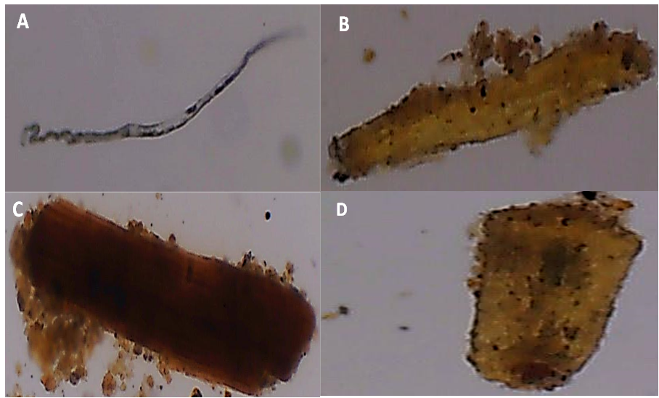
Figure S1. Xylopia aethiopica fruit powder: (A) fiber fragment; (B, C, D) tannin cells.
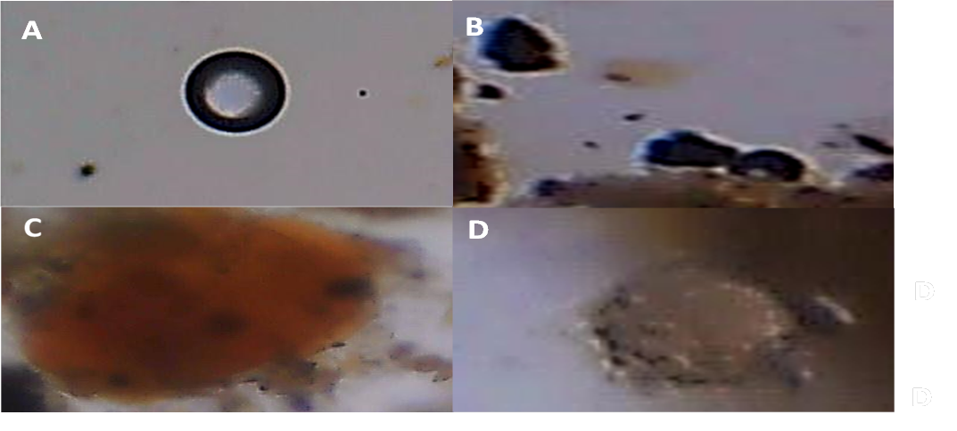
Figure S2. Xylopia aethiopica fruit powder: (A, B) starch grains; (C) uncharacterized orange-colored droplets; (D) oil droplets.
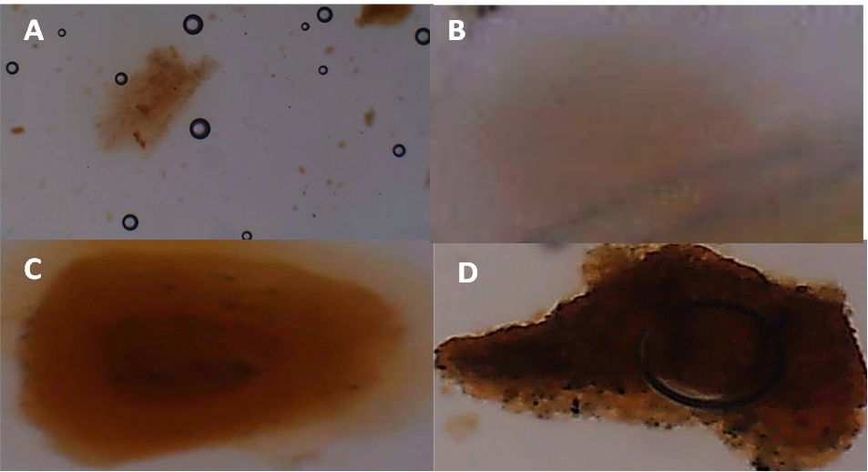
Figure S3. Tetrapleura tetraptera fruit powder: (A) starch grains; (B) oil droplet; (C, D) elements to be determined.
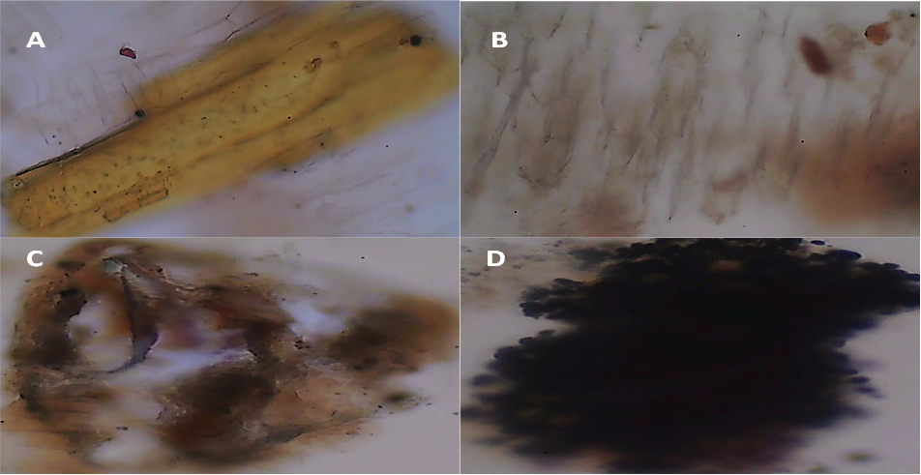
Figure S4. Tetrapleura tetraptera fruit powder: (A) fibre bundle; (B) striated fibre fragment; (C, D) clustered starch grains.
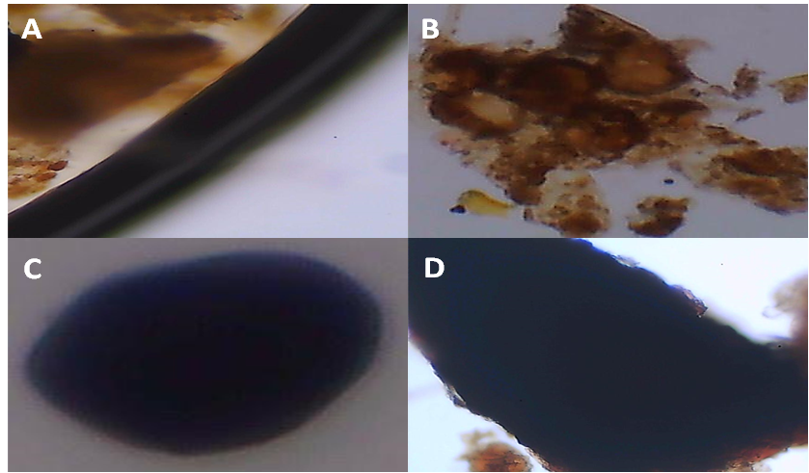
Figure S5. Monodora myristica fruit powder: (A, B) elements to be determined; (C, D) spherical starch grains.
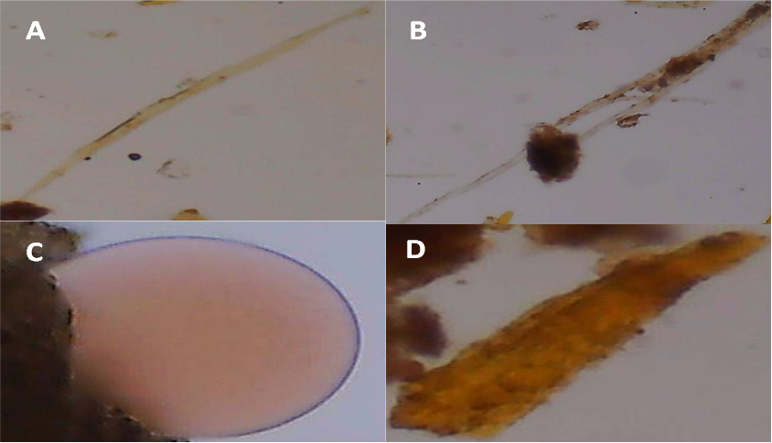
Figure S6. Monodora myristica fruit powder: (A, B) trichomes; (C) oil droplet; (D) fibre fragment.
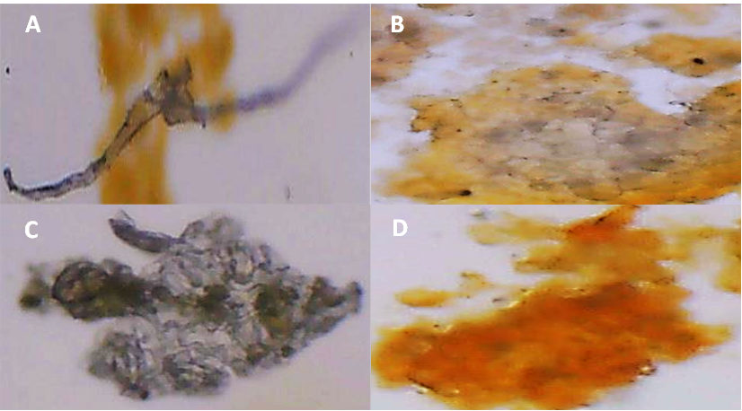
Figure S7. Ricinodendron heudelotii fruit powder: (A) trichome-like fibre; (B) starch grain aggregate; (C) urchin-like calcium oxalate crystal cluster; (D) element to be determined.
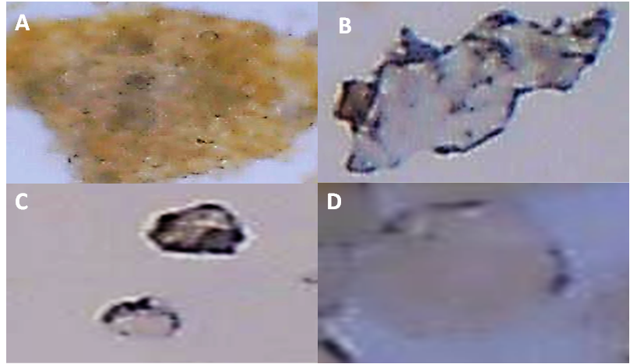
Figure S8. Ricinodendron heudelotii fruit powder: (A) starch grain aggregate; (B) urchin-like crystal; (C) oil droplet; (D) element to be determined.

Figures S19–S12. Foaming power photos
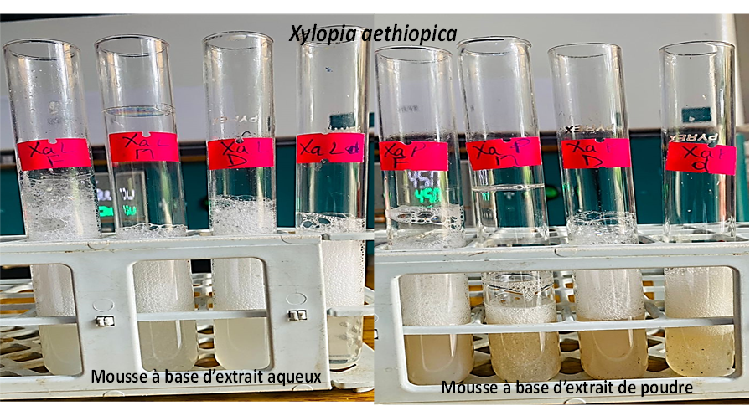
Figure S9. Foaming power of Xylopia aethiopica soaps across four water types.
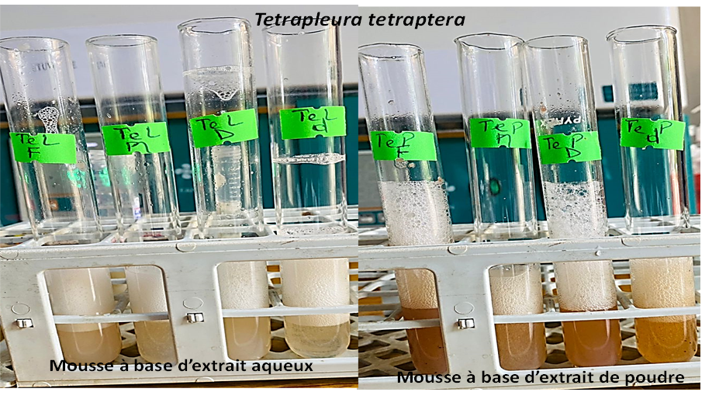
Figure S10. Foaming power of Tetrapleura tetraptera soaps.
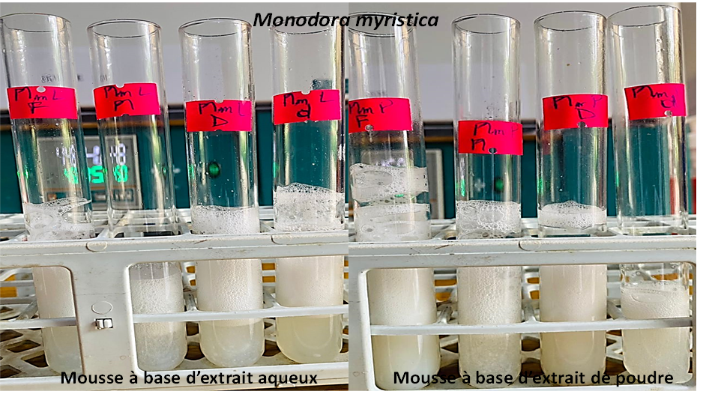
Figure S11. Foaming power of Monodora myristica soaps.
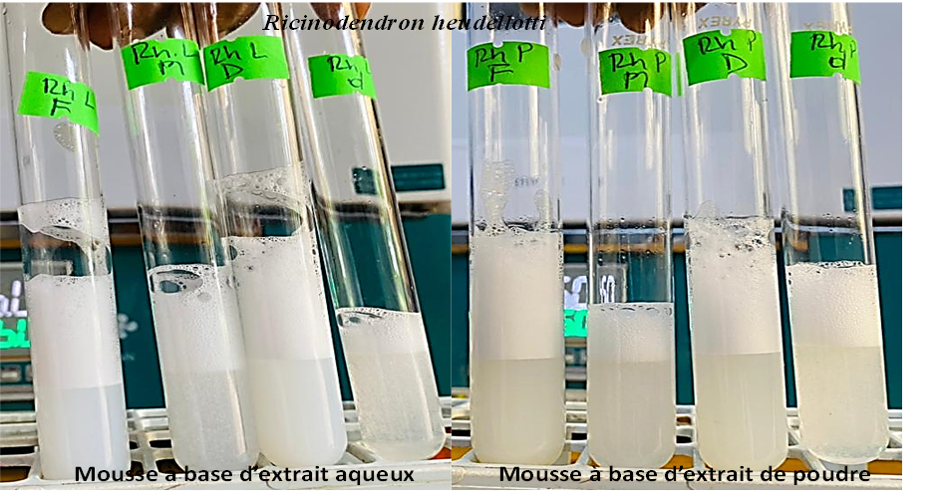
Figure S12. Foaming power of Ricinodendron heudelotii soaps.

