Online Resource 1: Supplementary Tables and Figures
Accuracy of 11 intraocular lens power calculation formulas in short eyes
Tingting Pan, Xue Ding, Weikang Bi, Daguang Bi, Chenxi Hu, Qian Zhao, Yan Gao, Ping Zhao, Yan Wen, and Shaowei Li*
*Corresponding author: Shaowei Li; E-mail: lishaowei@aierchina.com
Table S1 Predictive outcomes of intraocular lens calculation formulas based on axial-length subgroups
Table S1. Predictive outcomes of intraocular lens calculation formulas based on axial-length subgroups
Formula | MEª | SD | MAE | MedAE | ± 0.25 D (%) | ± 0.50 D (%) | ± 0.75 D (%) | ± 1.00 D (%)
AL ≤ 21.0 mm (n = 28)
New-generation formulas
BUII | -0.29^{b} | 0.59 | 0.55 | 0.53 | 25.00 | 46.43 | 75.00 | 85.71
Kane | 0.01^{b} | 0.66 | 0.52 | 0.50 | 32.14 | 53.57 | 64.29 | 89.29
EVO | -0.06 | 0.69 | 0.56 | 0.53 | 28.57 | 46.43 | 64.29 | 82.14
T2 | -0.05 | 0.80 | 0.64 | 0.62 | 25.00 | 46.43 | 53.57 | 78.57
Pearl-DGS | -0.20 | 0.68 | 0.59 | 0.54 | 21.43 | 46.43 | 67.86 | 85.71
K6 | 0.05 | 0.68 | 0.53 | 0.38 | 28.57 | 60.71 | 67.86 | 82.14
Traditional formulas
Holladay 1 | -0.04 | 0.68 | 0.57 | 0.50 | 28.57 | 50.00 | 71.43 | 85.71
SRK/T | -0.04 | 0.83 | 0.66 | 0.57 | 28.57 | 50.00 | 64.29 | 71.43
Hoffer Q | -0.26^{b} | 0.65 | 0.56 | 0.55 | 35.71 | 50.00 | 64.29 | 82.14
Haigis | -0.14 | 0.55 | 0.44 | 0.36 | 46.43 | 57.14 | 75.00 | 92.86
SRK-II | 0.13^{b} | 0.95 | 0.77 | 0.67 | 17.86 | 42.86 | 50.00 | 60.71
21.0 mm < AL ≤ 21.5 mm (n = 63)
New-generation formulas
BUII | -0.18^{b} | 0.59 | 0.50 | 0.42 | 36.51 | 53.97 | 76.19 | 87.30
Kane | -0.16 | 0.66 | 0.55 | 0.35 | 36.51 | 55.56 | 74.60 | 82.54
EVO | -0.14 | 0.69 | 0.52 | 0.42 | 41.27 | 61.90 | 74.60 | 84.13
T2 | -0.18 | 0.80 | 0.52 | 0.44 | 30.16 | 57.14 | 80.95 | 88.89
Pearl-DGS | -0.18 | 0.68 | 0.53 | 0.40 | 36.51 | 61.90 | 77.78 | 84.13
K6 | -0.11 | 0.68 | 0.55 | 0.37 | 39.68 | 60.32 | 77.78 | 82.54
Traditional formulas
Holladay 1 | -0.15 | 0.68 | 0.48 | 0.40 | 34.92 | 61.90 | 80.95 | 88.89
SRK/T | -0.18 | 0.83 | 0.54 | 0.50 | 23.81 | 49.21 | 79.37 | 85.71
Hoffer Q | -0.18 | 0.65 | 0.48 | 0.36 | 34.92 | 63.49 | 80.95 | 87.30
Haigis | 0.18 | 0.55 | 0.52 | 0.41 | 30.16 | 60.32 | 76.19 | 85.71
SRK-II | 0.09 | 0.95 | 0.56 | 0.47 | 22.22 | 52.38 | 73.02 | 84.13
21.5 mm < AL ≤ 22.0 mm (n = 206)
New-generation formulas
BUII | 0.17^{b} | 0.57 | 0.46 | 0.39 | 35.44 | 62.62 | 80.10 | 92.23
Kane | 0.20 | 0.58 | 0.46 | 0.38 | 37.38 | 64.08 | 81.07 | 90.78
EVO | 0.18 | 0.57 | 0.45 | 0.36 | 39.81 | 66.99 | 80.10 | 90.29
T2 | 0.06 | 0.58 | 0.46 | 0.36 | 36.41 | 63.11 | 81.55 | 89.32
Pearl-DGS | 0.33^{b} | 0.58 | 0.46 | 0.37 | 33.50 | 64.08 | 78.64 | 89.81
K6 | 0.38^{b} | 0.60 | 0.46 | 0.39 | 36.89 | 65.53 | 78.16 | 89.81
Traditional formulas
Holladay 1 | 0.09^{b} | 0.57 | 0.45 | 0.36 | 39.21 | 63.59 | 81.07 | 89.32
SRK/T | 0.07 | 0.60 | 0.48 | 0.38 | 33.98 | 61.17 | 80.58 | 88.83
Hoffer Q | 0.01 | 0.58 | 0.47 | 0.38 | 34.47 | 61.17 | 81.07 | 88.83
Haigis | 0.27^{b} | 0.61 | 0.49 | 0.40 | 33.50 | 61.17 | 78.64 | 87.38
SRK-II | 0.39^{b} | 0.67 | 0.52 | 0.44 | 31.07 | 59.22 | 75.24 | 85.92
AL = axial length; BUII = Barrett Universal II formula; EVO = Emmetropia Verifying Optical formula version 2.0; ME = mean prediction error; SD = standard deviation of prediction error; MAE = mean absolute prediction error; MedAE = median absolute prediction error; ± 0.25 D (%), ± 0.50 D (%), ± 0.75 D (%), ± 1.00 D (%) = percentage of eyes within ± 0.25 D, ± 0.50 D, ± 0.75 D, or ± 1.00D of prediction error; D = diopters. All values were calculated using prediction errors after overall zero-centered optimization. ME represents the residual mean prediction error within each subgroup after overall optimization. Superscript letters indicate whether subgroup-specific ME differed significantly from zero.
a Comparison between prediction error and zero.
b Statistically significant (P < 0.05).

Table S2 Predictive outcomes of intraocular lens calculation formulas based on mean-keratometry subgroups
Table S2. Predictive outcomes of intraocular lens calculation formulas based on mean-keratometry subgroups
Formula | MEª | SD | MAE | MedAE | ± 0.25 D (%) | ± 0.50 D (%) | ± 0.75 D (%) | ± 1.00 D (%)
Km ≤ 44 D (n = 20)
New-generation formulas
BUII | -0.08 | 0.65 | 0.53 | 0.50 | 25.00 | 50.00 | 85.00 | 85.00
Kane | 0.10 | 0.61 | 0.51 | 0.41 | 25.00 | 60.00 | 75.00 | 85.00
EVO | 0.10 | 0.64 | 0.53 | 0.44 | 25.00 | 65.00 | 75.00 | 90.00
T2 | 0.32 | 0.72 | 0.60 | 0.44 | 30.00 | 55.00 | 70.00 | 80.00
Pearl-DGS | 0.04 | 0.63 | 0.52 | 0.44 | 15.00 | 65.00 | 80.00 | 85.00
K6 | 0.09 | 0.64 | 0.53 | 0.45 | 20.00 | 70.00 | 75.00 | 90.00
Traditional formulas
Holladay 1 | 0.13 | 0.68 | 0.55 | 0.49 | 30.00 | 55.00 | 70.00 | 80.00
SRK/T | 0.44^{b} | 0.72 | 0.65 | 0.49 | 30.00 | 55.00 | 70.00 | 75.00
Hoffer Q | -0.03 | 0.65 | 0.51 | 0.33 | 35.00 | 55.00 | 70.00 | 85.00
Haigis | -0.17 | 0.54 | 0.47 | 0.39 | 20.00 | 55.00 | 80.00 | 95.00
SRK-II | 0.57^{b} | 0.73 | 0.71 | 0.51 | 25.00 | 45.00 | 70.00 | 70.00
44 D < Km ≤ 45 D (n = 45)
New-generation formulas
BUII | 0.03 | 0.59 | 0.50 | 0.48 | 31.11 | 55.56 | 82.22 | 91.11
Kane | 0.04 | 0.62 | 0.50 | 0.43 | 24.44 | 57.78 | 82.22 | 91.11
EVO | 0.04 | 0.62 | 0.49 | 0.44 | 28.89 | 60.00 | 77.78 | 88.89
T2 | 0.10 | 0.60 | 0.50 | 0.42 | 20.00 | 57.78 | 84.44 | 91.11
Pearl-DGS | 0.06 | 0.64 | 0.51 | 0.43 | 28.89 | 57.78 | 77.78 | 88.89
K6 | 0.08 | 0.67 | 0.51 | 0.51 | 37.78 | 48.89 | 73.33 | 86.67
Traditional formulas
Holladay 1 | -0.01 | 0.59 | 0.49 | 0.46 | 31.11 | 53.33 | 77.78 | 93.33
SRK/T | 0.18 | 0.59 | 0.51 | 0.41 | 20.00 | 57.78 | 82.22 | 91.11
Hoffer Q | -0.06 | 0.60 | 0.49 | 0.46 | 31.11 | 53.33 | 82.22 | 93.33
Haigis | -0.09 | 0.68 | 0.55 | 0.48 | 26.67 | 51.11 | 75.56 | 91.11
SRK-II | 0.18 | 0.61 | 0.52 | 0.45 | 28.89 | 55.56 | 75.56 | 86.67
45 D < Km ≤ 46 D (n = 79)
New-generation formulas
BUII | 0.11 | 0.63 | 0.51 | 0.46 | 34.18 | 55.70 | 74.68 | 89.87
Kane | 0.05 | 0.64 | 0.49 | 0.42 | 39.24 | 56.96 | 75.95 | 88.61
EVO | 0.05 | 0.61 | 0.47 | 0.38 | 41.77 | 60.76 | 77.22 | 89.87
T2 | 0.09 | 0.63 | 0.50 | 0.37 | 40.51 | 56.96 | 75.95 | 86.08
Pearl-DGS | 0.10 | 0.62 | 0.50 | 0.37 | 31.65 | 56.96 | 72.15 | 88.61
K6 | 0.06 | 0.66 | 0.51 | 0.40 | 37.97 | 62.03 | 72.15 | 86.08
Traditional formulas
Holladay 1 | 0.05 | 0.63 | 0.49 | 0.39 | 39.24 | 60.76 | 77.22 | 86.08
SRK/T | 0.12^{b} | 0.64 | 0.51 | 0.46 | 34.18 | 53.16 | 73.42 | 84.81
Hoffer Q | 0.06 | 0.63 | 0.50 | 0.39 | 34.18 | 62.03 | 75.95 | 86.08
Haigis | 0.04 | 0.63 | 0.49 | 0.38 | 36.71 | 62.03 | 75.95 | 84.81
SRK-II | 0.13 | 0.67 | 0.54 | 0.45 | 31.65 | 58.23 | 68.35 | 81.01
46 D < Km ≤ 47 D (n = 76)
New-generation formulas
BUII | -0.02 | 0.60 | 0.48 | 0.40 | 31.58 | 61.84 | 77.63 | 89.47
Kane | -0.04 | 0.61 | 0.47 | 0.37 | 42.11 | 59.21 | 77.63 | 88.16
EVO | -0.07 | 0.62 | 0.48 | 0.39 | 42.11 | 63.16 | 73.68 | 85.53
T2 | -0.08 | 0.60 | 0.49 | 0.40 | 31.58 | 59.21 | 80.26 | 88.16
Pearl-DGS | -0.04 | 0.62 | 0.48 | 0.36 | 36.84 | 60.53 | 76.32 | 86.84
K6 | -0.06 | 0.63 | 0.48 | 0.38 | 38.16 | 61.84 | 76.32 | 86.84
Traditional formulas
Holladay 1 | -0.06 | 0.59 | 0.47 | 0.40 | 32.89 | 63.16 | 80.26 | 89.47
SRK/T | -0.08 | 0.61 | 0.48 | 0.41 | 32.89 | 59.21 | 81.58 | 88.16
Hoffer Q | -0.02 | 0.60 | 0.47 | 0.42 | 32.89 | 61.84 | 84.21 | 86.84
Haigis | -0.02 | 0.66 | 0.50 | 0.41 | 35.53 | 59.21 | 76.32 | 86.84
SRK-II | -0.10 | 0.69 | 0.55 | 0.45 | 31.58 | 55.26 | 69.74 | 82.89
47 D < Km ≤ 48 D (n = 47)
New-generation formulas
BUII | 0.03 | 0.56 | 0.46 | 0.39 | 34.04 | 59.57 | 78.72 | 93.62
Kane | -0.07 | 0.72 | 0.51 | 0.43 | 31.91 | 65.96 | 76.60 | 89.36
EVO | -0.07 | 0.62 | 0.46 | 0.38 | 40.43 | 68.09 | 82.98 | 91.49
T2 | -0.07 | 0.61 | 0.47 | 0.36 | 40.43 | 61.70 | 76.60 | 89.36
Pearl-DGS | -0.07 | 0.67 | 0.49 | 0.43 | 34.04 | 65.96 | 85.11 | 91.49
K6 | -0.09 | 0.72 | 0.48 | 0.34 | 31.91 | 74.47 | 87.23 | 91.49
Traditional formulas
Holladay 1 | 0.01 | 0.61 | 0.46 | 0.33 | 46.81 | 59.57 | 82.98 | 89.36
SRK/T | -0.12 | 0.58 | 0.45 | 0.31 | 42.55 | 63.83 | 80.85 | 89.36
Hoffer Q | 0.06 | 0.65 | 0.51 | 0.40 | 34.04 | 55.32 | 76.60 | 85.11
Haigis | 0.09 | 0.61 | 0.49 | 0.36 | 34.04 | 63.83 | 76.60 | 82.98
SRK-II | -0.15 | 0.59 | 0.48 | 0.41 | 27.66 | 61.70 | 78.72 | 89.36
Km > 48 D (n = 30)
New-generation formulas
BUII | -0.11 | 0.49 | 0.37 | 0.22 | 56.67 | 73.33 | 83.33 | 93.33
Kane | -0.01 | 0.52 | 0.37 | 0.26 | 50.00 | 76.67 | 83.33 | 90.00
EVO | -0.03 | 0.58 | 0.41 | 0.26 | 46.67 | 73.33 | 80.00 | 83.33
T2 | -0.29^{b} | 0.47 | 0.42 | 0.32 | 36.67 | 76.67 | 83.33 | 93.33
Pearl-DGS | -0.14 | 0.56 | 0.41 | 0.36 | 43.33 | 76.67 | 80.00 | 86.67
K6 | -0.02 | 0.58 | 0.40 | 0.26 | 46.67 | 76.67 | 83.33 | 86.67
Traditional formulas
Holladay 1 | -0.06 | 0.47 | 0.36 | 0.30 | 43.33 | 83.33 | 93.33 | 93.33
SRK/T | -0.48^{b} | 0.49 | 0.55 | 0.46 | 20.00 | 56.67 | 83.33 | 83.33
Hoffer Q | -0.11 | 0.47 | 0.35 | 0.26 | 46.67 | 76.67 | 83.33 | 93.33
Haigis | 0.06 | 0.48 | 0.37 | 0.30 | 43.33 | 73.33 | 90.00 | 93.33
SRK-II | -0.52^{b} | 0.66 | 0.65 | 0.48 | 10.00 | 53.33 | 76.67 | 83.33
Km = mean keratometry; BUII = Barrett Universal II formula; EVO = Emmetropia Verifying Optical formula version 2.0; ME = mean prediction error; SD = standard deviation of prediction error; MAE = mean absolute prediction error; MedAE = median absolute prediction error; ± 0.25 D (%), ± 0.50 D (%), ± 0.75 D (%), ± 1.00 D (%) = percentage of eyes within ± 0.25 D, ± 0.50 D, ± 0.75 D, or ± 1.00 D of prediction error; D = diopters. All values were calculated using prediction errors after overall zero-centered optimization. ME represents the residual mean prediction error within each subgroup after overall optimization. Superscript letters indicate whether subgroup-specific ME differed significantly from zero.
a Comparison between prediction error and zero.
b Statistically significant (P < 0.05).

Supplementary Figures
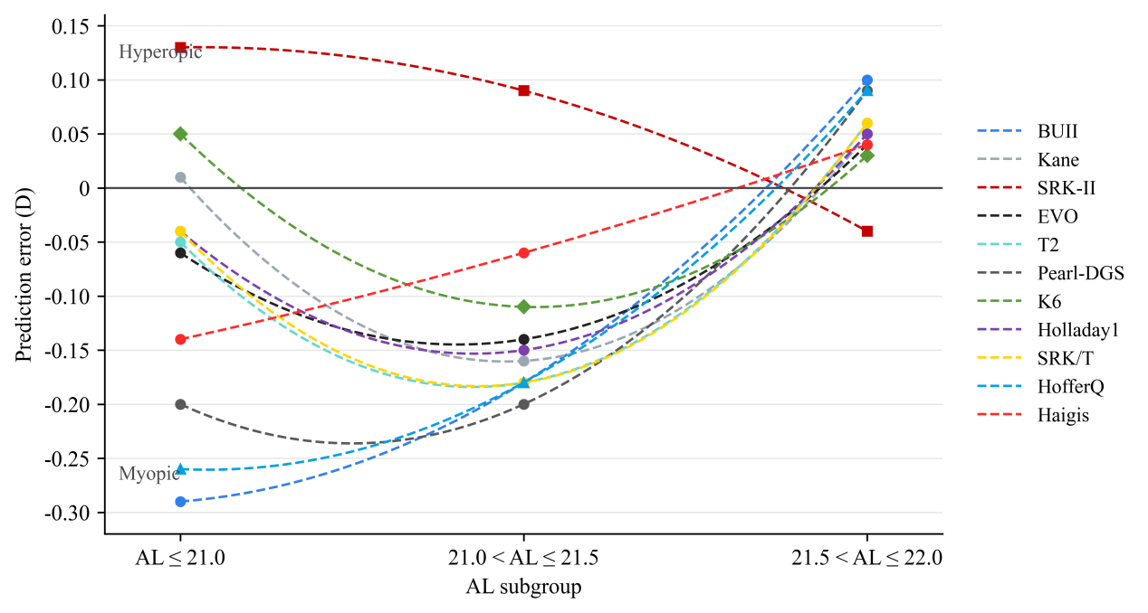
Fig. S1 Comparison of IOL power prediction errors across different AL subgroups. The x-axis represents the AL (mm), and the y-axis represents the prediction error (D). Positive values indicate hyperopic shifts, and negative values indicate myopic shifts. Each dashed line represents the trend of a specific intraocular lens (IOL) calculation formula
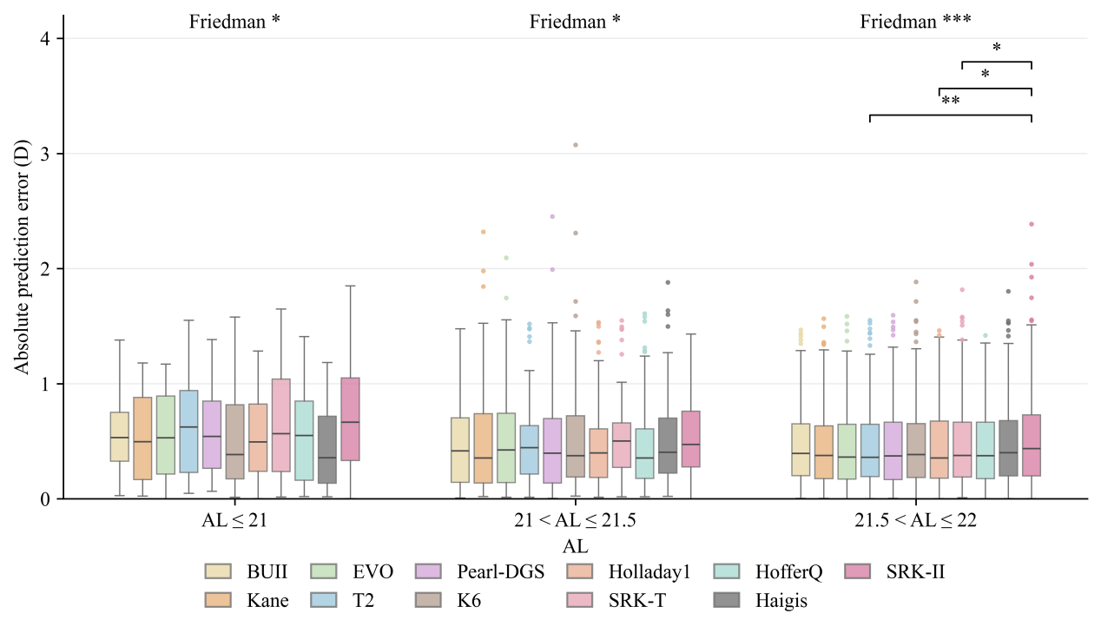
Fig. S2 Absolute prediction error across AL subgroups. Boxes indicate the median and interquartile range, and whiskers extend to 1.5 × IQR. Colored points indicate outliers, which were retained in the analysis. Differences among formulas were assessed using the Friedman test, followed by Bonferroni-adjusted Wilcoxon signed-rank post hoc tests when appropriate. *P < 0.05, **P < 0.01, ***P < 0.001
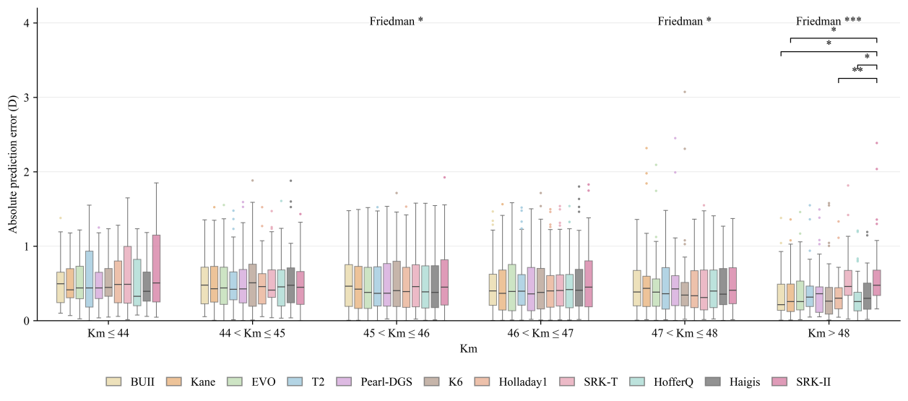
Fig. S3 Absolute prediction error across Km subgroups. Boxes indicate the median and interquartile range, and whiskers extend to 1.5 × IQR. Colored points indicate outliers, which were retained in the analysis. Differences among formulas were assessed using the Friedman test, followed by Bonferroni-adjusted Wilcoxon signed-rank post hoc tests when appropriate. *P < 0.05, **P < 0.01, ***P < 0.001

