Supplementary Material
Heterogeneity in quality of life among patients receiving first postoperative chemotherapy for gastric cancer: A latent profile analysis of psychosocial and symptom pathways

Supplementary Methods S1. Detailed rationale for latent profile model selection
The five QLICP-ST domain scores (physical function, psychological function, social function, symptom/side-effect domain, and disease-specific domain) were used as profile indicators. Exploratory latent profile analysis was conducted using the equal-variance, locally independent model (EEI) implemented in the mclust package. One- to five-class solutions were fitted. Model selection was based on the following criteria:
(1) Information criteria. The adjusted Bayesian information criterion (aBIC) decreased as the number of classes increased, with a visible elbow at the 3-class solution in the scree plot. Although AIC, BIC, and aBIC continued to decrease in the 4- and 5-class solutions, the magnitude of improvement beyond three classes was limited, and these solutions yielded very small subgroups. Therefore, information criteria were interpreted together with classification precision, subgroup proportions, and clinical interpretability rather than in isolation (Supplementary Figure S2).
(2) Statistical tests. From the 2-class to the 5-class models, both the bootstrap likelihood ratio test (BLRT) and the Lo–Mendell–Rubin likelihood ratio test (LRT) were statistically significant (all p < 0.001). However, since both tests remained significant through 5-class solutions, class enumeration decisions were additionally informed by classification quality, subgroup proportions, and interpretability criteria described below
(3) Classification precision. Entropy was 0.762 for the 2-class solution and 0.766 for the 3-class solution. Although the 4-class solution showed a slightly higher entropy (0.795), one class accounted for only 1.1% of the sample, indicating limited statistical stability and clinical relevance. Classification diagnostics supported acceptable assignment quality for the 3-class solution, indicating good classification accuracy.
(4) Interpretability and clinical relevance. The 3-class solution yielded three clearly distinguishable and clinically meaningful subgroups. Class proportions were 17.7%, 22.1%, and 60.3%, respectively, all of which were sufficiently large for interpretation. In contrast, the 4-class and 5-class solutions each contained a very small subgroup (1.1% and 0.9%, respectively), limiting their practical interpretability.
(5) Model stability. A parametric bootstrap procedure based on 999 resamples was used to evaluate the stability of the 3-class solution, and the results supported the robustness of the parameter estimates.
Taken together, the 3-class solution under the EEI covariance structure was retained as the final latent profile model.

Supplementary Methods S2. Relative importance analysis
To estimate the relative explanatory contribution of the core predictors to overall quality of life (QoL), a relative importance analysis was performed based on a multiple linear regression model. The QoL total score was entered as the dependent variable, and social support (SSRS), resilience (CD-RISC), self-efficacy (GSES), fear of progression (FoP), and chemotherapy-related symptom burden (MDASI-GI) were entered as predictors. Relative importance was estimated using the Lindeman–Merenda–Gold (LMG) method, which decomposes the model R² by averaging each predictor's incremental contribution across all possible orderings of entry. Results were expressed as percentages and visualized using a lollipop plot. All analyses were conducted in R using the relaimpo, ggplot2, and dplyr packages.

Supplementary Table S1. Demographic, clinical, laboratory, and psychosocial characteristics by latent profile

Variables | Total  (n=453) | C1  (n=80) | C2  (n=100) | C3  (n=273) | Statistic | P
Gender [n(%)] |  |  |  |  | Χ²=2.789 | 0.248
Male | 314(69.3) | 50(62.5) | 74(74.0) | 190(69.6)
Female | 139(30.7) | 30(37.5) | 26(26.0) | 83(30.4)
Place of residence [n(%)] |  |  |  |  | Χ²=0.298 | 0.861
Countryside | 164(36.2) | 31(38.8) | 35(35.0) | 98(35.9)
City | 289(63.8) | 49(61.2) | 65(65.0) | 175(64.1)
Educational background [n(%)] |  |  |  |  | Χ²=3.389 | 0.759
Primary or below | 152(33.6) | 30(37.5) | 34(34.0) | 88(32.2)
Junior high | 146(32.2) | 26(32.5) | 33(33.0) | 87(31.9)
High school | 109(24.1) | 15(18.8) | 21(21.0) | 73(26.7)
College or above | 46(10.2) | 9(11.2) | 12(12.0) | 25(9.2)
Marital status [n(%)] |  |  |  |  | Fisherª | 0.583
Unmarried | 4(0.9) | 2(2.5) | 1(1.0) | 1(0.4)
Married | 439(96.9) | 77(96.2) | 97(97.0) | 265(97.1)
Divorced | 3(0.7) | 0(0.0) | 0(0.0) | 3(1.1)
Widowed | 6(1.3) | 1(1.2) | 2(2.0) | 3(1.1)
Remarried | 1(0.2) | 0(0.0) | 0(0.0) | 1(0.4)
Monthly household income per capita (RMB) [n(%)] |  |  |  |  | Χ²=6.731 | 0.566
<2000 | 44(9.7) | 8(10.0) | 10(10.0) | 26(9.5)
2000-3999 | 116(25.6) | 20(25.0) | 24(24.0) | 72(26.4)
4000-5999 | 206(45.5) | 41(51.2) | 43(43.0) | 122(44.7)
6000-7999 | 54(11.9) | 9(11.2) | 11(11.0) | 34(12.5)
>=8000 | 33(7.3) | 2(2.5) | 12(12.0) | 19(7.0)
Medical payment method [n(%)] |  |  |  |  | Fisherª | 0.595
Medical insurance | 411(90.7) | 72(90.0) | 92(92.0) | 247(90.5)
Public expense | 0(0.0) | 0(0.0) | 0(0.0) | 0(0.0)
Self-pay | 16(3.5) | 3(3.8) | 5(5.0) | 8(2.9)
Rural cooperative | 26(5.7) | 5(6.2) | 3(3.0) | 18(6.6)
Others | 0(0.0) | 0(0.0) | 0(0.0) | 0(0.0)
Smoking history [n(%)] |  |  |  |  | Χ²=0.992 | 0.609
No | 344(75.9) | 62(77.5) | 79(79.0) | 203(74.4)
Yes | 109(24.1) | 18(22.5) | 21(21.0) | 70(25.6)
Alcohol history [n(%)] |  |  |  |  | Χ²=2.056 | 0.358
No | 353(77.9) | 67(83.8) | 78(78.0) | 208(76.2)
Yes | 100(22.1) | 13(16.2) | 22(22.0) | 65(23.8)
Tumor location [n(%)] |  |  |  |  | Fisherª | 0.209
Proximal | 252(55.6) | 53(66.2) | 55(55.0) | 144(52.7)
Distal | 183(40.4) | 25(31.2) | 39(39.0) | 119(43.6)
Whole stomach | 18(4.0) | 2(2.5) | 6(6.0) | 10(3.7)
Histological grade [n(%)] |  |  |  |  | Χ²=4.747 | 0.314
Well | 38(8.4) | 4(5.0) | 13(13.0) | 21(7.7)
Moderate | 54(11.9) | 8(10.0) | 11(11.0) | 35(12.8)
Poor/undifferentiated | 361(79.7) | 68(85.0) | 76(76.0) | 217(79.5)
Surgery type [n(%)] |  |  |  |  | Fisherª | 0.897
Laparoscopic | 202(44.6) | 37(46.2) | 46(46.0) | 119(43.6)
Open | 238(52.5) | 41(51.2) | 50(50.0) | 147(53.8)
Robotic | 13(2.9) | 2(2.5) | 4(4.0) | 7(2.6)
Chemotherapy regimen [n(%)] |  |  |  |  | Χ²=5.945 | 0.203
XELOX | 116(25.6) | 23(28.8) | 21(21.0) | 72(26.4)
SOX | 69(15.2) | 8(10.0) | 22(22.0) | 39(14.3)
Others | 268(59.2) | 49(61.2) | 57(57.0) | 162(59.3)
Comorbidities [n(%)] |  |  |  |  | Χ²=0.396 | 0.82
No | 324(71.5) | 57(71.2) | 74(74.0) | 193(70.7)
Yes | 129(28.5) | 23(28.8) | 26(26.0) | 80(29.3)
Age M(P25,P75) | 65.0(57.0, 70.0) | 67.0(57.0, 69.5) | 64.0(56.0, 68.5) | 65.0(57.0, 70.0) | H=1.373 | 0.503
BMI M(P25,P75) | 21.3(19.1, 23.5) | 20.8(19.1, 22.7) | 21.4(19.3, 24.1) | 21.4(19.1, 23.6) | H=2.395 | 0.302
Time since diagnosis (months) M(P25,P75) | 2.5(1.0, 6.0) | 3.0(1.0, 7.5) | 2.5(1.0, 5.5) | 2.0(1.0, 5.5) | H=3.288 | 0.193
KPS score M(P25,P75) | 90.0(90.0, 90.0) | 90.0(80.0, 90.0) | 90.0(90.0, 100.0) | 90.0(90.0, 90.0) | H=47.407 | <0.001
WBC M(P25,P75) | 4.6(3.8, 5.9) | 4.7(3.8, 6.4) | 4.2(3.5, 5.4) | 4.7(4.0, 5.8) | H=6.059 | 0.048
RBC M(P25,P75) | 3.8(3.4, 4.1) | 3.6(3.3, 3.9) | 3.8(3.5, 4.1) | 3.8(3.4, 4.1) | H=10.939 | 0.004
HGB M(P25,P75) | 111.0(100.0, 122.0) | 106.5(94.0, 115.5) | 111.0(101.0, 119.0) | 112.0(100.0, 124.0) | H=8.970 | 0.011
PLT M(P25,P75) | 176.0(133.0, 229.0) | 205.5(153.0, 246.5) | 166.5(134.0, 218.0) | 173.0(129.0, 227.0) | H=8.005 | 0.018
Neutrophil% M(P25,P75) | 56.0(47.9, 66.3) | 57.8(51.0, 71.7) | 55.1(48.7, 64.1) | 56.0(45.6, 65.3) | H=4.519 | 0.104
ALT M(P25,P75) | 18.0(13.0, 27.0) | 18.0(11.5, 24.6) | 19.0(13.0, 28.5) | 18.0(13.0, 26.0) | H=1.051 | 0.591
AST M(P25,P75) | 20.0(17.0, 26.4) | 20.0(17.0, 24.5) | 20.0(17.0, 26.5) | 20.0(16.0, 27.0) | H=0.133 | 0.935
ALB M(P25,P75) | 37.9(35.6, 40.3) | 37.0(34.5, 40.2) | 37.8(36.0, 40.7) | 37.9(35.7, 40.2) | H=2.529 | 0.282
UREA M(P25,P75) | 4.9(4.0, 6.2) | 5.2(4.1, 6.6) | 4.9(4.3, 6.0) | 4.9(3.9, 6.2) | H=2.755 | 0.252
GGT M(P25,P75) | 25.0(16.0, 36.0) | 24.0(15.0, 33.5) | 25.0(15.0, 40.0) | 25.0(17.0, 36.0) | H=2.518 | 0.284
AFP M(P25,P75) | 2.9(2.1, 3.7) | 2.9(1.9, 3.8) | 2.9(2.2, 3.5) | 2.9(2.1, 3.7) | H=0.363 | 0.834
CEA M(P25,P75) | 2.3(1.6, 3.9) | 2.3(1.7, 4.9) | 2.3(1.5, 3.2) | 2.3(1.6, 4.0) | H=2.469 | 0.291
Fear of progression (FoP-Q-SF) M(P25,P75) | 34.0(25.0, 38.0) | 36.0(33.5, 41.5) | 26.5(20.5, 35.0) | 35.0(26.0, 38.0) | H=47.068 | <0.001
General self-efficacy (GSES) M(P25,P75) | 24.0(20.0, 28.0) | 23.0(20.0, 27.0) | 27.0(21.0, 30.0) | 24.0(20.0, 28.0) | H=14.742 | <0.001
Resilience (CD-RISC) M(P25,P75) | 51.0(40.0, 65.0) | 49.0(36.0, 57.0) | 62.0(47.5, 73.5) | 51.0(38.0, 63.0) | H=27.312 | <0.001
Social support (SSRS) M(P25,P75) | 52.0(42.0, 57.0) | 52.0(45.5, 57.5) | 45.0(37.5, 54.0) | 53.0(43.0, 58.0) | H=17.646 | <0.001
Chemotherapy-related symptoms (reverse-coded MDASI-GI) M(P25,P75) | 29.0(15.0, 41.0) | 52.5(40.0, 71.0) | 14.0(8.0, 29.0) | 29.0(17.0, 36.0) | H=133.109 | <0.001
Note. Values are presented as n (%) for categorical variables and median (P25, P75) for continuous variables. C1 = psychosocially supported but physically vulnerable (n = 80); C2 = functionally preserved but symptomatically and psychologically challenged (n = 100); C3 = intermediate adaptation (n = 273). Categorical variables were compared using chi-square tests or Fisher's exact tests (ª); continuous variables were compared using the Kruskal–Wallis H test. KPS = Karnofsky Performance Status; WBC = white blood cell count; RBC = red blood cell count; HGB = hemoglobin; PLT = platelet count; ALT = alanine aminotransferase; AST = aspartate aminotransferase; ALB = albumin; UREA = blood urea nitrogen/urea; GGT = gamma-glutamyl transferase; AFP = alpha-fetoprotein; CEA = carcinoembryonic antigen; FoP-Q-SF = Fear of Progression Questionnaire–Short Form; GSES = General Self-Efficacy Scale; CD-RISC = Connor–Davidson Resilience Scale; SSRS = Social Support Rating Scale; MDASI-GI = M. D. Anderson Symptom Inventory–Gastrointestinal Module. Higher MDASI-GI scores indicate lighter symptom burden (reverse-coded; see Methods).

Supplementary Figure S1. Relative contributions of predictors to explained variance in quality of life
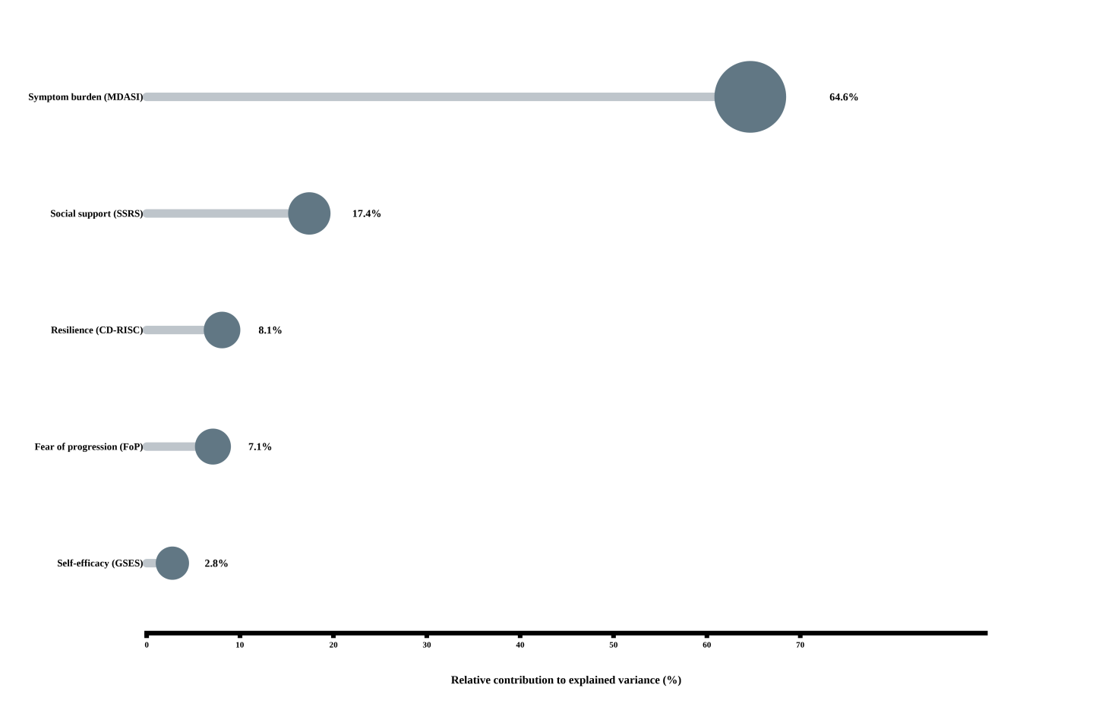Note. Relative importance was estimated using the Lindeman–Merenda–Gold (LMG) method based on a multiple linear regression model. The horizontal axis represents the percentage contribution of each variable to the explained variance (R²) in overall quality of life (QLICP-ST total score). MDASI-GI = chemotherapy-related symptom burden; SSRS = social support; CD-RISC = resilience; FoP = fear of progression; GSES = general self-efficacy. Point size is proportional to contribution magnitude.

Supplementary Figure S2. Scree plot of model fit indices for latent profile solutions
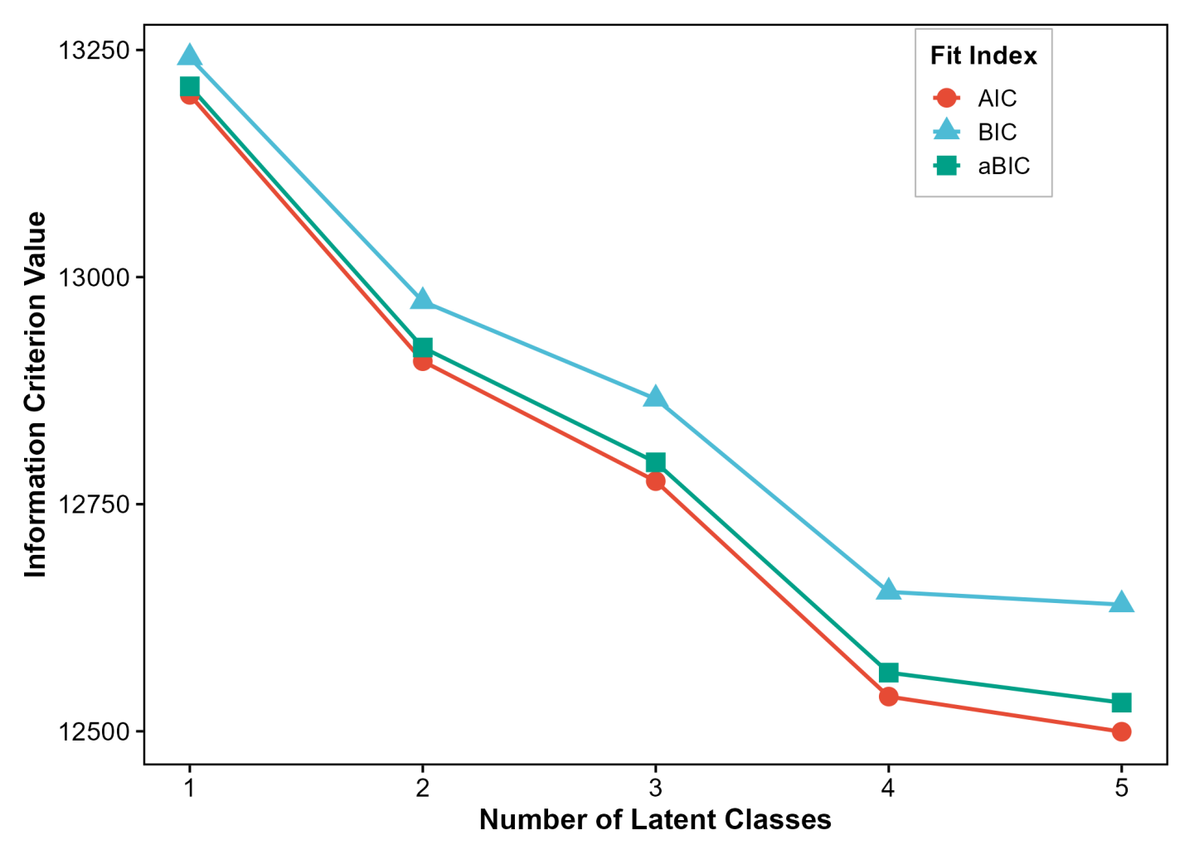Note. The plot shows the trends of the Akaike information criterion (AIC), Bayesian information criterion (BIC), and adjusted Bayesian information criterion (aBIC) across 1- to 5-class latent profile models. The elbow at the 3-class solution indicates the optimal balance between model fit and parsimony.

