Supplementary Information
This Supplementary Information describes the inventory architecture, module definitions, notation, equation set, evidence-treatment rules and figure-based diagnostics supporting the revised Methods. It is written as a readable companion document rather than a list of disconnected method notes. The structure follows the 2024 facility-source operations boundary and the disclosure-based manufacturing allocation described in the main Methods. Operations are calculated from approved facility-source records without a separate company-completion path. Market-based operational factors are assigned through a tiered evidence protocol, with procurement-related reductions used only when the evidence is attributable to the relevant operations electricity boundary^{1,2}.

Table of Contents
1. Inventory architecture, notation and units 1
2. AI hardware server/node boundary 3
3. Evidence coding and boundary flags 5
4. Location-based and market-based accounting definitions 7
5. Facility-source operations boundary 8
6. Operational emission factors and tiered market-based protocol 9
7. Operations scenario scaling and diagnostics 11
8. Manufacturing supplier-evidence mapping and exact-geography aggregation 12
9. Manufacturing market-based corporate disclosure envelopes 14
10. Manufacturing allocation equations and product-family decomposition 16
11. PCF and shipment-equivalent manufacturing diagnostics 17
12. Robustness checks, incomplete-data treatment and reporting limits 18
References 20

1. Inventory architecture, notation and units
The inventory is a boundary-explicit annual accounting framework for 2024. It reports two modules in parallel: upstream AI hardware manufacturing and downstream AI data center operations. The framework is not a full product life-cycle assessment and does not mechanically add the two modules into a single headline AI life-cycle total, because the two modules use different public-disclosure boundaries and attribution evidence^{1,3,4}.
All results are reported on location-based (LB) and market-based (MB) accounting bases. Within each module, the activity boundary is fixed: the same approved facility electricity values are used for operational LB and MB calculations, and the same AI hardware module-to-supplier evidence mapping is used for manufacturing LB and MB calculations. Differences between LB and MB estimates therefore reflect the accounting basis and emission-factor source, not a change in the underlying AI activity boundary².
Table S1 provides the common notation used throughout the SI. The table separates facility records, supplier entities, module shares, evidence mappings and accounting bases so that subsequent equations can be read without redefining variables in each section.
Supplementary Table S1 | Core symbols and units.
Symbol | Definition | Unit or range | Used in
$$f$$ | Approved facility-source record | index | operations
$$c\left(f\right)$$ | Company matched to facility record $f$ | text | operations
$$E_{f}$$ | Annual AI-attributable electricity for facility record $f$ | MWh or TWh per year | operations
$$E_{ops}$$ | Total AI-attributable operations electricity | TWh per year | operations
$${\text{EF}}_{f}^{LB}$$ | Location-based operational emission factor for facility record $f$ | g CO2e per kWh | operations
$${\text{EF}}_{f}^{MB}$$ | Approved market-based operational emission factor for facility record $f$ | g CO2e per kWh | operations
$${\text{GHG}}_{ops}^{B}$$ | Operational GHG emissions under accounting basis $B$ | tCO2e per year or Mt CO2e per year | operations
$$B$$ | Accounting basis, $B∈\{LB,MB\}$ | set | both modules
$$k$$ | Scenario case, $k∈\{low,central,high\}$ | set | both modules
$$r_{k}$$ | Scenario scaling ratio applied to the central facility-source operations case | dimensionless | operations
$$s$$ | Selected manufacturing disclosure entity | index | manufacturing
$$m$$ | AI hardware module | index | manufacturing
$$E_{s,B}^{2024}$$ | 2024 corporate or division emissions envelope for entity $s$ under basis $B$ | tCO2e per year | manufacturing
$$θ_{m,k}$$ | Module share within the AI server/node boundary | 0-1 | manufacturing
$$π_{s,m}$$ | Supplier-evidence mapping share from entity $s$ to module $m$ | 0-1 | manufacturing
$$λ_{s,m,k}$$ | Coverage modifier for partial or incomplete public attribution | documented value | manufacturing
$$α_{s,k}$$ | AI-attributable allocation share for entity $s$ | 0-1 | manufacturing
$${\text{GHG}}_{mfg}^{B,k}$$ | AI hardware manufacturing GHG estimate | tCO2e per year or Mt CO2e per year | manufacturing

2. AI hardware server/node boundary
The hardware boundary is defined at the AI server/node level. It represents the structural decomposition of a representative high-density AI node rather than a vendor-specific bill of materials. The boundary is used for allocation and diagnostic comparison, not for mechanical design.
The 12-module boundary is retained even when public evidence supports attribution for only part of the hardware stack. This avoids assigning distributed components to selected manufacturers without evidence while still preserving the full server/node accounting boundary.
Supplementary Fig. 1 makes this boundary concrete. It shows how compute, memory, accelerator, interconnect, power, cooling, enclosure, control electronics and residual parts are all inside the server/node boundary. The figure should be read as an accounting map: it identifies where evidence can support module-to-supplier attribution and where the boundary must remain unallocated rather than being forced into a selected supplier¹⁹⁻²⁴.
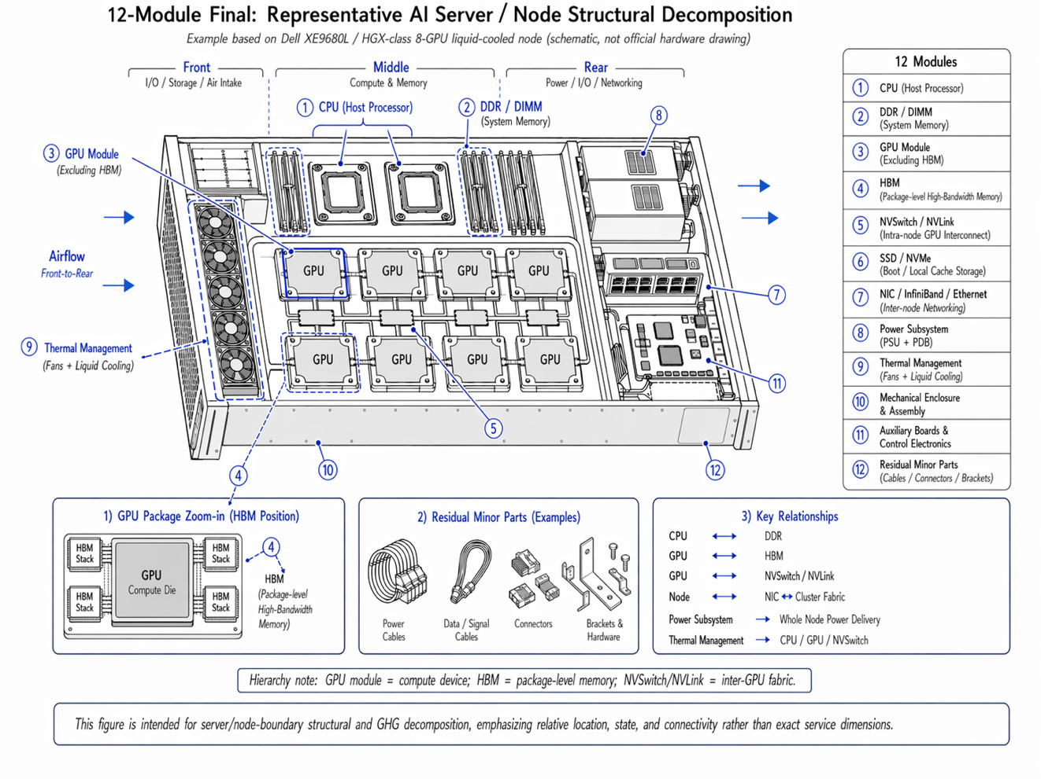
Supplementary Fig. 1 | Twelve-module AI server/node boundary. The schematic defines the full hardware boundary used for allocation and diagnostics. Modules are assigned to selected manufacturing disclosure entities only where public production-route, supplier-share or process evidence supports mapping. Power, thermal, mechanical, auxiliary and residual components remain in the boundary even when they are not assigned to selected entities. The unallocated bucket is therefore a boundary-preserving remainder rather than a zero-emissions assumption.
Table S2 translates the schematic into an accounting treatment for each module. The table distinguishes modules that can be assigned under public evidence from modules retained in the full boundary as unallocated residuals.
Supplementary Table S2 | Twelve-module AI hardware boundary and accounting treatment.
No. | Module | Function | Accounting treatment
1 | CPU | Host compute and orchestration | Assigned where public CPU and manufacturing-pathway evidence supports mapping.
2 | DDR/DIMM | System memory attached to host CPUs | Assigned using public DRAM supplier evidence or proxy shares where appropriate.
3 | GPU module excluding HBM | Accelerator compute package or module excluding HBM | Assigned only for logic-fabrication exposure; board-level ownership is not assumed.
4 | HBM | Package-level high-bandwidth memory stacks attached to accelerator packages | Assigned using public HBM shipment or supplier-share evidence.
5 | NVSwitch/NVLink | Intra-node accelerator interconnect fabric | Assigned only for logic-die exposure where public process or foundry evidence supports mapping.
6 | SSD/NVMe | Boot, cache and local storage | Assigned using enterprise SSD or storage-share evidence where available; otherwise retained as residual.
7 | NIC/InfiniBand/Ethernet | Inter-node network connectivity | Retained in the full boundary and generally unallocated unless robust public manufacturing evidence exists.
8 | Power subsystem | Power conversion and distribution | Retained in the full boundary and generally unallocated.
9 | Thermal management | Cooling for CPU, GPU, interconnect and chassis | Retained in the full boundary and generally unallocated.
10 | Mechanical enclosure and assembly | Chassis, structural components and system assembly | Retained in the full boundary and generally unallocated.
11 | Auxiliary boards and control electronics | Control boards, auxiliary circuits and management electronics | Retained in the full boundary and generally unallocated unless robust public manufacturing evidence exists.
12 | Residual minor parts | Cables, connectors, brackets and small components | Retained in the full boundary as part of the unallocated residual bucket.

The unallocated category is not a physical module and is not a zero-emissions assumption. It is a boundary-preserving remainder that includes module 12 and any unassigned fractions of modules 1-11 that cannot be robustly mapped to selected manufacturing disclosure entities using public evidence.

3. Evidence coding and boundary flags
Each workbook input is coded by evidence type, boundary role and accounting basis. The coding distinguishes quantities used in the primary calculations from quantities used only for checks, interpretation or audit. It also prevents qualitative mitigation statements from being converted into quantitative market-based reductions unless a comparable, attributable factor can be derived.
Table S3 is the control layer for the inventory. It separates approved facility electricity records from grid factors, market-based disclosure factors, supplier evidence, product-carbon-footprint files and shipment-equivalent diagnostics. This coding is important because the same public source can play different roles: a value can define the activity boundary, assign an emission factor, document a market-based tier or serve only as a robustness check.
Supplementary Table S3 | Evidence coding schema^{1,2,5,6,19-21}.
Code | Evidence type | Used for | Treatment
FAC-E | Approved facility electricity record | Operations activity boundary | Direct use of $E_{f}$ in the facility-source calculation.
GRID-LB | Local, regional or national grid factor | Operations LB | Used to construct or assign ${\text{EF}}_{f}^{LB}$.
LOCAL-SUP | Local-grid or on-site-generation evidence | Operations factor audit | Used to assess physical supply evidence; procurement reduction is assigned only if a market-based factor is attributable.
MB-DIR | Direct operations or data-center MB factor | Operations MB tier 1 | Direct use as ${\text{EF}}_{f}^{MB}$ or facility/operator-specific MB factor.
MB-CORP | Attributable company-level MB electricity factor | Operations MB tier 2 | Assigned to matched facility records when the reporting boundary is comparable.
REN-SH | Attributable renewable-electricity share | Operations MB tier 3 | Used only when no disclosed MB factor is available and the share is attributable to the relevant electricity boundary.
NO-MB | No clear attributable market-based EF | Operations MB tier 4 | Retain ${\text{EF}}_{f}^{MB}={\text{EF}}_{f}^{LB}$.
CORP-LB | Corporate or division LB emissions envelope | Manufacturing LB | Used as $E_{s,LB}^{2024}$.
CORP-MB | Corporate or division MB emissions envelope | Manufacturing MB | Used as $E_{s,MB}^{2024}$ within the reporting boundary of the disclosing entity.
SUP-EV | Public supplier, production-route, process-node or module-share evidence | Manufacturing mapping | Used to assign $π_{s,m}$ and coverage modifiers.
PCF-D | Server/node product-carbon-footprint file | Manufacturing diagnostics | Used for scale checks and unallocated-remainder diagnostics only.
SHIP-D | Shipment-equivalent node-PCF evidence | Manufacturing diagnostics | Used for order-of-magnitude checks only.

4. Location-based and market-based accounting definitions
Location-based estimates represent the physical geography of manufacturing or computing activity. They use local grid-emission factors, facility-specific grid exposure, on-site fuel evidence or location-based Scope 2 disclosures where available. They are used to interpret physical grid and regional exposure^{2,5,6}.
Market-based estimates represent contractual or procurement-based electricity accounting. They reflect reported electricity attributes and qualifying procurement instruments only when those claims can be tied to the relevant company, facility or electricity boundary. Market-based values are attributional reporting factors; they are not hourly physical grid-emissions factors and are not avoided-emissions offsets^{2,12,13}.
For operations, the market-based basis is assigned at the facility–source record level using a tiered evidence protocol. Evidence on renewable-electricity procurement, decarbonization measures, market-based accounting basis, and related entity-level claims is drawn from the relevant companies’ ESG reports, sustainability reports, environmental reports, public disclosures, and other cited source documents. Full evidence links, original text locations, and source-level annotations are provided in Supplementary_data_appendix.xlsx, Sheet S8.
For manufacturing, market-based estimates are based on reported corporate- or division-level emissions envelopes, and are then linked to products through the same module-to-supplier evidence mapping used for the location-based estimate. This ensures that the market-based manufacturing estimate remains tied to identifiable supplier and module evidence rather than being applied as a generic reduction factor.
Supplementary Fig. 2 is placed in this section because it explains why renewable status, clean-energy procurement, and decarbonization maturity are treated as evidence attributes, not as automatic numerical reductions. The panel summarizes each entity’s reported renewable-electricity status, market-based accounting information, and decarbonization maturity indicators. However, missing, qualitative, or non-comparable claims are retained as missing or qualitative unless they can be linked to a comparable market-based emissions factor^{2,12-14}. Full source evidence, including original URLs and document locations, is provided in Supplementary_data_appendix.xlsx, Sheet S8.
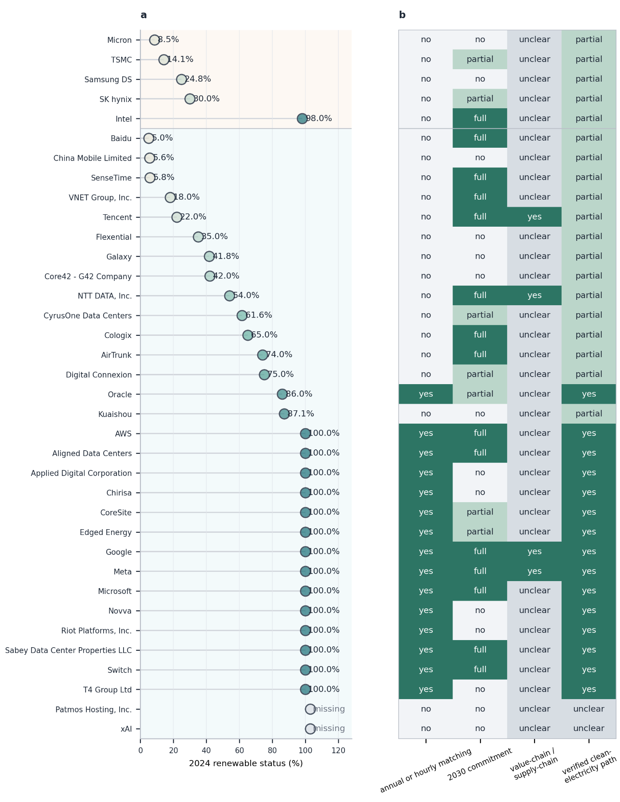
Supplementary Fig. 2 | 2024 renewable status and decarbonization maturity. a, Reported 2024 renewable-electricity status for manufacturing suppliers and operations entities. Missing values are retained as missing rather than imputed. b, Qualitative maturity indicators for annual or hourly matching, 2030 commitments, value-chain or supply-chain action and verified clean-electricity pathways. These indicators are used for source-policy interpretation and audit; they do not change central LB or MB estimates unless they provide a comparable, attributable market-based factor^{2,12-14}.

5. Facility-source operations boundary
The downstream operations module is calculated from the approved 2024 facility-source inventory generated by the reference facility-inclusion method and carried forward in the source audit. The row-level admission procedure is documented in the reference-method material; this Supplementary Information defines how approved records enter the emissions calculation⁷⁻¹¹.
For 2024, the approved central facility-source inventory contains 100 facility records across 30 companies and represents 54.3 TWh of annual AI-attributable electricity. The central calculation uses approved facility electricity values as the activity boundary. Facility coordinates, capacities, power-usage effectiveness values and load-factor metadata are retained for audit and display, but they do not create a separate operator-completion route in the central calculation⁷⁻¹¹.
Let $f$ index approved facility-source records, $c\left(f\right)$ denote the matched company, $E_{f}$ denote annual AI-attributable electricity, ${\text{EF}}_{f}^{LB}$ denote the assigned location-based emission factor and ${\text{EF}}_{f}^{MB}$ denote the approved market-based emission factor. Total operations electricity is calculated as:
Eops=f​Ef
Operational emissions are calculated by multiplying the same facility electricity boundary by the accounting-basis-specific factor:
GHGopsLB=f​EfEFfLB
GHGopsMB=f​EfEFfMB
The effective aggregate operational intensity is calculated after aggregation:
$${\text{EF}}_{ops}^{B}=\frac{{\text{GHG}}_{ops}^{B}}{E_{ops}}, B∈\{LB,MB\}$$
In the central case, this aggregation yields effective operational intensities of 375.4 g CO2e per kWh under location-based accounting and 105.5 g CO2e per kWh under market-based accounting.

6. Operational emission factors and tiered market-based protocol
Market-based electricity disclosure is uneven across operators, co-located facilities and AI-dominant campuses. We therefore assign operational market-based factors through a tiered evidence protocol. The protocol gives priority to directly disclosed operations-relevant market-based factors, uses renewable-share-derived estimates only when no such factor is available, and retains the location-based factor where no clear attributable market-based factor can be derived. This preserves comparability by holding the physical facility electricity boundary fixed while allowing procurement-related reductions only when the public evidence is comparable and attributable^{2,12,13}.
Tier 1 uses a directly disclosed operations market-based factor. If an entity discloses an operations- or data-center-relevant market-based electricity factor, or discloses market-based emissions with a relevant electricity denominator, the factor is used directly for matched facility records within that reporting boundary.
Tier 2 uses an attributable company-level market-based electricity factor. If a facility-level factor is unavailable but a company-level market-based electricity factor is clearly attributable to the operator’s data-center or operations electricity boundary, the company-level factor is assigned to matched facility records. The assignment is documented as a company-boundary factor rather than a facility-specific renewable claim.
Tier 3 uses an attributable renewable-electricity share. If no disclosed market-based factor is available but the entity reports a renewable-electricity share that is attributable to the relevant operations electricity boundary, the market-based factor is derived from the location-based factor and the non-renewable share:
$${\text{EF}}_{f}^{MB}={\text{EF}}_{f}^{LB}\left(1-R_{f}\right)$$
where $R_{f}$ is the attributable renewable-electricity share. This is a lower-tier estimate and is not used when a disclosed operations-relevant market-based factor is available.
Tier 4 covers cases with no clear attributable market-based emission factor. Some entities disclose mitigation activity, local supply, on-site generation or qualitative decarbonization plans but do not disclose a comparable, attributable market-based electricity factor for the relevant facility or operations electricity boundary. In these cases, the location-based factor is retained as the market-based factor:
$${\text{EF}}_{f}^{MB}={\text{EF}}_{f}^{LB}$$
This treatment does not assume the absence of mitigation activity. It prevents non-comparable or non-quantified claims from being converted into numerical procurement reductions. Facilities with local-grid or on-site-gas evidence but no clear attributable market-based electricity factor are included under this tier. The xAI local-grid/on-site-gas case is therefore treated with ${\text{EF}}_{f}^{MB}={\text{EF}}_{f}^{LB}$ rather than an operator-wide renewable-procurement reduction.
The operations market-based protocol does not add Scope 3 Category 3 fuel-and-energy-related activity adjustments to operational factors, does not apply renewable life-cycle floors, does not use residual-mix fallback factors and does not estimate avoided emissions. Those treatments are excluded from the current operations MB factor assignment^{2,12,13,15}.
Table S4 summarizes this protocol as a source-policy rule. The table is central to interpretation of the MB estimate because it prevents non-comparable claims from being converted into numerical reductions.
Supplementary Table S4 | Tiered evidence protocol for operational market-based factors^{2,12,13,15}.
Tier | Evidence basis | Data source | Processing rule | Interpretation
1 | Direct operations MB factor | Operations/data-center MB emissions and electricity, or a disclosed MB intensity | Use disclosed factor directly | Strongest comparable operations MB evidence
2 | Attributable company-level MB factor | Company electricity and market-based emissions tied to relevant operations boundary | Assign to matched facility records | Reporting-basis factor, not a facility-specific claim
3 | Attributable renewable share | Renewable-electricity share tied to relevant facility or operations boundary | $${\text{EF}}_{f}^{MB}={\text{EF}}_{f}^{LB}\left(1-R_{f}\right)$$ | Lower-tier procurement estimate
4 | No clear attributable MB EF | Qualitative mitigation, local supply, on-site generation or no usable MB source path | $${\text{EF}}_{f}^{MB}={\text{EF}}_{f}^{LB}$$ | No quantitative procurement reduction assigned

Supplementary Fig. 3 applies the protocol after facility records have been matched to companies. It explains the operational LB/MB comparison at company level: LB emissions vary with local or regional grid factors, while MB emissions vary only when a relevant facility, operator or company-boundary factor passes the evidence tier rules^{2,12}.
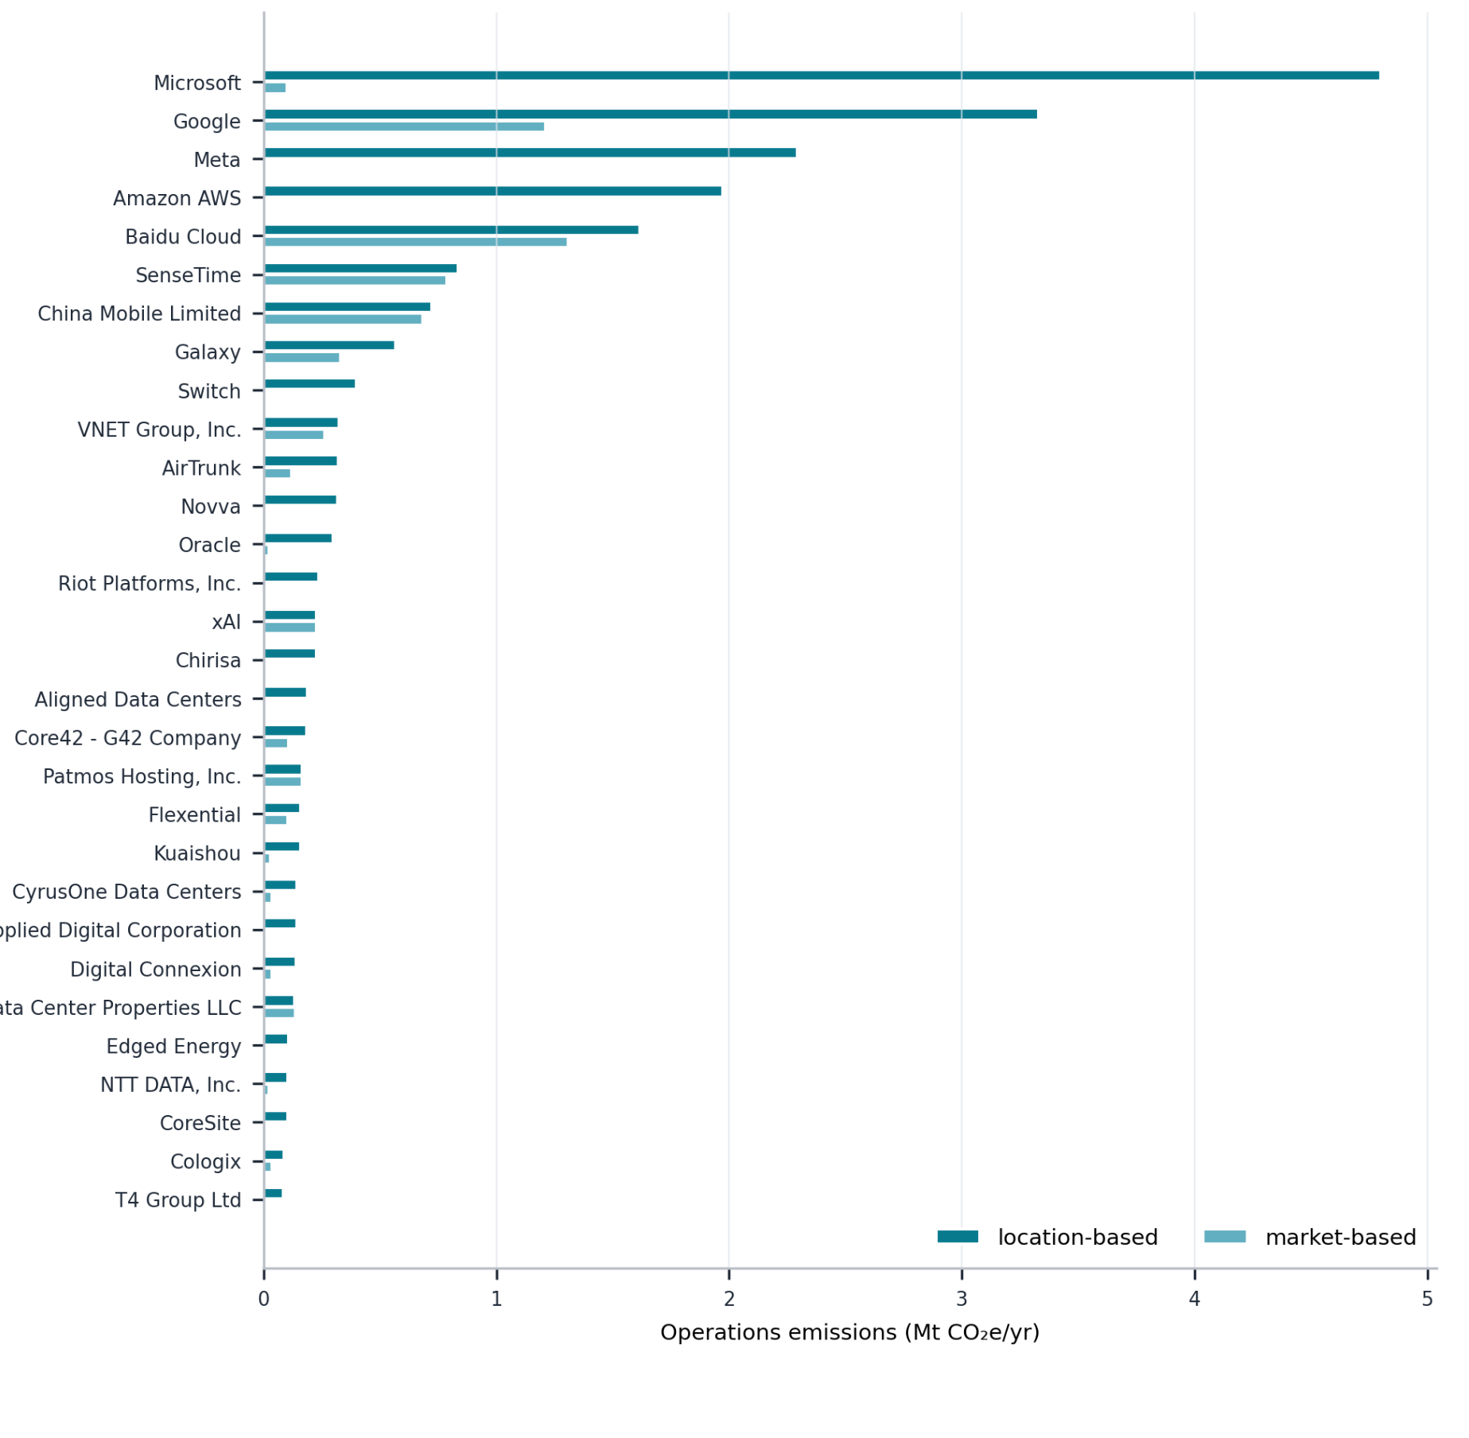
Supplementary Fig. 3 | 2024 operations facility LB/MB by company. Bars aggregate approved facility-source records by matched company. Location-based emissions apply local or regional emission factors to the facility electricity boundary. Market-based emissions apply the approved facility market-based factor selected through the tiered evidence protocol. The comparison holds facility electricity fixed and changes only the accounting-basis-specific factor; records with no clear attributable market-based emission factor retain the location-based factor^{2,12}.

7. Operations scenario scaling and diagnostics
The central operations estimate is the approved facility-source calculation. Low and high operations cases use external step07 low/mid and high/mid ratios applied to the central facility-source values. The ratios preserve the central facility inclusion policy, the market-based source policy and the facility electricity boundary⁸⁻¹⁰.
For scenario k, the operations electricity and emissions are:
$$E_{ops,k}=r_{k}E_{ops,central}$$
$${\text{GHG}}_{ops,k}^{B}=r_{k}{\text{GHG}}_{ops,central}^{B}$$
with r_central = 1. The quantities r_low and r_high are imported from the external step07 low/mid and high/mid ratios. This scenario treatment changes the scale of the approved central facility-source estimate but does not introduce a separate company-completion calculation⁸⁻¹⁰.
Operations diagnostics are reported in three forms. First, a facility-coverage audit reports the distribution of approved facility records and electricity across companies and geographies. Second, a market-based source-policy audit reports the tier used to assign the market-based emission factor for each record. Third, an emission-factor exposure audit reports the activity-weighted location-based emission-factor distribution across approved facility records. These diagnostics test scale, comparability and source quality; they do not redefine the activity boundary⁸⁻¹⁰.

8. Manufacturing supplier-evidence mapping and exact-geography aggregation
Location-based manufacturing mapping links AI hardware modules to physical manufacturing exposure using public fab, foundry, process-node, production-route and company-disclosure evidence. The disclosure-based manufacturing estimate assigns only those module fractions for which public evidence supports a defensible link between AI-relevant hardware production and one of the selected manufacturing disclosure entities¹⁶⁻¹⁸.
Table S5 summarizes the location-based evidence schema. It distinguishes direct CPU manufacturing, logic-fabrication exposure, memory pathways, storage pathways and residual modules. The table also records where public evidence is partial, so that the allocation does not infer non-public product shares.
Supplementary Table S5 | Location-based manufacturing evidence schema¹⁶⁻¹⁸.
Module group | Manufacturing pathway | Evidence basis | Treatment
CPU | Intel direct; AMD-related exposure represented through the TSMC manufacturing pathway where appropriate | Public CPU share, foundry or process evidence | Does not infer non-public product allocation.
GPU logic excluding HBM | TSMC logic-fabrication pathway where public process evidence supports mapping | Foundry or process-node disclosure | Logic die only; not full board-level GPU module.
HBM | Samsung Electronics DS, Micron and SK hynix HBM pathways | Public HBM shipment or supplier-share evidence | Supplier shares may not be server-node-specific.
DDR/DIMM | DRAM supplier pathways | Public total-DRAM evidence | Server-only DDR shares are generally unavailable.
SSD/NVMe | NAND or enterprise SSD pathways | Public enterprise SSD or storage evidence | Affiliated storage buckets are retained explicitly where reporting combines entities.
Other modules | Distributed suppliers | PCF residual and public component evidence | Not forced into selected suppliers without robust evidence.

Exact-geography manufacturing aggregation is retained at the most resolved public geography supported by the evidence audit. Exact-geography results are aggregated only after module-level attribution. The market-based comparison in the exact-geography figure applies the relevant market-based disclosure adjustment to the same physical activity weights and is not interpreted as a change in physical production geography^{2,16-18}.
Supplementary Fig. 4 brings manufacturing and operations geography into the same diagnostic frame. It shows where location-based emissions are concentrated and then overlays market-based implied values on the same activity weights. The key reading rule is that diamonds or MB markers change the accounting factor, not the physical location of manufacturing or computing activity.
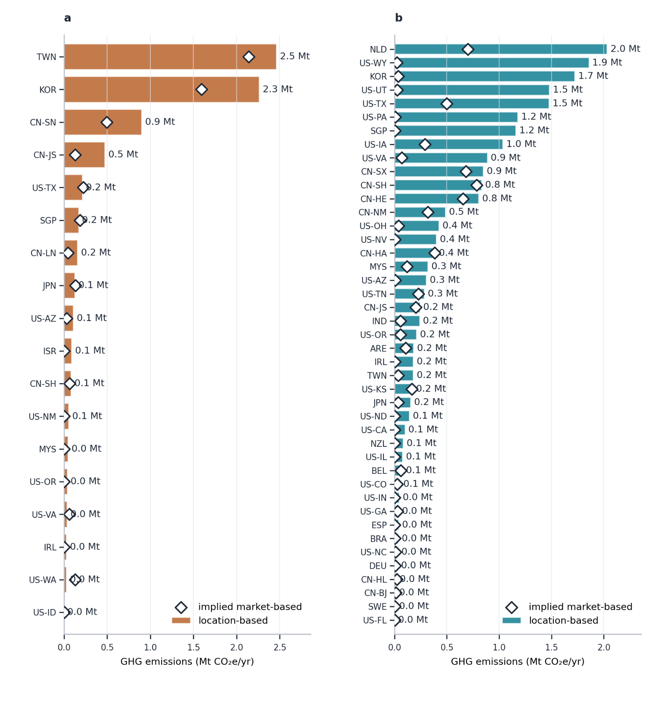
Supplementary Fig. 4 | 2024 full exact-geography rankings. a, Manufacturing exact-geography location-based emissions ranked by geography. Bars show location-based emissions and diamonds show market-based implied values allocated to the same activity weights. b, Operations exact-geography location-based emissions for resolved data-center geographies, with market-based values shown for comparison. Market-based values apply approved facility or company-boundary factors from the evidence protocol to the same physical activity weights and should not be interpreted as facility-specific renewable-electricity claims unless the relevant tier evidence supports that treatment.

9. Manufacturing market-based corporate disclosure envelopes
Market-based manufacturing estimates use corporate or division-level electricity procurement and Scope 2 accounting to construct market-based emissions envelopes for selected manufacturing disclosure entities. If an entity reports comparable market-based Scope 1 and Scope 2 values, those emissions envelopes are used directly. If only partial market-based information is disclosed, renewable-electricity share or procurement information is used only within the reporting boundary of the disclosing entity and is documented as a modeled bridge^{1,2,25-29}.
The same module structure and supplier-evidence mapping are used for LB and MB manufacturing calculations. Differences between the two estimates therefore reflect the corporate emissions envelope used for the selected accounting basis, not a change in the AI hardware boundary. Market-based electricity procurement by one company is not transferred to products or modules manufactured outside that company boundary².
Table S6 records the manufacturing market-based electricity-emission-factor source audit. It shows the disclosure source, processing rule, selected factor and allocation logic for each selected manufacturer, which makes the MB estimate traceable to the disclosing entity boundary²⁵⁻²⁹.
Supplementary Table S6 | Market-based electricity-emission-factor source audit for hardware manufacturers.
Entity | Electricity/emissions source | Processing rule | Selected factor | Logic used in allocation
TSMC | Corporate electricity and Scope 2 market-based disclosure²⁵ | Scope 2 MB emissions divided by corporate electricity use | 428.0 g CO2e per kWh | Direct supplier-level MB EF for GPU logic, AMD-related CPU pathway and eligible interconnect logic.
Intel | Corporate electricity and Scope 2 market-based disclosure²⁶ | Scope 2 MB emissions divided by corporate electricity use | 10.1 g CO2e per kWh | Direct supplier-level MB EF for CPU manufacturing pathway; low value reflects disclosed renewable procurement.
Samsung Electronics DS | Device Solutions division electricity and Scope 2 market-based disclosure²⁷ | DS-level Scope 2 MB emissions divided by DS electricity use | 346.9 g CO2e per kWh | Division-specific MB EF for DRAM, HBM and storage-related pathways where supported.
Micron | Scope 2 market-based disclosure with reconstructed electricity denominator²⁸ | Scope 2 MB emissions divided by derived electricity use | 435.1 g CO2e per kWh | Derived-denominator MB EF for DRAM, HBM and storage-related pathways.
SK hynix | Corporate electricity and Scope 1+2 market-based disclosure²⁹ | Derive Scope 2 MB as Scope 1+2 MB less Scope 1, then divide by electricity use | 137.8 g CO2e per kWh | Derived Scope 2 MB EF for DRAM, HBM and affiliated storage bucket where supported.

10. Manufacturing allocation equations and product-family decomposition
Let $s$ index selected manufacturing disclosure entities, $m$ index AI hardware modules, $B∈\{LB,MB\}$ denote accounting basis and $k∈\{low,central,high\}$ denote scenario case. The company-level AI allocation share is constructed from the module share, supplier-evidence mapping share and coverage modifier:¹⁹⁻²⁴
αs,k=m​θm,kπs,mλs,m,k
The disclosure-based AI hardware manufacturing estimate is then calculated by applying the allocation share to the corresponding corporate emissions envelope:
GHGmfgB,k=s​Es,B2024αs,k
The entity-level contribution can be written as:
$${\text{GHG}}_{s,mfg}^{B,k}=E_{s,B}^{2024}α_{s,k}$$
where $E_{s,B}^{2024}$ is the 2024 corporate or division emissions envelope, $θ_{m,k}$ is the module share within the 12-module AI server/node boundary, $π_{s,m}$ is the supplier-evidence mapping share and $λ_{s,m,k}$ is the coverage modifier used when public evidence supports partial attribution but not full module ownership¹⁹⁻²⁴.
Table S7 gives the coefficient schema used in this allocation. It links each module group to a supplier-evidence basis, a module-share source and a coverage-modifier rule, keeping partial public attribution separate from full module ownership.
Supplementary Table S7 | Manufacturing coefficient schema¹⁹⁻²⁴.
Module group | Supplier-evidence basis | Module-share source | Coverage-modifier use
CPU | Server CPU share and manufacturing pathway | PCF/module decomposition | AMD-through-TSMC pathway or partial coverage where applicable.
GPU logic excluding HBM | Foundry/process evidence | PCF/module decomposition | Limits attribution to logic-fabrication exposure.
HBM | HBM supplier or shipment-share evidence | PCF/module decomposition | Generation or package coverage where public evidence is partial.
DDR/DIMM | Total-DRAM proxy | PCF/module decomposition | Server-only shares are not robustly disclosed.
SSD/NVMe | Enterprise SSD/storage proxy | PCF/module decomposition | Affiliated storage buckets where reporting combines entities.
Other modules | No robust selected-entity evidence | PCF residual | Retained as unallocated.

Supplementary Fig. 5, formerly separated as an extended-data-style panel, is integrated here because it directly interprets the allocation result. The figure decomposes manufacturing emissions by product-family layer and shows how assigned module fractions relate to the unallocated remainder under both LB and MB accounting.
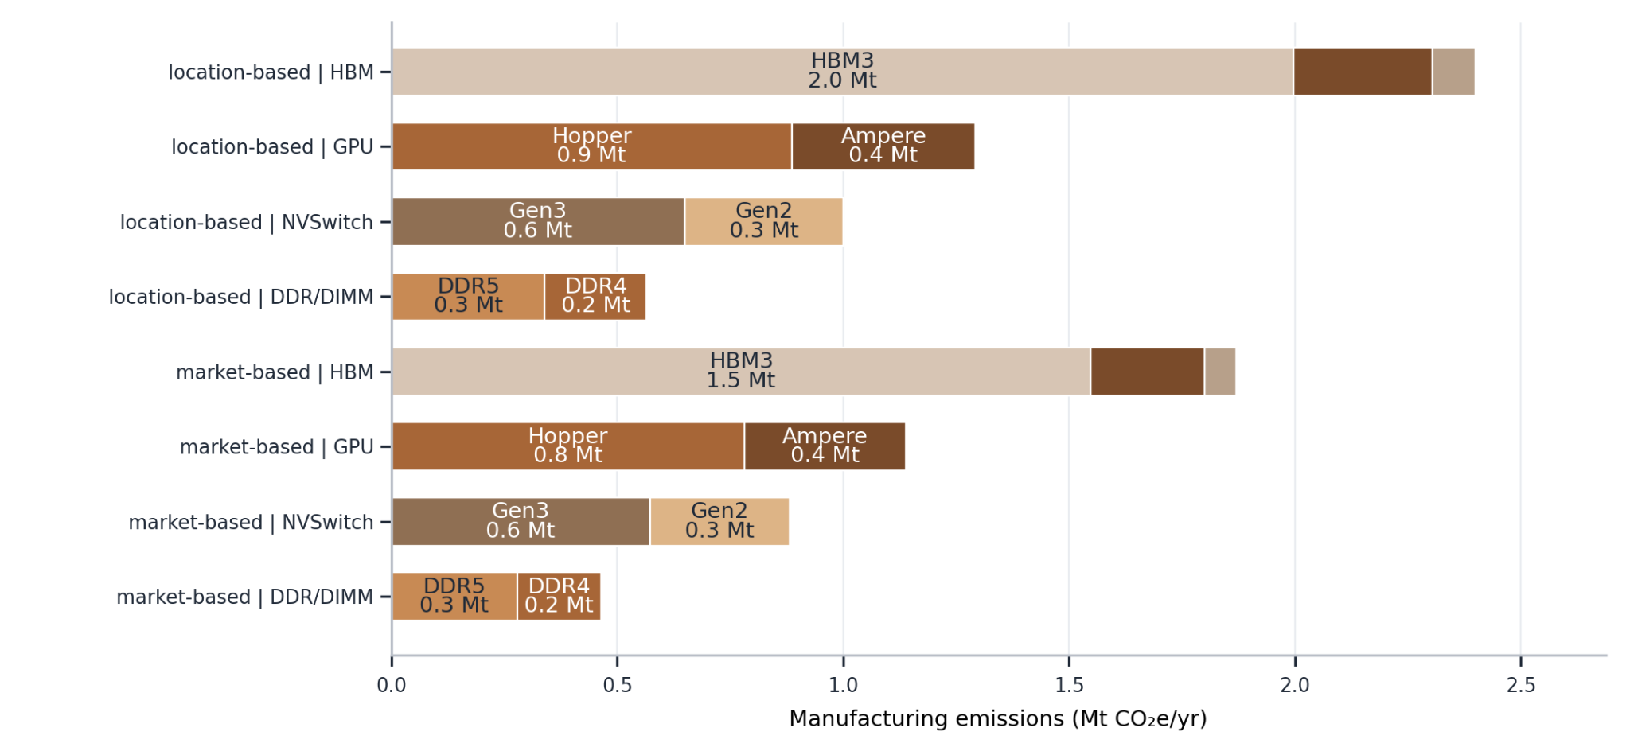
Supplementary Fig. 5 | Product-family decomposition integrated into the manufacturing allocation section. The panel reports manufacturing emissions by product-family layer for selected hardware module groups under location-based and market-based accounting. It supports interpretation of module-level manufacturing contributions while preserving the 12-module hardware boundary and the distinction between assigned module fractions and unallocated remainder.

11. PCF and shipment-equivalent manufacturing diagnostics
Server- and node-level product-carbon-footprint (PCF) files are used to preserve the full hardware boundary and to test the scale of the unallocated remainder. They do not replace the disclosure-based manufacturing estimate. For shipment-equivalent diagnostics, the product-side manufacturing estimate is:^{3,4,19-24}
$${\text{GHG}}_{\text{PCF}}^{k}=N_{k}{\text{PCF}}_{k}$$
where $N_{k}$ is the shipment-equivalent node count and ${\text{PCF}}_{k}$ is the node manufacturing-stage product carbon footprint in case $k$. The diagnostic difference relative to the manufacturing estimate is:
$$Δ_{\text{PCF}}^{B,k}=\frac{{\text{GHG}}_{\text{PCF}}^{k}-{\text{GHG}}_{mfg}^{B,k}}{{\text{GHG}}_{mfg}^{B,k}}$$
For product anchors that define a fuller hardware boundary, the boundary-expanded diagnostic is:
$${\text{GHG}}_{mfg,expanded}^{B,k}=\frac{{\text{GHG}}_{mfg}^{B,k}}{ρ_{k}}$$
where $ρ_{k}$ is the selected-supplier-covered share of the PCF boundary. The uncovered remainder is interpreted as a PCF-constrained boundary gap rather than an error term. These diagnostics provide order-of-magnitude checks on the manufacturing estimate and do not close unobserved hardware fractions by assumption¹⁹.

12. Robustness checks, incomplete-data treatment and reporting limits
Robustness checks evaluate whether the estimates are sensitive to evidence coverage, emission-factor assignment and aggregation choices. For manufacturing, checks include PCF-scale comparisons, shipment-equivalent node-PCF calculations and the size of the unallocated boundary-preserving remainder. For operations, checks include facility coverage, market-based source-policy tiers and activity-weighted location-based emission-factor exposure^{2,5,6,8-10,19}.
Missing or non-comparable evidence is not reassigned by assumption. It is retained as an explicit unallocated remainder, a lower-tier evidence classification or a diagnostic quantity. Qualitative mitigation statements and forward-looking decarbonization commitments are reported as evidence attributes but do not modify the 2024 central estimates unless they provide a comparable, attributable emissions or electricity factor^{2,12,13}.
Market-based factors in this study are procurement-based attributional reporting factors. They are interpreted alongside location-based estimates because annual procurement matching can differ from hourly physical grid consumption. The final reporting preserves the distinction between physical electricity burden and procurement-adjusted reported emissions^{2,12-14}.
Supplementary Fig. 6 is the final diagnostic because it tests the emission-factor exposure behind the location-based estimates. The figure asks whether the LB results are driven by a few high-intensity geographies or by broadly distributed activity-weighted exposure. It is therefore a robustness figure, not a separate accounting boundary.
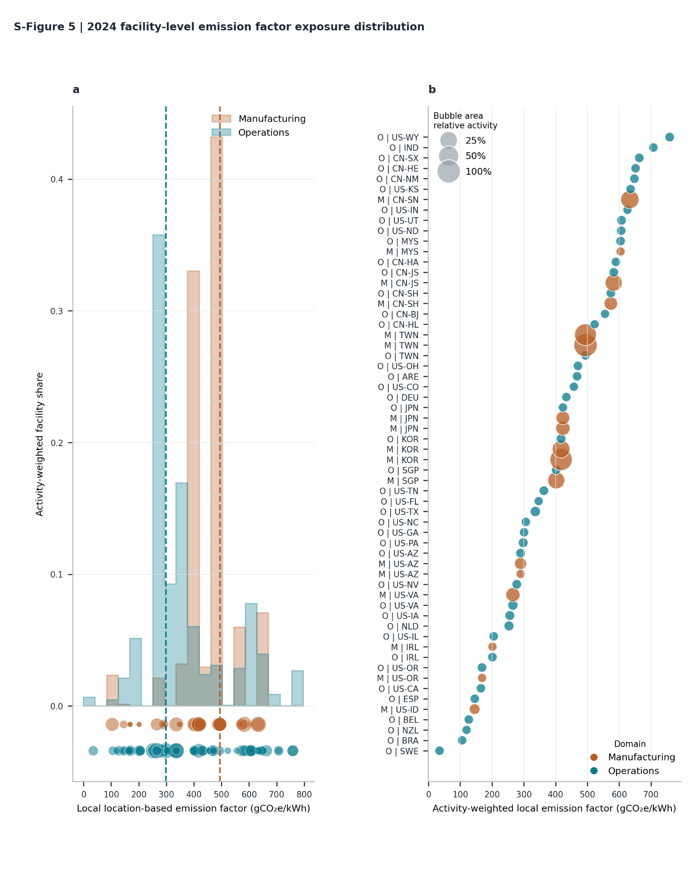
Supplementary Fig. 6 | 2024 facility-level emission-factor exposure distribution. a, Activity-weighted local location-based emission-factor exposure distributions for manufacturing and operations, with dashed lines showing activity-weighted central tendencies. b, Sorted exact-geography exposure audit for manufacturing and operations geographies. The figure is used to diagnose whether the LB results are driven by a small number of high-emission-factor geographies or by broader activity-weighted exposure^{5,6}.

References
1. World Resources Institute and World Business Council for Sustainable Development. The Greenhouse Gas Protocol: A Corporate Accounting and Reporting Standard, revised edition (2004).
2. Greenhouse Gas Protocol. Scope 2 Guidance: An Amendment to the GHG Protocol Corporate Standard (2015). https://ghgprotocol.org/sites/default/files/2023-03/Scope%202%20Guidance.pdf
3. World Resources Institute and World Business Council for Sustainable Development. Product Life Cycle Accounting and Reporting Standard (Greenhouse Gas Protocol, 2011). https://ghgprotocol.org/sites/default/files/ghgp/standards/Product-Life-Cycle-Accounting-Reporting-Standard_041613.pdf
4. International Organization for Standardization. ISO 14067:2018 Greenhouse gases - Carbon footprint of products - Requirements and guidelines for quantification (2018). https://www.iso.org/standard/71206.html
5. U.S. Environmental Protection Agency. Emissions & Generation Resource Integrated Database (eGRID) (2025). https://www.epa.gov/egrid
6. Ember. Global Electricity Review 2025 (2025). https://ember-energy.org/latest-insights/global-electricity-review-2025/
7. The Green Grid. The Green Grid Data Center Power Efficiency Metrics: PUE and DCiE (2007). https://www.thegreengrid.org/resources/library-and-tools/green-grid-data-center-power-efficiency-metrics-pue-and-dcie
8. Masanet, E., Shehabi, A., Lei, N., Smith, S. and Koomey, J. Recalibrating global data center energy-use estimates. Science 367, 984-986 (2020). https://doi.org/10.1126/science.aba3758
9. Mytton, D. and Ashtine, M. Sources of data center energy estimates: a comprehensive review. Joule 6, 2032-2056 (2022). https://doi.org/10.1016/j.joule.2022.07.011
10. IEA-4E. Data Centre Energy Use: Critical Review of Models and Results (2025). https://www.iea-4e.org/wp-content/uploads/2025/05/Data-Centre-Energy-Use-Critical-Review-of-Models-and-Results.pdf
11. Uptime Institute. Global Data Center Survey 2024 (2024). https://intelligence.uptimeinstitute.com/resource/uptime-institute-global-data-center-survey-2024
12. Brander, M., Gillenwater, M. and Ascui, F. Creative accounting: a critical perspective on the market-based method for reporting purchased electricity (scope 2) emissions. Energy Policy 112, 29-33 (2018). https://doi.org/10.1016/j.enpol.2017.09.051
13. Bjorn, A., Lloyd, S. M., Brander, M. and Matthews, H. D. Renewable energy certificates threaten the integrity of corporate science-based targets. Nat. Clim. Chang. 12, 539-546 (2022). https://doi.org/10.1038/s41558-022-01379-5
14. Riepin, I. and Brown, T. On the means, costs, and system-level impacts of 24/7 carbon-free energy procurement. Energy Strateg. Rev. 54, 101488 (2024). https://doi.org/10.1016/j.esr.2024.101488
15. World Resources Institute and World Business Council for Sustainable Development. Corporate Value Chain (Scope 3) Accounting and Reporting Standard (Greenhouse Gas Protocol, 2011). https://ghgprotocol.org/corporate-value-chain-scope-3-standard
16. Williams, E. D., Ayres, R. U. and Heller, M. The 1.7 kilogram microchip: energy and material use in the production of semiconductor devices. Environ. Sci. Technol. 36, 5504-5510 (2002).
17. Boyd, S., Dornfeld, D. and Krishnan, N. Life cycle inventory of a CMOS chip. In Proc. IEEE International Symposium on Electronics and the Environment 253-257 (2006). https://doi.org/10.1109/ISEE.2006.1650071
18. Roussilhe, G., Pirson, T., Xhonneux, M. and Bol, D. From silicon shield to carbon lock-in? The environmental footprint of electronic components manufacturing in Taiwan (2015-2020). J. Ind. Ecol. 28 (2024). https://doi.org/10.1111/jiec.13487
19. Weber, C. L. Uncertainty and variability in product carbon footprinting: case study of a server. J. Ind. Ecol. 16, 203-211 (2012). https://doi.org/10.1111/j.1530-9290.2011.00407.x
20. NVIDIA. Product Carbon Footprint Summary for NVIDIA HGX H100 (2025). https://www.nvidia.com/en-us/about-nvidia/sustainability/
21. Dell Technologies. Product Carbon Footprint: Generic XE9680L EU+UK (2025). https://www.delltechnologies.com/asset/en-us/products/servers/briefs-summaries/poweredge-xe9680l-pcf-report.pdf
22. Gupta, U. et al. Architectural CO2 footprint tool: designing sustainable computer systems with an architectural carbon modeling tool. IEEE Micro 43, 107-117 (2023). https://doi.org/10.1109/MM.2023.3275139
23. Ji, S. et al. SCARIF: towards carbon modeling of cloud servers with accelerators. Preprint at https://doi.org/10.48550/arXiv.2401.06270 (2024).
24. Schneider, I. et al. Life-cycle emissions of AI hardware: a cradle-to-grave approach and generational trends. Preprint at https://arxiv.org/html/2502.01671v1 (2025).
25. TSMC. 2024 TSMC Sustainability Report (2025). https://esg.tsmc.com/
26. Intel Corporation. 2024-25 Corporate Responsibility Report (2025). https://csrreportbuilder.intel.com/pdfbuilder/pdfs/CSR-2024-25-Full-Report.pdf
27. Samsung Electronics. Samsung Electronics Sustainability Report 2024 (2024). https://csr.samsung.com/data/Sustainability_report_2024_en.pdf
28. Micron Technology. Sustainability Report 2025 (2025). https://www.micron.com/about/sustainability/sustainability-report
29. SK hynix. SK hynix Sustainability Report 2025 (2025). https://sustainability.skhynix.com/

