Synergy of Surface Oxygen Vacancies and Built-in Electric Field in 0D/2D CeO₂/SnSe₂ S-scheme Heterojunctions for Enhanced Photocatalytic Malachite Green Degradation
Yan Luo¹, Fangfang Cheng¹, Lin Han^{1,2}, Zhiwang Sun¹, Yingxu Wang¹, Hong Zhong^{3,*}, Shifeng Wang^{1,*}
¹ Key Laboratory of Plateau Oxygen and Living Environment of Xizang Autonomous Region, College of Science, Xizang University, Lhasa 850000, China;
² School of Ecology, Xizang University, Lhasa 850000, China
³ The Department of Building Environment and Energy Engineering, The Hong Kong Polytechnic University, Hong Kong 999077, China
* Correspondence: wsf@utibet.edu.cn (S.W.); auston.zhong@connect.polyu.hk (H. Z,)

Figure S1. Composites with different CeO₂/SnSe₂ ratios: (a) 0.02 g CeO₂/SnSe₂, (b) 0.05 g CeO₂/SnSe₂, (c)0.1 g CeO₂/SnSe₂, (d) 0.2 g CeO₂/SnSe₂, (e) 0.5 g CeO₂/SnSe₂, (f) 1 g CeO₂/SnSe₂, (g) 2 g CeO₂/SnSe₂.
(a)
Figure S2. Adsorption capacities of the respective photocatalysts under dark-state equilibration
(a)
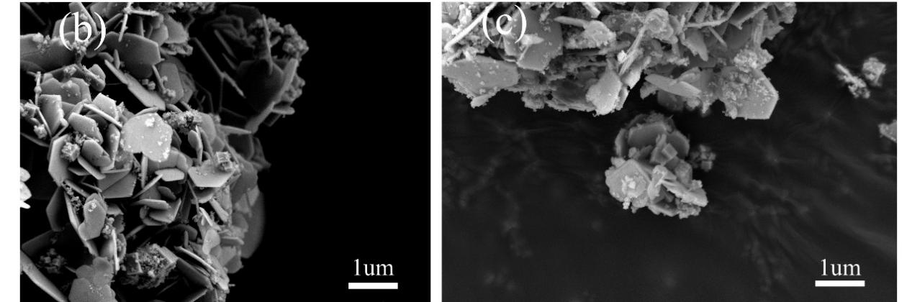
Figure S3. (a) XRD of 0.2 g CeO₂/SnSe₂ before and after photocatalysis. (b) SEM of 0.2 g CeO₂/SnSe₂ before photocatalysis. (c)0.2 g CeO₂/SnSe₂ after photocatalysis.

