Supplementary Information

Low flow enhances pigmentation and lipid reserves but reduces survival in newly settled Acropora digitifera corals

Saskia Jurriaans^{1*}, Mark Deleja¹, Victoria Jenkins², Annika Withers², Carrie A Sims³, Carly J Randall^{1,2}

¹ Australian Institute of Marine Science, Townsville QLD Australia
² AIMS@JCU, James Cook University, Townsville QLD Australia
³ Smithsonian Institute, Panama

*Corresponding author: s.jurriaans@aims.gov.au

Methods S1 - Qualitative pigmentation scoring protocol
Symbiont acquisition was assessed using a qualitative visual pigmentation score rather than direct cell counts or photosynthetic measurements. This approach was based on previous work showing that colour variation in early coral life stages can reflect differences in symbiont density (Chamberland et al. 2017), that coral colour scores can correspond to symbiont density and chlorophyll a content (Siebeck et al. 2006), and that image-derived colour metrics can provide quantitative proxies for Symbiodiniaceae density and chlorophyll content under standardised imaging conditions (Ferrara et al. 2026). The pigmentation score was therefore used as an ordinal proxy for symbiont acquisition and relative symbiont density, rather than as a direct quantitative estimate of cell abundance.
Attempts to quantify symbiont uptake using imaging pulse amplitude modulated (PAM) fluorometry were unsuccessful because fluorescence from the surrounding substrate interfered with measurements of individual spat. Tissue samples could not be used to quantify symbiont density because spat were required for destructive lipid-class analyses. Images were collected under standardised camera settings, strobe position, image distance, and lighting conditions; however, they could not be reliably calibrated for quantitative RGB-based colour analysis. Therefore, pigmentation was assessed using a qualitative ordinal scale.
Spat pigmentation was scored from high-resolution images using a four-point qualitative scale in ImageJ. Images were blinded before scoring by removing identifying information, including treatment, tab position, and census time. The scoring card was kept open as a reference during scoring, and each spat was assigned a score from 0 to 3 based on visible pigmentation (Figures 1b and S1). Score 0 represented translucent, aposymbiotic spat with no visible pigmentation; score 1 represented the first visible appearance of pigmentation; score 2 represented intermediate pigmentation; and score 3 represented highly pigmented tissue, with dense, dark pigmentation particularly visible through the tentacles. In cases of uncertainty, the lower score was assigned, or the spat was discussed with other members of the group before classification. Dead, damaged, broken, out-of-focus, or partially obscured spat were excluded from scoring. Scores were recorded in a corresponding spreadsheet, and annotated images were saved to allow later checking.

References
Chamberland VF, Latijnhouwers KR, Huisman J, Hartmann AC, Vermeij MJ (2017) Costs and benefits of maternally inherited algal symbionts in coral larvae. Proceedings of the Royal Society B: Biological Sciences 284:
Ferrara EF, Bauer L, Puntin G, Bautz F, Celayir S, Do M, Eck F, Heider M, Wissel P, Arnold A (2026) Red, green, blue color indices as proxy for Symbiodiniaceae cell density and chlorophyll content during coral bleaching. Limnology and Oceanography: Methods e70047
Siebeck U, Marshall N, Klüter A, Hoegh-Guldberg O (2006) Monitoring coral bleaching using a colour reference card. Coral Reefs 25:453–460

Figure S1 – Pigmentation scoring card

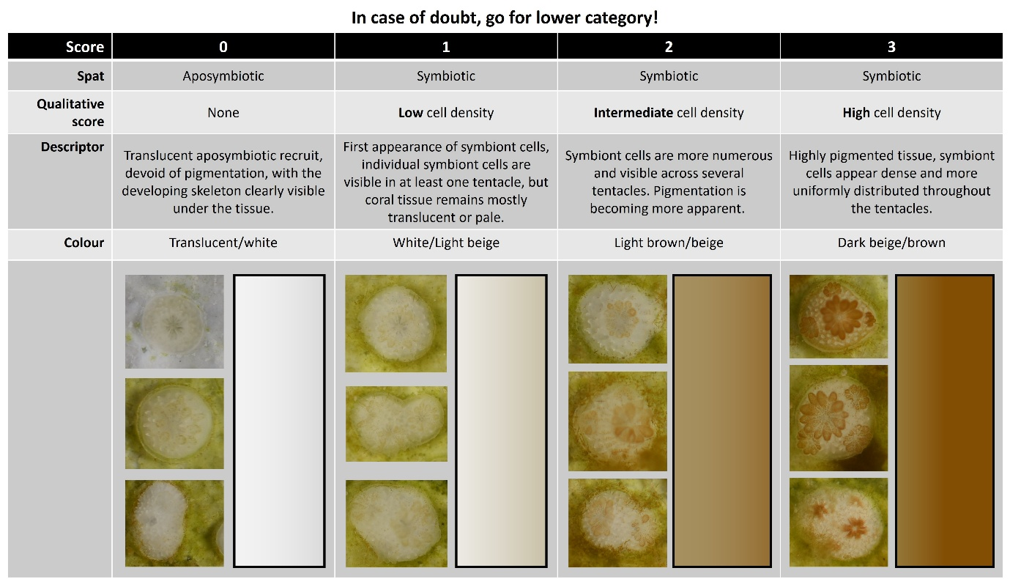
Figure S1. Qualitative scoring card used to assess visible pigmentation in Acropora digitifera spat. Scores ranged from 0 to 3 and represented an ordinal increase in visible pigmentation and apparent symbiont cell density: 0 = no visible pigmentation, 1 = low pigmentation, 2 = intermediate pigmentation, and 3 = high pigmentation. In cases of uncertainty, the lower score was assigned.

Table S1 Occurrence and contribution of MG-region peaks
Table S1. Occurrence and contribution of peaks detected in the monoacylglycerol (MG) retention region. Peaks were labelled operationally as MG1, MG2, and MG3 and inspected before pooling. MG1 coincided with the MG standard, while MG2 also occurred consistently across samples. MG3 occurred in only three samples and was excluded from the final lipid-class analysis. Contribution to total lipid area is shown as the percentage of the normalised lipid-class profile.

Peak | n rows | n samples | Mean % total lipid area | Median % total lipid area | Max % total lipid area
MG1 | 150 | 50 | 26.6 | 25.5 | 64.0
MG2 | 147 | 49 | 16.5 | 13.6 | 85.7
MG3 | 9 | 3 | 15.7 | 15.1 | 21.8

Table S2 Sensitivity analysis of MG peaks
Table S2. Sensitivity analysis testing whether alternative pooling of peaks in the monoacylglycerol retention region changed the interpretation of lipid-class composition. Three MG-pooling options were compared. Option 1: MG1 and MG2 were pooled as a single MG class and MG3 was excluded; Option 2: only MG1 was retained and both MG2 and MG3 were excluded; and Option 3: MG1 and MG2 were retained as separate classes, with MG2 treated as an unidentified peak because no corresponding analytical standard was available, and MG3 excluded. MG1 coincided with the MG standard, whereas MG2 occurred consistently across samples but could not be assigned with the same confidence. MG3 was excluded in all options because it occurred rarely. PERMANOVA was based on Bray–Curtis dissimilarities, with flow regime, experimental day, and their interaction as fixed effects. Across all three options, lipid-class composition changed through time, with no significant effect for flow or flow × time interaction.

Option | MG region treatment | Flow p-value | Time p-value | Flow × time p-value
Option 1 | MG1 and MG2 pooled,  MG3 excluded | 0.315 | 0.001 | 0.440
Option 2 | MG1 retained;  MG2 and MG3 excluded | 0.655 | 0.001 | 0.715
Option 3 | MG1 and MG2 retained separately; MG3 excluded | 0.643 | 0.001 | 0.708

Table S3 Pigmentation score analysis: Cumulative Link Mixed Model
Table S3. Output from the cumulative link mixed model testing the effects of flow regime, experimental day, and their interaction on spat pigmentation score. The model included random intercepts for raceway nested within flow regime and tab nested within raceway. Experimental day was scaled by dividing by 10; therefore, time coefficients represent change per 10 days. Estimates are shown on the latent logit scale.

Fixed effects | Estimate | SE | z value | p
Moderate flow | -2.413 | 0.282 | -8.566 | <0.001
High flow | -3.281 | 0.362 | -9.053 | <0.001
Experimental day | 0.915 | 0.031 | 29.514 | <0.001
Moderate flow × Exp. day | -0.060 | 0.045 | -1.332 | 0.183
High flow × Exp. day | -0.200 | 0.058 | -3.472 | <0.001
Random effects | Name | Variance | Std. Dev. | N of groups
Raceway nested within flow | Intercept | <0.001 | <0.001 | 15
Tab nested within raceway | Intercept | 1.116 | 1.056 | 225

Table S4 Pigmentation score analysis: Contrasts
Table S4. Tukey-adjusted pairwise comparisons of spat pigmentation score among flow regimes at selected experimental days. Comparisons were estimated from the cumulative link mixed model including flow regime, experimental day, and their interaction. Experimental day was scaled by dividing by 10 in the model, but contrasts are presented for the original experimental days. Estimates are shown on the latent logit scale.

Experimental day | Contrast | Estimate | SE | z value | p
19 | Low – Moderate | 2.53 | 0.243 | 10.39 | <0.001
 | Low – High | 3.66 | 0.296 | 12.37 | <0.001
 | Moderate – High | 1.13 | 0.322 | 3.52 | 0.001
43 | Low – Moderate | 2.67 | 0.234 | 11.40 | <0.001
 | Low – High | 4.14 | 0.258 | 16.06 | <0.001
 | Moderate – High | 1.47 | 0.268 | 5.48 | <0.001
83 | Low – Moderate | 2.91 | 0.317 | 9.19 | <0.001
 | Low – High | 4.94 | 0.341 | 14.50 | <0.001
 | Moderate – High | 2.03 | 0.330 | 6.14 | <0.001

