Figure S1. An example of gating strategy for tumor cells. Cell counts are reported as whole numbers using a dual platform approach. A dual platform approach uses WBC and lymphocyte counts from the ADIVA analyzer (hematology data) to calculate cells/μL from the enumerated relative cell percentages using flow cytometry. For example, total T cells (cells/µl) = lymphocyte count from ADVIA cells (cells/µl) x total T cells (%)/100.
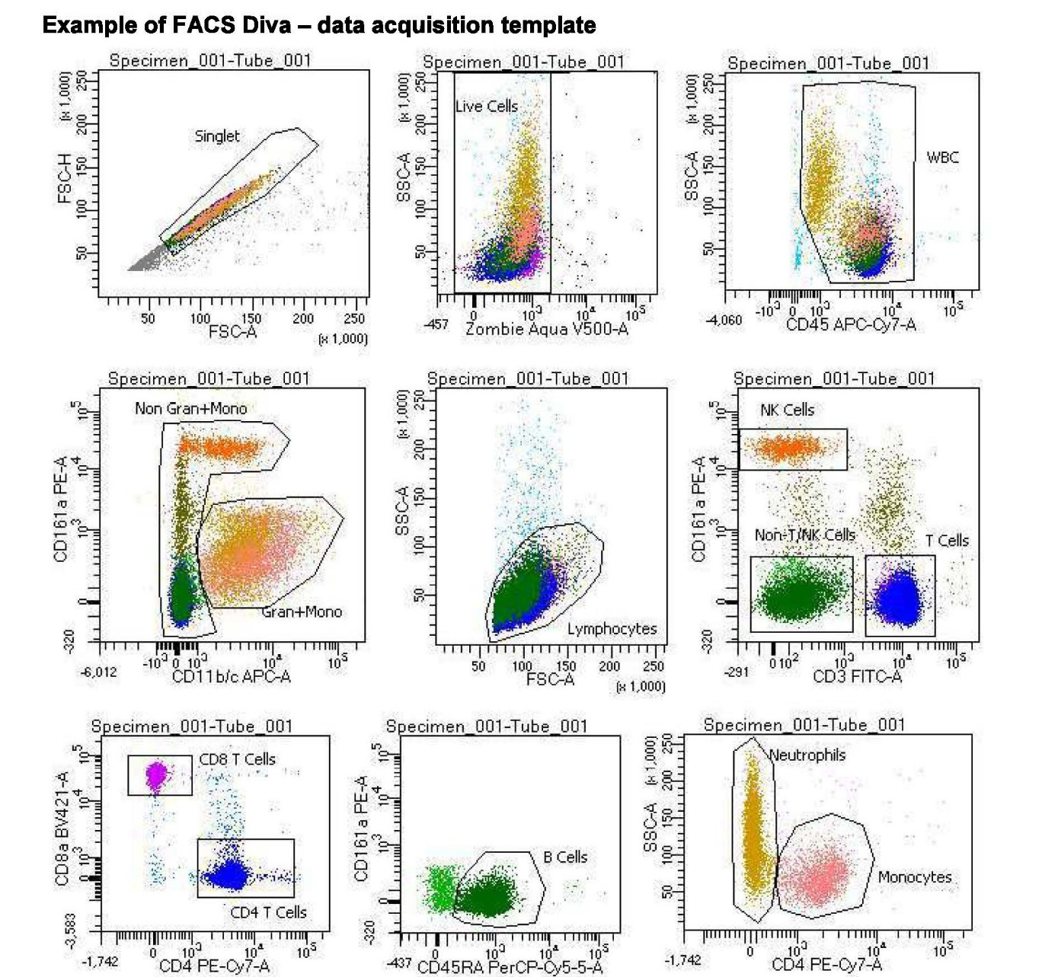

Figure S2. A) An example of cytokine gating strategy from analysis of tumor cells. B) An example of gating strategy from analysis of tumor cell lymphocytes. C) An example of gating strategy from analysis of tumor cell monocytic cells and DCs.

Figure S2A.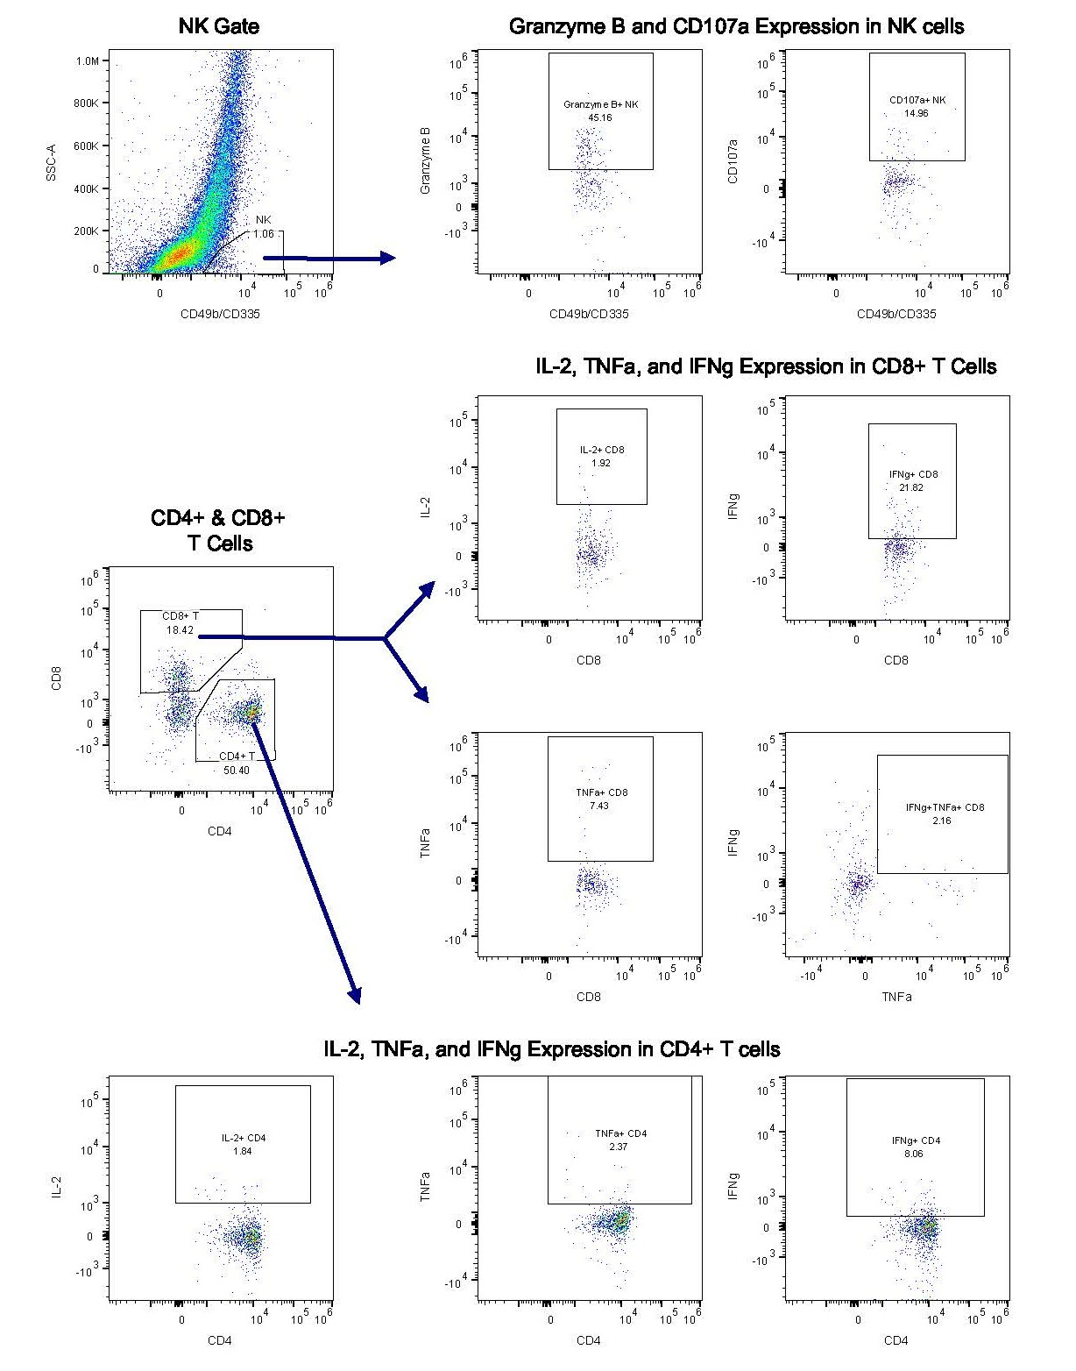

Figure S2B.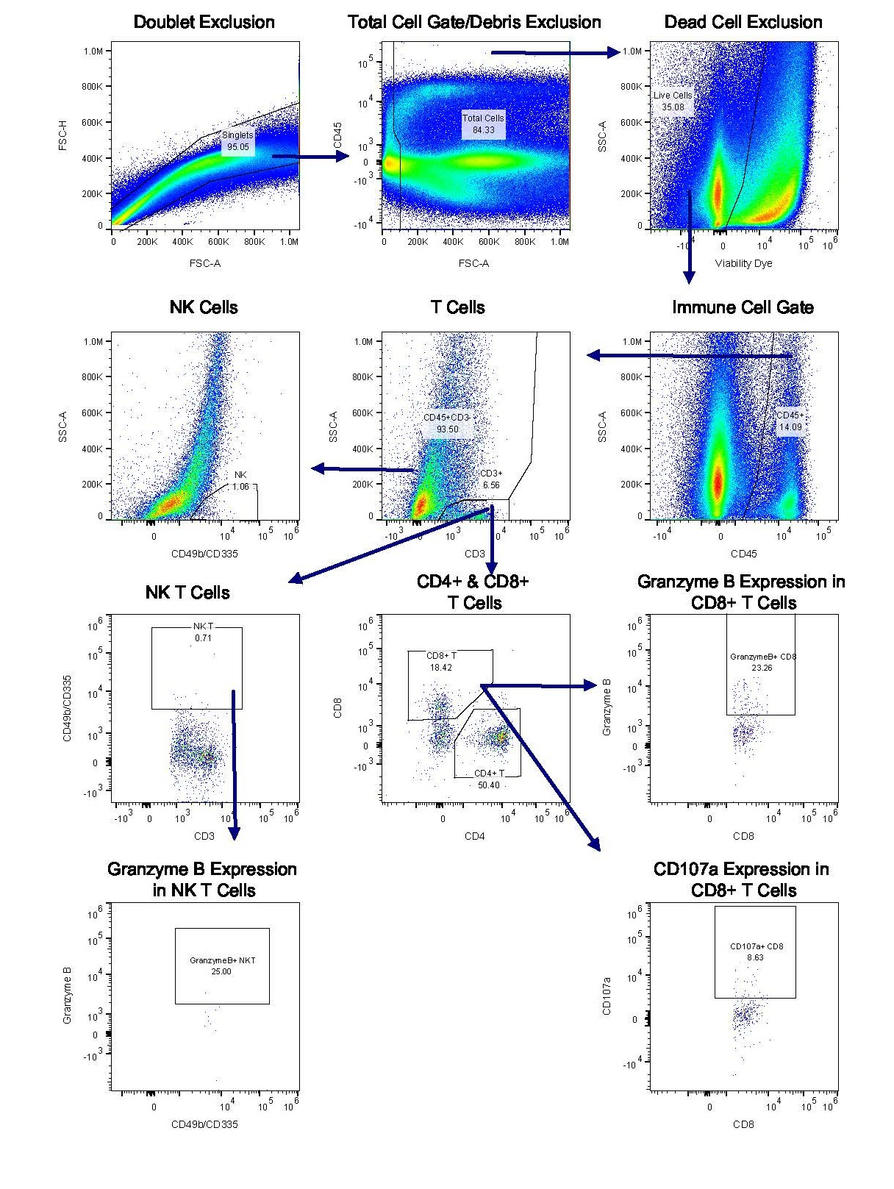

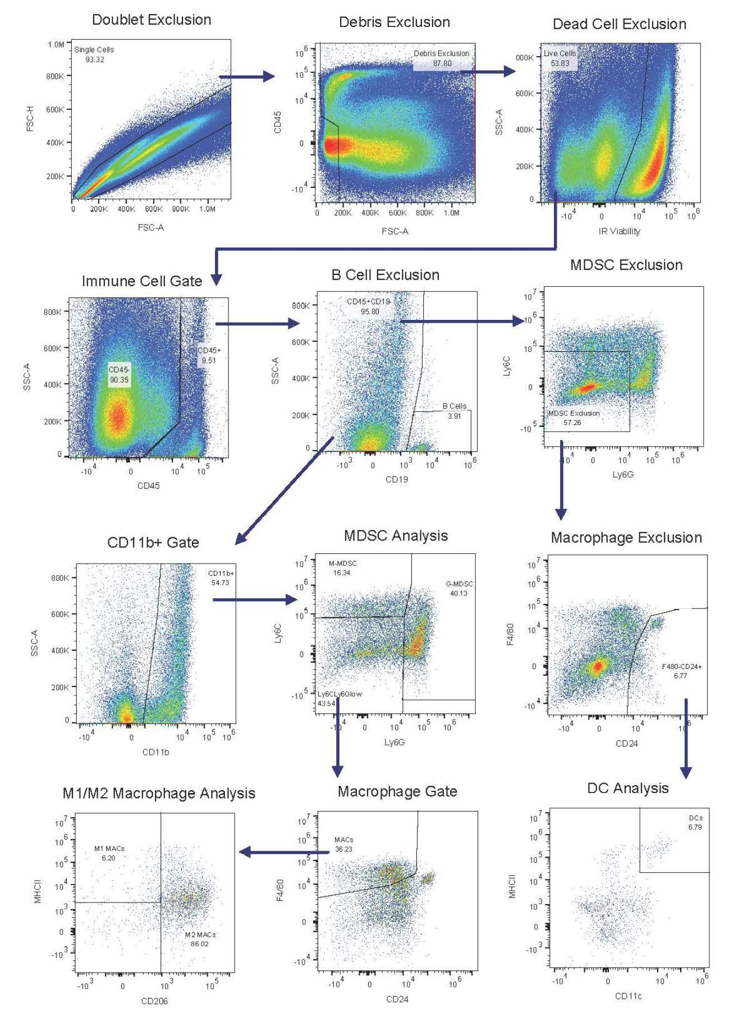
Figure S2C.

