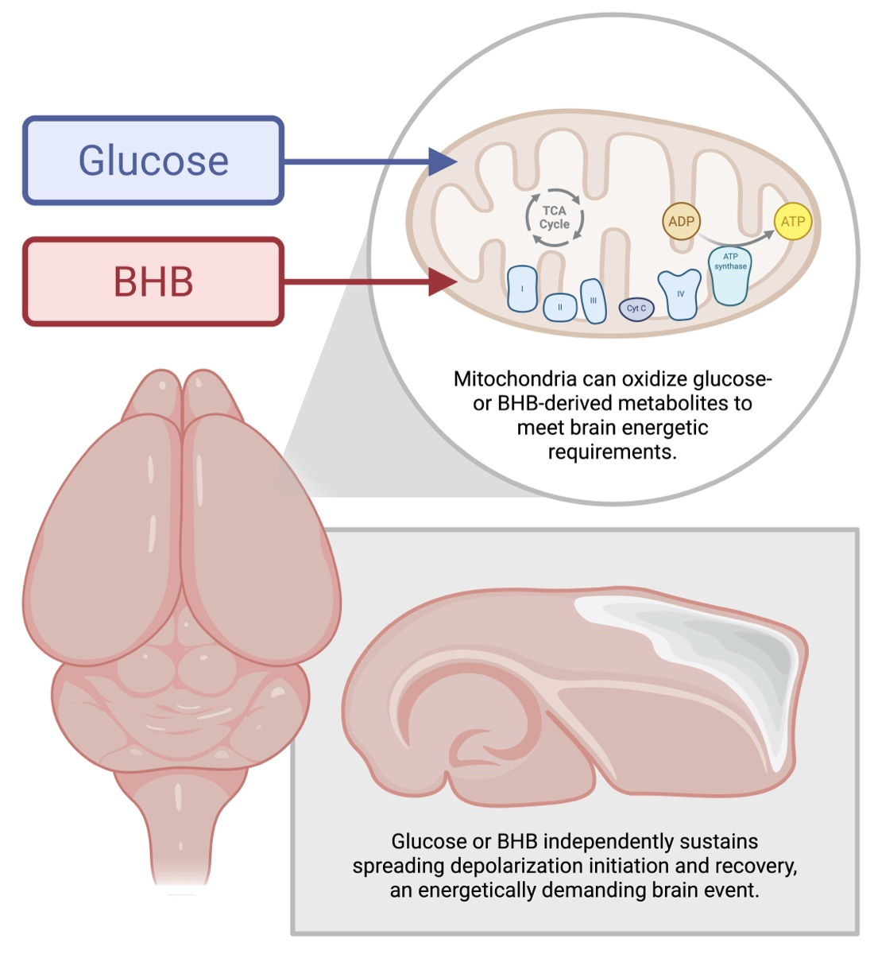
Cerebral fuel flexibility: glucose and ketones. β-Hydroxybutyrate (BHB) supports continual mitochondrial oxygen flux, along with induction of and recovery from repeated spreading depolarizations in mouse brain tissue in the absence of glucose. These findings demonstrate that ketone-supported metabolism can sustain energetically demanding neural function through a distinct bioenergetic strategy. Created in BioRender. Parrish, R. (2026) https://BioRender.com/k92j91u.

