Supplementary Information
Self-correcting sun compass, spherical geometry and cue-transfers predict
naïve migratory performance

James D. McLaren¹*, Heiko Schmaljohann^{2,3}, Bernd Blasius^{1,4}
¹ Institute for Chemistry and Biology of the Marine Environment (ICBM), University of Oldenburg; 26129 Oldenburg, Germany.
² Institute for Biology and Environmental Sciences (IBU), Carl von Ossietzky University of Oldenburg, 26129 Oldenburg, Germany.
³ Institute of Avian Research, 26386 Wilhelmshaven, Germany.
⁴ Helmholtz Institute for Functional Marine Biodiversity (HIFMB), University of Oldenburg; 26129 Oldenburg, Germany.
*Corresponding author. Email: james.mclaren@uol.de

Supplementary Information 1
Sunset azimuth
Here we derive an equation for sunset azimuth, which aids interpretation and can speed up simulations involving large numbers of modelled individuals. The sun’s zenith (angle relative to vertical, $γ_{s}$), is the inverse of solar elevation, i.e., $γ_{s}={ 90}^{°}$at sunset. Solar zenith can be calculated using
$\cos{γ_{s}}=\sin{∅}sin{δ_{s}}+cos ∅\cos{δ_{s}}cos H$,
where $∅$ is latitude, $δ_{s}$ is the solar declination, i.e., the angle between the tilt of the Earth’s axis and the plane of its orbit around the sun (see below), and $H=15°∙\left(h-12\right)$ (degrees) is the solar hour, h = 12 representing local noon⁵⁷. Sunsets occur at 90° solar zenith, i.e.,
$cos H=- tan ∅\tan{δ_{s}}$. (S1)
Solar azimuth (measured clockwise from equatorward, i.e., clockwise from South in the Northern Hemisphere) can be calculated as
$$cos \left(θ_{s}\right)=-\frac{\sin{δ_{s}}cos ∅-cos H cos{δ_{s}\sin{∅}}}{\sin{γ_{s }}},$$
which, if there is a sunset, reduces after substituting for H using equation (S1) to
$$θ_{s}=\cos^{-1}\left(\frac{- sin{δ_{s}}}{cos ∅}\right),$$
with the minus signs arising from referencing a geographic South axis⁵⁸, with $θ_{s}$always positive since the sun sets Westward in both Hemispheres. If no sunset occurs, substituting H = $180°$ results in $cos θ_{s}=-1$, i.e., $θ_{s}=0°$or $180°$, indicating the sun being at its lowest due-North (in the Northern Hemisphere) during polar summer and its highest (closest to the horizon) due-South during polar winter.
Hence, a general formula for sunset azimuth relative to geographic South (or, in the Southern Hemisphere, to geographic North) is
$θ_{s}=\left\{\begin{aligned}\cos^{-1}\left({- sin{δ_{s}}}/{cos ∅}\right) \\ 180°\text{ (24-hour light)} \\ 0°\text{ (24-hour dark})\end{aligned}\right.$
When simulating compass courses, solar declination, $δ_{s},$ was calculated using a formulation, precise to within 0.01°, as used in the SunAlign package (https://web.archive.org/web/20120423120622/http://www.green-life-innovators.org/tiki-index.php?page=ETIMSDEC.BAS+Equation+of+TIMe+and+Solar+DEClination), accounting for the number of days since winter solstice and the eccentricity of the Earth’s orbit:
$\sin{δ_{s}=\sin\left(-23.44°\right)\cos\left(\frac{360°}{365.24}(t_{i}+10)-\frac{360°}{π}0.0167 sin\left(\frac{360°}{365.24}(t_{i}-2)\right)\right)}$ (18),
where $t_{i}$ is the day of year (beginning January 1st).

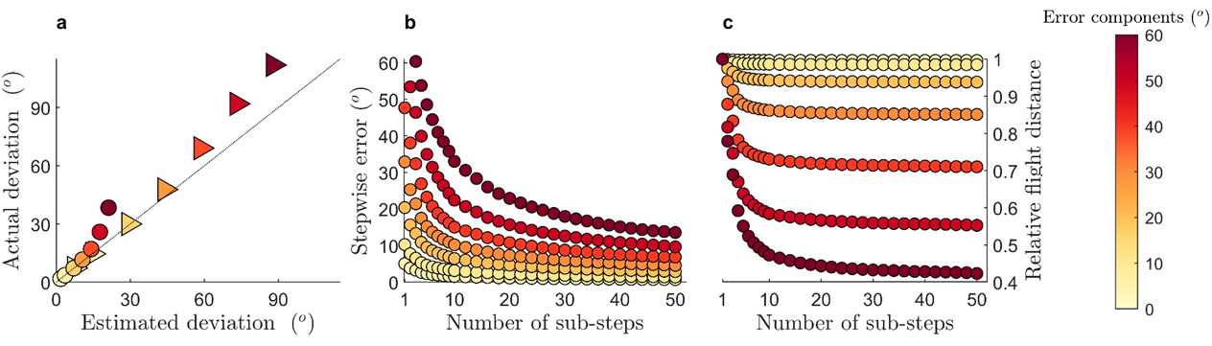

Supplementary Fig. 1. Within-step sums of von Mises vs. normal headings., i.e., assuming summation properties for normal distributions based on uniform “effective standard errors”, $σ=1/{\sqrt{κ}}$ , for cue detection, cue transfers and cue maintenance (equation 6). (a) Resultant circular standard deviations¹ for (coloured triangles) cue-transferred von Mises steps and (coloured circles) non-transferred von Mises steps, color-coded by the magnitude of within-step effective standard errors. For this panel, steps were subdivided into eight (von Mises) sub-steps, i.e., re-determined in 7 maintenance sub-steps. (b) Effective stepwise standard error and (c) relative stepwise flight distance (here, in the absence of cue transfers and within-step drift) as a function of the number of (hourly) in-flight maintenance events, color-coded to the effective standard error of cue detection and maintenance. Based on numerical simulations of 10,000 von Mises headings using MATLAB package vmrand (Dylan Muir).

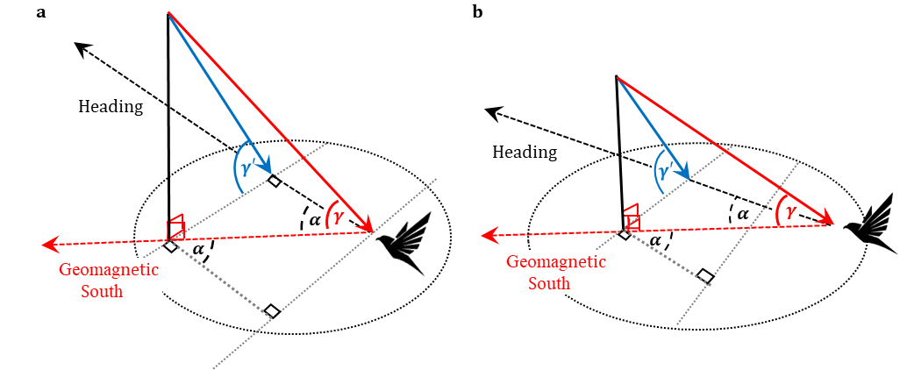
Supplementary Fig. 2. Magnetoclinic compass headings.

The magnetoclinic compass course hypothesizes that a migrant adjusts its heading, $α$, relative to the geomagnetic axis (dashed red arrow) such that it maintains a fixed “magnetoclinic” projection,$γ^{'}$, transverse to its chosen heading, of the inclination angle, $γ$, (blue arrow) gauges the inclination angle, of the Earth’s geomagnetic field (solid red arrow), and then chooses. As the inclination angle decreases from higher (a) to lower (b) latitudes, the migrant’s heading relative to the geomagnetic axis decreases in magnitude accordingly, causing a gradual orientation shift towards due South. Modified from fig. S5 in ².

1. Mardia, K. V. Statistics of Directional Data. Journal of the Royal Statistical Society. Series B (Methodological) 37, 349–393 (1975).
2. Muheim, R., Schmaljohann, H. & Alerstam, T. Feasibility of sun and magnetic compass mechanisms in avian long-distance migration. Mov Ecol 6, 8 (2018).

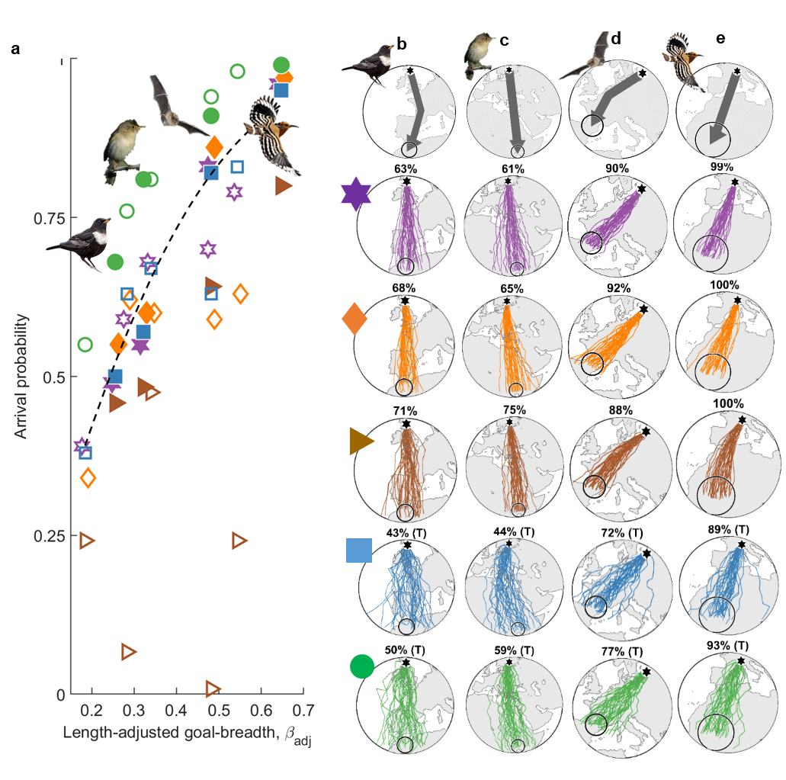

Supplementary Fig. 3.

Supplementary Fig. 3. Compass course trajectories of remaining species.

(a) Analogous to Fig. 4a, performance of simulated compass courses, assuming 20° total stepwise equivalent error, of (solid symbols, left to right) night-migratory Ring Ouzel (Turdus torquatus), Marsh Warbler (Acrocephalus palustris), Nathusius Bat (Pipistrellus nathusii) and Euraian Hoopoe (Upupa epops) vs. length-adjusted goal-breadth, $β_{adj}$ (equation 13), with open symbols depicted in Fig. 4 and dashed line depicting expected performance in the normal planar limit (equation 11). Random-selected trajectories assuming biologically-relevant error (see Fig. 4b-f), modelled after known routes (grey arrows) of (b) Ring Ouzel, (c) Marsh Warbler, (d) Nathusius Bat and (e) Euraian Hoopoe, following geographic loxodromes (i.e., star compass courses, purple hexagons and tracks), geomagnetic loxodromes (orange diamonds), magnetoclinic courses (brown squares), fixed sun compass courses (blue circles) and time-compensated sun compass (TCSC) courses (green hexagons). Known migration routes, from natal grounds (black hexagons) to natural goal areas (open circles), are depicted by grey arrows (great circles appear as straight lines in the stereographic projection). Performance (%) and, where applicable, also cue-transferred courses (“T”) are depicted above each panel. Photographs of (a-b) Wikicommons, (c) Roger Jones and (d) Gordon Langsbury.
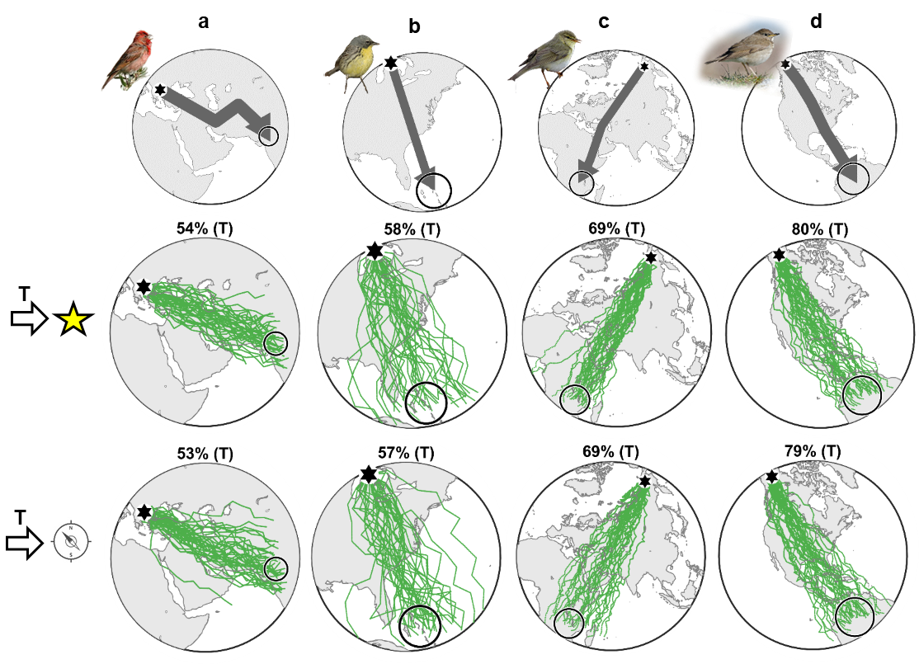

Supplementary Fig. 4. Comparison of nightly star compass with nightly geomagnetic compass for cue-transferred TCSC courses.

As in Fig. 3c-f, randomly-selected TCSC trajectories of biologically-relevant simulations (but here with 20º effective cue errors and 15º effective drift error) for known migration routes (top row) of (a) Common Rosefinch (Carpodacus erythrinus), (b) Kirtland’s Warbler (Setophaga kirtlandii), (c) Willow Warbler (Phylloscopus trochilus) and (d) Gray-cheeked Thrush (Catharus minimus) (Table 2) based on (middle row) cue-transfer to a nocturnal star compass (i.e., as in bottom row of Fig. 5c-f) and (bottom row) transfer to a nocturnal geomagnetic compass. Numbers in percentages indicate arrival probabilities among 10,000 simulated migrants.

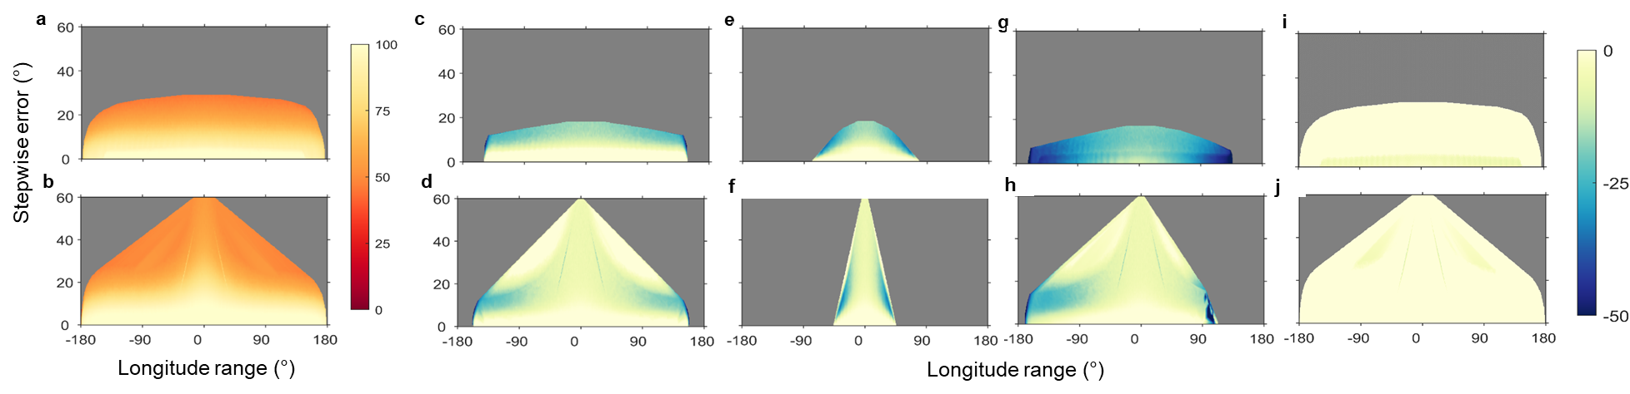
Supplementary Fig. 5. Global performance among compass courses for generic migrant.

(a-b) Heat map of maximum arrival probability within a 500 km goal radius among compass courses (colour scale on near right) for migration of a generic migrant in a geomagnetic dipole between (a) 65°N-0° and (b) 45°N-25°N, as a function of effective stepwise error and longitudinal range (both in degrees). Grey-shaded areas indicate untenable combinations of range and error. (c-j) Relative (percentage) performance difference between each compass course and the maximum (colour scale on far right) for migration between (top row) 65°N-0° and (bottom row) 45°N-25°N, following (c-d) geographic or geomagnetic loxodrome (e-f) magnetoclinic, (g-h) fixed sun compass and (i-j) time-compensated sun compass (TCSC) courses.

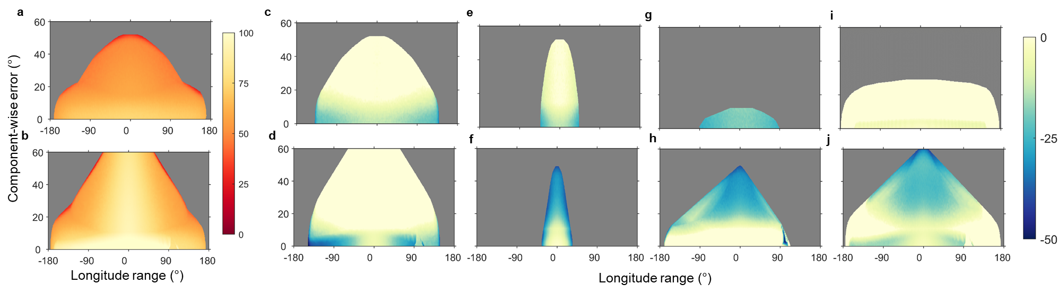

Supplementary Fig. 6. Global compass-course performance for biologically-relevant error.

As in Supplementary Fig. 5, but including within-step cue detection, maintenance and drift errors (y-axes, assumed equivalent), and within-individual variability. (a-b) Heat map of maximum arrival probability among compass courses (colour scale on near right) for migration of a generic migrant in a geomagnetic dipole between (a) 65°N-0° and (B) 45°N-25°N. (c-j) Relative (percentage) performance difference between the maximum and each compass course (colour scale on far right) for migration between (top row) 65°N-0° and (bottom row) 45°N-25°N, following (c-d) geographic or geomagnetic loxodrome (e-f) non-transferred magnetoclinic, (g-h) cue-transferred fixed sun compass and (i-j) cue-transferred TCSC courses.

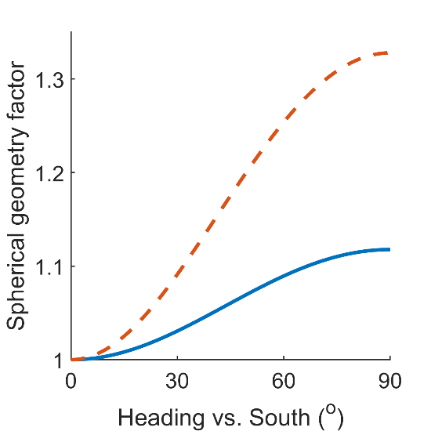

Supplementary Fig. 7. The spherical geometry factor. The spherical geometry factor (equation 31) vs. heading (clockwise from South) for long-distance migration (red dashed line, 65°N – 0º) and medium distance migration (solid blue line, 45ºN-25ºN)

Supplementary Table 1.

AICc-selected parameter values of most parsimonious regression model (with lowest ΔAICc value) among model-selected regression based on route-optimized performance among species for each compass course.

Compass course and adjusted R-squared | Parameter value and CI | p-value
Geographic loxodrome $R_{adj}^{2}=0.98$ | g = 0.9 ± 0.3 | 0.002
Geographic loxodrome $R_{adj}^{2}=0.98$ | $b_{0}$= -0.02 ± 0.01 | 0.04
Geographic loxodrome $R_{adj}^{2}=0.98$ | s = 0.17 ± 0.03 | 10⁻⁵
Geographic loxodrome $R_{adj}^{2}=0.98$ | ρ = (0) | not tested
Geomagnetic loxodrome $R_{adj}^{2}=0.97$ | g = 2.7 ± 0.3 | 10⁻¹¹
Geomagnetic loxodrome $R_{adj}^{2}=0.97$ | $b_{0}$= 0 ± 0.01 | 0.9
Geomagnetic loxodrome $R_{adj}^{2}=0.97$ | s = 0.15 ± 0.03 | 10⁻⁶
Geomagnetic loxodrome $R_{adj}^{2}=0.97$ | ρ = (0) | not tested
TCSC  $$R_{adj}^{2}=0.98$$ | g = 0.8 ± 0.3 | 0.01
TCSC  $$R_{adj}^{2}=0.98$$ | $b_{0}$= 0.15 ± 0.01 | 10⁻¹⁴
TCSC  $$R_{adj}^{2}=0.98$$ | s = 0.30 ± 0.03 | 10⁻¹¹
TCSC  $$R_{adj}^{2}=0.98$$ | ρ = 0.6 ± 0.2 | 0.001

Supplementary Table 2.

AICc-selected parameters (with ΔAICc < 2) among model-selected regression based on route-optimized performance among species for each compass course.

Compass course and adjusted R-squared | Selected parameters | ΔAICc
Geographic loxodrome | g, $b_{0}$, s | 0
Geographic loxodrome | $b_{0}$, s | 0.23
Geomagnetic loxodrome | g, $b_{0}$, s | 0
Geomagnetic loxodrome | g, s | 0.01
TCSC | g, $b_{0}$, s, ρ | 0
TCSC | $b_{0}$, s, ρ | 0.80

