Waterborne and Airborne Microfibers shed from non-woven materials in water and air environments
Soojin Kwon, Marielis C. Zambrano, Richard A. Venditti, Ryen Fraizer, Franklin Zambrano, Ronalds W. Gonzalez, Joel J. Pawlak *
Department of Forest Biomaterials, College of Natural Resources, North Carolina State University, Raleigh, North Carolina, USA
* Corresponding author: jjpawlak@ncsu.edu

Supplemental information
Characterization of nonwoven commercial products
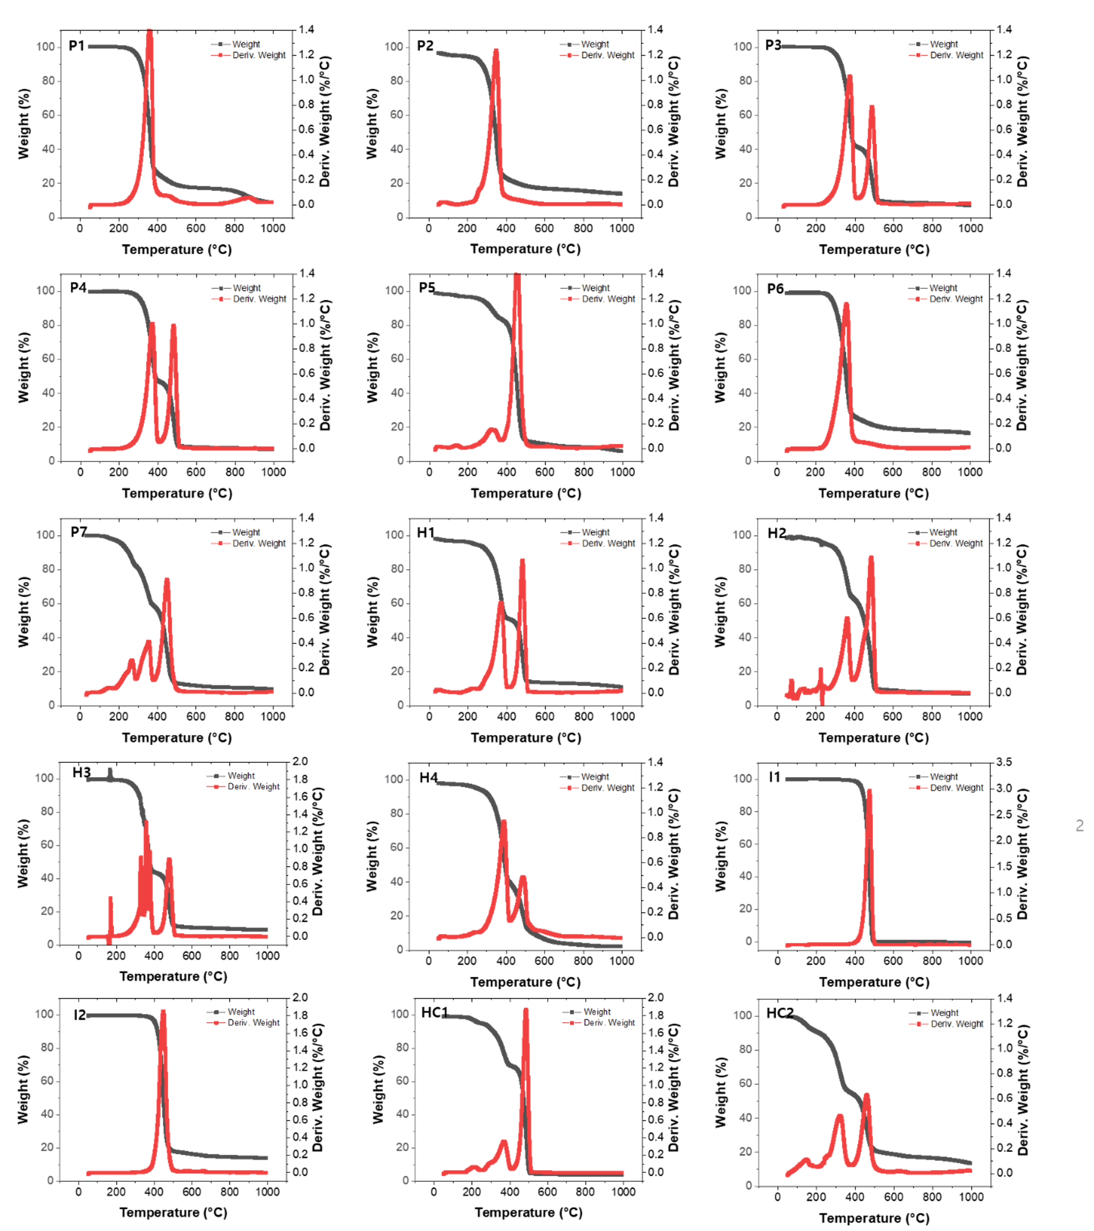
Fig. S1 TGA results of commercial nonwoven products.

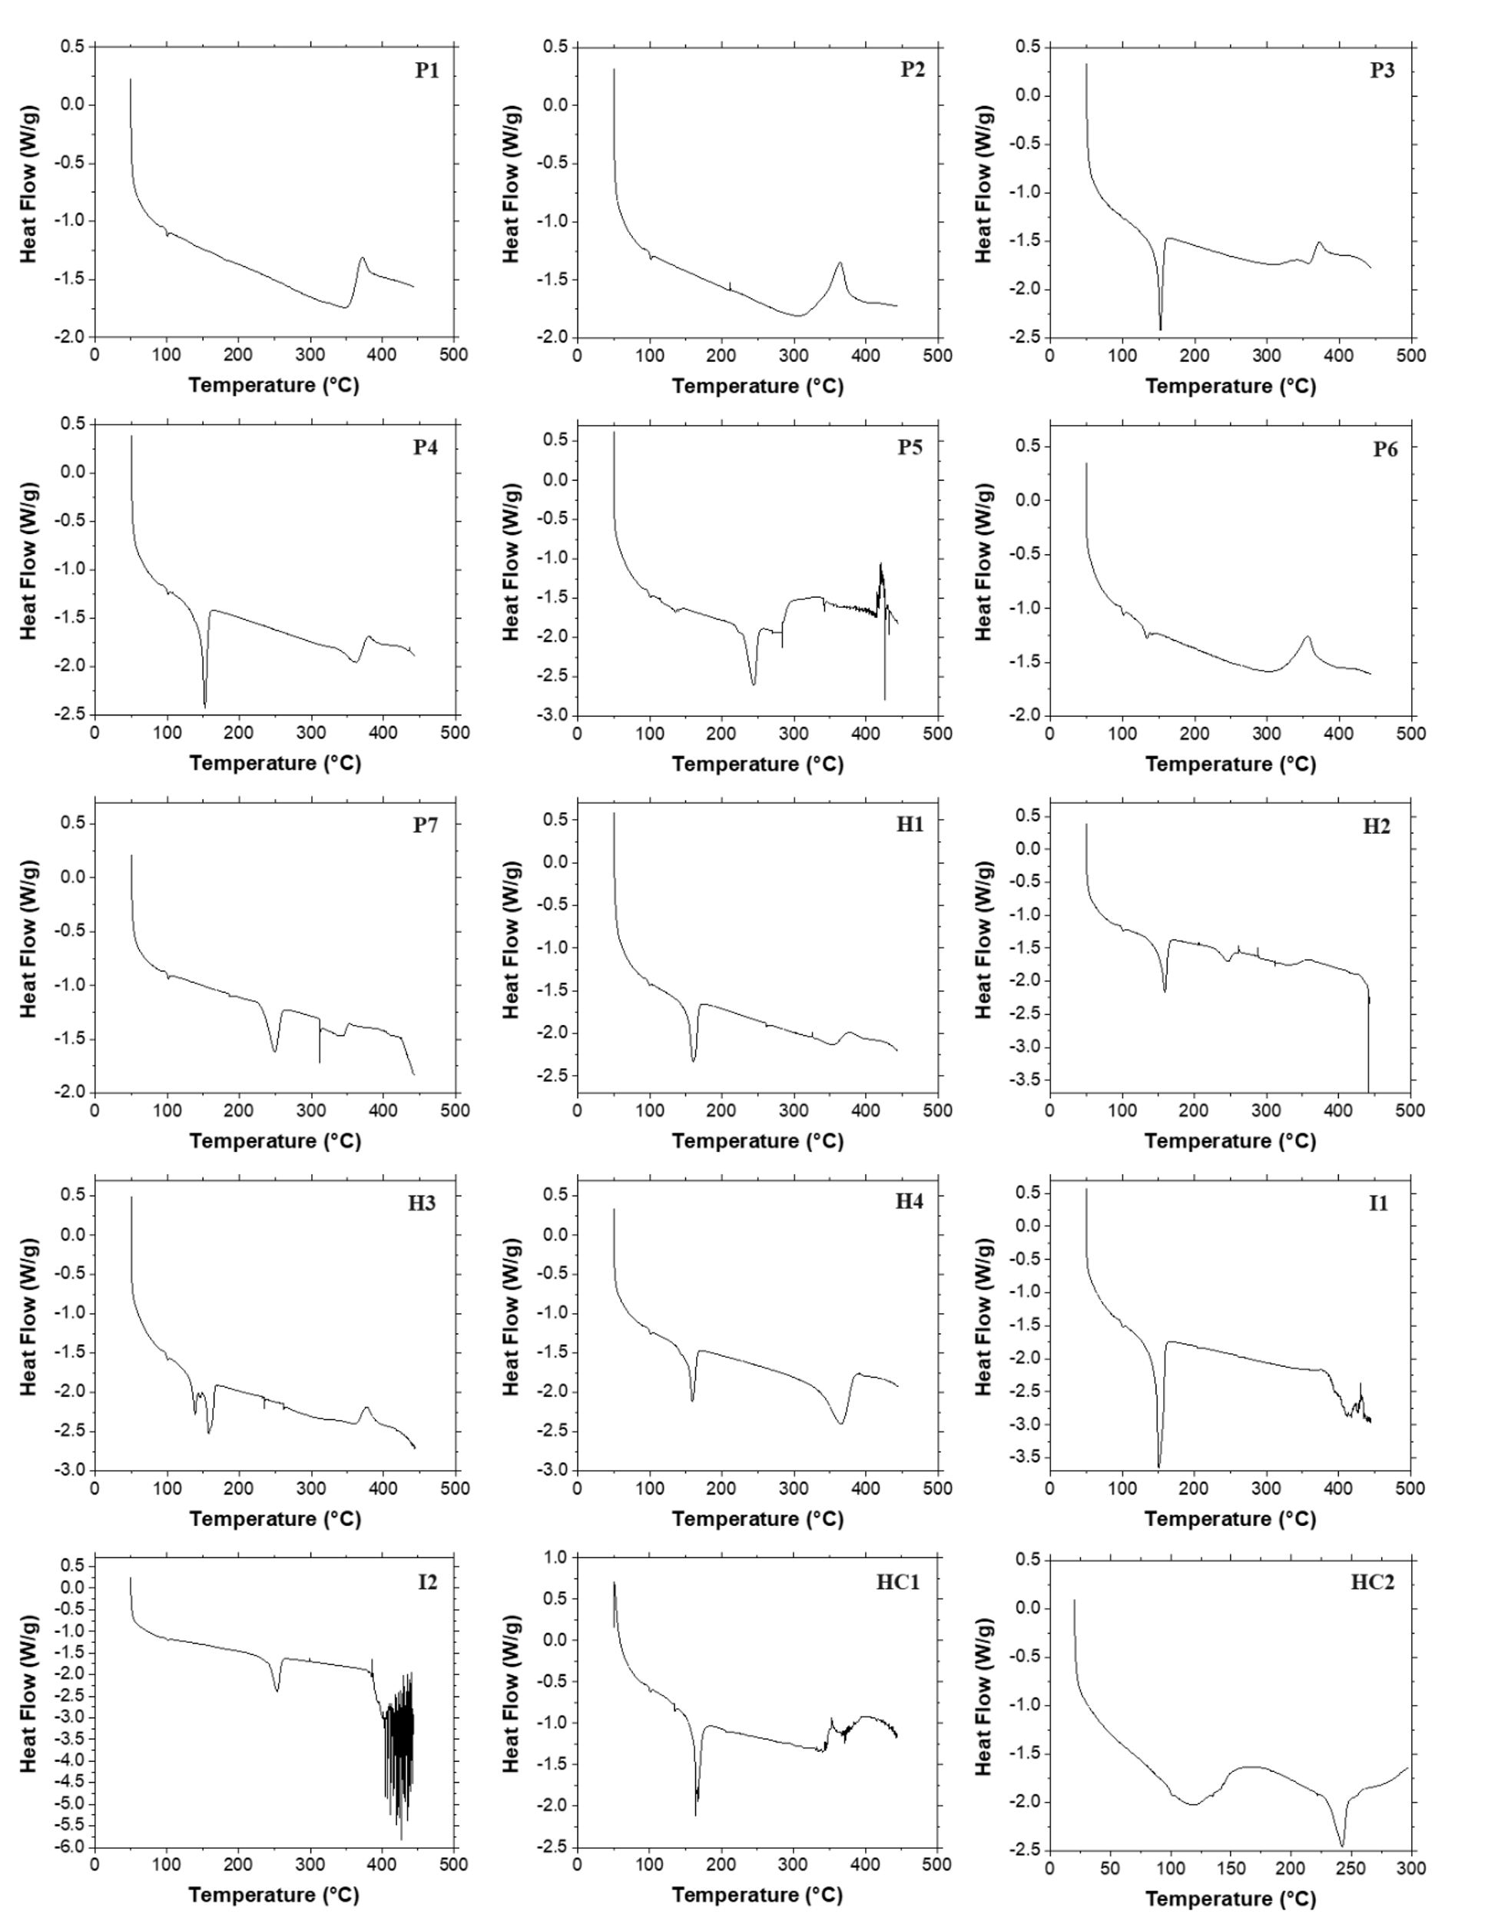
Fig. S2 DSC results of commercial nonwoven products.

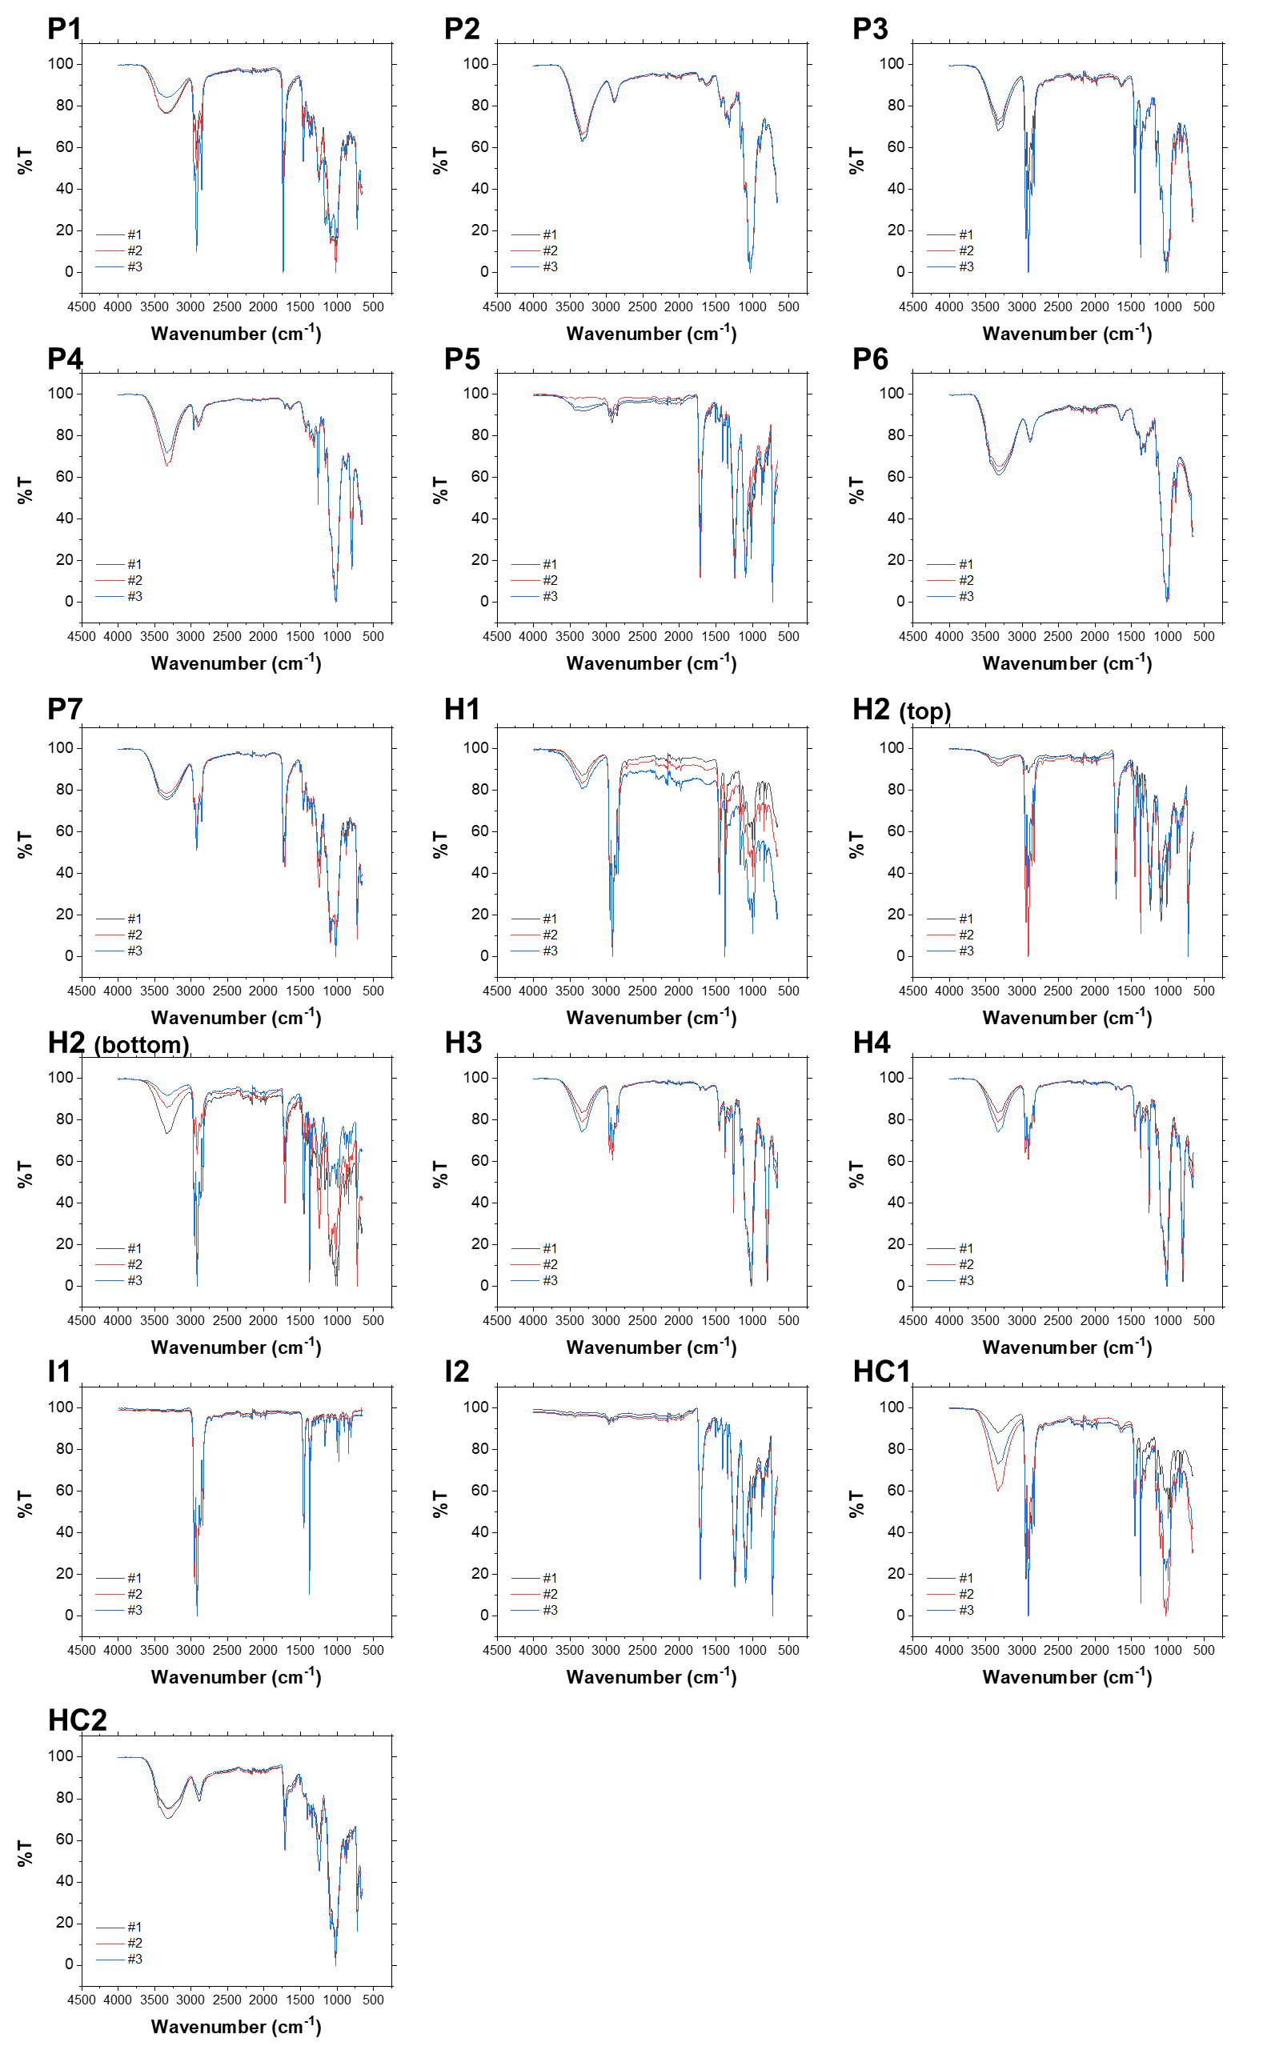
Fig. S3 FT-IR results of nonwoven commercial products. Since some nonwoven products are composed of complex structure and several raw materials, the measurement was done triplicate for each sample. H2 sample has different macro-surfaces of top and bottom side, so both surfaces were analyzed.

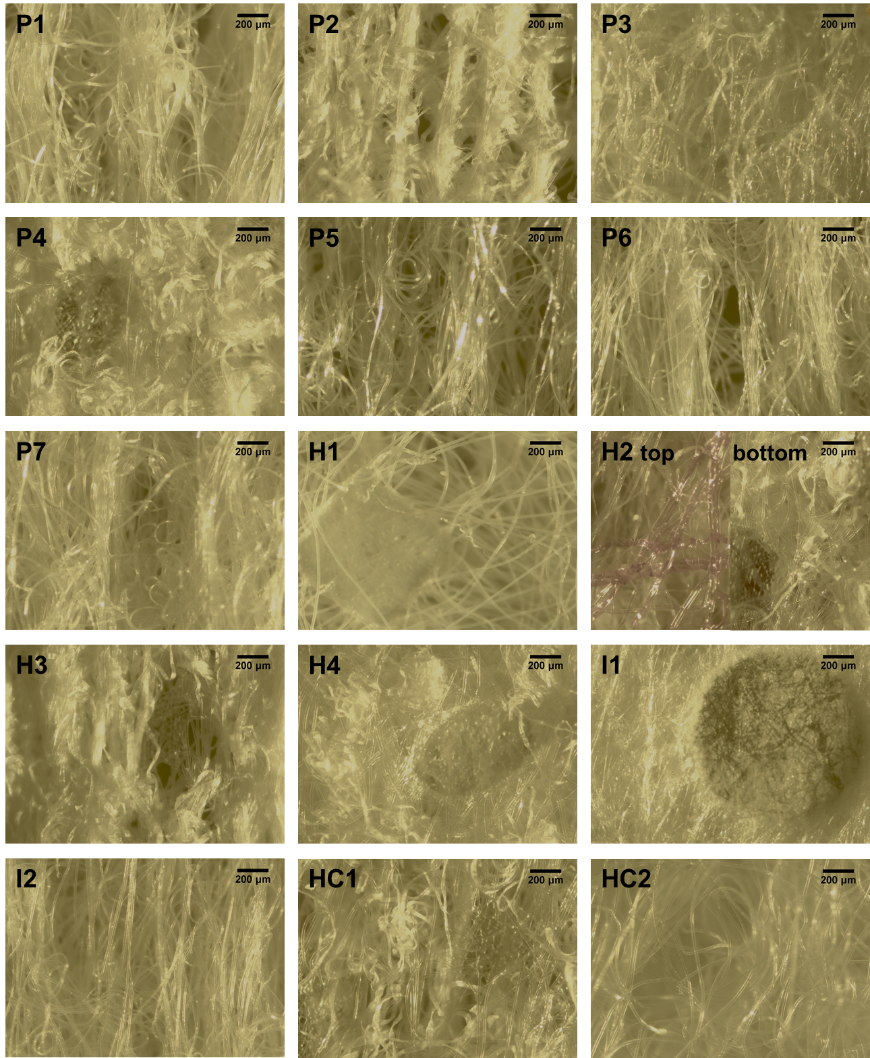
Fig. S4 Microscopic images of nonwoven commercial products (unstained).
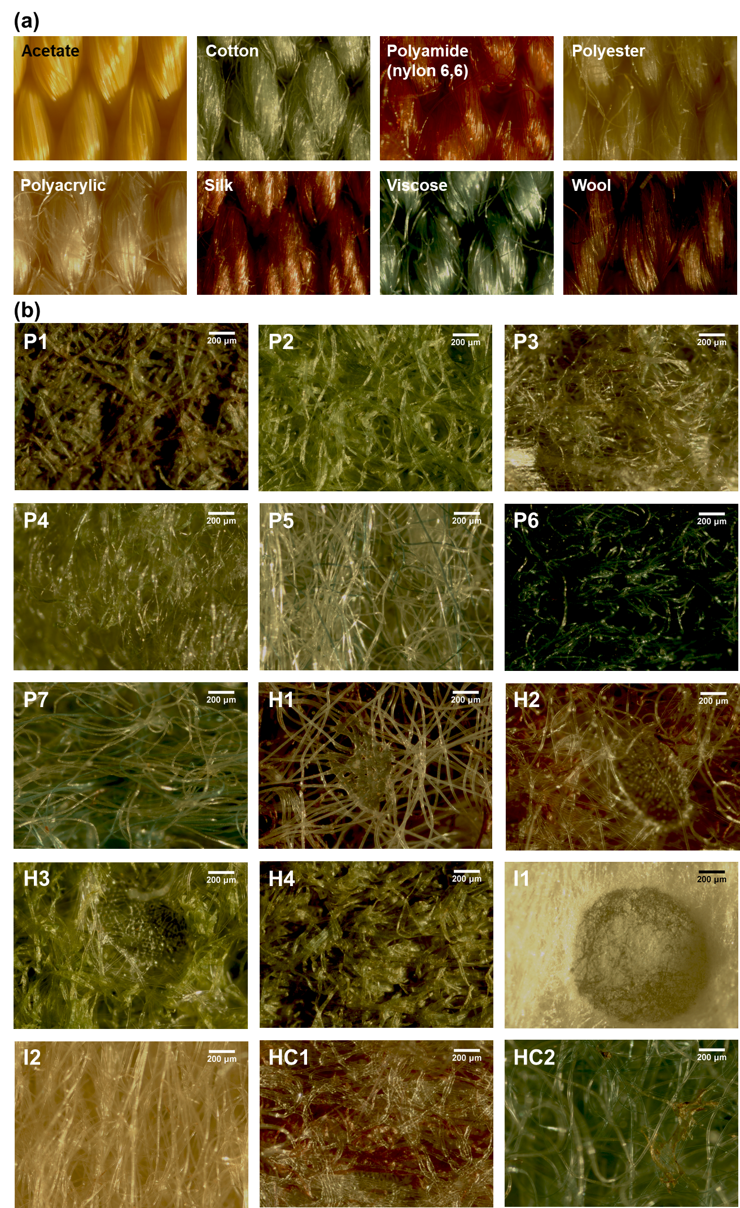
Fig. S5 Microscopic images of nonwoven commercial products (stained; x40). a: images of the reference materials of Textile Identification DuPont Stain#4, b: stained nonwoven products

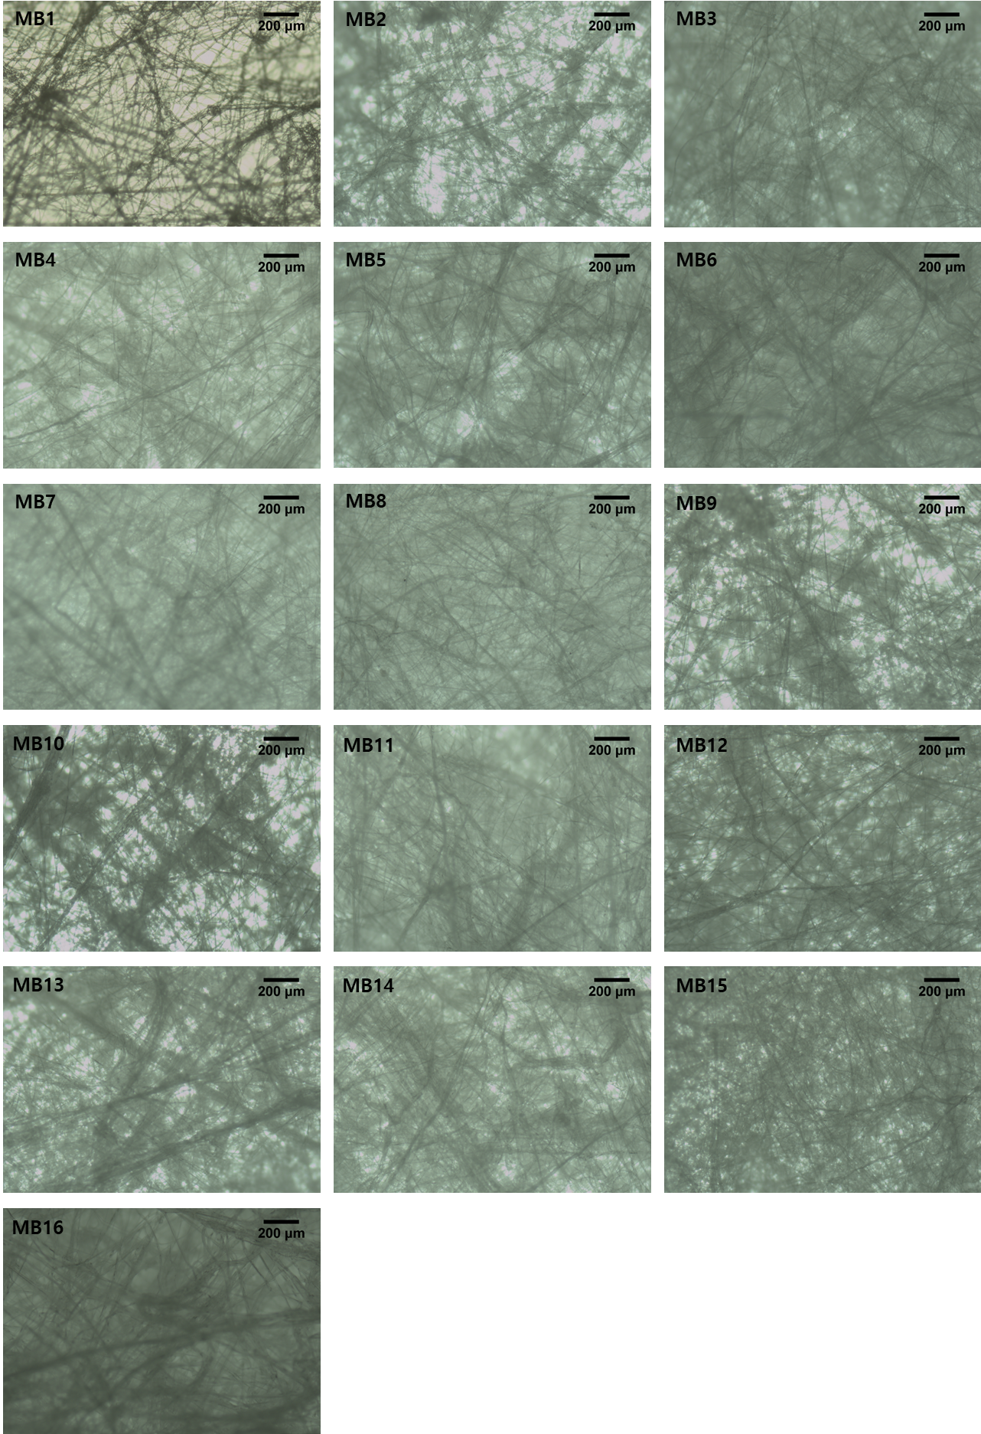
Fig. S6 Microscopic images of meltblown nonwovens. (40x)

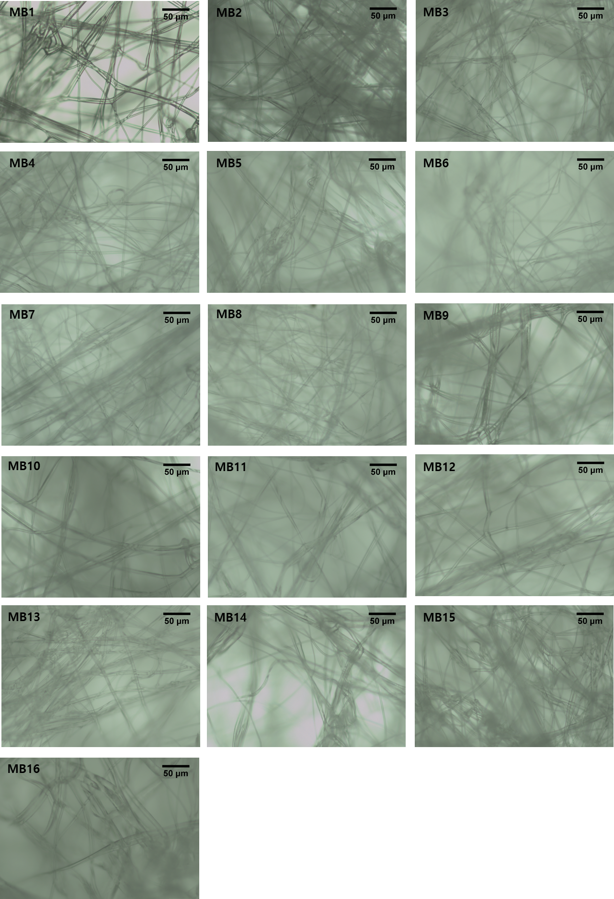
Fig. S7 Microscopic images of meltblown nonwovens. (200x)

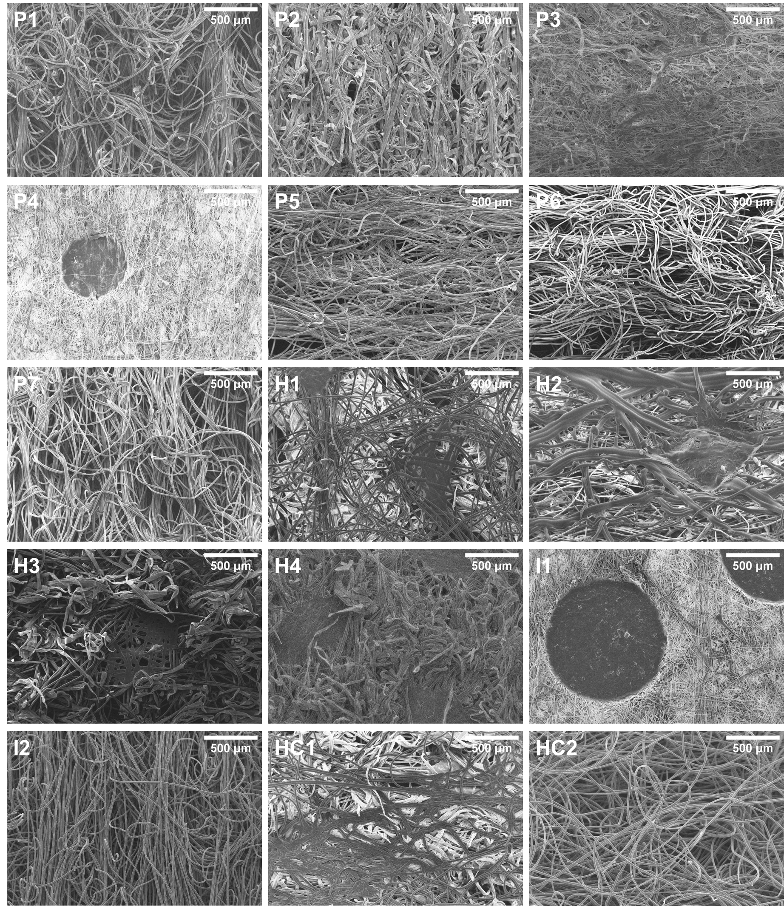
Fig. S8 Scanning electron microscopic images of nonwoven commercial products (x50)

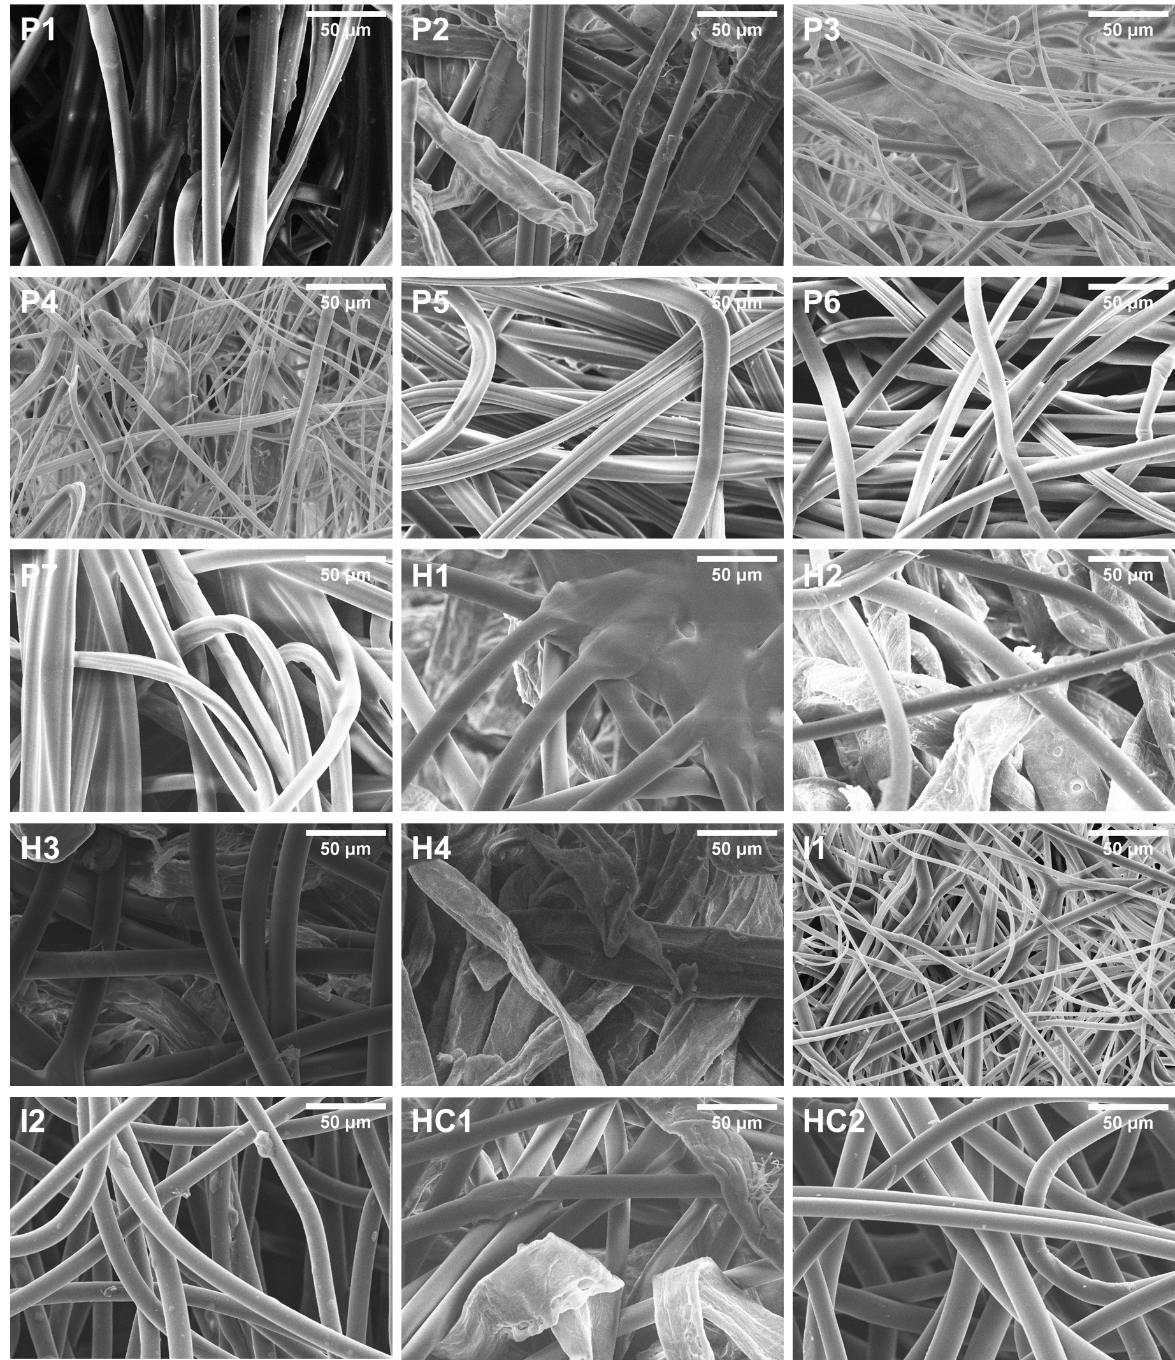
Fig. S9 Scanning electron microscopic images of nonwoven commercial products (x500)
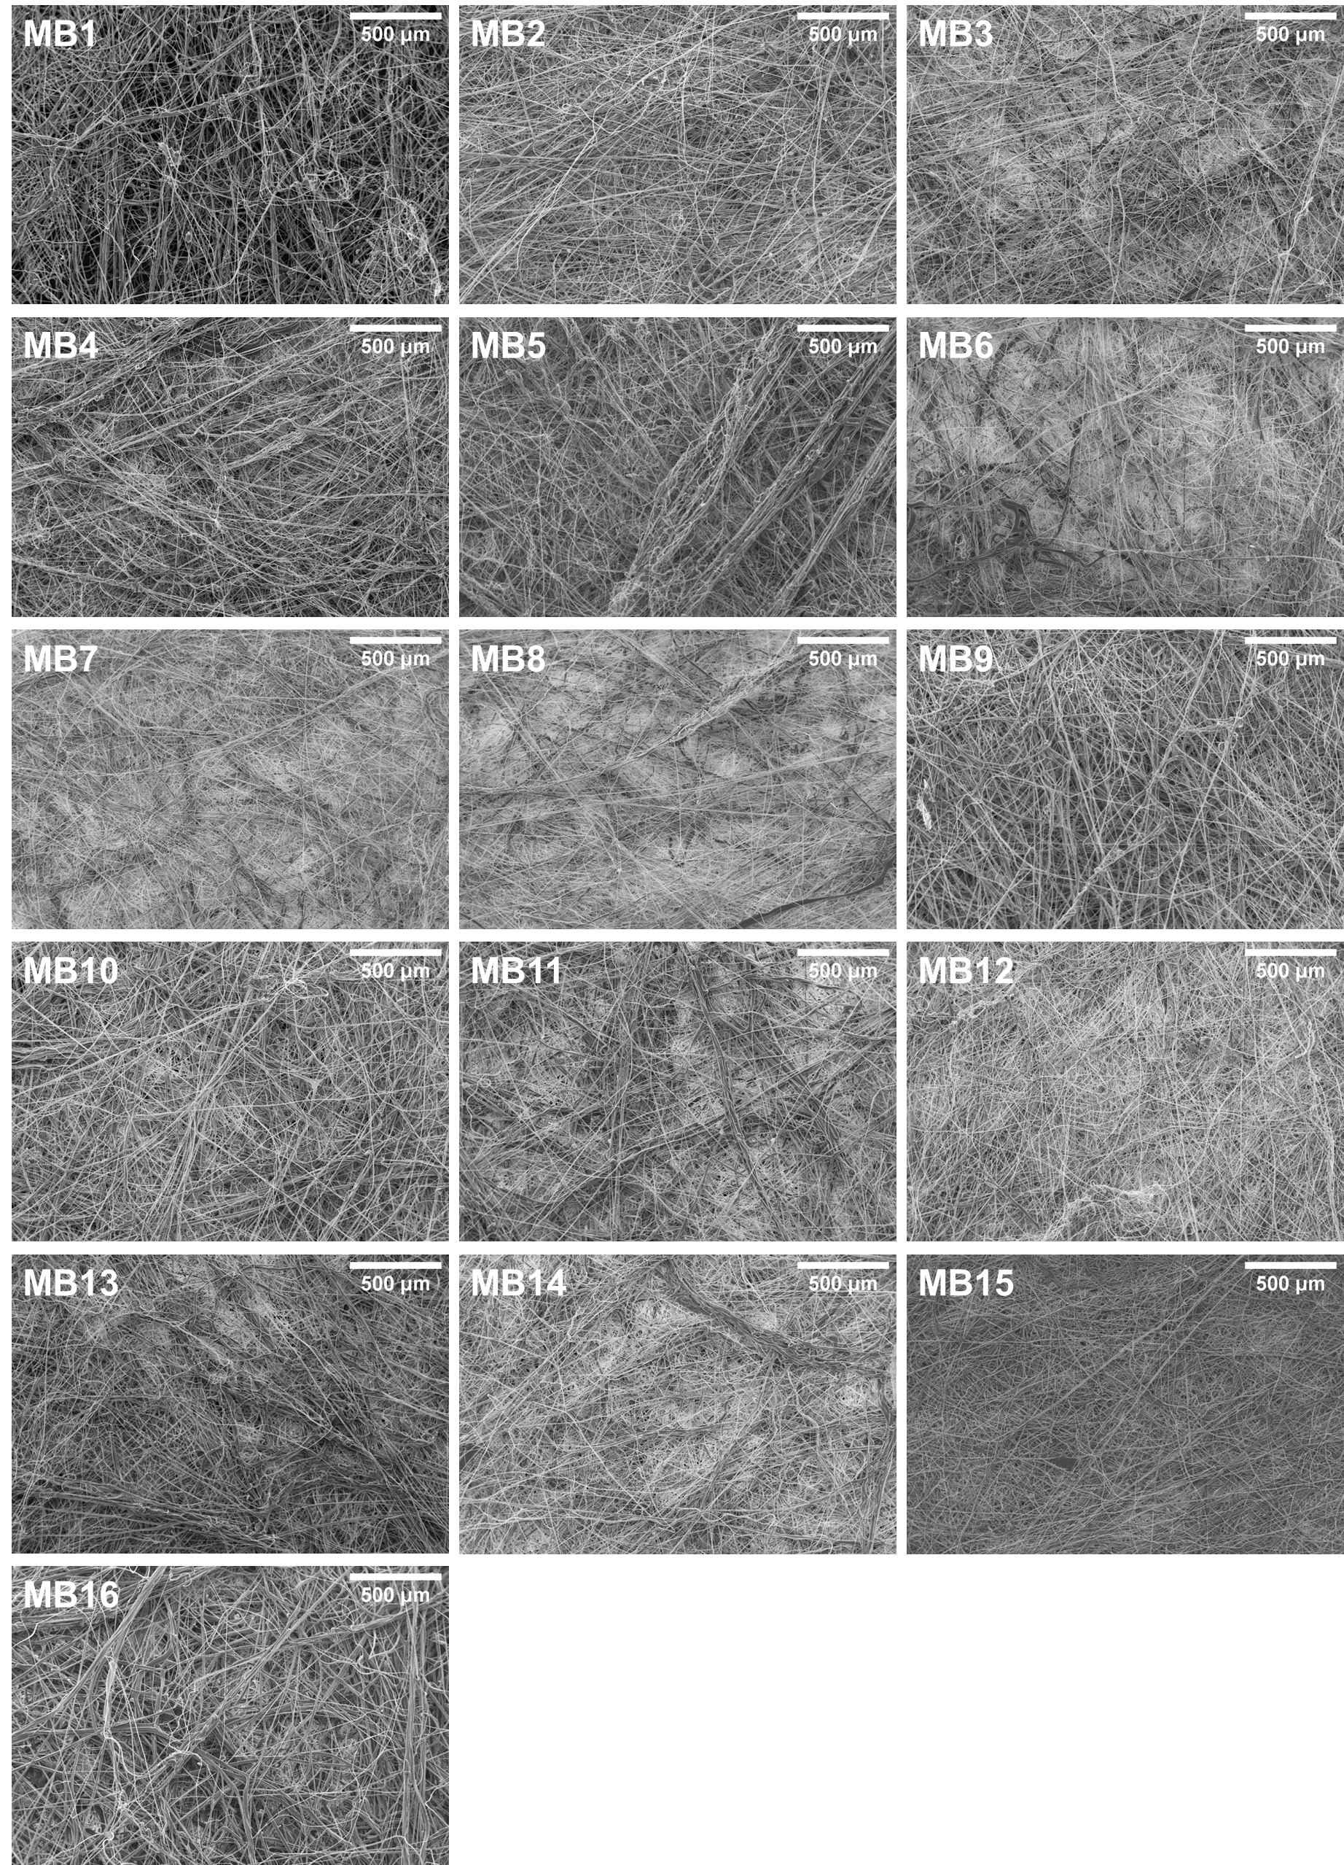Fig. S10 Scanning electron microscopic images of meltblown nonwovens (x50)

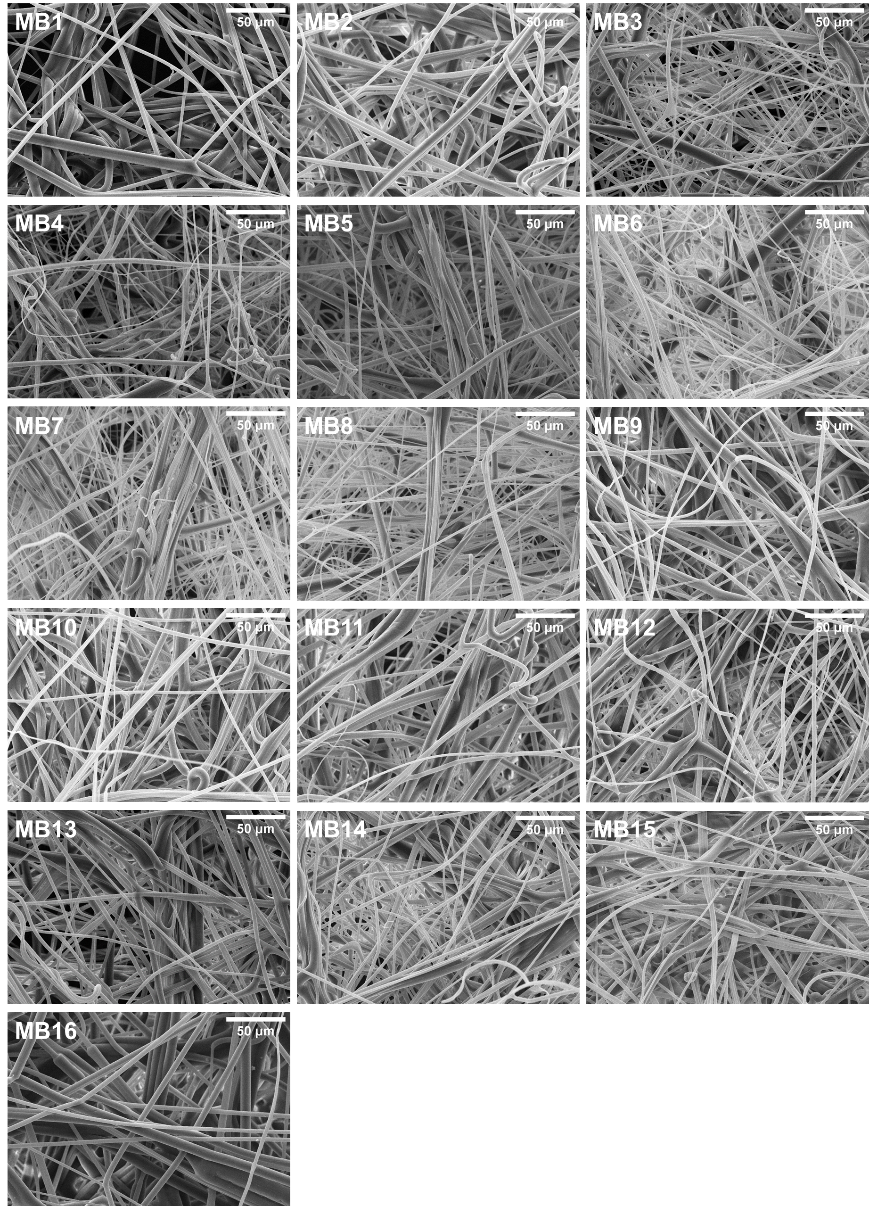
Fig. S11 Scanning electron microscopic images of meltblown nonwovens (x500)

Table S1 TSA results of commercial nonwoven products (unwashed). The nonwoven materials were fully dried before the measurement since they are wet wipes with liquids and TSA cannot measure wet materials. (Values in parentheses are the standard deviation of three repetition of the measurement)
Samples | P1 |  | P2 |  | P3 |  | P4 |  | P5
TS750 (roughness) | 103 | (±20.5) | 36.8 | (±7.85) | 17.7 | (±2.88) | 19.9 | (±5.26) | 11.9 | (±2.86)
TS7 (softness) | 21.1 | (±4.69) | 9.33 | (±2.07) | 6.20 | (±0.55) | 7.07 | (±1.50) | 3.68 | (±0.29)
Compliance (mm/N) | 1.80 | (±0.12) | 1.97 | (±0.22) | 3.01 | (±0.08) | 2.67 | (±0.15) | 2.69 | (±0.27)
Elasticity (mm/N) | 1.66 | (±0.07) | 1.70 | (±0.11) | 2.85 | (±0.06) | 2.54 | (±0.12) | 2.28 | (±0.19)
Plasticity (μm) | -110 | (±41.9) | -200 | (±68.0) | -110 | (±16.9) | -86.9 | (±22.3) | -307 | (±63.7)
Hysteresis (J) | 60.8 | (±10.9) | 82.1 | (±20.4) | 33.9 | (±4.68) | 27.0 | (±1.55) | 77.2 | (±2.73)
Caliper (um) | 526 |  | 484 |  | 686 |  | 619 |  | 512
Grammage (g/m2) | 72.4 |  | 51.7 |  | 51.5 |  | 54.3 |  | 42.0
Density (g/cm³) | 0.14 |  | 0.11 |  | 0.08 |  | 0.09 |  | 0.08
Samples | P6 |  | P7 |  | H1 |  | H2 |  | H3
TS750 (roughness) | 12.4 | (±0.87) | 19.3 | (±8.13) | 13.1 | (±8.10) | 52.7 | (±5.79) | 49.7 | (±8.20)
TS7 (softness) | 6.18 | (±0.72) | 4.69 | (±0.75) | 7.17 | (±2.37) | 26.2 | (±2.96) | 11.4 | (±2.20)
Compliance (mm/N) | 2.39 | (±0.06) | 2.46 | (±0.08) | 2.23 | (±0.04) | 2.19 | (±0.13) | 2.24 | (±0.61)
Elasticity (mm/N) | 1.96 | (±0.08) | 1.77 | (±0.06) | 2.09 | (±0.04) | 2.06 | (±0.11) | 1.77 | (±0.14)
Plasticity (μm) | -280 | (±23.6) | -435 | (±22.3) | -68.5 | (±15.6) | -80.8 | (±32.0) | -273 | (±257)
Hysteresis (J) | 74.6 | (±6.20) | 141 | (±51.4) | 23.8 | (±8.41) | 38.2 | (±7.15) | 87.1 | (±45.3)
Caliper (um) | 342 |  | 477 |  | 573 |  | 490 |  | 373
Grammage (g/m2) | 42.6 |  | 51.2 |  | 46.6 |  | 56.2 |  | 56.0
Density (g/cm³) | 0.13 |  | 0.11 |  | 0.08 |  | 0.12 |  | 0.15
Samples | H4 |  | I1 |  | I2 |  | HC1 |  | HC2
TS750 (roughness) | 41.9 | (±7.61) | 53.3 | (±8.15) | 13.3 | (±2.44) | 20.8 | (±3.24) | 17.4 | (±2.80)
TS7 (softness) | 7.75 | (±1.25) | 10.3 | (±0.56) | 3.16 | (±0.05) | 6.94 | (±0.46) | 3.45 | (±0.23)
Compliance (mm/N) | 2.29 | (±0.33) | 2.21 | (±0.17) | 2.18 | (±0.03) | 2.58 | (±0.16) | 2.67 | (±0.22)
Elasticity (mm/N) | 1.92 | (±0.10) | 2.10 | (±0.08) | 1.55 | (±0.05) | 2.25 | (±0.10) | 1.84 | (±0.09)
Plasticity (μm) | -235 | (±138) | -42.2 | (±62.1) | -427 | (±13.7) | -206 | (±53.9) | -540 | (±148)
Hysteresis (J) | 70.9 | (±15.2) | 16.7 | (±17.1) | 188 | (±47.1) | 58.9 | (±6.79) | 200 | (±14.2)
Caliper (um) | 393 |  | 282 |  | 496 |  | 349 |  | 2040
Grammage (g/m2) | 59.5 |  | 33.0 |  | 53.5 |  | 33.9 |  | 174
Density (g/cm³) | 0.15 |  | 0.12 |  | 0.11 |  | 0.10 |  | 0.09

Table S2 TSA results of commercial nonwoven products (washed). The nonwoven materials were fully dried after washed by deionized water to remove any liquids including lotion in wet wipes. (Values in parentheses are the standard deviation of three repetition of the measurement)
Samples | P1 |  | P2 |  | P3 |  | P4 |  | P5
TS750 (roughness) | N/A |  | N/A |  | 22.3 | 4.6 | 20.3 | (±3.19) | 10.1 | (±0.70)
TS7 (softness) |  |  |  |  | 4.80 | 1.14 | 5.93 | (±0.39) | 3.32 | (±0.59)
Compliance (mm/N) |  |  |  |  | 3.10 | 0.19 | 2.42 | (±0.14) | 2.92 | (±0.15)
Elasticity (mm/N) |  |  |  |  | 2.80 | 0.09 | 2.35 | (±0.17) | 2.59 | (±0.11)
Plasticity (μm) |  |  |  |  | -190 | 76.3 | -42.0 | (±26.6) | -265 | (±62.0)
Hysteresis (J) |  |  |  |  | 43.8 | 9.82 | 27.3 | (±11.1) | 67.2 | (±5.92)
Caliper (um) |  |  |  |  | 791 |  | 573 |  | 521
Grammage (g/m2) |  |  |  |  | 52 |  | 54 |  | 42
Density (g/cm³) |  |  |  |  | 0.07 |  | 0.10 |  | 0.08
Samples | P6 |  | P7 |  | H1 |  | H2 |  | H3
TS750 (roughness) | 10.8 | (±0.77) | 8.84 | (±0.56) | 15.8 | (±4.24) | 42.9 | (±9.95) | 55.3 | (±4.29)
TS7 (softness) | 5.31 | (±0.54) | 3.17 | (±0.22) | 11.2 | (±0.15) | 21.9 | (±3.20) | 10.8 | (±0.70)
Compliance (mm/N) | 2.82 | (±0.14) | 2.68 | (±0.09) | 2.29 | (±0.15) | 2.56 | (±0.30) | 1.64 | (±0.11)
Elasticity (mm/N) | 2.32 | (±0.17) | 1.81 | (±0.10) | 2.17 | (±0.13) | 2.27 | (±0.12) | 1.66 | (±0.08)
Plasticity (μm) | -330 | (±40.7) | -543 | (±77.7) | -54.5 | (±36.1) | -194 | (±119) | 24.4 | (±16.9)
Hysteresis (J) | 74.5 | (±9.29) | 152 | (±46.7) | 23.2 | (±2.77) | 54.3 | (±9.02) | 9.77 | (±14.0)
Caliper (um) | 366 |  | 456 |  | 572 |  | 528 |  | 456
Grammage (g/m2) | 43 |  | 51 |  | 47 |  | 56 |  | 56
Density (g/cm³) | 0.12 |  | 0.11 |  | 0.08 |  | 0.11 |  | 0.12
Samples | H4 |  | I1 |  | I2 |  | HC1 |  | HC2
TS750 (roughness) | 49.7 | (±4.52) | 44.2 | (±2.84) | 14.4 | (±0.65) | 19.1 | (±2.49) | 27.2 | (±1.55)
TS7 (softness) | 5.96 | (±0.66) | 9.89 | (±0.19) | 3.62 | (±0.26) | 7.60 | (±0.33) | 4.19 | (±0.30)
Compliance (mm/N) | 2.01 | (±0.21) | 1.71 | (±0.16) | 2.23 | (±0.03) | 2.24 | (±0.11) | 2.88 | (±0.15)
Elasticity (mm/N) | 1.87 | (±0.14) | 1.70 | (±0.15) | 1.64 | (±0.03) | 2.20 | (±0.09) | 2.04 | (±0.07)
Plasticity (μm) | -66.1 | (±69.9) | 31.6 | (±11.9) | -397 | (±6.72) | -33.2 | (±29.3) | -542 | (±99.3)
Hysteresis (J) | 40.8 | (±16.9) | -17.4 | (±11.8) | 114 | (±5.50) | 20.1 | (±21.5) | 190 | (±8.35)
Caliper (um) | 446 |  | 288 |  | 479 |  | 360 |  | 1730
Grammage (g/m2) | 60 |  | 33 |  | 54 |  | 34 |  | 174
Density (g/cm³) | 0.13 |  | 0.12 |  | 0.11 |  | 0.09 |  | 0.10

Table S3 TSA results of meltblown nonwovens. (Values in parentheses are the standard deviation of four repetition of the measurement)
Samples | MB1 |  | MB2 |  | MB3 |  | MB4 |  | MB5
TS750 (roughness) | 28.01 | (±8.03) | 79.31 | (±14.60) | 49.23 | (±2.58) | 30.22 | (±5.72) | 30.95 | (±3.04)
TS7 (softness) | 17.16 | (±2.55) | 19.14 | (±0.97) | 11.04 | (±0.88) | 8.88 | (±0.25) | 9.14 | (±0.39)
Compliance (mm/N) | 3.16 | (±0.04) | 2.29 | (±0.15) | 2.17 | (±0.05) | 2.44 | (±0.05) | 2.42 | (±0.07)
Elasticity (mm/N) | 3.16 | (±0.01) | 2.27 | (±0.13) | 2.14 | (±0.05) | 2.41 | (±0.05) | 2.39 | (±0.06)
Plasticity (μm) | -36.40 | (±6.92) | 4.15 | (±20.19) | 7.08 | (±9.04) | -1.30 | (±6.37) | -1.33 | (±3.43)
Hysteresis (J) | 15.13 | (±6.69) | 2.95 | (±7.63) | 1.55 | (±11.68) | 4.28 | (±3.12) | 10.15 | (±6.28)
Caliper (um) | 259 |  | 388 |  | 298 |  | 300 |  | 333
Grammage (g/m2) | 11 |  | 26 |  | 27 |  | 25 |  | 26
Density (g/cm³) | 0.04 |  | 0.07 |  | 0.09 |  | 0.08 |  | 0.08
Samples | MB6 |  | MB7 |  | MB8 |  | MB9 |  | MB10
TS750 (roughness) | 23.38 | (±1.81) | 27.60 | (±4.13) | 28.59 | (±6.52) | 66.28 | (±23.95) | 59.66 | (±11.95)
TS7 (softness) | 5.04 | (±0.32) | 6.30 | (±0.82) | 7.08 | (±0.52) | 18.75 | (±3.55) | 15.24 | (±1.00)
Compliance (mm/N) | 3.03 | (±0.11) | 2.66 | (±0.11) | 2.47 | (±0.08) | 2.39 | (±0.07) | 2.40 | (±0.09)
Elasticity (mm/N) | 2.99 | (±0.10) | 2.62 | (±0.10) | 2.43 | (±0.05) | 2.39 | (±0.05) | 2.39 | (±0.07)
Plasticity (μm) | -37.75 | (±12.83) | -25.15 | (±14.00) | -15.05 | (±14.43) | 6.55 | (±13.21) | 10.63 | (±11.94)
Hysteresis (J) | 13.13 | (±0.61) | 18.23 | (±2.75) | 11.48 | (±6.00) | 5.95 | (±5.74) | 3.60 | (±2.99)
Caliper (um) | 413 |  | 362 |  | 314 |  | 388 |  | 395
Grammage (g/m2) | 27 |  | 27 |  | 26 |  | 25 |  | 26
Density (g/cm³) | 0.07 |  | 0.08 |  | 0.08 |  | 0.06 |  | 0.07
Samples | MB11 |  | MB12 |  | MB13 |  | MB14 |  | MB15
TS750 (roughness) | 85.36 | (±7.89) | 78.89 | (±11.11) | 38.57 | (±4.55) | 40.38 | (±5.70) | 110.09 | (±2.64)
TS7 (softness) | 12.73 | (±0.95) | 18.11 | (±2.72) | 13.02 | (±1.15) | 13.60 | (±1.42) | 22.16 | (±1.57)
Compliance (mm/N) | 1.98 | (±0.20) | 1.98 | (±0.06) | 2.36 | (±0.04) | 2.27 | (±0.05) | 1.79 | (±0.08)
Elasticity (mm/N) | 1.94 | (±0.15) | 1.97 | (±0.05) | 2.36 | (±0.04) | 2.26 | (±0.07) | 1.78 | (±0.08)
Plasticity (μm) | 4.93 | (±30.55) | 13.58 | (±7.78) | 3.48 | (±5.25) | 7.53 | (±8.14) | 18.65 | (±11.50)
Hysteresis (J) | 9.53 | (±12.33) | -1.38 | (±3.27) | 8.03 | (±2.68) | 1.30 | (±9.55) | -0.75 | (±7.10)
Caliper (um) | 538 |  | 305 |  | 293 |  | 287 |  | 263
Grammage (g/m2) | 50 |  | 24 |  | 24 |  | 24 |  | 24
Density (g/cm³) | 0.09 |  | 0.08 |  | 0.08 |  | 0.09 |  | 0.09

