Supplementary Information
Multiscale analysis of the acute levodopa response in Parkinson's disease: from whole-brain functional remodelling to molecular–transmitter mechanisms and individualised prediction
Contents
Supplementary Figure S1 — Edge-wise ΔFC–improvement brain–behaviour map
Supplementary Figure S2 — Network-level functional connectivity across the three contrasts
Supplementary Figure S3 — Edge-level glass-brain rendering of the NBS subnetworks
Supplementary Figure S4 — Subcortical (Tian S3) molecular alignment
Supplementary Table S1 — NBS complete statistics (3 contrasts × 2 thresholds × 2 directions)
Supplementary Table S2 — Multimodal CPM performance across five UPDRS-III domains
Supplementary Table S3 — Cortical subject-level ALFF↔PET alignment group tests (10 PET maps)
Supplementary Table S4 — Cortical spatial-colocalization (spin permutation) results
Supplementary Table S5 — Subcortical ALFF↔PET alignment group tests (10 PET maps)
Supplementary Table S6 — Robustness of primary findings to a stricter head-motion threshold (FD < 0.3 mm)

Supplementary Figures
Supplementary Figure S1. Edge-wise brain–behaviour mapping. Pearson correlations between the levodopa-induced connectivity change (ΔFC = FC[PD-OFF] − FC[PD-ON]) at each of the 101,025 edges of the 450-ROI connectome and the UPDRS-III total improvement rate (n = 34). (a) Distribution of edge-wise r values against the empirical null; 109 edges surpass p < 0.001 (chance ≈ 101). (b) The strongest brain–behaviour couplings rendered on a glass brain, including the left DMN–right frontoparietal control anti-correlation (r = −0.726), the SalVentAttn↔DorsAttn coupling (r = +0.690), and cortico-subcortical thalamus/hippocampus links. (c) Network-level aggregation: mean ΔFC between dorsal and ventral attention systems versus motor improvement (r = 0.374, p = 0.029). File: 作图/Juspace/FigureS1_edgewise.pdf.
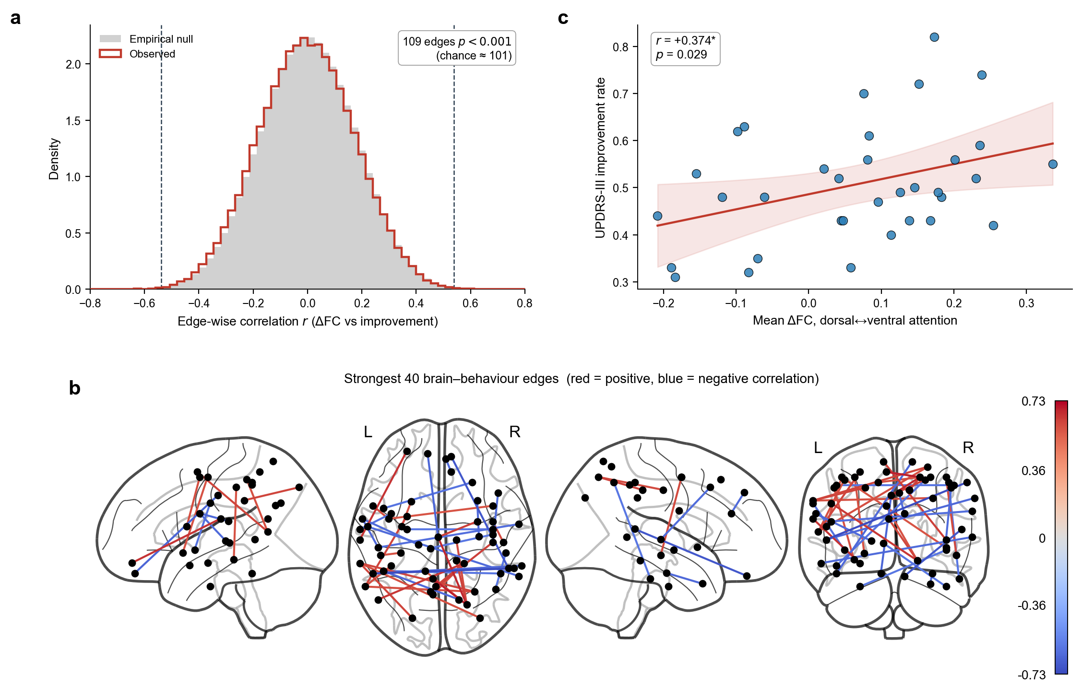

Supplementary Figure S2. Network-level functional connectivity (450-ROI parcellation). Network-aggregated FC (8 systems: 7 Yeo cortical networks + subcortex) for the three contrasts: (a) PD-OFF vs HC (disease state), (b) PD-ON vs HC (treated state), (c) PD-ON vs PD-OFF (direct drug effect). Each contrast shows the lower-triangular t-matrix, a network chord diagram and a top-edge glass brain. Although several cortical pairs reached nominal significance (e.g. DMN–salience t = 3.22 in the treated state), no contrast survived FDR correction, indicating diffuse rather than focal network-level reorganisation. File: 作图/Juspace/Figure3_NetworkFC_combined.pdf.
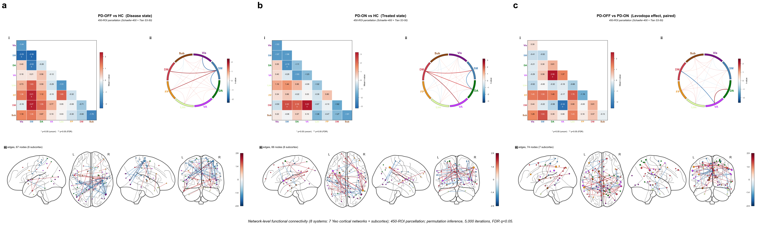

Supplementary Figure S3. Edge-level glass-brain rendering of the levodopa-associated NBS subnetworks. Complete edge-level rendering of the two family-wise-error-significant components from the PD-ON vs HC contrast summarised at the network level in main-text Figure 3 (edge-defining threshold T = 3.0; 5,000 permutations; component-level FWE correction). (a) Increased subnetwork (PD-ON > HC; 387 edges, p_FWE = 0.034) and (b) decreased subnetwork (PD-ON < HC; 355 edges, p_FWE = 0.047), each shown in lateral, anterior, lateral and posterior glass-brain projections. Every node is a region of the 450-ROI parcellation (Schaefer-400 + Tian S3-50) plotted at its centroid and coloured by its Yeo-network/subcortex assignment (legend); lines denote the supra-threshold edges of the component. No component survived correction in the PD-OFF vs HC contrast. File: 作图/Juspace/Figure2_NBS_450.pdf.

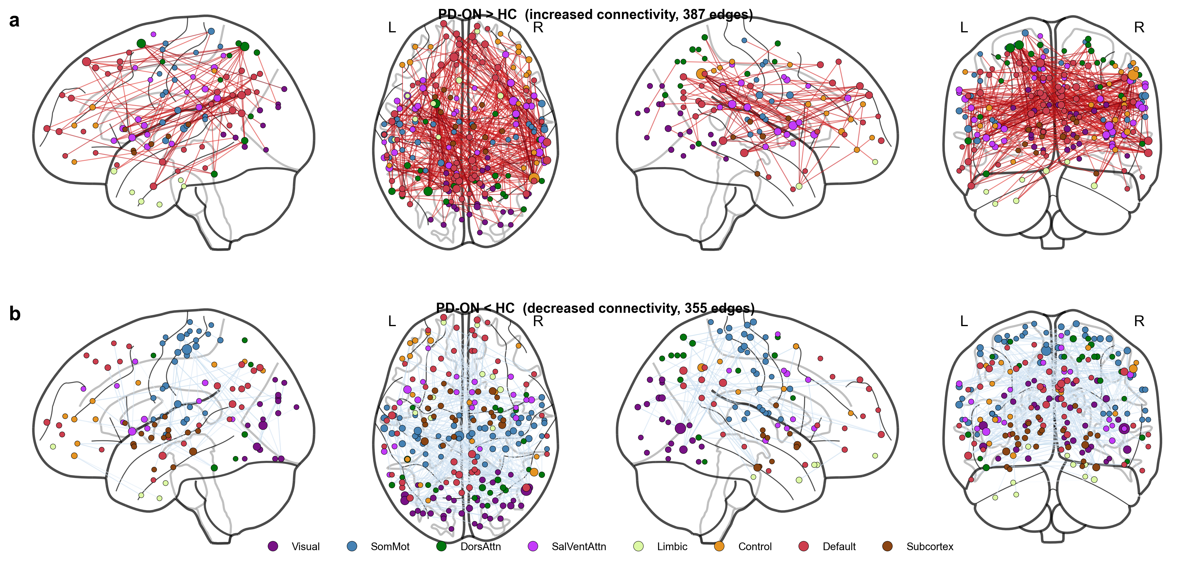

Supplementary Figure S4. Subcortical molecular alignment (Tian S3, 50 ROIs). Subject-level spatial correlations between subcortical ALFF and ten neurotransmitter PET atlases, compared across groups (36 HC, 34 PD-OFF, 34 PD-ON). As in the cortex the unmedicated state is indistinguishable from controls, whereas the treated state diverges along the striatal dopamine-receptor (D1, D2), VMAT2, cholinergic (VAChT) and serotonergic (5-HT2a) axes. File: 作图/Juspace/FigureS_subcortical_combined.pdf.
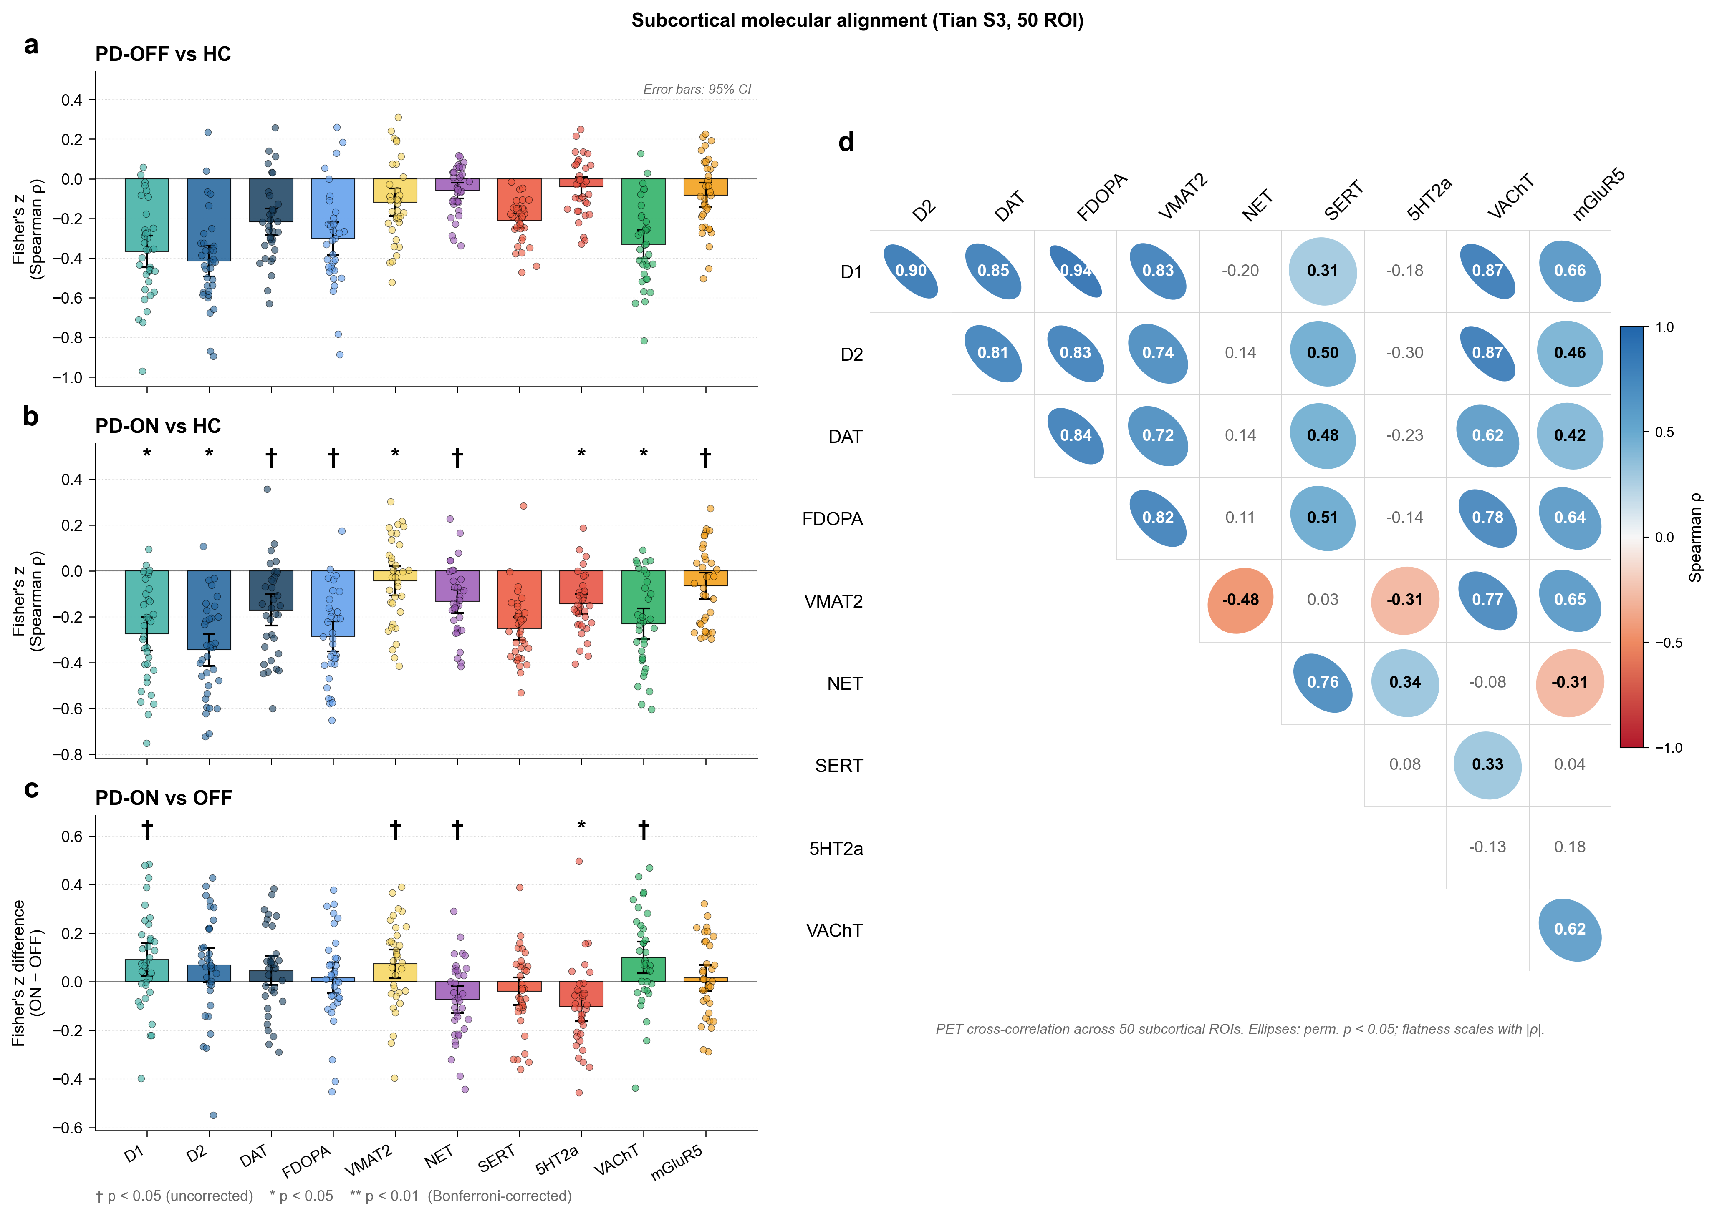

Supplementary Tables
Supplementary Table S1. Network-Based Statistics — complete results.
Contrast | Direction | T | Edges | Nodes | Subcortex nodes | p (FWE) | p (FDR)
PD-ON vs PD-OFF | increased | 2.5 | 1298 | 425 | 47 | 0.099 | 0.026
PD-ON vs PD-OFF | increased | 3.0 | 372 | 267 | 31 | 0.114 | 0.062
PD-ON vs PD-OFF | decreased | 2.5 | 1022 | 393 | 41 | 0.281 | 0.144
PD-ON vs PD-OFF | decreased | 3.0 | 296 | 205 | 17 | 0.238 | 0.177
PD-OFF vs HC | increased | 2.5 | 1006 | 395 | 43 | 0.188 | 0.101
PD-OFF vs HC | increased | 3.0 | 235 | 179 | 22 | 0.204 | 0.185
PD-OFF vs HC | decreased | 2.5 | 936 | 345 | 41 | 0.223 | 0.158
PD-OFF vs HC | decreased | 3.0 | 208 | 117 | 7 | 0.250 | 0.201
PD-ON vs HC | increased | 2.5 | 1309 | 387 | 33 | 0.053 | 0.029
PD-ON vs HC | increased | 3.0 | 387 | 210 | 11 | 0.034 | 0.016
PD-ON vs HC | decreased | 2.5 | 1182 | 400 | 48 | 0.086 | 0.016
PD-ON vs HC | decreased | 3.0 | 355 | 228 | 25 | 0.047 | 0.020
Bold-significant components (main text): PD-ON vs HC increased, T=3.0 (387 edges, p_FWE=0.034); decreased, T=3.0 (355 edges, p_FWE=0.047). 5,000 permutations; sign-flip (paired) / label-shuffle (unpaired). 450-ROI connectome.
Supplementary Table S2. Multimodal CPM prediction across five UPDRS-III domains. The three rightmost columns report leakage-free validation in which the connectivity feature set was re-derived entirely within cross-validation folds: re-computing the PD-ON > HC edge mask within each leave-one-out fold (excluding the held-out patient), and a fully nested whole-connectome model with no network-based pre-selection. The final column gives the Bonferroni-adjusted permutation P across the five domains.
Domain | n | LOO r | perm P | 5-fold mean r | CI low | CI high | % folds + | Nested LOO r (per-fold PD-ON>HC mask) | Nested LOO r (whole connectome) | P (Bonferroni, primary, 5 domains)
Total | 34 | -0.083 | 0.440 | -0.065 | -0.342 | 0.185 | 36 | -0.24 (0.624) | -0.37 (0.756) | 1.000
Tremor | 33 | -0.418 | 0.756 | -0.302 | -0.562 | -0.025 | 2 | -0.42 (0.757) | -0.53 (0.869) | 1.000
Rigidity | 33 | 0.252 | 0.119 | 0.062 | -0.169 | 0.285 | 66 | +0.12 (0.214) | +0.50 (0.015) | 0.595
Bradykinesia | 34 | 0.303 | 0.028 | 0.189 | -0.047 | 0.391 | 96 | +0.30 (0.032) | +0.30 (0.031) | 0.140
Axial | 34 | -0.451 | 0.799 | -0.185 | -0.471 | 0.068 | 7 | -0.52 (0.867) | -0.61 (0.946) | 1.000
Negative-network model; features = ΔFC + ΔALFF + ΔReHo. Leave-one-out with 1,000-permutation testing and 100×5-fold cross-validation. Bradykinesia is the only domain with significant individual predictability (LOO r=+0.303, P=0.028). 450-ROI connectome.

Supplementary Table S3. Cortical subject-level ALFF↔PET alignment, group comparisons.
Contrast | PET map | t | p | p (Bonf) | sig
PD-OFF vs HC | D1 | 0.19 | 0.847 | 1.000
PD-OFF vs HC | D2 | 0.51 | 0.612 | 1.000
PD-OFF vs HC | DAT | -0.28 | 0.781 | 1.000
PD-OFF vs HC | FDOPA | -0.16 | 0.871 | 1.000
PD-OFF vs HC | VMAT2 | -0.15 | 0.879 | 1.000
PD-OFF vs HC | NET | -0.02 | 0.987 | 1.000
PD-OFF vs HC | SERT | -0.50 | 0.620 | 1.000
PD-OFF vs HC | 5HT2a | -0.20 | 0.842 | 1.000
PD-OFF vs HC | VAChT | 0.82 | 0.415 | 1.000
PD-OFF vs HC | mGluR5 | 1.09 | 0.280 | 1.000
PD-ON vs HC | D1 | -1.75 | 0.084 | 0.843
PD-ON vs HC | D2 | -1.01 | 0.317 | 1.000
PD-ON vs HC | DAT | -2.87 | 0.005 | 0.055
PD-ON vs HC | FDOPA | -2.80 | 0.007 | 0.067
PD-ON vs HC | VMAT2 | -3.53 | 0.001 | 0.008 | *
PD-ON vs HC | NET | -1.00 | 0.323 | 1.000
PD-ON vs HC | SERT | -3.03 | 0.003 | 0.035 | *
PD-ON vs HC | 5HT2a | -0.95 | 0.345 | 1.000
PD-ON vs HC | VAChT | -1.85 | 0.069 | 0.686
PD-ON vs HC | mGluR5 | -1.54 | 0.127 | 1.000
PD-ON vs OFF | D1 | -2.35 | 0.025 | 0.252
PD-ON vs OFF | D2 | -1.47 | 0.150 | 1.000
PD-ON vs OFF | DAT | -2.55 | 0.016 | 0.156
PD-ON vs OFF | FDOPA | -2.79 | 0.009 | 0.086
PD-ON vs OFF | VMAT2 | -3.33 | 0.002 | 0.021 | *
PD-ON vs OFF | NET | -1.41 | 0.169 | 1.000
PD-ON vs OFF | SERT | -2.37 | 0.024 | 0.240
PD-ON vs OFF | 5HT2a | -1.22 | 0.233 | 1.000
PD-ON vs OFF | VAChT | -3.05 | 0.004 | 0.045 | *
PD-ON vs OFF | mGluR5 | -3.12 | 0.004 | 0.037 | *
Two-sample (PD vs HC) / paired (PD-ON vs PD-OFF) tests on subject-level Spearman alignment between cortical ALFF (Schaefer-400) and each PET atlas. * survives Bonferroni (10 maps). VMAT2 and SERT survive in PD-ON vs HC.
Supplementary Table S4. Cortical spatial-colocalization (spin permutation).
Brain map | PET | ρ | p (spin) | p (Bonf)
Map A: PD-OFF vs HC (disease) | D1 | -0.184 | 0.025 | 0.248
Map A: PD-OFF vs HC (disease) | D2 | -0.073 | 0.355 | 1.000
Map A: PD-OFF vs HC (disease) | DAT | -0.129 | 0.121 | 1.000
Map A: PD-OFF vs HC (disease) | FDOPA | -0.135 | 0.072 | 0.718
Map A: PD-OFF vs HC (disease) | VMAT2 | -0.178 | 0.016 | 0.156
Map A: PD-OFF vs HC (disease) | NET | 0.228 | 0.004 | 0.038
Map A: PD-OFF vs HC (disease) | SERT | -0.016 | 0.875 | 1.000
Map A: PD-OFF vs HC (disease) | 5HT2a | -0.147 | 0.090 | 0.898
Map A: PD-OFF vs HC (disease) | VAChT | 0.065 | 0.463 | 1.000
Map A: PD-OFF vs HC (disease) | mGluR5 | -0.164 | 0.056 | 0.564
Map B: levodopa effect (OFF-ON |Δ|) | D1 | -0.200 | 0.074 | 0.742
Map B: levodopa effect (OFF-ON |Δ|) | D2 | 0.240 | 0.019 | 0.190
Map B: levodopa effect (OFF-ON |Δ|) | DAT | -0.257 | 0.020 | 0.204
Map B: levodopa effect (OFF-ON |Δ|) | FDOPA | -0.260 | 0.004 | 0.038
Map B: levodopa effect (OFF-ON |Δ|) | VMAT2 | -0.265 | 0.007 | 0.074
Map B: levodopa effect (OFF-ON |Δ|) | NET | -0.177 | 0.077 | 0.770
Map B: levodopa effect (OFF-ON |Δ|) | SERT | -0.382 | 0.002 | 0.020
Map B: levodopa effect (OFF-ON |Δ|) | 5HT2a | -0.133 | 0.299 | 1.000
Map B: levodopa effect (OFF-ON |Δ|) | VAChT | -0.222 | 0.044 | 0.438
Map B: levodopa effect (OFF-ON |Δ|) | mGluR5 | -0.081 | 0.413 | 1.000
Spatial correlation between group-level cortical maps and PET atlases, with significance from 5,000 spin permutations (Alexander-Bloch 2018). Map B (levodopa effect) co-localises with SERT (p_Bonf=0.020) and F-DOPA (p_Bonf=0.038). Bonferroni across 10 maps per brain map.

Supplementary Table S5. Subcortical (Tian S3) ALFF↔PET alignment, group comparisons.
Contrast | PET | t | p | p (Bonf) | sig
PD-OFF vs HC | D1 | 1.03 | 0.308 | 1.000
PD-ON vs HC | D1 | 2.99 | 0.004 | 0.039 | *
PD-ON vs OFF | D1 | 2.66 | 0.012 | 0.120 | (unc)
PD-OFF vs HC | D2 | 1.62 | 0.110 | 1.000
PD-ON vs HC | D2 | 3.09 | 0.003 | 0.029 | *
PD-ON vs OFF | D2 | 1.92 | 0.064 | 0.638
PD-OFF vs HC | DAT | 1.68 | 0.098 | 0.984
PD-ON vs HC | DAT | 2.67 | 0.010 | 0.096 | (unc)
PD-ON vs OFF | DAT | 1.52 | 0.139 | 1.000
PD-OFF vs HC | FDOPA | 1.59 | 0.116 | 1.000
PD-ON vs HC | FDOPA | 2.17 | 0.034 | 0.336 | (unc)
PD-ON vs OFF | FDOPA | 0.49 | 0.628 | 1.000
PD-OFF vs HC | VMAT2 | 1.32 | 0.192 | 1.000
PD-ON vs HC | VMAT2 | 3.04 | 0.003 | 0.033 | *
PD-ON vs OFF | VMAT2 | 2.40 | 0.022 | 0.222 | (unc)
PD-OFF vs HC | NET | -0.34 | 0.739 | 1.000
PD-ON vs HC | NET | -2.34 | 0.022 | 0.223 | (unc)
PD-ON vs OFF | NET | -2.63 | 0.013 | 0.129 | (unc)
PD-OFF vs HC | SERT | 1.44 | 0.154 | 1.000
PD-ON vs HC | SERT | 0.07 | 0.943 | 1.000
PD-ON vs OFF | SERT | -1.39 | 0.175 | 1.000
PD-OFF vs HC | 5HT2a | -0.04 | 0.967 | 1.000
PD-ON vs HC | 5HT2a | -3.19 | 0.002 | 0.021 | *
PD-ON vs OFF | 5HT2a | -3.43 | 0.002 | 0.016 | *
PD-OFF vs HC | VAChT | 0.74 | 0.460 | 1.000
PD-ON vs HC | VAChT | 2.97 | 0.004 | 0.041 | *
PD-ON vs OFF | VAChT | 2.98 | 0.005 | 0.054 | (unc)
PD-OFF vs HC | mGluR5 | 1.95 | 0.056 | 0.559
PD-ON vs HC | mGluR5 | 2.37 | 0.021 | 0.207 | (unc)
PD-ON vs OFF | mGluR5 | 0.56 | 0.577 | 1.000
Subject-level alignment between subcortical ALFF (Tian S3, 50 ROIs) and PET atlases; 70 scans mapped uniformly from 91k ALFF. * survives Bonferroni. D2, D1, VMAT2, VAChT, 5-HT2a survive in PD-ON vs HC; 5-HT2a in PD-ON vs PD-OFF. D2/DAT/FDOPA cover 36/50 ROIs (limited atlas coverage).

Supplementary Table S6. Robustness of the primary findings to a stricter head-motion threshold.
Analysis | Main analysis  (mean FD < 0.5) | Sensitivity analysis  (mean FD < 0.3)
NBS, PD-ON > HC increased subnetwork (T = 3.0) | 387 edges, p_FWE = 0.034 | 429 edges, p_FWE = 0.028
NBS, PD-ON < HC decreased subnetwork (T = 3.0) | 355 edges, p_FWE = 0.047 | 419 edges, p_FWE = 0.031
NBS, PD-OFF vs HC (T = 3.0) | n.s. (p_FWE = 0.13) | n.s. (p_FWE = 0.13)
CPM bradykinesia (LOO r; perm p) | r = 0.30; p = 0.028 | r = 0.31; p = 0.097
CPM rigidity (LOO r; perm p) | r = 0.25; p = 0.119 | r = 0.14; p = 0.235
CPM total (LOO r; perm p) | r = -0.08; p = 0.440 | r = 0.04; p = 0.294
CPM tremor (LOO r; perm p) | r = -0.42; p = 0.756 | r = -0.08; p = 0.420
CPM axial (LOO r; perm p) | r = -0.45; p = 0.799 | r = -0.15; p = 0.501
Main analysis: 34 paired PD scans (OFF/ON) + 36 HC. Sensitivity analysis: scans with mean FD > 0.3 mm additionally excluded, yielding 28 paired PD scans + 30 HC. The treated-state NBS subnetworks (PD-ON vs HC) survive family-wise error correction under the stricter threshold, and the CPM bradykinesia effect size is preserved (LOO r = 0.31 vs 0.30); the permutation p-value falls to a trend level, consistent with the ~18% reduction in sample size rather than a motion-driven artefact. n.s., not significant.

