Supplementary Figures

Deep Learning and Feature Selection Reveal Compact Gene Panels Characterizing Drought and Heat Stress Responses in Rice

Masoud Shahsavari ^{a,} *

ª Department of Agronomy and Plant Breeding, College of Agriculture and Natural Resources, University of Tehran, Karaj, Iran.

* Corresponding author: Mobile: +989352326448. E-mail addresses: mshahsavari@ut.ac.ir; masoudsisa@gmail.com

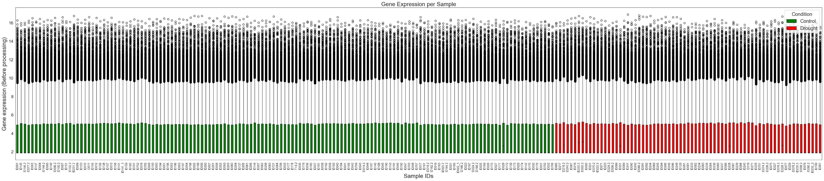
Fig. S1 Boxplots of RNA‑seq samples (control and drought‑stressed) prior to preprocessing

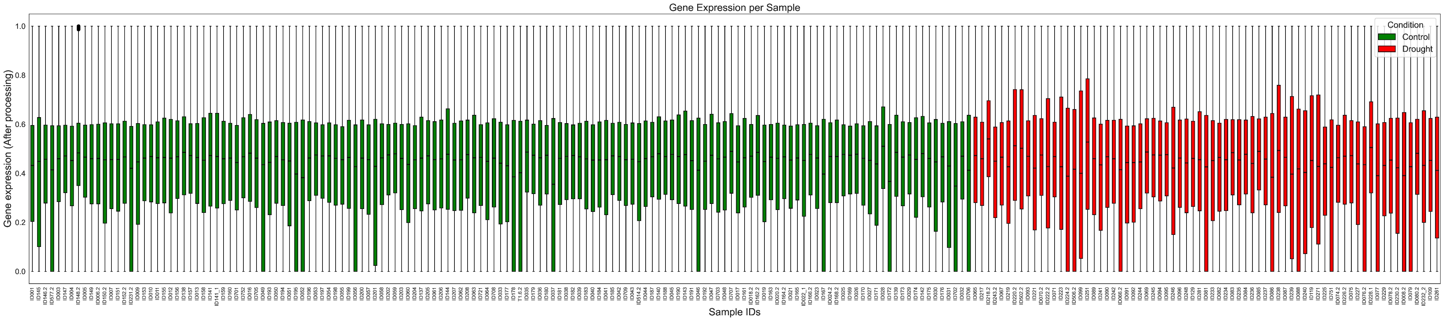
Fig. S2 Boxplots of RNA‑seq samples (control and drought‑stressed) after preprocessing

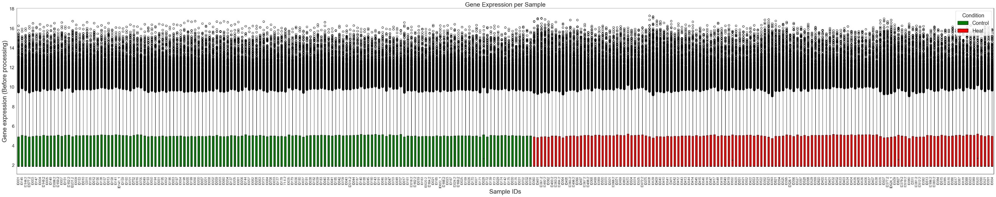

Fig. S3 Boxplots of RNA‑seq samples (control and heat‑stressed) prior to preprocessing

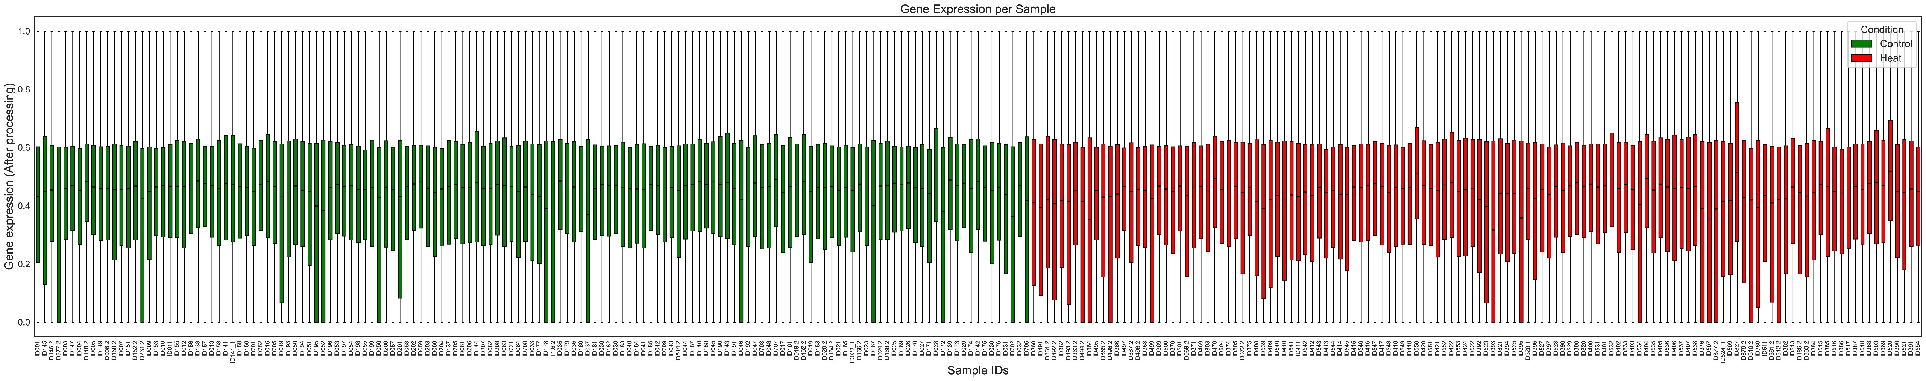

Fig. S4 Boxplots of RNA‑seq samples (control and heat‑stressed) after preprocessing

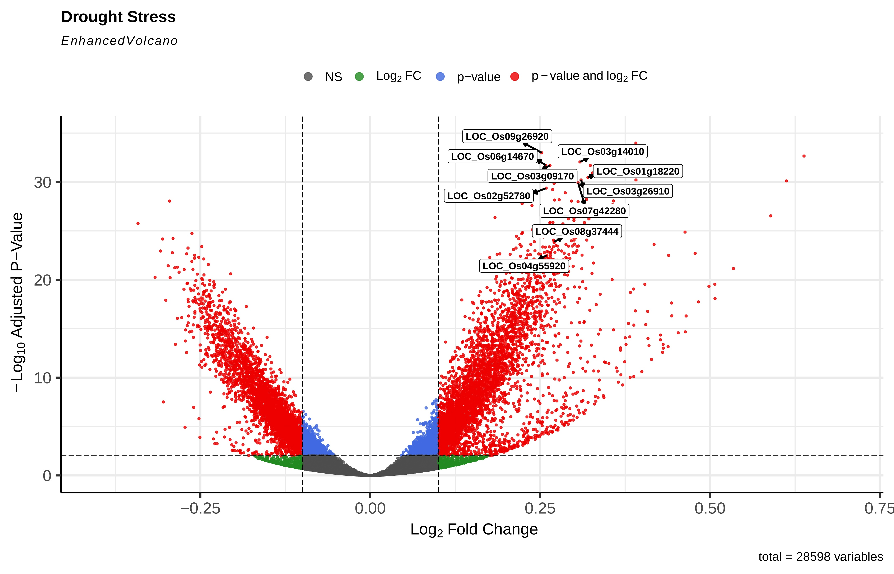

Fig. S5 Distribution of MImRMR-selected genes according to log₂ fold change and adjusted p-value in the drought vs. control differential expression analysis. Points are colored as follows: red, DEGs; blue, genes passing only the adjusted p-value < 10e⁻³ threshold; green, genes passing only the |log₂FC| > 0.1 threshold; and grey, genes meeting neither criterion.

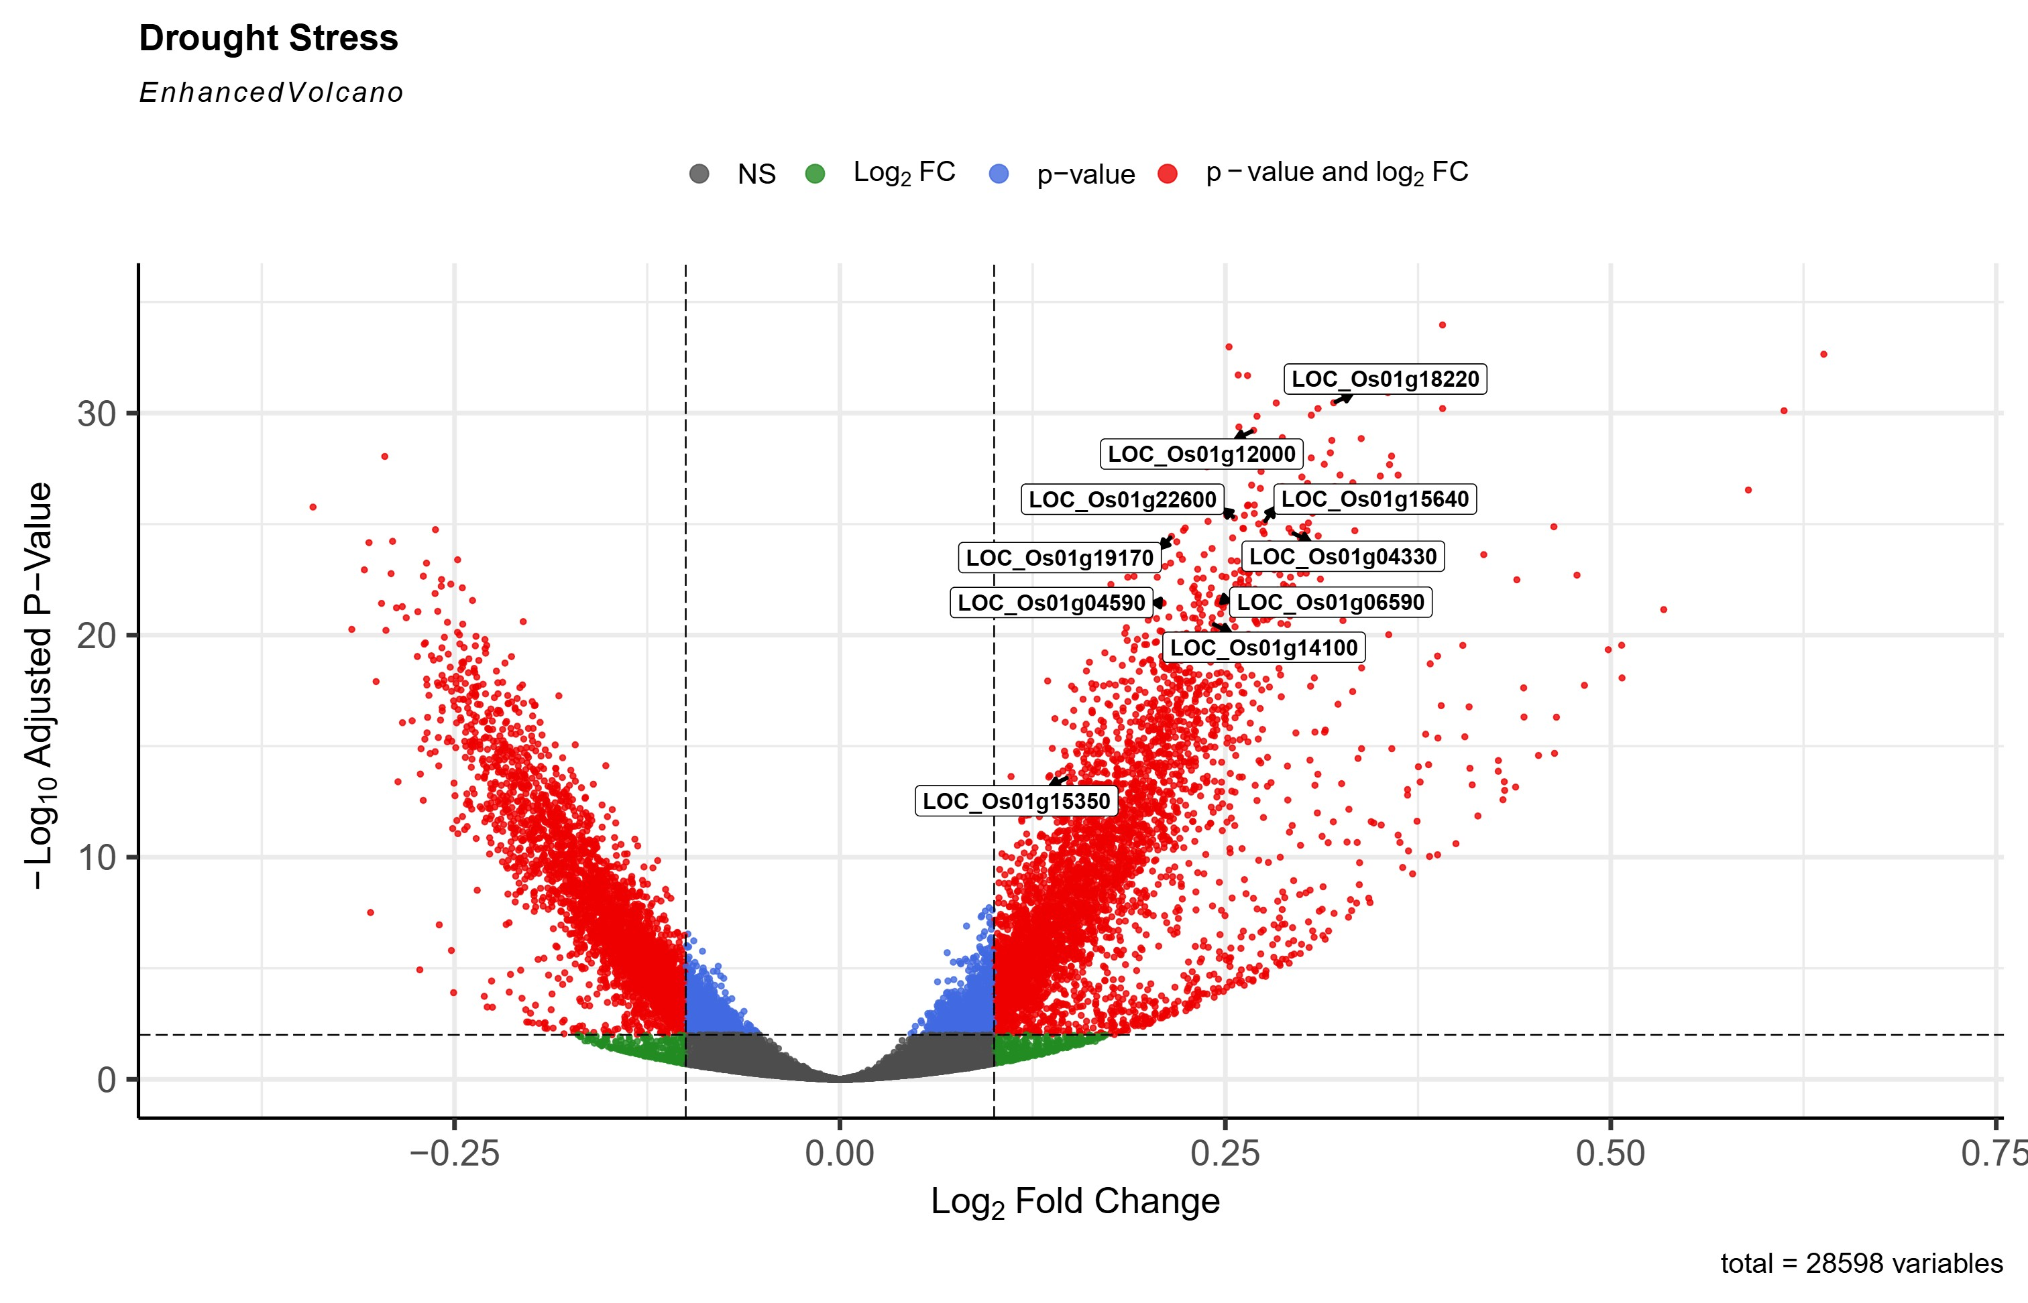
Fig. S6 Distribution of Boruta-selected genes according to log₂ fold change and adjusted p-value in the drought vs. control differential expression analysis. Points are colored as follows: red, DEGs; blue, genes passing only the adjusted p-value < 10e⁻³ threshold; green, genes passing only the |log₂FC| > 0.1 threshold; and grey, genes meeting neither criterion.

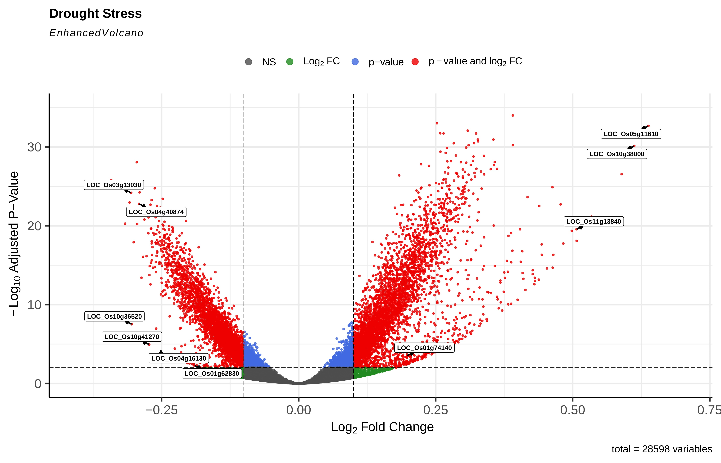

Fig. S7 Distribution of SS-selected genes according to log₂ fold change and adjusted p-value in the drought vs. control differential expression analysis. Points are colored as follows: red, DEGs; blue, genes passing only the adjusted p-value < 10e⁻³ threshold; green, genes passing only the |log₂FC| > 0.1 threshold; and grey, genes meeting neither criterion.

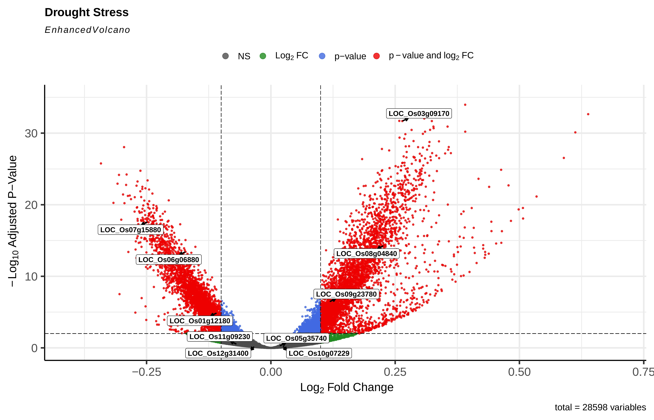

Fig. S8 Distribution of EGBFS-selected genes according to log₂ fold change and adjusted p-value in the drought vs. control differential expression analysis. Points are colored as follows: red, DEGs; blue, genes passing only the adjusted p-value < 10e⁻³ threshold; green, genes passing only the |log₂FC| > 0.1 threshold; and grey, genes meeting neither criterion.

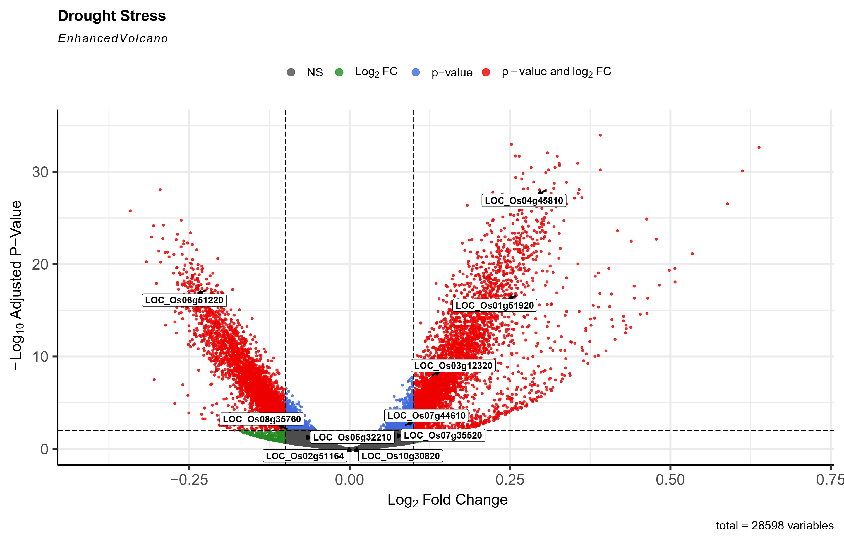
Fig. S9 Distribution of GA-selected genes according to log₂ fold change and adjusted p-value in the drought vs. control differential expression analysis. Points are colored as follows: red, DEGs; blue, genes passing only the adjusted p-value < 10e⁻³ threshold; green, genes passing only the |log₂FC| > 0.1 threshold; and grey, genes meeting neither criterion.

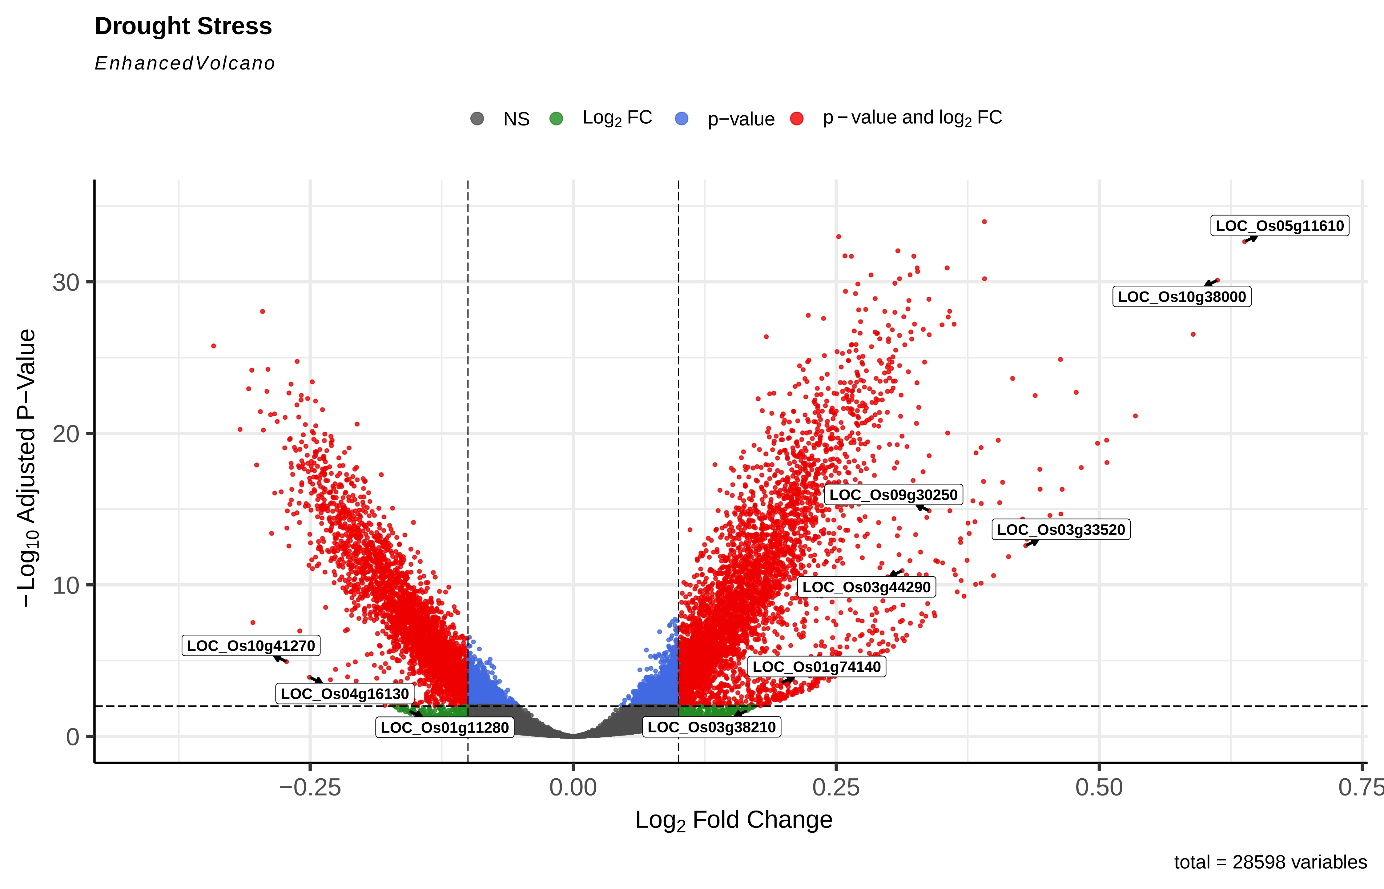

Fig. S10 Distribution of RFECV-selected genes according to log₂ fold change and adjusted p-value in the drought vs. control differential expression analysis. Points are colored as follows: red, DEGs; blue, genes passing only the adjusted p-value < 10e⁻³ threshold; green, genes passing only the |log₂FC| > 0.1 threshold; and grey, genes meeting neither criterion.

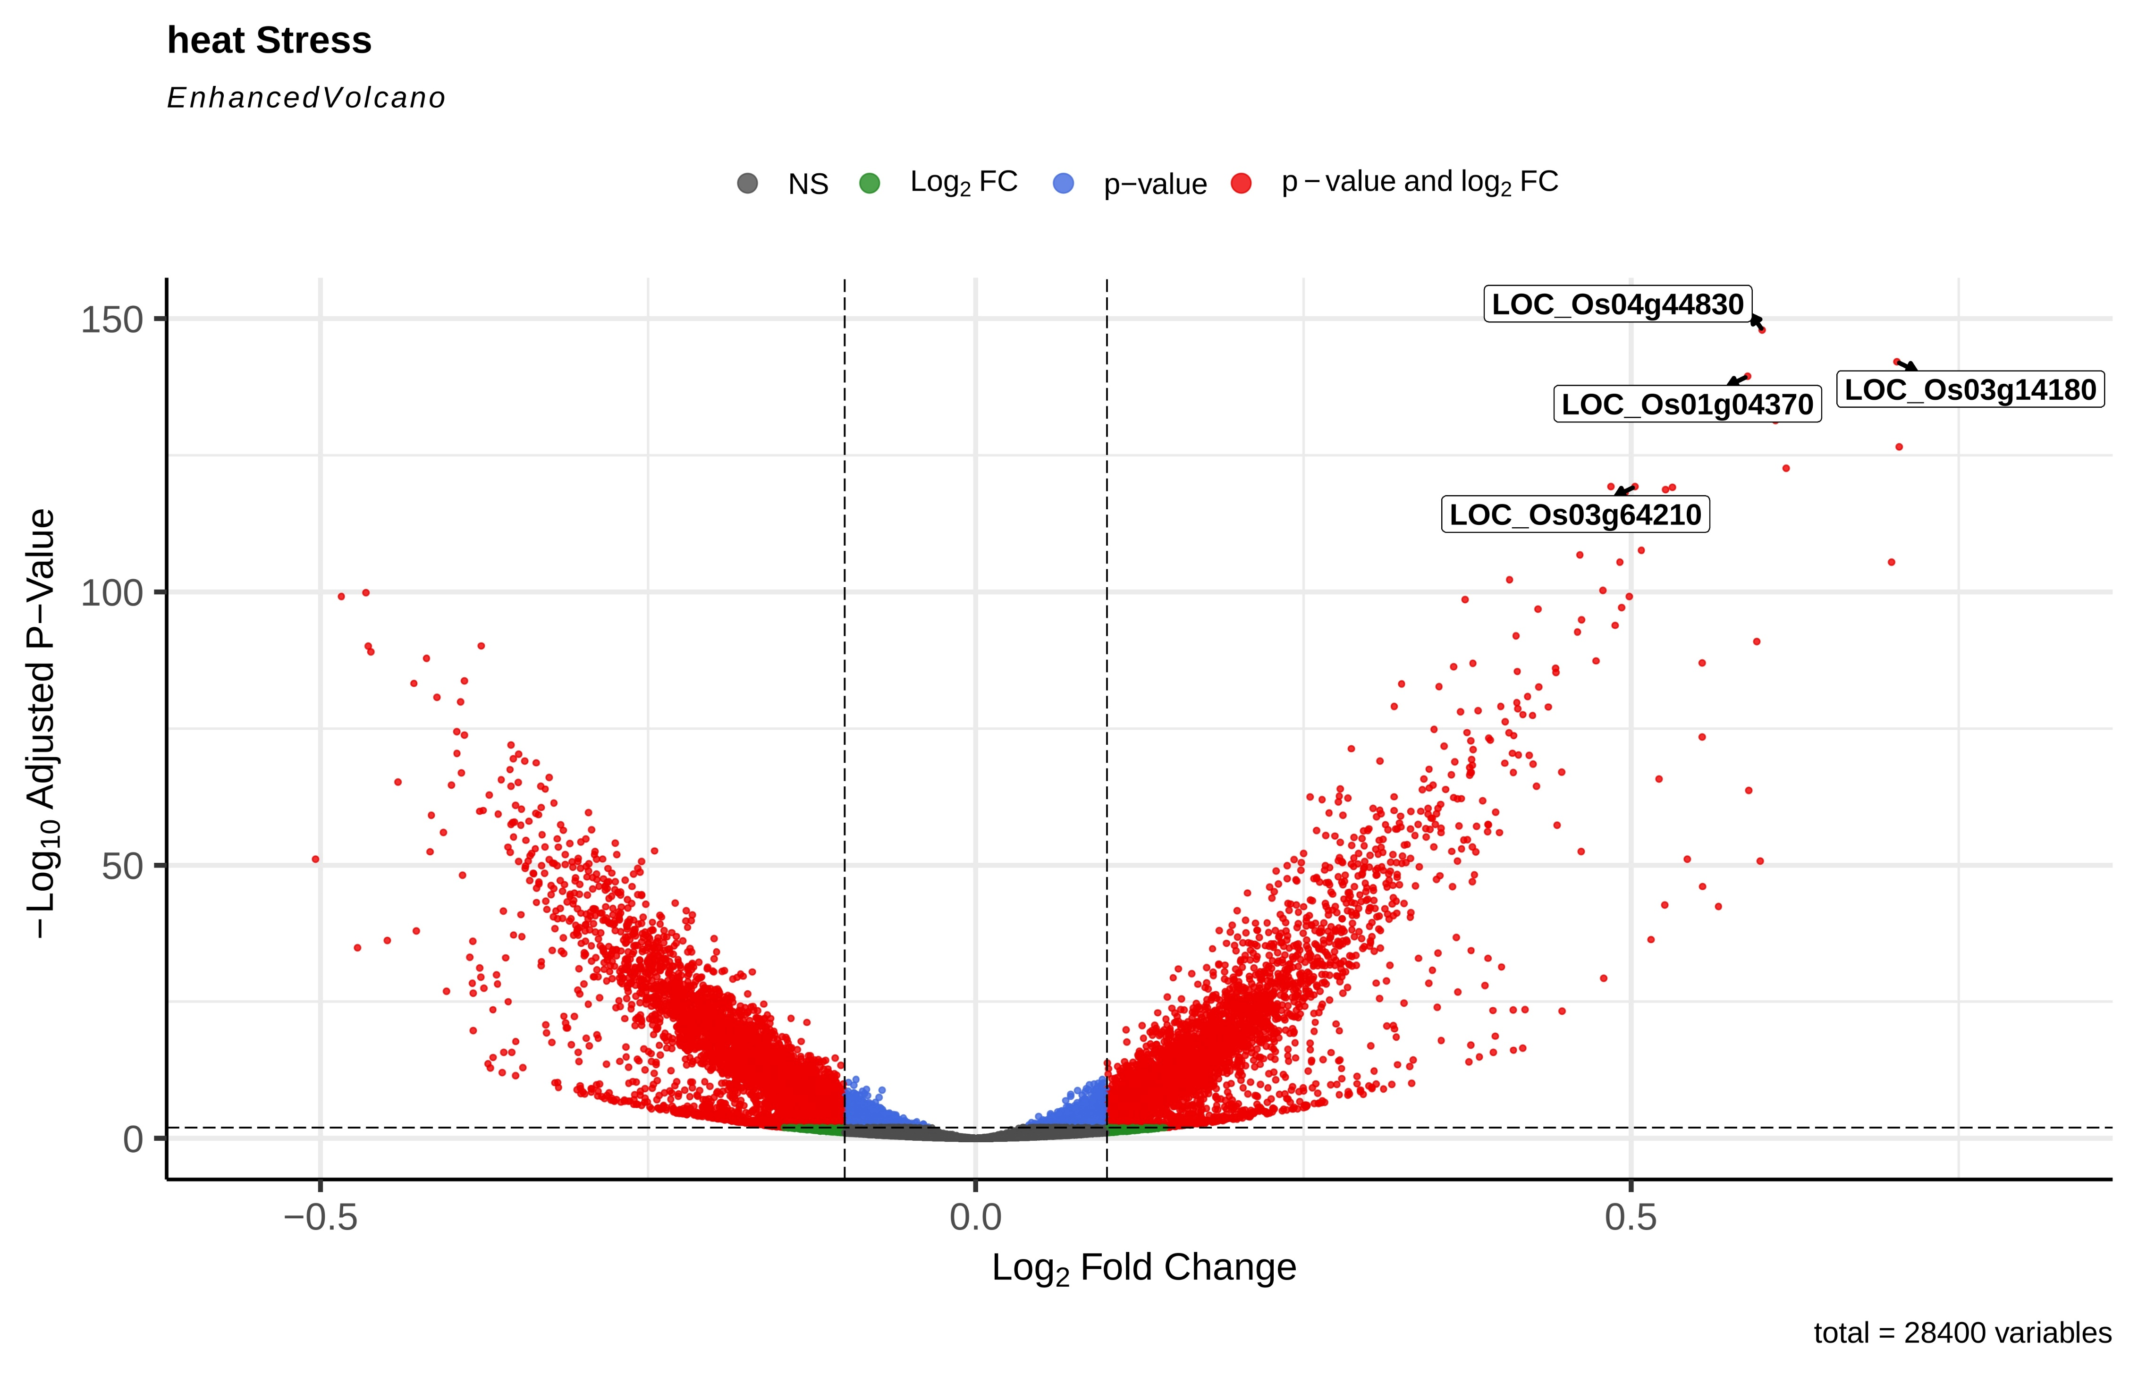

Fig. S11 Distribution of MImRMR-selected genes according to log₂ fold change and adjusted p-value in the heat vs. control differential expression analysis. Points are colored as follows: red, DEGs; blue, genes passing only the adjusted p-value < 10e⁻³ threshold; green, genes passing only the |log₂FC| > 0.1 threshold; and grey, genes meeting neither criterion.

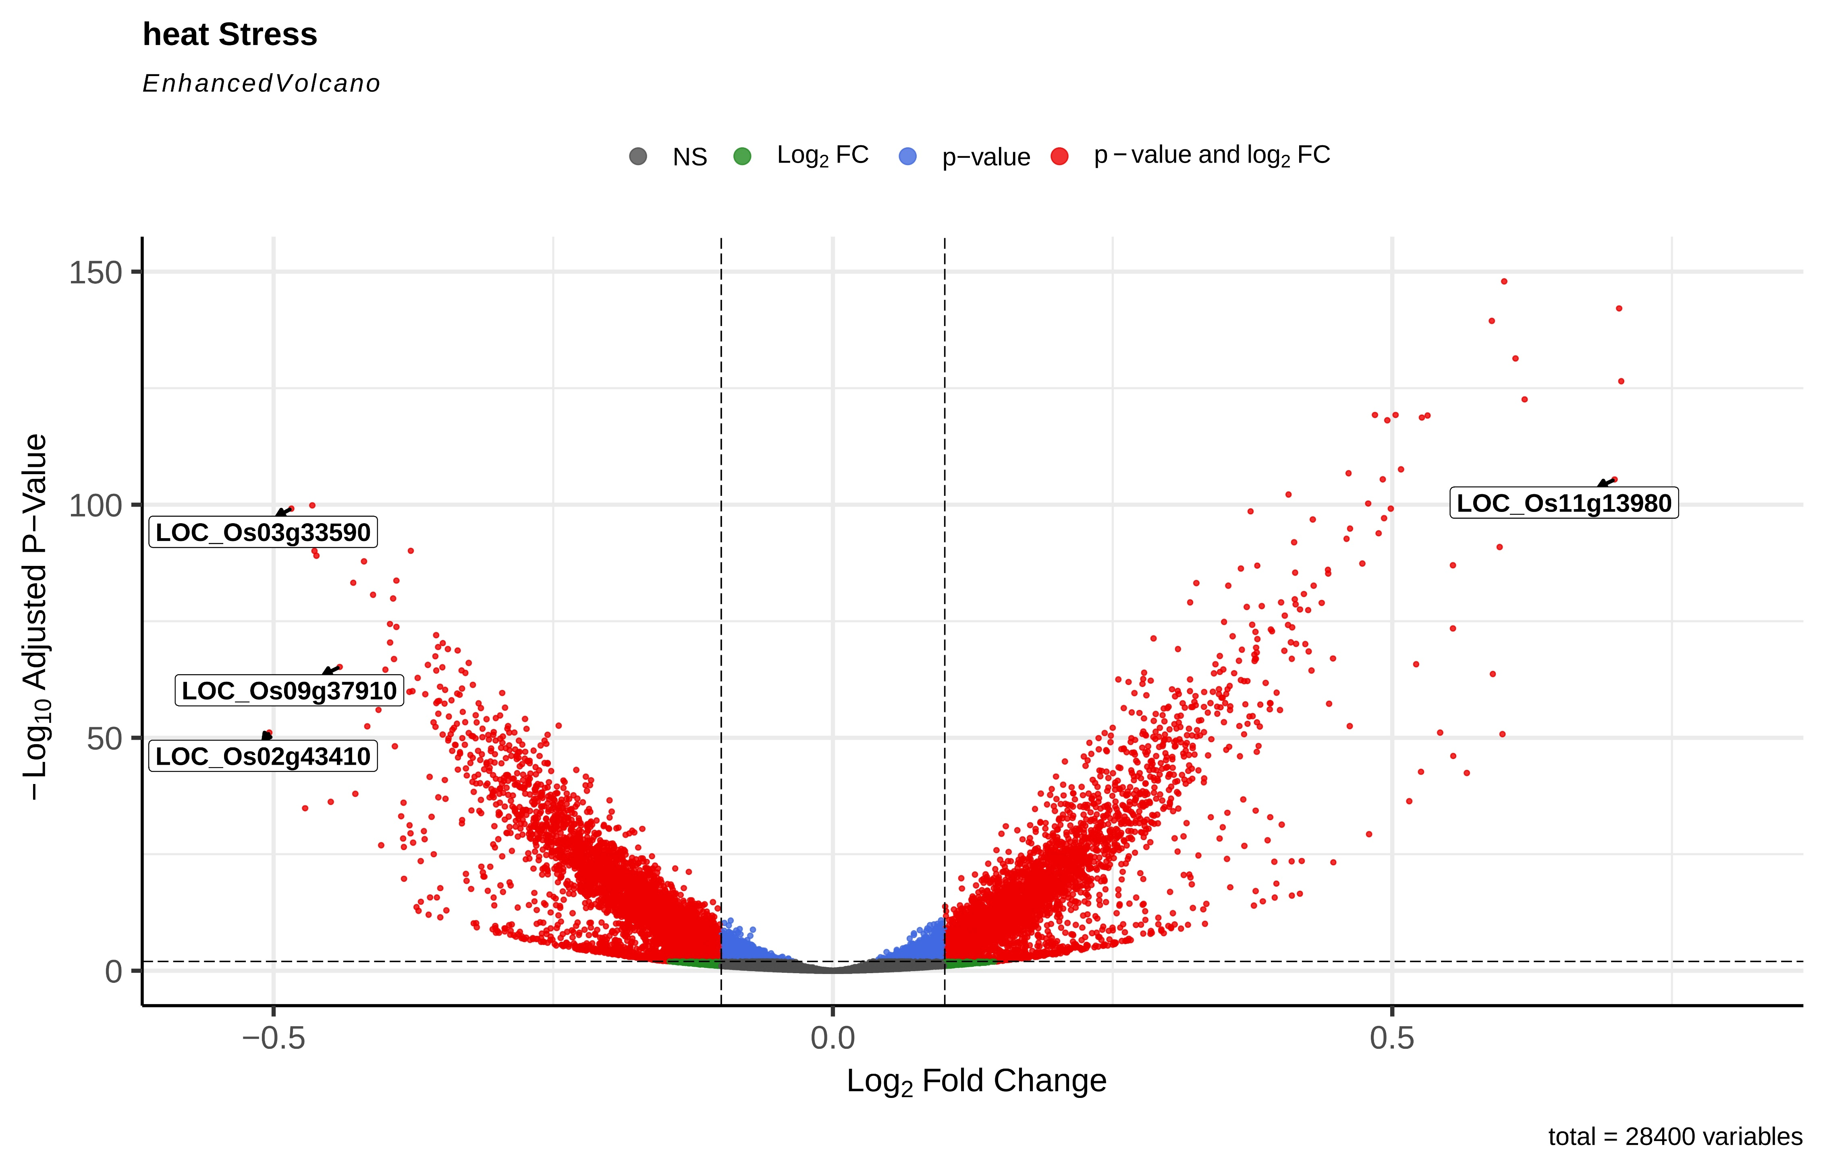

Fig. S12 Distribution of SS-selected genes according to log₂ fold change and adjusted p-value in the heat vs. control differential expression analysis. Points are colored as follows: red, DEGs; blue, genes passing only the adjusted p-value < 10e⁻³ threshold; green, genes passing only the |log₂FC| > 0.1 threshold; and grey, genes meeting neither criterion.

