Supplementary data

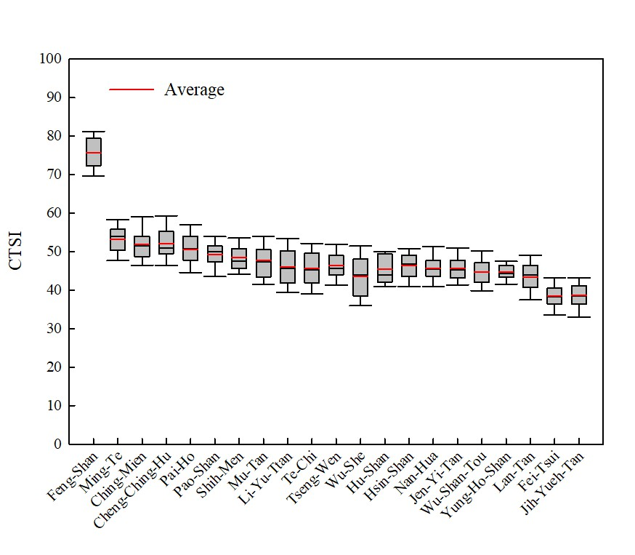
Fig. S1 CTSI values of 21 drinking water reservoirs in Taiwan from 2008-2019

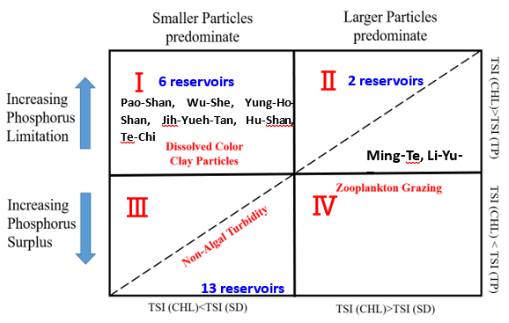
Fig. S2 The interpretation of trophic state index deviations on 21 reservoirs in Taiwan.

