Title: Are AI knowledge and educational expectations homogeneous across clinical training stages and intended specialties?
Authors: Vincent Garrouste, MD ; Frédéric Paris, MD ;

SUPPLEMENTARY DIGITAL CONTENT

Supplementary Table S1. AI knowledge, attitudes, and educational expectations according to interest in image-/data-intensive specialties | 2 - 3
Supplementary Figure S1. Exploratory specialty-specific adjusted differences in selected AI attitudes. | 4 - 5

Supplementary Table S1. AI knowledge, attitudes, and educational expectations according to interest in image-/data-intensive specialties
Variable | Other specialties (n=854) | Image-/data-intensive specialties (n=488) | P value | Effect size
AI definition category |  |  | .89 | Cramer’s V=0.022
Unknown | 42 (4.9%) | 24 (4.9%)
Incorrect | 488 (57.1%) | 280 (57.4%)
Partially correct | 279 (32.7%) | 163 (33.4%)
Correct | 45 (5.3%) | 21 (4.3%)
Adequate AI knowledge | 324 (37.9%) | 184 (37.7%) | .93 | Cramer’s V=0.002
AI attitude scores, median [IQR]
Support for AI development | 7 [5–8] | 7 [6–8] | .09 | ε ²=0.001
AI will impact my career | 8 [7–9] | 8 [7–10] | .03 | ε ²=0.003
Students should learn AI basics | 7 [5–8] | 7 [6–9] | <.001 | ε ²=0.015
Understanding ethical implications | 8 [6–10] | 8 [6–10] | .49 | ε ²=0.000
Optimism toward AI | 6 [5–7] | 6 [5–8] | .001 | ε ²=0.005
Concern about AI’s role | 7 [4.25–8] | 7 [5–8] | .05 | ε ²=0.002
AI requires careful management | 10 [9–10] | 10 [9–10] | .76 | ε ²=0.000
Preferred place for AI learning |  |  | .07 | Cramer’s V=0.063
In curriculum | 359 (42.0%) | 227 (46.5%)
Outside curriculum | 434 (50.8%) | 217 (44.5%)
Other / free text | 61 (7.1%) | 44 (9.0%)
Educational objectives
Identify ways AI can improve healthcare quality | 607 (71.1%) | 342 (70.1%) | .70 | Cramer’s V=0.011
Identify when AI is appropriate in clinical context | 594 (69.6%) | 322 (66.0%) | .18 | Cramer’s V=0.037
Identify ethical implications | 590 (69.1%) | 308 (63.1%) | .03 | Cramer’s V=0.061
Understand and interpret AI-generated outputs | 481 (56.3%) | 270 (55.3%) | .72 | Cramer’s V=0.010
Understand underlying technological processes | 104 (12.2%) | 85 (17.4%) | .01 | Cramer’s V=0.072
Learn terminology to communicate with engineers/developers | 86 (10.1%) | 73 (15.0%) | .01 | Cramer’s V=0.073
Communicate how the technology works | 84 (9.8%) | 60 (12.3%) | .16 | Cramer’s V=0.038
Preferred teaching formats
1- or 2-hour workshop | 444 (52.0%) | 245 (50.2%) | .53 | Cramer’s V=0.017
Series of workshops | 402 (47.1%) | 246 (50.4%) | .24 | Cramer’s V=0.032
One-day course | 141 (16.5%) | 78 (16.0%) | .80 | Cramer’s V=0.007
Master/PhD-level training | 103 (12.1%) | 86 (17.6%) | .01 | Cramer’s V=0.077
Legend: AI, artificial intelligence; IQR, interquartile range.
Values are presented as n (%) or median [IQR]. Image-/data-intensive specialties included radiology, dermatology, ophthalmology, pathology, nuclear medicine, cardiology, genetics, and public health. Adequate AI knowledge was defined as a partially correct or correct AI definition. P values were derived from chi-square or Fisher’s exact tests for categorical variables and Kruskal-Wallis tests for score variables. Effect sizes are reported as Cramer’s V for categorical variables and epsilon² for Kruskal-Wallis tests. For educational objectives and teaching formats, multiple responses were allowed; therefore, percentages may exceed 100%.

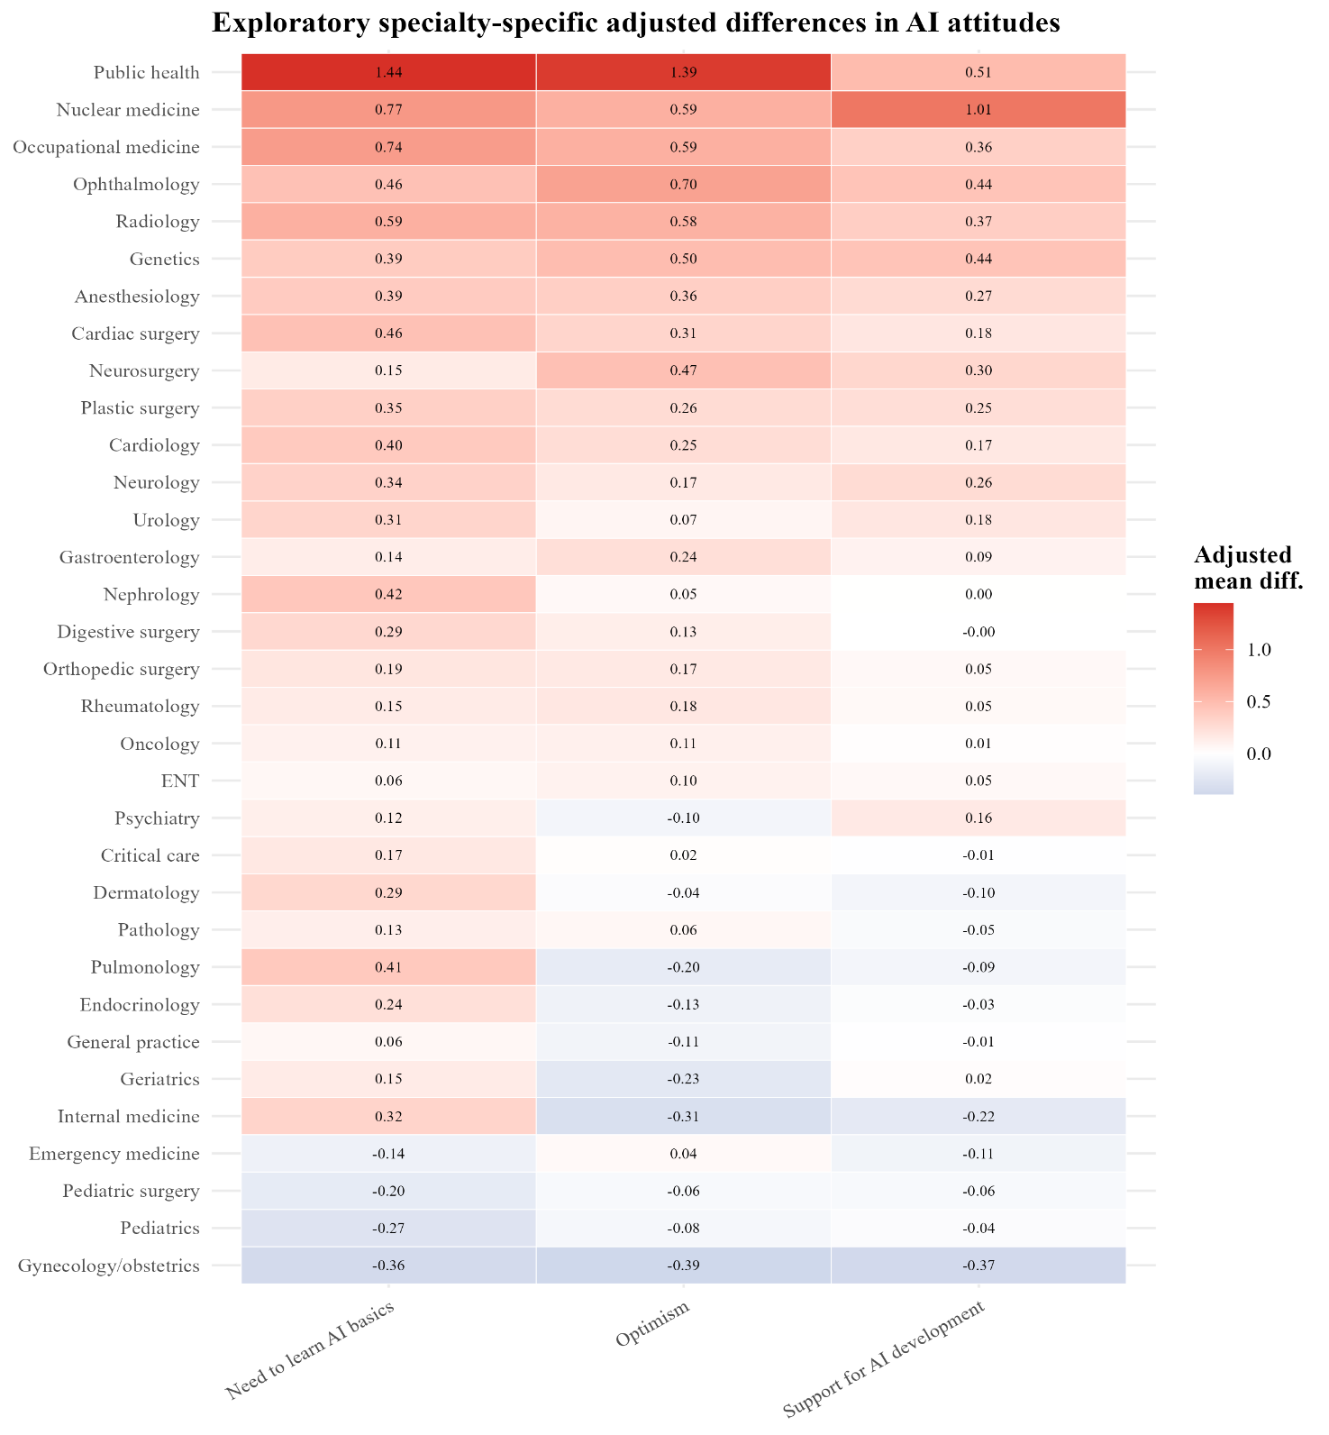
Supplementary Figure S1. Exploratory specialty-specific adjusted differences in selected AI attitudes.
Caption: Heatmap showing exploratory adjusted mean differences in selected 0-to-10 AI attitude scores according to individual intended specialties. Each estimate compares students reporting interest in a given specialty with those not reporting interest in that specialty. Models were adjusted for year of study, age, and class ranking. Positive values indicate higher scores among students interested in the corresponding specialty. These analyses were exploratory because students could select multiple intended specialties and because multiple comparisons were performed.

