Supplementary Materials for
“Disorder-Driven Topological Localization Transitions
in Floquet Non-Hermitian Systems”

Huahui Qiu^{1,2}, Shuaishuai Tong¹, Xiling Feng¹, Kun Zhang¹, Qicheng Zhang¹, and Chunyin Qiu^{1*}

¹Key Laboratory of Artificial Micro- and Nano-Structures of Ministry of Education
and School of Physics and Technology, Wuhan University, Wuhan 430072, China
²School of Physics and Materials Science, Nanchang University, Nanchang 330031, China

*To whom correspondence should be addressed: cyqiu@whu.edu.cn

Note 1. Quasienergy Spectra and Topological Invariants in Floquet Non-Hermitian Systems.
In momentum-space, the system is described by a periodically driven two-band Hamiltonian:
$$\begin{aligned}H\left(t\right)=\left(\begin{matrix}0 & μ_{0}+μ_{1}e^{-ik} \\ μ_{0}+\left[μ_{1}+κ\left(t\right)\right]e^{ik} & 0\end{matrix}\right),\#\left(S1\right)\end{aligned}$$
where $k$ is the Bloch wave vector, and $μ_{0}$ and $μ_{1}$ are static, reciprocal intra- and inter-cell couplings, respectively. The unidirectional inter-cell coupling $κ(t)$ characterizes the time-periodic drive that switches between $0$ and $κ_{1}$ with period $T$ at a $50\%$ duty cycle. Consequently, the system is governed by the static Hamiltonian $H_{1}=H\left(t=0\right)$ for the first half period and by $H_{2}=H\left(t=\frac{T}{2}\right)$ for the second half period. According to Floquet theory, the time-evolution operator over one period defines the Floquet operator $U_{T}=e^{-\frac{iH_{2}T}{2}}e^{-\frac{iH_{1}T}{2}}$. The system’s quasienergy spectra and Floquet eigenstates are obtained by diagonalizing the effective Floquet Hamiltonian1,2,
$$\begin{aligned}H_{eff}=\frac{i}{T}\ln{U_{T}},\#\left(S2\right)\end{aligned}$$
where $ln$ denotes the matrix logarithm and the quasienergies $ε$ of $H_{eff}$ satisfy $U_{T}|ψ⟩=e^{-iεT}|ψ⟩$.
To investigate the disordered system, the real-space Hamiltonian for a finite 1D chain should be considered:
$$\begin{aligned}H^{R}=\sum_{j=1}^{L}{(μ_{0}c_{j,1}^{†}c_{j,2}}+H.c.)+\sum_{j=1}^{L-1}{(μ_{1}c_{j,2}^{†}c_{j+1,1}}+H.c.)+\sum_{j=1}^{L-1}{κ\left(t\right)c_{j,2}^{†}c_{j+1,1}}+H_{B},\#\left(S3\right)\end{aligned}$$
where $c_{j,α}^{†}$ and $c_{j,α}$ are the creation and annihilation operators for sublattice $α=1,2$. The boundary term $H_{B}$ depends on the boundary conditions: under open boundary conditions (OBC), $H_{B}=0$, while under periodic boundary conditions (PBC),
$$\begin{aligned}H_{B}=\left(μ_{1}c_{L,2}^{†}c_{1,1}+H.c.\right)+κ\left(t\right)c_{L,2}^{†}c_{1,1}.\#\left(S4\right)\end{aligned}$$
To study disorder effects, we introduce site-dependent random coupling strengths. Specifically, the parameters for each unit cell $j$ are modified as:
$$\begin{aligned}μ_{0}^{j}=μ_{0}+D_{0}ξ_{0}^{j}, κ_{1}^{j}=κ_{1}-D_{1}ξ_{1}^{j},\#\left(S5\right)\end{aligned}$$
where $ξ_{0}^{j}$, $ξ_{1}^{j}∈\left[0,1\right]$ are independent, uniformly distributed random variables, and $D_{0}$ and $D_{1}$ are the corresponding disorder strengths. In our work, we typically set $D_{0}=D_{1}=d$ to maximize the band gap width, which facilitates the study of topological edge states and localization phenomena in the presence of disorder.

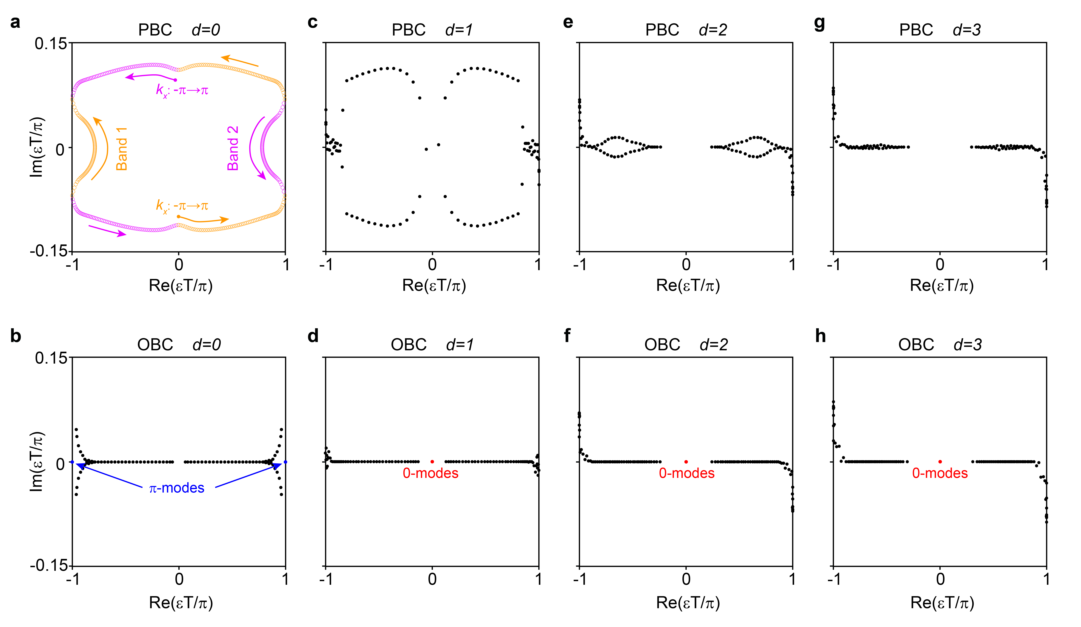
Fig. S1. Evolution of quasienergy spectra with disorder. Quasienergy spectra under PBC (upper panels) and OBC (lower panels) for a system of length $L=50$ at increasing disorder strength $d$. In the clean limit ($d=0$), the PBC spectrum (a) forms a loop in the complex quasienergy plane, while the OBC spectrum (b) is constrained within this loop, signaling the presence of a leftward NHSE. As d increases from a, b to g, h, the PBC spectrum progressively collapses onto the OBC bulk spectrum, signifying the suppression and eventual disappearance of the NHSE. Concurrently, the OBC spectra unveil a disorder-driven dual-gap topological phase transition, characterized by the disappearance of $π$-modes and the concomitant emergence of $0$-modes.

Figure S1 presents the evolution of the quasienergy spectra with increasing disorder strength $d$. In the clean limit ($d=0$), a marked distinction exists between the PBC and OBC spectra (Figs. S1a and 1b). The OBC spectrum lies entirely within the loop formed by the PBC spectrum in the complex quasienergy plane. This is a direct consequence of the non-Hermitian skin effect (NHSE)3,4, which forces all bulk eigenstates under OBC to localize at the boundary—a phenomenon visualized in the state distribution of Fig. S2a. As disorder is introduced and strengthened, the PBC spectra gradually converge towards the OBC bulk spectra (excluding topological edge states) (Figs. S1c-1h). This convergence signifies the suppression of the NHSE, as random disorder breaks the delicate non-Hermitian interference necessary for the skin effect. Under strong disorder, the NHSE is completely replaced by Anderson localization, as evidenced by the transition from boundary-accumulation to randomly localized spatial profiles in Figs. S2b-2d. This demonstrates a dynamic competition between these two fundamentally different localization mechanisms. Simultaneously, the OBC spectra in Fig. S1 reveal a pivotal topological consequence of disorder. The system undergoes a dual-gap topological phase transition: the original $π$-gap edge states diminish and vanish, while new $0$-gap edge states emerge and stabilize within the quasienergy gap. This indicates that disorder can not only destroy the NHSE but also drive the system between distinct Floquet topological phases, showcasing a rich interplay between disorder, non-Hermitian topology, and periodicity-driven dynamics.

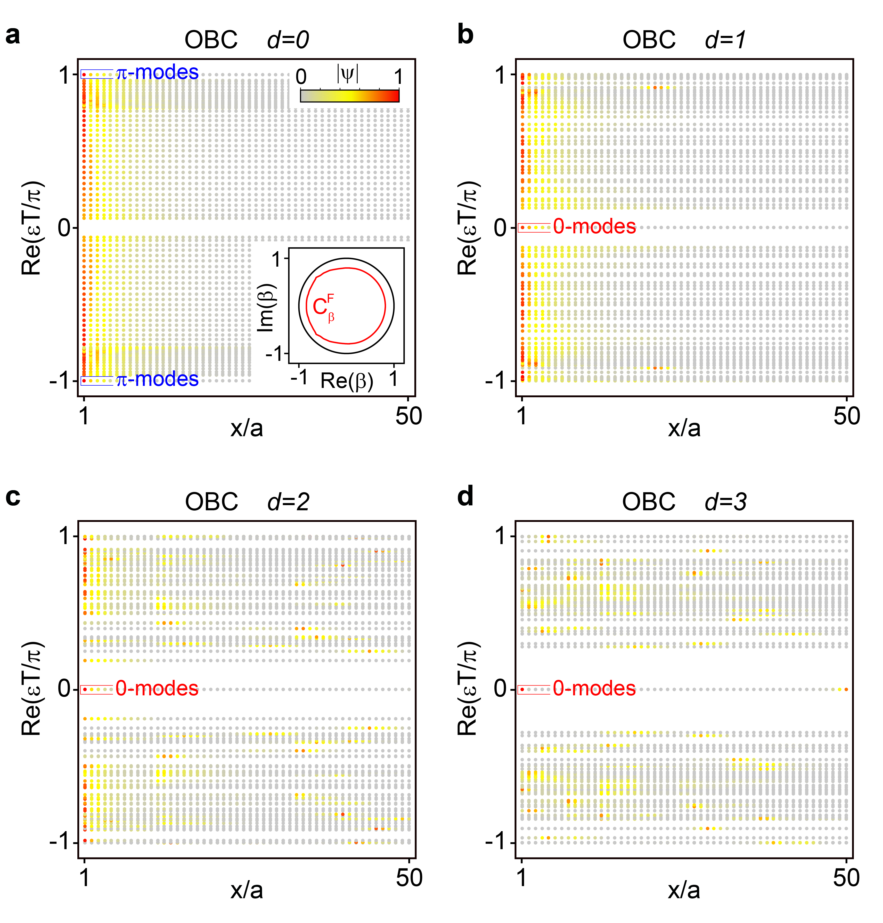
Fig. S2. Evolution of Floquet eigenstates under OBC with increasing disorder strength $d$. a Spatial distribution of all Floquet eigenstates at $d=0$, exhibiting $π$-gap edge states and a leftward Floquet NHSE. Inset: Floquet generalized Brillouin zone $C_{β}^{F}$ (red curve) compared to the conventional Brillouin zone (black curve). b-d As disorder increases, the topological $0$-modes emerge and remain pinned at the boundary, while the boundary accumulation characteristic of the NHSE is progressively suppressed and supplanted by bulk Anderson localization.

Below we present further details for the calculations of Floquet generalized Brillouin zone (GBZ), IPR and center-of-mass $x_{c}$, topological invariants $N_{0,π}$, and winding number $w\left(ε_{0}\right)$.
(i) Floquet GBZ.
In non-Hermitian systems, the difference between PBC and OBC spectra results in the failure of the conventional bulk-boundary correspondence5. This issue is resolved within the framework of the Floquet generalized Brillouin zone (GBZ), which is constructed from the effective Floquet Hamiltonian:
$$\begin{aligned}H_{eff}\left(e^{ik}\right)=\frac{i}{T}\ln{[e^{-\frac{iH_{2}\left(e^{ik}\right)T}{2}}e^{-\frac{iH_{1}\left(e^{ik}\right)T}{2}}}],\#\left(S6\right)\end{aligned}$$
where $H_{1}$ and $H_{2}$ are the Hamiltonians $H\left(t\right)$ at $t=0$ and $t=\frac{T}{2}$, respectively. We then introduce a complex parameter $β$ to replace $e^{ik}$, and yield $H_{eff}\left(β\right)$ that satisfies the equation
$$\begin{aligned}det\left[H_{eff}\left(β\right)-ε\right]=0,\#\left(S7\right)\end{aligned}$$
where $ε$ denotes the quasienergy spectrum under OBC. For each $ε$, this equation gives two solutions $β_{1}$ and $β_{2}$. The Floquet GBZ, denoted $C_{β}^{F}$, is defined as the set of $β$ satisfying6:
$$\begin{aligned}\left|β_{1}\right|=\left|β_{2}\right|.\#\left(S8\right)\end{aligned}$$
The geometrical shape of $C_{β}^{F}$ determines the nature of the NHSE:
- If $C_{β}^{F}$ lies entirely inside (outside) the unit circle of conventional BZ, all bulk modes exhibit leftward (rightward) Floquet NHSE.
- If $C_{β}^{F}$ intersects the unit circle of conventional BZ, the system exhibits a bipolar Floquet NHSE.
(ii) IPR and $x_{c}$.
To describe the localization properties of eigenstates, we calculate the IPR and the center-of-mass $x_{c}$. For each normalized eigenstate $ψ_{n}$(with $n$ denoting the state index), the IPR is defined as7,8:
$$\begin{aligned}{IPR}_{n}=\sum_{j=1}^{N}{{\left|ψ_{n}\left(j\right)\right|}^{4}},\#\left(S9\right)\end{aligned}$$
where $N=2L$ is the total number of sites. For an extended state, ${IPR}_{n}\sim \frac{1}{N}$; for a state localized over $n_{L}$ sites ($n_{L}≪N$), ${IPR}_{n}≃\frac{1}{n_{L}}$. After averaging over all eigenstates, we obtain the state-averaged $\overline{{IPR}_{n}}$,
$$\begin{aligned}\overline{{IPR}_{n}}=\frac{1}{N}\sum_{n=1}^{N}{{IPR}_{n}.}\#\left(S10\right)\end{aligned}$$
A further average is then performed over an ensemble of disorder configurations, yielding the final eigenstate- and disorder-averaged IPR:
$$\begin{aligned}IPR=〈\overline{{IPR}_{n}}〉,\#\left(S11\right)\end{aligned}$$
where $〈…〉$ denotes the average over different disorder realizations.
While a finite IPR indicates localization, it cannot distinguish between the NHSE and Anderson localization. To resolve this, we compute the center of mass7,9:
$$\begin{aligned}x_{c}=〈\frac{1}{N^{2}}\sum_{n=1}^{N}{\sum_{j=1}^{N}{j{\left|ψ_{n}\left(j\right)\right|}^{2}}}〉.\#\left(S12\right)\end{aligned}$$
For localized states ($IPR≃\frac{1}{n_{L}}$):
- $x_{c}\sim 0$ ($1$)indicates leftward (rightward) Floquet NHSE.
- $x_{c}\sim 0.5$ suggests Anderson localization.
(iii) $N_{0}$ and $N_{π}$.
To precisely characterize the number of $0$- and $π$-mode topological edge states in disordered Floquet non-Hermitian systems, we employ real-space topological invariants $N_{0}$ and $N_{π}$10,11
$$\begin{aligned}N_{0}=\frac{\left|ν_{1}+ν_{2}\right|}{2}, N_{π}=\frac{\left|ν_{1}-ν_{2}\right|}{2}.\#\left(S13\right)\end{aligned}$$
where the real-space winding number $ν_{j}\left(j=1 and 2\right)$ are defined as:
$$\begin{aligned}ν_{j}=\frac{1}{2L^{'}}{Tr}^{'}\left(SQ_{j}\left[Q_{j},X\right]\right),\#\left(S14\right)\end{aligned}$$
where ${Tr}^{'}$ denotes the trace over a central interval of length $L^{'}=L-2l$ (avoiding boundary effects), and $S=σ_{0}⊗σ_{z}$ is the chiral operator, and $X=Diag\left(1,…,L\right)⊗σ_{0}$ is the position operator. The operator $Q_{j}$ is given by:
$$\begin{aligned}Q_{j}=\sum_{n}^{'}{\left(\left|\left.n_{j}^{R}\right\rangle \left\langle n_{j}^{L}\right.\right|-S\left|\left.n_{j}^{R}\right\rangle \left\langle n_{j}^{L}\right.\right|S^{†}\right),}\#\left(S15\right)\end{aligned}$$
where the summation $Σ_{n}^{'}$ is over bulk states only. Here, $|\left.n_{j}^{R}\right\rangle$ and $\left\langle n_{j}^{L}\right.|$ are the right and left eigenstates of the effective Floquet Hamiltonian $H_{eff,j}$ that satisfies:
$$\begin{aligned}H_{eff,j}\left|\left.n_{j}^{R}\right\rangle =ε_{j,n}\right|\left.n_{j}^{R}\right\rangle , \left\langle n_{j}^{L}\right.\left|H_{eff,j}=\left\langle n_{j}^{L}\right.\right|ε_{j,n},\#\left(S16\right)\end{aligned}$$
where $H_{eff,j}=\frac{i}{T}\ln{U_{T,j}}$ and the Floquet operators $U_{T,j}$ are defined as:
$$\begin{aligned}U_{T,1}=e^{-\frac{iH_{1}T}{4}}e^{-\frac{iH_{2}T}{2}}e^{-\frac{iH_{1}T}{4}}, U_{T,2}=e^{-\frac{iH_{2}T}{4}}e^{-\frac{iH_{1}T}{2}}e^{-\frac{iH_{2}T}{4}}.\#\left(S17\right)\end{aligned}$$
(iv) $w\left(ε_{0}\right)$.
In disordered non-Hermitian systems, the NHSE can be characterized topologically by another real-space winding number12 $w\left(ε_{0}\right)$:
$$\begin{aligned}w\left(ε_{0}\right)=\frac{1}{2L^{'}}{Tr}^{'}\left(V^{†}\left[V,X\right]\right),\#\left(S18\right)\end{aligned}$$
where $L^{'}$ and $X$ have the same meanings as in Eq. (S14). The unitary matrix $V$ is derived from the polar decomposition of the shifted effective Hamiltonian:
$$\begin{aligned}H_{eff}-ε_{0}=VP,\#\left(S19\right)\end{aligned}$$
with $P$ being a positive semidefinite operator. Equivalently, $V$ and $P$ can be obtained via singular value decomposition:
$$\begin{aligned}H_{eff}-ε_{0}=MSN^{†},\#\left(S20\right)\end{aligned}$$
yielding $V=MN^{†}$ and $P=NSN^{†}$.
The value of $w\left(ε_{0}\right)$ determines the nature of localization:
- $w\left(ε_{0}\right)=+1\left(-1\right)$: Leftward (rightward) NHSE at quasienergy $ε_{0}$.
- $w\left(ε_{0}\right)=0$: Absence of NHSE, indicating Anderson localization.
To avoid influence from topological edge states near zero quasienergy, the reference $ε_{0}$ in Fig. 2f of the main text is chosen as the second smallest absolute quasienergy in the spectrum. The robustness of our results has been further confirmed using other generic values of $ε_{0}$.

Note 2. Structural design and experimental identification of the static acoustic system.
Based on the tight-binding model, we constructed a static acoustic structure with a lattice constant $a=100 mm$. As shown in Fig. S3a, each unit cell comprises two identical cavities (side length $s₀=27.2 mm$, height $h₀=52.0 mm$) coupled via narrow square-section tubes of side lengths $r₀=9.4 mm$ (for intracell coupling, $μ_{0}≃-100 Hz$) and $r₁=8.0 mm$ (for intercell coupling, $μ_{1}≃-75 Hz$). The cavity’s $P_{z}$ mode, with a resonant frequency of $3.3 kHz$, is used to mimic the zero onsite energy.

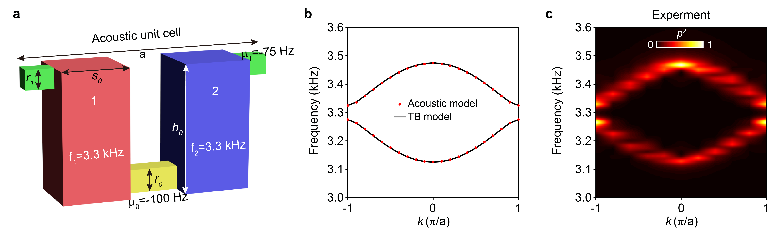
Fig. S3. Realization and verification of the static acoustic system. a Schematic of the acoustic unit cell geometry. Each cell consists of two identical cavities coupled via square-section tubes. The intracell coupling is realized by the yellow tubes, while the intercell coupling is implemented by the green tubes. The $P_{z}$ mode of the cavity is used to mimic the zero on-site energy of the acoustic lattice. b Numerically simulated bulk band structure (red dots) compared with the theoretical prediction from the tight-binding model (black curves), showing excellent agreement. c Experimentally measured bulk band structure, which matches well with both the theoretical and numerical results in b, thereby validating the design of the static acoustic lattice.

The validity of our acoustic lattice design was systematically verified through a sequence of numerical and experimental steps. First, the bulk band structure of this acoustic metamaterial was simulated numerically, showing close agreement with the theoretical prediction from the tight-binding model (Fig. S3b). To confirm this agreement in practice, a physical sample was fabricated using 3D printing (see Fig. 3a in the main text), and its bulk band structure was subsequently characterized experimentally (Fig. S3c). (Unless otherwise specified, all experimental data presented in this work were obtained by counting two independent measurements conducted in cavities 1 and 2.) The remarkable three-way consistency among the theoretical, numerical, and experimental results conclusively confirms the effectiveness of our design, demonstrating that the constructed static acoustic lattice accurately realizes the intended tight-binding model.

Note 3. Experimental details: driving protocol, signal processing, and setup calibration.
To identify the harmonic response of the Floquet system, we employed a frequency-swept excitation signal $X\left(t\right)$. It consists of $N_{J}=161$ sequential, quasi-monochromatic segments, each implemented as a Gaussian-modulated sinusoidal pulse. Within the $j$-th time interval $\left[\left(j-1\right)∆_{t},j∆_{t}\right]$, the signal is given by:
$$\begin{aligned}X\left(t\right)=e^{-{\left(\frac{t-0.5∆_{t}}{σ}\right)}^{2}}\sin\left(2πf_{j}t\right),\#\left(S21\right)\end{aligned}$$
where the center frequency $f_{j}$ is linearly swept according to $f_{j}=f_{0}+\left(j-1\right)∆_{f}$, with an initial frequency $f_{0}=2.5 kHz$ and a frequency step $∆_{f}=10 Hz$. In particular, we consider a sufficiently long Gaussian envelope width $σ=0.05 s$ to ensure each pulse is narrow enough in frequency (e.g., quasi-monochromatic). In addition, a pulse interval $∆_{t}=0.25 s$ is chosen to be substantially longer than $σ$, ensuring clear temporal separation between successive quasi-monochromatic signals. Overall, this composite signal has a total duration of $40 s$ and sweeps the frequency range from $2.5$ to $4.1 kHz$.

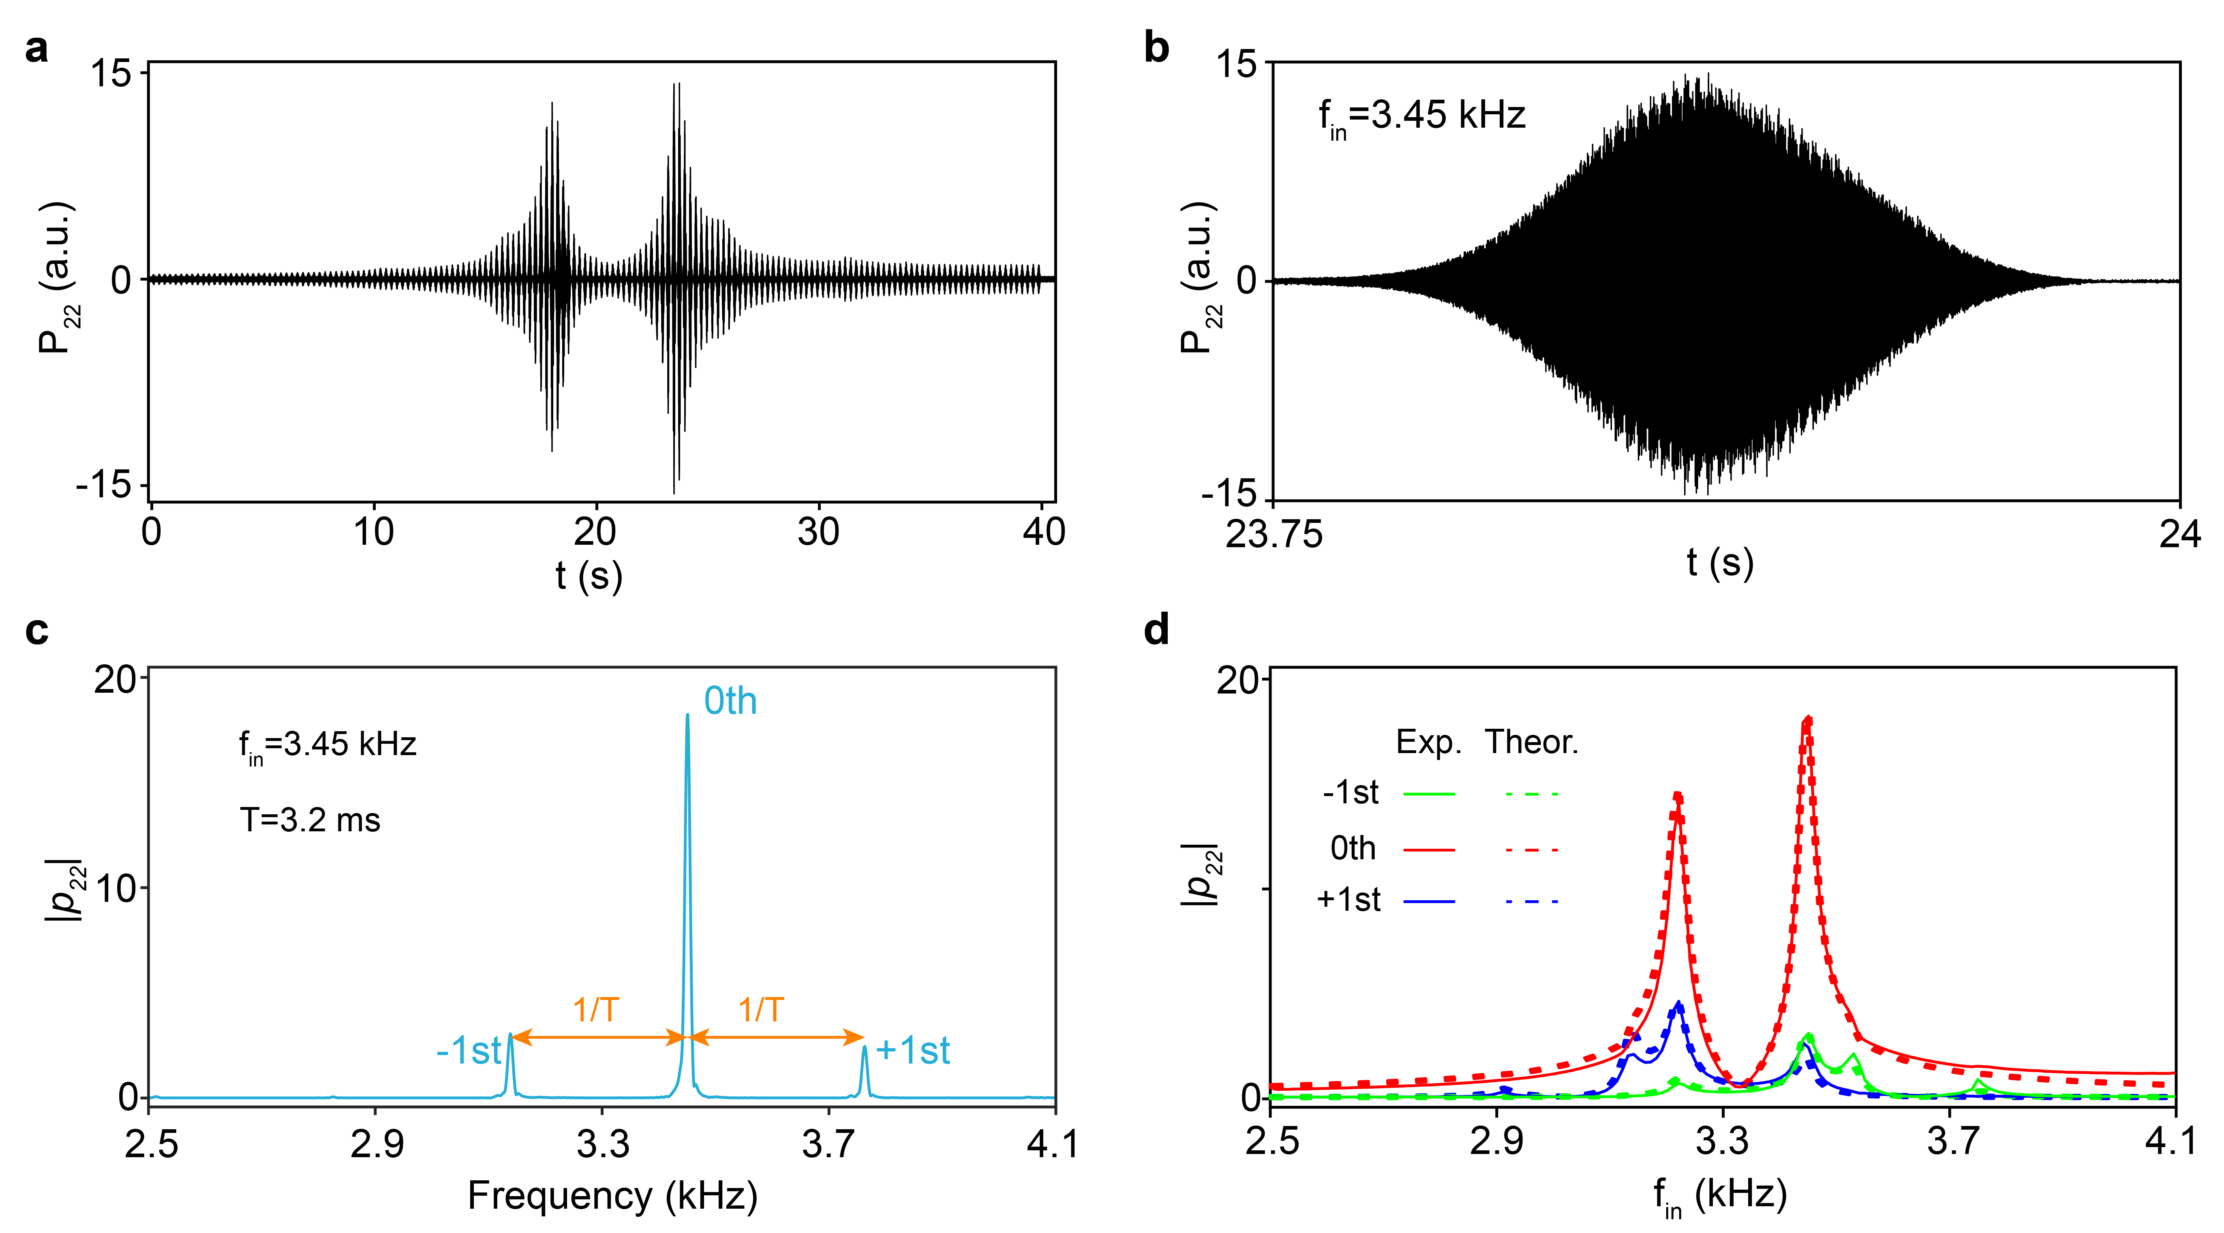
Fig. S4. Experimental calibration of $κ₁$ in a Floquet-driven two-cavity system. a Measured time-domain response $P_{22}\left(t\right)$ to $161$ successive quasi-monochromatic input signals. b Zoomed-in view within the time interval $t∈\left[23.75 s, 24 s\right]$ for a quasi-monochromatic input signal with $f_{in}=3.45 kHz$. c Corresponding frequency-domain amplitude $|p_{22}(f)|$, displaying the $0th$-order harmonic peak at $f_{in}$ and$±1st$-order sideband peaks at $f_{in}±\frac{1}{T}$. d Measured $0th$ and $±1st$ order harmonic responses (solid curves) as a function of the input frequency $f_{in}$, fitted by the coupled-mode theory with $κ_{1}=-158 Hz$ (dashed curves).

The amplitude of the dynamic coupling ($κ₁$) was calibrated using the binary cavity-tube structure illustrated in Fig. 3c (main text), where the feedback circuit was configured to implement the time-periodic, unidirectional coupling $κ(t)$ from cavity 1 to cavity 2. The Floquet system was probed by exciting cavity 2 with the frequency-swept signal described by Eq. (S21) and measuring the response within the same cavity. Figure S4a shows the full measured time-domain response $P_{22}\left(t\right)$ to this $161$-segment signal, and Fig. S4b exemplifies the zoomed-in view within the time interval $t∈\left[23.75 s, 24 s\right]$, corresponding to excitation at quasi-monochromatic frequency $f_{in}=3.45 kHz$. Fourier transformation of this short segment yields the frequency-domain response $|p_{22}(f)|$ in Fig. S4c. Clearly, it exhibits the characteristic fingerprint of a Floquet-driven system: a dominant peak at the input frequency $f_{in}$ ($0th$-order harmonic) accompanied by sideband peaks at $f_{in}±1/T$ ($±1st$-order harmonics). By processing each segment of the swept-frequency measurement in this manner, we obtained the amplitude of these harmonic peaks as a function of $f_{in}$ (Fig. S4d). Fitting the resulting spectral responses with coupled-mode theory gives the amplitude of the dynamic coupling in this specific case, $κ_{1}≃-158 Hz$. This calibrated setup and validated protocol form the basis for constructing the acoustic Floquet non-Hermitian lattices (both clean and disordered) studied in this work.

Note 4. Floquet Coupled-Mode Theory.
To validate the phenomena observed in our experiments and confirm their accuracy, we performed computational analysis based on temporal coupled-mode theory under the Floquet theorem. The theoretical framework is briefly outlined below13.
The dynamics of sound wave propagation in our time-varying acoustic lattice can be described by a Schrödinger-type equation:
$$\begin{aligned}-i\frac{∂}{∂t}\left.|Ψ\left(t\right)\right\rangle =H(t)\left.|Ψ\left(t\right)\right\rangle +\left.|s\left(t\right)\right\rangle ,\#\left(S22\right)\end{aligned}$$
where $H(t)$ is an $N×N$ Hamiltonian matrix incorporating intrinsic losses $-iγ_{0}$, with $N$ being the total number of cavities. The source term $\left.|s\left(t\right)\right\rangle ={\left[0,…,\sqrt{2γ_{s}}e^{iωt},0,…\right]}^{T}$ describes an external excitation at frequency $ω$, with the non-zero element $\sqrt{2γ_{s}}e^{iωt}$ indicating the cavity index where the sound source is placed. Applying the Floquet theorem1,2, the time-dependent wave function $\left.|Ψ\left(t\right)\right\rangle =\left[a_{1}\left(t\right),a_{2}\left(t\right),…,a_{N}\left(t\right)\right]$ can be expanded into Floquet harmonics:
$$\begin{aligned}a_{j}\left(t\right)=\sum_{m=-M}^{M}{A_{j}^{m}e^{i\left(ω+mΩ\right)t}}, j=1\sim N. \#\left(S23\right)\end{aligned}$$
where $A_{j}^{m}$ denotes the amplitude of the $m$-th harmonic component, and $Ω=\frac{2π}{T}$ represents the Floquet modulation frequency. A more direct calculation2 can be realized via the Floquet Hamiltonian $H$:
$$\begin{aligned}H_{αα^{'}}^{mm^{'}}=mΩδ_{αα^{'}}δ_{mm^{'}}+\frac{1}{T}\int_{0}^{T}{e^{-i\left(m{-m}^{'}\right)Ωt}H_{αα^{'}}\left(t\right)dt},\#\left(S24\right)\end{aligned}$$
which is substituted into the following coupled-mode equation:
$$\begin{aligned}ω\left.|ζ\right\rangle =H\left.|ζ\right\rangle +\left.|s\right\rangle ,\#\left(S25\right)\end{aligned}$$
where $\left.|ζ\right\rangle ={\left[…,A^{-1},A^{0},A^{+1},…\right]}^{T}$ contains the multi-order harmonic amplitudes, and $\left.|s\right\rangle ={\left[…,0,s^{0},0,…\right]}^{T}$ with $s^{0}={\left[0,…,\sqrt{2γ_{s}},0,…\right]}^{T}$ represents the source term in the $0th$-order harmonic subspace.

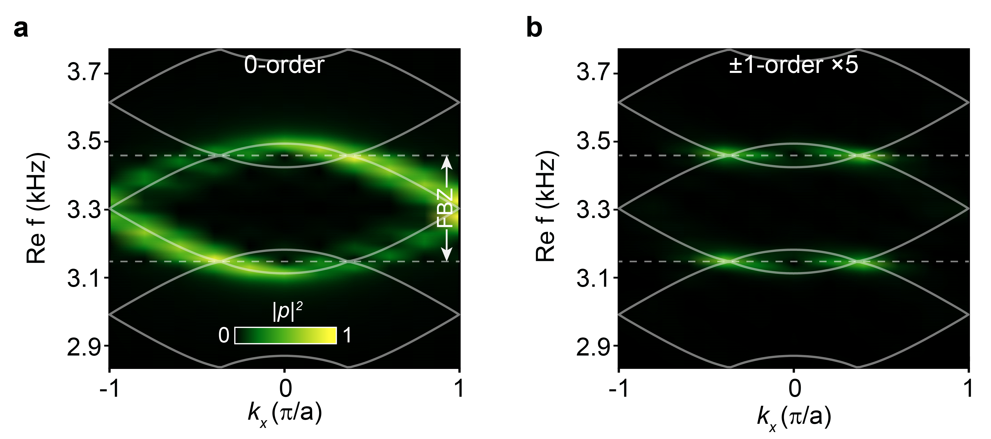
Fig. S5. Simulated quasienergy spectra based on Floquet coupled-mode theory. a Color map of the simulated $0th$-order harmonic component, overlaid with the theoretical prediction from the tight-binding model (white curves). b Corresponding $±1st$-order harmonic components. The simulations were performed with the loss parameters $γ_{0}=20 Hz$ and $γ_{s}=10 Hz$. The results show good agreement with the experimental data presented in Fig. 3d of the main text.

Using this theoretical framework, we calculated key results including the transmission spectra (Fig. S4d), the quasienergy band structures (Fig. S5), and the real-space field distributions (see insets in Figs. 4 and 5). The close agreement between these calculations and the experimental data provides strong confirmation of the accuracy of our experimental observations.

References
1 Kitagawa, T., Berg, E., Rudner, M. & Demler, E. Topological characterization of periodically driven quantum systems. Phys. Rev. B 82, 235114, (2010).
2 Rudner, M. S., Lindner, N. H., Berg, E. & Levin, M. Anomalous Edge States and the Bulk-Edge Correspondence for Periodically Driven Two-Dimensional Systems. Phys. Rev. X 3, 031005, (2013).
3 Okuma, N., Kawabata, K., Shiozaki, K. & Sato, M. Topological Origin of Non-Hermitian Skin Effects. Phys. Rev. Lett. 124, 086801, (2020).
4 Zhang, K., Yang, Z. & Fang, C. Correspondence between Winding Numbers and Skin Modes in Non-Hermitian Systems. Phys. Rev. Lett. 125, 126402, (2020).
5 Yao, S. & Wang, Z. Edge States and Topological Invariants of Non-Hermitian Systems. Phys. Rev. Lett. 121, 086803, (2018).
6 Shi, K., Qiao, L., Zheng, Z. & Zhang, W. Floquet topological phases and skin effects in periodically driven non-Hermitian systems. Phys. Rev. A 110, 022222, (2024).
7 Jin, W.-W. et al. Anderson Delocalization in Strongly Coupled Disordered Non-Hermitian Chains. Phys. Rev. Lett. 135, 076602, (2025).
8 Longhi, S. Erratic Non-Hermitian Skin Localization. Phys. Rev. Lett. 134, 196302, (2025).
9 Wang, B. B. et al. Observation of disorder-induced boundary localization. Proc. Natl. Acad. Sci. 122, e2422154122, (2025).
10 Song, F., Yao, S. & Wang, Z. Non-Hermitian Topological Invariants in Real Space. Phys. Rev. Lett. 123, 246801, (2019).
11 Wu, H. & An, J.-H. Floquet topological phases of non-Hermitian systems. Phys. Rev. B 102, 041119(R), (2020).
12 Claes, J. & Hughes, T. L. Skin effect and winding number in disordered non-Hermitian systems. Phys. Rev. B 103, L140201, (2021).
13 Koutserimpas, T. T. & Fleury, R. Nonreciprocal Gain in Non-Hermitian Time-Floquet Systems. Phys. Rev. Lett. 120, 087401, (2018).

