Supplementary information
Symmetry-guided interfacial Ti incorporation in epitaxial Sr-doped HfO₂ memristors for energy-efficient analog computing
Weifeng Zhang ^{1,7}, Pengfei Li ^{1,7}, Tengfei Cao ^{2,7}, Fatoye Sawyerr ^{2,7}, Yongqing Jia ¹, Biao Yang ¹, Yinxing Zhang ³, Huaqing Lan ¹, Zihang Liu ¹, Lihuang Liu ¹, Yue Hou ¹, Shushen Li ⁴, Tuo Shi ^{5,}*, Jingsheng Chen ^{6,}* , Xiaobing Yan ^{1,}*
¹ Key Laboratory of Brain-like Neuromorphic Devices and Systems of Hebei Province,
College of Electronic and Information Engineering, Hebei University,
Baoding, Hebei 071002, China
² School of Materials Science and Engineering, Northwestern Polytechnical University,
Xi’an, Shaanxi 710072, China
³ Tianjin Key Laboratory of Optoelectronic Thin Film Devices and Technology, College of Electronic Information and Optical Engineering, Academy for Advanced Interdisciplinary Studies, Nankai University, Tianjin 300350, China
⁴ State Key Laboratory of Superlattices and Microstructures, Institute of Semiconductors,
Chinese Academy of Sciences, Beijing 100083, China.
⁵ Zhejiang Lab,
Hangzhou, Zhejiang 311100, China
⁶ Department of Materials Science and Engineering, National University of Singapore,
Singapore 117575, Singapore
⁷ These authors contributed equally: Weifeng Zhang, Pengfei Li, Tengfei Cao, Fatoye Sawyerr.
* Corresponding authors. E-mail: shituo@zhejianglab.com, msecj@nus.edu.sg, yanxiaobing@ime.ac.cn

Contents
1. Crystallinity and growth optimization of distinct heterostructures, and their corresponding electrical characterization
1.1 X-ray diffraction analysis under various deposition conditions and interfacial terminations
1.1.1 XRD patterns of SHO films with different deposition parameters and thicknesses
1.1.2 Rocking curve and φ-scan comparison under varying growth conditions
1.1.3 Pole figure measurements under optimized growth parameters
1.1.4 XRD characterization of SHO films grown on substrates with different out-of-plane crystallographic orientations
1.2 Polarization–voltage dependence and cycling behavior in heterostructures with different interfacial terminations
1.3 Hysteresis and surface morphology analysis via atomic force microscopy
1.3.1 Voltage-dependent PFM phase and amplitude loops in SrO-terminated films
1.3.2 Retention of PFM domain patterns in both terminations over time
1.3.3 Surface morphology evolution under different oxygen partial pressures
1.4 Compositional analysis of thin films via X-ray photoelectron spectroscopy
1.5 Linear-scale I–V characteristics of T-terminated films under optimal crystallinity
1.6 Retention characteristics of neighboring multilevel conductance states
2. Atomic-scale STEM analysis of heterointerfaces
2.1 Cross-sectional structural and elemental mapping of SHO/NSTO heterostructures
2.2 Atomic-resolution images and corresponding lattice models of different termination layers
2.3 Crystalline quality of S-terminated films analyzed at atomic resolution
2.4 EELS characterization of interfacial chemical environments in both heterostructures
2.5 Interfacial spacing measurement at the atomic scale
3. Density functional theory analysis
4. The application of ferroelectric memristor system in scientific computing and lightweight fuzzy neural network
4.1 Mapping the complex-valued matrix operation of the inverse discrete Fourier transform (IDFT)
4.2 Membership function design in Mamdani-Type robotic control
4.3 Dataset from Mamdani-type Neuro-Fuzzy system for lightweight FNN training
4.4 Real-world signal acquisition using a commercial ROS-based robot
4.5 Lightweight memristor-based SHO system for real-world robotic tasks
4.6 Readout strategy for weight mapping in SHO memristor arrays
4.7 Performance Comparison of SHO-LFNN, DNN, and RBF Models Under Different Quantization Bit-Widths
4.8 Energy Consumption Analysis for Readout and Inference
4.9 Real-time SLAM scene modeling with LiDAR on a ROS mobile robot

1. Crystallinity and growth optimization of distinct heterostructures, and their corresponding electrical characterization
1.1 X-ray diffraction analysis under various deposition conditions and interfacial terminations
1.1.1 XRD patterns of SHO films with different deposition parameters and thicknesses
Owing to the alternating AO/BO₂ stacking of the perovskite lattice, (111)-oriented Nb-doped SrTiO₃ (NSTO) substrates were chemically treated to obtain two distinct surface terminations. Based on these engineered terminations, 5 at% Sr-doped HfO₂ (SHO) thin films were subsequently deposited under various growth conditions, including different oxygen partial pressures.
We first varied the oxygen partial pressure during pulsed laser deposition (PLD) to regulate the plume dynamics and growth environment, followed by X-ray diffraction (XRD) analysis of the deposited films. The film thickness was controlled at 12 nm using a deposition rate calibrated from atomic force microscopy (AFM) step-height measurements, where the measured film/substrate height difference was normalized by the number of laser pulses. On (111)-oriented substrates, the crystallinity of the HfO₂ thin films exhibited an inverted U-shaped dependence on oxygen partial pressure. As shown in Fig. S1a, the strongest diffraction peak intensity was observed under an oxygen pressure of 53 mTorr. Diffraction peaks corresponding to the out-of-plane (111) reflection of the orthorhombic phase of HfO₂ were detected in all samples, and the detailed peak positions are highlighted in the inset. For the film grown under optimal conditions, the XRD data near the out-of-plane (111) reflection were normalized and plotted in Fig. S1b. Periodic satellite peaks were observed around the main peak, which are attributed to Laue oscillations, confirming the high crystalline quality and single-crystalline nature of the film.
Subsequently, we reduced the film thickness and compared the films grown on the two well-defined surface terminations. When the thickness was reduced to 7 nm, the T-type film still exhibited relatively sharp diffraction peaks indicative of good crystallinity, albeit with broader peak widths. In contrast, the S-type film showed a significant reduction in diffraction intensity (Fig. S1c), providing a clue for understanding the distinct stabilization mechanisms of the ferroelectric phase in the subsequent sections. Moreover, despite the significantly reduced thickness of 3 nm, the T-type film still exhibited a discernible out-of-plane (111) diffraction peak corresponding to the ferroelectric orthorhombic phase of HfO₂, as shown in Fig. S1d^{1,2}.
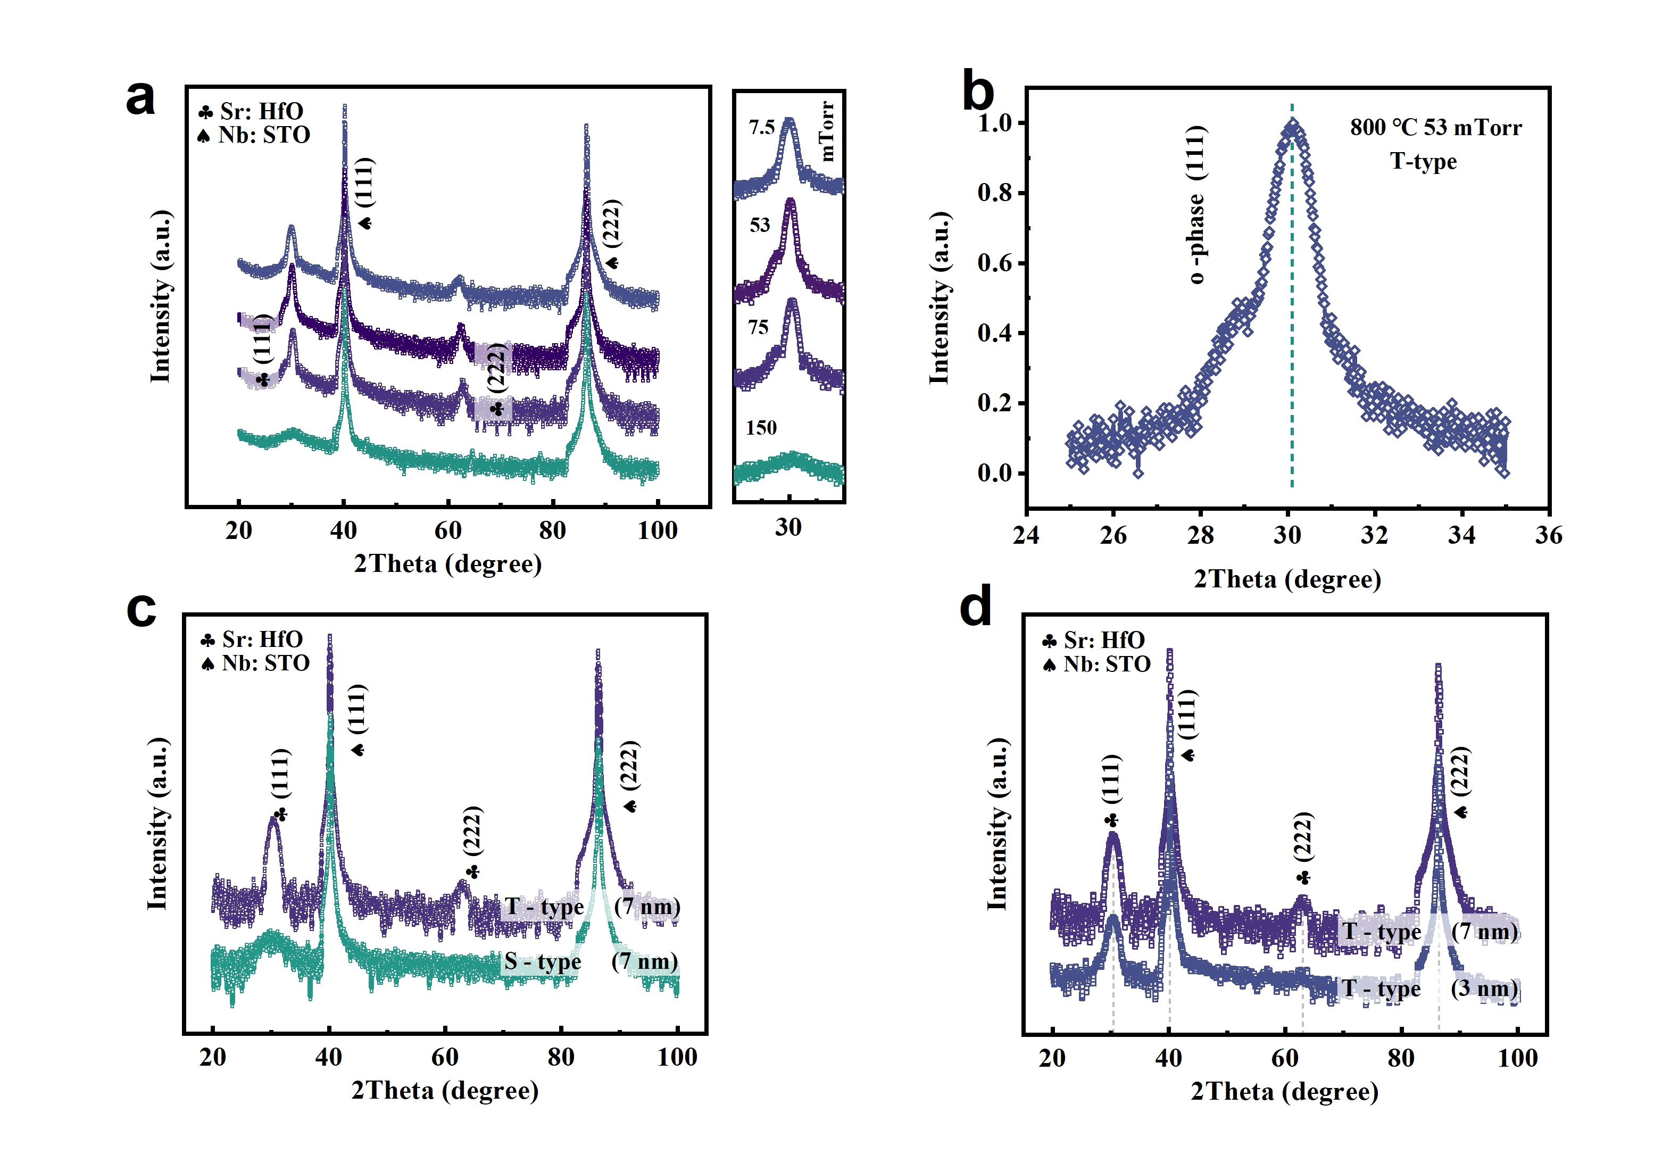
Fig. S1 | a, XRD patterns of the films grown under different oxygen partial pressures; the inset shows a magnified view of the diffraction peaks near 2θ ≈ 30°. b, Normalized out-of-plane (111) diffraction profile of the film grown under an oxygen pressure of 53 mTorr. c, XRD patterns of the two types of heterostructured films with a reduced thickness of 7 nm. d, Structural characterization of the T-type film at an ultrathin thickness of 3 nm.

1.1.2 Rocking curve and φ-scan comparison under varying growth conditions
To gain deeper insight into the material's anisotropy and microscopic orientation characteristics, we quantitatively characterized the crystallographic texture of SHO using XRD pole figure analysis. The pole figure data not only intuitively reveal the preferential orientation distribution of the grains, but also provide critical structural parameters for correlating texture with macroscopic properties³.
As shown in Fig. S2a, rocking curve measurements were conducted to further assess the crystalline quality of films deposited under different oxygen atmospheres. The full width at half maximum (FWHM) exhibits an inverted U-shaped trend: 0.205° under the lowest oxygen pressure, 0.058° at 53 mTorr, 0.065° at 75 mTorr, and 0.486° at 150 mTorr (to further improve the resolution, both the divergence slit and the receiving slit in the incident optical path were adjusted to a width of 0.2 mm, reducing beam divergence and minimizing instrumental broadening effects). This confirms that 53 mTorr yields the optimal crystalline quality, consistent with the conclusions drawn from XRD structural analysis. Subsequently, φ-scan measurements were carried out. To determine the required χ angle, we fixed 2θ at 30.04° and measured the diffraction intensity of the film under various χ angles. As shown in Fig. S2b, distinct diffraction peaks appear when χ is near 2° and 71°, indicating the need for a specific sample tilt during φ scanning. Based on literature, the tested plane was identified as the (−111) plane. The angle between the (−111) and (111) plane normals can be calculated via the dot product formula (n_{hkl} denotes the normal vector of the (hkl) crystallographic plane),
$$\cos{χ}= \frac{n111 ‧ n-111}{\left|n111\right| ‧ |n-111|}= \frac{-1+1+1}{\sqrt{3} ‧ \sqrt{3}}≈\frac{1}{3}$$
yielding χ = arccos(1/3) ≈ 70.5°, which matches our experimental observations. The corresponding 2θ value can be derived from Bragg’s law, 2dsinθ = nλ, where the interplanar spacing d is calculated using the Miller indices.
$\frac{1}{d_{hkl}^{2}}= \frac{h^{2}}{a^{2}}+ \frac{k^{2}}{b^{2}}+ \frac{l^{2}}{c^{2}}$ ; substitute to obtain $\frac{1}{d_{-1+1+1}^{2}}= \frac{{(-1)}^{2}}{{5.00}^{2}}+ \frac{1^{2}}{{5.06}^{2}}+ \frac{1^{2}}{{5.23}^{2}}$ ; d ≈ 2.94Å
This gives θ = arcsin(0.2568) ≈ 14.9°, corresponding to 2θ ≈ 29.8°, which agrees well with the experimental value near 30°.
Therefore, we fixed 2θ at 30° and χ at approximately 70.5° (with a gradient scan across 0–75°), and performed φ scanning from 0° to 360°, as shown in Fig. S2c. Based on the φ-scan data at various χ angles, pole figures were constructed and will be separately presented in Fig. S3. Additionally, Fig. S2d shows the φ-scan results of the (111)-oriented NSTO substrate, measured using the (−111) plane (χ ≈ 71°, 2θ ≈ 40°). The diffraction peaks of both materials appear periodically at 60° and 120° intervals, with matching peaks every 60°, further confirming the high-quality epitaxial relationship within the heterostructure.
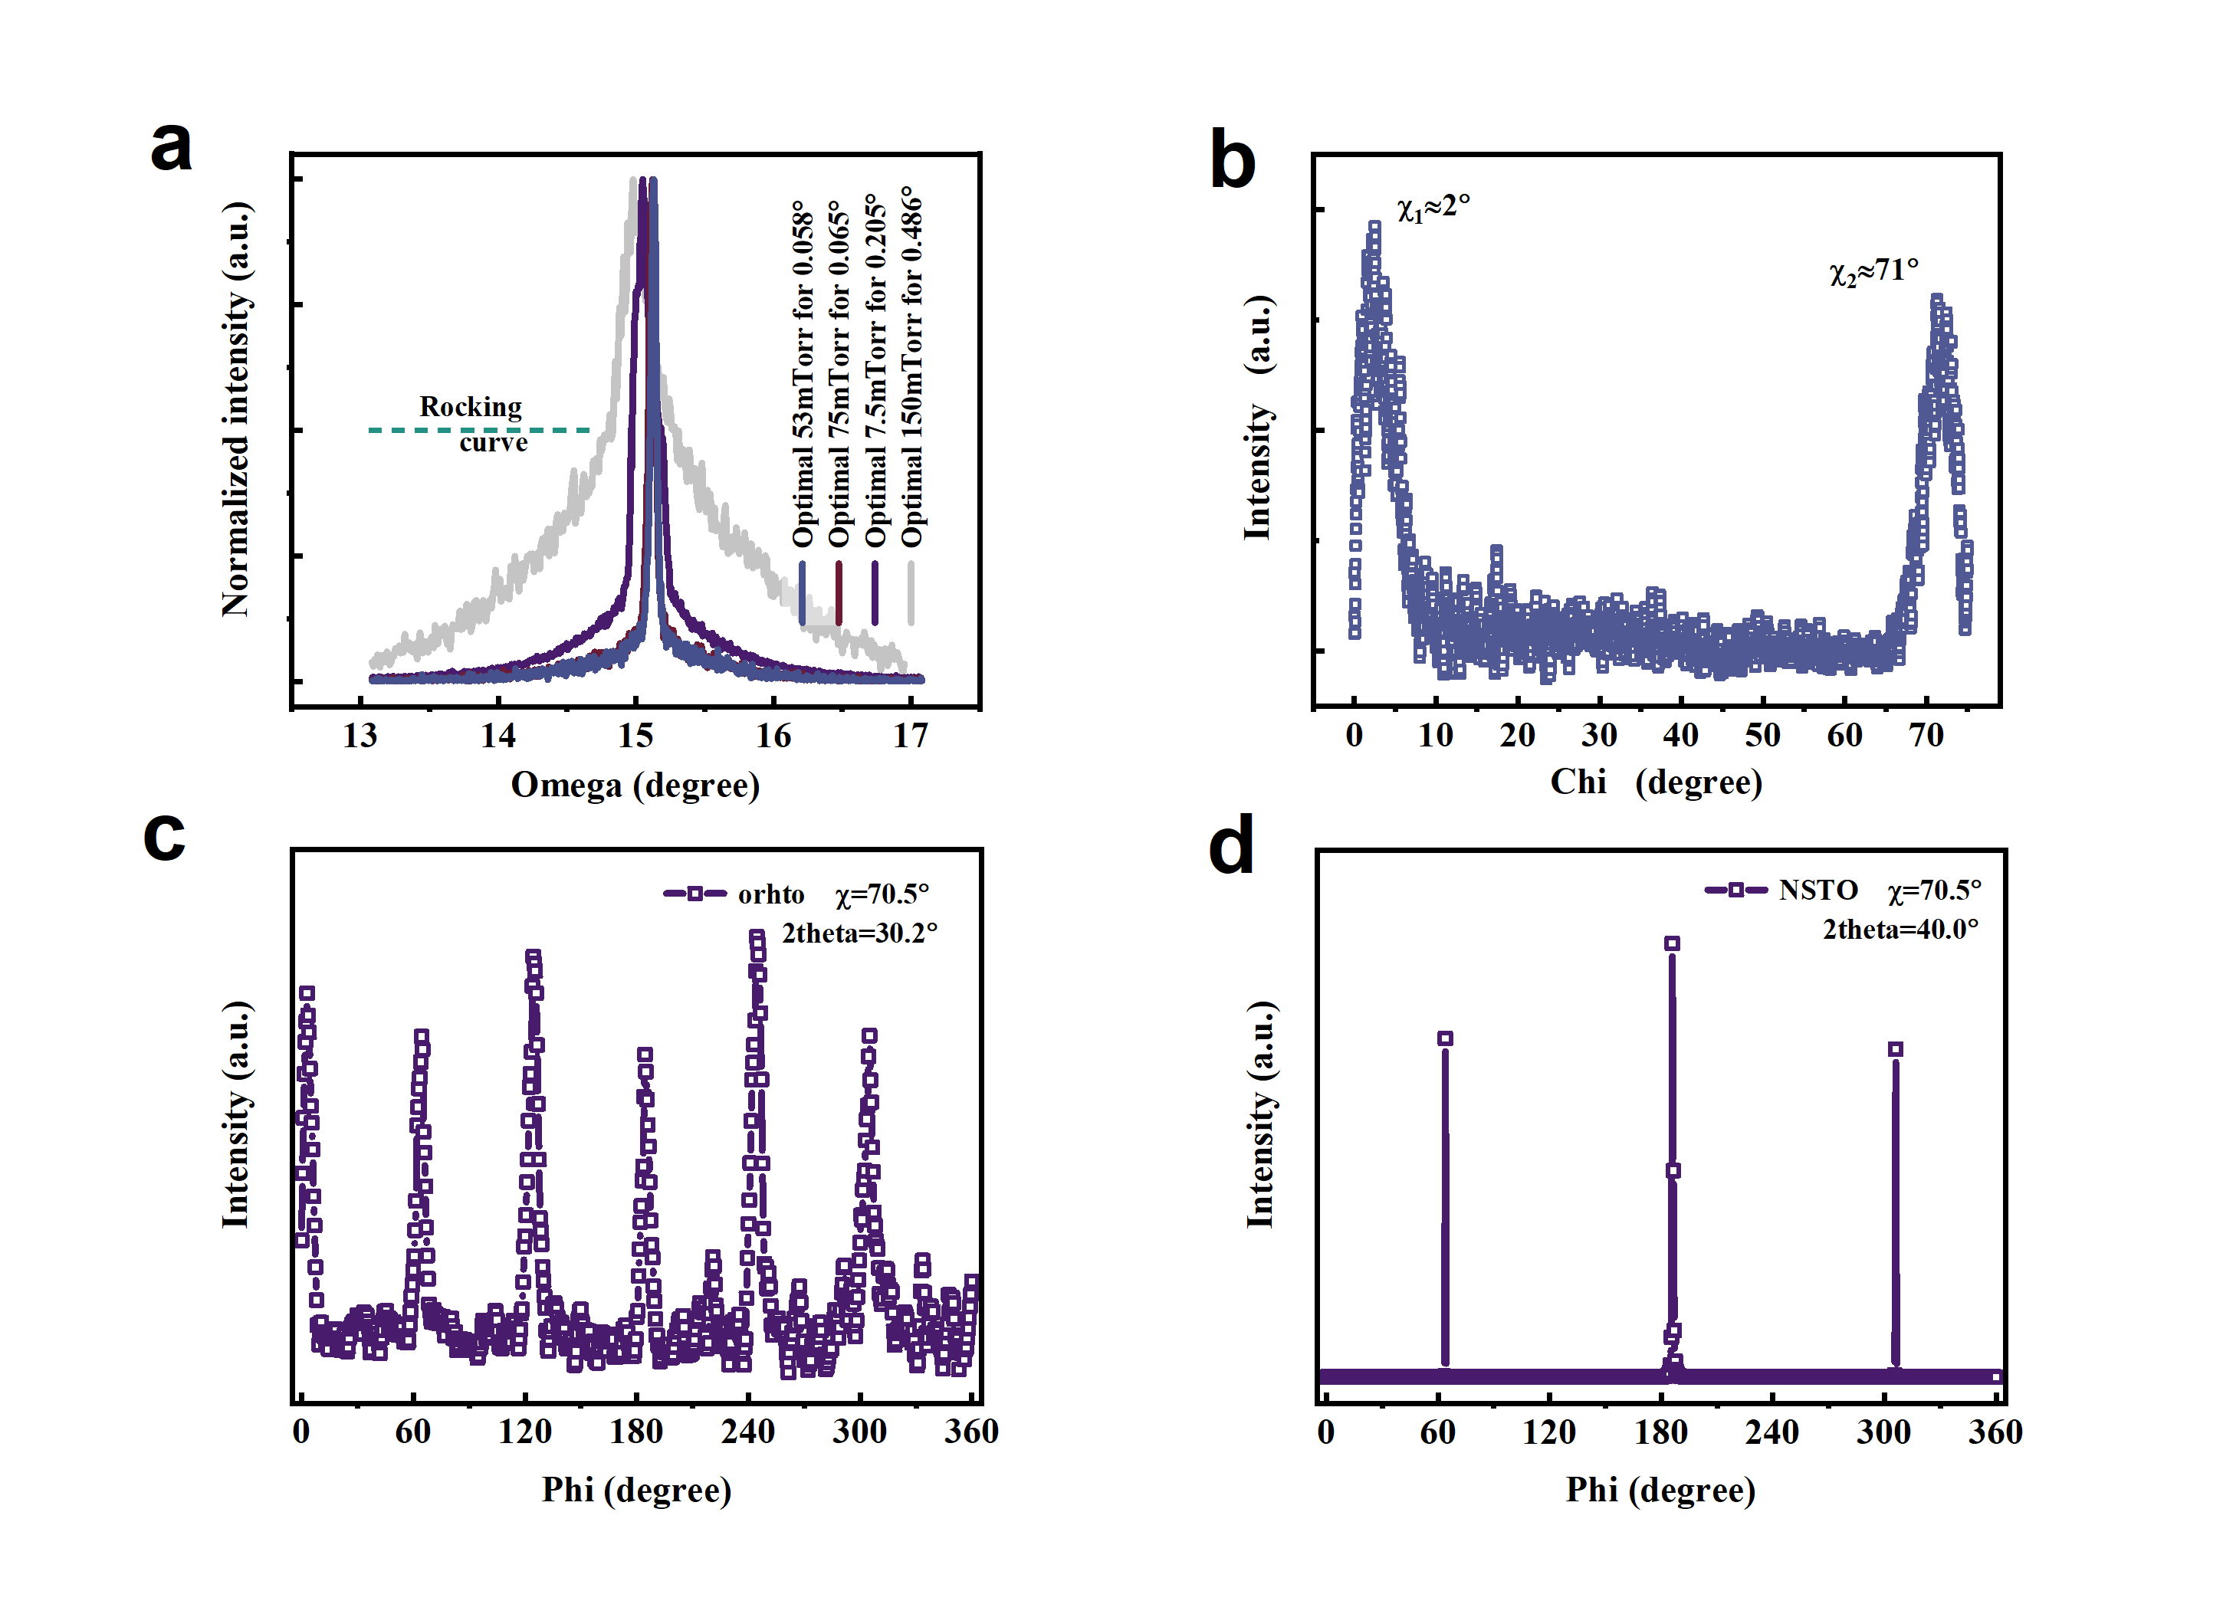
Fig. S2 | a, Rocking curve analysis of SHO films deposited under different oxygen atmospheres. b, χ-scan of the SHO film, showing the relationship between χ angle and diffraction intensity, used to analyze the diffraction response at various crystal plane tilt angles. c, φ-scan profile acquired at a fixed χ angle of 70.5°, corresponding to the (–111) plane with an interplanar spacing of approximately 3.0 Å. d, φ-scan of the substrate under the same χ angle (70.5°) and crystallographic plane (–111), revealing the substrate’s symmetry and epitaxial relationship (During φ-scan measurements in both c and d, the sample position remained fixed).

1.1.3 Pole figure measurements under optimized growth parameters
In this study, the crystallographic texture of the films was systematically characterized by X-ray diffraction, with the orientation distribution of the {111} family analyzed via pole figure projection⁴⁻⁶. To balance the high angular resolution required for weak signals at large tilt angles with the completeness of data at low angles, a segmented χ-scan strategy was employed⁷. The χ angle was divided into four optimized intervals: 75–65°, 75–50°, 75–10°, and 75–3°, thereby covering the full angular range of 0–75°.
For the 75–65° interval, a continuous 360° φ-scan was performed with a 0.5° step size, and the detector was triggered at each step with an exposure time of 1 s per frame to accumulate weak high-angle diffraction signals. In the 65–50° range, the step size was increased to 1° and the exposure time reduced to 0.5 s per frame to improve efficiency. When no diffraction intensity was observed in a given angular range (as confirmed by the χ-scan), the step interval was further increased to 10° for rapid coverage.
The combined data from the four χ segments were plotted in polar coordinates to construct a complete pole figure. The SHO thin film initially exhibited six continuous diffraction arcs, which gradually evolved into six discrete diffraction spots with increasing tilt angle. This sixfold pattern confirms the presence of three rotationally equivalent ferroelastic variants in the SHO film, induced by the rotational symmetry of the (111)-oriented NSTO substrate. Each variant is oriented along the [110], [1-10], or [-110] direction, consistent with the expected symmetry. As illustrated in Fig. S3, this pole-figure evolution robustly confirms the presence and directional distribution of three ferroelastic domain variants in the SHO film on NSTO (111).
Compared with the fourfold in-plane symmetry of STO (001) and the lower, twofold rectangular symmetry of STO (110), the STO (111) surface exhibits a threefold rotational symmetry with a pseudo-hexagonal surface arrangement. This distinct surface symmetry leads to a different epitaxial variant selection for orthorhombic HfO₂. In the reported tilted epitaxial configuration of HZO/LSMO/STO (111), one orthorhombic axis of HfO₂ can align parallel to the STO [01-1] direction, whereas the other two orthorhombic axes are inclined by approximately 24° and 66° with respect to the surface normal⁷. Within this orientation relationship, the sixfold pole distribution observed in the pole figure can be rationalized by two symmetry-allowed epitaxial registries of the orthorhombic HfO₂ unit cell on the STO (111) surface. Each registry is further replicated by the threefold rotational symmetry of STO (111), giving rise to three equivalent in-plane rotational variants separated by 120°. The overall pole distribution therefore reflects a 2×3 variant configuration.

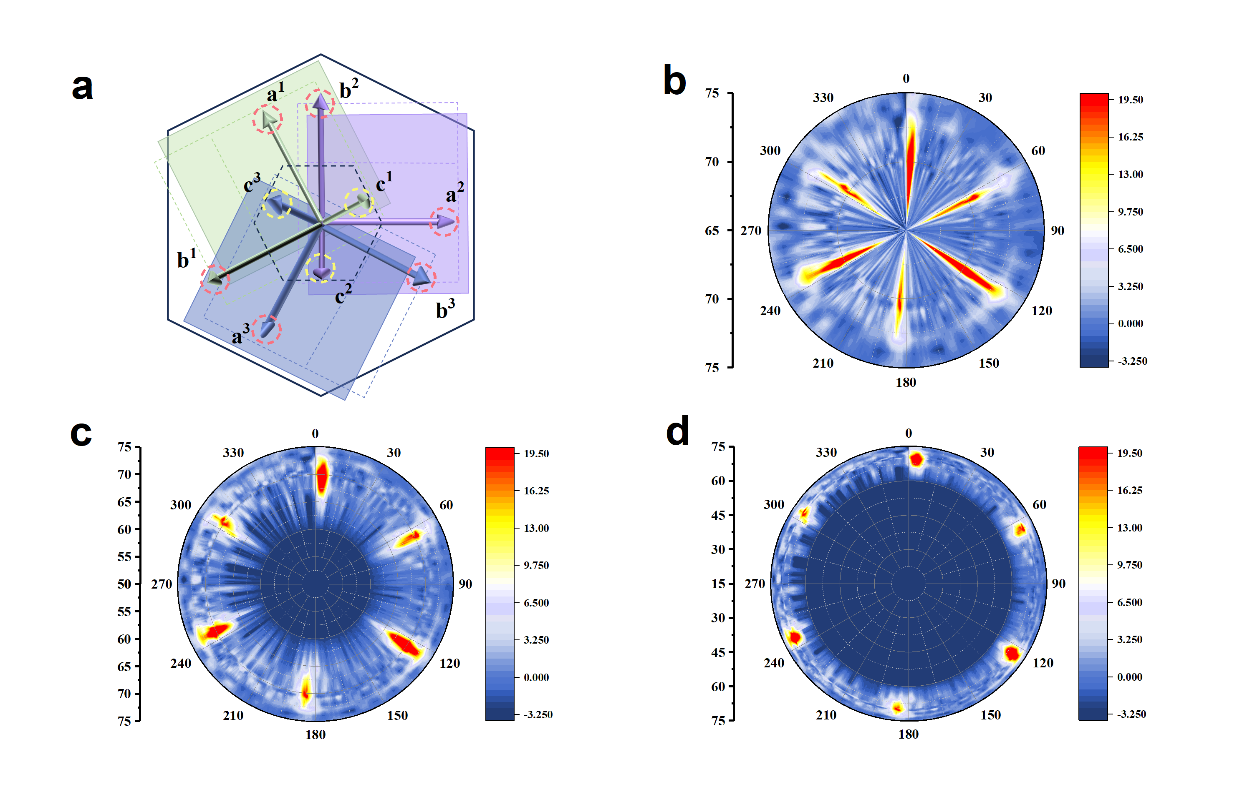
Fig. S3 | a, Schematic illustration of all possible in-plane orientations of the polarization axis in ferroelectric HfO₂ films epitaxially grown on NSTO (111) substrates. b, Pole plot of φ-scan data collected at χ = 75–65°, showing six continuous diffraction arcs due to partial crystal alignment. c, Corresponding plot for χ = 75–50°, where the arcs begin to condense into discrete spots. d, Data from χ = 75–15°, revealing further localization into six distinct diffraction spots (The pole figure shown in the main text corresponds to the χ = 75–3° interval).

1.1.4 XRD characterization of SHO films grown on substrates with different out-of-plane crystallographic orientations
To investigate the influence of different out-of-plane crystallographic orientations of substrates on the crystal structure and growth behavior of SHO films, we performed XRD analysis on samples grown on various NSTO substrates. The substrates include (100)-oriented with fourfold symmetry, (110)-oriented with twofold symmetry, and the (111)-oriented substrate used in the main text (whose symmetry was confirmed via φ-scan measurements). As shown in Fig. S4, no distinct HfO₂ diffraction peaks were detected on the (100) substrate, which may be attributed to surface polarity unfavorable for nucleation and growth. On the (110) substrate, both the orthorhombic (111) 30° peak and a more prominent monoclinic paraelectric (002) 34.2° peak were observed, indicating that this orientation facilitates the formation of the monoclinic phase. In contrast, the (111)-oriented substrate yielded a strong orthorhombic (111) diffraction peak, accompanied by its epitaxial (222) reflection. Insets show magnified views of key diffraction regions to clearly distinguish the phase components.
To understand the underlying mechanisms responsible for these substrate-orientation-dependent growth behaviors, we further performed density functional theory (DFT) calculations, which provided a consistent explanation for the observed trends.
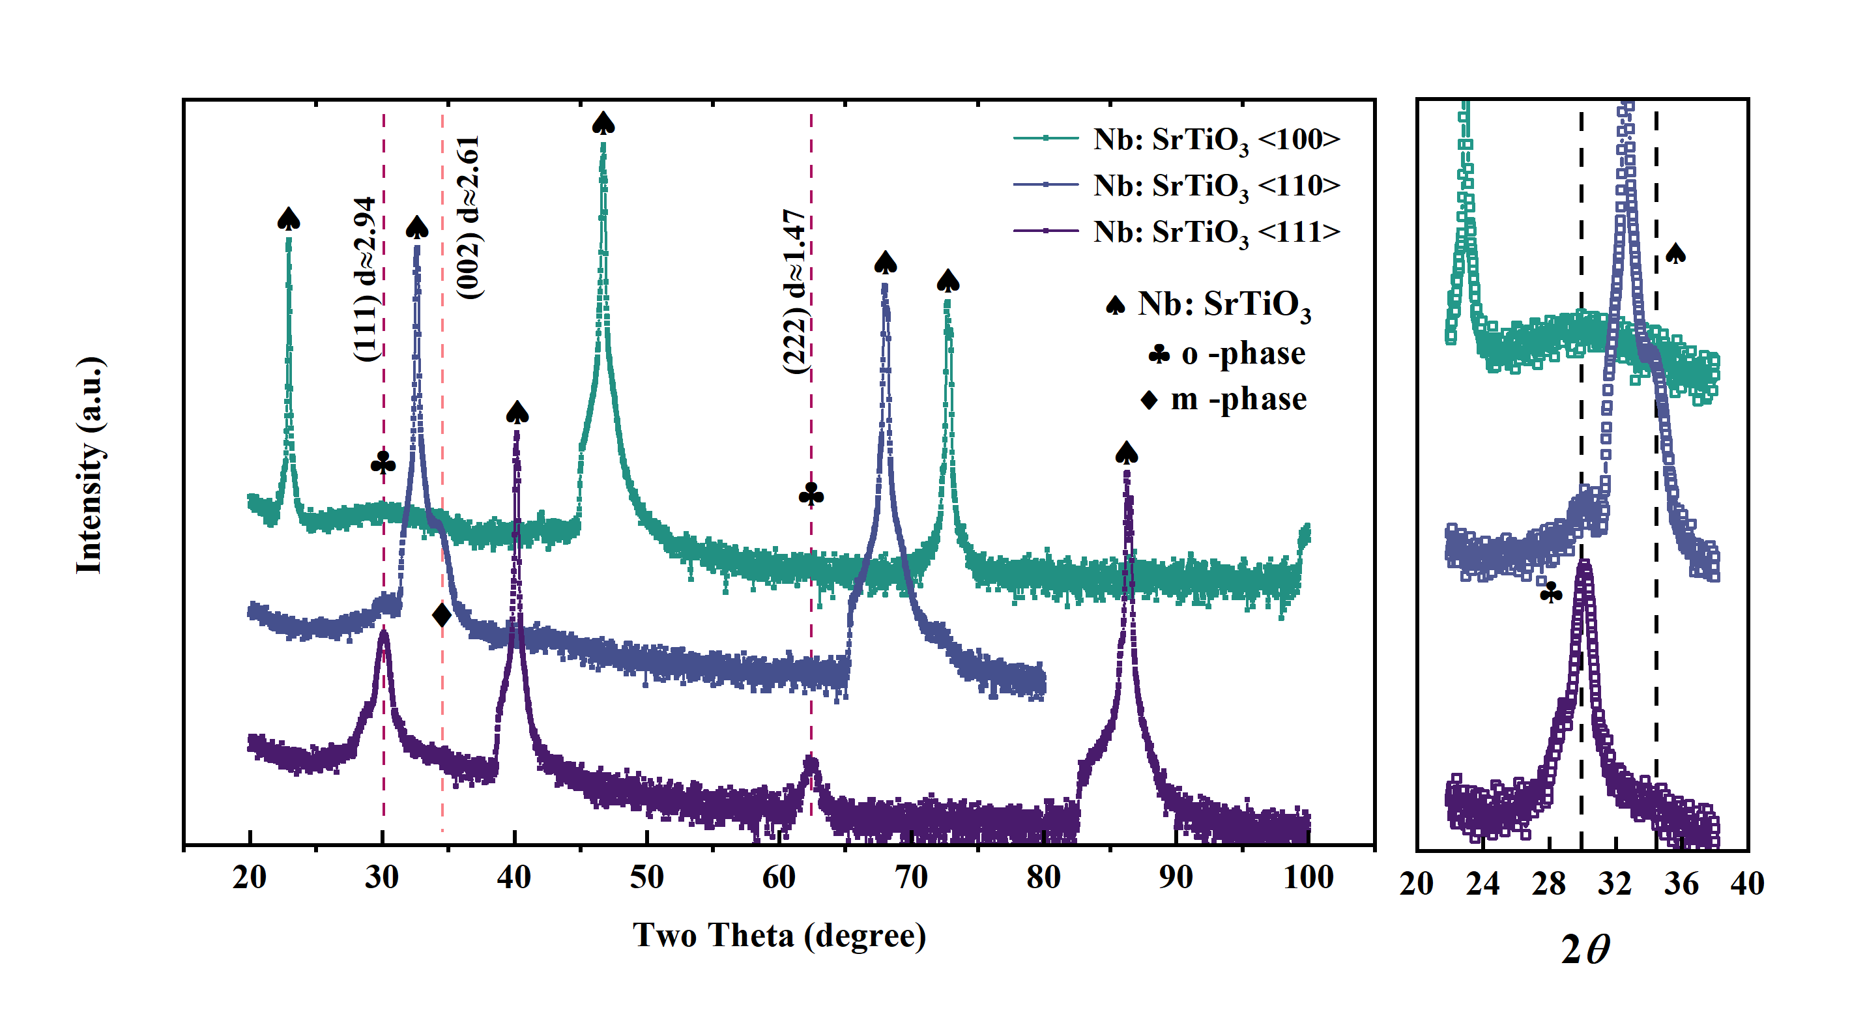
Fig. S4 | XRD patterns of Sr-doped HfO₂ thin films grown on substrates with (100), (110), and (111) out-of-plane crystallographic orientations.

1.2 Polarization–voltage dependence and cycling behavior in heterostructures with different interfacial terminations
To evaluate the endurance and stability of SHO thin films with different interfacial terminations, we performed electrical cycling tests and analyzed the presence of wake-up effects and fatigue behavior, as shown in Fig. S5a, b. Fig. S5a presents the polarization evolution of the T-type film under increasing cycling numbers. Within the range of 1 to 10⁵ cycles, the polarization increased by only ~5.8%, and remains close to the value measured after 10¹⁰ cycles. These results indicate a negligible wake-up effect and demonstrate the excellent fatigue resistance of the T-type structure.
In contrast, the S-type film exhibited ~25.0% polarization fluctuation at 10⁷ cycles, followed by a clear decline in polarization with continued cycling, accompanied by increasing asymmetry between the positive and negative polarization branches, as shown in Fig. S5b. This deterioration suggests that the S-type film cannot sustain stable polarization behavior as effectively as the T-type counterpart. Such degradation is consistent with STEM observations of localized polycrystalline regions in the S-type interface, where grain boundaries introduce structural defects that undermine the overall endurance performance of the film.
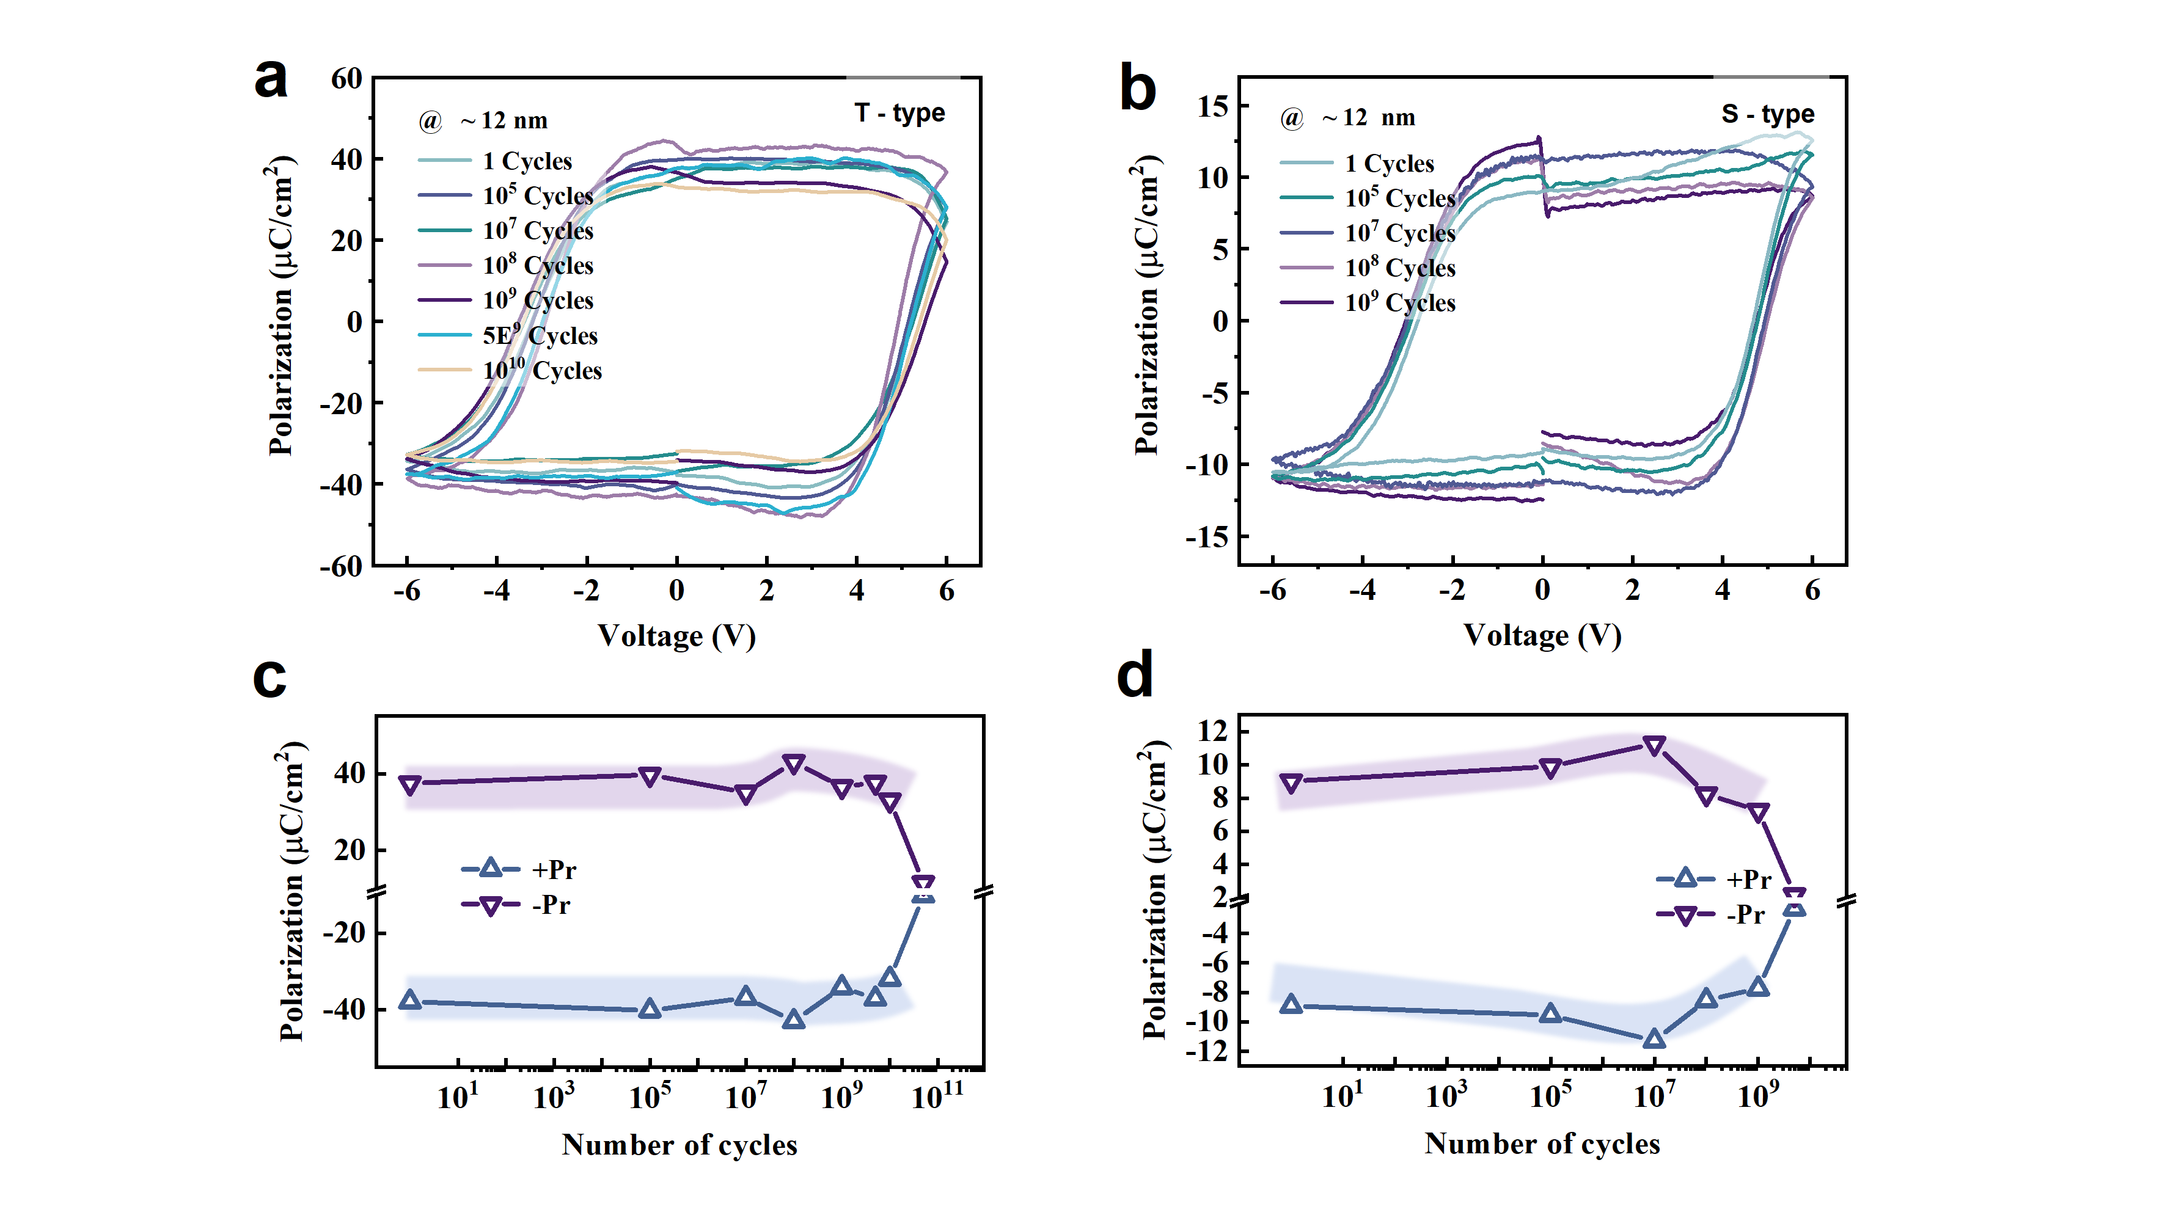
Fig. S5 | a, b Polarization evolution as a function of cycling number for T-type and S-type heterostructures.

1.3 Hysteresis and surface morphology analysis via atomic force microscopy
1.3.1 Voltage-dependent PFM phase and amplitude loops in SrO-terminated films
Figure S6 shows the out-of-plane piezoresponse force microscopy (PFM) results of the SHO/SrO–NSTO heterostructure. Figure S6a displays the PFM phase image of the sample, where a nearly 180° ferroelectric domain switching behavior is observed, similar to that of the T-type structure in Fig. 2g of the main text. However, under the same ±7 V bias voltage, the domain contrast in the SrO-terminated sample is significantly weaker than that in the TiO2-terminated sample, indicating a larger domain size and less complete switching. In contrast, the T-type film exhibits smaller domain structures, resulting in clearer switching responses and more pronounced color contrast within the same area.
Figure S6b shows the PFM amplitude image from the same region of the SrO-terminated film, where clear domain wall distributions can still be identified. Its maximum amplitude is somewhat lower than that of the T-type structure (~76 pm), further indicating that its polarization switching capability is slightly inferior to the T-type sample described in the main text.
In addition, as shown in Fig. S6c, the PFM phase and amplitude loops measured at random locations reveal that the switching speed of the S-type sample is also comparatively slower than that of the T-type film, further supporting the significant differences in microscopic domain behavior between the two termination structures.
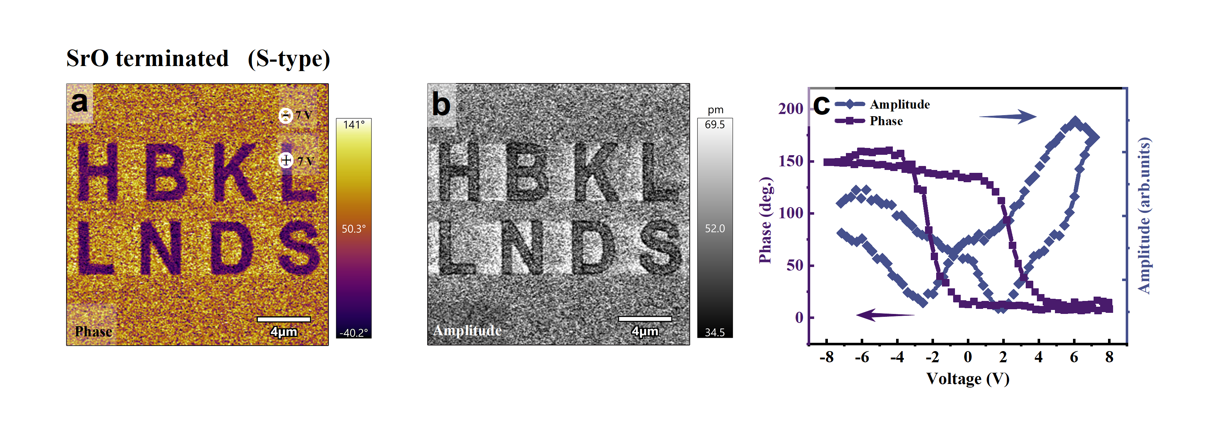
Fig. S6 | a, Out-of-plane PFM characterization: Phase image of the SrO-terminated SHO films. b, Amplitude image (scale bar: 4 μm). c, Voltage-dependent hysteresis loops of phase and amplitude signals measured by local point spectroscopy on the film surface.

1.3.2 Retention of PFM domain patterns in both terminations over time
The domain retention capability of ferroelectric thin films is crucial for long-term data storage. To this end, we evaluated the temporal evolution of the phase and amplitude contrasts in two heterostructures following polarization under a bias voltage. The results are presented in Fig. S7 and Fig. S8, which respectively show the out-of-plane PFM images of T-type and S-type films recorded over a time period of 0 to 120 minutes.
A comparison of the two images shows that the T-type film maintains a larger phase angle and well-defined domain boundaries over a longer time period, whereas the S-type film loses clear domain boundary features after 120 minutes. These results indicate that the T-type film exhibits superior domain retention behavior, which correlates with its higher polarization strength and more ideal single-crystalline structure.
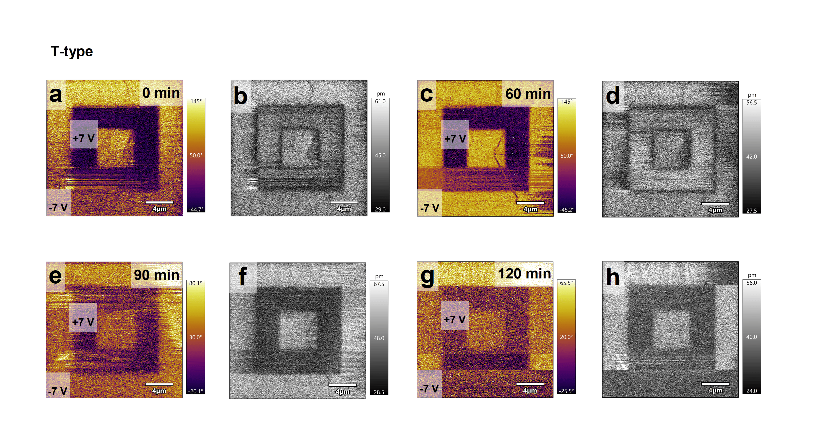
Fig. S7 | Time-dependent out-of-plane PFM phase and amplitude response of the T-type film. 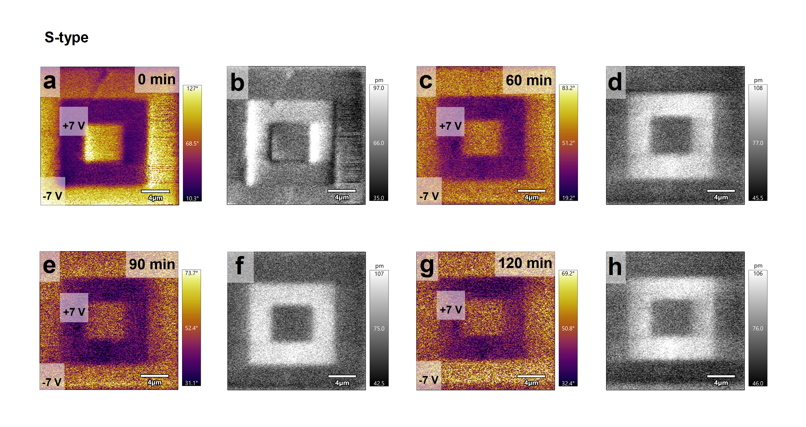
Fig. S8 | Time-dependent out-of-plane PFM phase and amplitude response of the S-type film.

1.3.3 Surface morphology evolution under different oxygen partial pressures
During the deposition of ferroelectric thin films, surface roughness serves as a critical indicator of whether the film grows uniformly on the substrate and whether the atomic arrangement is ordered. To assess the uniformity and structural order of the films, we characterized the surface morphology under various deposition conditions using atomic force microscopy (AFM), as shown in Fig. S9. Notably, under a deposition pressure of 53 mTorr, the film exhibited the most uniform step-terrace morphology.
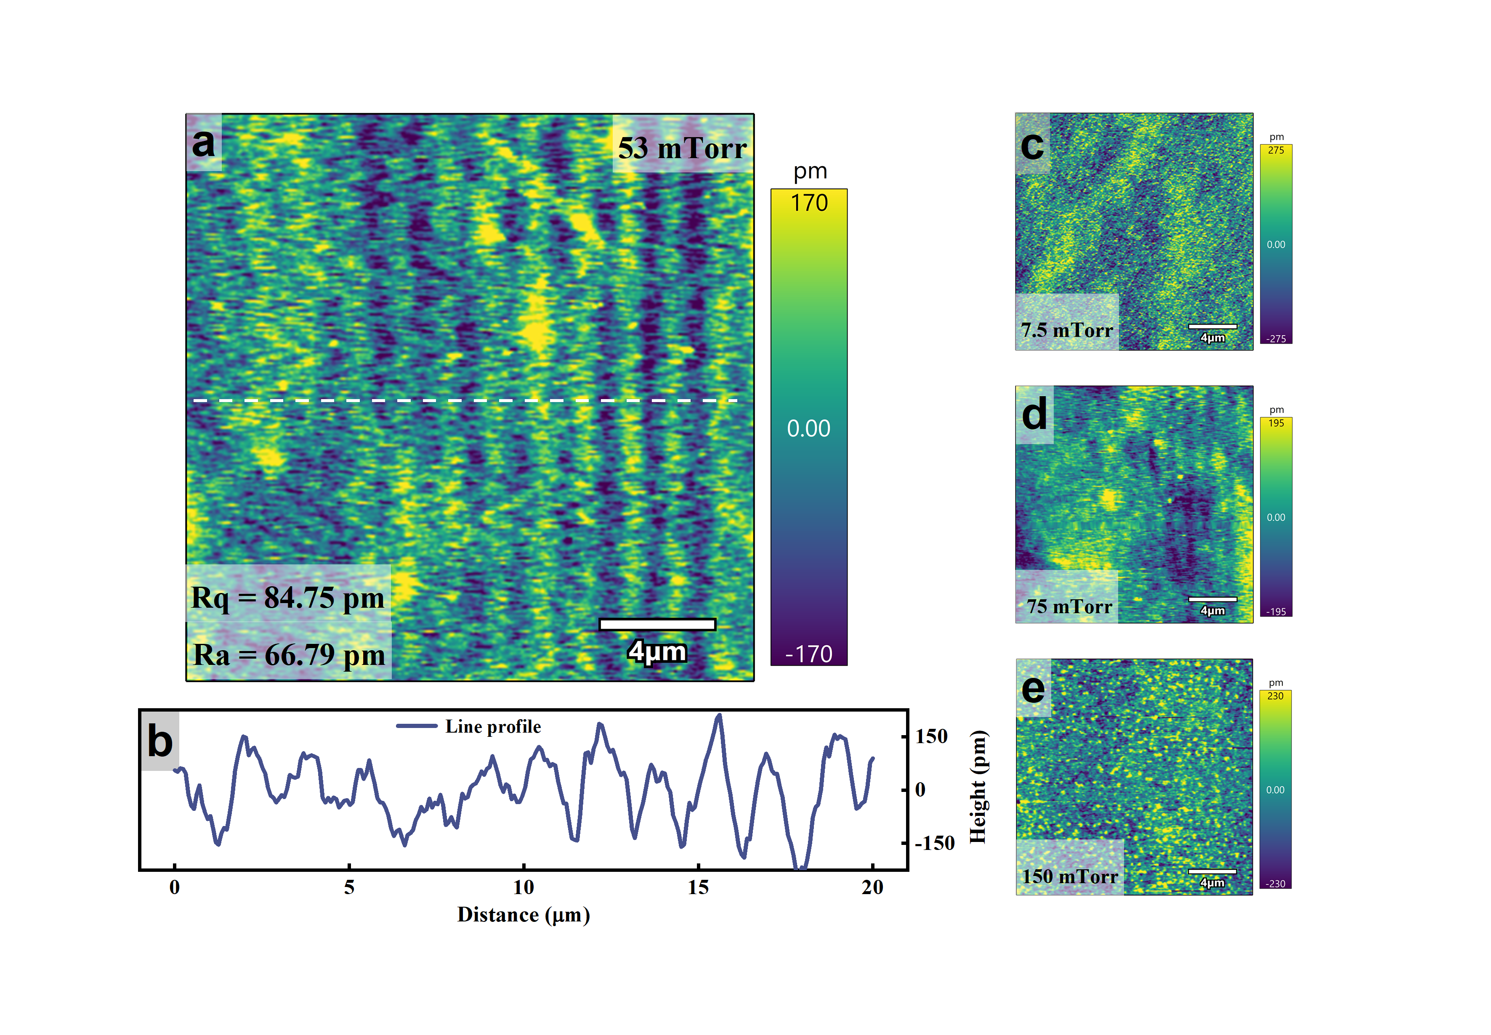
Fig. S9 | a, c–e, AFM topography images of SHO films deposited under four representative oxygen pressures. b, Line profile of surface roughness extracted from the film deposited at 53 mTorr.

1.4 Compositional analysis of thin films via X-ray photoelectron spectroscopy
To investigate the elemental valence states and defect characteristics in SHO thin films, X-ray photoelectron spectroscopy (XPS) analysis was performed in this study, as shown in Fig. S10. The O 1s spectrum exhibits a low concentration of non-lattice oxygen. The Sr 3d core-level spectrum presents two characteristic peaks at 133.50 eV (3d_{5/2}) and 135.60 eV (3d_{3/2}), confirming that Sr is incorporated into the film in the +2 oxidation state (Fig. S10b). This indicates that despite the ionic radius of Sr²⁺ (1.13 Å) being much larger than that of Hf⁴⁺ (0.78 Å), no obvious structural defects are introduced, demonstrating the excellent epitaxial quality of the SHO films. Furthermore, the survey spectrum in Fig. S10c verifies the overall elemental composition of the doped system, reflecting its high chemical purity.
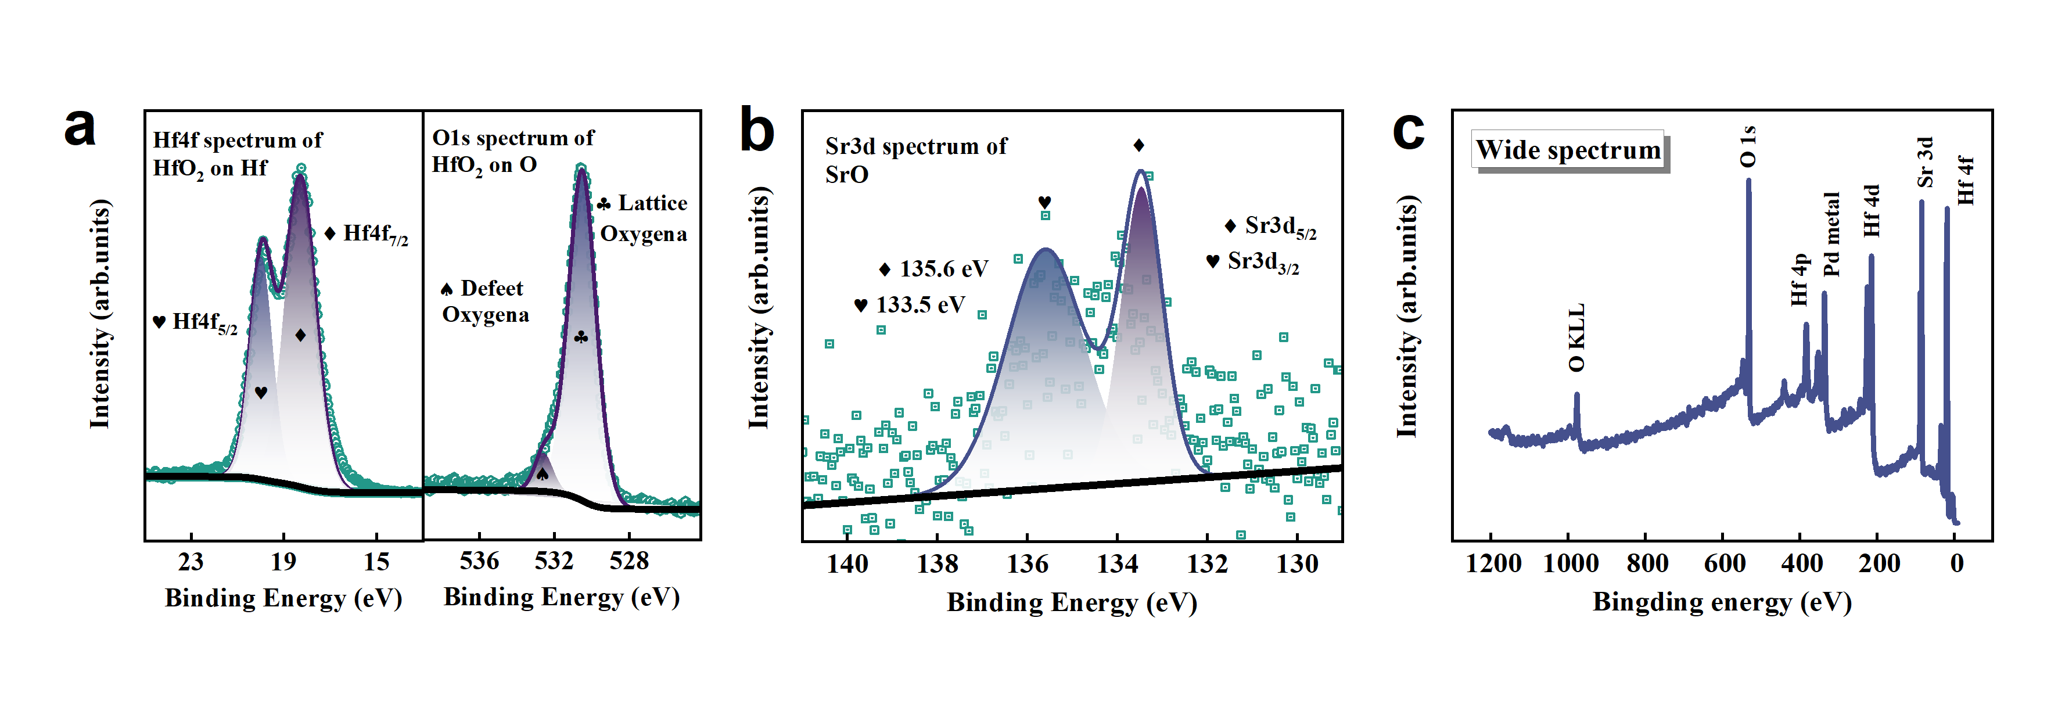
Fig. S10 | a, b, XPS spectrum of the Hf 4f, O 1s, Sr 3d core levels in the SHO thin film. c, XPS survey scan illustrating the overall surface elemental composition.

1.5 Linear-scale I–V characteristics of T-terminated films under optimal crystallinity
After establishing how interface termination regulates crystalline quality, ferroelectricity and microscopic domain structure, we next evaluated memristive devices fabricated from the highest-quality T-type film. The device adopts a metal/ferroelectric/semiconductor stack, allowing the switching characteristics, memory window, resistance-state tunability and cycling stability to be examined in a device-relevant configuration.
Under a compliance current of 1 mA, cyclic quasi-static voltage sweeps were applied along the sequence from 0 V to 8.4 V, then to −7 V and back to 0 V for multiple consecutive switching cycles (Supplementary Fig. S11a). The central panel of Supplementary Fig. S11a shows the cyclic I–V characteristics, whereas the surrounding SKPM maps track the evolution of the surface-potential landscape under different negative and positive writing voltages. The device exhibits a clear memristive window exceeding 1.4 × 10⁴, as calculated in the main text. It also shows pronounced self-rectifying behavior and stable switching over repeated sweeps, without any indication of electroforming activation, highlighting the good reproducibility of the resistive switching process.
After positive-bias writing, the polarization tends to orient toward the NSTO (111) interface. This polarization configuration promotes electron accumulation on the NSTO (111) side, narrows the interfacial depletion region and lowers the effective Schottky barrier, thereby driving the device into the LRS. At the same time, the negative bound charges at the top surface of the ferroelectric film are compensated by positive screening/trapped charges, producing a higher SKPM surface potential. Conversely, negative-bias writing reverses the polarization away from the NSTO (111) substrate, leading to electron depletion at the bottom interface, an increased effective barrier and the HRS. The positive bound charges at the top surface are then compensated by negative screening/trapped charges, resulting in a reduced SKPM potential.
Importantly, SKPM probes the electrostatic potential at the film surface and does not directly detect electron accumulation or depletion at the SHO/TiO₂-terminated NSTO interface. Instead, the SKPM contrast and bottom-interface charge modulation should be understood as two coupled consequences of the same polarization-reversal process. Thus, the SKPM potential evolution, positive-set/negative-reset behavior and self-rectifying transport can be consistently interpreted within a polarization dominated interfacial barrier modulation mechanism^{8,9}. The pronounced SKPM changes around ±2, 3 V also coincide with the current transition in the I-V curve over a similar voltage range, further linking the resistive modulation to polarization reversal. Supplementary Fig. S11b–d present the three-dimensional SKPM potential landscapes recorded after the maximum negative writing voltage, in the initial unwritten region and after the maximum positive writing voltage, respectively. Compared with the initial region, the positively written region exhibits an elevated potential, whereas the negatively written region shows a reduced potential, further supporting polarization-reversal-induced surface charge reconstruction and its correlation with memristive switching.
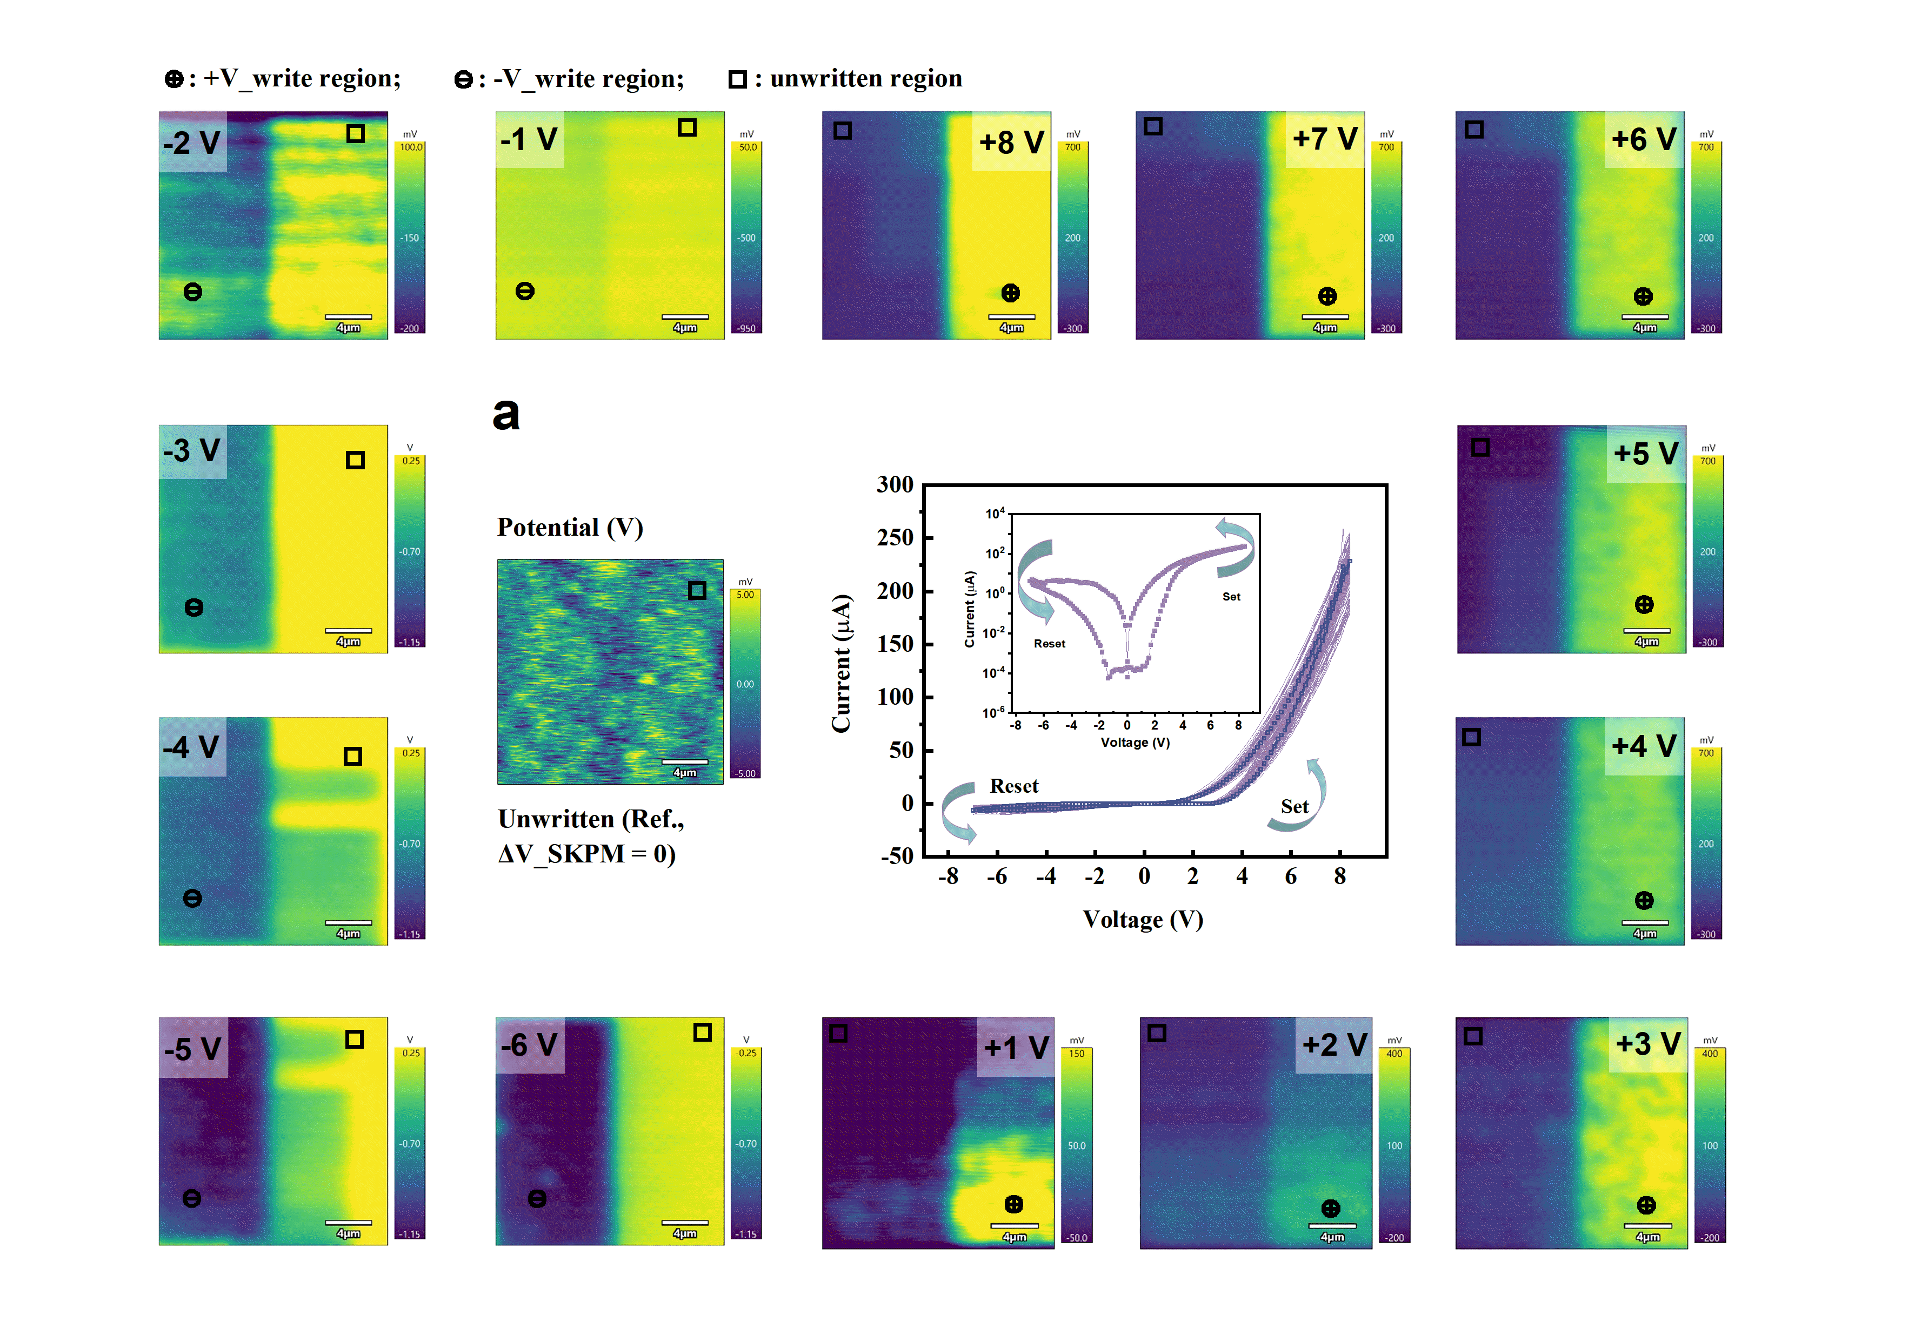
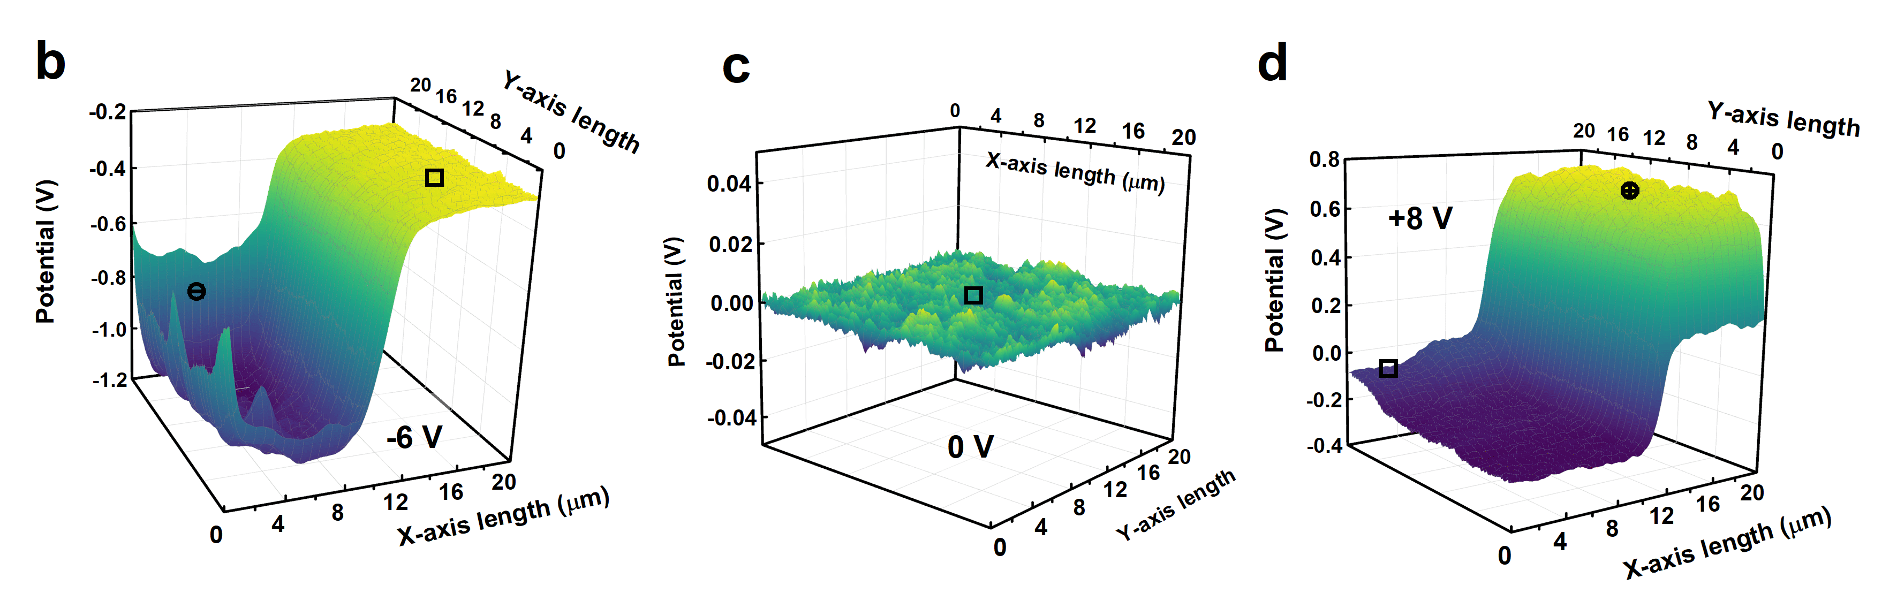
Fig. S11 | a, I–V characteristics of the T-type SHO/TiO₂-terminated NSTO memristor measured under a compliance current of 1 mA. The surrounding SKPM maps show the surface-potential evolution recorded after different negative and positive writing voltages, revealing a pronounced potential modulation near the switching-voltage range. b-d, Three-dimensional SKPM surface-potential distributions corresponding to the maximum negative writing voltage, the initial unwritten region and the maximum positive writing voltage, respectively.

1.6 Retention characteristics of neighboring multilevel conductance states
To further assess the stability of closely spaced multilevel states, retention measurements were carried out for neighboring programmed conductance states in three representative conductance regions of the Pd/SHO/T-NSTO memristor. As shown in Supplementary Fig. S12, the adjacent states remain clearly distinguishable over the measurement period and exhibit stable conductance evolution without obvious overlap. These results confirm that the device preserves reliable state separation even for closely spaced intermediate levels, further demonstrating the robustness and practicability of its multilevel memristive operation.
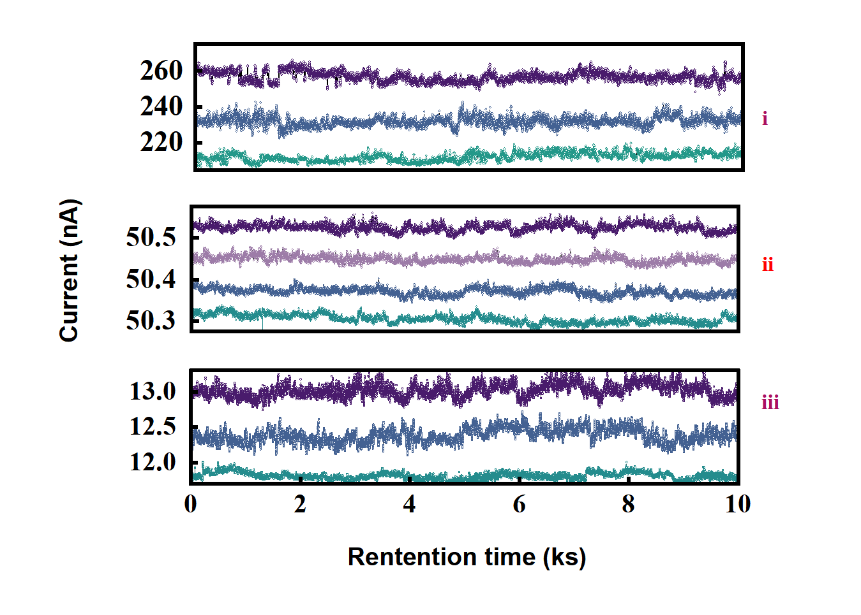
Fig. S12 | Retention behavior of programmed conductance states in three representative conductance regions of the Pd/SHO/T-NSTO memristor, confirming the distinguishability and stability of adjacent multilevel states.
2. Atomic-scale STEM analysis of heterointerfaces
2.1 Cross-sectional structural and elemental mapping of SHO/NSTO heterostructures
To further investigate the detailed crystal structure of the SHO/NSTO heteroepitaxial thin film, we conducted analysis using aberration-corrected scanning transmission electron microscopy (STEM). As shown in Fig. S13a, a low-magnification STEM image acquired in high-angle annular dark-field (HAADF) mode clearly reveals the SHO (111)/NSTO (111) architecture, with the various layers outlined by dashed lines to facilitate thickness measurements. Elemental mapping by energy-dispersive X-ray spectroscopy (EDS), presented in Fig. S13b, distinctly shows the spatial distribution of Sr, Pd, and Hf elements. Both the interface between the SHO film and the underlying NSTO substrate (serving as the bottom electrode), and the interface with the top structure exhibit exceptional sharpness, reflecting the high interfacial stability achieved during the fabrication process.
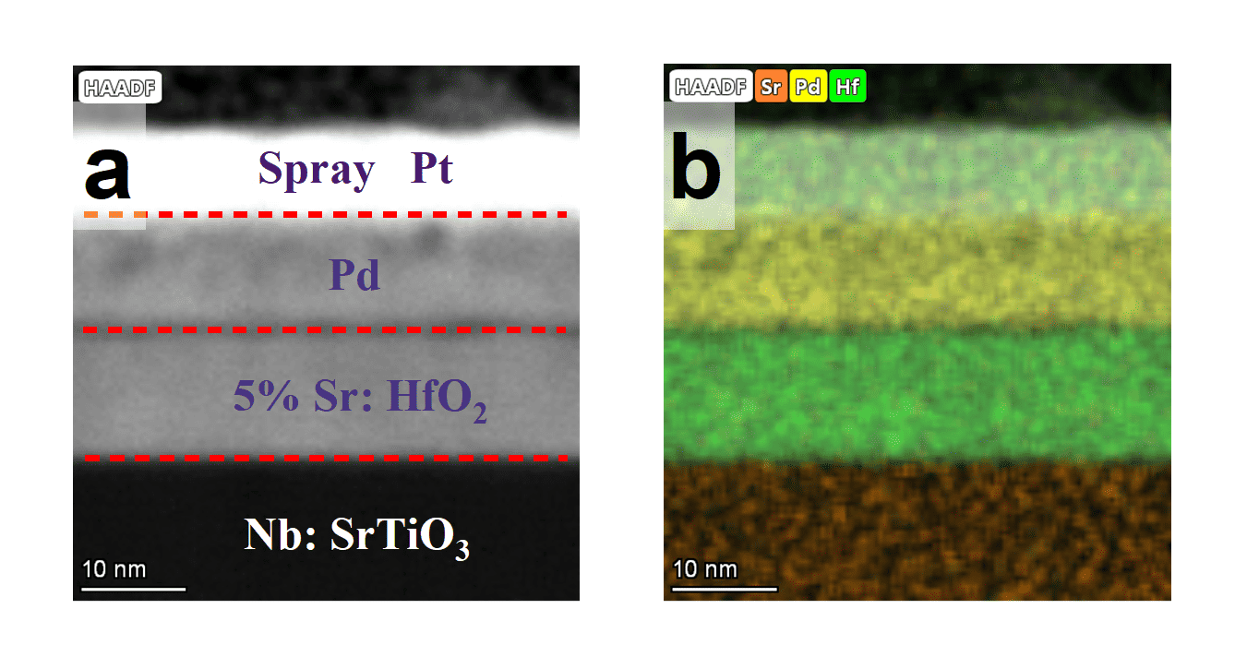
Fig. S13 | a, Low-magnification HAADF-STEM image showing the full cross-sectional architecture from top to bottom: Pd/SHO/NSTO. The thicknesses of the top electrode and ferroelectric layer are approximately 10 nm and 12 nm, respectively. b, EDS elemental mapping corresponding to the region in (a), highlighting the spatial distribution of Pd, Sr and Hf elements.

2.2 Atomic-resolution images and corresponding lattice models of different termination layers
In TEM, rotating the zone axis plays a crucial role in analyzing the crystal structure of materials via multi-angle electron diffraction and imaging. By rotating the sample holder, different sets of crystal planes can satisfy the Bragg condition, producing symmetric diffraction patterns that reveal information about the crystal orientation, symmetry, and phase¹⁰.
In this study, we first confirmed the effective control of different termination layers, as shown in Fig. S14a and Fig. S14b. By analyzing atomic-resolution images with varying contrast, we clearly identified Ti atoms with a smaller ionic radius as the terminating layer in Fig. S14a, while Sr atoms served as the terminating layer in Fig. S14b. The SHO films grown on these distinct termination layers exhibited different zone-axis orientations; however, their out-of-plane crystallographic plane consistently remained (111). We further performed a series of analyses on the different layers, including inverse Fourier transform (IFT) processing, crystallographic orientation calibration, and SAED pattern simulation. The results indicate that all the films exhibit highly symmetric structural features, as illustrated in the inset of Fig. S14. Fig. S14c and S14d display atomic models of SHO films oriented along the [101] and [100] zone axes, respectively¹¹. In subsequent analyses, we conducted detailed measurements of the crystal planes to further confirm the epitaxial growth directions.
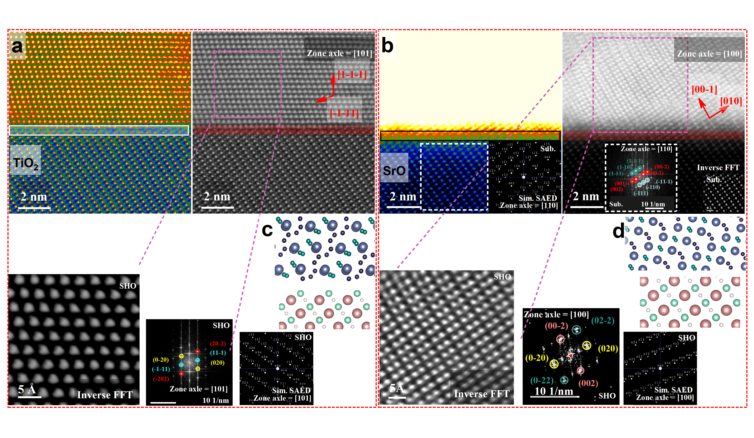
Fig. S14 | a, b, Atomic-resolution images of T-type and S-type heterostructure films, the inset on the left shows thermal contrast images to facilitate the observation of interfacial contact atoms (presented in the lower-left inset are the IFT atomic image, along with the experimental and simulated SAED patterns). c, d, Atomic lattice models of SHO films in T-type and S-type heterostructures along the [101] and [100] zone axes, respectively.
2.3 Crystalline quality of S-terminated films analyzed at atomic resolution
To compare the crystalline quality of SHO films grown on different termination surfaces, we also performed atomic-scale high-magnification HAADF imaging on the sample with SrO termination. As shown in Fig. S15a, the SHO film grown on the S-type termination exhibits slightly reduced crystallinity, with local regions showing the presence of crystal boundaries, rather than a large-area, fully coherent single-crystalline epitaxial structure. The film is primarily oriented along the [101] zone axis, while polycrystalline domains with different orientations appear on the left and right sides.
In contrast, the SHO film grown on the T-type heterostructure exhibits continuous ferroelectric-phase lattice planes aligned along the [110] zone axis across the entire HAADF image, as shown in Fig. S15b and Fig. 3a in the main text, indicating its excellent crystalline integrity. The epitaxial relationship is determined to be SHO [2-20] // NSTO [1-10] and SHO [-11-2] // NSTO [-11-2]. The inset presents the inverse Fourier transform and corresponding lattice model along this zone axis, further confirming its superior epitaxial quality. These structural features are consistent with the XRD analysis results presented in the main text.
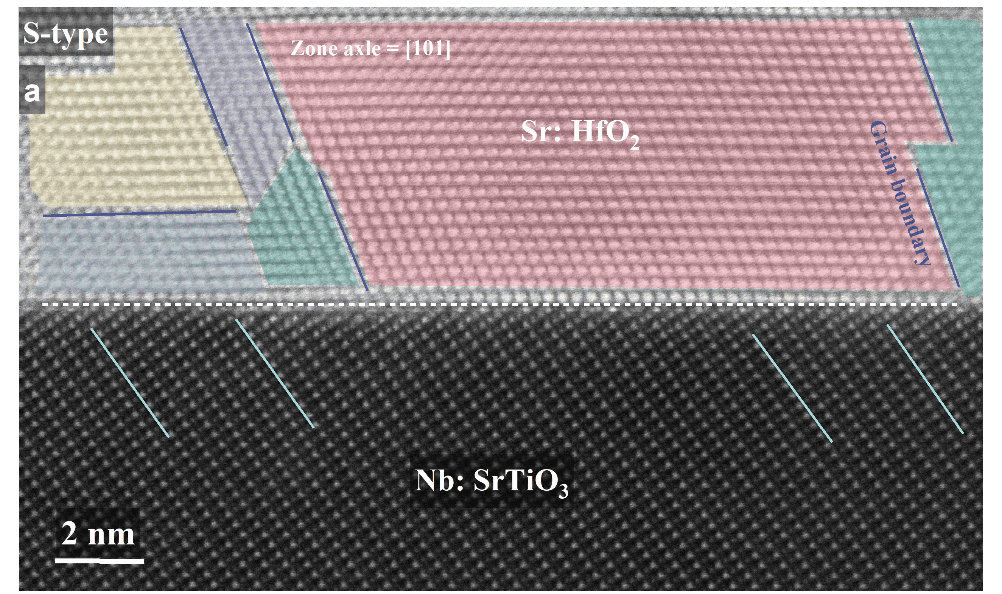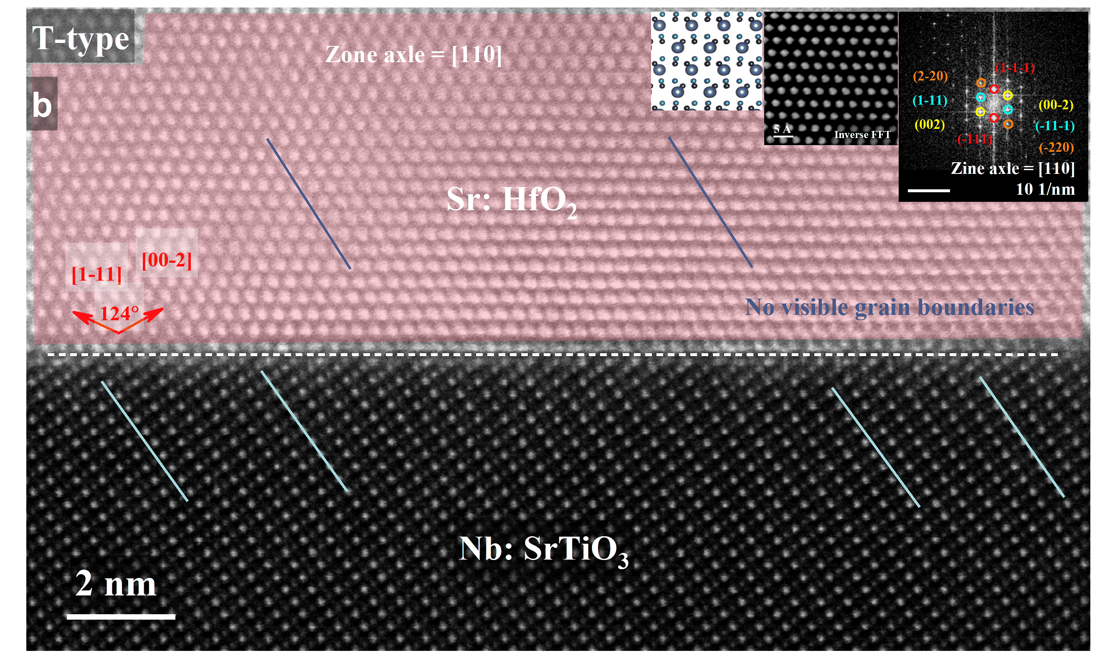
Fig. S15 | a, b, HAADF-STEM images of the SHO/NSTO interface for the S-type and T-type heterostructures, respectively.
2.4 EELS characterization of interfacial chemical environments in both heterostructures
After a detailed evaluation of the heterostructure crystallinity, we employed electron energy‐loss spectroscopy (EELS) in a TEM to probe the electronic structure immediately above and below the two distinct interface terminations (Fig. S16). First, a pristine interface region was identified in high‐resolution TEM mode, and EELS line scans were subsequently performed at equidistant positions across the interface. The resulting spectra reveal pronounced differences in the electronic structure of SHO (111) / NSTO (111) heterostructure films depending on the type of interface termination.
Figs. S16a–c presents the O K-edge and Hf M-edge EELS spectra for SHO films grown on T-type terminated substrates. The O K-edge exhibits two well‐resolved peaks, corresponding to transitions into the e_g and t_2g molecular orbitals arising from Hf 5d–O 2p hybridization¹². The energy separation between these peaks reflects the crystal field splitting of the Hf 5d states within the local oxygen environment (the background area is distinguished by different colors, representing the discrete crystal field configuration inside the material). This observation is consistent with previously reported EELS and NEXAFS spectra of highly crystalline ferroelectric HfO₂ films, further confirming the stability of the orthorhombic ferroelectric phase in these T-type structures, rather than a dopant-induced tetragonal phase. Moreover, the Hf M-edge spectra display peak insertion features analogous to those observed for the Ti L-edge in the main text, indicative of Hf–Ti intermixing.
Figs. S16d–f show the corresponding O K-edge and Hf M-edge spectra for SHO films grown on S-type terminated substrates under identical conditions. Although the O K-edge again reveals a dual-peak structure—confirming a dominant orthorhombic ferroelectric phase—the overall spectral intensity is slightly reduced compared to that of the T-type films, consistent with the lower crystallinity observed in STEM atomic-resolution images. In contrast, the hybridization between Hf 6sp orbitals and O 2p orbitals is relatively weak — a feature that may be obscured in the o-phase (Pca2₁) but could become more apparent in the amorphous state or in other phases, such as the monoclinic phase (P2₁/c). As shown in Fig. S16e, this phenomenon occurs at the S-type terminated interface, further confirming the possible presence of a small amount of monoclinic phase or amorphous phase. The Hf M-edge insertion features are less pronounced, reflecting marginally diminished atomic structural integrity and compositional uniformity in the S-type films, and suggesting a relatively lower stability of the orthorhombic phase in these structures.
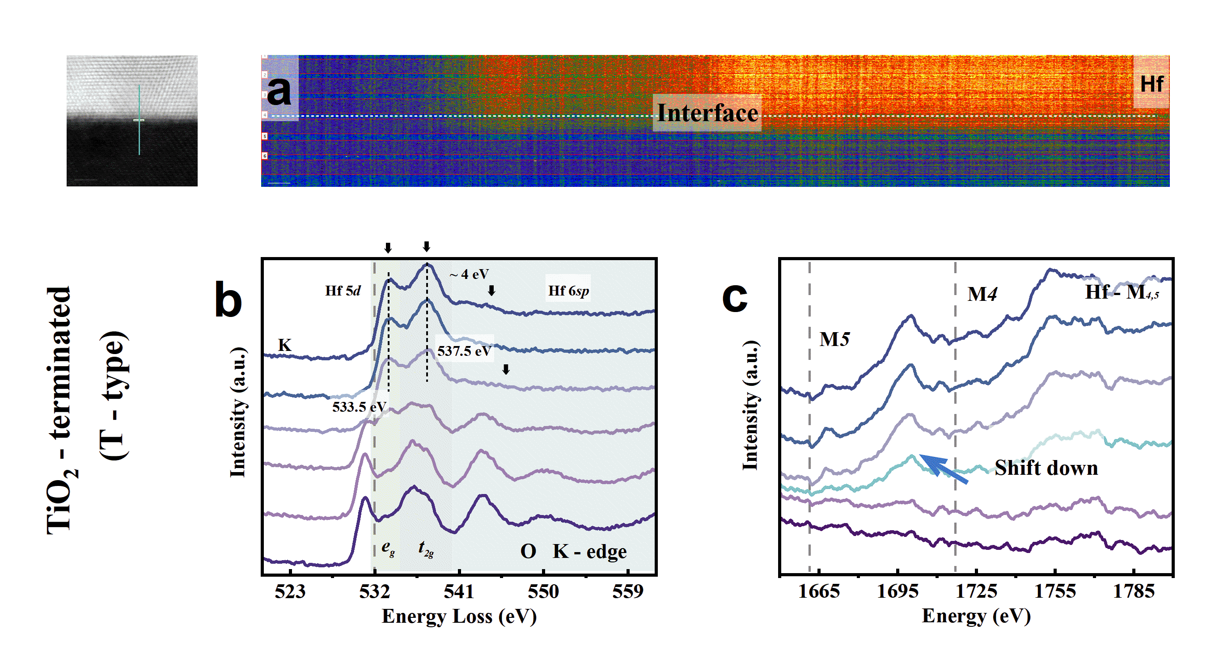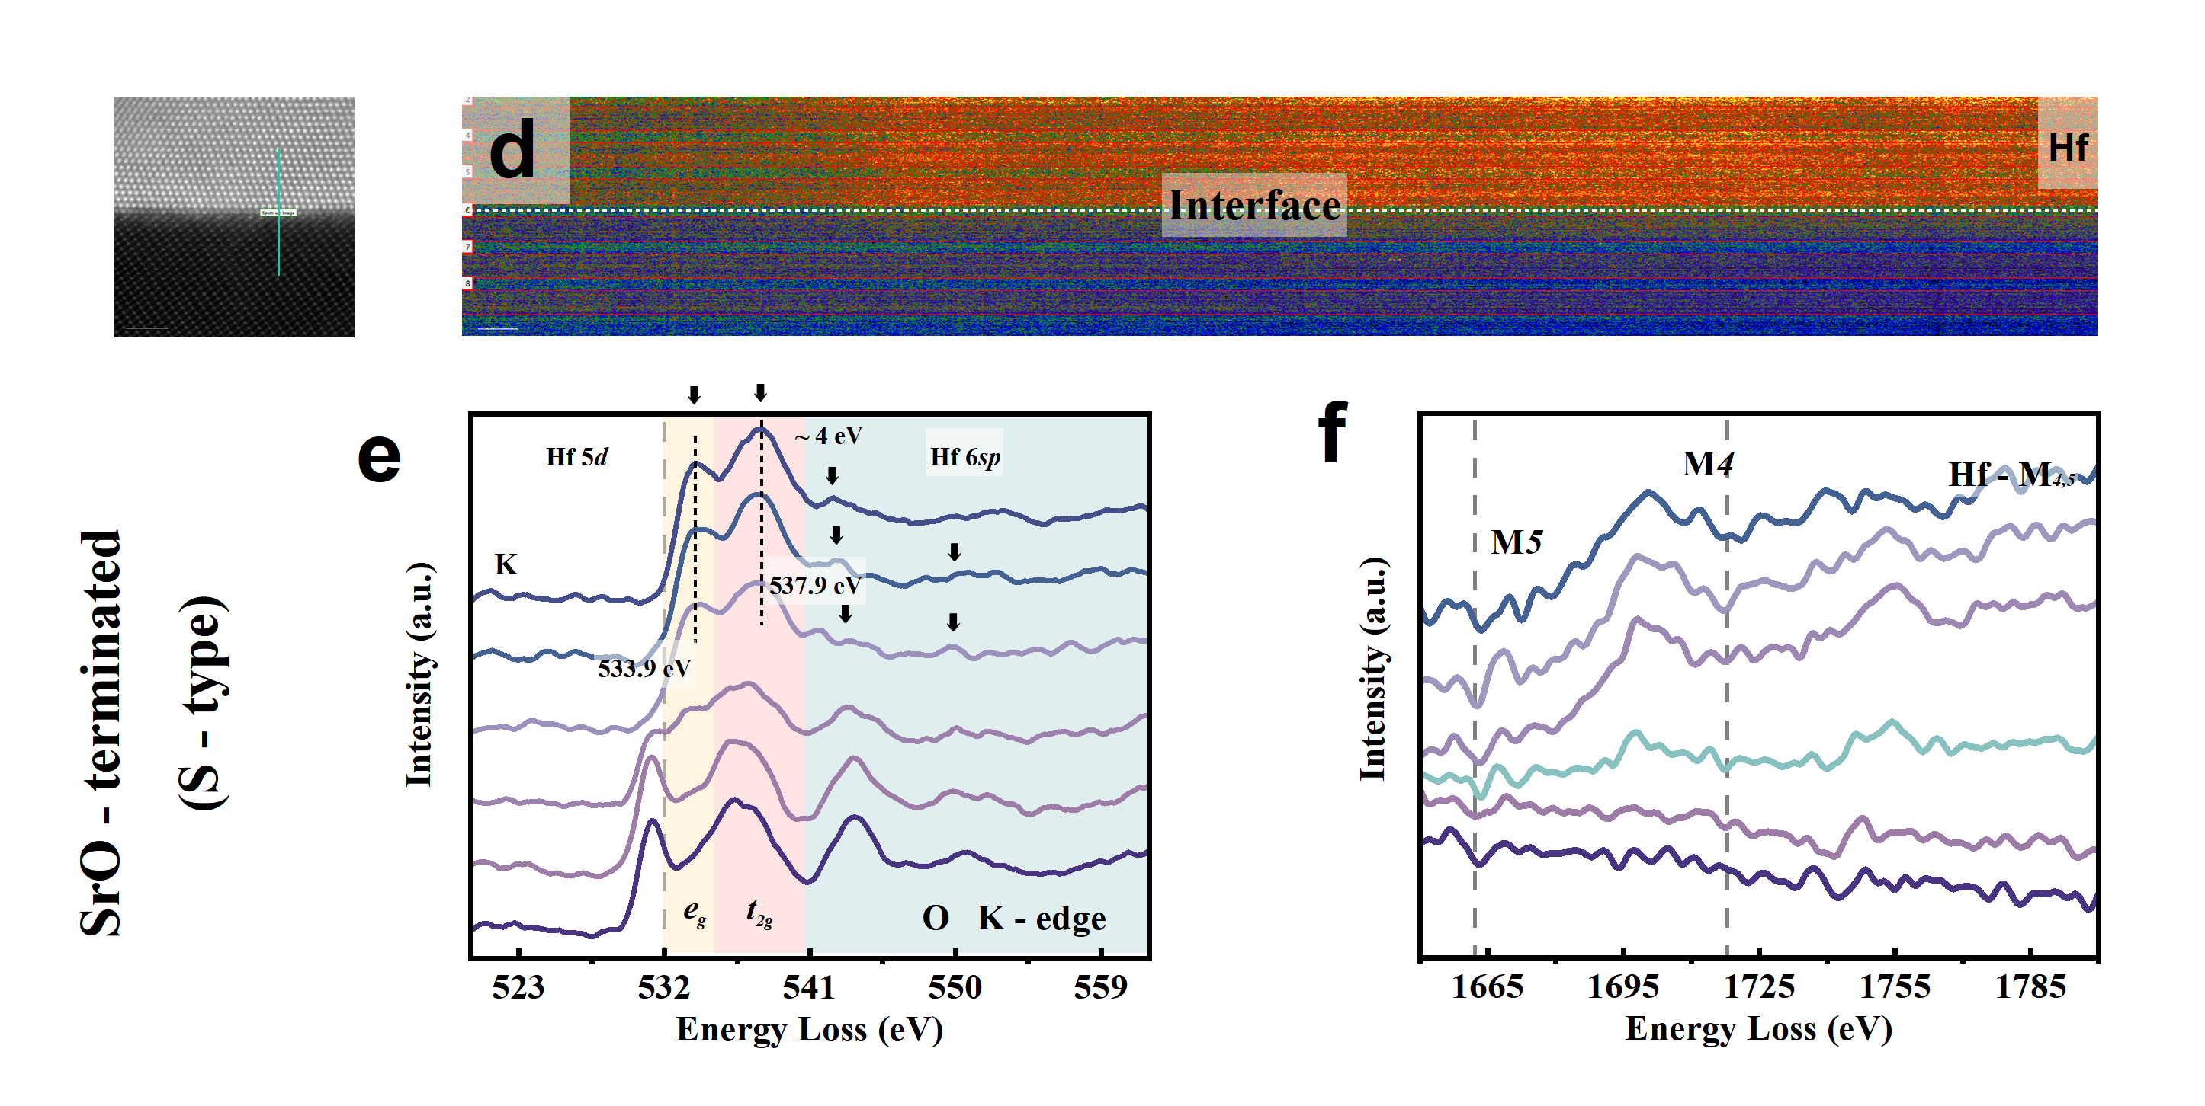
Fig. S16 | a–c, O K-edge and Hf M-edge EELS spectra of SHO films grown on T-type-terminated substrates, showing pronounced peak splitting and strong hybridization features. d–f, Corresponding spectra of SHO films grown on S-type-terminated substrates under the same conditions, showing reduced intensity and weaker Hf–Ti hybridization, consistent with lower crystallinity and phase stability.

2.5 Interfacial spacing measurement at the atomic scale
In addition, structural differences are also reflected in the out-of-plane lattice spacing at the interface between the SHO and NSTO heterostructures, as shown in Fig. S17. Fig. S17a shows the analysis of the out-of-plane atomic layer spacing in the interfacial region of the T-type sample. The interfacial spacing is approximately 4.00 Å, significantly larger than in regions farther from the interface (approximately 2.96 Å above and 2.31 Å below the interface). In contrast, the interfacial out-of-plane spacing in the S-type sample is about 2.67 Å (Fig. S17b), whereas the spacing in regions away from the interface is comparable to that in the T-type structure. This interfacial spacing is close to that of the (002) plane of the paraelectric monoclinic phase, suggesting that a small amount of the paraelectric phase may be present at the interface. This may disrupt the continuous epitaxial growth of the ferroelectric phase in the S-type structure, a hypothesis further supported by the STEM observations. This pronounced difference further indicates substantial interfacial reconstruction in the T-type heterostructure. Similar phenomena have also been reported by Chambers et al., who attributed the interfacial reconstruction observed in LaFeO₃/n-SrTiO₃ heterojunctions to the introduction of free carriers via partial Fe–Ti substitution¹³.
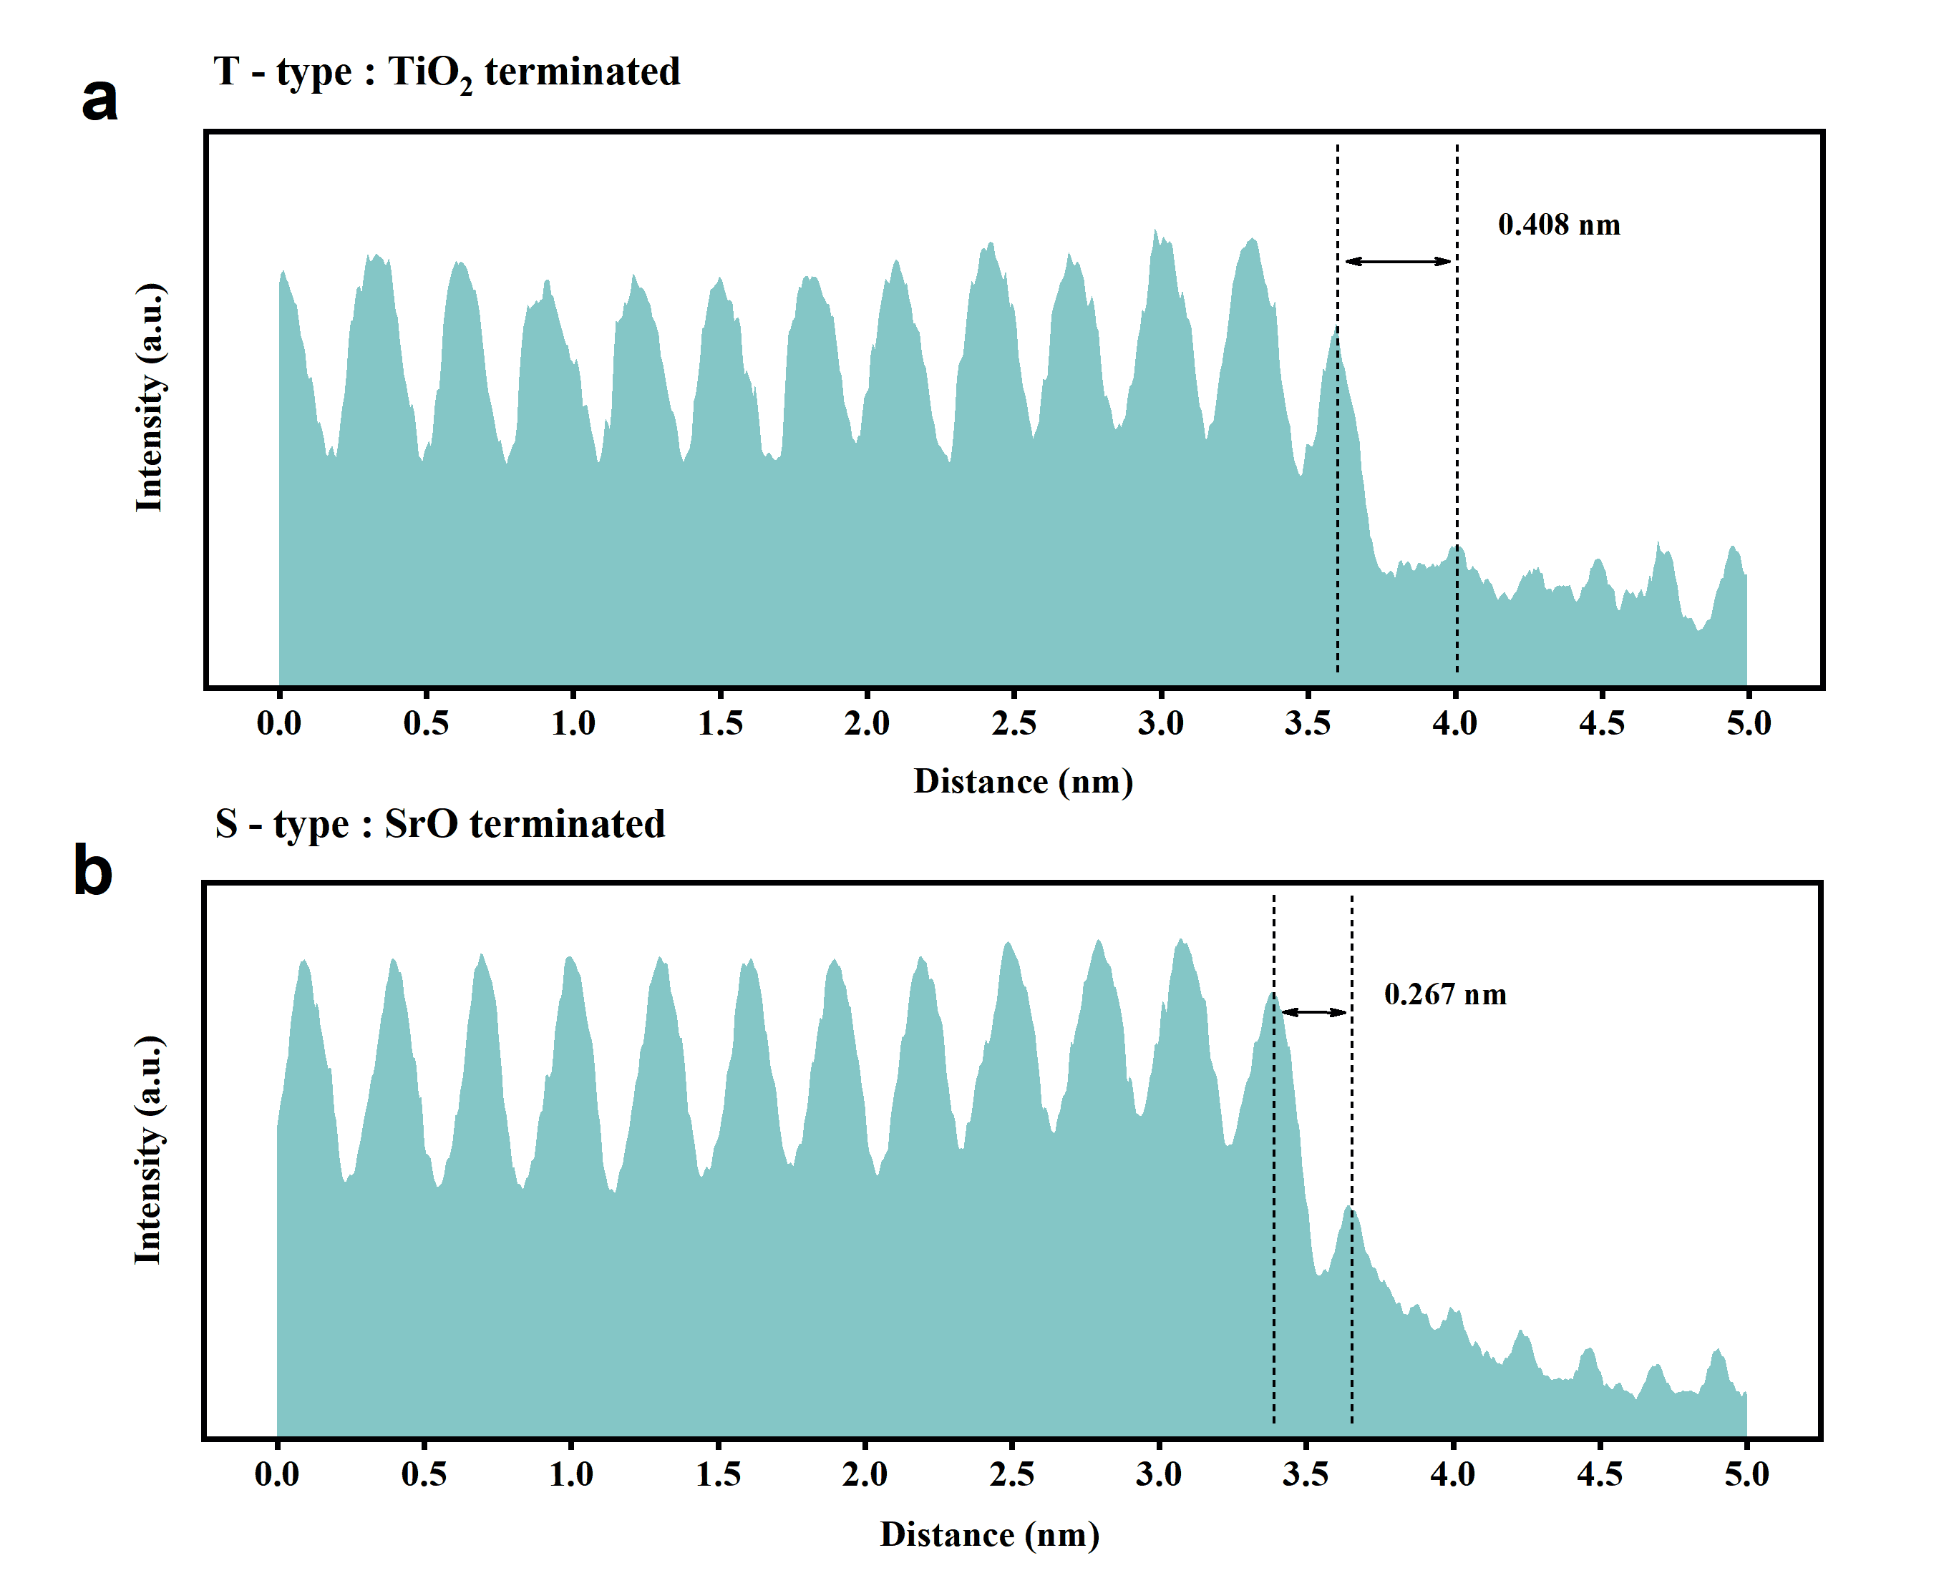
Fig. S17 | Interplanar spacing across the interface in T-type (a) and S-type (b) heterostructures, measured from high-resolution STEM images.
3. Density functional theory analysis
To understand the strain effect on the phase stability we consider different crystallographic orientations (001,110,111) as shown in Fig. S18¹⁴. The difference in cell axes corresponding to (001)-oriented films cause the in-plane lattice constant to span from 4.8 to 5.5 Å, as is seen in Fig. S18a. Whereas the m-phase has its lowest energy at 5.2 Å and rises on both sides of the minimum, the o-phase loses energy at lower in-plane constants of 5.0 Å and gains energy as it is stretched. Therefore, the m-phase is stabilized by tensile epitaxy (a > 5.2 Å) while the o-phase is highly favored by compressive epitaxy (a < 5.0 Å). At the strain where the monoclinic phase becomes more stable than the orthorhombic phase, the curves intersect at 5.1 Å. Fig. S18b illustrates how the (110) and (001)-orientations behave similarly. However, the m-phase is at 5.20 Å, while the o-phase minimum is at 5.07 Å. Tensile strain (> 5.20 Å) drives the balance to the monoclinic phase, while compressive strain (< 5.07 Å) brings the o-phase down below the m-phase in energy once more. Due to the unique lattice-matching geometry of the (110) plane, the crossover is displaced at (≈ 5.13 Å) with respect to the (001) direction.
In Fig. S18c, this step probes into the polarization of the Pca21 phase in different orientations. The polarization results were analyzed using the Berry-phase approach in the (001), (110) and (111) oriented direction for the ferroelectric phase. The results highlight (001), (110) and (111) with polarization of ~51.3 µC/cm², ~53.8 µC/cm² and 38.5~42.7 µC/cm² respectively. Even though the polarization values are higher for (001) and (110), stabilizing the ferroelectric phase in these orientations are shown to be unfavorable. The (111) orientation however, proves to be a more favorable direction to stabilize and grow the ferroelectric phase regardless of its lower polarization.
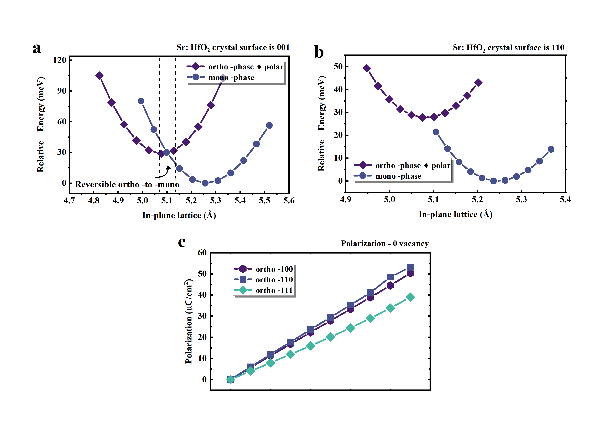
Fig. S18 | Epitaxial Strain and Polarization of HfO₂ Polymorph. a, (001)-oriented monoclinic and orthorhombic phase under strain. b, 110-oriented monoclinic and orthorhombic phase under strain. c, calculated polarization of (001,110,111) orthorhombic phase.

4. The application of ferroelectric memristor system in scientific computing and lightweight fuzzy neural network
4.1 Mapping the complex-valued matrix operation of the inverse discrete Fourier transform (IDFT)
To highlight the fundamental differences between the two mapping mechanisms, we compared their voltage-distribution characteristics. Under the direct mapping (DM) strategy, a single global voltage scaling rule leads to highly compressed voltage distribution with extremely narrow dynamic range. For example, in block 3707 of the B channel, the mapped voltage spans only 0.4975~0.5040 V, corresponding to merely 1.10% voltage dynamic range utilization. Such limited dynamic range fails to distinguish amplitude variations between low- and high-frequency components, degrading frequency-to-voltage mapping accuracy and inducing information aliasing and reconstruction distortion, as illustrated in Fig. S19a.
In contrast, the baseline-separation and high–low-frequency–partition (BS-HLFP) strategy establishes independent normalization baselines and voltage mapping rules for low-frequency components related to image contours and high-frequency components corresponding to astronomical details and textures. Under identical block and channel conditions, the exploitable voltage range is extended to 0.2000~0.8000 V, reaching 100% utilization of hardware voltage window and fully covering the optimal operating region of SHO memristors. Benefiting from the strict linearity of IDFT:
$$IDFT\left(X_{low}+X_{high}\right)=IDFT\left(X_{low}\right)+IDFT(X_{high})$$
independent voltage optimization is only performed in the voltage domain, and all optimized voltage signals are merged before computation. Only one complete 2D-IDFT operation is executed per block without redundant overhead, which is well compatible with the fixed computational dimension constraint. This mechanism greatly improves the precision of frequency-to-conductance mapping, as shown in Fig. S19b, and lays a solid foundation for high-precision physical IDFT computation.
Figs. S19c and S19d further verify the comprehensive performance advantages of the proposed strategy from quantization compatibility and multi-dimensional reconstruction metrics. Under 10-bit quantization matching the intrinsic hardware resolution of SHO memristors, the BS-HLFP strategy achieves distinctly lower reconstruction mean squared error (MSE) than pure algorithmic quantization under the same precision. Meanwhile, structural similarity metrics including SSIM, MS-SSIM and FSIM all approach unity, achieving collaborative optimization of pixel-level accuracy and structural fidelity. These results complement the peak signal-to-noise ratio (PSNR) and signal-to-noise ratio (SNR) advantages presented in Fig. 4e of the main text, collectively demonstrating that BS-HLFP enhances frequency-domain voltage mapping precision, and synergizes with accurate multilevel conductance modulation of SHO devices to suppress frequency-domain distortion. Consequently, the reconstruction quality surpasses low-bit (6-bit, 8-bit) pure algorithmic quantization, and approaches the performance of the 10-bit ideal algorithm benchmark.
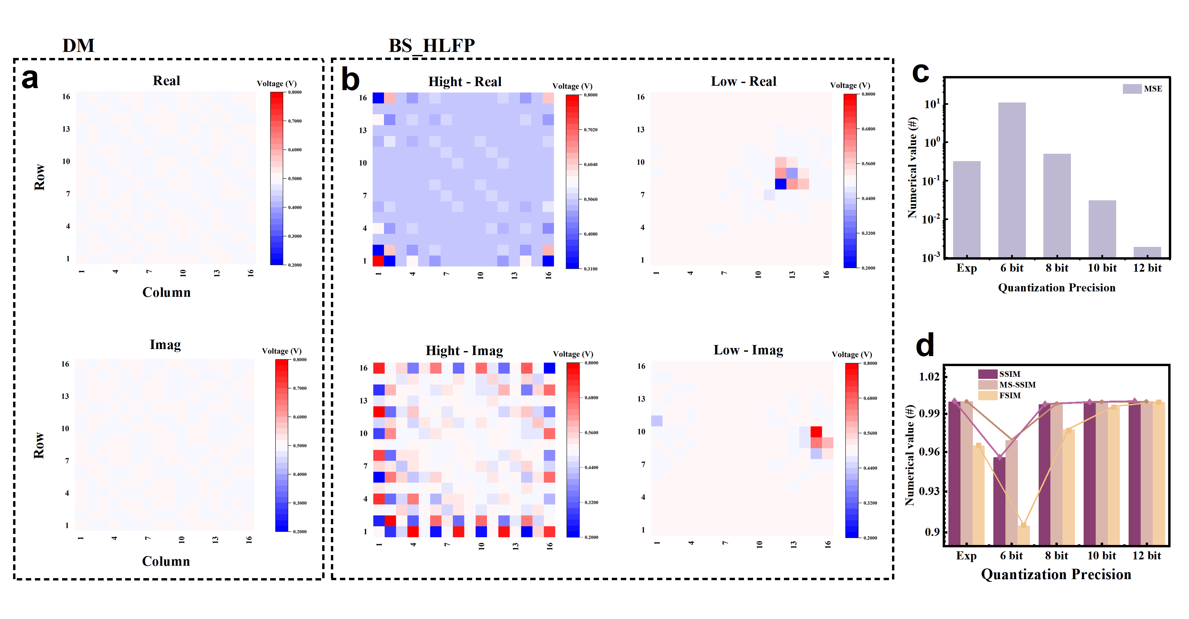
Fig. S19 | a, Heatmaps of the voltage distributions corresponding to the real and imaginary parts obtained from the IDFT operation under the direct mapping strategy. b, Heatmaps of the voltage distributions for the real and imaginary parts of the high-frequency and low-frequency components under the BS-HLFP strategy. c, Comparison of the MSE between the BS-HLFP strategy and the direct algorithm at quantization precisions of 6, 8, 10, and 12 bits. d, Comparison of the image reconstruction quality metrics.
A total of 4096 non-overlapping blocks from the 512×512 RGB galaxy image were processed and evaluated point by point. The overall framework adopts a scheme of hardware calibration combined with CrossSim platform simulation. The original large image was divided into 8×8 blocks and zero-padded to 16×16 to match computational dimensions. One-time single-device conductance calibration was completed in advance with all measured parameters stored, and all subsequent block computations were carried out on the platform based on the imported conductance dataset. Merely zero-padding was adopted for dimension matching without extra software post-processing, and the complete image was finally obtained via algorithmic block splicing.
In the frequency domain, the amplitude reconstruction accuracy is excellent: the relative amplitude error of all three channels remains below 0.04, with the B channel exhibiting the best performance (relative error of 0.0335 and an MSE of 38163.93). The errors of all channels are confined within a narrow distribution range, and no noticeable distortion of frequency-domain energy is observed. The phase reconstruction accuracy further surpasses stringent high-precision thresholds, mean phase errors for all channels are below 0.04 rad, substantially outperforming the π/10 (≈0.314 rad) criterion. In the low-frequency region, which encodes the core structural information of the galaxy, the phase deviation approaches zero, providing essential support for the accurate recovery of astrophysical morphology.
In the spatial domain, pixel-level distribution matching reaches an exceptionally high level: the Bhattacharyya coefficients of all channels approach zero, and the histogram correlation coefficients consistently exceed 0.995, with the B channel reaching an ultrahigh value of 0.9997. Combined with the measured spatial-domain MSE (0.19–0.40) and PSNR (52.13–55.24 dB), these results indicate that the reconstructed images faithfully preserve the statistical characteristics of the original data. The dual validation across frequency and spatial domains demonstrates that the SHO-memristor IDFT architecture achieves outstanding performance in energy recovery, structural fidelity, and overall image quality, confirming the high-precision nature of its physical computing process.
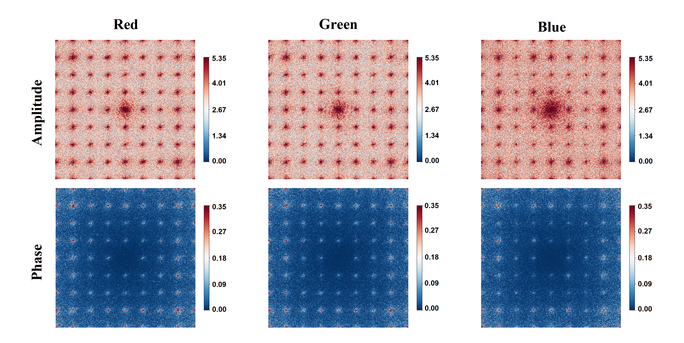
Fig. S20 | Error characteristics in the frequency-domain amplitude and phase for the R, G, and B channels, between the reconstructed and the original images.
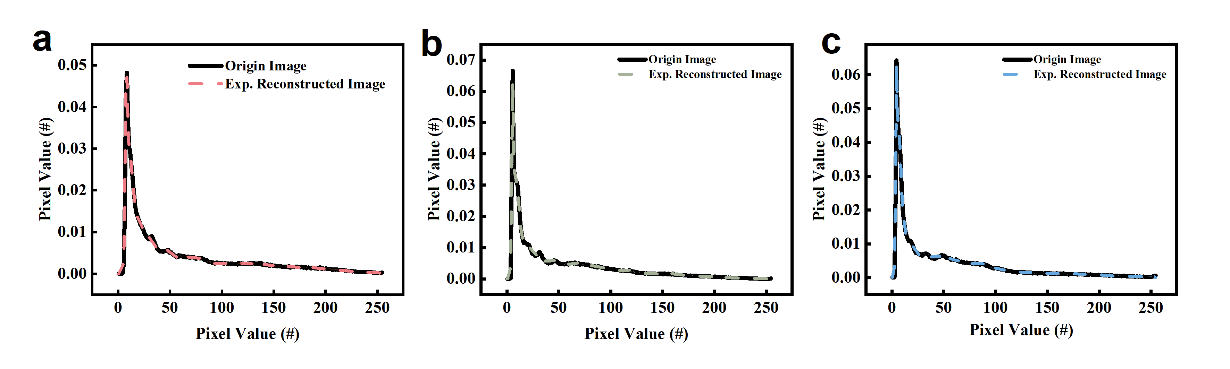
Fig. S21 | a-c, Spatial-domain histogram matching of pixel intensities, with a focus on the Bhattacharyya distance and correlation coefficient, reflecting the distribution consistency between the reconstructed and original images.

4.2 Membership function design in Mamdani-Type robotic control
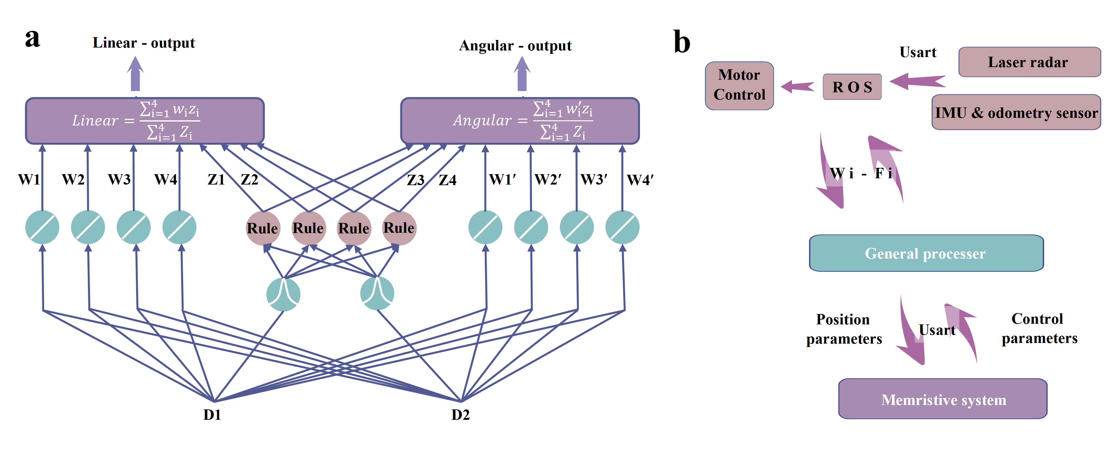 Fig. S22 | a, Schematic of the lightweight FNN control architecture for computing linear and angular velocity outputs. Nodes W₁–W₄ represent weight nodes, Z₁–Z₄ denote rule nodes, and D1, D2 are the input nodes. The final linear and angular velocity control parameters are obtained via defuzzification. b, System-level robot architecture integrating the SHO-based neuromorphic core. LiDAR, IMU, and odometry sensors are connected to the motor controller via ROS, while a general-purpose processor handles real-time processing of environmental inputs and control signals through direct communication with the computing module.
In this study, a two-wheeled differential drive robot (WHEELTEC) is investigated, and its kinematic modeling is developed within a Cartesian coordinate framework. As illustrated in Fig. 5a, the robot’s spatial pose is defined by planar coordinates (x, y) and a heading angle θ. The angular velocities of the left and right driving wheels are denoted as ω_{L} and ω_{R}, respectively, and the corresponding linear velocities are given by:
$V_{L}= r‧ ω_{L}$, $V_{R}= r‧ ω_{R}$
where r represents the radius of the wheels. Based on the relationship between the left and right wheel velocities, the resultant linear velocity V and angular velocity ω of the robot can be derived as:
$V=\frac{V_{L}+V_{R}}{2}=\frac{r(ω_{L}+ω_{R})}{2}$, $ω=\frac{V_{R}-V_{L}}{D}=\frac{r(ω_{R}-ω_{L})}{D}$
where D denotes the distance between the two wheels (wheelbase). In continuous time, the kinematic equations governing the robot’s motion can be expressed as:
$\frac{dx}{dt}= V cos θ$, $\frac{dy}{dt}= V sin θ$, $\frac{dθ}{dt}= ω$
This model establishes a clear dynamic mapping between the robot’s pose and velocity parameters, forming a fundamental kinematic framework for the subsequent design of fuzzy control strategies.
Dual-branch LFNN structure and robotic system framework are demonstrated in this illustration. As shown in Fig. S22a, the network shares common rule nodes (Z₁–Z₄) for antecedent fuzzy inference, while independent weight nodes are configured for consequent linear computation. Each weight node corresponds to a linear combination of obstacle distance inputs and a bias term, which constitutes the consequent part of first-order Sugeno-type fuzzy rules. Final control outputs are obtained via weighted average defuzzification. The system-level robotic integration is presented in Fig. S22b. Multi-sensor data including LiDAR, IMU and odometry are transmitted through ROS, and the SHO memristive core executes fuzzy inference with calibrated weight parameters to realize closed-loop motion control and autonomous navigation.
Within the Mamdani-type fuzzy control architecture, membership functions play a crucial role in mapping sensor inputs (e.g., multi-directional obstacle distances) into fuzzy sets. To address the environmental perception requirements of the robot, the input variables—obstacle distances in the left and right directions (d₁ and d₂)—are characterized using Gaussian membership functions to enable nonlinear feature extraction:
$μD_{i}(x)=\exp\left(-\frac{{（x-C_{i}）}^{2}}{{2σ}_{i}^{2}} \right)$, $(i=1,2)$
where C_{i} and σ_{i} denote the center and width parameters of the i -th fuzzy set, respectively. As shown in Fig. S23a and S23b, the Gaussian curves corresponding to d1 and d2 effectively introduce nonlinearity, thereby enhancing the controller’s robustness in complex environments.
For the output control variables, i.e., the linear velocity V and angular velocity ω, linear membership functions are employed. As depicted in Fig. S23c and S23d, the linear velocity is divided into fuzzy regions labeled “low speed” and “high speed,” while the angular velocity is discretized into categories such as “left,” “straight,” and “right.”
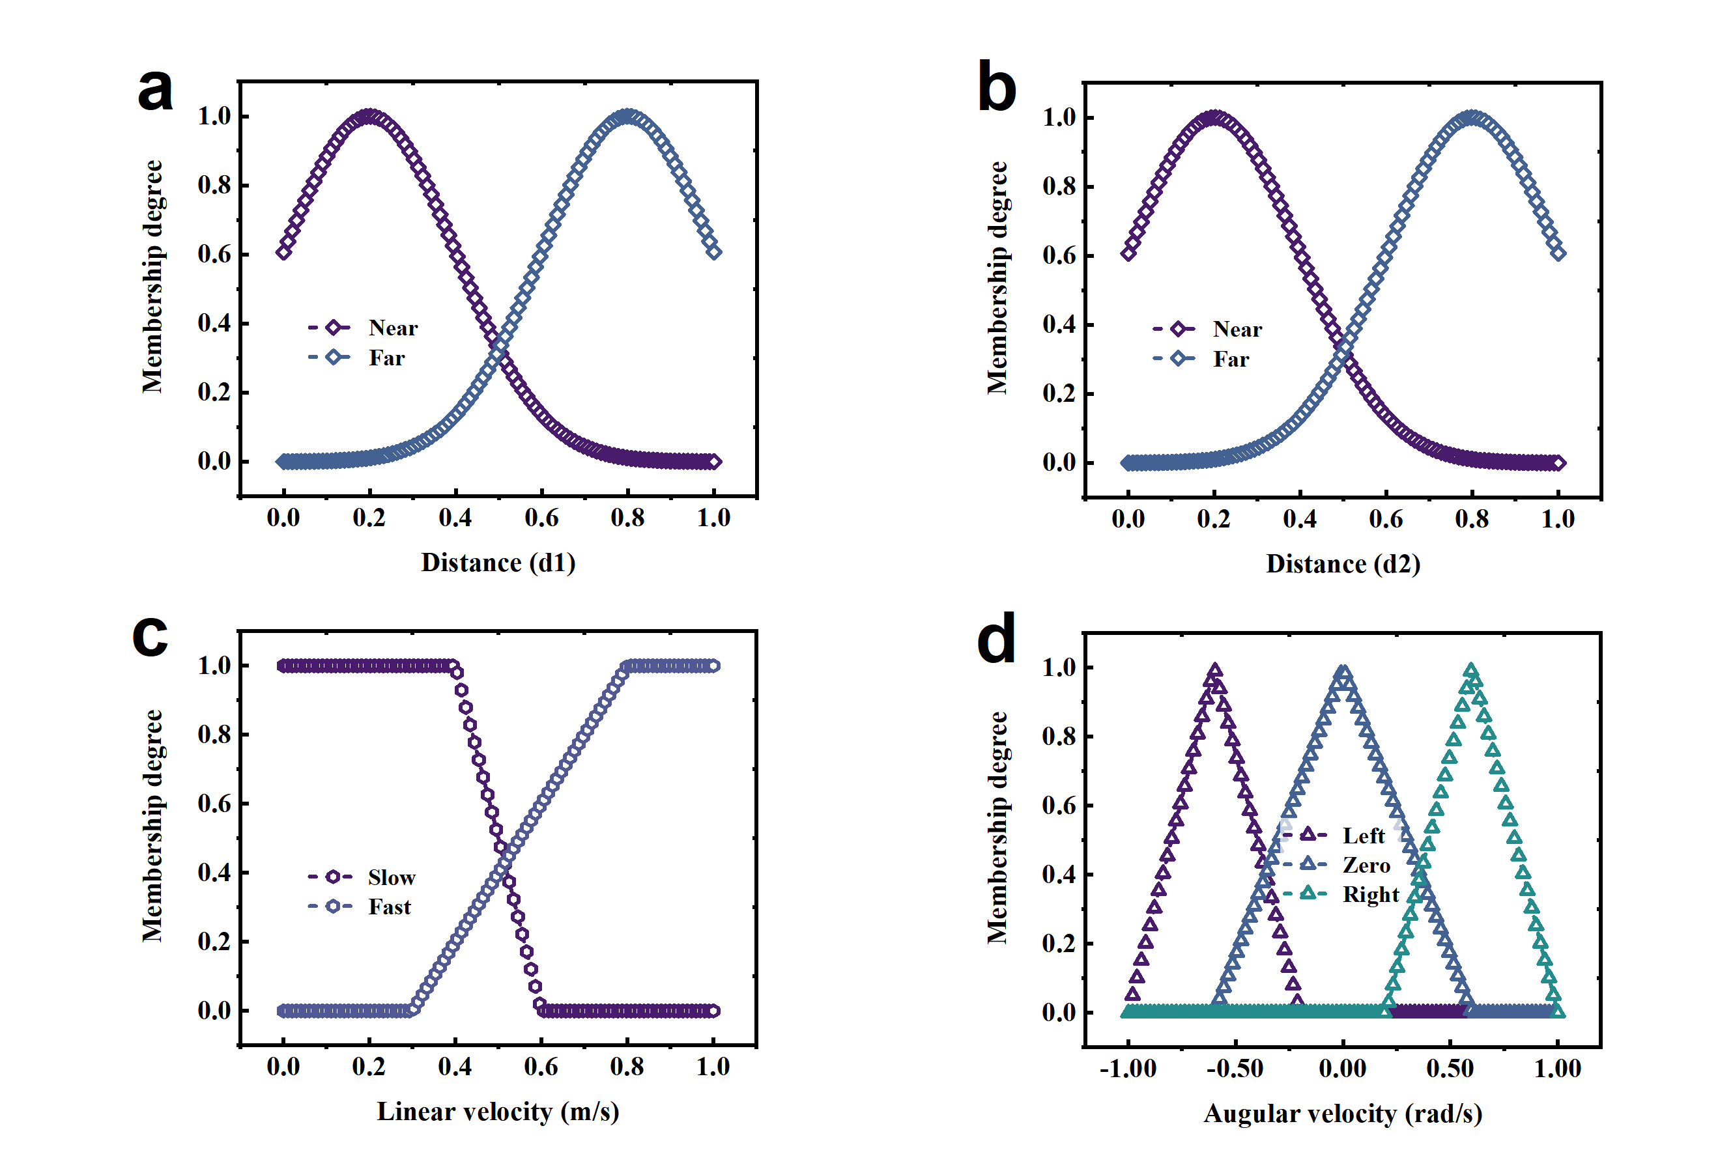
Fig. S23 | a, b, Gaussian membership functions for the d₁ and d₂ ranges, respectively. c, d, Linear membership functions for linear velocity and angular velocity, respectively.

4.3 Dataset from Mamdani-type Neuro-Fuzzy system for lightweight FNN training
To train the lightweight fuzzy neural network (FNN), a labeled dataset was generated using a Mamdani-type neuro-fuzzy system. Figs. S24a and S24b illustrate the three-dimensional relationships between the input variables from the LiDAR sensor (d₁ and d₂, representing obstacle distances) and the corresponding outputs of linear and angular velocities in the training data. The data distribution reflects typical fuzzy control rules—such as “decelerate and turn when approaching obstacles”—which serve as strong prior knowledge for learning the weight parameters of the FNN. The model’s prediction accuracy was evaluated using root mean square error (RMSE).
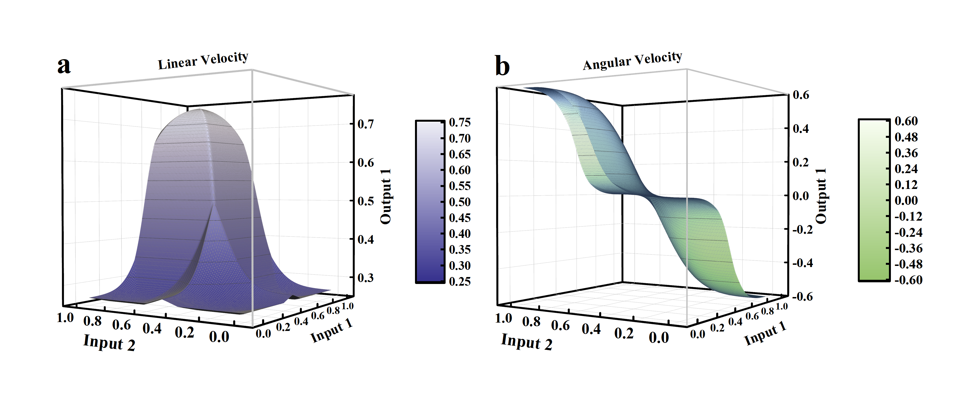
Fig. S24 | a, b, Linear velocity / angular velocity relationships in the training data for a Mamdani-type neuro-fuzzy system in lightweight FNN.

4.4 Real-world signal acquisition using a commercial ROS-based robot
In this section, we continued to employ a commercial mobile robot platform based on the Robot Operating System (ROS) (Fig. S25a), integrated with a LiDAR sensor to acquire distance signals in real-world environments. The robot communicates via Wi-Fi, transmitting LiDAR data in real time from the sensing node to the central control unit, thereby establishing a multi-region distance perception network covering areas such as the left (d₁) and right (d₂) directions. Figs. S25b and S25c show the LiDAR signal waveforms collected from the left and right regions during field tests, where the horizontal axis represents the data point index and the vertical axis denotes the normalized distance values (d₁, d₂). The fluctuating waveform characteristics reflect the robot’s capability for real-time obstacle distance perception under dynamic conditions, providing realistic input samples for the subsequent fuzzy control algorithm. Moreover, the system employs SHO-based ferroelectric memristors for signal processing and demonstrates strong compatibility between the memristive hardware and the ROS ecosystem. This configuration achieves millimeter-level precision in distance signal acquisition, supporting autonomous navigation and obstacle avoidance in complex scenarios (e.g., lab-scale test environments), and establishes a robust hardware foundation for lightweight intelligent driving systems.
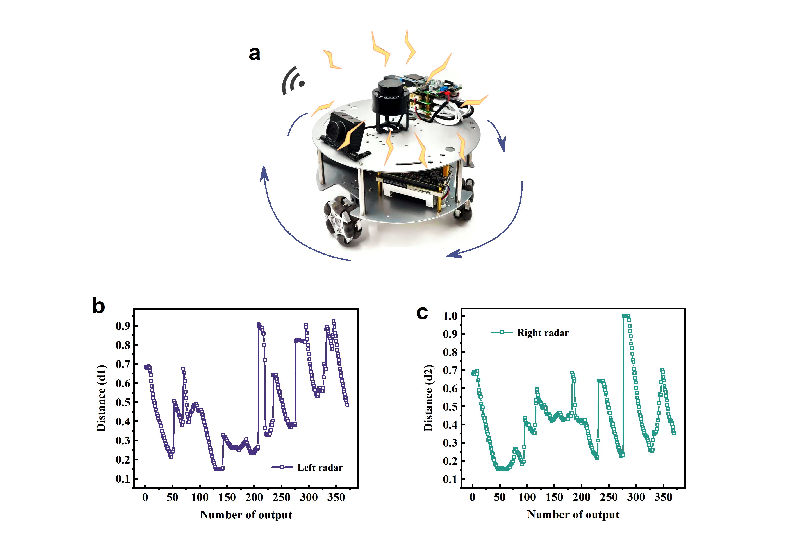
Fig. S25 | a, Schematic of LiDAR data collection on a ROS robot, showing signal transmission from the slave node to the master system via Wi-Fi. b, c, LiDAR signal waveforms from the left d₁ and right d₂ regions during field testing.

4.5 Lightweight memristor-based SHO system for real-world robotic tasks
Fig. S26a illustrates the hardware system architecture based on SHO memristors. This system integrates a probe-configured memristor array, a customized signal conditioning circuit, and a ROS communication module to construct a high-precision in-memory computing control architecture. In this system, the synaptic weights of the fuzzy neural network are directly encoded and stored within the memristor array, enabling direct computation of robot control signals (linear and angular velocities) from sensory inputs. This architecture completely eliminates the inherent data transfer latency caused by the physical separation of memory and processing units in conventional CMOS digital systems.
In the complex dynamic navigation experiment shown in Fig. S26b, the robot departs from the green starting point, perceives and successfully avoids yellow dynamic obstacles in real time, and finally reaches the blue destination accurately. These experimental results fully validate the feasibility of memristor-based in-memory computing technology in real-time robotic applications, provide an efficient hardware solution for lightweight intelligent robots, and represent a critical step forward in transitioning in-memory computing architectures from theoretical research to practical engineering deployment.
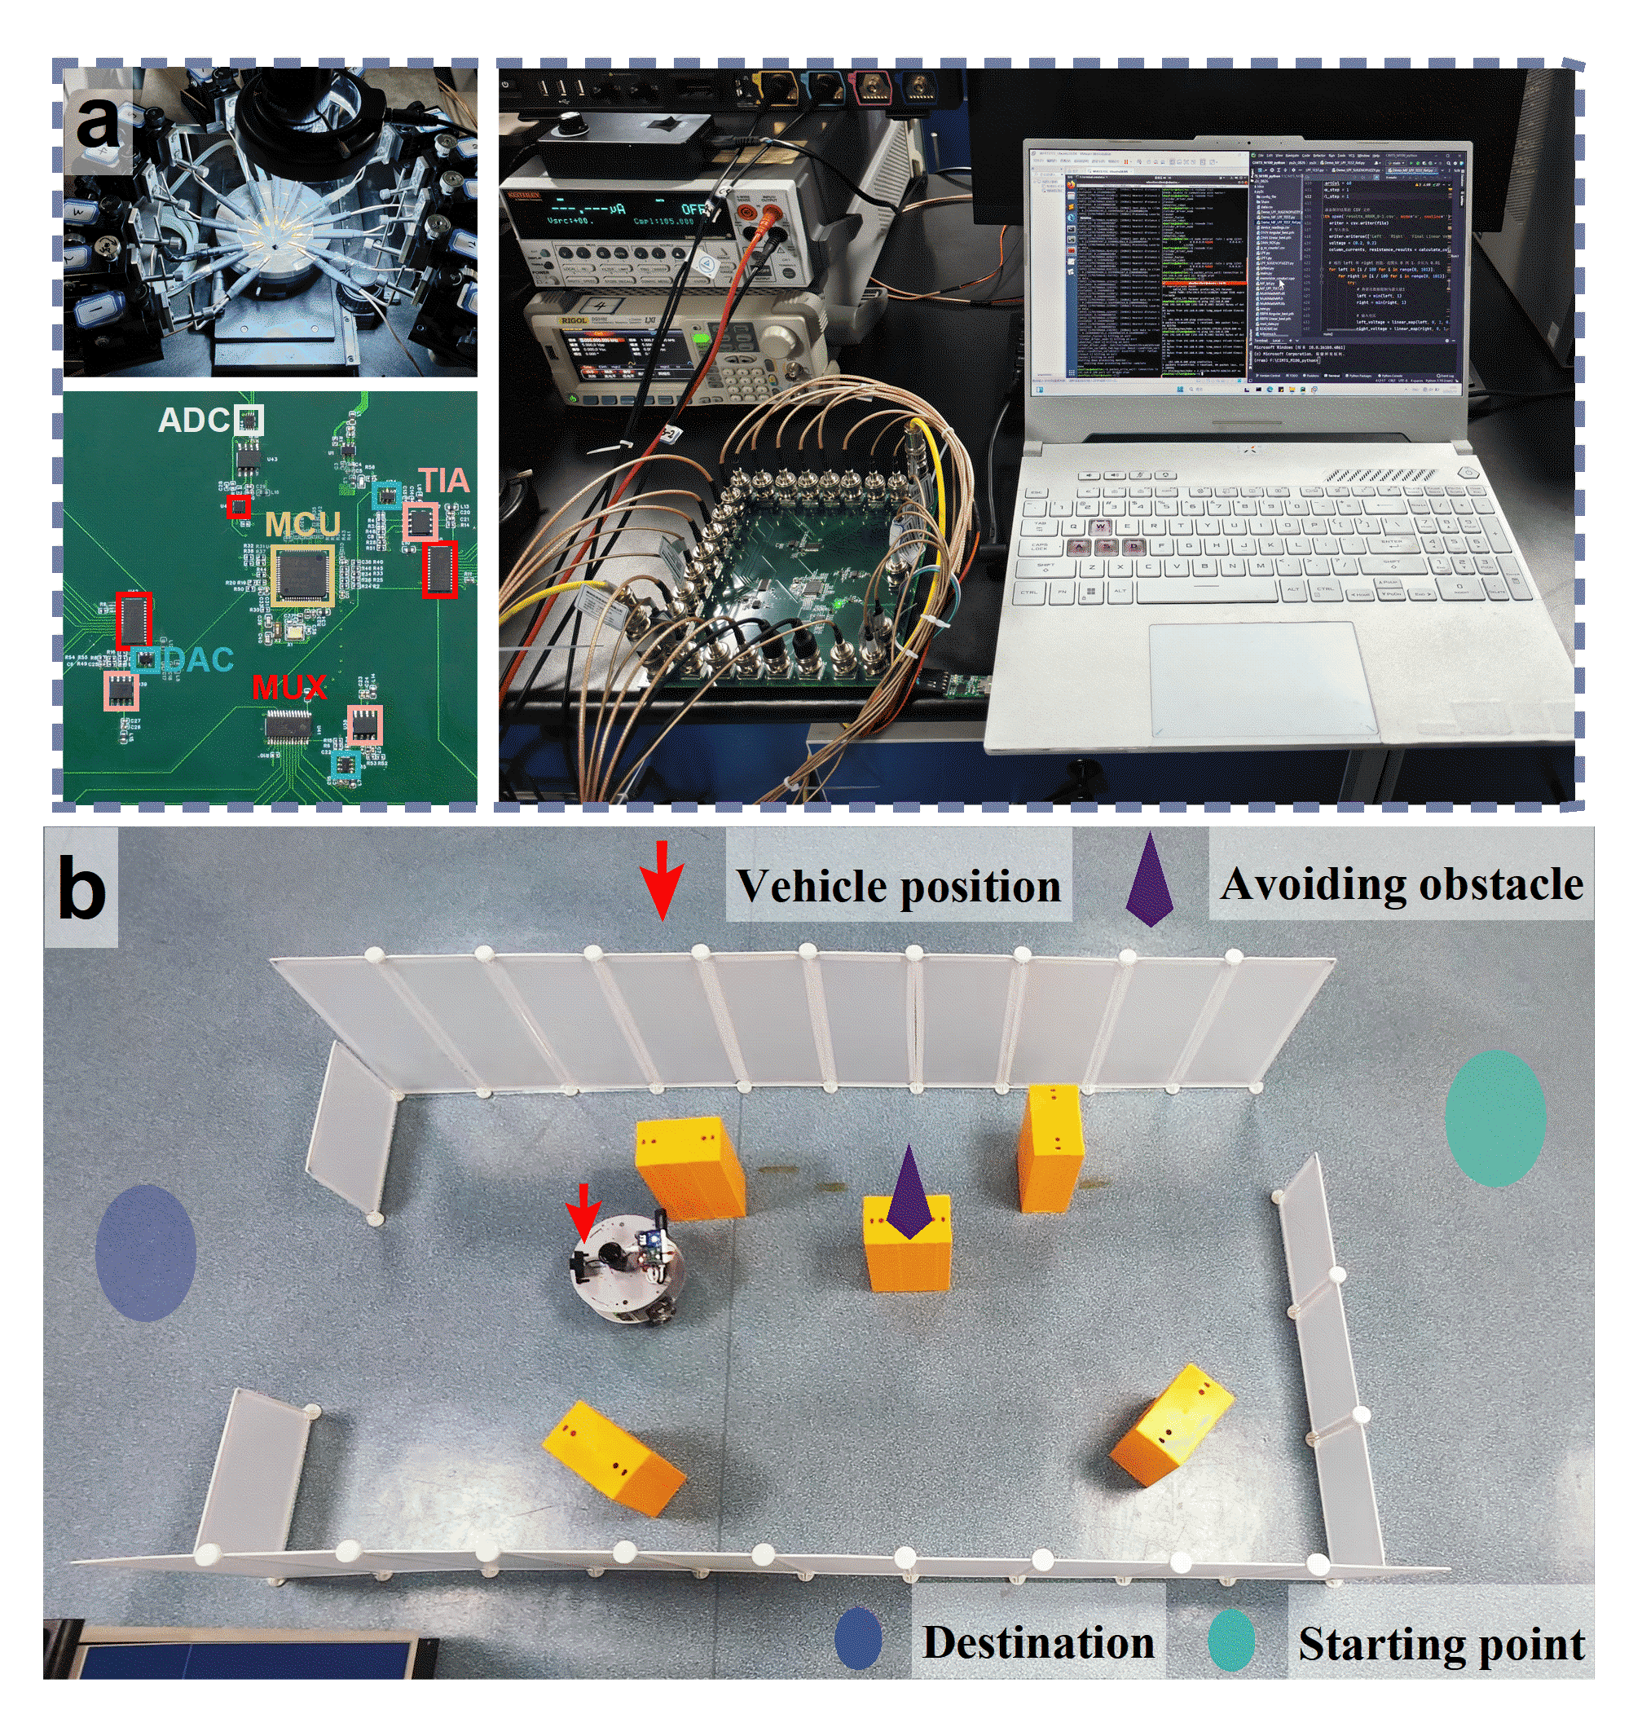
Fig. S26 | a, Physical diagram of the lightweight fuzzy neural network hardware system based on SHO memristors (Left: Core circuit module, including ADC, TIA, MCU and memristor array interface; Right: Complete experimental platform). b, Field testing in complex scenarios for task evaluation.
4.6 Readout strategy for weight mapping in SHO memristor arrays
The proposed scheme realizes weight encoding and differential readout using discrete SHO memristor devices. According to their functional roles, all devices are divided into three independently grounded groups: a linear velocity weight group, an angular velocity weight group, and a reference group. The linear velocity weight group consists of 12 discrete devices sharing a common ground within the group to maintain stable readout of weight-encoded signals. Similarly, the angular velocity weight group comprises 12 discrete devices with an independent common ground, providing electrical isolation from the linear velocity group to mitigate inter-group crosstalk. The remaining 3 devices constitute the reference group with internal common grounding, acting as pre-calibrated conductance references to deliver a stable baseline for differential computation.
Time-division multiplexing (TDM) is implemented across the three groups using analog multiplexers for sequential operation. On the input side, a single 8-bit digital-to-analog converter (DAC) applies read pulses to the three groups in a time-multiplexed sequence, whose resolution is sufficient to fully cover the effective conductance readout range of SHO memristors. This configuration ensures reliable readout accuracy while minimizing redundant hardware overhead. All control weights are quantized at the algorithmic level with 10-bit precision to preserve the fine-grained distribution of fuzzy inference rules, and are mapped onto the effective conductance range of the discrete SHO memristors. On the readout side, a transimpedance amplifier (TIA) and an 8-bit analog-to-digital converter (ADC) are employed to sequentially capture and convert the differential output signals of the three groups via multiplexing. The independently grounded structure of the three device groups effectively suppresses electrical crosstalk and enhances the signal-to-noise ratio during differential readout, while being well matched to the time-division multiplexing architecture to simplify circuit design, reduce hardware redundancy, and lower overall system power consumption.
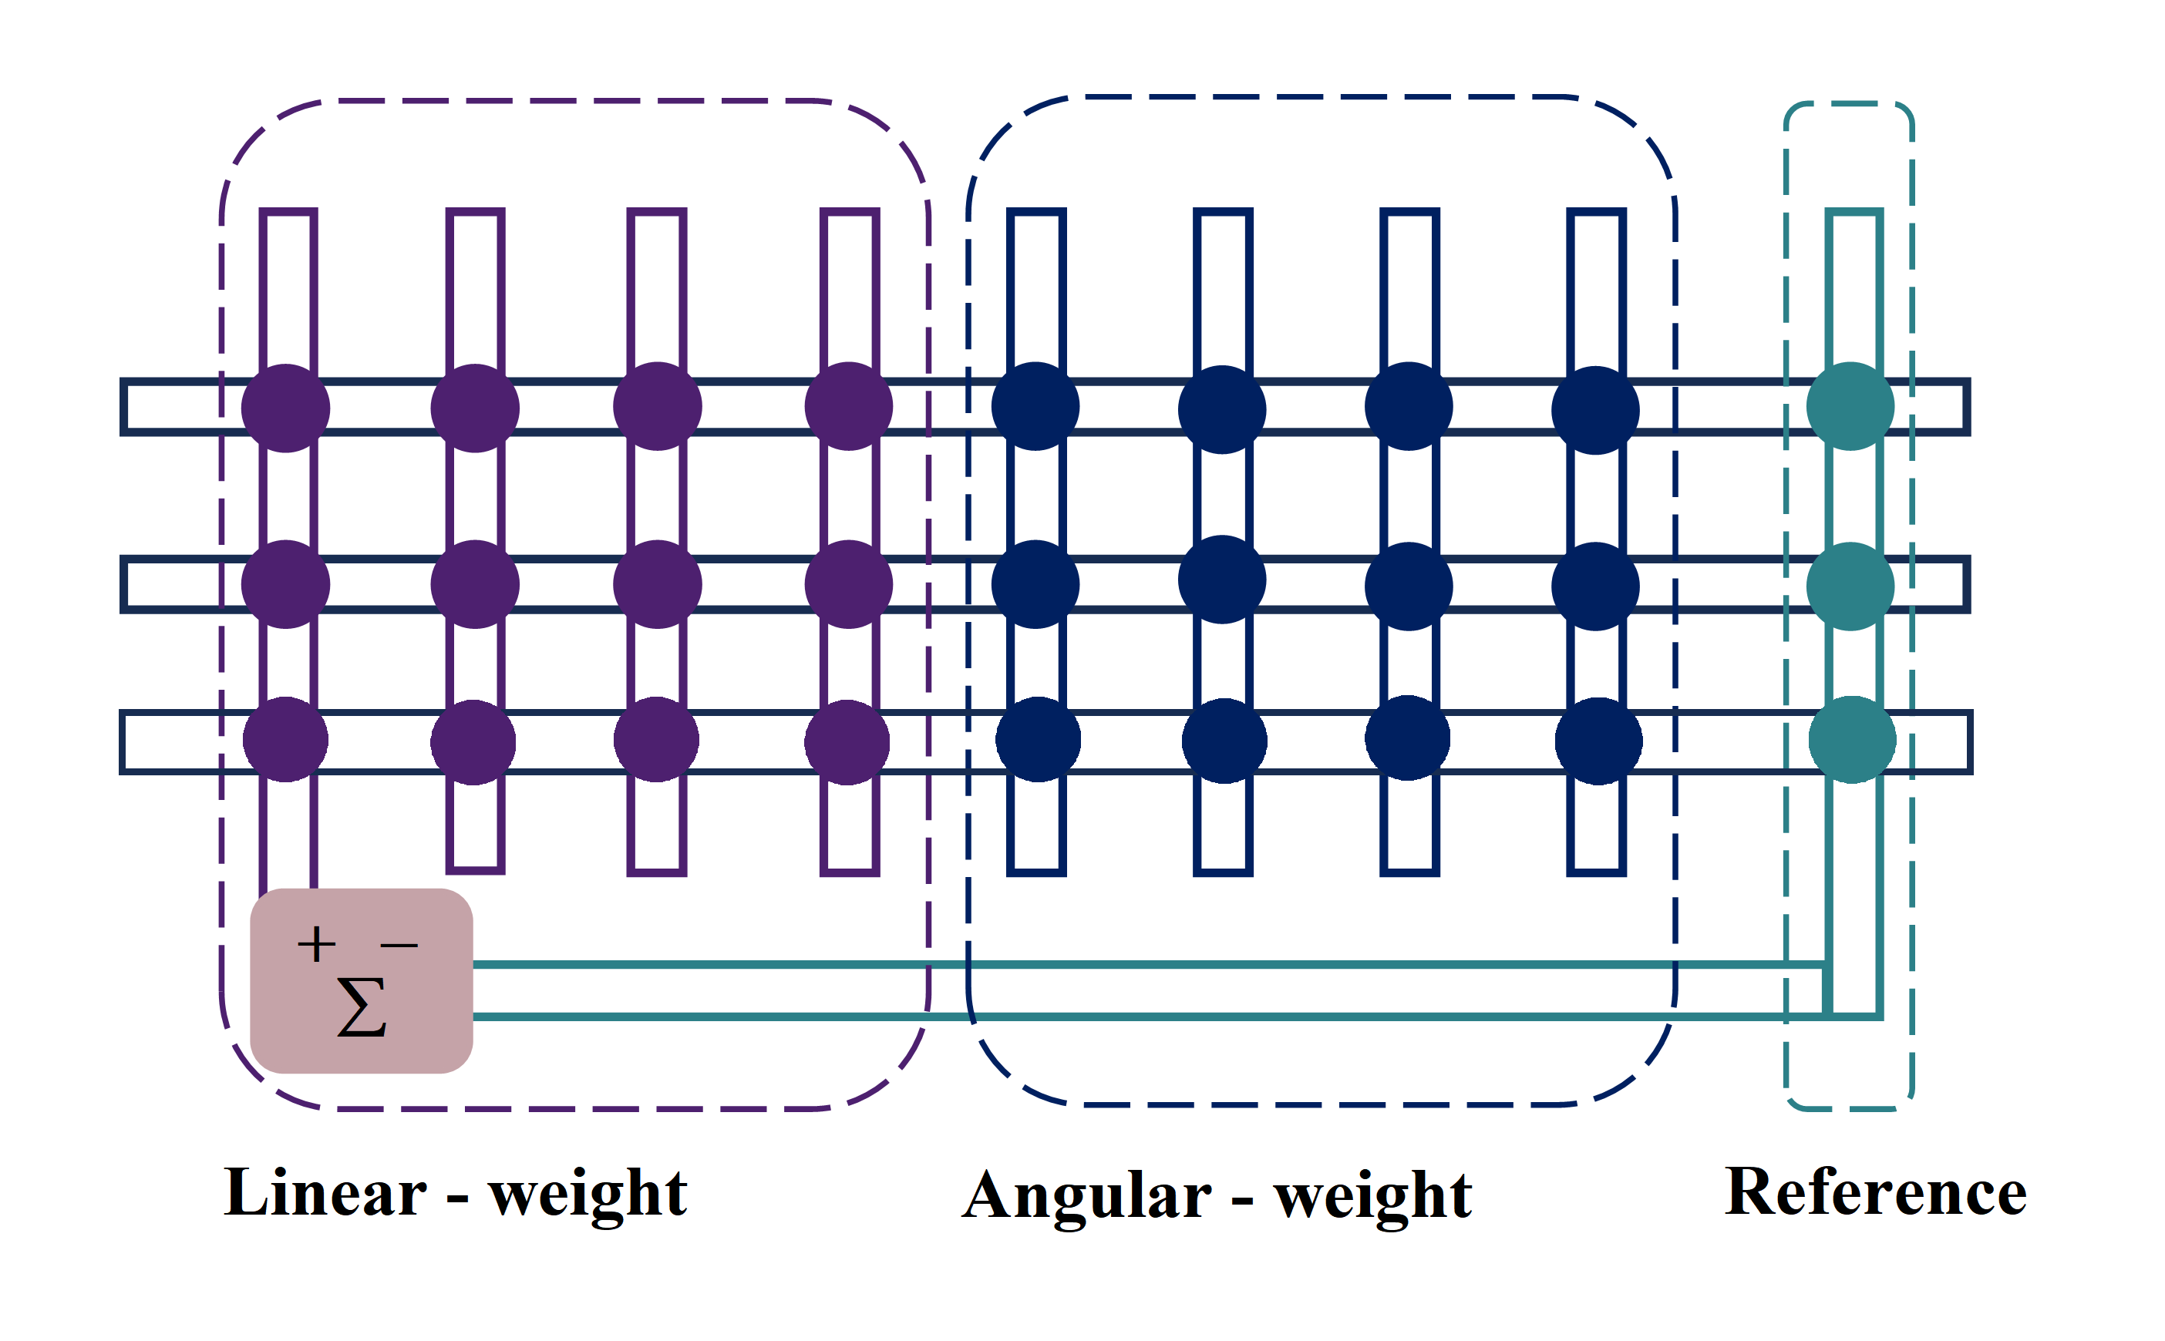
Fig. S27 | Weight reading strategy for fuzzy neural network arrays.
4.7 Performance Comparison of SHO-LFNN, DNN, and RBF Models Under Different Quantization Bit-Widths
To verify the hardware-friendly property of the proposed SHO-LFNN inference system under quantization, we conduct a comprehensive comparison with fully connected DNNs and RBF networks under 32-bit, 10-bit, 8-bit, and 5-bit quantization. The number of model parameters is used to represent the number of required memristor cells in a CrossSim-compatible crossbar array, which directly reflects the hardware area and implementation cost. Prediction accuracy is evaluated by the coefficient of determination (R²) for both linear and angular velocities of the robot.
The results show that the SHO-LFNN model maintains stable and competitive prediction accuracy with a fixed and minimal number of parameters (24) across all quantization bit-widths, without expanding the model structure. In contrast, DNNs require a significant increase in network size and parameter count to compensate for quantization-induced performance loss. RBF networks exhibit relatively low prediction accuracy even with an increased number of kernel centers. These results validate that the SHO-LFNN model achieves a superior balance between inference accuracy and hardware complexity, making it well-suited for memristive crossbar-based edge computing hardware.
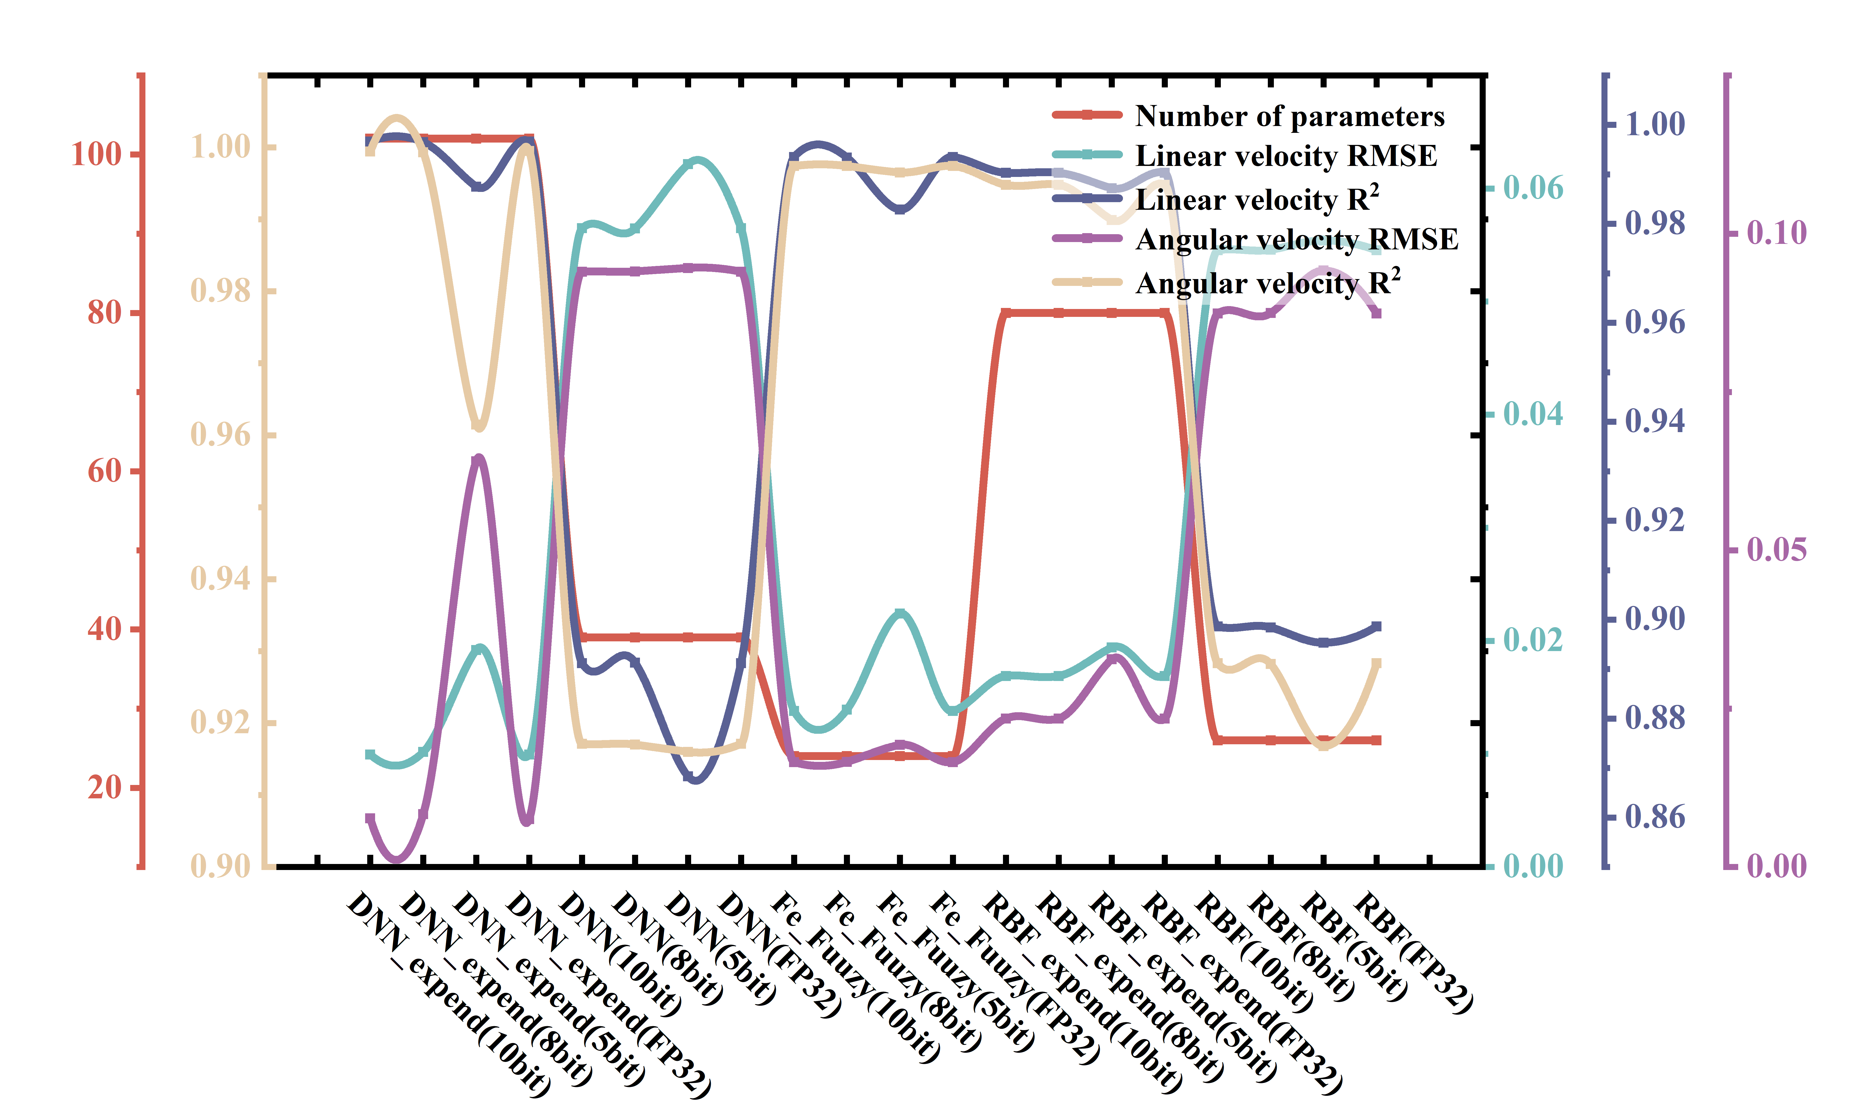
Fig. S28 | Performance and model size comparison of SHO-LFNN, DNN and RBF models under FP32/10/8/5-bit quantization.

4.8 Energy Consumption Analysis for Readout and Inference
The energy efficiency of the SHO memristor-based fuzzy inference system is quantitatively evaluated using experimentally measured transient pulse data obtained from a Keysight B1500A semiconductor parameter analyzer. A 0.5 V, 125 ns read pulse is employed to characterize the non-destructive readout behavior of the discrete memristor devices, and the energy consumption is determined via numerical integration of the measured voltage–current waveforms, which is the standard and reliable method for pulse-driven memristor energy characterization.
To evaluate the energy efficiency of the in-memory computing scheme accurately, we focus on power consumption during inference-mode read operations, which matches the target low-power operating scenario of mobile robots. The device-level energy is calculated using the transient energy integral:
$E = \int_{t1}^{t2}{V\left(t\right)*I(t)dt}$,
where V(t) denotes the 0.5 V read pulse and I(t) represents the corresponding measured read current. Based on the measured data, a single SHO memristor consumes an ultra-low 2.4 fJ per read operation, corresponding to the multiply step in a standard multiply-accumulate (MAC) operation. This ultra-low readout energy benefits from the stable conductance response and negligible current relaxation under low-voltage read conditions.
In the proposed hardware implementation, core linear computations required for fuzzy inference—including weight mapping, weighted summation, and differential readout for defuzzification—are realized using 27 discrete SHO memristors arranged into three independently grounded groups (linear-weight, angular-weight, and reference) with time-division multiplexing (TDM) via analog multiplexers. Nonlinear operations such as membership function evaluation and fuzzy logic decision-making are performed on a host PC and are not included in the hardware energy consumption.
To comprehensively evaluate the energy efficiency of the proposed lightweight fuzzy neural controller utilizing a 3×9 memristor array with 27 devices in total, and to analyze the underlying architectural trade-offs, we conducted an ASIC-level energy projection based on a standard 180-nm CMOS process. This evaluation explores the energy dynamics between TDM and fully parallel array processing. The specific energy consumption per operation and the number of instances for each hardware component are detailed in Table S4. Building upon these fundamental parameters, we explored the energy dynamics between TDM and fully parallel array processing, as summarized in Table S5.
The fundamental hardware operation involves activating three input rows to read a single column. The energy consumption for this baseline single-column read transient, which includes the activation of three DACs, one TIA, multiplexer routing, and one ADC sampling, is evaluated at 130.1 pJ. To minimize the peripheral circuit area overhead, such as massive TIA and ADC arrays, our current system adopts a column-wise TDM architecture. Processing the entire 3×9 array requires nine sequential column-read cycles, accumulating a total inference energy of approximately 1.17 nJ, which demonstrates an area-optimized hardware strategy suitable for resource-constrained edge devices. Conversely, to demonstrate the ultimate energy limit of the devices, we projected an ideal fully parallel architecture. By deploying parallel readout circuits and utilizing analog-domain summation, the system only requires a single ADC conversion for the final output. Driven by the ultralow intrinsic switching energy of our memristors (~2.4 fJ per device, contributing only ~0.06 pJ in total), the energy for a complete inference under this energy-optimized scenario plummets to 130.57 pJ. As detailed in the energy breakdown in Table S4, compared with state-of-the-art memristive neuro-fuzzy hardware (215.43 pJ) reported in previous work, the proposed system reduces energy consumption by approximately 39.39% ^{15,16}. It should be noted that this significant reduction is jointly empowered by the ultralow intrinsic switching energy of our individual ferroelectric memristors and the strategically optimized network scale. Furthermore, it improves energy efficiency by more than two orders of magnitude over conventional CMOS-based fuzzy ASICs (~103.2 nJ), demonstrating significant advantages in low-power edge robotic intelligence applications.
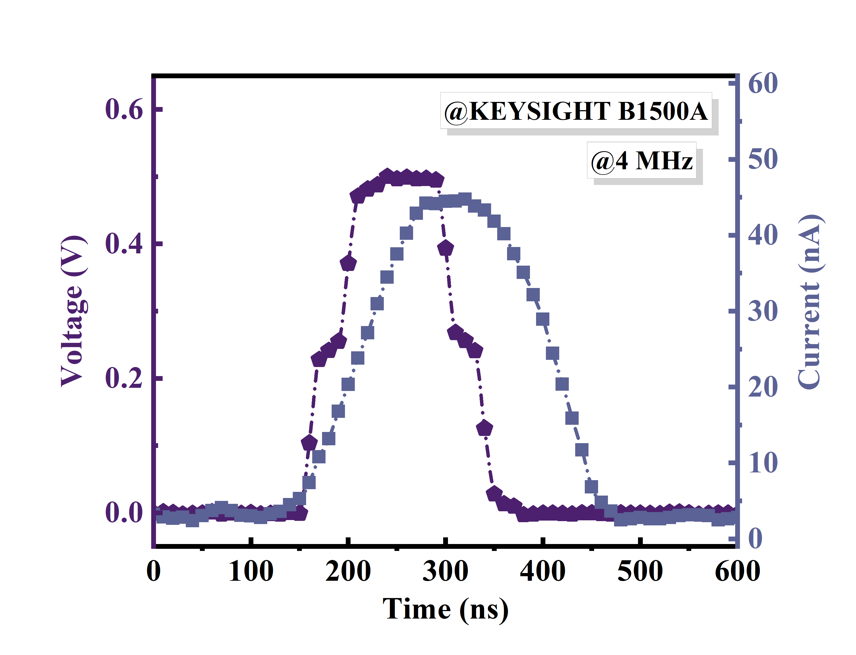
Fig. S29 | Transient voltage–current response of the SHO memristor under a 0.5 V read pulse.
4.9 Real-time SLAM scene modeling with LiDAR on a ROS mobile robot
The map used in the experiment was generated using the Karto algorithm, a simultaneous localization and mapping (SLAM) method based on LiDAR data, implemented as a software package within the ROS platform and visualized through Rviz. This experiment establishes a closed-loop control workflow of “perception (LiDAR-SLAM) — decision-making (fuzzy control based on SHO memristors) — execution (robot locomotion),” leveraging the ROS ecosystem to integrate multi-sensor data and providing an experimental paradigm for end-to-end system design in lightweight intelligent robotics. The real-time mapping capability of the Karto algorithm works synergistically with the in-memory computing characteristics of SHO memristors, facilitating the evolution of control systems from “digitally dominated” to “analog–digital hybrid optimization” architectures and highlighting the engineering application potential of SHO-based systems in real-world scenarios.
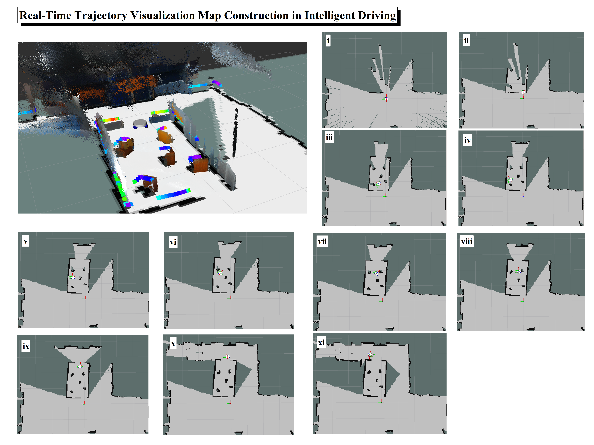
Fig. S30 | Real-time trajectory visualization during different testing phases of the robot.

Table S1:
Functional materials structures | Single crystal/  epitaxy | Function/total thickness | Roughness | PFM voltage /PE field | Pr  μC cm⁻² | Fatigue  Cycle | ε_{r} | Set/reset | On/off ratio | Rectify  -ing ratio | # of states | References
Pd/Sr: HfO₂/  NSTO | Yes/Yes | 3~12/22 nm ↑ | 66.8 pm ↑ | -2.2/+3.0 EV/cm | 41.2 [111]  71 [001] ↑ | 10¹⁰ ↑ | 38.0 ↑ | ±2.0 V | 1.4*10⁴ ↑ | 1.5*10¹ | 1,104 ↑  (10bit) | This work
Pt/Y: HfO₂/  LSMO/STO | Yes/Yes | 11/51 nm | N/A | -3.8/+2.5 V | 38~50 | 10⁴~10⁶ | N/A | N/A | N/A | N/A | N/A | Nat Mater 21.8 (2022): 903-09
TiN/  HfZr_{(1+x)}O₂/TiN/Si | No/No | 12/84 nm | N/A | -0.58/+0.73 EV/cm | 22 | 10⁹~10¹⁰ | 33.15 | N/A | N/A | N/A | N/A | Science  381.6657 (2023): 558-63
Pt/  Hf_{0.5}Zr_{0.5}O₂/LSMO/STO | No/Yes | 1.5~8/90 nm | N/A | -2.8/+3.0 EV/cm | 21 | 10⁹ | N/A | N/A | N/A | N/A | N/A | Nat Commun  1780 (2023):14
LSMO/  Hf_{0.5}Zr_{0.5}O₂/LSMO/STO | No/Yes | 5~9/70 nm | ~10 nm | ±5.0 EV/cm | 34 | 10³ | N/A | N/A | N/A | N/A | N/A | Nat Mater 17.12 (2018): 1095-100
Bulk Y: HfO₂ | Yes/N/A | N/A | N/A | -3.8/+4.0 EV/cm | 3 | N/A | N/A | N/A | N/A | N/A | N/A | Nat Mater  20.6 (2021): 826-32
LSMO/  Hf_{0.5}Zr_{0.5}O₂/LSMO/  NSTO | Yes/Yes | 7/67 nm | N/A | -3.0/+2.0 V | ~30 | N/A | N/A | N/A | N/A | N/A | N/A | Science  372.6542 (2021):  30-35
Pt/  Hf_{0.5}Zr_{0.5}O₂/LSMO/STO | Yes/Yes | 10/N/A nm | 0.256 nm | ±3.2 EV/cm | 15 | 10⁵ | N/A | N/A | N/A | N/A | N/A | Acs Appl Mater Inter  16.21 (2024): 27532-40
TiN/  Hf_{1-x}Zr_{x}O₂/  TiN/Si | N/A | 10/70 nm | N/A | -0.72/+0.81 EV/cm | 26 | N/A | 35 | N/A | N/A | N/A | N/A | Appl Phys Lett  114.14 (2019)
TiN/  Hf_{1-x}Zr_{x}O₂/  TiN/Si | No/No | 12/N/A nm | 0.1 nm | ±1.3 V | 12.8 | 10⁸ | 30 | N/A | N/A | N/A | N/A | Adv Funct Mater  33.31 (2023): 2301746
Au/  Hf_{0.5}Zr_{0.5}O₂/LSMO/  LAO | Yes/Yes | 10/120 nm | 250 pm | -2.0/+2.8 EV/cm | 20 | 10³ | N/A | N/A | 161 | N/A | N/A | Adv Funct Mater  28.50 (2018): 1806037
Al/TiN/  HfAlO_{x}/n-si | No/No | 9/179 nm | N/A | ±5 V | 21.5 | 10⁵ | N/A | -1.7/+3.0 V | 10 | 10² | 16(4bit) | Nanoscale  15.18 (2023): 8366-76
Al/TiN/  Y: HfO₂/W/Si | No/No | 10/170 nm | N/A | ±2.0 EV/cm | 17 | 10⁶ | 29 | N/A | N/A | N/A | N/A | J Appl Phys  133.5 (2023)
Pt/  Hf_{0.5}Zr_{0.5}O₂/NSTO | No/No | 1.5~10/  41.5 nm | N/A | ±1.5~2.7 EV/cm | 2~13 | N/A | N/A | ±1.5 V | <10² | NS | N/A | IEEE Electr  Device L  42.9 (2021): 1303-06
Pt/  Hf_{0.5}Zr_{0.5}O₂/TiN/Si | N/A | 10/65 nm | N/A | N/A | N/A | N/A | N/A | ±3.0 V | 10⁴ | 10⁴ ↑ | N/A | Electron Lett  59.2 (2023): e12717
Au/Ti/HfO_{x}/Ti₂AlN/Ti/Si | N/A | 5/480 nm | N/A | N/A | N/A | N/A | N/A | ±0.8 V ↑ | 6000 | NS | 9 | Adv Funct Mater  34.29 (2024): 2316290
Ag/HfO₂/  NiO/Pt/  Si | N/A | 20/320 nm | N/A | N/A | N/A | N/A | N/A | -0.45/+0.4 V ↑ | <10³ | NS | N/A | Nano Lett  24.17 (2024):  371-78
Pt/  LaTa: HfO₂/LSMO/STO | Yes/Yes | 6/N/A nm | N/A | -5.0/+4.0 MV/cm | 19 | 10⁸ | 19 | N/A | N/A | N/A | N/A | Nat Commun  15.1 (2024): 2893
Pt/Ti/HfO₂/Gr/Si | No/No | 10/40 nm | 0.5 nm | N/A | N/A | N/A | N/A | -2.0/+1.0 V | <10³ | N/A | N/A | Adv Funct Mater  34.19 (2024): 2309558
Pt/SiO₂/  Hf_{0.5}Zr_{0.5}O₂/TiN/Si | No/No | 5.5/96 nm | 0.1 nm | -1.7/+2 V | 16 | N/A | N/A | -1.7/2.5 V | 652 | N/A | 128 | Adv Mater  36.15 (2024): 2211305
W/H₂Z₈/  H₅Z₅/H₈Z₂/W/Si | No/Yes | 10/90 nm | N/A | ±1.2 V | 20.5 | 10⁹ | ~30 | N/A | N/A | N/A | N/A | J Adv Ceram  13.7 (2024): 1023-31
Au/TiW/HfO₂/Au/Cr/  PET | N/A | 9/174 nm | N/A | N/A | N/A | N/A | N/A | -1.0/+1.3 V | <10² | NS | 32 | Adv Mater  34.34 (2022): 2201962
Pt/Ba: HfO₂/NSTO | Amorph  -ous | 25/95 nm | <1 nm | N/A | N/A | N/A | N/A | ±0.5 V | 10 | NS | 7 | Sci Adv  9.25 (2023): eadg1946
Pt/  Hf_{0.5}Zr_{0.5}O₂/  LSMO/STO | Yes/Yes | 5/N/A nm | N/A | -4.5 MV/cm | 25 | N/A | 30 | -6.0/+5.0 V | 500 | 10 | 6 | Appl Mater Today  29 (2022): 101587
Ta/Al₂O₃:  TaO_{x}/HfO₂/Pt/Si | Amorph  -ous | 1/N/A nm | N/A | N/A | N/A | N/A | N/A | N/A | N/A | N/A | 2048  (11bit) ↑ | Nature  615.7954 (2023):  23-29
Ag/IPS/GR/Si | N/A | ~20/85 nm | N/A | N/A | N/A | N/A | N/A | -0.6/+0.9 V ↑ | 10⁸ ↑ | NS | 278  (>8bit) | Nat Electron 8.1 (2025): 36-45
Pt/Ta/TaO_{x}/HfO₂/RuO₂/Pt/Si | Amorph  -ous | 3.6/164 nm | N/A | N/A | N/A | N/A | N/A | -1.0/+2.0 V | >10² | NS | 256 | Acs Appl Mater Inter  16.13 (2024): 462-73

Table S2:
Rule Number | Input |  | Output
Rule Number | d₁ | d₂ | Linear | Angular
1. | Near | Near | Slow | Front
2. | Near | Far | Slow | Right
3. | Far | Near | Slow | Left
4. | Far | Far | Fast | Front

Table S3:
Algorithm model | Network architecture | Model weight parameters | Data dependency level | Weight quantization bit-width | Weights / Device | Lightweight level | Task completion | Inference MAC operations (Multiply-accumulate) | Task complexity level | Model interpretability | Device quantity & type | References
Lightweight fuzzy neural network (LFNN) | 2 parallel fuzzy inference branches + 4 shared rules + weighted defuzzification network | 24 weights + 4 membership params | Low dependency, small-sample, no labeled data required | 8/10-bit configurable | 1024 | High | Lightweight obstacle avoidance in complex dynamic environments (regression) | 27 | Relatively high (nonlinear regression in dynamic environments) | High (fuzzy rule visual mapping) | 27 SHO | This work
High - precision memristor - based neural morphology algorithm | 256×256 memristor array | N/A | N/A | 11 - bit | 2048 | N/A | Neural network inference in edge computing, improving accuracy | N/A | N/A | N/A | 256×256  HfO₂-Al₂O₃ | Nature  615 (2023), 823–829
Molecular memristor - based neural morphology algorithm | 64×64 molecular memristor crossbar array | N/A | N/A | 14 - bit | 16,520 | N/A | Vector - matrix multiplication, DFT, matrix - matrix multiplication for signal processing and image reconstruction | 64 | N/A | N/A | 64×64  [RuIIL₂](BF₄)₂ | Nature  633 (2024), 560–566
Stochastic Neural-Fuzzy System (SNFS) | N/A | N/A | Moderate | 8-bit quantization | 256 | Relatively high | Edge Detection,  Nonlinear System Identification,  Robotic Navigation | 281 | High (Multi-task Dynamic Capability) | High (Explicit Storage of Fuzzy Rules + Transparent Neural Learning Process) | 562 HfO₂-TaO | Sci Adv  10.12 (2024): eadl3135
Spiking Neural Network (SNN) | 3 Hodgkin-Huxley Neurons (Mixed Coding Neuron + Burst Detection Neuron + Comparator Interface) | N/A | Low (Bio-neural simulation properties, no large-scale training data required) | N/A | N/A | Relatively high | Robot dynamic environment obstacle (Spike-Feature Encoding/Decoding) | N/A | High (Real-time dynamic obstacle avoidance) | Moderate  (Bio-neural Mechanism + Traceable Feature Encoding, but Partially Black-box Parameter Optimization) | 6 NbO_{x} | Nat Commun 15.1 (2024): 4318
Artificial neural network (ANN) based ferroelectric induction | 4 × 1  sensor array (Pt/PZT/SRO ferroelectric photoelectric sensor) +hardware multiply accumulate (MAC) operation | 4 | Low (Self supervised in situ training, without external annotation data) | 2 bit | 4 | High | Real-time image recognition and automatic driving control | 5 | Simple (real-time decision-making, dynamic environment) | Low (neural network part black box) | 4 PZT | Nat Commun 16.1 (2025): 421
Convolutional neural network (CNN mobilenetv2) | 16 inverted residual blocks + custom expansion blocks +2 full connection layers | 2.5M | Moderate | FP32 | N/A | Low | Visual obstacle avoidance of mobile robot (monocular camera+ ultrasonic fusion) | ~2.5M | Moderate (static obstacles, structured environment) | Low (Black-box CNN, feature extraction dependent) | N/A | Internet Things-Neth (2025): 101538
LSTM/CW-RNN | LSTM45: 45 memory blocks, including input gate, forget gate, cell state, and output gate  -CW-RNN180: 180 neurons | 19440 | Moderate | FP32 | N/A | Low | UUV Online Obstacle Avoidance (Dynamic Environment, Complex Obstacles) | N/A | High (Dynamic Environment, Complex Obstacle Distribution) | Low (Black-box RNN, Reliant on Temporal Features) | N/A | Complexity 2019.1 (2019): 6320186
ResNet18 (CNN) | ResNet18 backbone with 3 transposed convolutional layers | 3.5M | Moderate | 8bit | N/A | Low | Multi-sensor Fusion Obstacle Detection (Real-time UAV Obstacle Avoidance) | 4.6G  FLOPs | High (dynamic environment, multiple weather conditions) | Low (Black-box CNN, integrating feature abstraction) | N/A | Appl Intell  54.22 (2024): 11510-24
Hybrid fuzzy controller (A* search + fuzzy logic) | N/A | N/A | Low | FP32 | N/A | Low | Path navigation and obstacle avoidance for multiple autonomous vehicles (static + dynamic environments) | N/A | High (Dynamic environment, multi-obstacle collaboration) | Medium (Explicit fuzzy rules + A* search path visualization) | N/A | Int J Intell Robot  (2025): 1-16.
N/A | N/A | 7.5M | High | FP16 | N/A | Moderate | Outdoor obstacle avoidance for visually impaired people (multi-modal fusion, supporting snowy, rainy and nighttime scenarios) | N/A | ~7.5G  FLOPs | Extremely high (Dynamic environment, low visibility, multiple obstacles) | N/A | Nat Commun  16.1 (2025): 2857
LSTM | LSTM (3 hidden layers, 94 units per layer) + Input layer (188 features) + Output layer (2 units) | N/A | Moderate | FP32 | N/A | Moderate | Obstacle avoidance in a dynamic environment (mobile robot + dynamic obstacles) | N/A | High (Dynamic obstacles, multi-scenario training) | Low (Black-box neural network, relying on temporal features) | N/A | Sensors-Basel 24.10 (2024): 3004
pCNN + ORB-SLAM | ResNet18 (2 input branches + residual modules + deconvolution layer) | N/A | N/A | N/A | N/A | Moderate | Obstacle avoidance of a monocular drone in a dynamic environment | N/A | N/A | Low (Black-box neural network, relying on feature learning) | N/A | IEEE T Intell Transp  22.1 (2019): 156-167
GMD + SNN | N/A | N/A | Moderate | N/A | N/A | Moderate | Real-time obstacle avoidance of drones (driven by a dynamic vision sensor, DVS) | N/A | High (Dynamic obstacles, real-scene testing) | Medium (Biological neuron mechanism + traceable optimized parameters) | N/A | IEEE T Neur Net Lear  31.9 (2019): 3305-18
Fuzzy Attention Mechanism (FAM) and Heterogeneous Graph Neural Network (HGNN) | Heterogeneous graph propagation (2 layers) + Fuzzy rule system (9 rules) | N/A | Moderate | FP32 | N/A | Low | Obstacle avoidance and navigation control for mobile robots (multiple obstacles, dynamic targets) | N/A | Relatively high (Customized environment of 8×8 meters, with multiple obstacles) | Relatively high (Explicit physical meaning of fuzzy rules + Interpretability of graph structure) | N/A | Eng Appl Artif Intel  130 (2024): 107764
Q-learning + Feedforward neural network (Pos-Net) + Fuzzy logic | 30-20-3 MLP (Input layer: 30 units, Hidden layer: 20 units, Output layer: 3 units) | 683 | Moderate | FP32 | N/A | Moderate | Obstacle avoidance of mobile robots in dynamic environments (static + dynamic obstacles) | 660 times | Relatively high (multiple obstacles, dynamic targets) | Medium (Q-learning + neural network, enhanced interpretability with fuzzy logic) | N/A | Expert Syst Appl  62 (2016): 104-15
Spiking Artificial Neural Network + Deep Reinforcement Learning - Soft-reset Integrate-and-Fire Spiking Neurons | SANN (3 layers, 512 neurons per layer) + DCNN (3 layers, 512 neurons per layer) | N/A | Moderate | FP32 | N/A | Low | Obstacle avoidance of underwater robots in complex environments (multiple obstacles, dynamic targets) | ~1.5 M | High (Dynamic underwater environment, distribution of multiple obstacles) | Low (Biological neuron mechanism + Spike encoding) | N/A | Expert Syst Appl  274 (2025): 127021

Table S4:
 | Energy per operation | Number of instances
Memristor Cell | E_{cell} = 2.4 fJ | 27
DAC¹⁷ | 53.8 fJ | 3
ADC¹⁸ | 129 pJ | 1
TIA¹⁹ | 0.336 pJ | 4
MUX | 0.198 pJ | 3

Table S5:
Architecture Scenario | Operational Description | ADC Conversions | Total Inference Energy
A. Single Column (Baseline) | 1-column active  (3 devices) | 1 | 130.1 pJ
B. TDM Array (Area-Optimized) | 9 sequential cycles (27 devices) | 9 | ~1.17 nJ
C. Parallel Array (Energy-Optimized) | Fully parallel analog summation  (27 devices) | 1 | 130.57 pJ

Reference
1 Wang, Y. et al. Texture in atomic layer deposited Hf0.5Zr0.5O2 ferroelectric thin films. Ceramics International 50, 51770-51774, doi:10.1016/j.ceramint.2024.02.200 (2024).
2 Li, T. et al. Origin of Ferroelectricity in Epitaxial Si-Doped HfO2 Films. ACS Applied Materials & Interfaces 11, 4139-4144, doi:10.1021/acsami.8b19558 (2019).
3 Lyu, J., Fina, I., Fontcuberta, J. & Sanchez, F. Epitaxial Integration on Si(001) of Ferroelectric Hf(0.5)Zr(0.5)O(2) Capacitors with High Retention and Endurance. ACS Appl Mater Interfaces 11, 6224-6229, doi:10.1021/acsami.8b18762 (2019).
4 Siannas, N. et al. Electronic Synapses Enabled by an Epitaxial SrTiO3‐δ/ Hf0.5Zr0.5O2Ferroelectric Field‐Effect Memristor Integrated on Silicon. Advanced Functional Materials 34, doi:10.1002/adfm.202311767 (2023).
5 de Hond, K., Rijnders, G. & Koster, G. Synthesis of rhombohedral Hf0.5Zr0.5O2 and analysis by X-ray diffraction through dynamical diffraction simulations. Materials Advances 5, 7342-7348, doi:10.1039/d4ma00550c (2024).
6 Yang, K. et al. Texture modulation of ferroelectric Hf0.5Zr0.5O2 thin films by engineering the polymorphism and texture of tungsten electrodes. Journal of Materiomics 11, doi:10.1016/j.jmat.2025.101015 (2025).
7 Tan, H., Song, T., Dix, N., Sánchez, F. & Fina, I. Vector piezoelectric response and ferroelectric domain formation in Hf0.5Zr0.5O2 films. Journal of Materials Chemistry C 11, 7219-7226, doi:10.1039/d3tc01145c (2023).
8 Luo, Z. et al. High-precision and linear weight updates by subnanosecond pulses in ferroelectric tunnel junction for neuro-inspired computing. Nat Commun 13, 699, doi:10.1038/s41467-022-28303-x (2022).
9 Ren, Z.-Q. et al. Probing the origins of electroresistance switching behavior in ferroelectric thin films. Applied Physics Letters 115, doi:10.1063/1.5119970 (2019).
10 Lee, K. et al. Deterministic Orientation Control of Ferroelectric HfO(2) Thin Film Growth by a Topotactic Phase Transition of an Oxide Electrode. ACS Nano 18, 12707-12715, doi:10.1021/acsnano.3c07410 (2024).
11 Song, T. et al. Ferroelectric Hf0.5Zr0.5O2 films on SrTiO3(111). Journal of Materials Chemistry C 10, 8407-8413, doi:10.1039/d2tc00996j (2022).
12 Liu, Z. et al. Interface-type tunable oxygen ion dynamics for physical reservoir computing. Nat Commun 14, 7176, doi:10.1038/s41467-023-42993-x (2023).
13 Spurgeon, S. R., Sushko, P. V., Chambers, S. A. & Comes, R. B. Dynamic interface rearrangement inLaFeO3/n−SrTiO3heterojunctions. Physical Review Materials 1, doi:10.1103/PhysRevMaterials.1.063401 (2017).
14 Mao, G.-Q. et al. Unique switching mode of HfO2 among fluorite-type ferroelectric candidates. Journal of Materials Chemistry C 12, 15463-15474, doi:10.1039/d4tc02418d (2024).
15 De La Fuente-Cortes, G., Diaz-Mendez, A., Flores-Verdad, G. E. & Gonzalez-Diaz, V. R. On-Chip Fuzzy Logic Synthesis of a New Ischemic and Non-Ischemic Heartbeat Classifier. IEEE Transactions on Circuits and Systems II: Express Briefs 68, 476-480, doi:10.1109/tcsii.2020.3007464 (2021).
16 Shi, T. et al. Stochastic neuro-fuzzy system implemented in memristor crossbar arrays. 10, eadl3135 (2024).
17 Ramakrishna, P., Nagarani, M., Kishore, K. H. J. I. J. o. I. T. & Exploring Engineering, I. A low power 8-bit current-steering DAC using CMOS technology. 2278-3075 (2019).
18 Dosi, H., Agrawal, R. J. I. J. o. S. & Research. Low power 8 bit analog to digital converter (ADC) in 180 nm CMOS technology. 2, 417-418 (2013).
19 Raut, A., Bhagat, N. & Rathod, S. J. I. J. S. E. Comparative analysis of transimpedance amplifier of 45 nm and 180nm CMOS technology. 2, 1022-1025 (2013).

