Supplementary Material
Article title: Spatial Distribution and Controlling Factors of Vanadium and Chromium in a Vanadium-Titanium Magnetite Tailings Reservoir and Surrounding Soils in the Panxi Region
Authors: Yulin Xu, Kaibin Fu, Zeming Liu, Xiangliang Pan, Baogang Zhang, Manhui Li, Xiangni Li, Liang Dai and Jian Meng

*Corresponding author:
Kaibin Fu
1 School of Environment and Resource, Southwest University of Science and Technology, Mianyang, 621010, China
Tel.: +86-0816-6089454
E-mail address: fukaibin@swust.edu.cn
Supplementary contents
Figure S1

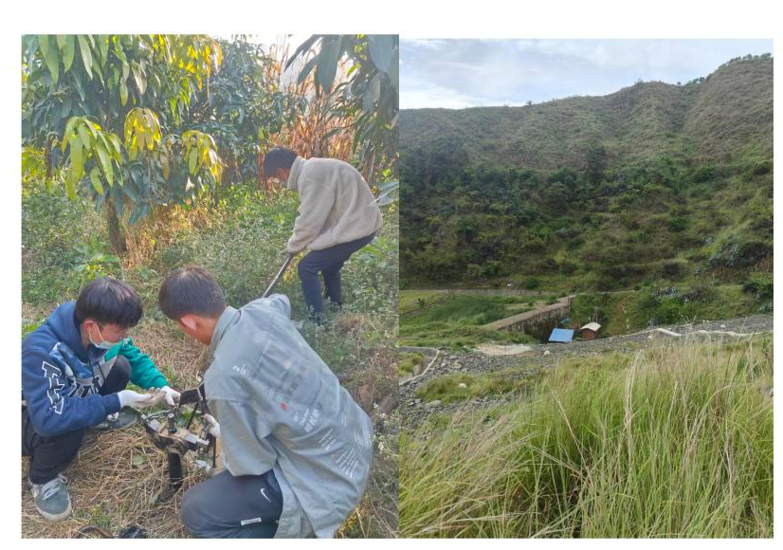
field photograph references
Figure S2

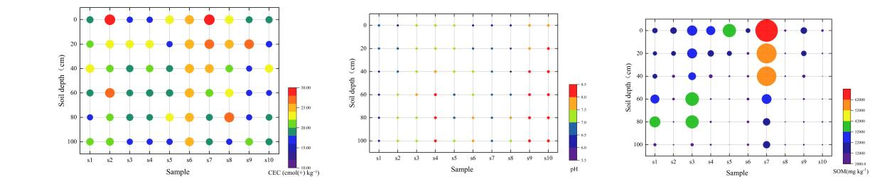
Vertical distributions of CEC, pH and SOM in soil profile samples

Figure S3

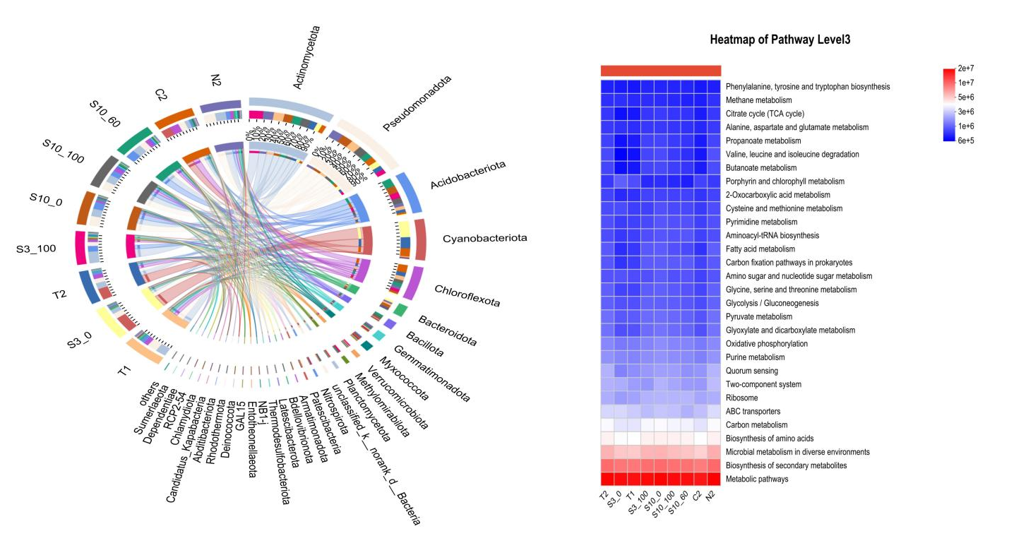
Microbial distribution at the cellular level, along with KEGG metabolic pathways

Figure S4
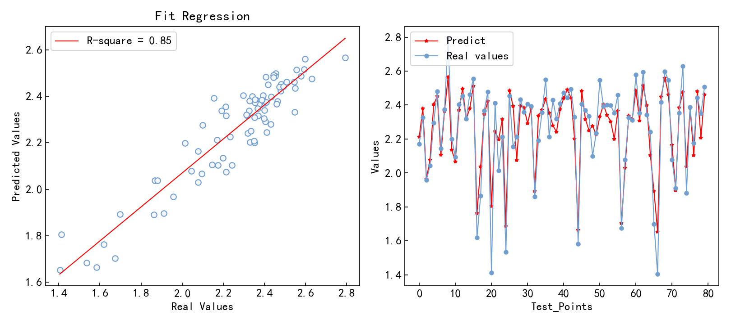
Training set performance with random seed=7
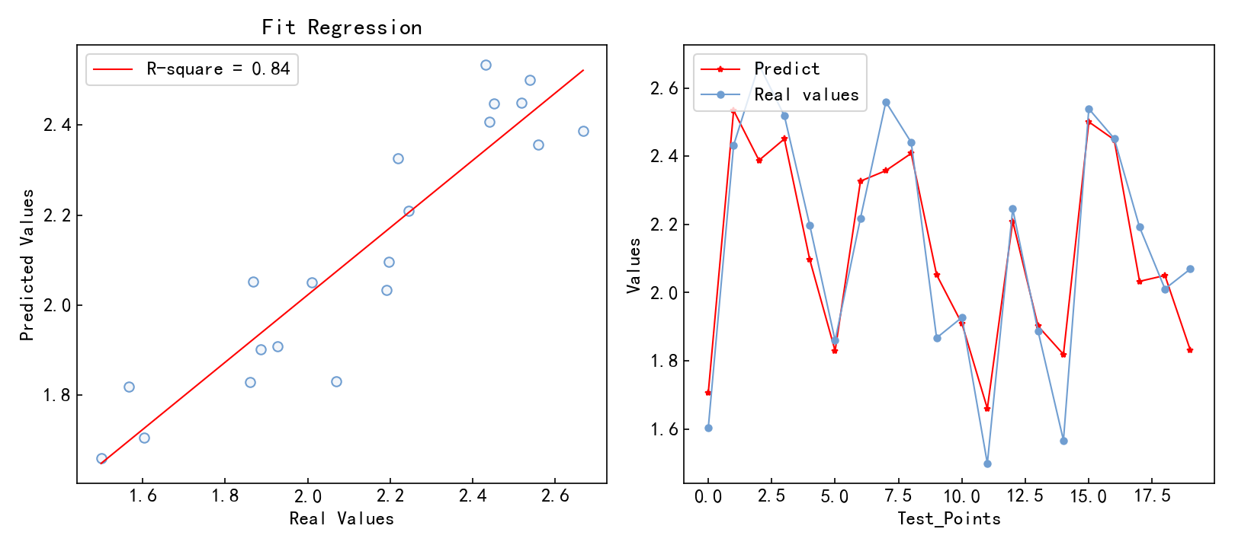
Test set performance with random seed = 7

