Supplementary Figures

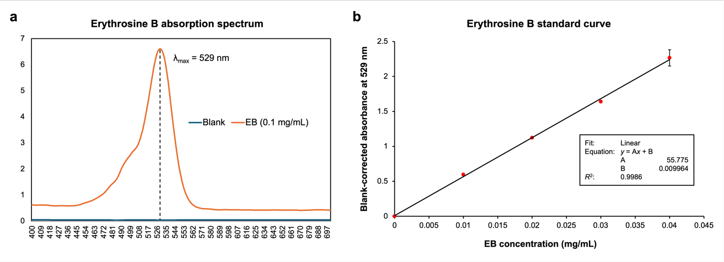
Supplementary Figure 1. Spectral characterization and calibration of Erythrosine B. (a) Absorption spectrum of EB (0.1 mg/mL) recorded from 400 to 700 nm, showing a maximum absorbance wavelength at 529 nm (λ_{max}). (b) EB standard curve generated from serial dilutions ranging from 0 to 0.04 mg/mL. Blank-corrected absorbance at 529 nm was fitted by linear regression, yielding the equation y = 55.775x + 0.009964 (R² = 0.999), where y represents blank-corrected absorbance at 529 nm and x represents EB concentration in mg/mL.

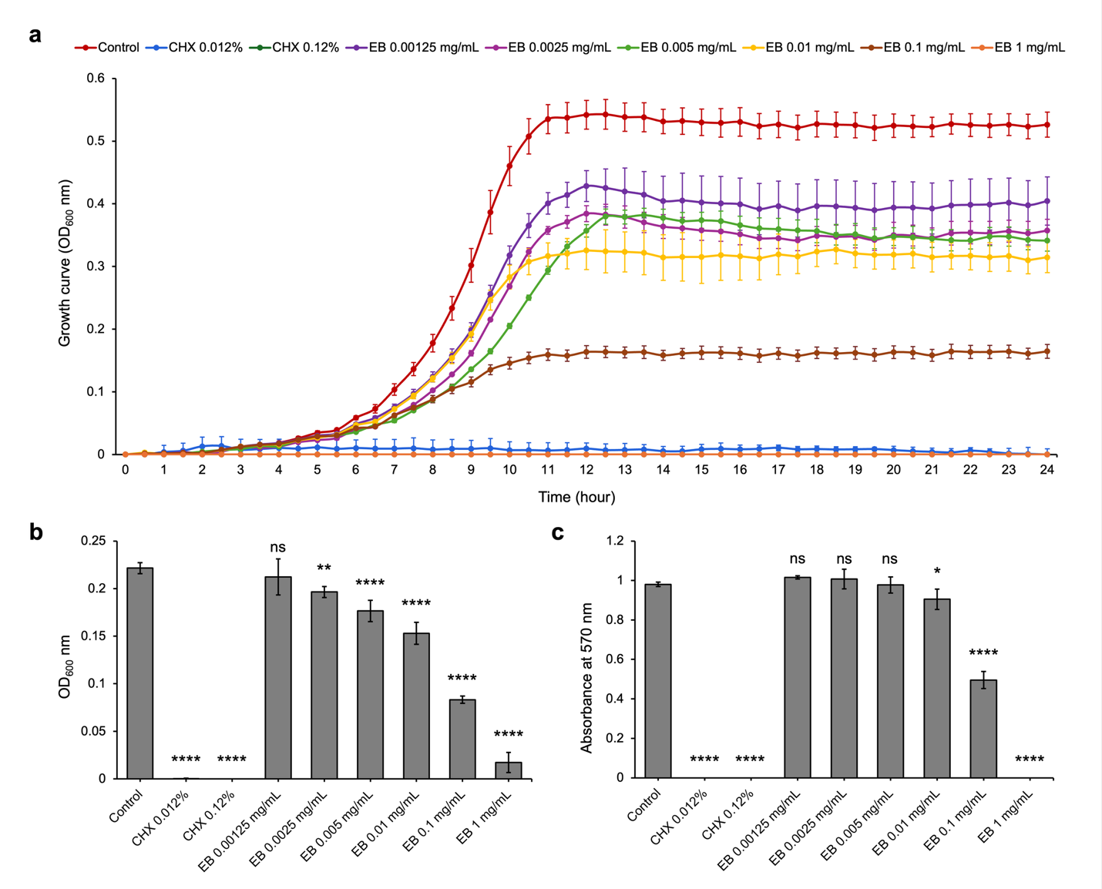
Supplementary Figure 2. Concentration-dependent effects of erythrosine B on planktonic growth and biofilm formation of S. mutans. (a) Planktonic growth kinetics of S. mutans cultured in UFTYE medium supplemented with 1% (w/v) glucose in the presence of EB at the indicated concentrations. Optical density at 600 nm (OD₆₀₀) was monitored over 24 h. Chlorhexidine (CHX, 0.12%) was included as a positive control. (b) Endpoint planktonic growth measured as OD₆₀₀ after 24 h incubation. (c) Biofilm biomass quantified by crystal violet staining after 24 h growth in UFTYE medium supplemented with 1% (w/v) sucrose. Absorbance was measured at 570 nm. Data are presented as mean ± SD. Statistical analysis was performed using one-way ANOVA followed by Dunnett’s multiple comparisons test against the untreated control. ns, not significant; *P < 0.05; **P < 0.01; ****P < 0.0001.

