Supplementary Information for
A Global Outlook for Climate-Driven Soil Shrink-swell Subsidence
Chen Liang, Arman Pouyaei, Zac Flamig, Jeremy R. Porter, Edward J. Kearns

Contents
Supplementary Methods
Supplementary Tables 1–4
Supplementary Figures 1–7
Supplementary References

Supplementary Methods
Data integration and pre-processing
Building exposure was derived from the Overture Maps Foundation “Buildings” theme, aggregated to a global 250 m grid as building counts per cell. Soil data consisted of the 60–100 cm and 100–200 cm clay-content layers from SoilGrids250m²⁴, combined into a weighted mean of the two layers. SoilGrids assigns null values beneath sealed urban surfaces because field calibration samples are absent. Because cities overlie the same geological formations as the surrounding land, we propagated peri-urban clay values into data-void urban pixels using an iterative Gaussian filter (σ = 5.0, 10 iterations) at 2.5 km resolution, then resampled to the native 250 m grid by nearest-neighbor interpolation. Sensitivity tests over metropolitan France with narrower (σ = 2.5, 5 iterations) and wider (σ = 10.0, 15 iterations) kernels changed national loss estimates by less than 8%, confirming that the gap-filling radius is not a dominant source of uncertainty.
A desert mask eliminated spurious risk in hyper-arid regions. We computed the median annual scPDSI range (2000–2023) from CRU TS4.08 at 0.5° resolution and set drought episode counts to zero wherever this range fell below 0.2, removing areas that lack a seasonal wetting–drying cycle.
Model formulation, loss function, and optimization
The model expresses the annual subsidence damage probability at each pixel as the product of a drought-driven exposure term and a clay-content eligibility term, with three free parameters: the scPDSI drought threshold d, the clay-content threshold c_{t}, and the per-episode damage probability p. The full functional form is given in Equation 2 (below, in the Block-based downscaling section); here we describe the loss function used to calibrate (d, c_{t}, p) against observed Catastrophes Naturelles claims. Three parameters are learned via gradient descent using JAX⁶: a scPDSI drought threshold d, a clay content threshold c, and a per-episode damage probability p. A fixed cost of $16,485 per building converts episode counts to monetary loss. This value is the mean cost per recognized Sécheresse claim under the French Catastrophes Naturelles regime, computed as the ratio of total annual national subsidence losses to the total number of communes with recognized claims over 2018–2022. It is consistent with published per-claim costs for retrait-gonflement-des-argiles damage to single-family homes (~€16,500–16,700)¹¹, though lower than the broader average drought claim of ~€24,000 per individual policyholder, which includes higher-cost multi-unit cases. The objective function is:
L = L_{national} + λ_{s} · L_{spatial} + λ_{v} · L_{variability} + λ_{r} ((c_{t} − 350) / 100)²(1)
where L_{national} is the mean squared relative error between predicted and observed annual losses across 2018–2022; L_{spatial} penalizes predicted losses in communes with zero observed claims; L_{variability} penalizes deviation from perfect Pearson correlation between predicted and observed annual time series; and the final term is an L2 regularisation anchoring the clay threshold near 350 g kg⁻¹, the Atterberg-based value used in French engineering practice.
The weights λ_{s} = 0.3, λ_{v} = 1.0, and λ_{r} = 0.01 are fixed hyperparameters. Only d, c_{t}, and p are optimized. At the converged solution, the L2 penalty contributes approximately 3% of total loss, sufficient to prevent parameter drift along a flat ridge in the (c, p) subspace without overriding the data signal. Grid-search initialization over the three-parameter space precedes gradient descent (5,000 epochs, learning rate 0.001, Adam optimizer via Optax). The model was calibrated against 2018–2022 French Catastrophes Naturelles insurance claims.
Block-based downscaling
To manage computation on the global 62,760 × 159,264-pixel grid at 250 m resolution, we partitioned the domain into 540 discrete 10° × 10° geodetic blocks for parallel processing. Ensemble-mean episode counts at 0.5° were interpolated to 250 m via bilinear interpolation, followed by land-fraction-normalized Gaussian smoothing (σ = 10 pixels, ~2.5 km) to suppress grid aliasing. Each block was processed with 4σ padding on all edges to ensure spatial continuity across boundaries. Annual damage probability per pixel was computed as:
P_{annual} = [1 − (1 − p)^{ε}] · σ(c − c_{t})(2)
where σ(x) = 1 / (1 + e^{−x}) is the standard logistic function; p is the learned per-episode damage probability; ε is the smoothed ensemble-mean drought-episode count; c is the interpolated and gap-filled 60–200 cm clay content at 250 m resolution; c_{t} is the learned clay threshold. The clay gap-filling Gaussian (σ = 5 px at 2.5 km grid spacing) and the episode-field smoothing (σ = 10 px at 250 m grid spacing) are independent operations applied to different variables at different resolutions. This hierarchical approach captures macro-scale regional trends of clay basins while allowing high-resolution Overture Maps Foundation building footprints to dictate specific local exposure.
The logistic scale parameter is fixed at 1 g kg⁻¹ (not optimized), producing a near-binary eligibility transition: clay content more than ~2 g kg⁻¹ below the threshold contributes negligibly to damage probability, while content above the threshold contributes fully. This deliberate design choice reflects the geotechnical understanding that shrink-swell susceptibility increases sharply above a mineralogical threshold rather than gradually¹⁹. Fixing this parameter at 1 g kg⁻¹ preserves the three-parameter model formulation.
The 250 m grid is the computational resolution at which building exposure and clay content are resolved. The drought climatology, however, operates at the native 0.5° (~50 km) resolution of CRU TS4.08 scPDSI, interpolated to 250 m via bilinear interpolation and then smoothed (σ = 10 pixels, ~2.5 km) to suppress grid aliasing. The effective resolution of the annual damage probability, therefore, varies by component: building counts and clay content carry genuine sub-kilometer spatial information, while the drought episode frequency is resolved at ~5 km after smoothing. The 250 m designation refers to the grid at which all three components are combined and at which per-building exposure is computed, not to the resolution of the climate forcing.
Seasonal block bootstrap
Stochastic uncertainty in drought extremes was quantified using a seasonal block bootstrap²⁸. The procedure removes the per-pixel linear trend from the 1950–2100 scPDSI time series, groups residual spatial fields by calendar month into 12 pools, and for each synthetic month draws a complete residual field from that month’s pool before re-adding the projected trend. This preserves realistic spatial covariance of drought events while sampling from the full historical range of severity. We generated 1,000 synthetic realizations, each covering 1950–2100.
Comparison against observed CRU TS4.08 scPDSI (2000–2023) across 60,740 global land pixels shows that the ensemble mean reproduces observed spatial gradients of variability, with a mean variance ratio of 0.895 and a median of 0.768 (Supplementary Fig. 1). A systematic conservative bias of 10–30% is evident across Northern Hemisphere mid-latitudes, arising from the removal of low-frequency variability during linear detrending. At the calibrated threshold of −2.62, a 12% reduction in standard deviation decreases drought exceedance probability by 15–25%. Because the damping is applied consistently to current and future periods, it affects absolute risk levels but preserves relative scenario differences. All damage probabilities should therefore be read as conservative lower-bound estimates.
Multi-model pattern scaling
SSP5-8.5 serves as the reference scenario. Projections under SSP2-4.5 and SSP1-2.6 are derived by scaling the inter-period change at each grid cell:
s_{t,ssp} = ΔT_{ssp} / ΔT_{ssp5-8.5} = (T_{t,ssp} − T_{base,ssp}) / (T_{t,ssp5-8.5} − T_{base,ssp5-8.5})(3)
using near-surface air temperature from seven CMIP6 models that provide output for all three scenarios: CMCC-ESM2, CNRM-CM6-1, CNRM-ESM2-1, INM-CM4-8, INM-CM5-0, MIROC-ES2L, and GISS-E2-1-G. The scaling factor is clamped to [0, 1]. Temperature was chosen over precipitation because CMIP6 temperature projections exhibit higher signal-to-noise ratios and stronger inter-model consensus. Replacing the ensemble mean with the median changes the global mean projection by less than 3%.
Population and GDP weighting
Population-weighted risk was computed as:
R_{pop} = Σ_{i} (R_{i} · P_{i}) / Σ_{i} P_{i}(4)
where R_{i} is the annual damage probability at grid cell i and P_{i} is the population count, using gridded population fields from the First Street Global Climate Migration Model¹⁶ at 12.5 km resolution. GDP-weighted risk was computed analogously using empirically derived GDP fields:
R_{GDP} = Σ_{i} (R_{i} · G_{i}) / Σ_{i} G_{i}(5)
where G_{i} is the gridded GDP at cell i, derived from empirical relationships between population and economic output²⁰. A combined metric was defined as the mean of standardized ranks across all three weighting schemes. Countries were stratified by population and GDP quartiles to evaluate risk separately for the most populous and largest economies (Supplementary Tables 1 and 2). The global top-10 rankings across all four metrics are reported in Supplementary Table 3.
Geographic transferability
To test transferability across climate zones, we split France at 46°N into a northern oceanic region (61% of claims) and a southern Mediterranean-to-continental region (39% of claims), trained on each half, and predicted the other. When trained on northern France and tested on the south, the model achieved a Pearson correlation of r = 0.70; trained on southern France and tested on the north, r = 0.42. The higher north-to-south correlation is consistent with the wetter northern climate providing a more informative drought variability signal for calibration. Across both experiments, the scPDSI threshold converged to nearly identical values (−2.73 and −2.78), strongly supporting the physical robustness of this parameter across France’s Mediterranean-to-oceanic climate gradient.
Qualitative validation
We compiled 26 shrink-swell hotspots documented in national geological-survey reports and the peer-reviewed literature (Supplementary Table 4; Supplementary Fig. 7). The hotspots span the London Clay basin, the Spanish Tierras de Bujeo, the French BRGM RGA zones, the Texas Gulf Coast, Mexico City, the Deccan vertosols, the North China Plain, the Australian Vertosol belts and Gauteng’s expansive residuum. Nineteen of the 26 hotspots (69%) fall in the top quartile of modelled risk within a 50 km neighbourhood; all 26 fall above the global median. The eight hotspots below the top-quartile threshold sit in humid temperate climates (the four UK sites, Houston-Dallas, Mexico City, Hebei-Shandong and Greater Cairo), where shrink-swell is well documented but year-round moisture damps the modelled probability relative to dry-summer zones. The model, trained only on French claims, recovers most of the documented global hotspots.

Supplementary Tables
Supplementary Table 1 | Top 10 countries by shrink-swell hazard exposure among the highest population quartile.
Countries are ranked across four metrics: average (area-based) risk, population-weighted risk, GDP-weighted risk, and a combined metric integrating all three. Iraq, Bangladesh, and Burkina Faso rank consistently high across multiple metrics, indicating that subsidence risk in these populous countries is both widespread and closely aligned with population centres and economic activity.
Rank | Average hazard exposure | Population-weighted | GDP-weighted | Combined (area, pop, GDP)
1 | Iraq | Australia | Burkina Faso | Iraq
2 | France | Iraq | Bangladesh | Bangladesh
3 | Burkina Faso | France | Iraq | Burkina Faso
4 | Bangladesh | Algeria | Spain | Thailand
5 | Thailand | Bangladesh | Thailand | Spain
6 | Ghana | Burkina Faso | Guatemala | Guatemala
7 | Guatemala | Thailand | Turkey | Ghana
8 | Spain | Spain | Ghana | Turkey
9 | Turkey | Malaysia | Afghanistan | Afghanistan
10 | Venezuela, RB | Japan | Angola | Congo, Dem. Rep.

Supplementary Table 2 | Top 10 countries by shrink-swell hazard exposure among the highest economy quartile.
Countries in the top 25th percentile of global GDP are ranked across the same four metrics as Supplementary Table 1. Iraq, Singapore, and Bangladesh rank highest in combined risk, reflecting environments where dense urbanization and economic concentration coincide with elevated subsidence exposure. Australia ranks first in population-weighted risk despite moderate area-based risk, indicating disproportionate population concentration in higher-risk zones.
Rank | Average hazard exposure | Population-weighted | GDP-weighted | Combined (area, pop, GDP)
1 | Iraq | Australia | Bangladesh | Iraq
2 | Romania | Romania | Iraq | Singapore
3 | Singapore | Iraq | Singapore | Bangladesh
4 | France | France | Spain | Thailand
5 | Korea, Rep. | Algeria | Thailand | Spain
6 | Bangladesh | Singapore | Guatemala | Guatemala
7 | Thailand | Korea, Rep. | Turkey | Turkey
8 | Italy | Bangladesh | United Kingdom | Belgium
9 | Guatemala | Thailand | Ireland | United Kingdom
10 | Spain | South Africa | Belgium | Philippines

Supplementary Table 3 | Top 10 countries by shrink-swell hazard exposure probability across four complementary metrics.
Luxembourg, Andorra, and San Marino rank near the top across all columns, indicating that subsidence risk in these countries is geographically widespread and aligned with population and economic activity concentrations. Differences across columns highlight cases where weighting reveals hidden vulnerability—for example, Monaco and Guinea-Bissau rise in the GDP-weighted ranking, while Morocco and Australia rise in the population-weighted ranking.
Rank | Average hazard exposure | Population-weighted | GDP-weighted | Combined (area, pop, GDP)
1 | Andorra | Luxembourg | Luxembourg | Luxembourg
2 | Luxembourg | Andorra | Andorra | Andorra
3 | San Marino | San Marino | San Marino | San Marino
4 | Gibraltar | Morocco | Lesotho | Gibraltar
5 | Iraq | Lesotho | Gibraltar | Lesotho
6 | Romania | Australia | Monaco | Monaco
7 | Monaco | Gibraltar | Guinea-Bissau | Iraq
8 | Azerbaijan | Romania | Burkina Faso | Azerbaijan
9 | Moldova | Azerbaijan | Bangladesh | Guinea-Bissau
10 | Lesotho | Iraq | Zimbabwe | Moldova

Supplementary Table 4 | Documented shrink-swell hotspots (n = 26).
Coordinates, geological/observational context, and primary source for each documented hotspot used in the qualitative validation (see Supplementary Fig. 7).
# | Location | Lon | Lat | Geological / observational context | Source
1 | London, UK | −0.128 | 51.507 | London Clay: highest density of subsidence claims in the UK. | [10]
2 | South East England (Kent/Essex), UK | 0.500 | 51.300 | Young, moisture-sensitive clay formations (Gault Clay). | [18]
3 | East Midlands (Nottingham), UK | −1.100 | 52.900 | Lias Group deposits; frequent shrink-swell hazards for transport infrastructure. | [4]
4 | The Wash/Fenlands, UK | 0.300 | 52.800 | Holocene alluvium and peat-rich soils prone to volume change. | [25]
5 | Seville (Guadalquivir Basin), Spain | −5.985 | 37.389 | Known as “Tierras de Bujeo” (highly expansive vertisols). | [3]
6 | Zaragoza (Ebro Basin), Spain | −0.889 | 41.649 | Expansive clays and marls; sulfate-induced heave in the presence of gypsum. | [15]
7 | Paris Basin, France | 2.352 | 48.857 | High smectite content; primary region for national subsidence insurance claims. | [7]
8 | Toulouse (Occitanie), France | 1.444 | 43.605 | Molasse formations with high shrink-swell potential. | [7]
9 | Bordeaux (Nouvelle-Aquitaine), France | −0.579 | 44.838 | Significant risk area identified by the BRGM RGA maps. | [8]
10 | Marseille (Provence), France | 5.370 | 43.297 | Localized expansive marls and clays in coastal hills. | [9]
11 | Darling Downs (QLD), Australia | 151.951 | −27.560 | Extensive Vertosols; major challenges for agriculture and foundations. | [13]
12 | Adelaide Plains, Australia | 138.601 | −34.929 | Deep reactive clay profiles (Hindmarsh Clay) requiring pier foundations. | [17]
13 | Melbourne (Western Suburbs), Australia | 144.963 | −37.814 | Quaternary basalt-derived clays (highly reactive Class E). | [5]
14 | Perth (Swan Coastal Plain), Australia | 115.861 | −31.951 | Guildford Formation clays; significant shrink-swell in winter/summer cycles. | [14]
15 | Mexico City (Lake Texcoco Basin), Mexico | −99.133 | 19.433 | High-plasticity volcanic lacustrine clays; extreme subsidence/swell. | [1]
16 | Monterrey (Nuevo Leon), Mexico | −100.316 | 25.687 | Expansive “Méndez Shale” formations in semi-arid climate. | [26]
17 | Querétaro, Mexico | −100.390 | 20.589 | Fissured expansive clays causing damage to historical structures. | [23]
18 | Denver (Front Range), USA | −104.990 | 39.739 | Pierre Shale; notorious for multi-inch vertical heave. | [22]
19 | Houston/Dallas (Texas), USA | −95.370 | 29.760 | Coastal Plain clays (Blackland Prairies) with extreme PI. | [21]
20 | Jackson (Mississippi), USA | −90.185 | 32.299 | Yazoo Clay: high-swell potential affecting the entire metro area. | [29]
21 | Addis Ababa, Ethiopia | 38.750 | 9.033 | High-plasticity black cotton soils covering large parts of the city. | [31]
22 | Deccan Plateau, India | 73.857 | 18.520 | Regur (Black Cotton Soils) covering ~20% of India’s landmass. | [30]
23 | Hebei/Shandong Plains, China | 117.000 | 36.600 | Vast areas of expansive soils affecting high-speed rail networks. | [27]
24 | Gauteng (Johannesburg/Pretoria), South Africa | 28.047 | −26.204 | Expansive residuum from shales and norites; major foundation costs. | [12]
25 | Greater Cairo (Nasr City/New Cairo), Egypt | 31.236 | 30.044 | Highly expansive Paleogene desert clays (smectite-rich); free-swell values 60-170% along the Cairo Ring Road. | [2]
26 | Saskatchewan (Regina), Canada | −104.619 | 50.445 | Glacial Lake Regina clays; significant seasonal basement damage. | [32]

Supplementary Figures
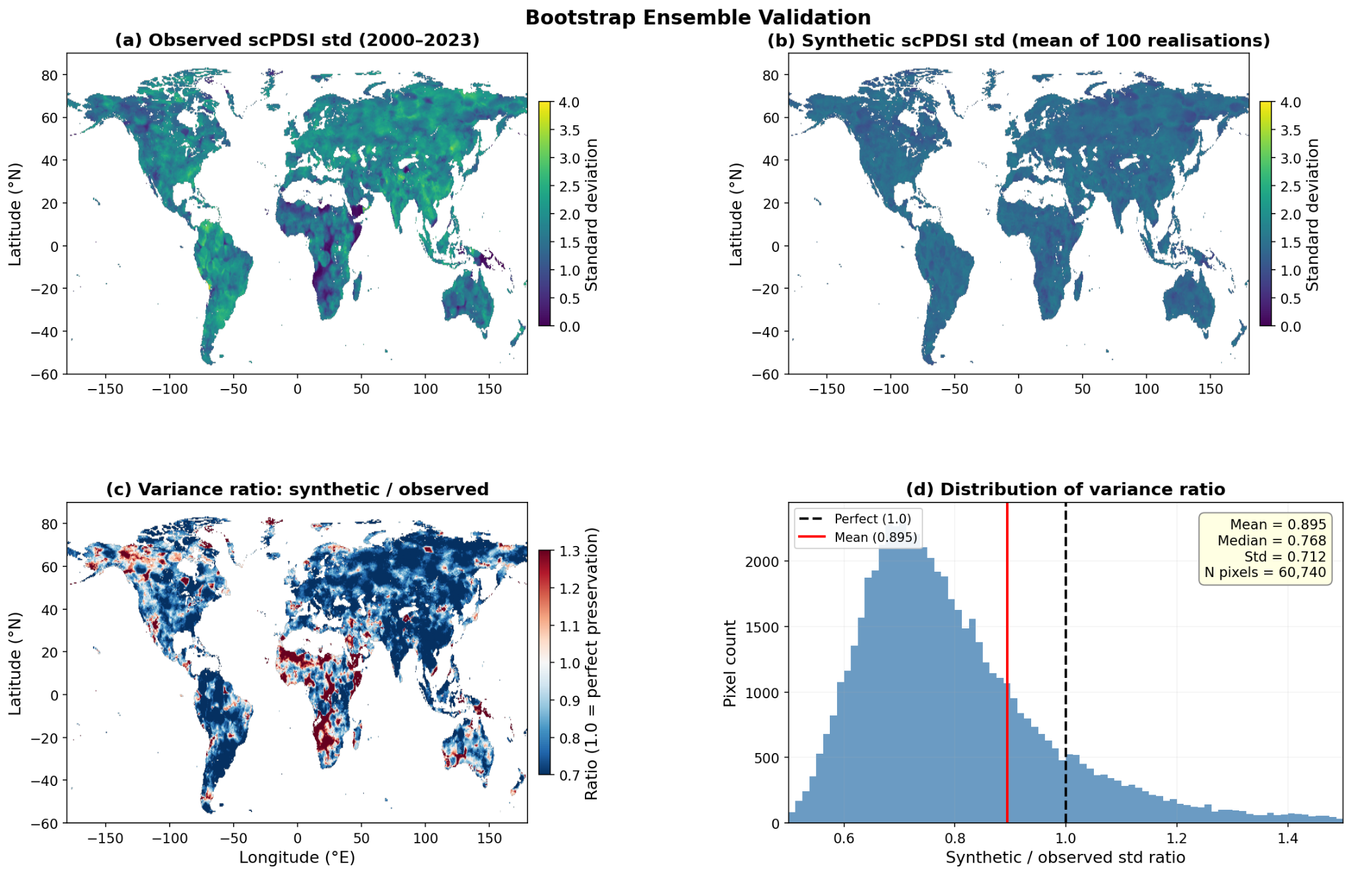
Supplementary Fig. 1 | Bootstrap ensemble variance validation. Validation used 100 realizations for computational tractability; the full 1,000-member ensemble was used for all risk projections. a, Observed per-pixel scPDSI standard deviation from CRU TS4.08 (2000–2023). b, Mean per-pixel standard deviation across 100 synthetic realizations generated by the seasonal block bootstrap over the equivalent time window. c, Variance ratio (synthetic divided by observed); values near 1.0 (white shading) indicate faithful variance preservation, while blue shading indicates underestimation. d, Histogram of per-pixel variance ratios across 60,740 land pixels (mean = 0.895, median = 0.768). The systematic ~10% underestimation stems from the removal of low-frequency natural variability during per-pixel linear detrending, yielding a conservative estimate of future drought risk.

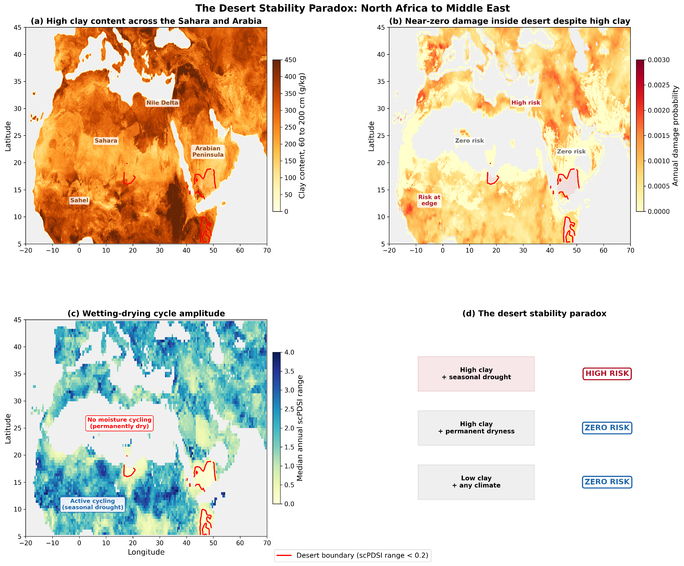
Supplementary Fig. 2 | The desert stability paradox. a, Clay content (60 to 200 cm depth, g kg⁻¹) across North Africa and the Middle East. The red contour marks the desert boundary where the median annual scPDSI range falls below 0.2. High clay content (>300 g kg⁻¹) is present throughout the Sahara and Arabian Peninsula. b, Annual damage probability for the current period (2015 to 2035) over the same region. Despite the high clay content shown in panel a, damage probability drops to zero inside the desert boundary. Risk is concentrated at the Nile Delta, the Mediterranean coast, and along the southern Sahel fringe, where seasonal rainfall sustains a wetting-drying cycle. c, Median annual scPDSI range (2000 to 2023), which quantifies the amplitude of soil moisture oscillation. Regions below 0.2 (red contour) lack the moisture cycling required to drive volumetric strain in clay soils. d, Schematic summary: structural damage requires both expansive clay and a seasonal wetting-drying cycle; permanently dry soils do not undergo the volumetric oscillations that cause foundation settlement, regardless of clay content.

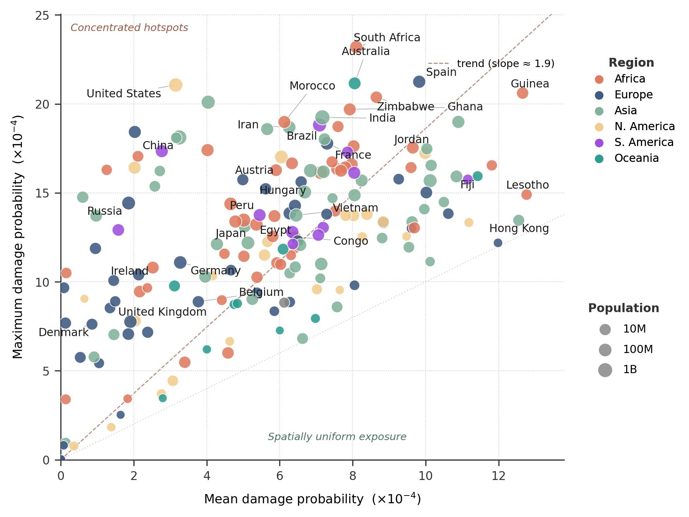
Supplementary Fig. 3 | Relationship between mean and maximum subsidence risk by country (×10⁻⁴). Each point represents a country, with mean damage probability on the x-axis and maximum damage probability on the y-axis. Countries well above the general trend (e.g., United States, China) harbor concentrated hotspots where extreme risk substantially exceeds the national average, while countries near the lower-left (e.g., Hong Kong, Lesotho) exhibit more spatially uniform exposure due to their small land area. Marker size scales with the logarithm of population.

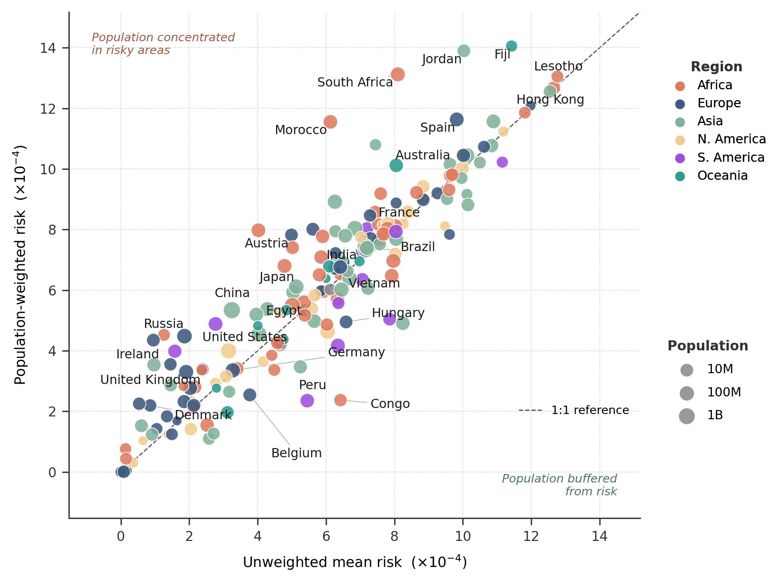
Supplementary Fig. 4 | Relationship between unweighted mean risk and population-weighted risk by country (×10⁻⁴). The dashed line indicates the 1:1 reference. Countries above the line (e.g., Morocco, South Africa, Jordan, Austria, Fiji, Ireland, Australia, Spain) have populations disproportionately concentrated in higher-risk areas, while countries below the line (e.g., Congo, Peru, Hungary, Belgium) have population centers that are relatively less exposed than the national average.

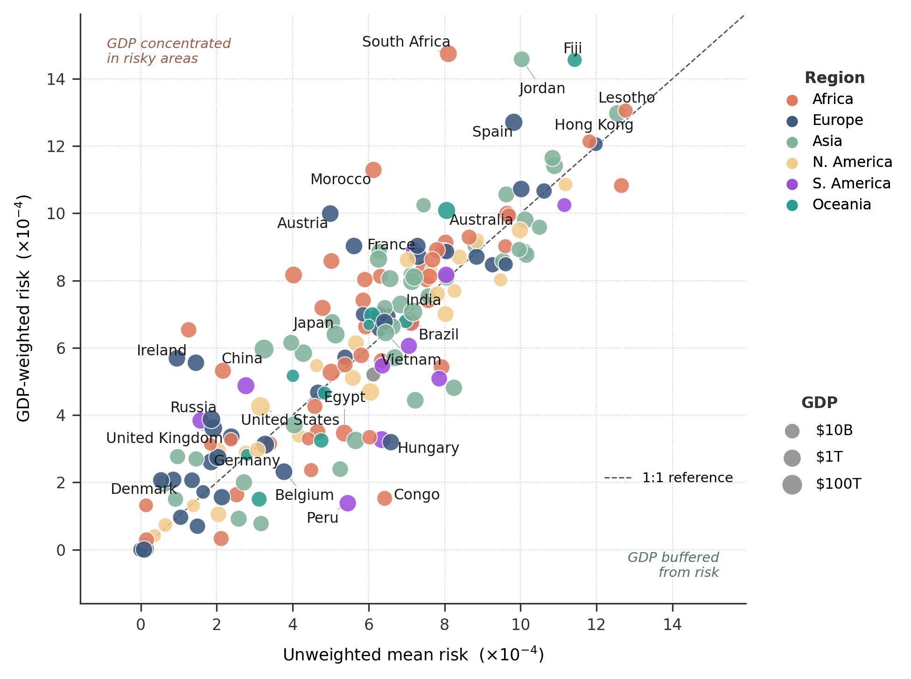
Supplementary Fig. 5 | Relationship between unweighted mean risk and GDP-weighted risk by country (×10⁻⁴). The dashed line indicates the 1:1 reference. Countries above the line (e.g., South Africa, Morocco, Austria, Jordan, Ireland, Fiji, Spain, China) have economic activity disproportionately concentrated in higher-risk areas. Countries below the line (e.g., Congo, Peru, Hungary, Egypt, Belgium) have economic output relatively concentrated in lower-risk zones despite moderate overall exposure.

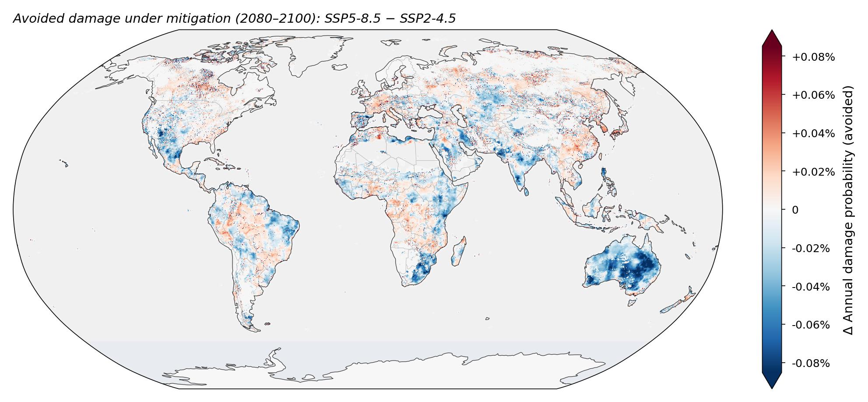
Supplementary Fig. 6 | Difference in annual subsidence damage probability between the unmitigated SSP5-8.5 and intermediate SSP2-4.5 pathways for the far future (2080–2100). Red shading indicates regions where SSP5-8.5 yields a higher damage probability than SSP2-4.5, reflecting the additional risk associated with unmitigated emissions. The largest positive differences occur in Northern Europe, where drought frequency is most sensitive to the emissions trajectory. Blue shading indicates regions where pattern-scaling artifacts from internal climate variability across the seven-model ensemble produce locally higher estimates under SSP2-4.5. Rendered at ~25 km from the native 250 m grid using stride-100 subsampling.

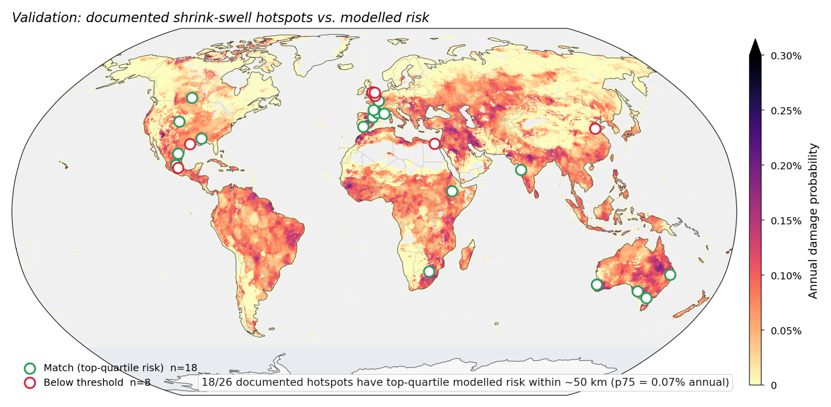
Supplementary Fig. 7 | Qualitative validation against documented shrink–swell hotspots. Locations of 26 documented shrink–swell hotspots (coordinates and sources in Supplementary Table 4). Green rings, locations where the maximum modelled annual damage probability within a 50 km radius is in the top quartile of the global non-zero land distribution (p₇₅ = 0.072% yr⁻¹); red rings, locations below this threshold. The model, trained on French insurance claims, places 18 of 26 hotspots (69%) in the top quartile and all 26 above the global median (p₅₀ = 0.030% yr⁻¹). The eight below-threshold cases (the four UK sites, Houston–Dallas, Mexico City, Hebei–Shandong and Greater Cairo) are humid-temperate regions in which absolute modelled probabilities are damped by year-round moisture availability relative to the dry-summer hotspots that dominate the top quartile.

Supplementary References
1.Auvinet, G., Méndez, E. & Juárez, M. Soil fracturing induced by land subsidence in Mexico City. In Proceedings of the 18th International Conference on Soil Mechanics and Geotechnical Engineering 2921–2924 (ISSMGE, Paris, 2013).
2.Awad, H. A. et al. Geotechnical and geophysical investigations for infrastructure safety zones: a case study of the supporting ring road, Cairo, Egypt. Sci. Rep. 14, 29670 (2024).
3.Ayala-Carcedo, F. J. & Olcina Cantos, J. (eds) Riesgos Naturales (Editorial Ariel, Barcelona, 2002).
4.Bateson, L., Jones, L. & Hulbert, A. User Guide for the British Geological Survey Property Subsidence Assessment Dataset. BGS Open Report OR/20/005 (British Geological Survey, Keyworth, 2020).
5.Bell, G. et al. Geology of the Melbourne District, Victoria. Bulletin No. 59 (Geological Survey of Victoria, Melbourne, 1967).
6.Bradbury, J. et al. JAX: composable transformations of Python+NumPy programs. http://github.com/google/jax (2018).
7.BRGM. Cartographie de l’aléa retrait–gonflement des argiles https://www.georisques.gouv.fr/risques/retrait-gonflement-des-argiles (Bureau de Recherches Géologiques et Minières, Orléans, accessed May 2026).
8.BRGM. Cartographie de l’aléa retrait-gonflement des sols argileux dans le département des Landes. Rapport BRGM/RP-56583-FR (BRGM, Orléans, 2008).
9.BRGM. Cartographie de l’aléa retrait-gonflement des argiles dans le département des Bouches-du-Rhône. Rapport BRGM/RP-55403-FR (BRGM, Marseille, 2004).
10.British Geological Survey. GeoSure: shrink–swell https://www.bgs.ac.uk/datasets/geosure/ (BGS, Keyworth, accessed May 2026).
11.CCR. Bilan Cat Nat 2022 — Sécheresse (Caisse Centrale de Réassurance, Paris, 2023).
12.Council for Geoscience. South African Geohazard Atlas https://www.geohazard.org.za (Council for Geoscience, Pretoria, accessed April 2026).
13.CSIRO. Australian Soil Resource Information System (ASRIS) https://www.asris.csiro.au (CSIRO Land and Water, Canberra, accessed April 2026).
14.Gozzard, J. R. Geology and Landforms of the Perth Region (Geological Survey of Western Australia, East Perth, 2007).
15.Gutiérrez, F. et al. The origin, typology, spatial distribution and detrimental effects of the sinkholes developed in the alluvial evaporite karst of the Ebro River valley downstream of Zaragoza city (NE Spain). Earth Surf. Process. Landf. 32, 912–928 (2007).
16.Hirsch, Z. M., Medgyesi, D. N., Buresch, J. M. & Porter, J. R. A global multi-hazard framework for projecting climate migration flows to 2100 along shared socioeconomic pathways. Climate 14, 81 (2026).
17.Jaksa, M. B. Geotechnical risk and inadequate site investigations: a case study. Aust. Geomech. 35, 39–46 (2000).
18.Jones, L., Banks, V. & Jefferson, I. Swelling and shrinking soils. Geol. Soc. Lond. Eng. Geol. Spec. Publ. 29, 223–242 (2020).
19.Jones, L. D. & Jefferson, I. Expansive soils. In ICE Manual of Geotechnical Engineering Vol. 1 (eds Burland, J. et al.) 413–441 (ICE Publishing, London, 2012).
20.Medgyesi, D., Hirsch, Z., Herrera, J. S., Buresch, J. & Porter, J. Tracing global macroeconomic change through population change and severe climate exposure pathways. Humanit. Soc. Sci. Commun. (in press).
21.Nelson, J. D. & Miller, D. J. Expansive Soils: Problems and Practice in Foundation and Pavement Engineering (Wiley, New York, 1992).
22.Noe, D. C., Jochim, C. L. & Rogers, W. P. A Guide to Swelling Soils for Colorado Homebuyers and Homeowners 2nd edn, Special Publication SP-43 (Colorado Geological Survey, Denver, 2007).
23.Pacheco, J. et al. Delimitation of ground failure zones due to land subsidence using gravity data and finite element modeling in the Querétaro valley, Mexico. Eng. Geol. 86, 143–160 (2006).
24.Poggio, L. et al. SoilGrids 2.0: producing soil information for the globe with quantified spatial uncertainty. SOIL 7, 217–240 (2021).
25.Pritchard, O. G., Hallett, S. H. & Farewell, T. S. Soil geohazard mapping for improved asset management of UK local roads. Nat. Hazards Earth Syst. Sci. 15, 2079–2090 (2015).
26.Servicio Geológico Mexicano. Carta Geológico-Minera Monterrey G14-7, escala 1:250,000 https://www.sgm.gob.mx (Servicio Geológico Mexicano, Pachuca, 2008).
27.Shi, B., Jiang, H., Liu, Z. & Fang, H. Y. Engineering geological characteristics of expansive soils in China. Eng. Geol. 67, 63–71 (2002).
28.Steinschneider, S. & Brown, C. A semiparametric multivariate, multisite weather generator with low-frequency variability for use in climate risk assessments. Water Resour. Res. 49, 7205–7220 (2013).
29.Stover, C. W., Williams, R. D. & Peel, C. O. M. Yazoo Clay: Engineering Aspects and Environmental Geology of an Expansive Clay. Circular 1 (Mississippi Department of Natural Resources, Bureau of Geology, Jackson, 1988).
30.Subba Rao, K. S. Swell–shrink behaviour of expansive soils — geotechnical challenges. Indian Geotech. J. 30, 1–69 (2000).
31.Teferra, A. & Yohannes, S. Investigations on the expansive soils of Addis Ababa. J. EAEA 7, 1–9 (1986).
32.Yoshida, R. T., Fredlund, D. G. & Hamilton, J. J. The prediction of total heave of a slab-on-ground floor on Regina clay. Can. Geotech. J. 20, 69–81 (1983).

