Supplementary Information

Supplementary Text S1 | How prior technological waves reshaped urban space and the labor market 3
Supplementary Text S2 | Related research on the labor-market impact of AI 5
Supplementary Table S1 | Evolution of research on AI and the labor market (2017–2026) 6
Supplementary Text S3 | Marginal effects of GenAI on wages across education levels and job-market heat 9
Supplementary Fig. S1 | Heterogeneous marginal effects of GenAI exposure on wages. 9
Supplementary Text S4 | Prompts and rubrics for GenAI exposure assessment 10
1. Multi-model ensemble strategy 10
2. Taxonomy of GenAI exposure (E0–E3) 10
3. Standardized evaluation prompts 11
4. Aggregation and index construction 13
Supplementary Text S5 | Variable definitions 14
Supplementary Table S2 | Variable definitions and data sources 14
Supplementary Text S6 | Bartik IV — extended results and limitations 16
1. Industry-level GenAI exposure 16
Supplementary Fig. S2 | Industry-level GenAI exposure (basis for the Bartik shift-share IV). 16
2. First-stage diagnostics 17
Supplementary Fig. S3 | First stage — Bartik IV relevance. 18
3. Reduced form and 2SLS 18
4. Parallel-trends test 19
Supplementary Fig. S4 | Event-study robustness — parallel-trends validation (2020–2024). 20
5. Summary 20
Supplementary Table S3 | Full DID results (extended specifications) 20
Supplementary Table S4 | Long-difference instrumental-variables estimation 22
Supplementary Text S7 | Triple-DID mechanism analysis 24
Supplementary Table S5 | Triple-DID mechanism estimates 24
Supplementary Text S8 | Robustness checks 26
1. Randomization inference for the DID estimate 26
Supplementary Fig. S5 | Permutation test — randomization inference for the DID estimate. 27
2. Placebo tests for the fixed-effects models 27
Supplementary Fig. S6 | Placebo tests for the fixed-effects interaction terms. 30
References 31

Supplementary Text S1 | How prior technological waves reshaped urban space and the labor market
To contextualize the impact of GenAI, it is useful first to review how earlier waves of technological change reshaped urban space and labor markets.
The era of mechanized assembly lines (early twentieth century–1970s). The defining feature of Fordist technologies—most notably the conveyor belt—was the mechanical substitution of physical labor. Through “de-skilling,” complex craftsmanship was decomposed into simple machine operations, weakening workers’ bargaining power¹ and pushing low-end manufacturing toward low-cost peripheral regions and smaller cities^{2,3}.
The era of computer and internet diffusion (1980s–1990s). This wave triggered skill-biased technological change (SBTC), in which technological progress raised both the demand for, and the wage returns to, high-skilled labor⁴. Contrary to the “death of distance” thesis—which predicted that lower information costs would weaken agglomeration forces⁵—the era instead empowered high-skilled workers with complex cognitive abilities⁶, increased the value of face-to-face knowledge spillovers^{7,8}, and produced a triple polarization of “space–structure–wage”: educated talent concentrated in large cities, employment shares rose, and wages climbed⁹⁻¹².
The era of industrial robots and software automation (2000s–2010s). Technologies including robotic arms, enterprise resource planning (ERP) systems and ATMs deepened substitution into routine-biased technological change (RBTC). Technology eroded middle-skilled routine tasks^{13,14}, producing job polarization—growth in high- and low-wage employment alongside a shrinking middle^{15,16}—and consolidating the high-end service functions of urban cores^{11,14}.
The era of remote work and early discriminative AI (post-2010s). Even this wave failed to break the polarization trend. Remote-collaboration tools that became prominent during the pandemic—Zoom, Slack and similar platforms—largely served as supplementary workplace amenities for high-skilled knowledge workers^{17,18}. Early discriminative AI, focused on classification, prediction and recognition, functioned as an auxiliary tool within expert systems, augmenting the productivity of analysts and programmers rather than replacing their core functions^{19,20}.
In short, the technological narrative of the past three decades is unambiguous: technology has functioned as a substitute for blue-collar work and a complement to white-collar work, rewarding cognitive skills and reinforcing the position of urban cores as incubators of high-value employment.

Supplementary Text S2 | Related research on the labor-market impact of AI
The literature on AI’s labor-market effects has expanded rapidly, yet substantial heterogeneity remains in measurement frameworks, methods and findings. Existing studies construct indicators along three principal dimensions: macro labor-market structure, micro skill demand and occupational exposure. With respect to measurement methods, early work relied largely on expert evaluation of task content²¹⁻²⁴, scoring whether specific tasks were susceptible to automation. Subsequent contributions introduced quantitative approaches based on text similarity²⁵ and skill decomposition^{16,26,27}, leveraging natural language processing (NLP) to match patent texts, task descriptions and skill requirements. With the breakthrough of GenAI, however, the limitations of these static matching approaches have become increasingly apparent, and current research is shifting toward direct evaluation methods based on large language models (LLMs)^{28,29}. Following Eloundou et al.²⁹, the present study adopts an exposure indicator that moves beyond pure substitution assumptions to jointly consider technology's effects on labor costs and output. Specifically, we evaluate whether GenAI can reduce the time required to complete a given work task by at least 50% while preserving quality.
Empirical results derived from these methods exhibit clear stage-specific patterns (Supplementary Table S1). Phase I (2017–2022) concentrated on the substitution of blue-collar physical labor by industrial robots, predicting comparatively long and gradual transition timelines^{30,31}. Phase II (2022–2024)—initiated by the launch of ChatGPT and related GenAI models—pivoted to white-collar cognitive work, with markedly more aggressive forecasts. Goldman Sachs³², for instance, projected that 300 million jobs globally faced automation risk and emphasized the vulnerability of highly educated workers. Phase III (2024–2026) has begun to recalibrate, shifting the analytical lens from technical feasibility to economic feasibility. MIT³³ found that, owing to compute and deployment costs, only 23% of vision tasks are currently economically viable to automate; Microsoft and LinkedIn³⁴ document a corporate preference for skill reshaping over direct layoffs; and international organizations have warned that AI’s macro-productivity gains may be delayed until the 2030s and could exacerbate divergence between countries and generations^{35,36}. In sum, while the existing literature has clarified exposure at the technical level, systematic evidence remains scarce on the economic costs of technology adoption, the dynamic adjustment of skill supply and demand, and the macro-level structural divergence induced by AI.

Supplementary Table S1 | Evolution of research on AI and the labor market (2017–2026)
Phase | Date | Organization | Report / Source Title | Core Conclusion & Prediction
Phase I:  Early Focus  (Physical & Routine) | 2017.01 | McKinsey Global Inst.³⁰ | A Future that Works: Automation, Employment, and Productivity | Physical Automation: Half of today’ work activities could be automated by 2055, primarily affecting routine physical tasks.
 | 2021.12 | OECD³¹ | Artificial Intelligence and Employment: New Cross-Country Evidence | Ambiguous Impact: No clear negative relationship between AI exposure and employment growth yet; high computer-use jobs actually saw growth.
Phase II:  The GenAI Boom  (Cognitive & Aggressive) | 2023.03 | Goldman Sachs³² | The Potentially Large Effects of AI on Economic Growth | White-Collar Shock: Globally, 300 million full-time jobs could be automated; approx. 2/3 of U.S. jobs are exposed to some degree of automation.
 | 2023.07 | Pew Research³⁷ | Which U.S. Workers Are More Exposed to AI on Their Jobs? | High-Ed Vulnerability: 19% of U.S. workers are in high-exposure jobs, disproportionately affecting high-income, college-educated roles.
 | 2023.07 | McKinsey³⁸ | Generative AI and the Future of Work in America | Acceleration: By 2030, activities accounting for 30% of hours worked in the U.S. could be automated, accelerated by GenAI capabilities.
 | 2024.01 | IMF³⁹ | Gen-AI: Artificial Intelligence and the Future of Work | Advanced Economy Risk: 40% of global employment is exposed; this rises to 60% in advanced economies, compared with 40% in emerging markets.
Phase III:  Economic Rationality  & Structural Divergence  (2024–2026) | 2024.01 | MIT CSAIL & IBM³³ | Beyond AI Exposure: Which Tasks are Cost-Effective to Automate with Computer Vision? | Cost Constraints: Technical feasibility does not equal economic viability. Only 23% of vision tasks are economically attractive to automate due to high costs.
 | 2024.05 | Microsoft & LinkedIn³⁴ | 2024 Annual Work Trend Index | Skills Gap: The crisis is not a lack of jobs, but a lack of skills. 66% of leaders would not hire a candidate without AI aptitude.
 | 2025.02 | World Bank⁴⁰ | The Exposure of Workers to AI in Low- and Middle-Income Countries | Digital Divide: Only 12% of workers in low-income countries are exposed; developing nations risk missing the “AI dividend” due to infrastructure gaps.
 | 2025.10 | Gartner⁴¹ | Top Strategic Technology Trends for 2026 | Managerial Shift: By 2028, 33% of enterprise software interactions will be autonomous agents; risk shifts from creators to middle-management.
 | 2025.12 | UNDP³⁵ | The Macroeconomic Consequences of AI: The Next Great Divergence | Delayed Gains: Significant productivity gains are not expected until the 2030s; AI is likely to widen inequality between nations in the short term.
 | 2025.12 | OpenAI⁴² | The state of enterprise AI | Enterprise Divide & Role Expansion: Deepening AI use widens the gap between leading and lagging firms. It empowers non-technical workers to perform complex tasks (e.g., coding), saving 40-60 minutes daily.
 | 2026.01 | IMF³⁶ | Bridging Skill Gaps for the Future: New Jobs Creation in the AI Age | The “Broken Rung”: While AI skills command a wage premium, high exposure reduces hiring for entry-level roles by 3.6%, creating barriers for youth.
 | 2026.02 | Upwork & Freelancer⁴³ | In-Demand Skills 2026: A Market View of Skills Demand in an AI Economy | Taskification: 45% of businesses are replacing junior roles with AI-augmented freelancers, signaling a structural shift to a “task-based” labor market.
 | 2026.03 | Anthropic⁴⁴ | labor market impacts of AI: A new measure and early evidence | Observed Exposure & Youth Hiring: Actual AI adoption lags theoretical potential. While overall employment is stable, hiring for young workers (22-25) in highly exposed roles fell by 14%.

Supplementary Text S3 | Marginal effects of GenAI on wages across education levels and job-market heat
To visualize how the marginal effect of GenAI exposure on wages varies with educational attainment and labor-market competition, we computed and plotted the marginal-effect curves implied by Models (2) and (3) of Table 2 in the main text (Supplementary Fig. S1). For the de-skilling channel, the marginal effect is defined as $∂\ln{(}Wage)/∂GenAI=α_{1}+α_{3}×Educ$; for the crowding channel, $∂\ln{(}Wage)/∂GenAI=α_{1}+α_{3}×Crowd$. The figure reports point estimates with 95% confidence intervals across the empirical range of each moderator.

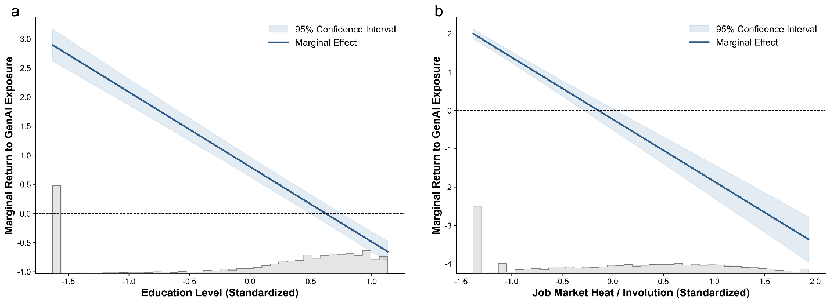

Supplementary Fig. S1 | Heterogeneous marginal effects of GenAI exposure on wages.
a, Moderating effect of education on the GenAI wage premium. The blue solid line shows the estimated marginal effect of standardized GenAI exposure on log wages across the distribution of standardized education. The light-blue band gives the 95% confidence interval; the grey histogram at the bottom shows the empirical distribution of education. The negative slope indicates a de-skilling (or levelling) effect: as education rises, the wage premium associated with GenAI exposure shrinks. b, Moderating effect of labor-market competition on GenAI returns. The marginal effect of GenAI exposure is plotted against the standardized job-market-heat index. The downward trajectory indicates that in highly competitive markets, the economic returns to GenAI are substantially attenuated.

Supplementary Text S4 | Prompts and rubrics for GenAI exposure assessment
This section documents the prompt-engineering framework, the E0–E3 taxonomy and the multi-model ensemble strategy used to quantify the GenAI exposure index for the 1,605 detailed occupations defined in the 2022 Occupational Classification of the People’s Republic of China.

1. Multi-model ensemble strategy
To mitigate the biases, hallucination risks and alignment idiosyncrasies inherent in any single LLM, we constructed an ensemble matrix comprising five state-of-the-art (SOTA) models: ChatGPT-4o, Gemini-2.5-pro, Claude-3.5-Sonnet, GLM-4 and Deepseek-R1.
For each of the 1,605 occupations, we conducted five independent evaluation rounds across the five models, yielding 25 independent inferences per occupation. The final exposure score for each occupation is the mean of these 25 inferences, which is then standardized (Z-score) to construct the GenAI exposure index used in the baseline regressions.

2. Taxonomy of GenAI exposure (E0–E3)
We adapted the task-level exposure rubrics of Eloundou et al. (2024)²⁹ and Chen et al. (2025)⁴⁵ to accommodate the multimodal capabilities of contemporary GenAI systems. Models were instructed to classify each occupation according to whether GenAI could reduce the time required to complete its core tasks by at least 50% without quality loss.
· E0 (No exposure). Direct access to GenAI or to GenAI-powered applications cannot reduce core-task completion time by half. This category applies to occupations requiring high physical dexterity, precise physical measurement or deep emotional human connection (for example, manual labor and specialized healthcare).
· E1 (Direct exposure). Direct access to standard GenAI interfaces (for example, conversational text or code generation) alone can reduce completion time by at least 50%. This applies to occupations heavily reliant on writing, translation, basic coding and routine data summarization.
· E2 (Application-augmented exposure). Standard GenAI interfaces alone are insufficient, but the 50% time reduction is readily achievable through specialized software built on top of GenAI APIs (for example, customized agents, retrieval-augmented generation systems over internal databases or domain-fine-tuned models).
· E3 (Multimodal-capability exposure). The 50% time reduction is achievable specifically through GenAI’s advanced multimodal capabilities, including computer vision, complex image processing and audio/video generation (for example, graphic designers and visual inspectors).

3. Standardized evaluation prompts
Because the occupational descriptions in the Occupational Classification are in Chinese, prompts were administered in Chinese to avoid translation-induced semantic loss. The English translation of the system prompt is provided below for reproducibility.

English version (for reference)
System role. You are an expert labor economist and evaluator of the potential of Generative AI (GenAI) to replace or augment human labor. GenAI models are advanced deep-learning systems capable of processing and generating natural-language text, code, images, audio and video.
Task. Based on the provided occupation name and its official core-task descriptions, evaluate the GenAI exposure level of this occupation. Assume the worker has average expertise and access to current SOTA GenAI models, standard computer hardware and any necessary GenAI-powered specialized software.
Scoring rubric. Classify the occupation into one of the following categories and assign the corresponding score:
- Score 0 (E0): GenAI cannot reduce the human-labor time required for this occupation by 50%.
- Score 1 (E1): Standard GenAI text/code interfaces can reduce labor time by at least 50%.
- Score 0.5 (E2): Specialized applications built on GenAI APIs can reduce labor time by at least 50%.
- Score 0.5 (E3): Multimodal GenAI (vision, image, audio generation) can reduce labor time by at least 50%.
Output format. Provide step-by-step reasoning for your classification, followed by the final assigned category (E0, E1, E2 or E3) and corresponding score.

Chinese version (the prompt actually used in the pipeline)
系统角色：你是一位权威的劳动经济学家和人工智能评估专家。生成式人工智能（GenAI）是先进的深度学习模型，能够处理和生成自然语言文本、代码、图像、音频和视频。
任务：请根据提供的《中华人民共和国职业分类大典》中的职业名称及其核心工作任务描述，评估该职业的 GenAI 暴露度。假设该岗位的劳动者具备平均专业水平，且能够使用当前最先进的 GenAI 模型、标准计算机硬件以及基于 GenAI 开发的专业软件应用。
评分标准：请判断在保持同等工作质量的前提下，GenAI 能否将完成该职业核心任务所需的人类劳动时间减少至少 50%。请将其归入以下四类之一并赋分：
- 赋分 0（E0 – 无暴露）：即使使用 GenAI，也无法将完成核心任务的时间减少 50%（通常涉及重体力劳动、高精度物理操作或深度人际情感交互）。
- 赋分 1（E1 – 直接暴露）：仅通过直接使用现有的 GenAI 文本/代码对话界面，即可将工作时间减少至少 50%。
- 赋分 0.5（E2 – 应用增强暴露）：仅靠基础 GenAI 界面不够，但通过基于 GenAI API 开发的专用软件（如企业知识库检索、定制化智能体）即可将工作时间减少至少 50%。
- 赋分 0.5（E3 – 多模态能力暴露）：必须依赖 GenAI 的高级多模态能力（如计算机视觉、图像生成、音视频处理）才能将工作时间减少至少 50%。
输出格式：请首先给出详细的推理过程（结合该职业的具体任务），然后明确输出最终的分类标签（E0、E1、E2 或 E3）以及对应的赋分（0、1 或 0.5）。

4. Aggregation and index construction
For occupation $i$, let $S_{i,m,r}$ denote the score (0, 0.5 or 1) assigned by model $m$ in evaluation round $r$. The raw GenAI exposure score $E_{i}$ is computed as:
$$E_{i}=\frac{1}{25}\sum_{m=1}^{5}{\sum_{r=1}^{5}{S_{i,m,r}}}$$
The raw scores were then standardized (Z-score) across the 1,605 occupations to produce the GenAI Exposure (Std.) variable used in the fixed-effects models (Equations 1 and 2 in the main text). Inter-model reliability was high: pairwise correlations among the five models ranged from 0.66 to 0.86, supporting the robustness of the ensemble approach.

Supplementary Text S5 | Variable definitions

Supplementary Table S2 | Variable definitions and data sources
Variable | Symbol | Definition & Measurement | Unit | Source / Reference
Core Recruitment Indicators
Recruitment Share | job_share | Ratio of street-level job postings to city total | – | RESSET Recruitment DB
Relative Recruitment Heat | job_index | Standardized relative heat index of the street block | Score | RESSET Recruitment DB
Wage Level | salary | Average monthly salary of jobs in the street block | CNY/Month | RESSET Recruitment DB
Skill Level (Education) | education | Average years of schooling required for the jobs | Years | RESSET Recruitment DB
GenAI Exposure
Occupational Exposure | GenAI_exp | Degree to which tasks are substituted/augmented by GenAI | Index | Eloundou et al.²⁹; Self-test via 5 SOTA models
Industry Classification
Industry Category | industry | 18 first-level industry categories per the Chinese National Standard for Industrial Classification (GB/T 4754-2017): (A) Agriculture, (B) Mining, (C) Manufacturing, (D) Utilities, (E) Construction, (F) Wholesale/Retail, (G) Transport, (H) Hospitality, (I) IT & Software, (J) Finance, (K) Real Estate, (L) Business Services, (M) Science & Tech, (N) Water/Environment, (O) Resident Services, (P) Education, (Q) Health, (R) Culture/Sports | Category | RESSET Recruitment DB
Confounder Exposure Variables
Tech-Regulation Exposure | TechReg | Share of street-block employment in IT & Software (Code I) in 2018 | % | Calculated from RESSET
COVID-Recovery Exposure | COVID | Share of street-block employment in Hospitality (H) + Transport (G) in 2018 | % | Calculated from RESSET
Real-Estate Exposure | RealEstate | Share of street-block employment in Real Estate (K) + Construction (E) in 2018 | % | Calculated from RESSET
Bartik IV
Bartik Shift-Share Instrument | Bartik | Weighted sum of leave-one-out industry-level GenAI exposure, using 2018 industry employment shares as weights (Methods Eq. 4–5) | Index | Calculated from RESSET
Control Variables
Living Convenience | poi_density | Density of Points of Interest (POI) per unit area | Count/km² | Amap (2018–2024)
Development Intensity | landuse_ratio | Proportion of construction land (impervious surface) | % | Yang & Huang⁴⁶
Environmental Quality | ndvi | Annual mean Normalized Difference Vegetation Index | – | NASA MOD13A3
Economic Activity | nightlight | Sum of nighttime light intensity | nW/cm²/sr | NOAA NPP/VIIRS⁴⁷
Population Size | population | Resident population count in the street block | Person | WorldPop⁴⁸

Supplementary Text S6 | Bartik IV — extended results and limitations

1. Industry-level GenAI exposure
The leave-one-out industry-level GenAI exposures are reported in the final two columns of Supplementary Table S3. The three highest-exposure industries are Information Technology and Software (0.398), Scientific and Technical Services (0.388) and Finance (0.387); the three lowest are Agriculture (0.304), Transportation (0.318) and Mining (0.281). The ranking accords with intuition: knowledge-intensive industries exhibit substantially higher GenAI exposure than industries dominated by manual labor. Supplementary Fig. S2 visualizes these inter-industry differences.

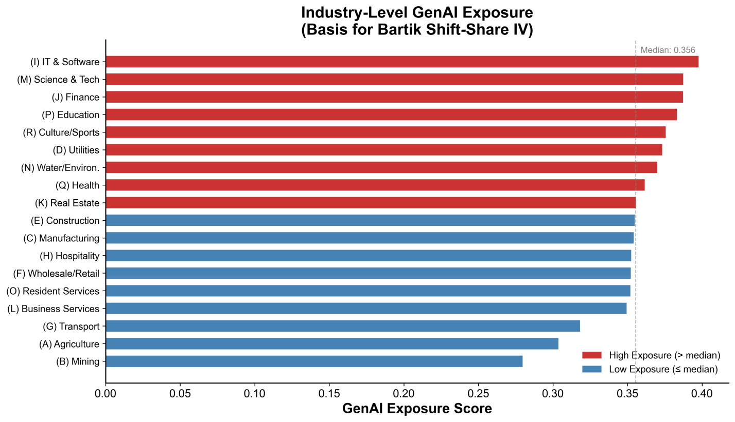

Supplementary Fig. S2 | Industry-level GenAI exposure (basis for the Bartik shift-share IV).
Horizontal bar chart of the leave-one-out GenAI exposure score for each of the 18 first-level industry categories, sorted in descending order. The dashed vertical line indicates the cross-industry median (0.356). Bars above the median are shaded dark red (high exposure); bars at or below the median are light blue (low exposure). Agriculture (A), Transport (G) and Mining (B) rank lowest, reflecting their predominance of manual and physical tasks. The inter-industry variation shown here provides the shift component of the Bartik instrument (Methods Eqs. 4–5).

2. First-stage diagnostics
The first-stage F-statistic is 53.5, far exceeding the conventional weak-instrument threshold of 10⁴⁹ and confirming the relevance condition of the IV. Note, however, that the first-stage coefficient is negative (${\hat{π}}_{1}=−0.022$, $p<0.001$): neighborhoods with higher Bartik IV values subsequently exhibited smaller changes in GenAI exposure. This counterintuitive sign reflects a ceiling effect. neighborhoods whose 2018 industrial composition was already heavily weighted toward AI-intensive industries had high GenAI exposure as early as 2018, leaving limited room for further marginal change—producing a regression-to-the-mean pattern (Supplementary Fig. S3).

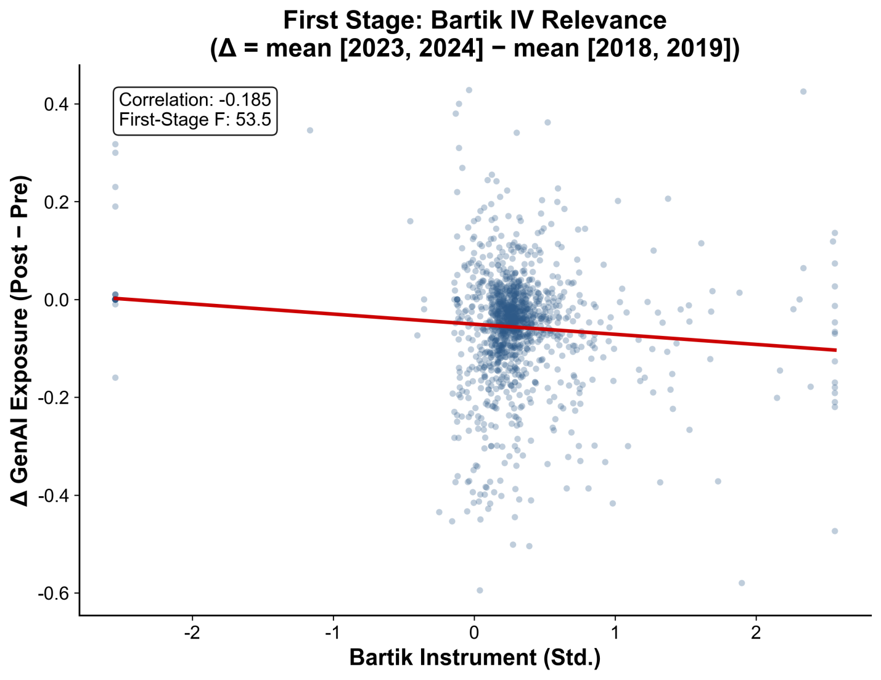

Supplementary Fig. S3 | First stage — Bartik IV relevance.
Scatter plot of the standardized Bartik shift-share instrument (x-axis) against the change in GenAI exposure (Δ = mean[2023, 2024] − mean[2018, 2019], y-axis) for the 1,383 neighborhood blocks. The red line gives the linear fit. The correlation is -0.185 and the first-stage F-statistic is 53.5, confirming instrument relevance. The negative slope reflects the ceiling effect: blocks whose 2018 industry composition was already concentrated in high-GenAI sectors had limited scope for further increases in exposure, producing smaller or negative changes over 2018–2024. See Supplementary Text S6 for interpretation.

3. Reduced form and 2SLS
The reduced-form estimate is ${\hat{β}}_{RF}=−0.436$ ($p<0.001$): a one-standard-deviation increase in the Bartik IV is associated with a 0.436 log-point reduction in the wage growth rate. This direction is fully consistent with the pre-determined DID—neighborhoods more deeply tied to GenAI-intensive industries experienced larger wage declines.
The 2SLS structural estimate is ${\hat{β}}_{IV}=19.82$ ($p<0.001$). This positive and very large coefficient is opposite in sign to the negative pre-determined DID estimate, but the apparent contradiction follows mechanically from the negative first stage: ${\hat{β}}_{IV}={\hat{β}}_{RF}/{\hat{π}}_{1}=−0.436/−0.022≈19.8$. The 2SLS estimator recovers a Local Average Treatment Effect (LATE) defined over the complier subpopulation—the neighborhoods whose GenAI exposure declined because of their industrial composition. For these compliers, a decline in GenAI exposure (potentially reflecting attrition of high-paying AI jobs) is accompanied by a wage decline, producing the positive structural coefficient. Conceptually, the 2SLS LATE and the pre-determined DID identify different causal parameters, and the two are not contradictory; nevertheless, careful interpretation is required.

4. Parallel-trends test
Embedding the Bartik IV in an event-study framework (Supplementary Fig. S4) reveals that the 2020 coefficient is significantly different from zero (${\hat{β}}_{2020}=0.295$, $p=0.001$), and the joint Wald test rejects parallel trends ($χ^{2}=11.04$, $p=0.004$). This indicates that the industrial-composition signal captured by the Bartik IV is systematically correlated with pre-treatment wage trends—plausibly because AI-intensive industries displayed distinctive wage elasticities (for example, remote-work premia) during the early COVID-19 period (2020), and this differential trend predates the GenAI shock.
Given the failure of the parallel-trends test, the 2SLS structural parameter from the Bartik specification should not be treated as primary causal evidence. The significant negative reduced-form coefficient nevertheless provides directional corroboration: conditional on industrial composition, neighborhoods more deeply linked to GenAI-intensive industries experienced larger wage declines.

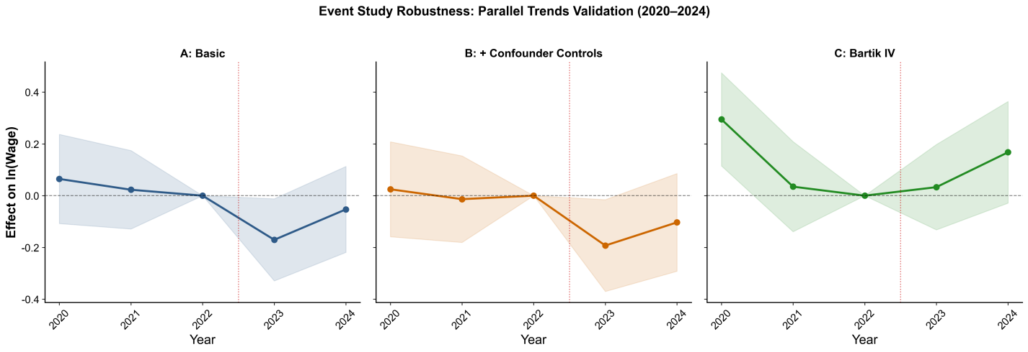

Supplementary Fig. S4 | Event-study robustness — parallel-trends validation (2020–2024).
Event-study estimates under three specifications. Panel A (Baseline): Pre-determined GenAI exposure interacted with year dummies, with baseline controls only. Pre-treatment coefficients for 2020 (β = 0.065, p = 0.462) and 2021 (β = 0.023, p = 0.767) are statistically insignificant; the joint Wald test passes (χ² = 0.553, p = 0.758). The 2023 coefficient is -0.171 (p = 0.035). Panel B (+ Confounder controls): Adds interactions of tech-regulation, COVID-recovery and real-estate shock exposures with Post. Pre-trend validation strengthens (p = 0.916), and the 2023 effect rises slightly to -0.193 (p = 0.033), consistent with confounders mildly attenuating the baseline estimate. Panel C (Bartik IV): Replaces pre-determined GenAI exposure with the Bartik shift-share instrument. The 2020 coefficient is significantly positive (β = 0.295, p = 0.001) and the joint pre-trend test fails (χ² = 11.04, p = 0.004); post-treatment coefficients are positive and insignificant, reflecting the sign reversal discussed above. This specification is presented for transparency but is not used for primary causal inference.

5. Summary
Causal identification in this study rests primarily on the pre-determined DID design, which exhibits clean parallel trends (p = 0.916), passes randomization-inference tests (p = 0.004) and explicitly controls for concurrent confounders. The Bartik reduced form provides directionally consistent supplementary evidence, but its structural causal interpretation is constrained by the failure of parallel trends and the counterintuitive negative first stage.

Supplementary Table S3 | Full DID results (extended specifications)
 | (1) Basic DID | (2) + Confounders | (3) Bartik RF | (4) GenAI + Bartik
Dep. Var.: ln(Wage)
GenAI₂₀₁₈ × Post | −0.140** | −0.151** |  | −0.287**
 | (0.061) | (0.068) |  | (0.131)
Bartik × Post |  |  | −0.010 | 0.204
 |  |  | (0.061) | (0.128)
TechReg × Post |  | 0.035 | −0.009 | 0.026
 |  | (0.061) | (0.061) | (0.061)
COVID × Post |  | 0.092 | 0.083 | 0.035
 |  | (0.087) | (0.092) | (0.095)
RealEstate × Post |  | −0.039 | −0.054 | −0.072
 |  | (0.109) | (0.111) | (0.109)
ln(Population) | −89.73 | −89.45 | −93.88 | −84.69
 | (84.84) | (83.43) | (85.09) | (82.66)
Nightlight | 0.190 | 0.180 | 0.202 | 0.171
 | (0.383) | (0.385) | (0.388) | (0.385)
NDVI (Std.) | −0.006 | 0.006 | −0.018 | −0.010
 | (0.285) | (0.286) | (0.288) | (0.285)
POI Density (Std.) | −0.097* | −0.094* | −0.091* | −0.094*
 | (0.050) | (0.050) | (0.048) | (0.050)
Land Use (Std.) | −1.023 | −1.035 | −0.985 | −0.991
 | (0.959) | (0.970) | (0.968) | (0.961)
Entity FE / Time FE | Yes / Yes | Yes / Yes | Yes / Yes | Yes / Yes
Observations | 6,895 | 6,895 | 6,895 | 6,895
R² (within) | 0.0005 | 0.0013 | −0.0002 | 0.0028
F-statistic | 2.67** | 2.25** | 1.36 | 2.69***
Notes. Standard errors clustered at the neighborhood level are in parentheses. Column (3) replaces the pre-determined GenAI exposure with the Bartik shift-share instrument. Column (4) includes both treatment proxies simultaneously. When both are included, the GenAI coefficient roughly doubles in magnitude, suggesting that the Bartik IV captures orthogonal variation that, once partialled out, sharpens the GenAI estimate. *** p < 0.01; ** p < 0.05; * p < 0.1.

Supplementary Table S4 | Long-difference instrumental-variables estimation
Panel A | First stage — ΔGenAI exposure on Bartik instrument
 | Coefficient | Std. Error | p-value
Bartik (Std.) | −0.022 | 0.003 | < 0.001
Δln(Population) | −11.293 | 6.537 | 0.084
Δln(Nightlight) | −0.010 | 0.014 | 0.482
TechReg Exposure | 0.008 | 0.031 | 0.787
COVID Exposure | 0.010 | 0.018 | 0.572
RealEstate Exposure | −0.008 | 0.031 | 0.787
First-Stage F | 53.5

Panel B | Reduced form — Δln(Wage) on Bartik instrument
 | Coefficient | Std. Error | p-value
Bartik (Std.) | −0.436 | 0.067 | < 0.001
Δln(Population) | −560.96 | 157.06 | < 0.001
COVID Exposure | −0.877 | 0.367 | 0.017

Panel C | 2SLS — Δln(Wage) on instrumented ΔGenAI
 | Coefficient | Std. Error | p-value
ΔGenAI Exposure (instrumented) | 19.82 | 2.42 | < 0.001
Δln(Population) | −337.16 | 108.42 | 0.002
COVID Exposure | −1.077 | 0.304 | < 0.001
N | 1,383
R² | 0.276
Notes. The long-difference is defined as Δ = mean(2023, 2024) − mean(2018, 2019). The IV uses a wider window than the event study to maximize first-stage power. The Bartik instrument is constructed from 2018 industry employment shares and leave-one-out industry-level GenAI exposure. Standard errors are heteroskedasticity-robust. The positive 2SLS coefficient reflects the sign reversal from the negative first stage (see Supplementary Text S6).

Supplementary Text S7 | Triple-DID mechanism analysis
Supplementary Table S5 reports triple-difference estimates for the de-skilling and crowding mechanisms. For the de-skilling channel, the triple-interaction coefficient is ${\hat{δ}}_{3}=−0.135$ ($p=0.177$); the sign is consistent with the de-skilling result in Table 2 of the main text (-1.286, $p<0.01$) but does not reach the 5% significance threshold. For the crowding channel, the triple-interaction coefficient is ${\hat{δ}}_{3}=−0.063$ ($p=0.439$); again, the sign is consistent with the corresponding main-text result (-1.619, $p<0.01$) but is statistically insignificant.
The directional consistency yet weak statistical significance plausibly reflects three factors. First, the post-treatment window is short. With only two post-treatment years (2023–2024), a triple-interaction term must identify a third-order heterogeneous treatment effect over a brief window, severely limiting statistical power. Second, pre-determined moderators may suffer signal attenuation. The triple-DID uses 2018 values of education and job-market heat; by 2023–2024, deviations from contemporaneous values may introduce attenuation bias. Third, the estimated parameters differ conceptually. Table 2 in the main text reports concurrent conditional correlations, whereas the triple-DID identifies the heterogeneity dimension of the causal effect—a parameter with stronger requirements on the temporal stability of the moderating variables.

Supplementary Table S5 | Triple-DID mechanism estimates
 | (1) De-skilling | (2) Crowding
Dep. Var.: ln(Wage)
GenAI₂₀₁₈ × Post | −0.151 | −0.106
 | (0.179) | (0.135)
Education₂₀₁₈ × Post | −0.168
 | (0.187)
GenAI₂₀₁₈ × Education₂₀₁₈ × Post | −0.135
 | (0.100)
JobHeat₂₀₁₈ × Post |  | −0.152
 |  | (0.116)
GenAI₂₀₁₈ × JobHeat₂₀₁₈ × Post |  | −0.063
 |  | (0.081)
Confounder Controls × Post | Yes | Yes
Controls / Entity FE / Time FE | Yes / Yes / Yes | Yes / Yes / Yes
Observations | 6,895 | 6,895
F-statistic | 2.38*** | 2.34***
Notes. All moderating variables are measured at 2018 values to preserve the pre-determined design. The triple-interaction coefficients are directionally consistent with the panel fixed-effects mechanism results in Table 2 of the main text but do not reach conventional significance, likely because of the short post-treatment window.

Supplementary Text S8 | Robustness checks
This section reports detailed results for three sets of robustness checks, corresponding to the DID model and the two-way fixed-effects models in the main text.

1. Randomization inference for the DID estimate
To evaluate the statistical robustness of the DID estimates without invoking large-sample asymptotics or specific error-structure assumptions, we implemented randomization inference based on Fisher’s exact test (see Methods, “Randomization inference”). The pre-determined GenAI exposure of the 1,383 neighborhoods was randomly permuted 500 times; in each iteration, the DID coefficient (with concurrent shock controls) was re-estimated to generate a placebo distribution. Supplementary Fig. S5 shows that the placebo coefficients are tightly centered on zero with an approximately normal distribution (mean = 0.001, standard deviation = 0.058), whereas the true estimate (-0.151, red vertical line) lies in the extreme left tail. The two-sided permutation p-value is 0.004—only 2 of 500 placebo simulations produced a coefficient with absolute value greater than 0.151. The result confirms the statistical significance of the GenAI wage penalty without distributional assumptions and rules out spurious significance arising from data structure or spatial correlation.

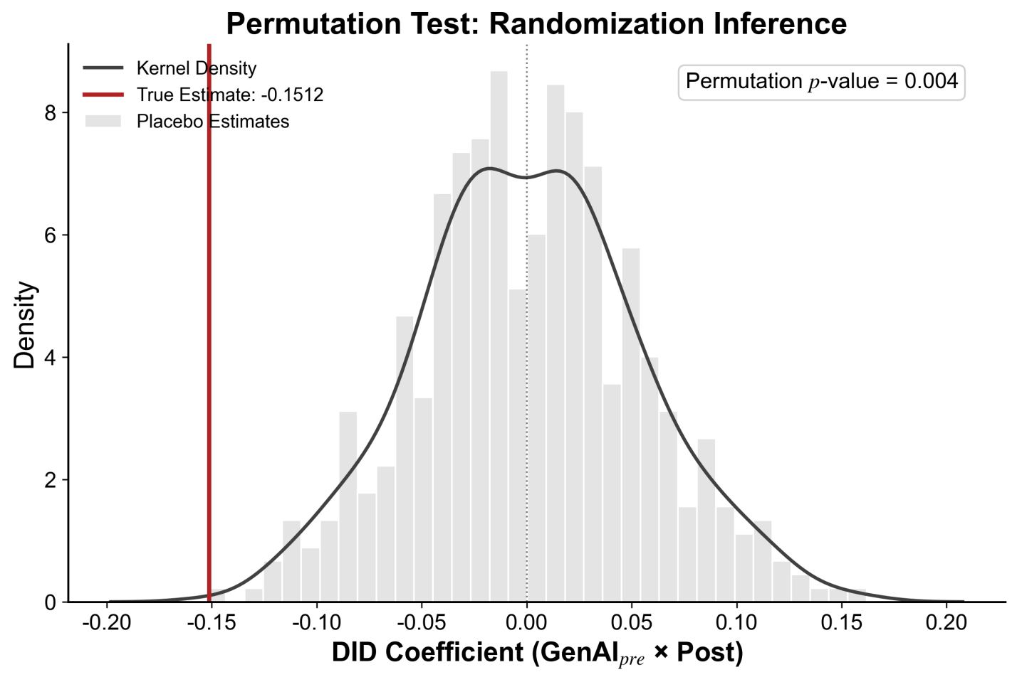

Supplementary Fig. S5 | Permutation test — randomization inference for the DID estimate.
Histogram (with overlaid kernel-density curve) of 500 placebo DID coefficients (${GenAI}_{pre}×Post$) obtained by randomly shuffling the pre-determined GenAI exposure vector across the 1,383 neighborhood blocks. The red vertical line marks the true estimate (-0.1512) from the confounder-controlled specification (Table 1, Column 2). The permutation p-value is 0.004, indicating that the observed wage penalty lies far in the left tail of the null distribution.

2. Placebo tests for the fixed-effects models
To verify the robustness of the de-skilling effect (GenAI × Education, coefficient = -1.286) and the crowding effect (GenAI × JobMarketHeat, coefficient = -1.619) reported in Table 2 of the main text, we conducted placebo tests for the corresponding two-way fixed-effects specifications (Methods Equations 10–11). Specifically, the GenAI exposure variable was randomly shuffled across neighborhood–year observations, and the shuffled variable was used to reconstruct the interaction terms and re-estimate the placebo interaction coefficients. The procedure was repeated 500 times for each mechanism.
Supplementary Fig. S6a shows the placebo distribution for the de-skilling interaction. The 500 placebo coefficients are tightly clustered around zero (mean ≈ -0.05), and the true coefficient of -1.286 (red vertical line) lies far outside the placebo distribution (empirical p < 0.001$), confirming the statistical reliability of the de-skilling effect.
Supplementary Fig. S6b reports the analogous distribution for the crowding interaction. The 500 placebo coefficients are tightly clustered around zero (mean ≈ -0.04) and form a standard unimodal distribution. The true coefficient of -1.619 (red vertical line) again lies far outside the placebo distribution (empirical p < 0.001), confirming that the crowding effect is not random noise.
Together, these tests indicate that the de-skilling and crowding effects identified in this study reflect genuine structural patterns of the Beijing labor market rather than artefacts of model specification or data structure.

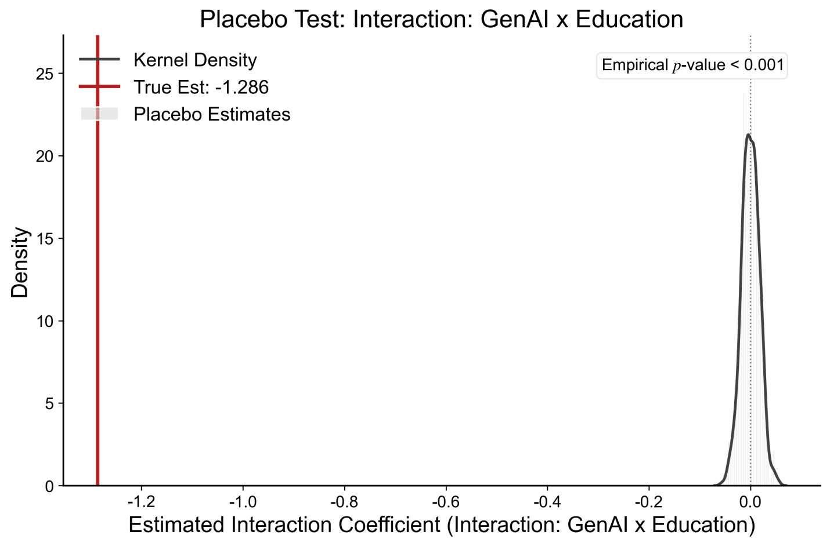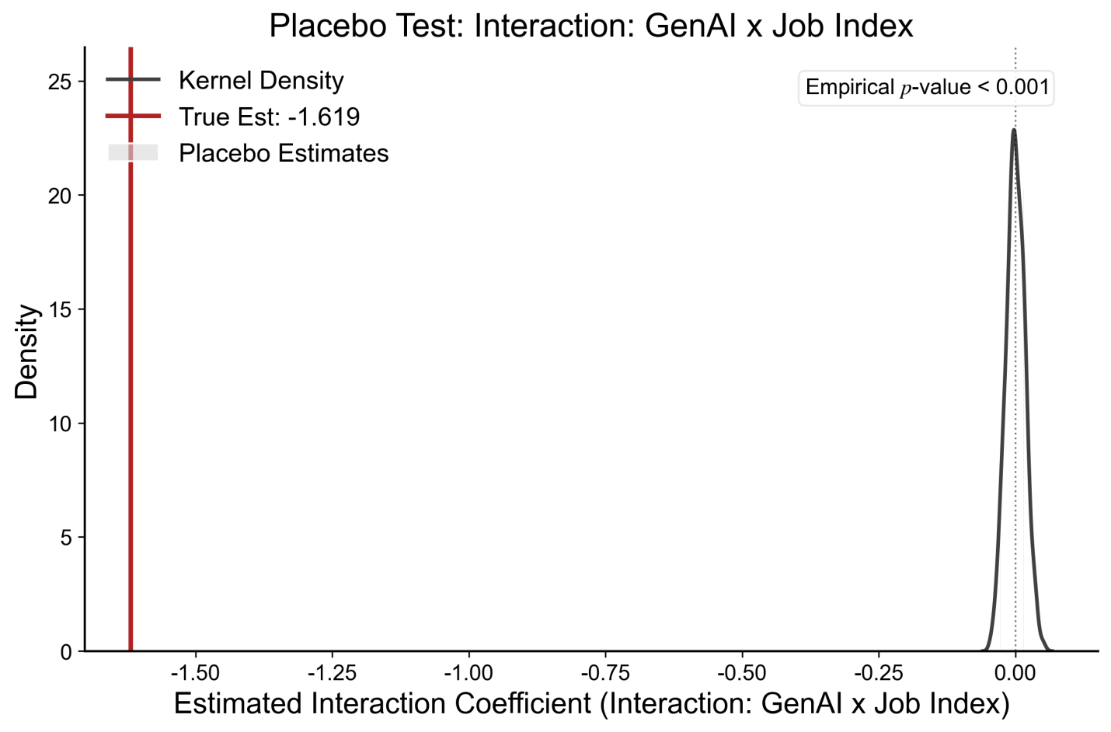

Supplementary Fig. S6 | Placebo tests for the fixed-effects interaction terms.
a, Distribution of 500 placebo interaction coefficients for GenAI × Education (de-skilling mechanism). The true estimate (-1.286, red line) lies far in the left tail (empirical p < 0.001). b, Distribution of 500 placebo interaction coefficients for GenAI × JobIndex (crowding mechanism). The true estimate (-1.619, red line) lies far outside the placebo distribution (empirical p < 0.001). Together, these tests confirm that the observed mechanisms are not artefacts of the data structure.

References
1 Braverman, H. labor and monopoly capital: The degradation of work in the twentieth century. (nyu Press, 1998).
2 Desmet, K. & Fafchamps, M. Changes in the spatial concentration of employment across US counties: a sectoral analysis 1972–2000. Journal of economic geography 5, 261–284 (2005).
3 Glaeser, E. L. & Kohlhase, J. E. Cities, regions and the decline of transport costs. Papers in regional Science 83, 197–228 (2004).
4 Katz, L. F. & Murphy, K. M. Changes in relative wages, 1963–1987: supply and demand factors. The quarterly journal of economics 107, 35–78 (1992).
5 Cairncross, F. The death of distance: How the communications revolution will change our lives. (No Title) (1997).
6 Spitz-Oener, A. Technical change, job tasks, and rising educational demands: Looking outside the wage structure. Journal of labor economics 24, 235–270 (2006).
7 Capello, R. & Lenzi, C. Spatial heterogeneity in knowledge, innovation, and economic growth nexus: conceptual reflections and empirical evidence. Journal of Regional Science 54, 186–214 (2014).
8 Gaspar, J. & Glaeser, E. L. Information technology and the future of cities. Journal of urban economics 43, 136–156 (1998).
9 Card, D. & DiNardo, J. E. Skill-biased technological change and rising wage inequality: Some problems and puzzles. Journal of labor economics 20, 733–783 (2002).
10 Moretti, E. The new geography of jobs. (Houghton Mifflin Harcourt, 2012).
11 Bárány, Z. L. & Siegel, C. Job polarization and structural change. American Economic Journal: Macroeconomics 10, 57–89 (2018).
12 Autor, D. H. in AEA Papers and Proceedings. 1–32 (American Economic Association 2014 Broadway, Suite 305, Nashville, TN 37203).
13 Acemoglu, D. & Autor, D. in Handbook of labor economics Vol. 4 1043–1171 (Elsevier, 2011).
14 Autor, D. H., Levy, F. & Murnane, R. J. The skill content of recent technological change: An empirical exploration. The Quarterly journal of economics 118, 1279–1333 (2003).
15 Goos, M. & Manning, A. Lousy and lovely jobs: The rising polarization of work in Britain. The review of economics and statistics 89, 118–133 (2007).
16 Autor, D. H. & Dorn, D. The growth of low-skill service jobs and the polarization of the US labor market. American economic review 103, 1553–1597 (2013).
17 Dingel, J. I. & Neiman, B. How many jobs can be done at home? Journal of public economics 189, 104235 (2020).
18 Ramani, A., Alcedo, J. & Bloom, N. How working from home reshapes cities. Proceedings of the National Academy of Sciences 121, e2408930121 (2024).
19 Agrawal, A., Gans, J. S. & Goldfarb, A. Artificial intelligence: the ambiguous labor market impact of automating prediction. Journal of Economic Perspectives 33, 31–50 (2019).
20 Yang, C.-H. How artificial intelligence technology affects productivity and employment: Firm-level evidence from Taiwan. Research Policy 51, 104536 (2022).
21 Brynjolfsson, E. & Mitchell, T. What can machine learning do? Workforce implications. Science 358, 1530–1534 (2017).
22 Brynjolfsson, E., Mitchell, T. & Rock, D. in AEA papers and proceedings. 43–47 (American Economic Association 2014 Broadway, Suite 305, Nashville, TN 37203).
23 Tolan, S. et al. Measuring the occupational impact of AI: tasks, cognitive abilities and AI benchmarks. Journal of Artificial Intelligence Research 71, 191–236 (2021).
24 Acemoglu, D. & Restrepo, P. Tasks, automation, and the rise in US wage inequality. Econometrica 90, 1973–2016 (2022).
25 Webb, M. The impact of artificial intelligence on the labor market. Available at SSRN 3482150 (2019).
26 Felten, E. W., Raj, M. & Seamans, R. in AEA Papers and proceedings. 54–57 (American Economic Association 2014 Broadway, Suite 305, Nashville, TN 37203).
27 Deming, D. J. The growing importance of social skills in the labor market. The quarterly journal of economics 132, 1593–1640 (2017).
28 Gmyrek, P., Berg, J. & Bescond, D. Generative AI and jobs: A global analysis of potential effects on job quantity and quality. (2023).
29 Eloundou, T., Manning, S., Mishkin, P. & Rock, D. GPTs are GPTs: labor market impact potential of LLMs. Science 384, 1306–1308 (2024).
30 Manyika, J. et al. A future that works: AI, automation, employment, and productivity. McKinsey Global Institute Research, Tech. Rep 60, 1–135 (2017).
31 Georgieff, A. & Hyee, R. Artificial intelligence and employment: New cross-country evidence. OECD Social, Employment, and Migration Working Papers, 0_1–60 (2021).
32 Hatzius, J. The potentially large effects of artificial intelligence on economic growth (Briggs/Kodnani). Goldman Sachs 1, 268–296 (2023).
33 Svanberg, M., Li, W., Fleming, M., Goehring, B. & Thompson, N. Beyond AI exposure: which tasks are cost-effective to automate with computer vision? Available at SSRN 4700751 (2024).
34 Microsoft, L. 2024 Annual Work Trend Index. (2024).
35 Yusuf, S. The Macroeconomic Consequences of AI. (2025).
36 Jaumotte, M. F. et al. Bridging Skill Gaps for the Future: New Jobs Creation in the AI Age. (International Monetary Fund, 2026).
37 Kochhar, R. Which US workers are more exposed to AI on their jobs? , (Pew Research Center Washington, DC, 2023).
38 Ellingrud, K. et al. Generative AI and the future of work in America. (2023).
39 Cazzaniga, M. et al. Gen-AI: Artificial intelligence and the future of work. (International Monetary Fund, 2024).
40 Demombynes, G., Langbein, J. & Weber, M. The exposure of workers to Artificial Intelligence in low-and middle-income countries. (World Bank, 2025).
41 Top, G. Strategic Technology Trends for 2020. URL: https://www. gartner. com/smarterwithgartner/gartner-top-10-strategic-technology-trends-for-2020 10
42 OpenAI. The state of enterprise AI. (2025).
43 Teng Liu, T. M., and Gabby Burlacu In-Demand Skills 2026: A Market View of Skills Demand in an AI Economy. (2026).
44 McCrory, M. M. a. P. labor market impacts of AI: A new measure and early evidence. (2026).
45 Chen, Q., Ge, J., Xie, H., Xu, X. & Yang, Y. Large language models at work in China’s labor market. China Economic Review 92, 102413 (2025).
46 Yang, J. & Huang, X. The 30 m annual land cover dataset and its dynamics in China from 1990 to 2019. Earth System Science Data 13, 3907–3925 (2021).
47 Elvidge, C. D., Baugh, K., Zhizhin, M., Hsu, F. C. & Ghosh, T. in Remote Sensing of Night-time Light 6–25 (Routledge, 2021).
48 Tatem, A. J. WorldPop, open data for spatial demography. Scientific data 4, 170004 (2017).
49 Stock, J. H. & Yogo, M. (National Bureau of Economic Research Cambridge, Mass., USA, 2002).

