Additional File 3
Supplementary Tables and Figure
Table of Content
Table S1. AI Uncertainty Index by program 2
Figure S1. Distribution of the AI Uncertainty Index (N = 193) 3
Table S2. Per-item “I don’t know enough to say” rates across the 20 AICPER items 4
Table S3. Regression of the AI Uncertainty Index on respondent characteristics 5
Table S4. Regression of mean AICPER score on the AI Uncertainty Index 6
Figure S2. Scree plot of the polychoric correlation matrix with parallel analysis 7
Table S5. EFA factor retention criteria (18-item AICPER scale) 8
Table S6. Convergence of the ML/Pearson and ULS/polychoric EFA 9
Table S7. Modification indices and SEPC for candidate correlated error pairs 11
Table S8. Per-item method-factor standardized loadings 12
Table S9. Measurement invariance across programs 13
Table S10. Internal consistency (Cronbach’s α) by program 14
Table S11. Bootstrap 95% CIs on CFA standardized loadings 15
Table S12. Sensitivity analysis: MICE-imputed vs. listwise deletion 16

Supplementary Table S1. Artificial intelligence (AI) Uncertainty Index by program.
Program | Mean IDK responses | SD | Minimum | Maximum
Nursing | 2.26 | 2.45 | 0 | 9
Pharmacy | 2.02 | 2.58 | 0 | 10
Public Health | 2.05 | 2.37 | 0 | 8

Footnote: The AI Uncertainty Index is defined as the count of “I don’t know [IDK]enough to say” responses per respondent across the 20 AICPER items. SD=standard deviation. Lower scores indicate more confident self-reported AI literacy.

Supplementary Figure S1. Distribution of the AI Uncertainty Index (N = 193).
Histogram of the per-respondent count of 'I don't know enough to say' responses across the 20 Artificial Intelligence in Competence and Preparedness Evaluation Resource (AICPER) items. Bins are centered on integer values (0–20). The distribution is right-skewed (skew = +1.20) with a modal value of 0; 38.9% of respondents reported no uncertainty on any item, while 19.2% reported ≥ 5 uncertain responses. The dashed red line marks the sample median.
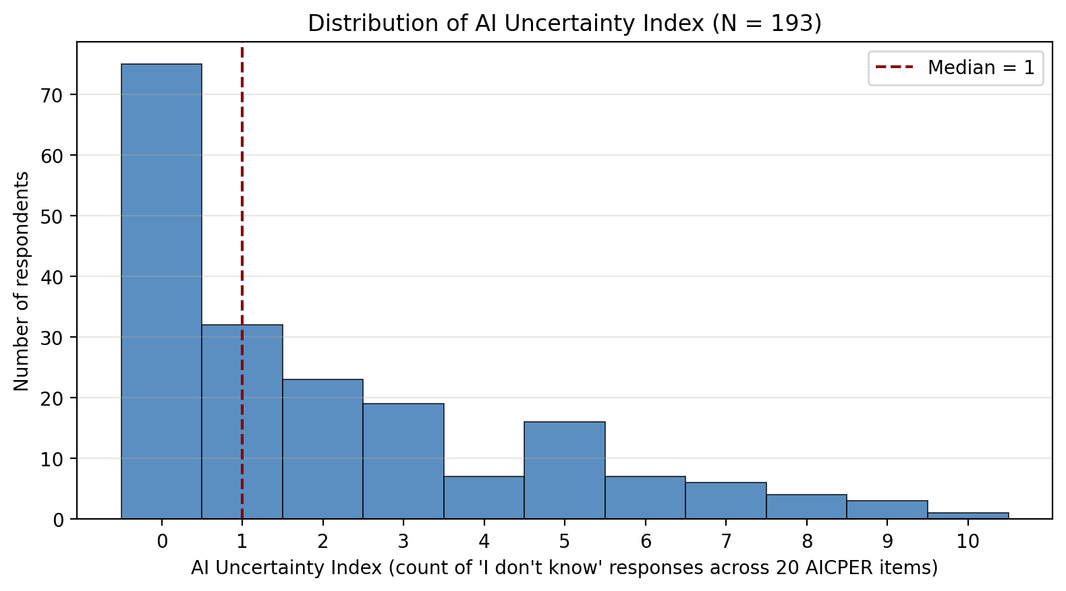

Supplementary Table S2. Per-item 'I don't know enough to say' rates across the 20 AICPER items, pooled across the three programs (N = 193). Items are ranked from highest to lowest uncertainty.
Item code | Item content (abbreviated) | 'I don't know' count | 'I don't know' rate (%)
A10 | Agencies should invest in AI | 47 | 24.4
A15 | Confidence in AI-assisted publications | 41 | 21.2
A11 | AI makes research more efficient | 36 | 18.7
A3 | AI-driven analyses will help [profession] make better decisions | 32 | 16.6
A13 | AI assistance in academic writing is acceptable | 29 | 15
A5 | AI can improve efficiency | 25 | 13
A2 | AI will improve [profession] outcomes | 23 | 11.9
A1 | AI will play a significant role in [profession] practice | 22 | 11.4
A14 | AI could help in peer review | 18 | 9.3
A19 | Likelihood to seek AI training | 17 | 8.8
A12 | AI compromises academic integrity | 14 | 7.3
A8 | I worry AI may make biased decisions | 13 | 6.7
A20 | Concerned AI replaces jobs | 13 | 6.7
A6 | I would trust AI recommendations | 12 | 6.2
A4 | AI can reduce workload | 12 | 6.2
A17 | Likelihood of AI elective | 12 | 6.2
A9 | Ethical/legal concerns about AI | 11 | 5.7
A16 | AI use should be disclosed in publications | 9 | 4.7
A18 | Likelihood of AI certificate | 9 | 4.7
A7 | I worry AI may make errors | 1 | 0.5

Footnote: Uncertainty concentrated on items requiring projection of AI's applicability in specialized domains (A10 organizational investment, A15 confidence in AI-assisted publications, A11 AI in research workflows, A3 AI-supported professional decision-making, A13 AI in academic writing). Items capturing direct personal attitudes or preferences showed minimal uncertainty (A7 worry about AI errors, A16 disclosure of AI use, A18 likelihood of pursuing a certificate).

Supplementary Table S3. Regression of the AI Uncertainty Index on respondent characteristics. Complete-case (CC, N = 141) and MICE-pooled (MI, N = 193) estimates side by side.
Predictor | CC β (N=141) | CC SE | CC p | MI β (N=193) | MI SE | MI p
Intercept | 4.619 | 1.087 | 0 | 4.025 | 0.994 | 0
Program: Pharmacy (vs Nursing) | 0.022 | 0.558 | 0.969 | 0.001 | 0.433 | 0.999
Program: Public Health (vs Nursing) | 0.071 | 0.608 | 0.907 | 0.106 | 0.511 | 0.836
Prior AI exposure (0–3 ordinal) | 0.02 | 0.454 | 0.965 | -0.145 | 0.43 | 0.737
Self-rated AI understanding (1–3 ordinal) | -1.268 | 0.341 | 0 | -0.92 | 0.318 | 0.004
Year of training | -0.146 | 0.186 | 0.434 | -0.069 | 0.172 | 0.688

Footnote: MICE imputation (M=20) of the two covariates with missingness (prior AI exposure, n = 31 missing; self-rated AI understanding, n = 29 missing). Pooled estimates and standard errors computed under Rubin's rules. Self-rated AI understanding was the only significant predictor of AI Uncertainty Index in both models (CC β = −1.27, p < 0.001; MI β = −0.92, p = 0.004); the approximately 27% attenuation under MI pooling reflects the inclusion of covariate-imputation uncertainty in the standard errors. Prior AI exposure, year of training, and program were not significant in either model.

Supplementary Table S4. Regression of the mean AICPER score on the AI Uncertainty Index, controlling for respondent characteristics. Complete-case (CC, N = 141) and MICE-pooled (MI, N = 193) estimates side by side.
Predictor | CC β (N=141) | CC SE | CC p | MI β (N=193) | MI SE | MI p
Intercept | 2.348 | 0.138 | 0 | 2.412 | 0.127 | 0
Program: Pharmacy (vs Nursing) | 0.088 | 0.066 | 0.19 | 0.095 | 0.053 | 0.075
Program: Public Health (vs Nursing) | 0.133 | 0.072 | 0.069 | 0.14 | 0.062 | 0.025
AI Uncertainty Index | -0.015 | 0.01 | 0.14 | -0.012 | 0.009 | 0.203
Prior AI exposure (0–3 ordinal) | 0.232 | 0.054 | 0 | 0.164 | 0.052 | 0.002
Self-rated AI understanding (1–3 ordinal) | 0.022 | 0.043 | 0.602 | 0.048 | 0.042 | 0.25
Year of training | 0.031 | 0.022 | 0.168 | 0.032 | 0.021 | 0.128

Footnote: MICE imputation (M = 20) of the two covariates with missingness. Pooled estimates and standard errors under Rubin's rules. The AI Uncertainty Index was not significantly associated with mean AICPER score in either model (CC β = −0.015, p = 0.140; MI β = −0.012, p = 0.203), supporting that uncertainty is orthogonal to attitude direction. Prior AI exposure remained a significant positive predictor of more favorable attitudes under both treatments (CC β = 0.23, p < 0.001; MI β = 0.16, p = 0.002). Public Health respondents reported marginally higher attitudes than Nursing respondents under complete-case (β = 0.13, p = 0.069) and significantly higher under MI pooling (β = 0.14, p = 0.025), where the additional 52 cases provided power to detect the difference.

Supplementary Figure S2. Scree plot of the polychoric correlation matrix with parallel analysis (PA) comparison.
Solid line shows actual eigenvalues of the polychoric correlation matrix (18 items). Dashed line shows the 95th-percentile eigenvalues from 500 iterations of randomly generated data of the same size and dimensionality (Horn's parallel analysis). Dotted horizontal line marks the Kaiser criterion (eigenvalue = 1). Parallel analysis retains the three factors whose actual eigenvalues exceed the 95th-percentile comparison threshold (F1, F2, F3).
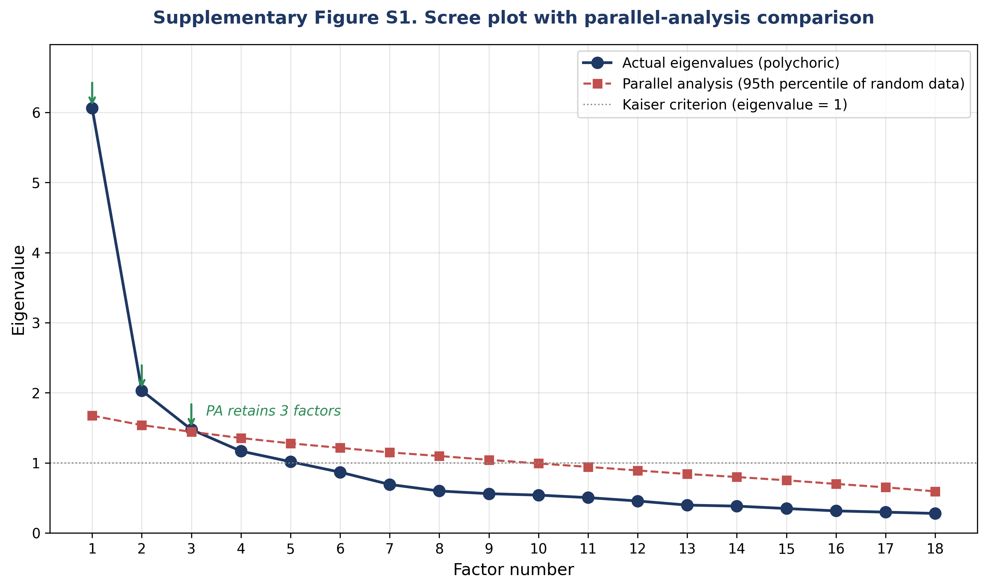

Supplementary Table S5. Exploratory factor analysis (EFA) factor retention criteria evaluated on the polychoric correlation matrix of the 18-item AICPER scale.
Factor | Eigenvalue | PA 95th pctile | Retain (PA) | Retain (Kaiser >1) | Prop. variance | Cum. variance
1 | 6.062 | 1.675 | yes | yes | 0.337 | 0.337
2 | 2.031 | 1.539 | yes | yes | 0.113 | 0.45
3 | 1.476 | 1.444 | yes | yes | 0.082 | 0.532
4 | 1.168 | 1.355 | no | yes | 0.065 | 0.597
5 | 1.017 | 1.279 | no | yes | 0.057 | 0.653
6 | 0.868 | 1.214 | no | no | 0.048 | 0.701
7 | 0.692 | 1.15 | no | no | 0.038 | 0.74
8 | 0.599 | 1.098 | no | no | 0.033 | 0.773
9 | 0.561 | 1.043 | no | no | 0.031 | 0.804
10 | 0.54 | 0.992 | no | no | 0.03 | 0.834
11 | 0.505 | 0.943 | no | no | 0.028 | 0.862
12 | 0.457 | 0.892 | no | no | 0.025 | 0.888
13 | 0.398 | 0.841 | no | no | 0.022 | 0.91
14 | 0.384 | 0.799 | no | no | 0.021 | 0.931
15 | 0.349 | 0.752 | no | no | 0.019 | 0.95
16 | 0.316 | 0.7 | no | no | 0.018 | 0.968
17 | 0.298 | 0.651 | no | no | 0.017 | 0.984
18 | 0.279 | 0.594 | no | no | 0.016 | 1

Footnote: PA = parallel analysis; Cum. = cumulative; Prop. = proportion. Horn’s parallel analysis retains a factor when its actual eigenvalue exceeds the 95th-percentile eigenvalue from 500 iterations of randomly generated data of the same size. The Kaiser criterion retains factors with eigenvalues > 1. Of the five retention criteria evaluated, four converged on a three-factor solution: parallel analysis (3 factors), the scree-plot bend (3 factors, see Supplementary Figure S2), cumulative variance ≥ 50% (reached at 3 factors), and conceptual interpretability (3 factors). The Kaiser criterion suggested 5 factors but is widely recognized to over-extract under these conditions; factors 4 and 5 had eigenvalues (1.17 and 1.02) only marginally above 1.0 and below the parallel-analysis thresholds (1.36 and 1.28), indicating that they were not statistically distinguishable from random noise.

Supplementary Table S6. Convergence of the primary ML/Pearson EFA and the sensitivity ULS/polychoric EFA (oblimin rotation, 18 items, three factors, N = 193).
Item | A priori factor | ML/Pearson dominant factor | ML/Pearson loading | ML/Pearson h² | ULS/polychoric dominant factor | ULS/polychoric loading | ULS/polychoric h² | Agreement
A1 | FB | FB | 0.73 | 0.54 | FB | 0.72 | 0.52 | ✓
A2 | FB | FB | 0.82 | 0.67 | FB | 0.81 | 0.65 | ✓
A3 | FB | FB | 0.73 | 0.55 | FB | 0.72 | 0.54 | ✓
A4 | FB | FB | 0.58 | 0.36 | FB | 0.59 | 0.36 | ✓
A5 | FB | FB | 0.76 | 0.58 | FB | 0.78 | 0.63 | ✓
A10 | FB | FB | 0.59 | 0.40 | FB | 0.59 | 0.40 | ✓
A6 | ET | FB | 0.40 | 0.29 | FB | 0.39 | 0.26 | ✓
A7 | ET | ET | 0.48 | 0.24 | ET | 0.51 | 0.27 | ✓
A8 | ET | ET | 0.47 | 0.24 | ET | 0.51 | 0.28 | ✓
A9 | ET | ET | 0.75 | 0.57 | ET | 0.78 | 0.62 | ✓
A11 | ET | FB | 0.54 | 0.31 | FB | 0.54 | 0.31 | ✓
A12 | ET | ET | 0.58 | 0.36 | ET | 0.53 | 0.32 | ✓
A13 | ET | ET | 0.39 | 0.27 | EE | 0.38 | 0.27 | ✗
A14 | ET | ET | 0.23 | 0.09 | ET | 0.22 | 0.09 | ✓
A15 | ET | FB | 0.42 | 0.27 | FB | 0.41 | 0.25 | ✓
A17 | EE | EE | 0.81 | 0.66 | EE | 0.81 | 0.67 | ✓
A18 | EE | EE | 0.74 | 0.55 | EE | 0.71 | 0.51 | ✓
A19 | EE | EE | 0.63 | 0.43 | EE | 0.64 | 0.44 | ✓

Footnote: ML/Pearson is the primary registered EFA; ULS/polychoric is reported as a sensitivity analysis to address the ordinal scaling of Likert items. Dominant-factor assignments are reported by content label (FB = Functional Benefits, ET = Ethics & Trust, EE = Educational Engagement) rather than raw F1/F2/F3 indices because rotation can permute factor ordering. Dominant loadings are the largest absolute pattern coefficient per item. The two methods agreed on the dominant factor for every item except A13. The Functional Benefits and Educational Engagement factors recovered perfectly; the Ethics & Trust core (A7, A8, A9, A12) also recovered across methods. Three research-domain items conceptually assigned to Ethics & Trust (A11, A13, A15) showed cross-method behavior consistent with their conceptual proximity to Functional Benefits or Educational Engagement perceptions. A14 (AI in peer review) was the weakest indicator under both methods (h² ≈ 0.09); under ULS/polychoric its strongest pattern coefficient (λ = 0.22, Ethics & Trust) fell just below the 0.25 display threshold. The convergent weakness of A14 indicates a substantive item-quality concern rather than method-sensitive behavior.

Table S7. Modification index (MI) and standardized expected parameter change (SEPC) values for the four pre-identified candidate correlated error pairs in the baseline 3-factor confirmatory factor analysis (CFA) model.
Pair (manuscript codes) | Substantive content overlap | Modification Index (MI) | MI > 9.0 | Standardized EPC (SEPC) | SEPC > 0.20
A4 ↔ A5 | Workflow burden reduction | 6.53 | no | 0.228 | yes
A7 ↔ A8 | AI failure-mode concerns | 13.76 | yes | 0.33 | yes
A13 ↔ A14 | AI in scholarly publishing | 0.43 | no | 0.061 | no
A17 ↔ A18 | Formal AI credentialing | 3.56 | no | 0.193 | no

Footnote: MI = modification index; SEPC = standardized expected parameter change; EPC = expected parameter change; CFI = comparative fit index; RMSEA = root mean square error of approximation; DWLS = diagonally weighted least squares. Conventional thresholds: MI > 9.0 indicates substantively meaningful model misfit attributable to the fixed parameter; |SEPC| > 0.20 indicates a substantively meaningful magnitude for the freed parameter. Only A7 ↔ A8 met both thresholds. Given the already-excellent baseline-model fit (CFI = 0.987, RMSEA = 0.032 under DWLS), no correlated errors were added to the final model.

Supplementary Table S8. Per-item method-factor standardized loadings from the method-effects confirmatory factor analysis (CFA) specification.
Item code | Item content | Method-factor loading | Squared loading | Variance explained
A7 | I worry AI may make errors | 0.505 | 0.255 | 25.5%
A8 | I worry AI may make biased decisions | 0.536 | 0.287 | 28.7%
A9 | I have ethical/legal concerns about AI | 0.626 | 0.392 | 39.2%
A12 | AI-generated content compromises academic integrity | 0.243 | 0.059 | 5.9%

Footnote: Squared loadings represent the proportion of variance in each item attributable to the orthogonal method factor (representing reverse-scoring direction). The method factor accounted for substantial variance in three items (A7, A8, A9; 25.5%-39.2%) and minimal variance in A12 (5.9%), suggesting that academic-integrity perceptions function more as a substantive content domain than as a reverse-scoring artifact.

Supplementary Table S9. Measurement invariance across programs (baseline 3-factor model).
Model | chi2 | df | CFI | TLI | RMSEA
configural | 4990 | 1341 | 0.307 | 0.261 | 0.169
metric | 5029 | 1371 | 0.306 | 0.275 | 0.168
delta (metric - configural) |  |  | -0.001 |  | -0.001

Footnote: CFI = comparative fit index; TLI = Tucker–Lewis index; RMSEA = root mean square error of approximation; df = degrees of freedom; SEM = structural equation modeling; CFA = confirmatory factor analysis; Δ = change between nested models. Acceptance criteria: ΔCFI ≤ 0.010 and ΔRMSEA ≤ 0.015 between nested models. ΔCFI = −0.001 and ΔRMSEA = −0.001 between configural and metric models support metric invariance across nursing, pharmacy, and public health student samples. The absolute fit indices for the stacked multi-group SEM specification are depressed relative to single-group CFA because of the limitations of approximated multi-group estimation in this software framework; per-program Cronbach’s α (reported in Supplementary Table S10) provides supplementary evidence of cross-program scale stability.

Supplementary Table S10. Internal consistency (Cronbach’s α) by program.
Program | Subscale | n | alpha | mean_score | sd_score
Nursing | FB | 58 | 0.863 | 2.894 | 0.551
Nursing | ET | 58 | 0.721 | 2.17 | 0.35
Nursing | EE | 58 | 0.761 | 2.362 | 0.715
Nursing | AICPER18 | 58 | 0.861 | 2.443 | 0.384
Pharmacy | FB | 96 | 0.83 | 3.043 | 0.453
Pharmacy | ET | 96 | 0.755 | 2.083 | 0.387
Pharmacy | EE | 96 | 0.768 | 2.694 | 0.715
Pharmacy | AICPER18 | 96 | 0.862 | 2.505 | 0.375
Public Health | FB | 39 | 0.886 | 3.103 | 0.577
Public Health | ET | 39 | 0.849 | 1.983 | 0.493
Public Health | EE | 39 | 0.835 | 2.632 | 0.878
Public Health | AICPER18 | 39 | 0.915 | 2.464 | 0.5

Footnote: FB = Functional Benefits; ET = Ethics and Trust; EE = Education Engagement; AICPER18 = 18-item Artificial Intelligence in Competence and Preparedness Evaluation Resource (AICPER); α = Cronbach’s alpha; n = sample size; SD = standard deviation. AICPER 18-item α was stable across all three programs (range 0.86–0.92), supporting cross-disciplinary applicability of the scale.

Supplementary Table S11. Bootstrap 95% confidence intervals (CIs) on confirmatory factor analysis (CFA) standardized loadings (baseline 3-factor model, 2000 resamples).
Item code | Variable | Factor | Point loading | Bootstrap mean | Bootstrap SE | 95% CI lower | 95% CI upper | CI excludes 0?
A1 | p1_role | FB | 0.669 | 0.677 | 0.055 | 0.565 | 0.776 | yes
A2 | p2_outcomes | FB | 0.75 | 0.768 | 0.038 | 0.689 | 0.837 | yes
A3 | p3_decisions | FB | 0.751 | 0.779 | 0.049 | 0.672 | 0.864 | yes
A4 | p4_workload | FB | 0.515 | 0.515 | 0.063 | 0.391 | 0.633 | yes
A5 | p5_efficiency | FB | 0.628 | 0.647 | 0.058 | 0.517 | 0.748 | yes
A10 | p6_invest | FB | 0.767 | 0.818 | 0.046 | 0.723 | 0.901 | yes
A6 | t4_trust_rec | ET | 0.658 | 0.683 | 0.057 | 0.565 | 0.792 | yes
A7 | t1_worry_err | ET | 0.425 | 0.428 | 0.082 | 0.267 | 0.583 | yes
A8 | t2_worry_bias | ET | 0.351 | 0.351 | 0.077 | 0.201 | 0.5 | yes
A9 | t3_ethics | ET | 0.354 | 0.357 | 0.072 | 0.211 | 0.493 | yes
A11 | r1_efficient | ET | 0.612 | 0.624 | 0.062 | 0.496 | 0.733 | yes
A12 | r3_integrity | ET | 0.532 | 0.541 | 0.07 | 0.397 | 0.668 | yes
A13 | r2_writing_ok | ET | 0.578 | 0.61 | 0.058 | 0.492 | 0.717 | yes
A14 | r4_peerreview | ET | 0.392 | 0.407 | 0.079 | 0.24 | 0.549 | yes
A15 | r6_confidence | ET | 0.602 | 0.682 | 0.066 | 0.541 | 0.798 | yes
A17 | i1_elective | EE | 0.68 | 0.699 | 0.074 | 0.543 | 0.832 | yes
A18 | i2_certificate | EE | 0.635 | 0.65 | 0.071 | 0.497 | 0.776 | yes
A19 | i3_more_train | EE | 0.83 | 0.863 | 0.048 | 0.767 | 0.959 | yes

Footnote: Resamples drawn with replacement from the MICE-imputed analytic dataset (N = 193); each resample re-fit with the DWLS estimator. All 18 loadings yielded 95% percentile intervals excluding zero, indicating stable parameter recovery. Monte Carlo standard error on the percentile endpoints at B = 2,000 averaged 0.003–0.004 in standardized-loading units.

Supplementary Table S12. Sensitivity analysis: multivariate imputation by chained equations (MICE)-imputed vs. listwise-deletion results.
Metric | MICE imputed (N=193) | Listwise (N=74)
Sample size (N) | 193 | 74
Cronbach's α — Functional Benefits | 0.856 | 0.878
Cronbach's α — Ethics & Trust | 0.776 | 0.801
Cronbach's α — Educational Engagement | 0.787 | 0.797
Cronbach's α — AICPER (18 items) | 0.873 | 0.888
CFI (DWLS estimator) | 0.995 | 1.056
TLI (DWLS estimator) | 0.994 | 1.067
RMSEA (DWLS estimator) | 0.02 | 0
χ² (DWLS estimator) | 138.12 | 66.41
CFI (ML estimator, comparison) | 0.884 | 0.915
TLI (ML estimator, comparison) | 0.862 | 0.898
RMSEA (ML estimator, comparison) | 0.076 | 0.07

Footnote: FB = Functional Benefits; ET = Ethics and Trust; EE = Education Engagement; AICPER18 = 18-item Artificial Intelligence in Competence and Preparedness Evaluation Resource (AICPER); α = Cronbach’s alpha; CFI = comparative fit index; TLI = Tucker–Lewis index; RMSEA = root mean square error of approximation; DWLS = diagonally weighted least squares; ML = maximum likelihood; MICE = multivariate imputation by chained equations; M = number of imputations. Reliability estimates differed by less than 0.03 between MICE-imputed and listwise samples for all subscales; CFA fit indices under DWLS were equivalent or slightly more favorable in the listwise subset. Substantive conclusions did not depend on imputation choice.

