Spatial–Electronic Synergy of Frustrated Lewis Pairs for High‑Selectivity Gas Sensing
Feiyu Zhang¹, Wenxue Wang¹, Xudong Liang¹, Dajian Wang¹, Yuhang Yao¹, Jiayu Li*², Ruiqin Gao*³, Lei Shi*⁴, Guo-Dong Li*¹
¹ State Key Laboratory of Inorganic Synthesis and Preparative Chemistry, College of Chemistry, Jilin University, Changchun, 130012, P.R. China.
² School of Energy and Materials, Shihezi University, Shihezi, 832000, P.R. China.
³ School of Biological and Chemical Engineering, NingboTech University, Ningbo, 315100, P.R. China.
⁴ School of Materials Science and Engineering, NingboTech University, Ningbo 315100, P.R. China
e-mail: jiayu22@shzu.edu.cn; gaorq@nbt.edu.cn; shiileii@163.com; lgd@jlu.edu.cn;
Figure S1. XRD patterns of pure ZnO and the series of GZO samples.

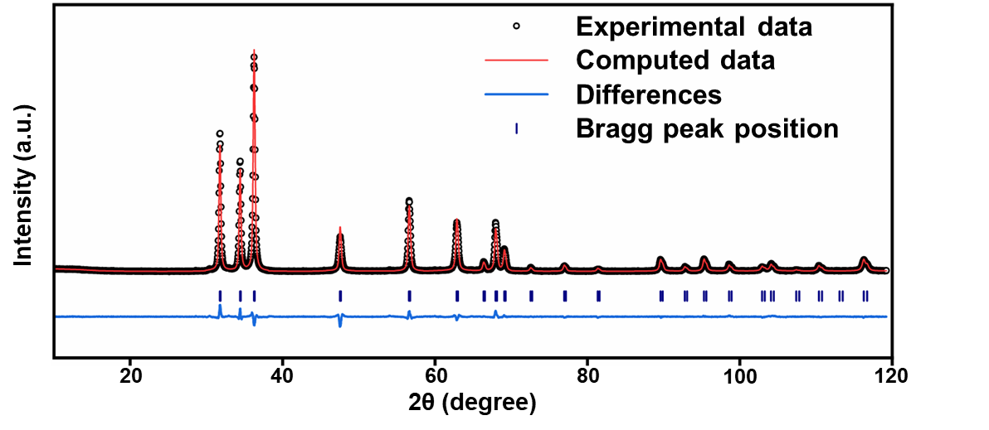
Figure S2. Rietveld refinement results of the XRD pattern for ZnO.

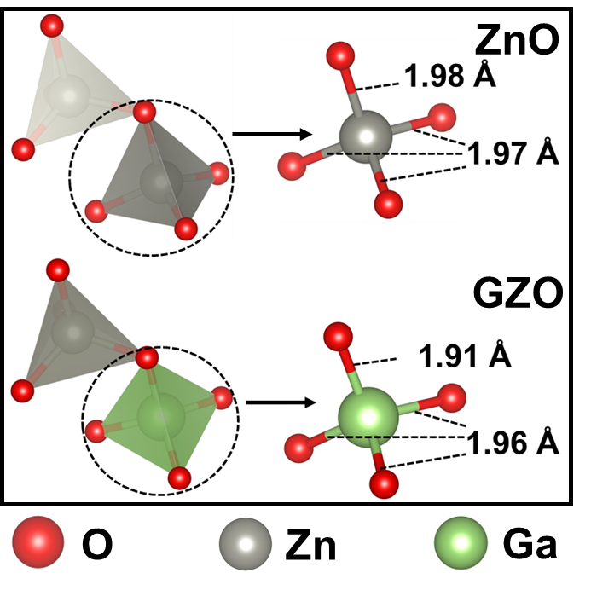
Figure S3. Local structures and bond lengths of ZnO and GZO, showing Zn-O and Ga-O bond lengths in the figure.
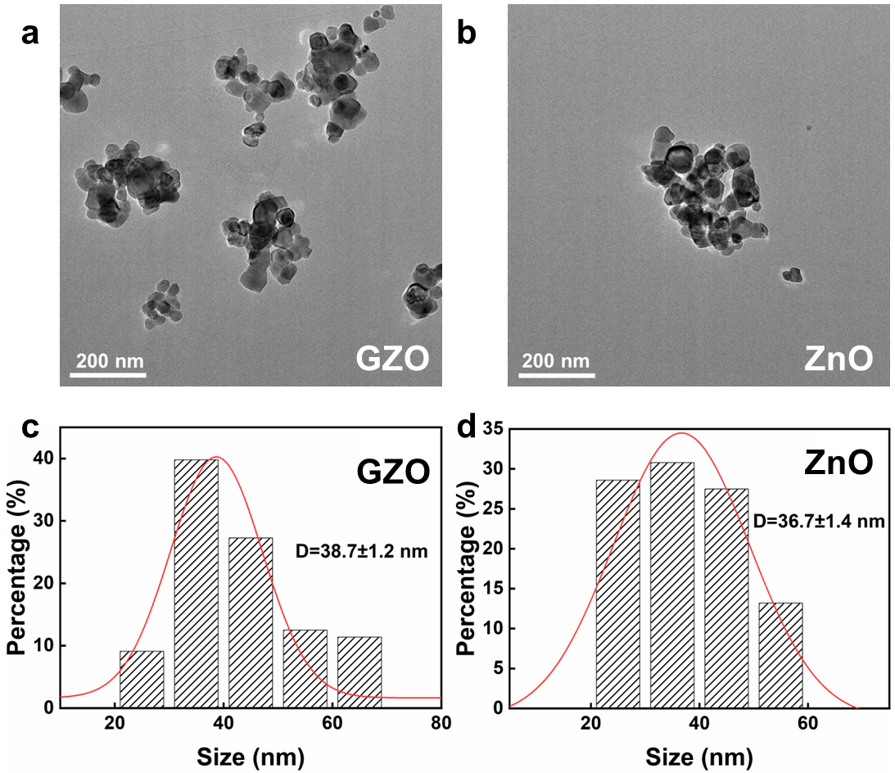
Figure S4. Typical TEM morphology images for (a) GZO and (b) ZnO, and particle size distribution statistics for (c) GZO and (d) ZnO.
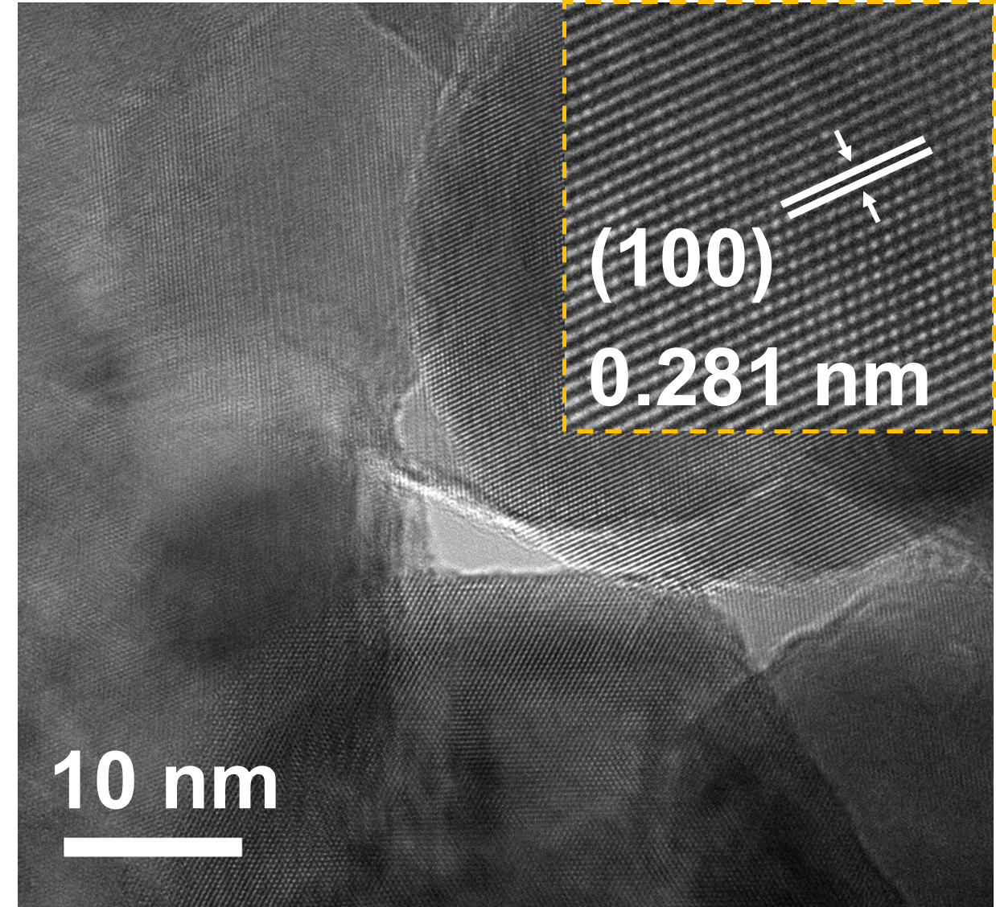
Figure S5. High-resolution TEM image of ZnO.
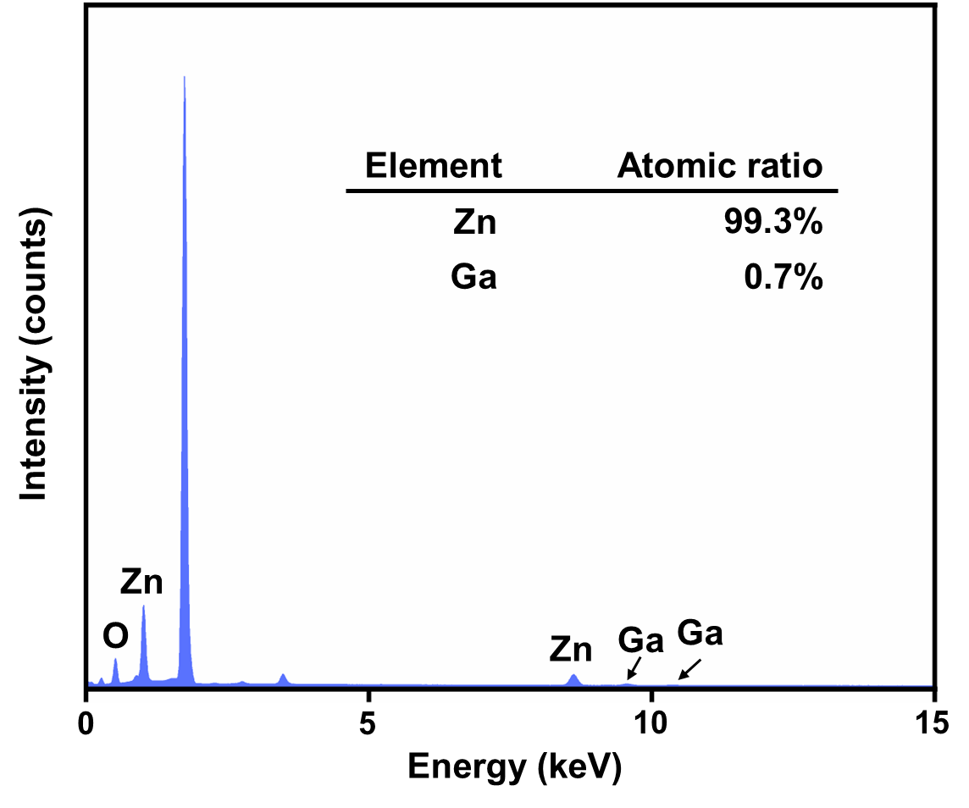
Figure S6. Quantitative analysis results of the EDS spectrum for GZO.
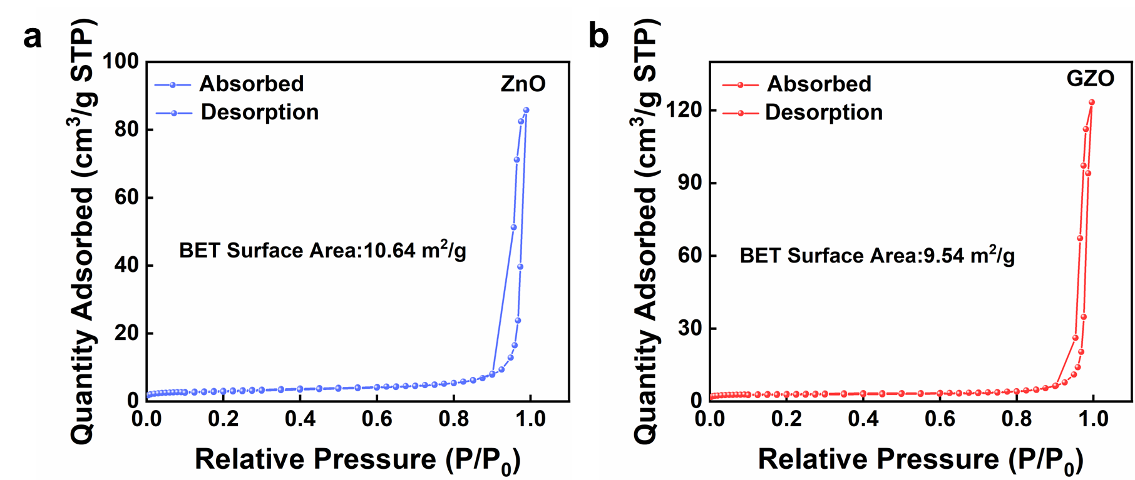
Figure S7. N₂ adsorption-desorption isotherms and pore size distribution for (a) ZnO and (b) GZO.

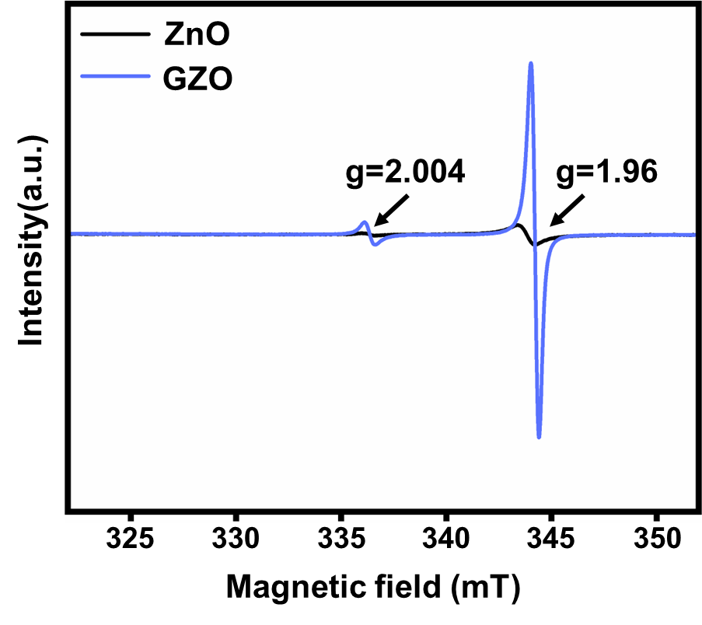
Figure S8. EPR spectra of ZnO and GZO.
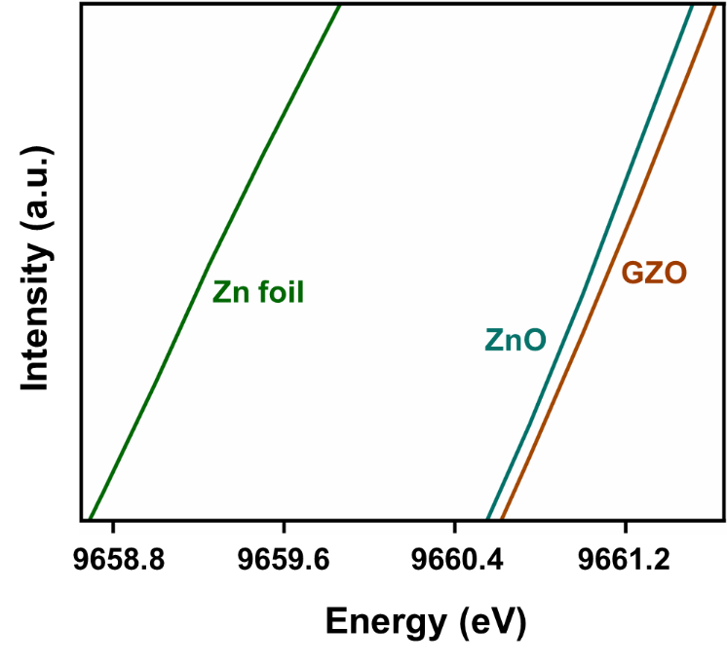
Figure S9. Comparison of Zn K-edge XANES absorption edge energies.
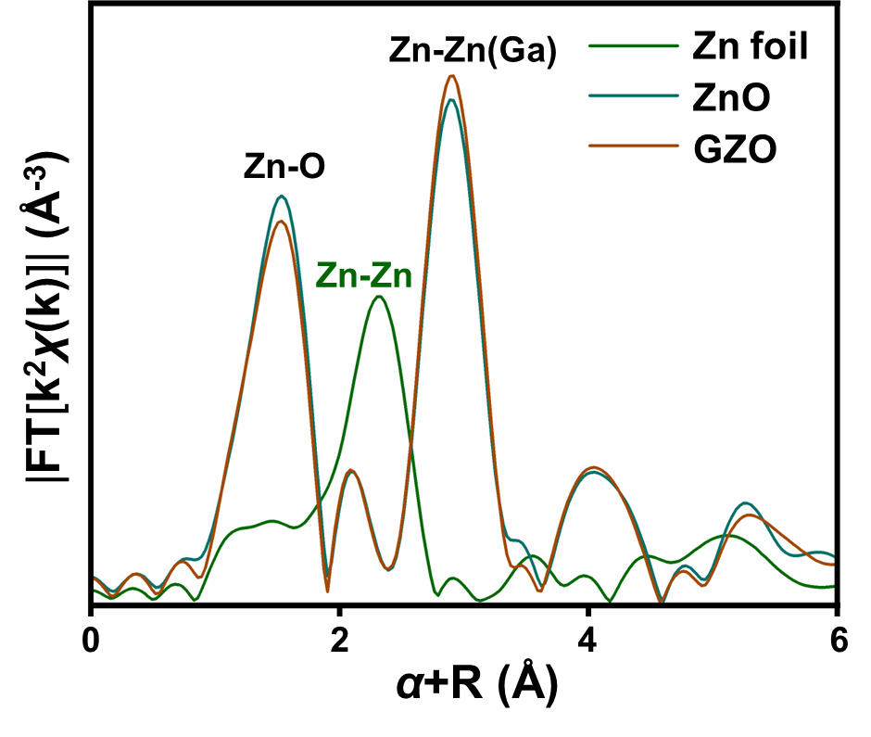
Figure S10. Fourier-transformed EXAFS spectra of ZnO and GZO.
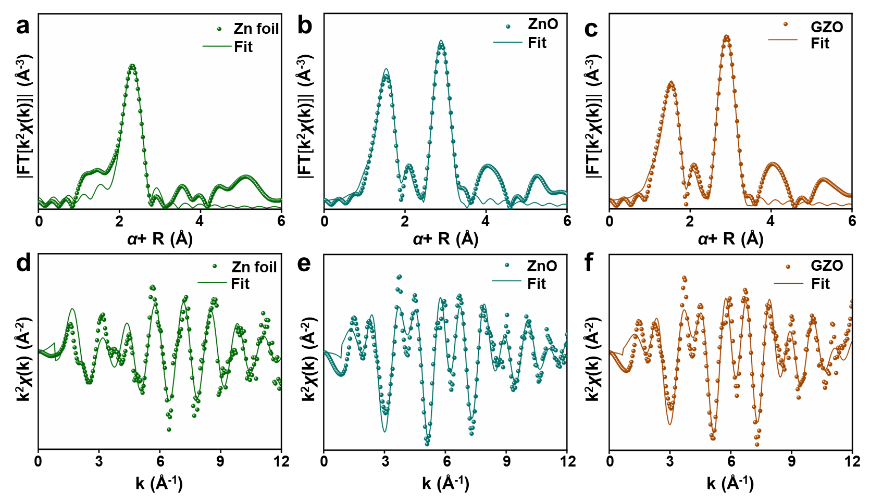
Figure S11. Fitting results of the EXAFS oscillation curves for (a,d) Zn foil, (b,e) ZnO, and (c,f) GZO.
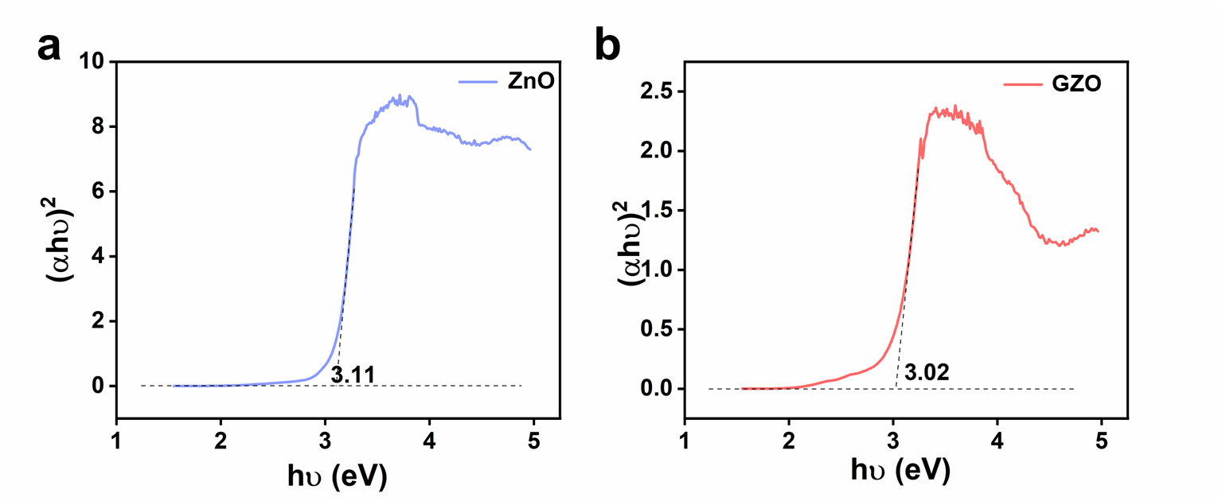
Figure S12. Solid-state UV–Vis diffuse reflectance spectra (UV–Vis DRS) and optical band gaps of (a) ZnO and (b) GZO.
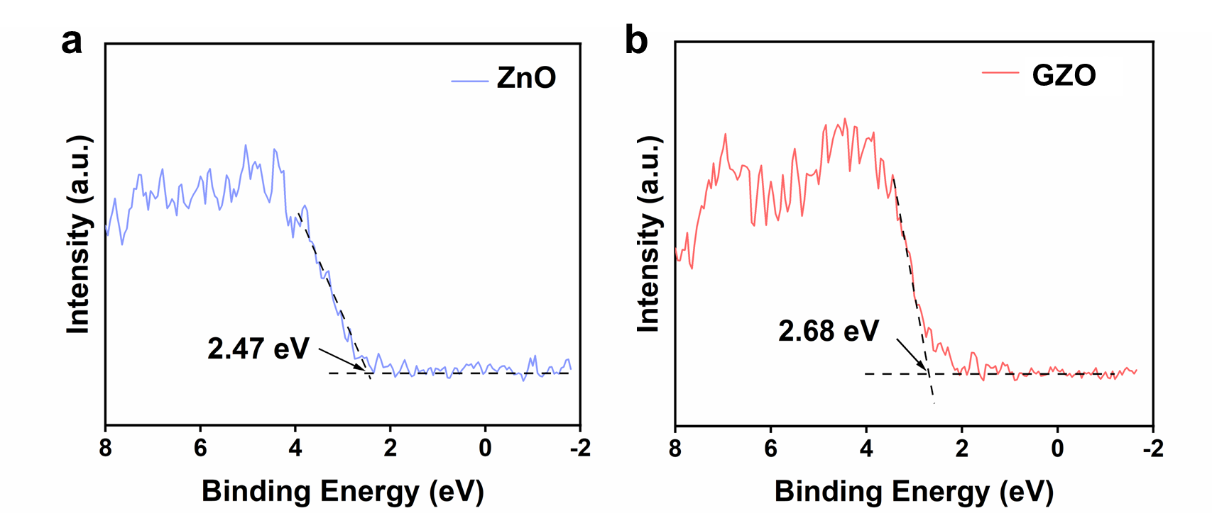
Figure S13. X-ray photoelectron spectroscopy (XPS) valence band spectra of (a) ZnO and (b) GZO.
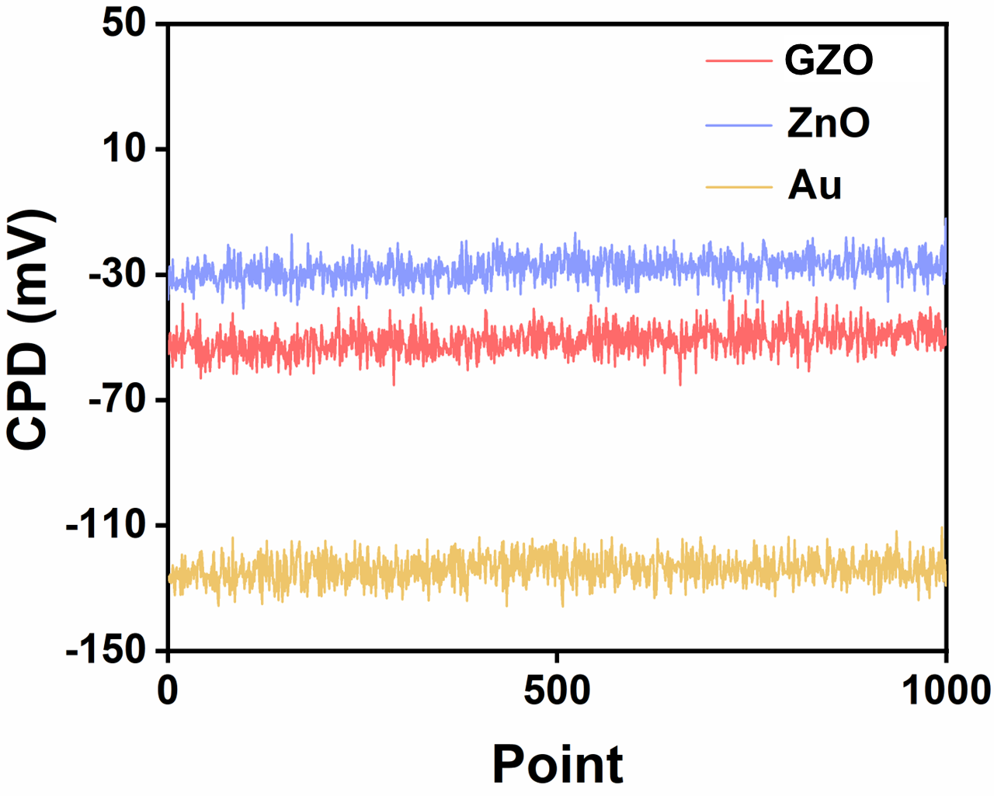
Figure S14. Work functions of Au, ZnO, and GZO measured by Kelvin probe (KP).
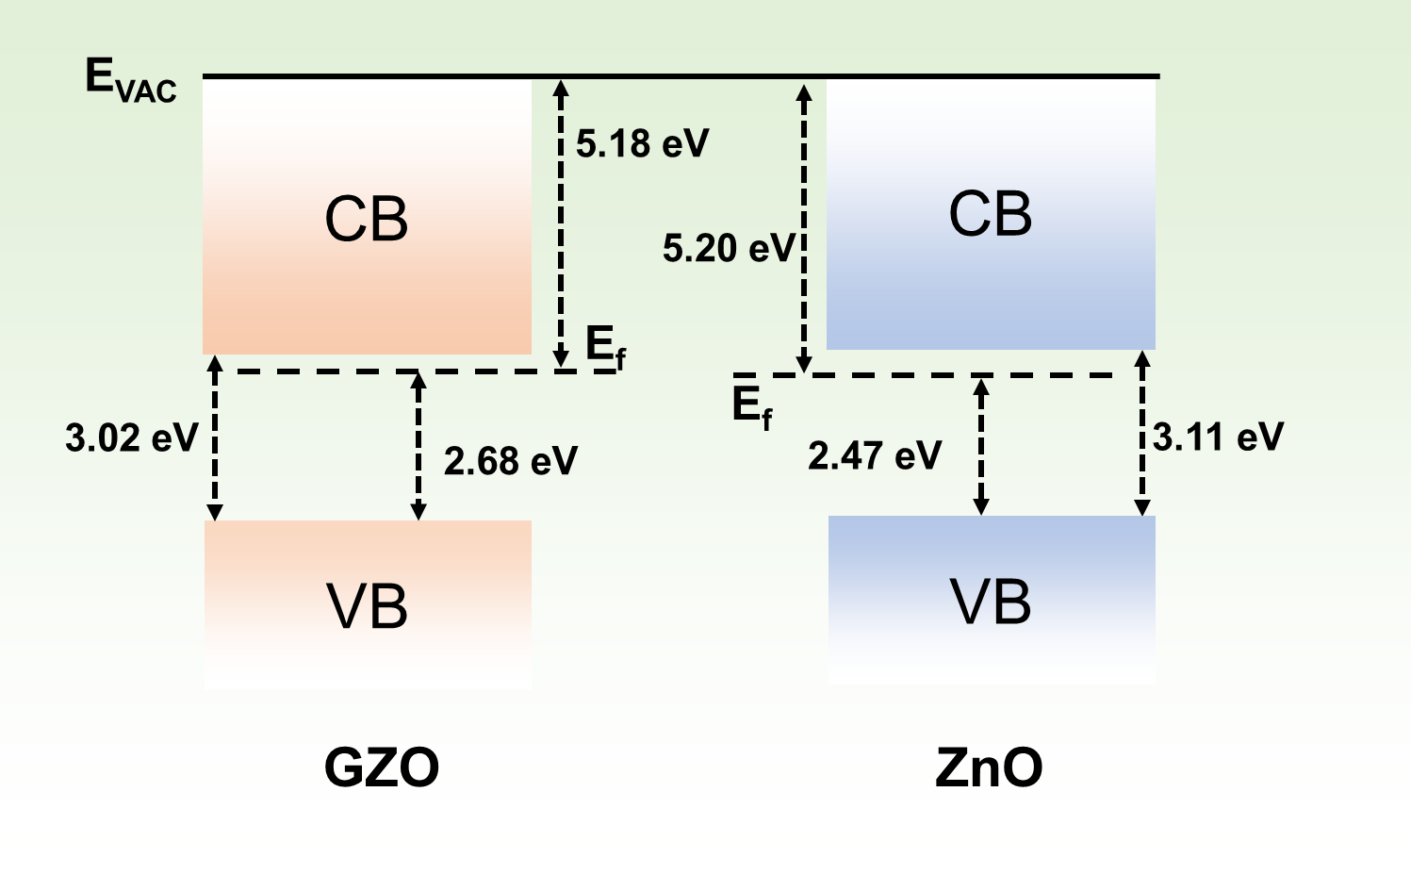
Figure S15. Schematic energy level diagrams of ZnO and GZO.
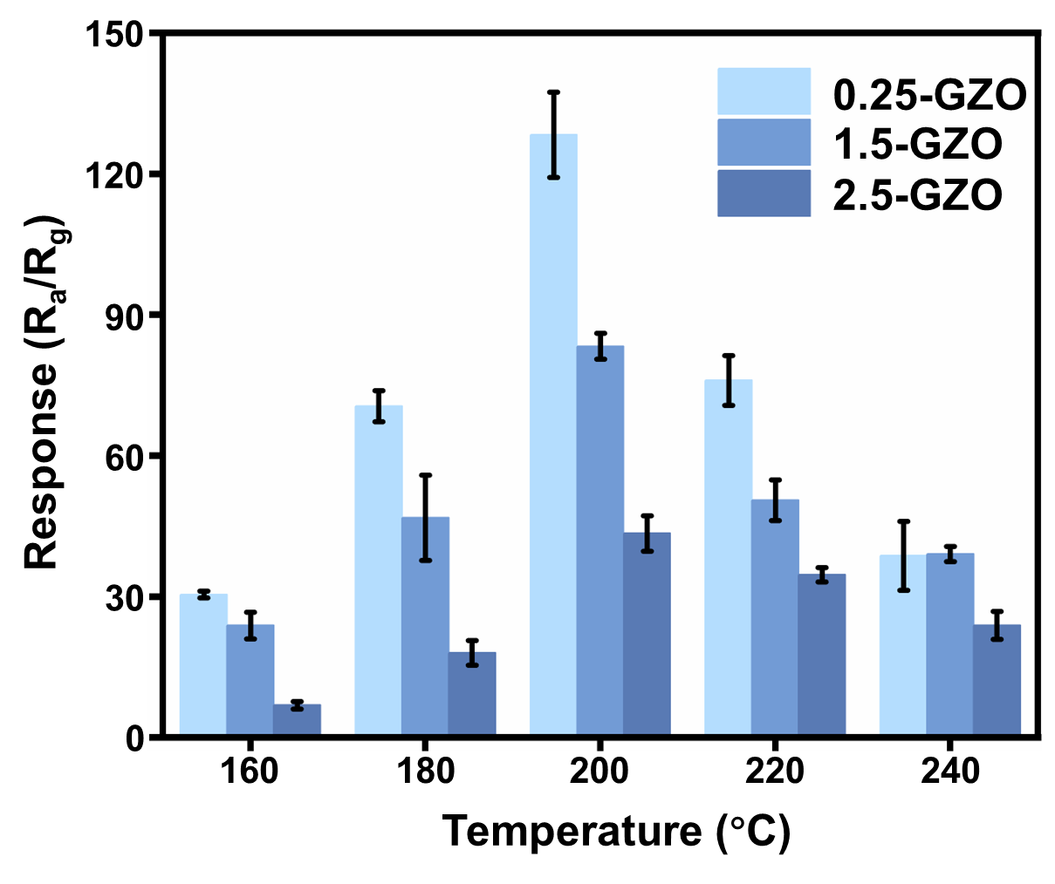
Figure S16. Response comparison of sensors with different Ga doping levels toward 100 ppm ethanol at various temperatures.
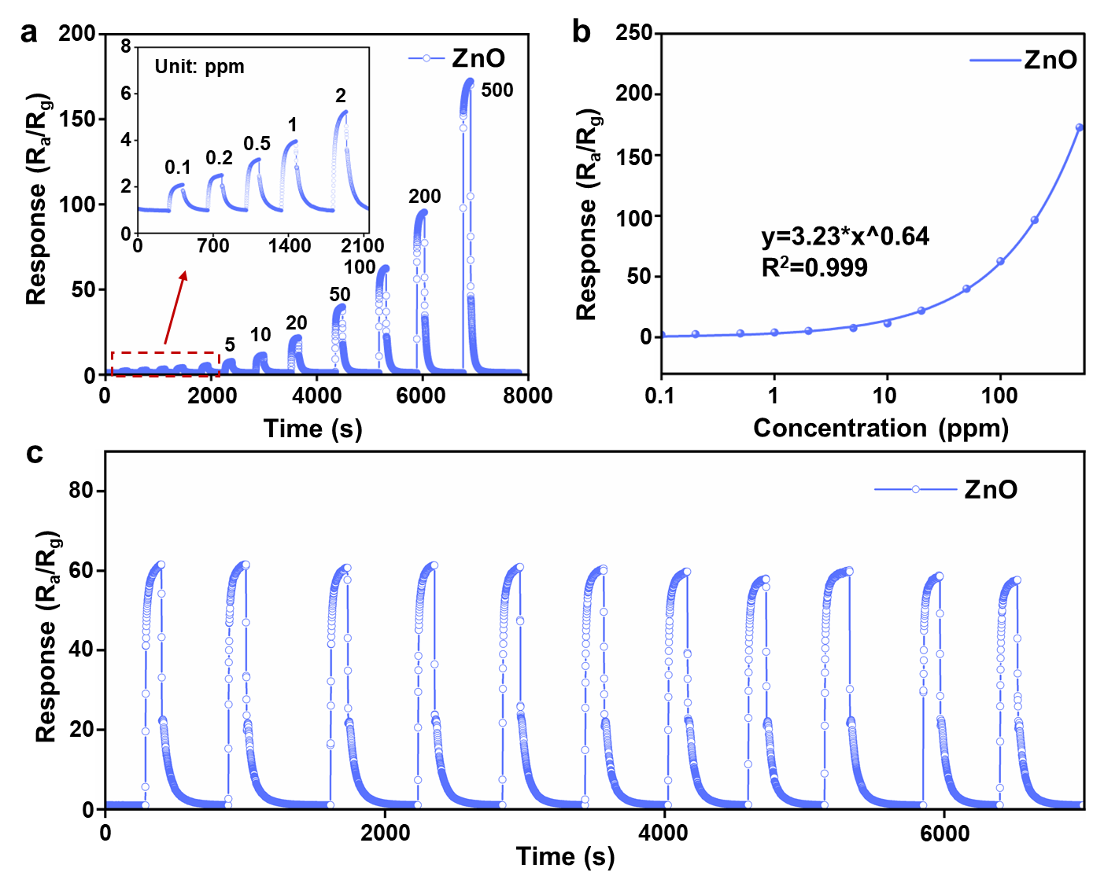
Figure S17. (a) Concentration dependence, (b) fitting curve, and (c) repeatability test for the pure ZnO sensor.
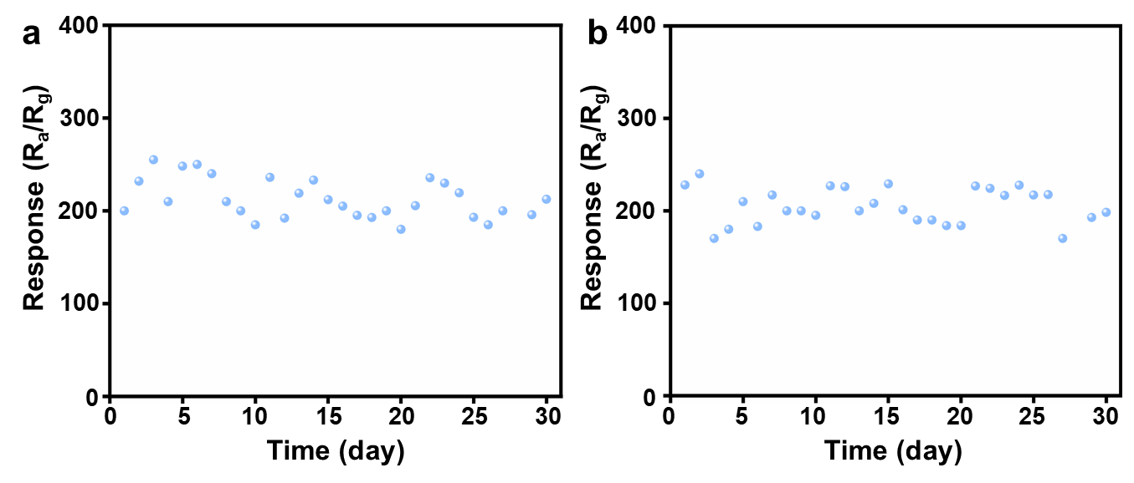
Figure S18. Trend of response values for two independent sensors during long-term stability testing.
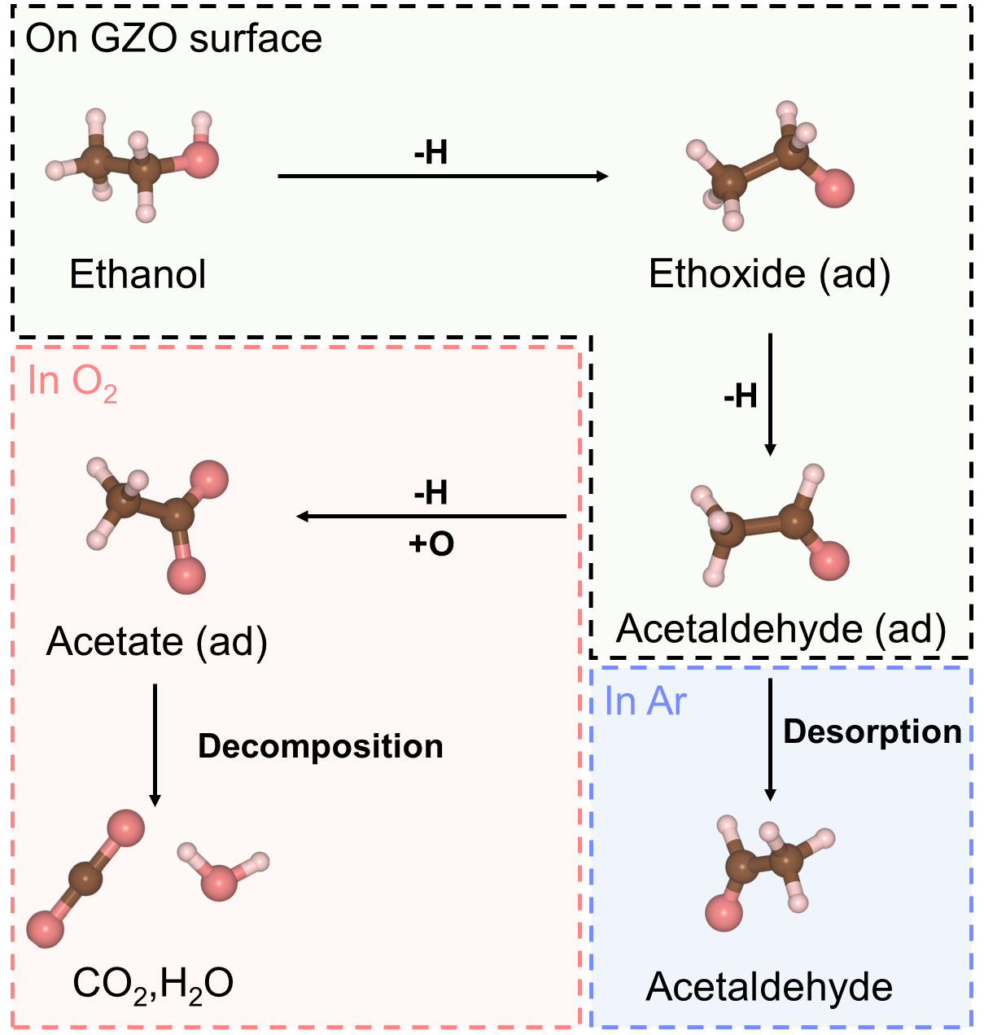
Figure S19. Schematic diagram of the stepwise oxidation decomposition pathway of ethanol on the GZO surface under different atmospheres.
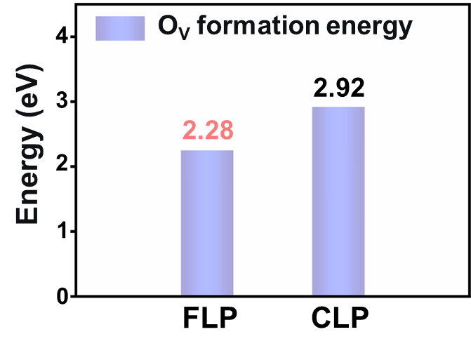
Figure S20. Formation energies of oxygen vacancies for different Ga-O_{V} configurations calculated by DFT.
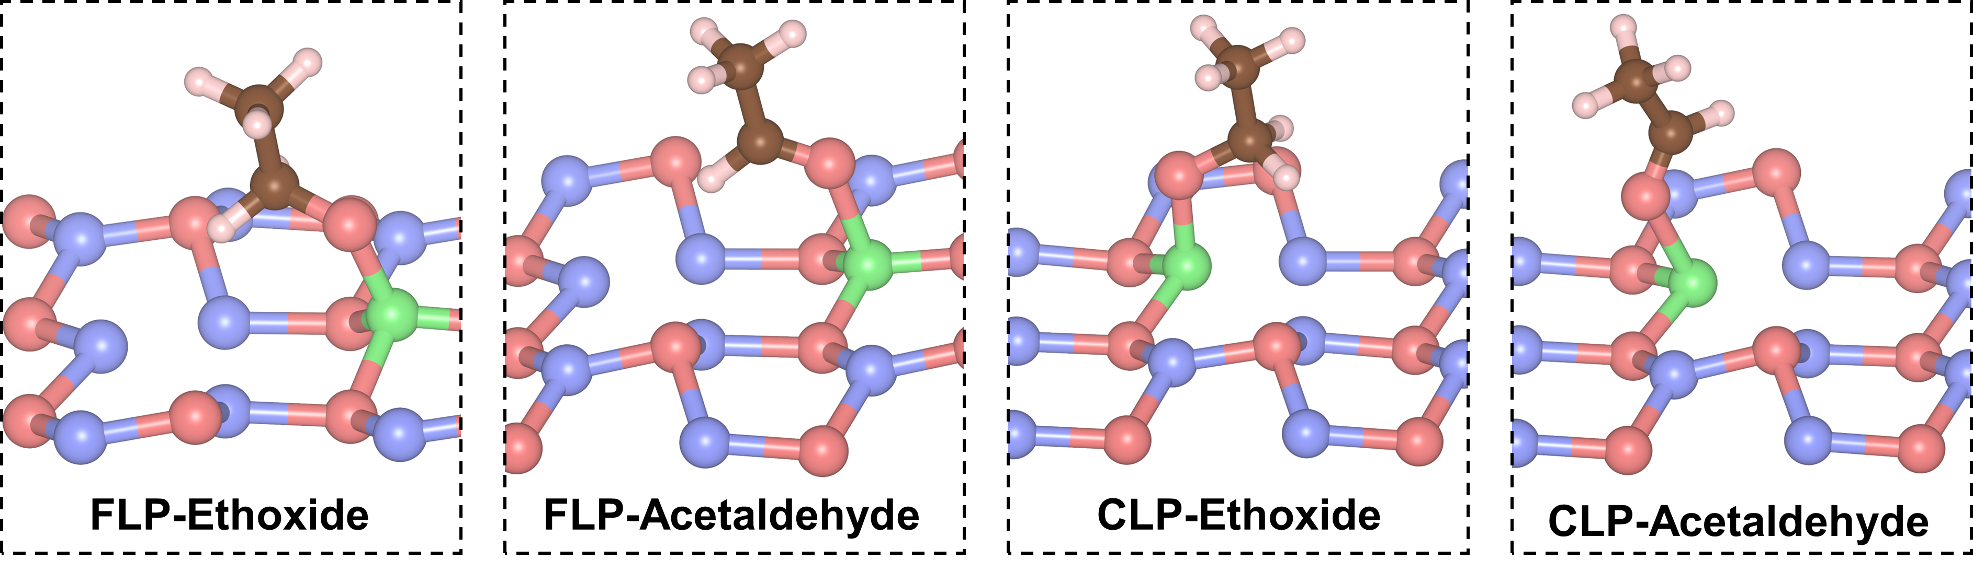
Figure S21. Views of adsorption models for ethoxy and acetaldehyde on the FLP and CLP surface.

Supplementary Table 1. The crystallographic information for ZnO and GZO according to the XRD profile fitting results.
Chemical name | Zinc oxide | Gallium-doped zinc oxide
Chemical formula | ZnO | Ga_{0.005}Zn_{0.995}O
Crystal system | Hexagonal | Hexagonal
Space group | P63mc | P63mc
Cell length a (Å) | 3.2498 | 3.2500
Cell length b (Å) | 3.2498 | 3.2500
Cell length c (Å) | 5.2077 | 5.2082
Cell angle α (°) | 90.0 | 90.0
Cell angle β (°) | 90.0 | 90.0
Cell angle γ (°) | 120.0 | 120.0
Cell size (Å³) | 47.63 | 47.64

Supplementary Table 2. EXAFS fitting results of ZnO and GZO.
Sample | Shell | CN | R (Å) | σ²(Å²/10³) | ΔE₀(eV) | R-factor (%)
Zn foil | Zn-Zn | 6* | 2.669±0.014 | 0.0102 | 2.709±2.279 | 1.76
Zn foil | Zn-Zn | 6* | 2.888±0.014 | 0.0235 | 2.709±2.279 | 1.76
ZnO | Zn-O | 3.20±0.36 | 1.965±0.019 | 0.0028 | 2.994±1.810 | 1.48
ZnO | Zn-Zn | 12* | 3.234±0.016 | 0.0100 | 2.994±1.810 | 1.48
GZO | Zn-O | 2.88±0.18 | 1.952±0.020 | 0.0026 | 1.936±2.141 | 1.23
GZO | Zn-Zn(Ga) | 12* | 3.231±0.015 | 0.0095 | 1.936±2.141 | 1.23

The EXAFS fitting was done over the region k = 2.75 - 10.30 Å⁻¹ with 𝑆₀² fixed at 0.84.

