Supplementary data

Supplementary figures.
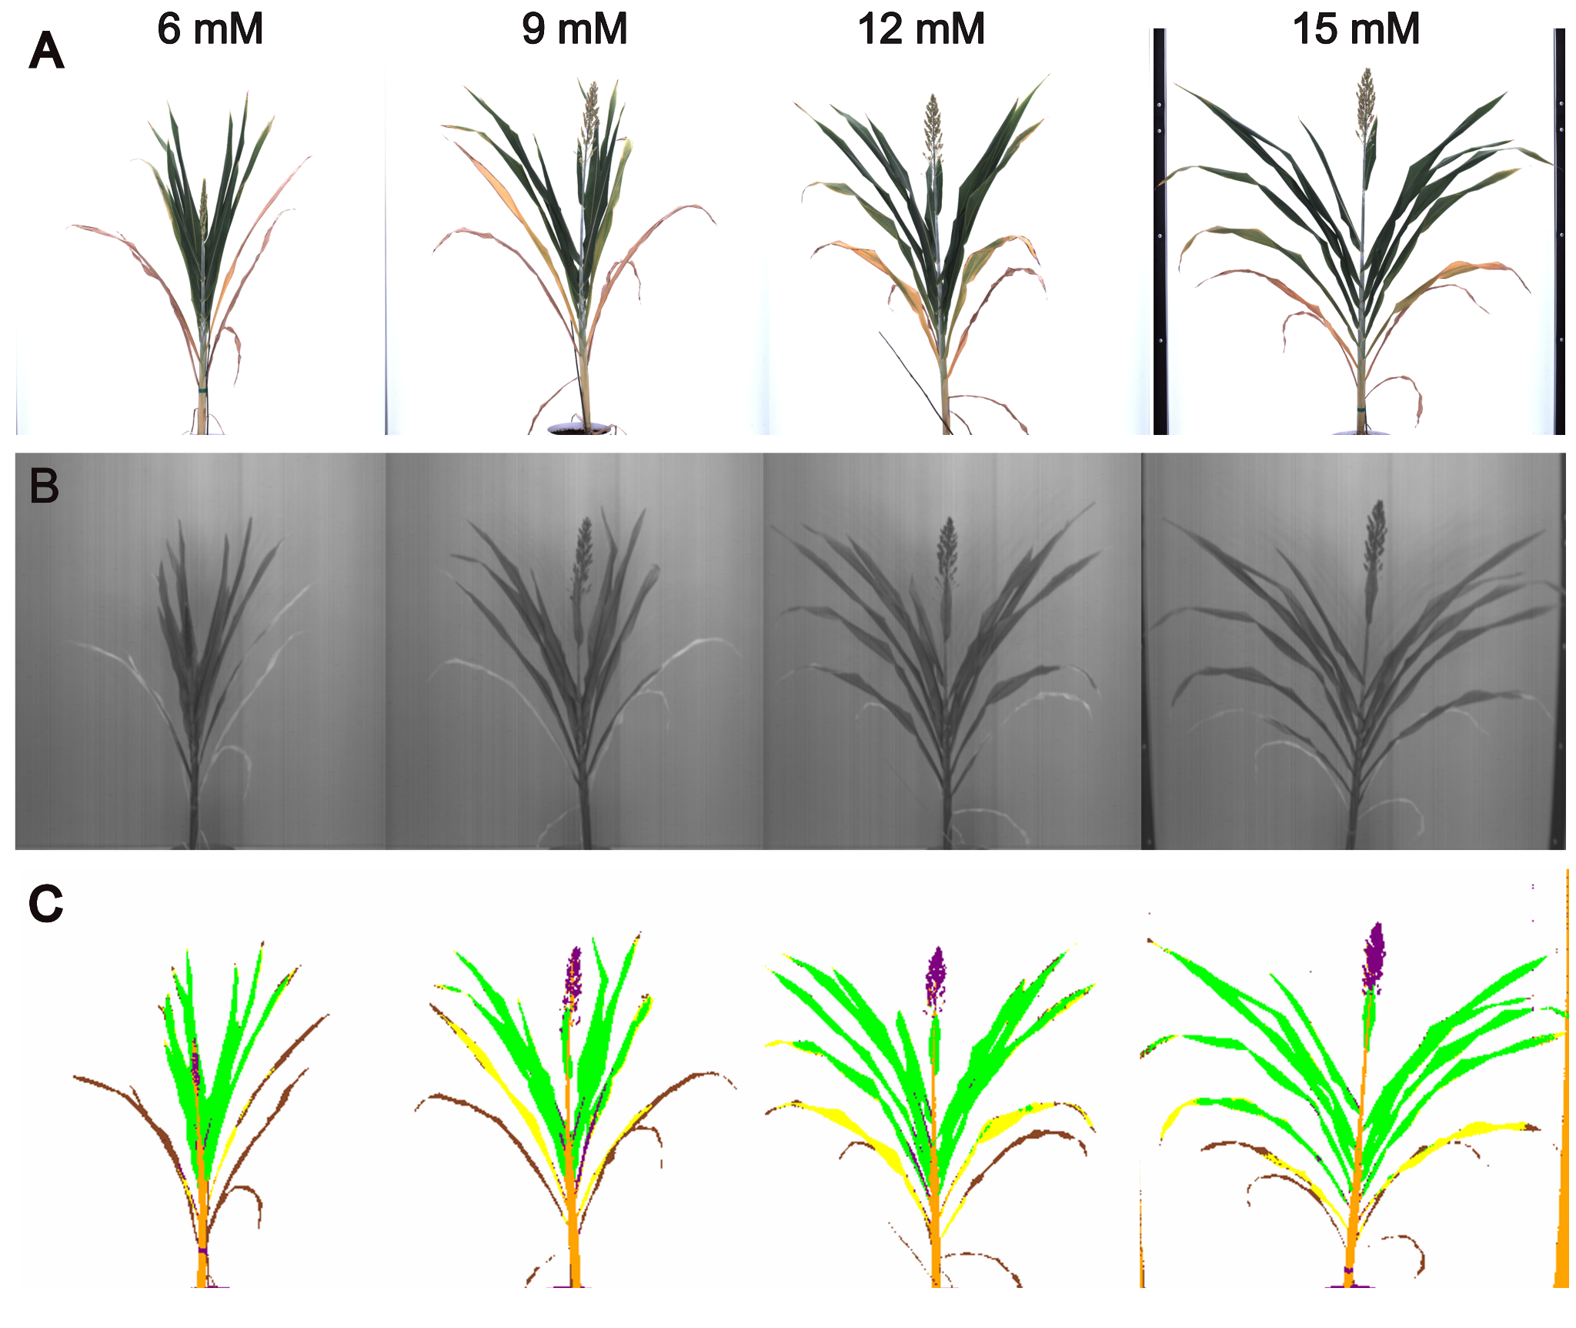
Figure S1. (A) RGB Images of Tx430 plants grown in soil with four N levels: 6 mM, 9 mM, 12 mM, and 15 mM, taken at 99 DAP. (B) Hyperspectral images of the same plants, taken on the same day. (C) Tissues segmented by the SVM model (segmentation classes: green leaf (green), yellow leaf (yellow), dried leaf (brown), stalk (orange), panicle (purple) and background (white)).

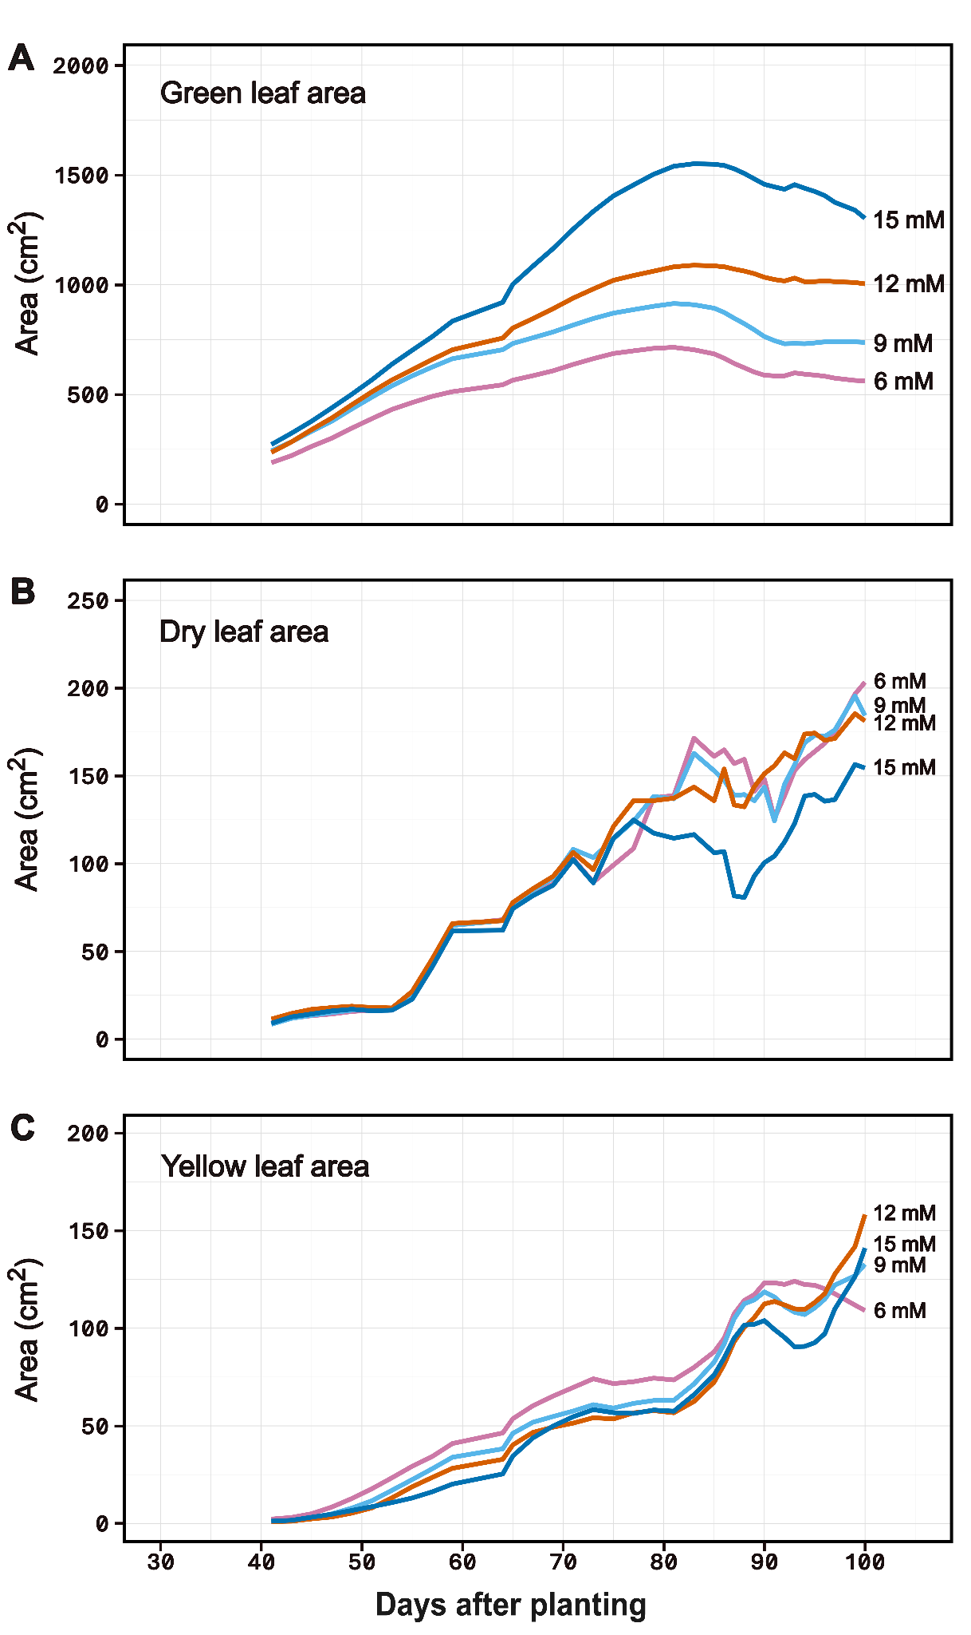
Figure S2. Area of (A) green, (B) dry, and (C) yellow leaves derived from Tx430 plants grown under four N treatments: 6 mM, 9 mM, 12 mM, and 15 mM. Hyperspectral images were taken between 29 to 100 DAP. The calculated areas are the mean of five biological replicates per treatment.
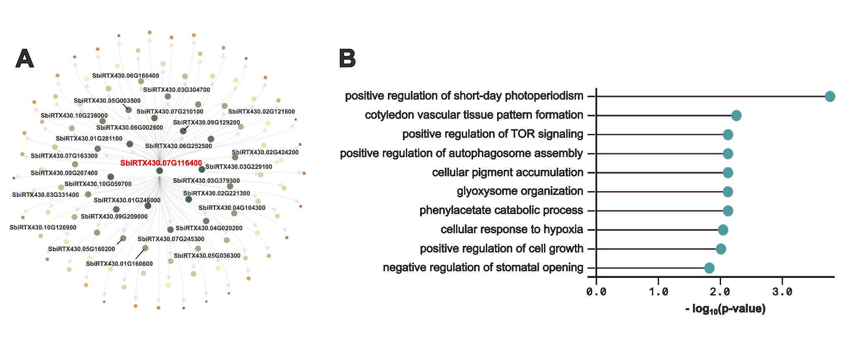
Figure S3. Correlation between senescence and gene expression under variable nitrogen levels. (A) Gene regulatory network of SbiRTX430.07G116400, a senescence-associated transcription factor derived from the top 100 genes highly correlated with senescence ratio. (B) Enriched Gene Ontology (GO) terms among genes in the regulatory network from panel (A).

Supplementary Tables.
Table S1. Composition of nutrients in Hoagland solution used for nitrogen treatments.

Nutrient stock | 6 mM N (vol. in mL) | 9 mM N  (vol. in mL) | 12 mM N  (vol. in mL) | 15 mM N  (vol. in mL)
2 M KNO₃ | 1 | 1.5 | 2 | 2.5
2 M Ca(NO₃)₂⸱4H₂O | 1 | 1.5 | 2 | 2.5
1 M KH₂PO₄ (pH 6.0) | 1 | 1 | 1 | 1
2 M MgSO₄⸱7H₂O | 1 | 1 | 1 | 1
0.05 M Fe-EDTA | 1 | 1 | 1 | 1
0.5 M K₂SO₄ | 4 | 2 | 1 | -
2 M CaCl₂⸱2H₂O | 2 | 1 | 0.5 | -
Standard Hoagland micronutrient stock | 1 | 1 | 1 | 1
Water | Up to 1000 mL

Table S2. Sorghum plants used for pixel collection in Zooniverse, a total of 74 plants on the last day of imaging, September 19th, 2019 (100 DAP).
Plant number | Nitrogen level | Variety | Plant number | Nitrogen level | Variety
340 | 6 mM | ACME | 399 | 12 mM | P898012
344 | 6 mM | SC500 | 401 | 12 mM | ACME
345 | 6 mM | SC301 | 414 | 12 mM | SC301
347 | 6 mM | 90M | 415 | 12 mM | 90M
348 | 6 mM | SC1439 | 416 | 12 mM | P850029
350 | 6 mM | P898012 | 417 | 12 mM | SC85
351 | 6 mM | P850029 | 419 | 12 mM | P898012
352 | 6 mM | SC301 | 422 | 12 mM | SC85
353 | 6 mM | SC500 | 423 | 12 mM | 90M
354 | 6 mM | ACME | 424 | 12 mM | SC301
357 | 6 mM | ACME | 425 | 12 mM | P898012
358 | 6 mM | 90M | 426 | 12 mM | SC1439
359 | 6 mM | SC1439 | 427 | 12 mM | SC500
360 | 6 mM | P898012 | 429 | 12 mM | ACME
361 | 6 mM | P850029 | 430 | 12 mM | SC85
362 | 6 mM | SC85 | 431 | 12 mM | SC500
363 | 6 mM | SC500 | 432 | 12 mM | P850029
365 | 6 mM | SC500 | 435 | 12 mM | 90M
366 | 6 mM | SC85 | 437 | 12 mM | SC301
368 | 6 mM | P898012 | 438 | 12 mM | ACME
369 | 6 mM | SC301 | 454 | 6 mM | Tx430
370 | 6 mM | SC1439 | 455 | 6 mM | Tx430
371 | 6 mM | 90M | 456 | 6 mM | Tx430
372 | 6 mM | P850029 | 457 | 6 mM | Tx430
373 | 6 mM | ACME | 458 | 6 mM | Tx430
374 | 6 mM | ACME | 459 | 9 mM | Tx430
375 | 6 mM | P898012 | 460 | 9 mM | Tx430
376 | 6 mM | SC85 | 461 | 9 mM | Tx430
377 | 6 mM | 90M | 462 | 9 mM | Tx430
379 | 6 mM | SC301 | 463 | 9 mM | Tx430
380 | 6 mM | SC500 | 464 | 12 mM | Tx430
382 | 6 mM | SC1439 | 465 | 12 mM | Tx430
393 | 12 mM | SC301 | 466 | 12 mM | Tx430
394 | 12 mM | SC1439 | 467 | 12 mM | Tx430
395 | 12 mM | P850029 | 468 | 12 mM | Tx430
396 | 12 mM | 90M | 469 | 15 mM | Tx430
397 | 12 mM | SC85 | 472 | 15 mM | Tx430

Table S3. The number of pixels in each of the six pixel classes within the training dataset.
Pixel class | Number of pixels
Background | 2,746
Green leaf | 1,406
Panicle | 796
Stalk | 1,305
Yellow leaf | 1,162
Dry leaf | 1,372

