Supplementary material
Understanding Sahelian rainfall prediction skill in NMME seasonal forecast
Verónica Martín – Gómez^{1,2}, Elsa Mohino¹, Belén Rodriguez – Fonseca^{1,2}, Emilia Sanchez – Gómez³
⁽¹⁾ Departamento de Física de la Tierra y Astronomía, Universidad de Complutense de Madrid, Spain.
⁽²⁾ Instituto de Geociencias IGEO – CSIC, Madrid, Spain.
⁽³⁾ CERFACS, CECI, Toulouse, France.
¹Corresponding author: vero.martin.gomez@gmail.com

Section 1. Correlation between observed and regressed precipitation index
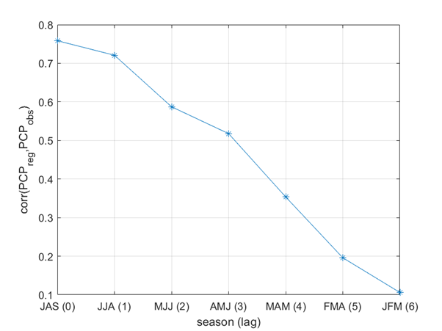
Figure S1.1. Correlation between JAS regressed PCP (PCP=a·eMED + b·Nino3) and the JAS Sahelian observed precipitation index. JAS regressed PCP only contains the terms associated with the eMED and Niño3 signals, the residual one was removed in order to see when the influence of the oceans is larger. Lags were introduced in eMED and Niño3 indices (x-axis). JJA(1) means eMED and Niño3 centered in JJA and PCP in JAS (lag 1).
Section 2. Variance of the indices in observations and models
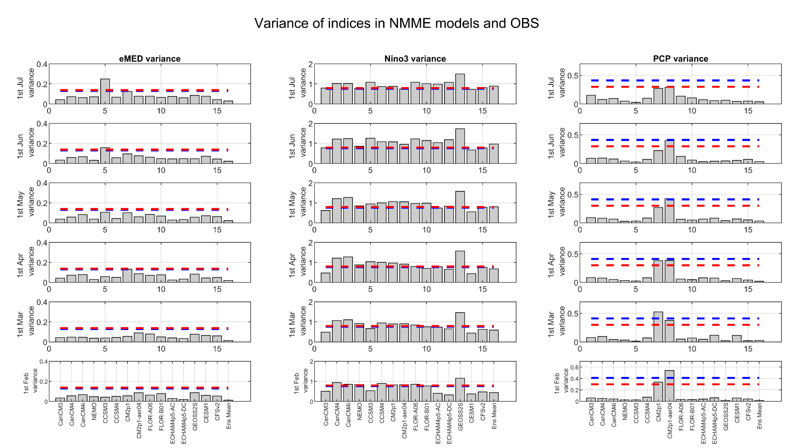Figure S2.1 Variance of eMED (first column), Nino3 (second column) and PCP (third column). Bars of the diagram refer to models and red and blue lines to observations. The red (blue) one is associated with PCP from CRU TS 4.03 (GPCPv2.3) and SST from ERSSTv5 (HadISSTv1.1).

Section 3. Scatter plots relating skill in predictors and teleconnections to precipitation skill and/or contributions to precipitation skill
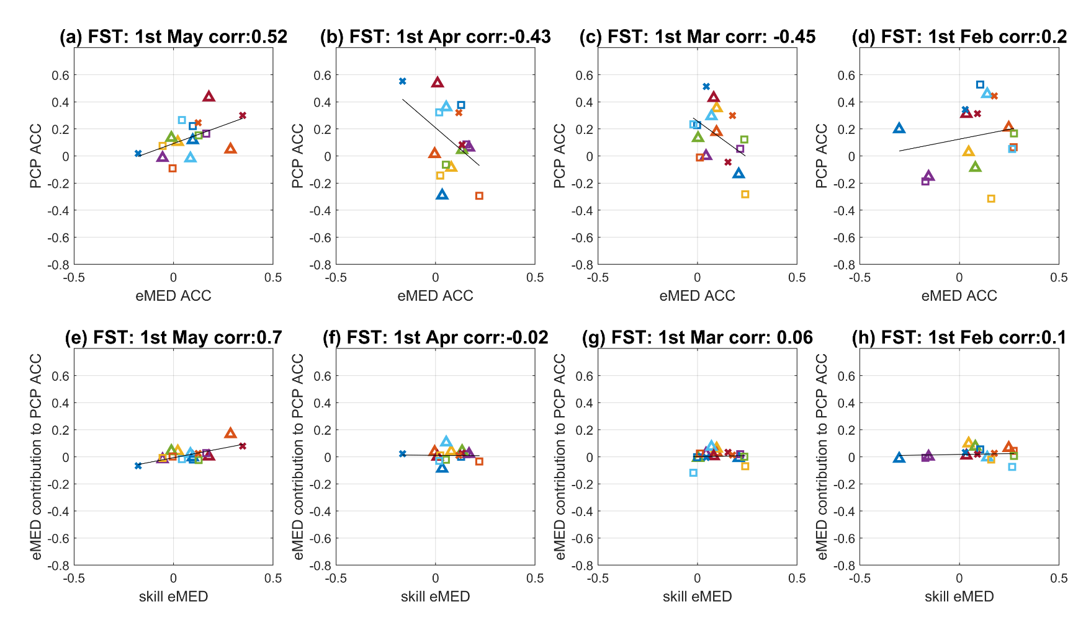Figure S3.1 Scatter plot of PCP ACC vs eMED ACC for (a) FST=1st May, (b) FST=1st Aug, (c) FST=1st March and (d) FST= 1st Feb. Scatter plots of eMED contribution to PCP ACC vs. eMED ACC for (e) FST=1st May, (f) FST=1st Aug, (g) FST=1st March and (h) FST= 1st Feb. Black line represents the linear regression between variables.
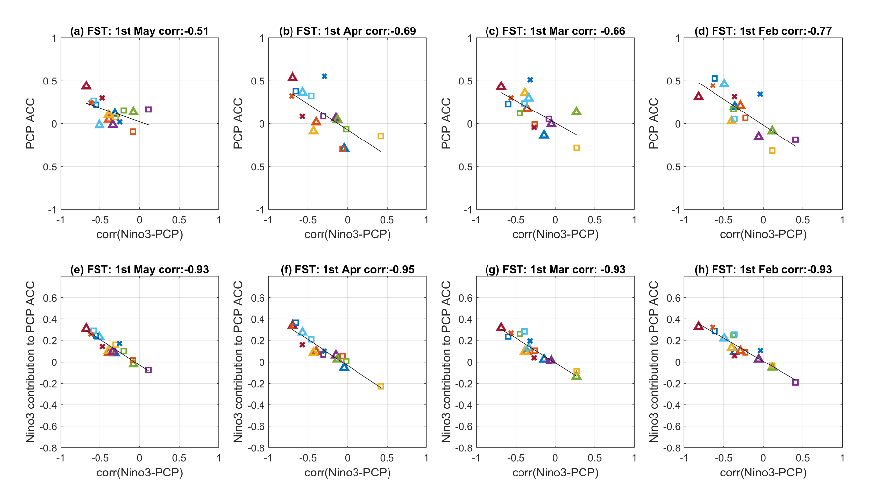
Figure S3.2 Scatter plot of corr(Niño3,PCP) vs PCP ACC for (a) FST=1st May, (b) FST=1st Aug, (c) FST=1st March and (d) FST= 1st Feb. Scatter plots of Niño3 contribution to PCP ACC vs. corr(Niño3,PCP) for (e) FST=1st May, (f) FST=1st Aug, (g) FST=1st March and (h) FST= 1st Feb. Black line represents the linear regression between variables.

Section 4. Spatial eMED-Sahel teleconnection patterns for FST from 1st May to 1st February.
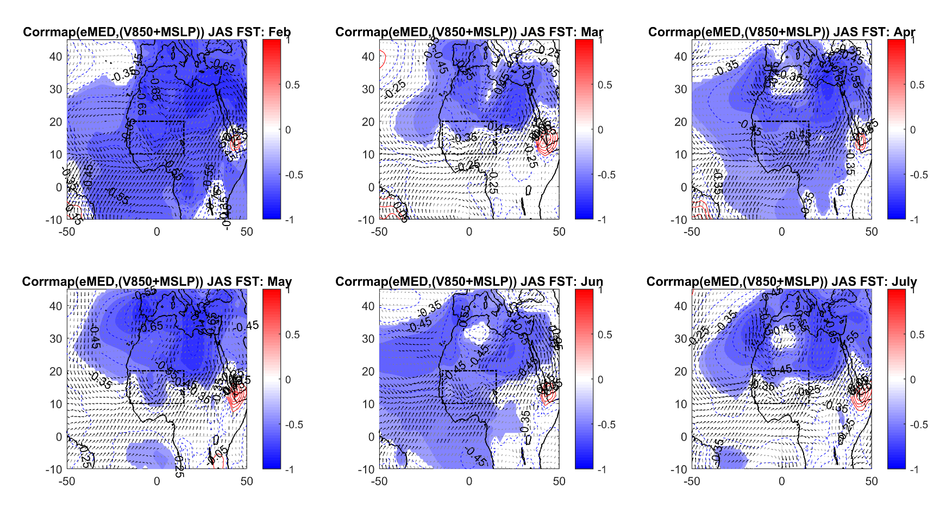Figure S4.1 Correlation map of the eMED index onto the anomalous mean sea level pressure (contours) and the horizontal winds at 850hPa (arrous). FST from 1st February to 1st July. Shaded regions represent the significance for the mean sea level pressure. Arrows in black (gray) are significant (not significant). For significance, we consider a two tailed t-test with a 95% confidence level and an effective number of degrees of freedom.

Section 5. Spatial Niño3-Sahel teleconnection patterns for FST from 1st May to 1st February.
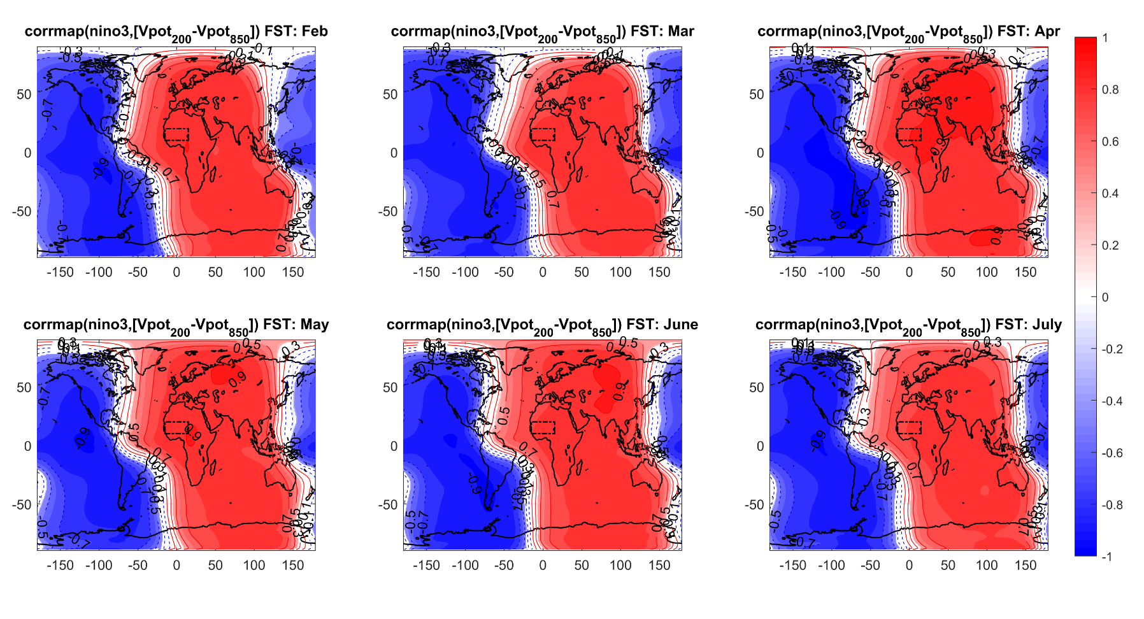
Figure S5.1 Correlation map of the Niño3 index onto the anomalous velocity potential difference between the levels 200hPa and 850hPa. FST from 1st February to 1st July. Shaded regions are statistically significant considering a two tailed t-test with a 95% confidence level and an effective number of degrees of freedom.
Section 6. Percentage of total precipitation variance explained by eMED, Niño3, cov(Niño3,eMED) and the residue in FST from 1st May to 1st February.
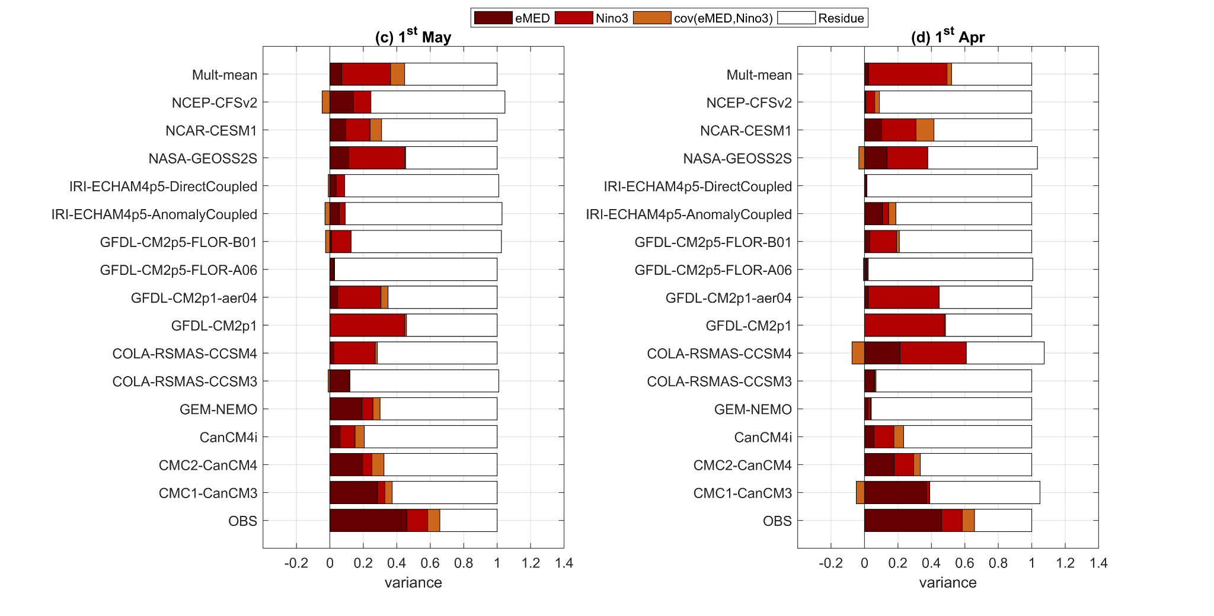
Figure S6.1 Total precipitation variance decomposition. Given that the variance of precipitation index in observations is larger than in models, precipitation indices are standardized in order to better compare results from observations and models. OBS means observations. FST=1st May (c) and FST=1st April (d).
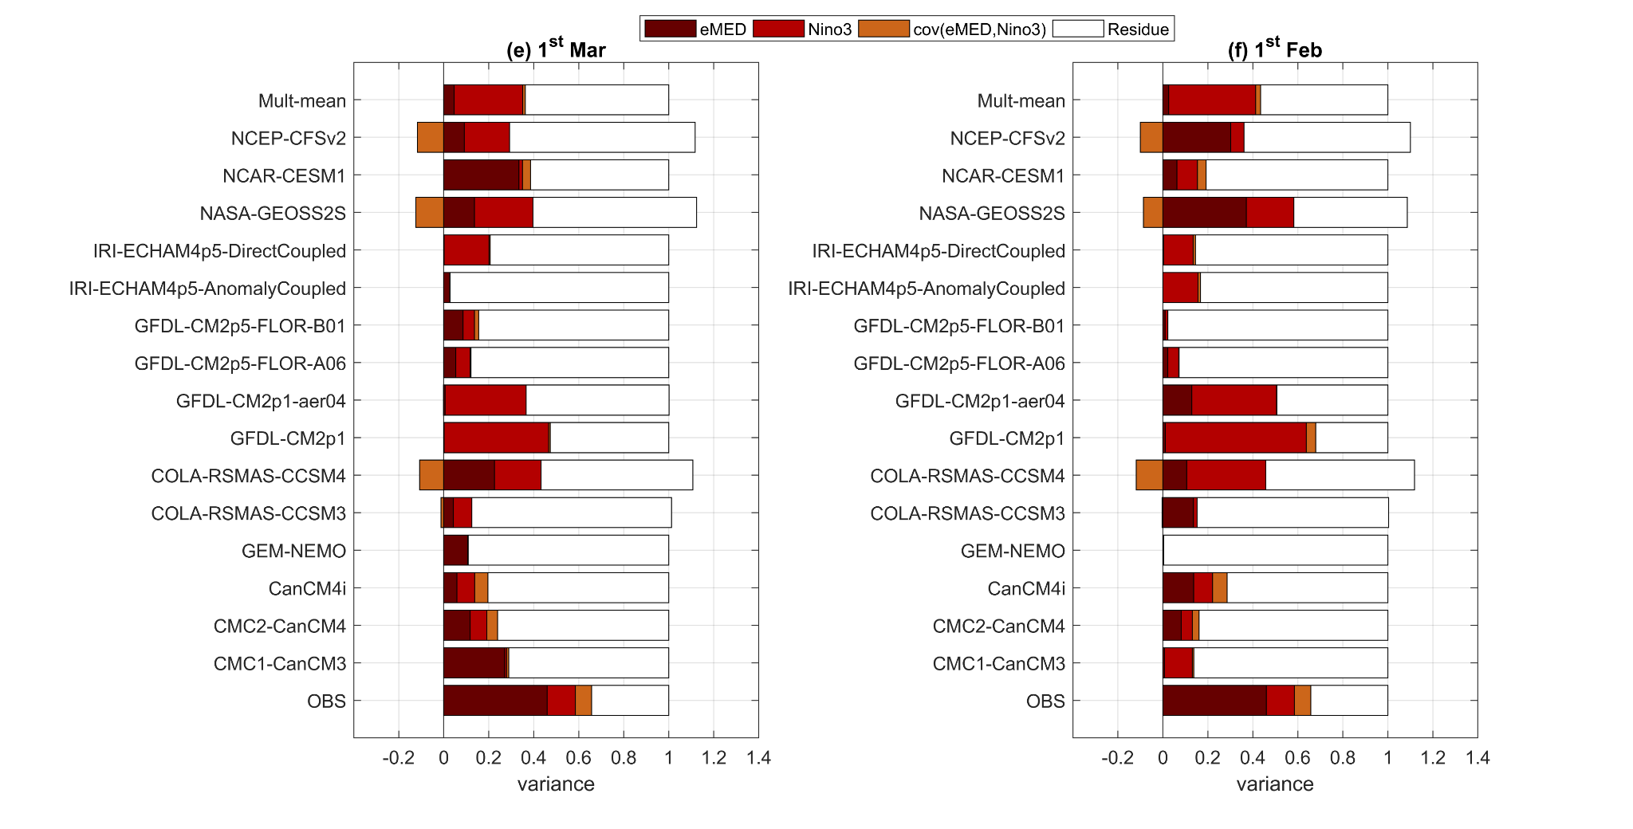
Figure S6.2 Total precipitation variance decomposition. Given that the variance of precipitation index in observations is larger than in models, precipitation indices are standardized in order to better compare results from observations and models. OBS means observations. FST=1st March (e) and FST=1st February (f).

Section 7. Contributions to PCP skill from eMED, Niño3 and the residue. FST from 1st May to 1st February.
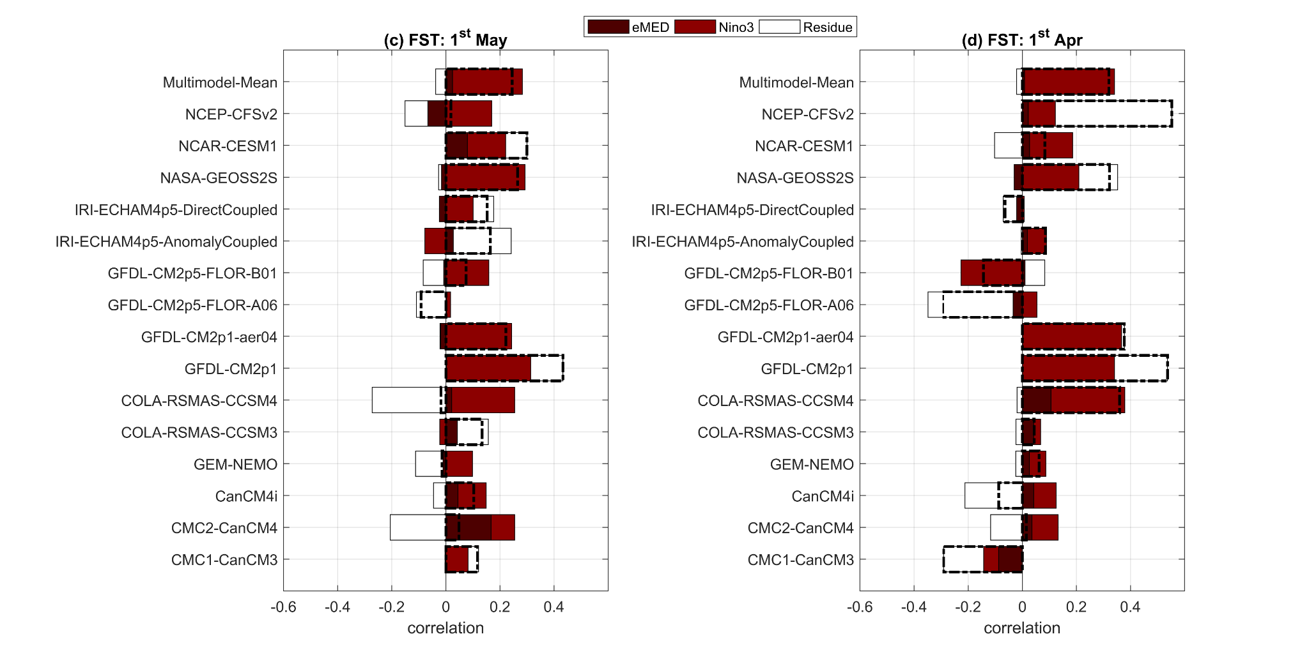
Figure S7.1 Contributions of eMED, Niño3 and the residue to PCP prediction skill in models. FST=1st May (c) and FST=1st April (d).
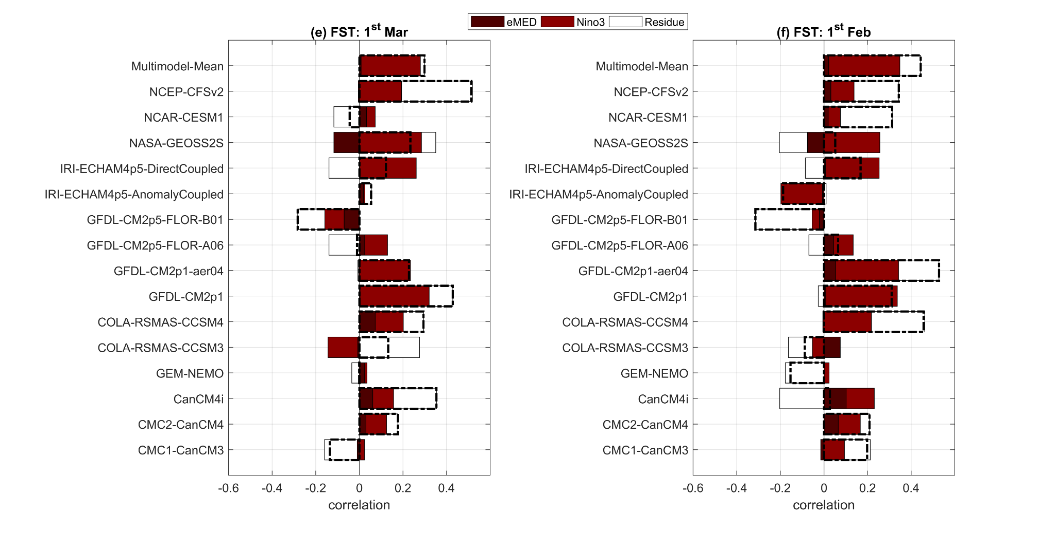
Figure S7.2 Contributions of eMED, Niño3 and the residue to PCP prediction skill in models. FST=1st March (e) and FST=1st February (f).

Section 8. Evaluation of the modeled multiple regression coefficients and predictands on the precipitation ACC scores.
In this work we have seen that models present low skill for predicting precipitation over Sahel. Our results suggest this is mainly related to the lack of skill for simulating the changes in the SST anomalies over the eMED and the underestimation of the eMED – precipitation teleconnection amplitud. In order to check which is the most important term, we evaluate the ACC scores considering the following methodology:
The multiple regression analysis in observations was expressed as:
PCP_{reg}=α_{obs}·eMED_{index observed}+β_{obs}·Nino3_{index observed} + ε eq. 1
If we correlate the observed precipitation index with the one obtained from the multiple regression analysis (eq .1), correlation value is equal to 1. In order to check how this correlation is modified by each one of the terms which appear in eq. 1, we will compute 4 type of PCP_{reg}^{i}:
PCP_{reg}¹= α_{nmme models} ·eMED_{index observed}+β_{obs observed}·Nino3_{index observed} + ε₁ eq. 2
PCP_{reg}²= α_{observed} ·eMED_{index nmme models}+β_{obs observed}·Nino3_{index observed} + ε₂ eq. 3
PCP_{reg}³= α_{observed} ·eMED_{index observed}+β_{obs nmme models}·Nino3_{index observed} + ε₃ eq. 4
PCP_{reg}⁴= α_{observed} ·eMED_{index observed}+β_{obs observed}·Nino3_{index nmme models} + ε₄ eq. 5
In this way, the new ACC values will be computed as the correlation between precipitation index observed and the one obtained by eqs. 2 – 5. The farther from 1 the correlation value is, the stronger reduction of precipitation skill is induced by the therm.
Figure S8 shows the boxplot of the ACC values for each lead time (LT). It is possible to see that the stronger reduction of the ACC values is given by when we consider eq. 2, when ACC values are between 0.7 and 0.8 (Figure S89 (b)). There is also a strong reduction related to α, however this reduction is lower than in the one observed for eMED index (Figure S8 (a)). These results suggest the lack of skill to correctly simulate the variability of the SST anomalies over the eMED to be the most important factor reducing the precipitation skill in NMME models. On the other hand, the reduction in ACC due to α could be, in turn, related to the small variance of the SST anomalies over the eMED.
Finally, the impacts of β and Nino3 index were also analyzed (Figures S9 (c) and (d)). Results suggest that the reduction of the ACC values in these cases is much smaller than for α and eMED index. The ACC values are higher than 0.8 (Figures S8 (c) and (d)), while in the other cases they are smaller than 0.8 (Figures S8 (a) and (b)).
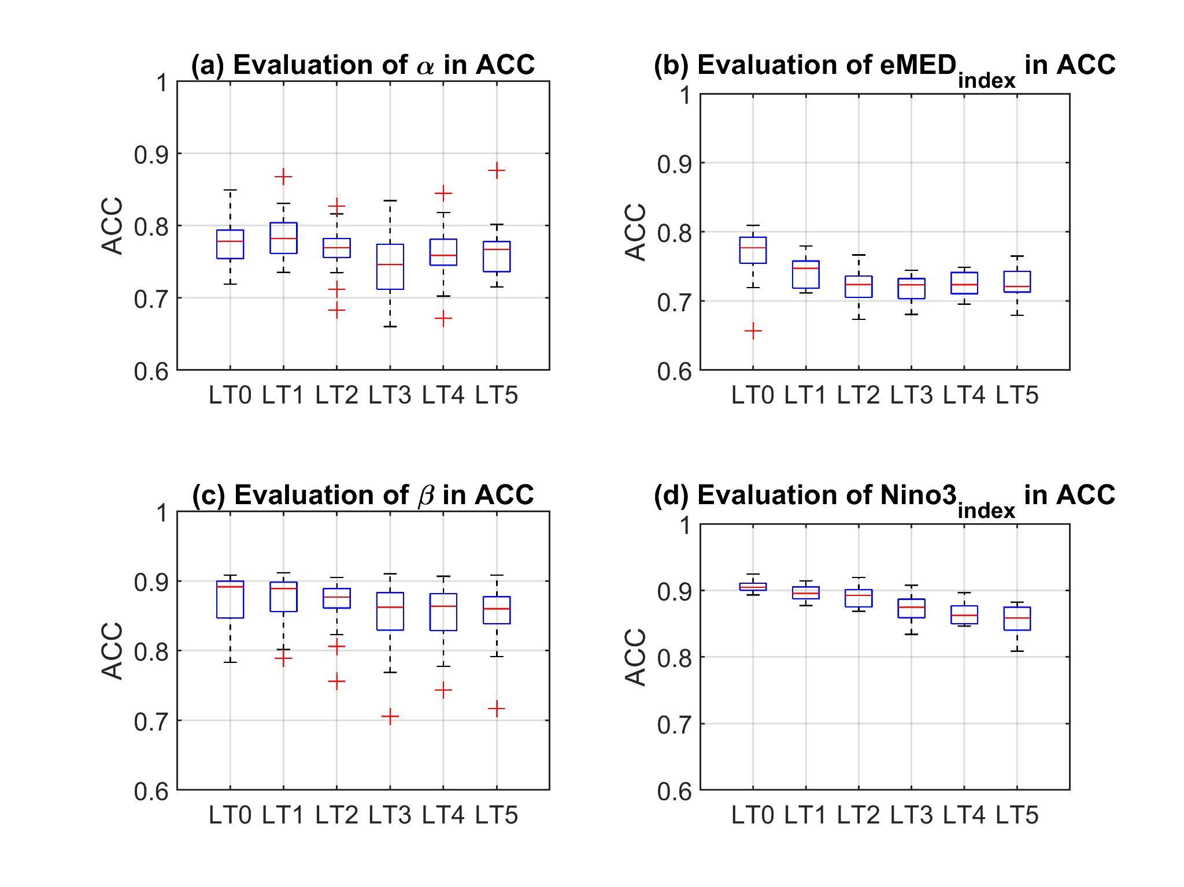
Figure S8.1 Evaluation of the contribution to ACC of (a) regression coefficient of eMED, (b) eMED index, (c) regression coefficient of Nino3 and (d) Nino3 index. LTn represents the lead time n. In turn, LT0 means FST = 1st July.

