Supplementary Materials

Actively Tunable Sb₂S₃ Metasurface with Polarization-insensitive Quasi-bound Flat-Band in the Continuum for Enhancing Third-harmonic Generation
Siwen Qian^{1,2}, Ruhao Pan²*, Yongliang Li¹, Junhao Tan³, Zhenggang Pan¹, Bo Wang², Jingbo Sun³, Chuanbao Liu¹*, Junjie Li²*, Ji Zhou³ and Yang Bai¹*

¹Institute for Advanced Materials and Technology, University of Science and Technology Beijing, Beijing, 100083, China
S. Qian (d202310726@xs.ustb.edu.cn), Y. Li (d202210679@xs.ustb.edu.cn), Z. P (D202520065@xs.ustb.edu.cn), C. Liu (cbliu@ustb.edu.cn, 15652931130), and Y. Bai (baiy@mater.ustb.edu.cn, 13671041060)

²Beijing National Laboratory for Condensed Matter Physics, Institute of Physics, Chinese Academy of Sciences, Beijing, 100190, China
R. Pan (panruhao@iphy.ac.cn, 13020049070), B. Wang (wangbo2014@iphy.ac.cn), and J. Li (jjli@iphy.ac.cn, 13683088593)

³School of Materials Science and Engineering, Tsinghua University, Beijing, 100084, China
J. Tan (tanjunhao22@mails.ucas.ac.cn), J. Sun (jingbosun@mail.tsinghua.edu.cn), and J. Zhou (zhouji@tsinghua.edu.cn)

Table of Contents
Section 1. The fabrication of the hybrid metasurfaces
Section 2. The simulation of the hybrid metasurfaces
Section 3. The Optical Characterization of the hybrid metasurfaces

Section 1. The fabrication of the hybrid metasurfaces
In the main text, we have only briefly mentioned the fabrication process of metasurfaces. Here we will show everything in details. Similar to main text and methods, the samples are fabricated by two main processes. Supplementary Fig. 1 summarizes the entire process for the fabrication of phase-change metasurface. We start with a K9 glass substrate, which is cleaned with ultrasonic in acetone, ethanol, and deionized water for 15 minutes and dried with N₂. Then the Si nanostructures are fabricated by the following steps.
1. Deposition of Sb₂S₃ layer. The Sb₂S₃ film is deposited onto the K9 glass substrate via magnetron sputtering (MS) (JSP-4, vacuum of 3×10⁻¹⁰ Torr). The deposition rate is 1.7 Å /s. The thickness of deposited Sb₂S₃ film is 50nm.
2. Deposition of Al₂O₃ layer. The 15nm Al₂O₃ is deposited onto the developed Sb₂S₃ film as a protective film via Atomic Layer Deposition (ALD) (Savannah G2, vacuum of 5×10⁻⁶ Torr). The deposition rate is 0.04 Å /s.
3. Deposition of α-Si layer. The amorphous Si film is deposited onto the Al₂O₃ film via Plasma Enhanced Chemical Vapor Deposition (PECVD) (PD-220NL, vacuum of 5×10⁻⁷ Torr). The deposition rate is 1.0 Å /s. The thickness of deposited Si film is 200 nm.
4. Spin-coating of E-beam resist. The PMMA.A2 resist is spin-coated onto the Si membrane with a rotational speed of 4000 rpm. After the spin-coating process, the samples are placed onto a 180°C hotplate for 1 minutes. The thickness of PMMA film is 100 nm. Next, the AR- N 7520.17 resist is spin-coated onto the PMMA membrane with a rotational speed of 4000 rpm. After the spin-coating process, the samples are placed onto a 85°C hotplate for 1 minutes.
5. Pattern generation and development. The 7520.17 resist is exposed by E-beam lithography (EBPG 5200, Raith) to generate the designed structural pattern. The samples are developed with AR300-46 developer for 90s and fixed with water for 30s.
6. Etching. Taking the 7520.17 film as mask, the PMMA film is etched with O₂ (RIE-200NL Dual, SAMACO). The etching rate is 0.3 Å /s. Next, taking the 7520.17 film and PMMA film as mask, the Si film is etched with HBr (Si 500, Sentech). The etching rate is 3 nm /s.
7. E-beam resist removal. The samples are soaked in acetone for 30 min at a temperature of 65°C. The residual resist is removed with O₂ (RIE-200NL Dual, SAMACO).
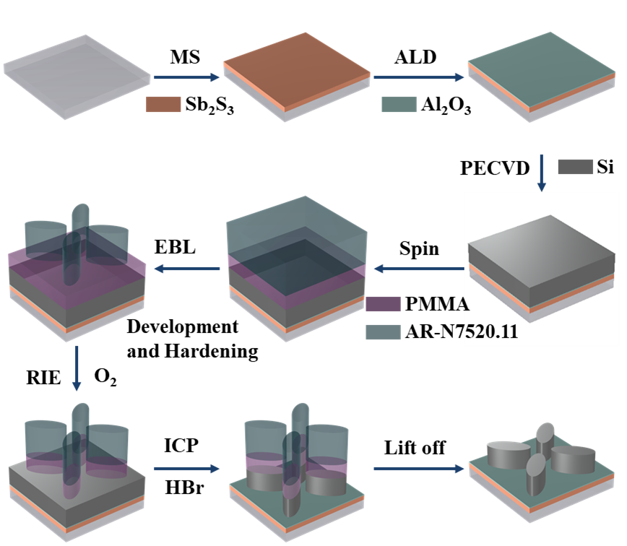
Supplementary Figure 1. Schematic of the nanofabrication process of phase-change metasurface.

Section S2. The simulation of the hybrid metasurfaces
As mentioned in the main text, all the refractive indices of Si, Sb₂S₃, and Al₂O₃ are taken from the experimental results. These parameters are the bases of all the numerical simulation. In experiment, we have prepared amorphous Si (α-Si) film with Plasma Enhanced Chemical Vapor Deposition (PECVD) and Al₂O₃ with Atomic layer deposition (ALD). Then the dielectric constants including refractive index n and light extinction coefficient k are measured by ellipsometer and numerically fitted. The results are shown in Supplementary Fig. 2 (a) and (b). We can see that α-Si maintains a high refractive n > 3.3 over the entire telecommunication wavelength range. The corresponding light extinction coefficient is negligibly small. With a similar process, Al₂O₃ maintains a low refractive n < 1.5 over the entire telecommunication and light extinction coefficient is also negligibly small.
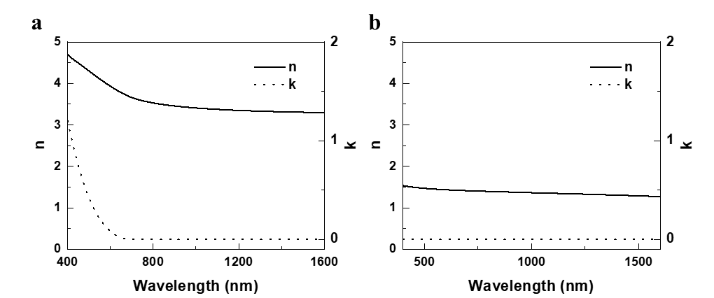
Supplementary Figure 2. The experimentally measured n and k of the materials. (a) Amorphous Si film. (b) Al₂O₃
To further figure out the mechanism of the BIC mode, the scattering powers of different multipoles, including the electric dipole (ED), the magnetic dipole (MD), the toroidal dipole (TD), the electric quadrupole (EQ), and the magnetic quadrupole (MQ) in the Cartesian coordinate system were analyzed and demonstrated in Supplementary Fig.3. They are calculated as follows:
$$ED=\frac{1}{iω}\int{jd^{3}r}$$
$$MD=\frac{1}{2c}\int{\left(r×j\right)d^{3}r}$$
$$TD=\frac{1}{10c}\int{\left[(r∙j)r-2r^{2}j\right]d^{3}r}$$
$$EQ=\frac{1}{iω}\int{\left[r_{α}j_{β}+r_{β}j_{α}-\frac{2}{3}(r∙j)\right]d^{3}r}$$
$$MQ=\frac{1}{3c}\int{\left[{\left(r×j\right)}_{α}r_{β}+{(r×j)}_{β}r_{β}\right]d^{3}r}$$
where r refers to the position vector and j represents the displacement current density. As seen in Supplementary Fig.3. (a), the contribution of the TD (deep blue solid line) is predominant, indicating that the BIC mode is mainly induced by the TD. By decomposing the x, y, and z components of the TD scattering power in Supplementary Fig.3. (b), we find that the y component of the scattering power from the TD dominates the TD scattering power dissipation and is almost equal to it in value. And compared to the y component, the x and z components of the scattered power of the TD are almost close to 0. The distribution of the normalized electromagnetic field for the BIC mode of the metasurface is presented in Supplementary Fig.3. (c) and (d). The black arrow represents the displacement current density and magnetic field vector in Supplementary Fig.3. (c) and (d), respectively. For BIC Mode, as shown in Supplementary Fig.3. (c), circulation orientations of displacement currents in the y direction of the Si neighboring cylindrical meta-atoms are opposite and the same in the x direction of the neighboring cylindrical meta-atoms, which indicates that the opposite phase magnetic dipoles along the z direction are induced in the y direction meta-atoms pair. Supplementary Fig.3. (d) depicts the magnetic field distribution at the y–z plane. As indicated by the brown circle, opposite phase magnetic dipoles form a closed magnetic vortex in the y–z plane. The magnetic field vector circulates clockwise between adjacent cuboids in the intra-cluster x direction meta-atoms and counterclockwise between adjacent cuboids in the inter-cluster x direction neighboring metaatoms. The magnetic field distribution is head to tail, which is characteristic of TD multipole.
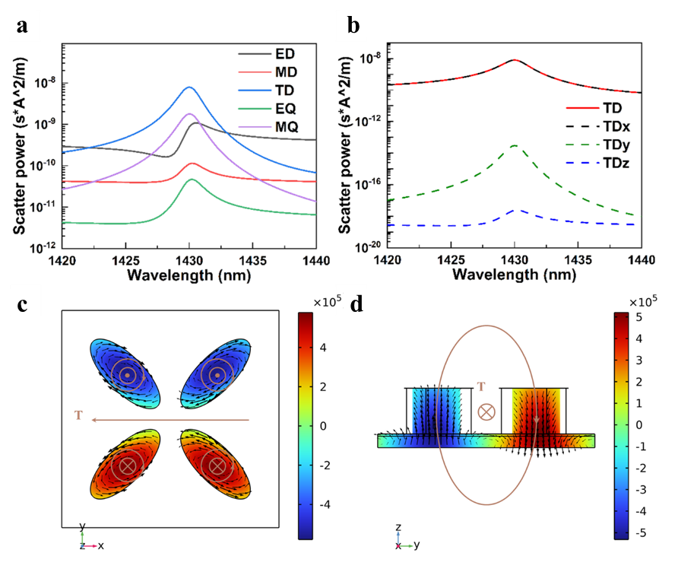
Supplementary Figure 3. (a) The scattering powers of different multipoles. (b) X, Y, and Z components of the TD scattering power. (c) The distribution of the normalized electromagnetic field in X-Y plane. (d) The distribution of the normalized electromagnetic field in Y-Z plane.
The topological property of this mode in the momentum space holds an integer charge + 1 at point V as shown in Supplementary Fig.4. More specifically, the BIC is marked by V-points to perform polarization singularities, in which the carried topological charge q can be defined as follows:$q=\frac{1}{2π}\oint_{c}{dk}∙∇_{k}∅\left(k\right)$, where φ(k) denotes the angle of the polarization state and C represents a simple closed path to revolve around the V-point in the counterclockwise direction.
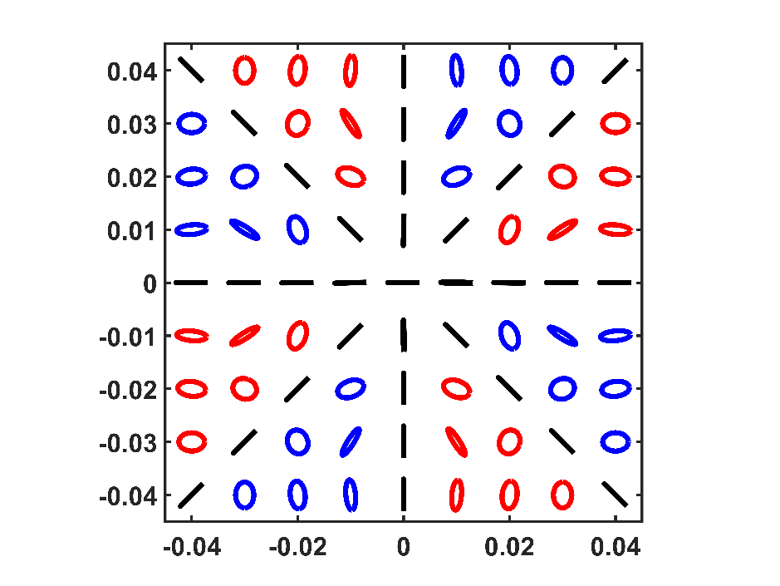
Supplementary Figure 4. Topological properties of TM modes under disturbance parameters α = 0.

Section S3. The simulation of phase-change metasurfaces
The optical setup for THG intensity measurement used in this work is shown in Supplementary Fig.5. The laser was produced by a 7 mJ Ti: sapphire laser system (Astrella, Coherent) with a central wavelength of 800 nm, with a repetition rate of 1 kHz and pulse width of around 35 fs. The beam was used to pump a commercial femtosecond optical parametric amplifier (OPerASolo, Coherent), which delivers an optical laser beam with a tunable wavelength from 1300 to 1600 nm. Variable attenuator used to examine the power slope of THG signal by changing the pump laser power. A half-wave plate was used to control the linearly polarized light. An objective of 4× magnification and 0.10 NA (Olympus) focused the laser beam on the sample. White light LED used to align laser spot on the fabricated pattern. The transmitted light was collected using an objective of 20× magnification and 0.40 NA (Olympus). The collimated light was directed to a filter (FGV9, Thorlab) with a working bandwidth of 485-565nm. The beam splitter divides the signal collected by Lens 2 into two beams. One beam is directed to a Charge coupled Device (MUS500C-G, Oeabt) for imaging, while the other is coupled into an optical fiber and transmitted to a spectrometer (HR2000+ES, Ocean Optics) for analyzing the THG intensity signal on a PC.
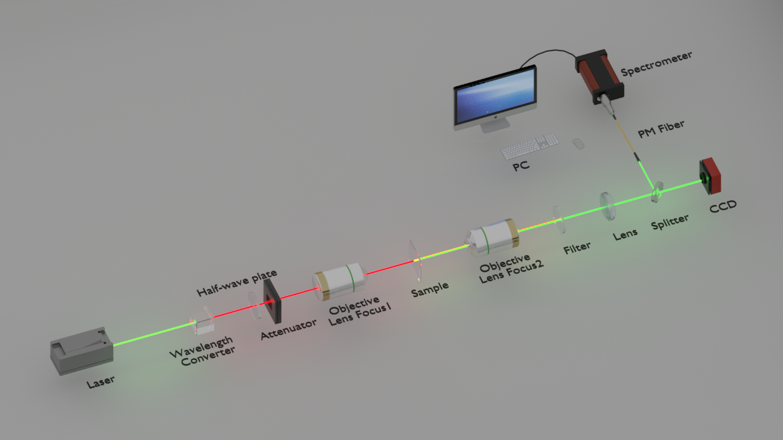
Supplementary Figure 5. Experimental optical setup for THG intensity measurement.

