Supplementary Methods
User testing environment
All experiments were conducted across multiple hardware and operating system configurations to assess robustness and usability.

The author performed experiments on a MacBook Pro (16-inch, 2023) equipped with an Apple M2 Pro chip and 32 GB memory, running macOS Sequoia 15.7.5. The software was executed under Rosetta 2 (x86 emulation).

Test User 1 used a MacBook Pro (14-inch, 2021) with an Apple M1 Pro chip and 16 GB memory, running macOS Tahoe 26.4.1, executing the software natively on ARM architecture.

Test User 2 used a Windows desktop with an Intel Core i7-14700 CPU and 16 GB memory, running Microsoft Windows 11 Enterprise (build 26100).

Test User 3 used a virtual machine running Ubuntu 26.04 Desktop (ARM64), allocated 6 CPU cores and 16 GB memory, hosted on a MacBook Pro (16-inch, 2023, M2 Pro, 32 GB memory) running macOS Sequoia 15.7.5.

User study protocol
Users performed the complete PHARAOH workflow on each dataset, including image import, orientation adjustment, manual initialization, and automated refinement. Each user processed all datasets independently. No extensive prior training was provided beyond minimal instructions required to operate the interface. User interactions and system events were recorded throughout the workflow.

Definition of user interaction time
User interaction time was derived from recorded interaction events and defined based on intervals between system readiness and subsequent user actions. Specifically, interaction time was measured from each system-ready event to the next user-triggered action (e.g., button click), representing the time required for the user to proceed to the next step.

To reduce the influence of idle time and variability in user behavior, interaction intervals were capped. In this analysis, interaction intervals were capped at 10 seconds, meaning that any interval exceeding 10 seconds between a system-ready event and the subsequent user action was truncated to 10 seconds. This threshold mitigates the impact of prolonged inactivity while preserving meaningful variation in interaction efficiency.

Certain steps were excluded from this definition to avoid conflating interaction time with task-dependent effort. These include:
(1) The interval between image import completion and orientation confirmation, during which users may spend time adjusting image orientation.
(2) The manual alignment stage, defined as the interval between the system indicating readiness for alignment and the user confirming the alignment result.
These excluded steps involve deliberate user effort and are instead reported separately as manual alignment time.

Timing measurement
All timing measurements were obtained from recorded event logs. User actions were identified as discrete interaction events (e.g., button clicks), and system processing stages were marked by system-ready events.

System processing time was defined as the duration between a user-triggered action and the subsequent system-ready event. User interaction time was defined as the duration between a system-ready event and the next user-triggered action, following the definition described above.

Total time was computed as the sum of system processing time and user interaction time.

Manual alignment procedure
Manual alignment was performed using Xenium Explorer on a subset of three datasets. The user loaded the Xenium project and corresponding H&E image, and manually identified corresponding anatomical landmarks across modalities. Specifically, 25 matching keypoint pairs were selected per dataset to estimate the alignment transformation. Following keypoint selection, the user visually assessed alignment quality and finalized the registration by saving the transformation results.

Manual alignment timing
Timing for the manual alignment baseline was recorded using three key timestamps:
(1) Initialization completion — recorded after the Xenium project was fully loaded and the H&E image was imported.
(2) Keypoint selection completion — recorded after the user finished identifying 25 corresponding keypoint pairs.
(3) Alignment completion — recorded after the user completed alignment quality checking, saved the alignment results, and closed the files.

The total manual alignment time was defined as the duration from the start of file opening to the final timestamp. The interval between the first and second timestamps corresponds to keypoint selection time, and the interval between the second and third timestamps corresponds to alignment verification and saving.

The manual alignment baseline represents a fully user-driven workflow. Therefore, all recorded time, including file loading, keypoint selection, alignment verification, and saving, was treated as user active time. No distinction between system processing and user interaction was made for the manual baseline, as system latency is minimal relative to manual operations and not directly comparable to the automated processing steps in PHARAOH.

Datasets used in user study
The user study was conducted on all 16 Xenium datasets included in this work. Detailed dataset descriptions, including tissue type and acquisition information, are provided in Supplementary

Reproducibility and scope of user study
All manual alignment results and final outputs for each participant, including the author and test users, are provided in JSON format on GitHub. These files include the user-provided alignment results, final transformation outputs, and relevant metadata required to reproduce the reported user-study results.

Tile-level information used during the alignment workflow can be provided upon request to further support reproducibility.

For the user study, only timing measurements and the number of matched anchor pairs were analyzed. The main-text results were generated using a separate set of production-level configurations with a larger number of sampled tiles (typically 200–400) and corresponding anchor points, enabling more comprehensive alignment refinement at the cost of moderately increased processing time (approximately 2–4 additional minutes).

Therefore, the user study was designed to evaluate usability, interaction efficiency, and consistency across users, rather than to represent the final benchmark configuration used for the main alignment results.
Supplementary Table 1: Datasets analyzed in this paper.
1. For datasets stored in OME-TIFF format, reported image dimensions correspond to the full-resolution image (level 0 of the image pyramid).
2. For the four 10x Visium HD / 10x Visium colorectal cancer datasets, H&E images were cropped to regions containing gene expression spots for visualization purposes in the manuscript, rather than for computational performance.
3. For the artery datasets, each H&E image contains multiple tissue sections; therefore, the full-slide images were subdivided into individual samples prior to analysis.
Protocol | Species | Tissue | Dimensions of the H&E image (pixels) | Dimensions of the DAPI/DNA image (pixels), if available | Data Source
10x  Xenium | Human | Colorectal cancer P1 (CRC-P1) | 70534 ×  60222 | 31345 ×  34111 | https://www.10xgenomics.com/platforms/visium/product-family/dataset-human-crc
10x  Xenium | Human | Colorectal cancer P2 (CRC-P2) | 75184 ×  48582 | 31395 ×  34224 | https://www.10xgenomics.com/platforms/visium/product-family/dataset-human-crc
10x  Xenium | Human | Colorectal cancer P5 (CRC-P5) | 71082 ×  66226 | 31470 ×  30874 | https://www.10xgenomics.com/platforms/visium/product-family/dataset-human-crc
10x  Xenium | Human | Liver cancer | 15404 ×  33795 | 42618 ×  20528 | https://www.10xgenomics.com/datasets/human-liver-data-xenium-human-multi-tissue-and-cancer-panel-1-standard
10x  Xenium | Human | Lung cancer (10x) | 25078 ×  43448 | 54061 ×  34191 | https://www.10xgenomics.com/datasets/visium-hd-cytassist-gene-expression-human-lung-cancer-post-xenium-expt
10x  Xenium | Human | Lung cancer  (LUAD S1) | 107520 ×  52992 | 53958 ×  57804 | https://zenodo.org/records/18165537
10x  Xenium | Human | Lung cancer  (LUAD S2) | 107520 ×  48384 | 51253 ×  61225 | https://zenodo.org/records/18165537
10x  Xenium | Human | Lung cancer  (LUAD S3) | 111360 ×  57600 | 54026 ×  51141 | https://zenodo.org/records/18165537
10x  Xenium | Human | Lung cancer  (LUAD S4) | 107520 ×  57600 | 54156 ×  61168 | https://zenodo.org/records/18165537
10x  Xenium | Human | Lung cancer  (LUAD S5) | 103680 ×  36864 | 39803 ×  57779 | https://zenodo.org/records/18165537
10x  Xenium | Human | Breast cancer | 69821 ×  69821 | 35416 ×  25778 | https://www.10xgenomics.com/products/xenium-in-situ/preview-dataset-human-breast
10x  Xenium 5K | Human | Breast cancer | 57382 ×  37433 | 51265 ×  74945 | https://www.10xgenomics.com/datasets/xenium-prime-ffpe-human-breast-cancer
10x  Xenium | Human | Artery P4D | 45075 ×  28000 | 42647 ×  34041 | https://zenodo.org/records/18165537
10x  Xenium | Human | Artery P4H | 26000 ×  22000 | 28458 ×  27283 | https://zenodo.org/records/18165537
10x  Xenium | Mouse | Colon | 32201 ×  28329 | 29492 ×  34104 | https://www.10xgenomics.com/datasets/fresh-frozen-mouse-colon-with-xenium-multimodal-cell-segmentation-1-standard
10x  Xenium | Mouse | Brain S1 | 18071 ×  11798 | 48352 ×  33135 | https://www.10xgenomics.com/datasets/fresh-frozen-mouse-brain-for-xenium-explorer-demo-1-standard
NanoString CosMx | Human | Kidney cancer  HK2844-3039 | 92160 ×  80640 | 113981 ×  149147 | https://zenodo.org/records/17228449
RareCyte Orion | Human | Descending colon  adenocarcinoma NOS  HTA7_919_6 (1st sample) | 36354 ×  52740 | 36354 ×  52740 | https://humantumoratlas.org/publications/hta7_2022_cell_jia-ren-lin?tab=overview
RareCyte Orion | Human | Descending colon  adenocarcinoma NOS  HTA7_919_6 (2nd sample) | 34779 ×  62059 | 34779 ×  62059 | https://humantumoratlas.org/publications/hta7_2022_cell_jia-ren-lin?tab=overview
RareCyte Orion | Human | Rectum NOS  adenocarcinoma NOS  HTA7_920_9 | 45089 ×  66125 | 45089 ×  66125 | https://humantumoratlas.org/publications/hta7_2022_cell_jia-ren-lin?tab=overview
RareCyte Orion | Human | Rectosigmoid junction  adenocarcinoma NOS  HTA7_934_9 | 87043 ×  43367 | 87043 ×  43367 | https://humantumoratlas.org/publications/hta7_2022_cell_jia-ren-lin?tab=overview
CycIF | Human | Cecum mucous adenocarcinoma  HTA13_1_106 | 52010 ×  52226 | 24897 ×  27121 | https://humantumoratlas.org/publications/hta7_2022_cell_jia-ren-lin?tab=overview
CODEX | Human | Colon adenocarcinoma | 49221 ×  36102 | 20264 ×  15006 | https://spatch.pku-genomics.org/#/dataset/xenium
10x  Visium HD | Human | Colorectal cancer P1 (CRC-P1) | 23958 ×  24553 | NA | https://www.10xgenomics.com/platforms/visium/product-family/dataset-human-crc
10x  Visium HD | Human | Colorectal cancer P2 (CRC-P2) | 24701 ×  22724 | NA | https://www.10xgenomics.com/platforms/visium/product-family/dataset-human-crc
10x  Visium HD | Human | Colorectal cancer P5 (CRC-P5) | 24505 ×  24615 | NA | https://www.10xgenomics.com/platforms/visium/product-family/dataset-human-crc
10x  Visium | Human | Colorectal cancer P2 (CRC-P2) | 26500 ×  25000 | NA | https://www.10xgenomics.com/platforms/visium/product-family/dataset-human-crc

Supplementary Table 2 | Runtime breakdown across all datasets and users for PHARAOH registration workflow
Per-dataset runtime measurements for the complete PHARAOH registration workflow across the author and three independent test users. Total runtime was decomposed into system processing time and user interaction time. User interaction time was further separated into manual alignment time and other interaction time. Manual alignment time corresponds to the interval between initialization of the manual alignment interface and user confirmation of the alignment result. Other interaction time includes all remaining user operations, including orientation confirmation, parameter adjustment, and workflow navigation. All timings exclude prolonged inactive periods as described in the Methods and Supplementary Methods. Results demonstrate that the majority of runtime was attributable to automated system processing, while user interaction remained relatively limited across datasets and users.
User | Dataset | Total Time (s) | System Processing Time (s) | User Interaction Time (s) | Manual Alignment Time (s) | Other Interaction Time (s)
Author | human_CRC_P1 | 182 | 120 | 62 | 25 | 37
Author | human_CRC_P2 | 213 | 122 | 91 | 57 | 34
Author | human_CRC_P5 | 211 | 117 | 94 | 41 | 53
Author | human_artery_P4D | 272 | 211 | 61 | 21 | 40
Author | human_artery_P4H | 180 | 129 | 51 | 10 | 41
Author | human_breast_cancer_5K | 187 | 134 | 53 | 19 | 34
Author | human_breast_cancer_S1 | 181 | 122 | 59 | 28 | 31
Author | human_liver_cancer | 191 | 134 | 57 | 23 | 34
Author | human_lung_cancer_10x_Genomics | 191 | 130 | 61 | 23 | 38
Author | human_lung_cancer_LUADS1 | 217 | 155 | 62 | 28 | 34
Author | human_lung_cancer_LUADS2 | 220 | 151 | 69 | 25 | 44
Author | human_lung_cancer_LUADS3 | 211 | 141 | 70 | 27 | 43
Author | human_lung_cancer_LUADS4 | 225 | 162 | 63 | 25 | 38
Author | human_lung_cancer_LUADS5 | 203 | 148 | 55 | 15 | 40
Author | mouse_brain_S1 | 180 | 103 | 77 | 21 | 56
Author | mouse_colon | 179 | 128 | 51 | 15 | 36
Test User 1 | human_CRC_P1 | 308 | 137 | 171 | 88 | 83
Test User 1 | human_CRC_P2 | 328 | 139 | 189 | 116 | 73
Test User 1 | human_CRC_P5 | 309 | 130 | 179 | 118 | 61
Test User 1 | human_artery_P4D | 300 | 176 | 124 | 60 | 64
Test User 1 | human_artery_P4H | 209 | 149 | 60 | 17 | 43
Test User 1 | human_breast_cancer_5K | 208 | 111 | 97 | 41 | 56
Test User 1 | human_breast_cancer_S1 | 300 | 144 | 156 | 98 | 58
Test User 1 | human_liver_cancer | 269 | 148 | 121 | 52 | 69
Test User 1 | human_lung_cancer_10x_Genomics | 294 | 155 | 139 | 75 | 64
Test User 1 | human_lung_cancer_LUADS1 | 354 | 183 | 171 | 78 | 93
Test User 1 | human_lung_cancer_LUADS2 | 289 | 163 | 126 | 64 | 62
Test User 1 | human_lung_cancer_LUADS3 | 301 | 151 | 150 | 76 | 74
Test User 1 | human_lung_cancer_LUADS4 | 270 | 171 | 99 | 57 | 42
Test User 1 | human_lung_cancer_LUADS5 | 236 | 139 | 97 | 56 | 41
Test User 1 | mouse_brain_S1 | 224 | 114 | 110 | 52 | 58
Test User 1 | mouse_colon | 231 | 138 | 93 | 54 | 39
Test User 2 | human_CRC_P1 | 312 | 166 | 146 | 43 | 103
Test User 2 | human_CRC_P2 | 236 | 146 | 90 | 47 | 43
Test User 2 | human_CRC_P5 | 267 | 121 | 146 | 62 | 84
Test User 2 | human_artery_P4D | 475 | 335 | 140 | 37 | 103
Test User 2 | human_artery_P4H | 322 | 161 | 161 | 40 | 121
Test User 2 | human_breast_cancer_5K | 483 | 194 | 289 | 149 | 140
Test User 2 | human_breast_cancer_S1 | 266 | 143 | 123 | 33 | 90
Test User 2 | human_liver_cancer | 252 | 160 | 92 | 25 | 67
Test User 2 | human_lung_cancer_10x_Genomics | 280 | 189 | 91 | 34 | 57
Test User 2 | human_lung_cancer_LUADS1 | 281 | 180 | 101 | 35 | 66
Test User 2 | human_lung_cancer_LUADS2 | 276 | 196 | 80 | 18 | 62
Test User 2 | human_lung_cancer_LUADS3 | 252 | 168 | 84 | 22 | 62
Test User 2 | human_lung_cancer_LUADS4 | 271 | 185 | 86 | 26 | 60
Test User 2 | human_lung_cancer_LUADS5 | 245 | 154 | 91 | 17 | 74
Test User 2 | mouse_brain_S1 | 222 | 128 | 94 | 37 | 57
Test User 2 | mouse_colon | 264 | 179 | 85 | 24 | 61
Test User 3 | human_CRC_P1 | 308 | 136 | 172 | 103 | 69
Test User 3 | human_CRC_P2 | 329 | 160 | 169 | 73 | 96
Test User 3 | human_CRC_P5 | 271 | 129 | 142 | 66 | 76
Test User 3 | human_artery_P4D | 429 | 272 | 157 | 72 | 85
Test User 3 | human_artery_P4H | 334 | 154 | 180 | 50 | 130
Test User 3 | human_breast_cancer_5K | 343 | 190 | 153 | 67 | 86
Test User 3 | human_breast_cancer_S1 | 380 | 167 | 213 | 134 | 79
Test User 3 | human_liver_cancer | 268 | 176 | 92 | 31 | 61
Test User 3 | human_lung_cancer_10x_Genomics | 335 | 212 | 123 | 46 | 77
Test User 3 | human_lung_cancer_LUADS1 | 326 | 202 | 124 | 65 | 59
Test User 3 | human_lung_cancer_LUADS2 | 455 | 243 | 212 | 76 | 136
Test User 3 | human_lung_cancer_LUADS3 | 329 | 174 | 155 | 56 | 99
Test User 3 | human_lung_cancer_LUADS4 | 394 | 214 | 180 | 85 | 95
Test User 3 | human_lung_cancer_LUADS5 | 297 | 181 | 116 | 35 | 81
Test User 3 | mouse_brain_S1 | 276 | 122 | 154 | 58 | 96
Test User 3 | mouse_colon | 293 | 177 | 116 | 59 | 57

Supplementary Table 3 | Per-vertex displacement statistics under FOV subsampling
Per-vertex displacement statistics relative to full sampling (100%) for different FOV sampling proportions (80%, 60%, 40%, and 20%). Displacements were computed for all vertices after alignment and are reported as mean, median, and maximum pixel shifts. Results show consistently low displacement across subsampling levels, indicating that PHAROAH maintains stable alignment performance even under substantial reductions in spatial coverage.
Sampling Proportion | Vertices Number | Mean Shift  (pixels) | Median Shift  (pixels) | Max Shift  (pixels)
80% | 20132110 | 7.657 | 4.268 | 48.576
60% | 20132110 | 8.779 | 6.296 | 50.307
40% | 20132110 | 5.018 | 4.133 | 15.320
20% | 20132110 | 5.518 | 6.626 | 49.653

Supplementary Fig. 1 | Additional examples of PHARAOH alignment performance across Xenium datasets
Representative regions from Xenium Human Artery P4H, Xenium Human Colorectal Cancer P2, and Xenium Human Liver Cancer datasets. For each dataset, H&E images are compared with overlays of Xenium-measured nucleus boundaries mapped to H&E space using PHARAOH and VALIS across multiple representative regions of interest. PHARAOH demonstrates improved correspondence between Xenium-derived nuclear boundaries and hematoxylin-stained nuclei, particularly in regions with complex tissue architecture, variable staining quality, or local deformation. Quantitative comparisons of nucleus coverage scores and transcript-to-nearest-nucleus distances further support improved nuclei-level spatial correspondence achieved by PHARAOH relative to VALIS.
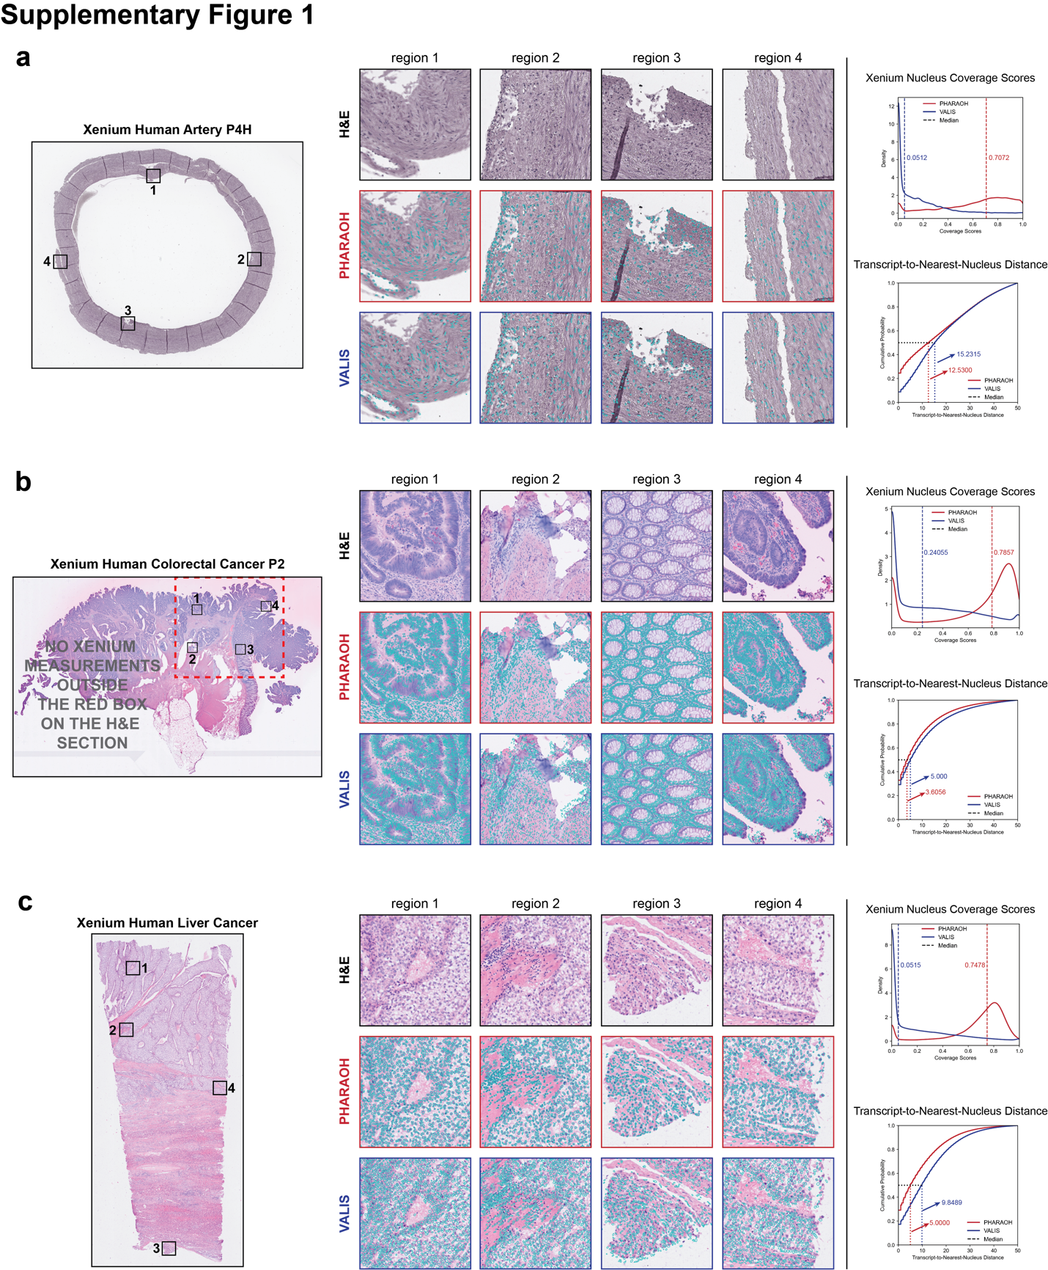
Supplementary Fig. 2 | Additional evaluation of PHARAOH on Xenium lung cancer datasets
Representative alignment results from Xenium Human Lung Cancer (10x Genomics), Xenium Human Lung Cancer LUADS3, Xenium Human Lung Cancer LUADS4, and Xenium Human Lung Cancer LUADS5 datasets. H&E images are shown together with overlays of Xenium-measured nucleus boundaries registered using PHARAOH and VALIS. Across diverse lung adenocarcinoma samples, PHARAOH consistently produced improved alignment between fluorescence-derived nuclear structures and histological nuclei, including regions containing dense tumor architecture, stromal boundaries, and heterogeneous tissue morphology. Quantitative evaluations using nucleus coverage scores and transcript-to-nearest-nucleus distances demonstrate consistently improved spatial correspondence relative to VALIS.
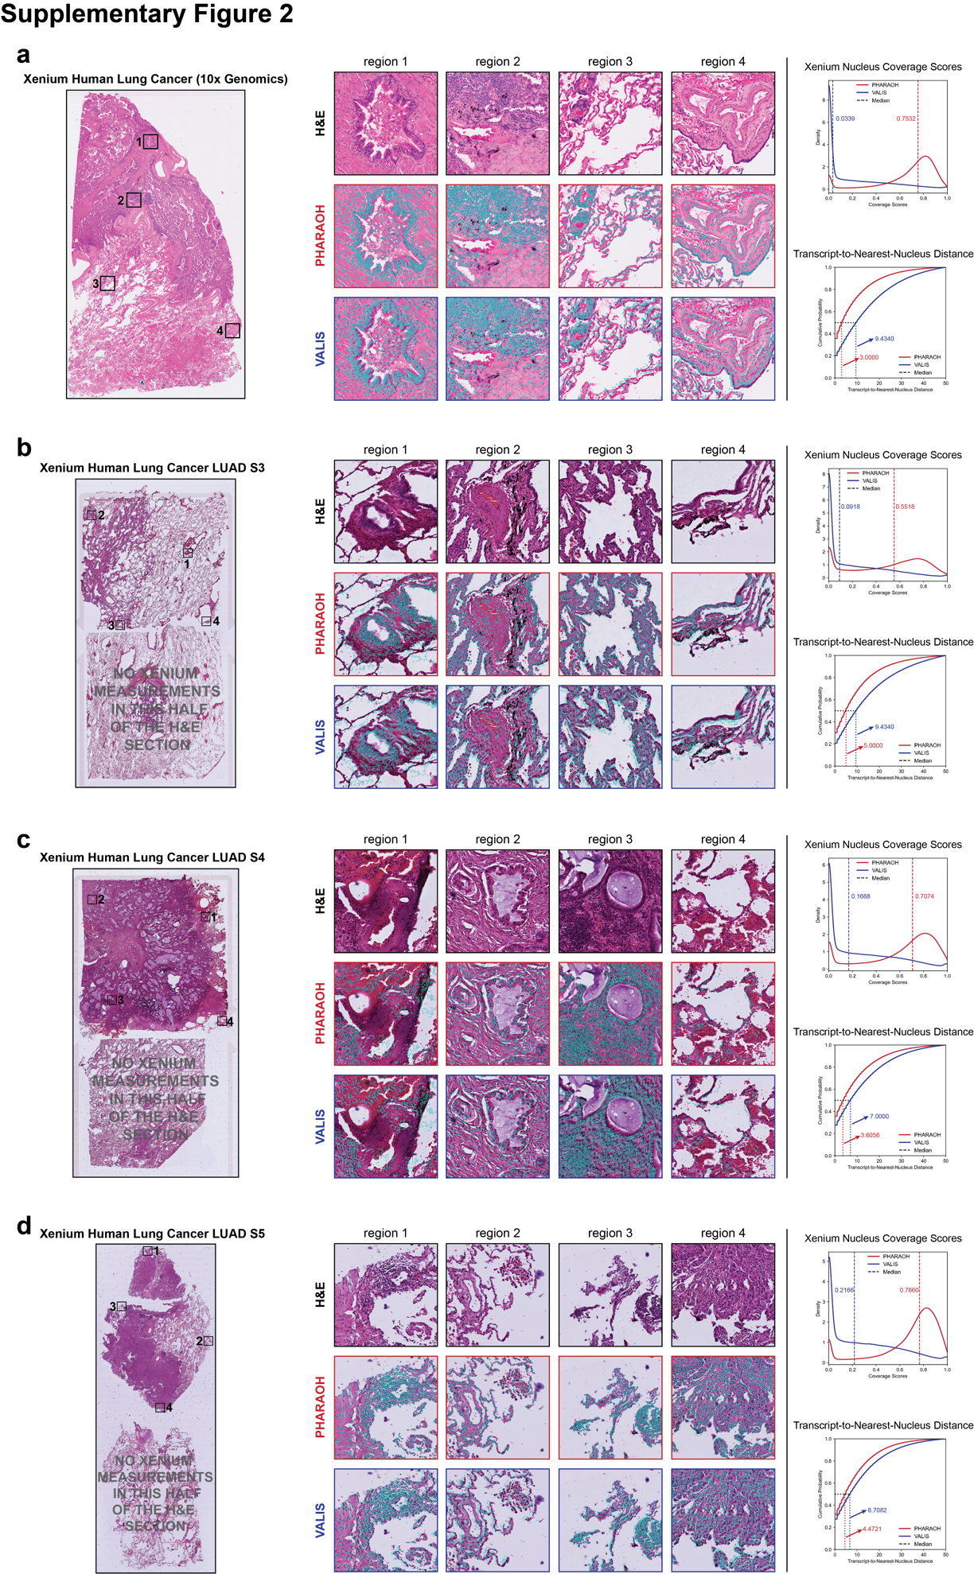
Supplementary Fig. 3 | Evaluation of PHARAOH on mouse Xenium datasets
Representative alignment results from Xenium Mouse Brain S1 and Xenium Mouse Colon datasets. H&E images are compared with overlays of Xenium-measured nucleus boundaries mapped into histological space using PHARAOH and VALIS. PHARAOH maintains accurate nuclei-level alignment across distinct mouse tissue types with substantially different structural organization and cellular density. Quantitative comparisons based on nucleus coverage scores and transcript-to-nearest-nucleus distances further demonstrate robust cross-modality alignment performance across mouse datasets.

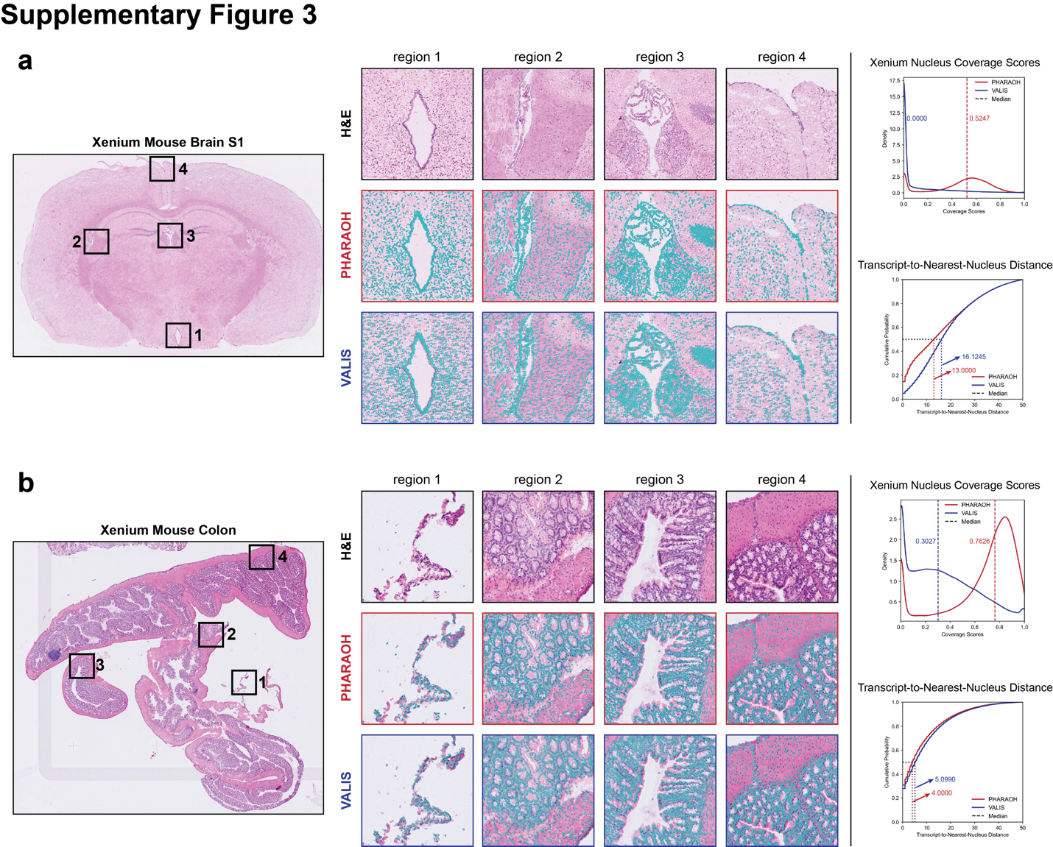
Supplementary Fig. 4 | Representative examples of registration failure using VALIS
Representative Xenium datasets in which VALIS produced substantial local or global registration errors. H&E images are shown together with overlays of Xenium-measured nucleus boundaries mapped into histological space using VALIS and PHARAOH. Examples include regions with tissue deformation, sparse structural features, staining variation, or heterogeneous morphology that challenge feature-based registration approaches. In contrast to VALIS, PHARAOH maintained substantially improved nuclei-level correspondence through hierarchical initialization and local landmark refinement.
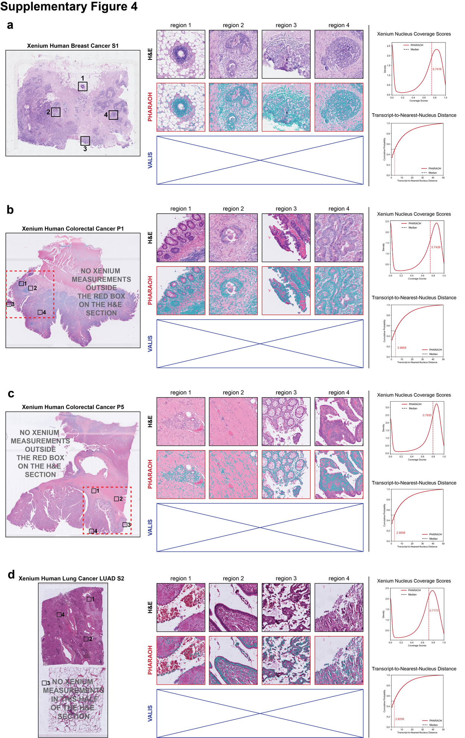
Supplementary Fig. 5 | Representative FOV subsampling configurations used for robustness evaluation
Representative field-of-view (FOV) subsampling configurations used to evaluate the robustness of PHARAOH under reduced spatial coverage. Rows correspond to sampling proportions of 80%, 60%, 40%, and 20% of available FOVs. Left, stitched DAPI whole-section images with sampled and excluded FOVs overlaid. Right, corresponding H&E sections with aligned FOV locations after registration. Red boxes indicate mandatory anchor FOVs retained across all sampling conditions, gray boxes indicate additional sampled FOVs, and blue crossed boxes indicate excluded FOVs. Despite substantial reductions in sampled spatial coverage, the retained FOV distribution continued to provide broad tissue representation for hierarchical alignment.
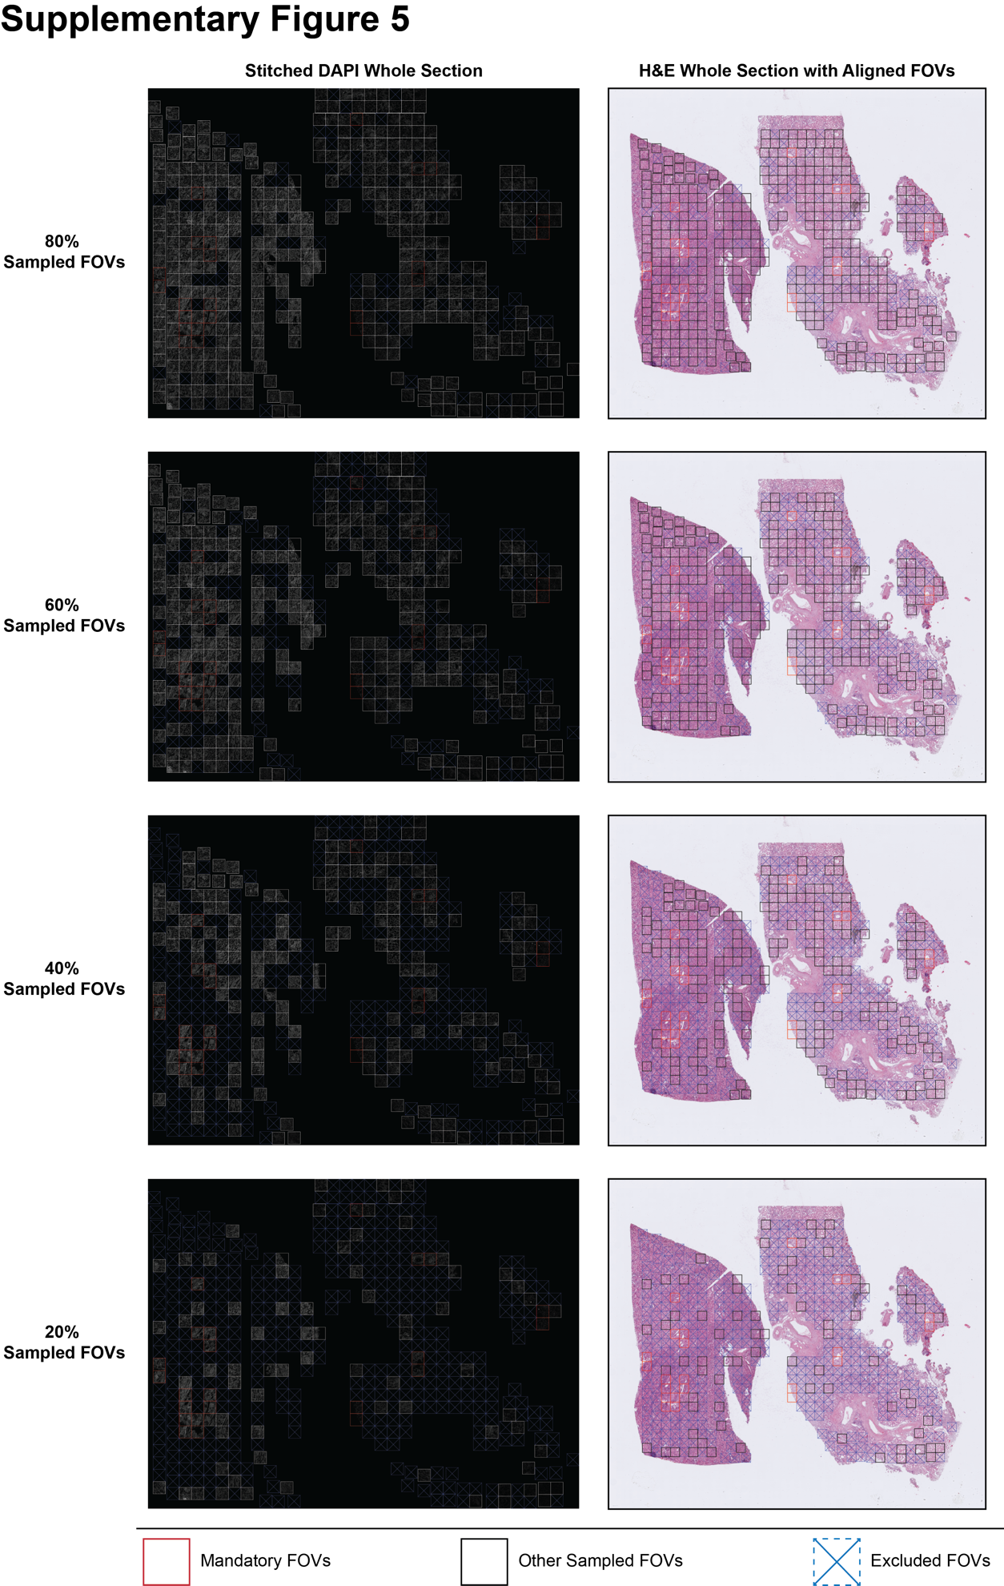
Supplementary Fig. 6 | Additional examples of cross-platform adjacent-section integration enabled by PHARAOH
Additional examples of adjacent-section integration between Xenium and Visium HD datasets following PHARAOH registration into a unified spatial coordinate space. Registered Xenium transcripts were aggregated into Visium HD 8 µm bins based on bin centers and spatial extent and integrated with corresponding Visium HD measurements at the bin level. Representative genes demonstrate improved spatial consistency and enhanced visualization of biologically coherent expression patterns after integration. Examples include genes with weak or sparse Visium HD signal that become more spatially resolved following integration.

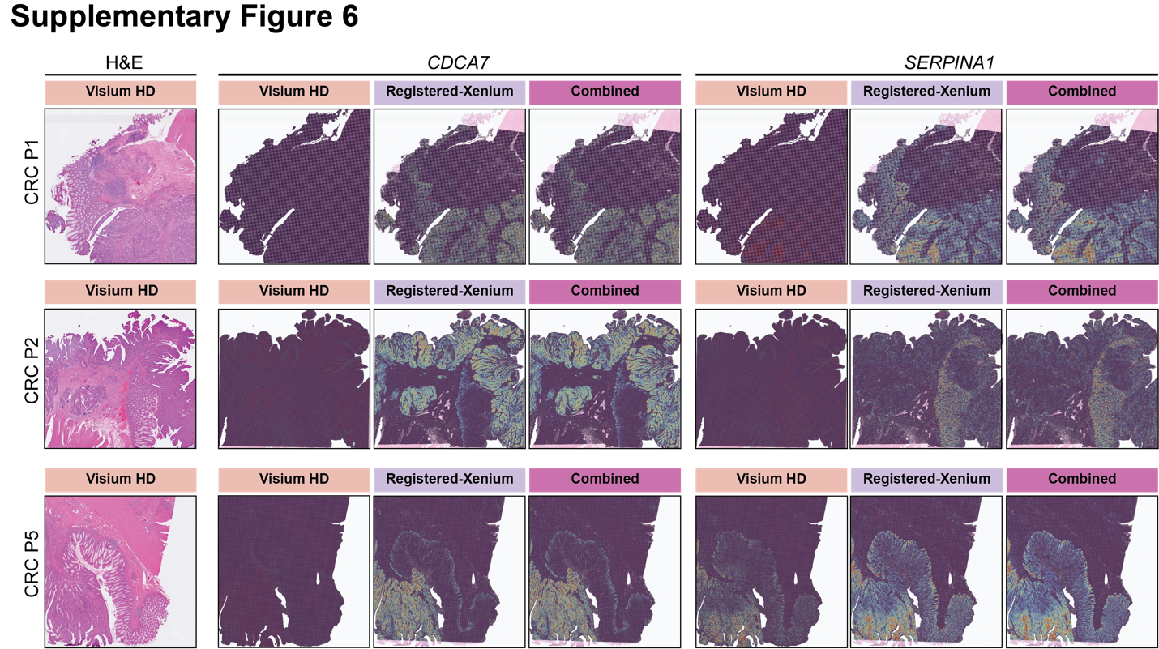
Supplementary Fig. 7 | Additional examples of Orion mIF–H&E registration using PHARAOH
Additional in-sample registration results between Orion multiplexed immunofluorescence (mIF) datasets and corresponding H&E sections using the Hoechst nuclear channel for alignment. Three additional representative Orion samples are shown. For each sample, representative protein channels spanning epithelial, immune, and stromal markers are displayed together with corresponding H&E regions of interest (ROIs) and overlays of aligned fluorescence signals. PHARAOH consistently preserves accurate spatial correspondence between multiplexed fluorescence markers and histological tissue architecture across diverse staining patterns, tissue morphologies, and cellular compositions.
