ENCSR267XBT  Supplementary Material  Long-Read RNA Sequencing Reveals Tissue-Specific Expression and Transcript Boundary Variation of Mouse Prxl2b  Preeti Pilania, Sikander Saini, Diksha Sethi, Sameer Kumar Sahani, Prem Kumar, Suman Chopra, Satish Kumar, and Dhruba Malakar*.  Animal Biotechnology Division, National Dairy Research Institute, Karnal, Haryana, 132001, India  *Correspondence to Dhruba Malakar, email: dhrubamalakar@gmail.com  Supplementary Table S1 | ENCFF356MNK  ENCFF032HOK | Mus musculus strain B6CASTF1/J heart tissue female adult (18-20 months)
- ENCSR926OGQ | ENCFF314QJI  ENCFF376LTY | Mus musculus strain B6NCrl layer of hippocampus tissue adult (6 months)
- ENCSR137PNB | ENCFF158DUZ  ENCFF656AEP | Mus musculus strain B6CASTF1/J layer of hippocampus tissue nuclear fraction female postnatal (36 days)
- ENCSR524XLA | ENCFF477GNS  ENCFF462TIY | Mus musculus strain B6CASTF1/J gastrocnemius tissue female postnatal (4 days)
- ENCSR221XGR | ENCFF019HRC  ENCFF676BYQ | Mus musculus C2C12 Myoblast, cell line
- ENCSR038FOD | ENCFF330HVI | Mus musculus strain B6CASTF1/J layer of hippocampus tissue female postnatal (10 days)
- ENCSR497PUD | ENCFF075ZWJ  ENCFF794ROZ | Mus musculus strain B6CASTF1/J adrenal gland tissue nuclear fraction male adult (2 months)
- ENCSR472CHU | ENCFF346JYL  ENCFF896RNF | Mus musculus strain B6CASTF1/J layer of hippocampus tissue female adult (18-20 months)
- ENCDR399GDY | ENCFF123SLL  ENCFF381VIC | Mus musculus strain B6CASTF1/J adrenal gland tissue nuclear fraction male postnatal (25 days)
- ENCSR938RPH | ENCFF836SSV  ENCFF031EVU | Mus musculus strain B6CASTF1/J heart tissue female adult (2 months)
- ENCSR917FMK | ENCFF416IZV  ENCFF725PIN | Mus musculus strain B6CASTF1/J layer of hippocampus tissue nuclear fraction male postnatal (25 days)
- ENCSR170VWE | ENCFF104NEJ  ENCFF499VXS | Mus musculus strain B6CASTF1/J layer of hippocampus tissue nuclear fraction male postnatal (36 days)
- ENCSR483UXN | ENCFF014KBY  ENCFF366YEX | Mus musculus strain B6CASTF1/J layer of hippocampus tissue nuclear fraction female postnatal (10 days)
- ENCSR604GLK | ENCFF146EOT  ENCFF902LQF | Mus musculus strain B6CASTF1/J layer of hippocampus tissue nuclear fraction male postnatal (10 days)
- ENCSR060OTU | ENCFF448KBZ  ENCFF890RGD | Mus musculus strain B6.Cg-Tg(APPSwFlLon,PSEN1*M146L*L286V)6799Vas/Mmjax layer of hippocampus tissue
- ENCSR674HUF | ENCFF434FSM  ENCFF963IBU | Mus musculus strain B6CASTF1/J layer of hippocampus tissue nuclear fraction male adult (2 months)
- ENCSR082JMB | ENCFF417EKT | Mus musculus strain B6NCrl forelimb tissue embryo (13 days)
- ENCSR038WNY | ENCFF735PDS | Mus musculus myotube nuclear fraction originated from C2C12
- ENCSR804QMV | ENCFF348TRU | Mus musculus strain B6NCrl forelimb tissue embryo (11 days)
- ENCSR298LJY | ENCFF740VMZ | Mus musculus C2C12 nuclear fraction
- ENCSR418ZYU | ENCFF008ATT  ENCFF238DPX | Mus musculus C2C12, cell line, myoblast cell line derived from thigh muscle of C3H mice after crush injury
- ENCSR172GXL | ENCFF874VSI  ENCFF667VXS  ENCFF313VYZ | Mus musculus F121-9, cell line, LRGASP Mouse ES
- ENCSR447CQS | ENCFF442FCG | Mus musculus C2C12, cell line, long-read Split-seq single-cell myoblast
- ENCSR644GDT | ENCFF683BZL  ENCFF476MLA | Mus musculus strain B6NCrl left cerebral cortex tissue adult (6 months)
- ENCSR920WYI | ENCFF618PJT  ENCFF124DBU | Mus musculus strain B6CASTF1/J gastrocnemius tissue female postnatal (14 days)
- ENCSR187TGD | ENCFF885OVT  ENCFF484VDN | Mus musculus strain B6CASTF1/J heart tissue female postnatal (14 days)
- ENCSR340GWV | ENCFF479GNP  ENCFF402ZUC | Mus musculus strain B6NCrl left cerebral cortex tissue adult (6 months)
- ENCSR842KTN | ENCFF584WWA  ENCFF860CBL | Mus musculus strain B6CASTF1/J heart tissue male postnatal (14 days)
- ENCSR410XGE | ENCFF177KNR  ENCFF468BPP | Mus musculus strain B6CASTF1/J heart tissue male adult (18-20 months)
- ENCSR674BKT | ENCFF095CHU  ENCFF201HBC | Mus musculus strain B6.Cg-Tg(APPSwFlLon,PSEN1*M146L*L286V)6799Vas/Mmjax left cerebral cortex tissue adult (8 months)
- ENCSR907NKV | ENCFF003OWX  ENCFF669LWV | Mus musculus myotube, in vitro differentiated cells, C2C12 myotube
- ENCSR280VKU | ENCFF944JXN  ENCFF148ESR | Mus musculus strain B6.Cg-Tg(APPSwFlLon,PSEN1*M146L*L286V)6799Vas/Mmjax left cerebral cortex tissue
- ENCSR375EOW | ENCFF583MVR  ENCFF358AEP | Mus musculus strain B6CASTF1/J heart tissue male adult (2 months)
- ENCSR404AEI | ENCFF110OOL  ENCFF997NDX | Mus musculus strain B6.Cg-Tg(APPSwFlLon,PSEN1*M146L*L286V)6799Vas/Mmjax layer of hippocampus tissue adult (8 months)
- ENCSR879GEQ | ENCFF535DQA  ENCFF310IPO  ENCFF654JHQ | Mus musculus F121-9, cell line, LRGASP CapTrap Mouse ES
- ENCSR131CES | ENCFF319GBG  ENCFF046XAX | Mus musculus strain B6NCrl left cerebral cortex tissue adult (8 months)
- ENCSR628IMW | ENCFF565RLW  ENCFF325BXV | Mus musculus strain B6CASTF1/J left cerebral cortex tissue male adult (18-20 months)
- ENCSR862DMK | ENCFF285NUG  ENCFF977AFJ | Mus musculus strain B6CASTF1/J left cerebral cortex tissue male adult (2 months)
- ENCSR861RCH | ENCFF605NQH  ENCFF937WKF | Mus musculus strain B6CASTF1/J left cerebral cortex tissue female adult (2 months)
- ENCSR791JQO | ENCFF100UBG  ENCFF812RTU | Mus musculus strain B6CASTF1/J left cerebral cortex tissue male postnatal (14 days)
- ENCSR550KPM | ENCFF520HCL  ENCFF132MEJ | Mus musculus strain B6CASTF1/J left cerebral cortex tissue female adult (18-20 months)
- ENCSR964OKW | ENCFF798HCT  ENCFF069POP | Mus musculus strain B6CASTF1/J gastrocnemius tissue male postnatal (4 days)
- ENCSR631KNS | ENCFF773BXP  ENCFF468KWN | Mus musculus strain B6CASTF1/J left cerebral cortex tissue female postnatal (14 days)
- ENCSR734WEK | ENCFF047OYU  ENCFF389RMT | Mus musculus strain B6CASTF1/J gastrocnemius tissue male postnatal (10 days)
ENCSR754VEZ | ENCFF337DWM  ENCFF696VVK | Mus musculus strain B6CASTF1/J gastrocnemius tissue female postnatal (10 days)
- ENCSR411ZHA | ENCFF228VBQ  ENCFF978EIJ | Mus musculus strain B6NCrl layer of hippocampus tissue
- ENCSR791CDT | ENCFF221ABY  ENCFF435GLV | Mus musculus strain B6CASTF1/J gastrocnemius tissue male postnatal (25 days)
- ENCSR818JQK | ENCFF556BPF  ENCFF837UMP | Mus musculus strain B6CASTF1/J gastrocnemius tissue female postnatal (25 days)
- ENCSR437WYC | ENCFF107CZA  ENCFF957OYJ | Mus musculus strain B6CASTF1/J gastrocnemius tissue male postnatal (36 days)
- ENCSR402DOZ | ENCFF948TOU  ENCFF369DHX | Mus musculus strain B6CASTF1/J gastrocnemius tissue male postnatal (14 days)
- ENCSR588IRT | ENCFF524YTF  ENCFF294TJX | Mus musculus strain B6CASTF1/J gastrocnemius tissue female postnatal (36 days)
- ENCSR845IUJ | ENCFF327DHL  ENCFF441MLQ | Mus musculus strain B6CASTF1/J gastrocnemius tissue male adult (2 months)
- ENCSR370BHF | ENCFF271ZDH  ENCFF095FKV | Mus musculus strain B6CASTF1/J gastrocnemius tissue female adult (2 months)
- ENCSR116DUT | ENCFF865ZOH  ENCFF421HRA | Mus musculus strain B6CASTF1/J gastrocnemius tissue male adult (18-20 months)
- ENCSR223AZQ | ENCFF281GTL  ENCFF028QQV | Mus musculus strain B6CASTF1/J gastrocnemius tissue female adult (18-20 months)
- ENCSR146ZFC | ENCFF809BZD | Mus musculus strain B6CASTF1/J layer of hippocampus tissue female postnatal (14 days)
- ENCSR026WRM | ENCFF182ZKL  ENCFF402OZL | Mus musculus strain B6CASTF1/J layer of hippocampus tissue male postnatal (14 days)
- ENCSR909NPF | ENCFF223JJA  ENCFF326JTG | Mus musculus strain B6CASTF1/J layer of hippocampus tissue female adult (2 months)
- ENCSR972DID | ENCFF338YTG  ENCFF509RD | Mus musculus strain B6CASTF1/J layer of hippocampus tissue male adult (2 months)
- ENCSR683IIF | ENCFF109QIF  ENCFF880OVL | Mus musculus strain B6CASTF1/J layer of hippocampus tissue nuclear fraction female adult (2 months)
- ENCSR239HYJ | ENCFF050NID  ENCFF415BJF | Mus musculus strain B6CASTF1/J adrenal gland tissue nuclear fraction female postnatal (4 days)
- ENCSR214HSG | ENCFF103DSA  ENCFF309DMQ | Mus musculus strain B6NCrl layer of hippocampus tissue adult (6 months)
- ENCSR637ORL | ENCFF544EHY  ENCFF513JKU | Mus musculus strain B6CASTF1/J layer of hippocampus tissue nuclear fraction female postnatal (14 days)
- ENCSR068XEK | ENCFF639CLK  ENCFF152GWA | Mus musculus strain B6CASTF1/J layer of hippocampus tissue nuclear fraction male adult (18-20 months)
- ENCSR152PAT | ENCFF532MMA  ENCFF175BNQ | Mus musculus strain B6CASTF1/J layer of hippocampus tissue male adult (18-20 months)
- ENCSR232UUS | ENCFF249FRD  ENCFF259BWH | Mus musculus strain B6CASTF1/J layer of hippocampus tissue nuclear fraction female postnatal (25 days)
- ENCSR604HPH | ENCFF322JSF  ENCFF950DPX | Mus musculus strain B6CASTF1/J adrenal gland tissue nuclear fraction male postnatal (14 days)
- ENCSR146ZFC | ENCFF809BZD  ENCFF518QIV | Mus musculus strain B6CASTF1/J layer of hippocampus tissue female postnatal (14 days)
- ENCSR598DOS | ENCFF275ZGA  ENCFF533RQB | Mus musculus strain B6CASTF1/J adrenal gland tissue nuclear fraction female adult (2 months)
- ENCSR423FFY | ENCFF743CNI  ENCFF437LET | Mus musculus strain B6CASTF1/J adrenal gland tissue nuclear fraction female postnatal (36 days)
- ENCSR355VSY | ENCFF956RJU  ENCFF303MQG | Mus musculus strain B6CASTF1/J layer of hippocampus tissue nuclear fraction male postnatal (14 days)
- ENCSR741JGK | ENCFF388RB  ENCFF659ODZ | Mus musculus strain B6CASTF1/J adrenal gland tissue nuclear fraction female postnatal (25 days)
- ENCSR628CKI | ENCFF468IEZ  ENCFF442VCD | Mus musculus strain B6CASTF1/J adrenal gland tissue nuclear fraction female postnatal (10 days)
- ENCSR000GUP | ENCFF674HLP  ENCFF893WPX | Mus musculus strain B6CASTF1/J adrenal gland tissue nuclear fraction female postnatal (14 days)
- ENCSR062QQH | ENCFF266WEC  ENCFF293DRQ | Mus musculus strain B6CASTF1/J adrenal gland tissue nuclear fraction male postnatal (10 days)
- ENCSR641RYW | ENCFF940SGC  ENCFF721PKC | Mus musculus strain B6CASTF1/J adrenal gland tissue nuclear fraction male postnatal (4 days)
- ENCSR673ZVY | ENCFF550CAR  ENCFF597YCE | Mus musculus strain B6CASTF1/J adrenal gland tissue nuclear fraction female adult (18-20 months)
- ENCSR899YHN | ENCFF410RFK  ENCFF229DZC | Mus musculus strain B6CASTF1/J adrenal gland tissue nuclear fraction male postnatal (36 days)
- ENCSR766SVW | ENCFF056SGY  ENCFF606YZS | Mus musculus strain B6CASTF1/J adrenal gland tissue nuclear fraction male adult (18-20 months)
- ENCSR598DOS | ENCFF275ZGA  ENCFF533RQB | Mus musculus strain B6CASTF1/J adrenal gland tissue nuclear fraction female adult (2 months)

Supplementary Table S2:

Sample_ID | TPM
ENCFF309DMQ | 90.74825426
ENCFF103DSA | 84.38925054
ENCFF462TIY | 81.16973992
ENCFF356MNK | 79.49327805
ENCFF032HOK | 73.57785708
ENCFF865ZOH | 68.52435713
ENCFF477GNS | 64.29277943
ENCFF095FKV | 48.52033204
ENCFF028QQV | 48.25607893
ENCFF326JTG | 46.78761265
ENCFF721PKC | 46.54410054
ENCFF338YTG | 45.09439026
ENCFF223JJA | 43.5917825
ENCFF518QIV | 43.55660992
ENCFF509RDZ | 39.04616516
ENCFF281GTL | 38.65051264
ENCFF271ZDH | 38.11742986
ENCFF532MMA | 37.14172167
ENCFF421HRA | 34.76182513
ENCFF809BZD | 32.833304
ENCFF175BNQ | 32.78677775
ENCFF997NDX | 31.69556373
ENCFF314QJI | 22.85808502
ENCFF182ZKL | 18.76598041
ENCFF376LTY | 16.04099437
ENCFF402OZL | 15.70264333
ENCFF050NID | 0
ENCFF656AEP | 0
ENCFF158DUZ | 0
ENCFF322JSF | 0
ENCFF303MQG | 0
ENCFF293DRQ | 0
ENCFF275ZGA | 0
ENCFF266WEC | 0
ENCFF229DZC | 0
ENCFF249FRD | 0
ENCFF259BWH | 0
ENCFF152GWA | 0
ENCFF109QIF | 0
ENCFF056SGY | 0
ENCFF442VCD | 0
ENCFF437LET | 0
ENCFF415BJF | 0
ENCFF410RFK | 0
ENCFF388RBI | 0
ENCFF544EHY | 0
ENCFF533RQB | 0
ENCFF468IEZ | 0
ENCFF513JKU | 0
ENCFF639CLK | 0
ENCFF550CAR | 0
ENCFF606YZS | 0
ENCFF597YCE | 0
ENCFF743CNI | 0
ENCFF674HLP | 0
ENCFF659ODZ | 0
ENCFF880OVL | 0
ENCFF893WPX | 0
ENCFF940SGC | 0
ENCFF950DPX | 0
ENCFF956RJU | 0

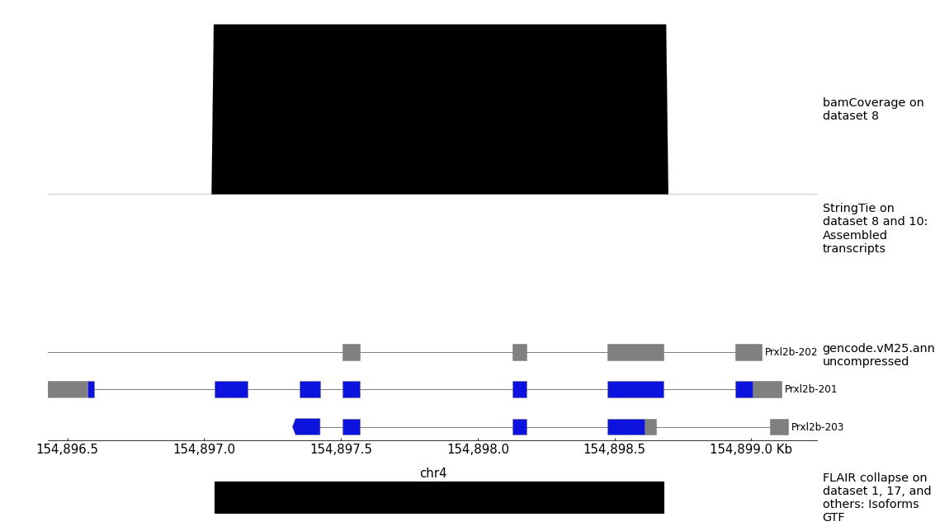

Supplementary Figure S1. Comparison of reconstructed PRXL2B transcript isoforms with reference annotation. Long-read transcript assemblies generated by FLAIR were compared with GENCODE vM25 annotations across the PRXL2B genomic locus. Three transcript isoforms (Prxl2b-201, Prxl2b-202, and Prxl2b-203) were identified. Exon–intron organization demonstrates agreement with annotated coding exons while revealing alternative transcript structures supported by long-read sequencing data.

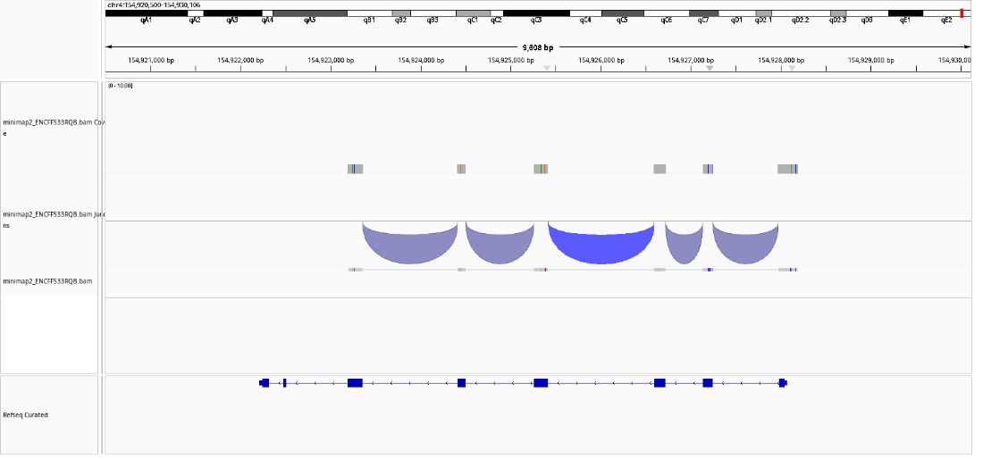

Supplementary Figure S2. Long-read splice-junction support across the PRXL2B locus. Integrative Genomics Viewer (IGV) visualization showing splice-junction arcs derived from long-read RNA sequencing alignments. Junction-spanning reads support exon connectivity and validate the exon–intron structure of reconstructed PRXL2B transcripts.

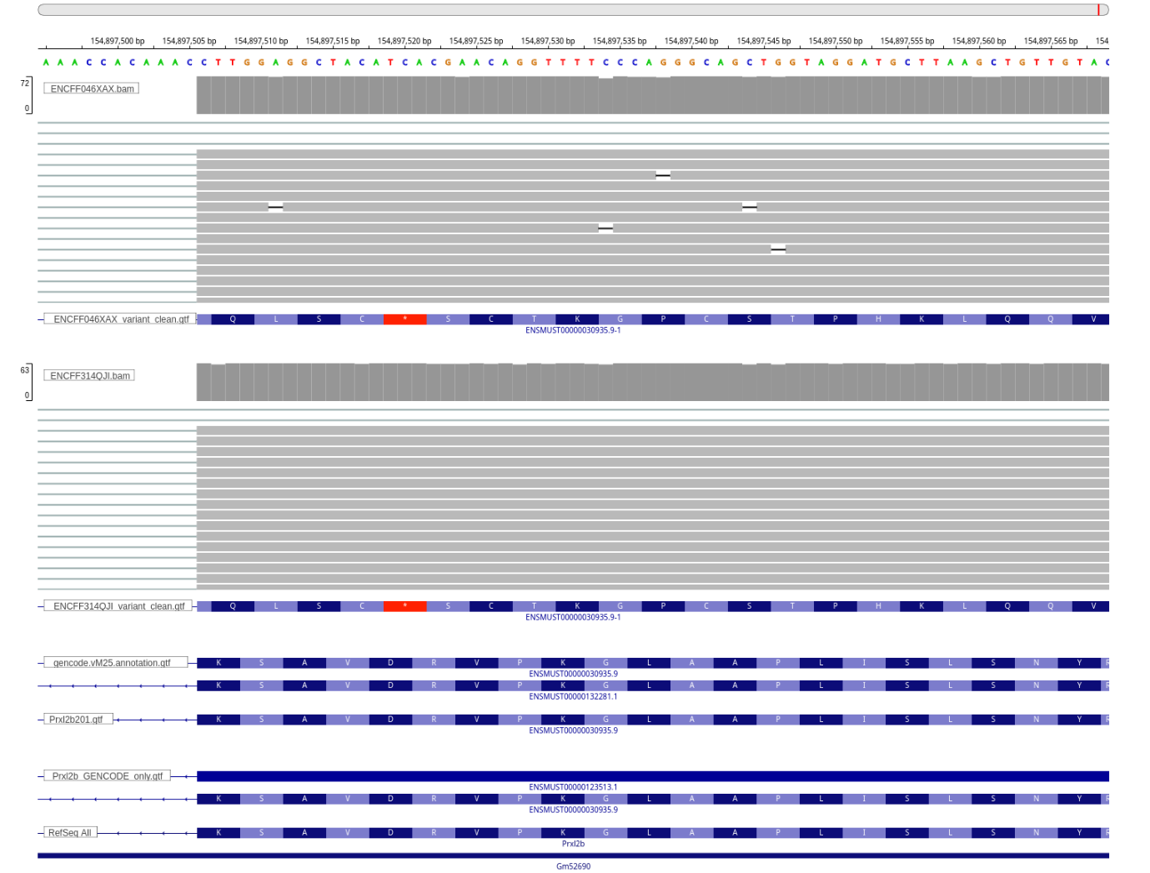

Supplementary Figure S3. Nucleotide and amino acid-level validation of the PRXL2B coding sequence. Long-read alignments mapped to the coding region of PRXL2B demonstrate concordance between reconstructed transcripts and the annotated coding sequence. Amino acid translations derived from aligned reads indicate preservation of the predicted open reading frame.

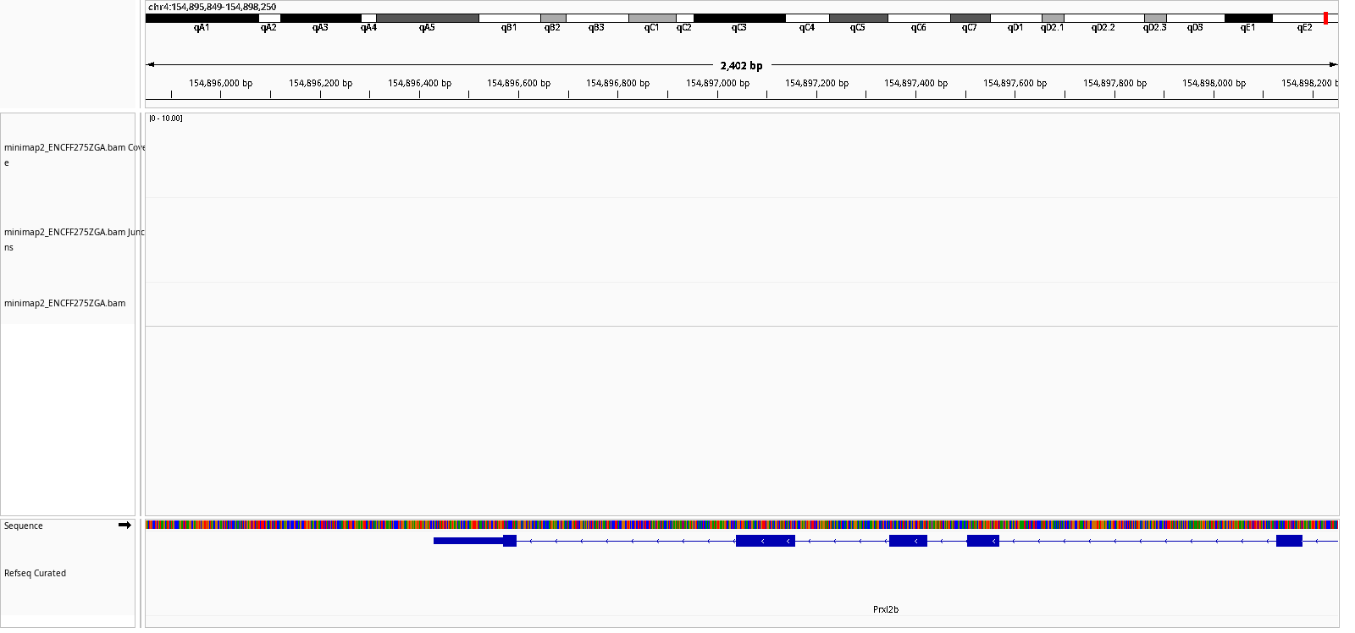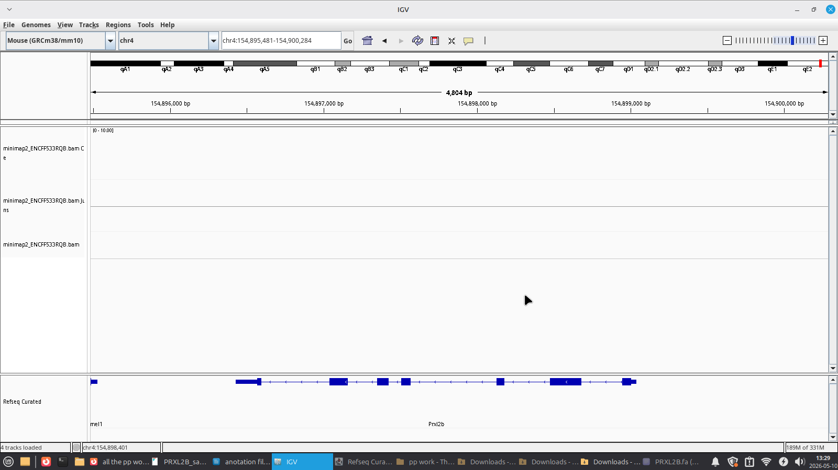

Supplementary Figure S4. Absence of detectable PRXL2B expression in selected ENCODE biosamples. Coverage tracks from long-read RNA sequencing datasets ENCFF275ZGA and ENCFF533RQB across the PRXL2B genomic locus. No substantial transcript coverage was detected, indicating minimal or absent PRXL2B expression in these samples.

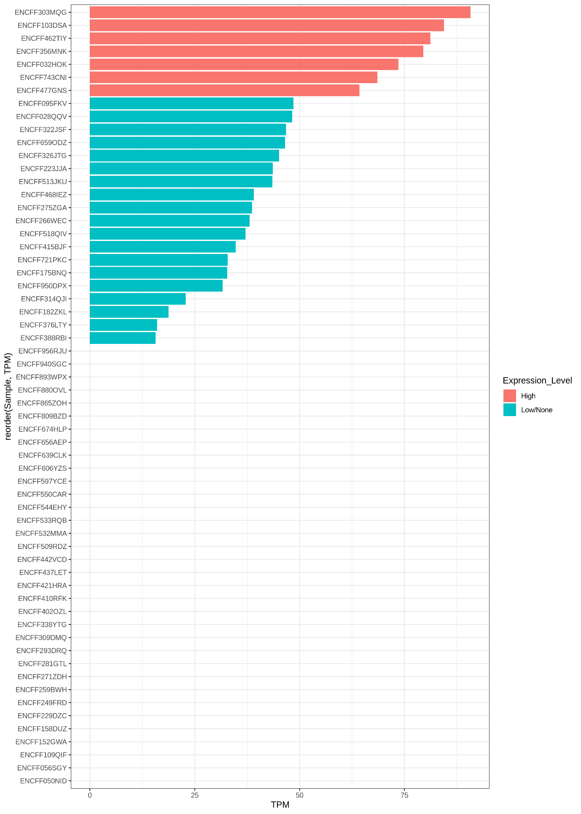
Supplementary Figure S5. Ranking of PRXL2B expression levels across all analyzed ENCODE mouse long-read RNA sequencing samples. Samples are ordered according to transcript abundance (TPM). High-expression samples are highlighted and were selected for downstream transcript reconstruction and isoform analysis.

