Supplementary materials of
Widespread impacts of climate extremes on terrestrial carbon cycling revealed by station-scale observations
Haiyang Shi^{1,2,6*}, Ruixiang Gao¹, Yuanyuan Huang⁵, Wenli Zhao³, Zengyun Hu^{6*}, Philippe De Maeyer^{2,4}, Tim Van de Voorde^{2,4} and Geping Luo^{1*}

1 State Key Laboratory of Desert and Oasis Ecology, Xinjiang Institute of Ecology and Geography, Chinese Academy of Sciences, Urumqi, 830011, China
2 Sino-Belgian Joint Laboratory for Geo-Information, Ghent, 9000, Belgium
3 Earth and Environmental Engineering and Earth Institute, Columbia University, New York, New York, USA
4 Department of Geography, Ghent University, Ghent 9000, Belgium.
5 Key Laboratory of Ecosystem Network Observation and Modeling, Institute of Geographic Sciences and Natural Resources Research, Chinese Academy of Sciences, Beijing 100101, China
6 School of Global Health, Chinese Center for Tropical Diseases Research, Shanghai Jiao Tong University School of Medicine, Shanghai, 200025, China

*Correspondence: Haiyang Shi (haiyang.shi9473@outlook.com), Zengyun Hu (hzyhjq@sjtu.edu.cn) and Geping Luo (luogp@ms.xjb.ac.cn)

Supplementary Note 1
Supplementary Table 1
Supplementary Figures 1-5

Supplementary Note 1: Detailed procedures for the generation and evaluation of the station-scale GPP and Reco dataset
To generate high-quality, continuous daily Gross Primary Productivity (GPP) and Ecosystem Respiration (Reco, referred to as ER in the model development phase) data at global meteorological stations, we developed a similarity-based machine learning extrapolation framework. The generation of this dataset incorporated rigorous data preprocessing, model cross-validation, and multi-model fusion.
1. Data Integration and Preprocessing
The framework integrated eddy covariance data from 194 FLUXNET2015 towers, daily meteorological observations from over 9,000 GSOD weather stations, and spatially matched remote sensing products (e.g., MOD15A2H LAI, BESS Downward Shortwave Radiation, HWSD soil properties, and NOAA DEM). To enhance the spatial representativeness of the remote sensing variables for both flux towers and meteorological stations, we extracted the average pixel values within a 500 × 500 m area centered on each location, which optimally matches the footprint of typical eddy covariance towers. To address data gaps in both in-situ observations and remote sensing time series, a two-dimensional sliding window interpolation method was employed: data were first interpolated along the continuous time series, followed by inter-annual interpolation based on the Day of Year (DOY) sequence, effectively minimizing data loss and uncertainties.
2. LSTM Model Development and Variable Sensitivity Analysis
Flux towers and meteorological stations were categorized into four generalized climatic zones (arid, semi-arid, dry sub-humid, and humid). Within each zone, Long Short-Term Memory (LSTM) neural networks were constructed to inherently capture the memory effects of climate variables on carbon fluxes. A robust "leave-one-location-out" (LLO) cross-validation strategy was employed: one flux station was iteratively withheld for validation while the remaining stations in the corresponding climate zone were used for model training. The LLO cross-validation demonstrated robust predictive capabilities, with median R² values predominantly exceeding 0.5 across different climatic regions (Supplementary Fig. 1).
To quantify the contribution of each explanatory variable to the model predictions, a gradient-based sensitivity analysis was conducted. The sensitivity value for each variable was derived by calculating the absolute value of the partial derivative of the model output with respect to the input feature:
$$S_{i}\left(x\right)=|\frac{∂V\left(x\right)}{∂x_{i}}|$$
This provided a relative weight (W_i) for the 14 explanatory variables, highlighting that GPP is highly sensitive to Downward Shortwave Radiation (DSR) and Leaf Area Index (LAI), while Reco is predominantly driven by minimum temperature (T-Min) and precipitation across most regions (Supplementary Fig. 2).
3. Extrapolability Assessment based on Environmental Similarity
Applying models to ungauged meteorological stations introduces uncertainties driven by spatial heterogeneity. To quantify the environmental difference between the training data of a specific LSTM model and the target meteorological station, we introduced an Aggregated Euclidean Distance (AED).
First, the Euclidean distance (ED_i) for each explanatory variable was calculated using the multi-year average DOY data. Specifically, the distance between the training set (v_i) and the target station or validation set (V_i) was computed over a 365-day cycle:
$$ED_{i}=\sqrt{\frac{\sum{{\left(v_{i}-V_{i}\right)}^{2}}}{365}}$$
Incorporating the variable importance (W_i) derived from the sensitivity analysis, the Aggregated Euclidean Distance (DisModel_n) for a specific model n was computed as:
$$DisModel_{n}=MEAN\left(\sum_{i=1}^{14}{{\left(ED_{i}×W_{i}\right)}^{2}}\right)$$
A significant negative correlation (p < 0.01) was observed between the LLO validation R² and the AED, confirming that a smaller environmental distance yields higher predictive reliability (Supplementary Fig. 3).
4. Fuzzy Membership, Multi-model Fusion, and Uncertainty Evaluation
To evaluate model applicability at a target meteorological station, we constructed a Gaussian fuzzy membership function:
$$F\left(x\right)=\exp\left(\frac{-{\left(x-C\right)}^{2}}{2σ^{2}}\right)$$
where F(x) represents the fuzzy membership degree, x is the calculated AED, C is the distance at maximum membership (C=0), and σ is the width parameter determined by the optimal AED threshold (median AED of models with R² > 0.5).
Only models yielding a membership degree ≥ 0.5 were deemed applicable for a given station. The overall classification accuracies of this similarity-based evaluation framework were 79.8% for GPP and 76.8% for Reco, proving its efficacy in identifying reliable model extrapolations (Supplementary Fig. 4).
When a meteorological station matched multiple applicable models, a weighted average of their predictions was calculated based on their respective membership degrees, resulting in a robust, fused daily carbon flux estimation. Furthermore, the prediction uncertainty (U_i) for each meteorological station i was quantified based on the maximum environmental similarity among the t applicable models:
$$U_{i}=1-\max\left(V_{i,1},V_{i,2},…,V_{i,t}\right)$$
Applying this framework globally, approximately 70% of the GSOD meteorological stations successfully matched at least one applicable model. These retained stations are predominantly distributed across the Northern Hemisphere, providing a reliable and extensively evaluated site-scale carbon flux dataset for our spatial analyses (Supplementary Fig. 5).
Supplementary Table 1. Explanatory variables used for the development of carbon flux models.
Nr. | ID | Description | Unit | Temporal/Spatial resolution | Source
1 | T-Max | Maximum Air Temperature | °C | Daily | Sites
2 | T-Min | Minimum Air Temperature | °C | Daily | Sites
3 | T-Mean | Mean Air Temperature | °C | Daily | Sites
4 | P | Precipitation | mm | Daily | Sites
5 | WS | Wind Speed | m/s | Daily | Sites
6 | VPD | Vapor pressure deficit | hPa | Daily | Sites
7 | LAI | Leaf Area Index | m²/m² | 8-day/500m | MODIS
8 | DSR | Downward shortwave Radiation | W/m² | Daily/500m | Seoul National University
9 | DEM | Elevation | m | Static | GLOBE from NOAA
10 | Aspect | Aspect | ° | Static | GLOBE from NOAA
11 | Slope | Slope | ° | Static | GLOBE from NOAA
12 | Clay | Topsoil clay fraction | % | Static | HWSD from FAO
13 | Sand | Topsoil sand fraction | % | Static | HWSD from FAO
14 | Silt | Topsoil silt fraction | % | Static | HWSD from FAO

Supplementary Figure 1. Boxplots of the coefficient of determination (R²) for the LSTM models. Performance of the LLO cross-validation for GPP and Reco (ER) across arid, semi-arid, dry sub-humid, and humid regions. The red dashed line indicates the R² threshold of 0.5 used for model selection.

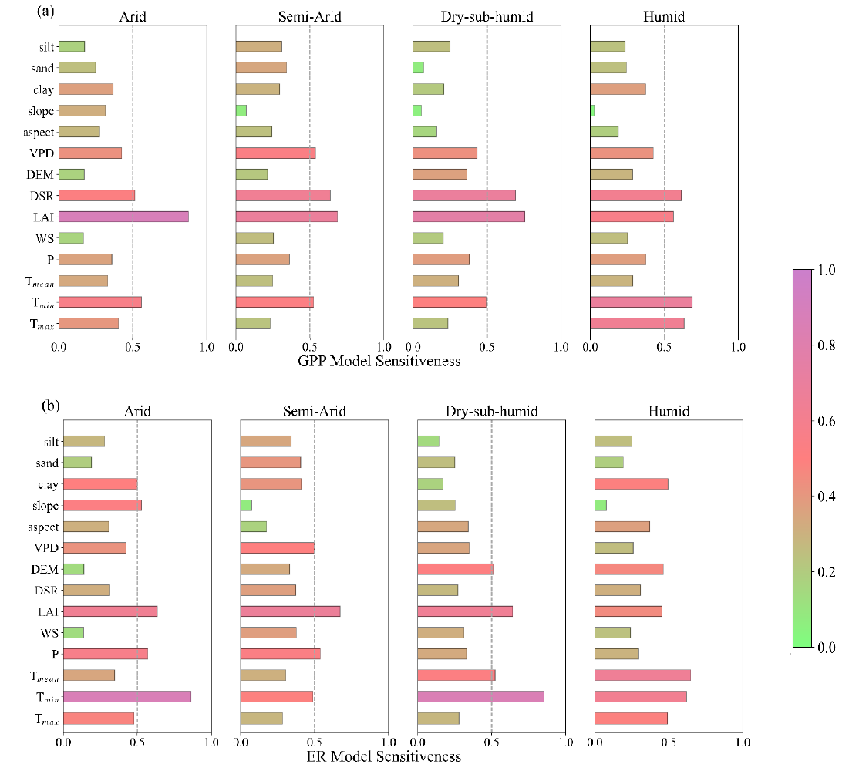
Supplementary Figure 2. Sensitivity analysis of the explanatory variables. Gradient-based sensitivity of the LSTM models for GPP (a) and Reco (b) across the four distinct climatic regions.
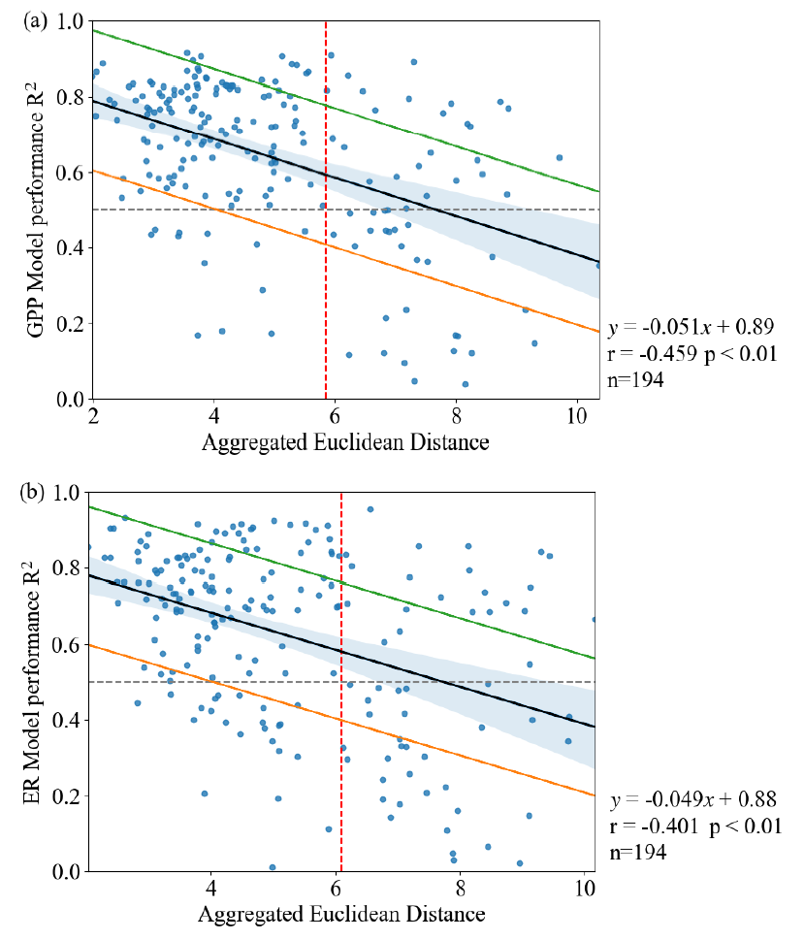
Supplementary Figure 3. Relationship between the Aggregated Euclidean Distance (AED) and LLO validation R². The significant negative correlation validates the use of AED as an indicator of model extrapolability. The red dashed line represents the AED threshold, and the gray dashed line represents R² = 0.5.
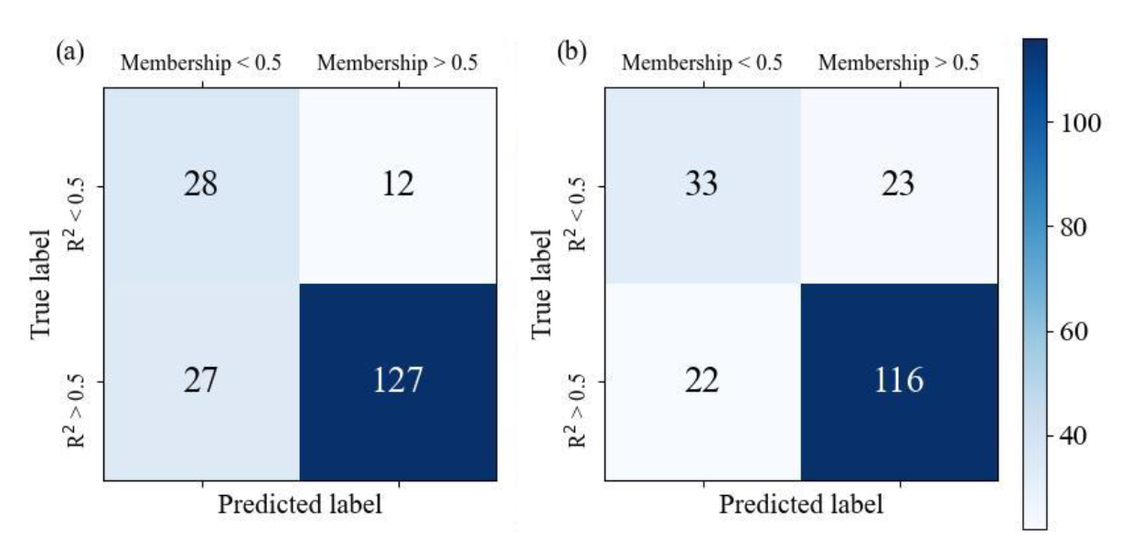
Supplementary Figure 4. Confusion matrices of the extrapolation evaluation framework. Classification accuracy of the framework in identifying applicable (extrapolable) models for GPP (a) and Reco (b) based on the fuzzy membership threshold.

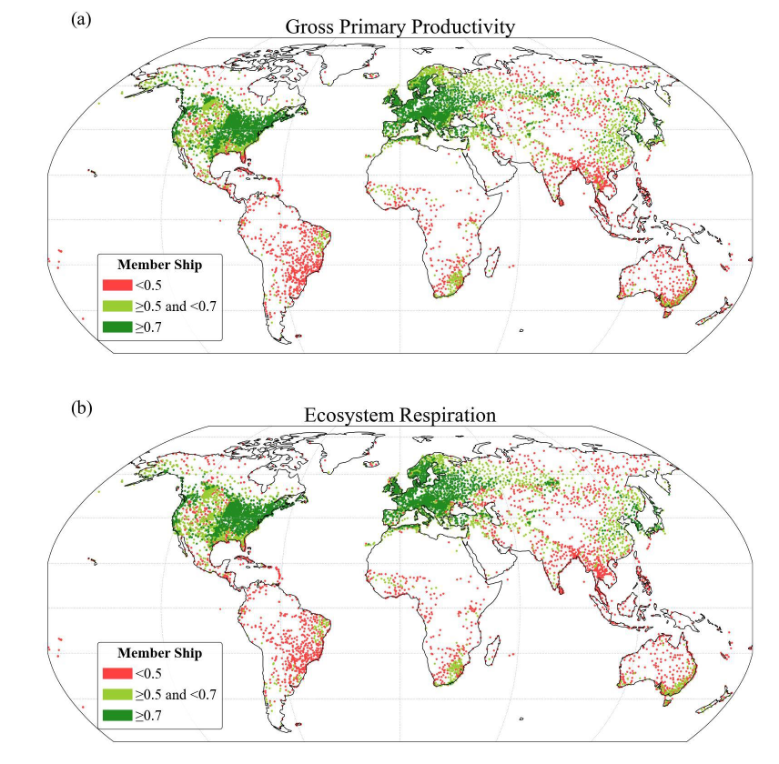
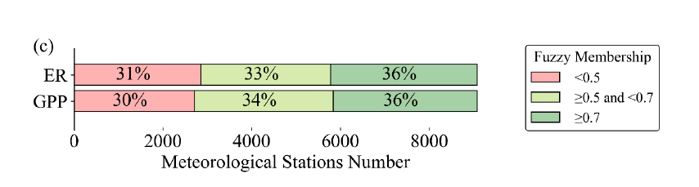
Supplementary Figure 5. Global distribution and fuzzy membership of the extrapolated meteorological stations. Stations with dark green dots represent high model applicability (membership > 0.7), light green dots represent moderate applicability (0.5–0.7), and red dots indicate stations without suitable carbon flux models (membership < 0.5), which were excluded from the analysis.

