The structural basis of SRSF6-mediated splicing decisions governed by tandem-domain RNA recognition and RS-domain tuning
Julian von Ehr^{1,2,3}, Sunesh Sethumadhavan^{3,4}, Friederike E. Schubert^{2,5}, Sophie M. Korn^{6,7}, Natalie Meixner¹, Lasse Oberstrass⁸, Bernd Simon⁹, Julia E. Weigand^{8,10}, Gerhard Hummer^{3,5,11}, Michaela Müller-McNicoll^{3,4,5*}, and Andreas Schlundt^{1,3,6*}

¹Institute for Molecular Biosciences and Biomolecular Resonance Center (BMRZ), Goethe University Frankfurt, Max-von-Laue-Str. 7-9, 60438 Frankfurt, Germany.
²IMPRS on Cellular Biophysics, Max-von-Laue-Str. 3, 7-9, 60438 Frankfurt, Germany.
³Cluster of Excellence SubCellular Architecture of Life (SCALE), Goethe University Frankfurt, Frankfurt, Germany
⁴Institute for Molecular Biosciences, Goethe University Frankfurt, Max-von-Laue-Str. 13, 60438 Frankfurt, Germany.
⁵Department of Theoretical Biophysics, Max Planck Institute of Biophysics, Max-von-Laue-Straße 3, 60438 Frankfurt am Main, Germany
⁶University of Greifswald, Institute of Biochemistry, Felix-Hausdorff-Str. 4, 17489 Greifswald, Germany.
⁷Department of Biochemistry and Molecular Biophysics, Columbia University, New York, NY 10032, United States.
⁸Marburg University, Department of Pharmacy, Institute of Pharmaceutical Chemistry, Marbacher Weg 6, 35037 Marburg, Germany.
⁹Department of Molecular Biology and Biophysics, University of Connecticut Health Center, 263 Farmington Avenue, Farmington, CT 06030, USA.
¹⁰Marburg University, Center for Synthetic Microbiology (SYNMIKRO), Karl-von-Frisch-Str. 14, 35043 Marburg, Germany
¹¹Institute of Biophysics, Goethe University Frankfurt, 60438 Frankfurt am Main, Germany

*To whom correspondence should be addressed: mueller-mcnicoll@bio.uni-frankfurt.de, andreas.schlundt@uni-greifswald.de

Supplementary Figures

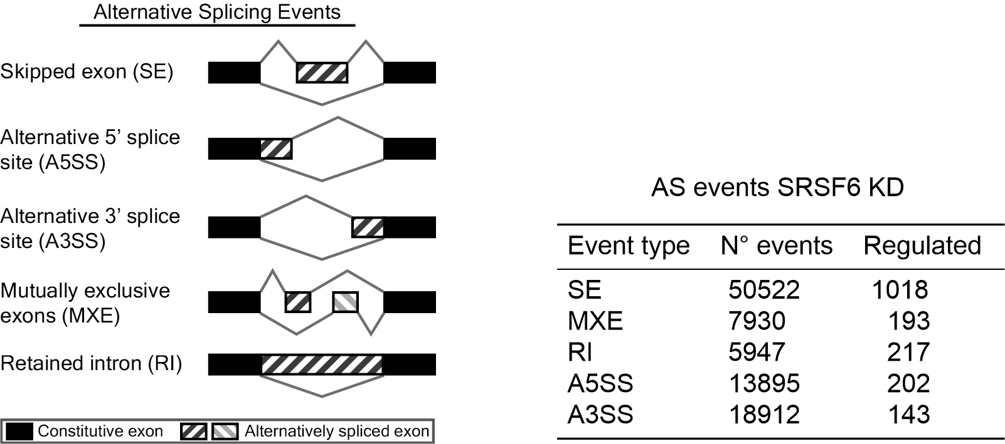
Supplementary Figure 1: Alternative splicing events in SRSF6 KD cells.
Left: Alternative Splicing Events identified by rMATS, using an improved version of the generalized linear mixed model to detect differential AS from RNA-seq data with replicates (Shen et al., 2014). It accounts for exon-specific sequencing coverage in individual samples as well as variation in exon splicing levels among replicates. Right: Alternative splicing events in HeLa cells upon SRSF6 KD identified using rMATS applying a cut-off of FDR<0.1and ΔPSI > 5%.

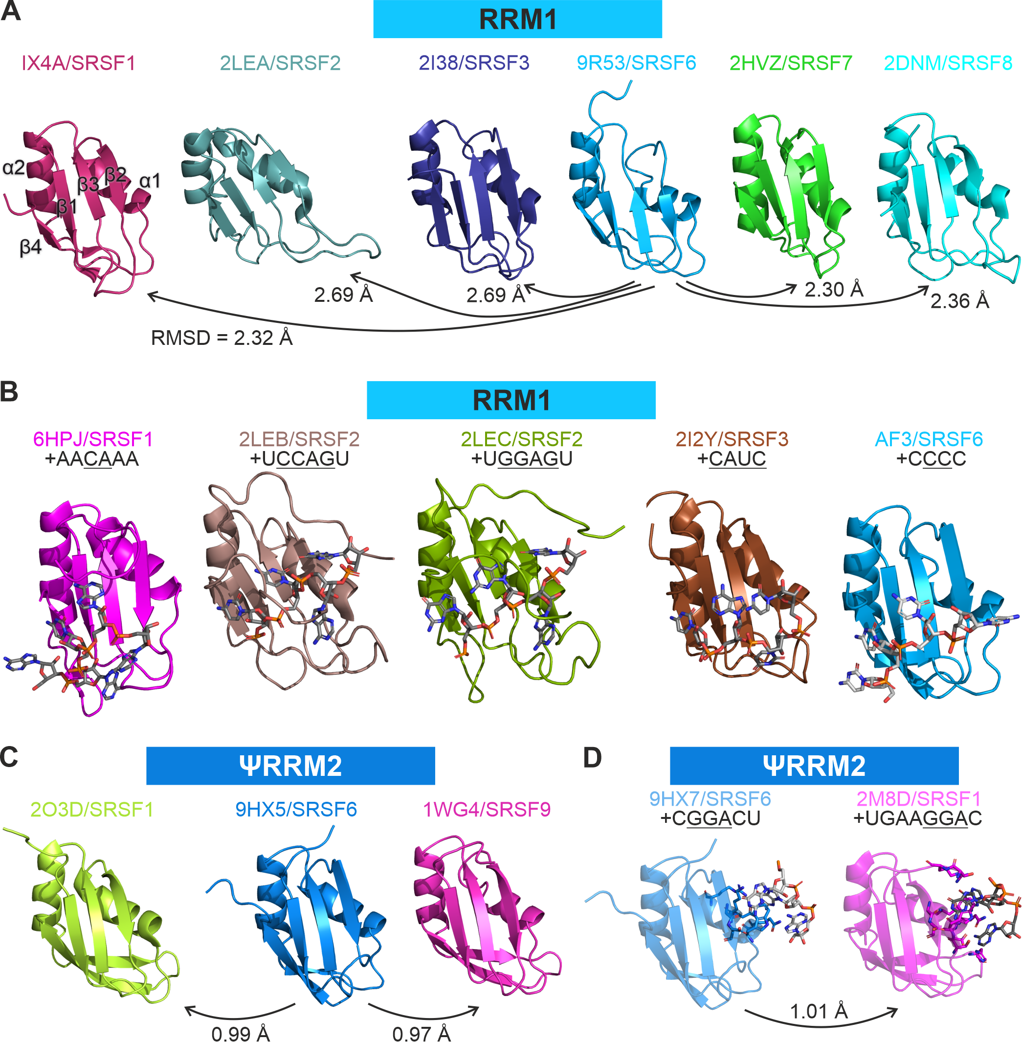
Supplementary Figure 2: Comparison of available structures of SRSF proteins.
A: Comparison of RRM1 apo structures with their respective PDB IDs and the SRSF protein given above each structure. RMSDs for each structure in comparison to SRSF6 RRM1 are highlighted. Secondary structure elements are labeled for SRSF1 RRM1 and are the same for all other structures. B: Comparison of RRM1 structures in complex with RNA. RNA sequences used are shown with bound nucleotides underlined. C: Comparison of ΨRRM2 apo structures. D: Comparison of ΨRRM2 structures in complex with RNA. All structures have been aligned before rendering the image to assure identical orientation.

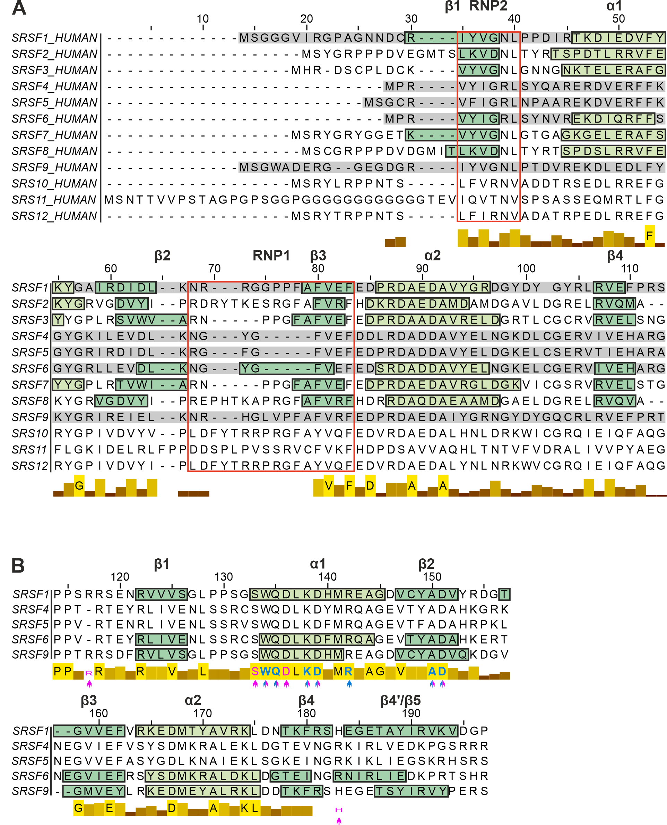
Supplementary Figure 3: Sequence alignment of SRSF RRM1 (A) and ΨRRM2 (B).
A: Sequence alignment of all twelve human SRSF proteins. Sequence numbering is based on SRSF11. Sequences of SRSF proteins that contain a second RRM are highlighted in gray. Secondary structure elements are highlighted and labeled according to PDB IDs 1X4A (SRSF1), 2LEA (SRSF2), 2I38 (SRSF3), 9R53 (SRSF6), 2HVZ (SRSF7) and 2DNM (SRSF8). RNPs are highlighted in red boxes according to the RNP consensus motifs applied for SRSF6. B: Sequence alignment of ΨRRM2. Sequence numbering is based on SRSF1. Secondary structure elements are highlighted and labeled according to PDB IDs 2O3D (SRSF1), 9HX5 (SRSF6) and 1WG4 (SRSF9). Arrows highlight residues of SRSF1 (magenta) and SRSF6 (blue) that directly interact with “GGA” RNA. The bars below sequences indicate sequence conservation, with letters in bars representing 100 % identity between all twelve/five members. Alignments were performed in Jalview 2.11.5.0.

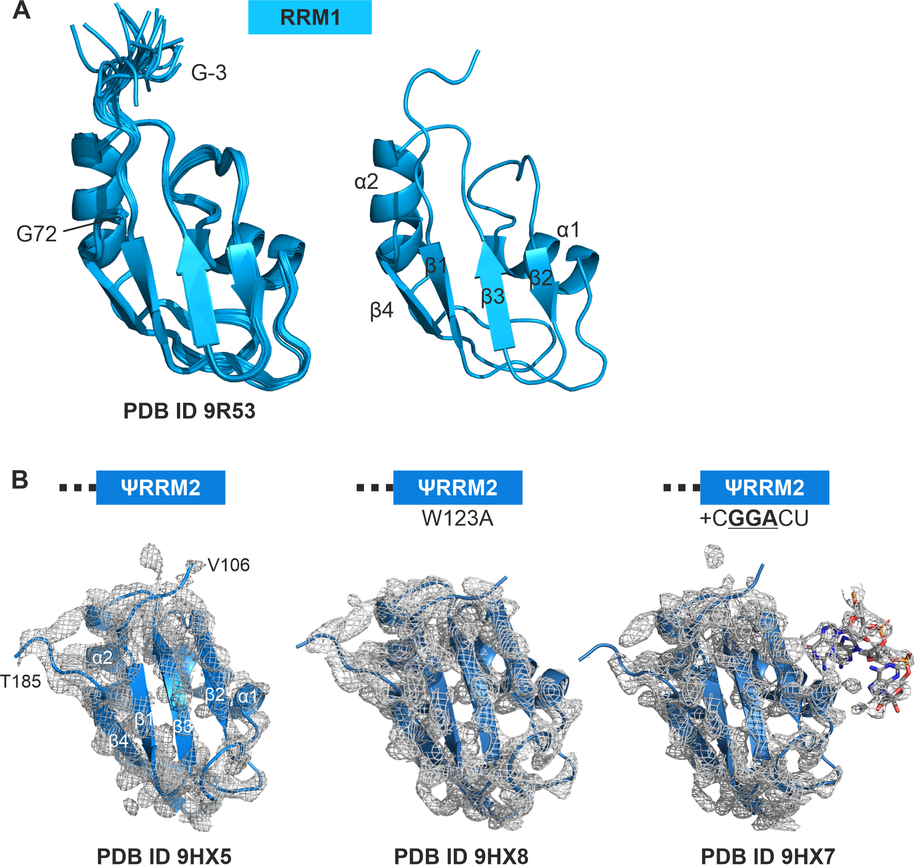
Supplementary Figure 4: Structures of SRSF6 RRM1 (A) and ΨRRM2 (B).
A: Structural ensemble of 20 lowest energy NMR structures of SRSF6 RRM1 with one representative structure highlighted. N- and C-terminus as well as secondary structure elements are highlighted. B: Crystal structures of SRSF6 ΨRRM2 in its apo state (left) as a W123A mutant (middle) and in complex with CGGACU RNA (right). The electron density (2F_{o}F_{c} map) is shown at σ=1.5 for the protein and σ=2.0 for the RNA. N- and C-terminus as well as secondary structure elements are highlighted for the apo protein.
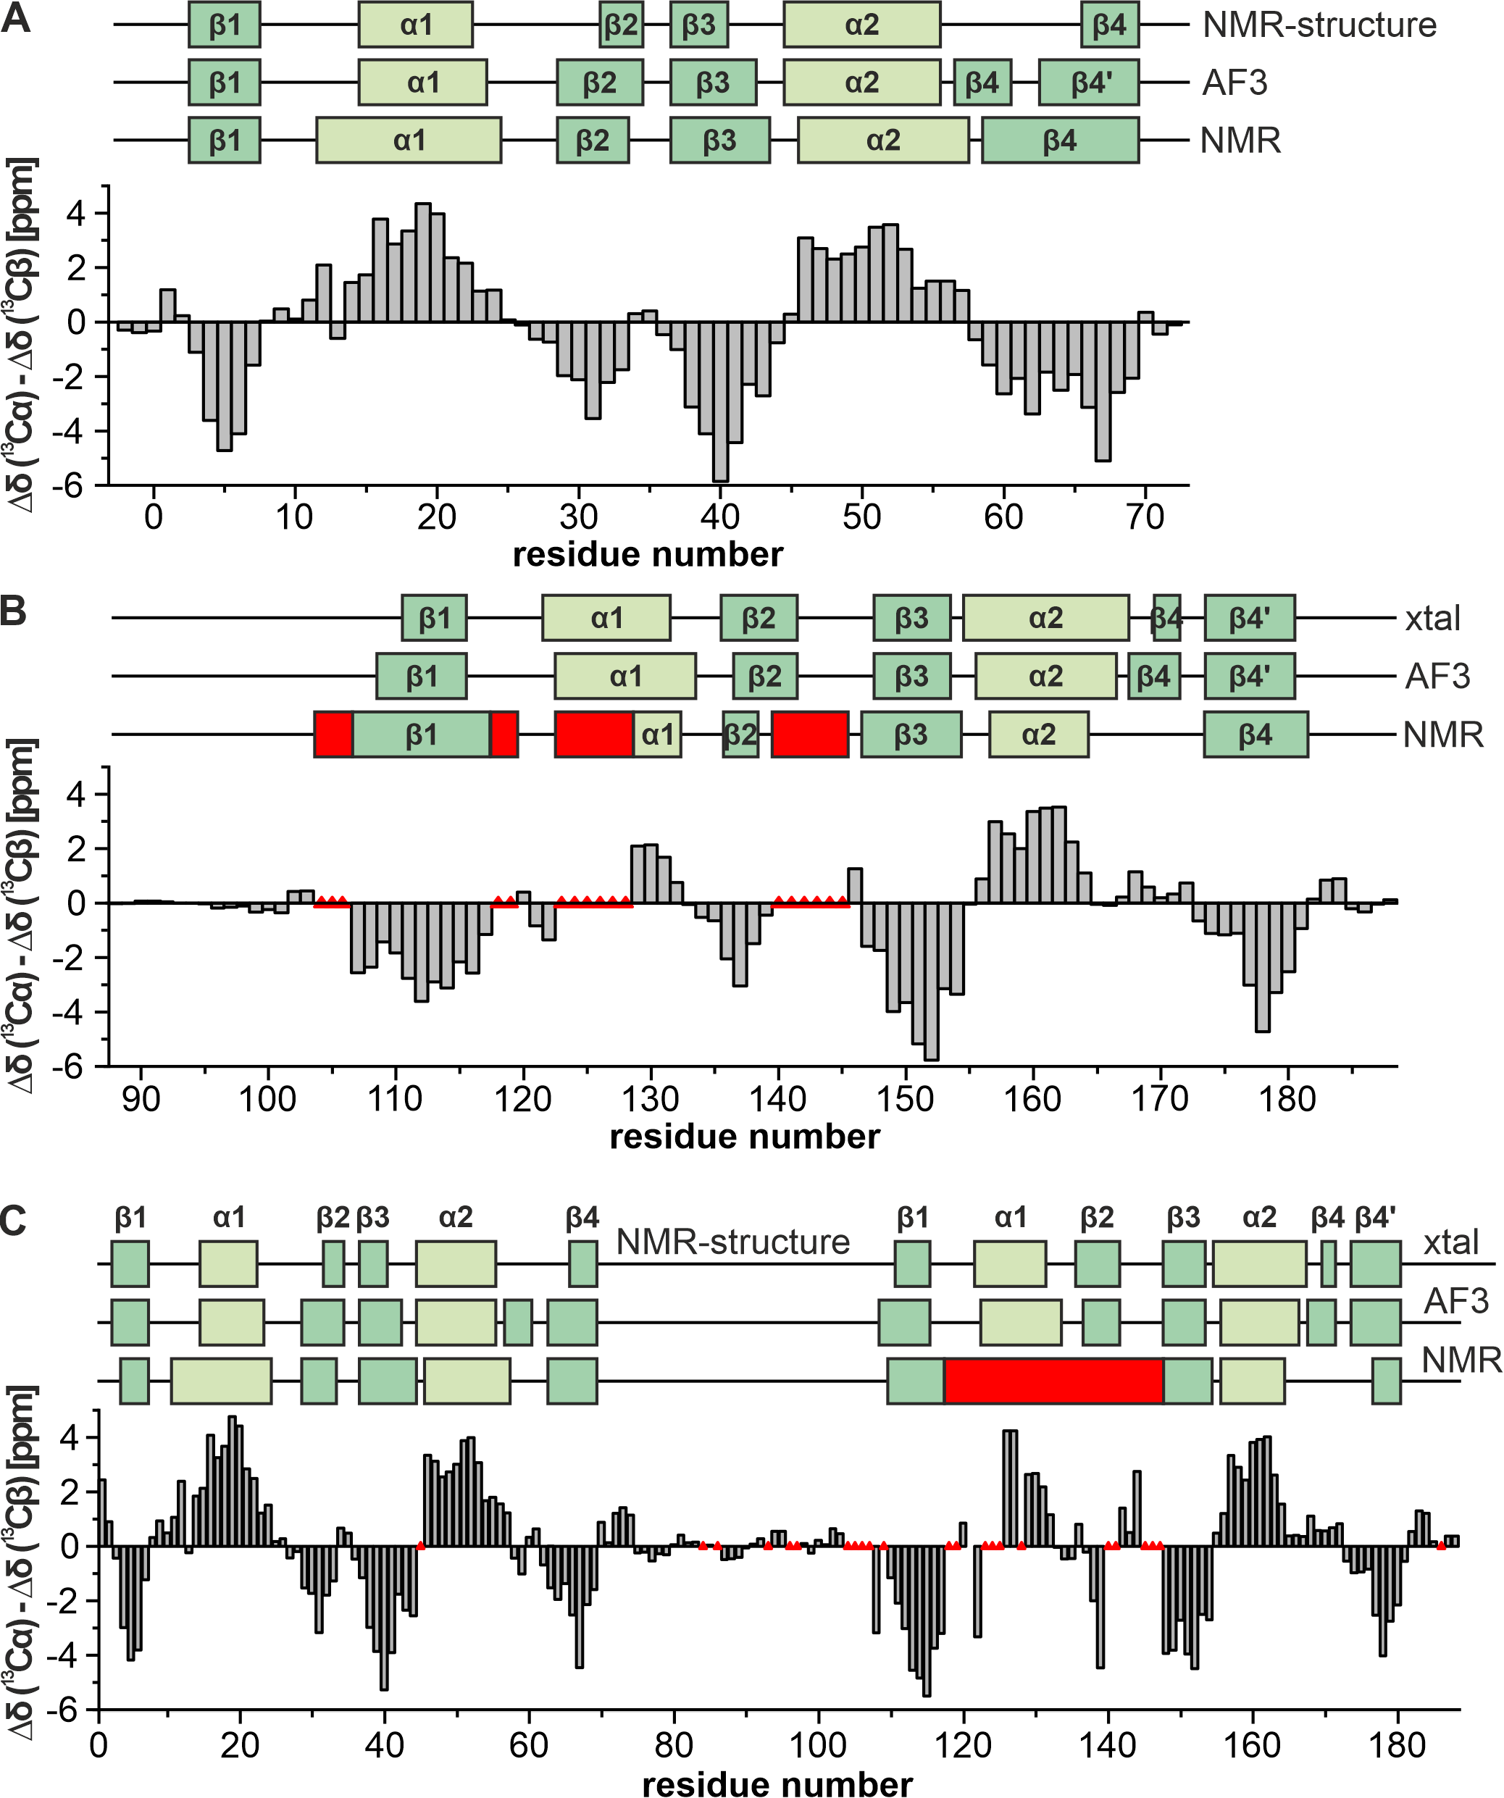
Supplementary Figure 5: Secondary structure comparison of RRM1 (A) and ΨRRM2 (B) and tandem RRM (C).
Secondary structure derived from SCS data ¹ is plotted above each graph in two different green tones for β-strands and α-helices. Red triangles and boxes indicate areas of missing assignments and therefore uncertainty in secondary structures. A: Secondary structure comparison of RRM1 NMR secondary chemical shift data, AF3 data and the here presented NMR structure (PDB ID 9R53). B: Secondary structure comparison of ΨRRM2 NMR secondary chemical shift data, AF3 data and the here presented crystal structure (PDB ID 9HX5). C: Secondary structure comparison of tandem RRM NMR secondary chemical shift data, AF3 data and the here presented NMR (RRM1) and crystal (ΨRRM2) structure.
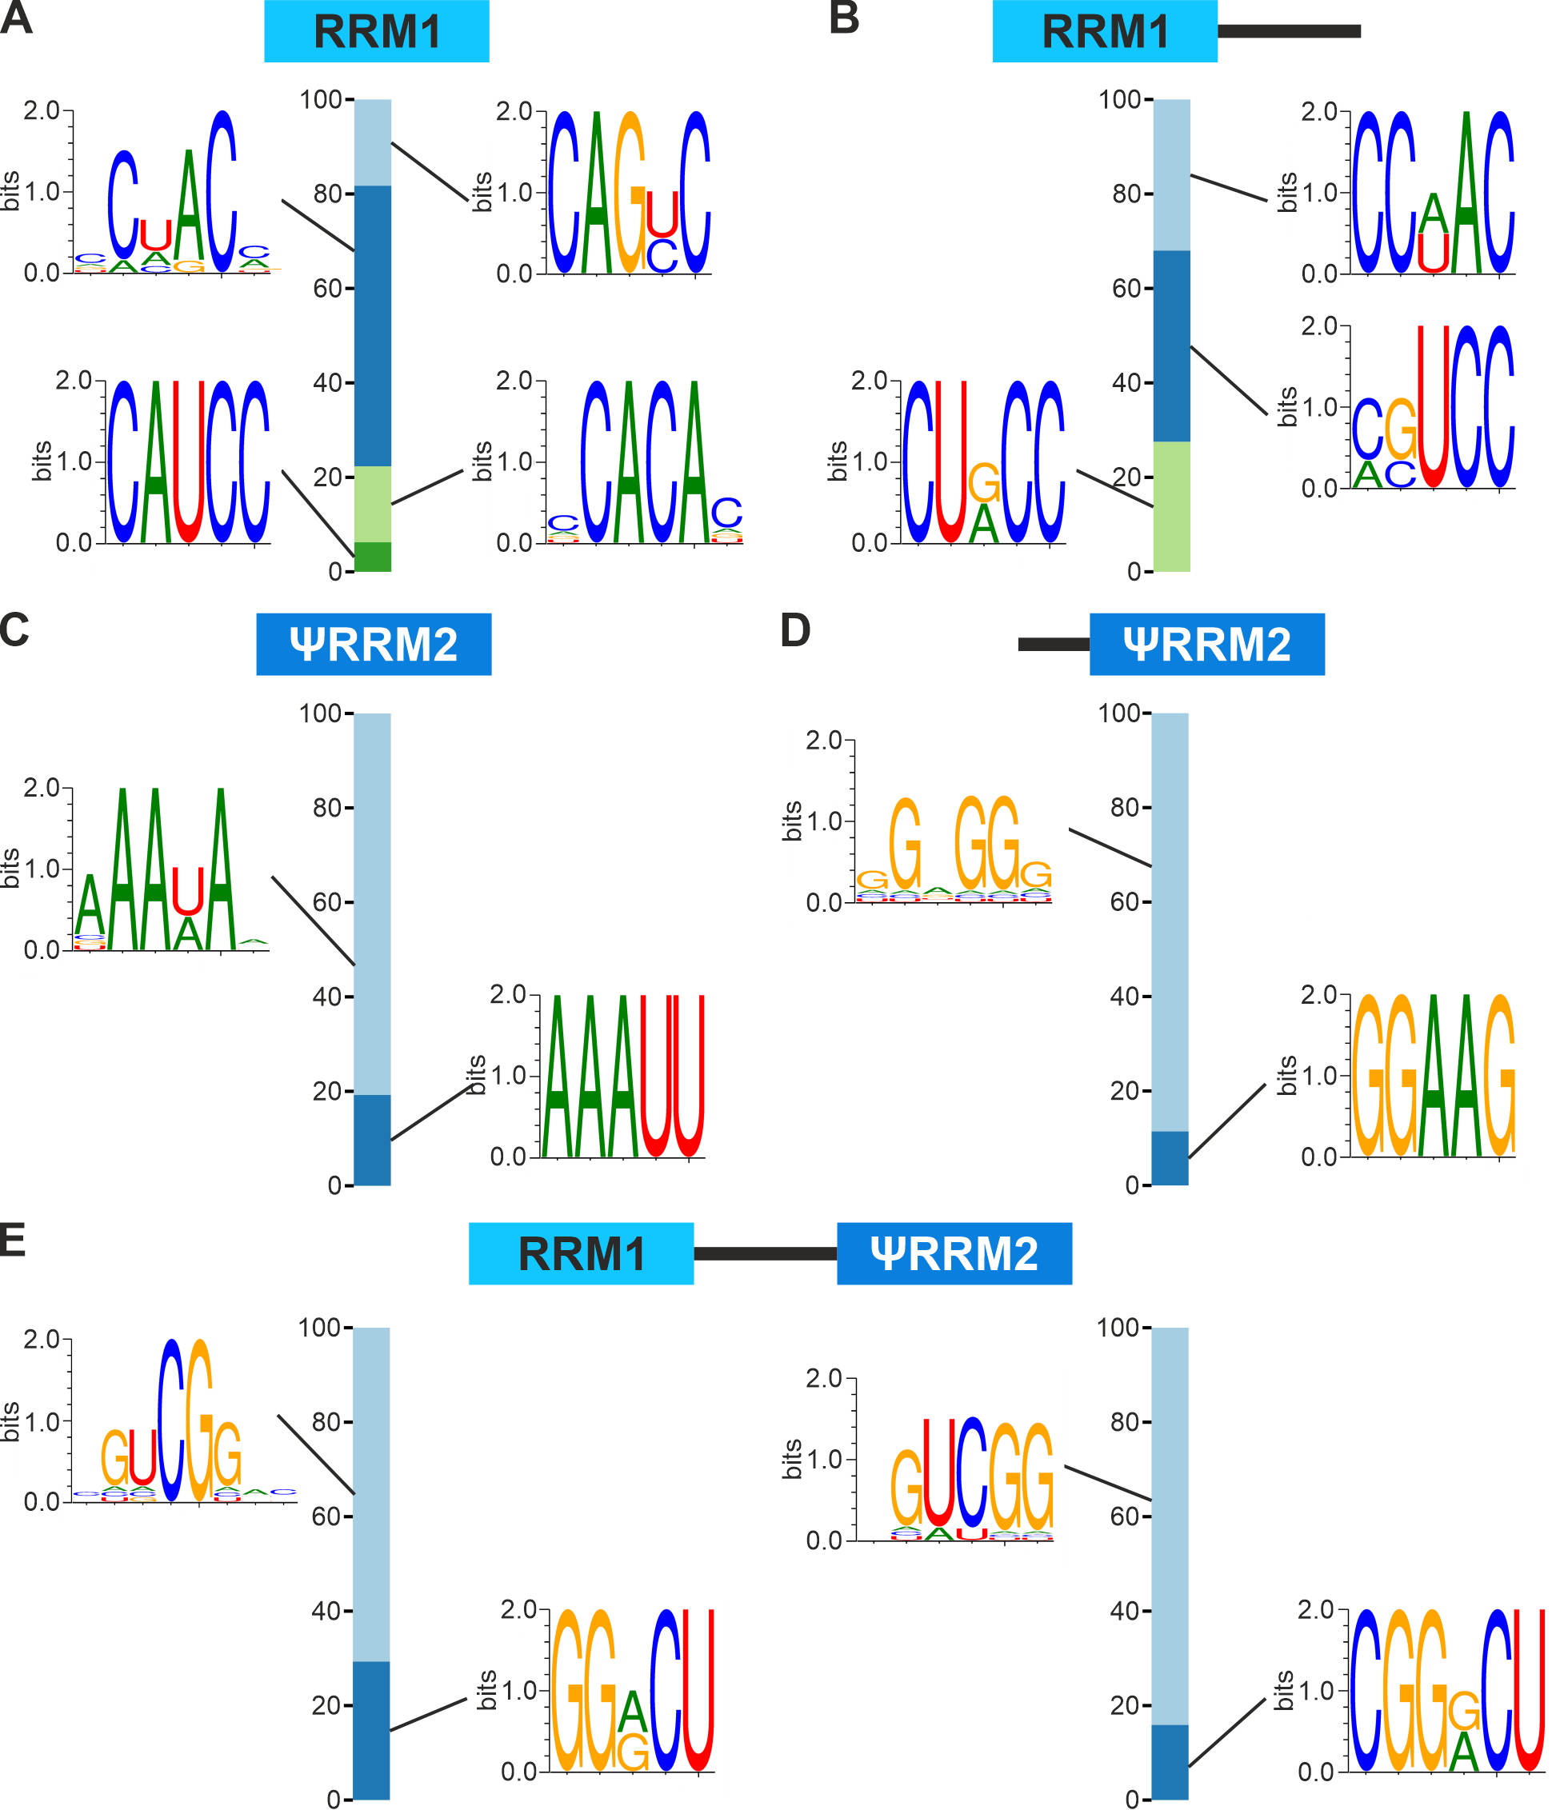
Supplementary Figure 6: RBNS sequence logos of single and tandem RRMs.
A-D: Sequence logos of respective single RRMs without (A and C) or with (B and D) linker region containing the significantly enriched (z-score > 2) 5-mers (left) weighted by the R-values. E: Sequence logos of the tandem RRM containing the significantly enriched (z-score > 2) 5-mers (left) and 6-mers (right) weighted by the R-values .The fraction of each logo in the bar graph is proportional to the sum of its R-1 -kmer values. Protein concentrations in (A) 40 µM, (B) 10 µM, (C) 40 µM, (D) 5 µM and (E) 5 µM.

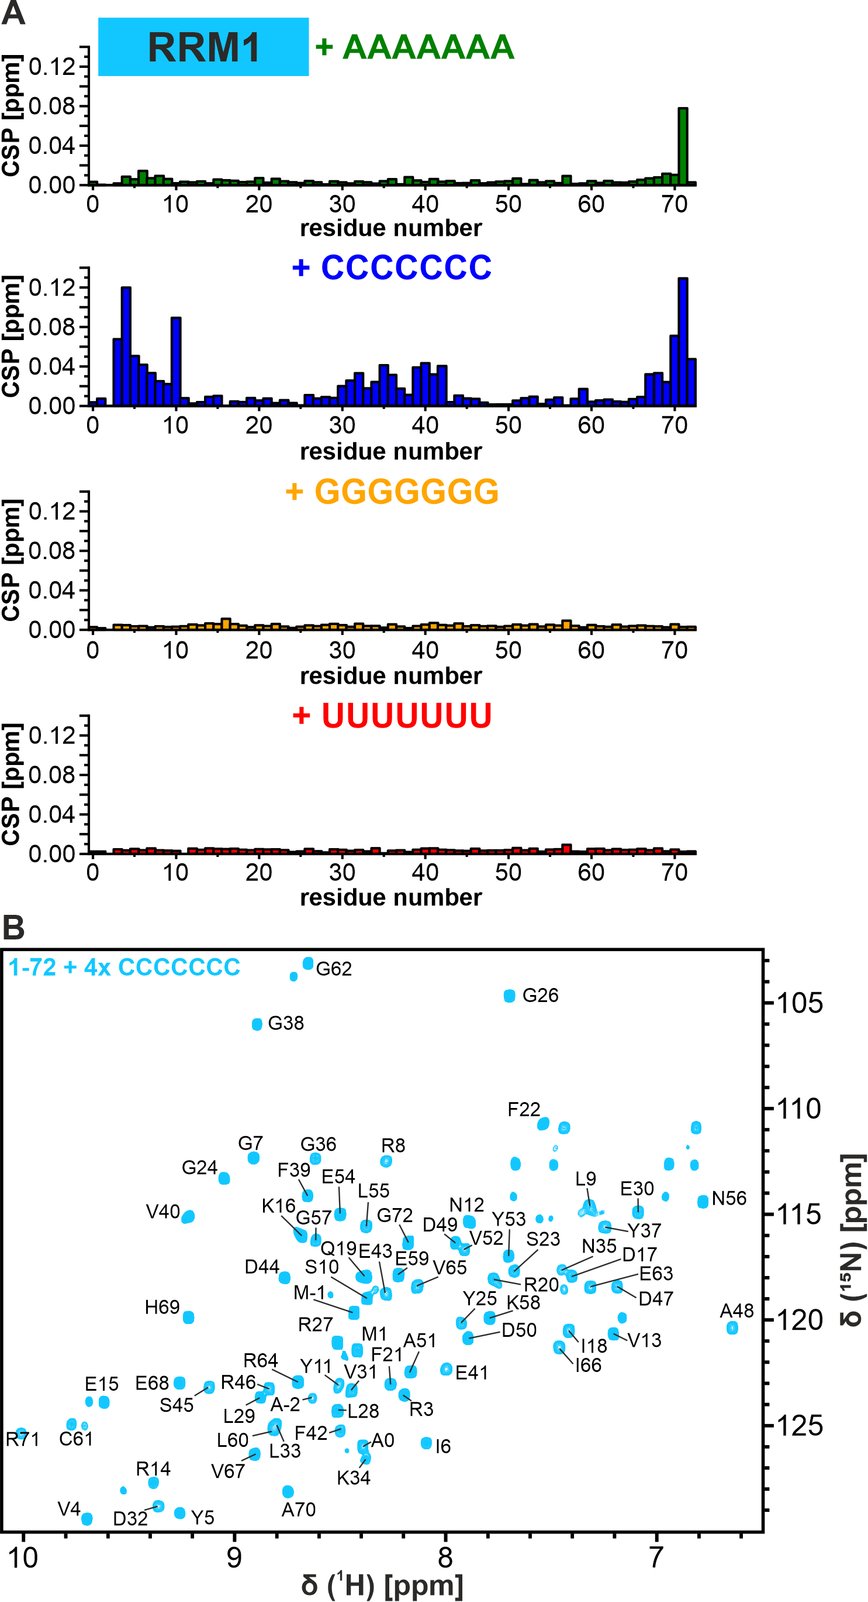
Supplementary Figure 7: SRSF6 RRM1 binding to poly-N RNAs.
A: CSP plots of RRM1 upon addition of 2-fold molar excess of poly-N RNAs. RNA sequences for 7-mer poly-N-RNA are given above each plot respectively. All measurements were performed with 40 µM of protein at 298K and 600 MHz in buffer containing 25 mM NaPi, 150 mM NaCl, 2 mM DTT, 0.02 % NaN₃ and 5% (v/v) D₂O at pH 6.5. B: ¹H-¹⁵N-HSQC of RRM1 with 4-fold molar excess of poly-C RNA. Assignments based on triple resonance experiments are shown for respective peaks.
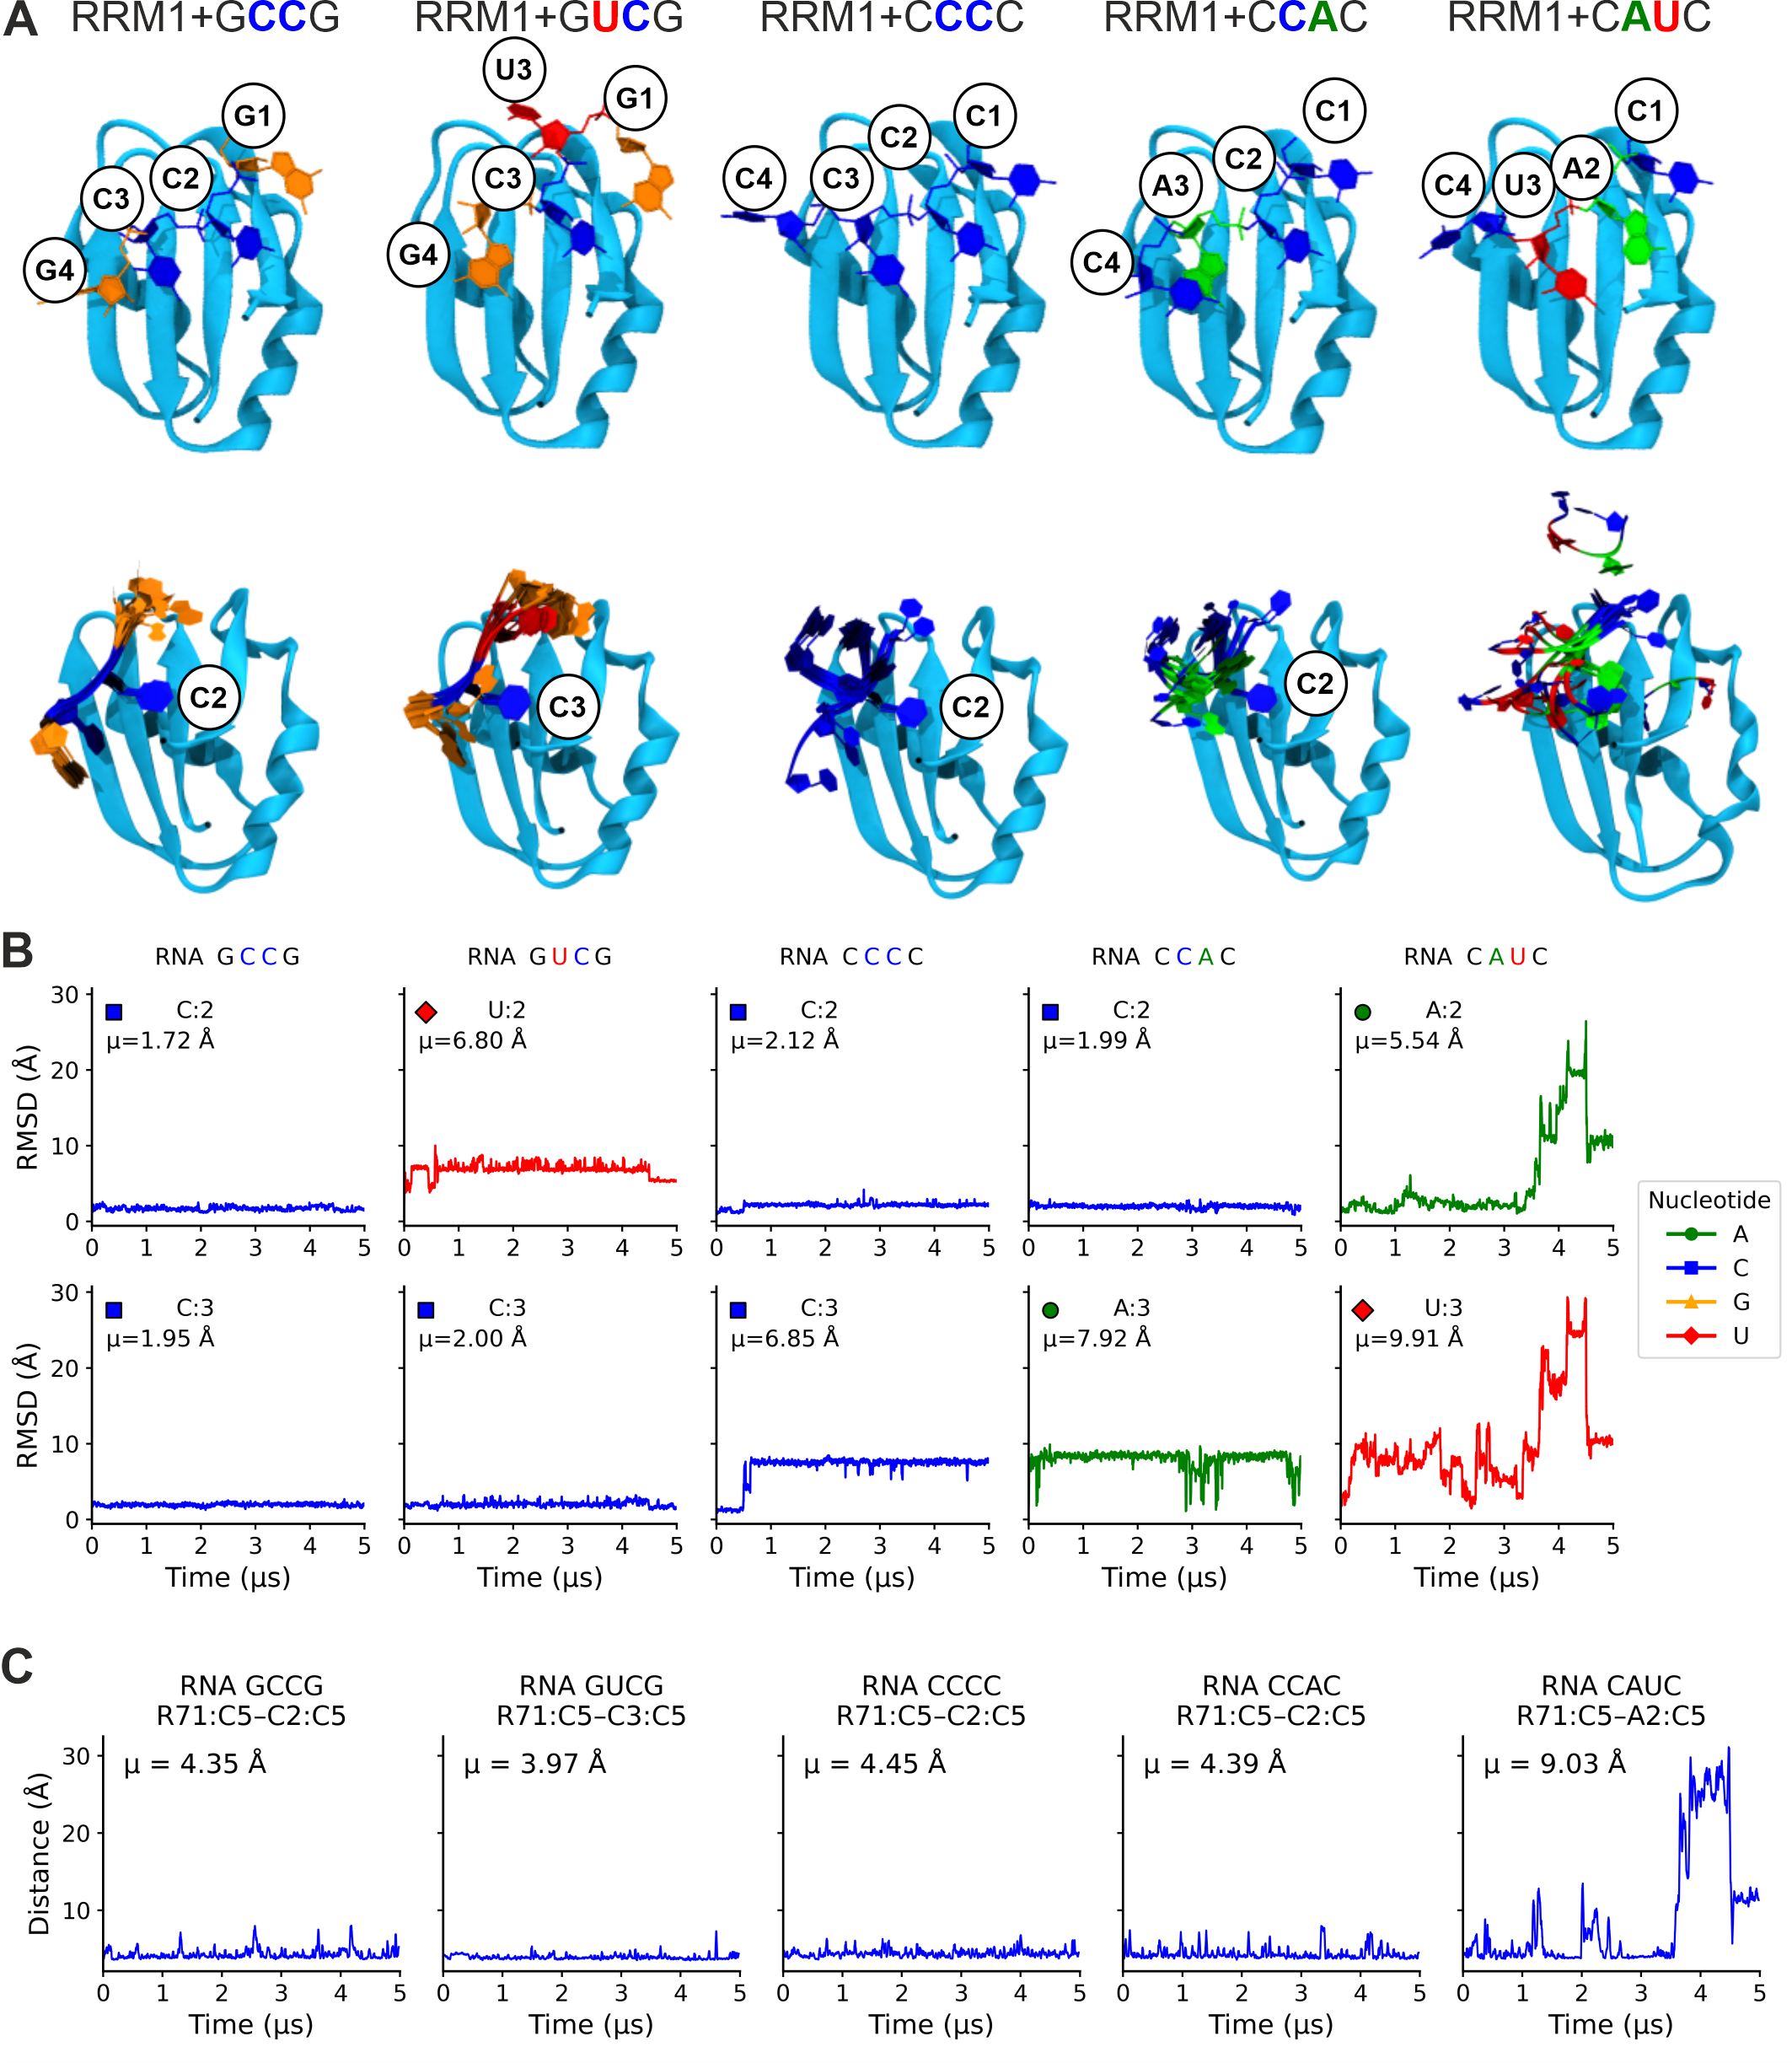
Supplementary Figure 8: Overview of Molecular simulations for SRSF6 RRM1.
A: Top: Structures of SRSF6 RRM1 in complex with RNA tetramers (GCCG, GCUG, CCCC, CACC, and CUAC). Structures are generated using AF3 and were used as starting structures for MD simulations.
Bottom: RNA dynamics from 5-μs simulations per system. RNA configurations are shown in a time step of 0.5 μs after alignment of protein and RNA heavy atoms. The residue placed in the binding pocket is labeled accordingly. Nucleotides are color-coded: A green, C blue, G orange, U red. RMSDs of protein backbone atoms to the NMR structure were between 1.85 and 2.04 Å. B: RMSDs of the second and third RNA residues in RNA tetramers as a function of time. RMSDs were calculated after alignment of protein and RNA heavy atoms. Mean RMSD values are given on top of each plot. Nucleotides are color-coded and marked as follows: A (green circles), C (blue squares), G (orange triangles), and U (red diamonds). The corresponding RNA sequence for each simulation is shown above the plots. C: Distance between Arg71:C5 and Cytosine (C2/C3):C5 over time for each simulation of RRM1 in complex with an RNA tetramer. In systems 1 and 3–5, the second RNA residue occupies the RRM1 binding site. In system 2 (RRM1 + RNA GUCG), the third RNA residue (C3) is positioned at the RRM1 binding site and is therefore shown. Mean distance values are given for each system. The corresponding RNA sequence for each simulation is shown above the plots.

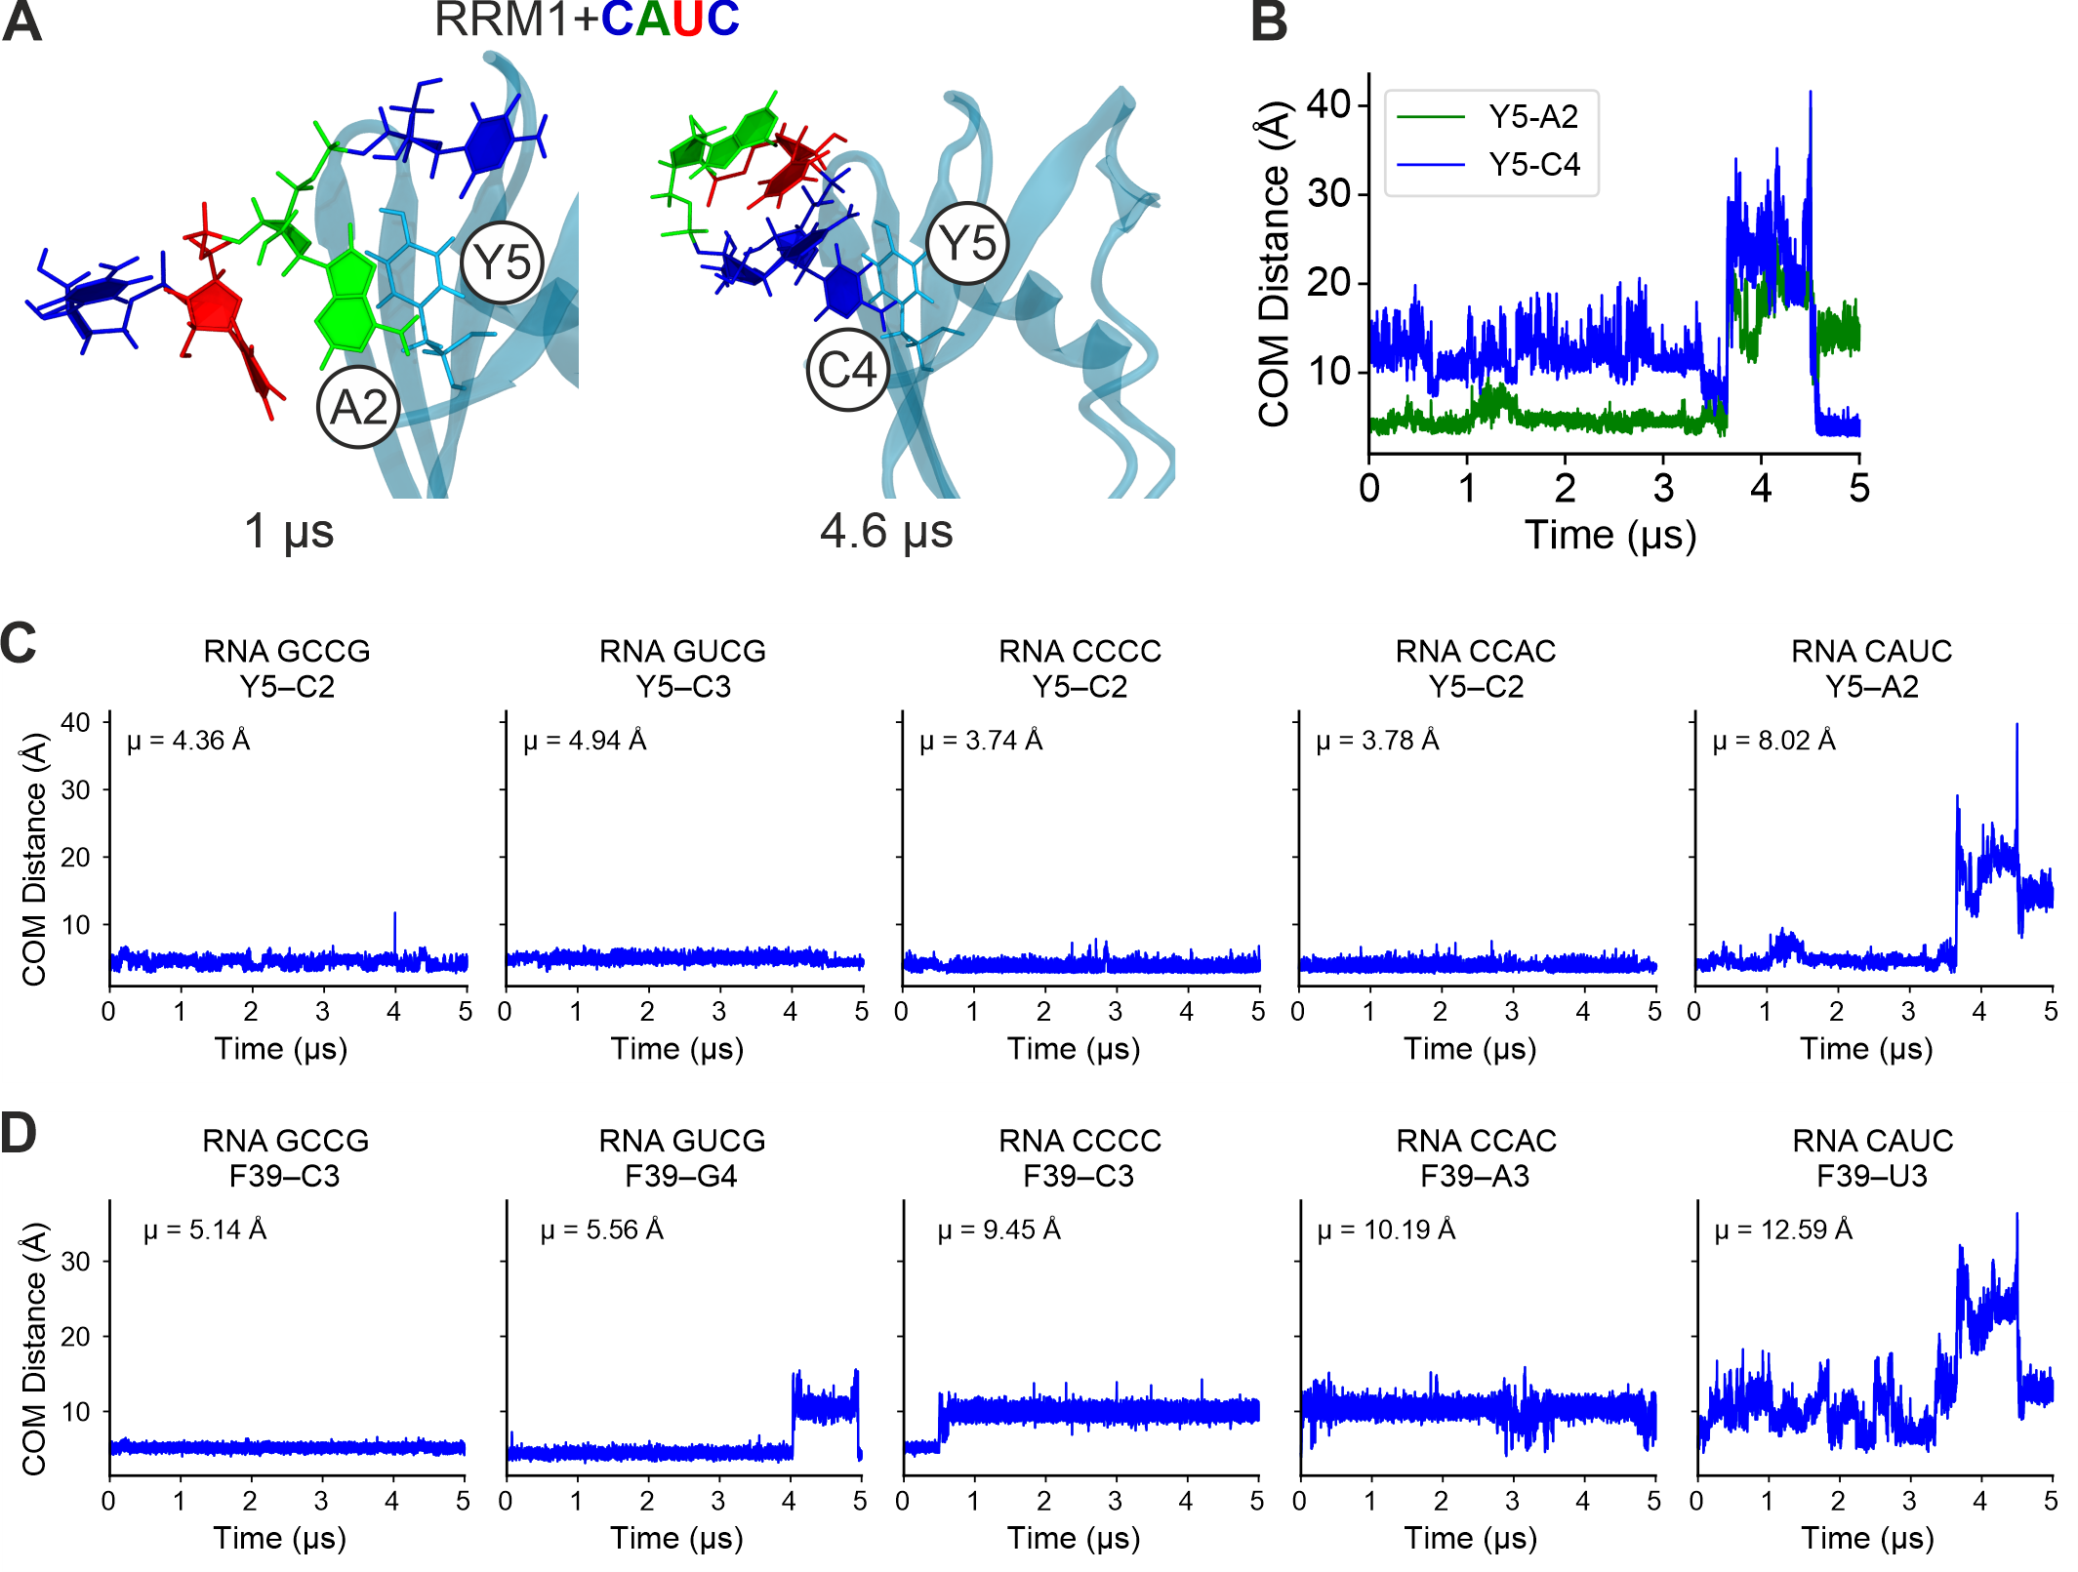
Supplementary Figure 9: Molecular simulations of SRSF6 RRM1 with CAUC RNA.
A: Snapshots from RRM1 RNA CAUC simulations at 1 µs and 4.6 µs. First, A2 (green) is bound to RRM1, after detaching, RNA residue C4 (blue) binds at this position. B: Center of mass distance of RRM1 Tyr5 ring with RNA residues A2 (green) and C4 (blue) rings from simulations. C: Center of mass distance of Tyr5 ring with the respective nucleotide rings over time. D: Center of mass distance of Phe39 rings with the respective nucleotide rings over time.
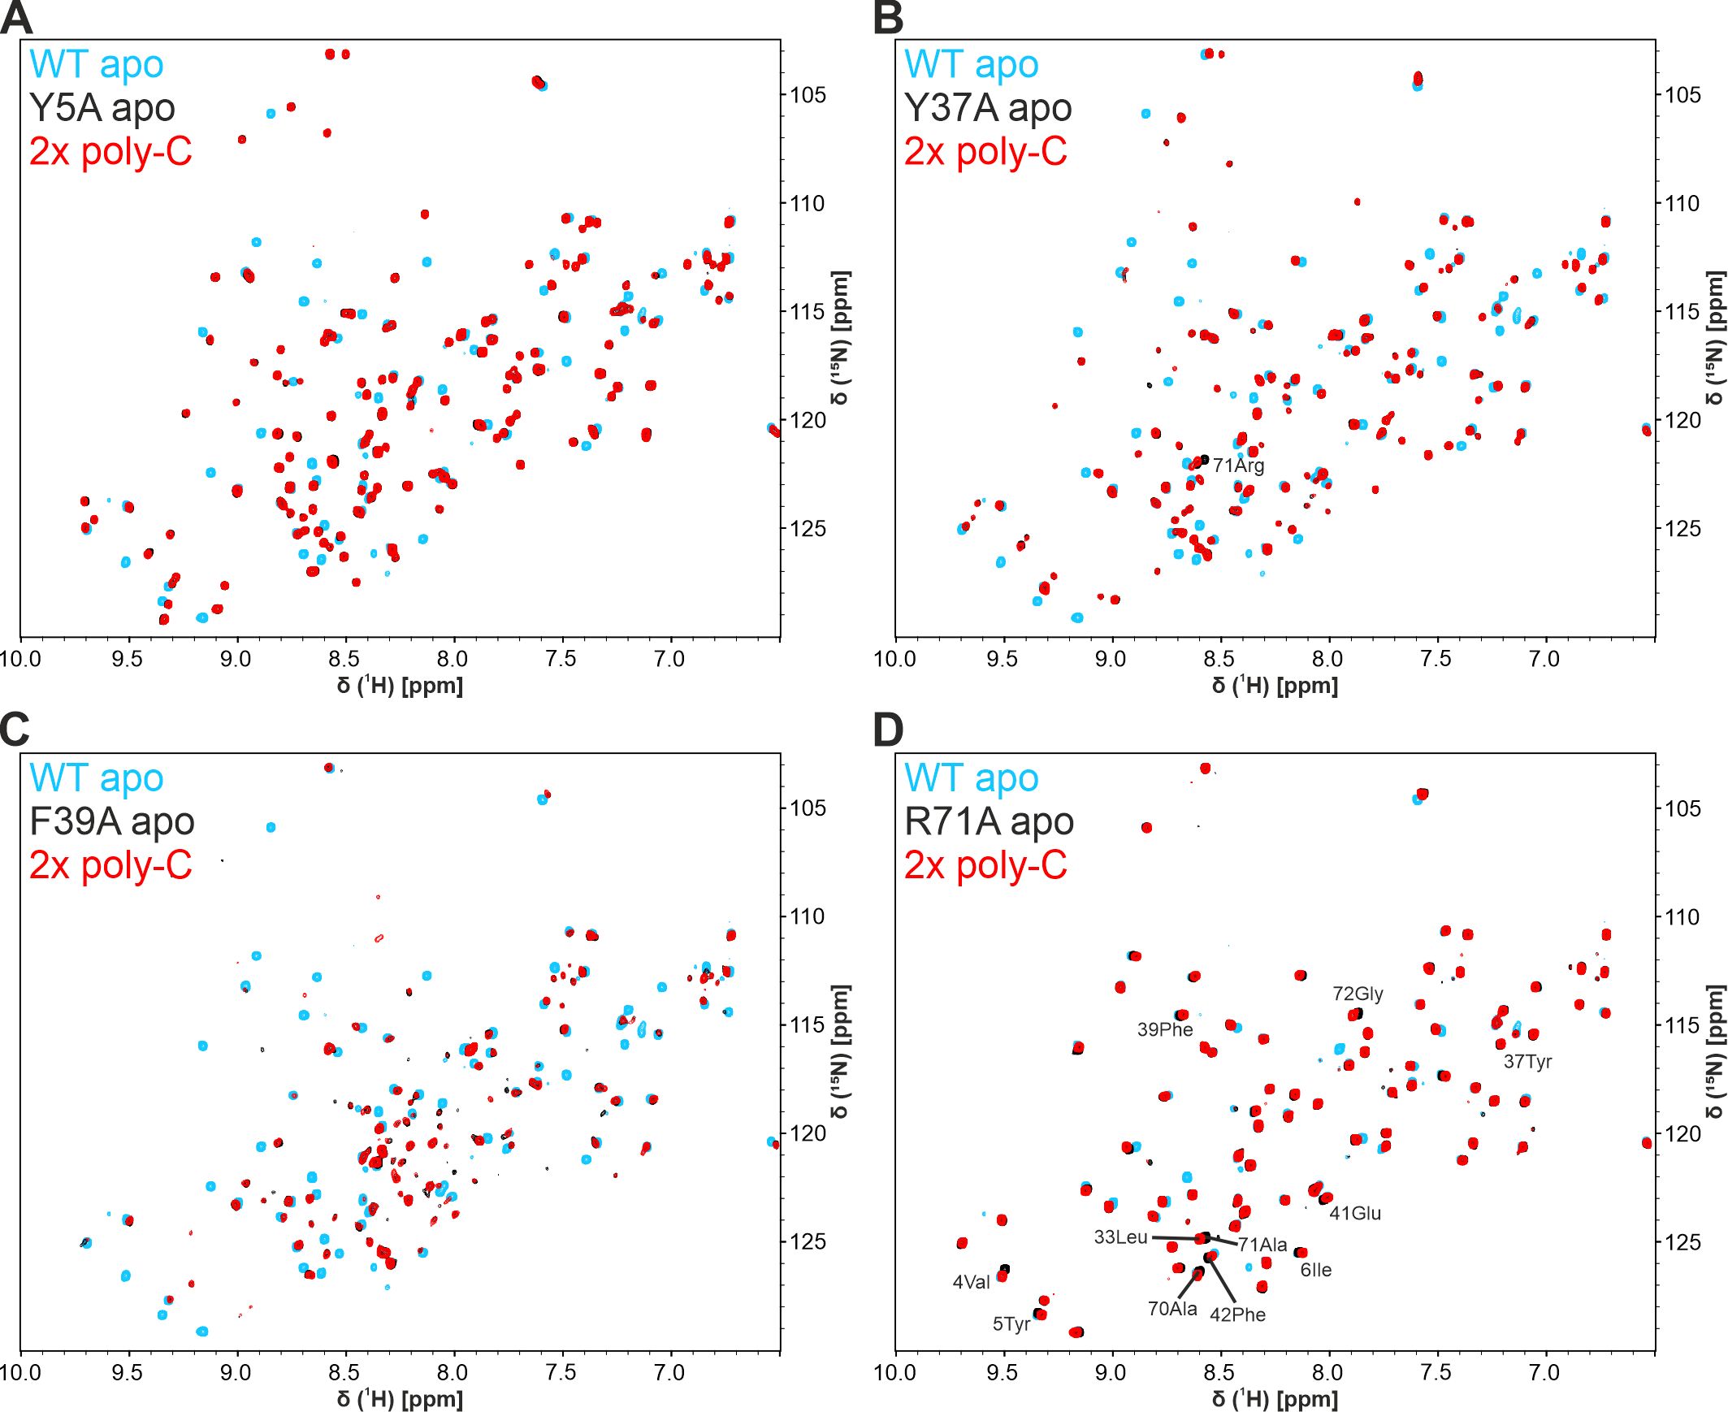
Supplementary Figure 10: Effects of SRSF6 RRM1 mutants on domain conformation and binding to poly-C RNA.
Overlays of ¹H-¹⁵N-HSQC spectra showing RRM1 WT apo (blue) compared to RRM1 mutants apo (black) and with 2-fold molar excess of poly-C RNA (red) as indicated in upper left corner of each spectrum. Spectra were recorded with 70 µM of protein at 298K and 700 MHz in buffer containing 25 mM NaPi, 150 mM NaCl, 50 mM l-R/E, 2 mM DTT, 0.02 % NaN₃ and 5 % (v/v) D₂O at pH 6.5.

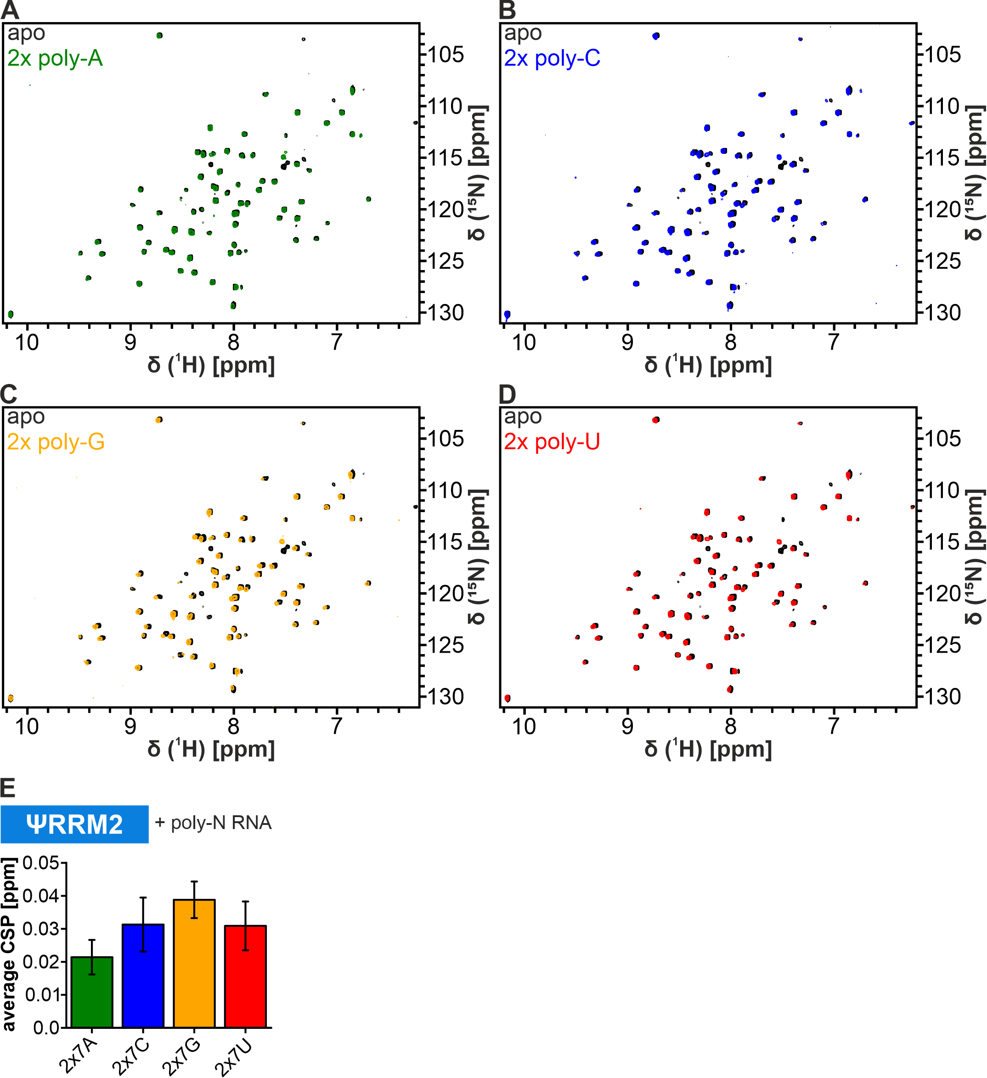
Supplementary Figure 11: ΨRRM2 interaction with RNA.
A-D: Overlays of ¹H-¹⁵N-HSQC spectra of ΨRRM2 upon addition of 2-fold molar excess of poly-N RNAs. All measurements were performed with 40 µM of protein at 298K and 600 MHz in buffer containing 25 mM NaPi, 150 mM NaCl, 2 mM DTT, 0.02 % NaN₃ and 5 % (v/v) D₂O at pH 6.5. E: Average CSPs from spectra in A-D.

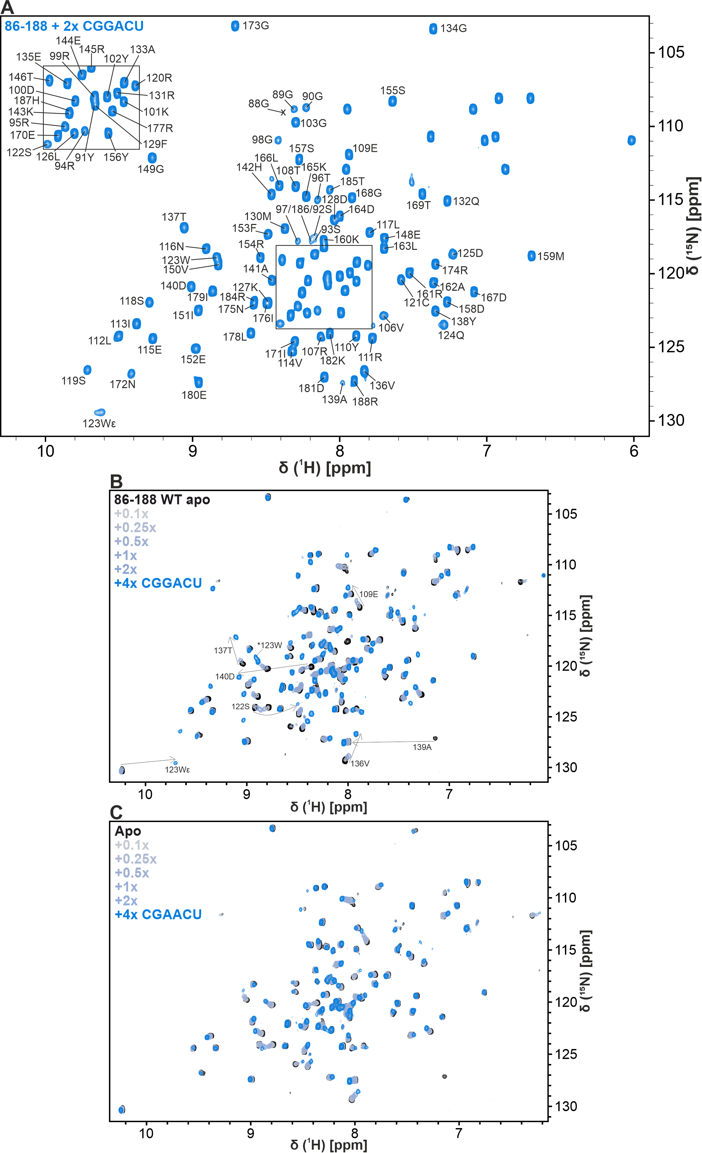
Supplementary Figure 12: NMR-observed titrations of ΨRRM2 (86-188) with 6-mer RNAs.
A: ¹H-¹⁵N-HSQC of ΨRRM2 with 2-fold molar excess of CGGACU RNA. Assignments based on triple resonance experiments are shown for respective peaks. B/C: ¹H-¹⁵N-HSQC spectra of ΨRRM2 titrated with CGGACU RNA (B) and CGAACU RNA (C). Spectra in B and C were recorded with 100 µM of protein at 600 MHz and 298 K in buffer containing 20 mM NaPi, 170 mM NaCl, 60 mM l-R/E, 2 mM DTT, 0.02 % NaN₃ and 5 % (v/v) D₂O at pH 7.0.

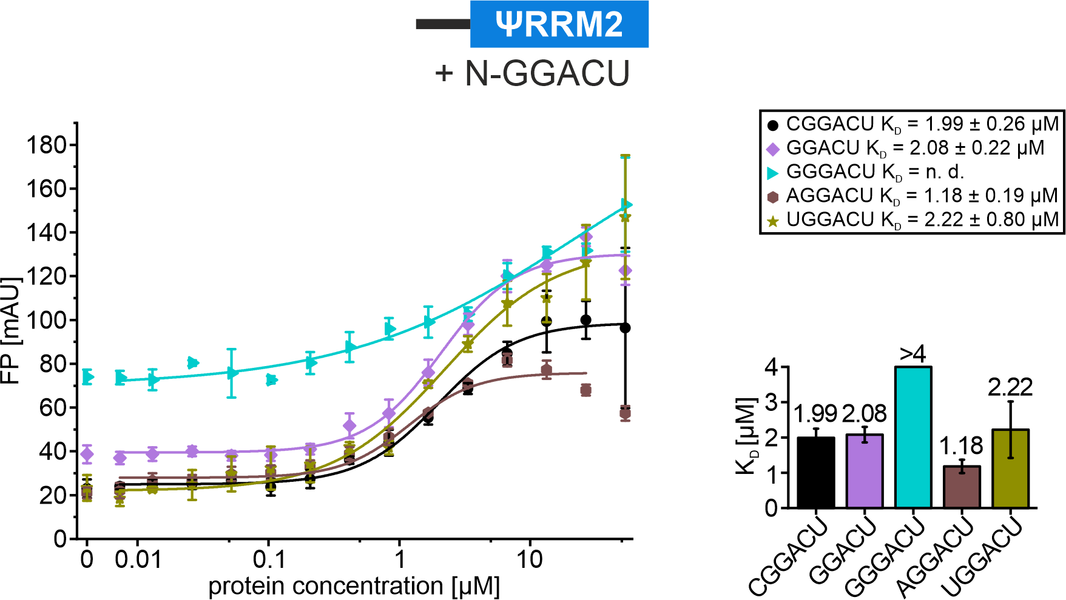
Supplementary Figure 13: FP assay of ΨRRM2 (86-188) with N-GGACU RNA.
Measurements were performed in triplicates; averages with standard deviation plotted and fitted to derive affinities (K_{D}).
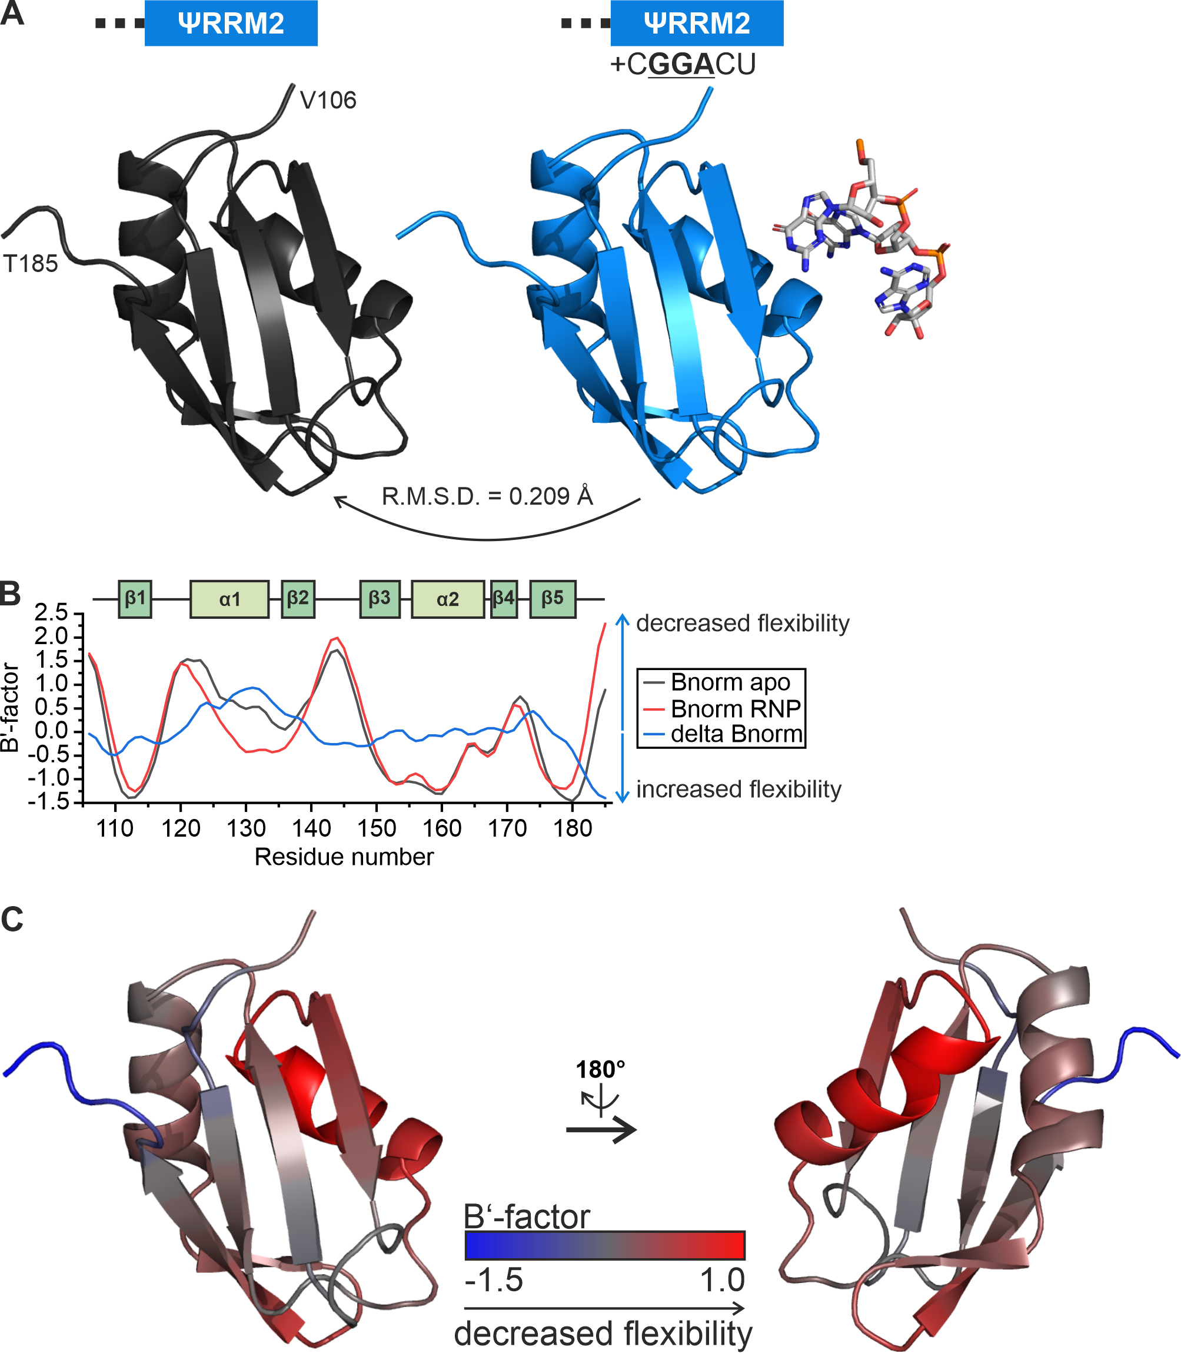
Supplementary Figure 14: Comparison of SRSF6 ΨRRM2 apo and RNP structure.
A: Alignment and comparison of the SRSF6 ΨRRM2 apo structure with the structure in complex with CGGACU RNA. B: Comparison of B-factors from the crystal structures in A. The comparison has been performed using BANΔIT ². Secondary structure elements from the crystal structure are shown at the top for comparison. C: Change in B-factor (delta Bnorm from B) between the apo and complex structure plotted on the apo protein. Red indicates decreased flexibility and blue an increase in flexibility.

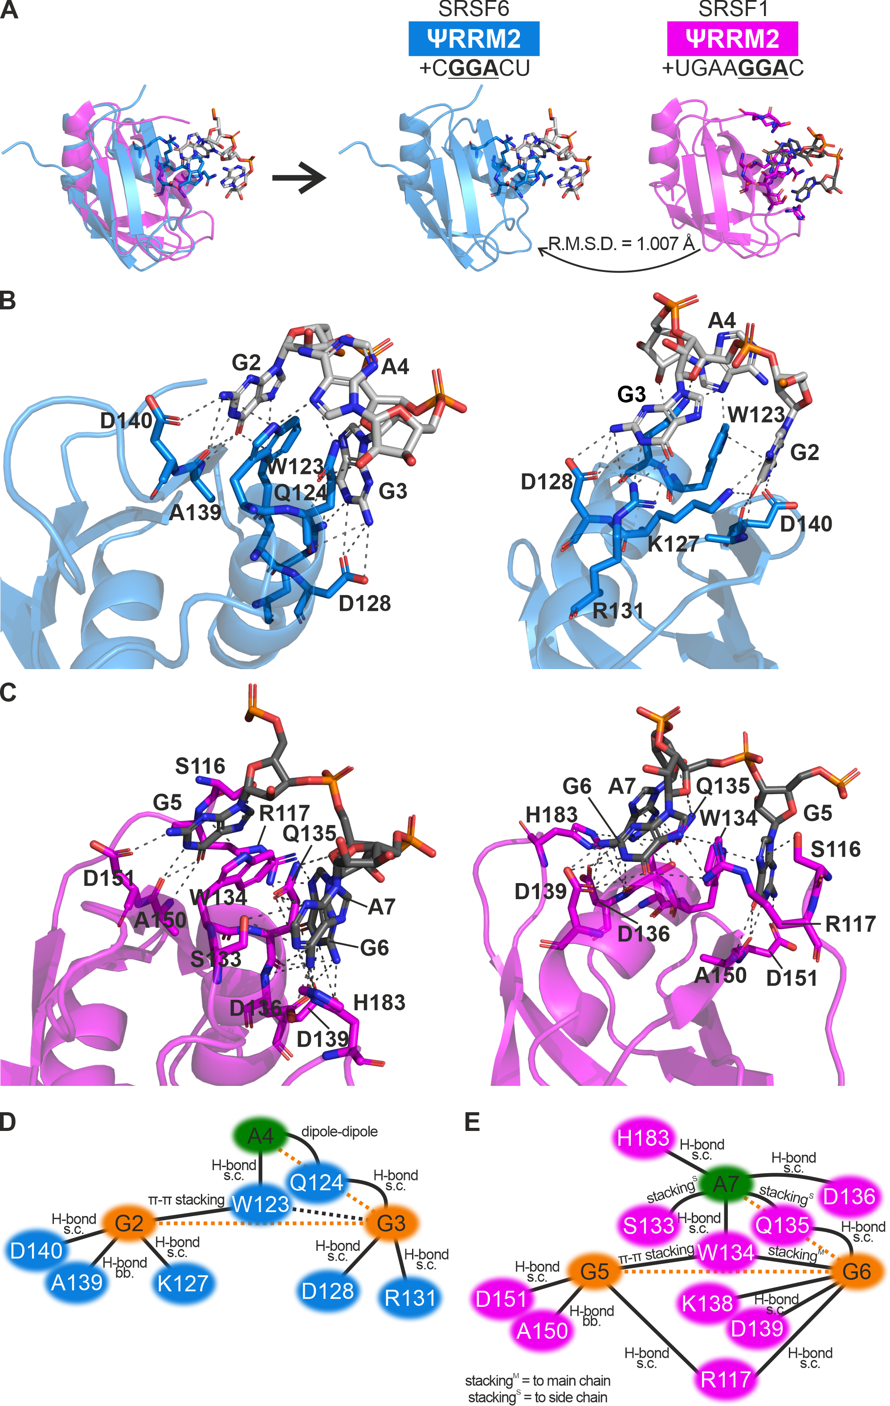
Supplementary Figure 15: Comparison of SRSF1 and SRSF6 ΨRRM2 in complex with RNA.
A: Direct alignment of SRSF1 and SRSF6 ΨRRM2 in complex with UGAAGGAC and CGGACU RNA, respectively. B: Zoom-ins on the SRSF6 ΨRRM2 structure in complex with CGGACU RNA as shown in Fig. 3B/C. C: Zoom-ins on the SRSF1 ΨRRM2 in complex with UGAAGGAC RNA. D: Contact map of SRSF6 ΨRRM2 in complex with CGGACU RNA. E: Contact map of SRSF1 ΨRRM2 in complex with UGAAGGAC RNA.

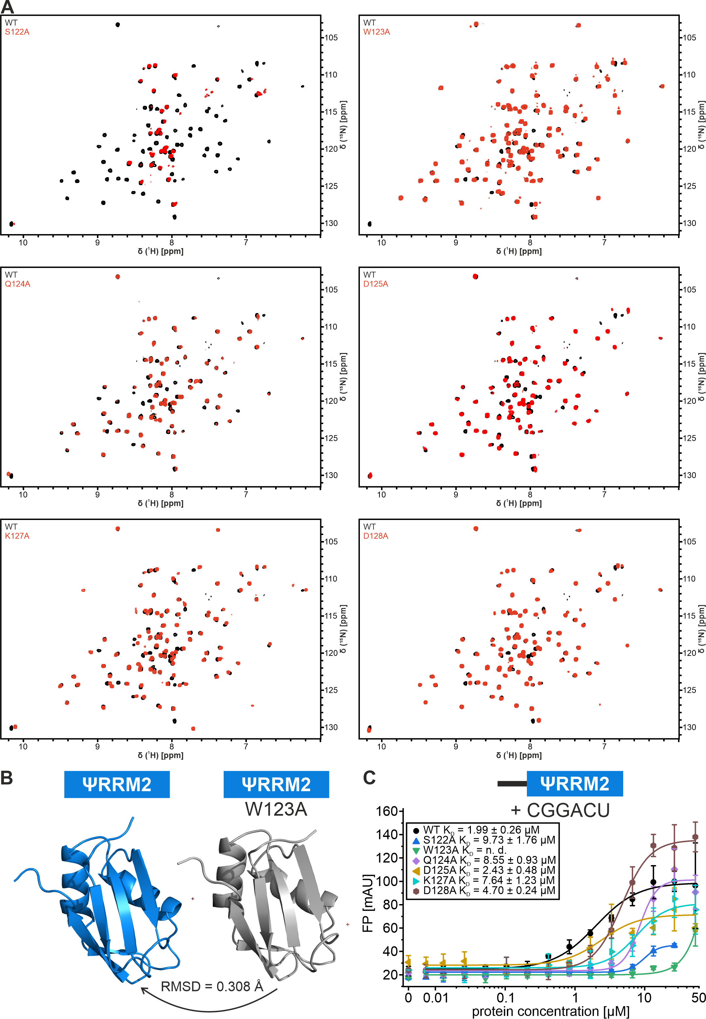
Supplementary Figure 16: Comparisons of ΨRRM2 WT and mutants.
A: ¹H-¹⁵N-HSQC comparison of ΨRRM2 WT and mutants. B: Comparison of the ΨRRM2 WT and W123A crystal structure. The RMSD between backbone atoms is given at the bottom. C: FP measurements of ΨRRM2 mutants with CGGACU RNA.

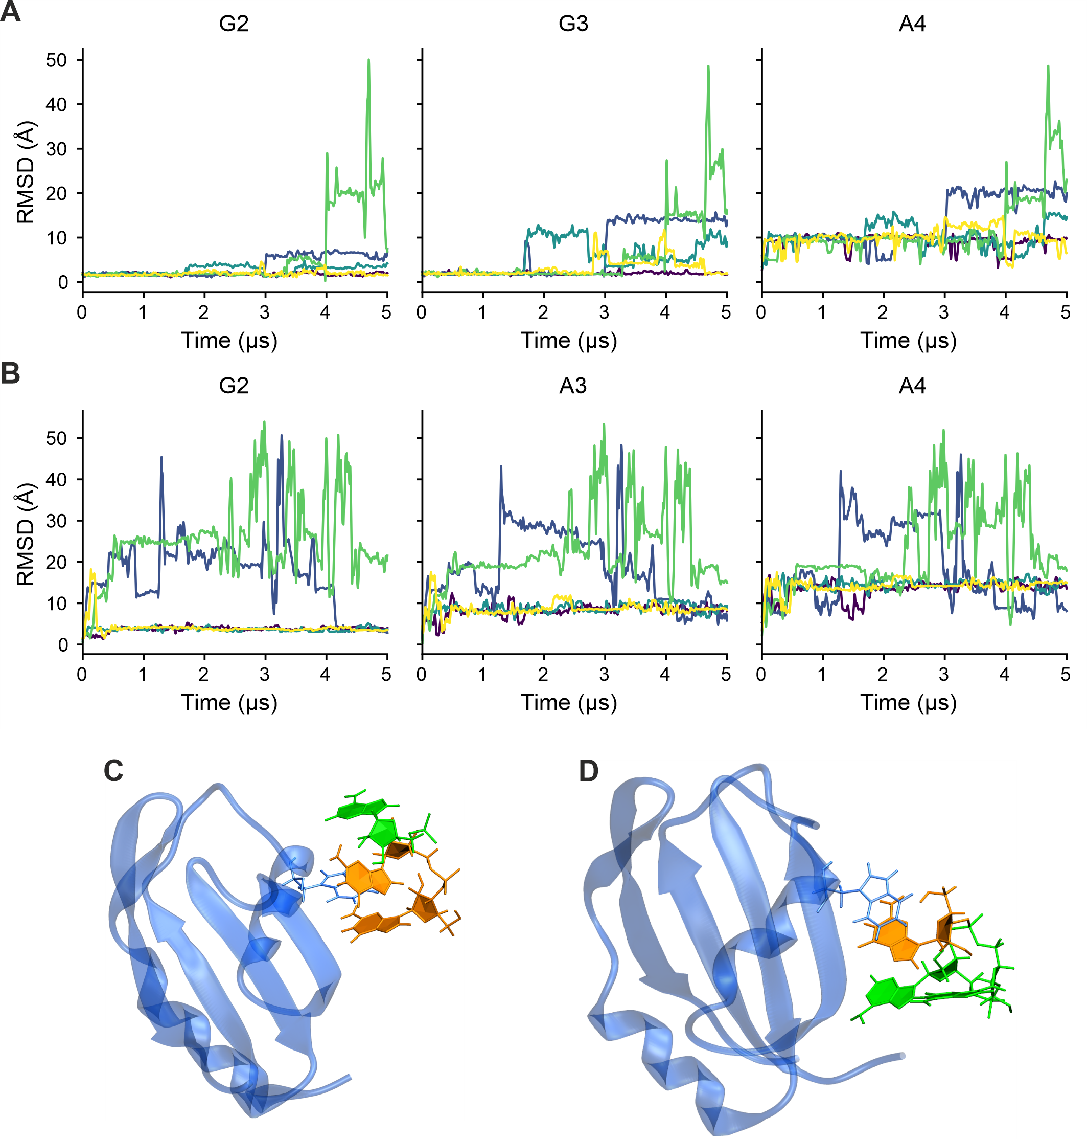
Supplementary Figure 17: RNA RMSDs from simulations of SRSF6 ΨRRM2 in complex with GGA (A/C) and GAA (B/D) RNA.
A/B: RMSDs were calculated after alignment of protein and RNA heavy atoms. Each plot shows the RMSD for a single RNA residue, with colors indicating individual replicas. For the GGA RNA in two of the five replicas, the RNA reoriented: G3 flipped, allowing its O6 atom to engage with the guanidinium group of R131. This rearrangement did not preserve the initial binding pose. C/D: Time-averaged structures of SRSF6 ΨRRM2 in complex with GGA (C) or GAA (D) RNA from MD simulations. Guanines and adenines are depicted orange and green, respectively. From the protein, the W123 sidechain is highlighted in stick representation.
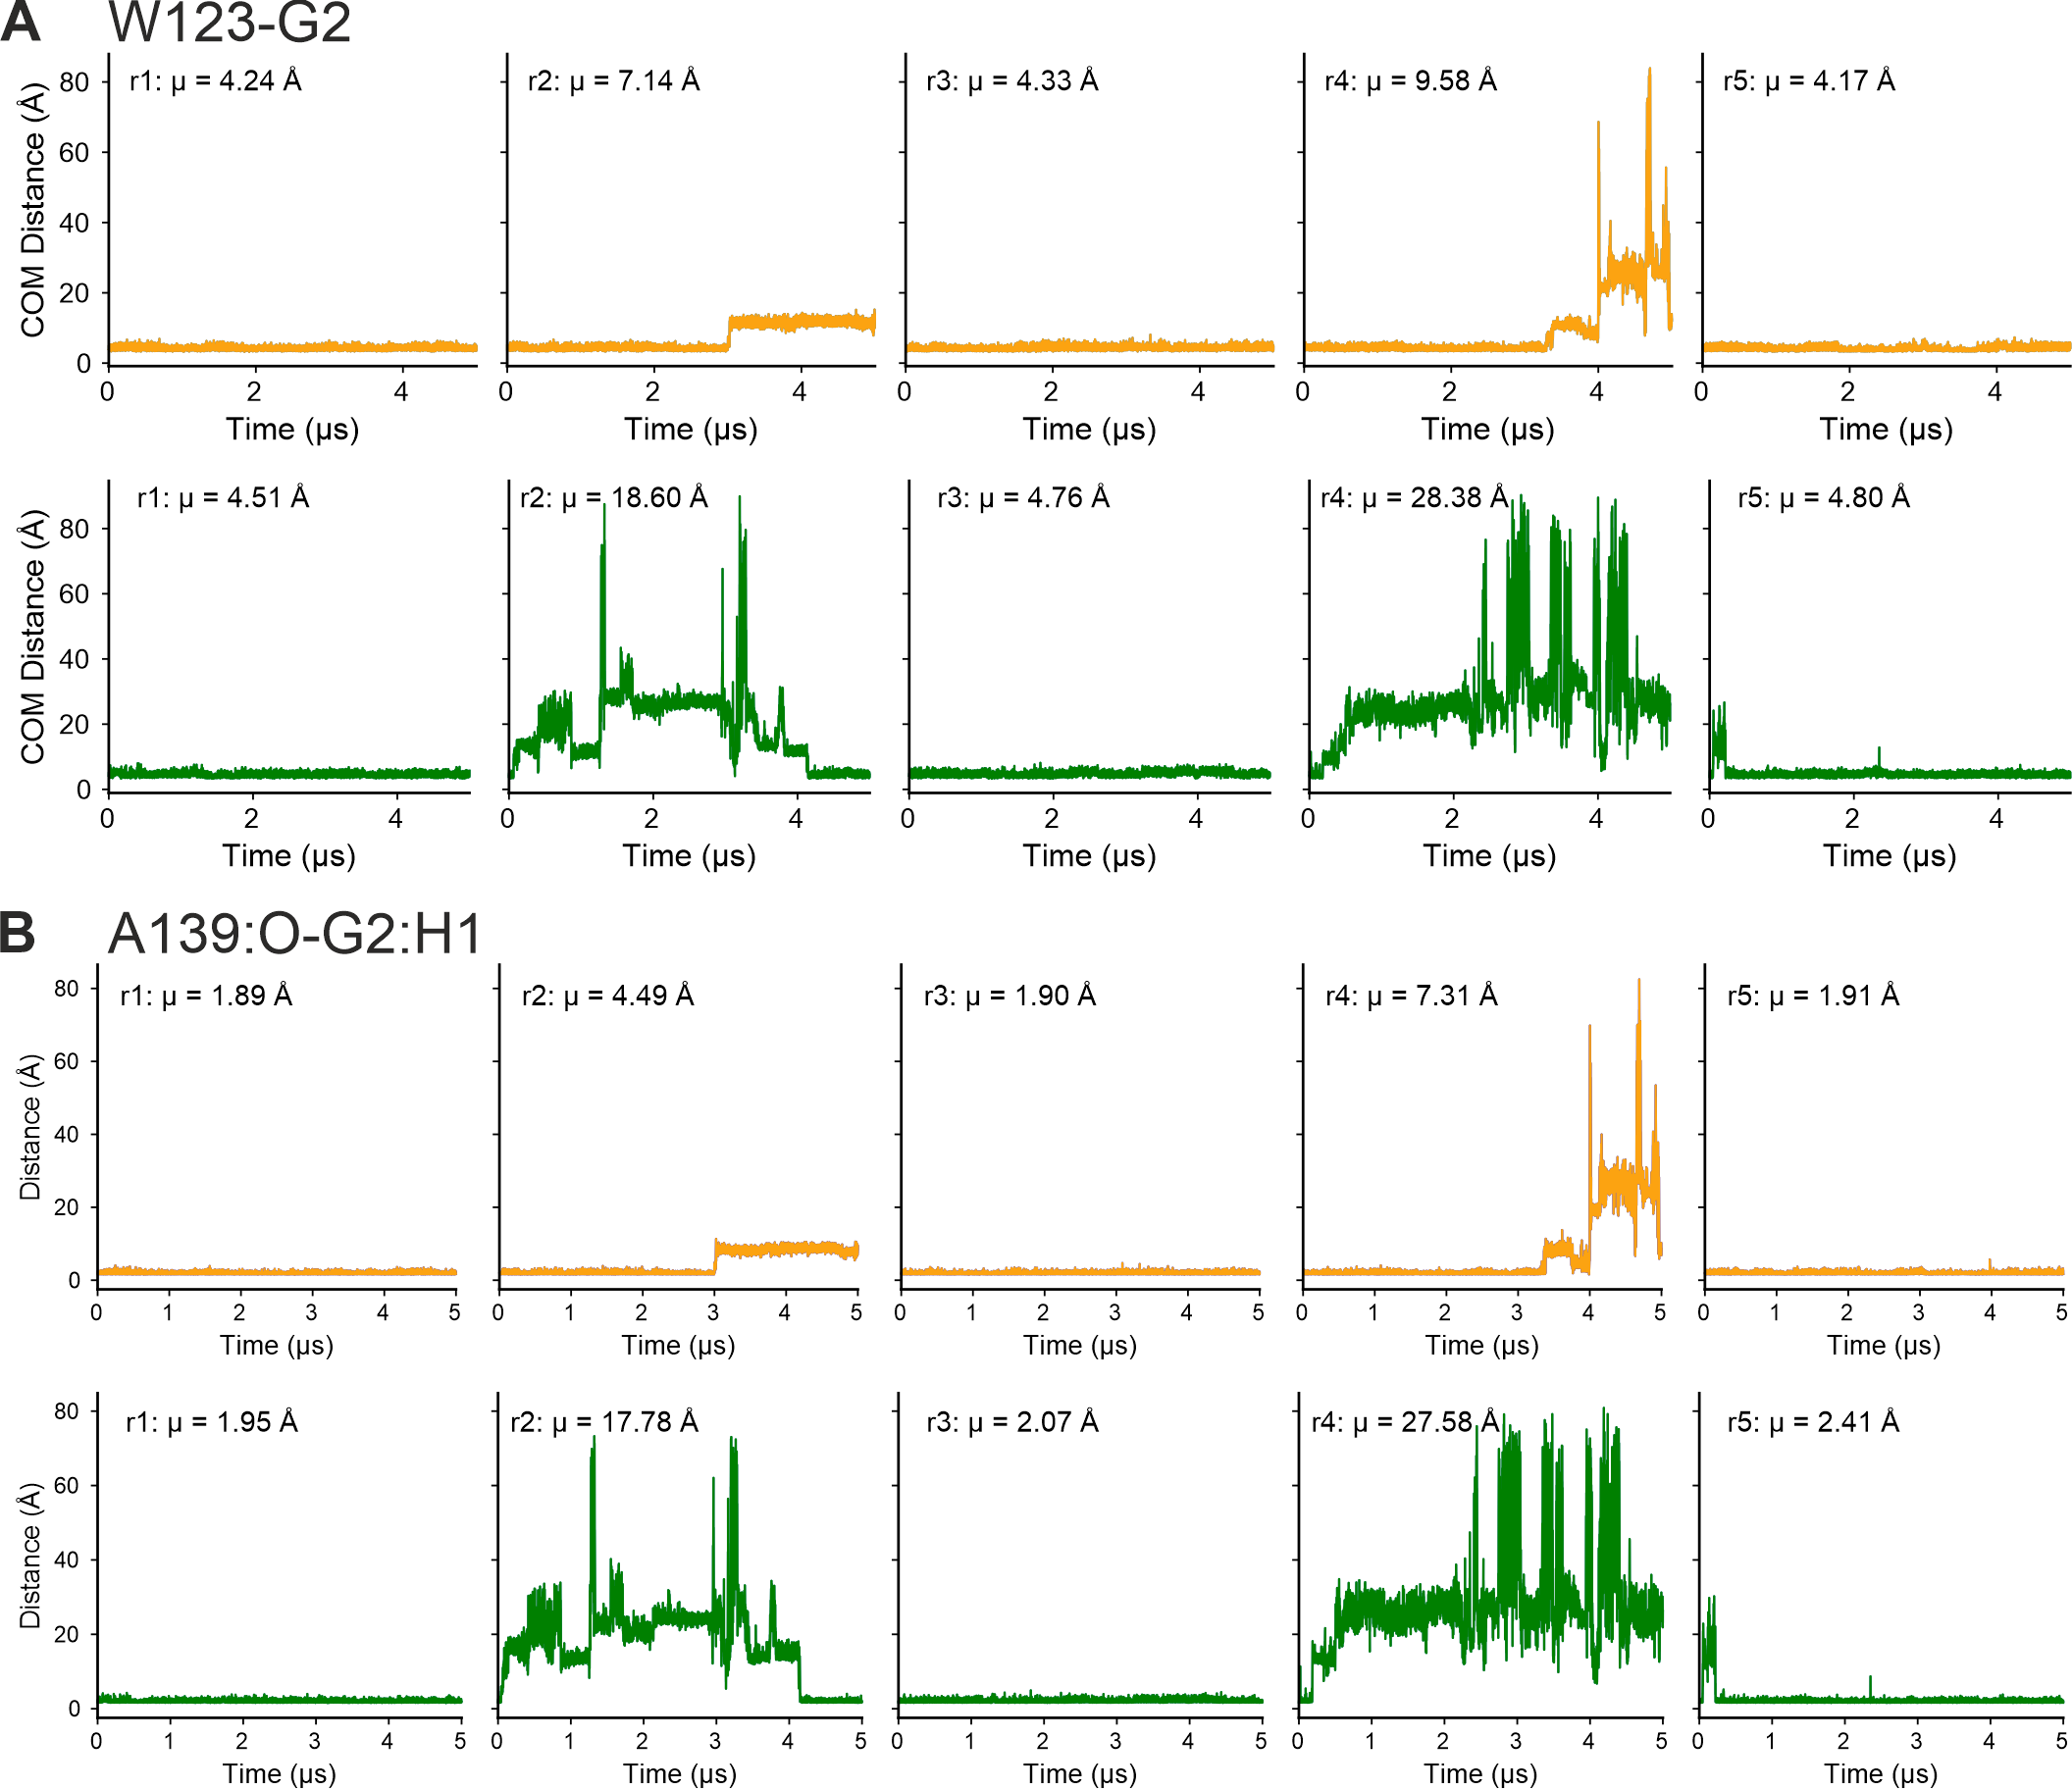
Supplementary Figure 18: Distance measurements of SRSF6 ΨRRM2 residues with GGA (orange and GAA (green) RNA.
A: Center of mass distances of Tryptophan 123 with Guanine 2 from simulations of SRSF6 ΨRRM2 with GGA (top) and GAA (bottom) RNA. Mean values are given for each replica. B: Distances measurements of Alanine 139:O with Guanine 2:H1 from simulations of SRSF6 ΨRRM2 with GGA (top) and GAA (bottom) RNA. Mean values are given for each replica.

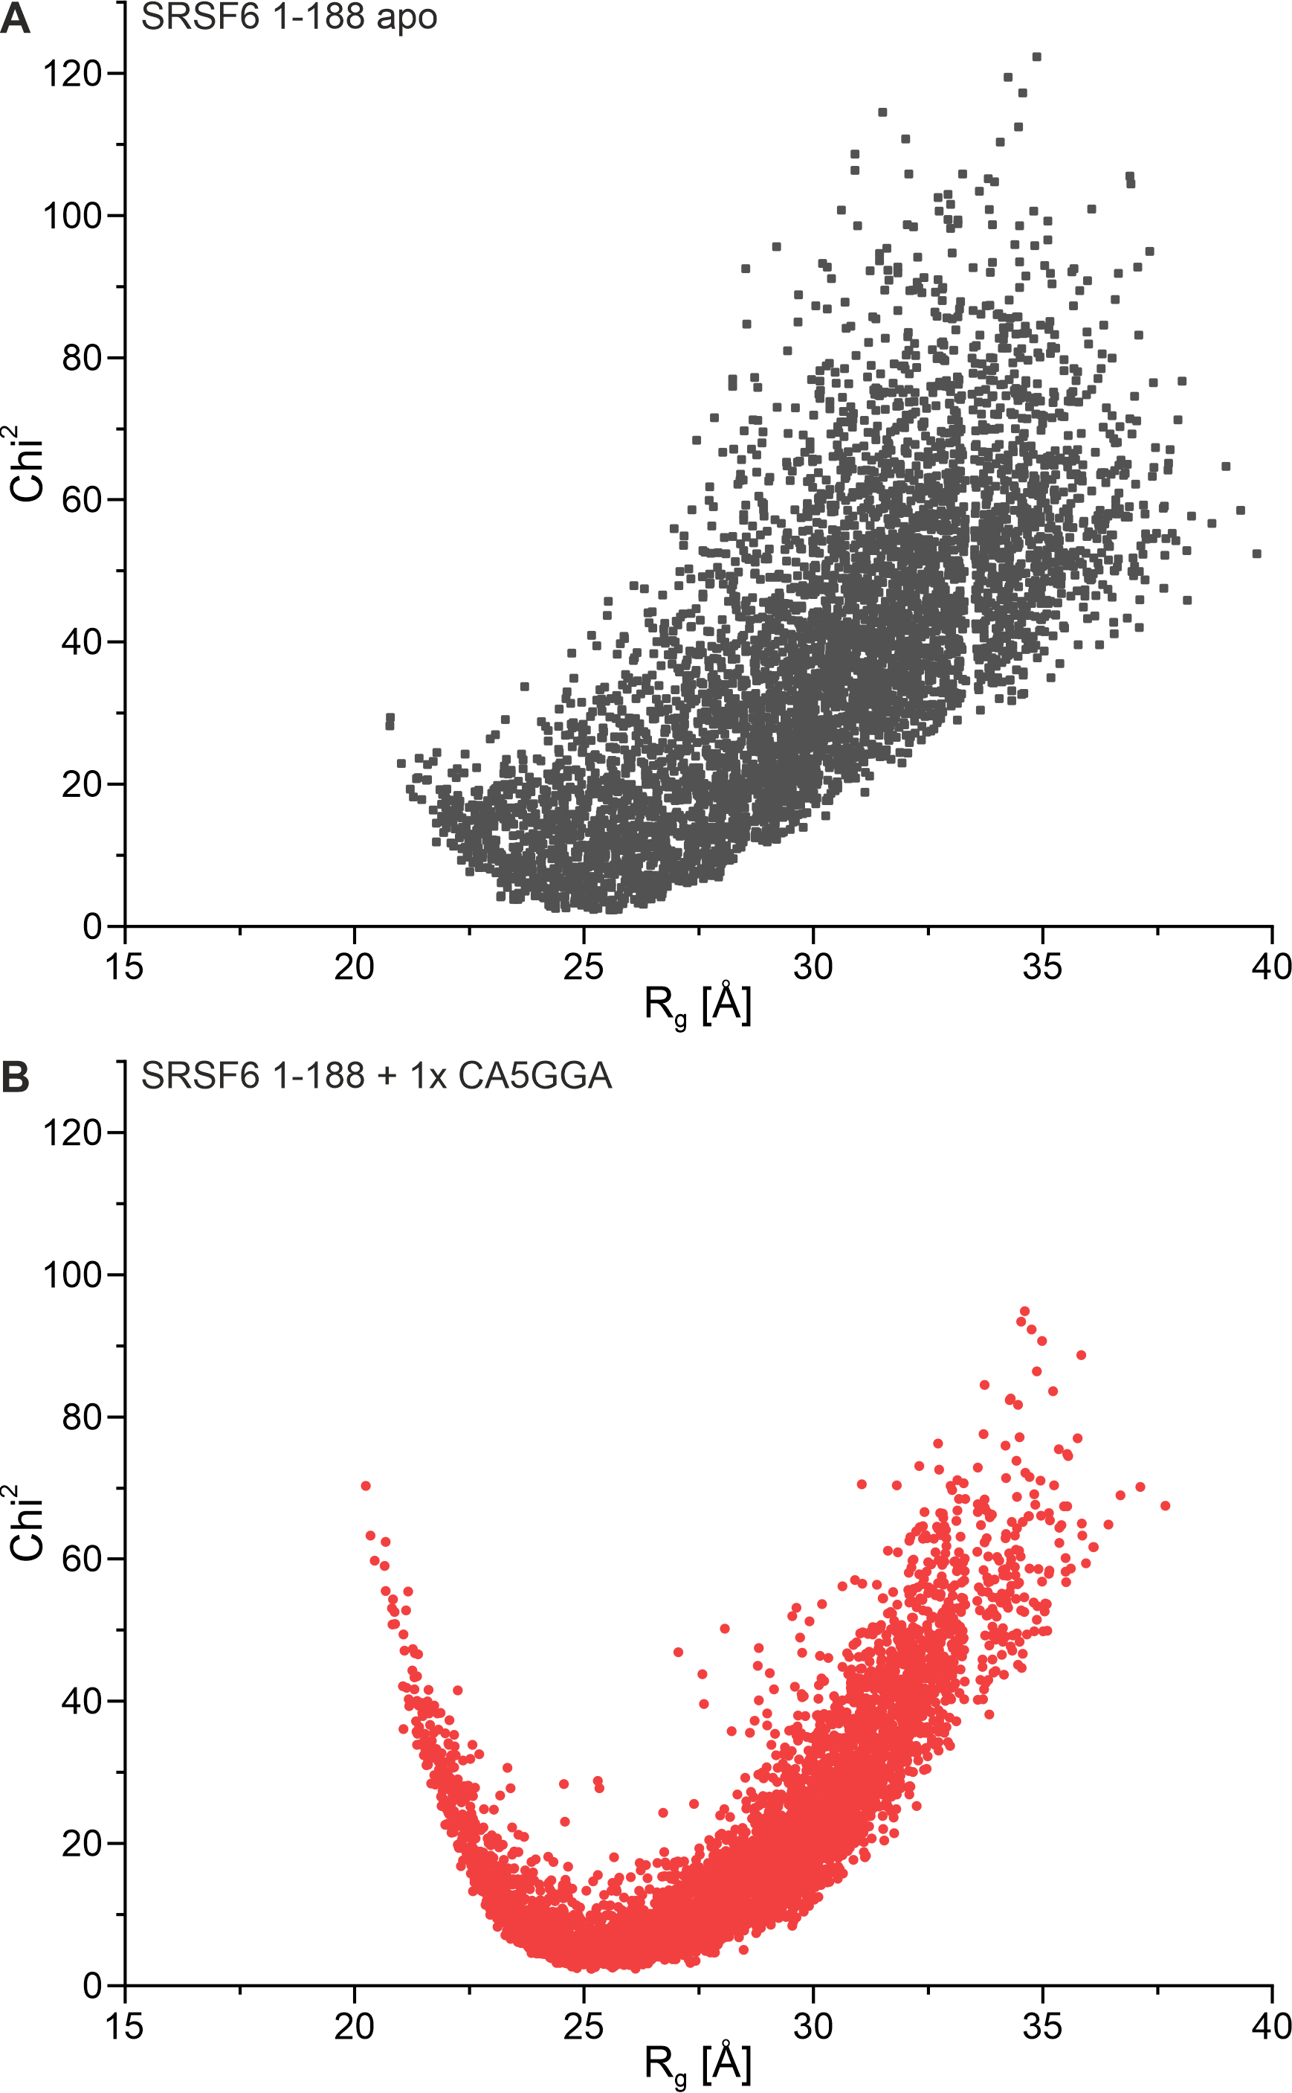
Supplementary Figure 19: Scatter plots of the 5000 models used for SAXS filtering.
Scatter plot for tandem RRM apo (1-188, A) and in complex with CA5GGA RNA (B), showing the distribution of R_{g} of each model and how well the single models fit to the SAXS data (Chi²).
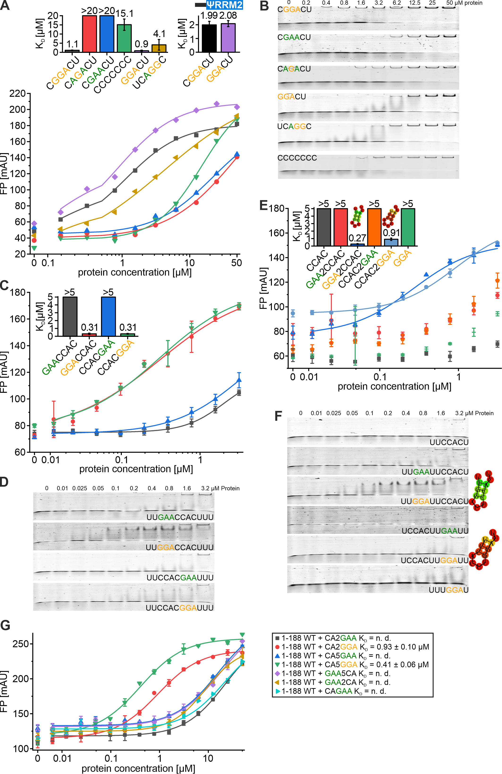
Supplementary Figure 20: Protein-RNA interactions of SRSF6 RRM1-2 as observed by FP and EMSA.
A: FP curves and fits of SRSF6 tandem RRM (1-188) binding to 5-7-mer RNAs. Obtained affinities are plotted as a bar chart. Affinity plot for ΨRRM2 for CGGACU and GGACU RNA is taken from Supplementary Figure 12 for reference. B: Representative EMSAs corresponding to A. C: FP curves and fits of SRSF6 tandem RRM (1-188) binding to 12-mer RNAs with inverted motifs for RRM1/ΨRRM2 RNA recognition. Obtained affinities are plotted as a bar chart. D: Representative EMSAs corresponding to C. E: FP curves and fits of SRSF6 tandem RRM (1-188) binding to 12-mer RNAs with inverted motifs for RRM1/ ΨRRM2 RNA recognition as well as single RRM preference motifs (CCAC and GGA RNA). Obtained affinities are plotted as a bar chart. Secondary structure icons are shown for RNAs that have been predicted to potentially form base pairing. F: Representative EMSAs corresponding to E. G: FP curves and fits of SRSF6 tandem RRM (1-188) binding to 12-mer RNAs with CA (RRM1) and GGA/GAA (ΨRRM2) motifs.

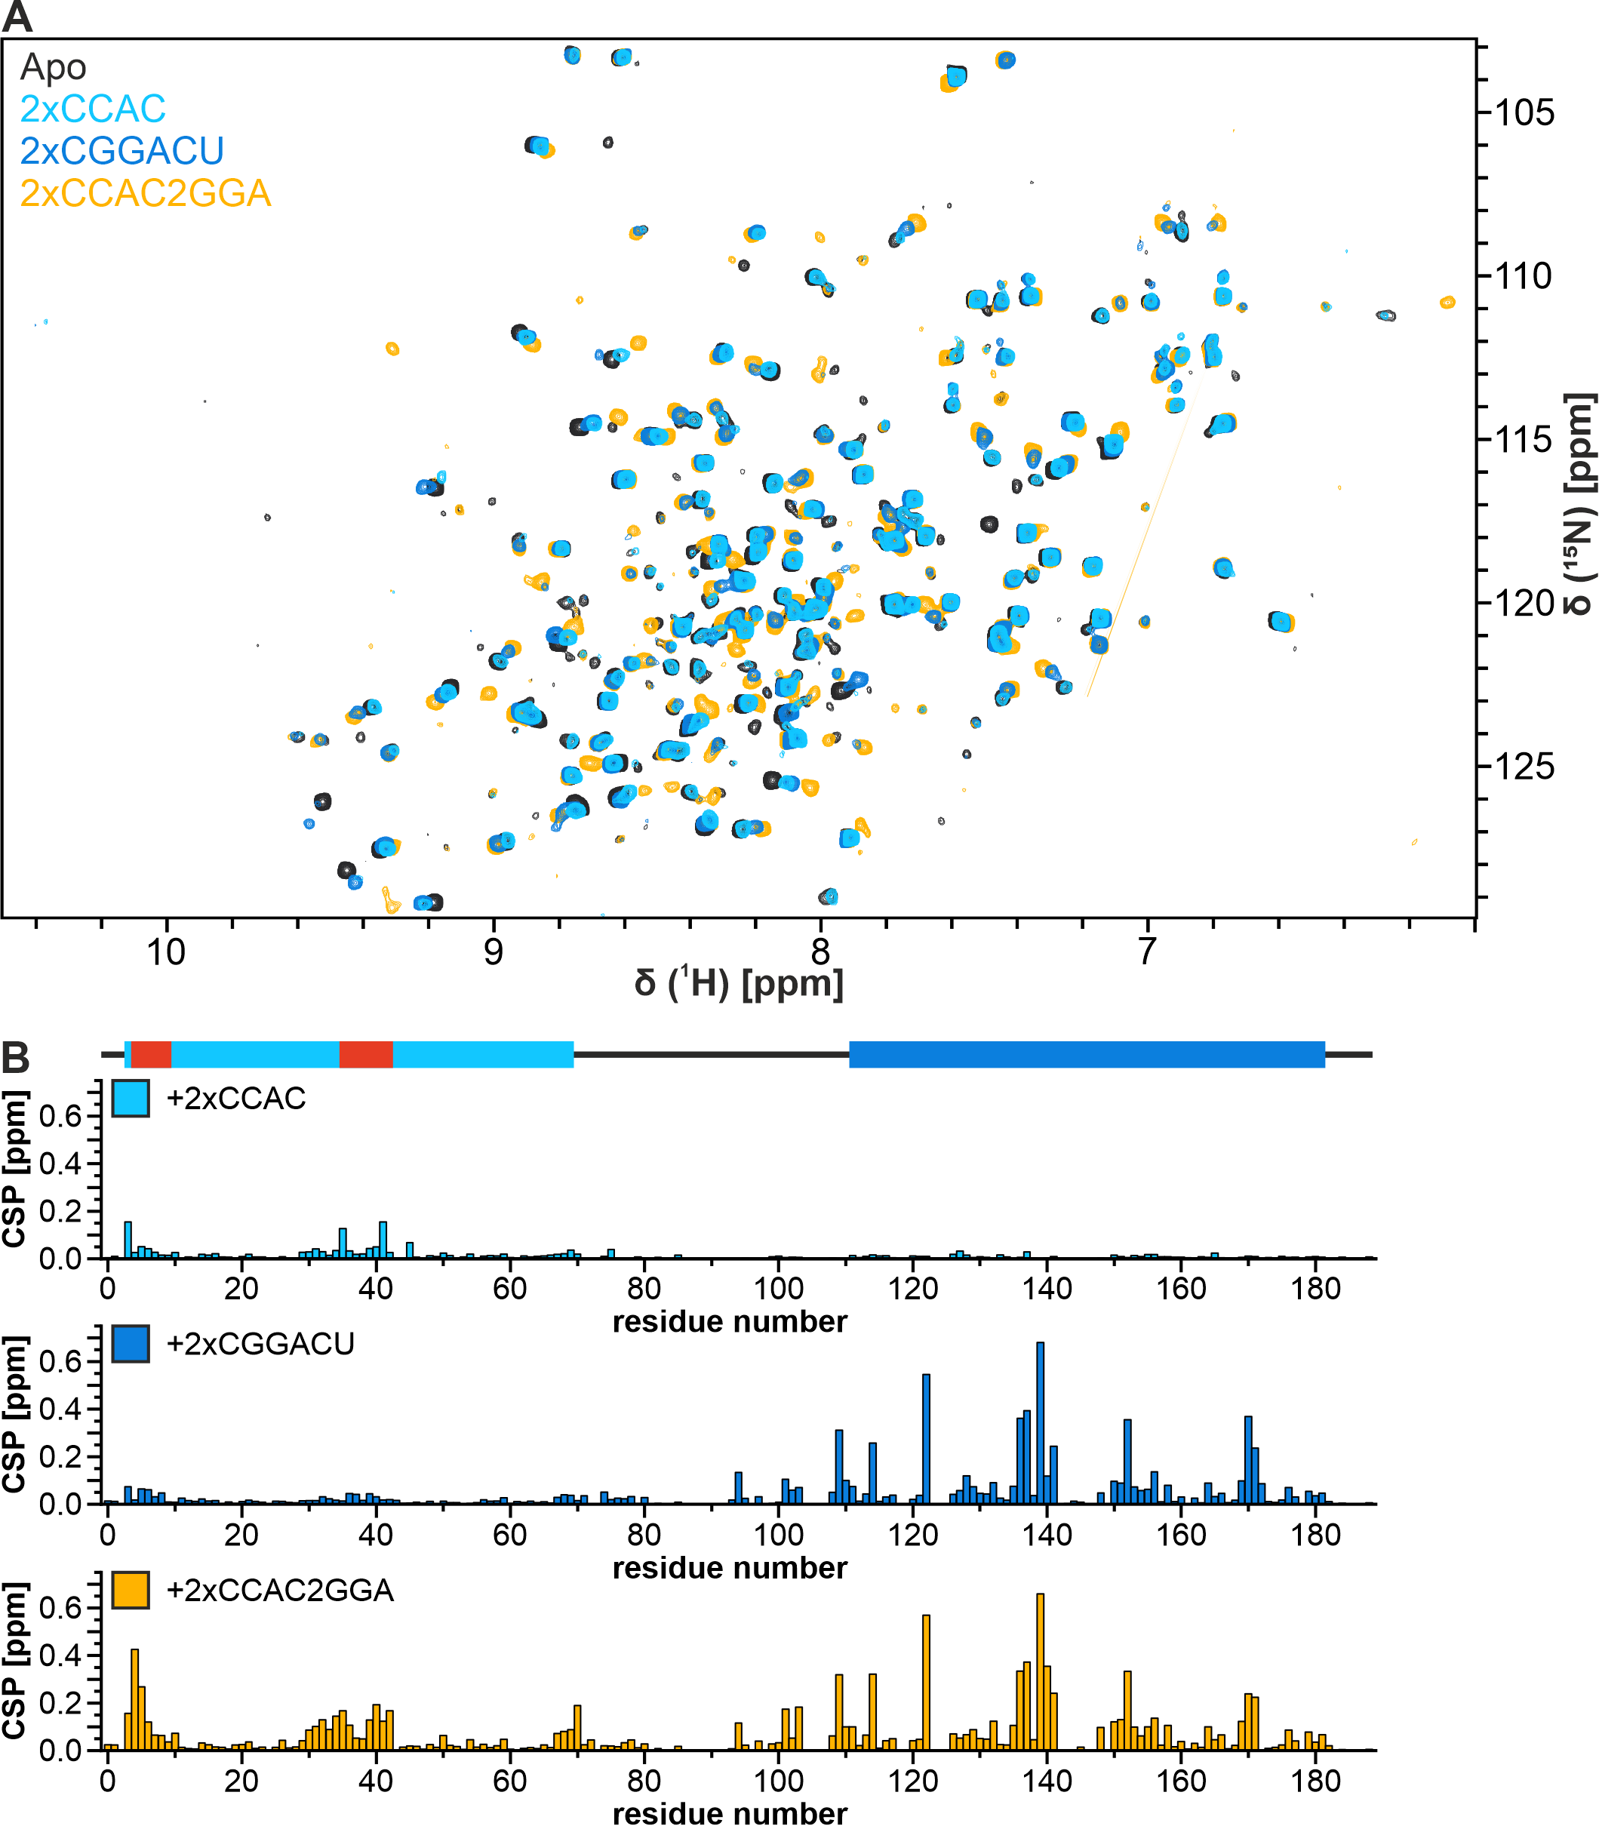
Supplementary Figure 21: SRSF6 Tandem RRM-RNA interaction with three different RNAs.
A: ¹H-¹⁵N-HSQC spectra of the tandem RRM alone and in presence of 2-fold molar excess of three different RNAs as indicated in top left corner. Spectra were recorded at a ¹H-Larmor frequency of 950 MHz at a protein concentration of 100 µM (apo/+2xCCAC2GGA-RNA), 40 µM (+2xCGGACU-RNA) or 25 µM (+2xCCAC-RNA) in buffer containing 20 mM NaPi, 150 mM NaCl, 380 mM l-R/E, 2 mM TCEP, 0.02 % NaN₃, 100 µM DSS and 7 % D₂O at pH 7.0 and 310K. B: ¹H-¹⁵N-combined chemical shift perturbation plot of tandem RRM upon addition of 2-fold molar excess of CCAC, CGGACU and CCAC2GGA RNA as indicated in top left corner of each panel.

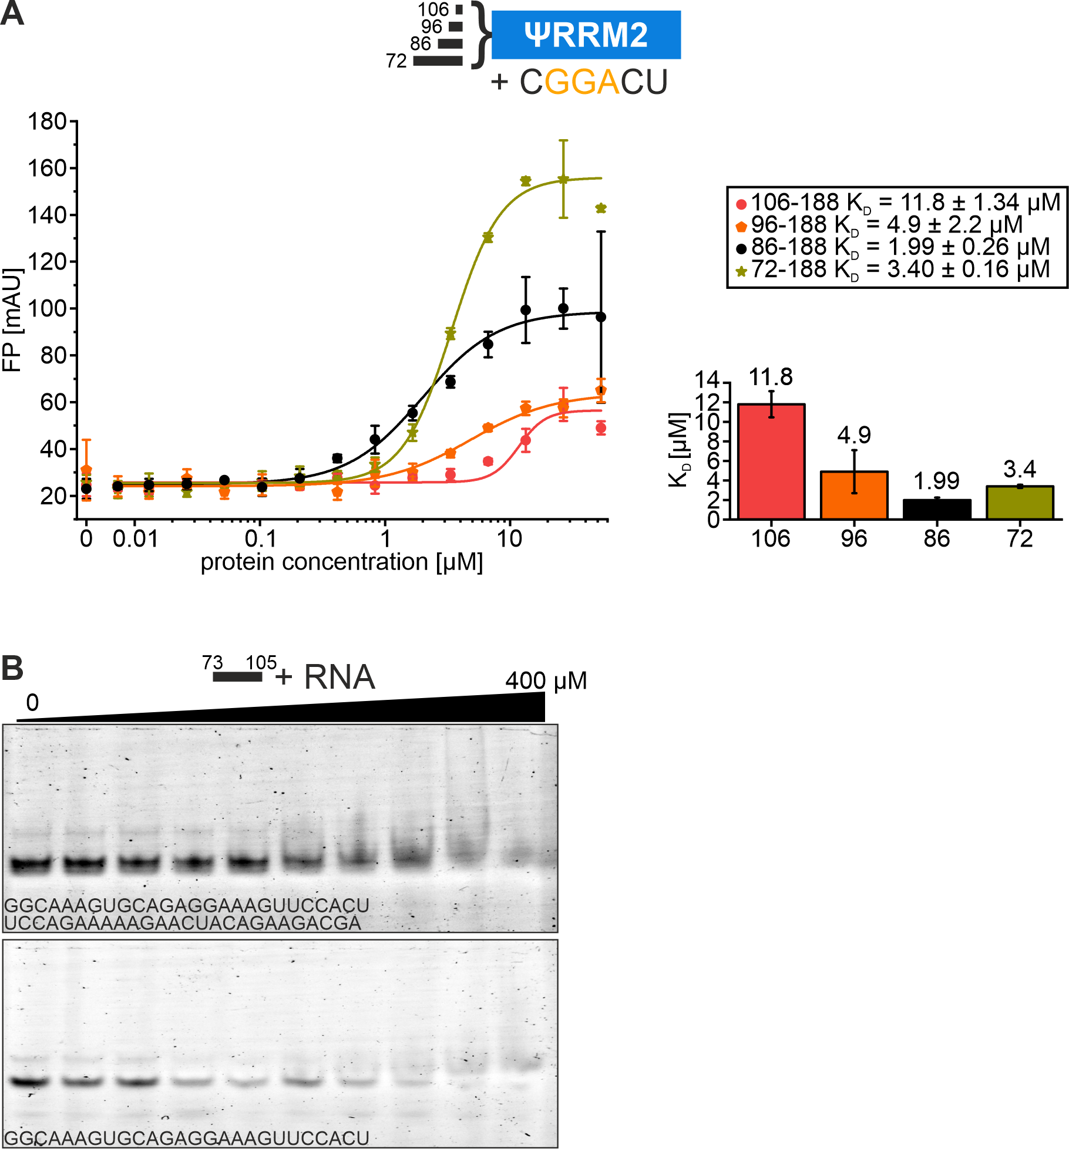
Supplementary Figure 22: The linker increases binding affinity of ΨRRM2.
A: FP assay of SRSF6 ΨRRM2 and different linker lengths, as indicated by icons on top, binding to Fl-CGGACU RNA. Each data point is the average from triplicate measurements shown with the standard deviation. Averaged data points are fitted with Hill1-fit in Origin 2021b from which the individual K_{D} was derived. B: EMSAs of the linker peptide with two different RNAs. Highest peptide concentration was 400 µM with serial two-fold dilutions.

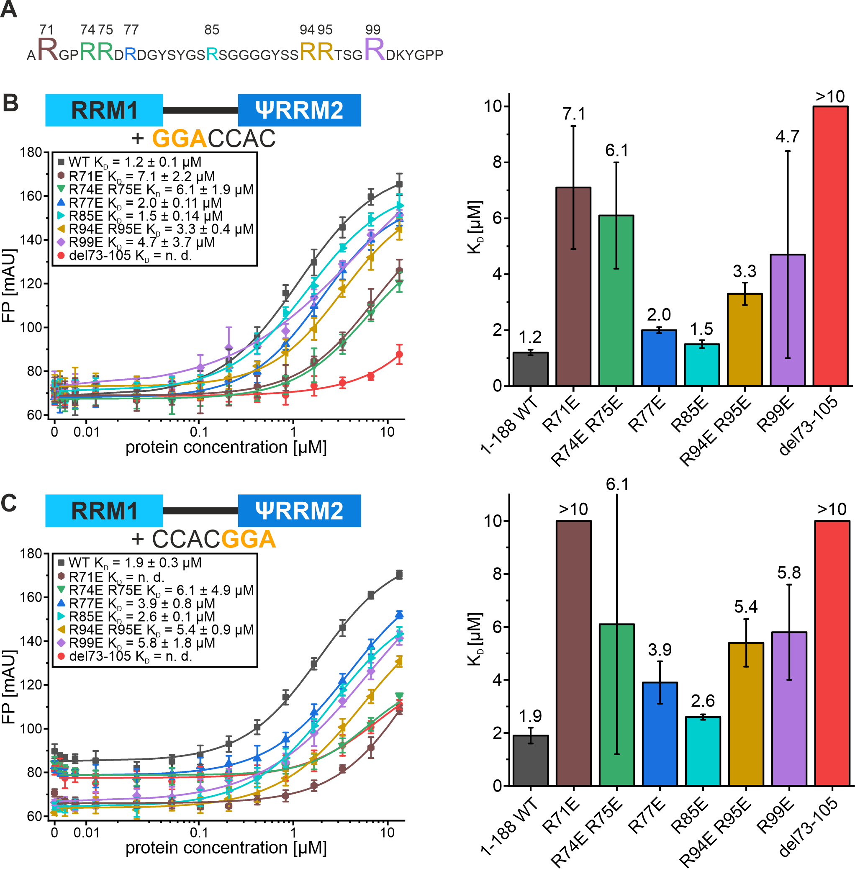
Supplementary Figure 23: R-to-E linker mutants in SRSF6 RRM1-2 confirm importance of single arginines for RNA-binding in inter-RRM linker.
A: Amino acid sequence of SRSF6 linker (residues 70-105). Arginines are highlighted and color-coded according to data in B-C. B-C: FP assays of tandem RRM (1-188) WT and R-to-E mutants with GGACCAC (B), CCACGGA (C) RNA. Each data point is the average from triplicate measurements shown with the standard deviation. Averaged data points are fitted with Hill1-fit in Origin 2021b from which the individual K_{D} was derived.

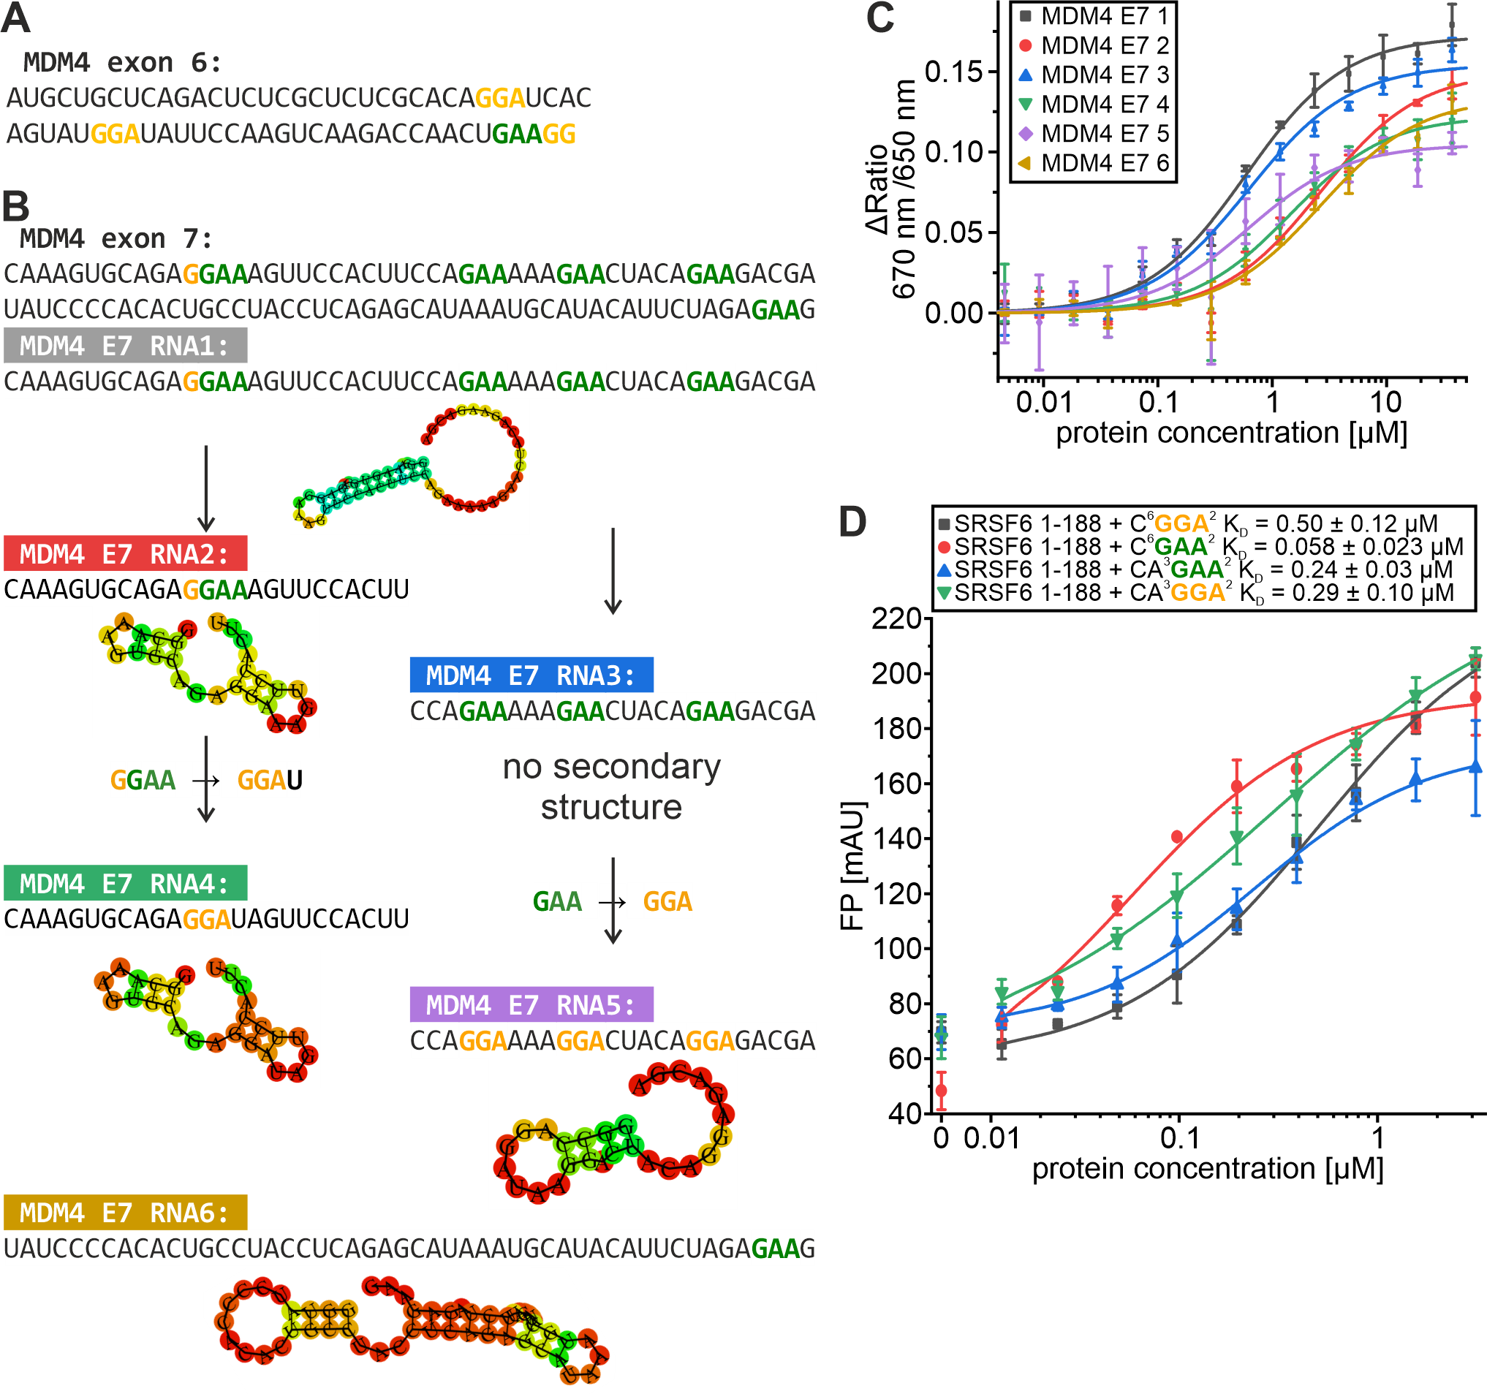
Supplementary Figure 24: Overview of MDM4-E6 and E7 RNA constructs with their respective secondary structure predictions.
A: Sequence of MDM4 exon 6. B: Sequence of MDM4 exon 7 and individual RNA constructs derived thereof. Mutations between constructs are highlighted with arrows. Secondary structure formation has been predicted using the RNAfold Webserver (http://rna.tbi.univie.ac.at/ ³). C: Dual-emission spectral shift assay of tandem RRM (1-188) with six different MDM4 exon 7 RNAs. Each data point is the average from triplicate measurements shown with the standard deviation. Averaged data points are fitted with Hill1-fit in Origin 2021b from which the individual K_{D} was derived. D: FP assay of tandem RRM (1-188) with 12-mer RNAs containing C-/CA repeats (RRM1) and GGA-/GAA-repeats. Each data point is the average from triplicate measurements shown with the standard deviation. Averaged data points are fitted with Hill1-fit in Origin 2021b from which the individual K_{D} was derived.

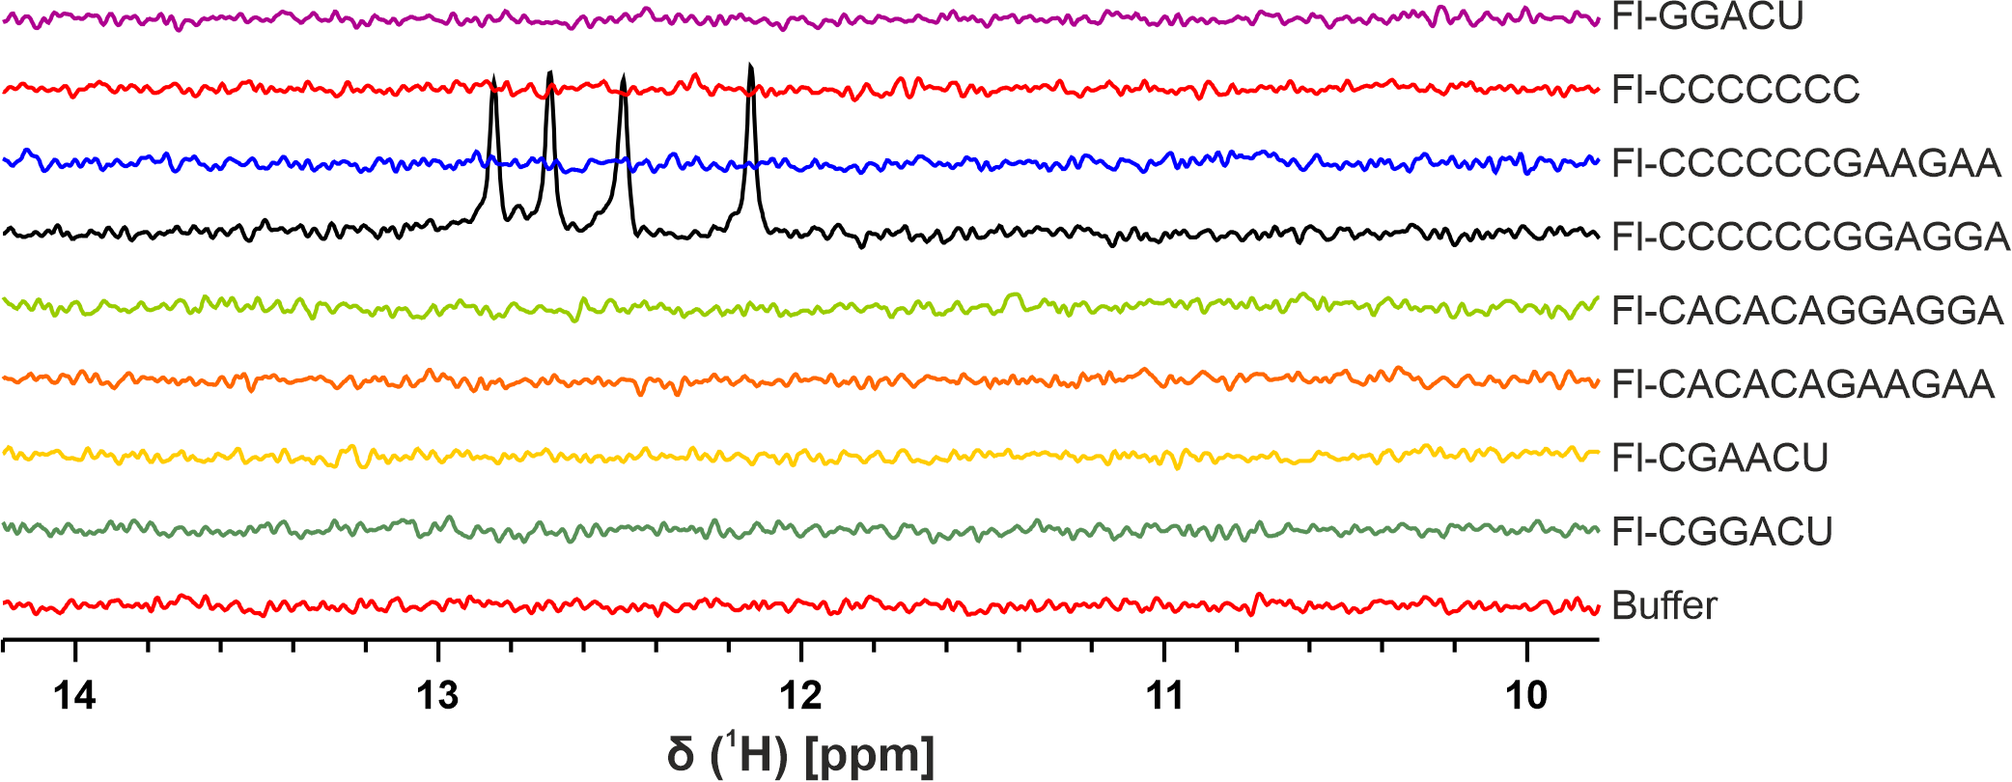
Supplementary Figure 25: ¹H-NMR spectra of (fluorescently labeled) RNAs used for binding assays.
For each RNA the imino proton region is shown. Spectra were recorded at a ¹H-Larmor frequency of 600 MHz in buffer containing 20 mM NaPi, 150 mM NaCl, 7% D₂O, 100 µM DSS at pH 6.5 and 295K.

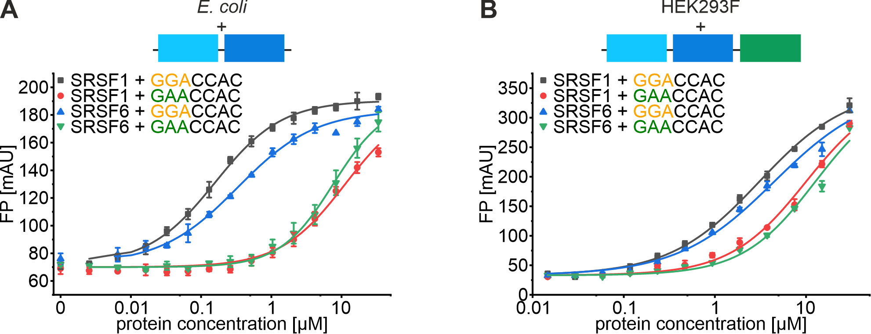
Supplementary Figure 26: The phosphorylated RS domain inhibits RNA binding for SRSF1/6.
FP assay of tandem RRM SRSF1 (1-199) and SRSF6 (1-188) from E. coli (A) or full-length SRSF1 and SRSF6 from HEK293F cells (B) each binding to GGACCAC or GAACCAC RNA. Each data point is the average from triplicate measurements shown with the standard deviation. Averaged data points are fitted with Hill1-fit in Origin 2021b from which the individual K_{D} was derived.
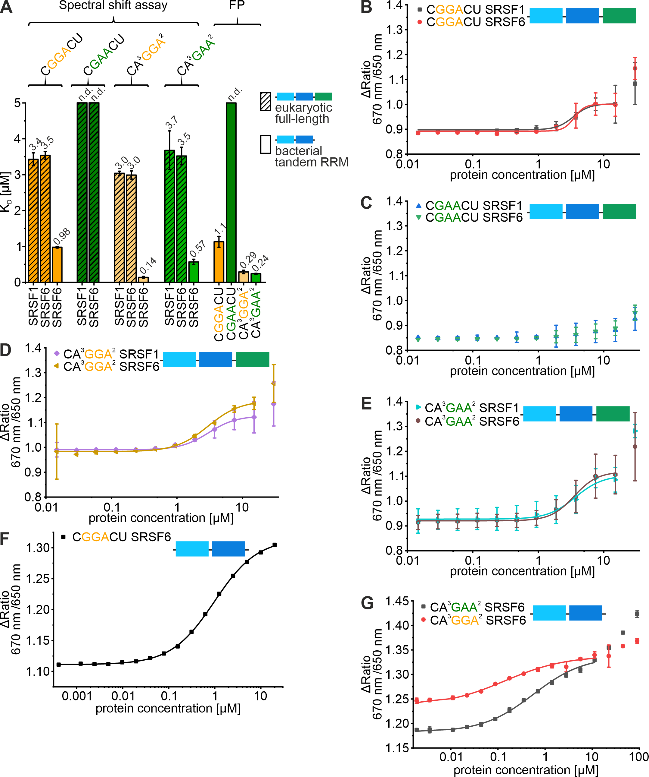
Supplementary Figure 27: The phosphorylated RS domain inhibits RNA binding for SRSF1/6.
A: Binding affinities of SRSF1 and SRSF6 (full-length (HEK293F) vs tandem RRM (E. coli), see icons on the right) with four different RNAs as indicated at the top. K_{D} values for each combination are given above the respective bar. Affinities have been obtained from spectral shift measurements or FP measurements as indicated at the top. B-E: Spectral shift measurements for full-length (HEK293F) SRSF1 and SRSF6 to different RNAs as indicated at the top left corner of each panel. Data points have been fit where possible to obtain binding affinities plotted in A. F-G: Spectral shift measurements for tandem RRM (E. coli) of SRSF1 (1-199) and SRSF6 (1-188) to different RNAs as indicated at the top left corner of each panel. Data points have been fit where possible to obtain binding affinities plotted in A.

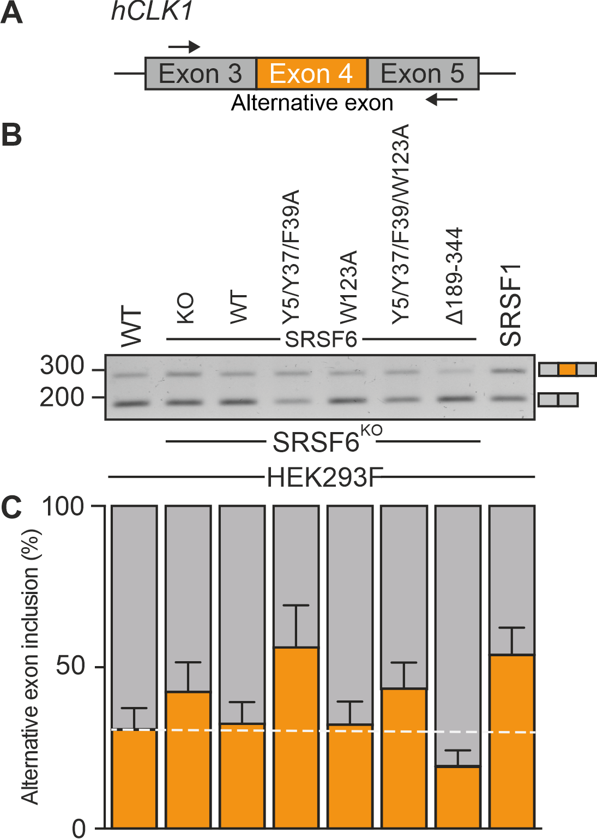
Supplementary Figure 28: In vivo splice analysis of hCLK1.
A: The human CLK1 (hCLK1) gene model shows exons E3, alternative exon E4 (orange), and E5. B: Analysis of alternative exon 4 inclusion in hCLK1 transcripts in the indicated cell lines. Total RNA was isolated to generate cDNA used as template for the in vivo splice analysis. CEs that were more included are marked in orange. Semi-quantitative RT-PCR of hCLK1 transcripts shows the expression of spliced products either including (top band representing E3-E4-E5) or skipping (lower band representing E3-E5) alternative exon 4. The PCR product was analysed on a 2% Agarose gel in TBE buffer. C: Bar graph showing the percentage of alternative exon inclusion based on densitometric analysis of the RT-PCR products. The average values from three independent biological replicates are shown, and error bars represent standard deviation. Inclusion percentage is color-coded (orange) by alternative exon inclusion level. The dotted line indicates the inclusion level in parental HEK293F cells.

Supplementary Tables
Supplementary Table 1: Overview of DNA oligonucleotides used to generate different SRSF6/SRSF1 domain constructs.
Name | Sequence 5' → 3' | Usage
VE11 | GAACAGATTGGTGGTATGCCGCGCGTCTACATTGGC | amplify backbone of pET-Trx1a-SRSF6-1-188 with deletion of Trx
VE24 | GTGATGGTGATGGTGATGTTTC
VE27 | CACCATCACCATCACGGGTCCGAGGTC | amplify SUMO insert for GA
VE36 | ACCACCAATCTGTTCACGATGGGCC | amplify SUMO insert for GA
VE33 | AGGAATGCCGCGCGTCTACATT | add "GAG" to pET-SUMO-SRSF6-1-188
VE34 | GCTCCACCACCAATCTGTTCACGATG | add "GAG" to pET-SUMO-SRSF6-1-188
VE122 | CGGTGGCCCATATTTGTCACGACCGG | create construct 1-105
VE70 | TAAGGGTCGGGATCCGGCTGCTAACAAAGCC | create construct 1-105
VE78 | GTGCGTACGGAGTATCGCCTGATCG | create construct 106-188
VE36 | ACCACCAATCTGTTCACGATGGGCC | create construct 106-188
VE35 | AGCGGGGGCGGCGGTTAT | create construct 86-188
VE36 | ACCACCAATCTGTTCACGATGGGCC | create construct 86-188
VE153 | GGCCCTCGTCGGGATCGCGATGGG | create construct 72-188
VE36 | ACCACCAATCTGTTCACGATGGGCC | create construct 72-188
VE160 | GCTACGGGGCCCATCAACTTTAACCC | create construct SRSF1 1-199
VE161 | TAAAAGCTTGCGGCCGCACTCG | create construct SRSF1 1-199

Supplementary Table 2: Overview of DNA oligonucleotides used to generate mutants within SRSF6 RRM1.
Non-capital letters indicate site of mutation.
Name | Sequence 5' → 3' | Usage
VE51 | GCCGCGCGTCgcgATTGGCCGACTGTCGTAC | Y5A
VE52 | ATGGCCATGGCGCCCTGA | Y5A
VE53 | TAAGAACGGTgcgGGGTTTGTCGAGTTTG | Y37A
VE54 | AGGTCTACCTCTAGGAGC | Y37A
VE55 | CGGTTACGGGgcgGTCGAGTTTG | F39A
VE56 | TTCTTAAGGTCTACCTCTAG | F39A
VE64 | GGAGCATGCCgcgGGGTAACTCGAGCACC | R71A
VE65 | ACGATCACGCGTTCGCCG | R71A
VE146 | cgCGGTTACGGGTTTGTCGAGTTTGAAGATTCTCG | N35R
VE147 | CTTAAGGTCTACCTCTAGGAGCCTGCCATAACC | N35R

Supplementary Table 3: Overview of DNA oligonucleotides used to generate mutants within SRSF6 RRM2.
Non-capital letters indicate site of mutation.
Name | Sequence 5' → 3' | Usage
VE-AH01 | gCGTGGCAGGACTTAAAGGATTTCATGCGTCAGG | S122A
VE-AH02 | ACAACGACTTGACAGGTTTTCAACGATCAGGC | S122A
VE-AH03 | gcGCAGGACTTAAAGGATTTCATGCGTCAGGCG | W123A
VE-AH04 | CGAACAACGACTTGACAGGTTTTCAACGATCAGG | W123A
VE-AH05 | gcGGACTTAAAGGATTTCATGCGTCAGGCGGG | Q124A
VE-AH06 | CCACGAACAACGACTTGACAGGTTTTCAACG | Q124A
VE-AH07 | gcgTTAAAGGATTTCATGCGTCAGGCGGGCG | D125A
VE-AH08 | CTGCCACGAACAACGACTTGACAGG | D125A
VE-AH09 | gcgAAGGATTTCATGCGTCAGGCGGG | L126A
VE-AH10 | GTCCTGCCACGAACAACGACTTGACAGG | L126A
VE-AH11 | gcGGATTTCATGCGTCAGGCGGGCG | K127A
VE-AH12 | TAAGTCCTGCCACGAACAACGACTTGACAGG | K127A
VE-AH13 | gcgTTCATGCGTCAGGCGGGCGAAGTTACC | D128A
VE-AH14 | CTTTAAGTCCTGCCACGAACAACGACTTGACAGG | D128A

Supplementary Table 4: Overview of DNA oligonucleotides used to generate point mutants within SRSF6 RRM1-RRM2 linker.
Name | Sequence 5' → 3' | Usage
VE176 | GAAGGGCCTCGTCGGGATCGCG | R71E
VE135 | GGCATGCTCCACGATCACGCG | R71E
VE175 | GAAGAGAGGCCCACGGGCATGCTCC | R74E R75E
VE183 | AGGCCCACGGGCATGCTCC | R74E R75E
VE174 | GAAGATGGGTACTCTTACGGCAGCCGAAGC | R77E
VE105 | ATCCCGACGAGGCCCACGG | R77E
VE172 | GAAAGCGGGGGCGGCGG | R85E
VE173 | GCTGCCGTAAGAGTACCCATCGCGATCCC | R85E
VE171 | GAGGAAACTTCCGGTCGTGACAAATATGGGCC | R94E R95E
VE109 | TGATGAATAACCGCCGCCCCCGC | R94E R95E
VE170 | GAAGACAAATATGGGCCACCGGTGCG | R99E
VE111 | ACCGGAAGTACGCCGTGATGAATAACCG | R99E

Supplementary Table 5: Overview of DNA oligonucleotides used to generate deletion mutant of SRSF6 RRM1-RRM2 linker.
Name | Sequence 5' → 3' | Usage
VE78 | GTGCGTACGGAGTATCGCCTGATCG | V106_fw
VE31 | CCCACGGGCATGCTCCAC | G72_rev

Supplementary Table 6: Overview of DNA oligonucleotides used to generate Twin-Strep-Tag constructs of various SRSF6 variants for RBNS.
Name | Sequence 5' → 3' | Usage
VE79 | CTTTATTTTCAGGGCAGCGCATGGAGTCATCCTCAATTCG | Strep_GA_Trx_fw
VE80 | GTAGACGCGCGGCATTTTTTCGAACTGCGGGTGGCTCCACGC | Strep_GA_M1_rev
VE81 | GAACAGATTGGTGGTAGCGCATGGAGTCATCCTCAATTCGAGAAAGG | Strep_GA_SUMO_fw
VE82 | ATACTCCGTACGCACTTTTTCGAACTGCGGGTGGCTCCACGC | Strep_GA_V106_rev
VE83 | ACCGCCGCCCCCGCTTTTTTCGAACTGCGGGTGGCTCCACGC | Strep_GA_S86_rev
VE76 | ATGCCGCGCGTCTACATTGGCC | M1_for
VE77 | GCCCTGAAAATAAAGATTCTCAGAACCACTGCC | Trx_c-term_rev
VE36 | ACCACCAATCTGTTCACGATGGGCC | SUMO_c-term_rev
VE78 | GTGCGTACGGAGTATCGCCTGATCG | V106_fw
VE35 | AGCGGGGGCGGCGGTTAT | S86_fw

Supplementary Table 7: Overview of short RNAs used for various assays.
 |  | Labeling
Name | Sequence 5' → 3' | - | Fl | Cy5 | Usage
7xA | AAAAAAA | × |  |  | NMR
7xC | CCCCCCC | × | × |  | NMR, FP, EMSA
7xG | GGGGGGG | × |  |  | NMR
7xU | UUUUUUU | × |  |  | NMR
CGGACU | CGGACU | × | × | × | NMR, FP, EMSA, SS, xtal
CGAACU | CGAACU | × | × |  | NMR, FP, EMSA
GGGACU | UGGGACU |  | × |  | FP, EMSA
AGGACU | UAGGACU |  | × |  | FP, EMSA
UGGACU | UUGGACU |  | × |  | FP, EMSA
GGACU | GGACU | × | × |  | NMR, FP, EMSA
UCAGGC | UCAGGC |  | × |  | FP, EMSA
CA2GAA | UUCAUUGAAUUU |  | × |  | FP, EMSA
CA2GGA | UUCAUUGGAUUU |  | × |  | FP, EMSA
CA5GAA | UCAUUUUUGAAU |  | × |  | FP, EMSA
CA5GGA | UCAUUUUUGGAU |  | × |  | FP, EMSA
GAA5CA | UGAAUUUUUCAU |  | × |  | FP, EMSA
GAA2CA | UUGAAUUCAUUU |  | × |  | FP, EMSA
CAGAA | UUUCAGAAUUUU |  | × |  | FP, EMSA
GGACCAC | UUGGACCACUUU |  | × | × | FP, EMSA, SS
GAACCAC | UUGAACCACUUU |  | × | × | FP, EMSA, SS
CCACGAA | UUCCACGAAUUU |  | × | × | FP, EMSA, SS
CCACGGA | UUCCACGGAUUU |  | × | × | FP, EMSA, SS
CCAC | UUCCACU | × | × |  | NMR, FP, EMSA
GAA2CCAC | UUGAAUUCCACU |  | × |  | FP, EMSA
GGA2CCAC | UUGGAUUCCACU |  | × |  | FP, EMSA
CCAC2GAA | UCCACUUGAAUU | × | × |  | NMR, FP, EMSA
CCAC2GGA | UCCACUUGGAUU | × | × |  | NMR, FP, EMSA
GGA | UUUGGAU |  | × |  | FP, EMSA
C⁶GGA² | CCCCCCGGAGGA |  | × |  | FP, EMSA
C⁶GAA² | CCCCCCGAAGAA |  | × |  | FP, EMSA
CA³GGA² | CACACAGGAGGA | × | × | × | NMR, FP, EMSA, SS
CA³GAA² | CACACAGAAGAA | × | × | × | NMR, FP, EMSA, SS

Supplementary Table 8: Overview of templates for in vitro transcription of natural target RNAs.
Name | Sequence 5' → 3' | Length
T7-Promotor | TAATACGACTCACTATAGG | 19
MDM4 E7_1 | TCGTCTTCTGTAGTTCTTTTTCTGGAAGTGGAACTTTCCTCTGCACTTTGCCTATAGTGAGTCGTATTA | 69
MDM4 E7_2 | AAGTGGAACTTTCCTCTGCACTTTGCCTATAGTGAGTCGTATTA | 44
MDM4 E7_3 | TCGTCTTCTGTAGTTCTTTTTCTGGCCTATAGTGAGTCGTATTA | 44
MDM4 E7_4 | AAGTGGAACTATCCTCTGCACTTTGCCTATAGTGAGTCGTATTA | 44
MDM4 E7_5 | TCGTCTCCTGTAGTCCTTATCCTGGCCTATAGTGAGTCGTATTA | 44
MDM4 E7_6 | CTTCTCTAGAATGTATGCATTTATGCTCTGAGGTAGGCAGTGTGGGGATACCTATAGTGAGTCGTATTA | 69

Supplementary Table 9: Overview of natural target RNAs.
All RNAs have been produced in-house by in-vitro transcription and subsequently labeled with Fluorescein and Cy5 individually.
Name | Sequence 5' → 3' | Usage
MDM4 exon7_1 | GGCAAAGUGCAGAGGAAAGUUCCACUUCCAGAAAAAGAACUACAGAAGACGA | Fl-labelled EMSAs, Cy5-labelled SS
MDM4 exon7_2 | GGCAAAGUGCAGAGGAAAGUUCCACUU | Fl-labelled EMSAs, Cy5-labelled SS
MDM4 exon7_3 | GGCCAGAAAAAGAACUACAGAAGACGA | Fl-labelled EMSAs, Cy5-labelled SS
MDM4 exon7_4 | GGCAAAGUGCAGAGGAUAGUUCCACUU | Fl-labelled EMSAs, Cy5-labelled SS
MDM4 exon7_5 | GGCCAGGAUAAGGACUACAGGAGACGA | Fl-labelled EMSAs, Cy5-labelled SS
MDM4 exon7_6 | GGUAUCCCCACACUGCCUACCUCAGAGCAUAAAUGCAUACAUUCUAGAGAAG | Fl-labelled EMSAs, Cy5-labelled SS

Supplementary Table 10: Proteins used in RBNS and corresponding indices used for Illumina sequencing.
Constructs | Construct Concentration(s) [µM] | i7 index Sequence
RRM1-WT (1-72) | 40 | ATCACG
RRM1ext (1-105) | 10 | TTAGGC
ψRRM2-WT (106-188) | 40 | TAGCTT
ψRRM2ext-WT (86-188) | 5 | GCCAAT
ψRRM2ext-WT (86-188) | 25 | CAGATC
RRM1-2-WT (1-188) | 0.5 | ACTTGA
RRM1-2-WT (1-188) | 5 | GATCAG
input control | - | GGCTAC

Supplementary Table 11: Oligonucleotides used for the RBnS assay.
Name | Sequences 5' → 3'
T7 promoter oligo | GTATAATACGACTCACTATAGGG
RBNS T7 template (20mer) | CCTTGGCACCCGAGAATTCCA(N)₂₀GATCGTCGGACTGTAGAACTCCCTATAGTGAGTCGTATTATAC
RNA RT Primer (RTP) | GCCTTGGCACCCGAGAATTCCA
RNA PCR Primer (RP1) | AATGATACGGCGACCACCGAGATCTACACGTTCAGAGTTCTACAGTCCGACGATC
RNA PCR Index 1 (RPI1) | CAAGCAGAAGACGGCATACGAGATCGTGATGTGACTGGAGTTCCTTGGCACCCGAGAATTCCA
RNA PCR Index 2 (RPI2) | CAAGCAGAAGACGGCATACGAGATACATCGGTGACTGGAGTTCCTTGGCACCCGAGAATTCCA
RNA PCR Index 3 (RPI3) | CAAGCAGAAGACGGCATACGAGATGCCTAAGTGACTGGAGTTCCTTGGCACCCGAGAATTCCA
RNA PCR Index 4 (RPI4) | CAAGCAGAAGACGGCATACGAGATTGGTCAGTGACTGGAGTTCCTTGGCACCCGAGAATTCCA
RNA PCR Index 5 (RPI5) | CAAGCAGAAGACGGCATACGAGATCACTGTGTGACTGGAGTTCCTTGGCACCCGAGAATTCCA
RNA PCR Index 6 (RPI6) | CAAGCAGAAGACGGCATACGAGATATTGGCGTGACTGGAGTTCCTTGGCACCCGAGAATTCCA
RNA PCR Index 7 (RPI7) | CAAGCAGAAGACGGCATACGAGATGATCTGGTGACTGGAGTTCCTTGGCACCCGAGAATTCCA
RNA PCR Index 8 (RPI8) | CAAGCAGAAGACGGCATACGAGATTCAAGTGTGACTGGAGTTCCTTGGCACCCGAGAATTCCA
RNA PCR Index 9 (RPI9) | CAAGCAGAAGACGGCATACGAGATCTGATCGTGACTGGAGTTCCTTGGCACCCGAGAATTCCA
RNA PCR Index 10 (RPI10) | CAAGCAGAAGACGGCATACGAGATGTAGCCGTGACTGGAGTTCCTTGGCACCCGAGAATTCCA

Supplementary Table 12: NMR and refinement statistics for SRSF6 RRM1.
 | Protein
NMR distance and dihedral constraints
Distance constraints
Total NOE | 827
Intra-residue | 155
Inter-residue
Sequential (|i – j| = 1) | 135
Medium-range (1<|i – j| < 5) | 154
Long-range (|i – j| > 5) | 383
Intermolecular | 0
Hydrogen bonds | 25
Total dihedral angle restraints | 140
φ | 69
ψ | 71
Structure statistics
Violations (mean and s.d.)
Distance constraints (Å) | 0
Dihedral angle constraints (º) | 0
Max. dihedral angle violation (º) | 0
Max. distance constraint violation (Å) | 0
Deviations from idealized geometry
Bond lengths (Å) | 0.0044 ± 0.0006
Bond angles (º) | 0.879 ± 0.030
Impropers (º)
Average pairwise r.m.s. deviation** (Å)
Heavy | 0.94 ± 0.07
Backbone | 0.24 ± 0.05
** Protein r.m.s deviation was calculated using residues 1 to 72 for the ensemble of 20 refined structures.

Supplementary Table 13: Crystal data collection and refinement statistics.
Values in parentheses are for highest resolution shell.
 | extRRM2 WT | extRRM2 W123A | extRRM2 + CGGACU
PDB ID | 9HX5 | 9HX8 | 9HX7
Data Collection
Resolution range (Å) | 58.01 - 2.10 (2.16-2.10) | 57.22 - 2.00 (2.05-2.00) | 56.97 - 2.30 (2.38-2.30)
Space group | P 31 2 1 | P 31 2 1 | P 31 2 1
Cell dimensions
a, b, c (Å) | 66.98, 66.98, 45.28 | 66.07, 66.07, 46.32 | 65.78, 65.78, 45.75
α, β, γ (°) | 90.0, 90.0, 120.0 | 90.0, 90.0, 120.0 | 90.0, 90.0, 120.0
I/σI | 11.80 (1.10) | 14.80 (1.70) | 23.70 (3.90)
Rmeas | 0.11 (2.54) | 0.10 (1.62) | 0.08 (1.13)
Rpim | 0.03 (0.58) | 0.02 (0.35) | 0.02 (0.25)
CC1/2 | 1.00 (0.94) | 1.00 (0.95) | 1.00 (0.98)
Multiplicity | 18.50 (18.60) | 19.90 (20.70) | 19.60 (20.50)
Completeness (%) | 99.50 (98.50) | 98.70 (99.50) | 99.90 (99.60)
Refinement
Rwork | 0.247 | 0.248 | 0.244
Rfree | 0.258 | 0.259 | 0.25
No. atoms
Protein | 661 | 652 | 662
Water | 0 | 2 | 1
Ligand | 0 | 0 | 66
B-factors
Protein | 89 | 85 | 66
Water | 0 | 98 | 78
Ligand | 0 | 0 | 137
R.m.s. deviations
Bond lengths (Å) | 0.0114 | 0.0111 | 0.0098
Bond angles (°) | 1.44 | 1.41 | 1.29
Ramachandran favored (%) | 100 | 100 | 97.4
Ramachandran allowed (%) | 0 | 0 | 2.6
Ramachandran outliers (%) | 0 | 0 | 0
Rotamer outliers (%) | 0 | 0 | 0
Clash score | 1.52 | 0.8 | 2.1
MolProbity score | 0.89 | 0.74 | 1.1

Supplementary Table 14: Oligonucleotides used for splicing assay.
Name | Sequence 5' → 3' | Usage
hCLK1_e3_fw | CAAGGATGTGAACCTGGACATCGC | PCR
hCLK1_e5_rw | CTCCTTCACCTAAAGTATCAAC | PCR
hMDM4_Exon4_fw | ACGTCAGAGCTTCTCCGTGA | PCR
hMDM4_Exon8_rev | CTCAAATCCAAGGTCCAGCCT | PCR

Supplementary Table 15: sg-RNA for CRISPR Knock-out of SRSF6 used in this study.
Species | Name/Target | Protospacer sequence | PAM | Purpose | Supplier
Human | SRSF6_sgRNA | AACCTATGCGGATGCCCACA | cgg | NHEJ | IDT

Supplementary Table 16: List of plasmids used or generated in this study.
Name | Resistance | Source | Species
pSBTetBla | Ampicillin/Blasticidin | S. Sethumadhavan, Addgene #60510 | Human
pCAG globin pA100 SB100X | Ampicillin | S. Sethumadhavan, Addgene #127909 | -
pSBTet(Mod) | Ampicillin/Blasticidin | S. Sethumadhavan | Human
pSBTet(Mod)-SRSF6-fl | Ampicillin/Blasticidin | S. Sethumadhavan | Human
pSBTet(Mod)-SRSF6Y5A/Y37A/F39A | Ampicillin/Blasticidin | S. Sethumadhavan | Human
pSBTet(Mod)-SRSF6W123A | Ampicillin/Blasticidin | S. Sethumadhavan | Human
pSBTet(Mod)-SRSF6Y5A/Y37A/F39A/W123A | Ampicillin/Blasticidin | S. Sethumadhavan | Human
pSBTet(Mod)-SRSF1-fl | Ampicillin/Blasticidin | S. Sethumadhavan | Human
pSBTet(Mod)-SRSF6∆189-344 | Ampicillin/Blasticidin | S. Sethumadhavan | Human

Supplementary Table 17: Oligonucleotides used for generation of full-length SRSF6 constructs.
Name | Sequence 5' → 3' | Usage
SfiII_RP common | aagcttggcctgacaggccttacttttcgaattgcgggtggctcca | Cloning
SRSF6_SfiI_FP | aagctggcctctgaggccaccatgccgcgcgtctacataggacgc | Cloning
SRSF6Y5A_RP | gttgtagctcaggcgtcctatggcgacgcgcggccatg | Mutation
SRSF6Y5A_FP | gtccgggagaaggacatccagcgctttttcagtggc | Mutation
SRSF6Y37A_RP | agtcctcgaactccacgaagccggccccatttttgaggtctaC | Mutation
SRSF6Y37A_FP | cccgcgacgccgacgacgccgtttac | Mutation
SRSF6F39A_RP | gcgggagtcctcgaactccacggcgccgtacccatttttgaggtc | Mutation
SRSF6F39A_FP | gacgccgacgacgccgtttacgagctgaacggc | Mutation
SRSF6W123A_RP | gcataaaatcctttaaatcttgcgcactgcaccgactagaaagattttc | Mutation
SRSF6W123A_FP | gacaagcaggtgaagtaacctatgcggatgc | Mutation
d189-344_FP | caagggacgctcgaagtactctttcaa | Deletion
d189-344_RP | agtacttcgagcgtcccttgtcgcctatggcttgtgcgtggctt | Deletion

Supplementary Table 18: List of antibodies used in this study.
Antibody | Supplier | Catalogue number | Purpose
Donkey anti-Mouse IgG-Alexa Fluor 647 antibody | Thermo Fisher | A-31571 | IF
NREBP (C-10; anti-human SON) antibody | Santa Cruz | sc-398508 | IF
Rabbit anti-SRSF6 antibody | Biozol | LS-C290327 | WB
beta-Actin Monoclonal antibody | Thermo Fisher | (AC-15) M4302 | WB
Donkey Anti-Rabbit HRP conjugate antibody | Millipore Sigma | AP182P | WB
Donkey anti-Mouse HRP conjugate antibody | Thermo Fisher | A16011 | WB

Supplementary Table 19: List of cell lines used or generated in this study.
Name | Selection | Source | Species
HEK293F WT | - | Thermo Fischer | Human
HEK293F SRSF6KO | Blasticidin | S. Sethumadhevan / This work | Human
HEK293F KO SRSF6-fl | Blasticidin | S. Sethumadhevan / This work | Human
HEK293F KO SRSF6 Y5A/Y37A/F39A | Blasticidin | S. Sethumadhevan / This work | Human
HEK293F KO SRSF6 W123A | Blasticidin | S. Sethumadhevan / This work | Human
HEK293F KO SRSF6Y5A/Y37A/F39A/W123A | Blasticidin | S. Sethumadhevan / This work | Human
HEK293F KO SRSF6∆189-344 | Blasticidin | S. Sethumadhevan / This work | Human
HEK293F WT SRSF1-fl | Blasticidin | S. Sethumadhevan / This work | Human
HEK293F WT SRSF6-fl | Blasticidin | S. Sethumadhevan / This work | Human

Supplementary Table 20: Overview of R_{g}, D_{max} and Chi² from SAXS-based models.
 | Model | R_{g} [nm] | D_{max} [nm] | χ²
apo | m1058 | 2.56 | 7.86 | 2.26
apo | m3792 | 2.55 | 8.08 | 2.28
apo | m1449 | 2.57 | 8.34 | 2.36
apo | m2807 | 2.52 | 8.07 | 2.36
apo | m1317 | 2.43 | 7.65 | 2.48
apo | m1125 | 2.53 | 8.07 | 2.5
apo | m0057 | 2.46 | 8.01 | 2.6
apo | m3074 | 2.5 | 8.03 | 2.68
apo | m4213 | 2.42 | 7.58 | 2.79
apo | m3675 | 2.57 | 8.22 | 2.84
apo | average | 2.51 | 7.99 | 2.52
RNP | m1170 | 2.51 | 8.68 | 2.32
RNP | m1764 | 2.61 | 9.35 | 2.37
RNP | m1713 | 2.51 | 9.08 | 2.38
RNP | m2227 | 2.48 | 9.14 | 2.41
RNP | m0416 | 2.56 | 9.25 | 2.47
RNP | m1209 | 2.52 | 9.17 | 2.55
RNP | m0353 | 2.52 | 8.76 | 2.57
RNP | m0046 | 2.47 | 8.55 | 2.62
RNP | m2026 | 2.56 | 8.54 | 2.7
RNP | m4609 | 2.56 | 9.52 | 2.72
RNP | average | 2.53 | 9 | 2.51

References
1. von Ehr, J. & Schlundt, A. 1H, 13C, 15N backbone chemical shift assignments and relaxation analysis of the single and tandem RRMs of the human serine-arginine rich splicing factor 6 (SRSF6). Journal of Magnetic Resonance, 108079; 10.1016/j.jmr.2026.108079 (2026).
2. Barthels, F., Schirmeister, T. & Kersten, C. BANΔIT: B'-Factor Analysis for Drug Design and Structural Biology. Molecular informatics 40, e2000144; 10.1002/minf.202000144 (2021).
3. Gruber, A. R., Lorenz, R., Bernhart, S. H., Neuböck, R. & Hofacker, I. L. The Vienna RNA websuite. Nucleic Acids Res 36, W70-4; 10.1093/nar/gkn188 (2008).

