Supplementary material
Itzel Mercado-Sánchez¹, Ismael Várgas-Rodríguez¹, Rogelio Chávez-Rocha¹, Cristina Fonseca-Yepez¹, Esthela P. García-Tejada¹, Miguel A Vazquez¹, Adán Bazan-Jimenez¹, Juvencio Robles², Marco A. García-Revilla¹*
¹Department of Chemistry and ²Department of Pharmacy, Universidad de Guanajuato, Noria Alta,
S/N, Guanajuato, 36050, Guanajuato, México.
*Corresponding author(s). E-mail(s): magarcia@ugto.mx;

Table S1 Values of the QC descriptors of the molecules.
Molecule | logIC50 | _inter_DNAª | E_inter_Topoª | S^{b} | W^{b} | w+ ^{b} | w- ^{b} | Gap-HOMO-LUMO ᵃ | I ^{b} | A ^{b} | χ v | µ^{b} | Qzz ^{c} | Dipole Moment | ∆w± ^{b}
4a | 0.10 | -6.70 | -8.50 | 0.15 | 1.75 | 1.45 | 6.40 | 5.35 | 8.46 | 1.44 | 4.95 | -4.95 | -136.54 | 1.26 | 7.75
5a | -0.92 | -6.30 | -8.01 | 0.15 | 1.75 | 1.48 | 6.40 | 5.59 | 8.37 | 1.47 | 4.92 | -4.92 | -133.98 | 5.90 | 7.75
5b | -0.72 | -5.60 | -8.27 | 0.15 | 1.69 | 1.45 | 6.13 | 5.34 | 7.92 | 1.44 | 4.68 | -4.68 | -145.85 | 7.39 | 7.75
CID443939 | -1.37 | -7.40 | -12.64 | 0.23 | 2.30 | 2.73 | 6.98 | 3.59 | 6.21 | 2.29 | 4.25 | -4.25 | -229.05 | 15.05 | 9.11
CID3885 | -0.34 | -5.60 | -7.44 | 0.2 | 1.74 | 1.45 | 6.41 | 5.69 | 8.5 | 1.43 | 4.97 | -4.97 | -105.96 | 6.71 | 8.02
CID57186217 | -2.15 | -6.65 | -8.26 | 0.17 | 1.36 | 1.07 | 5.12 | 4.90 | 7.08 | 1.03 | 4.05 | -4.05 | -14.71 | 3.26 | 6.20
CID2764 | 1.06 | -6.47 | -8.42 | 0.13 | 0.95 | 0.48 | 4.24 | 6.32 | 7.49 | 0.03 | 3.76 | -3.76 | -164.27 | 8.19 | 4.73
CID135908529 | 0.59 | -7.80 | -8.90 | 0.18 | 1.82 | 1.77 | 6.20 | 2.74 | 7.12 | 1.74 | 4.43 | -4.43 | -155.14 | 8.41 | 7.24
CID68897 | -0.49 | -7.14 | -8.63 | 0.17 | 1.92 | 1.76 | 6.74 | 5.00 | 8.19 | 1.76 | 4.97 | -4.97 | -288.06 | 5.52 | 8.88
CID137100894 | -1.70 | -7.59 | -8.88 | 0.16 | 1.72 | 1.53 | 6.13 | 5.11 | 7.66 | 1.53 | 4.6 | -4.60 | -166.95 | 1.44 | 7.44
CID381319 | 1.18 | -7.70 | -8.20 | 0.15 | 1.26 | 0.79 | 5.25 | 5.46 | 8.4 | 0.52 | 4.46 | -4.46 | -227.48 | 5.58 | 8.89
CID41867 | -0.10 | -6.60 | -8.10 | 0.15 | 1.66 | 1.38 | 6.11 | 5.68 | 8.08 | 1.37 | 4.72 | -4.72 | -235.11 | 5.01 | 5.43
CID42890 | -0.54 | -6.60 | -8.10 | 4.3 | 1.91 | 1.75 | 6.67 | 5.16 | 8.08 | 1.75 | 4.91 | -4.91 | -213.08 | 5.01 | 0.31
CID68063 | -1.10 | -6.39 | -7.73 | 0.16 | 0.86 | 0.45 | 3.79 | 5.16 | 6.61 | 0.08 | 3.35 | -3.35 | -110.29 | 2.91 | 8.42
CID36462 | -0.44 | -6.10 | -7.00 | 3.37 | 1.10 | 0.65 | 4.69 | 6.68 | 7.72 | 0.35 | 4.04 | -4.04 | -238.62 | 5.59 | 0.16
CID30623 | -0.47 | -6.03 | -7.48 | 0.15 | 1.43 | 0.92 | 5.89 | 5.01 | 9.29 | 0.66 | 4.98 | -4.98 | -110.29 | 2.03 | 4.24
CID12567021 | -0.14 | -6.81 | -8.56 | 0.15 | 2.03 | 1.88 | 7.09 | 4.37 | 8.56 | 1.87 | 5.22 | -5.22 | -116.10 | 1.26 | 9.61
CID135494322 | -2.00 | -6.73 | -8.24 | 0.21 | 1.70 | 1.70 | 5.69 | 3.81 | 6.33 | 1.65 | 3.99 | -3.99 | -170.15 | 5.55 | 7.41
CID3220 | -1.57 | -6.54 | -8.18 | 0.16 | 1.95 | 1.81 | 6.76 | 5.70 | 8.11 | 1.8 | 4.96 | -4.96 | -117.25 | 2.52 | 8.61
CID139585971 | 0.71 | -6.07 | -7.42 | 6.04 | 1.98 | 2.13 | 6.35 | 6.43 | 6.48 | 1.97 | 4.23 | -4.23 | -229.05 | 6.16 | 0.31
CID1382 | -1.54 | -6.58 | -7.93 | 0.16 | 1.99 | 1.85 | 6.91 | 5.68 | 8.29 | 1.84 | 5.07 | -5.07 | -112.83 | 0.40 | 8.81
CID2948 | -2.00 | -6.17 | -7.57 | 0.15 | 2.20 | 2.09 | 7.54 | 6.03 | 8.82 | 2.07 | 5.44 | -5.44 | -121.12 | 3.99 | 9.66
CID2134 | 0.08 | -6.00 | -6.95 | 0.2 | 1.53 | 1.39 | 5.38 | 3.01 | 6.59 | 1.39 | 3.99 | -3.99 | -179.99 | 4.33 | 7.53
CID3663 | 0.08 | -7.16 | -9.66 | 0.21 | 1.72 | 1.67 | 5.85 | 4.07 | 6.72 | 1.64 | 4.18 | -4.18 | -216.71 | 10.06 | 8.20
CID65907 | -1.70 | -7.08 | -9.48 | 0.12 | 2.20 | 2.21 | 7.34 | 6.68 | 8.11 | 2.14 | 5.12 | -5.12 | -229.05 | 6.50 | 4.37
CID30323 | -1.77 | -6.57 | -8.35 | 0.19 | 1.69 | 1.37 | 6.25 | 3.68 | 8.4 | 1.35 | 4.88 | -4.88 | -229.05 | 4.15 | 6.66
CID2179 | -0.34 | -5.60 | -7.44 | 0.17 | 1.42 | 1.12 | 5.36 | 4.84 | 7.4 | 1.08 | 4.24 | -4.24 | -170.40 | 2.44 | 6.05
CID3213 | -0.92 | -6.30 | -8.01 | 0.17 | 1.04 | 0.61 | 4.43 | 5.09 | 7.34 | 0.31 | 3.82 | -3.82 | -118.32 | 4.14 | 9.56
CID4212 | -0.46 | -5.60 | -8.27 | 0.14 | 1.59 | 1.46 | 5.55 | 5.86 | 6.72 | 1.46 | 4.09 | -4.09 | -192.43 | 2.75 | 7.62

ᵃ kcal/mol
ᵇ eV
^{c} Debye

Table S2 The values of binding energies result from docking between molecules studied and DNA sequence.
 | DNA
Molecule | E_{bonding} (kcal/mol) | Ligand Efficiency (kcal/mol) | HB | π- π | π-alkil | π -sigma | π -anion
4a | -10.2 | -0.44 | - | C8 | C8 | -- | -
 | - | - | - | T9 | T9 | - | -
 | - | - | - | G13 | G7 | - | -
5a | -9.7 | -0.42 |  | C8 | G7 | T9 | -
 | - | - | - | G13 | C8 | - | -
 | - | - | - | T9 |  | - | -
5b | -9.8 | -0.39 | G13 | C8 | C8 | T9 | -
 | - | - | - | G13 | T9 | A12
 | - | - | - | T9 | G7 | - | -
CID443939 | -9.2 | -0.24 | G13 | T9 | - | - | -
 | - | - | - | C8 | - | - | -
CID3885 | -8.8 | -0.49 | - | G13 | C8 | T9 | -
 | - | - | - | C8 | T9 | - | -
CID57186217 | -10.6 | -0.37 | C8 | - | - | - | T9
 | - | - | G13 | - | - | - | -
 | - | - | A12 |  |  | - | -
CID2764 | -8.5 | -0.29 | C8 | G13 | C7 | -
 |  |  | A12 | T9 |  | - | -
CID135908529 | -9.7 | -0.37 | T9 | G13 | T9 | - | -
 |  |  | C8 | C8 | A12 | - | -
CID68897 | -8.9 | -0.19 | C11 | - | - | -
 | - | - | G7 | - | - | - | -
 | - | - | C14 | - | - | - | -
 | - | - | A12 | - | - | - | -
CID137100894 | -9.5 | -0.34 | T9 | C8 | - | - | -
 |  |  |  | T9 | - | - | -
CID381319 | -10.3 | -0.27 | G10 | - | - | - | -
 | - | - | C11 | - | - | -
 | - | - | T9 | - | - | - | -
 | - | - | A12 | - | - | - | -
 | - | - | G13 | - | - | - | -
 | - | - | C14 | - | - | - | -
 | - | - | G7 | - | - | - | -
CID41867 | -10.2 | -0.26 | A12 | T9 | C11 | - | -
 | - | - | - | G13 | - | - | -
 | - | - | - | C8 | - | - | -
CID42890 | -10.0 | -0.28 | T9 | - | - | -
 | - | - | A12 | - | - | - | -
 | - | - | C11 | - | - | - | -
 | - | - | G10 | - | - | - | -
CID68063 | -8.5 | -0.47 | G13 | T9 |  | T9 | -
CID36462 | -9.8 | -0.23 | G5 | - | C3 | - | G5
 | - | - | A6 | - | C4 | - | -
CID30623 | -8.3 | -0.44 | G7 | - | A12 | - | -
 | - | - | G13 | - | - | - | -
 | - | - | - | - | - | - | -
 | - | - | T9 | - | - | - | -
CID12567021 | -9.8 | -0.49 | - | T9 | - | - | -
 | - | - | - | G13 | - | - | -
 | - | - | - | C8 | - | - | -
CID135494322 | -9.7 | -0.35 | - | G13 | - | - | -
 | - | - | - | C8 | - | - | -
CID3220 | -9.9 | -0.50 | G10 | G13 | A12 | - | -
CID139585971 | -9.8 | -0.26 | A12 | G13 | G13 | - | -
 |  |  | C8 |  | A12 | - | -
CID1382 | -9.2 | -0.48 | - | G13 | C8 | - | -
 | - | - | - | C8 | - | - | -
 | - | - | - | T9 | - | - | -
CID2948 | -8.9 | -0.42 | - | T9 | G13 | - | -
 |  |  | - |  | T9 | - | -
CID2134 | -8.3 | -0.28 | - | G13 | - | - | -
 | - | - | - | T9 | - | - | -
 | - | - | - | C8 | - | - | -
CID3663 | -10.4 | -0.27 | A12 | - | G5 | - | -
 | - | - | C14 | - | - | - | -
 | - | - | A6 | - | - | - | -
CID65907 | -11.2 | -0.24 | A12 | C8 | - | - | -
 | - | - |  | T9 | - | - | -
 | - | - |  | G13 | - | - | -
CID30323 | -10.2 | -0.27 | A12 | T9 | C11 | A12
 | - | - | G13 | C8 | - | - | -
 | - | - |  | A12 | - | - | -
 | - | - |  | G13 | - | - | -
CID2179 | -8.8 | -0.31 | G13 | G13 | T9 | - | -
 | - | - | A12 | T9 | - | - | -
 | - | - | C14 | C8 | - | - | -
CID3213 | -9.6 | -0.51 | T9 | T9 | C8 | T9
 | - | - |  | G9 | - | - | -
 | - | - |  | C8 | - | - | -
CID4212 | -8.0 | -0.25 | G7 | G13 | - | - | -
 | - | - | T9 | T9 | - | - | -
 | - | - |  | C8 | - | - | -

Table S3 Intermolecular interactions between molecules and the enzyme Topoisomerase IIα.
 | Topoisomerase IIα
Molecule | HB | π - π | π-sulfur | π-alkil | π-sigma | VDW
4a | - | - | - | MET766 | - | -
5a | - | - | - | Met762 | - | -
 | - | - | - | Met766 | - | -
5b | GLY488 | - | - | MET766 | - | -
 | - | - | - | MET762 | - | -
CID443939 | LYS798 | - | - | THR467 | - | -
 | SER802 | - | - | - | - | -
 | ARG804 | - | - | - | - | -
CID3885 | - | - | - | MET762 | - | -
 | - | - | - | - | - | -
CID57186217 | ARG487 | - | - | - | - | -
CID2764 | - | - | - | MET762 | - | -
 | - | - | - | MET766 | - | -
CID135908529 | - | - | - | - | - | AR487
CID68897 | MET766 | - | - | MET765 | - | -
 | - | - | - | MET762 | - | -
 | - | - | - | PRO803 | - | -
CID137100894 | ASP463 |  | MET766 | - | - | -
CID381319 | SER802 | MET766 | - | MET762 | - | -
 | ARG804 | - | - | - | - | -
CID41867 | - | - | - | - | - | -
CID42890 | ARG804 | - | - | - | - | -
 | SER802 | - | - | - | - | -
CID68063 | ARG487 | ARG487 |  |  | - | GLY488
CID36462 | GLN773 | - | - | MET766 | - | -
 | ASN770 | - | - | LYS798 | - | -
CID30623 | ARG487 | - | - | - | - | -
 | SER763 | - | - | - | - | -
 | Gly760 | - | - | - | - | -
 | GLY488 | - | - | - | - | -
CID12567021 | - | - | - | ARG487 | - | -
CID135494322 | ARG487 | - | MET766 | ARG487 | - | -
 | - | - | - | - | - | -
CID3220 | - | ARG487 | - | ARG487 | - | GLY488
CID139585971 | - | - | - | MET762 | - | -
CID1382 | - | - | - | MET762 | - | -
CID2948 | ARG487 | ARG487 | - | - | - | -
CID2134 | ARG463 | - | - | ARG487 | - | -
CID3663 | SER800 | - | - | LYS798 | MET766 | -
 | - | - | - | MET766 | - | -
CID65907 | ARG804 | - | - | MET766 | - | -
CID30323 | - | - | - | - | - | -
CID2179 | - | - | - | - | - | -
CID3213 | - | - | - | MET762 |  | -
CID4212 | ARG487 | - | - | - | - | -
 | ASP463 | - | - | - | - | -

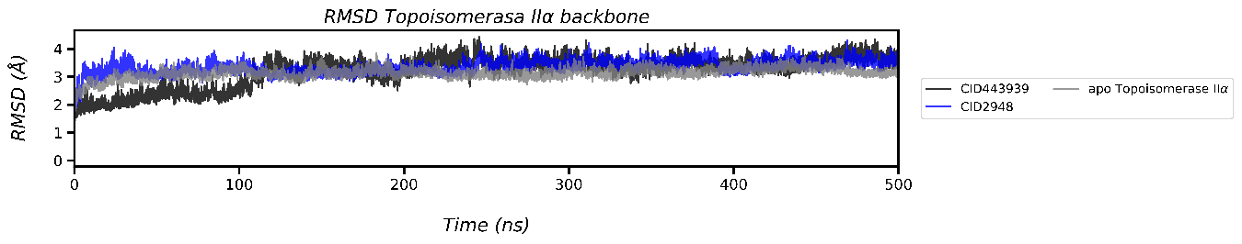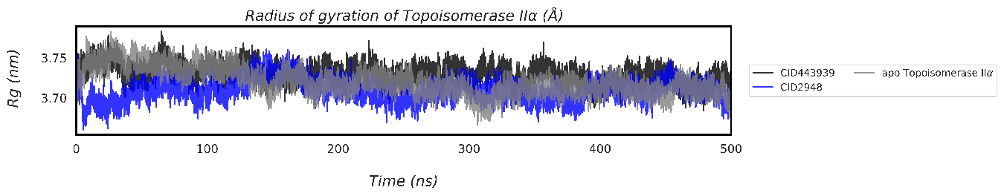
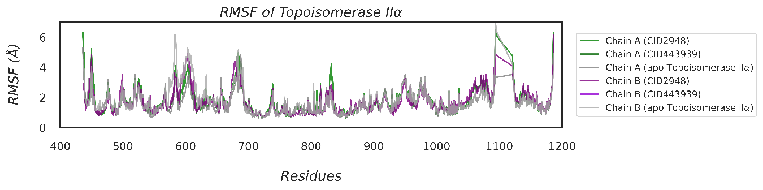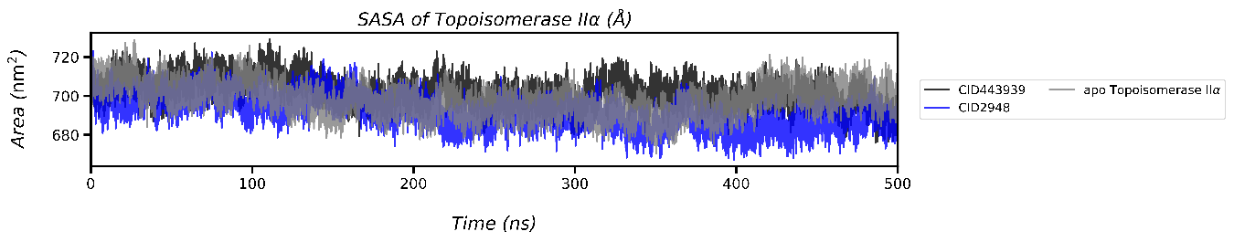
Fig. S1 Structural stability analysis of Topoisomerase IIα from molecular dynamics simulations over a period of 500 ns

