Supplementary Materials
Designing and Resourcing European Medical Affairs Under the EU HTA Regulation: A Market Complexity Index for Hub-and-Spoke Structures

Supplementary S1. Indicator definitions and coding scheme
The Market Complexity Index (MCI) is a composite of 10 publicly observable indicators across three sub-dimensions: regulatory complexity (R), market access complexity (A), and operational complexity (O). Each indicator is standardized to a z-score across the 31 markets (population standard deviation). Each sub-dimension score is the mean of the z-scores of its constituent indicators; the composite MCI is the sum of the three sub-dimension scores, rescaled linearly to a 0–100 range (Germany = 100, Iceland = 0). The computation is reproducible from the dataset in S6 and a fixed random seed for the clustering step.
Table S1. Indicator definitions and data sources.
Indicator | Sub-dim | Definition / coding | Primary source
National regulatory authorities | R | Count of distinct national competent authorities (e.g., Germany = 2: BfArM + PEI) | National regulator publications
Mandatory languages | R | Count of languages required for labelling/promotion (e.g., Switzerland = 3) | National agencies / EFPIA
Independent regulator | R | Binary; 1 for non-EMA-reliant regulators (UK, Switzerland), 0 otherwise | EC HTAR / national agency
Sub-national contracting | R | 0 = none; 1 = regional layer; 2 = federal + sub-national (Germany) | Vogler S, WHO Regional Office for Europe, 2022 + national
HTA / pricing touchpoints | A | Count of HTA and pricing decision points to reach reimbursement | CRA/EFPIA Root Causes 2025
Regional formulary fragmentation | A | Binary; 1 for strong regional formulary variation (Italy, Spain) | CRA/EFPIA Root Causes 2025
MEA / RSA prevalence | A | Ordinal 0/1/2 by prevalence of managed-entry / risk-sharing agreements | Vogler S, WHO Regional Office for Europe, 2022
Population | O | Inhabitants (millions), log-transformed | Eurostat 2024 / World Bank 2024
Pharmaceutical market size | O | Annual market (€B), log-transformed; see S3 sourcing note | EFPIA Industry Figures 2024 [2]
Top-ranked medical universities | O | Count of top-500 medical universities (KOL-density proxy) | QS / ARWU 2024
Coding note. The independent-regulator flag treats Norway and Iceland as 0 (EMA-reliant via the EEA), reserving 1 for the United Kingdom and Switzerland. Sub-national contracting, regional formulary fragmentation, and MEA/RSA prevalence are coded from documentary sources and retain a residual element of judgment in their coding rules; the underlying observations are public.

Supplementary S2. Per-market regulatory and HTA body mapping
Competent authorities and HTA / payer bodies for the 31 markets in the primary analysis. Mapping is factual and independent of the MCI computation.
Table S2. Per-market regulatory and HTA body mapping.
Market | Competent authority | HTA / payer body | Key access features
Germany | BfArM (drugs) / PEI (biologics) | G-BA + IQWiG | AMNOG early-benefit assessment; GKV negotiations
France | ANSM | HAS / CEPS | SMR/ASMR rating; CEPS price negotiation; Accès précoce
Italy | AIFA | AIFA CTS/CPR + Regional HTAs | Centralized AIFA reimbursement; regional formulary variation
Spain | AEMPS | DG Cartera Común + 17 CCAA | Regional access heterogeneity; IPT positioning reports
United Kingdom | MHRA (independent) | NICE / SMC / AWMSG | Technology appraisals; IRP route; VPAG pricing
Switzerland | Swissmedic (independent) | FOPH (BAG) / SwissDRG | SL listing; cantonal hospital tariffs
Belgium | FAMHP | INAMI-RIZIV + KCE | Reimbursement dossier; managed-entry agreements
Netherlands | MEB (CBG) | ZIN | BIA/CUA; sluis procedure for high-cost drugs
Sweden | MPA | TLV + NT-council | Value-based pricing; regional NT cooperation
Denmark | DKMA | Medicinrådet | Centralized hospital HTA; rapid assessment
Poland | URPL | AOTMiT + MoH | Bimonthly reimbursement list; risk-sharing common
Czech Republic | SÚKL | SÚKL (HTA) + VZP | Short-term reimbursement; §16 exceptional access
Hungary | NNGYK / OGYÉI | NEAK + OGYÉI HTA | Price-volume agreements; limited HTA capacity
Norway | NoMA | Beslutningsforum + NoMA | New Methods system; centralized decision forum
Finland | Fimea | PPB (Hila) + Palko | PPB pricing; Palko hospital assessments
Austria | BASG / AGES | HVB / federal states | EKO listing; regional hospital variation
Portugal | INFARMED | INFARMED (HTA) + SPMS | National formulary; hospital committees (CFT)
Ireland | HPRA | NCPE + HSE | NCPE rapid review and full HTA; managed access
Greece | EOF | EOF HTA Committee + EOPYY | HTA since 2018; clawback/rebate complexity
Romania | ANMDMR | ANMDMR (HTA) + NHIH | Conditional reimbursement; cost-volume contracts
Bulgaria | BDA | NCPRMP | Positive list; HTA since 2019
Slovakia | ŠÚKL | MoH + categorisation commission | Categorisation; reference pricing
Slovenia | JAZMP | HIIS + JAZMP | Reference pricing; limited formal HTA
Croatia | HALMED | HZZO | Basic/supplementary lists; HTA guidelines
Lithuania | VVKT | NHIF + State Medicines Agency | Reimbursement algorithm; reference pricing
Latvia | ZVA | NHS (NVD) | Compensation list; reference-country basket
Estonia | State Agency of Medicines | Health Insurance Fund | Positive list; Nordic/Baltic reference basket
Luxembourg | Ministère de la Santé | CNS | Full EMA reliance; limited national HTA
Malta | Medicines Authority | Government formulary | Full EMA reliance; minimal national HTA
Cyprus | Pharmaceutical Services (MoH) | Health Insurance Org. (GHS) | EMA reliance; positive list
Iceland | Icelandic Medicines Agency | Landspítali / MoH | EMA reliance via EEA; minimal national-specific work

Supplementary S3. EFPIA Patients W.A.I.T. 2024—per-market access figures
Figures for medicines approved 2020–2023, as extracted from the EFPIA Patients W.A.I.T. Indicator 2024 Survey [3]. Median time-to-availability is in days; availability rate and full-availability share are percentages of centrally authorized medicines. The MCI is validated against the availability rate (Pearson r = 0.72; Spearman ρ = 0.69; both p < 0.001).
Table S3. EFPIA Patients W.A.I.T. 2024 per-market figures.
Market | Median time-to-availability (days) | Availability rate (%) | Full availability (%)
Germany | 52 | 83 | 75
United Kingdom | 310 | 61 | 35
Italy | 363 | 82 | 58
Spain | 550 | 65 | 35
France | 523 | 60 | 32
Switzerland | 204 | 71 | 47
Poland | 737 | 39 | 6
Belgium | 503 | 51 | 51
Sweden | 265 | 50 | 23
Romania | 710 | 19 | 13
Austria | 232 | 73 | 51
Czech Republic | 859 | 60 | 10
Finland | 305 | 50 | 16
Ireland | 646 | 27 | 25
Portugal | 775 | 54 | 28
Greece | 689 | 43 | 25
Netherlands | 391 | 57 | 58
Hungary | 710 | 27 | 7
Denmark | 264 | 58 | 28
Slovakia | 689 | 27 | 9
Bulgaria | 705 | 53 | 44
Norway | 476 | 37 | 32
Luxembourg | 402 | 58 | 58
Croatia | 608 | 27 | 23
Lithuania | 795 | 10 | 6
Slovenia | 513 | 50 | 50
Latvia | 567 | 16 | 6
Estonia | 646 | 24 | 18
Malta | — | 8 | 7
Cyprus | 391 | 34 | 1
Iceland | 514 | 31 | 11
Caveats. Malta submitted a single product date and is excluded from time-to-availability (shown as “—”). Croatia and the Netherlands have incomplete reporting in the source. The access sub-score of the MCI captures structural complexity, not access speed alone; the MCI–time-to-availability association is weak and confounded by market size (main text, Methods 2.5).

Supplementary S4. Industry and professional-society evidence base
Benchmarking observations are triangulated from publicly available reports. Percentages are paraphrased from each report’s public summary, not extrapolated.
Table S4. Industry and professional-society evidence base.
Source | Publisher / year | Principal finding used | Framework element informed
Medical Affairs Outlook 2025 | ZS Associates, 2025 | 13% of leaders rate their organization in the top tier (down from 19% in 2024) | Capability-gap narrative; MCI-weighted resourcing
Medical Affairs Outlook 2024 | ZS Associates, 2024 | 19% top-tier baseline; majority describe teams as still maturing | Trend comparison (19%→13%) in Discussion
Medical Affairs Metrics Benchmarking | MAPS, 2023 | Persistent heterogeneity in impact measurement; no shared standards | Measurement-infrastructure gap; governance
Digital, Analytics & AI Benchmark | MAPS, 2024 | Uneven digital/analytics maturity between hub and affiliate | Hub omnichannel/analytics capabilities
JCA multi-stakeholder workshop | CIRS, 2024 (PMC11943332) | JCA readiness rated 6–7/10; PICO/timeline concerns; divergent national methods | Hub JCA composition; Box 1; governance

Supplementary S5. Sensitivity analyses: indicator weighting and revenue thresholds
S5.1 Indicator weighting
To test whether equal weighting drives the results, each sub-dimension and, separately, each individual indicator was reweighted by ±20% and MCI tier membership recomputed (cut-offs: low <30, moderate 30–60, high >60). The composite was rescaled 0–100 after each reweighting.
Table S5. Weighting sensitivity (±20% per sub-dimension and per indicator).
Reweighting | Markets crossing an MCI tier boundary (of 31)
Regulatory (R) ×1.2 | 1
Regulatory (R) ×0.8 | 0
Access (A) ×1.2 | 0
Access (A) ×0.8 | 1
Operational (O) ×1.2 | 0
Operational (O) ×0.8 | 1
Any single indicator ±20% (worst case) | 1
Across every single-factor ±20% reweighting, at most one of the 31 markets crosses a tier boundary, and no market changes archetype (archetype depends jointly on MCI tier and the exogenous revenue tier). The tier structure is therefore stable under the equal-weight default.
S5.2 Revenue-threshold sensitivity
The archetype assignment overlays a revenue tier (high > €40B; medium €10–40B; small < €10B) on the MCI tier. Varying the high/medium threshold shows that only the France/Italy distinction is sensitive: at thresholds of €38–44B both France (€45.0B) and Italy (€44.4B) fall in the high-revenue tier; at €45B only Germany and France; at €46B only Germany. The archetype-1/archetype-2 split between France and Italy therefore turns on a €1–2B margin and should be read as a fine-grained commercial judgment rather than a robust classification. The €10B medium/small threshold changes revenue labels for markets near it (Switzerland €9B, Netherlands €10B, Poland €11.5B) but does not change their archetype assignment, which is fixed by MCI tier and, for Switzerland, by independent-regulator status. Incremental value beyond market size: the MCI correlates with market size at r = 0.94 (R² = 0.89); its non-size content is concentrated in the independent-regulatory archetype (United Kingdom and Switzerland, defined by regulatory independence rather than scale) and in access-dimension tier shifts for a minority of markets (main text, Section 2.5).

Supplementary S6. Full indicator dataset, clustering, validation, and reproducibility
Table S6a. Raw indicator values and computed scores for the 31 markets (sorted by MCI).
Market | Pop (M) | Mkt (€B) | Reg | Lang | Indep | HTA | SubNat | RegFrag | MEA | KOL | MCI | Clust
Germany | 84.5 | 69.8 | 2 | 1 | 0 | 2 | 2 | 1 | 2 | 5 | 100.0 | 1
United Kingdom | 67.7 | 37 | 1 | 1 | 1 | 3 | 1 | 0 | 2 | 5 | 86.6 | 3
Italy | 58.9 | 44.4 | 1 | 1 | 0 | 2 | 1 | 2 | 2 | 4 | 79.4 | 4
Spain | 48.6 | 28 | 1 | 1 | 0 | 2 | 1 | 2 | 2 | 3 | 74.8 | 4
France | 68.4 | 45 | 1 | 1 | 0 | 2 | 1 | 0 | 2 | 4 | 64.5 | 0
Switzerland | 8.9 | 9 | 1 | 3 | 1 | 1 | 1 | 0 | 1 | 2 | 58.3 | 3
Poland | 37 | 11.5 | 1 | 1 | 0 | 2 | 0 | 0 | 2 | 2 | 47.7 | 0
Belgium | 11.7 | 7.5 | 1 | 3 | 0 | 2 | 0 | 0 | 1 | 2 | 47.6 | 0
Sweden | 10.6 | 7.5 | 1 | 1 | 0 | 2 | 1 | 0 | 1 | 2 | 43.3 | 0
Romania | 19 | 3.5 | 1 | 1 | 0 | 2 | 0 | 0 | 2 | 1 | 39.9 | 0
Austria | 9.1 | 6 | 1 | 1 | 0 | 1 | 1 | 1 | 1 | 1 | 39.8 | 0
Czech Republic | 10.6 | 4 | 1 | 1 | 0 | 2 | 0 | 0 | 2 | 1 | 38.5 | 0
Finland | 5.6 | 4 | 1 | 2 | 0 | 2 | 0 | 0 | 1 | 1 | 36.1 | 0
Ireland | 5.1 | 4 | 1 | 1 | 0 | 2 | 0 | 0 | 1 | 2 | 33.6 | 0
Portugal | 10.4 | 4.5 | 1 | 1 | 0 | 2 | 0 | 0 | 1 | 1 | 33.2 | 0
Greece | 10.4 | 3.5 | 1 | 1 | 0 | 2 | 0 | 0 | 1 | 1 | 32.6 | 0
Netherlands | 17.9 | 10 | 1 | 1 | 0 | 1 | 0 | 0 | 1 | 2 | 32.3 | 0
Hungary | 9.6 | 3 | 1 | 1 | 0 | 2 | 0 | 0 | 1 | 1 | 31.9 | 0
Denmark | 5.9 | 5.5 | 1 | 1 | 0 | 1 | 0 | 0 | 1 | 2 | 27.5 | 0
Slovakia | 5.4 | 1.8 | 1 | 1 | 0 | 2 | 0 | 0 | 1 | 0 | 26.2 | 0
Bulgaria | 6.5 | 1.2 | 1 | 1 | 0 | 2 | 0 | 0 | 1 | 0 | 25.7 | 0
Norway | 5.5 | 4.5 | 1 | 1 | 0 | 1 | 0 | 0 | 1 | 1 | 24.0 | 0
Luxembourg | 0.65 | 0.5 | 1 | 3 | 0 | 1 | 0 | 0 | 0 | 0 | 13.7 | 2
Croatia | 3.9 | 1 | 1 | 1 | 0 | 1 | 0 | 0 | 0 | 0 | 10.8 | 2
Lithuania | 2.8 | 0.8 | 1 | 1 | 0 | 1 | 0 | 0 | 0 | 0 | 9.2 | 2
Slovenia | 2.1 | 0.8 | 1 | 1 | 0 | 1 | 0 | 0 | 0 | 0 | 8.4 | 2
Latvia | 1.9 | 0.5 | 1 | 1 | 0 | 1 | 0 | 0 | 0 | 0 | 6.9 | 2
Estonia | 1.4 | 0.5 | 1 | 1 | 0 | 1 | 0 | 0 | 0 | 0 | 6.0 | 2
Malta | 0.55 | 0.2 | 1 | 2 | 0 | 1 | 0 | 0 | 0 | 0 | 5.9 | 2
Cyprus | 0.92 | 0.4 | 1 | 1 | 0 | 1 | 0 | 0 | 0 | 0 | 4.2 | 2
Iceland | 0.4 | 0.2 | 1 | 1 | 0 | 1 | 0 | 0 | 0 | 0 | 0.0 | 2
Reproducibility metadata. Sub-dimension scores = mean of within-dimension indicator z-scores (population SD across 31 markets); MCI = sum of the three sub-dimension scores, rescaled 0–100. Clustering: k-means (k = 5; 50 initializations; random_state = 42); Ward hierarchical clustering agrees at adjusted Rand index 0.80; the k-means five-cluster partition corresponds broadly to the EURO-HEALTHY typology [20]. Silhouette analysis does not select k = 5 (the strongest separation is a two-cluster large-versus-small-market split); the five-cluster structure is a framework choice supported by external correspondence. Principal component analysis: PC1 explains 53% of variance (market size, KOL density, population), PC2 explains 14% (regulatory independence, language). External validation against EFPIA W.A.I.T. 2024: availability rate Pearson r = 0.72 (Spearman ρ = 0.69; both p < 0.001, n = 31); full-availability share r = 0.52 (p = 0.003); median time-to-availability r = −0.42 (Spearman ρ = −0.28, non-significant; n = 30, Malta excluded), partial r = −0.19 after controlling for market size. The complete computational procedure is given below, and the full indicator dataset appears in Table S6a, so the MCI can be reproduced from this Supplement alone. The analysis code and dataset are additionally deposited in the public Open Science Framework repository at doi:10.17605/OSF.IO/BA8R2.
Computational procedure. (1) Assemble the 10 indicators for the 31 markets (Table S6a). (2) Standardize each indicator to a z-score across the 31 markets using the population standard deviation. (3) Compute each sub-dimension score as the mean of the z-scores of its constituent indicators: R = mean(z of the four regulatory indicators); A = mean(z of the three access indicators); O = mean(z of the three operational indicators). (4) MCI(z) = R + A + O. (5) Rescale linearly to 0–100: MCI = 100 × (MCI(z) − min) / (max − min), giving Germany = 100 and Iceland = 0. (6) Cluster the 31 × 10 standardized matrix with k-means (k = 5; 50 initializations; random seed = 42), confirmed with Ward hierarchical clustering. (7) Validate by Pearson and Spearman correlation of the MCI against the EFPIA W.A.I.T. availability rate, full-availability share, and median time-to-availability, with partial correlation controlling for log market size. Applying these steps to Table S6a reproduces the published scores exactly.

Supplementary Figure S1. Diagnostics: silhouette analysis (cluster validity), PCA biplot (dimensionality), and leave-one-out validation robustness.
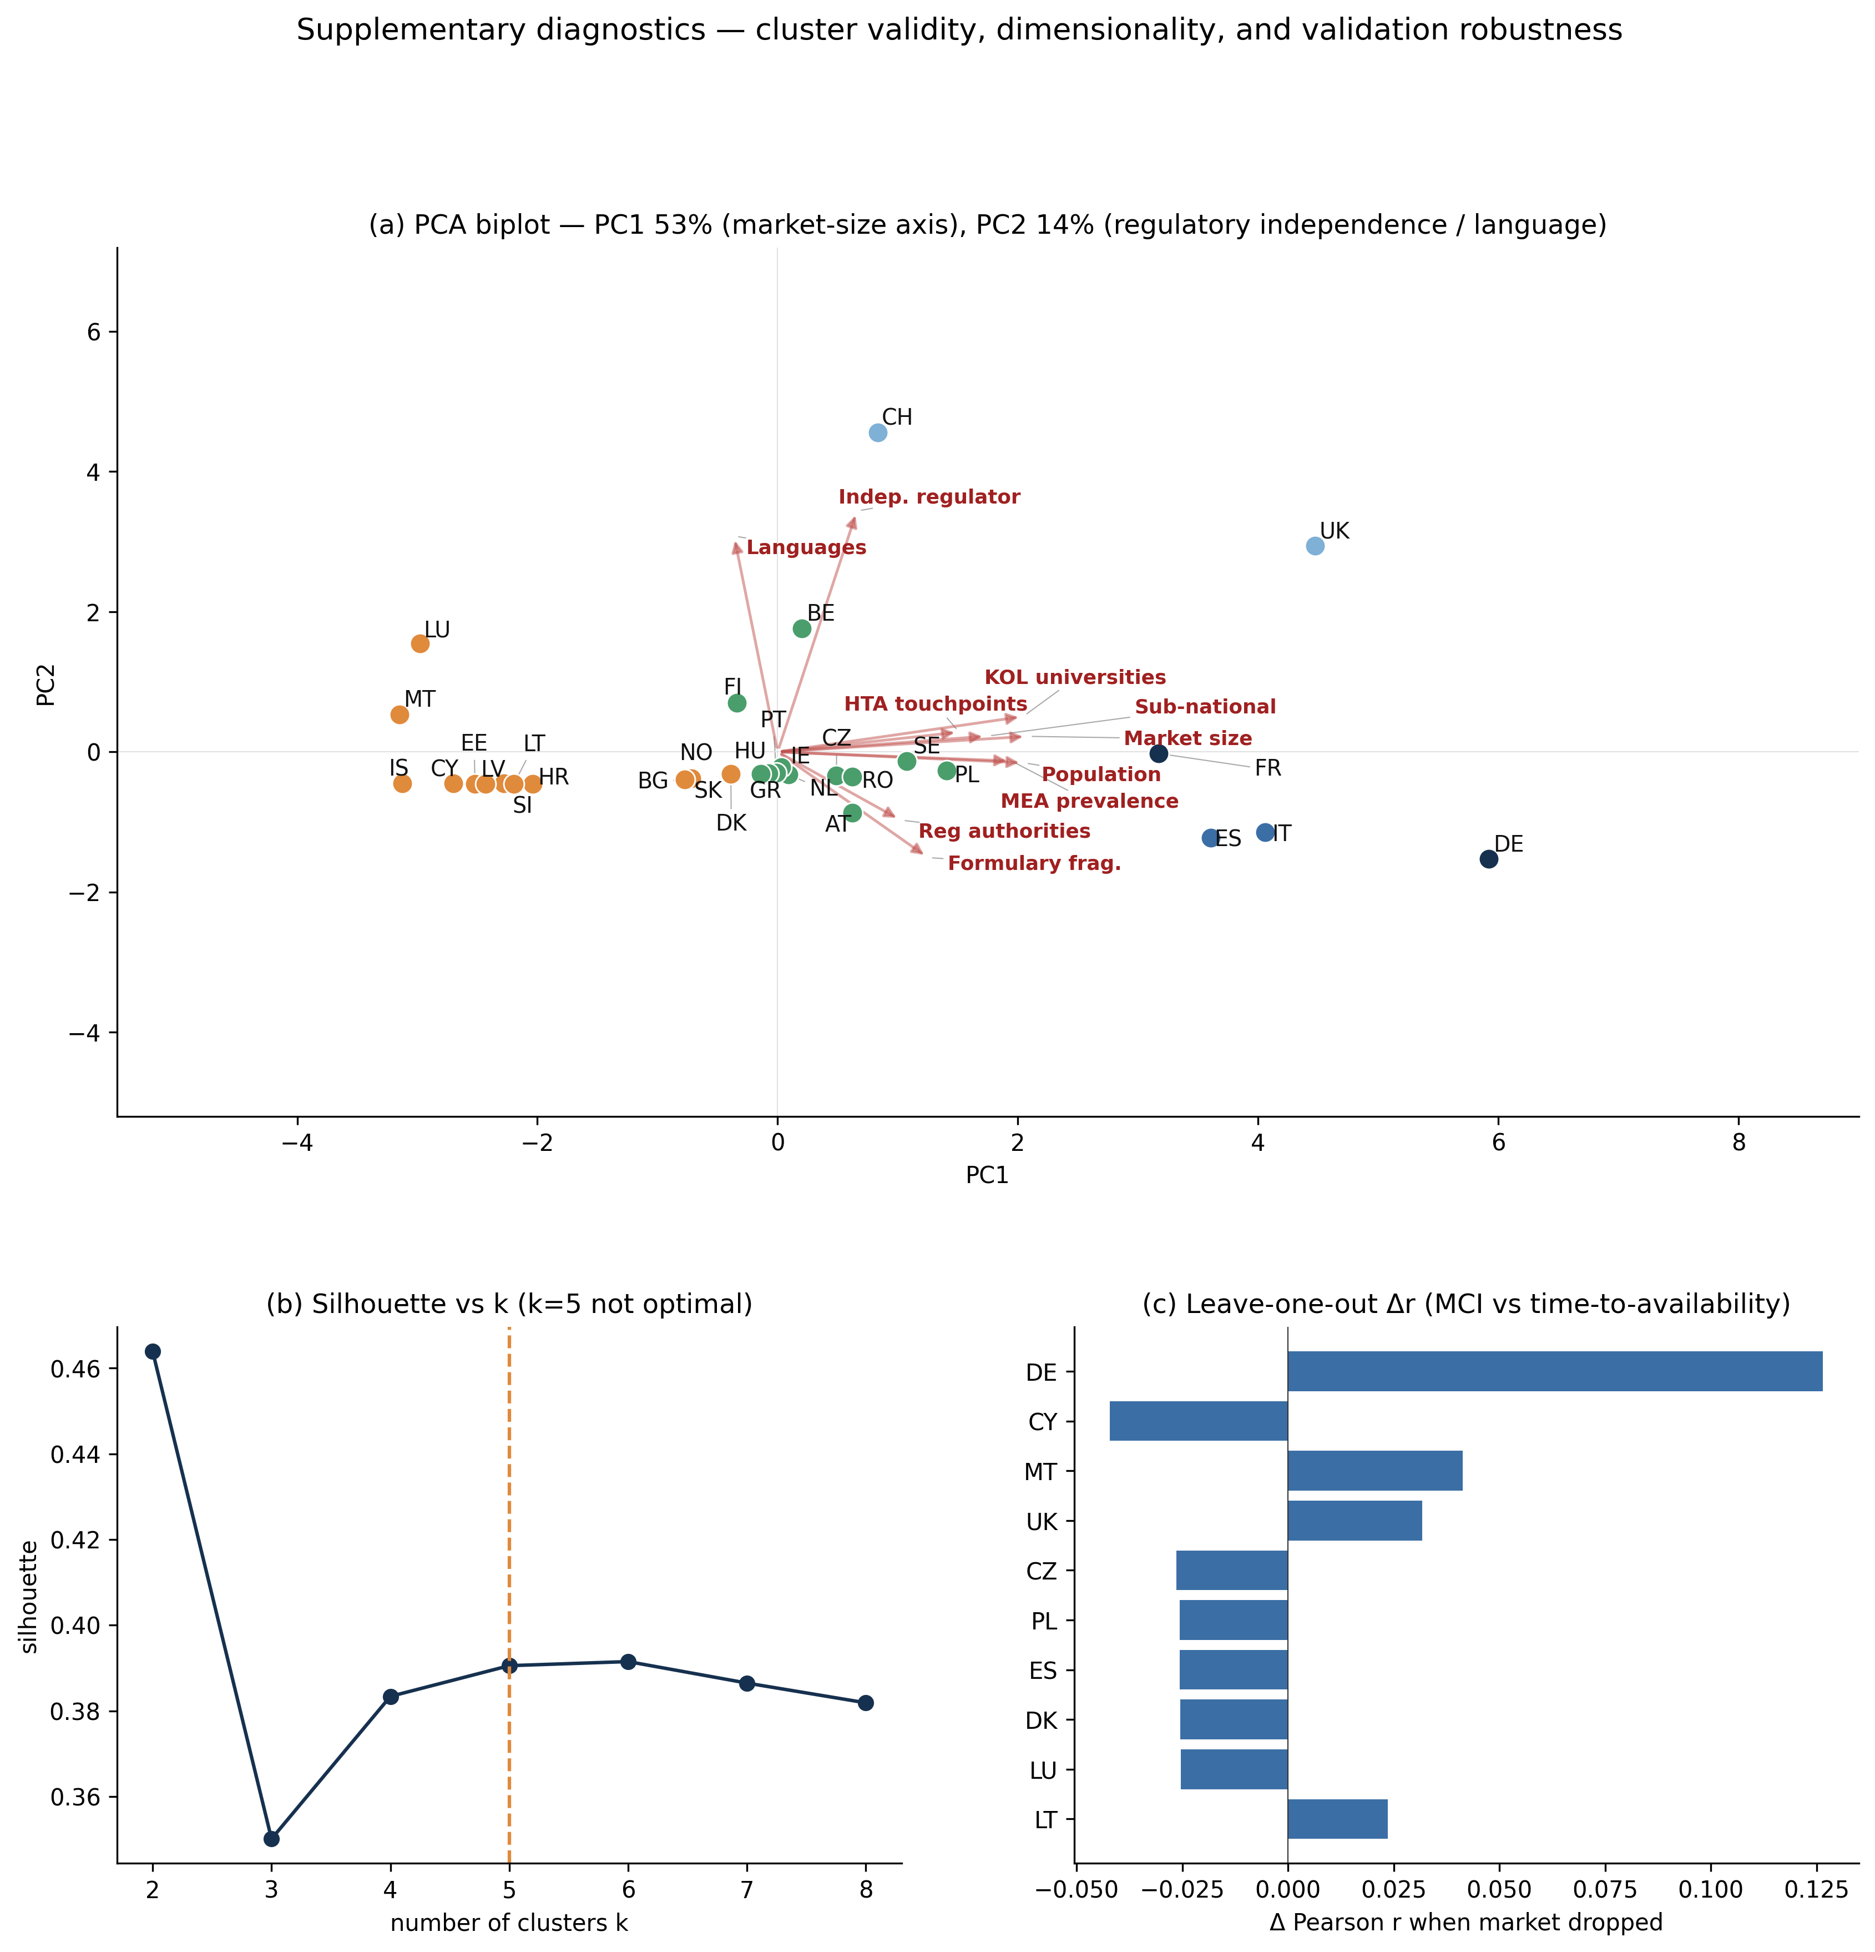

Supplementary S7. Illustrative case studies
The following four scenarios illustrate how the framework's outputs translate into concrete organizational choices across company situations of increasing scale and maturity. All company profiles are fictional and all headcount and investment figures are illustrative starting ranges, not benchmarks (Table 4; Supplementary S6). The scenarios are summarized in Table S7.
Scenario 1: single-asset biotech, first European launch. A US-headquartered oncology biotech holds FDA approval for a first-in-class targeted therapy and awaits the EMA decision, with a peak European forecast of approximately €600 million across the EU and the United Kingdom and no prior European medical affairs presence. Because the asset is JCA-eligible from launch, a hub is non-negotiable even at minimal scale: roughly 10–15 full-time equivalents concentrated in evidence strategy and JCA coordination, regulatory and HTA strategy, and medical communications, with operational-excellence functions such as medical information and training largely outsourced. Dedicated spokes are built only for the two archetype-1 markets at launch—Germany, where the AMNOG dossier is due within seven days, and France (HAS/CEPS)—while Italy, Spain, and the United Kingdom are covered through thin dedicated or hub-supported arrangements and the regional-cluster and tiered-partnership markets through partnership and distributor models. Sequencing is hub-first: stand up the hub and the German and French spokes, add the remaining EU5 and the United Kingdom on approval, and defer or partner Central-Eastern Europe and the micro-markets. This is the framework at its leanest—the prioritization that answers where a constrained company's first ten to fifteen scientific hires should go.
Scenario 2: single asset with a pipeline indication. The same company has a second oncology indication in pivotal Phase III trials, with sites in Germany, Spain, Poland, and the Netherlands. The pipeline changes the design in two ways. The hub gains a second JCA and evidence workstream and grows modestly, to roughly 14–18 full-time equivalents; and a trial-site override is applied to the spoke map—Poland and the Netherlands, regional-cluster markets that the launch logic would serve through partnership, receive earlier MSL and medical presence because pre-approval investigator engagement and scientific exchange at trial sites cannot wait for the second approval. Governance must sequence two PICO responses and two congress plans, and the spokes for the second launch are staged eighteen to twenty-four months ahead. The scenario shows that the archetype map is a starting prior that a development pipeline adjusts, and that complexity should be resourced ahead of need where trials demand it.
Scenario 3: established multi-asset company, full European build. A profitable US company with four to six marketed assets spanning oncology, immunology, and a rare disease decides to build a European medical affairs organization from scratch. Mixed therapy areas bring mixed JCA exposure—oncology assessed jointly now, the orphan asset from 2028—so the hub is portfolio-level and larger, roughly 25–40 full-time equivalents, with all four capability domains in-house, multiple concurrent JCA workstreams, and the orphan workstream staged toward the 2028 phase-in. The full archetype ladder is built: dedicated spokes for Germany, France, Italy, Spain, the United Kingdom, and Switzerland; genuine regional clusters for the Nordics (including Denmark and Norway) and Benelux; and a structured Central-Eastern European tiered partnership anchored by Poland. Outsourcing is light and used as a flexibility buffer; governance operates across products with therapy-area pods; and, because resources allow, the build proceeds in parallel rather than in sequence. The scenario shows the framework at full scale, where the hub is amortized across assets and the therapy-area and JCA-timeline overlays drive staging.
Scenario 4: multi-asset incumbent restructuring an existing footprint. A company with several marketed products already operates in Europe, but its footprint grew ad hoc: Switzerland is run through a German-speaking (DACH) hub, Iceland is folded into a Nordic cluster, and country resourcing reflects legacy headcount rather than current complexity. Applying the framework re-clusters the footprint—pulling Switzerland out of the DACH grouping into the independent-regulatory archetype, splitting the Nordics so that Denmark, Sweden, Norway, and Finland form a regional cluster anchored by the JNHB while Iceland moves to tiered partnership, and reassigning Greece from a generic southern bucket into the regional-cluster archetype. An off-diagonal analysis of current headcount against the MCI then rebalances the organization: capacity is released from over-resourced low-complexity markets and redirected to under-resourced high-complexity ones, and duplicated country-level JCA effort is consolidated into a central hub. Here the framework is a restructuring instrument rather than a greenfield blueprint, and it makes the cost of geography-based clustering explicit.

Table S7. Illustrative application of the framework across four company situations. All profiles, headcount, and investment figures are illustrative and are not externally validated benchmarks (Table 4; Supplementary S6).
Dimension | S1 single asset, greenfield | S2 single asset + pipeline | S3 multi-asset, full build | S4 incumbent restructuring
Company / assets | 1 asset, 1 indication | 1 asset, +1 in Phase III | 4–6 assets, multiple TAs | several marketed products
Financial posture | constrained | constrained | well-funded | established
EU footprint at start | greenfield | greenfield | greenfield | fragmented / existing
Therapy area & JCA | oncology, JCA now | oncology ×2, JCA now | onc + immuno + orphan (2028) | mixed
Hub size & composition | ~10–15 FTE, evidence-weighted | ~14–18 FTE, two JCA workstreams | ~25–40 FTE, portfolio hub, in-house | re-centralized from duplication
Dedicated spokes at launch | Germany, France | Germany, France (+Spain reinforced) | DE, FR, IT, ES, UK, CH | rebuild around true archetypes
Clusters / partnerships | partner the tail | + trial-site override (PL, NL) | full ladder (Nordics, Benelux, CEE) | re-cluster (split Nordics; free CH)
Outsourcing reliance | heavy | heavy–moderate | light | shift in-house at hub
Governance focus | hub owns JCA / evidence | sequence two PICOs | cross-product, TA pods | redraw hub–spoke boundary
Sequencing logic | hub + DE/FR first | build ahead of trial sites | parallel; orphan staged to 2028 | rebalance, not rebuild
Indicative resourcing (illustrative) | ~€10–18M | ~€15–25M | ~€40–70M+ | reallocation, not net add
What it demonstrates | lean hub-first prioritization | pipeline overrides the prior | framework at scale + TA/JCA phasing | incumbent re-clustering; geography ≠ complexity

