Supplementary information for:

The earliest European lions and the restructuring of carnivore guilds during the Early–Middle Pleistocene Transition
Adrian Marciszak¹, Darío Fidalgo², Saverio Bartolini-Lucenti^{3,4}, Maria Prat-Vericat⁴, Bienvenido Martínez-Navarro^{5,6,7}, Lorenzo Rook³, Joan Madurell-Malapeira^{3*}
¹Department of Palaeozoology, University of Wrocław, Sienkiewicza 21, 50-335 Wrocław, Poland.
²Museum für Naturkunde, Leibniz Institute for Research on Evolution and Biodiversity, Berlin, Germany
³Earth Sciences Department, Paleo[Fab]Lab, Università di Firenze, Via G. La Pira 4, 50121 Firenze, Italy
⁴Institut Català de Paleontologia Miquel Crusafont, Universitat Autònoma de Barcelona, Edifici ICTA-ICP, c/ Columnes s/n, Campus de la UAB, 08193 Cerdanyola del Vallès, Spain
⁵Institut Català de Paleoecologia Humana i Evolució Social (IPHES-CERCA), Zona Educacional 4, Campus Sescelades URV (Edifici W3), 43007, Tarragona, Spain.
⁶Area de Prehistoria, Universitat Rovira i Virgili (URV), Avda. Catalunya 35, 43002 Tarragona, Spain.
⁷ICREA, Pg. Lluís Companys 23, 08010 Barcelona, Spain.

Geographical and geological context: The Vallparadís Section
The Vallparadís Section comprises the paleontological localities of Cal Guardiola (CGR) and Vallparadís Estació (EVT), situated in the Vallès-Penedès Basin (northeastern Iberian Peninsula) (Fig. S1). The sequence represents one of the most complete continental records spanning the latest Early Pleistocene to the early Middle Pleistocene in southwestern Europe and constitutes a key reference framework for investigating the environmental and faunal dynamics associated with the ‘Early–Middle Pleistocene Transition’ (EMPT) ^{1–9}.
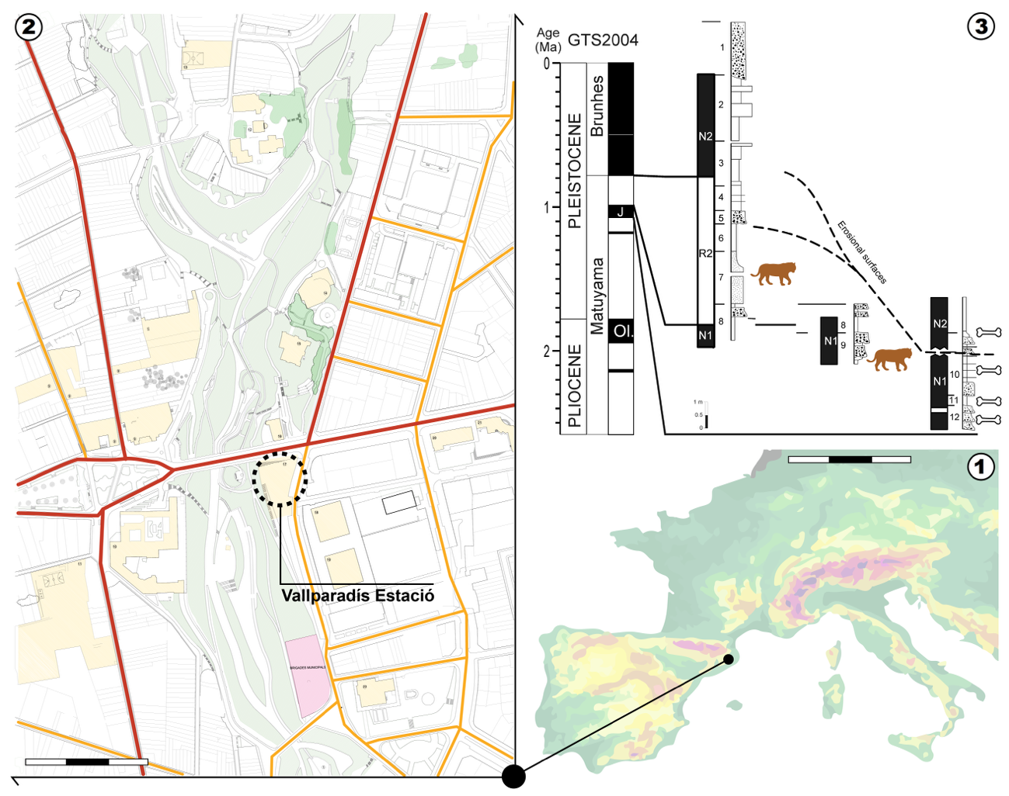
Figure S1. Geographical and geological background. 1 - Geographical location of the Vallparadís Seciton within the Iberian Peninsula, 2 - Location of the studied site within the Vallparadís River, 3 - Stratigraphical synthesis of the Vallparadís Estació site with the lion finds marked.

The sedimentary infilling of the section was strongly controlled by the interaction between an alluvial fan system and the irregular Miocene paleorelief of the basin margins. The excavated deposits mainly consist of debris-flow and mud-flow facies generated by alluvial fan dynamics, locally influenced by colluvial processes and episodic fluvial activity. Biochronological, magnetostratigraphic, and U-series/ESR analyses indicate that the sequence spans from pre-Jaramillo times (ca. 1.2–1.1 Ma; MIS35) to the early Middle Pleistocene (ca. 0.6 Ma), thus encompassing several critical climatic oscillations of the EMPT and the ‘900 ka event’ ^{1–4,7–12}.
The older layers of the section, especially layer CGRD2 (ca. 1.1 Ma), document relatively humid and warm-temperate environmental conditions. Palynological and wood analyses indicate the presence of a riverine or marsh-like ecosystem characterized by aquatic macrophytes, deciduous trees, and grasses, suggesting the persistence of permanent water bodies and well-developed riparian habitats ¹³. During the Jaramillo subchron and immediately after it, the Vallparadís record documents substantial paleoenvironmental fluctuations linked to the onset and progressive intensification of the EMPT. Mesowear, microwear, and stable isotope analyses performed on ungulate assemblages indicate a marked alternation between open grass-dominated landscapes and more humid wooded phases ^{6,10–12}. Layer EVT12 (ca. 1.0 Ma; MIS31) records relatively open and dry environments with expanded grasslands and significant seasonality, whereas the younger layers EVT7 and CGRD7 (ca. 0.86 Ma; MIS21) indicate a shift toward more humid and wooded habitats under increasingly seasonal climatic regimes. These paleoenvironmental changes are consistent with broader patterns documented across Mediterranean Europe during the ‘900 ka event’, when climatic instability and the amplitude of glacial–interglacial oscillations substantially increased ^{7,14}.
Additional evidence for this progressive increase in climatic seasonality comes from the study of dental enamel hypoplasia in Hippopotamus antiquus populations from Vallparadís Section ⁷. Analyses of anterior dentition revealed recurrent enamel stress episodes interpreted as periods of nutritional and environmental stress linked to seasonal fluctuations in water and food availability. The post-Jaramillo units of Vallparadís (ca. 0.90–0.86 Ma) show a particularly high prevalence of hypoplasia, suggesting that hippopotamus populations were increasingly affected by harsher and more unstable environmental conditions during MIS24–MIS21 ⁷. These results reinforce previous paleoecological reconstructions indicating a progressive increase in seasonality, humidity fluctuations, and habitat heterogeneity throughout the EMPT in southwestern Europe.

Addenda to Results
Qualitative morphological comparisons
All comparisons presented below refer to the homologous anatomical elements of the Vallparadís Estació felid.
Radius—Compared with the Vallparadís specimen, the radius of Homotherium crenatidens is proportionally slenderer and more elongated in lateral view, with a straighter shaft and a less pronounced median expansion (Fig. S2.3–4). The coronoid process is less developed, and the coronoid fossa is shallower and more oval in outline. Muscle attachments and articular structures associated with the ulna, including the radial tuberosity, are generally weaker and smoother. Owing to the slender shaft, the distal epiphysis appears proportionally larger. The glenoid cavity is shallower and more rounded, whereas the transverse ridge is thinner, sharper, and more elongated. Likewise, the styloid process is less prominent and shows a more rounded-deltoid outline instead of the triangular morphology observed in the Vallparadís specimen.
The gracile morphology of Homotherium is particularly evident in the proximal epiphysis and distal half of the shaft. The proximal articulation for the humerus is broader, and the articular surface for the lesser sigmoid cavity is proportionally larger. The tubercle located below the radial head on the mesial side is smaller and directed more toward the ulnar border. Distally, the ulnar facet is reduced, the styloid process is less developed, and the groove for the extensor digitorum communis tendon is broader but shallower. The scapholunar articulation is wider and shorter than in the Vallparadís specimen (Fig. S2.3–4).
The radius of Panthera gombaszoegensis differs markedly from the Vallparadís specimen by its smaller but substantially more robust morphology (Fig. S2.6). The shaft is straighter and more massive, and both epiphyses are proportionally larger in lateral view. Muscle scars and tendon grooves are more deeply incised and rugose. At the distal end, the transverse ridge forms an almost continuous line with the styloid process, whereas in the Vallparadís specimen a clear indentation separates both structures. The distal enlargement extends more gradually proximally in P. gombaszoegensis, while in the Vallparadís felid the distal expansion is steeper and more abruptly delimited. Grooves for the tendons of the extensor ossis metacarpi pollicis and extensor carpi radialis longus and brevis are deeper and more widely separated (Fig. S2.6).

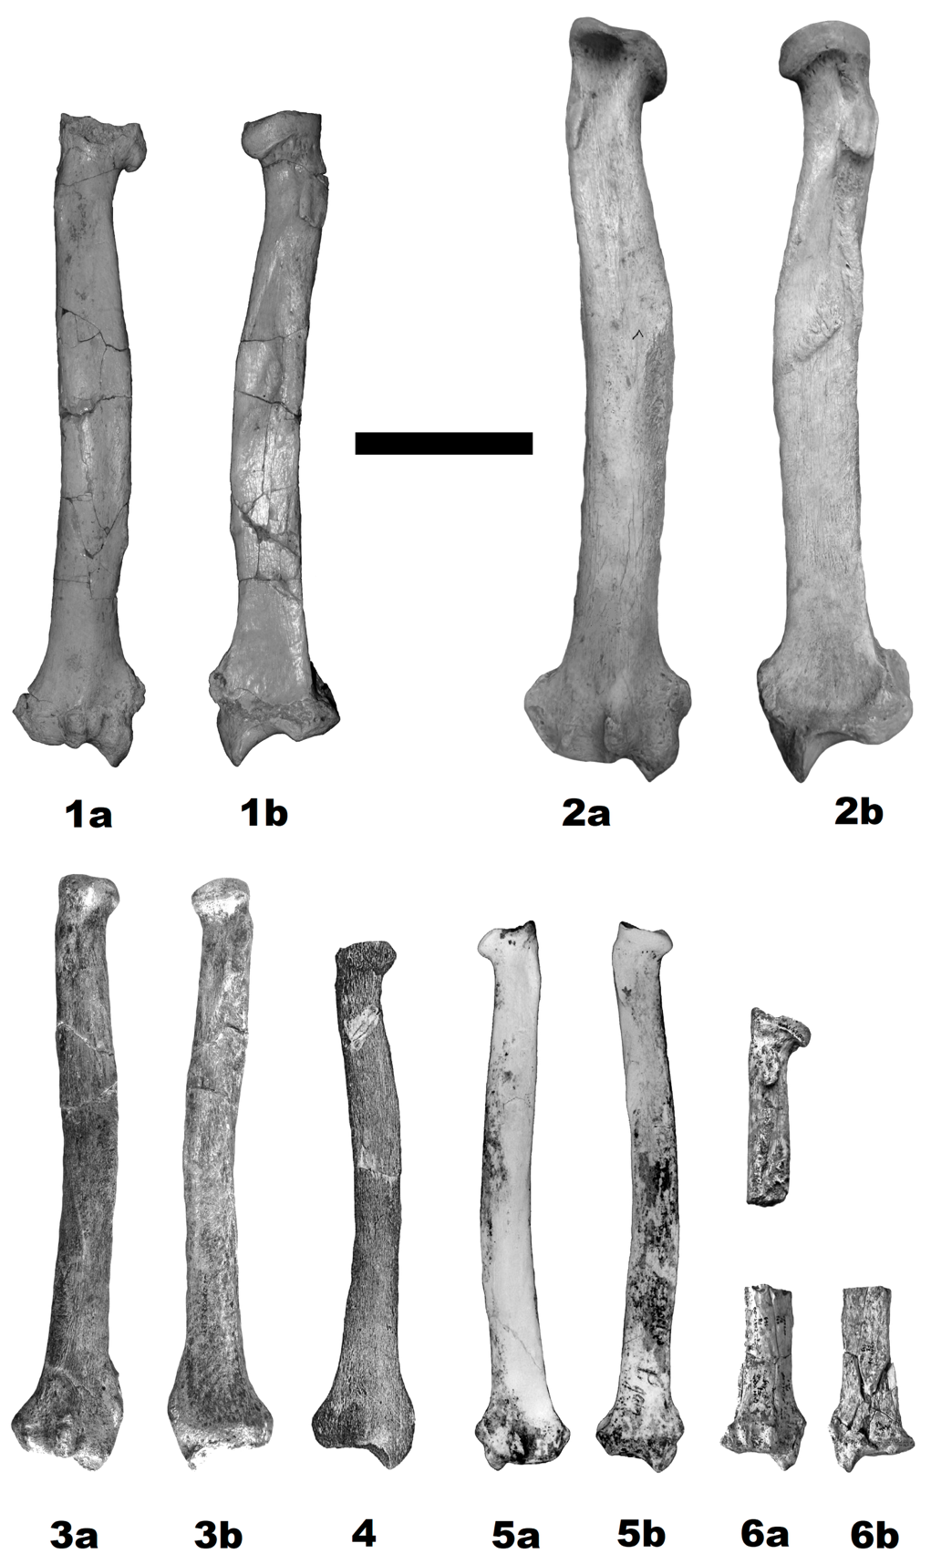
Figure S2. Comparison of radii of Eurasian Pleistocene large felids: 1 - Panthera spelaea fossilis from Vallparadís (EVT 14269), 2 - Panthera spelaea fossilis from Biśnik Cave (layer 19ad, JB.Ps.24), 3 - Homotherium crenatidens from Senèze (SE311), 4 - Homotherium crenatidens from Hundsheim (after Freudenberg¹⁵: Plate 17/3), 5 - Acinonyx pardinensis pleistocaenicus from Dmanisi (D 2001; after Hemmer et al. 2011: 2709, fig. 3), 6 - Panthera gombaszoegensis gombaszoegensis from Château Breccia (CHA. 1-07-EE-25-16; after Argant and Argant¹⁶: 258, plate 3/2). a - dorsal view, b - ventral view, c - medial view (specimens no. 1, 4) and lateral view (specimens no. 2, 3, 5). Scale bar 50 mm.
Femur—The femur of Homotherium crenatidens is noticeably slenderer throughout its length, with the shaft widening gradually toward both epiphyses (Fig. S3.3). In contrast to the Vallparadís specimen, the shaft is slightly curved in lateral view and becomes flatter distally rather than maintaining a cylindrical cross-section. The femoral head is proportionally larger, and the patellar trochlea is deeper and more dorsally prominent. The medial and lateral condyles are more symmetrical in size and are separated by a narrower intercondylar notch. Rugose attachment areas above the condyles are less pronounced. Additional differences include a shallower trochanteric fossa and a more strongly developed linea aspera on the caudal surface. The distal epiphysis is narrower mediolaterally, with smaller and more widely spaced condyles and a deeper trochlea. The intercondylar line and supracondylar tuberosities are comparatively weaker than in the Vallparadís specimen (Fig. S3.3). Finally, the femur of Panthera gombaszoegensis is considerably shorter and more robust, with proportionally larger and more heavily built epiphyses (Fig. S3.2).
Tibia—The tibia of Homotherium crenatidens is slightly more curved in craniocaudal view and has a less laterally expanded proximal epiphysis (Fig. S4.2). The tibial crest is more strongly developed distally, and the nutrient groove on the caudal surface is deeper and narrower. The distal epiphysis is smaller overall and lacks the characteristic hook-like lateral projection typical of Panthera. In distal view, the articular surface is shallower, more restricted, and oval-shaped, with nearly straight cranial and caudal margins. The distal trochlear surfaces are smaller and more triangular. At the proximal end, the femoral articular facets are less prominent. The insertion area for the ligamentum patellae is broader and projects further anteriorly in lateral view. The fibular articulations are also larger. The shaft transitions more smoothly into the lateral surface, and the distal notch on the mesial border is distinctly smaller than in the Vallparadís specimen (Fig. S4.2).
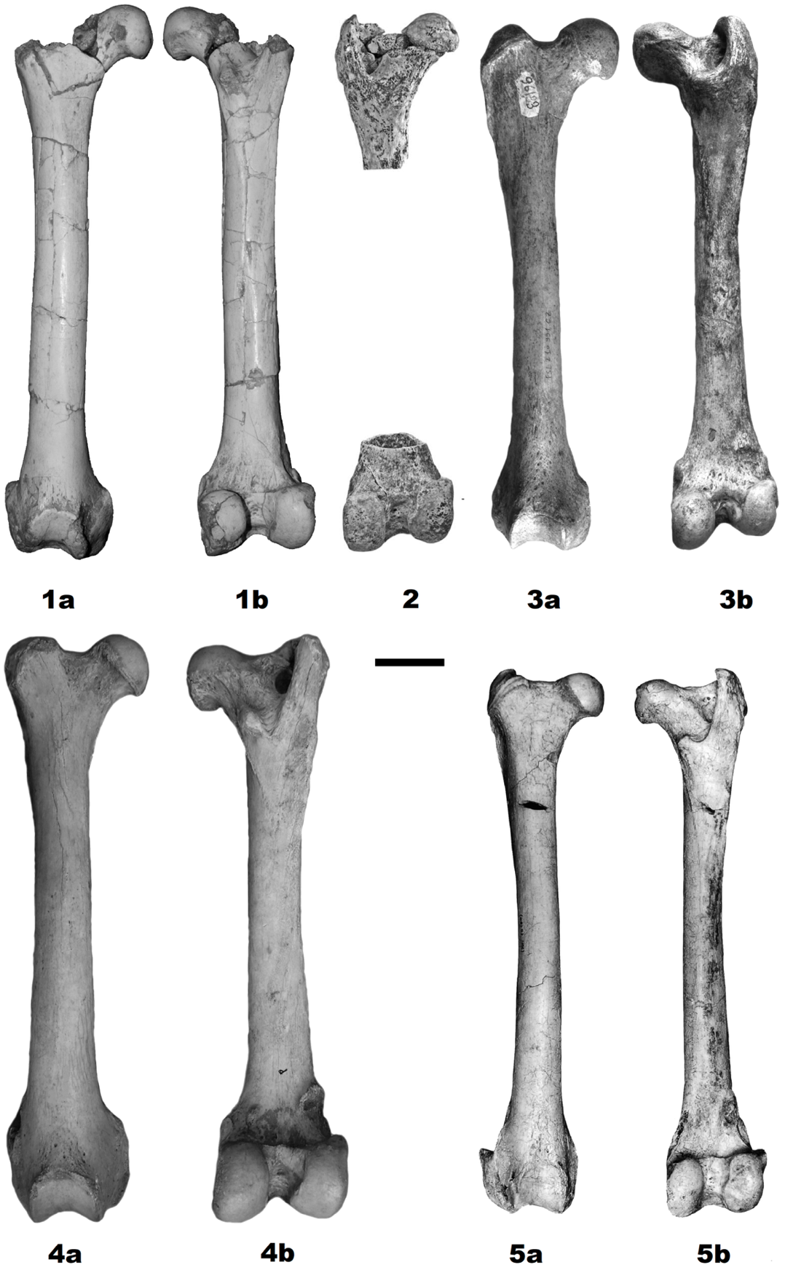
Figure S3. Comparison of femora of Eurasian Pleistocene large felids: 1 - Panthera spelaea fossilis from Vallparadís (EVT 00385), 2 - Panthera gombaszoegensis gombaszoegensis from Château Breccia (CHA.1-01-f.7-132; CHA.1-02-G.8-354; after Argant and Argant¹⁶: 259, plate 4), 3 - Homotherium crenatidens from Senèze (SE311), 4 - Panthera spelaea fossilis from Wschodnia Cave, 5 - Acinonyx pardinensis pleistocaenicus from Untermassfeld (after Hemmer et al. 2001: 137, fig. 1-2). a - lateral view, b - medial view. Scale bar 50 mm.
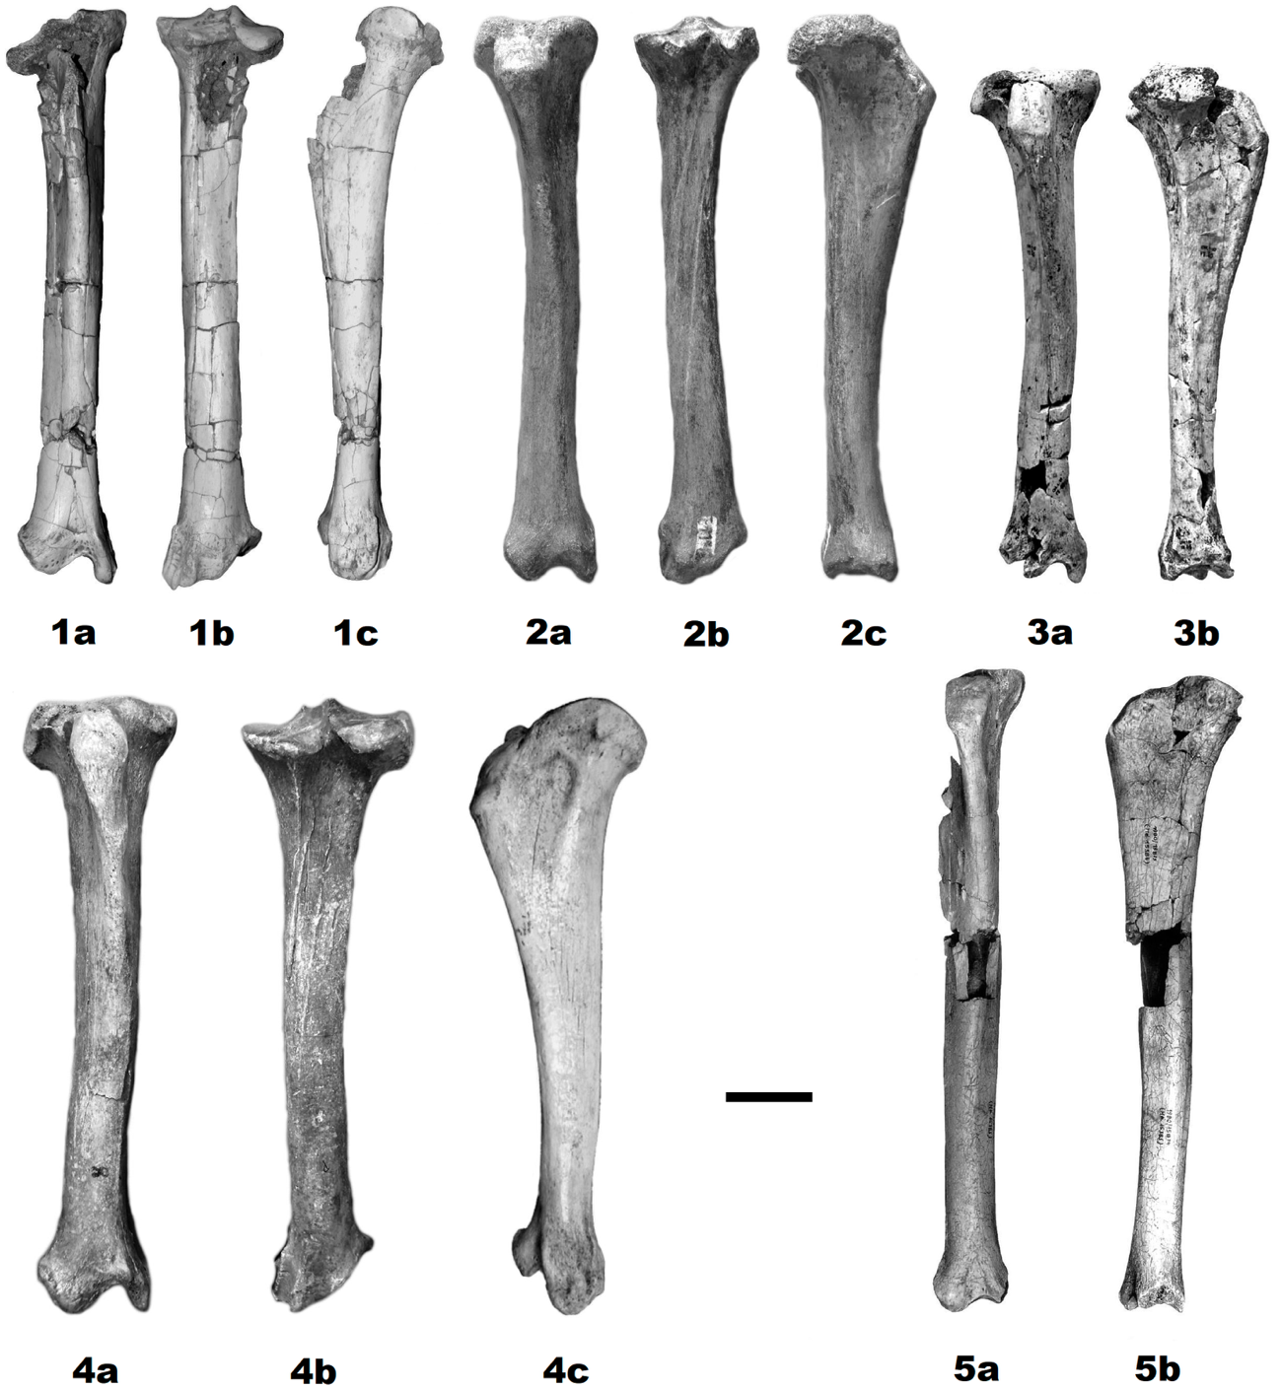
Figure S4. Comparison of tibiae of Eurasian Pleistocene large felids: 1 - Panthera spelaea fossilis from Vallparadís (EVT 04786), 2 - Homotherium crenatidens from Senèze (SE311), 3 - Panthera gombaszoegensis gombaszoegensis from Château Breccia (CHA. 1-07-EE-25-16; after Argant and Argant¹⁶: 259, plate 4/3a-b), 4 - Panthera spelaea fossilis from Mosbach 2, 5 - Acinonyx pardinensis pleistocaenicus from Untermassfeld (IQW 1980/15874 + 15875; after Hemmer et al. 2001: plate 137/3-4). a - dorsal view, b - ventral view, c - medial view (specimens no. 1, 4) and lateral view (specimens no. 2, 3, 5). Scale bar 50 mm.

The tibia of Panthera gombaszoegensis is shorter, heavier, and more robust, with a more massive proximal half and a more strongly developed tibial crest (Fig. S4.3). The crest is higher, broader, and more medially deflected, producing a markedly deeper tibial fossa. As already noted by Argant and Argant ¹⁶, this feature clearly distinguishes the jaguar-like pantherine from Panthera spelaea fossilis, Panthera leo, and the Vallparadís specimen.
Metacarpal II—In Homotherium crenatidens, the proximal articular surface lacks the characteristic triangular outline observed in the Vallparadís specimen (Fig. S5.3). The dorsal surface does not widen proximally from the central groove, whereas the swelling along the dorso-medial border is more pronounced. The trapezium facet is proportionally larger and more elongated proximodistally, projecting proximally in lateral view. On the lateral side, the dorsal facet for Mc III is straighter and less obliquely elongated. Distally, the collateral tuberosities are more prominent, and the depression above the articular surface is broader and extends further dorsally (Fig. S5.3).
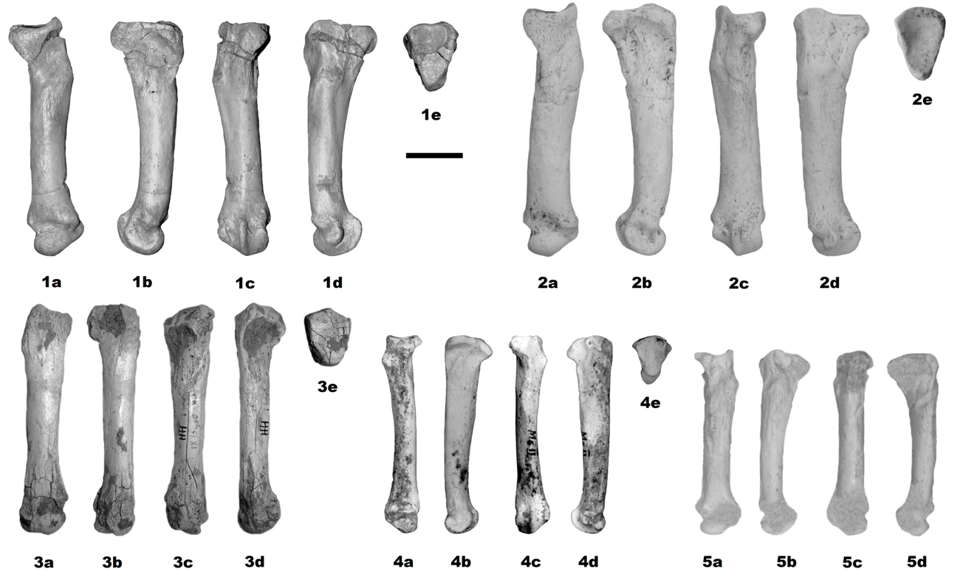
Figure S5. Comparison of metacarpal 2 of Eurasian Pleistocene large felids: 1 - Panthera spelaea fossilis from Vallparadís (EVT 14276), 2 - Panthera spelaea fossilis from Carrière Cave (GDC2019-D5-545-Nv4; after Prat‑Vericat et al. 2022: 554, fig. 6b), 3 - Homotherium latidens latidens from Hundsheim (HH 1914), 4 - Acinonyx pardinensis pleistocaenicus from Dmanisi (D 2002a; after Hemmer et al. 2011: 2710, fig. 5), 5 - Panthera gombaszoegensis gombaszoegensis from Koněprusy C 718. a - dorsal view, b - lateral view, b - ventral view, d - medial view, e - proximal view. Scale bar 30 mm.

Metacarpal III—The shaft of Mc III in Homotherium expands more distally than in the Vallparadís specimen (Fig. S6.3). The proximal articulation for the capitatum is narrower and sharply separated from the hamatum facet laterally. Medially, a pronounced ridge separates the capitatum surface from the dorsal facet for Mc II. A broad and deep notch penetrates the capitatum articulation between the dorsal and palmar facets for Mc II. The facet for Mc IV is broader laterally, especially palmarly (Fig. S6.3).
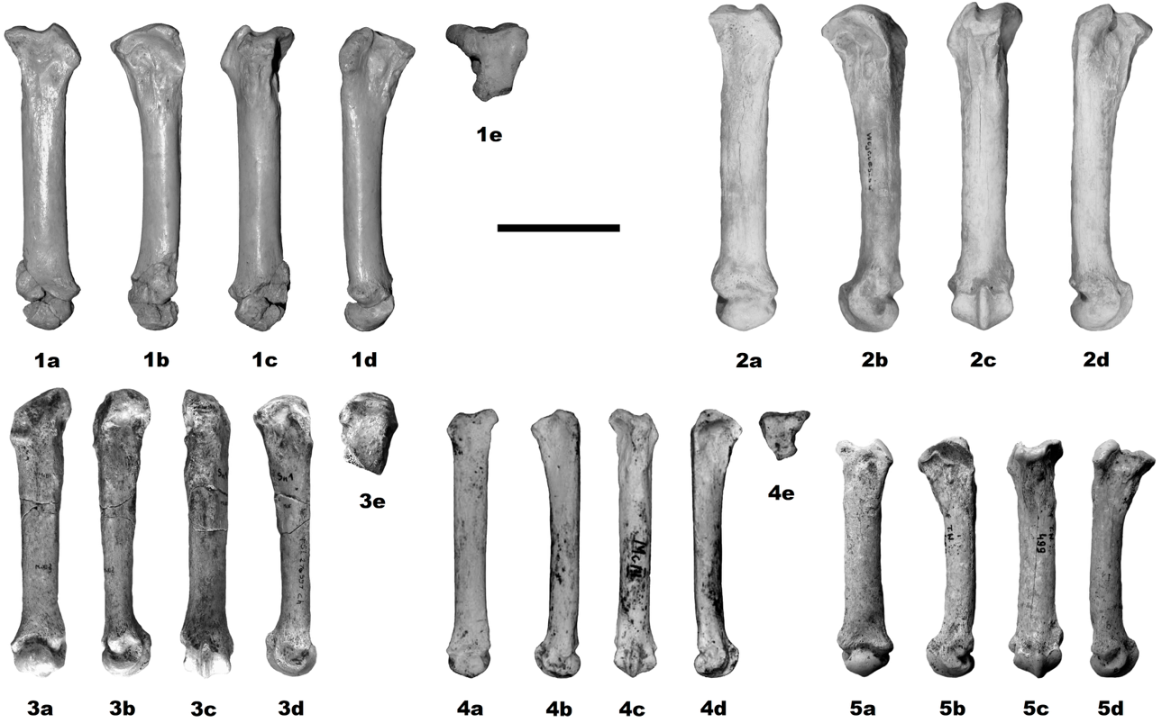
Figure S6. Comparison of metacarpal 3 of Eurasian Pleistocene large felids: 1 - Panthera spelaea fossilis from Vallparadís (EVT 14270), 2 - Panthera spelaea fossilis from Wschodnia Cave, 3 - Homotherium crenatidens from Senèze (SE311), 4 - Acinonyx pardinensis pleistocaenicus from Dmanisi (D 2002b; after Hemmer et al. 2011: 2710, fig. 6), 5 - Panthera gombaszoegensis gombaszoegensis from Tunel Wielki Cave (MF/7674; after Marciszak and Lipecki¹⁷: 42, fig. 3). a - dorsal view, b - lateral view, b - ventral view, d - medial view, e - proximal view. Scale bar 30 mm.

Metacarpal IV—The proximal epiphysis of Mc IV in Homotherium is narrower (Fig. S7.3). The hamatum facet curves more strongly toward the palmar border, and the medial indentation is only weakly notched. In dorsal view, the hamatum and Mc III facets form a marked angle, unlike the smoother alignment observed in the Vallparadís specimen. The articular surfaces for Mc V are more clearly separated, and the dorsal facet reaches the proximal margin. Distally, the shaft is more dorsoventrally compressed, and the dorsal keel is more prominent (Fig. S7.3).

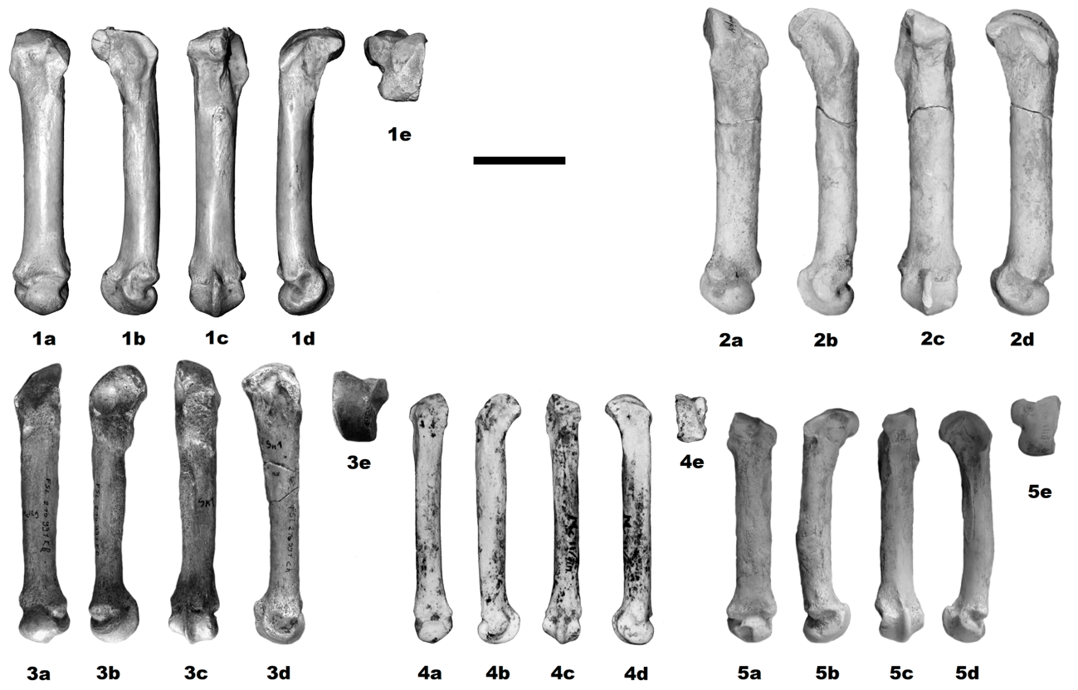
Figure S7. Comparison of metacarpal 4 of Eurasian Pleistocene large felids: 1 - Panthera spelaea fossilis from Vallparadís (EVT 16016), 2 - Panthera spelaea fossilis from Wschodnia Cave, 3 - Homotherium latidens crenatidens from Senèze (SE311), 4 - Acinonyx pardinensis pleistocaenicus from Dmanisi (D 2002c; after Hemmer et al. 2011: 2710, fig. 7), 5 - Panthera gombaszoegensis gombaszoegensis from Południowa Cave (JP.9.5). a - dorsal view, b - lateral view, b - ventral view, d - medial view, e - proximal view. Scale bar 30 mm.

Metacarpal V—In Homotherium, the proximal hamatum facet is narrower and descends less steeply from the dorsal surface (Fig. S8.3). The medial ear-shaped projection is smaller, and the notch separating the Mc IV facet is broader. In the Vallparadís specimen, this notch is narrower, and the Mc IV articulation extends further palmarly. The shaft of Homotherium is relatively stouter, with flatter medial and palmar surfaces separated by sharper borders. In contrast, the Vallparadís specimen retains a more oval shaft cross-section with smoother transitions between surfaces (Fig. S8.3).
Metatarsal III—The shaft of Mt III in Homotherium becomes distinctly narrower in its midsection, whereas in the Vallparadís specimen the shaft maintains a more uniform thickness throughout its length (Fig. S9.4). The distal epiphysis of Homotherium is proportionally larger and more expanded, with a more prominent dorsal area. Although overall more robust, the distal shaft is thinner dorsoventrally. Proximally, the shaft is less cylindrical and more triangular in cross-section. The ventral rugose tendon area is stronger and extends further distally. In lateral view, the shaft is slightly more curved. The articular facets also differ substantially. In Homotherium, the ventral arm of the hammer-shaped ectocuneiform facet is shorter. The dorsal articulation for Mt IV extends to the proximal margin, whereas the ventral facet does not; the opposite condition is observed in the Vallparadís specimen. In lateral view, the ventral keel of the distal articulation is straighter in Homotherium (Fig. S9.4).
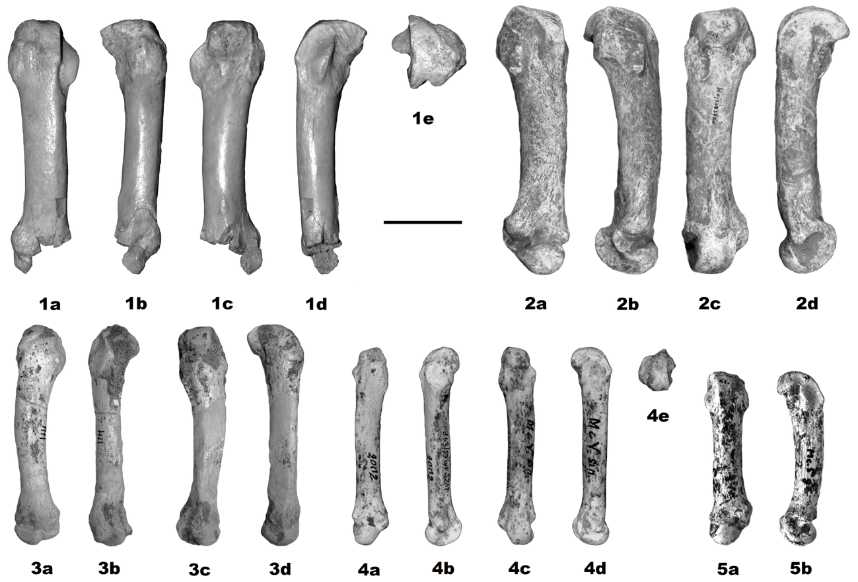
Figure S8. Comparison of metacarpal 5 of Eurasian Pleistocene large felids: 1 - Panthera spelaea fossilis from Vallparadís (EVT 16012), 2 - Panthera spelaea fossilis from Południowa Cave, 3 - Homotherium crenatidens from Hundsheim (HH 1914), 4 - Acinonyx pardinensis pleistocaenicus from Dmanisi (D 2002d; after Hemmer et al. 2011: 2710, fig. 8), 5 - Panthera gombaszoegensis gombaszoegensis from Château Breccia (CHA. 1-07-EE-25-16; after Argant and Argant¹⁶: 261, plate 6/2c-d). a - dorsal view, b - lateral view, b - ventral view, d - medial view, e - proximal view. Scale bar 30 mm.

The metapodials of Panthera gombaszoegensis are morphologically more variable, preventing the recognition of a single diagnostic configuration. Nevertheless, they are consistently smaller and proportionally more robust than those of the Vallparadís felid. Their epiphyses are more massive, and muscle insertions and tendon grooves are generally deeper, rougher, and more heavily marked (Figs. S4-S9).
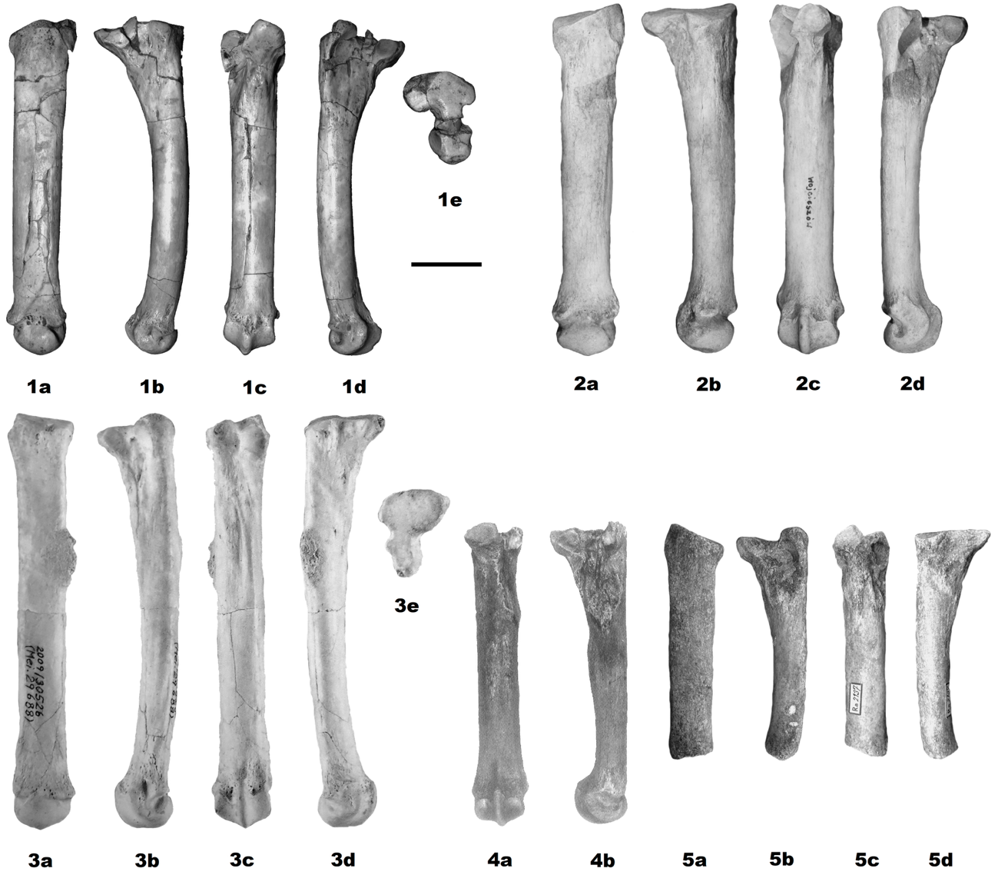
Figure S9. Comparison of metatarsal 3 of Eurasian Pleistocene large felids: 1 - Panthera spelaea fossilis from Vallparadís (EVT 01338), 2 - Panthera spelaea fossilis from Biśnik Cave (JB/Ps/144), 3 - Acinonyx pardinensis pleistocaenicus from Untermassfeld (IQW 2009/30526; after Hemmer and Kahlke¹⁸: 1496, fig. 8), 4 - Homotherium crenatidens from Incarcal 5 (IN-V-77; after Galobart et al. 2003: 141. fig. 14C-D), 5 - Panthera gombaszoegensis gombaszoegensis from Chlum 4 (Rv 2137). a - dorsal view, b - lateral view, b - ventral view, d - medial view, e - proximal view. Scale bar 30 mm.

Table S1. Dimensions of Panthera spelaea fossilis bones from Vallparadís Section

Bones | Coll. no. | L | pL | pB | mL | mB | dL | dB
Radius | EVT 14269 | 335.0 | 32.4 | 45.7 | 20.5 | 36.7 | 39.3 | 65.5
Femur | EVT 04786 | 370.0 |  | 83.1 | 30.9 | 32.5 | 65.8 | 69.0
Tibia | EVT 00385 | 325.0 |  | 70.0 | 31.9 | 30.0 | 38.8 | 56.0
Mc II | EVT 14276 | 114.7 | 34.6 | 25.7 | 17.2 | 17.2 | 24.7 | 25.8
Mc III | EVT 14270 | 129.1 | 30.9 | 31.7 | 16.3 | 18.2 | 21.6 | 26.5
Mc IV | EVT 16016 | 122.6 | 29.7 | 24.5 | 15.9 | 16.7 | 22.9 | 24.1
Mc V | EVT 16012 | [120] | 25.8 | 27.3 | 14.1 | 16.1
Mt III | EVT 01338 | 123.4 | 33.2 | 25.9 | 13.6 | 16.8 | 21.2 | 22.7
Ph I-1-a | EVT 16014 | 36.5 | 15.6 | 23.7 |  |  | 14.9 | 21.1
Ph I-3-a | EVT 14260 | 65.2 | 21.2 | 26.5 | 14.7 | 17.6 | 15.6 | 20.0
Ph I-4-a | EVT 14275 | 61.4 | 21.1 | 24.7 | 14.2 | 16.4 | 15.6 | 19.3

 | Vallparadís | P. s. fossilis | P. leo ♂♂ | P. leo ♀♀ | P. gombaszoegensis | H. latidens | A. pardinensis | P. pardus
 | Radius
L | 335.0 | 350.6 | 306.3 | 269.0 | 208.6 | 303.6 | 271.4 | 205.8
 |  | 328.0-372.4 | 282.5-329.5 | 248.0-284.5 | 195.0-242.0 | 273.0-328.0 |  | 195.0-216.0
pB | 45.7 | 47.4 | 42.2 | 37.0 | 29.4 | 39.0 | 30.9 | 24.5
 |  | 37.5-53.0 | 37.5-50.0 | 34.0-40.0 | 22.0-38.4 | 26.7-55.0 |  | 24.2-24.7
dB | 65.5 | 61.2 | 62.0 | 54.0 | 45.3 | 51.0 | 47.3 | 39.5
 |  | 39.4-86.9 | 57.0-70.5 | 51.5-61.0 | 35.2-53.5 | 34.1-70.0 |  | 36.3-41.0
 | Femur
L | 370.0 | 407.1 | 362.0 | 326.7 | 318.7 | 354.6 | 336.0 | 251.4
 |  | 340.0-497.0 | 331.5-391.5 | 285.0-355.5 | 291.0-339.0 | 338.1-380.0 | 311.0-369.0 | 243.8-259.1
pB | 83.1 | 106.1 | 90.6 | 82.0 | 74.8 | 65.3 | 69.5 | 51.1
 |  | 82.8-128.0 | 81.5-103.0 | 73.0-88.0 | 59.0-83.3 | 58.7-90.0 | 61.1-78.0 | 46.0-54.7
dB | 69.0 | 95.1 | 75.9 | 69.1 | 66.0 | 69.8 | 59.4
 |  | 68.8-114.6 | 71.0-88.0 | 63.0-81.0 | 53.2-73.3 | 64.7-73.8 | 53.7-67.0
 | Tibia
L | 325.0 | 390.4 | 322.2 | 290.0 | 286.1 | 304.6 | 336.3 | 237.0
 |  | 325.0-445.8 | 301.5-348.0 | 263.0-313.5 | 257.0-310.0 | 285.5-321.0 | 322.0-362.0 | 234.0-239.9
pB | 70.0 | 98.2 | 80.1 | 73.2 | 70.9 | 69.7 | 60.7
 |  | 70.0-118.1 | 73.0-94.5 | 67.0-83.5 | 59.6-76.0 | 60.5-76.0
dB | 56.0 | 68.6 | 61.2 | 56.7 | 51.4 | 51.9 | 38.6
 |  | 54.5-81.0 | 56.0-69.0 | 52.0-65.0 | 47.6-55.6 | 47.6-55.6
Table S2. Long bones size comparison of Eurasian Pleistocene large felids (for data see Supplementary Information).

Table S3. Metapodials size comparison of Eurasian Pleistocene large felids (for data see Supplementary Information).
 | Vallparadís | P. s. fossilis | P. leo ♂♂ | P. leo ♀♀ | P. gombaszoegensis | H. latidens | A. pardinensis | P. pardus
 | Metacarpal II
L | 114.7 | 124.4 | 106.3 | 96.4 | 81.3 | 106.8 | 95.3 | 66.7
 |  | 102.0-150.1 | 99.7-113.5 | 91.5-101.0 | 73.0-92.8 | 93.8-116.2 |  | 58.9-74.0
mB | 17.2 | 20.0 | 13.6 | 11.7 | 13.0 | 15.8 | 10.7 | 9.4
 |  | 17.0-23.2 | 12.0-16.0 | 11.0-12.5 | 10.8-14.2 | 13.9-17.6 |  | 7.7-10.4
dB | 25.8 | 26.9 | 22.4 | 19.4 | 18.1 | 20.7 | 16.7 | 14.5
 |  | 22.2-32.1 | 20.0-25.5 | 18.5-21.5 | 16.1-20.1 | 15.0-23.2 |  | 13.0-16.3
 | Metacarpal III
L | 129.1 | 132.7 | 119.9 | 108.5 | 91.3 | 117.0 | 118.0 | 73.5
 |  | 116.0-149.0 | 112.5-128.0 | 101.0-114.0 | 86.0-98.9 | 109.0-127.5 | 106.2-134.0 | 60.2-82.0
mB | 18.2 | 19.7 | 15.0 | 12.9 | 13.5 | 17.7 | 13.4 | 10.2
 |  | 16.9-21.1 | 13.0-18.0 | 12.0-14.0 | 12.5-14.5 | 13.3-21.1 | 11.5-15.0 | 7.8-11.9
dB | 26.5 | 28.1 | 23.9 | 20.7 | 20.7 | 22.4 | 18.3 | 14.7
 |  | 24.2-32.3 | 22.0-26.0 | 19.5-22.0 | 18.5-22.3 | 18.4-25.6 | 16.6-20.0 | 11.0-17.0
 | Metacarpal IV
L | 122.6 | 133.5 | 115.9 | 105.1 | 91.5 | 119.1 | 120.7 | 73.1
 |  | 114.0-157.8 | 107.0-127.0 | 98.0-110.5 | 78.7-106.6 | 109.2-129.5 | 106.9-137.0 | 64.2-79.8
mB | 16.7 | 19.4 | 13.6 | 12.0 | 12.5 | 15.8 | 11.6 | 9.4
 |  | 16.1-27.1 | 12.0-16.5 | 11.0-13.0 | 11.0-14.4 | 13.7-17.7 | 10.8-12.3 | 7.5-11.0
dB | 24.1 | 27.2 | 21.3 | 18.9 | 17.9 | 21.4 | 17.4 | 14.1
 |  | 21.9-34.1 | 17.5-20.5 | 17.5-20.5 | 14.0-20.0 | 18.5-23.8 | 16.8-17.9 | 12.3-16.3
 | Metacarpal V
L | [120] | 119.6 | 94.9 | 86.6 | 71.1 | 99.8 | 86.8 | 60.2
 |  | 100.0-134.5 | 89.5-101.5 | 80.0-90.0 | 66.0-74.6 | 91.5-110.3 | 79.8-95.0 | 52.2-64.5
mB | 14.1 | 21.4 | 14.0 | 11.6 | 11.9 | 13.2 | 10.1 | 9.5
 |  | 16.0-28.1 | 12.0-16.0 | 10.5-13.5 | 11.0-12.6 | 9.9-16.4 | 8.8-11.5 | 7.4-12.7
dB |  | 29.8 | 21.5 | 18.6 | 18.5 | 20.1 | 15.4 | 13.3
 |  | 18.0-26.5 | 19.5-25.5 | 17.5-20.0 | 17.3-19.5 | 17.5-22.0 | 13.5-17.5 | 12.0-15.0
 | Metatarsal III
L | 123.4 | 157.0 | 137.4 | 123.8 | 105.4 | 115.7 | 136.0 | 92.9
 |  | 123.4-192.0 | 128.0-145.0 | 115.0-129.0 | 93.3-115.7 | 103.7-126.5 | 134.0-138.0 | 84.0-102.0
mB | 16.8 | 23.7 | 16.1 | 14.2 | 14.4 | 15.3 | 16.9 | 11.9
 |  | 16.8-27.6 | 13.5-18.5 | 13.0-15.5 | 12.0-16.4 | 14.0-17.2 |  | 10.3-13.0
dB | 22.7 | 30.0 | 23.9 | 21.0 | 18.9 | 20.6 | 18.1 | 15.7
 |  | 22.7-34.6 | 21.5-27.5 | 19.5-23.0 | 15.0-22.7 | 17.5-23.5 | 17.6-18.5 | 13.7-17.3

Table S4. Radius measurements of different Pleistocene felid species mentioned in the text.

Collection number | Taxa | Locality | Reference | L | pL | pB | mL | mB | dL | dB | mL/L
EVT14269 | This paper | Vallparadís Estació | This paper | 335,0 | 32,4 | 45,7 | 20,5 | 36,7 | 39,3 | 65,5 | 0,061194
K.13-43 | Panthera spelaea fossilis | Aze Cave | ¹⁹ | 354,0 | 37,7 | 51,9 | 25,3 | 41,4 | 44,5 | 73,6 | 0,071469
JB/Ps/1 | Panthera spelaea fossilis | Biśnik cave, layer 19ad | ²⁰ | 372,4 | 54,3 | 38,9 | 44,6 | 27,3 | 75,6 | 49,7 | 0,119764
JB/Ps/13 | Panthera spelaea fossilis | Biśnik cave, layer 18 | ²⁰ | ? | 55,4 | 37,5 | ? | ? | ? | ? | ?
JB/Ps/245 | Panthera spelaea fossilis | Biśnik cave, layer 19ad | ²⁰ | ? | 56,8 | 45,3 | ? | ? | ? | ? | ?
H.5-65 | Panthera spelaea fossilis | Château | ²¹ | ? | 35,5 | 51,0 | ? | ? | ? | ? | ?
H.4-21 | Panthera spelaea fossilis | Château | ²¹ | ? | ? | ? | ? | ? | 38,5 | ? | ?
G.6-64 | Panthera spelaea fossilis | Château | ²¹ | ? | 34,8 | 48,7 | ? | ? | ? | ? | ?
CHA.1-98.D4-149 | Panthera spelaea fossilis | Château | ²² | 347,2 | 37,5 | 52,5 | 24,3 | 39,4 | 44,4 | 74,3 | 0,069988
 | Panthera spelaea fossilis | Château | ²² | 367,8 | 37,0 | 53,0 | 25,6 | 40,6 | 47,2 | 76,9 | 0,069603
30174 | Panthera spelaea fossilis | Heppenloch | ²³ | ? | 36,0 | 48,0 | ? | ? | ? | ? | ?
SHB 8219 | Panthera spelaea fossilis | Sima de los Huesos | ²⁴ | ? | 33,2 | 47,0 | ? | ? | ? | ? | ?
 | Panthera spelaea fossilis | Toralba Ambrona | ²⁵ | 328,0 | ? | ? | ? | ? | ? | ? | ?
Ata85 TG G19 18 | Panthera spelaea fossilis | Trinchera Galeria | ²⁴ | ? | 36,9 | ? |  | ? | 42,2 | 69,0 | ?
 | Panthera spelaea fossilis | Za Hájovnou Cave | ²⁶ | ? | ? | 50,1 | 41,8 | ? | ? | 39,4 | ?
 | Panthera spelaea fossilis | Za Hájovnou Cave | ²⁶ | ? | ? | 50,5 | ? | ? | ? | 47,3 | ?
CHA.1-00-f.8-25 | Panthera gombaszoegensis | Château | ¹⁶ | ? | 40,1 | 26,3 | ? | 16,8 | 29,0 | ? | ?
CHA.1-07-EE.25-16 | Panthera gombaszoegensis | Château | ¹⁶ | ? | 39,1 | 27,0 | ? | 16,8 | 28,6 | ? | ?
CHA.1-01-f.8-135 | Panthera gombaszoegensis | Château | ¹⁶ | ? |  | 25,6 | ? | ? |  | ? | ?
CHA.1-G.6-72 | Panthera gombaszoegensis | Château | ¹⁶ | ? | 38,6 | 25,4 | ? | ? |  | ? | ?
CHA.1-00-f.8-149 | Panthera gombaszoegensis | Château | ¹⁶ | ? | ? | ? | ? | 15,2 | 29,9 | ? | ?
CD 615 | Panthera gombaszoegensis | Escale Cave | ²⁷ | ? | ? | ? | ? | ? | 22,5 | ? | ?
CD 616 | Panthera gombaszoegensis | Escale Cave | ²⁷ | ? | ? | ? | ? | ? | 21,8 | ? | ?
CD 757 | Panthera gombaszoegensis | Escale Cave | ²⁷ | ? | ? | ? | ? | ? | 22,9 | 46,8 | ?
PL.6 | Panthera gombaszoegensis | Punta Lucero | ²⁸ | ? | ? | ? | ? | ? | 28,4 | 44,4 | ?
 | Panthera gombaszoegensis | Olivola | ²⁹ | ? | 33,3 | 25,0 | 26,6 | 15,0 | ? | ? | ?
 | Panthera gombaszoegensis | Valdarno superiore 2 | ²⁹ | ? | ? | ? | 17,0 | 11,0 | ? | ? | ?
FGS V-5690 | Panthera gombaszoegensis | Reddick | ³⁰ | 231,0 | 26,6 | 35,8 | 18,2 | 27,6 | ? | 53,5 | 0,078788
UF 3643 | Panthera gombaszoegensis | Haile VII | ³⁰ | 240,0 | 26,1 | 38,4 | 18,7 | 25,7 | ? | ? | 0,077917
UF 8981 | Panthera gombaszoegensis | Haile VII | ³⁰ | 230,0 | ? | 35,5 | 17,0 | 28,0 | ? | 51,0 | 0,073913
UF 9122 | Panthera gombaszoegensis | Haile VII | ³⁰ | 242,0 | 23,9 | 36,3 | 16,8 | 27,5 | ? | 52,0 | 0,069421
ISM 1068 | Panthera gombaszoegensis |  | ³⁰ | 166,0 | 15,6 | 22,0 | 10,4 | 13,8 | ? | 35,2 | 0,062651
MZB 2003-1166 | Panthera gombaszoegensis |  | Madurell unpublished | 180,0 | 18,1 | 26,5 | 11,6 | 19,5 | 25,5 | 42,4 | 0,064611
MZB 2003-1166 | Panthera gombaszoegensis |  | Madurell unpublished | 180,0 | 18,5 | 27,1 | 11,5 | 20,2 | 25,8 | 38,7 | 0,064056
D2001 | Acinonyx pardinensis | Dmanisi | ³¹ | 271,4 | 21,4 | 30,9 | ? | 21,8 | 31,0 | 47,3 | ?
 | Homotherium creatidens | Friesenhahn Cave | ³² | 323,0 | ? | 37,0 | 22,0 | 30,0 | 36,7 | 61,4 | 0,068111
 | Homotherium creatidens | Friesenhahn Cave | ³² | 328,0 | ? | 38,5 | 21,5 | 29,0 | 36,0 | 57,0 | 0,065549
 | Homotherium creatidens | Friesenhahn Cave | ³² | 295,7 | ? | 51,4 | 21,4 | 25,6 | 31,4 | 35,4 | 0,072371
 | Homotherium creatidens | Friesenhahn Cave | ³² | 309,1 | ? | 55,0 | 20,1 | 26,1 | 31,6 | 38,9 | 0,065027
 | Homotherium creatidens | Friesenhahn Cave | ³² | 300,9 | ? | ? | 19,1 | 27,6 | 31,3 | 37,8 | 0,063476
 | Homotherium creatidens | Friesenhahn Cave | ³² | 297,3 | ? | 51,3 | 19,7 | 24,3 | ? | 34,1 | 0,066263
 | Homotherium creatidens | Hundsheim | ¹⁵ | 273,0 | 30,0 | 33,0 | 20,0 | 24,0 | 33,0 | 52,0 | 0,07326
 | Homotherium creatidens | Hundsheim | ¹⁵ | ? | 40,0 | 40,0 | 21,0 | 24,0 | 40,0 | 70,0 | ?
 | Homotherium creatidens | Idaho | ³³ | 296,0 | 21,1 | 35,5 | ? | 27,0 | 40,7 | 57,2 | ?
 | Homotherium creatidens | Idaho | ³³ | 303,0 | 21,3 | 35,8 | ? | 27,0 | 41,0 | 56,0 | ?
IN-V 83 | Homotherium creatidens | Incarcal | ³⁴ | 286,0 | 26,8 | 31,6 | 20,1 | 25,4 | 31,2 | 50,0 | 0,070315
IN-V 47 | Homotherium creatidens | Incarcal | ³⁴ | ? | 25,9 | 31,1 | ? | ? | ? | ? | ?
IN-V 158 | Homotherium creatidens | Incarcal | ³⁴ | ? | 26,2 | 31,8 | ? | ? | ? | ? | ?
IN-V 23 | Homotherium creatidens | Incarcal | ³⁴ | ? | 24,7 | 29,4 | ? | ? | ? | ? | ?
IN-V 545 | Homotherium creatidens | Incarcal | ³⁴ | ? | ? | ? | ? | ? | 33,4 | 48,5 | ?
IN-V 840 | Homotherium creatidens | Incarcal | ³⁴ | ? | ? | ? | ? | ? | 37,5 | 55,4 | ?
IN-V 29 | Homotherium creatidens | Incarcal | ³⁴ | ? | ? | ? | ? | ? | 32,8 | 47,2 | ?
G 32 | Homotherium creatidens | Pirro Nord | ³⁵ | 307,0 | 36,2 | 26,7 | 30,3 | 19,4 | 34,2 | 52,4 | 0,098632
 | Homotherium creatidens | Seneze | ³⁶ | 317,0 | 29,0 | 34,0 | 29,0 | 28,0 | 39,0 | 55,0 | 0,091483
 | Homotherium creatidens | Seneze | ³⁶ | 317,0 | 29,0 | 34,0 | 23,0 | 28,0 | 38,0 | 55,0 | 0,072555
IQW 1992/23856 (Mei 23385) | Homotherium creatidens | Untermassfeld | ¹⁸ | 316,0 | 27,0 | 32,0 | ? | ? | 34,5 | 54,5 | ?
SNHM-1954-M | Panthera pardus | Baumann’s Cave | ³⁷ | 216,0 | ? | ? | ? | ? | ? | 41,0 | ?
 | Panthera pardus | Loutra Arideas Cave | ³⁸ | 196,0 | 16,6 | 24,7 | 12,5 | 18,8 | 20,6 | 36,3 | 0,063622
 | Panthera pardus | Loutra Arideas Cave | ³⁸ | ? | 18,5 | 24,2 | ? | ? | ? | ? | ?
VJET 84 | Panthera pardus | Vjetrenica Cave | ³⁷ | 203,2 | ? | ? | ? | ? | ? | 40,5 | ?
VJET 116 | Panthera pardus | Vjetrenica Cave | ³⁷ | 202,6 | ? | ? | ? | ? | ? | 40,6 | ?
VR 63 | Panthera pardus | Vraona Cave | ³⁷ | 215,0 | ? | ? | ? | ? | ? | 40,4 | ?
VR 39 | Panthera pardus | Vraona Cave | ³⁷ | 213,0 | ? | ? | ? | ? | ? | 40,3 | ?
VR 214 | Panthera pardus | Vraona Cave | ³⁷ | 195,0 | ? | ? | ? | ? | ? | ? | ?
IQW 2016/43817 (Mei 49126) | Puma pardoides | Untermassfeld | ¹⁸ | 162,5 | 14,9 | 20,9 | ? | 15,0 | 19,9 | 30,8 | ?
IQW 2017/45022 (Mei 50331) | Puma pardoides | Untermassfeld | ¹⁸ | ? | ? | 20,2 | ? | ? | ? | ? | ?

Table S5. Femur measurements of different Pleistocene felid species mentioned in the text.

Collection number | Taxa | Locality | Reference | L | pL | pB | mL | mB | dL | dB | mL/L
EVT04786 | This paper | Vallparadís Estació | This paper | 370,0 | ? | 83,1 | 30,9 | 32,5 | 65,8 | 69,0 | 0,08357
170/305 | Panthera spelaea fossilis | Bilzingsleben | ³⁹ | ? | 42,2 | 88,0 | ? | ? | ? | ? | ?
JB/Ps/95 | Panthera spelaea fossilis | Biśnik cave, layer 19 | ²⁰ | ? | ? | 128,0 | ? | ? | ? | ? | ?
CHA.1-98.D6-124 | Panthera spelaea fossilis | Château | ²² | 434,7 | 59,0 | 107,0 | 34,3 | 40,3 | 96,2 | 104,5 | 0,0789
 | Panthera spelaea fossilis | Château | ²² | ? | 68,2 | 110,9 | 38,1 | 41,8 | 100,6 | 103,7 | ?
H.4-11 | Panthera spelaea fossilis | Château | ²¹ | ? | 56,0 | 119,8 | ? | ? | 102,0 | 107,2 | ?
C.4-18 | Panthera spelaea fossilis | Château | ²¹ | ? | ? | ? | ? | ? | 99,3 | 101,7 | ?
C.3-24 | Panthera spelaea fossilis | Château | ²¹ | ? | ? | ? | ? | ? | 100,7 | 104,5 | ?
G.7-84 | Panthera spelaea fossilis | Château | ²¹ | ? | ? | ? | ? | ? | 95,5 | 96,0 | ?
 | Panthera spelaea fossilis | Einchorn Cave | ⁴⁰ | ? | ? | 95,2 | ? | ? | ? | ? | ?
 | Panthera spelaea fossilis | Einchorn Cave | ⁴⁰ | 425,0 | ? | 100,0 | ? | ? | ? | 87,0 | ?
 | Panthera spelaea fossilis | Einchorn Cave | ⁴⁰ | ? | ? | 100,5 | ? | ? | ? | ? | ?
 | Panthera spelaea fossilis | Einchorn Cave | ⁴⁰ | ? | ? | 110,3 | ? | ? | ? | ? | ?
 | Panthera spelaea fossilis | Einchorn Cave | ⁴⁰ | ? | ? | 113,8 | ? | ? | ? | ? | ?
 | Panthera spelaea fossilis | Holstyn | ⁴¹ | 350,0 | ? | ? | ? | 37,0 | ? | ? | ?
 | Panthera spelaea fossilis | Kövesvarad | ⁴⁰ | 340,0 | ? | ? | ? | ? | ? | ? | ?
 | Panthera spelaea fossilis | Mosbach 2 | ⁴⁰ | ? | ? | ? | ? | ? | ? | 75,0 | ?
 | Panthera spelaea fossilis | Mosbach 2 | ⁴⁰ | ? | ? | 112,0 | ? | ? | ? |  | ?
 | Panthera spelaea fossilis | Mosbach 2 | ⁴⁰ | ? | ? | ? | ? | ? | ? | 97,0 | ?
 | Panthera spelaea fossilis | Nauterie I | ⁴² | ? | ? | 97,6 | ? | 87,0 | ? | ? | ?
 | Panthera spelaea fossilis | Południowa Cave | This paper | 497,0 | 74,1 | 127,1 | 41,2 | 44,5 | 112,1 | 114,6 | 0,0829
 | Panthera spelaea fossilis | Wschodnia Cave | Marciszak unpublished | 404,5 | ? | ? | ? | ? | ? | ? | ?
Ata96 TZ GIIC L2 92 | Panthera spelaea fossilis | Trinchera Dolina 10 | ²⁴ | ? | 45,3 | ? | ? | ? | ? | ? | ?
 | Panthera spelaea fossilis | Vertesszöllös 2 | ⁴³ | 410,0 | ? | 98,0 | ? | 40,0 | ? | 88,0 | ?
CHA.1-01-f.7-132 | Panthera gombaszoegensis | Château | ¹⁶ |  | 50,7 | 83,3 | 28,1 | 31,6 | ? | ? | ?
CHA.1- | Panthera gombaszoegensis | Château | ¹⁶ |  | ? | ? | ? | ? | 70,1 | 73,3 | ?
02-G.8-354 | Panthera gombaszoegensis | Escale Cave | ²⁷ | ? | ? | ? | ? | 24,9 | ? | ? | ?
CD 620 | Panthera gombaszoegensis | Escale Cave | ²⁷ | ? | ? | ? | ? | 26,9 | ? | ? | ?
CD 621 | Panthera gombaszoegensis | Escale Cave | ²⁷ | ? | ? | ? | ? | 25,9 | ? | ? | ?
CD 622 | Panthera gombaszoegensis | Escale Cave | ²⁷ | ? | ? | ? | ? | 24,0 | ? | ? | ?
SL 107 | Panthera gombaszoegensis | Slivnitsa | ⁴⁴ |  | ? | ? | ? | ? | 54,7 | 53,2 | ?
 | Panthera gombaszoegensis | Valdarno superiore 2 | ²⁹ | ? | ? | 59,0 | 22,0 | 23,0 | ? | ? | ?
 | Panthera gombaszoegensis | Salt Lake Cave | ⁴⁵ | 291,0 | ? | ? | ? | ? | ? | ? | ?
TMM 40673 | Panthera gombaszoegensis | Laubach Cave | ⁴⁶ | 312,0 | ? | 78,0 | ? | 29,3 | ? | 67,0 | ?
UF 9023 | Panthera gombaszoegensis | Coleman II A | ⁴⁶ | 324,0 | ? | 76,0 | ? | 29,9 | ? | 67,0 | ?
UF 12134 | Panthera gombaszoegensis | Coleman II A | ⁴⁶ | 335,0 | ? | 81,0 | ? | 27,0 | ? | 71,0 | ?
UF 12134 | Panthera gombaszoegensis | Coleman II A | ⁴⁶ | 339,0 | ? | 79,0 | ? | 27,2 | ? | 70,0 | ?
 | Acinonyx pardinensis | Casa Frata | ⁴⁷ | 342,0 | ? | ? | ? | ? | ? | ? | ?
 | Acinonyx pardinensis | Les Etouaires | ⁴⁸ | 311,0 | ? | ? | ? | ? | ? | ? | ?
 | Acinonyx pardinensis | Mosbach 2 | ⁴⁹ | 322,0 | ? | ? | ? | 22,7 | ? | ? | ?
1949-13/51 | Acinonyx pardinensis | Slivnitsa | ⁴⁴ | ? | ? | ? | ? | ? | ? | 55,5 | ?
IPS17066 M154 | Acinonyx pardinensis | Olivola | Madurell unpublished | 328,0 | 36,6 | 61,1 | 24,0 | 23,7 | 52,2 | 53,7 | 0,07308
IQW 1980/15 643 | Acinonyx pardinensis | Untermassfled | ⁵⁰ | 369,0 | ? | 78,0 | ? | 26,0 | 69,0 | 67,0 | ?
 | Homotherium creatidens | Friesenhahn Cave | ³² | 338,1 | ? | ? | ? | ? | ? | 69,1 | ?
 | Homotherium creatidens | Friesenhahn Cave | ³² | 349,7 | ? | ? | ? | ? | ? | 68,8 | ?
 | Homotherium creatidens | Friesenhahn Cave | ³² | 340,1 | ? | ? | ? | ? | ? | 64,7 | ?
 | Homotherium creatidens | Friesenhahn Cave | ³² | 341,1 | ? | ? | ? | ? | ? | 67,3 | ?
 | Homotherium creatidens | Friesenhahn Cave | ³² | 349,1 | ? | ? | ? | ? | ? | 70,5 | ?
 | Homotherium creatidens | Friesenhahn Cave | ³² | 353,0 | ? | ? | ? | ? | ? | 73,5 | ?
 | Homotherium creatidens | Friesenhahn Cave | ³² | 351,0 | ? | ? | ? | ? | ? | 72,0 | ?
 | Homotherium creatidens | Hundsheim | ¹⁵ | ? | ? | ? | ? | ? | 63,5 | 66,0 | ?
 | Homotherium creatidens | Idaho | ³³ | 377,0 | ? | ? | ? | ? | ? | 73,2 | ?
 | Homotherium creatidens | Idaho | ³³ | 380,0 | ? | ? | ? | ? | ? | 73,8 | ?
PP283 | Homotherium creatidens | Pirro Nord | Madurell unpublished |  | 25,2 | 28,7 | 63,4 | 65,8 | 87,0 |  | ?
 | Homotherium creatidens | Seneze | ³⁶ | 356,0 | ? | 89,0 | 29,0 | 33,0 | 70,0 | 70,0 | 0,08146
 | Homotherium creatidens | Seneze | ³⁶ | 357,0 | ? | 90,0 | 28,0 | 32,0 | 70,0 | 70,0 | 0,07843
 | Panthera pardus | Apidima Cave | ⁵¹ | ? | ? | 54,7 | ? | ? | ? | ? | ?
 | Panthera pardus | Kudaro 3 Cave | ⁵² | ? | ? | 46,0 | ? | ? | ? | ? | ?
 | Panthera pardus | Mezmaiskaya Cave | ⁵³ | ? | 25,9 | 54,3 | ? | 21,6 | ? | ? | ?
 | Panthera pardus | Mezmaiskaya Cave | ⁵³ | ? | 26,3 | ? | ? | 22,0 | ? | ? | ?
VJET 94 | Panthera pardus | Observatoire Cave | ³⁷ | 243,8 | ? | ? | ? | ? | ? | ? | ?
VJET 125 | Panthera pardus | Observatoire Cave | ³⁷ | 251,2 | ? | ? | ? | ? | ? | ? | ?
VJET 324 | Panthera pardus | Vjetrenica Cave | ³⁷ | 259,1 | ? | ? | ? | ? | ? | ? | ?

Table S6. Tibia measurements of different Pleistocene felid species mentioned in the text.

Collection number | Taxa | Locality | Reference | L | pL | pB | mL | mB | dL | dB | mL/L
EVT00385 | This paper | Vallparadís Estació | This paper | 325,0 | ? | 70,0 | 31,9 | 30,0 | 38,8 | 56,0 | 0,0981538
F18 1975 | Panthera spelaea fossilis | Arago Cave | ⁵⁴ | ? | ? | ? | ? | ? | 30,0 | 65,0 | ?
D14 dfm4 1170 | Panthera spelaea fossilis | Arago Cave | ⁵⁴ | ? | ? | ? | 43.8 | 37.6 | 49.2 | 73.7 | ?
 | Panthera spelaea fossilis | Arago Cave | ⁵⁴ | ? | ? | ? | ? | ? | 41.3 | 61,0 | ?
 | Panthera spelaea fossilis | Aze Cave | ¹⁹ | ? | ? | ? | ? | 24,0 | ? | ? | ?
90/32 | Panthera spelaea fossilis | Bilzingsleben | ³⁹ | ? | ? | ? | ? | ? | ? | 54.5 | ?
CHA.1-D6-93 | Panthera spelaea fossilis | Château | ²² | 410,0 | 114.7 | 105.5 | 44.5 | 40.7 | 58.9 | 74.9 | 0.108536585365854
 | Panthera spelaea fossilis | Einchorn Cave | ⁴⁰ | 400,0 | ? | ? | ? | ? | ? | 81,0 | ?
 | Panthera spelaea fossilis | Einchorn Cave | ⁴⁰ | ? | ? | 91.5 | ? | ? | ? | ? | ?
 | Panthera spelaea fossilis | Einchorn Cave | ⁴⁰ | ? | ? | ? | ? | ? | ? | 69.5 | ?
Mog. 85/14 | Panthera spelaea fossilis | Moggaster Cave | ⁵⁵ | ? | ? | 110,0 | ? | ? | ? | ? | ?
 | Panthera spelaea fossilis | Mosbach 2 | ⁴⁰ | 381,0 | ? | 102,0 | ? | ? | ? | 74,0 | ?
 | Panthera spelaea fossilis | Mosbach 2 | This paper | ? | ? | ? | ? | ? | ? | ? | ?
 | Panthera spelaea fossilis | Południowa Cave | This paper | 445.8 | 123.4 | 118.1 | 49.7 | 44.7 | 64.3 | 81,0 | 0.111484970838941
SHB 1176 | Panthera spelaea fossilis | Sima de los Huesos | ²⁴ | ? | ? | ? | ? | ? | 43.9 | 67.3 | ?
 | Panthera spelaea fossilis | Vertesszöllös II | ⁴³ | ? | ? | ? | ? | ? | ? | 67,0 | ?
IPS43470 | Panthera gombaszoegensis | Cal Guardiola | Madurell unpublished | ? | ? | ? | 28.64 | 23.81 | 32.38 | 47.9 | ?
CHA.1-00-f.8-40 | Panthera gombaszoegensis | Château | ¹⁶ | 295.5 | 78.1 | 75.3 | 30.9 | 29.4 | 35.1 | 52.9 | 0.104568527918782
CHA.1-01-f.8-263 | Panthera gombaszoegensis | Château | ¹⁶ | ? | ? | ? | 27.3 | 25.1 | ? | ? | ?
CHA.1-01-f.8-229 | Panthera gombaszoegensis | Château | ¹⁶ | ? | ? | ? | ? | ? | 35.8 | 53,0 | ?
CHA.1-02-G.8-338 | Panthera gombaszoegensis | Château | ¹⁶ | ? | ? | ? | ? | ? | 36.1 | 56.7 | ?
CD 623 | Panthera gombaszoegensis | Escale Cave | ²⁷ | ? | ? | ? | ? | 21.5 | ? | ? | ?
1527 | Panthera gombaszoegensis | Escale Cave | ²⁷ | ? | ? | ? | ? | ? | ? | 50,0 | ?
CD 66 1527 | Panthera gombaszoegensis | Escale Cave | ⁵⁶ | ? | ? | ? | ? | ? | 34.6 | 49,0 | ?
FM 1506 SL 109 | Panthera gombaszoegensis | Escale Cave | ⁵⁶ | ? | ? | ? | ? | ? | 27.5 | 42.5 | ?
IPS 33036 | Panthera gombaszoegensis | Gran Dolina | Madurell unpublished | 271,0 | 61.82 | 59.63 | 26.4 | 25.87 | 31.18 | 47.39 | 0.0974169741697417
SL 102 | Panthera gombaszoegensis | Slivnitsa | ⁴⁴ | ? | ? | ? | ? | ? | 27.2 | 43.4 | ?
 | Panthera gombaszoegensis | Valdarno superiore 2 | ²⁹ | 308,0 | 81.5 | 73.7 | 32.4 | 26,0 | 37.7 | 51.5 | 0.105194805194805
 | Panthera gombaszoegensis | Olivola | ²⁹ | 310,0 | ? | ? | 32,0 | 27.5 | ? | ? | 0.103225806451613
 | Panthera gombaszoegensis | Salt Lake Cave | ⁴⁵ | 257,0 | ? | ? | ? | ? | ? | ? | ?
TMM 40673 | Panthera gombaszoegensis | Laubach Cave | ⁴⁶ | 265,0 | ? | 71,0 | ? | 27,0 | 33,0 | 52,0 | ?
UF 9023 | Panthera gombaszoegensis | Devil's Den | ⁴⁶ | 272,0 | ? | ? | ? | 24.8 | 36,0 | 60,0 | ?
UF 12134 | Panthera gombaszoegensis | Coleman II A | ⁴⁶ | 300,0 | ? | 76,0 | ? | 26.7 | 36,0 | 57,0 | ?
UF 12134 | Panthera gombaszoegensis | Coleman II A | ⁴⁶ | 301,0 | ? | 76,0 | ? | 26.5 | 37,0 | 57,0 | ?
 | Acinonyx pardinensis | Les Etouaires | ⁴⁸ | 322,0 | ? | ? | ? | ? | ? | ? | ?
IPS 17068 M162 | Acinonyx pardinensis | Olivola | Madurell unpublished | 325,0 | 65.77 | 60.67 | 25.87 | 25.18 | 29.13 | 37.67 | 0.0796
1949-13/51 | Acinonyx pardinensis | Slivnitsa | ⁴⁴ | ? | ? | ? | ? | ? | 30,0 | 39.5 | ?
IQW 1980/15 874 | Acinonyx pardinensis | Untermassfeld | ⁵⁰ | 362,0 | ? | ? | 31,0 | 28.5 | ? | ? | 0.0856353591160221
 | Homotherium creatidens | Friesenhahn Cave | ³² | 285.5 | ? | 67.4 | 29.5 | 28,0 | 37.5 | 47.6 | 0.103327495621716
 | Homotherium creatidens | Friesenhahn Cave | ³² | 297,0 | ? | 76,0 | ? | 27.5 | 39,0 | 54.5 | ?
 | Homotherium creatidens | Friesenhahn Cave | ³² | 297,0 | ? | ? | ? | 28,0 | 38,0 | 55.6 | ?
 | Homotherium creatidens | Hundsheim | ¹⁵ | ? | ? | ? | 23,0 | 26,0 | 36.5 | 55,0 | ?
 | Homotherium creatidens | Idaho | ³³ | 321,0 | 80,0 | 74,0 | 28.2 | 26.5 | 49,0 | 50.9 | 0.0878504672897196
 | Homotherium creatidens | Idaho | ³³ | 320,0 | 80,0 | 74,0 | 31,0 | 26.1 | 40,0 | 51.8 | 0.096875
PP276 | Homotherium creatidens | Pirro Nord | Madurell unpublished | 296,0 | 67.47 | 60.45 | 28.93 | 28.41 | 37.99 | 50.82 | 0.0977364864864865
PP277 | Homotherium creatidens | Pirro Nord | Madurell unpublished | ? | ? | ? | ? | 30.2 | 39.47 | 51.88 | ?
 | Homotherium creatidens | Seneze | ³⁶ | 315,0 | ? | ? | 34,0 | 30,0 | 40,0 | 51,0 | 0.107936507936508
 | Homotherium creatidens | Seneze | ³⁶ | 308,0 | 80,0 | 69,0 | 34,0 | 29,0 | 41,0 | 50,0 | 0.11038961038961
IQW 2004/28645 (Mei 27807) | Homotherium creatidens | Untermassfeld | ¹⁸ | ? | 78.9 | 71.4 | ? | ? | ? | ? | ?
VJET 125 | Panthera pardus | Baumann's Cave | ³⁷ | 234,0 | ? | ? | ? | ? | ? | ? | ?
VJET 101 | Panthera pardus | Vjetrenica Cave | ³⁷ | 239.9 | ? | ? | ? | ? | ? | ? | ?

Table S7. Second metacarpal measurements of different Pleistocene felid species mentioned in the text.

Collection number | Taxa | Locality | Reference | L | pL | pB | mL | mB | dL | dB | mL/L
EVT14276 | This paper | Vallparadís Estació | This paper | 114,7 | 34,6 | 25,7 | 17,2 | 17,2 | 24,7 | 25,8 | 0,14996
JB/Ps/25 | Panthera spelaea fossilis | Biśnik cave, layer 19 | ²⁰ | 136,8 | 41,9 | 32,1 | 21,4 | 20,8 | 29,7 | 31,9 | 0,15643
JB/Ps/176 | Panthera spelaea fossilis | Biśnik cave, layer 18 | ²⁰ | ? | ? | 31,8 | 21,4 | 21,6 | ? | ? | ?
JB/Ps/336 | Panthera spelaea fossilis | Biśnik cave, layer 19ad | ²⁰ | 150,1 | ? | ? | 20,0 | 23,2 | 28,7 | 32,1 | 0,13324
GDC-D5-545-Nv4 | Panthera spelaea fossilis | Carrière Grotte | ⁵⁷ | 124,5 | 37,3 | 29,5 | 21,3 | 20,1 | 27,5 | 28,2 | 0,17108
GDC-D6-216-Nv6 | Panthera spelaea fossilis | Carrière Grotte | ⁵⁷ | 117,4 | 36,9 | 27,7 | 21,3 | 20,7 | 25,2 | 25,9 | 0,18143
GDC-D6-137-Nv8 | Panthera spelaea fossilis | Carrière Grotte | ⁵⁷ | 111,3 | ? | 27,7 | 20,7 | 19,7 | ? | ? | 0,18598
B.4-2 | Panthera spelaea fossilis | Château | ²¹ | ? | ? | 33,3 | 20,0 | 21,6 | ? | ? | ?
H.3-1 | Panthera spelaea fossilis | Château | ²¹ | 124,0 | 39,0 | ? | 18,7 | 19,8 | 26,6 | 27,1 | 0,15081
 | Panthera spelaea fossilis | Einchorn Cave | ⁴⁰ | ? | 38,0 | 28,5 | ? | ? | ? | ? | ?
 | Panthera spelaea fossilis | Einchorn Cave | ⁴⁰ | ? | 31,0 | 22,5 | ? | ? | ? | ? | ?
 | Panthera spelaea fossilis | Einchorn Cave | ⁴⁰ | ? | 34,0 | 24,0 | ? | ? | ? | ? | ?
4-302 | Panthera spelaea fossilis | Lunel-Viel | ²⁷ | 102,0 | ? | 23,0 | ? | 18,0 | ? | 22,2 | ?
5-334 | Panthera spelaea fossilis | Lunel-Viel | ⁴¹ | 104,0 | ? | 23,5 | ? | 17,0 | ? | 22,9 | ?
 | Panthera spelaea fossilis | Mosbach 2 | This paper | 138,9 | 37,4 | 29,2 | ? | 20,2 | 26,9 | 30,3 | ?
 | Panthera spelaea fossilis | Solymar | ⁴¹ | 124,0 | ? | ? | ? | 21,0 | ? | ? | ?
 | Panthera spelaea fossilis | Vertesszöllös 2 | ⁴³ | 116,0 | ? | ? | ? | 18,0 | ? | ? | ?
 | Panthera spelaea fossilis | Vertesszöllös 2 | ⁴³ | 116,0 | ? | ? | ? | 18,0 | ? | ? | ?
 | Panthera spelaea fossilis | Za Hájovnou Cave | ⁵⁸ | 125,6 | 38,7 | 29,4 | ? | 19,9 | 26,3 | 28,9 | ?
 | Panthera spelaea fossilis | Żernava | ⁵⁹ | 138,8 | ? | 26,1 | ? | 22,9 | ? | 22,6 | ?
 | Panthera gombaszoegensis | Artenac Cave | ⁶⁰ | 76,6 | 23,3 | 15,9 | 12,3 | 12,7 | 16,1 | 16,1 | 0,16057
 | Panthera gombaszoegensis | Csarnota | ⁴⁰ | 75,0 | ? | 16,8 | ? | ? | ? | 17,5 | ?
CHA.1-00-F.8-91 | Panthera gombaszoegensis | Château | ¹⁶ | 79,3 | ? | 20,1 | 12,7 | 13,3 | 17,4 | 19,0 | 0,16015
CHA.1-00-F.8-30 | Panthera gombaszoegensis | Château | ¹⁶ | 79,0 | ? | 20,4 | 13,9 | 13,5 | ? | ? | 0,17595
CHA.1-00-F.8-167 | Panthera gombaszoegensis | Château | ¹⁶ | ? | ? | ? | 13,7 | 13,5 | 17,1 | 19,9 | ?
C-D 814 | Panthera gombaszoegensis | Escale cave | ⁵⁶ | ? | 24,1 | 19,5 | ? | ? | ? | ? | ?
C-D 2514 | Panthera gombaszoegensis | Escale cave | ⁵⁶ | ? | 23,6 | 18,4 | ? | ? | ? | ? | ?
823 | Panthera gombaszoegensis | Gombasek | ⁵⁶ | 78,7 | ? | 16,1 | ? | 12,4 | 12,3 | 18,4 | ?
 | Panthera gombaszoegensis | Holstyn | ⁴¹ | 91,0 | ? | ? | ? | 14,0 | ? | ? | ?
 | Panthera gombaszoegensis | Koneprusy C 718 | ⁴¹ | 85,0 | ? | ? | ? | 14,0 | ? | ? | ?
 | Panthera gombaszoegensis | Koneprusy C 718 | ⁴¹ | 76,0 | ? | ? | ? | 13,0 | ? | ? | ?
 | Panthera gombaszoegensis | Koneprusy C 718 | ⁴¹ | 85,0 | ? | ? | ? | 14,0 | ? | ? | ?
V 63/244 | Panthera gombaszoegensis | Kövesvárad | ⁵⁶ | ? | 24,8 | 17,0 | ? | ? | ? | ? | ?
V 63/244 | Panthera gombaszoegensis | Kövesvárad | ⁵⁶ | ? | 25,0 | ? | ? | ? | ? | ? | ?
K/1139 | Panthera gombaszoegensis | Kozarnika Cave | ⁶⁰ | 76,0 | ? | 15,5 | 12,2 | 12,9 | 17,5 | 17,2 | 0,16053
K/1117 | Panthera gombaszoegensis | Kozarnika Cave | ⁶⁰ | 73,0 | 24,5 | 16,9 | 12,8 | 12,5 | ? | 17,4 | 0,17534
IGF 1224 V | Panthera gombaszoegensis | Olivola | ⁵⁶ | 92,2 | 28,4 | 16,5 | ? | 10,8 | 12,2 | 17,6 | ?
90 | Panthera gombaszoegensis | Petralona Cave | ⁶¹ | 74,0 | 24,7 | 16,6 | ? | 12,8 | ? | 18,3 | ?
V 65/182 | Panthera gombaszoegensis | Uppony I | ⁵⁶ | 82,6 | ? | 18,2 | ? | 14,2 | 13,6 | 20,1 | ?
 | Panthera gombaszoegensis | Uppony I | ⁴¹ | 83,0 | ? | ? | ? | 14,0 | ? | ? | ?
IQW 1980/16621/Mei. 16142 | Panthera gombaszoegensis | Untermassfeld | ⁶² | ? | 25,0 | 19,0 | ? | 13,5 | ? | ? | ?
 | Panthera gombaszoegensis | Valdarno superiore 2 | ²⁹ | 92,8 | 23,6 | 16,8 | 13,0 | 10,8 | 15,8 | 17,5 | 0,14009
GSF V-5890 | Panthera gombaszoegensis | Reddick | ³⁰ | 80,0 | 25,3 | 17,5 | ? | 13,0 | 19,7 | ? | ?
D2001 | Acinonyx pardinensis | Dmanisi | ³¹ | 95,3 | 23,5 | 19,8 | ? | 10,7 | 16,6 | 16,7 | ?
IQW 2015/42082 (Mei 47391) | Acinonyx pardinensis | Untermassfeld | ¹⁸ | 104,3 | 25,0 | 19,2 | ? | 12,5 | 17,4 | 18,7 | ?
APL-332 | Homotherium creatidens | Apollonia 1 | ⁶³ | 93,8 | 26,6 | 20,9 | 13,6 | 14,1 | 19,6 | 20,7 | 0,14499
 | Homotherium creatidens | Friesenhahn Cave | ³² | 108,8 | 29,4 | 25,8 | 16,1 | 16,0 | 20,5 | 21,9 | 0,14798
 | Homotherium creatidens | Friesenhahn Cave | ³² | 110,1 | 31,5 | 28,3 | 17,9 | 16,7 | 24,3 | 22,9 | 0,16258
 | Homotherium creatidens | Friesenhahn Cave | ³² | 113,9 | 31,0 | 28,0 | 17,8 | 17,0 | 21,5 | 22,2 | 0,15628
 | Homotherium creatidens | Friesenhahn Cave | ³² | 111.6 | 28.8 | 26,0 | 17.6 | 15.9 | 23,0 | 22.8 | 0.157706093189964
 | Homotherium creatidens | Friesenhahn Cave | ³² | 116.1 | 31.7 | 27.8 | 18.3 | 17.2 | 24.1 | 22.9 | 0.157622739018088
 | Homotherium creatidens | Friesenhahn Cave | ³² | 109.4 | 28.7 | 24.6 | 16.5 | 15.6 | 21.3 | 20.3 | 0.150822669104205
 | Homotherium creatidens | Friesenhahn Cave | ³² | 111.1 | 30.5 | 28.3 | 18.8 | 17.6 | 23.5 | 22.5 | 0.169216921692169
 | Homotherium creatidens | Friesenhahn Cave | ³² | 112.2 | 31.2 | 26,0 | 17.7 | 15.5 | 22.9 | 21.4 | 0.157754010695187
 | Homotherium creatidens | Friesenhahn Cave | ³² | 110.2 | 28.2 | 26.8 | 15.5 | 15.8 | 22.7 | 21.8 | 0.14065335753176
 | Homotherium creatidens | Friesenhahn Cave | ³² | 116.2 | 33.7 | 29.8 | 18.1 | 16.4 | 23.8 | 23.2 | 0.155765920826162
 | Homotherium creatidens | Friesenhahn Cave | ³² | 108,0 | 27.4 | 24.8 | 15.7 | 16.2 | 21.5 | 21.7 | 0.14537037037037
TMM 933-3941 | Homotherium creatidens | Friesenhahn Cave | ⁶⁴ | 102.2 | 25,0 | 21,0 | ? | ? | ? | 15,0 | ?
 | Homotherium creatidens | Hundsheim | ¹⁵ | ? | 26,0 | 21,0 | ? | ? | ? | ? | ?
IN-I 266 | Homotherium creatidens | Incarcal | ³⁴ | 105.2 | 28.5 | 24.9 | 17.5 | 15.5 | 21.1 | 19.9 | 0.166349809885932
IN-I 415 | Homotherium creatidens | Incarcal | ³⁴ | 100,0 | 26.6 | 22.5 | 15.5 | 12.3 | 21.1 | 19,0 | 0.155
LACMCIT 135/543 | Homotherium creatidens | Owyhee Cave | ⁶⁴ | 102.2 | 30,0 | 24.9 | ? | ? | ? | 20,0 | ?
G 41 | Homotherium creatidens | Pirro Nord | ³⁵ | 98.9 | 26.47 | 22.91 | 14.96 | 13.94 | 19.17 | 19.38 | 0.151263902932255
DE 13E.1 | Homotherium creatidens | Pirro Nord | Madurell unpublished | 94.96 | 25.09 | 22.41 | 13.12 | 13.97 | 17.93 | 18.12 | 0.138163437236731
LACMHC8998 | Homotherium creatidens | Rancho la Brea | ⁶⁴ | 105.4 | 24.5 | 24,0 | ? | ? | ? | 18.3 | ?
B 1963 | Homotherium creatidens | Senéze | ³⁶ | 110,0 | 27,0 | 23,0 | 18,0 | 15,0 | 21,0 | 23,0 | 0.163636363636364
SNHM-1963-M | Panthera pardus | Baumann’s Cave | ³⁷ | 68,0 | ? | ? | ? | ? | ? | 14,0 | ?
SNHM-1964-M | Panthera pardus | Baumann’s Cave | ³⁷ | 67,0 | ? | ? | ? | ? | ? | 14,0 | ?
SNHM-1965-M | Panthera pardus | Baumann’s Cave | ³⁷ | 72,0 | ? | ? | ? | ? | ? | 16,0 | ?
SNHM-1966-M | Panthera pardus | Baumann’s Cave | ³⁷ | 73,0 | ? | ? | ? | ? | ? | 15,0 | ?
SNHM-1982-M | Panthera pardus | Baumann’s Cave | ³⁷ | 74,0 | ? | ? | ? | ? | ? | 16,0 | ?
 | Panthera pardus | Bolinkoba Cave | ⁶⁵ | 66,0 | ? | ? | ? | 10.4 | ? | 15.3 | ?
 | Panthera pardus | Bolinkoba Cave | ⁶⁵ | 66,0 | ? | ? | ? | 10,0 | ? | 15,0 | ?
 | Panthera pardus | Bolinkoba Cave | ⁶⁵ | 67.5 | ? | ? | ? | 9.2 | ? | 13.9 | ?
V.5108-1 | Panthera pardus | Cerè cave | ⁶⁶ | 62.6 | ? | 13.5 | ? | ? | ? | 13.3 | ?
AB4-6 P.E | Panthera pardus | Drachenloch | ⁶⁶ | 66.9 | ? | 12,0 | ? | 9,0 | 13.4 | 14.5 | ?
 | Panthera pardus | Equi Cave | ⁶⁷ | 61,0 | 19.4 | 19,0 | 9,0 | 9.4 | 12.8 | 14,0 | 0.147540983606557
 | Panthera pardus | Equi Cave | ⁶⁷ | ? | 16.4 | 11.7 | 7.5 | 7.7 | ? | ? | ?
 | Panthera pardus | Equi Cave | ⁶⁷ | 63.8 | 18,0 | 11.7 | 9.6 | 9.2 | 12,0 | 13,0 | 0.150470219435737
 | Panthera pardus | Equi Cave | ⁶⁷ | 64.3 | 18.5 | 12.2 | 9,0 | 8.5 | 13.6 | 13.6 | 0.139968895800933
 | Panthera pardus | Equi Cave | ⁶⁷ | ? | 18.3 | 13,0 | 8.3 | 9,0 | ? | ? | ?
301.066 | Panthera pardus | Jaurens Cave | ⁶⁸ | 67.8 | ? | ? | ? | 10,0 | ? | 16.2 | ?
K 1010 612 | Panthera pardus | Hortus | ⁵⁴ | 69.3 | 20.2 | 12.7 | 10.1 | 10,0 | 14.2 | 15.3 | 0.145743145743146
99 18H 26 140 | Panthera pardus | Karain E | ⁵⁴ | 62,0 | 18.4 | 11.9 | 8.8 | 9.6 | 12.7 | 14,0 | 0.141935483870968
96 16F 27 141 | Panthera pardus | Karain E | ⁵⁴ | 64.3 | 18.6 | 13.2 | 9.4 | 9,0 | 13.2 | 13,0 | 0.146189735614308
ZIN 36456 | Panthera pardus | Kudaro 3 Cave | ⁵² | 72.6 | 20,0 | 14.8 | ? | 10.3 | 14.2 | 16.3 | ?
P11-367 | Panthera pardus | Lazaret | ⁶⁹ | 67.9 | 20.1 | 13.7 | ? | 10.1 | ? | 15.4 | ?
T17-321 | Panthera pardus | Lazaret | ⁶⁹ | 69,0 | 20.4 | 13.7 | ? | 10.2 | ? | 15.2 | ?
18-60025 | Panthera pardus | Lazaret | ⁶⁹ | ? | 20.9 | 15,0 | ? | ? | ? | ? | ?
22d-60008 | Panthera pardus | Lazaret | ⁶⁹ | 72.9 | 20.8 | 15,0 | ? | 10,0 | ? | ? | ?
VJET 94 | Panthera pardus | Vjetrenica Cave | ³⁷ | 66,0 | ? | ? | ? | ? | ? | 14.2 | ?
VJET 125 | Panthera pardus | Vjetrenica Cave | ³⁷ | 65.9 | ? | ? | ? | ? | ? | 14.3 | ?
VJET 324 | Panthera pardus | Vjetrenica Cave | ³⁷ | 59.5 | ? | ? | ? | ? | ? | 13,0 | ?
VR 77 | Panthera pardus | Vraona Cave | ⁷⁰ | 69.1 | ? | ? | ? | 10.3 | ? | ? | ?
VR 81 | Panthera pardus | Vraona Cave | ⁷⁰ | 69.6 | ? | ? | ? | 10.4 | ? | ? | ?
VR 121/45 | Panthera pardus | Vraona Cave | ⁷⁰ | 61.1 | ? | ? | ? | 8.6 | ? | ? | ?
VR 79 | Panthera pardus | Vraona Cave | ⁷⁰ | ? | ? | ? | ? | 8.9 | ? | ? | ?
VR 195 | Panthera pardus | Vraona Cave | ⁷⁰ | 67.6 | ? | ? | ? | ? | ? | ? | ?
93-P10-Zi 140 | Panthera pardus | Zafarraya | ⁵⁴ | 58.9 | 15,0 | 12.8 | 8.3 | 8.4 | ? | 13,0 | 0.140916808149406

Table S8. Third metacarpal measurements of different Pleistocene felid species mentioned in the text.

Collection number | Taxa | Locality | Reference | L | pL | pB | mL | mB | dL | dB | mL/L
EVT14270 | This paper | Vallparadís Estació | This paper | 129.1 | 30.9 | 31.7 | 16.3 | 18.2 | 21.6 | 26.5 | 0.126258714175058
80 I 3163 | Panthera spelaea fossilis | Aldène | ⁵⁴ | 131.5 | 33.4 | 33.8 | 18.5 | 20.5 | 26.5 | 29.3 | 0.140684410646388
 | Panthera spelaea fossilis | Belle Roche | ⁷¹ | 143.5 | 33.6 | 33.1 | 17.8 | 19.2 | 29,0 | 29.3 | 0.12404181184669
JB/Ps/14 | Panthera spelaea fossilis | Biśnik cave, layer 19ad | ²⁰ | 149,0 | 36,0 | 32.9 | 19.1 | 21.1 | 29.4 | 32.3 | 0.128187919463087
JB/Ps/28 | Panthera spelaea fossilis | Biśnik cave, layer 19 | ²⁰ | 138.5 | 34.6 | 31,0 | 19,0 | 20.2 | 28.7 | 30.9 | 0.137184115523466
GDC-D7-21-Nv4 | Panthera spelaea fossilis | Carrière Grotte | ⁵⁷ | 133.4 | 34.1 | 31.3 | 19.8 | 18.9 | ? | 29.1 | 0.148425787106447
GDC-D6-277-Nv6 | Panthera spelaea fossilis | Carrière Grotte | ⁵⁷ | 131.5 | ? | ? | 19.3 | 18.2 | 27.7 | 28.3 | 0.146768060836502
GDC-D6-276-Nv8 | Panthera spelaea fossilis | Carrière Grotte | ⁵⁷ | 131.9 | 34.7 | ? | 20.7 | 18.7 | 27.7 | 28.3 | 0.156937073540561
GDC-C6-17-Nv4 | Panthera spelaea fossilis | Carrière Grotte | ⁵⁷ | 138.6 | 35.5 | 32,0 | 19,0 | 20.8 | 28.4 | 28.8 | 0.137085137085137
H.5-23 | Panthera spelaea fossilis | Château | ²¹ | ? | 31.9 | 33.5 | 18,0 | 20,0 | ? | ? | ?
ZPAL M.11/76 | Panthera spelaea fossilis | Draby 5 | ²⁰ | ? | 26.7 | ? | 15.5 | 16.9 | ? | ? | ?
 | Panthera spelaea fossilis | Einchorn Cave | ⁴⁰ | 125,0 | ? | 28,0 | ? | ? | ? | 25,0 | ?
 | Panthera spelaea fossilis | Einchorn Cave | ⁴⁰ | 121,0 | ? | 27.5 | ? | ? | ? | 25,0 | ?
5-378 | Panthera spelaea fossilis | Lunel-Viel | ²⁷ | 116,0 | ? | 26.5 | ? | ? | ? | ? | ?
5-1319 | Panthera spelaea fossilis | Lunel-Viel | ²⁷ | 116.5 | ? | 26.5 | ? | ? | ? | 24.2 | ?
 | Panthera spelaea fossilis | Lunel-Viel | This paper | 130,0 | ? | ? | ? | 18,0 | ? | ? | ?
 | Panthera spelaea fossilis | Moggaster Cave | ⁵⁵ | 147.9 | 41.7 | 37.5 | ? | 20.8 | 32.3 | 31.3 | ?
 | Panthera spelaea fossilis | Mosbach 2 | ⁴⁰ | 133,0 | ? | 29,0 | ? | ? | ? | 25,0 | ?
 | Panthera spelaea fossilis | Mosbach 2 | This paper | 144,0 | 35.2 | 31.7 | 18.8 | 20.8 | 29.1 | 31.9 | 0.130555555555556
MF/6807 | Panthera spelaea fossilis | Tunel Wielki cave | ²⁰ | ? | 31.6 | 29.3 | ? | ? | ? | ? | ?
 | Panthera spelaea fossilis | Wschodnia Cave | Marciszak unpublished | 139.7 | ? | ? | ? | ? | ? | ? | ?
 | Panthera spelaea fossilis | Za Hájovnou Cave | ²⁶ | ? | 38.7 | 35.2 | 19.1 | 21,0 | ? | ? | ?
 | Panthera spelaea fossilis | Za Hájovnou Cave | ⁵⁸ | 140.9 | 36.8 | 35.1 | ? | 20.5 | 27.3 | 30.7 | ?
 | Panthera spelaea fossilis | Za Hájovnou Cave | ⁵⁸ | 139.7 | 36.7 | 33.8 | ? | 20.4 | 27.7 | 30.8 | ?
 | Panthera spelaea fossilis | Żernava | ⁵⁹ | 143.8 | ? | 35.9 | ? | 21.1 | ? | 27.4 | ?
 | Panthera gombaszoegensis | Csarnota | ⁴⁰ | 86,0 | ? | ? | ? | ? | ? | ? | ?
CHA.1-00-F.7-53+F.8-31 | Panthera gombaszoegensis | Château | ¹⁶ | 98.9 | 15.1 | 23.1 | 13,0 | 13.3 | 19.8 | 22.3 | 0.131445904954499
CHA.1-00-F.7-87 | Panthera gombaszoegensis | Château | ¹⁶ | 92.5 | 13.9 | 25.7 | 12.4 | 14,0 | 17.2 | 22.2 | 0.134054054054054
Rv 20470 | Panthera gombaszoegensis | Chlum 1 | This paper | ? | ? | 23.91 | 16.45 | ? | ? | ? | ?
D/Pg/2 | Panthera gombaszoegensis | Draby 3 | ¹⁷ | ? | ? | ? | 12.7 | 14.5 | ? | 22.7 | ?
C-D | Panthera gombaszoegensis | Escale cave | ⁵⁶ | ? | 21.2 | 24.8 | ? | ? | ? | ? | ?
C-D 2514 | Panthera gombaszoegensis | Escale cave | ⁵⁶ | ? | 21.3 | 23.1 | ? | ? | ? | ? | ?
MF/7674 | Panthera gombaszoegensis | Tunel Wielki Cave | ¹⁷ | 96.9 | 23.6 | 24.2 | 12.3 | 14.5 | 19.4 | 22.3 | 0.126934984520124
IQW 1980/16622/Mei 16143 | Panthera gombaszoegensis | Untermassfeld | ⁶² | ? | 22.5 | 24,0 | ? | 14,0 | ? | ? | ?
GSF V-5890 | Panthera gombaszoegensis | Reddick | ³⁰ | 90,0 | 23.5 | 23.1 | ? | 14.5 | ? | 21.8 | ?
UF 8399 | Panthera gombaszoegensis | Reddick | ³⁰ | 90,0 | ? | ? | ? | 12.5 | ? | 18.5 | ?
 | Panthera gombaszoegensis | Salt Lake Cave | ⁴⁵ | 88,0 | ? | ? | ? | ? | ? | ? | ?
D2001 | Acinonyx pardinensis | Dmanisi | ³¹ | 109.2 | 20.5 | 22,0 | ? | 12.8 | 19,0 | 17.8 | ?
 | Acinonyx pardinensis | Perrier Estouaries | ⁷² | 134,0 | 27.7 | 20.7 | ? | 14.5 | ? | 19.8 | ?
 | Acinonyx pardinensis | Puebla del Valverde | ⁷² | 114,0 | 25.3 | 20.3 | ? | 13.7 | ? | 17.3 | ?
SV.99.883 | Acinonyx pardinensis | Saint Vallier | ⁷² | 106.2 | 18.5 | 17.5 | 11.4 | 11.5 | 16.4 | 16.6 | 0.107344632768362
IQW 1980/15656 (Mei 15168) | Acinonyx pardinensis | Untermassfeld | ¹⁸ | 122.5 | 21,0 | 21,0 | ? | 15,0 | ? | 20,0 | ?
IQW 2015/42081 (Mei 47390) | Acinonyx pardinensis | Untermassfeld | ¹⁸ | 123.1 | 21.1 | 20.8 | ? | 14.1 | 19.3 | 20.1 | ?
IQW 2014/41900 (Mei 47209) | Acinonyx pardinensis | Untermassfeld | ¹⁸ | 113.5 | ? | ? | ? | 13.5 | ? | ? | ?
IQW 2014/41900 (Mei 47209) | Acinonyx pardinensis | Untermassfeld | ¹⁸ | 117,0 | ? | ? | ? | 13,0 | ? | ? | ?
TMM 933-2573 | Homotherium creatidens | Friesenhahn Cave | ⁶⁴ | 122.7 | 26.5 | 22.4 | ? | ? | ? | 18.6 | ?
 | Homotherium creatidens | Friesenhahn Cave | ³² | 121.1 | 26.2 | 25.1 | 16,0 | 17.7 | 24.9 | 23.8 | 0.132122213047069
 | Homotherium creatidens | Friesenhahn Cave | ³² | 127.5 | 27.6 | 26.4 | 17.4 | 19.5 | 27.7 | 25,0 | 0.136470588235294
 | Homotherium creatidens | Friesenhahn Cave | ³² | 118.1 | 28.5 | 26.5 | ? | ? | 23,0 | 24.9 | ?
 | Homotherium creatidens | Friesenhahn Cave | ³² | 124.3 | 27.5 | 24.1 | 17.3 | 18.4 | 25.8 | 23.1 | 0.13917940466613
 | Homotherium creatidens | Friesenhahn Cave | ³² | 117,0 | 28.2 | 27.4 | 20.8 | 20.3 | 26.3 | 25.6 | 0.177777777777778
 | Homotherium creatidens | Friesenhahn Cave | ³² | 112.1 | 27.4 | 26.5 | 18.2 | 20.7 | 23.8 | 24.3 | 0.16235504014273
 | Homotherium creatidens | Friesenhahn Cave | ³² | 112,0 | 27.5 | 26.2 | 18.6 | 21.1 | ? | 25.1 | 0.166071428571429
 | Homotherium creatidens | Friesenhahn Cave | ³² | 117.3 | 27.7 | 27.3 | 17.2 | 18,0 | 25.4 | 24.5 | 0.146632566069906
 | Homotherium creatidens | Hundsheim | ¹⁵ | 109,0 | ? | 23,0 | ? | ? | 19.5 | 19,0 | ?
 | Homotherium creatidens | Hundsheim | ¹⁵ | 111,0 | ? | ? | ? | ? | ? | ? | ?
1963/120 | Homotherium creatidens | Mosbach 2 | ⁷³ | 110,0 | ? | 21,0 | 10.9 | 13.3 | 19,0 | 20,0 | 0.0990909090909091
SHU.6 | Homotherium creatidens | Mauer | ⁷³ | 109,0 | ? | 22.5 | 11.8 | 14.4 | 20,0 | 21,0 | 0.108256880733945
LACMCIT543 | Homotherium creatidens | Owyhee Cave | ⁶⁴ | 112,0 | 28.7 | 25.6 | ? | ? | ? | 20.5 | ?
G 42 | Homotherium creatidens | Pirro Nord | ³⁵ | ? | 23.83 | 18.91 | 12.33 | 16.11 | ? | ? | ?
LACMHCX5220 | Homotherium creatidens | Rancho la Brea | ⁶⁴ | 119.4 | ? | 23,0 | ? | ? | ? | 18.4 | ?
LACMCIT48804 | Homotherium creatidens | Rancho la Brea | ⁶⁴ | ? | ? | 22,0 | ? | ? | ? | 19.2 | ?
 | Homotherium creatidens | Senéze | This paper | 122,0 | 24,0 | 22,0 | 15,0 | 16,0 | 22,0 | 24,0 | 0.122950819672131
 | Homotherium creatidens | Senéze | ³⁶ | 122,0 | 24,0 | ? | ? | ? | ? | 24,0 | ?
 | Panthera pardus | Bolinkoba Cave | ⁶⁵ | 72,0 | ? | ? | ? | 10.7 | ? | 15,0 | ?
 | Panthera pardus | Bolinkoba Cave | ⁶⁵ | 75.5 | ? | ? | ? | 11.5 | ? | 15.6 | ?
V.5108.1 | Panthera pardus | Cere Cave | ⁷⁴ | 62.6 | ? | 13.5 | ? | ? | ? | 13.3 | ?
 | Panthera pardus | Equi Cave | ⁶⁷ | 69,0 | 16,0 | 15.5 | 8,0 | 9.6 | 13.3 | 15,0 | 0.115942028985507
 | Panthera pardus | Equi Cave | ⁶⁷ | ? | 14.2 | 14.2 | 7.3 | 8,0 | ? | ? | ?
 | Panthera pardus | Equi Cave | ⁶⁷ | ? | 14.3 | 14.3 | 6.8 | 7.8 | ? | ? | ?
 | Panthera pardus | Equi Cave | ⁶⁷ | 72,0 | 16,0 | 16,0 | 8.5 | 9.6 | 13.3 | 14.5 | 0.118055555555556
 | Panthera pardus | Equi Cave | ⁶⁷ | 73,0 | 15.4 | 15,0 | 8.7 | 9,0 | 13.5 | 14.2 | 0.119178082191781
 | Panthera pardus | Equi Cave | ⁶⁷ | ? | 15.6 | 15.2 | ? | ? | ? | ? | ?
 | Panthera pardus | Equi Cave | ⁶⁷ | 78.4 | 17.7 | 17.6 | 9.8 | 10,0 | 14.6 | 15.8 | 0.125
 | Panthera pardus | Equi Cave | ⁶⁷ | 78.5 | 16,0 | 15.8 | 8.7 | 10,0 | 14,0 | 15.5 | 0.110828025477707
 | Panthera pardus | Ferrara Cave | ⁷⁴ | 60.2 | ? | 14.3 | ? | ? | ? | 11,0 | ?
86 A 10 147 | Panthera pardus | Karain E | ⁵⁴ | 78.3 | 17.3 | 17,0 | 9.4 | 10.5 | 14.3 | 16,0 | 0.120051085568327
ZIN 36453-4 | Panthera pardus | Kudaro 1 Cave | ⁵² | ? | 19.6 | 18,0 | ? | ? | ? | ? | ?
ZIN 36452 | Panthera pardus | Kudaro 1 Cave | ⁵² | ? | ? | ? | ? | 11.1 | 15.4 | 17,0 | ?
P10-12015 | Panthera pardus | Lazaret | ⁶⁹ | ? | 16.7 | 17.8 | ? | ? | ? | ? | ?
H 212 | Panthera pardus | Malarnaud Cave | ⁷⁵ | 82,0 | ? | 18,0 | ? | 11.6 | ? | 14.1 | ?
VJET 95 | Panthera pardus | Vjetrenica Cave | ³⁷ | 75.1 | ? | ? | ? | ? | ? | 15.4 | ?
VJET 126 | Panthera pardus | Vjetrenica Cave | ³⁷ | 75,0 | ? | ? | ? | ? | ? | 15.6 | ?
VJET 325 | Panthera pardus | Vjetrenica Cave | ³⁷ | 69.4 | ? | ? | ? | ? | ? | 14.4 | ?
VJET 328 | Panthera pardus | Vjetrenica Cave | ³⁷ | 70.9 | ? | ? | ? | ? | ? | 14.7 | ?
VR 1 | Panthera pardus | Vraona Cave | ⁷⁰ | 71.6 | ? | ? | ? | 9.8 | ? | ? | ?
VR 32 | Panthera pardus | Vraona Cave | ⁷⁰ | 79.7 | ? | ? | ? | 11.9 | ? | ? | ?
VR 99 | Panthera pardus | Vraona Cave | ⁷⁰ | 77.2 | ? | ? | ? | 11.7 | ? | ? | ?
VR 121/48 | Panthera pardus | Vraona Cave | ⁷⁰ | 80.1 | ? | ? | ? | 11.8 | ? | ? | ?
VR 36 | Panthera pardus | Vraona Cave | ⁷⁰ | ? | ? | ? | ? | 10.5 | ? | ? | ?
VR 51 | Panthera pardus | Vraona Cave | ⁷⁰ | ? | ? | ? | ? | 10,0 | ? | ? | ?

Table S9. Fourth metacarpal measurements of different Pleistocene felid species mentioned in the text.
Collection number | Taxa | Locality | Reference | L | pL | pB | mL | mB | dL | dB | mL/L
EVT 16016 | This paper | Vallparadís Estació | This paper | 122.6 | 29.7 | 24.5 | 15.9 | 16.7 | 22.9 | 24.1 | 0.129690048939641
JB/Ps/15 | Panthera spelaea fossilis | Biśnik cave, layer 18 | ²⁰ | 146.6 | 35,0 | 28.5 | 19.1 | 19.9 | 28.9 | 30,0 | 0.130286493860846
JB/Ps/337 | Panthera spelaea fossilis | Biśnik cave, layer 19 | ²⁰ | 146.7 | 34.9 | 28.6 | 19.2 | 19.4 | 29,0 | 29.9 | 0.130879345603272
JB/Ps/21 | Panthera spelaea fossilis | Biśnik cave, layer 19 | ²⁰ | 137.2 | 29.8 | 24,0 | 19,0 | 18.8 | 23.4 | 26,0 | 0.138483965014577
JB/Ps/338 | Panthera spelaea fossilis | Biśnik cave, layer 19ad | ²⁰ | ? | ? | ? | ? | ? | 27.9 | 29.1 | ?
GDC-D6-79-Nv6 | Panthera spelaea fossilis | Carrière Grotte | ⁵⁷ | 127,0 | 26.7 | ? | ? | ? | ? | ? | ?
GDC2019-C7-147-Nv4 | Panthera spelaea fossilis | Carrière Grotte | ⁵⁷ | 124.5 | 30.9 | 25.4 | 17.2 | 19.4 | ? | ? | 0.138152610441767
 | Panthera spelaea fossilis | Château | ²¹ | 138,0 | ? | ? | 18.8 | 18.9 | ? | 28.8 | 0.136231884057971
 | Panthera spelaea fossilis | Château | ²¹ | ? | 32.4 | 27.3 | 16.7 | 19.1 | ? | ? | ?
 | Panthera spelaea fossilis | Za Hajovnou Cave | ⁷⁶ | ? | ? | ? | 20.3 | 27.1 |  | ? | ?
 | Panthera spelaea fossilis | Za Hajovnou Cave | ⁷⁶ | ? | 28,0 | ? |  | ? | 27.6 | ? | ?
 | Panthera spelaea fossilis | Za Hajovnou Cave | ⁷⁶ | ? | 33.7 | 27,0 | ? | ? | 26.5 | 34.1 | ?
 | Panthera spelaea fossilis | Lunel-Viel | ²⁷ | 114,0 | ? | 27.6 | ? | ? | ? | 21.9 | ?
 | Panthera spelaea fossilis | Lunel-Viel | ²⁷ | 114.5 | ? | 22.5 | ? | ? | ? | 22.1 | ?
 | Panthera spelaea fossilis | Mauer | ⁷¹ | 144.1 | 34.7 | 28.2 | 18.2 | 18.4 | 25.6 | 24.9 | 0.126301179736294
 | Panthera spelaea fossilis | Mosbach 2 | ⁴⁰ | ? | ? | 29.5 | ? | ? | ? | ? | ?
 | Panthera spelaea fossilis | Mosbach 2 | ⁷¹ | 144.1 | 35.9 | 28.1 | ? | 19.3 | 29.6 | 27.4 | ?
 | Panthera spelaea fossilis | Petralona Cave | ⁷⁷ | 133,0 | 32.2 | 25.2 | ? | 17.6 | ? | 24.6 | ?
P/P/4 | Panthera spelaea fossilis | Południowa Cave | ²⁰ | 157.8 | 36.4 | 27.9 | 19.4 | 20.5 | 31.6 | 31.4 | 0.122940430925222
 | Panthera spelaea fossilis | Sima de los Huesos | ²⁴ | ? | ? | 24.8 | ? | ? | ? | ? | ?
 | Panthera spelaea fossilis | Sima de los Huesos | ²⁴ | ? | ? | 24.9 | ? | ? | ? | ? | ?
 | Panthera spelaea fossilis | Trinchera Dolina 10 | ²⁴ | 125,0 | ? | 24,0 | ? | 16.1 | ? | 23.6 | ?
MF/6827 | Panthera spelaea fossilis | Tunel Wielki cave | ²⁰ | ? | 28.2 | 28.2 | ? | ? | ? | ? | ?
 | Panthera spelaea fossilis | Vertesszöllös 2 | ⁴³ | 127,0 | ? | ? | ? | 17,0 | ? | ? | ?
 | Panthera spelaea fossilis | Vertesszöllös 2 | ⁴³ | 127,0 | ? | ? | ? | 18,0 | ? | ? | ?
 | Panthera spelaea fossilis | Vertesszöllös 2 | ⁴³ | 127,0 | ? | ? | ? | 18,0 | ? | ? | ?
 | Panthera spelaea fossilis | Wschodnia Cave | This paper | 137.4 | ? | ? | ? | ? | ? | ? | ?
 | Panthera spelaea fossilis | Za Hájovnou Cave | ⁵⁸ | 138.6 | 34.6 | 26.9 | ? | 19.6 | 27,0 | 27.8 | ?
 | Panthera spelaea fossilis | Za Hájovnou Cave | ⁵⁸ | 139.1 | ? | 26.5 | ? | 18.2 | 25.6 | 26.2 | ?
 | Panthera spelaea fossilis | Żernava | ⁵⁹ | 137,0 | ? | 27.6 | ? | 20,0 | ? | 26.3 | ?
 | Panthera gombaszoegensis | Arago Cave | ⁵⁴ | 96.2 | 26.8 | 21.5 | ? | 14.1 | ? | ? | ?
CHA.1-00-F.8-29 | Panthera gombaszoegensis | Château | ¹⁶ | ? | 22.4 | 19.1 | 13,0 | 13.5 | ? | ? | ?
 | Panthera gombaszoegensis | Dmanisi | ⁷⁸ | 106.6 | 20,0 | 13.1 | 11.7 | 11,0 | 18.1 | 16.6 | 0.109756097560976
C-D 660 | Panthera gombaszoegensis | Escale cave | ⁵⁶ | ? | 22,0 | 18.2 | ? | ? | ? | ? | ?
C-D 2514 | Panthera gombaszoegensis | Escale cave | ⁵⁶ | ? | 21,0 | 17.8 | ? | ? | ? | ? | ?
C 1843 | Panthera gombaszoegensis | Escale cave | ⁵⁶ | ? | 21.8 | 17.9 | ? | ? | ? | ? | ?
CD 66 661 | Panthera gombaszoegensis | Escale cave | ⁵⁶ | ? | 21.9 | 18.2 | ? | ? | ? | ? | ?
M1 | Panthera gombaszoegensis | Gombasek | ⁵⁶ | 81.3 | 18.2 | 15.1 | ? | 11.2 | ? | 17.5 | ?
 | Panthera gombaszoegensis | Hundsheim | ¹⁵ | 94,0 | 18,0 | 16,0 | 10.5 | 11,0 | 15,0 | 14,0 | 0.111702127659574
 | Panthera gombaszoegensis | Olivola | ²⁹ | 95.6 |  |  | 11,0 | 14.4 | 15,0 | 16.3 | 0.115062761506276
IGF 4347 | Panthera gombaszoegensis | Olivola | ⁷⁹ | 78.7 |  | 16,0 |  | 11.6 |  | 17.4 | ?
 | Panthera gombaszoegensis | Oubeidiya | ⁷⁹ | 97.1 | 21.2 | 17.9 | 11.9 | 12.1 | 18.6 | 18.1 | 0.122554067971164
 | Panthera gombaszoegensis | Stranska skala 1 | ⁸⁰ | 91,0 | 20.8 | 17.4 | ? | 13.4 | ? | 20,0 | ?
TAG 13/097 | Panthera gombaszoegensis | Ti's al Ghadah | ⁸¹ | 88.72 | 19.14 | 17.16 | 11.74 | 11.4 | 18.04 | 17.3 | 0.132326420198377
TRL 01/14/9 | Panthera gombaszoegensis | Trlica | ⁸² | 76,0 | 16.5 | 14.6 | 11,0 | 10.8 | 16.4 | 16.3 | 0.144736842105263
Ata 94 t.29 I16 22 | Panthera gombaszoegensis | Trinchera Dolina 8 | ²⁴ | 100,0 | ? | 19.6 | ? | 14.2 | ? | 18.8 | ?
 | Panthera gombaszoegensis | Untermassfeld | ⁶² | ? | 18,0 | 21.5 | ? | 13,0 | ? | ? | ?
IQW 1980/16624 (Mei 16145) | Panthera gombaszoegensis | Untermassfeld | ⁶² | ? | 21.8 | 18,0 | ? | 13,0 | ? | ? | ?
 | Panthera gombaszoegensis | Westbury-sub-Mendip | ³⁹ | 89.9 | 19.5 | 17.2 | ? | 11.1 | ? | 18.5 | ?
 | Panthera gombaszoegensis | Westbury-sub-Mendip | ³⁹ | 90.2 | ? | 16.7 | ? | 12.8 | ? | 19.4 | ?
 | Panthera gombaszoegensis | Reddick | ³⁰ | 87,0 | 22,0 | 17.7 | ? | 12.7 | ? | 19.8 | ?
 | Panthera gombaszoegensis | Reddick | ³⁰ | 89.5 | 22.5 | 17.4 | ? | ? | ? | 20,0 | ?
 | Panthera gombaszoegensis | Haile VII | ³⁰ | 84.5 | 19.5 | 16.4 | ? | 12,0 | ? | 18.5 | ?
 | Acinonyx pardinensis | Dmanisi | ⁸³ | 106.9 | 20.4 | 13.7 | ? | 11.3 | 18.6 | 16.8 | ?
 | Acinonyx pardinensis | las Higueruelas | ⁸⁴ | 110.1 | 21.8 | 16.7 | 11.4 | 10.8 | 18.4 | 17.6 | 0.103542234332425
 | Acinonyx pardinensis | Puebla del Valverde | ⁷² | 113,0 | 21.4 |  | ? | 11.4 | ? | ? | ?
 | Acinonyx pardinensis | Perrier Estouaries | ⁷² | 134,0 | 25,0 | ? | ? | 12.3 | ? | 17.9 | ?
StV.268 | Acinonyx pardinensis | Saint Vallier | ⁷² | 137,0 | ? | ? | ? | 12.3 | ? | 17.6 | ?
IQW 2012/38493 (Mei 35467) | Acinonyx pardinensis | Untermassfeld | ¹⁸ | 119.4 | 18.9 | 15.5 | ? | 12.6 | 18.9 | 17.9 | ?
IQW 2014/41900 (Mei 47209) | Acinonyx pardinensis | Untermassfeld | ¹⁸ | 111,0 | ? | ? | ? | 11.5 | ? | ? | ?
IQW 2014/41900 (Mei 47209) | Acinonyx pardinensis | Untermassfeld | ¹⁸ | 103,0 | ? | ? | ? | 11,0 | ? | ? | ?
 | Homotherium creatidens | Friesenhahn Cave | ³² | 119.1 | 27.4 | 16.9 | 16.2 | 16.2 | 23.9 | 22.9 | 0.136020151133501
 | Homotherium creatidens | Friesenhahn Cave | ³² | 122.2 | 31.2 | 22.7 | 18.8 | 16.6 | 25.5 | 23.8 | 0.153846153846154
 | Homotherium creatidens | Friesenhahn Cave | ³² | 127,0 | 31.8 | 22.5 | 19.6 | 17.7 | 26.1 | 22.9 | 0.154330708661417
 | Homotherium creatidens | Friesenhahn Cave | ³² | 129.5 | 30.9 | 22.7 | 19,0 | 16,0 | 25.5 | 22.1 | 0.146718146718147
 | Homotherium creatidens | Friesenhahn Cave | ³² | 121.2 | 30.3 | 20.4 | 17.4 | 16.5 | 24.9 | 21.8 | 0.143564356435644
 | Homotherium creatidens | Friesenhahn Cave | ³² | 123.8 | 29.5 | 21.6 | 17.3 | 17.5 | 26.7 | 23,0 | 0.139741518578352
 | Homotherium creatidens | Friesenhahn Cave | ³² | 122,0 | 28.2 | 19.6 | 16.7 | 16.2 | 24.9 | 21.2 | 0.136885245901639
 | Homotherium creatidens | Friesenhahn Cave | ³² | 118,0 | 29.4 | 20.5 | 17.1 | 14.5 | 23.4 | 20.8 | 0.144915254237288
 | Homotherium creatidens | Hundsheim | ¹⁵ | 110,0 | 22,0 | 19,0 | ? | ? | 20,0 | 19,0 | ?
 | Homotherium creatidens | Hundsheim | ¹⁵ | 115,0 | ? | ? | ? | ? | ? | ? | ?
G 42 | Homotherium creatidens | Pirro Nord | ³⁵ | 109.2 | 24.15 | 16.99 | 10.8 | 14.36 | 20.23 | 19.73 | 0.0989010989010989
 | Homotherium creatidens | Pirro Nord | Madurell unpublished | 109.86 | 24.41 | 16.79 | 11.9 | 13.65 | 20.46 | 18.45 | 0.108319679592208
 | Homotherium creatidens | Senéze | ³⁶ | 120,0 | 25,0 | 20,0 | 14,0 | 15,0 | 22,0 | 22,0 | 0.116666666666667
 | Panthera pardus | Blanot 2 | ²¹ | 66.6 | 11.1 | 10.2 | 7,0 | 7.5 | 10.2 | 12.3 | 0.105105105105105
 | Panthera pardus | Bolinkoba Cave | ⁶⁵ | 64.2 | ? | ? | ? | 9.8 | ? | 14.7 | ?
 | Panthera pardus | Bolinkoba Cave | ⁶⁵ | 74.6 | ? | ? | ? | 9.2 | ? | 13.8 | ?
 | Panthera pardus | Equi Cave | ⁶⁷ | ? | 14,0 | 9.5 | 7.4 | 8.5 | ? | ? | ?
 | Panthera pardus | Equi Cave | ⁶⁷ | 68.8 | 14,0 | 11.7 | 9,0 | 9,0 | ? | 13,0 | 0.130813953488372
 | Panthera pardus | Equi Cave | ⁶⁷ | 69,0 | 15.7 | 12,0 | 8.5 | 8.2 | 13.7 | 13,0 | 0.123188405797101
 | Panthera pardus | Equi Cave | ⁶⁷ | 69,0 | 15.6 | 12,0 | 8.3 | 8.5 | 13.8 | 13,0 | 0.120289855072464
 | Panthera pardus | Equi Cave | ⁶⁷ | 69.4 | 15.4 | 11,0 | 8.5 | 9,0 | ? | 13,0 | 0.122478386167147
 | Panthera pardus | Equi Cave | ⁶⁷ | 78,0 | 18,0 | 14,0 | 10.8 | 10.5 | 14.7 | 14.5 | 0.138461538461538
 | Panthera pardus | Hortus | ⁵⁴ | 77,0 | 17.2 | 12.8 | 10.6 | 9.3 | 14.5 | 14.6 | 0.137662337662338
 | Panthera pardus | Hundsheim | ⁶⁶ | 75,0 | 17.6 | 14.8 | ? | 9.6 | ? | 15.2 | ?
 | Panthera pardus | Jaurens Cave | ⁶⁸ | 75.4 | ? | ? | ? | 9.3 | ? | 15,0 | ?
 | Panthera pardus | Karain E | ⁵⁴ | 70.4 | 15.1 | 12,0 | 9.2 | 9.4 | 13,0 | 13.5 | 0.130681818181818
 | Panthera pardus | Kudaro 1 Cave | ⁵² | ? | 17.6 | 14.6 | ? | ? | ? | ? | ?
 | Panthera pardus | Kudaro 1 Cave | ⁵² | ? | 18.8 | 14.6 | ? | ? | ? | ? | ?
 | Panthera pardus | Lazaret | ⁶⁹ | 76.2 | 16.5 | ? | ? | 9.5 | ? | 15,0 | ?
 | Panthera pardus | Lazaret | ⁵⁴ | 76,0 | 17,0 | 13,0 | ? | 9.5 | ? | 15,0 | ?
LMJ 54613 | Panthera pardus | Repolust Cave | ⁶⁶ | 76,0 | ? | ? | ? | 10.8 | 14.4 | 16.3 | ?
VJET 96 | Panthera pardus | Vjetrenica Cave | ³⁷ | 73.1 | ? | ? | ? | ? | ? | 14.6 | ?
VJET 127 | Panthera pardus | Vjetrenica Cave | ³⁷ | 74.4 | ? | ? | ? | ? | ? | 14.3 | ?
VJET 228 | Panthera pardus | Vjetrenica Cave | ³⁷ | 71.5 | ? | ? | ? | ? | ? | 15.5 | ?
VJET 326 | Panthera pardus | Vjetrenica Cave | ³⁷ | 68.4 | ? | ? | ? | ? | ? | 12.7 | ?
VJET 329 | Panthera pardus | Vjetrenica Cave | ³⁷ | 68.9 | ? | ? | ? | ? | ? | 13.5 | ?
 | Panthera pardus | Vraona Cave | ⁷⁰ | 77.8 | ? | ? | ? | 9.7 | ? | ? | ?
 | Panthera pardus | Vraona Cave | ⁷⁰ | 77.1 | ? | ? | ? | 11,0 | ? | ? | ?
 | Panthera pardus | Vraona Cave | ⁷⁰ | 79,0 | ? | ? | ? | 10.4 | ? | ? | ?
 | Panthera pardus | Vraona Cave | ⁷⁰ | 79.8 | ? | ? | ? | 10.4 | ? | ? | ?
 | Panthera pardus | Vraona Cave | ⁷⁰ | 73.7 | ? | ? | ? | 8.6 | ? | ? | ?
 | Panthera pardus | Vraona Cave | ⁷⁰ | ? | ? | ? | ? | 10.1 | ? | ? | ?
 | Panthera pardus | Wildkirchli cave | ⁶⁶ | ? | 17.2 | 14,0 | ? | ? | ? | ? | ?
Table S10. Fifth metacarpal measurements of different Pleistocene felid species mentioned in the text.

Collection number | Taxa | Locality | Reference | L | pL | pB | mL | mB | dL | dB | mL/L
EVT 16012 | This paper | Vallparadís Estació | This paper | [120] | 25.8 | 27.3 | 14.1 | 16.1 | ? | ? | 0.1175
JB/Ps/173 | Panthera spelaea fossilis | Biśnik cave, layer 19ad | ²⁰ | 123.9 | 33.6 | 32.7 | 15.5 | 18.6 | 28.4 | 28.8 | 0.125100887812752
JB/Ps/339 | Panthera spelaea fossilis | Biśnik cave, layer 19ad | ²⁰ | ? | ? | ? | ? | ? | 34.7 | 23.5 | ?
JB/Ps/27 | Panthera spelaea fossilis | Biśnik cave, layer 19ad | ²⁰ | 125.1 | 33.1 | 32.3 | 19.7 | 21.1 | 27.6 | 28.9 | 0.157474020783373
JB/Ps/20 | Panthera spelaea fossilis | Biśnik cave, layer 19ad | ²⁰ | 128.1 | 33.8 | 33.9 | 19.8 | 18.9 | 28,0 | 28,0 | 0.154566744730679
JB/Ps/22 | Panthera spelaea fossilis | Biśnik cave, layer 18 | ²⁰ | ? | ? | ? | ? | ? | 24.5 | ? | ?
GDC-D6-283-Nv8 | Panthera spelaea fossilis | Carrière Grotte | ⁵⁷ | 106.3 | 29.6 | 30.1 | 18.1 | 14.8 | ? | ? | 0.170272812793979
CHA.1- 99-C5-200 | Panthera spelaea fossilis | Château | ⁸⁵ | 132.4 | 34.6 | 39.8 | 22.5 | 24.2 | 31.1 | 34.6 | 0.169939577039275
F.6-51 | Panthera spelaea fossilis | Château | ²¹ | ? | 30,0 | 31.6 | 24.7 | 26.5 | 15.7 | 18,0 | ?
 | Panthera spelaea fossilis | Einchorn cave | ⁴⁰ | 100,0 | ? | 27.5 | ? | ? | ? | 22,0 | ?
 | Panthera spelaea fossilis | Einchorn cave | ⁴⁰ | 101,0 | ? | 25,0 | ? | ? | ? | 22,0 | ?
 | Panthera spelaea fossilis | Einchorn cave | ⁴⁰ | ? | ? | ? | ? | ? | ? | 22,0 | ?
 | Panthera spelaea fossilis | Belle Roche | ⁷¹ | 137.7 | 35.8 | 32.9 | 16.8 | 21.4 | 28.8 | 28.9 | 0.122004357298475
 | Panthera spelaea fossilis | Mosbach 2 | Marciszak unpublished | 129.7 | 34.7 | 34.1 | ? | 20.8 | 32.9 | 25.7 | ?
 | Panthera spelaea fossilis | Południowa Cave | Marciszak unpublished | ? | ? | ? | ? | ? | ? | ? | ?
 | Panthera spelaea fossilis | Południowa Cave | ⁷¹ | 134.5 | 34.5 | 35.6 | 27.4 | 28.1 | 23.1 | 36.8 | 0.203717472118959
 | Panthera spelaea fossilis | Vertesszöllös 2 | ⁴³ | 117,0 | ? | ? | ? | 16,0 | ? | ? | ?
 | Panthera spelaea fossilis | Vertesszöllös 2 | ⁴³ | 117,0 | ? | ? | ? | 16,0 | ? | ? | ?
 | Panthera spelaea fossilis | Za Hájovnou Cave | ⁵⁸ | 119.1 | 31.8 | 31.8 | ? | 18.3 | 26.3 | 27.5 | ?
 | Panthera spelaea fossilis | Za Hájovnou Cave | ⁵⁸ | 119.9 | 32.6 | 32.1 | ? | 18.3 | 25.7 | 26.8 | ?
 | Panthera spelaea fossilis | Żernava | ⁵⁹ | 115.2 | ? | 25,0 | ? | ? | 20.8 | 26.1 | ?
 | Panthera spelaea fossilis | Żernava | ⁵⁹ | 117,0 | ? | 29.7 | ? | ? | 19.8 | 24,0 | ?
 | Panthera gombaszoegensis | Csarnota | ⁴⁰ | 69,0 | ? | ? | ? | ? | ? | ? | ?
CHA.1-G.7-124 | Panthera gombaszoegensis | Château | ¹⁶ | 73.6 | 18.7 | 20.7 | 12.3 | 12,0 | 17.5 | 19.3 | 0.167119565217391
CHA.1-00-F.8-100 | Panthera gombaszoegensis | Château | ¹⁶ | 74.6 | 18.5 | 20,0 | 12.2 | 12.2 | 17.2 | 19.5 | 0.163538873994638
CHA.1-HS-169 | Panthera gombaszoegensis | Château | ¹⁶ | ? | 20.1 | 19.6 | 11.6 | 12.5 | ? | ? | ?
CHA.1-07-EE.25-31 | Panthera gombaszoegensis | Château | ¹⁶ | 70.8 | 20.6 | 19,0 | 12.6 | 11.3 | 17.5 | 19.4 | 0.177966101694915
C-D 2514 | Panthera gombaszoegensis | Escale cave | ⁵⁶ | ? | 20.2 | 18.3 | ? | ? | ? | ? | ?
C-D 841 | Panthera gombaszoegensis | Escale cave | ⁵⁶ | ? | 19,0 | 20.4 | ? | ? | ? | ? | ?
C-D 716 | Panthera gombaszoegensis | Escale cave | ⁵⁶ | ? | 20.6 | 20.2 | ? | ? | ? | ? | ?
V 59/1028 | Panthera gombaszoegensis | Gombasek | ⁵⁶ | 73,0 | 20.3 | 15.6 | 12.6 | 12.6 | ? | 18.2 | 0.172602739726027
Gr XIV C1-215 | Panthera gombaszoegensis | Grotte XIV | ⁸⁶ | 73.38 | 20.6 | 19.4 | 12.8 | 11,0 | 17.1 | 17.3 | 0.174434450804034
Ah 29 | Panthera gombaszoegensis | Halykés | ⁵⁶ | ? | 17.4 | 18.8 | ? | ? | ? | ? | ?
 | Panthera gombaszoegensis | Koneprusy C 718 | ⁴¹ | 71,0 | ? | ? | ? | 12,0 | ? | ? | ?
 | Panthera gombaszoegensis | Koneprusy C 718 | ⁴¹ | 66,0 | ? | ? | ? | 11,0 | ? | ? | ?
IQW 1980/16623 /Mei.16144 | Panthera gombaszoegensis | Untermassfeld | ⁶² | ? | 21,0 | 20,0 | ? | 12,0 | ? | ? | ?
V 60/1193 | Panthera gombaszoegensis | Uppony 1 | ⁵⁶ | 69.7 | 21.3 | 15.2 | 11.4 | 11.7 | ? | 18,0 | 0.163558106169297
M 51488 | Panthera gombaszoegensis | Westbury-sub-Mendip | ⁵⁶ | 71.8 | 19.7 | 17.6 | ? | 12.2 | ? | 18.2 | ?
 | Acinonyx pardinensis | Hundsheim | ⁸⁷ | 79.8 | 14.9 | 14,0 | 8,0 | 10,0 | 13,0 | 13.5 | 0.100250626566416
D2001 | Acinonyx pardinensis | Dmanisi | ³¹ | 86.3 | 18.2 | 15.5 | ? | 9.8 | 16.6 | 16.5 | ?
SV.97.472 | Acinonyx pardinensis | Saint Vallier | ⁷² | 85,0 | 15.7 | 14.4 | 11.2 | 8.8 | 14,0 | 14.1 | 0.131764705882353
IQW 1980/16555 (Mei 16555) | Acinonyx pardinensis | Untermassfeld | ⁶² | 95,0 | 18,0 | 18,0 | ? | 11.5 | ? | 17.5 | ?
IQW 2014/41900 (Mei 47209) | Acinonyx pardinensis | Untermassfeld | ¹⁸ | 92,0 | ? | ? | ? | 10,0 | ? | ? | ?
TMM 933-272 | Homotherium creatidens | Friesenhahn Cave | ⁶⁴ | 100.5 | 20.2 | 21,0 | ? | ? | 11.4 | ? | ?
 | Homotherium creatidens | Friesenhahn Cave | ³² | 104.8 | 24.5 | 28.6 | 16.7 | 16.1 | 22.7 | 20.8 | 0.159351145038168
 | Homotherium creatidens | Friesenhahn Cave | ³² | 107.8 | 25.1 | 29.9 | 14.8 | 14.8 | 22,0 | 20.6 | 0.137291280148423
 | Homotherium creatidens | Friesenhahn Cave | ³² | 110.3 | 25.9 | 28.5 | 17.7 | 16.4 | 23.4 | 21.5 | 0.160471441523119
 | Homotherium creatidens | Friesenhahn Cave | ³² | 102.2 | 23,0 | 25.2 | 15.7 | 12.5 | 20.3 | 19.8 | 0.153620352250489
 | Homotherium creatidens | Friesenhahn Cave | ³² | 105.1 | 23.3 | 23.7 | 16.5 | 13.4 | 20.6 | 19.5 | 0.156993339676499
 | Homotherium creatidens | Idaho | ³³ | 96.3 | 23.7 | 18.3 | 16,0 | 11.3 | 20.3 | 19,0 | 0.166147455867082
IN-V 270 | Homotherium creatidens | Incarcal V | ³⁴ | ? | ? | ? | 13.7 | 9.9 | 18.4 | 18.2 | ?
IN-V 326 | Homotherium creatidens | Incarcal V | ³⁴ | 84.4 | 21.5 | 20.2 | 11.6 | 9.1 | 17.1 | 16.5 | 0.137440758293839
IN-V 54 | Homotherium creatidens | Incarcal V | ³⁴ | ? | 22.19 | 17.8 | 10.32 | 9.86 | ? | ? | ?
PN11 | Homotherium creatidens | Pirro Nord | Madurell unpublished | 94.84 | 22.41 | 24.09 | 10.67 | 14.56 | 20.26 | 20.06 | 0.112505272037115
G 44 | Homotherium creatidens | Pirro Nord | ³⁵ | 93.02 | 23.4 | 20.95 | 13.62 | 11.14 | 19.5 | 20.49 | 0.146420124704365
 | Homotherium creatidens | Senéze | Madurell unpublished | 102,0 | 26,0 | 24,0 | 13,0 | 15,0 | 21,0 | 22,0 | 0.127450980392157
 | Homotherium creatidens | Hundsheim | ¹⁵ | 91.5 | 12,0 | 11,0 | ? | ? | 19,0 | 17.5 | ?
 | Homotherium creatidens | Hundsheim | ¹⁵ | 91.5 | ? | ? | ? | ? | ? | ? | ?
LACMMHC58395 | Homotherium creatidens | Rancho la Brea | ⁶⁴ | 100.2 | 19.5 | 21,0 | ? | ? | 15,0 | ? | ?
 | Homotherium creatidens | Senéze | ³⁶ | 102,0 | 26,0 | 24,0 | 13,0 | 15,0 | 22,0 | 21,0 | 0.127450980392157
LACMCIT543 | Homotherium creatidens | Owyhee Cave | ⁶⁴ | 93.5 | 23.5 | 24.3 | ? | ? | 19.6 | ? | ?
LAO-B-649a | Panthera pardus | Apidima Cave | ⁵¹ | 52.2 | 13.7 | 12.9 | 7.8 | 8.2 | 12.3 | 12.5 | 0.149425287356322
BLA.2-A.3 | Panthera pardus | Blanot 2 | ²¹ | 52.7 | 13.3 | 11.9 | 7,0 | 7.4 | 11.7 | 12.2 | 0.132827324478178
 | Panthera pardus | Equi Cave | ⁶⁷ | ? | 13.3 | 8.5 | 7,0 | 7.5 | ? | ? | ?
 | Panthera pardus | Equi Cave | ⁶⁷ | 56,0 | 13.6 | 9.5 | 7.5 | 8.2 | 12.6 | 12.6 | 0.133928571428571
 | Panthera pardus | Equi Cave | ⁶⁷ | 56,0 | 12.5 | 10,0 | 12.3 | 12.7 | 12.6 | 12,0 | 0.219642857142857
 | Panthera pardus | Equi Cave | ⁶⁷ | 61.3 | 16,0 | 12.3 | 9,0 | 8.5 | 14,0 | 14,0 | 0.146818923327896
 | Panthera pardus | Equi Cave | ⁶⁷ | 63.8 | 16,0 | 10,0 | 9.6 | 9,0 | 14.4 | 14,0 | 0.150470219435737
 | Panthera pardus | Equi Cave | ⁶⁷ | 65.4 | 15.7 | 10,0 | 10.6 | 9.6 | 14.6 | ? | 0.162079510703364
K 10 10 579 | Panthera pardus | Hortus | ⁵⁴ | 60.9 | 16.1 | 14.1 | 8.6 | 9.3 | 11.3 | ? | 0.141215106732348
J10 9 110 | Panthera pardus | Hortus | ⁵⁴ | ? | ? | ? | ? | ? | 13.3 | 12.7 | ?
ZIN 36439-2 | Panthera pardus | Kudaro 3 Cave | ⁵² | 62.3 | 16.9 | 15.5 | ? | 9.2 | 14.4 | 14.7 | ?
VJET 97 | Panthera pardus | Vjetrenica cave | ³⁷ | 58,0 | ? | ? | ? | ? | ? | 13.8 | ?
VJET 128 | Panthera pardus | Vjetrenica cave | ³⁷ | 57.8 | ? | ? | ? | ? | ? | 14,0 | ?
VJET 327 | Panthera pardus | Vjetrenica cave | ³⁷ | 55.6 | ? | ? | ? | ? | ? | 12.2 | ?
VJET 330 | Panthera pardus | Vjetrenica cave | ³⁷ | 55.7 | ? | ? | ? | ? | ? | 12.2 | ?
VR 36 | Panthera pardus | Vraona Cave | ⁷⁰ | 63.1 | ? | ? | ? | 9.8 | ? | ? | ?
VR 36 | Panthera pardus | Vraona Cave | ⁷⁰ | 63.3 | ? | ? | ? | 9.7 | ? | ? | ?
VR 43 | Panthera pardus | Vraona Cave | ⁷⁰ | 63.2 | ? | ? | ? | 10.2 | ? | ? | ?
VR 103 | Panthera pardus | Vraona Cave | ⁷⁰ | 63.9 | ? | ? | ? | 10.1 | ? | ? | ?
VR 103 | Panthera pardus | Vraona Cave | ⁷⁰ | 65.2 | ? | ? | ? | 10.4 | ? | ? | ?
VR 170/1 | Panthera pardus | Vraona Cave | ⁷⁰ | 64.4 | ? | ? | ? | 10.4 | ? | ? | ?
VR 177/3 | Panthera pardus | Vraona Cave | ⁷⁰ | 59.8 | ? | ? | ? | 9.7 | ? | ? | ?
VR 196 | Panthera pardus | Vraona Cave | ⁷⁰ | 62.7 | ? | ? | ? | 8.4 | ? | ? | ?
VR 201 | Panthera pardus | Vraona Cave | ⁷⁰ | 61.8 | ? | ? | ? | 10.1 | ? | ? | ?
VR 1 | Panthera pardus | Vraona Cave | ⁷⁰ | ? | ? | ? | ? | 9.8 | ? | ? | ?
VR 121/102 | Panthera pardus | Vraona Cave | ⁷⁰ | ? | ? | ? | ? | 10,0 | ? | ? | ?
 | Panthera pardus | Wildkirchli | ³⁷ | 63,0 | ? | ? | ? | ? | ? | 15,0 | ?

Table S11. Third metatarsal measurements of different Pleistocene felid species mentioned in the text.

Collection number | Taxa | Locality | Reference | L | pL | pB | mL | mB | dL | dB | mL/L
EVT 01338 | This paper | Vallparadís Estació | This paper | 123.4 | 33.2 | 25.9 | 13.6 | 16.8 | 21.2 | 22.7 | 0.110210696920583
 | Panthera spelaea fossilis | Belle-Roche | ⁷¹ | 188.4 | 48.84 | 37.5 | 21.9 | 25.4 | 26.8 | 34.6 | 0.11624203821656
JB/Ps/170 | Panthera spelaea fossilis | Biśnik cave, layer 19ad | ⁷¹ | 162.3 | 46.2 | 35.7 | 22.2 | 27.6 | 29.1 | 32.9 | 0.136783733826248
JB/Ps/16 | Panthera spelaea fossilis | Biśnik cave, layer 19ad | ⁷¹ | 163.2 | 45.3 | 35.6 | 20.8 | 26.8 | 29.7 | 33,0 | 0.127450980392157
JB/Ps/144 | Panthera spelaea fossilis | Biśnik cave, layer 19ad | ⁷¹ | 134.5 | 37.4 | 28.9 | 15.4 | 17.7 | 23.4 | 24.6 | 0.114498141263941
D.6-13 | Panthera spelaea fossilis | Château | ²¹ | ? | 47.2 | 33.6 | 20.8 | 23.7 | ? | ? | ?
C.3-204 | Panthera spelaea fossilis | Château | ²¹ | 192,0 | 47.7 | 38.3 | 21.5 | 22,0 | ? |  | 0.111979166666667
C.3-196 | Panthera spelaea fossilis | Château | ²¹ | ? | 45.5 | 33,0 | ? | ? | ? | ? | ?
G.6-32 | Panthera spelaea fossilis | Château | ²¹ | ? | ? | ? |  | ? | 28.7 | 33.5 | ?
 | Panthera spelaea fossilis | Einchorn Cave | ⁴⁰ | 161,0 | ? | 32.7 | ? | ? | ? | 30.7 | ?
 | Panthera spelaea fossilis | Einchorn Cave | ⁴⁰ | 160,0 | ? | 33.5 | ? | ? | ? | 31.5 | ?
 | Panthera spelaea fossilis | Einchorn Cave | ⁴⁰ | 158.5 | ? | 32.2 | ? | ? | ? | 29.9 | ?
 | Panthera spelaea fossilis | Einchorn Cave | ⁴⁰ | 144.2 | ? | 29.1 | ? | ? | ? | 26.3 | ?
 | Panthera spelaea fossilis | Einchorn Cave | ⁴⁰ | ? | ? | 32.8 | ? | ? | ? | ? | ?
 | Panthera spelaea fossilis | Holstyn | ⁴¹ | 127.4 | 34.1 | 26.4 | 14.4 | 17.4 | 21.9 | 22.8 | 0.113029827315542
 | Panthera spelaea fossilis | Mauer | ²⁰ | 159,0 | 41.3 | 32.7 | ? | 24.8 | 33.7 | 34.4 | ?
 | Panthera spelaea fossilis | Mosbach 2 | ⁴⁰ | 141,0 | ? | 28.3 | ? | ? | ? | 25,0 | ?
 | Panthera spelaea fossilis | Mosbach 2 | ⁴⁰ | ? | ? | 24,0 | ? | ? | ? | ? | ?
P/P/3 | Panthera spelaea fossilis | Południowa cave | ²⁰ | 170.4 | 42.7 | 32.5 | 20.6 | 24.3 | 31.5 | 31.7 | 0.120892018779343
P/P/4 | Panthera spelaea fossilis | Południowa cave | ²⁰ | 177.8 | 45.7 | 34.6 | 21.4 | 25.2 | 32.8 | 31.9 | 0.120359955005624
 | Panthera spelaea fossilis | Solymar | ²⁰ | 159,0 | 42.1 | 34,0 | ? | 24.2 | 27.8 | 31.1 | ?
 | Panthera spelaea fossilis | Solymar | ²⁰ | 162,0 | 46.4 | 35.1 | ? | 26.3 | 28.2 | 31.8 | ?
 | Panthera spelaea fossilis | Solymar | ²⁰ | 156,0 | 46.6 | 31.4 | ? | 23.3 | 28.6 | 29.7 | ?
MF/6832 | Panthera spelaea fossilis | Tunel Wielki cave | ²⁰ | 164,0 | 46.6 | 32.3 | 24.7 | 25.9 | 29,0 | 31.5 | 0.150609756097561
 | Panthera spelaea fossilis | Uppony I | ⁴¹ | 125,0 | ? | ? | ? | 18,0 | ? | ? | ?
 | Panthera spelaea fossilis | Vertesszöllös 2 | ⁴¹ | 155,0 | ? | 35,0 | ? | 26,0 | ? | 32,0 | ?
 | Panthera spelaea fossilis | Vertesszöllös 2 | ⁴¹ | 146,0 | ? | 30,0 | ? | 22,0 | ? | 27,0 | ?
 | Panthera spelaea fossilis | Vertesszöllös 2 | ⁴¹ | 152,0 | ? | 32,0 | ? | 22,0 | ? | 29,0 | ?
 | Panthera spelaea fossilis | Wschodnia Cave | This paper | ? | ? | ? | ? | ? | ? | ? | ?
 | Panthera spelaea fossilis | Za Hájovnou Cave | ²⁶ | ? | ? | 33.6 | 20.9 | 26.8 | ? | ? | ?
 | Panthera spelaea fossilis | Za Hájovnou Cave | ⁵⁸ | 158.9 | 45.8 | 32.8 | ? | 24.3 | 27.2 | 31,0 | ?
 | Panthera spelaea fossilis | Żernava | ⁵⁹ | ? | ? | 31.7 | ? | 25.7 | ? | ? | ?
 | Panthera spelaea fossilis | Żernava | ⁵⁹ | 161.4 |  | 35.5 | ? | 25.3 | ? | 29.2 | ?
V 4130 | Panthera gombaszoegensis | Breccia di Soave-Sentiero | ⁸⁸ | 112.3 | 30.3 | 23.8 | 13.2 | 15.2 | 21,0 | 22.7 | 0.117542297417631
CHA.1-O1-F.7-146 | Panthera gombaszoegensis | Château | ¹⁶ | ? | 29.4 | 22.2 | 12.6 | 16,0 | ? | ? | ?
CHA.1-00-F.8-15 | Panthera gombaszoegensis | Château | ¹⁶ | ? | ? | 25,0 | ? | ? | ? | ? | ?
CHA.1-01-F.8-266 | Panthera gombaszoegensis | Château | ¹⁶ | ? | 29.5 | 22.6 | 12.5 | 15.8 | ? | ? | ?
CHA.1-G.6-79 | Panthera gombaszoegensis | Château | ¹⁶ | ? | 32.6 | 25.2 | ? | ? | ? | ? | ?
C-D 7640 | Panthera gombaszoegensis | Escale cave | ⁵⁶ | ? | 29.1 | 22.1 | ? | ? | ? | ? | ?
C-D 2594 | Panthera gombaszoegensis | Escale cave | ⁵⁶ | ? | 29.2 | 22.2 | ? | ? | ? | ? | ?
C-D 1209 | Panthera gombaszoegensis | Escale cave | ⁵⁶ | ? | ? | 23.5 | ? | ? | ? | ? | ?
MbMa 30050 | Panthera gombaszoegensis | Garussi Korongo | ⁵⁶ | 109.6 | 30.9 | 22.5 | 14,0 | 16.4 | ? | 21.5 | 0.127737226277372
 | Panthera gombaszoegensis | Hudsheim | ¹⁵ | 94,0 | 23,0 | 18,0 | 9,0 | 12,0 | 15,0 | 15,0 | 0.0957446808510638
 | Panthera gombaszoegensis | Koneprusy C 718 | ⁴¹ | 107,0 | ? | ? | ? | 16,0 | ? | ? | ?
IGF 4360 | Panthera gombaszoegensis | Olivola | ⁵⁶ | 94.5 | 23,0 |  | ? | ? | ? | 16,0 | ?
IGF 4361 | Panthera gombaszoegensis | Olivola | ⁵⁶ | 93.3 | 28.1 | 20.3 | ? | 14,0 | ? | 20.5 | ?
IGF 1221 V | Panthera gombaszoegensis | Olivola | ⁵⁶ | ? | 23.7 | 18.8 | ? | 12.7 | ? | ? | ?
IPS33031 | Panthera gombaszoegensis | Trinchera Gran Dolina | Madurell unpublished | 113.96 | 25.21 | 20.22 | 11.55 | 13.75 | 17.7 | 18.35 | 0.101351351351351
V60/1240 | Panthera gombaszoegensis | Uppony 1 | ⁵⁶ | 110,0 | ? | ? | ? | 13,0 | ? | 18.7 | ?
 | Panthera gombaszoegensis | Valdarno superiore 2 | ²⁹ |  | 23.7 | 20,0 | 9.5 | 12.8 | ? | 16.7 | ?
EVT06129 | Panthera gombaszoegensis | Vallparadís estació | Madurell unpublished | 115.7 | 30.27 | 22.7 |  | 15.26 | 19.54 | 20.81 | ?
NHM 51212 | Panthera gombaszoegensis | Westbury-sub-Mendip | ³⁹ | ? | 30.5 | 24,0 | ? | ? | ? | ? | ?
IPS 17081 | Acinonyx pardinensis | Olivola | Madurell unpublished | 137.96 | 27.05 | 20.65 | 13.12 | 16.56 | 19.65 | 17.6 | 0.0951000289939113
IPS 17080 | Acinonyx pardinensis | Olivola | Madurell unpublished | 133.99 | 25.7 | 21.09 | 13.51 | 14.98 | 18.82 | 18.51 | 0.100828420031346
IQW 1980/15796 (Mei 15307) | Acinonyx pardinensis | Untermassfeld | ⁶² | ? | 31,0 | 23,0 | ? | 19,0 | ? | ? | ?
IQW 2009/30526 (Mei 29688) | Acinonyx pardinensis | Untermassfeld | ¹⁸ | 143.5 | 29.1 | 22.5 | ? | 16,0 | 21,0 | 21.9 | ?
IQW 2016/43818 (Mei 49127) | Acinonyx pardinensis | Untermassfeld | ¹⁸ | 151,0 | 31.2 | 25,0 | ? | 17.9 | 22,0 | 21.5 | ?
 | Homotherium creatidens | Friesenhahn Cave | ³² | 117.6 | 29.7 | 20.9 | 18.3 | 14.7 | 21.6 | 20.5 | 0.155612244897959
 | Homotherium creatidens | Friesenhahn Cave | ³² | 116.3 | 28.6 | 20.6 | 18.7 | 14.8 | 22.5 | 20.9 | 0.16079105760963
 | Homotherium creatidens | Friesenhahn Cave | ³² | 116.2 | 29.6 | 19.5 | 18.4 | 14.3 | 22.2 | 19.3 | 0.158347676419966
 | Homotherium creatidens | Friesenhahn Cave | ³² | 105.6 | 27.8 | 19.2 | 17.8 | 14.9 | 21.3 | 18.2 | 0.168560606060606
 | Homotherium creatidens | Friesenhahn Cave | ³² | 123,0 | 31,0 | 22.6 | 18.5 | 17.2 | 23,0 | 20.6 | 0.150406504065041
 | Homotherium creatidens | Hundsheim | ¹⁵ | 106.5 | 28,0 | 18,0 | 12,0 | 14,0 | 19,0 | 17.5 | 0.112676056338028
 | Homotherium creatidens | Idaho | ³³ | 122.8 | 36.2 | 21,0 | 14.3 | 15,0 | 21.7 | 22,0 | 0.116449511400651
 | Homotherium creatidens | Idaho | ³³ | 121.2 | 34.5 | 21.1 | 15.5 | 15,0 | 20.6 | 21.7 | 0.127887788778878
IN-V-77 | Homotherium creatidens | Incarcal V | Madurell unpublished | 103.66 | 27.08 | 19.18 | 14.12 | 14.56 | 18.63 | 20.37 | 0.136214547559329
G 82 | Homotherium creatidens | Pirro Nord | ³⁵ | 110.7 | 30.29 | 21.22 | 14.68 | 17.03 | 21,0 | 20.36 | 0.132610659439928
 | Homotherium creatidens | Seneze | ³⁶ | 120,0 | ? | 23,0 | 15,0 | 16,0 | 20,0 | 22,0 | 0.125
NHM 17896 | Homotherium creatidens | West Runton | ³⁹ | 126.5 | ? | ? | ? | ? | ? | 23.5 | ?
 | Panthera pardus | Baumann's Cave | ⁸⁹ | 100,0 | ? | ? | ? | ? | ? | ? | ?
 | Panthera pardus | Bayol Cave | ⁹⁰ | 91.5 | ? | ? | ? | ? | ? | ? | ?
 | Panthera pardus | Bayol Cave | ⁹⁰ | 93,0 | ? | ? | ? | ? | ? | ? | ?
 | Panthera pardus | Bukovac Pecina | ⁹¹ | 99.2 | ? | ? | ? | 10.3 | ? | ? | ?
1909-II-174 | Panthera pardus | Hundsheim | ⁶⁶ | 94.4 | 23,0 | 18,0 | ? | 11.8 | 14.7 | 16.1 | ?
 | Panthera pardus | Isturitz Cave | ⁹¹ | 90,0 | ? | ? | ? | ? | ? | ? | ?
301.073 | Panthera pardus | Jaurens Cave | ⁶⁸ | 94.5 | ? | ? | ? | 13,0 | ? | 16.9 | ?
301.074 | Panthera pardus | Jaurens Cave | ⁶⁸ | 94.5 | ? | ? | ? | 12.6 | ? | 17,0 | ?
 | Panthera pardus | Kalman Lambrecht | ⁸⁹ | 84,0 | ? | ? | ? | 12,0 | ? | ? | ?
0-2956 | Panthera pardus | Lunel Viel | ²⁷ | 98.5 | ? | ? | ? | ? | ? | ? | ?
H 210 | Panthera pardus | Malarnaud Cave | ⁷⁵ | 102,0 | ? | 18,0 | ? | 10.3 | ? | 13.7 | ?
LMJ 57433 | Panthera pardus | Repolust Cave | ⁶⁶ | 84.8 | 21,0 | 15.9 | ? | 11.8 |  | 14.8 | ?
 | Panthera pardus | Vence | ⁹⁰ | 102,0 | ? | ? | ? | 13,0 | ? | ? | ?
 | Panthera pardus | Veternica Cave | ⁹¹ | 84.7 | ? | ? | ? | 11.6 | ? | ? | ?
VJET 111 | Panthera pardus | Vjetrenica Cave | ³⁷ | 93,0 | ? | ? | ? | ? | ? | 17.3 | ?
VJET 140 | Panthera pardus | Vjetrenica Cave | ³⁷ | 92.5 | ? | ? | ? | ? | ? | 16.5 | ?
VJET 231 | Panthera pardus | Vjetrenica Cave | ³⁷ | 93.5 | ? | ? | ? | ? | ? | 17,0 | ?
VJET 373 | Panthera pardus | Vjetrenica Cave | ³⁷ | 85.7 | ? | ? | ? | ? | ? | 14.3 | ?
VJET 369 | Panthera pardus | Vjetrenica Cave | ³⁷ | 86.6 | ? | ? | ? | ? | ? | 13.7 | ?
VR 121/43 | Panthera pardus | Vraona Cave | ⁷⁰ | 93,0 | ? | ? | ? | 12.3 | ? | ? | ?
VR 189/8 | Panthera pardus | Vraona Cave | ⁷⁰ | 93,0 | ? | ? | ? | 12.7 | ? | ? | ?

Supplementary References
1. Madurell-Malapeira, J., Minwer-Barakat, R., Alba, D. M. et al.. The Vallparadís section (Terrassa, Iberian Peninsula) and the latest Villafranchian faunas of Europe. Quat. Sci. Rev. 29(27-28), 3972–3982. https://doi.org/10.1016/j.quascirev.2010.09.020 (2010a).
2. Madurell-Malapeira, J., Ros-Montoya, S., Espigares, M. P., Alba, D. M. & Aurell-Garrido, J. Villafranchian large mammals from the Iberian Peninsula, paleobiogeography, paleoecology and dispersal events. J. Iber. Geol. 40(1), 167–178. https://doi.org/10.5209/rev_JIGE.2014.v40.n1.44093 (2014).
3. Madurell-Malapeira, J., Alba, D. M., Espigares, M. P. et al.. Were large carnivorans and great climatic shifts limiting factors for hominin dispersals? Evidence of the activity of Pachycrocuta brevirostris during the Mid-Pleistocene Revolution in the Vallparadís Section (Vallès-Penedès Basin, Iberian Peninsula). Quat. Int. 431B, 42–52. https://doi.org/10.1016/j.quaint.2015.07.040 (2017).
4. Madurell-Malapeira, J., Prat-Vericat, M., Bartolini-Lucenti, S. et al.. ). A review on the latest Early Pleistocene carnivoran guild from the Vallparadís Section (NE Iberia). Quaternary, 7(3), 40 (2024).
5. Madurell-Malapeira, J., Barrasa-Morondo, I., Bartolini-Lucenti, S. et al.. ). A review on Iberian and Italian occurrences of Quaternary lions. Earth History and Biodiversity, 3, 100016 (2025).
6. Vizcaíno Varo, V. Paleoecology and dietary habits of cave bear lineage through stable isotopes analyses (δ13C and δ18O) and dental microwear on Ursus deningeri from Vallparadís Section (Terrassa, Vallès-Penedès Basin, NE Iberian Peninsula) (2023).
7. Fidalgo, D., Rosas, A., Bartolini-Lucenti, S. et al.. Increase on environmental seasonality through the European Early Pleistocene inferred from dental enamel hypoplasia. Scientific Reports, 13(1), p.16941 (2023).
8. Fidalgo, D., Rosas, A., Vizcaíno-Varo, V., Tornero, C. & Madurell-Malapeira, J. New evidence for the distribution of C3-C4 grasslands throughout the Quaternary from stable isotope analysis in hippopotamuses. Spanish Journal of Palaeontology (2025).
9. Parparousi, E. M., Sorbelli, L., Cherin, M. et al.. ). Biochronological and paleobiogeographic implications of the Dama-like deer sample from the latest Early Pleistocene of Cal Guardiola (NE Iberia). Quaternary Science Advances, 100294 (2025).
10. Madurell-Malapeira, J., Fidalgo, D. & Prat-Vericat, M. 25 anys de recerca al Torrent de Vallparadís (Terrassa, Vallès Occidental). Tribuna d’Arqueologia (in press).
11. Strani, F., DeMiguel, D., Alba, D. M. et al.. The effects of the “0.9 Ma event” on the Mediterranean ecosystems during the Early-Middle Pleistocene transition as revealed by dental wear patterns of fossil ungulates. Quaternary Science Reviews, 210, pp.80-89 (2019).
12. Sorbelli, L., Alba, D. M., Cherin, M., Moullé, P.É., Brugal, J. P. & Madurell-Malapeira, J. A review on Bison schoetensacki and its closest relatives through the early-Middle Pleistocene transition: Insights from the Vallparadís Section (NE Iberian Peninsula) and other European localities. Quaternary Science Reviews, 261, p.106933 (2021).
13. Mijarra, J. M.P., Burjachs, F., Manzaneque, F. G. & Morla, C. A palaeoecological interpretation of the lower–middle Pleistocene Cal Guardiola site (Terrassa, Barcelona, NE Spain) from the comparative study of wood and pollen samples. Review of Palaeobotany and Palynology, 146(1-4), pp.247-264 (2007).
14. Head, M. J. & Gibbard, P. L. ). Early–Middle Pleistocene transitions: linking terrestrial and marine realms. Quaternary International, 389, 7-46 (2015).
15. Freudenberg, W. Die Säugetiere des älteren Quartärs von Mitteleuropa mit besonderer Berücksichtigung der Fauna von Hundsheim und Deutschaltenburg in Niederösterreich etc. Geol. Paläont. Abh. NF 12, 1–219 (1914).
16. Argant, A. & Argant, J. The Panthera gombaszogensis story, the contribution of the Château Breccia (Saône-et-Loire, Burgundy, France). Quaternaire, Horse-série 4, 247–269 (2011).
17. Marciszak, A. & Lipecki, G. Panthera gombaszoegensis (Kretzoi, 1938) from Poland in the scope of the species evolution. Quat. Int. 633, 36-51. https://doi.org/10.1016/j.quaint.2021.07.002 (2022).
18. Hemmer, H. & Kahlke, R. D. ). New results on felids from the Early Pleistocene site of Untermassfeld. The Pleistocene of Untermassfeld near Meiningen (Thüringen, Germany). Part, 5, 1465-1566 (2022).
19. Argant, A. Etude de l’exemplaire de Panthera spelaea (Goldfuss, 1810) (Mammalia, Carnivora, Felidae) du gisement Pléistocène moyen recent de la grotte d’Azé (Soane et Loire). Rév. Paléob. 7, 449–466 (1988).
20. Marciszak, A., Lipecki, G., Pawłowska, K. et al.. The Pleistocene lion Panthera spelaea (Goldfuss, 1810) from Poland - a review. Quat. Int. doi, https://doi.org/10.1016/j.quaint.2020.12.018 (2021).
21. Argant, A. Carnivores quaternaires de Bourgogne. Docum. Lab. Géol. Lyon 115, 1–301 (1991).
22. Argant, A. & Argant, J. La brèche à carnivores du Pléistocène moyen de Château (Saôn-et-Loire, France). Quaternaire 29(3), 271–285. https://doi.org/10.4000/quaternaire.10390 (2018).
23. Adam, K.D. Die mittelpleistozäne Säugetier-Fauna aus dem Heppenloch bei Gutenberg (Württemberg). Stutt. Beitr. Naturkd. B 3, 1–247 (1975).
24. García, N.G. Osos y otros carnivoros de la Sierra de Atapuerca. Fundacion Oso de Asturias, Asturia (2003).
25. Sesé, C., & Soto, E. 2005. Mamíferos del yacimiento del Pleistoceno Medio de Ambrona (Soria, España): Análisis faunístico e interpretación paleoambiental.
26. Sabol, M. Panthera fossilis (Reichenau, 1906) (Felidae, Carnivora) from Za Hájovnou Cave (Moravia, the Czech Republic), a fossil record from 1987-2007. Foss. Impr. 70(1-2), 59–70. https://doi.org/10.14446/AMNP.2014.59 (2014).
27. Bonifay, M.-F. Carnivores Quaternaires du Sud–Est de la France. Mémoires du Muséum National d’Histoire Naturelle, Serie C 21, 1–377 (1971).
28. Gómez-Olivencia, A., Sala, N., Arceredillo, D. et al.. The Punta Lucero Quarry site (Zierbena, Bizkaia), a window into the Middle Pleistocene in the Northern Iberian Peninsula. Quat. Sci. Rev. 121, 52–74. https://doi.org/10.1016/j.quascirev.2015.05.001 (2015).
29. Del Campana, D. Nuove ricerche sui felini del Pliocene italiano. Palaeontographia Italica 22, 1e30 (1916).
30. Kurtén, B. The Pleistocene Felidae of Florida. Bull. Fla. State Mus. Biol. Sci. 9(6), 215–273 (1965).
31. Hemmer, H., Kahlke, R. D. & Vekua, A.K. The cheetah Acinonyx pardinensis (Croizet et Jobert, 1828) s.l. at the hominin site of Dmanisi (Georgia) - a potential prime meat supplier in Early Pleistocene ecosystems. Quat. Sci. Rev. 30(19-20), 2703–2714. https://doi.org/10.1016/j.quascirev.2011.05.024 (2011).
32. Rawn-Schatzinger, V. The scimitar cat Homotherium serum Cope. Osteology, functional morphology, and predator behavior. Illinois State Mus. Rep. Investig. 47, 1–80 (1992).
33. Hearst, J. M., Martin, L. D., Babiarz, J. P. & Naples, V. L. Osteology and myology of Homotherium ischyrus from Idaho. The Other Saber-tooths: Scimitar-tooth Cats of the Western Hemisphere. The John Hopkins University Press, Baltimore, 12 (2011).
34. Galobart, A., Pons-Moyà, J., Antón, M. & Maroto, J. Descripción del material de Homotherium latidens (Owen) de los yacimientos del Pleistoceno inferior de Incarcal (Girona, NE de la Península Ibérica). Paleont. Evol. 34, 99e141 (2003).
35. Petrucci, M., Cipullo, A., Martínez-Navarro, B., Rook, L. & Sardella, R. The Late Villafranchian (Early Pleistocene) carnivores (Carnivora, Mammalia) from Pirro Nord (Italy). Palaeontogr. A 298(1), 113–145. https://doi.org/10.1127/pala/298/2013/113 (2013).
36. Ballesio, R. Monographie d’un Machairodus du gisement villafranchien de Senèze, Homotherium crenatidens Fabrini. Doc. Lab. Géol. Fac. Sci. Lyon NF 9, 1–129 (1963).
37. Diedrich, C.G. Late Pleistocene leopards across Europe e northernmost European German population, highest elevated records in the Swiss Alps, complete skeletons in the Bosnia Herzegowina Dinarids and comparison to the Ice Age cave art. Quat. Sci. Rev. 76, 167–193 (2013).
38. Tsoukala, E., Chatzopoulou, K., Rabeder, G., Pappa, S., Nagel, D. & Withalm, G. Paleontological and stratigraphical research in Loutra Arideas Bear Cave (Almopia Speleopark, Pella, Macedonia, Greece). Scient. Annals School Geol. Aristotle Univ. Thessaloniki 98, 41–67 (2006).
39. Turner, A. Bears and lions of Bilzingsleben, paleecological implications. In, Mania, D., (Ed.), Bilzingsleben V, Homo erectus, seine Kultur und Umwelt; zum Lebensbild des Urmenschen. Bad Homburg & Leipzig, Leipzig, pp. 189–196 (1997).
40. Hemmer, H. & Schütt, G. Körpergrösse und Extremitätenmasse Ältest- und Altpleistozäner Europäischer Pantherkatzen (Genus Panthera). Mainz. Naturwiss. Archiv 9, 132–146 (1970).
41. Jánossy, D. Stratigraphische Auswertung der europäischen mittelpleistozänen Wirbeltierfauna. Teil II. Ber. Deut. Gesell. Geol. Wiss. A 5, 573–643 (1969).
42. Clot, A. & Duranthon, F. Les mammifères fossiles du Quaternaire dans les Pyrénées. Muséum d'histoire naturelle de Toulouse, Toulouse (1990).
43. Jánossy, D. Vertebrate fauna of site II. In Vertesszölös. Site, man and culture, Kretzoi, M., Dobosi, V.T., (eds.). Akademiai Kiado, Budapest, 187–219 (1990).
44. Spassov, N. A new Late Villafranchian locality of vertebrate fauna - Slivnitsa (Bulgaria) and the carnivore dispersal events in Europe on the Pliocene/Pleistocene boundary. Hist. Nat. Bulg. 9, 101–113 (1998).
45. McCrady, E., Kirby-Smith, H. T. & Templeton, H. New finds of Pleistocene jaguar skeletons from Tennessee caves. Proc. U. S. Natl. Mus. 101 (3287), 497–511 (1951).
46. Kurtén, B. Pleistocene jaguars in North America. Comment. Biolog. 62, 1–23 (1973).
47. Ficcarelli, G. The Villafranchian cheetahs from Tuscany and remarks on the dispersal and evolution of the genus Acinonyx. Palaeontogr. Ital. 73 (41), 94–103 (1984).
48. Schaub, S. Was ist Felis elata Bravard? Eclog. Geol. Helv. 32, 187–193 (1939).
49. Hemmer, H., Kahlke, R.-D. & Keller, T. Cheetahs in the Middle Pleistocene of Europe, Acinonyx pardinensis (sensu lato) intermedius (Thenius, 1954) from the Mosbach Sands (Wiesbaden, Hesse, Germany). Neues Jahrb. Geol. Palaontol. Abh. 249, 345–356. https://doi.org/10.1127/0077-7749/2008/0249-0345 (2008).
50. Hemmer, H. Pleistozäne Katzen Europas - eine Übersicht. Cranium 20 (2), 6–22 (2003).
51. Tsoukala, E. Quarternary large mammals from the Apidima Caves (Lakonia, S Peloponnese, Greece). Beitr. Paläontol. 24, 207–229 (1992).
52. Baryshnikov, G.F. Pleistocene Felidae (Mammalia, Carnivora) from the Kudaro Paleolithic cave sites in the Caucasus. Proc. Zool. Inst. Russ. Acad. Sci. 315, 197–226. https://doi.org/10.31610/trudyzin/2011.315.3.197 (2011).
53. Baryshnikov, G., Hoffecker, J. & Burgess, R. Paleontology and zooarchaeology of Mezmaiskaya Cave (northwestern Caucasus, Russia). J. Archaeol. Sci. 23, 313–335. https://doi.org/10.1006/jasc.1996.0030 (1996).
54. Testu, A. Étude paléontologique et biostratigraphique des Felidae et Hyaenidae pléistocènes de l'Europe méditerranéenne. PhD Thesis, Faculté des Lettres et Sciences Humaines, Université de Perpignan, Perpignan (2006).
55. Groiss, J. Neue Funde von quartären Grossäugern aus der Moggaster Hӧhle bei Ebermannstadt (Ofr.). Archaeopteryx 10, 31–49 (1992).
56. O’Regan, H.J. A phylogenetic and palaeoecological review of the Pleistocene felid Panthera gombaszoegensis. Unpublished PhD Thesis, Liverpool John Moores University, Liverpool (2002).
57. Prat-Vericat, M., Marciszak, A., Rufí, I. et al.. Middle Pleistocene steppe lion remains from Grotte de la Carrière (Têt Valley, eastern Pyrenees). Journal of Mammalian Evolution, 29(3), 547-569 (2022).
58. Baryshnikov, Gennady F. "Large mammals of Kudaro Pleistocene fauna from Caucasus." Proc. Zool. Inst. Russ. Acad. Sci 315 (2020): 197-226.
59. Musil, R. Eine Karstspalte mit mittelpleistozänen Funden im Kalksteinbruch Žernavá. Acta Mus. Moraviae Sci. Nat. 54, 85–96 (1969).
60. Guadelli, Jean-Luc. "Étude paléontologique des grands mammifères." Sainte-Anne I, Sinzelles, Polignac, Haute-Loire. Le Paléolithique moyen de l'unité J1 (2007): 163-188.
61. Kurtén, B. & Poulianos, N. New stratigraphic and faunal material from Petralona Cave with special reference in the Carnivora. Acta Mus. Morav. Sci. Biol. 4, 47–130 (1977).
62. Hemmer, H., Kahlke, R.-D. & Vekua, A.K. The jaguar - Panthera onca gombaszoegensis (Kretzoi, 1938) (Carnivora, Felidae) in the late Lower Pleistocene of Akhalkalaki (South Georgia; Transcaucasia) and its evolutionary and ecological significance. Geobios 34(4), 475–486. https://doi.org/10.1016/S0016-6995(01)80011-5 (2001).
63. Koufos, G.D. New material and revision of the Carnivora, Mammalia from the Lower Pleistocene locality Apollonia 1, Greece. Quaternary 1(6), 1–38. https://doi.org/10.3390/quat1010006 (2018).
64. Jefferson, G. T. & Tejada-Flores, A.E. The Late Pleistocene record of Homotherium (Felidae, Machairodontinae) in the Southwestern United States. PaleoBios 15(3), 37–46. https://www.jstor.org/stable/25835839 (1993).
65. Castaños, P. Los carnivoros prehistoricos de Vizcaya. Kobie (Serie Paleoantropología) 16, 7–76 (1987).
66. Pacher, M. & Rabeder, G. The leopard (Panthera pardus), the rare hunter of the Alpine area during the Upper Pleistocene. Cranium 33(1), 42–50 (2016).
67. Del Campana, D. Carnivori quaternari della tecchia e della caverna di Equi nelle Alpi Apuane (Mustelidi, Canidi, Felidi). Palaeontographica Italica 114, 1–42 (1954).
68. Ballesio, R. Le gisement pléistocène supérieur de la grotte de Jaurens á Nespouls, Corrèze, France, les carnivores (Mammalia, Carnivora). II Felidae. Doc. Lab. Géol. Fac. Sci. Lyon 18, 61–102 (1980).
69. Valensi, P. Les grands mammifères de la grotte du Lazaret (Nice, Alpes-Maritimes). Etude paléontologique et biostratigraphique des Carnivores. Archéozoologie des grandes faunes. PhD Thesis, Muséum National d’Histoire Naturelle, Lyon (1994).
70. Nagel, D. Panthera pardus vraonensis n. ssp., a new leopard from the Pleistocene of Vraona/Greece. Neues Jahrb. Geol. Palaontol. Monatsh. 1999(3), 129–150. https://doi.org/10.1127/njgpm/1999/1999/129 (1999).
71. Marciszak, A., Ivanoff, D. V., Semenov, Y. A. et al.. The Quaternary lions of Ukraine and a trend of decreasing size in Panthera spelaea. Journal of Mammalian Evolution, 30(1), 109-135 (2023).
72. Argant, A. Les Carnivores du gisement Pliocène final de Saint-Vallier (Drôme, France). Geobios 37 (26), 133–182. https://doi.org/10.1016/S0016-6995(04)80013-5 (2004).
73. Schütt, G. Ein Gepardenfund aus den Mosbacher Sanden (Altpleistozän, Wiesbaden). Mainzer Naturwiss. Arch. 9, 118–131 (1970).
74. Ghezzo, E., Berté, D. F. & Sala, B. The revaluation of Galerian Canidae, Felidae and Mustelidae of the Cerè Cave (Verona, Northeastern Italy). Quat. Int. 339-340, 76–89. https://doi.org/10.1016/j.quaint.2012.12.031 (2014).
75. Dufour, R. Les carnivores pléistocènes de la caverne de Malarnaud (Ariège), (Collection E. Harle, Muséum d’Histoire Naturelle de Bordeaux). Déf. Sc. Nat. Univ. Bordeaux 1, 1-356 (1989).
76. Ábelová, Martina. "MIKROŠ TRUKTÚRY ZUBNÉHO CEMENTU MEDVEĎOV (URSIDAE)." Geological research (in Moravia and Silesia) 12 (2005).
77. Kurtén, B. & Poulianos, N.A. Remarks on the Middle and Lower Pleistocene vertebrate fauna in the Petralona Cave. Acta Mus. Morav., Sci. Biol. 8, 57–72 (1981).
78. Vekua, Abesalom, and David Lordkipanidze. The history of vertebrate fauna in Eastern Georgia." Bull. Georgian national academy of sciences 2.3 (2008).
79. Martinez-Navarro, B., Belmaker, M. & Yosef-Bar, O. The large carnivores from Ubeidiya (early Pleistocene, Israel), biochronological and biogeographical implications. J. Hum. Evol. 56(5), 514–524. https://doi.org/10.1016/j.jhevol.2009.02.004 (2009).
80. Stehlik, A. Fossilni ssavci ze Stranske scaly u Brna. – Acta Societatis et Scientatis Naturae Moravicae, 9: 1-94 (1934).
81. Stimpson, Christopher M., et al. Stratified Pleistocene vertebrates with a new record of a jaguar-sized pantherine (Panthera cf. gombaszogensis) from northern Saudi Arabia. Quaternary International 382 (2015): 168-180.
82. Crégut-Bonnoure, E. & Dimitrijević, V. New insights on carnivora (Mammalia) from trlica (Pljevlja, Montenegro). Revue de Paléobiologie, Genève, 41, 281-311 (2022).
83. Hemmer, H., Kahlke, R.-D. & Vekua, A.K. The jaguar - Panthera onca gombaszoegensis (Kretzoi, 1938) (Carnivora, Felidae) in the late Lower Pleistocene of Akhalkalaki (South Georgia; Transcaucasia) and its evolutionary and ecological significance. Geobios 34(4), 475–486. https://doi.org/10.1016/S0016-6995(01)80011-5 (2001).
84. Arribas, A. & Antón, M. Los carnivoros de los yacimientos Pliocenos de Las Higueruelas y Piedrabuena (Ciudad Real, España). Bol. Geol. Minero 108, 111–120 (1997).
85. Argant, A. & Brugal, J.P. The cave lion Panthera (Leo) spelaea and its evolution, Panthera spelaea intermedia nov. subspecies. Acta Zool. Cracov. 60 (2), 59–104. https://doi.org/10.3409/azc.60_2.59 (2017).
86. Langlois, A. Presence de Panthera gombaszoegensis Kretzoi, 1938 a la grotte XIV (Cenas–et Saint–Julien, Dordogne). Paleo 14(14), 213–220. https://doi.org/10.4000/paleo.1449 (2002).
87. Thenius, E. Gepardenreste aus dem Altquartär von Hundsheim in Niederösterreich. Neues Jahrb. Geol. Palaontol. Monatsh. 3, 225–238 (1954).
88. Bona, F. & Sardella, R. The Middle Pleistocene large felids (Mammalia) from breccia di Soave (Verona, N-E Italy). Rivista Italiana di Paleontologia e Stratigrafia 118 (1), 193–199 (2012).
89. Paulus, S. Études sur le faune quaternaire de la vallée inférieure du Gard ou Gardon (Canides, Felides, Mustelides). – Bulletin du Muséum d'Histoire Naturelle de Marseille, 7: 1-30 (1947).
90. Altuna, J. Fauna de Mamíferos de los yacimientos prehistóricos de Guipúzcoa. Con catálogo de los mamíferos cuaternarios del Cantábrico y del Pirineo Occidental. Munibe 24, 1–464 (1972).
91. Jánossy, D. Die altpleistozäne Wirbeltierfauna von Kövesvárad bei Répáshuta (Bükk-Gebirge). Annal. Hist.-Nat. Mus. Nat. Hung. Miner. Palaeont. 55, 109–141 (1963).

