Empty scaffold allocation bias in molecular distribution shift evaluation

Supplementary information

Contents
Supplementary Tables 1–5 provide dataset-level prevalence statistics, task-level distribution-shift summaries, and representative no-scaffold allocation examples. Supplementary Figs. 1–3 provide additional classification and regression summaries related to near-baseline ranking behavior and model-level regression sensitivity. Supplementary Fig. 7 provides fingerprint-based UMAP visualizations of the relative chemical-space localization of no-scaffold molecules across retained datasets. Supplementary Notes 1–4 provide methodological and diagnostic details: Supplementary Note 1 describes metric selection and sensitivity analyses and accompanies Supplementary Tables 6–11; Supplementary Note 2 describes diagnostic association analyses and accompanies Supplementary Figs. 4 and 5 and Supplementary Tables 12–15; Supplementary Note 3 describes the Empty-Scaffold-Aware repair procedure and accompanies Supplementary Algorithm 1; and Supplementary Note 4 describes ESA configuration selection and supplementary split-level diagnostics and accompanies Supplementary Tables 16 and 17 and Supplementary Fig. 6.

Supplementary Table 1. Prevalence of no-scaffold molecules across MoleculeNet datasets. The table reports the final molecule count after preprocessing, the number of molecules with an empty Bemis–Murcko scaffold representation, and the no-scaffold proportion for each dataset.
Prediction type | Dataset | Total Molecules | No-scaffold Molecules | No-scaffold Proportion
Regression | FreeSolv | 642 | 320 | 49.84%
Regression | QM7 | 6832 | 3035 | 44.42%
Regression | ESOL | 1117 | 316 | 28.29%
Classification | ToxCast | 8577 | 1956 | 22.81%
Classification | Tox21 | 7831 | 1781 | 22.74%
Regression | QM8 | 21766 | 3643 | 16.74%
Classification | SIDER | 1427 | 154 | 10.79%
Regression | QM9 | 133798 | 13998 | 10.46%
Classification | ClinTox | 1459 | 129 | 8.84%
Regression | PDBbind (core) | 174 | 10 | 5.75%
Classification | BBBP | 1975 | 95 | 4.81%
Classification | HIV | 41127 | 1582 | 3.85%
Classification | PCBA | 437929 | 2124 | 0.49%
Classification | BACE | 1513 | 5 | 0.33%
Regression | Lipophilicity | 4200 | 5 | 0.12%
Classification | MUV | 93087 | 106 | 0.11%

Supplementary Table 2. Prevalence of no-scaffold molecules across Deep-PK/ADMET tasks. The table reports the final molecule count after preprocessing, the number of molecules with an empty Bemis–Murcko scaffold representation, and the no-scaffold proportion for each task.
Prediction type | Dataset | Total Molecules | No-scaffold Molecules | No-scaffold Proportion
Regression | Hydration energy | 640 | 318 | 49.69%
Regression | Boiling point | 5402 | 2652 | 49.09%
Regression | logVP (vapor pressure) | 2692 | 1226 | 45.54%
Regression | Tetraphymena pyriformis | 1745 | 751 | 43.04%
Regression | Skin permeability | 186 | 74 | 39.78%
Classification | Genetic tox (micronucleus) | 641 | 233 | 36.35%
Classification | Biodegradation | 1660 | 589 | 35.48%
Regression | Marine tox (Fathead minnow) | 867 | 295 | 34.03%
Regression | Marine tox (Daphnia magna) | 346 | 102 | 29.48%
Classification | Marine tox (crustacean) | 666 | 192 | 28.83%
Classification | Skin sensitivity | 541 | 145 | 26.80%
Classification | NR-TR | 5366 | 1383 | 25.77%
Classification | NR-Aromatase | 6027 | 1538 | 25.52%
Regression | logS (water solubility) | 9964 | 2538 | 25.47%
Classification | SR-ARE | 5727 | 1446 | 25.25%
Regression | Melting point | 8548 | 2125 | 24.86%
Classification | SR-MMP | 6416 | 1588 | 24.75%
Classification | NR-ER | 6661 | 1637 | 24.58%
Classification | NR-PPAR-gamma | 6714 | 1650 | 24.58%
Classification | NR-AhR | 7183 | 1733 | 24.13%
Classification | SR-HSE | 6395 | 1540 | 24.08%
Classification | Eye corrosion | 2298 | 553 | 24.06%
Classification | SR-P53 | 7466 | 1768 | 23.68%
Classification | NR-AR-LBD | 6998 | 1648 | 23.55%
Classification | NR-GR | 6048 | 1424 | 23.54%
Classification | SR-ATAD5 | 7307 | 1692 | 23.16%
Classification | NR-ER-LBD | 7218 | 1659 | 22.98%
Classification | NR-AR | 7842 | 1778 | 22.67%
Regression | Rat oral acute | 10130 | 2283 | 22.54%
Classification | Carcinogenicity | 1632 | 349 | 21.38%
Classification | Bee tox | 182 | 36 | 19.78%
Classification | Eye irritation | 5209 | 986 | 18.93%
Classification | Avian | 579 | 100 | 17.27%
Regression | Bioconcentration factor | 676 | 115 | 17.01%
Classification | Ames | 7653 | 1294 | 16.91%
Classification | Respiratory tox | 3849 | 639 | 16.60%
Regression | pK_{b} | 3662 | 591 | 16.14%
Regression | pK_{a} | 3195 | 506 | 15.84%
Regression | BBB (CNS) | 153 | 23 | 15.03%
Regression | Rat oral chronic | 380 | 56 | 14.74%
Regression | logP (octanol-water partition coefficient) | 14895 | 1242 | 8.34%
Classification | Drug metabolism (cyp1a2 substrate) | 366 | 30 | 8.20%
Classification | Liver tox | 2905 | 236 | 8.12%
Regression | Maximum recommended daily dose | 1200 | 87 | 7.25%
Classification | Drug metabolism (cyp2c19 substrate) | 261 | 18 | 6.90%
Classification | Renal excretion (OCT2 - Organic Cation Transporter 2) | 894 | 60 | 6.71%
Classification | Liver Tox | 1213 | 75 | 6.18%
Classification | Drug metabolism (cyp3a4 substrate) | 1551 | 87 | 5.61%
Classification | Hepatic uptake rate (OATP1B3) | 1247 | 61 | 4.89%
Classification | Intestinal absorption | 1438 | 64 | 4.45%
Classification | Hepatic uptake rate (OATP1B1) | 1337 | 58 | 4.34%
Classification | Oral bioavailability 20% | 1005 | 42 | 4.18%
Classification | Oral bioavailability 50% | 994 | 41 | 4.12%
Classification | Half-life of a drug | 753 | 31 | 4.12%
Classification | Drug metabolism (cyp3a4 inhibitor) | 23040 | 919 | 3.99%
Classification | Drug metabolism (cyp2c9 substrate) | 1034 | 40 | 3.87%
Classification | Drug metabolism (cyp2d6 substrate) | 917 | 35 | 3.82%
Classification | BBB (logBB) | 3203 | 120 | 3.75%
Regression | Volume distribution | 1083 | 37 | 3.42%
Classification | Drug metabolism (cyp2d6 inhibitor) | 19700 | 527 | 2.68%
Classification | Drug metabolism (cyp2c9 inhibitor) | 19283 | 509 | 2.64%
Classification | Drug metabolism (cyp2c19 inhibitor) | 19652 | 509 | 2.59%
Classification | Drug metabolism (cyp1a2 inhibitor) | 19891 | 498 | 2.50%
Classification | Drug efflux pump substrate (pgp_substrate) | 1242 | 28 | 2.25%
Regression | Clearance | 835 | 15 | 1.80%
Classification | Drug efflux pump inhibitor (pgp_inhibitor) | 2244 | 36 | 1.60%
Regression | Plasma protein binding | 3611 | 54 | 1.50%
Regression | Caco 2 (Intestinal permeability) | 2473 | 20 | 0.81%
Regression | Fraction unbound in human plasma | 2377 | 18 | 0.76%
Classification | Heart rhythm disorder | 20728 | 94 | 0.45%
Regression | Intestinal permeability (MDCK - Madin-Darby canine kidney) | 1136 | 5 | 0.44%
Regression | logD (octanol-water distribution coefficient) | 10629 | 32 | 0.30%
Classification | Breast cancer resistance protein inhibitor | 694 | 0 | 0

Supplementary Table 3. Target-distribution shifts of no-scaffold molecules relative to scaffold-bearing molecules in regression tasks. Regression endpoints with ∣Hedges′ g∣ ≥ 0.5 are listed and ranked in descending order of ∣Hedges′ g∣. ∣Hedges′ g∣ measures the standardized difference in mean target values between no-scaffold and scaffold-bearing molecules, whereas the KS statistic measures the maximum difference between their empirical target-value distributions.
Benchmark | Task | |Hedges' g| | KS statistic
MoleculeNet | QM9 <R²> | 1.47 | 0.514
ADMET | Melting point | 1.259 | 0.49
ADMET | logVP (vapor pressure) | 1.152 | 0.46
MoleculeNet | QM9 C_{v} | 1.049 | 0.438
ADMET | Boiling point | 1.042 | 0.464
ADMET | pK_{b} | 0.89 | 0.437
MoleculeNet | QM9-ε(HOMO) | 0.83 | 0.382
ADMET | Marine tox (Daphnia magna) | 0.802 | 0.446
ADMET | Hydration energy | 0.798 | 0.383
MoleculeNet | Measured log solubility | 0.797 | 0.379
MoleculeNet | Experimental hydration free energy | 0.793 | 0.381
ADMET | Tetraphymena pyriformis | 0.761 | 0.386
ADMET | BBB (CNS) | 0.697 | 0.368
ADMET | logS (water solubility) | 0.616 | 0.312
ADMET | logP (octanol-water partition coefficient) | 0.586 | 0.27
ADMET | Marine tox (Fathead minnow) | 0.509 | 0.248
ADMET | Bioconcentration factor | 0.503 | 0.256

Supplementary Table 4. Label-distribution shifts of no-scaffold molecules relative to scaffold-bearing molecules in classification tasks. Classification endpoints with ∣Δpositive rate∣ ≥ 10% are listed and ranked in descending order of ∣Δpositive rate∣. ∣Δpositive rate∣ denotes the absolute difference in positive rate between no-scaffold and scaffold-bearing molecules, whereas Bernoulli JS divergence measures the Jensen–Shannon divergence between the corresponding Bernoulli label distributions.
Benchmark | Task | |Δ positive rate| (%) | Bernoulli JS divergence
ADMET | Eye corrosion | 63.1 | 0.218
ADMET | Genetic tox (micronucleus) | 35.7 | 0.071
MoleculeNet | ToxCast-NVS_NR_hAR | 34.5 | 0.065
ADMET | Biodegradation | 34.3 | 0.062
MoleculeNet | ToxCast-NVS_IC_hKhERGCh | 33.3 | 0.066
ADMET | Drug metabolism (cyp1a2 substrate) | 33.3 | 0.065
MoleculeNet | SIDER-Reproductive system and breast disorders | 33.1 | 0.06
MoleculeNet | ToxCast-NVS_ENZ_oCOX1 | 31.4 | 0.05
MoleculeNet | SIDER-Hepatobiliary disorders | 30.7 | 0.05
ADMET | Respiratory tox | 26.5 | 0.035
ADMET | Bee tox | 25.6 | 0.035
MoleculeNet | SIDER-Musculoskeletal and connective tissue disorders | 24.5 | 0.032
ADMET | Liver tox | 23.4 | 0.028
ADMET | Eye irritation | 22.9 | 0.046
MoleculeNet | SIDER-Renal and urinary disorders | 20.6 | 0.022
MoleculeNet | SIDER-Skin and subcutaneous tissue disorders | 20.6 | 0.043
MoleculeNet | SIDER-Nervous system disorders | 20.2 | 0.039
ADMET | Carcinogenicity | 20.1 | 0.02
MoleculeNet | SIDER-Immune system disorders | 19.3 | 0.02
MoleculeNet | SIDER-Ear and labyrinth disorders | 19 | 0.019
MoleculeNet | SIDER-Eye disorders | 18.6 | 0.017
MoleculeNet | SIDER-Cardiac disorders | 17.2 | 0.016
MoleculeNet | SIDER-Blood and lymphatic system disorders | 17.1 | 0.015
ADMET | SR-MMP | 16.5 | 0.039
MoleculeNet | SIDER-Injury, poisoning and procedural complications | 16.1 | 0.014
MoleculeNet | Tox21-SR-MMP | 16.1 | 0.033
MoleculeNet | SIDER-Metabolism and nutrition disorders | 15.6 | 0.013
MoleculeNet | ToxCast-NVS_ENZ_oCOX2 | 14.7 | 0.011
ADMET | Marine tox (crustacean) | 14.7 | 0.011
ADMET | Ames | 14.1 | 0.01
ADMET | NR-AhR | 14 | 0.038
MoleculeNet | Tox21-NR-AhR | 13.8 | 0.036
MoleculeNet | SIDER-Vascular disorders | 12.8 | 0.01
MoleculeNet | SIDER-Gastrointestinal disorders | 12.4 | 0.017
MoleculeNet | ToxCast-APR_HepG2_MitoMembPot_24h_dn | 12.3 | 0.016
MoleculeNet | SIDER-Respiratory, thoracic and mediastinal disorders | 11.9 | 0.008
MoleculeNet | ToxCast-NVS_NR_hER | 10.3 | 0.009
ADMET | Skin sensitivity | 10.3 | 0.006
MoleculeNet | SIDER-Endocrine disorders | 10.1 | 0.008

Supplementary Table 5. Representative cases of training-side underrepresentation of no-scaffold molecules in DataSAIL and LoHi splits.
Splitter/Dataset | Overall no-scaffold (%) | Train no-scaffold (%) | Validation no-scaffold (%) | Test no-scaffold (%)
DataSAIL/Bioconcentration factor | 17 | 2.1 | 0.8 | 82
DataSAIL/pK_{b} | 16.1 | 2.8 | 95.4 | 51.3
DataSAIL/Ames | 16.9 | 3.2 | 95.5 | 54.6
DataSAIL/Respiratory tox | 16.6 | 3 | 83 | 66.3
DataSAIL/Eye irritation | 18.9 | 3.7 | 88.3 | 79.6
LoHi/Biodegradation | 33.3 | 13.2 | 88.8 | 86.4
LoHi/Hydration energy | 48.7 | 25.9 | 81.1 | 87.7
LoHi/pK_{a} | 15.2 | 8.5 | 49.7 | 35.9
LoHi/pK_{b} | 15.5 | 10.3 | 42.9 | 30.1
LoHi/Marine tox (Fathead minnow) | 33.9 | 20.1 | 73.2 | 37.4

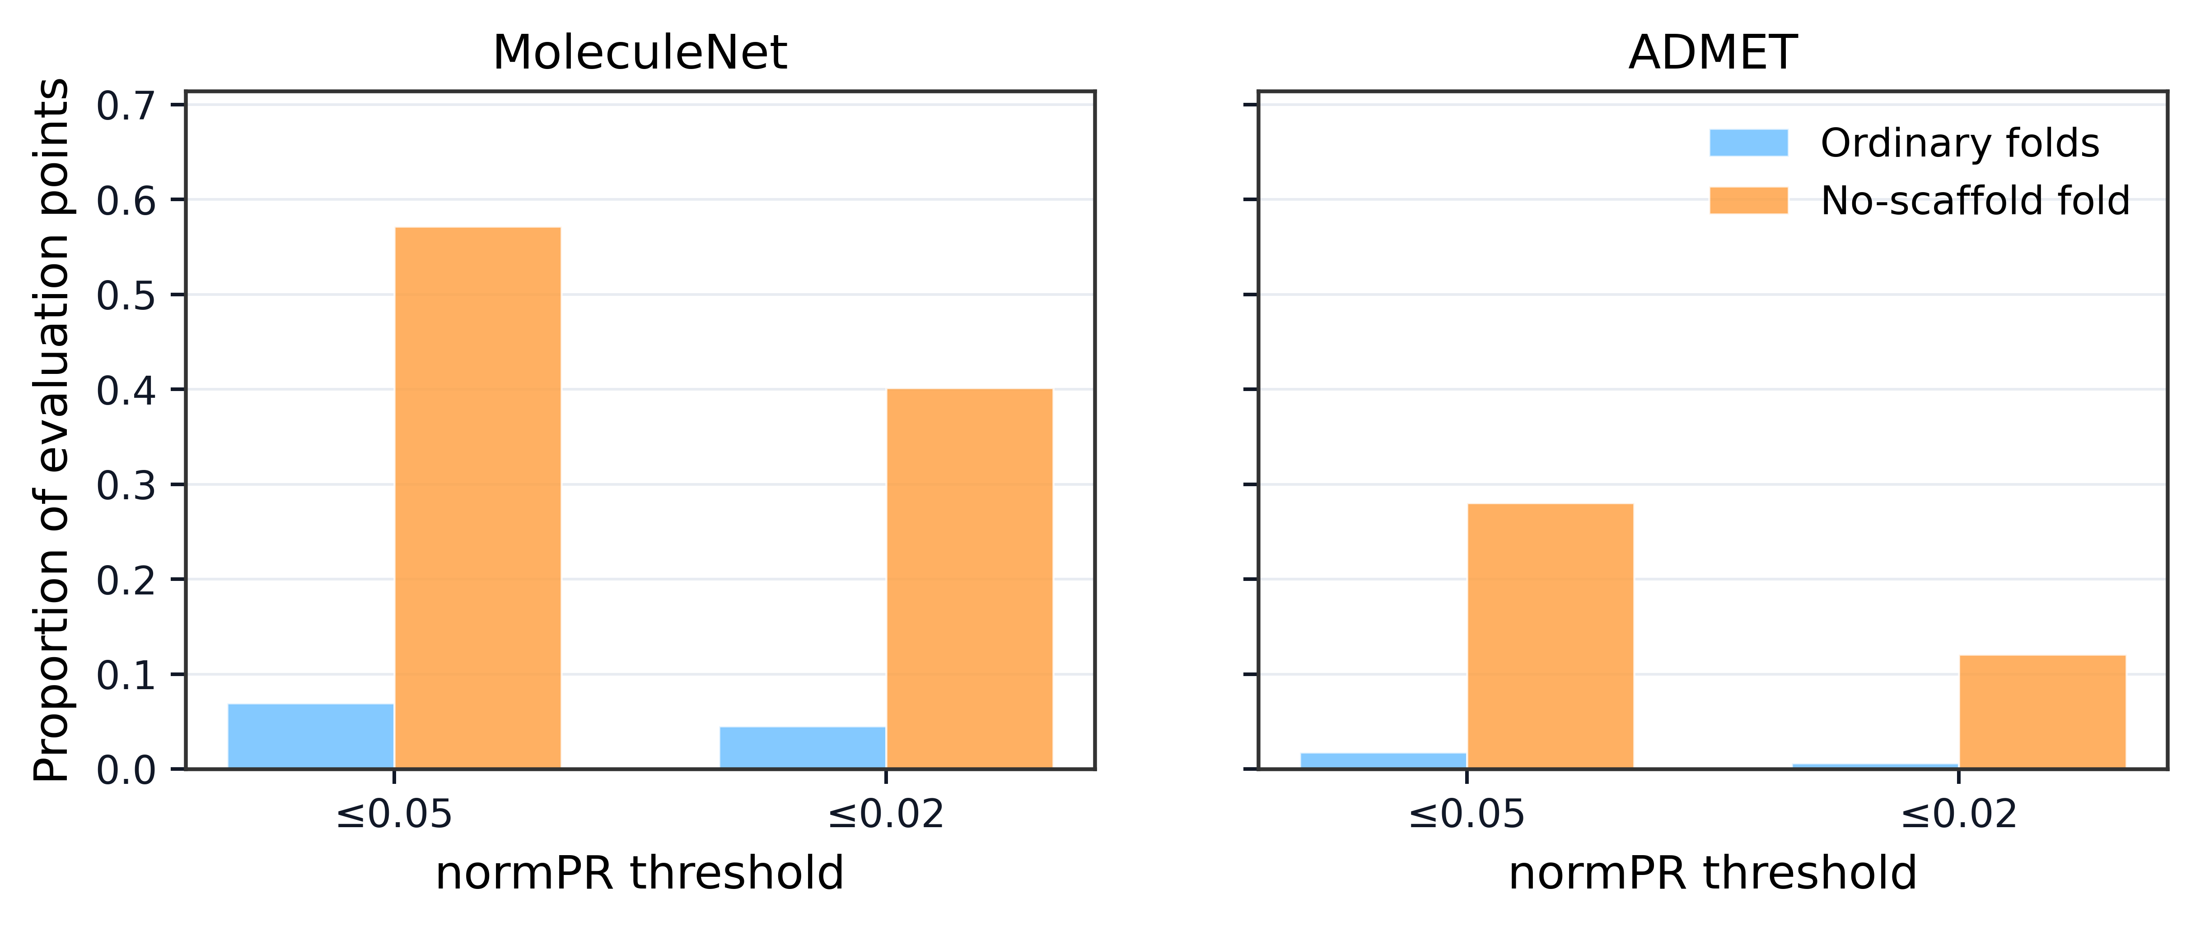
Supplementary Figure 1. Near-baseline normPR rates under the no-scaffold test distribution. The figure reports the proportions of model–task evaluation points with normPR ≤ 0.05 and normPR ≤ 0.02 in ordinary folds and in the no-scaffold test subset of the no-scaffold fold.
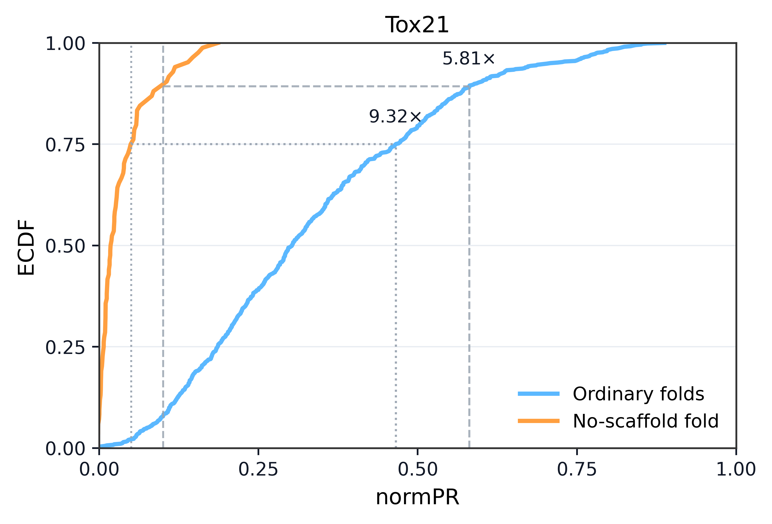
Supplementary Figure 2. normPR empirical cumulative distributions in the Tox21 sub-benchmark. The figure shows empirical cumulative distribution functions of normPR for pooled model–task evaluation points in Tox21, comparing ordinary folds with the no-scaffold test subset of the no-scaffold fold. Dashed lines indicate the reference thresholds $τ$ = 0.10 and $τ$ = 0.05.

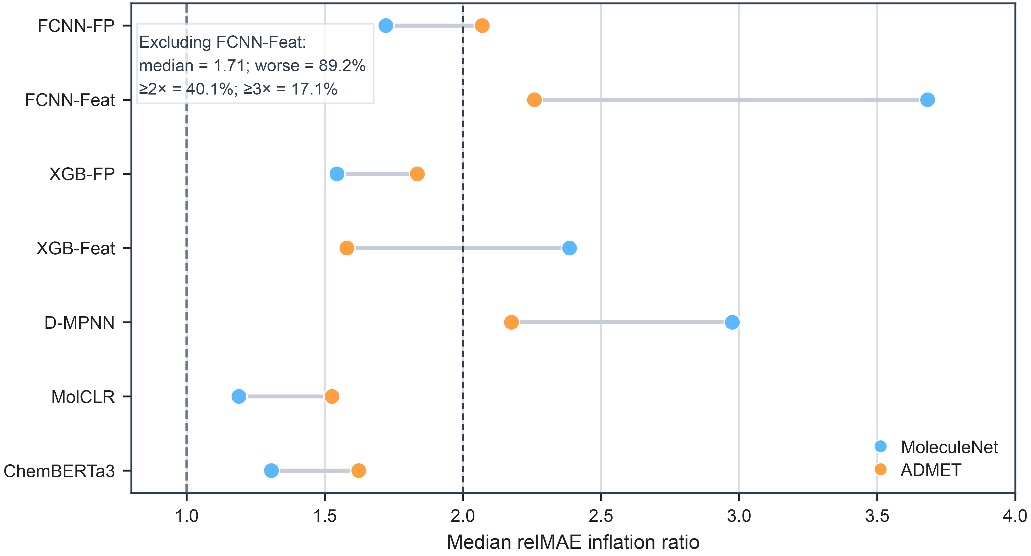
Supplementary Figure 3. Model-level relMAE inflation under no-scaffold exposure. The figure shows the median relMAE inflation ratio for each model in MoleculeNet and Deep-PK/ADMET. Dashed vertical lines indicate the 1× and 2× thresholds.

Supplementary Note 1. Metric selection and sensitivity analyses for primary performance metrics
This note describes the metric-selection and sensitivity analyses used to support the primary performance metrics in the no-scaffold evaluation. The goal was to select metrics that satisfy the requirements of this study: comparability across models, tasks, benchmarks, and evaluation subsets with different class priors or target scales.
For this purpose, a primary classification metric should quantify ranking performance in a way that accounts for the positive-rate baseline of each evaluated subset. A primary regression metric should quantify numerical error magnitude in a way that remains comparable across endpoints with different target scales. Supplementary Table 6 summarizes these study-specific metric requirements.
For classification tasks, average precision (AP), ROC-AUC, and normPR were compared. AP is directly related to precision–recall ranking, but its random-ranking baseline equals the positive rate of the evaluated subset. Therefore, raw AP values are difficult to compare across tasks or subsets with different positive rates. For example, an AP value close to 0.80 may be near baseline in a subset with an 80% positive rate, whereas an AP value of 0.20 may represent a substantial enrichment in a subset with a 5% positive rate. ROC-AUC has a fixed random-ranking baseline of 0.5, but it measures pairwise ROC-scale ranking rather than improvement above the precision–recall baseline. Under class imbalance, a model can retain non-random ROC-AUC while still providing little useful precision–recall improvement over the positive-rate baseline.
normPR was therefore retained as the primary classification metric because it normalizes AP against the positive-rate baseline of the evaluated subset:
$$\text{normPR}=\frac{AP-π}{1-π}$$
where $π$ is the positive rate. Under this definition, normPR = 0 corresponds to prior-only ranking, and normPR = 1 corresponds to perfect ranking. Among the compared classification metrics, normPR is the only metric that is both precision–recall-scale and positive-rate-baseline normalized, making it the most appropriate primary metric for cross-task and cross-distribution classification comparison in this study.
Supplementary Table 7 evaluates whether the classification degradation pattern depends on this metric choice. AP and ROC-AUC recovered the same overall direction of degradation as normPR, supporting that the observed classification decline was not an artifact of the primary metric. However, AP and ROC-AUC do not provide the same prior-baseline interpretation. Supplementary Table 8 further shows that normPR identifies a near-baseline regime that is not interchangeable with ROC-AUC: some evaluation points with normPR close to zero still had ROC-AUC above a near-random threshold. Supplementary Table 11, Panel A provides representative classification cases illustrating why AP or ROC-AUC alone is insufficient as the primary metric for this cross-distribution comparison. In C1, the no-scaffold subset has a much higher positive rate than the ordinary reference, so AP remains high despite a large loss of ranking quality relative to the positive-rate baseline; normPR makes this loss explicit. In C2, AP remains non-zero but normPR falls to approximately zero, indicating near-prior ranking. In C3 and C4, ROC-AUC remains above a near-random threshold even though normPR is close to zero, showing that non-random ROC-scale pairwise ranking does not necessarily imply meaningful precision–recall improvement over the positive-rate baseline.
For regression tasks, relMAE was compared with MAE, RMSE, $R^{2}$, Pearson $r$, and Spearman $ρ$. MAE and RMSE directly measure numerical error magnitude, but they are raw-scale metrics and therefore depend on the units and scale of the target. RMSE is additionally more sensitive to large residuals. In contrast, $R^{2}$, Pearson $r$, and Spearman $ρ$ are unit-free, but they measure variance explanation, linear association, or rank association rather than numerical error magnitude. Thus, they cannot by themselves quantify the size of prediction errors.
The scale-dependence problem is direct. Consider two regression problems that differ only by a multiplicative rescaling of the target. For the true(predicted) pairs 1800(1900), 1900(1800), 2000(2100), 2100(2200), and 2200(2100), the MAE is 100 and the target scale $S_{y}=\text{mean}\left(\left|y\right|\right)$ is 2000, giving relMAE = 0.05. For the rescaled pairs 0.18(0.19), 0.19(0.18), 0.20(0.21), 0.21(0.22), and 0.22(0.21), the MAE is 0.01 and $S_{y}=0.20$, again giving relMAE = 0.05. The two cases have the same relative prediction error, but raw MAE differs by four orders of magnitude. A primary cross-task regression metric should preserve this scale equivalence; raw MAE and RMSE do not, whereas relMAE does.
relMAE was therefore retained as the primary regression metric because it preserves the numerical error interpretation of MAE while normalizing by the target scale of the evaluated subset. Among the compared regression metrics, relMAE is the only metric that both measures numerical error magnitude and normalizes that error for target scale, making it the most appropriate primary metric for cross-task and cross-distribution regression comparison in this study.
Supplementary Table 9 evaluates whether the regression degradation pattern depends on this metric choice. MAE and RMSE were strongly aligned with relMAE inflation, supporting that the observed regression degradation was not an artifact of relMAE. However, raw MAE and RMSE remain scale-dependent. $R^{2}$, Pearson $r$, and Spearman $ρ$ were less aligned with scale-adjusted error inflation, consistent with their interpretation as goodness-of-fit or association metrics rather than direct error-magnitude metrics. Supplementary Table 10 further shows that high-multiple relMAE inflation was strongly enriched relative to ordinary fold-to-fold variability, while pooled MAE and RMSE robustness checks recovered the same qualitative high-error pattern. Supplementary Table 11, Panel B provides representative regression cases illustrating why raw error or association metrics alone are insufficient as primary metrics for the present comparison. In R1, raw MAE changes only modestly, but relMAE inflation is high because the no-scaffold target scale contracts, demonstrating why target-scale normalization is required. In R2 and R3, $R^{2}$ or Pearson $r$ remains high despite large relMAE inflation, showing that association metrics can miss large scale-adjusted numerical errors. In R4, RMSE inflation is much larger than MAE inflation, illustrating the tail sensitivity of RMSE and why it is better treated as a robustness or diagnostic metric rather than the primary cross-task error metric.
Together, Supplementary Tables 6–11 support the selection of normPR and relMAE as the primary performance metrics. Alternative metrics are useful as sensitivity or diagnostic measures and recover the same overall degradation direction, but they do not satisfy the full study-specific requirements for primary cross-task and cross-distribution comparison. normPR provides precision–recall-scale ranking normalized to the positive-rate baseline, and relMAE provides numerical error magnitude normalized to the target scale of the evaluated subset.

Supplementary Table 6. Metric requirements for primary no-scaffold performance comparisons. The table summarizes the study-specific requirements used to select primary performance metrics for cross-task and cross-distribution comparison. AP, ROC-AUC, MAE, RMSE, $R^{2}$, Pearson $r$, and Spearman $ρ$ are included as alternative or sensitivity metrics. normPR was selected as the primary classification metric because it normalizes precision–recall performance against the positive-rate baseline. relMAE was selected as the primary regression metric because it normalizes numerical error magnitude for target scale.
Panel A. Classification metrics
Metric | PR-scale ranking metric | Positive-rate baseline normalized | Direct prior-only baseline | Cross-task/subset comparability | Role in this study
AP | Yes | No | No; random baseline depends on positive rate | Limited when positive rates differ | Sensitivity metric
ROC-AUC | No; ROC-scale ranking metric | Not applicable | Yes; random baseline = 0.5 | Partial, but not PR-baseline interpretable | Sensitivity metric
normPR | Yes | Yes | Yes; normPR = 0 | Yes | Primary metric
Panel B. Regression metrics
Metric | Measures numerical error magnitude | Invariant to target rescaling | Unit-free | Cross-task/subset comparability | Role in this study
MAE | Yes | No | No | Limited when target scales differ | Sensitivity metric
RMSE | Yes | No | No | Limited; more sensitive to large residuals | Sensitivity metric
R² | No | Partly | Yes | Limited by test-set variance | Sensitivity metric
Pearson r | No | Yes | Yes | Does not measure numerical error magnitude | Sensitivity metric
Spearman ρ | No | Yes | Yes | Rank-only; does not measure numerical error magnitude | Sensitivity metric
relMAE | Yes | Yes | Yes | Yes | Primary metric

Supplementary Table 7. Classification metric sensitivity under no-scaffold exposure. Degradation was defined as a decrease from the ordinary-fold reference to the no-scaffold test subset. For AP, ROC-AUC, and normPR, the corresponding degradation scores were $D_{\text{AP}}=-ΔAP$, $D_{\text{ROC}}=-ΔROC\text{-}AUC$, and $D_{\text{normPR}}=-ΔnormPR$. Agreement with $D_{\text{normPR}}$ reports the Spearman correlation followed by the direction-agreement rate. Medians are pooled across all retained classification model–task evaluation points.
Metric | Median ordinary to no-scaffold | Degradation rate | Agreement with D_normPR | Association with |Δ positive rate|
AP | 0.563 → 0.230 (Δ = -0.228) | 89.1% | ρ = 0.774; 88.0% agreement | ρ = -0.031
ROC-AUC | 0.722 → 0.599 (Δ = -0.109) | 85.7% | ρ = 0.769; 90.0% agreement | ρ = -0.014
normPR | 0.310 → 0.060 (Δ = -0.208) | 90.2% | Reference | ρ = 0.071

Supplementary Table 8. Near-baseline classification behavior across ranking metrics. The table summarizes AP, ROC-AUC, normPR, and positive rate across normPR-defined near-baseline subsets. Values are pooled across all retained classification model–task evaluation points. The first two rows partition evaluation points by normPR > 0.05 and normPR ≤ 0.05; the normPR ≤ 0.02 row is a stricter subset of the near-baseline group. The ROC-AUC ≤ 0.55 row is included as a near-random ROC reference group.
Subset | n | Median AP | Median ROC-AUC | Median normPR | Median positive rate | ROC-AUC > 0.55, n (%)
normPR > 0.05 | 242 | 0.512 | 0.660 | 0.148 | 0.281 | 213 (88.0%)
normPR ≤ 0.05 | 199 | 0.076 | 0.531 | 0.012 | 0.052 | 76 (38.2%)
normPR ≤ 0.02 | 126 | 0.069 | 0.500 | 0.003 | 0.060 | 28 (22.2%)
ROC-AUC ≤ 0.55 | 152 | 0.237 | 0.500 | 0.009 | 0.247 | 0 (0.0%)

Supplementary Table 9. Regression metric sensitivity under no-scaffold exposure. The table compares common regression metrics under no-scaffold exposure. For MAE, RMSE, and relMAE, degradation was evaluated using no-scaffold/ordinary ratios; for $R^{2}$, Pearson $r$, and Spearman $ρ$, degradation was evaluated as the decrease from the ordinary-fold reference to the no-scaffold test subset. “Pooled median ratio/drop” is computed from the ordinary and no-scaffold medians shown in the table. “Median model–task ratio/drop” reports the median of model–task-specific ratios or drops and is therefore not necessarily equal to the ratio or difference of the pooled medians. Agreement with $D_{\text{relMAE}}$ reports the Spearman correlation followed by the direction-agreement rate.
Metric | Ordinary → no-scaffold median | Pooled median ratio/drop | Median model-task ratio/drop | Degradation rate | Agreement with D_relMAE | Scale/variance association
MAE | 0.857 → 1.245 | 1.45× | 1.51× | 90.0% | ρ = 0.866; 93.1% agreement | ρ-scale = 0.197; ρ-variance = 0.478
RMSE | 1.087 → 1.732 | 1.59× | 1.55× | 92.7% | ρ = 0.750; 90.3% agreement | ρ-scale = 0.260; ρ-variance = 0.473
relMAE | 0.190 → 0.256 | 1.35× | 1.80× | 90.0% | Reference | ρ-scale = -0.213; ρ-variance = 0.267
R² | 0.689 → 0.351 | 0.338 drop | 0.215 drop | 90.3% | ρ = 0.549; 88.0% agreement | ρ-scale = -0.020; ρ-variance = -0.115
Pearson r | 0.850 → 0.721 | 0.129 drop | 0.097 drop | 89.2% | ρ = 0.409; 84.6% agreement | ρ-scale = 0.067; ρ-variance = -0.116
Spearman ρ | 0.848 → 0.746 | 0.102 drop | 0.063 drop | 84.2% | ρ = 0.271; 82.6% agreement | ρ-scale = 0.176; ρ-variance = -0.051

Supplementary Table 10. High-multiple regression error enrichment relative to ordinary fold-to-fold variability. Panel A reports benchmark-specific relMAE tail enrichment under no-scaffold exposure, using the same benchmark-level ordinary fold-to-fold reference as the main regression tail-risk analysis. Tail enrichment is defined as the no-scaffold tail probability divided by the ordinary fold-to-fold tail probability at the corresponding threshold. Panel B provides pooled robustness checks using raw MAE and RMSE ratios.
Panel A. Benchmark-specific relMAE tail enrichment
Metric | Benchmark | Tail criterion | No-scaffold tail probability | Ordinary fold-to-fold tail probability | Tail enrichment
relMAE | MoleculeNet | ≥2× | 45.6% | 1.76% | 26×
relMAE | Deep-PK/ADMET | ≥2× | 43.8% | 1.32% | 33×
relMAE | MoleculeNet | ≥3× | 30.6% | 0.08% | 378×
relMAE | Deep-PK/ADMET | ≥3× | 11.6% | 0.09% | 132×
Panel B. Pooled robustness checks using raw error metrics
Metric | Benchmark | Tail criterion | No-scaffold tail probability | Ordinary fold-to-fold tail probability | Tail enrichment
MAE | Pooled | ≥2× | 29.7% | 0.62% | 48.1×
MAE | Pooled | ≥3× | 18.5% | 0.05% | 381.4×
RMSE | Pooled | ≥2× | 32.0% | 0.69% | 46.2×
RMSE | Pooled | ≥3× | 20.8% | 0.22% | 93.9×

Supplementary Table 11. Representative failure modes of alternative metrics. Panel A lists representative classification cases illustrating discordance among AP, ROC-AUC, and normPR under no-scaffold exposure. Panel B lists representative regression cases illustrating discordance among raw error, association, and scale-adjusted error metrics. Ordinary and no-scaffold values are shown as “Ord → NS” for classification metrics.
Panel A. Classification cases
Case | Benchmark | Dataset | Target | Model | Positive rate  Ord → NS | AP  Ord → NS | ROC-AUC  Ord → NS | normPR  Ord → NS
C1 | Deep-PK/ADMET | Eye corrosion | Eye corrosion | MolCLR | 0.119 → 0.864 | 0.829 → 0.880 | 0.940 → 0.563 | 0.801 → 0.118
C2 | MoleculeNet | SIDER | Nervous system disorders | MolCLR | 0.921 → 0.760 | 0.941 → 0.758 | 0.608 → 0.519 | 0.300 → −0.008
C3 | MoleculeNet | Tox21 | NR-Aromatase | XGboost-features | 0.065 → 0.011 | 0.229 → 0.022 | 0.783 → 0.731 | 0.176 → 0.012
C4 | MoleculeNet | Tox21 | NR-AR-LBD | XGboost-features | 0.035 → 0.014 | 0.637 → 0.026 | 0.866 → 0.684 | 0.625 → 0.012

Panel B. Regression cases
Case | Benchmark | Dataset | Target | Model | MAE ratio | RMSE ratio | relMAE inflation | Target-scale ratio | R²_NS | Pearson r_NS
R1 | Deep-PK/ADMET | logVP | logVP | XGboost-features | 1.03× | 1.01× | 2.49× | 0.43× | 0.738 | 0.887
R2 | MoleculeNet | QM9 | h298 | XGboost-features | 10.84× | 9.90× | 10.71× | 1.01× | 0.974 | 0.988
R3 | MoleculeNet | QM9 | u298 | D-MPNN | 12.58× | 5.46× | 12.49× | 1.01× | 0.730 | 0.894
R4 | MoleculeNet | QM9 | zpve | FCNN-features | 5.87× | 135.09× | 5.95× | 1.04× | −166.113 | 0.068

Supplementary Note 2. Diagnostic association analyses
This note summarizes association-based diagnostic analyses linking no-scaffold performance changes to candidate diagnostic variables. These analyses are intended to characterize accompanying patterns rather than to establish causal mechanisms. Unless otherwise stated, diagnostic associations were summarized at the task-level median scale.
For classification tasks, Supplementary Fig. 4 and Supplementary Tables 12 and 13 examine associations between ΔnormPR and training-support loss, positive-rate shift, calibration drift, and prediction-score compression. Supplementary Table 12 summarizes class imbalance, prediction-score compression, and training-support background in the no-scaffold fold, whereas Supplementary Table 13 reports task-level Spearman and partial Spearman correlations. Larger prediction-score compression indicates a smaller prediction-probability standard deviation on the no-scaffold test subset relative to ordinary folds. Larger support loss indicates lower nearest-neighbor training support in the no-scaffold fold relative to ordinary folds.
For regression tasks, Supplementary Fig. 5 and Supplementary Tables 14 and 15 examine associations between relMAE inflation and support loss, target-distribution shift, absolute MAE growth, target-scale contraction, and output-scale change. Supplementary Table 14 summarizes training support, error decomposition, and support-loss-stratified relMAE inflation, whereas Supplementary Table 15 reports task-level correlation analyses. Larger relMAE inflation indicates higher scale-adjusted regression error on the no-scaffold test subset relative to the corresponding ordinary-fold reference.
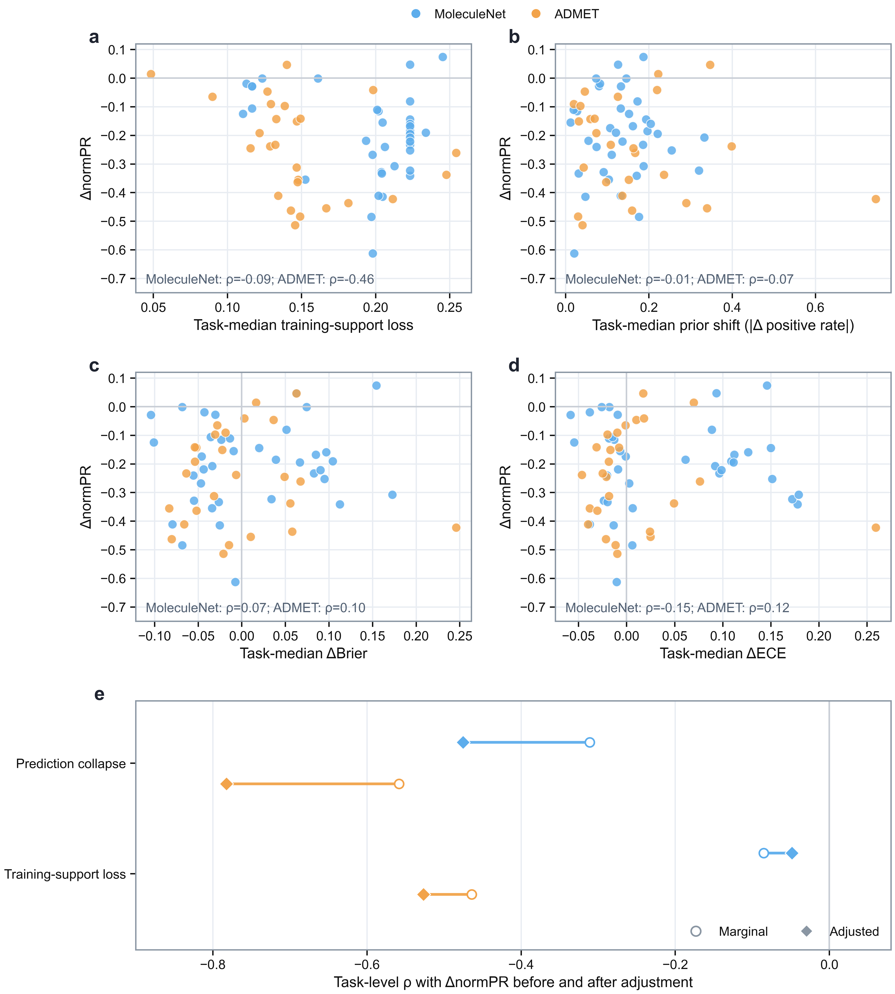
Supplementary Figure 4. Diagnostic associations for classification tasks. a, Relationship between support loss and ΔnormPR. b–d, Relationships between positive-rate shift, ΔBrier, ΔECE, and ΔnormPR. e, Task-level correlation analysis of prediction-score compression and training-support loss with ΔnormPR before and after adjustment.
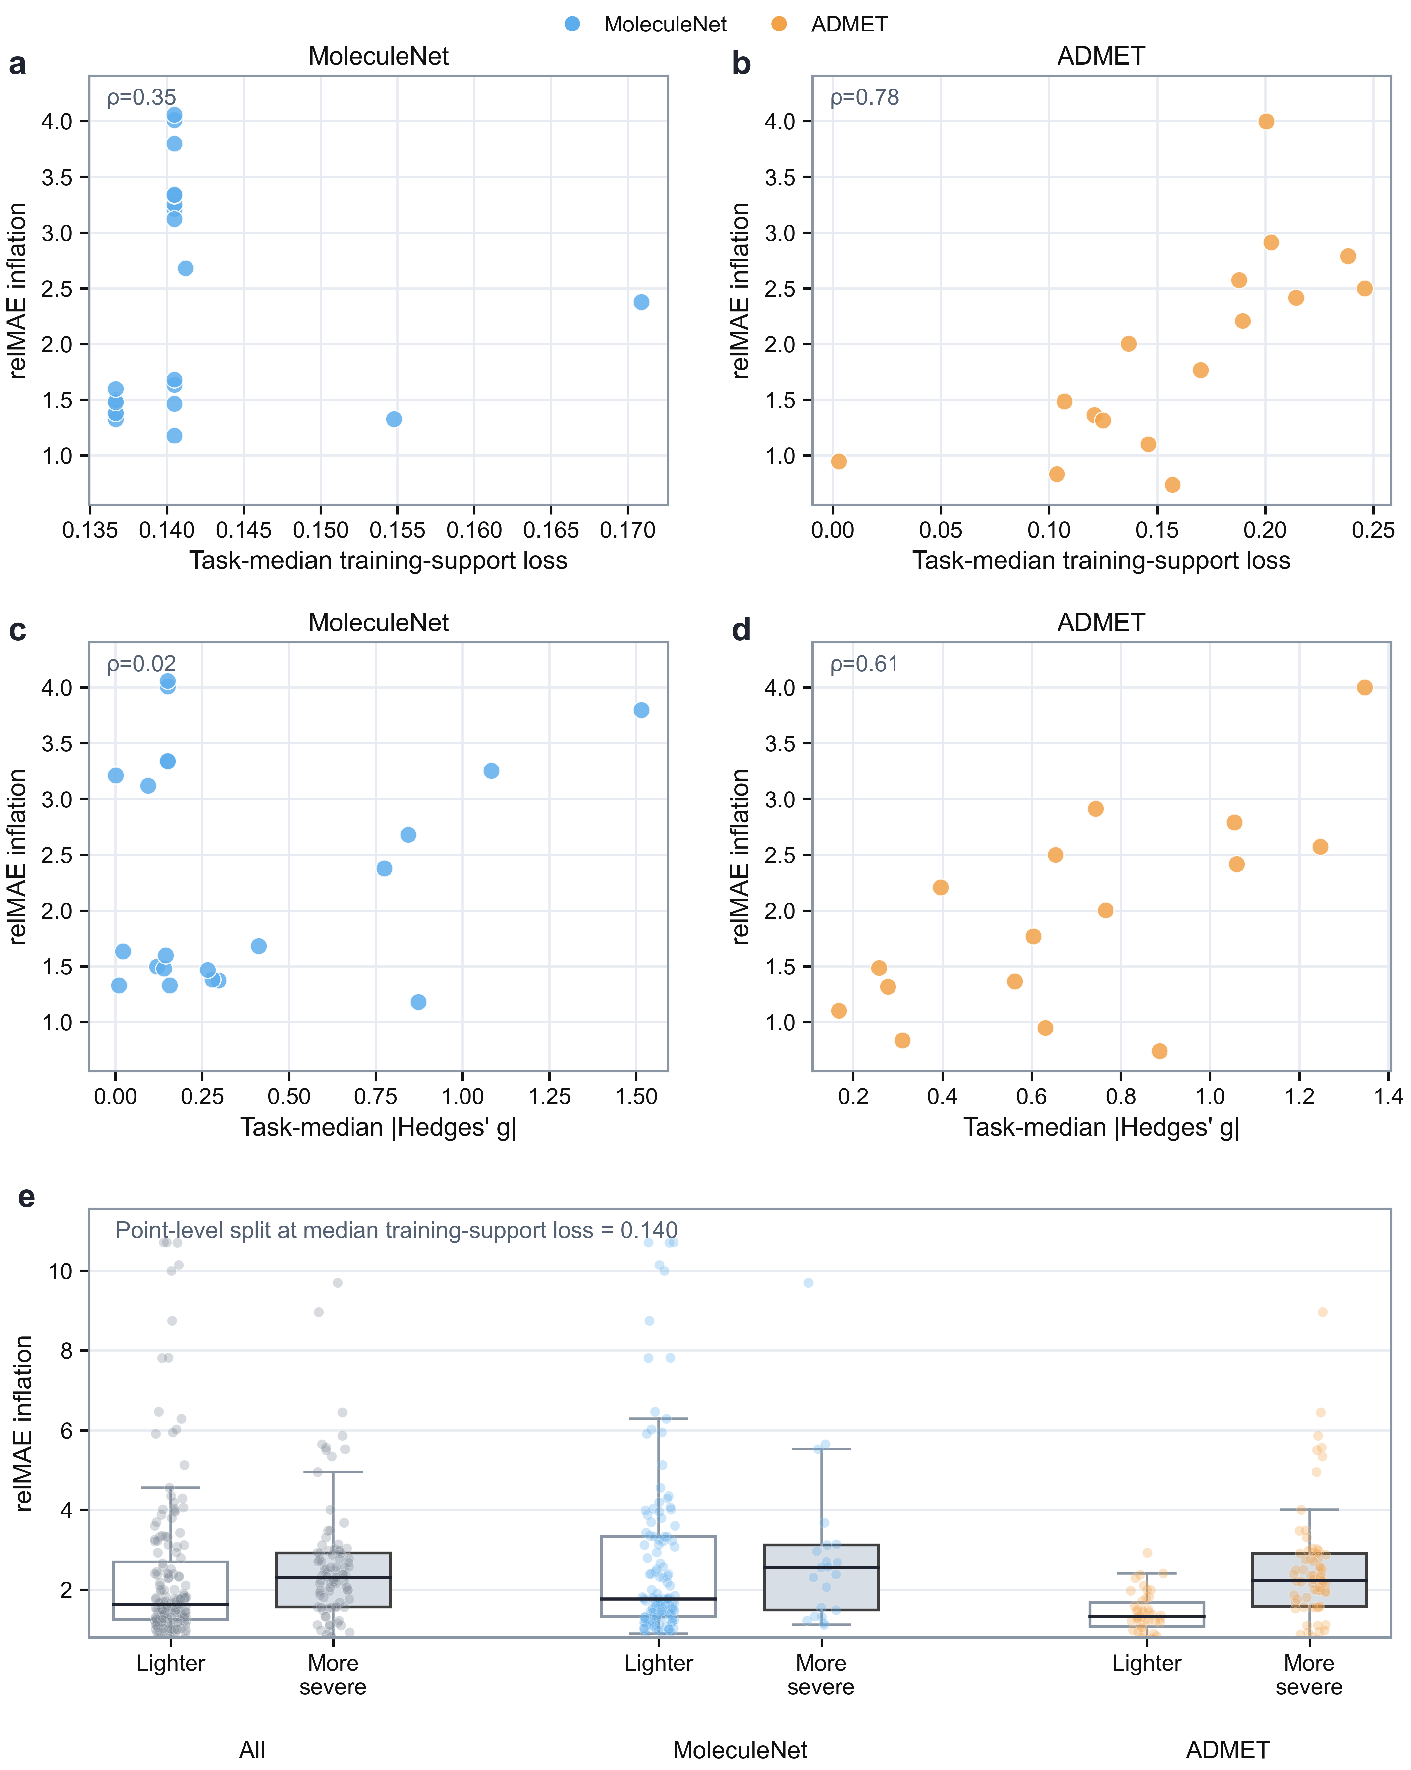
Supplementary Figure 5. Diagnostic associations for regression tasks. a–b, Relationships between support loss and relMAE inflation in MoleculeNet and Deep-PK/ADMET. c–d, Relationships between ∣Hedges′ g∣ and relMAE inflation in MoleculeNet and Deep-PK/ADMET. e, Point-level relMAE inflation distributions after stratification by support-loss severity.

Supplementary Table 12. Class imbalance, prediction-score compression, and training-support background in the no-scaffold fold for classification tasks. Values are reported as task-level statistics. Training-support similarity denotes the median nearest-neighbor similarity from test molecules to the training set.
Metric | Moleculenet | Deep-PK/ADMET
Number of tasks | 37 | 26
More imbalanced tasks | 23/37 (62.2%) | 19/26 (73.1%)
Median imbalance amplification ratio | 1.906 | 2.705
Median prediction-collapse strength | 1.478 | 1.839
Ordinary training-support similarity | 0.435 | 0.445
No-scaffold training-support similarity | 0.263 | 0.308
Ordinary low-support tasks (<0.30) | 0/37 (0.0%) | 3/26 (11.5%)
No-scaffold low-support tasks (<0.30) | 29/37 (78.4%) | 12/26 (46.2%)

Supplementary Table 13. Task-level correlations between candidate diagnostic variables and ΔnormPR in classification tasks. $ρ$ and $p$ denote Spearman correlation and the corresponding $p$-value. Partial $ρ$ and partial $p$ denote partial Spearman correlation after simultaneously controlling for ∣Δpositive rate∣, ΔBrier, and ΔECE.
Benchmark | Metric | $$ρ$$ | $$p$$ | Partial $ρ$ | partial $p$
Moleculenet | Prediction collapse | -0.311 | 0.061 | -0.475 | 0.005
Moleculenet | Training-support loss | -0.085 | 0.617 | -0.049 | 0.785
Moleculenet | Prior shift | -0.007 | 0.966 | — | —
Moleculenet | Calibration drift (Brier) | 0.067 | 0.692 | — | —
Moleculenet | Calibration drift (ECE) | -0.153 | 0.367 | — | —
ADMET | Prediction collapse | -0.558 | 0.003 | -0.782 | < 0.001
ADMET | Training-support loss | -0.464 | 0.017 | -0.527 | 0.010
ADMET | Prior shift | -0.072 | 0.726 | — | —
ADMET | Calibration drift (Brier) | 0.101 | 0.624 | — | —
ADMET | Calibration drift (ECE) | 0.121 | 0.557 | — | —

Supplementary Table 14. Training support, error decomposition, and support-loss-stratified relMAE inflation in regression tasks.
Panel A. Task-level benchmark summaries of training support and error decomposition.
Metric |  | MoleculeNet | ADMET
Number of regression tasks |  | 21 | 16
Ordinary-fold training-support similarity (median) |  | 0.533 | 0.429
No-scaffold-fold training-support similarity (median) |  | 0.393 | 0.261
Median MAE ratio |  | 1.591 | 1.449
Median target-scale ratio |  | 1.009 | 0.758
Median output-scale change |  | 1.103 | 0.946
Panel B. Evaluation-point-level relMAE inflation and tail-risk summaries after stratifying evaluation points by the median support loss.
Benchmark subset | Support-loss severity group | Number of evaluation points | Median relMAE inflation | RelMAE inflation ≥ 2x risk (%) | RelMAE inflation ≥ 3x risk (%)
All | Lighter support loss | 168 | 1.628 | 35.1 | 23.2
All | More severe support loss | 91 | 2.305 | 62.6 | 20.9
MoleculeNet | Lighter support loss | 126 | 1.77 | 42.1 | 31
MoleculeNet | More severe support loss | 21 | 2.558 | 66.7 | 28.6
ADMET | Lighter support loss | 42 | 1.327 | 14.3 | 0
ADMET | More severe support loss | 70 | 2.227 | 61.4 | 18.6

Supplementary Table 15. Task-level correlations between candidate diagnostic variables and relMAE inflation in regression tasks. $ρ$ and $p$ denote Spearman correlation and the corresponding $p$-value. The ΔMAE correlation is included to assess the association between support loss and absolute error growth.
Benchmark | Tasks | Metric | $$ρ$$ | $$p$$
MoleculeNet | 21 | Support loss vs relMAE inflation | 0.351 | 0.1187
MoleculeNet | 21 | Support loss vs ΔMAE | 0.538 | 0.0119
MoleculeNet | 21 | |Hedges' g| vs relMAE inflation | 0.023 | 0.9199
MoleculeNet | 21 | KS vs relMAE inflation | 0.194 | 0.3989
MoleculeNet | 21 | Output-scale change vs relMAE inflation | 0.548 | 0.0101
ADMET | 16 | Support loss vs relMAE inflation | 0.782 | 0.0003
ADMET | 16 | Support loss vs ΔMAE | 0.732 | 0.0013
ADMET | 16 | |Hedges' g| vs relMAE inflation | 0.609 | 0.0123
ADMET | 16 | KS vs relMAE inflation | 0.544 | 0.0293
ADMET | 16 | Output-scale change vs relMAE inflation | 0.041 | 0.8797

Supplementary Note 3. Empty-Scaffold-Aware repair procedure
This note describes the Empty-Scaffold-Aware repair procedure used to adjust no-scaffold allocation after an initial leakage-aware split. ESA is a post-split repair layer targeted specifically at no-scaffold molecules. It does not reconstruct the full split or replace leakage-aware splitters such as DataSAIL. Instead, it keeps the scaffold-bearing split backbone fixed and reassigns only no-scaffold molecules (Supplementary Algorithm 1).
For each dataset, scaffold-bearing molecules were first assigned to training, validation, and test branches using DataSAIL. These assignments were fixed throughout ESA repair. No-scaffold molecules were represented by 2048-bit Morgan fingerprints and partitioned into local micro-clusters using a Tanimoto similarity threshold of 0.40. Molecules without valid fingerprints were assigned as singleton groups.
ESA assigns no-scaffold micro-clusters to the training, validation, test, or drop branch using a coupled greedy scoring procedure. The assignment score considers train-facing similarity exposure, cross-branch similarity among no-scaffold micro-clusters, split-size imbalance, lower-bound deficits, and drop penalty. If validation or test lower bounds remain unmet after greedy assignment, small low-train-similarity micro-clusters are moved from the no-scaffold training branch to the underfilled branch without violating the training lower bound.
The repaired no-scaffold assignments are then merged with the fixed scaffold-bearing backbone. The final outputs include repaired train/validation/test assignments, dropped molecules if any, assignment audits, micro-cluster summaries, and split-level diagnostics.

Supplementary Algorithm 1. Empty-Scaffold-Aware repair with a fixed scaffold-bearing backbone.
Input: Dataset D with SMILES, target split ratios r, ESA condition c, random seed, and fingerprint parameters.
Output: ESA-repaired train/validation/test assignments and split-level diagnostics.
1. Preprocess molecules.
Standardize SMILES, remove unparsable molecules, and extract Bemis-Murcko scaffolds.
2. Separate scaffold classes.
Partition D into scaffold-bearing molecules B and no-scaffold molecules N.
3. Set split targets.
Determine dataset-size-dependent train/validation/test ratios and split weights.
4. Build the scaffold-bearing backbone.
Split B using DataSAIL with C1e, molecule mode M, SCIP solver, and the selected split weights.
5. Freeze the backbone.
Keep the resulting assignments of B fixed throughout ESA repair.
Comment: This preserves the leakage-aware structure of the scaffold-bearing molecules and restricts repair to the no-scaffold residual group.
6. Represent no-scaffold molecules.
Compute Morgan fingerprints for molecules in N.
7. Construct ESA micro-clusters.
Build micro-clusters among valid-fingerprint no-scaffold molecules using leader picking at Tanimoto similarity threshold 0.40. Molecules without valid fingerprints are assigned as singleton groups.
8. Refine oversized clusters.
Split oversized micro-clusters according to the condition-specific maximum cluster size.
Comment: This prevents a large no-scaffold cluster from dominating one split branch.
9. Estimate similarity costs.
For each no-scaffold micro-cluster, estimate similarity to the scaffold-bearing training branch and to other no-scaffold micro-clusters.
10. Order repair units.
Sort no-scaffold micro-clusters by decreasing cluster size and decreasing similarity to the scaffold-bearing training branch.
11. Assign no-scaffold micro-clusters.
Assign each no-scaffold micro-cluster to train, valid, test, or drop using coupled greedy scoring over train-facing similarity exposure, cross-branch no-scaffold similarity, split-size imbalance, lower-bound deficit and drop penalty.
12. Repair unmet evaluation lower bounds.
If valid or test lower bounds remain unmet, move small low-train-similarity clusters from train to the underfilled branch without violating the train lower bound.
Comment: This step ensures that ESA does not simply move all no-scaffold molecules into training.
13. Merge repaired assignments.
Merge the fixed scaffold-bearing backbone with the repaired no-scaffold assignments.
14. Export outputs and diagnostics.
Output train, validation, and test splits, dropped molecules if any, assignment audit, ESA cluster summary, and split-level diagnostics.
Note: The ESA conditions used in Supplementary Fig. 6 differ only in the micro-cluster size limit, split lower bounds, and coupled-greedy scoring weights.

Supplementary Note 4. ESA configuration selection and split-level diagnostics
This note summarizes the preliminary ESA configuration sweep and the supplementary split-level diagnostics for the selected repair configuration. Configuration selection was based only on split-composition and similarity-exposure diagnostics, not on downstream model performance.
Before full-dataset ESA evaluation, five predefined ESA configurations, denoted A–E, were evaluated on a fixed set of 10 tuning datasets. The configurations differed in micro-cluster size limits, greedy scoring weights, branch-level lower bounds, and drop penalties. Selection considered support recovery, sink ratio, distribution gap, train-facing similarity exposure, leak rate at a Tanimoto similarity threshold of 0.40, and drop fraction. The composite score reported in Supplementary Table 16 is included only as a configuration-screening summary; the individual split-level diagnostics used for interpretation are reported alongside it.
Two configurations were retained for comparison. ESA-Balanced (A) served as a conservative balanced repair baseline, whereas ESA-TrainSupport (D) prioritized training-side no-scaffold representation. Unless otherwise stated, the main-text ESA analyses use ESA-TrainSupport. Supplementary Table 17 lists the parameter settings for these two retained configurations.
Supplementary Fig. 6 provides split-level diagnostics for ESA repair, including no-scaffold proportions across split branches, full-split normalized leakage, comparison between ESA-Balanced and ESA-TrainSupport, and leak rates from no-scaffold validation/test branches to the full training set.

Supplementary Table 16. Preliminary ESA configuration sweep across 10 tuning datasets. The table reports split-level diagnostics for five predefined ESA configurations. The median score summarizes the trade-off among support recovery, sink ratio, distribution balance, train-facing similarity exposure, leak rate, and drop fraction; lower values indicate a more favorable trade-off. Maximum leak rate at 0.40 and maximum $L_{\text{norm}}$ are computed across the no-scaffold validation and test branches.
Configuration | Priority | Median score | Median support recovery | Median sink ratio | Max leak rate@0.4 | Max $L_{\text{norm}}$​
ESA-Balanced (A) | Balanced repair | 0.192 | 1.125 | 0.522 | 0.134 | 0.041
B | Test-leakage priority | 0.202 | 1.124 | 0.609 | 0.183 | 0.058
C | Distribution-uniformity priority | 0.21 | 1.073 | 0.73 | 0.187 | 0.051
ESA-TrainSupport (D) | Train-support priority | 0.167 | 1.148 | 0.417 | 0.135 | 0.046
E | Strict low-leakage | 0.186 | 1.125 | 0.522 | 0.171 | 0.054

Supplementary Table 17. ESA-Balanced and ESA-TrainSupport configurations retained after preliminary screening. The table lists the maximum micro-cluster fraction, coupled greedy scoring weights, branch-level lower bounds, drop budget, and similarity sampling cap for the two retained ESA configurations. Greedy scoring weights are ordered as $λ_{\text{internal}}$, $λ_{\text{valid-train}}$​, $λ_{\text{test-train}}$, and $λ_{\text{imbalance}}$​. Lower bounds are ordered as training, validation, and test. Similarity sampling cap is maximum number of fingerprints sampled per micro-cluster during similarity estimation.
Configuration | Purpose | Max cluster fraction | Greedy scoring weights* | Lower bounds† | Drop budget | Similarity sampling cap#
ESA-Balanced (A) | Balanced repair baseline | 0.7 | (1.0, 1.0, 1.0, 0.05) | (0.80, 0.50, 0.50) | 0.05 | 16
ESA-TrainSupport (D) | Train-support-priority repair | 0.8 | (0.5, 1.0, 1.5, 0.03) | (0.90, 0.40, 0.40) | 0.05 | 16

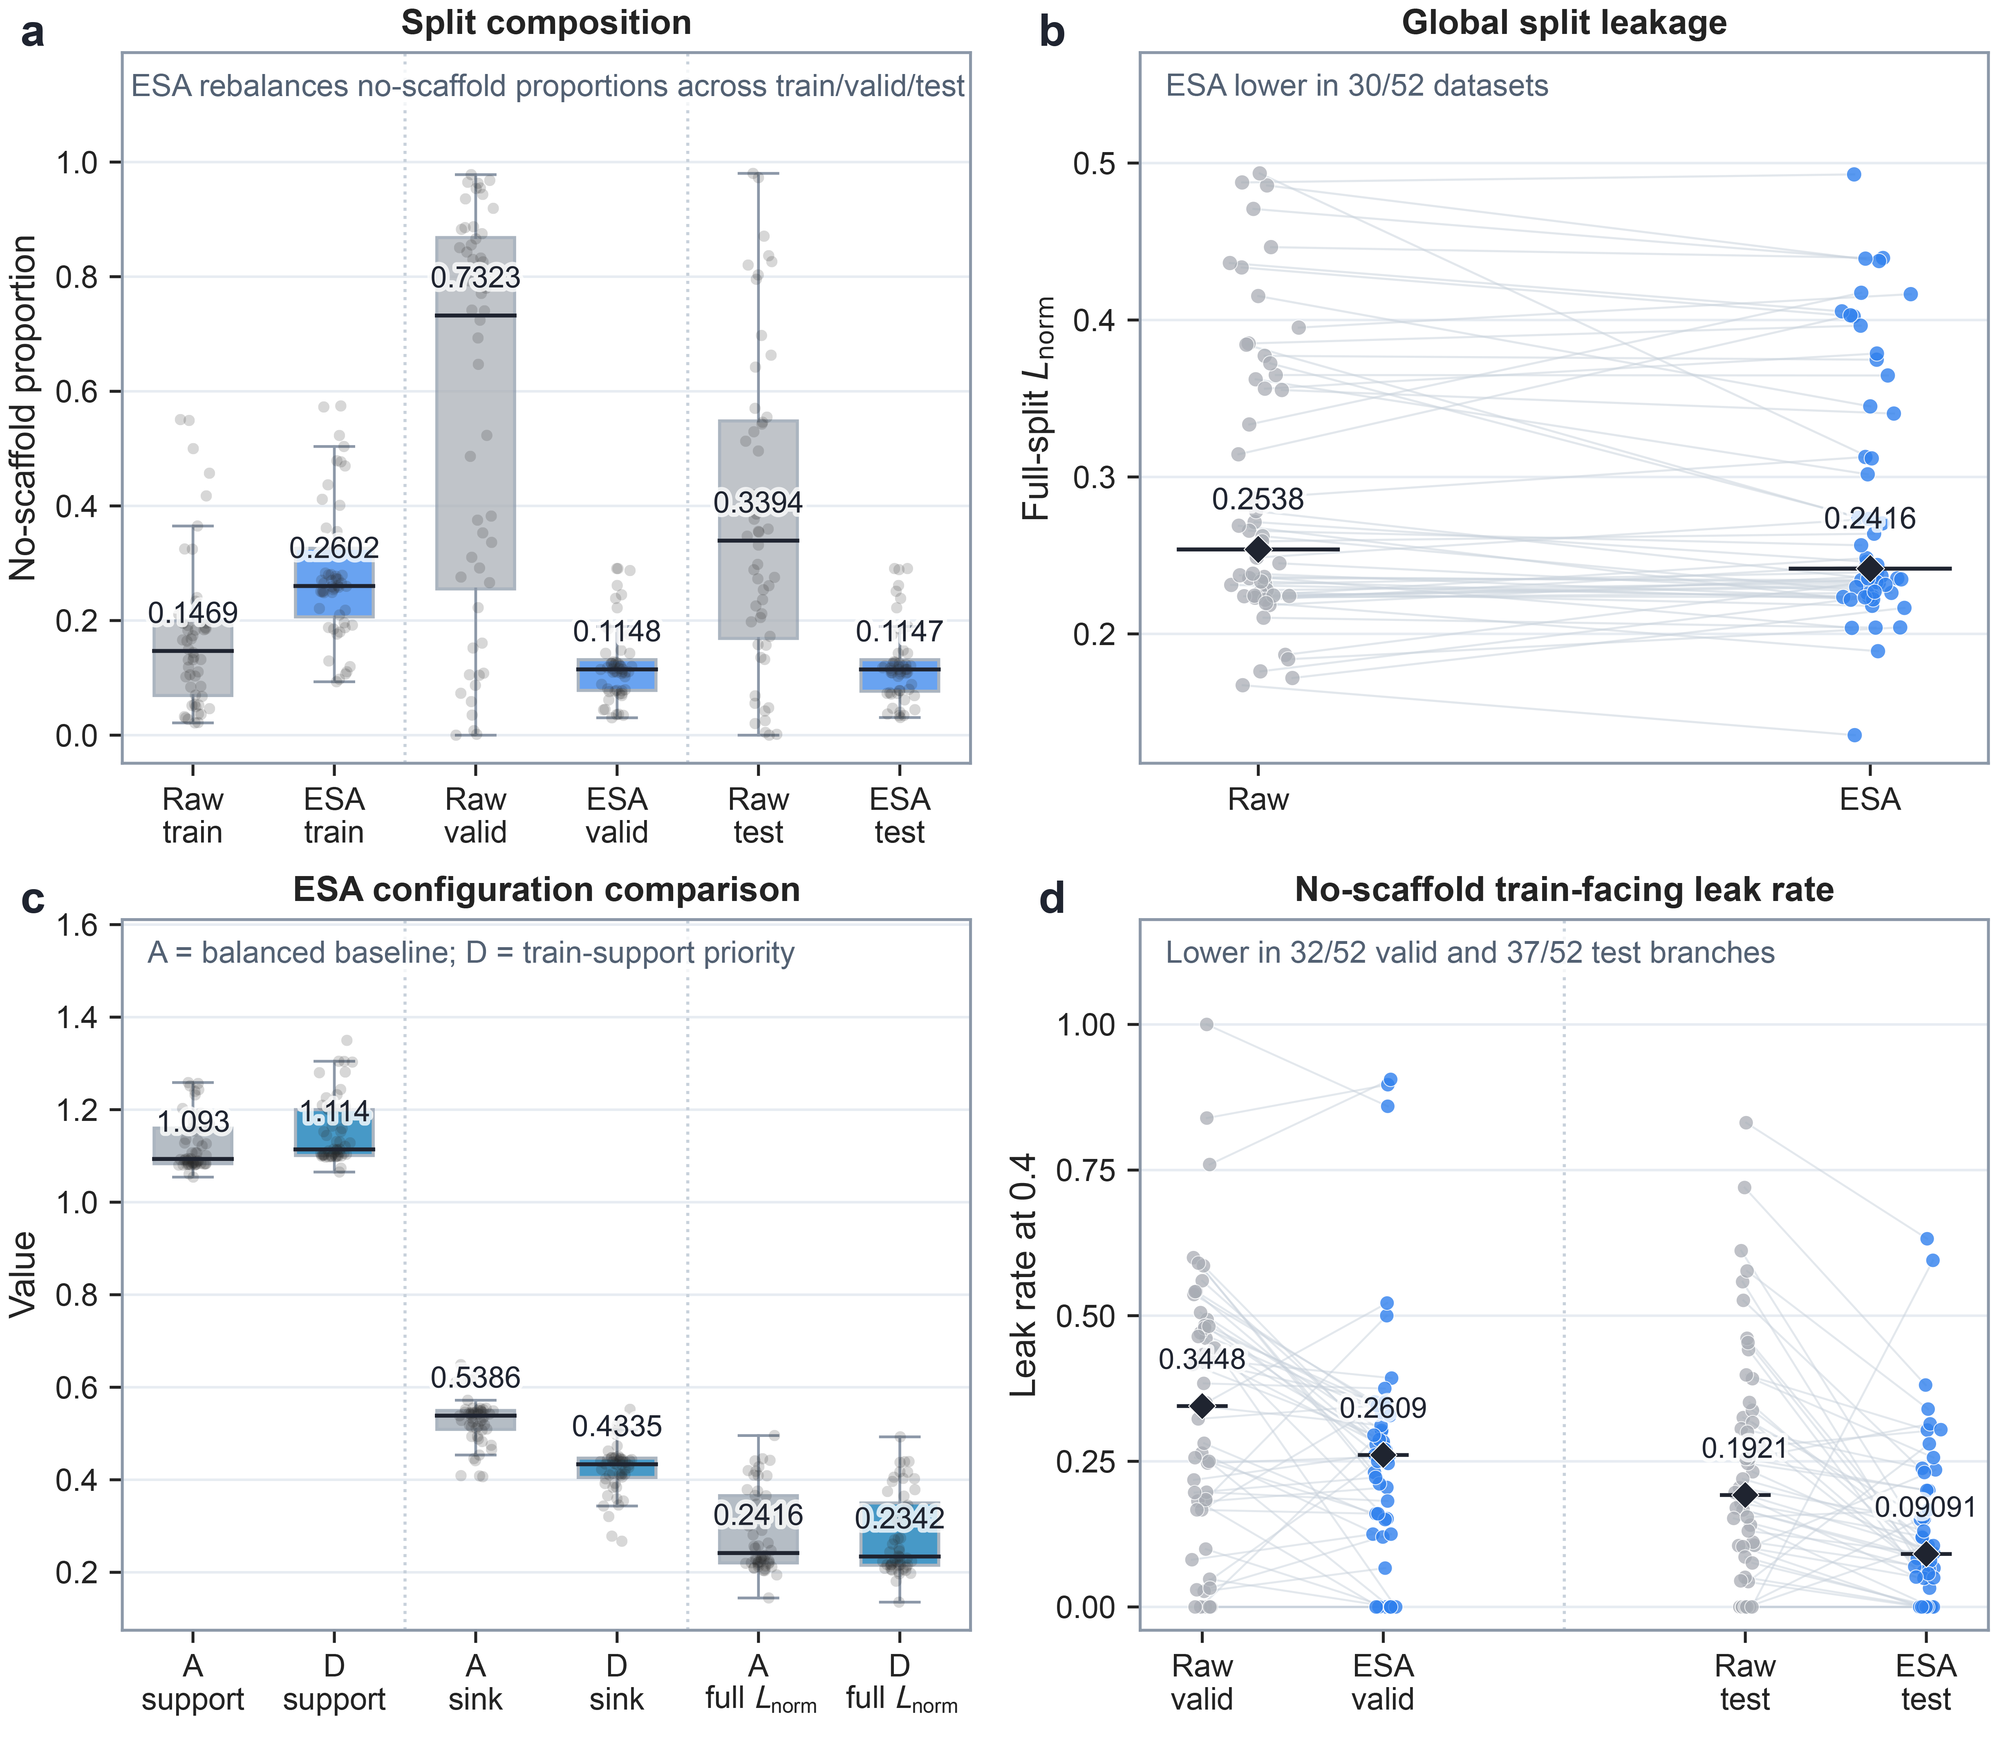
Supplementary Figure 6. Split composition, normalized leakage, and configuration comparison for ESA repair. a, Proportions of no-scaffold molecules in the training, validation, and test branches under raw DataSAIL and ESA. b, Full-split $L_{\text{norm}}$ under raw DataSAIL and ESA. c, Support recovery, sink ratio, and full-split $L_{\text{norm}}$ ​for ESA-Balanced and ESA-TrainSupport. d, Leak rate from no-scaffold validation and test branches to the full training set at a Tanimoto similarity threshold of 0.40.

Supplementary Figure 7. Fingerprint-based chemical-space localization of no-scaffold molecules. UMAP embeddings were generated from Morgan fingerprints for datasets with no-scaffold proportion ≥8%. Scaffold-bearing molecules are shown in grey and no-scaffold molecules in orange.

