Bilinear cross-attention networks implicitly supervise continuous thermodynamic gradients in supramolecular screening

Chih-Yang Cheng^{1*}, Yi-Huan Wu^{2*}, Feng-Yin Li^{1*}

¹Department of Chemistry, National Chung Hsing University, Taichung 402, Taiwan.
²Department of Chemistry, R. O. C. Military Academy, Kaohsiung, Taiwan.
*corresponding author: Chih-Yang Cheng (mushroom2368@gmail.com), Yi-Huan Wu (m1090008@rocma.edu.tw), Feng-Yin Li (feng64@nchu.edu.tw)

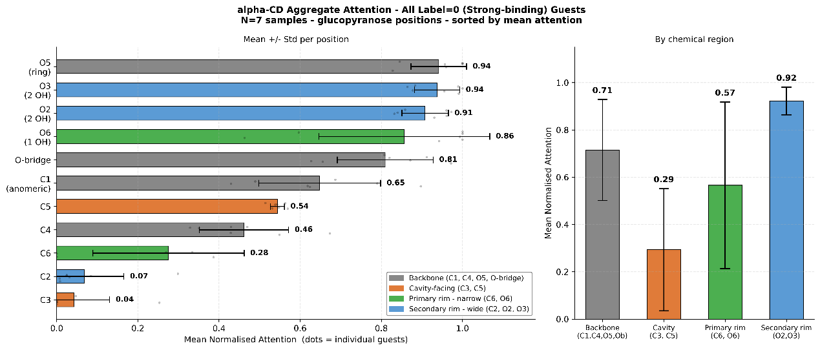
Supplementary Fig. S1 | Aggregate BANLayer attention distribution for $α–CD$ inclusion complexes. Mean normalized attention weights extracted from the Bilinear Attention Network for strong-binding guests (K > 10,000 M⁻¹, n = 7). The network correctly identifies the ring oxygen (O5) and secondary rim hydroxyls (O2, O3) as the dominant interaction sites, while ignoring the interior hydrophobic carbon backbone (C2, C3). Error bars denote standard deviations across individual guest samples.

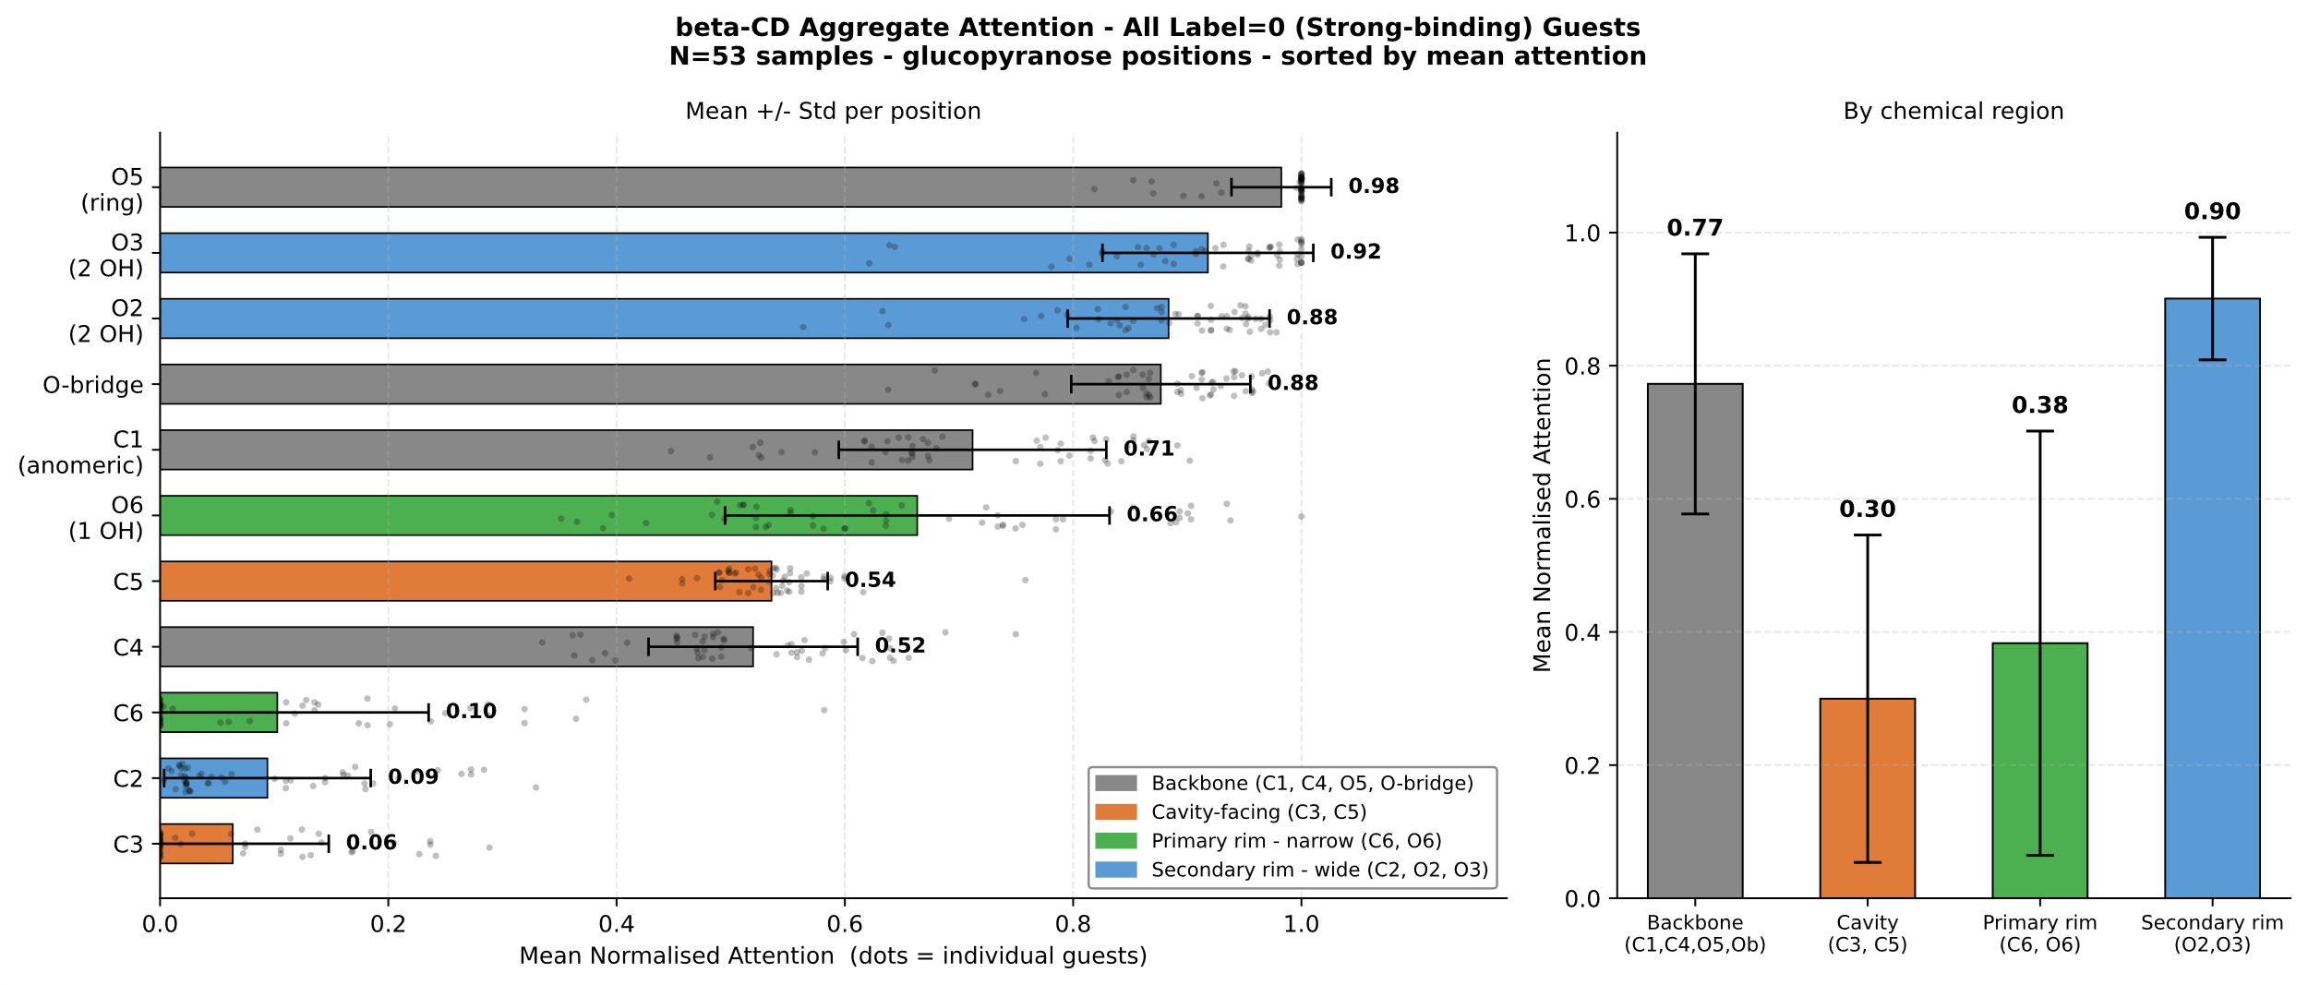
Supplementary Fig. S2 | Aggregate BANLayer attention distribution for $β–CD$ inclusion complexes. Mean normalized attention weights for $β–CD$ strong-binding guests (K > 10,000 M⁻¹, n = 53). Benefiting from the largest sample size within the extreme thermodynamic boundary, the model exhibits a highly robust, focused attention distribution heavily prioritizing the oxygen network (O5, O3, O2 $≥0.88$), perfectly corroborating established NMR observations of secondary-rim guest inclusion.

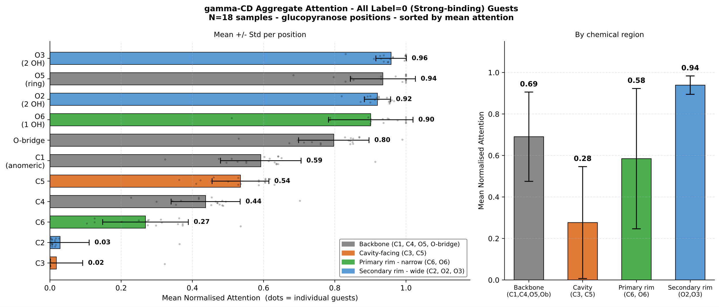
Supplementary Fig. S3 | Aggregate BANLayer attention distribution for $γ–CD$ inclusion complexes. Mean normalized attention weights for $γ–CD$ strong-binding guests (K > 10,000 M⁻¹, n = 18). In addition to the secondary rim (O2, O3), the model uniquely allocates significantly elevated attention to the primary rim hydroxyl (O6, 0.90) compared to other cyclodextrin variants. This implicitly captures the physical reality of $γ–CD$'s larger cavity size, which permits deep penetration of bulky guest molecules toward the narrower primary rim.

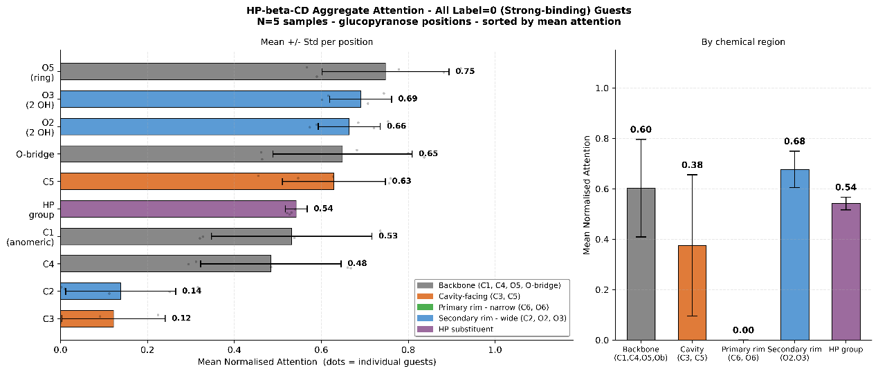
Supplementary Fig. S4 | Aggregate BANLayer attention distribution for $HP–β–CD$ inclusion complexes. Mean normalized attention weights for $HP–β–CD$ strong-binding guests (K > 10,000 M⁻¹, n = 5). The attention mass is distinctly flattened and widely distributed across multiple atomic positions, including an elevated focus on C5 (0.63) and the hydroxypropyl substituent group (0.54). This dispersed pattern reflects the random substitution of the host molecule, which breaks the symmetrical hydrogen-bonding network and diversifies the thermodynamic interaction landscape.

