Visualizing 5d-Mediated Electronic Interactions in Pt–Ln Complexes via Resonant Inelastic X-ray Scattering
Yujiro Ochi¹, Keiichi Katoh², Ryo Masuda,³ Shinji Kitao,⁴ Takuma Kaneko^{5,6}, Tomoya Uruga^{5,6}, Yasuhiro Iwasawa^{6,7}, Masahiro Yamashita^{8,9}, Takefumi Yoshida^{1,5,6,10*}

¹ Department of Systems Engineering, Faculty of Systems Engineering, Wakayama University,930 Sakaedani, Wakayama 640-8510, Japan
² Department of Chemistry, Graduate School of Science, Josai University, 1-1, Keyakidai, Sakado, Saitama 350-0295, Japan
³ Graduate School of Science and Technology, Hirosaki University, Hirosaki, Aomori, 036-8561, Japan
⁴ Institute for Integrated Radiation and Nuclear Science, Kyoto University, Kumatori, Osaka, 590-0494, Japan
⁵ Research & Utilization Division, Japan Synchrotron Radiation Research Institute (JASRI/SPring-8), 1-1-1 Kouto, Sayo, Hyogo 679-5198, Japan
⁶ Physical and Chemical Research Infrastructure Group, RIKEN SPring-8 Center, RIKEN, Hyogo, Japan
⁷ Innovation Research Center for Fuel Cells and Hydrogen, The University of Electro-Communications, Chofugaoka, Chofu, Tokyo 182-8585, Japan
⁸ Department of Chemical Science and Engineering, Tongji University, Siping Road 1239, Shanghai 200092, China
⁹ Institute for Materials Research, Tohoku University, 2-1-1 Katahira, Aoba-Ku, Sendai 980-8577, Japan
¹⁰ Cluster of Nanomaterials, Graduate School of Systems Engineering, Wakayama University,930 Sakaedani, Wakayama 640-8510, Japan

*Corresponding author: tyoshyd@wakayama-u.ac.jp
ORCID: https://orcid.org/0000-0003-3479-7890
 | 1 | 2
Temperature / K | 100 | 100
formula | C₇₀H₇₄N₃O₁₀Pt₂S₈Tb | C₇₀H₇₄DyN₃O₁₀Pt₂S₈
crystal system | monoclinic | monoclinic
space group | Cc | Cc
Flack | 0.024(6) | 0.047(5)
a / Å | 24.0670(6) | 24.1258(5)
b / Å | 15.1007(3) | 15.0761(2)
c / Å | 19.9591(4) | 19.9852(4)
β / ° | 97.693(2) | 97.7549(19)
V / Å³ | 7188.4(3) | 7202.6(2)
Z | 4 | 4
$$R_{1} (I>2σ (I))/\%$$ | 3.72 | 3.24
$$wR_{2} (I>2σ (I))/\%$$ | 7.35 | 6.30
S1. Synthesis of 1 and 2.
The aqueous solution (5 ml) of K₂[PtCl₄] (50 mg: 0.125 mmol) and LnCl₃·nH₂O (Ln = Tb, Dy, 0.062 mmol) was added to a DMF solution (15 ml) of 70 mg (0.5 mmol) (PhSAc)H and tetraethylammonium chloride (10 mg: 0.061 mmol). The solution was stirred at 60 ºC for 2 h. After evaporation, the resulting solid was dissolved in DMF, and KCl was removed by filtration. Yellow crystals were obtained after slow evaporation under flowing N₂

Table S1. Crystallographic data of complexes 1, 2.

S2. Computational details of Pt L₃-edge RIXS
Pt L₃-edge RIXS simulations were performed using the Quanty program. The Pt center was modeled as a Pt(II) 5d⁸ electronic configuration, including Pt 5d multiplet interactions, Pt 5d spin–orbit coupling, 2p core-level spin–orbit coupling, 2p–5d core–valence interactions, and a D4h crystal-field potential.
To examine the origin of the RIXS energy-loss features, two orbital-selective hybridization models were constructed. In the four-coordinate model, three in-plane bath orbitals were coupled selectively to the Pt dx²−y² orbital to represent square-planar Pt–S hybridization. In the six-coordinate hybridization model, three additional axial bath orbitals were introduced and coupled selectively to the Pt dz² orbital to represent the axial perturbation imposed by the neighboring Ln center. The Pt 5d multiplet, spin–orbit coupling, core–valence interaction, crystal-field parameters, and in-plane hybridization parameters were kept identical between the two models.
The four-coordinate model included three dx²−y²-type bath orbitals with bath energies of 2.8, 3.8, and 5.0 eV and hybridization strengths of 7.5, 5.8, and 4.2 eV, respectively. In the six-coordinate model, three additional dz²-type axial bath orbitals were included with bath energies of 3.0, 4.0, and 5.2 eV and hybridization strengths of 6.2, 4.8, and 3.5 eV, respectively.
The Slater integrals and spin–orbit coupling constants were treated as effective parameters. The values used were Udd = 4.0 eV, Fdd2 = 6.0 eV, Fdd4 = 3.5 eV, Upd = 14.0 eV, Fpd2 = 6.0 eV, Gpd1 = 5.0 eV, Gpd3 = 3.0 eV, ζ5d = 0.9 eV, and ζ2p = 350.0 eV. The D4h crystal-field parameters were set to Dq = 0.30 eV, Ds = 0.35 eV, and Dt = 0.12 eV.
The XAS spectra were calculated over an incident-energy range from −210 to −170 eV with 801 energy points and a lifetime broadening of 1.0 eV. The RIXS spectra were calculated over the same incident-energy range, with an energy-loss range of 0.3 to 10.0 eV, using 3000 points. The core-hole lifetime broadening was set to 0.4 eV for the four-coordinate model and 0.8 eV for the six-coordinate model, while the final-state broadening was set to 0.15 and 0.25 eV, respectively. The calculated spectra were compared on a relative energy scale after aligning the main XAS resonance. The hybridization parameters were introduced as effective descriptors of the Pt–ligand and axial Pt–Ln electronic interactions and should not be interpreted as quantitatively determined orbital interaction energies. The present calculations were used as minimal effective hybridization models to identify the electronic channels responsible for the observed RIXS features, rather than as fully ab initio simulations.

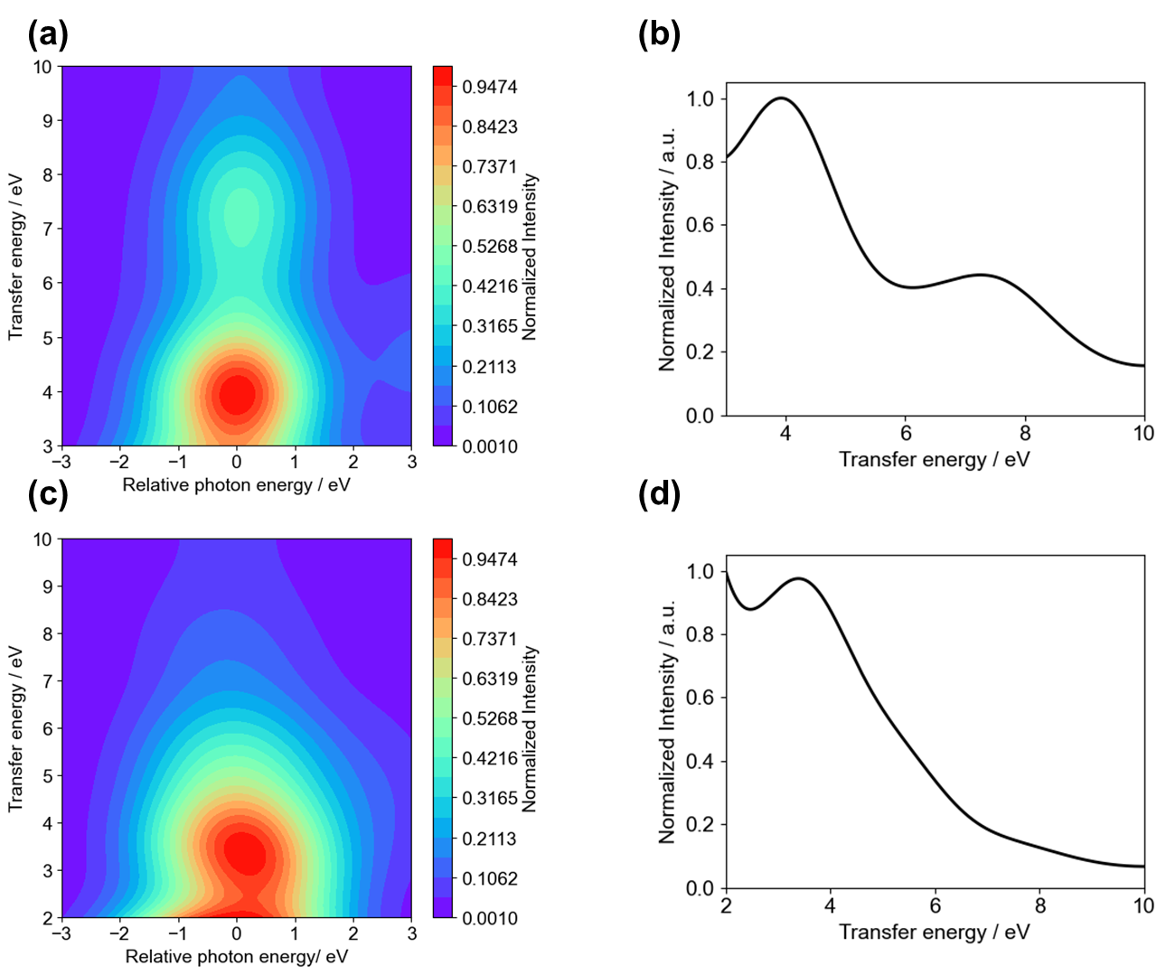
Fig. S1. Simulated (a, c) Pt L₃-edge 2D RIXS maps and (b, d) transfer-energy profiles for (a, b) four-coordinate model and (c, d) six-coordinate model.

To clarify the origin of the intermediate-energy-loss feature observed in the Pt L₃-edge RIXS spectra, two Quanty-based Pt L₃-edge RIXS models were compared using identical Pt 5d multiplet, spin–orbit coupling, core–valence interaction, and D4h crystal-field parameters. In the four-coordinate model, only in-plane bath orbitals coupled selectively to the Pt dx²−y² orbital were included, representing square-planar Pt–S hybridization. This model reproduced the major loss features at approximately 4 and 8 eV but did not generate the intermediate-energy excitation.
In the six-coordinate model, three additional axial bath orbitals selectively coupled to the Pt dz² orbital were introduced while retaining the same in-plane hybridization parameters. Including the axial dz² channel produced an additional spectral component around 6 eV while preserving the higher- and lower-energy-loss structures. These results indicate that the intermediate-energy excitation is specifically associated with the axial electronic perturbation introduced by the heterometallic Pt–Ln coordination environment.

S3. Computational details of Ln L₃-edge RIXS
Ln L₃-edge 2p3d RIXS simulations were performed using the Quanty program based on atomic multiplet calculations, including crystal-field splitting of the Ln 5d orbitals. The Tb and Dy centers were modeled as trivalent Ln3+ electronic configurations with 4f⁸ and 4f9 ground states, respectively. The calculations included 4f–4f multiplet interactions, spin–orbit coupling of the 4f and core states, and 2p–4f and 3d–4f core–valence Coulomb interactions associated with the intermediate and final states of the 2p3d RIXS process.
The intermediate states were described as 2p⁵3d¹⁰4f^{n}5d¹ configurations, whereas the final states were treated as 2p⁶3d⁹4f^{n}5d¹ configurations. Crystal-field splitting of the Ln 5d orbitals was introduced using orbital-dependent one-electron energies to represent the anisotropic perturbation imposed by the heterometallic Pt–Ln coordination environment. Therefore, the crystal-field parameters should be regarded as effective descriptors of the heterometallic perturbation rather than quantitatively determined ligand-field energies. In the Tb calculation, the 5d orbital energies were set to {0.0, 0.6, −2.0, 0.6, 2.0} eV, whereas the Dy calculation employed {0.0, 3.0, −2.5, 3.0, 5.5} eV to reproduce the experimentally observed enhancement of the multiplet-derived spectral separation.
The Slater integrals and spin–orbit coupling constants were treated as effective parameters derived from Hartree–Fock atomic values. For the Tb calculations, the parameters were F2(4f,4f) = 15.178 eV, F4(4f,4f) = 9.551 eV, F6(4f,4f) = 6.876 eV, F2(2p,4f) = 1.970 eV, G1(2p,4f) = 6.951 eV, G3(2p,4f) = 4.075 eV, F2(3d,4f) = 9.715 eV, F4(3d,4f) = 4.533 eV, G1(3d,4f) = 6.951 eV, G3(3d,4f) = 4.075 eV, and G5(3d,4f) = 2.815 eV. For the Dy calculations, the parameters were F2(4f,4f) = 15.586 eV, F4(4f,4f) = 7.050 eV, F6(4f,4f) = 5.251 eV, F2(2p,4f) = 2.143 eV, G1(2p,4f) = 7.524 eV, G3(2p,4f) = 3.049 eV, F2(3d,4f) = 1.5 eV, F4(3d,4f) = 0.8 eV, G1(3d,4f) = 4.5 eV, G3(3d,4f) = 2.5 eV, and G5(3d,4f) = 1.5 eV. The 4f–5d Coulomb and exchange parameters were also included as effective parameters. For Tb, F2(4f,5d) = 2.0 eV, F4(4f,5d) = 1.0 eV, G1(4f,5d) = 0.8 eV, G3(4f,5d) = 0.5 eV, and G5(4f,5d) = 0.3 eV were used. For Dy, F2(4f,5d) = 2.0 eV, F4(4f,5d) = 1.0 eV, G1(4f,5d) = 0.5 eV, G3(4f,5d) = 0.3 eV, and G5(4f,5d) = 0.2 eV were used. All Slater integrals were reduced to 80% of these values to account for intra-atomic screening effects. Part of the atomic multiplet parameters and scaling procedures were adapted from previous Quanty-based Ln L₃-edge 2p3d RIXS studies.¹²
No explicit charge-transfer bath orbitals or Pt–Ln hybridization channels were included in the Ln calculations. Therefore, the present simulations represent simplified crystal-field-modified atomic multiplet models intended to evaluate the influence of Ln 5d orbital perturbation on the Ln-centered RIXS spectral structures.
The RIXS spectra were calculated over an energy-transfer range from −5 to 35 eV using Lorentzian lifetime broadening parameters of 4.0 eV for the intermediate state and 1.5–2.0 eV for the final state. Additional Gaussian broadening was applied to simulate the experimental energy resolution. The calculated spectra were analyzed on a relative energy scale and compared with the experimentally obtained energy-transfer profiles and 2D RIXS maps. Because the simplified model does not explicitly reproduce the elastic scattering channel, comparisons with experiment focused primarily on the relative evolution and distribution of the inelastic spectral features rather than absolute energy separation from the elastic line.
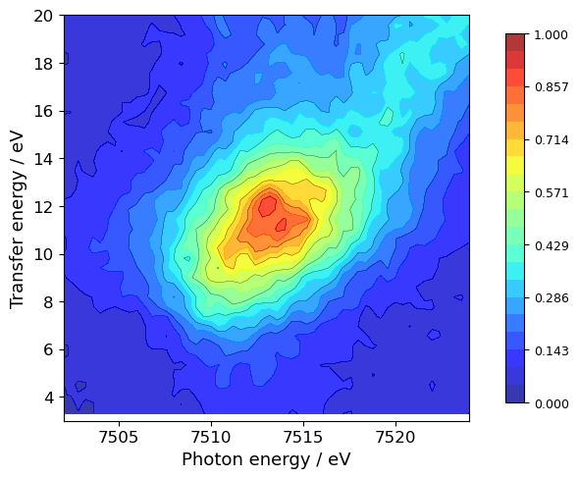
Fig. S2a. Tb L₃-edge 2D RIXS map of [TbPc₂]TBA.
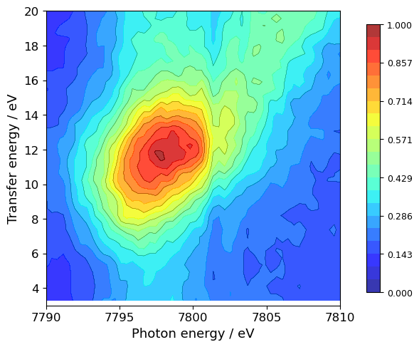
Fig. S2b. Dy L₃-edge 2D RIXS map of [DyPc₂]TBA.

S4. Magnetic property
The DC magnetic susceptibility measurements were performed on solid polycrystalline samples with a Quantum Design MPMS3 SQUID magnetometer in applied DC fields.
¹⁶¹Dy Mössbauer spectroscopy was performed at Institute for Integrated Radiation and Nuclear Science, Kyoto University (KURNS). The γ-ray source was ¹⁶¹Tb, which was synthesized by the following neutron irradiation and successive β⁻ decay: ¹⁶⁰Gd (n, γ) ¹⁶¹Gd and ${}_{}^{161}{Gd \underset{→}{β^{-}}}{}_{}^{161}{Tb}$. The chemical specimen of the source was Gd_{0.5}Dy_{0.5}F₃. The velocity of the source was controlled by a velocity transducer Wissel MVT-1000H and the velocity was shown relative to DyF₃ at room temperature. The source and the sample were cooled down to 26 K by a refrigerator in KURNS. The detector was Xe proportional counter.
The spectrum was evaluated with a simple single Lorentzian absorption. The isomer shift was -0.6(7) mm/s relative to DyF₃ at room temperature. This is consistent with an ionic Dy³⁺ state[S1]. No clear hyperfine splitting attributable to ferro-, ferri-, or antiferromagnetic ordering was observed consistent with the absence of long-range magnetic ordering. The slight broadening of the line width may reflect unresolved hyperfine interactions, possibly including nuclear quadrupole splitting, as is often observed in complex materials.
Additional DC magnetic susceptibility (Fig. S3a) and spectroscopic (Fig. S3b) measurements indicate predominantly paramagnetic behavior for the Dy–Pt complex, with no clear evidence of strong magnetic ordering or strong exchange coupling. The temperature dependence of the magnetic susceptibility is largely dominated by crystal-field-induced Stark sublevel depopulation characteristic of Dy³⁺ systems. These results suggest that the Pt–Ln interaction primarily perturbs the local electronic structure rather than generating strong bulk magnetic interactions.

[S1] E. R. Bauminger, G. M. Kalvius, and I. Nowik, Mössbauer Isomer Shifts, edited by G. K. Shenoy and F. E. Wagner (North-Holland, Amsterdam, 1978), p. 661

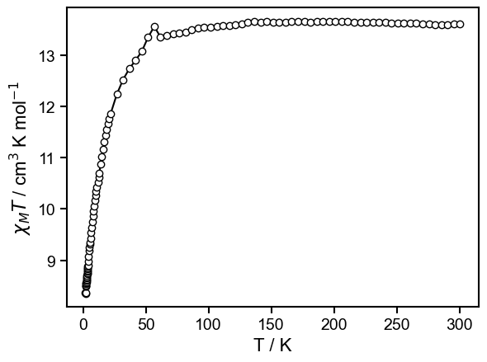
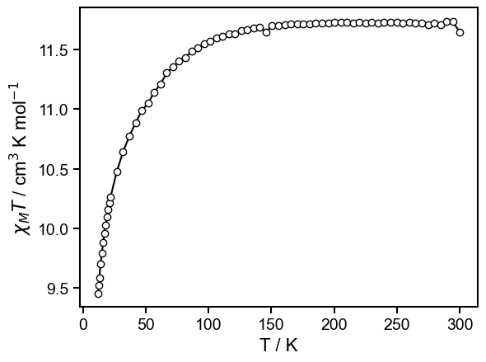
Fig. S3a. Temperature dependence of χMT for complex 1.
Fig. S3b. Temperature dependence of χMT for complex 2.
.

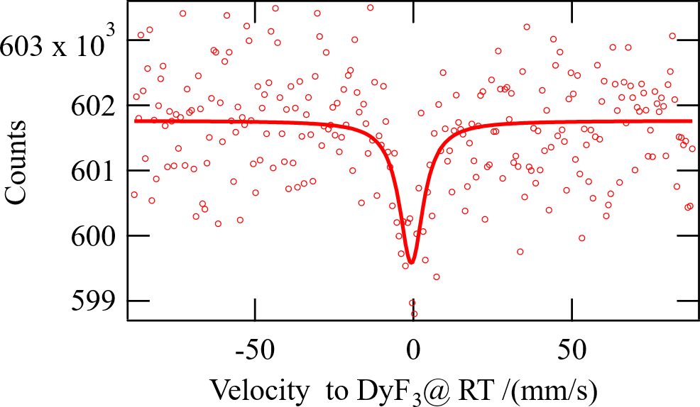
Fig. S4. Mössbauer spectrum of complex 2.

