Ulcerative Colitis Is Associated with Distinct Colonic Mucosa-Associated Microbial Profiles in a North Indian Cohort
Arpita Bhatt^{1*}, Dr Usha Dutta², Dr Amit Arora¹, Dr Balvinder Mohan¹, Dr Neelam Taneja^{1#}
_______________________________________________________________________________________________
Affiliations:
¹Department of Medical Microbiology, Postgraduate Institute of Medical Education and Research, Chandigarh, India-160012
²Department of Gastroenterology, Postgraduate Institute of Medical Education and Research, Chandigarh, India-160012

*First Author
# Corresponding Author
_______________________________________________________________________________________________
Correspondence:
Dr Neelam Taneja
Professor and Head, Department of Medical Microbiology
Postgraduate Institute of Medical Education and Research (PGIMER), Chandigarh, India
Phone: +91-172-2755160
Fax: +91-172-2744401
Email: drneelampgi@gmail.com; drneelampgi@yahoo.com
Mobile: +91-9780232453
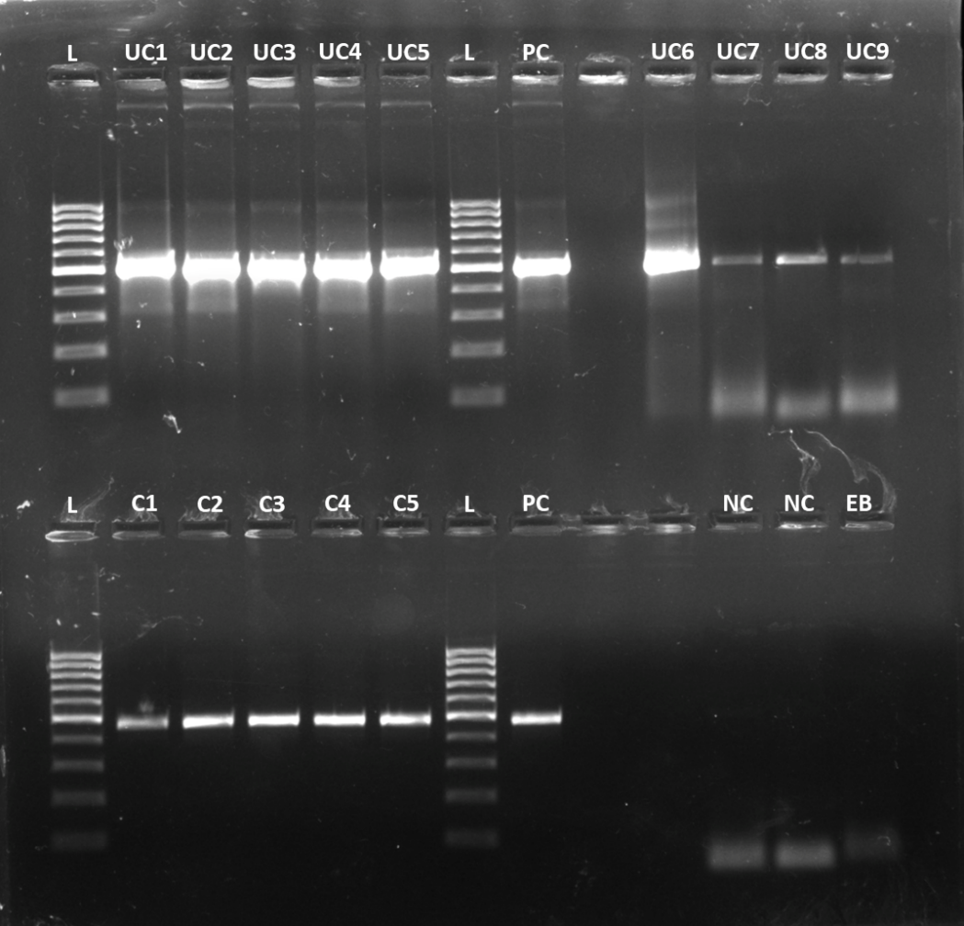
Supplementary Figure 1: Agarose gel image (1.5%) showing PCR amplification of the V3–V4 region of the bacterial 16S rRNA gene from representative ulcerative colitis (UC) and control (C) mucosal biopsy samples. PCR products were resolved using a Thermo Scientific GeneRuler 100 bp DNA Ladder (L). UC1–UC9 denote UC samples, C1–C5 denote control samples; PC, positive control; NC, negative control; EB, extraction blank. Expected amplicon size ~460 bp.
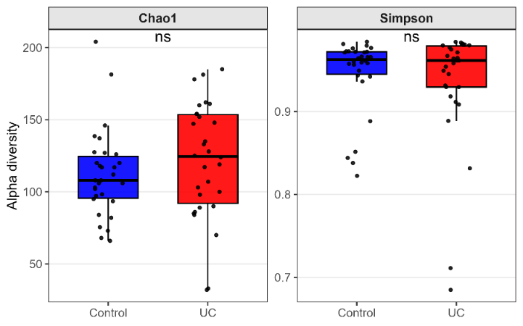
Supplementary Figure 2: Microbial alpha diversity: Comparison of alpha diversity between UC patients (n=30) and controls (n=30) as evaluated by alpha diversity indices: Chao1, and Simpson; (p-value, p≤ 0.05** significant, and 0 >0.5 ns = not significant, determined using the non-parametric Wilcoxon rank-sum test); Individual points represent samples; P value (Simpson=0.98, Chao1=0.17)
Supplementary Table S1. Median relative abundance, effect size, Wilcoxon p-values, and Benjamini–Hochberg FDR-adjusted p-values for different bacterial phyla between UC and controls.
Asterisk marks signify the statistical significance depicting p-values adjusted after multiple hypothesis testing correction method Benjamini-Hochberg; p<0.001***, p<0.01**, p<0.05*, ns = non-significant
Phylum | UC (Median) | Control (Median) | Effect size | p-value | Adjusted p-value | Significance*
Firmicutes | 0.449249 | 0.309452 | 0.139796519 | 4.94E-05 | 0.000345982 | ***
Fusobacteriota | 0.026472 | 0.069577 | 0.043105254 | 2.27E-05 | 0.000318089 | ***
Actinobacteriota | 0.067068 | 0.097111 | 0.030042657 | 0.006972441 | 0.013944883 | *
Patescibacteria | 0.004189 | 0.018666 | 0.014477212 | 0.000239674 | 0.000838857 | ***
Spirochaetota | 0.001152 | 0.012776 | 0.011624218 | 0.000221929 | 0.000838857 | ***
Bacteroidota | 0.239434 | 0.250506 | 0.011072119 | 0.970516051 | 0.970516051 | ns
Campylobacterota | 0.008742 | 0.017088 | 0.008345657 | 0.000902473 | 0.002526925 | **
Proteobacteria | 0.123073 | 0.126723 | 0.003649285 | 0.84180145 | 0.906555408 | ns
Synergistota | 5.12E-05 | 0.001045 | 0.000993642 | 0.015762897 | 0.027585069 | *
Nanoarchaeota | 0.000448 | 0 | 0.000447919 | 0.003135939 | 0.00731719 | **
Verrucomicrobiota | 0.000162 | 0 | 0.000162145 | 0.308088161 | 0.431323426 | ns
Desulfobacterota | 0.003103 | 0.003036 | 6.72E-05 | 0.711039165 | 0.829545692 | ns
Acidobacteriota | 0 | 0 | 0 | 0.516844538 | 0.657802139 | ns
Bdellovibrionota | 0 | 0 | 0 | 0.305045552 | 0.431323426 | ns

Supplementary Table S2: F/B ratio of relative abundances in individual samples (n=60)
SampleID | Group | Bacteroidota (B) | Firmicutes(F) | F/B Ratio
C1 | Control | 38.19131 | 23.19236 | 0.607268
C10 | Control | 33.62076 | 24.05106 | 0.715363
C11 | Control | 28.8936 | 32.96785 | 1.141009
C12 | Control | 17.72697 | 54.06682 | 3.049976
C13 | Control | 24.24242 | 34.93004 | 1.440864
C14 | Control | 20.36425 | 43.00344 | 2.111712
C15 | Control | 29.87417 | 29.24502 | 0.97894
C16 | Control | 20.2419 | 25.19398 | 1.244645
C17 | Control | 16.28154 | 48.36121 | 2.970309
C18 | Control | 30.94927 | 24.11941 | 0.779321
C19 | Control | 17.49216 | 35.05726 | 2.00417
C2 | Control | 49.50751 | 31.50977 | 0.636464
C20 | Control | 24.4844 | 21.49656 | 0.87797
C21 | Control | 20.65988 | 29.16742 | 1.411791
C22 | Control | 24.1765 | 30.94988 | 1.280164
C23 | Control | 32.11999 | 23.5996 | 0.734732
C24 | Control | 14.36531 | 19.67054 | 1.369309
C25 | Control | 18.82336 | 44.08102 | 2.341825
C26 | Control | 22.12198 | 23.36713 | 1.056286
C27 | Control | 30.05325 | 31.78977 | 1.057781
C28 | Control | 22.69657 | 28.92461 | 1.274405
C29 | Control | 20.60002 | 37.23396 | 1.807472
C3 | Control | 49.99693 | 33.85273 | 0.677096
C30 | Control | 24.37956 | 24.03893 | 0.986028
C4 | Control | 49.38661 | 38.65151 | 0.782631
C5 | Control | 41.33327 | 30.54415 | 0.738972
C6 | Control | 28.86223 | 42.43277 | 1.470183
C7 | Control | 28.15346 | 30.60905 | 1.087222
C8 | Control | 29.09785 | 22.80643 | 0.783784
C9 | Control | 18.56619 | 25.81979 | 1.390688
UC1 | Ulcerative colitis | 34.26438 | 24.25332 | 0.707829
UC10 | Ulcerative colitis | 30.78412 | 36.69732 | 1.192086
UC11 | Ulcerative colitis | 23.92193 | 59.96283 | 2.506605
UC12 | Ulcerative colitis | 22.94813 | 44.8835 | 1.955867
UC13 | Ulcerative colitis | 17.39277 | 44.13171 | 2.53736
UC14 | Ulcerative colitis | 22.35066 | 38.12637 | 1.705827
UC15 | Ulcerative colitis | 28.95407 | 33.05917 | 1.14178
UC16 | Ulcerative colitis | 27.74362 | 48.18016 | 1.736621
UC17 | Ulcerative colitis | 22.26875 | 29.64514 | 1.331244
UC18 | Ulcerative colitis | 32.27877 | 46.55693 | 1.442339
UC19 | Ulcerative colitis | 16.72006 | 52.47086 | 3.138198
UC2 | Ulcerative colitis | 48.47443 | 48.90417 | 1.008865
UC20 | Ulcerative colitis | 33.70044 | 35.9244 | 1.065992
UC21 | Ulcerative colitis | 21.85896 | 54.03907 | 2.47217
UC22 | Ulcerative colitis | 21.83434 | 22.40242 | 1.026018
UC23 | Ulcerative colitis | 20.30689 | 39.98531 | 1.969051
UC24 | Ulcerative colitis | 15.72347 | 29.03537 | 1.846626
UC25 | Ulcerative colitis | 22.36144 | 57.73979 | 2.582114
UC26 | Ulcerative colitis | 7.180585 | 58.35832 | 8.127237
UC27 | Ulcerative colitis | 21.36547 | 56.01887 | 2.621934
UC28 | Ulcerative colitis | 15.48259 | 37.44107 | 2.418269
UC29 | Ulcerative colitis | 26.62213 | 34.63946 | 1.301153
UC3 | Ulcerative colitis | 30.19278 | 53.54958 | 1.773589
UC30 | Ulcerative colitis | 15.44411 | 26.19997 | 1.696438
UC4 | Ulcerative colitis | 43.88046 | 44.9259 | 1.023825
UC5 | Ulcerative colitis | 36.13637 | 48.85108 | 1.351854
UC6 | Ulcerative colitis | 33.23931 | 34.99055 | 1.052686
UC7 | Ulcerative colitis | 39.31871 | 33.18418 | 0.843979
UC8 | Ulcerative colitis | 19.39492 | 33.02269 | 1.702646
UC9 | Ulcerative colitis | 20.80745 | 41.66482 | 2.002399

Supplementary Table S3. Differences in gut bacterial compositions between UC and controls at the species level. p<0.01**, p<0.05*, ns = non-significant
Species | Significance | p-value | Higher in the group
Actinomyces_dentalis | **p < 0.01 | 0.004738 | Control
Alloprevotella_tannerae | **p < 0.01 | 0.008519 | Control
Bacteroides_fragilis | *p < 0.05 | 0.038243 | Ulcerative colitis
Bacteroides_vulgatus | *p < 0.05 | 0.010895 | Ulcerative colitis
Bifidobacterium_choerinum | *p < 0.05 | 0.041926 | Ulcerative colitis
Blautia_faecis | **p < 0.01 | 0.001339 | Ulcerative colitis
Blautia_wexlerae | *p < 0.05 | 0.018236 | Ulcerative colitis
Butyricimonas_virosa | *p < 0.05 | 0.041926 | Ulcerative colitis
Campylobacter_concisus | *p < 0.05 | 0.017814 | Control
Campylobacter_curvus | *p < 0.05 | 0.035138 | Control
Campylobacter_showae | **p < 0.01 | 0.001741 | Control
Capnocytophaga_granulosa | *p < 0.05 | 0.012473 | Control
Capnocytophaga_leadbetteri | **p < 0.01 | 0.000109 | Control
Coprococcus_comes | *p < 0.05 | 0.03661 | Ulcerative colitis
Corynebacterium_durum | **p < 0.01 | 0.008038 | Control
Corynebacterium_matruchotii | **p < 0.01 | 0.003874 | Control
Enterococcus_durans | *p < 0.05 | 0.027601 | Ulcerative colitis
Escherichia_sp | *p < 0.05 | 0.012426 | Ulcerative colitis
Eubacterium_nodatum | **p < 0.01 | 0.001764 | Control
Leptotrichia_hongkongensis | *p < 0.05 | 0.018181 | Control
Massiliprevotella_massiliensis | *p < 0.05 | 0.041926 | Ulcerative colitis
Megasphaera_micronuciformis | *p < 0.05 | 0.021043 | Control
Neisseria_bacilliformis | *p < 0.05 | 0.043606 | Control
Parabacteroides_goldsteinii | *p < 0.05 | 0.027666 | Ulcerative colitis
Parasutterella_secunda | *p < 0.05 | 0.041926 | Ulcerative colitis
Porphyromonas_pasteri | *p < 0.05 | 0.026034 | Control
Prevotella_genomosp | *p < 0.05 | 0.021577 | Control
Prevotella_loescheii | *p < 0.05 | 0.018579 | Control
Prevotella_maculosa | *p < 0.05 | 0.016878 | Control
Prevotella_marshii | *p < 0.05 | 0.041926 | Control
Prevotella_multiformis | *p < 0.05 | 0.011031 | Control
Prevotella_nigrescens | **p < 0.01 | 0.003429 | Control
Prevotella_oulorum | **p < 0.01 | 0.00035 | Control
Prevotella_pallens | **p < 0.01 | 0.00816 | Control
Prevotella_salivae | **p < 0.01 | 0.00015 | Control
Prevotella_sp | *p < 0.05 | 0.043707 | Control
Propionibacter_sp | *p < 0.05 | 0.039857 | Control
Rahnella_aquatilis | *p < 0.05 | 0.041926 | Control
Ruminococcus_torques | *p < 0.05 | 0.034948 | Ulcerative colitis
SR1_bacterium | *p < 0.05 | 0.018201 | Control
Schaalia_odontolytica | **p < 0.01 | 0.007309 | Control
Selenomonas_artemidis | **p < 0.01 | 0.008269 | Control
Selenomonas_flueggei | *p < 0.05 | 0.027666 | Control
Selenomonas_noxia | *p < 0.05 | 0.013014 | Control
Selenomonas_sputigena | **p < 0.01 | 0.002356 | Control
Slackia_isoflavoniconvertens | **p < 0.01 | 0.00558 | Ulcerative colitis
Solobacterium_moorei | *p < 0.05 | 0.01718 | Control
Streptococcus_anginosus | *p < 0.05 | 0.027491 | Control
Streptococcus_infantis | *p < 0.05 | 0.025334 | Control
Sutterella_wadsworthensis | **p < 0.01 | 0.001566 | Ulcerative colitis
TM7_phylum | **p < 0.01 | 0.005584 | Control
Treponema_denticola | **p < 0.01 | 0.003657 | Control
Treponema_maltophilum | *p < 0.05 | 0.022357 | Control
Treponema_medium | **p < 0.01 | 0.001372 | Control
Treponema_socranskii | **p < 0.01 | 0.003557 | Control
Weissella_confusa | *p < 0.05 | 0.045264 | Control
bacterium_R49 | **p < 0.01 | 0.006274 | Ulcerative colitis
bacterium_YE57 | *p < 0.05 | 0.041926 | Ulcerative colitis
gut_metagenome | **p < 0.01 | 0.005418 | Ulcerative colitis
human_gut | **p < 0.01 | 0.002951 | Ulcerative colitis
metagenome | *p < 0.05 | 0.036403 | Ulcerative colitis
uncultured_Actinomyces | **p < 0.01 | 0.002592 | Control
uncultured_Blautia | **p < 0.01 | 0.001442 | Ulcerative colitis
uncultured_Capnocytophaga | *p < 0.05 | 0.029662 | Control
uncultured_Deferribacteraceae | *p < 0.05 | 0.040063 | Control
uncultured_Lachnospiraceae | **p < 0.01 | 0.008987 | Ulcerative colitis
uncultured_archaeon | **p < 0.01 | 0.000167 | Ulcerative colitis
uncultured_bacterium | **p < 0.01 | 0.00101 | Ulcerative colitis
uncultured_organism | **p < 0.01 | 0.000972 | Ulcerative colitis
uncultured_rumen | *p < 0.05 | 0.02918 | Ulcerative colitis
unidentified | **p < 0.01 | 0.000331 | Control

Differential Abundance of Bacterial Species Between UC and Controls
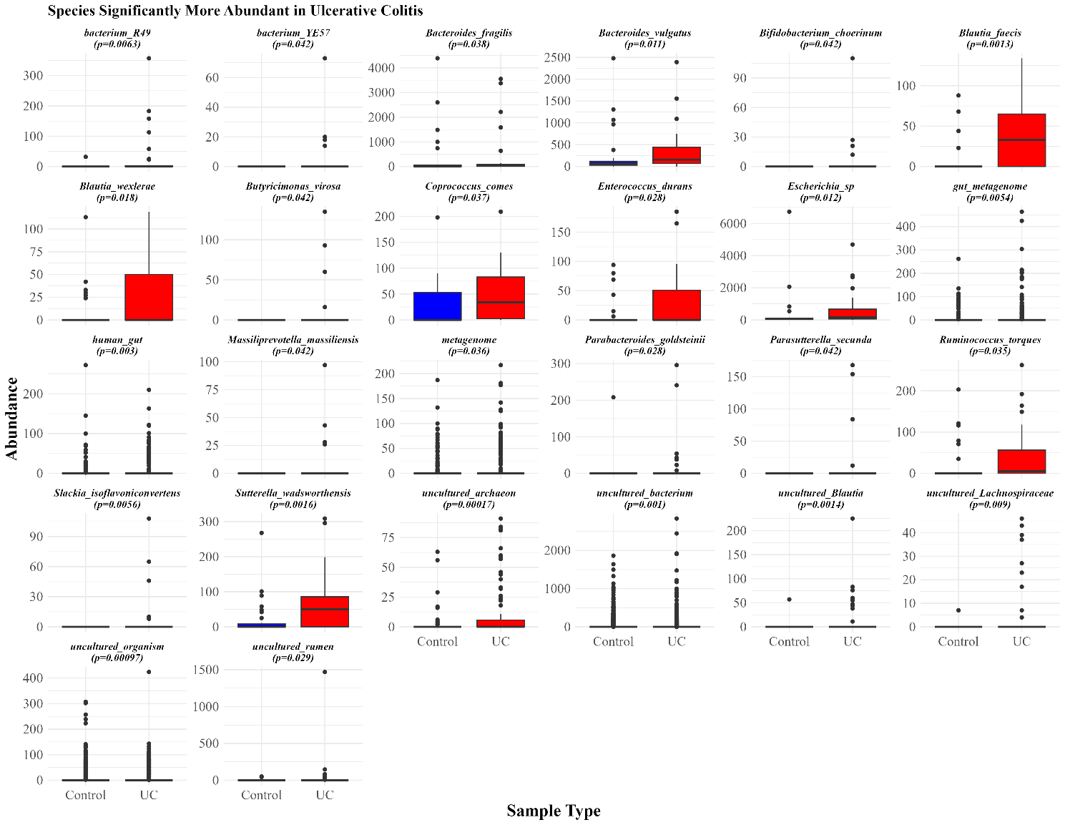
Panel A)
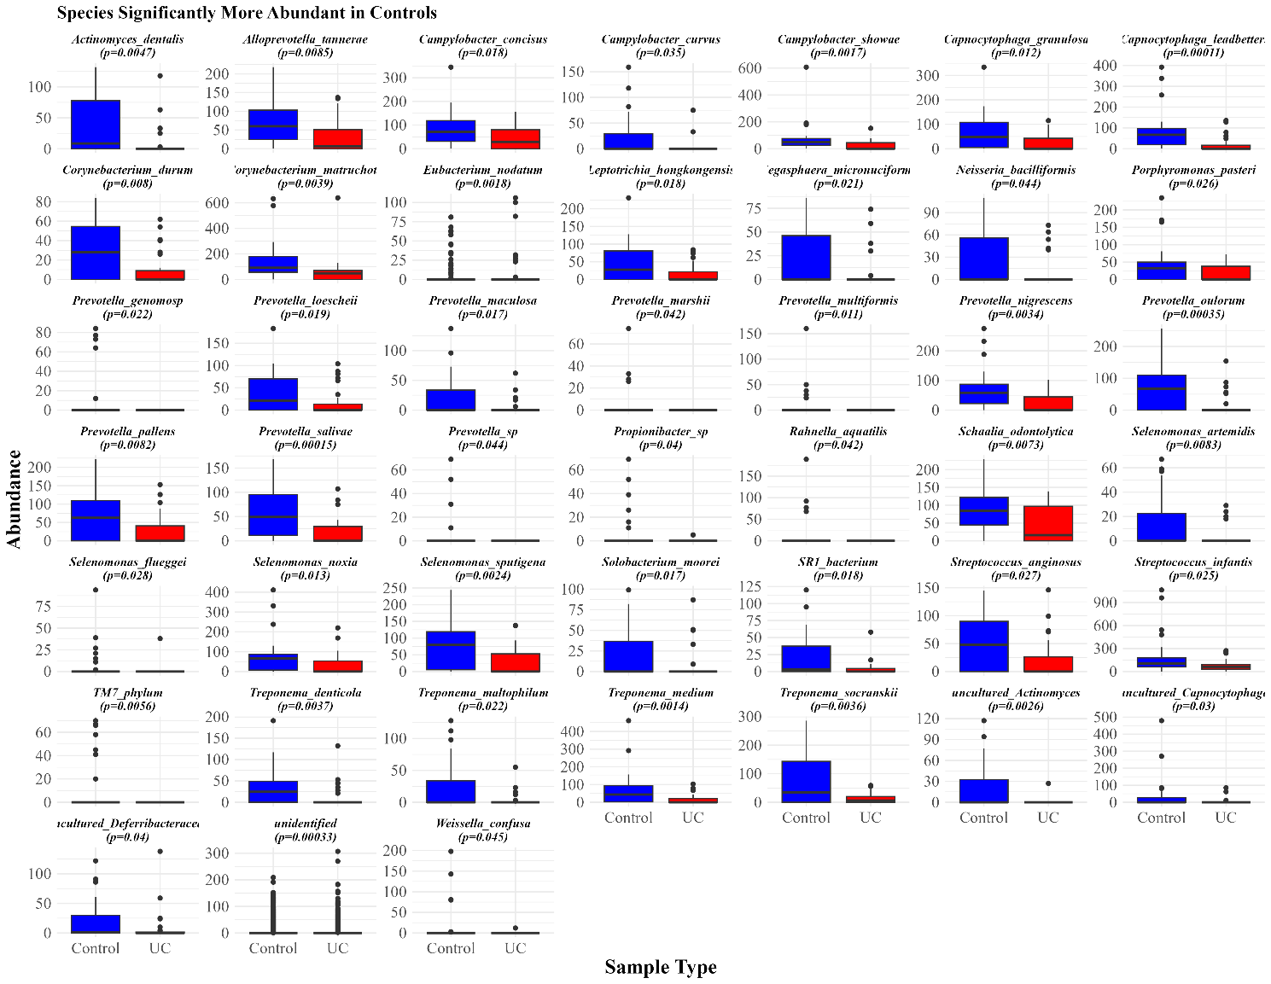
Panel B)
Supplementary Figure 3: Differentially abundant bacterial species between UC and Controls.
Panel A shows bacterial species significantly abundant in UC patients, and panel B displays species significantly abundant in controls. Asterisks denote significance levels (p<0.001***, p<0.01**, p<0.05*, ns = non-significant).

