AI-driven single-molecule lithography towards programmable molecular radical lattices
Henan Chen^{1,}‡, Zhiwen Zhu^{2,}‡, Haoran Li¹, Huilin Xie³*, Junxiang Yang¹, Chenyi Chen⁴, Jacky W.Y. Lam⁵, Ben Zhong Tang^{5,6}, Qiang Sun²*, Nian Lin¹*
¹Department of Physics, The Hong Kong University of Science and Technology, Clear Water Bay, Hong Kong 999077, China.
²Materials Genome Institute, Shanghai University, 200444 Shanghai, China.
³Nankai International Advanced Research Institute (Shenzhen Futian), Nankai University, Shenzhen 518045, China
⁴College of Mechanical and Electrical Engineering, Fujian Agriculture and Forestry University, Fuzhou, Fujian 350002, China
⁵Department of Chemistry, the Hong Kong Branch of Chinese National Engineering Research Center for Tissue Restoration and Reconstruction, State Key Laboratory of Nervous System Disorders, and Department of Chemical & Biological Engineering, The Hong Kong University of Science and Technology, Kowloon, Hong Kong 999077, China
⁶Guangdong Basic Research Center of Excellence for Aggregate Science, School of Science and Engineering, The Chinese University of Hong Kong (Shenzhen), Longgang, Shenzhen, Guangdong 518172, China.
*E-mail: phnlin@ust.hk, qiangsun@shu.edu.cn, hxieaj@connect.ust.hk

Table of Contents
- Materials and method
- Molecule recognition and programmed pattern generation
- Artificial radical lattices on Fe–TPM and Ni–TPM
- Additional examples and statistical analyses of scalable SML
- Virtual molecular environment simulator
- Supplementary references

1. Materials and methods
Supplementary Note 1.1 Deep learning models.
The Python codes of the deep learning models are available at:
https://github.com/gggg0034/Nanonis_AutoSTM_reactions_TPM
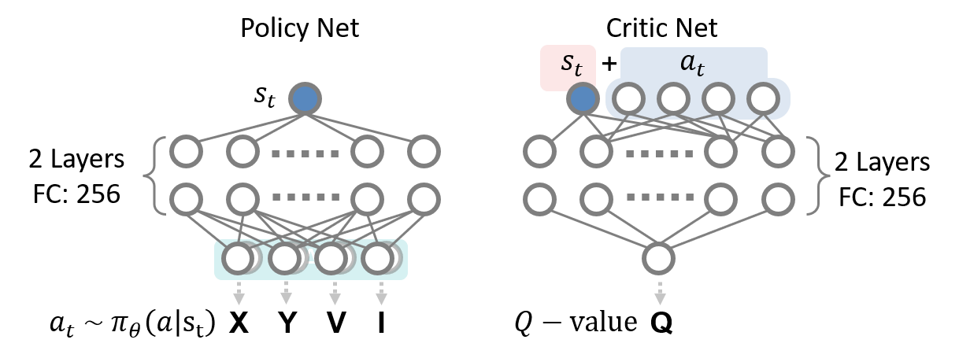Supplementary Scheme. 1 | Architecture of the Soft Actor-Critic.
Policy Net and Critic Net. The SAC agent was implemented with a stochastic policy network and two independent critic networks¹. The molecular configuration observed after STM-image analysis was encoded as a one-dimensional state descriptor, and the action was defined as a four-dimensional continuous vector, [X, Y, V, I], corresponding to the lateral tip offsets relative to the molecular center, the sample bias and the tunnelling current. The policy network consisted of two fully connected hidden layers with 256 neurons each, followed by two linear output heads that predicted the mean and logarithmic standard deviation of a Gaussian action distribution. The logarithmic standard deviation was clipped to the range from −20 to 2 for numerical stability. Actions were sampled using the reparameterization trick, passed through a hyperbolic tangent function to confine them to the normalized interval. [-1, 1], and then linearly remapped to the experimentally allowed manipulation range. Each critic network received the concatenated state–action vector as input and used the same two-hidden-layer architecture to output a scalar Q-value. Two target critic networks were initialized from the critic networks and updated by Polyak averaging during training.
The replay buffer stored up to 10,000 transition tuples $(s_{t},a_{t},r_{t+1},d_{t}​)$, from which mini-batches of 64 transitions were randomly sampled for off-policy updates. The critic target was computed using the smaller value from the two target critics, together with the entropy-regularized next-state action value. The critic networks were optimized by minimizing the mean-squared Bellman error, whereas the policy network was updated by minimizing the entropy-regularized actor loss, $αlogπ(at​∣st​)-Q(st​,at​)$ The entropy temperature was initialized as $α=0.2$ and was automatically adjusted toward a target entropy of $-\left|A\right|$, where $\left|A\right|=4$ is the action dimensionality. All networks were optimized using the Adam optimizer with a learning rate of 3×10⁻⁴ and a weight decay of 1×10⁻⁴. The discount factor was set to γ = 0.99, reflecting the short-horizon nature of the single-step dehydrogenation feedback, and the target critics were updated with a soft-update coefficient of τ = 0.005. To improve numerical stability, the policy-network gradients were clipped with a maximum norm of 2. With this implementation, the SAC agent learned a continuous manipulation policy that maps the detected TPM molecular state to experimentally executable STM parameters while maintaining exploration through entropy regularization.
Keypoint recognition of Molecules via YOLOv7. Molecular keypoint recognition was performed using a YOLOv7-based detection framework². The model takes STM image patches containing target molecular features as input, and the training data were expanded by data augmentation operations, including random cropping, flipping, rotation, dropout and elastic transformation, to increase dataset diversity and reduce overfitting. The augmented images were then processed by the YOLOv7 backbone, which is based on the Efficient Layer Aggregation Network (ELAN). ELAN improves feature propagation and feature reuse through cascaded feature-fusion modules, providing a balance between computational efficiency and high-resolution feature representation. This design is particularly suitable for extracting fine structural features from STM images, where the molecular contrast and apparent morphology can vary with imaging conditions.
After backbone feature extraction, multi-scale features were integrated through the FPN-PAN structure^{3,4}, which combines low-level spatial information with high-level semantic features. The low-level features help preserve precise positional information required for keypoint localization, whereas the high-level features improve discrimination between target molecular regions and the surrounding background. The prediction head was adapted for molecular keypoint regression. In addition to objectness and classification outputs, the model predicts the two-dimensional coordinates of the molecular keypoints and their corresponding confidence scores. Ground-truth molecular keypoints were manually annotated using LabelMe⁵. In total, 28 original STM images were labelled, and the dataset was expanded to 2280 images after augmentation.
During training, the learning rate was exponentially decayed as a function of the training step to improve convergence stability and avoid overshooting the optimum. The learning-rate schedule was defined as:
$$\text{lr}\left(t\right)={\text{lr}}_{0}×{\text{lrf}}^{\frac{t}{T}}$$
where t is the current training step, T is the total number of training steps, lr₀ is the initial learning rate and lrf is the final learning-rate factor. The model was optimized using SGD with momentum. The momentum term accumulates gradients along consistent descent directions, thereby smoothing the optimization trajectory and accelerating convergence. The velocity and parameter updates were calculated as:
$$v_{t+1}=\text{momentum}×v_{t}+\text{lr}×∇L\left(θ_{t}\right)$$
$$θ_{t+1}=θ_{t}-v_{t+1}$$
where vₜ₊₁ is the updated velocity, θₜ represents the model parameters at step t and ∇L(θₜ) is the gradient of the total loss with respect to θₜ.
The total loss function consisted of keypoint-regression, bounding-box, classification and objectness terms:
$$L=\text{kp}×L_{\text{kp}}+\text{box}×L_{\text{box}}+\text{cls}×L_{\text{cls}}+\text{obj}×L_{\text{obj}}$$
Here, $L_{\text{kp}}$ measures the deviation between the predicted and ground-truth keypoint coordinates, thereby enforcing accurate spatial localization. $L_{\text{box}}$ penalizes errors in bounding-box regression and ensures that the predicted molecular regions match the annotated regions. $L_{\text{cls}}$ is used for category-specific classification, and $L_{\text{obj}}$ evaluates whether a predicted region contains a target molecular feature. The weighting coefficients $L_{\text{kp}}$, $L_{\text{box}}$, $L_{\text{cls}}$ and $L_{\text{obj}}$ control the relative contributions of the corresponding loss terms during training.
After hyperparameter optimization, the YOLOv7-based keypoint recognition model achieved an accuracy of 0.929, a recall of 0.904 at 0.5 an mAP@0.5 of 0.898. For keypoint-level evaluation, the model reached a Percentage of Correct Keypoints at 0.5 threshold, PCK@0.5, of 0.943, a mean squared coordinate error of 0.52 pixels and a Percentage of Visible Keypoints Error of 0.010. These results indicate that the trained model can reliably localize molecular keypoints in STM images and provide accurate molecular coordinates for subsequent programmed pattern generation and autonomous STM manipulation.
Supplementary Note 1.2 Nanonis API for autonomous STM operation.
In our deep learning framework, the STM communication module is adapted from an open-source code library available at https://github.com/dilwong/nanonis_control.
The use of the Nanonis API in this work was officially authorized by SPECS.

2. Molecule recognition and programmed pattern generation
Supplementary Note 2.1 Molecule recognition.
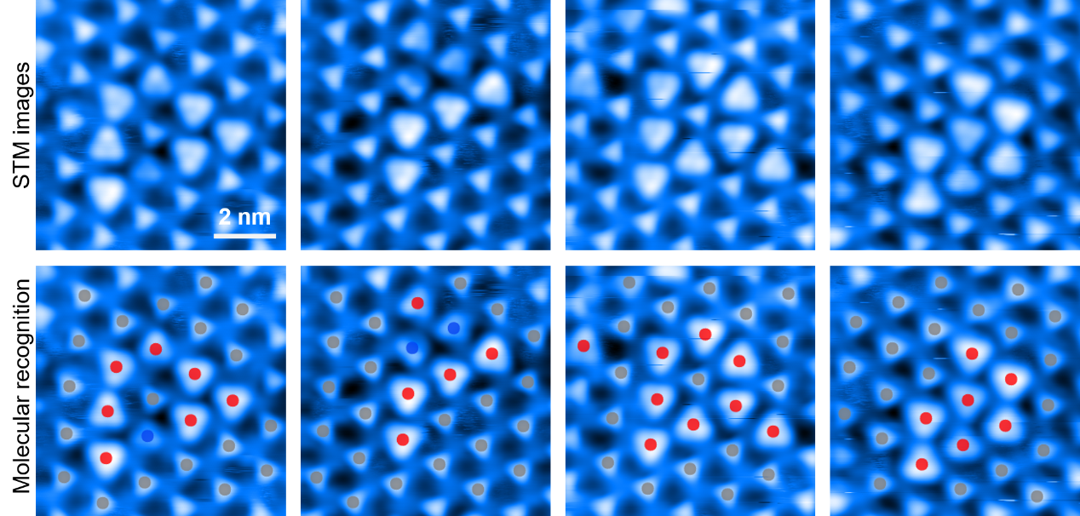
Supplementary Fig. 1 | Examples of molecule recognition. Representative STM images are shown in the top row, and the corresponding machine-vision classification results are shown in the bottom row. Red, blue and grey markers indicate successful reactions, failed reactions and unreacted molecules, respectively. The model was trained on 18 annotated STM images and augmented by rotation, flipping and elastic transformations. The results demonstrate reliable molecular-state recognition across different STM image contrasts and molecular configurations.

Supplementary Note 2.2 programmed pattern generation.
To autonomously construct predefined radical lattices from TPM molecular networks, the SML workflow converts the irregular set of detected molecular centroids into a local triangular-lattice reference frame and then selects the subset of molecules corresponding to the desired target pattern. This procedure allows the system to identify executable manipulation sites even when the molecular network contains missing molecules, local distortion, already reacted molecules or small recognition errors.
The input to the algorithm is the set of molecular keypoint detections obtained from the STM image. Each detected molecule is represented by a class label and a molecular center coordinate in the normalized image frame. Detections located too close to the image boundary are removed to avoid selecting molecules that cannot be reliably manipulated within the subsequent zoom-in scan window. In the implementation, the retained keypoints are those whose normalized center coordinates lie inside the central region of the image, and molecules with non-zero class labels are additionally recorded as already reacted sites. This produces two point sets: the full detected molecular set and the subset of reacted molecules. The target pattern search is then performed on the full molecular set, whereas the reacted subset is used to avoid repeated manipulation during lattice completion.
Let the detected molecular centers be
$$P={\{p_{i}=(x_{i},y_{i})\}}_{i=1}^{N}$$
where $p_{i}$​ is the centroid of the $i$ -th detected TPM molecule in the STM image coordinate frame and $i$ is the number of retained detections. To estimate the local triangular lattice, the algorithm first constructs neighbor vectors between each molecule and its local neighbors. For each point $p_{i}$​, distances to all other points are calculated, and the nearest neighbors within a prescribed distance cutoff are retained. From each valid neighbor pair, a vector
$$v_{ij}=p_{j}-p_{i}$$
is obtained. Its orientation and length are defined as
$$ϕ_{ij}=atan⁡2(v_{ij,y},v_{ij,x})mod{120}^{∘}, l_{ij}=∥v_{ij}∥.$$
Here, $ϕ_{ij}$ is folded into a ${120}^{∘}$ interval because a triangular lattice has three equivalent lattice directions, and $l_{ij}$​ is the corresponding intermolecular spacing. The algorithm does not assume that all nearest-neighbor vectors are correct. Instead, it applies a two-stage Mean Shift clustering procedure: one clustering is performed on the angular distribution $ϕ_{ij}$, and another is performed on the length distribution $l_{ij}$. Only vectors that belong simultaneously to the dominant angular cluster and the dominant length cluster are used to define the lattice. The final lattice orientation $θ$ is the mean angle of the filtered angular cluster, and the lattice spacing $d$ is the mean length of the dominant length cluster. This angle–length co-clustering makes the orientation estimation robust against missing molecules, local defects and spurious detections.
After determining $θ$ and $d$, the detected molecular coordinates are transformed into a lattice-aligned coordinate system. The rotation operation is written as
$$p_{i}^{'}=R(-θ)p_{i},$$
where $p_{i}^{'}$ is the coordinate of the $i$ -th molecule in the lattice-aligned frame and $R(-θ)$ is the two-dimensional rotation matrix. In this rotated frame, the ideal triangular lattice is described by two basis vectors,
$$a_{1}=(d,0),a_{2}=\left(\frac{d}{2},\frac{\sqrt{3}d}{2}\right).$$
Each detected molecule is then assigned to its nearest integer lattice index $\left(m_{i}, n_{i}\right)$by solving
$$p_{i}^{'}≈m_{i}a_{1}+n_{i}a_{2},$$
followed by rounding $(m_{i},n_{i})$ to the nearest integer pair. In this way, the experimentally observed molecular network is converted from a continuous, distorted coordinate set into a discrete triangular-lattice index map,
$$L=\{(m_{i},n_{i})→(p_{i},i)\}.$$
Here, $L$ stores both the original molecular coordinate and its index in the detection list. This mapping step is essential because subsequent pattern selection is performed on lattice indices rather than on raw image coordinates, thereby making the search insensitive to small coordinate noise. The same lattice-indexing strategy is used for triangular and extended pattern selection.
For a triangular motif with $n$ rows, the algorithm searches all possible index origins $(m_{0},n_{0})$ and tests whether the following set of lattice sites exists:
$$T_{n}(m_{0},n_{0})=\{(m_{0}+Δm,n_{0}+Δn)∣0≤Δm<n,0≤Δn<n-Δm\}.$$
This set contains $n(n+1)/2$ sites, corresponding to a triangular motif arranged in a $1+2+n$ sequence. A candidate group is accepted only if all required lattice sites are present in $L$. If multiple valid groups exist, the group whose geometric center is closest to the center of the detected molecular field is selected. This center-based selection favours motifs located in the most stable and fully imaged part of the scan frame, reducing the risk that target molecules fall near the scan boundary.
For Kagome and honeycomb structures, the same triangular-lattice index map is used, but the selected index masks differ. A finite Kagome motif is defined as a sparse subset of the triangular index grid, and a candidate is accepted only when all prescribed offset sites are present. Similarly, a finite honeycomb motif is defined by a different set of triangular-lattice offsets. For each candidate motif, the corresponding real molecular coordinates are retrieved from $L$, and the motif closest to the scan-center region is selected. This allows the algorithm to identify Kagome and honeycomb target molecules directly from the same experimentally measured TPM network, without manual coordinate assignment.
For extended Kagome or honeycomb lattice fabrication, the algorithm additionally considers that some molecules may have already been converted to d-TPM in previous manipulation cycles. In this case, several symmetry-equivalent lattice phases are generated and evaluated. For Kagome selection, four parity masks are constructed on the triangular lattice, corresponding to different combinations of even and odd lattice indices. For honeycomb selection, multiple phase-shifted masks are generated by changing the index bias in the filtering rule. The phase that contains the largest number of already reacted molecules is selected as the most consistent continuation of the current partially fabricated lattice. After this phase is chosen, the already reacted molecules are removed from the target list, leaving only the unreacted molecules that still need to be manipulated. This procedure allows the system to complete a lattice pattern progressively rather than restarting the pattern search after each reaction event.
Mathematically, for a candidate lattice phase α\alphaα, let $G_{α}$ be the corresponding candidate target set and $R$ be the set of already reacted molecular positions. The selected phase is
$$α^{*}=arg⁡\max_{α}|G_{α}∩R|,$$
and the remaining target set is
$$G_{\text{target} }=G_{α^{*}}∖R.$$
Here, $|G_{α}∩R|$ measures how well a candidate phase agrees with the lattice that has already been fabricated, and $G_{\text{target} }$ contains only molecules that are still available for subsequent manipulation. This phase-selection rule is important for experiments in which fabrication proceeds through repeated scan–manipulate–validate cycles and the network is gradually converted into the desired radical lattice.
Once a target molecule set has been selected in the normalized image coordinate frame, the coordinates are converted into the global scan-plane coordinate system. For a scan centerd at $\left(X_{s}, Y_{s}\right)$ with scan size $L_{s}$​, a normalized keypoint coordinate $\left(x_{i}, y_{i}\right)$is transformed as
$$\begin{aligned}X_{i}=X_{s}+X_{\text{offset} }+(x_{i}-0.5)L_{s}, \\ Y_{i}=-Y_{s}+Y_{\text{offset} }+(y_{i}-0.5)L_{s}.\end{aligned}$$
Here, $\left(X_{i}, Y_{i}\right)$ is the coordinate of the selected molecular site in the global scan-plane frame, $\left(X_{\text{offset} }, Y_{\text{offset} }\right)$ corresponds to the center of the internal scan plane, and the negative sign in the YYY transformation accounts for the difference between image coordinates and STM scan coordinates. Bounding boxes and all molecular keypoints are transformed using the same coordinate rule. Close duplicate detections are then removed by excluding molecular centers separated by less than a predefined distance threshold. The resulting molecules are registered into the molecular registry together with their keypoint coordinates and state labels.
Finally, the registered molecular list is passed to the tracking and manipulation workflow. When a target coordinate is specified, the molecular tracker queries the molecular registry to identify the registered molecule closest to that target position. Alternatively, the tracker can select the first unreacted molecule when the operation mode is designed to process targets sequentially. After the molecule is selected, the STM tip is moved to a position that places the molecule within the subsequent local scan or manipulation window, and the standard scan–manipulate–validate cycle is executed. This closes the loop between geometric pattern recognition and physical STM manipulation.
The algorithm can be summarized by the following rules:
- The machine-vision model detects TPM molecules and returns molecular states and centroids. Detections close to the scan-frame boundary are removed, and already reacted molecules are stored separately.
- The local triangular lattice is reconstructed from the detected centroids by neighbor-vector analysis. Vector orientations and lengths are clustered independently, and only the dominant angle–length population is used to estimate the lattice orientation and lattice spacing.
- The detected molecular coordinates are rotated into the lattice-aligned frame and assigned to integer triangular-lattice indices using the basis vectors of an ideal triangular lattice.
- A user-defined target structure, such as a triangular motif, Kagome lattice or honeycomb lattice, is expressed as an index mask on this triangular lattice. Valid candidate groups are those whose required lattice sites are all present in the detected molecular network.
- If several valid groups or lattice phases exist, the algorithm selects the group closest to the center of the scan frame or the phase that best matches already reacted molecules. Previously reacted molecules are removed from the remaining target list.
- The selected target sites are transformed from image coordinates to global STM coordinates, duplicate detections are removed, and the molecules are registered for tracking.
- The molecular tracker selects the closest registered molecule to each target site and transfers it to the autonomous manipulation workflow.
This lattice-indexing strategy enables SML to operate on imperfect molecular networks rather than requiring an ideal lattice. By separating local lattice estimation, discrete pattern matching, phase selection and target registration, the method converts a visually detected TPM network into an executable list of STM manipulation coordinates for programmable construction of triangular, Kagome and honeycomb radical lattices.

3. Artificial radical lattices on Fe–TPM and Ni–TPM

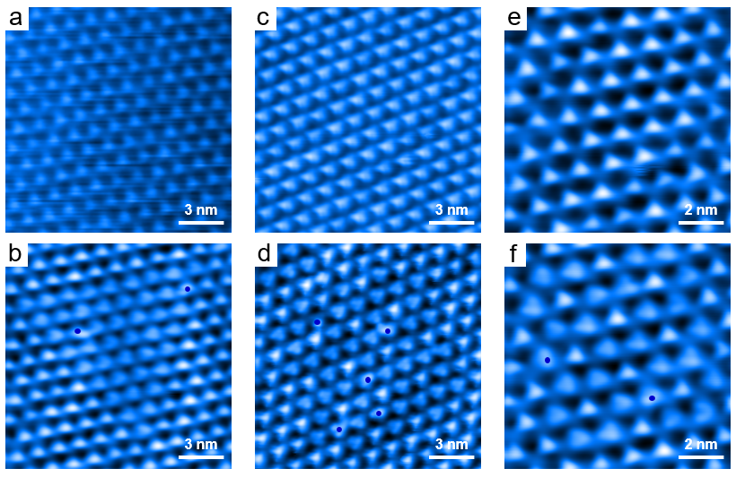
Supplementary Fig. 2 Tip-induced dehydrogenation of different d-TPM lattices in Fe-TPM. Blue dots indicate the defects in d-TPM lattices. (V = -500 mV, I =100 pA)

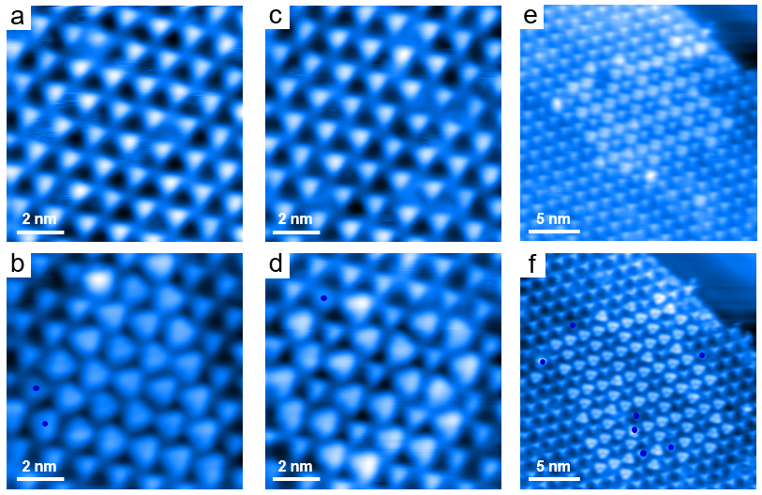
Supplementary Fig. 3 Tip-induced dehydrogenation of different d-TPM lattices in Ni-TPM. Blue dots indicate the defects in d-TPM lattices. (V = -500 mV, I =100 pA)

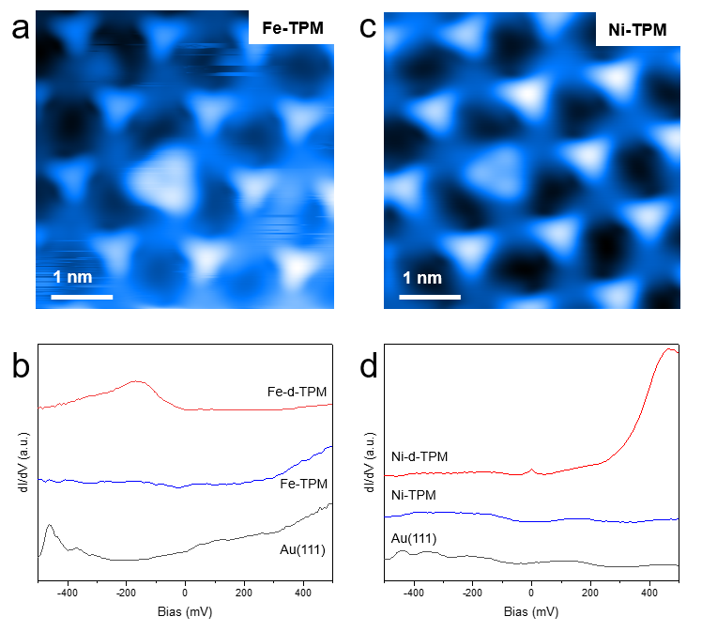
Supplementary Fig. 4 Electronic states of d-TPM and TPM monomers coordinated to Fe (a-b) and Ni atoms (c-d), respectively. (Red: d-TPM, blue: TPM, grey: Au(111), V = - 100 mV, I = 100 pA, scale bar: 1 nm) The Fe-d-TPM monomer show a broad peak at ~-167 meV compared to intact Fe-TPM, which is attributed to SOMO-related states. For Ni-TPM, the Ni-d-TPM monomer exhibits an intensive peak at ~ 490 meV and a narrow zero-bias peak, which are attributed to SUMO states and Kondo resonance, respectively.

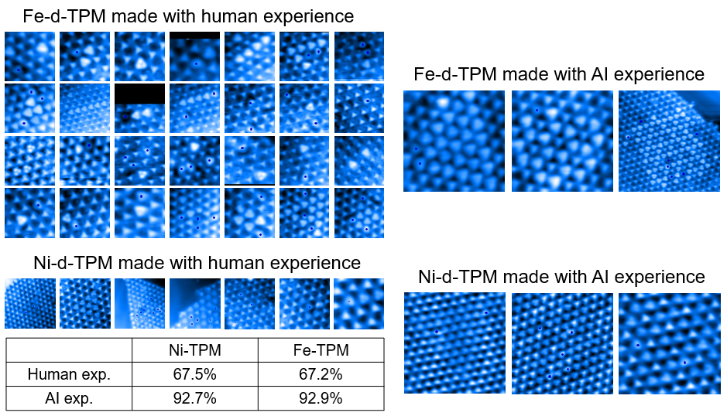
Supplementary Fig. 5 Distribution of d-TPM radicals fabricated via human experience and AI parameters in Ni-TPM and Fe-TPM MOF, respectively. Blue dots indicate the defects in d-TPM lattices.

4. Additional examples and statistical analyses of scalable SML
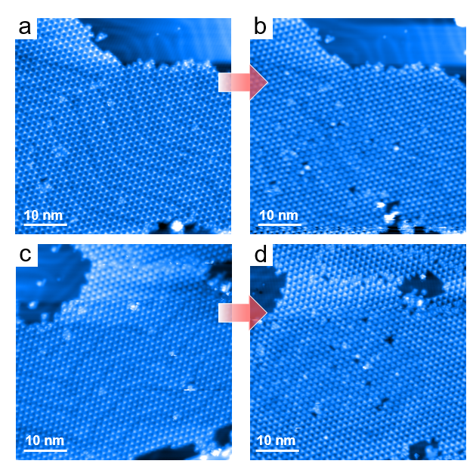
Supplementary Fig. 6 Additional examples for AI-constructed large-scale triangular lattices.

5. Virtual molecular environment simulator
To support the development and preliminary validation of the reinforcement-learning workflow, we constructed an interactive virtual molecular environment that emulates STM tip-induced molecular manipulation. In this environment, the TPM is represented by a simplified state model, and tip operations can induce predefined state transitions corresponding to successful reaction, no reaction or molecular degradation. The simulator provides two operation modes. In the manual mode, users can manipulate the virtual molecule through keyboard and mouse inputs, allowing intuitive inspection of the relationship between tip position, manipulation parameters and reaction outcome. In the programmatic mode, the environment communicates directly with the reinforcement-learning agent through a standardized interface, enabling automated policy testing, debugging and benchmark experiments before deployment in real STM measurements. This virtual platform was used only for algorithm development and workflow verification, whereas the final manipulation policy and statistical results reported in the main text were obtained from experimental STM feedback.
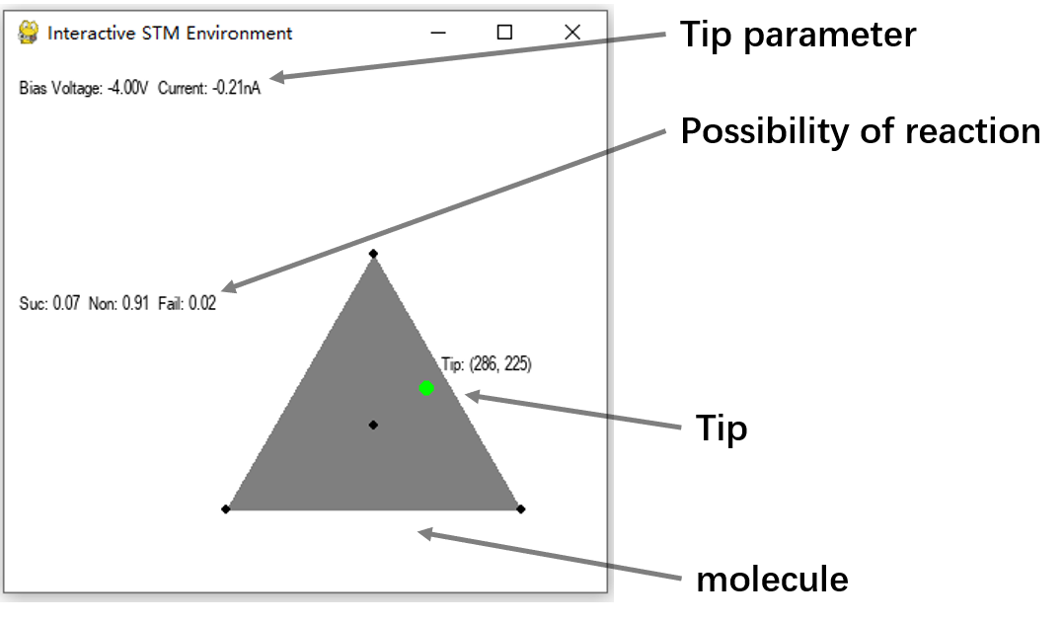
Supplementary Fig. 7 | Virtual STM environment for TPM molecular manipulation.
Interactive simulator used for testing the reinforcement-learning workflow before experimental STM deployment. The TPM molecule is represented by a threefold symmetric geometry, and the green marker denotes the current tip position. The interface displays the applied bias voltage, tunnelling current and the calculated probabilities of successful reaction, no reaction and failure. Following each virtual tip operation, the molecule is classified by color: red denotes successful reaction, blue denotes failed reaction and grey denotes an unreacted molecule.
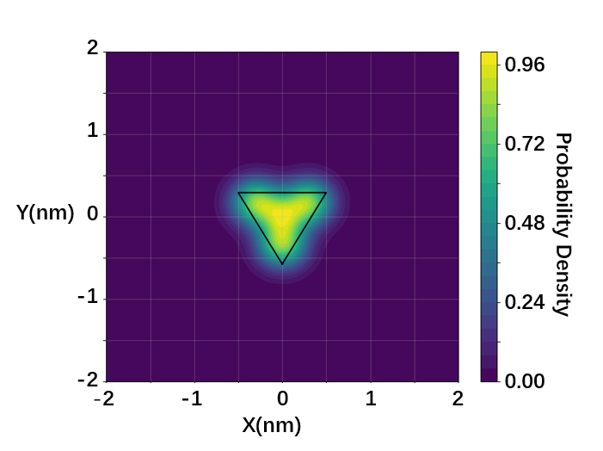
Supplementary Fig. 8| Probability distribution of tip-induced reactivity at the first Br site.
The virtual TPM molecular environment was formulated as a stochastic state-transition model for STM tip-induced molecular manipulation. Each TPM molecule was represented as a threefold symmetric triangular object, and the tip-induced reactivity was determined by two coupled factors: the lateral position of the STM tip relative to the molecule and the manipulation parameters applied during the virtual operation.
For a molecule centerd at, $R_{c}​=({X​}_{c},{Y​}_{c}​)$ the local interaction geometry was defined by one central point and three vertex points,

$$\begin{aligned}q_{0}=\left(0,0\right),q_{1}=\left(0,-\frac{\sqrt{3}L}{3}\right),q_{2}=\left(-\frac{L}{2},\frac{\sqrt{3}L}{6}\right),q_{3}=\left(\frac{L}{2},\frac{\sqrt{3}L}{6}\right).\#\left( AUTONUM \backslash * Arabic \right)\end{aligned}$$
Here, $q_{0}$ denotes the molecular center, $q_{1}$​, $q_{2}$​ and $q_{3}$​ denote the three triangular vertex points, and $L$ is the characteristic side-length parameter used to define the triangular molecular geometry. For a molecule with an in-plane rotation angle $θ$, the global coordinates of the interaction points are given by
$$\begin{aligned}r_{i}=R_{c}+\left(\begin{matrix}cos{θ} & -sin{θ} \\ sin{θ} & cos{θ}\end{matrix}\right)q_{i},i=0,1,2,3.\#\left( AUTONUM \backslash * Arabic \right)\end{aligned}$$
In this expression, $r$ ​ is the global coordinate of the $i$ interaction point, and the rotation matrix ensures that the rendered molecular geometry and the underlying interaction landscape rotate consistently.
The position-dependent contribution to the virtual reactivity was described by a normalized superposition of Gaussian-like kernels centerd at these four interaction points,
$$\begin{aligned}P_{pos}\left(r\right)=\frac{\sum_{i=0}^{3}{\frac{1}{2πσ_{i}^{2}}exp\left[-κ_{i}\frac{{∥r-r_{i}∥}^{2}}{2σ_{i}^{2}}\right]}}{\max_{u∈Ω}\sum_{i=0}^{3}{\frac{1}{2πσ_{i}^{2}}exp\left[-κ_{i}\frac{{∥u-r_{i}∥}^{2}}{2σ_{i}^{2}}\right]}}.\#\left( AUTONUM \backslash * Arabic \right)\end{aligned}$$
Here, $r=(x,y)$ is the current tip position, $Ω$ is the local working area around the molecule, $σ_{i}$ controls the spatial width of each interaction region, and $κ_{i}$​ modulates the decay of each kernel. The three vertex-associated kernels were assigned $σ_{i}=15$ pixels and $κ_{i}=0.6$, whereas the center-associated kernel was assigned$σ_{0}=18$pixels and $κ_{0}=1.0$. After normalization, $P_{pos}(r)$ is confined to the interval [0,1], with larger values corresponding to tip positions that are spatially favourable for inducing a molecular reaction.
The parameter-dependent contribution was defined in the two-dimensional space of sample bias VVV and tunnelling current III. The nominal optimal manipulation condition was set to V0=−4.0V_0=-4.0V0​=−4.0 V and I0=0.2I_0=0.2I0​=0.2 nA. Deviations from these values were transformed into scaled coordinates,
$$\begin{aligned}\left(ξ,η\right)=\left(α_{V}\left|V-V_{0}\right|,α_{I}\left(I-I_{0}\right)\right),V_{0}=-4.0V, I_{0}=0.2nA,{ α}_{V}=3,α_{I}=12.\#\left( AUTONUM \backslash * Arabic \right)\end{aligned}$$
Here, $ξ$ and $η$ are dimensionless coordinates representing the scaled bias and current deviations, respectively. The coefficients $α_{V}$​ and $α_{I}$​ determine the relative sensitivity of the virtual reaction probability to changes in bias voltage and tunnelling current. In this parameter space, the probability of successful manipulation is highest near $(ξ,η)=(0, 0)$, whereas larger deviations favour either no reaction or destructive manipulation.
The parameter-dependent probabilities for successful reaction, failure and no reaction were written as
$$\begin{aligned}P_{par}^{S}\left(V,I\right)=F_{S}\left(ξ,η\right),P_{par}^{F}\left(V,I\right)=F_{F}\left(ξ,η\right),P_{par}^{N}\left(V,I\right)=1-P_{par}^{S}\left(V,I\right)-P_{par}^{F}\left(V,I\right).\#\left( AUTONUM \backslash * Arabic \right)\end{aligned}$$
Here, $P^{S}$ ​, $P^{F}$ and $P^{N}$ denote the parameter-dependent probabilities of successful reaction, failure and no reaction, respectively. $F_{S}$​ is a bounded response function that peaks near the optimal bias-current condition, whereas $F_{F}$​ describes the increased probability of destructive or unstable manipulation under unfavourable parameters.
For each virtual manipulation event, the molecular state was updated by sampling from the resulting categorical distribution. The state-transition rule can be written as
$$\begin{aligned}s_{t+1}=\left\{\begin{matrix}1, & u<P^{S}\left(r,V,I\right), \\ 2, & u>1-P^{F}\left(r,V,I\right),u∼U\left(0,1\right). \\ 0, & \text{ otherwise} ,\end{matrix}\right.\#\left( AUTONUM \backslash * Arabic \right)\end{aligned}$$
Here, $s_{t}=0$ denotes the unreacted molecular state, $s_{t+1}=1$ denotes successful reaction, $s_{t+1}=2$ denotes failed or degraded manipulation, and $u$ is a random number drawn from a uniform distribution between 0 and 1. This stochastic rule avoids imposing a deterministic reaction boundary and mimics the variability of STM tip-induced molecular manipulation, where similar tip positions and parameters can lead to different outcomes.
The reinforcement-learning agent interacts with the simulator through a continuous action vector,
$$a_{t}=(Δx_{t},Δy_{t},V_{t},I_{t}), Δx_{t},Δy_{t}∈[-55,55], V_{t}∈[-5.0,-3.5]V, I_{t}∈[0.02,0.7]nA.$$
Here, $Δx_{t}$and $Δy_{t}$ are the lateral tip offsets relative to the molecular center, $V_{t}$ is the bias voltage and $I_{t}$ is the tunnelling current. These bounds define the virtual action space used for policy testing.
The reward function was defined only by the molecular-state transition,
$$\begin{aligned}R_{t}=\left\{\begin{matrix}15, & S_{t}=0, { S}_{t+1}=1, \\ -1, & S_{t}=0, { S}_{t+1}=0, \\ -5, & { S}_{t}=0, { S}_{t+1}=2,\end{matrix}\right.\#\left( AUTONUM \backslash * Arabic \right)\end{aligned}$$
Here, $R_{t}$ is the reward returned to the reinforcement-learning agent after a virtual manipulation. Successful reaction receives a large positive reward, no reaction receives a small penalty, and failed manipulation receives a stronger negative reward. The final penalty term is used for invalid state transitions. Overall, the simulator defines a probability-driven Markov decision process⁶,
$$\begin{aligned}s_{t+1}∼P\left(s_{t+1} ∣ s_{t},a_{t}\right),R_{t}=R\left(s_{t},a_{t},s_{t+1}\right),\#\left( AUTONUM \backslash * Arabic \right)\end{aligned}$$
where $P$ is the transition probability determined by the combined spatial and parameter-dependent reaction model, and $R$ is the reward function used for reinforcement-learning feedback. This formulation provides a simplified but physically motivated environment for testing action selection, probability assignment, reward calculation and agent-environment communication before experimental STM manipulation.

6. References
1 Haarnoja, T., Zhou, A., Abbeel, P. & Levine, S. Soft Actor-Critic: Off-Policy Maximum Entropy Deep Reinforcement Learning with a Stochastic Actor. in International conference on machine learning. 1861-1870 (Pmlr) (2018).
2 Wang, C. Y., Bochkovskiy, A. & Liao, H. Y. M. YOLOv7: Trainable bag-of-freebies sets new state-of-the-art for real-time object detectors. in 2023 IEEE/CVF Conference on Computer Vision and Pattern Recognition (CVPR). 7464-7475 (2023).
3 Lin, T.-Y. et al. Feature Pyramid Networks for Object Detection. in Proceedings of the IEEE conference on computer vision and pattern recognition. 2117-2125 (2017).
4 Liu, S., Qi, L., Qin, H., Shi, J. & Jia, J. Path Aggregation Network for Instance Segmentation. in Proceedings of the IEEE conference on computer vision and pattern recognition. 8759-8768 (2018).
5 Russell, B. C., Torralba, A., Murphy, K. P. & Freeman, W. T. LabelMe: A Database and Web-Based Tool for Image Annotation. International Journal of Computer Vision 77, 157-173 (2008).
6 Terven, J. Deep Reinforcement Learning: A Chronological Overview and Methods. AI 6, 46 (2025).

