Dual-Mode Deep-Ultraviolet Photodetection and neuromorphic vision sensor via Thermal Engineering of Oxygen Vacancies in Ga₂O₃ ​
Zichen Qi¹, Hao Zhang¹, Lin Zhu^{2,}*, Liyong Jiang^{1,}* and Yanqiang Cao^{1,}*
¹Institute of Micro-nano Photonics and Quantum Manipulation, Engineering Research Center of Semiconductor Device Optoelectronic Hybrid Integration in Jiangsu Province, School of Physics, Nanjing University of Science and Technology, Nanjing, 210094, China
²School of Physics, Nanjing University, Nanjing, 210093, China
Correspondence to: yqcao@njust.edu.cn, jly@njust.edu.cn, zlin@nju.edu.cn

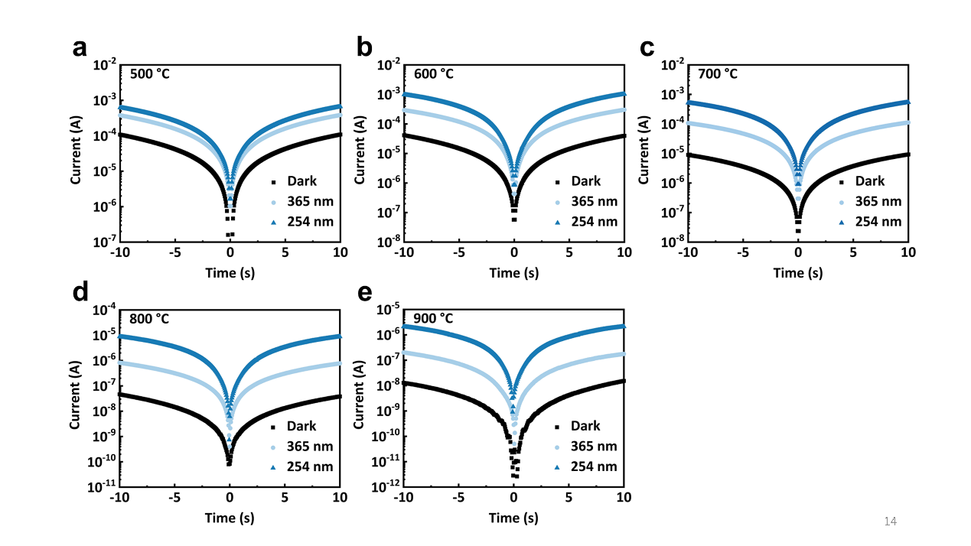
Fig. S1 Current-voltage characteristics of Ga₂O₃ films fabricated at different annealing temperatures. a 500 °C. b 600 °C. c 700 °C. d 800 °C. e 900 °C

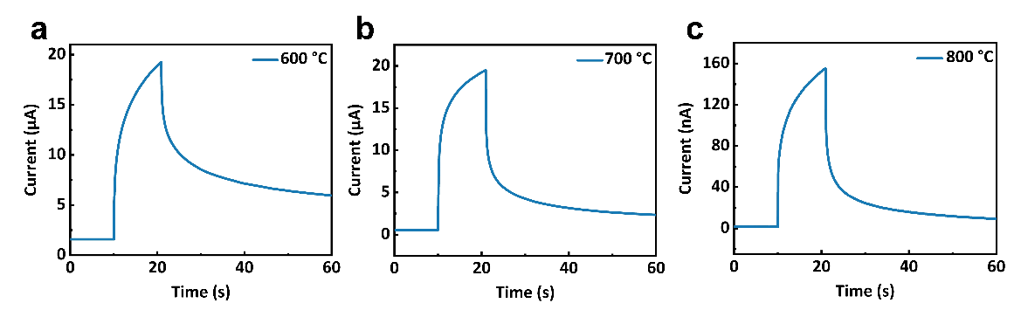
Fig. S2 Current-time characteristics of Ga₂O₃ films fabricated at different annealing temperatures. a 600 °C. b 700 °C. c 800 °C

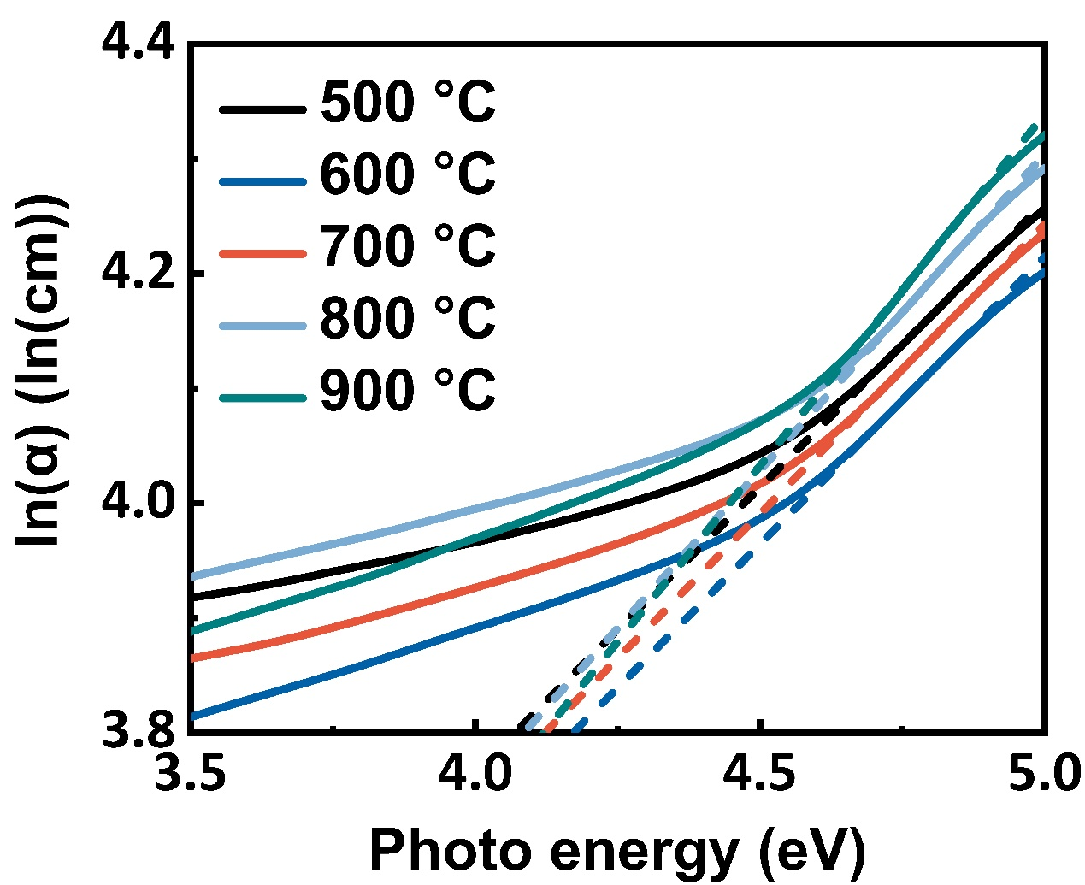
Fig. S3 Urbach energy evaluation of Ga₂O₃ annealed at different temperatures. The Urbach energy is extracted as the reciprocal slope of the linear regime in the logarithmic absorption coefficient versus photon energy plot. For films annealed at 500, 600, 700, 800, and 900 °C, the corresponding Urbach energies are 2.01, 2.00, 1.98, 1.81, and 1.63 eV, respectively. The progressive reduction in Urbach energy with increasing annealing temperature signifies improved crystalline order and a diminished density of band-tail states, consistent with the X-ray diffraction results.

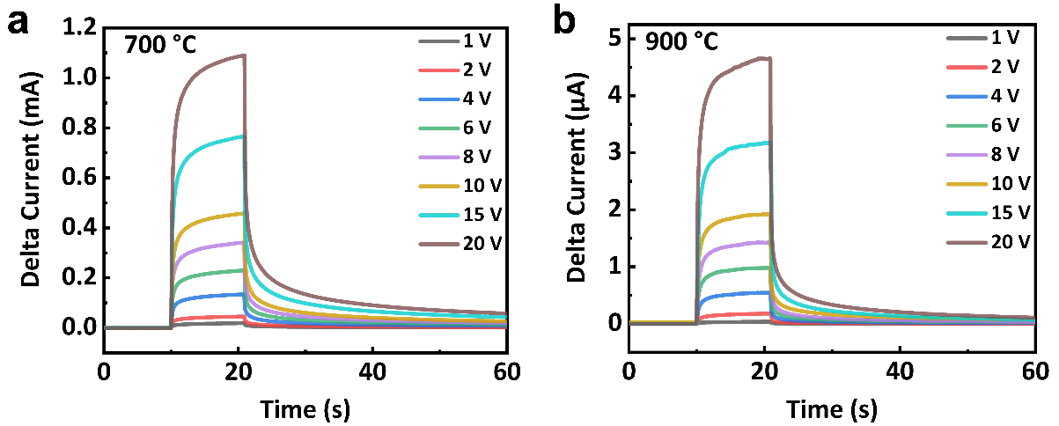
Fig. S4 Current-time characteristics under varying bias voltages at 1.0 mW cm⁻² illumination for films annealed at elevated temperatures. a 700 °C. b 900 °C

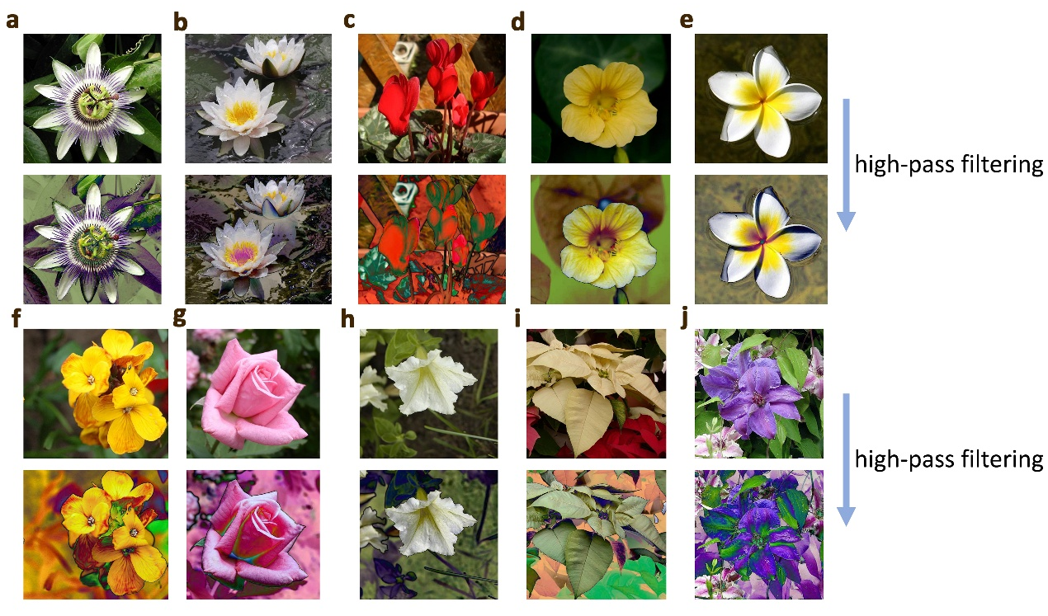
Fig. S5 Image filtering of 10-flowers. Samples of a passion flower. b frangipani. c foxglove. d water lily. e buttercup. f yellow iris. g rose. h morning glory. i poinsettia. j clematis

