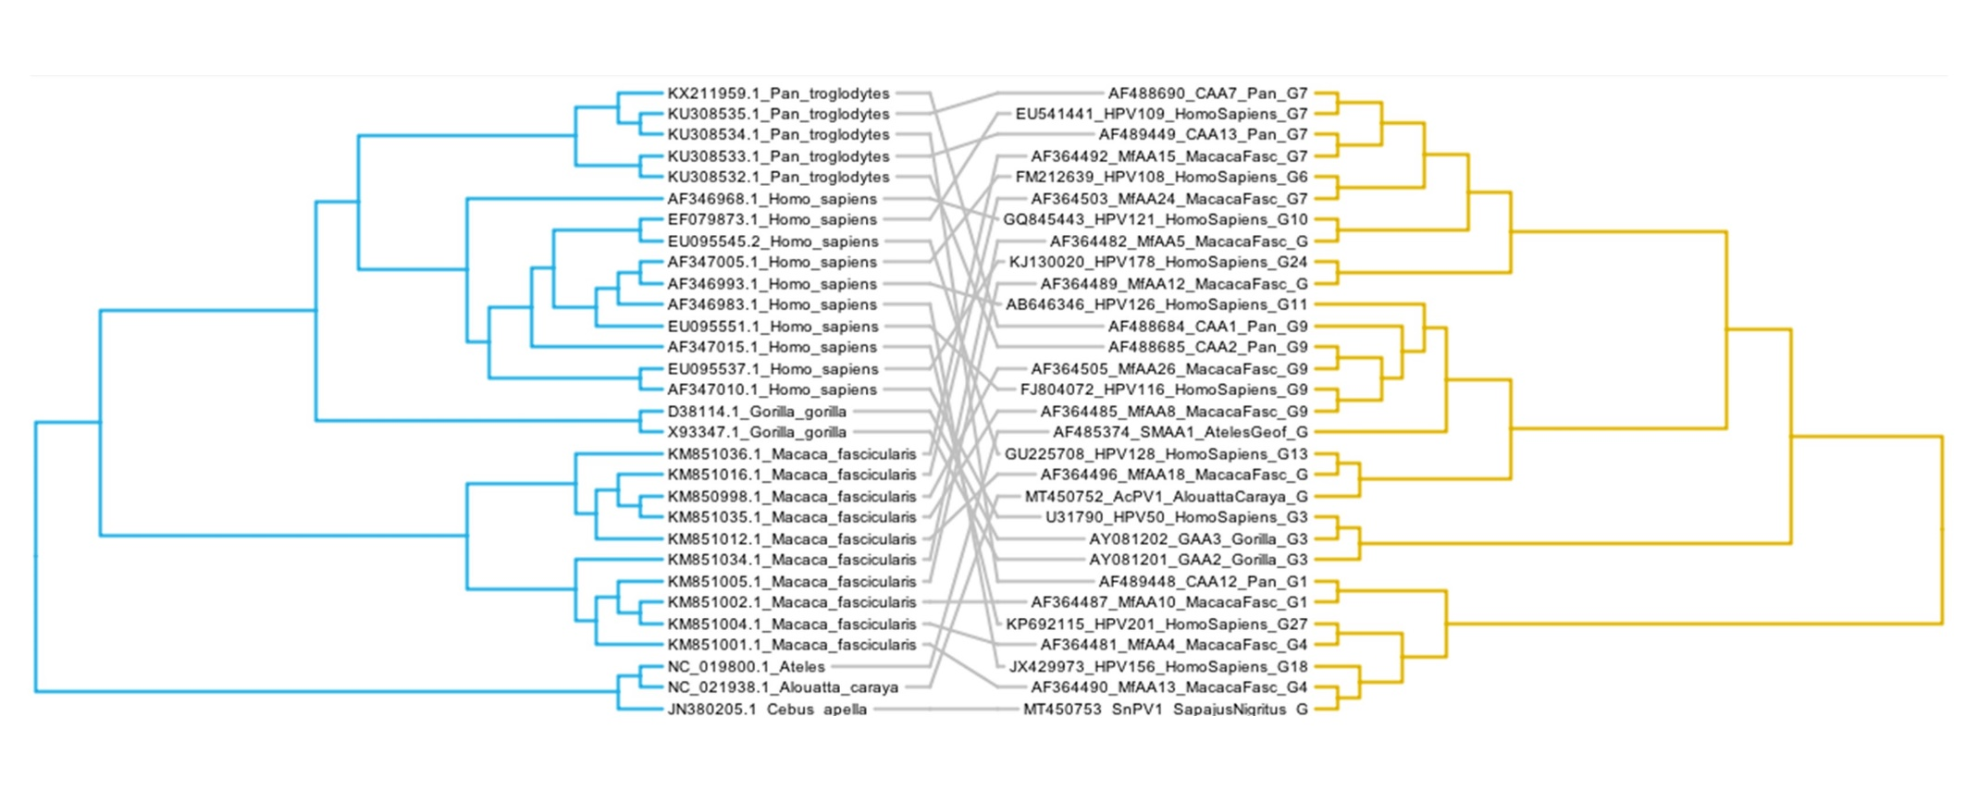
Supplementary Figure 1: Tanglegram for primate and viral sequences.
Figure Legend: Evolutionary relationships of complete mitochondrial DNA of Primate taxa (Homo, Pan, Gorilla, Macaca, Alouatta, Ateles, Cebus) and CUT sequence of primate Gamma-PVs. Virus and Host associations are shown by grey lines. Hosts are shown on the left, viruses on the right. The mitochondrial DNA tree topology (host) was consistent with the known primate taxonomy, with two major monophyletic groups consisting of Parvorders Catarrhine (Genera: Pan, Homo, Gorilla, Pongo and Macaca) and Platyrrhine (Genera: Sapajus, Ateles and Alouatta). On the other hand, the topology for the Gamma-PV tree (parasite) indicated that HPVs and the novel isolates were intermingled with those of other species. The crossing lines between the two trees reinforce the lack of a species-specific pattern.

