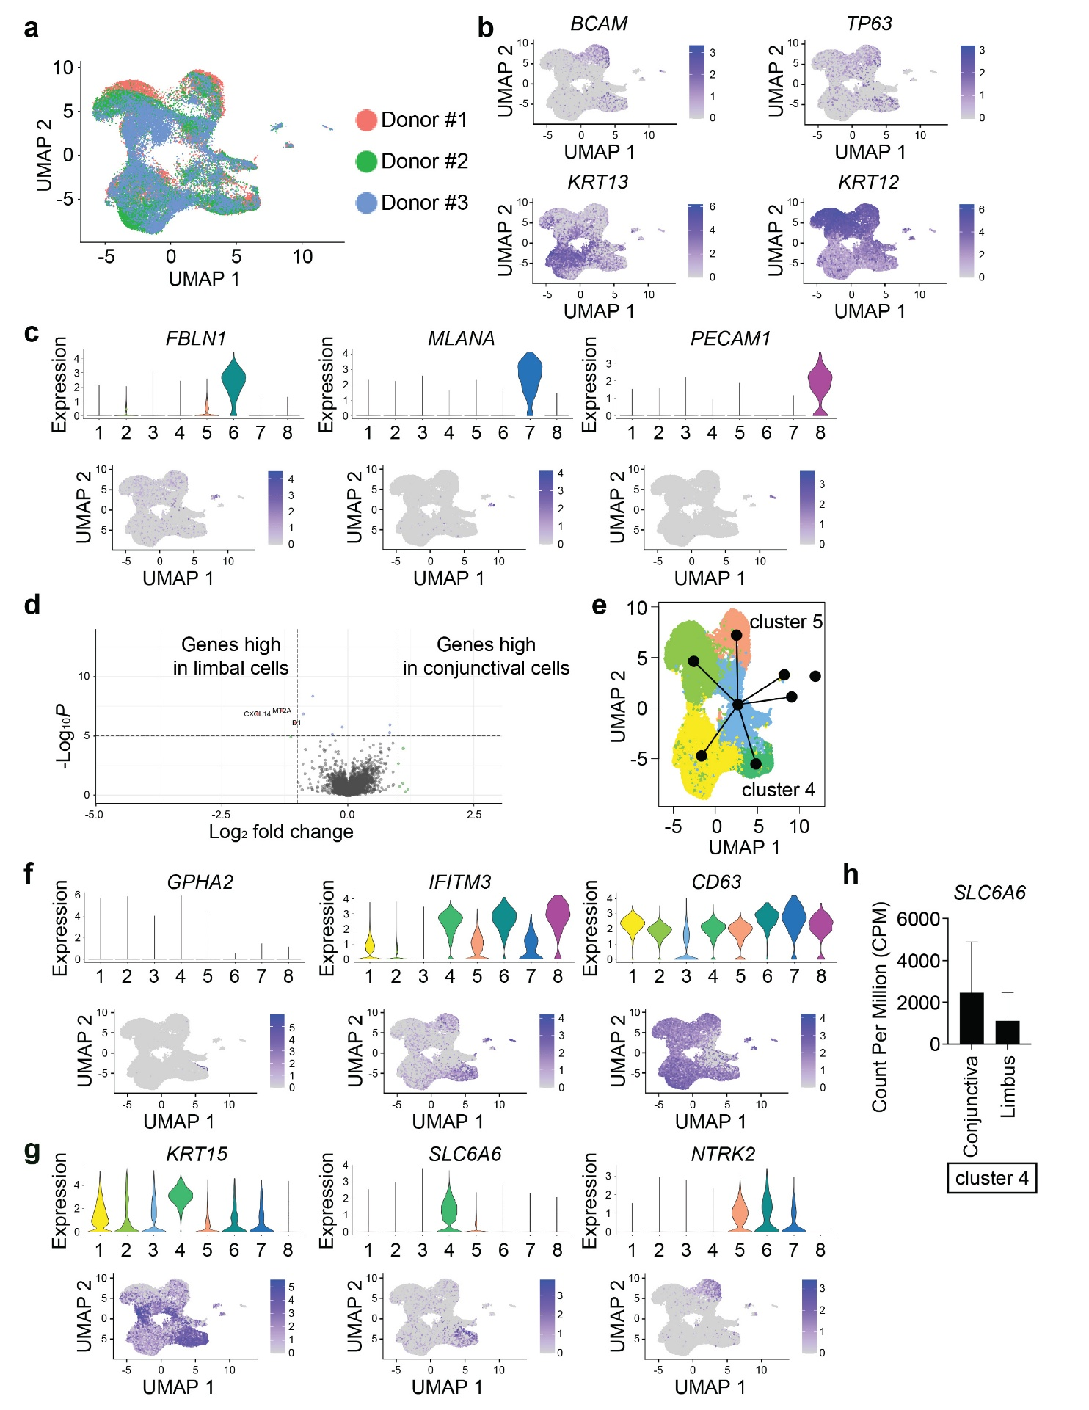
Extended Data Fig. 1 | CITE-seq data analysis.
a, UMAP visualization of integrated CITE-seq data, colored by donor origin. b, Feature plots showing expression of BCAM, TP63, KRT13, and KRT12. c, Violin plots (top) and corresponding feature plots (bottom) illustrating expression of FBLN1, MLANA and PECAM1. d, Volcano plot of differentially expressed genes (DEGs) between limbal- and conjunctiva-derived cells within cluster 4. e, Trajectory inference analysis performed using Slingshot. f, Violin plots (top) and feature plots (bottom) depicting expression of GPHA2, IFITM3 and CD63. g, Violin plots (top) and feature plots (bottom) showing expression of KRT15, SLC6A6 and NTRK2. h, Counts per million (CMP) of SLC6A6 in limbal- and conjunctiva-derived cells within cluster 4.

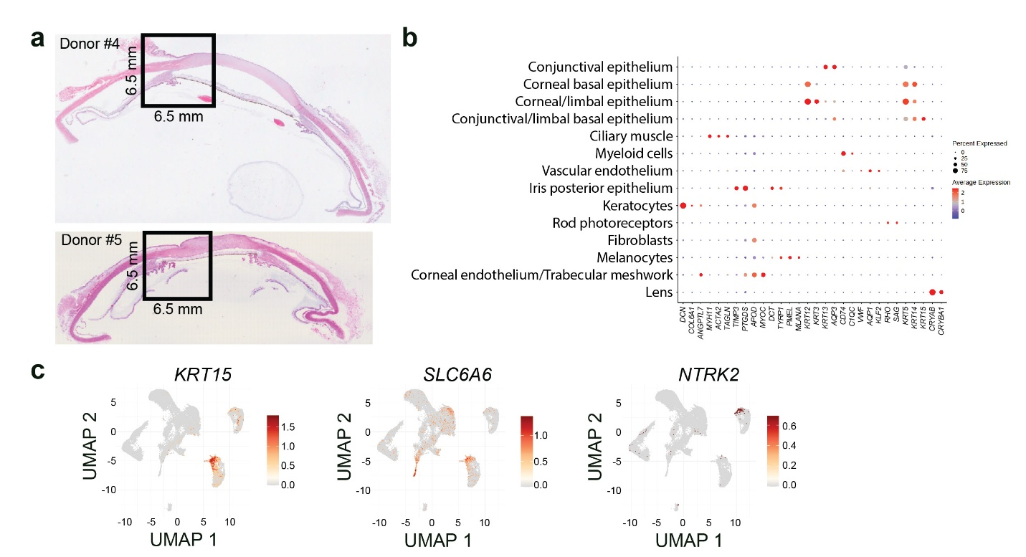
Extended Data Fig. 2 | Spatial transcriptomic profiling of human donor corneas.
a, Representative hematoxylin and eosin (H&E)-stained sections from donor corneas (#4 and #5) used for spatial transcriptomic analysis. Black boxes indicate regions selected for spatial capture (6.5 mm). b, Dot plot illustrating the expression of selected marker genes across annotated cell clusters identified by spatial transcriptomics. Dot size represents the proportion of cells expressing each gene, and color intensity denotes average expression level. c, UMAP feature plots showing the spatially resolved expression patterns of KRT15, SLC6A6 and NTRK2.

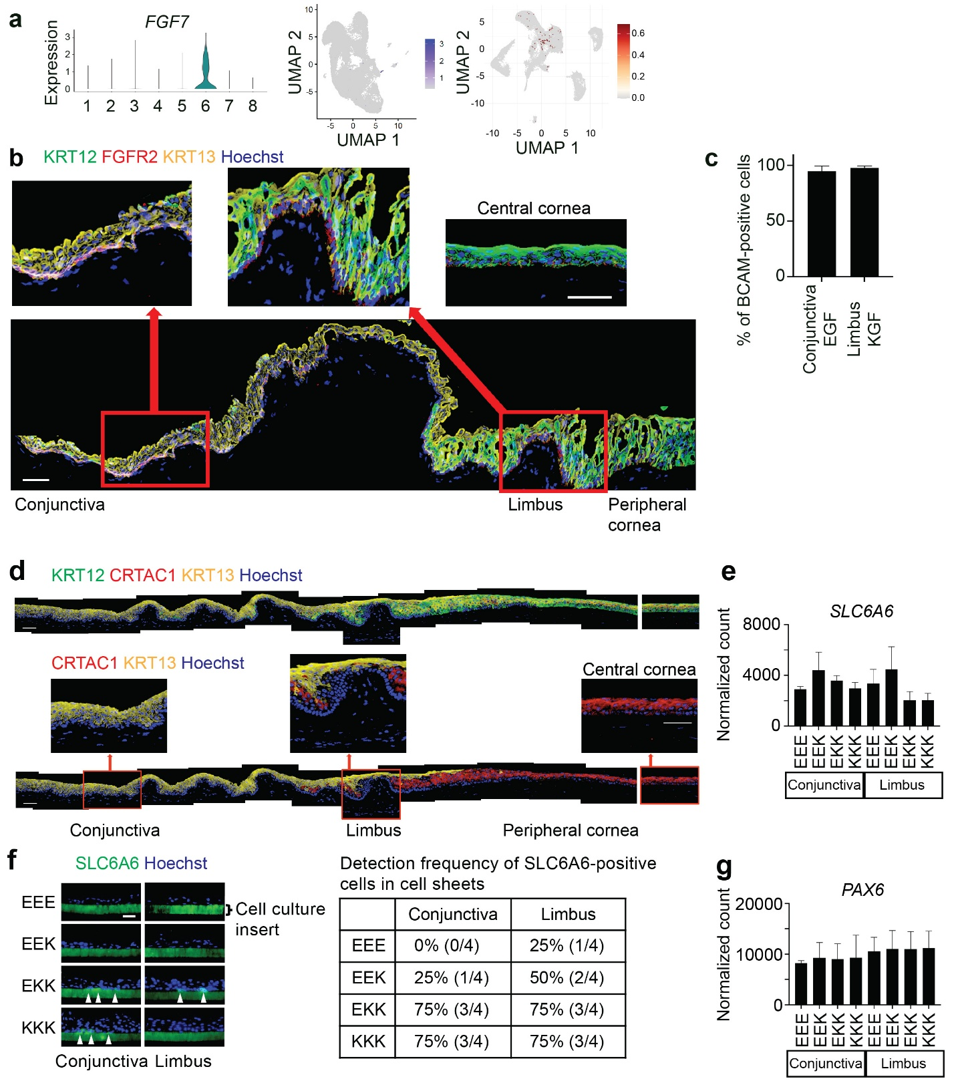

Extended Data Fig. 3 | Effect of KGF and EGF in the human ocular surface.
a, Violin plot (left) showing FGF7 expression across identified cell clusters, with corresponding feature plots from CITE-seq (middle) and spatial transcriptomics (right), demonstrating the spatial distribution and relative expression levels of FGF7 in the human ocular surface.
b, Representative immunofluorescence staining of KRT12 (green), FGFR2 (red), and KRT13 (yellow) across the human ocular surface, spanning conjunctiva, limbus, peripheral cornea, and central cornea. Nuclei are counterstained with Hoechst 33342 (blue). n = 3 donors. Scale bar: 50μm. c, Percentage of BCAM-positive cells within monolayer conjunctival epithelial cells cultured in EGF (n = 4 donors) or monolayer limbal epithelial cells cultured in KGF (n = 3 donors) (mean ± SD). d, Representative immunofluorescence staining of KRT12 (green), CRTAC1 (red), and KRT13 (yellow) across conjunctiva, limbus, peripheral cornea, and central cornea. Nuclei are counterstained with Hoechst 33342 (blue). The bottom panel shows isolated channels for CRTAC1, KRT13 and Hoechst 33352 extracted from the merged images above. n = 3 donors. Scale bar: 50μm. e, RNA-seq normalized counts of SLC6A6 expression under different culture conditions. n = 4 donors. f, Left, representative immunofluorescence staining of SLC6A6 (green) in conjunctival and limbal epithelial cell sheets cultured under various conditions. Nuclei are stained with Hoechst 33342 (blue). Right, frequency of samples containing SLC6A6-positive cells. Arrowheads indicate SLC6A6-positive cells. n = 4 donors. Scale bar: 50μm. g, RNA-seq normalized counts of PAX6 expression under different culture conditions. n = 4 donors.

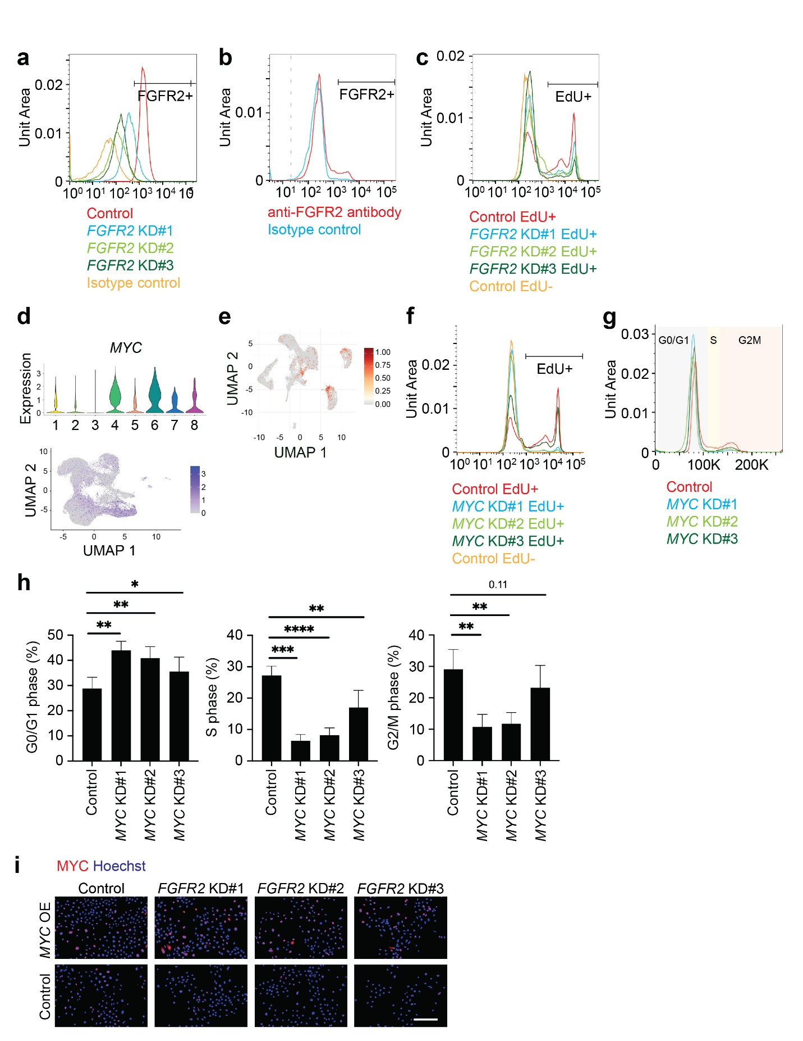

Extended Data Fig. 4 | Roles of FGFR2 and MYC in limbal epithelial cell proliferation.
a, Representative flow cytometry analysis of FGFR2 expression in human cultured limbal epithelial cells following FGFR2 knockdown (KD). n = 7 donors. b, Representative flow cytometry analysis of FGFR2 expression in human limbal tissue in vivo. n = 10 donors. c, Representative flow cytometry analysis of EdU incorporation in FGFR2 KD human cultured limbal epithelial cells. n = 4 donors. d, Violin plots (top) and corresponding feature plot (bottom) showing MYC expression levels determined by CITE-seq. e, Feature plot depicting spatial transcriptomic analysis of MYC expression. f, Representative flow cytometry analysis of EdU incorporation in MYC KD human cultured limbal epithelial cells. n = 4 donors. g, Representative cell cycle analysis of MYC KD human cultured limbal epithelial cells. n = 4 donors. h, Quantification of cell cycle distribution in MYC KD human cultured limbal epithelial cells, showing the percentage of cells in G0/G1 phase (left), S phase (middle), and G2/M phase (right) phases (mean ± SD). n = 4 donors. Statistical significance was determined using Dunnett’s test. *p < 0.05, **p < 0.01 ***p < 0.001, and ****p < 0.0001. i, Representative immunofluorescence staining of MYC (red) in the human cultured limbal epithelial cells with FGFR2 KD. Nuclei were counterstained with Hoechst 33342 (blue). n = 3 donors. Scale bar: 200μm. OE, overexpression.

Extended Data Table 1 | Top 30 genes highly expressed in each cluster in CITE-seq.
Cluster 1 (KRT13-high suprabasal epithelial cells)
 | Gene | Avg log2FC | Adj p |  | Gene | Avg log2FC | Adj p
1 | LCN2 | 3.44 | 0 | 16 | F3 | 1.66 | 0
2 | AQP5 | 3.35 | 0 | 17 | AQP3 | 1.53 | 0
3 | SLPI | 3.15 | 0 | 18 | HOPX | 1.52 | 0
4 | RARRES1 | 2.98 | 0 | 19 | C15orf48 | 1.51 | 0
5 | S100A9 | 2.96 | 0 | 20 | CP | 1.48 | 0
6 | CXCL17 | 2.62 | 0 | 21 | S100A11 | 1.44 | 0
7 | KRT13 | 2.51 | 0 | 22 | B2M | 1.37 | 0
8 | WFDC2 | 2.49 | 0 | 23 | GDF15 | 1.33 | 0
9 | KRT19 | 2.43 | 0 | 24 | MGST1 | 1.30 | 0
10 | S100P | 2.28 | 0 | 25 | MSMB | 1.30 | 0
11 | KRT4 | 2.15 | 0 | 26 | RAB11FIP1 | 1.24 | 0
12 | S100A8 | 2.11 | 0 | 27 | MDK | 1.22 | 0
13 | PLA2G2A | 2.09 | 0 | 28 | SERPINB1 | 1.18 | 0
14 | PSCA | 2.04 | 0 | 29 | DUSP5 | 1.16 | 0
15 | KRT7 | 1.69 | 0 | 30 | PLAAT4 | 1.15 | 0

Cluster 2 (KRT12-high suprabasal epithelial cells)
 | Gene | Avg log2FC | Adj p |  | Gene | Avg log2FC | Adj p
1 | KRT12 | 2.50 | 0 | 16 | ERICH5 | 1.21 | 0
2 | ADIRF | 2.31 | 0 | 17 | LINC01474 | 1.17 | 0
3 | MAL | 2.25 | 0 | 18 | RB1 | 1.16 | 0
4 | MGARP | 2.08 | 0 | 19 | LGALSL | 1.16 | 0
5 | KRT3 | 2.05 | 0 | 20 | KRT5 | 1.15 | 0
6 | DAPL1 | 1.76 | 0 | 21 | DSG1 | 1.15 | 0
7 | KRT6A | 1.64 | 0 | 22 | CAMK2N1 | 1.13 | 0
8 | NQO1 | 1.52 | 0 | 23 | ALDH1A1 | 1.09 | 0
9 | UPK1B | 1.51 | 0 | 24 | MAL2 | 1.07 | 0
10 | TKT | 1.48 | 0 | 25 | LYPD3 | 1.05 | 0
11 | C12orf75 | 1.45 | 0 | 26 | PIR | 1.04 | 0
12 | KRT24 | 1.41 | 0 | 27 | SH3BGRL3 | 1.03 | 0
13 | MRPL33 | 1.35 | 0 | 28 | CALML5 | 1.03 | 0
14 | S100A4 | 1.33 | 0 | 29 | DBI | 1.01 | 0
15 | ENO1 | 1.26 | 0 | 30 | C4orf3 | 0.99 | 0

Cluster 3 (KRT13-int KRT12-int suprabasal epithelial cells)
 | Gene | Avg log2FC | Adj p |  | Gene | Avg log2FC | Adj p
1 | MTRNR2L12 | 2.42 | 0 | 16 | AC020916.1 | 1.50 | 0
2 | MT-ATP6 | 2.13 | 0 | 17 | MT-ATP8 | 1.49 | 0
3 | MT-ND1 | 2.11 | 0 | 18 | VMP1 | 1.30 | 0
4 | MT-ND2 | 2.03 | 0 | 19 | AHNAK | 1.20 | 0
5 | MT-ND3 | 1.99 | 0 | 20 | DSP | 1.05 | 0
6 | MT-ND5 | 1.99 | 0 | 21 | TWF1 | -0.25 | 0
7 | MT-CO3 | 1.94 | 0 | 22 | LSM10 | -0.25 | 0
8 | MT-ND4 | 1.88 | 0 | 23 | MFAP1 | -0.25 | 0
9 | MT-CYB | 1.83 | 0 | 24 | MCUR1 | -0.25 | 0
10 | MT-CO2 | 1.81 | 0 | 25 | HCFC1R1 | -0.25 | 0
11 | MT-ND4L | 1.75 | 0 | 26 | POP5 | -0.25 | 0
12 | MT-CO1 | 1.73 | 0 | 27 | ADH7 | -0.25 | 0
13 | NEAT1 | 1.71 | 0 | 28 | NANS | -0.25 | 0
14 | MTRNR2L8 | 1.58 | 0 | 29 | CASP4 | -0.25 | 0
15 | MALAT1 | 1.55 | 0 | 30 | RCN2 | -0.25 | 0

Cluster 4 (KRT13-int basal epithelial cells)
 | Gene | Avg log2FC | Adj p |  | Gene | Avg log2FC | Adj p
1 | MMP10 | 2.80 | 0 | 16 | NAP1L1 | 1.27 | 0
2 | IFITM3 | 2.57 | 0 | 17 | RPL5 | 1.25 | 0
3 | IFITM2 | 2.15 | 0 | 18 | NPM1 | 1.24 | 0
4 | GAS5 | 1.87 | 0 | 19 | RPS6 | 1.23 | 0
5 | S100A2 | 1.82 | 0 | 20 | MYC | 1.20 | 0
6 | KRT15 | 1.61 | 0 | 21 | RPS9 | 1.19 | 0
7 | SLC6A6 | 1.58 | 0 | 22 | DST | 1.19 | 0
8 | SOD2 | 1.47 | 0 | 23 | RPS19 | 1.18 | 0
9 | SNHG29 | 1.47 | 0 | 24 | ARID5B | 1.17 | 0
10 | TSC22D1 | 1.45 | 0 | 25 | NCOA7 | 1.17 | 0
11 | FGFBP1 | 1.35 | 0 | 26 | RPL10 | 1.15 | 0
12 | RPS3 | 1.34 | 0 | 27 | RPL14 | 1.13 | 0
13 | RPL13 | 1.33 | 0 | 28 | RPS3A | 1.13 | 0
14 | CEBPD | 1.33 | 0 | 29 | SERPINF1 | 1.13 | 0
15 | RPS27A | 1.28 | 0 | 30 | RPL17 | 1.11 | 0

Cluster 5 (KRT12-int basal epithelial cells)
 | Gene | Avg log2FC | Adj p |  | Gene | Avg log2FC | Adj p
1 | CXCL14 | 2.60 | 0 | 16 | IVNS1ABP | 1.52 | 0
2 | IGFBP6 | 2.52 | 0 | 17 | LGALS1 | 1.50 | 0
3 | COL17A1 | 2.27 | 0 | 18 | MT2A | 1.46 | 0
4 | ALDH3A1 | 2.24 | 0 | 19 | NQO1 | 1.45 | 0
5 | IGFBP7 | 2.22 | 0 | 20 | TGM2 | 1.43 | 0
6 | KRT14 | 2.04 | 0 | 21 | MIR205HG | 1.39 | 0
7 | HTRA1 | 2.01 | 0 | 22 | CAV1 | 1.39 | 0
8 | CTSV | 1.90 | 0 | 23 | NTRK2 | 1.37 | 0
9 | TGFBI | 1.88 | 0 | 24 | LGALS7B | 1.35 | 0
10 | SPARC | 1.74 | 0 | 25 | CRTAC1 | 1.32 | 0
11 | IGFBP2 | 1.66 | 0 | 26 | GJA1 | 1.31 | 0
12 | GJB6 | 1.64 | 0 | 27 | TKT | 1.31 | 0
13 | S100A2 | 1.60 | 0 | 28 | GJB2 | 1.28 | 0
14 | CRYAB | 1.59 | 0 | 29 | BCAM | 1.25 | 0
15 | HSPA1A | 1.56 | 0 | 30 | SUCO | 1.23 | 0

Cluster 6 (Fibroblasts)
 | Gene | Avg log2FC | Adj p |  | Gene | Avg log2FC | Adj p
1 | APOD | 6.67 | 0 | 16 | COL1A2 | 2.65 | 0
2 | DCN | 5.92 | 0 | 17 | PLAC9 | 2.65 | 0
3 | MGP | 4.79 | 0 | 18 | FSTL1 | 2.63 | 0
4 | VIM | 4.58 | 0 | 19 | TIMP2 | 2.47 | 0
5 | ADH1B | 4.29 | 0 | 20 | CTSK | 2.39 | 0
6 | IGFBP5 | 4.28 | 0 | 21 | PMP22 | 2.34 | 0
7 | C1R | 3.72 | 0 | 22 | SCARA5 | 2.32 | 0
8 | SERPING1 | 3.61 | 0 | 23 | COL6A2 | 2.22 | 0
9 | FBLN1 | 3.44 | 0 | 24 | GPX3 | 2.21 | 0
10 | C1S | 3.33 | 0 | 25 | TMEM176B | 2.17 | 0
11 | LEPR | 3.32 | 0 | 26 | RARRES2 | 2.16 | 0
12 | NNMT | 3.21 | 0 | 27 | TNXB | 2.13 | 0
13 | PRELP | 3.12 | 0 | 28 | TCF4 | 2.07 | 0
14 | MMP2 | 3.09 | 0 | 29 | CYP1B1 | 2.06 | 0
15 | SOD3 | 2.77 | 0 | 30 | PRRX1 | 2.03 | 0

Cluster 7 (Melanocytes)
 | Gene | Avg log2FC | Adj p |  | Gene | Avg log2FC | Adj p
1 | DCT | 6.04 | 0 | 16 | ZEB2 | 2.00 | 0
2 | TYRP1 | 4.95 | 0 | 17 | GPX3 | 1.99 | 0
3 | PMEL | 4.92 | 0 | 18 | GPM6B | 1.95 | 0
4 | APOE | 4.61 | 0 | 19 | TYR | 1.91 | 0
5 | VIM | 4.57 | 0 | 20 | PMP22 | 1.91 | 0
6 | MLANA | 4.03 | 0 | 21 | GYPC | 1.87 | 0
7 | MITF | 3.50 | 0 | 22 | AKAP12 | 1.85 | 0
8 | TRPM1 | 3.40 | 0 | 23 | GPR143 | 1.76 | 0
9 | QPCT | 3.18 | 0 | 24 | PLP1 | 1.63 | 0
10 | EDNRB | 2.97 | 0 | 25 | PLXNC1 | 1.63 | 0
11 | CDC42EP3 | 2.48 | 0 | 26 | SNCA | 1.60 | 0
12 | CAPN3 | 2.19 | 0 | 27 | BCAN | 1.60 | 0
13 | GMPR | 2.14 | 0 | 28 | TRIB2 | 1.56 | 0
14 | SLCO4A1-AS1 | 2.03 | 0 | 29 | GAPDHS | 1.43 | 0
15 | GCNT2 | 2.02 | 0 | 30 | APOC1 | 1.33 | 0

Cluster 8 (Vascular endothelial cells)
 | Gene | Avg log2FC | Adj p |  | Gene | Avg log2FC | Adj p
1 | CCL21 | 5.68 | 0 | 16 | GIMAP7 | 2.37 | 0
2 | VIM | 4.77 | 0 | 17 | ECSCR | 2.32 | 0
3 | ACKR1 | 4.19 | 0 | 18 | TCF4 | 2.32 | 0
4 | MMRN1 | 4.04 | 0 | 19 | CALCRL | 2.29 | 0
5 | CLDN5 | 3.90 | 0 | 20 | DEPP1 | 2.24 | 0
6 | CCL14 | 3.77 | 0 | 21 | SELE | 2.24 | 0
7 | TFPI | 3.58 | 0 | 22 | LYVE1 | 2.17 | 0
8 | TFF3 | 3.49 | 0 | 23 | SRGN | 2.13 | 0
9 | GNG11 | 3.25 | 0 | 24 | POSTN | 2.10 | 0
10 | AQP1 | 3.01 | 0 | 25 | PLVAP | 2.01 | 0
11 | PECAM1 | 2.91 | 0 | 26 | RAMP2 | 1.99 | 0
12 | NNMT | 2.72 | 0 | 27 | VWF | 1.94 | 0
13 | PCAT19 | 2.67 | 0 | 28 | STC1 | 1.87 | 0
14 | CAVIN2 | 2.54 | 0 | 29 | GYPC.2 | 1.83 | 0
15 | SLC2A3 | 2.47 | 0 | 30 | ADGRL4 | 1.82 | 0

*Avg log2FC, average log2 fold change; adj p, adjusted p value.

Extended Data Table 2 | Top differentially expressed genes (DEGs) in cell sheets.
Conjunctiva EEE vs Conjunctiva EEK
Genes with positive log2 fold changes have higher expression in Conjunctiva EEE.
 | Gene | Log2FC | FDR
1 | DLL1 | -1.81 | 7.00E-03
2 | ADAMTS1 | 2.41 | 7.00E-03
3 | GAS1 | -3.36 | 5.00E-02

Conjunctiva EEE vs Conjunctiva EKK
Genes with positive log2 fold changes have higher expression in Conjunctiva EEE.
 | Gene | Log2FC | FDR
1 | EFNB3 | -2.13 | 7.10E-03
2 | CRTAC1 | -4.56 | 9.30E-03
3 | C1R | -2.26 | 9.30E-03
4 | CPXM2 | -3.23 | 1.10E-02
5 | CACNG4 | -2.32 | 1.20E-02
6 | KRT12 | -5.47 | 1.40E-02
7 | FGF1 | -1.68 | 2.50E-02
8 | GAS1 | -3.18 | 2.50E-02
9 | FIBIN | -2.93 | 3.60E-02
10 | DCDC1 | -4.15 | 4.70E-02
11 | VIT | -2.88 | 4.70E-02
12 | AL137804.1 | -4.12 | 4.70E-02

Conjunctiva EEE vs Conjunctiva KKK
Genes with positive log2 fold changes have higher expression in Conjunctiva EEE.
 | Gene | Log2FC | FDR
1 | KRT12 | -5.81 | 3.50E-02
2 | CRTAC1 | -4.6 | 3.50E-02

Limbus EEE vs limbus EEK
No DEGs.
Limbus EEE vs limbus EKK (Top 20)
Genes with positive log2 fold changes have higher expression in Limbus EEE.
 | Gene | Log2FC | FDR
1 | MUC1 | 2.73 | 1.60E-08
2 | CP | 3.04 | 1.30E-06
3 | HS3ST1 | 2.16 | 1.10E-05
4 | FGF1 | -2.06 | 2.20E-05
5 | GOLM1 | 2.27 | 2.60E-05
6 | TNFAIP8L3 | -2.8 | 1.70E-04
7 | VTCN1 | 2.84 | 1.80E-04
8 | ATP10B | 2.02 | 3.30E-04
9 | CRTAC1 | -4.76 | 8.50E-04
10 | OSR2 | 1.99 | 1.10E-03
11 | SYTL5 | 1.99 | 1.30E-03
12 | ADAM28 | 2.47 | 1.30E-03
13 | COL5A1 | -2.82 | 1.30E-03
14 | RAI2 | -2.63 | 2.00E-03
15 | ROBO2 | -2.63 | 4.30E-03
16 | SHISAL1 | -2.84 | 4.40E-03
17 | IGSF9B | -2.14 | 4.50E-03
18 | PTPRD | -3.12 | 4.50E-03
19 | CLIC6 | 1.83 | 4.50E-03
20 | SLC40A1 | 2.33 | 5.50E-03

Limbus EEE vs limbus KKK (Top 20)
Genes with positive log2 fold changes have higher expression in Limbus EEE.
 | Gene | Log2FC | FDR
1 | MUC1 | 3.09 | 1.70E-12
2 | CP | 3.57 | 6.30E-11
3 | HS3ST1 | 2.45 | 6.30E-09
4 | GOLM1 | 2.53 | 9.40E-08
5 | CXCL1 | 4.3 | 1.40E-07
6 | VTCN1 | 3.17 | 2.00E-06
7 | SLC6A14 | 3.29 | 3.60E-06
8 | SYTL5 | 2.3 | 3.60E-06
9 | ATP10B | 2.23 | 3.90E-06
10 | CXCL6 | 4.66 | 4.10E-06
11 | CXCL5 | 6.42 | 1.30E-04
12 | IL1R1 | 2.79 | 1.70E-04
13 | ADAM28 | 2.61 | 1.70E-04
14 | PLAT | 3.63 | 1.70E-04
15 | COL9A2 | 1.68 | 3.10E-04
16 | TNFAIP8L3 | -2.66 | 4.10E-04
17 | LRG1 | 2.18 | 4.30E-04
18 | FGF1 | -1.85 | 4.80E-04
19 | EFNB3 | -2.13 | 4.80E-04
20 | AC022034.1 | 1.81 | 4.80E-04

*Log2FC, log2 fold change; FDR, false discovery rate.

Extended Data Table 3 | Donor characteristics.
N/A; not available.
Age | Sex | Race | Death to  preservation  (hour:minutes) | Death to cell preparation (days) | Preservation | Cause of death
66 | N/A | N/A | 18:14 | 0 | Formalin | Cardiovascular disease
58 | Male | Caucasian | 22:03 | 0 | Formalin  Moist chamber | Cardiovascular disease
73 | N/A | N/A | 17:15 | 0 | Formalin | Cancer
81 | Female | Caucasian | 18:19 | 0 | Formalin | Cancer
59 | N/A | N/A | 31:46 | 1 | Formalin | Cardiovascular disease
77 | Female | Caucasian | 16:37 | 4 | Moist chamber | Cardiovascular disease
78 | Male | Caucasian | 5:13 | 3 | Moist chamber | N/A
59 | Female | Caucasian | 4:13 | 5 | Moist chamber | Cancer
61 | N/A | N/A | 5:43 | 0 | Formalin  Moist chamber | Respiratory disease
35 | Male | Caucasian | 6:35 | 0 | Formalin  Moist chamber | External causes
62 | Male | Caucasian | 9:48 | 0 | Formalin | Cancer
73 | N/A | N/A | 17:15 | 2 | Moist chamber | Cancer
77 | Male | Caucasian | 4:42 | 6 | Moist chamber | Infection
78 | Female | Caucasian | 9:13 | 3 | Moist chamber | Cardiovascular disease
73 | Male | Caucasian | 20:23 | 3 | Moist chamber | Cerebrovascular disease
66 | Male | Caucasian | 8:14 | 4 | Moist chamber | Infection
79 | Male | Caucasian | 16:02 | 5 | Moist chamber | Cancer
80 | Male | Caucasian | 6:52 | 7 | Moist chamber | Cardiovascular disease
67 | Female | Caucasian | 4:34 | 6 | Moist chamber | Cencer
63 | Female | Caucasian | 5:14 | 5 | Moist chamber | Infection
74 | Female | Caucasian | 9:46 | 6 | Moist chamber | Cardiovascular disease
77 | Male | Caucasian | 9:33 | 3 | Moist chamber | Cancer
69 | Male | Black | 5:15 | 5 | Moist chamber | Respiratory disease
64 | Female | Caucasian | 9:43 | 6 | Optisol-GS | External causes
74 | Male | Caucasian | 5:06 | 3 | Optisol-GS | Cardiovascular disease
70 | Female | Caucasian | 23:45 | 7 | Optisol-GS | Cerebrovascular disease
47 | Female | Caucasian | 12:55 | 5 | Optisol-GS | Cancer
69 | Female | Caucasian | 9:14 | 7 | Optisol-GS | Cancer
59 | Female | Caucasian | 14:24 | 5 | Optisol-GS | Cardiovascular disease
75 | Female | Caucasian | 7:18 | 3 | Moist chamber | Gastrointestinal / Hepatic disease
73 | Male | Caucasian | 16:12 | 6 | Optisol-GS | Respiratory disease
57 | Male | Caucasian | 12:53 | 4 | Optisol-GS | Cardiovascular disease
73 | Male | Caucasian | 21:37 | 6 | Optisol-GS | Cerebrovascular disease
50 | Male | Caucasian | 8:59 | 8 | Optisol-GS | Cardiovascular disease
73 | Male | Caucasian | 20:50 | 4 | Optisol-GS | Cardiovascular disease
69 | Female | Caucasian | 9:27 | 5 | Optisol-GS | Cardiovascular disease
69 | Male | Caucasian | 11:57 | 7 | Optisol-GS | Gastrointestinal / Hepatic disease
66 | Female | Caucasian | 9:45 | 5 | Optisol-GS | Cardiovascular disease
77 | Male | Caucasian | 19:42 | 4 | Moist chamber | Cardiovascular disease
61 | Male | Caucasian | 19:34 | 4 | Optisol-GS | Cardiovascular disease
74 | Male | Caucasian | 7:00 | 4 | Optisol-GS | Cerebrovascular disease
74 | Female | Caucasian | 14:11 | 3 | Optisol-GS | Cardiovascular disease
61 | Male | Caucasian | 5:28 | 3 | Optisol-GS | Gastrointestinal / Hepatic disease
66 | Female | Caucasian | 3:57 | 5 | Moist chamber | Infection
78 | Female | Caucasian | 14:31 | 3 | Moist chamber | Cardiovascular disease
61 | Female | Caucasian | 17:48 | 6 | Moist chamber | Vascular disease
63 | Male | Caucasian | 23:36 | 4 | Optisol-GS | Cerebrovascular disease
62 | Male | Caucasian | 8:21 | 4 | Optisol-GS | Cardiovascular disease
63 | Female | Caucasian | 6:19 | 5 | Optisol-GS | Cancer
62 | Female | Caucasian | 10:05 | 4 | Optisol-GS | Cardiovascular disease
60 | Female | Caucasian | 8:09 | 7 | Optisol-GS | External causes
78 | Male | Caucasian | 7:44 | 5 | Eusol-C | Cerebrovascular disease
78 | Female | Caucasian | 6:59 | 4 | Optisol-GS | Cardiovascular disease
74 | Female | Caucasian | 6:58 | 9 | Optisol-GS | Cerebrovascular disease
67 | Female | Caucasian | 5:44 | 3 | Optisol-GS | Cancer
74 | Male | Caucasian | 7:19 | 3 | Optisol-GS | Cardiovascular disease
77 | Male | Caucasian | 9:33 | 3 | Moist chamber | Cancer
66 | Male | Caucasian | 6:56 | 4 | Moist chamber | Infection
77 | Male | Caucasian | 5:24 | 4 | Moist chamber | Cardiovascular disease
60 | Female | Caucasian | 5:52 | 6 | Saline | Cancer
78 | Male | Caucasian | 11:38 | 5 | Optisol-GS | Cardiovascular disease

