Model acronym | Institution | Atmosphere resolution (lat × lon)
ACCESS-CM2 | Australian Community Climate and Earth System Simulator (ACCESS), Australia | 145x192
AWI-CM-1-1-MR | Alfred Wegener Institute (AWI), Germany | 192x192
BCC-CSM2-MR | Beijing Climate Center (BCC), China | 160x320
CanESM5-CanOE | Canadian Centre for Climate Modelling and Analysis (CCCma), Canada | 64x128
CESM2 | National Center for Atmospheric Research (NCAR), USA | 192x288
CIESM | Community Integrated Earth System Model (CIESM), China | 128x256
CMCC-CM2-SR5 | Centro Euro-Mediterraneo sui Cambiamenti Climatici (CMCC), Italy | 192x288
CMCC-ESM2 | CMCC, Italy | 192x288
CNRM-CM6-1 | CNRM/CERFACS, France | 128x256
CNRM-CM6-1-HR | CNRM/CERFACS, France | 256x512
CNRM-ESM2-1 | CNRM/CERFACS, France | 128x256
EC-Earth3-CC | EC-Earth Consortium, EU | 256x512
EC-Earth3-Veg-LR | EC-Earth Consortium, EU | 256x512
FGOALS-g3 | Chinese Academy of Sciences (CAS), China | 80x180
FIO-ESM-2-0 | First Institute of Oceanography (FIO), China | 192x288
GFDL-ESM4 | NOAA Geophysical Fluid Dynamics Laboratory (GFDL), USA | 180x288
HadGEM3-GC31-LL | Met Office Hadley Centre (MOHC), UK | 144x192
HadGEM3-GC31-MM | Met Office Hadley Centre (MOHC), UK | 192x192
INM-CM4-8 | Institute of Numerical Mathematics (INM), Russia | 120x180
INM-CM5-0 | Institute of Numerical Mathematics (INM), Russia | 120x180
IPSL-CM6A-LR | Institut Pierre-Simon Laplace (IPSL), France | 143x144
KIOST-ESM | Korea Institute of Ocean Science & Technology (KIOST), Korea | 144x192
MIROC-ES2L | University of Tokyo/NIES/JAMSTEC, Japan | 64x128
MIROC6 | University of Tokyo/NIES/JAMSTEC, Japan | 128x256
MPI-ESM1-2-LR | Max Planck Institute for Meteorology (MPI-M), Germany | 192x384
NESM3 | Nanjing University of Information Science & Technology (NUIST), China | 96x192
TaiESM1 | Academia Sinica, Taiwan | 144x192
UKESM1-0-LL | Met Office Hadley Centre + NERC, UK | 144x192
Table S1. Description of the climate models employed in this study. Model acronyms, associated modeling centers, and atmospheric grid resolutions (lat × lon) are provided for all CMIP6 models analyzed.

 | Q₇₀₀₋₅₀₀ | T2m | MTLR | UTLR | WS₅₀₀ | DD₈₅₀
All | 0.59 | 0.50 | 0.16 | 0.22 | -0.11 | 0.23
Yukon | 0.66 | 0.66 | 0.01 | 0.27 | -0.16 | 0.27
Northwest | 0.46 | 0.33 | 0.18 | 0.22 | -0.13 | 0.21
Nunavut | 0.27 | 0.31 | 0.20 | 0.26 | -0.04 | 0.23
Table S2. Pearson correlation coefficients ($r$) between seasonal (May–September) dry lightning counts and environmental variables for 1999–2023. Bold indicates $∣r∣≥0.30$(moderate association by our convention).
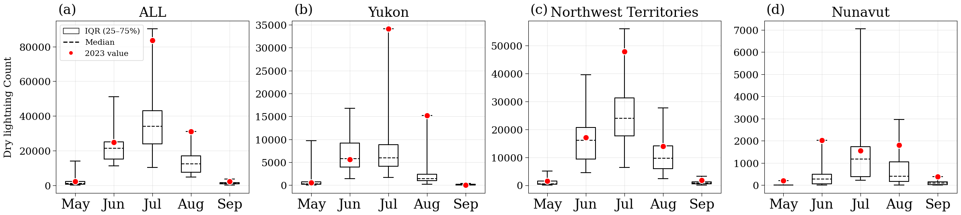Figure S1. Monthly distributions (May–September 1999–2023) of dry lightning flashes across Canada’s three northern territories. Box-and-whisker plots show medians (dashed lines) and interquartile ranges (boxes, 25–75%); whiskers indicate the full range. Red dots mark 2023 values. Panels: (a) ALL, (b) Yukon, (c) Northwest Territories, (d) Nunavut.

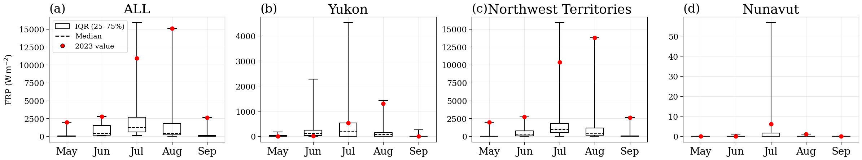
Figure S2. Monthly distributions (May–September 1999–2023) of Fire Radiative Power (FRP) across Canada’s three northern territories. Box-and-whisker plots show medians (dashed lines) and interquartile ranges (boxes, 25–75%); whiskers indicate the full range. Red dots mark 2023 values. Panels: (a) ALL, (b) Yukon, (c) Northwest Territories, (d) Nunavut.

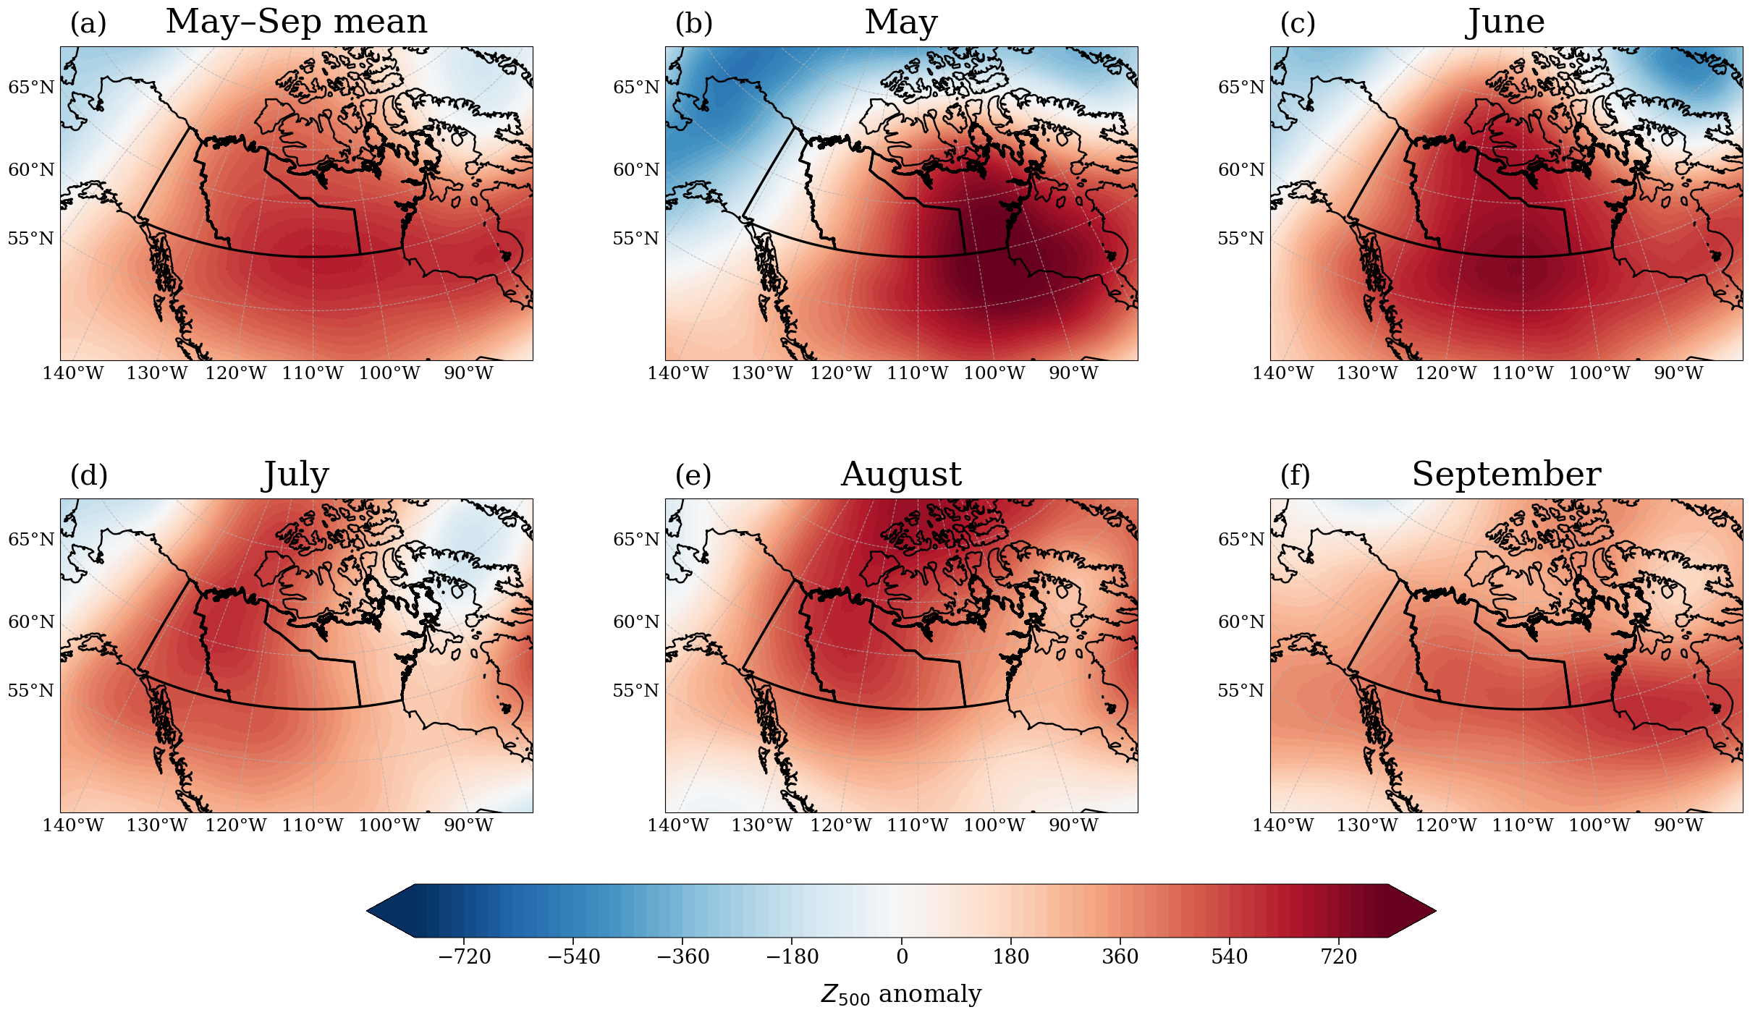
Figure S3. Three-month running-mean anomalies of 500-hPa geopotential height (Z₅₀₀) in 2023 over northern Canada. Panels show (a) May–September mean and monthly fields and for each month from May to September (b–f).
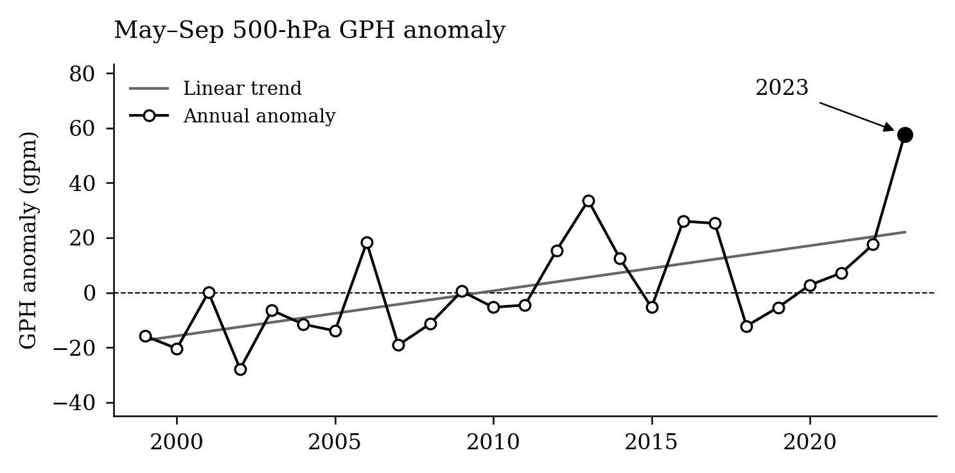
Figure S4. Time series of May–September 500-hPa geopotential height anomalies. Area-averaged 500-hPa geopotential height (GPH) anomalies (in geopotential meters, gpm) over northern Canada from 1999 to 2023.

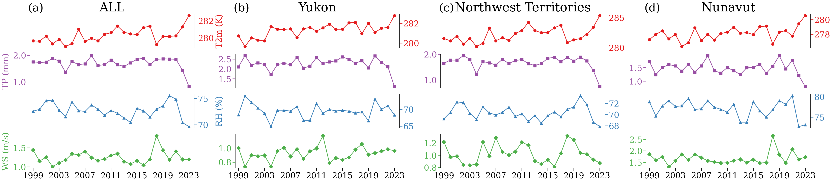
Figure S5. Interannual evolution (1999–2023) of May–September regional means for four Fire Weather Index (FWI) components—2-m air temperature (T2m), Total precipitation (TP), and relative humidity (RH), wind speed (WS)—averaged over (a) ALL, (b) Yukon, (c) Northwest Territories, and (d) Nunavut.

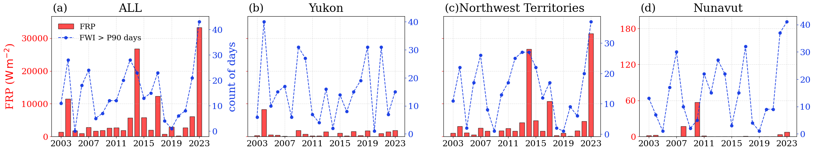
Figure S6. Seasonal (May–September) Fire Radiative Power (FRP; red bars, left axis) and number of days with Fire Weather Index above the 90th-percentile threshold (blue line, right axis) for northern Canada: (a) ALL, (b) Yukon, (c) Northwest Territories, (d) Nunavut.

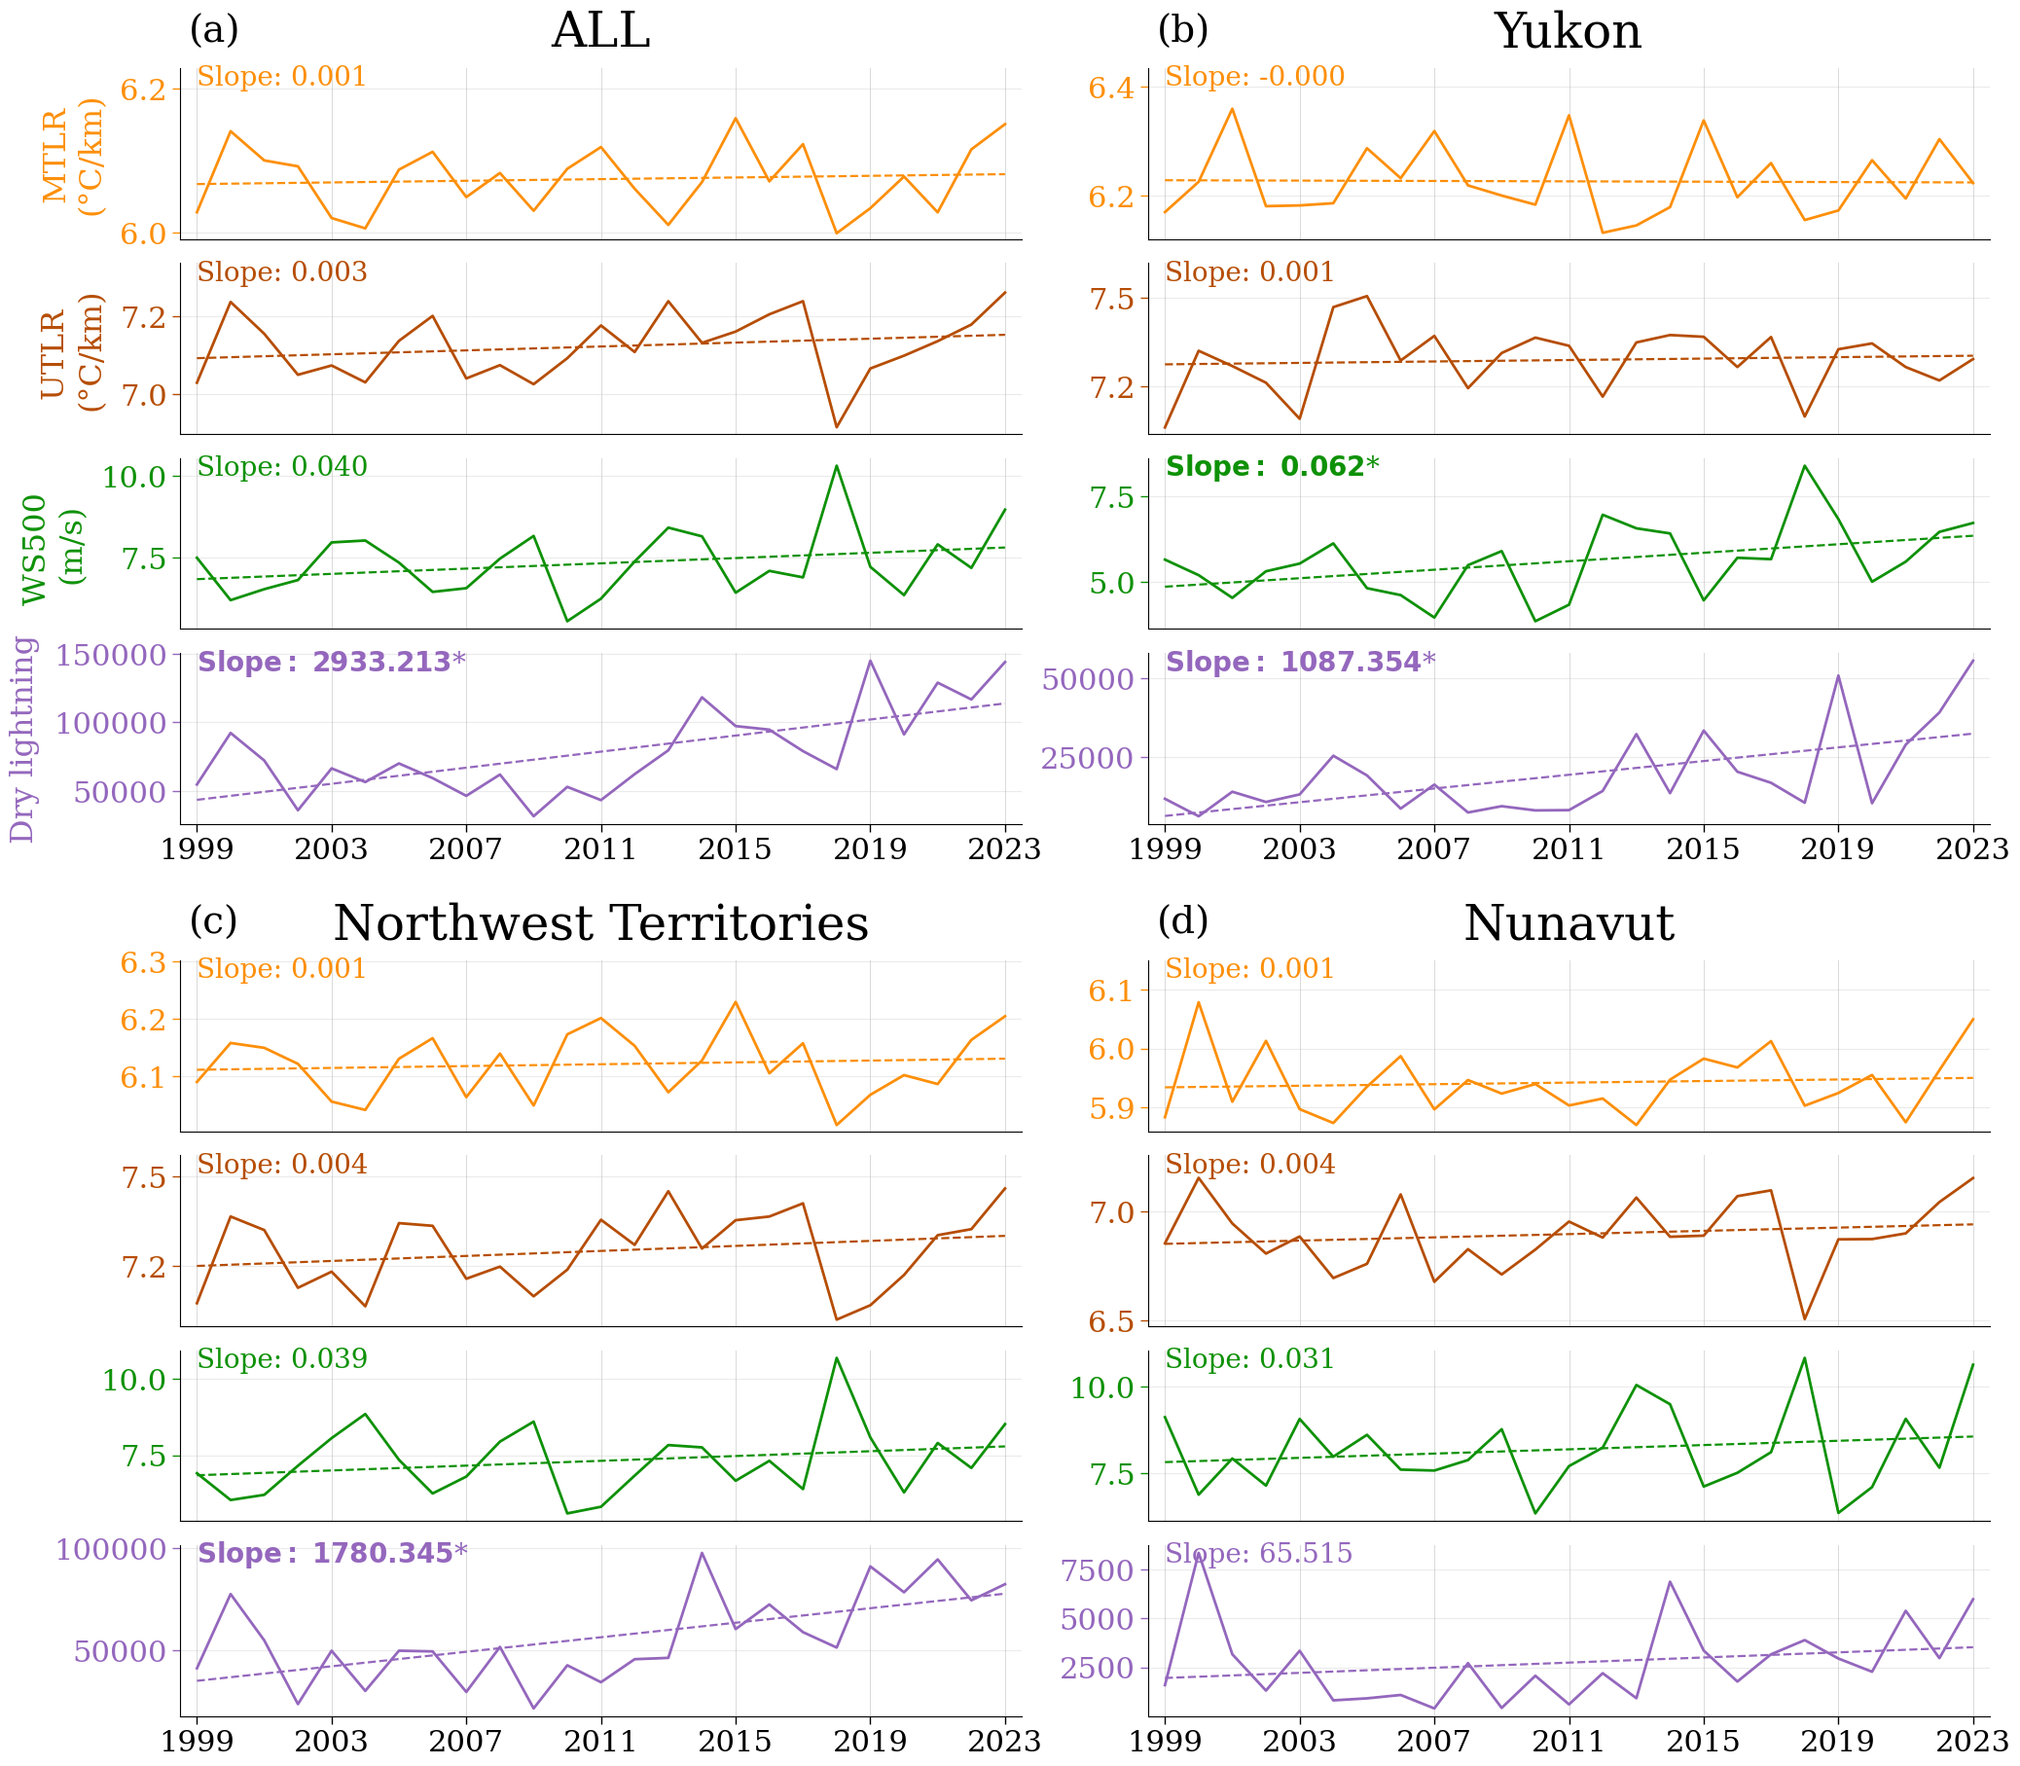
Figure S7. Long-term trends (1999–2023) MTLR, UTLR , WS500 and dry lightning counts for (a) ALL, (b) Yukon, (c) Northwest Territories, and (d) Nunavut. Solid lines show annual seasonal means; dashed lines show ordinary-least-squares linear trend. The annotated slope values are shown on each panel, with boldface and an asterisk (*) indicating statistically significant trends (p < 0.05).

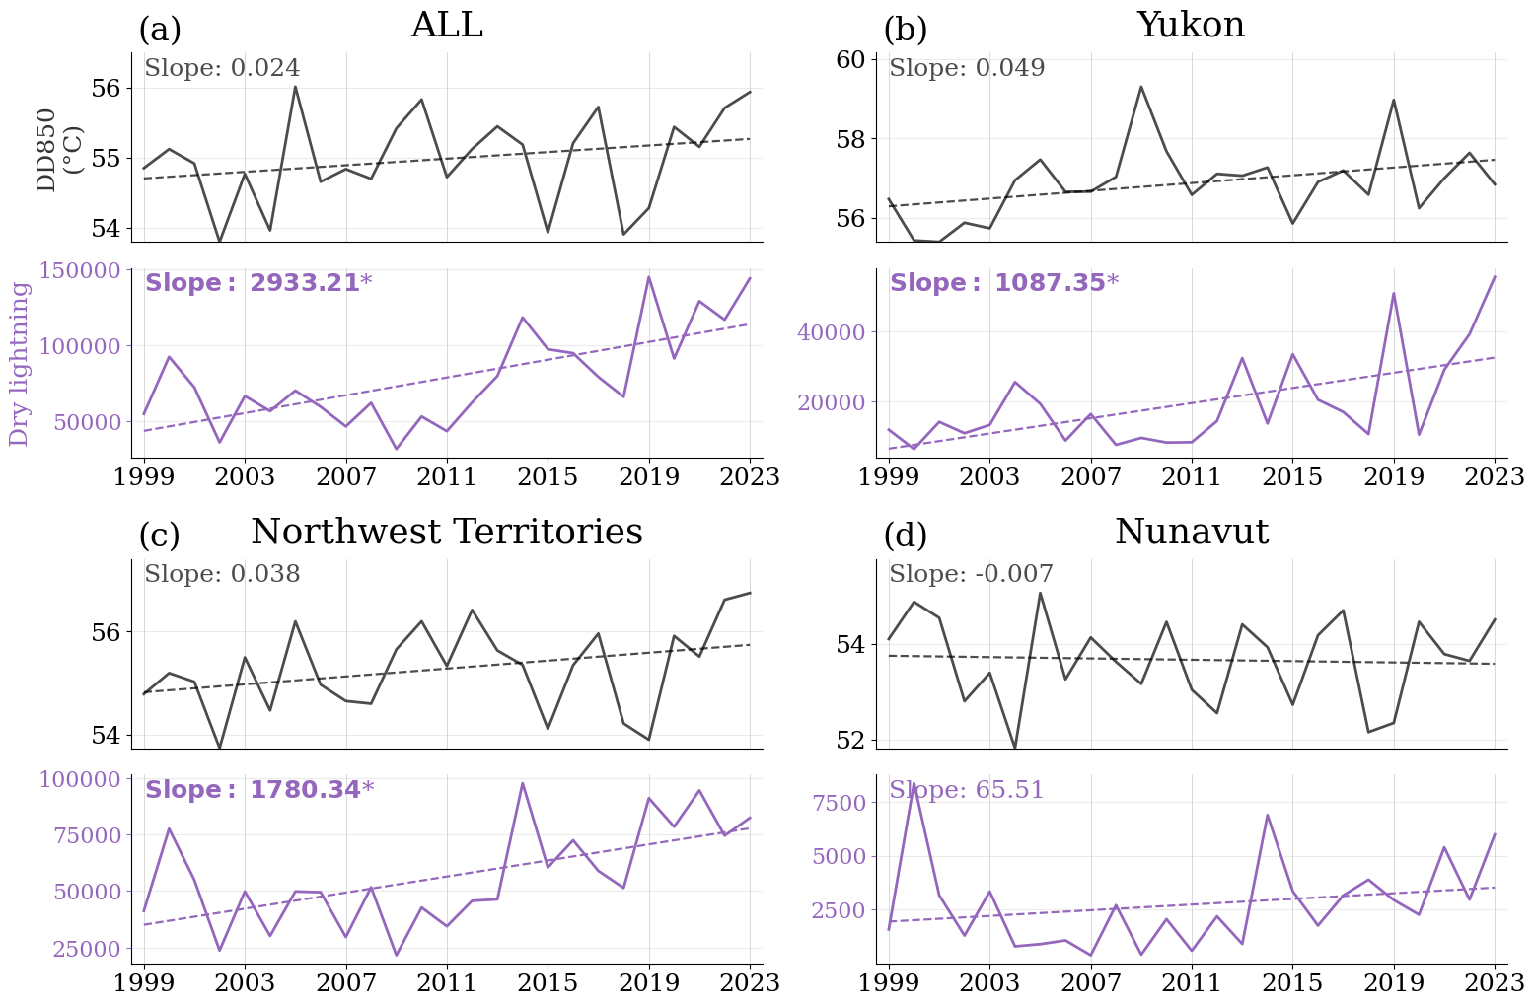
Figure S8. Long-term trends (1999–2023) DD850 and dry lightning counts for (a) ALL, (b) Yukon, (c) Northwest Territories, and (d) Nunavut. Solid lines show annual seasonal means; dashed lines show ordinary-least-squares linear trend. The annotated slope values are shown on each panel, with boldface and an asterisk (*) indicating statistically significant trends (p < 0.05).

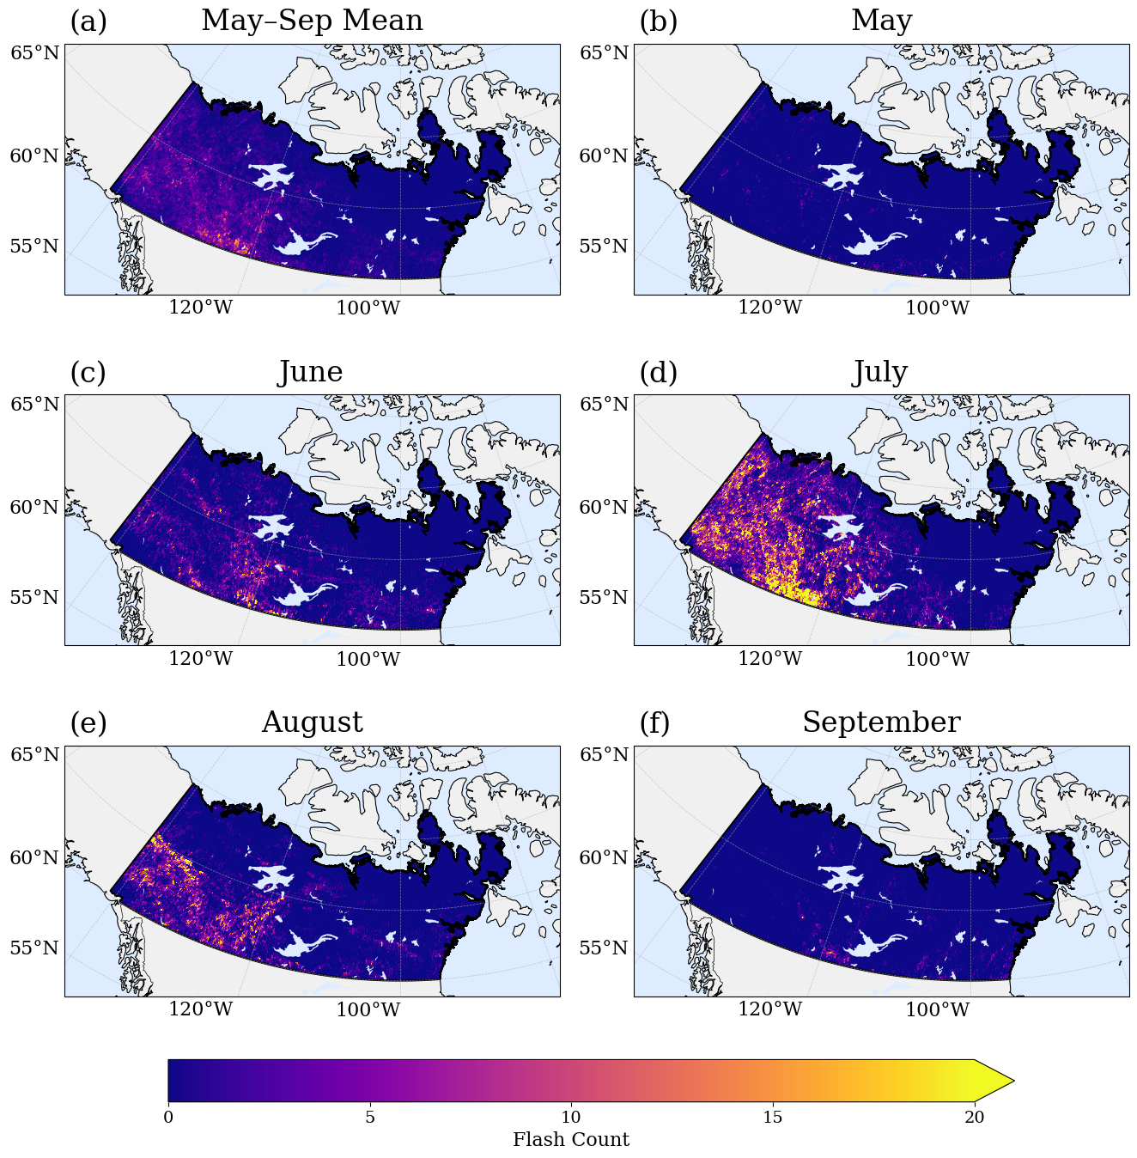 Figure S9. Spatial patterns of dry-lightning flash counts anomalies across northern Canada in 2023, relative to the 1999–2022 climatology. (a) May–September mean, and for each month from May to September (b–f). Color shading denotes flashes anomaly per grid cell.

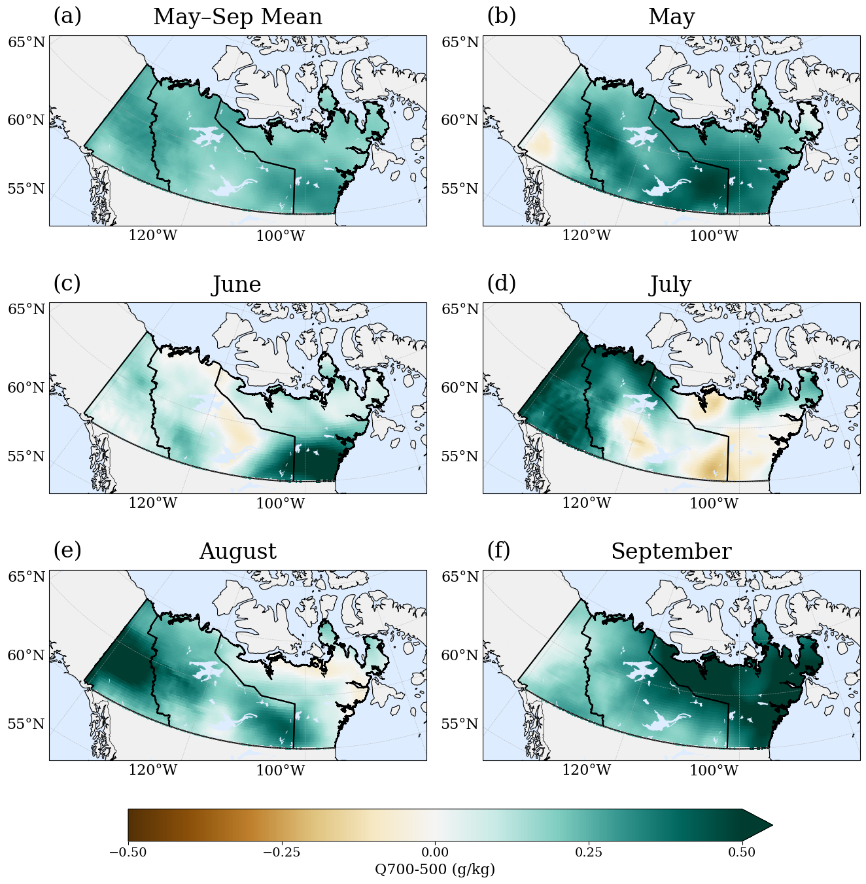
Figure S10. Spatial distribution of 2023 mid-tropospheric moisture (Q700–500, g kg⁻¹) anomalies, relative to the 1999–2022 climatology. averaged over May–September (a) and for each month from May to September (b–f).

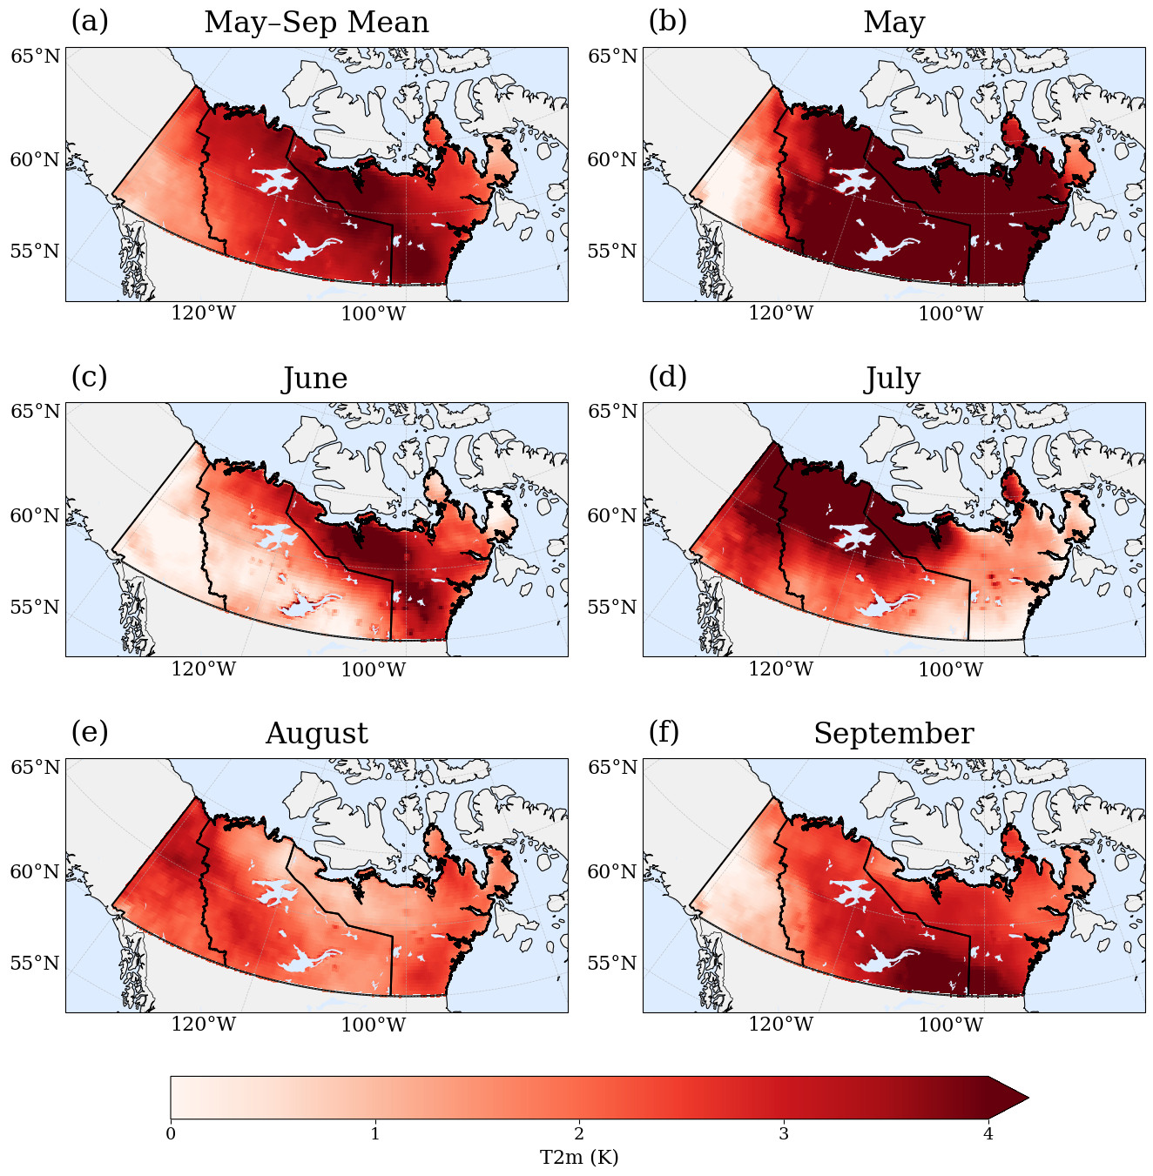
Figure S11. Spatial distribution of 2023 near-surface air temperature (T2m) anomalies, relative to the 1999–2022 climatology. averaged over May–September (a) and for each month from May to September (b–f).

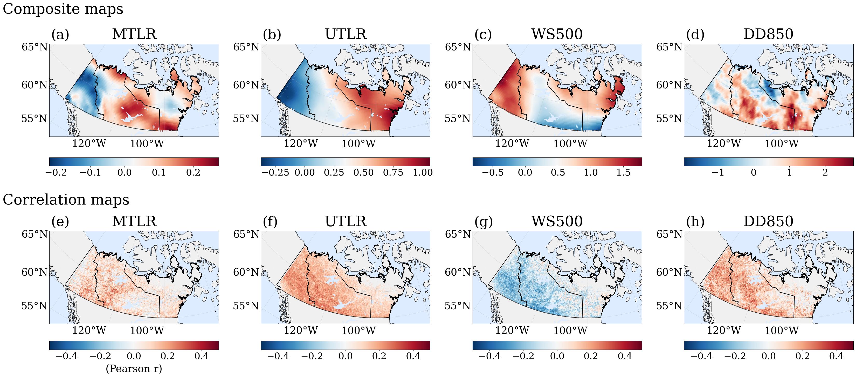
Figure S12. Composite (a–d) and spatial window correlation (d–e) maps of four environmental variables associated with dry-lightning mechanisms (May–September): MTLR (a, e) , UTLR (b, f), WS500 (c, g) and DD850 (d, h).

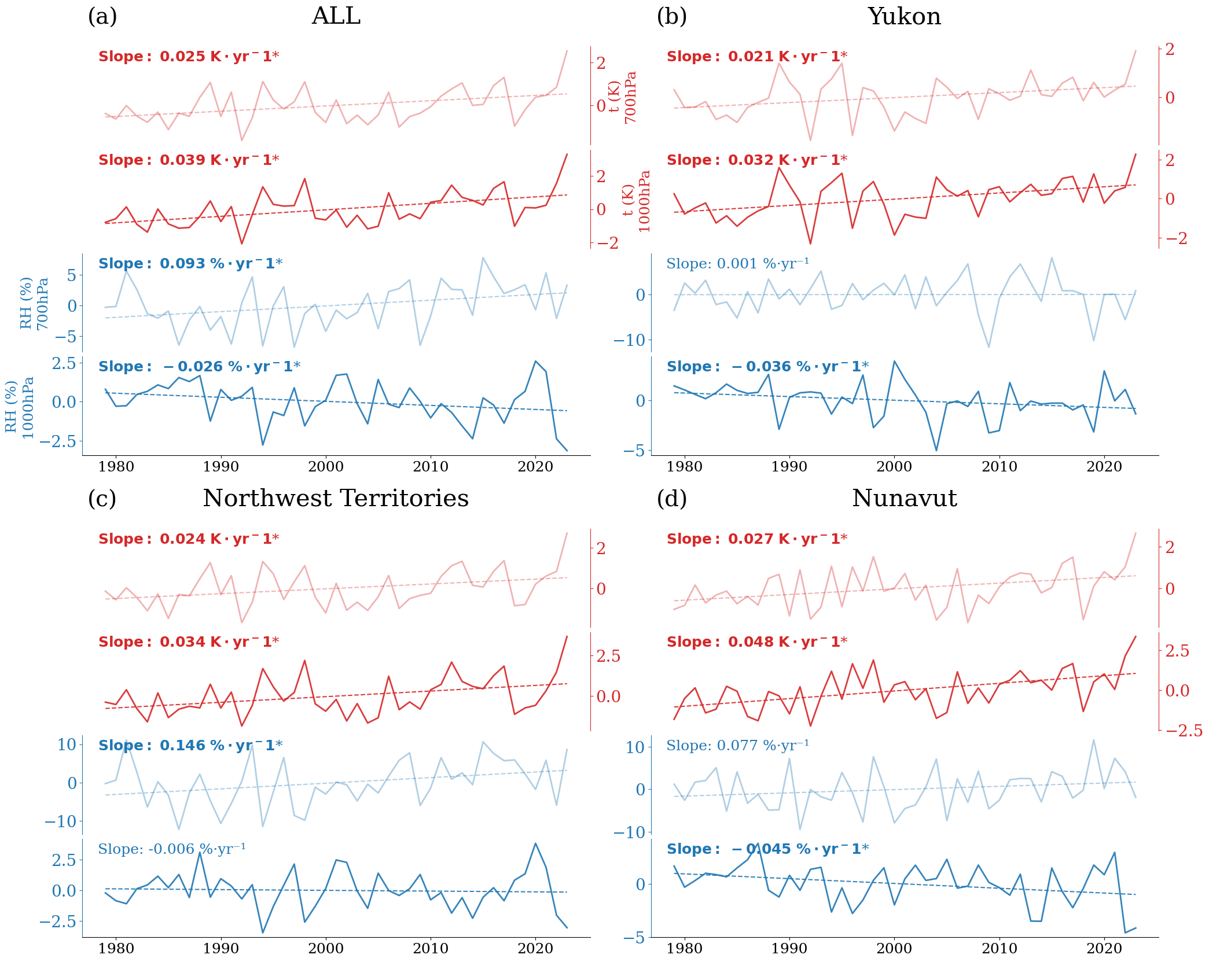
Figure S13. May–September anomalies (1980–2023) of temperature (t, red; right axis) and relative humidity (RH, blue; left axis) at 1000 hPa (dark hues; near-surface) and 700 hPa (light hues; mid-troposphere) for (a) ALL, (b) Yukon, (c) Northwest Territories, and (d) Nunavut. Solid lines indicate annual anomalies, and dashed lines represent linear trends. Boldface and an asterisk (*) denote statistically significant slopes (p < 0.05).

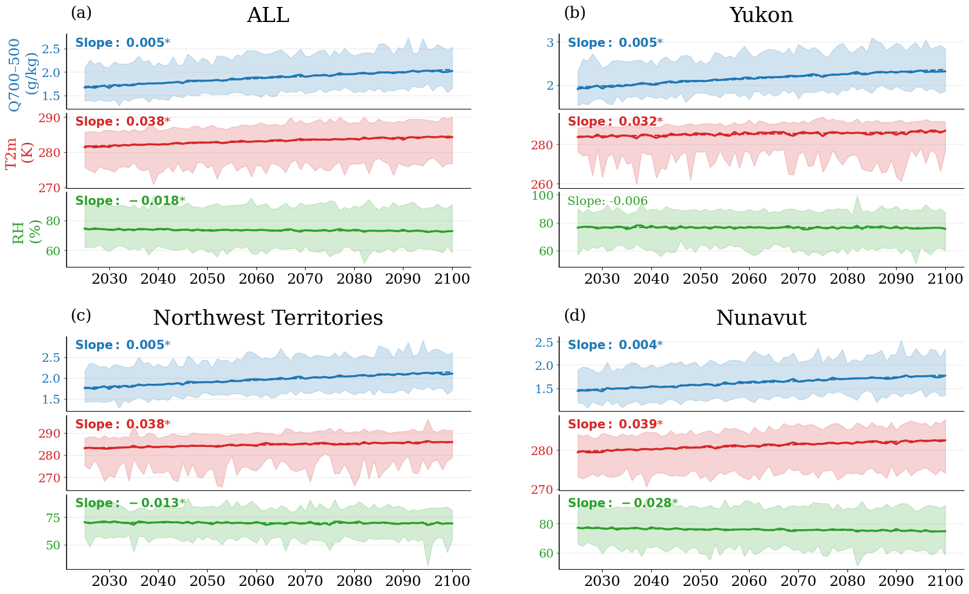
Figure S14. Projected trends in mid-tropospheric moisture (Q700–500), near-surface temperature (T2m), and relative humidity (RH) from 2023 to 2100 under the SSP2-4.5 scenario in the three northern territories of Canada (Yukon, Northwest Territories, and Nunavut). The annotated slope values are shown on each panel, with boldface and an asterisk (*) indicating statistically significant trends (p < 0.05).

