Supplementary information for BMC Cardiovascular Disorders submission
Supplementary Figures S1-S22
Supplementary Tables S1-S5
Supplementary Methods
Data provenance and evidence-boundary note
Clinical group labels used for the GSE309462 single-cell reanalysis were derived from the original public dataset annotations and were used only for secondary, hypothesis-generating interpretation. Donor-level summaries were emphasized for compositional comparisons to reduce pseudo-replication. Exploratory genetic-prioritization, CAD risk-gene burden and metabolic signature analyses were retained as contextual evidence and were not used as primary causal proof. The molecular-dynamics residue-decomposition panel was interpreted only after excluding the ligand self-term from protein-side residue discussion.
Single-cell quality control and annotation
Cells with low detected-gene complexity, extreme feature counts or high mitochondrial transcript fraction were excluded before normalization and integration. Cell identities were assigned using canonical marker hierarchies rather than single-marker labeling. Donor-level summaries were retained for compositional interpretation to reduce pseudo-replication.
Functional scoring and trajectory summaries
Rank-based signature scoring was used to summarize calcification, fibrosis, inflammation, lipid-metabolism and glycolysis-related programs across annotated cell types. Trajectory analyses were used only to visualize ordered transcriptional programs within major lineages and were not interpreted as definitive temporal proof.
Exploratory genetic-prioritization analyses
Cell-type-stratified Mendelian randomization and CAD risk-gene burden analyses were retained as exploratory contextual analyses. They were not used as the primary basis for the article's mechanistic conclusion. For this reason, all captions refer to these outputs as putative, genetically informed or hypothesis-generating.
Docking and molecular dynamics reporting
Molecular docking and molecular dynamics simulation were used to evaluate structural compatibility. The MM/GBSA residue-decomposition interpretation excludes the ligand self-term and focuses only on protein-side residues. The 100-ns trajectory is interpreted as supportive structural plausibility, not as biochemical confirmation of direct in vivo target engagement.
Macrophage perturbation experiments
RAW264.7 and THP-1-derived macrophage experiments were used to test whether colchicine attenuates an oxLDL-induced inflammatory-proteolytic state. TNF rescue and Tnf knockdown were interpreted as pathway-positioning experiments within the tested macrophage framework rather than as definitive proof of an exclusive upstream regulator.
Supplementary Figures
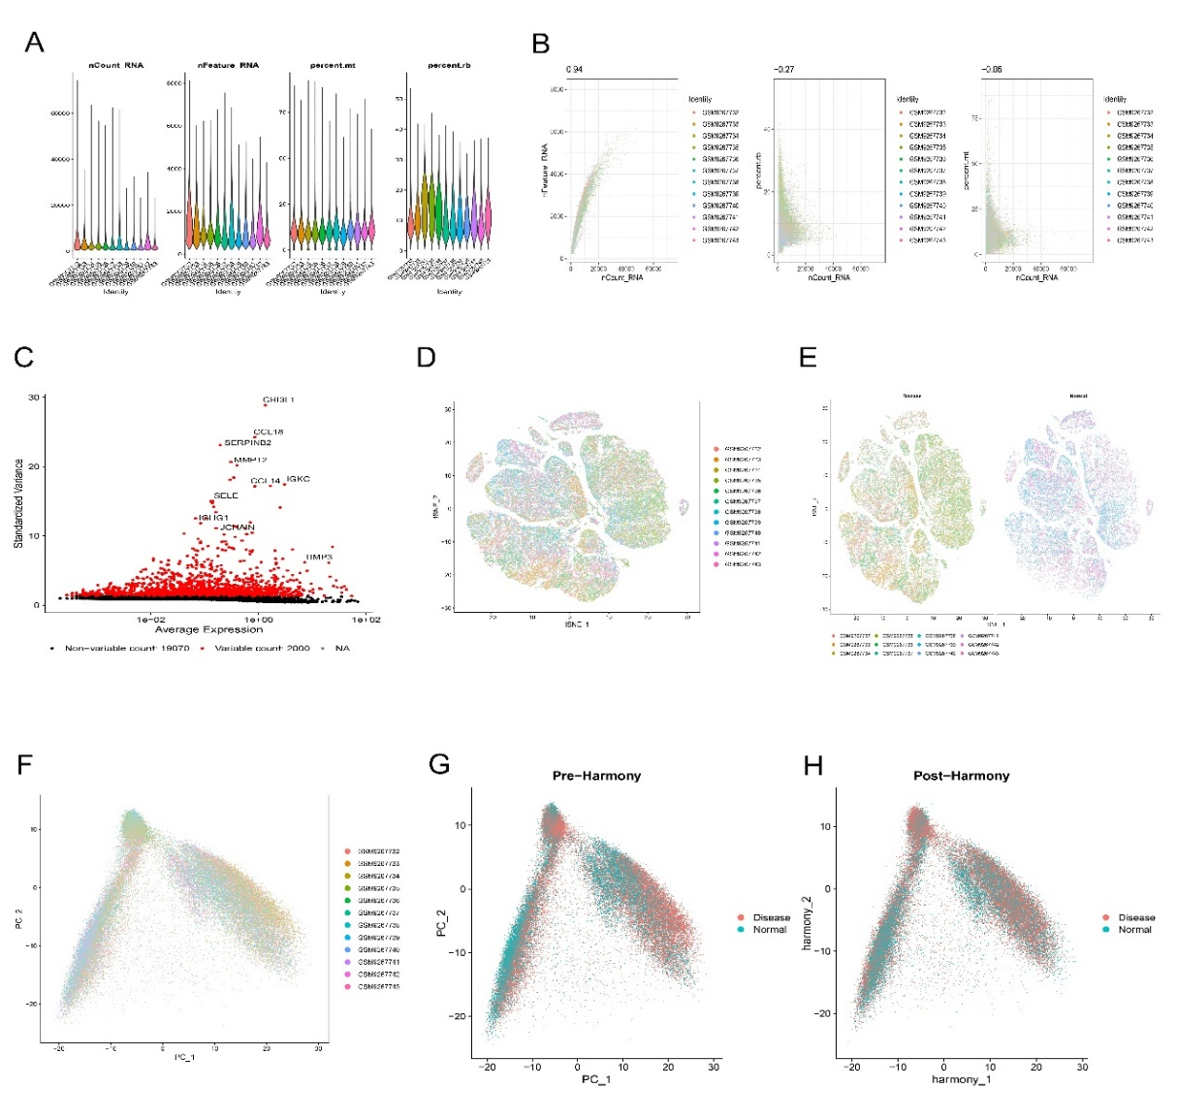
Supplementary Figure 1. Quality control, feature selection and integration of carotid plaque scRNA-seq (GSE309462). Violin plots, depth-complexity relationships, highly variable genes and pre/post-integration embeddings summarize the single-cell quality-control and integration workflow.
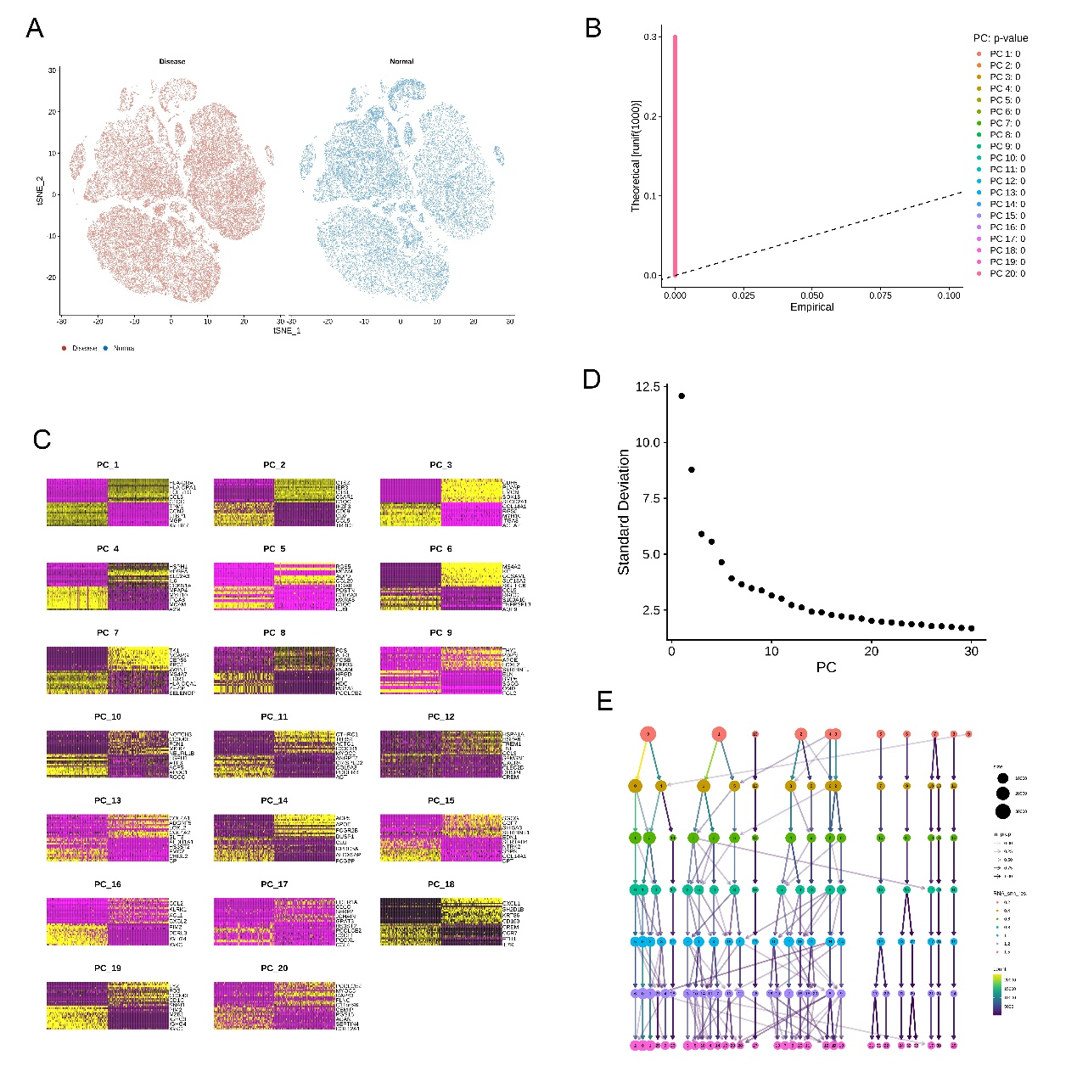
Supplementary Figure 2. Group structure, principal components and clustering topology of carotid plaque scRNA-seq. The panels summarize group distribution, principal-component structure and clustering-resolution stability used to guide annotation.
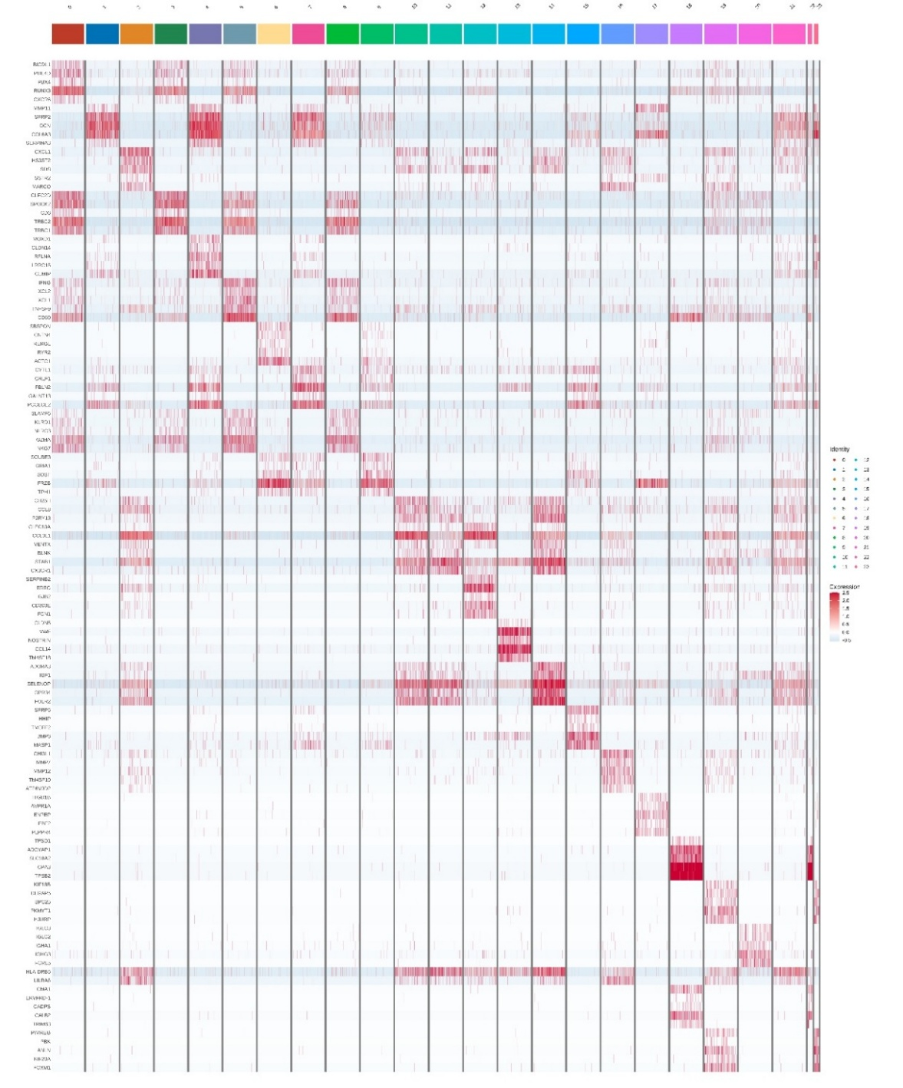
Supplementary Figure 3. Cluster-defining marker genes support cell-type annotation of carotid plaque scRNA-seq. Heat map of scaled marker expression across unsupervised clusters shows stromal, vascular, myeloid, lymphoid, plasma-cell and mast-cell programs.
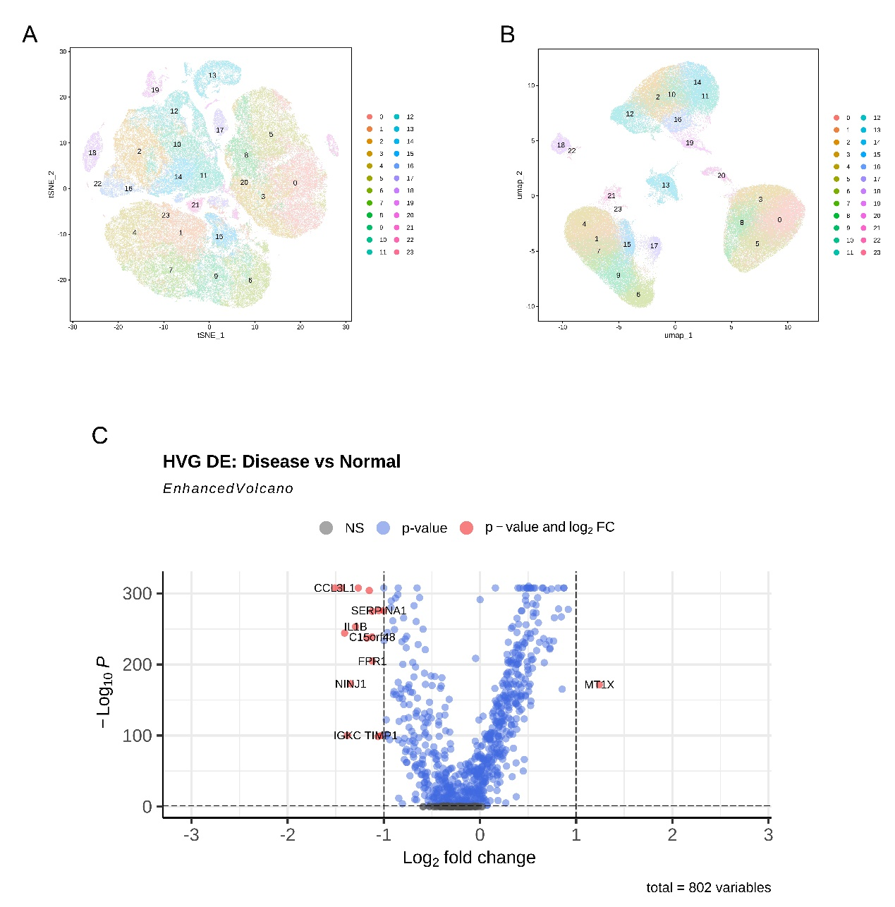
Supplementary Figure 4. Unsupervised clustering and HVG-level differential expression between symptomatic and asymptomatic plaques. t-SNE, UMAP and volcano representations summarize cluster topology and disease-associated highly variable genes.
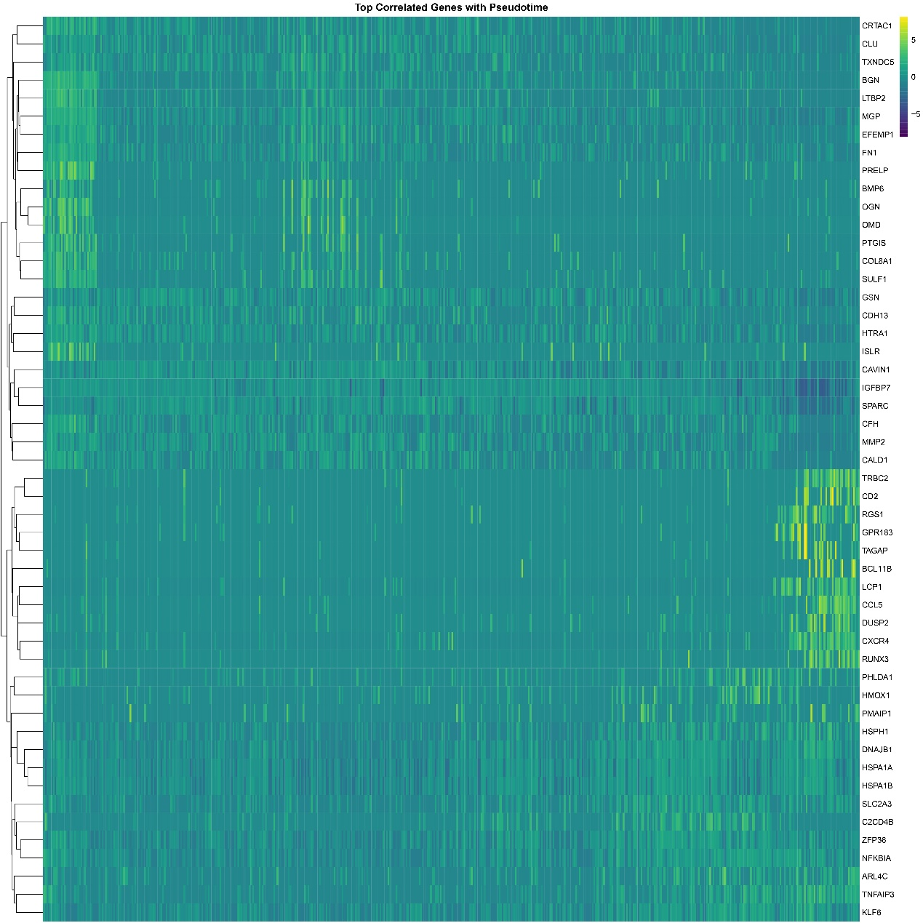
Supplementary Figure 5. Gene programs associated with trajectory ordering in carotid plaque cells. Heat map of pseudotime-associated genes highlights extracellular-matrix, inflammatory, immune-activation and chemotaxis-related transcriptional programs. This analysis is descriptive and hypothesis-generating.
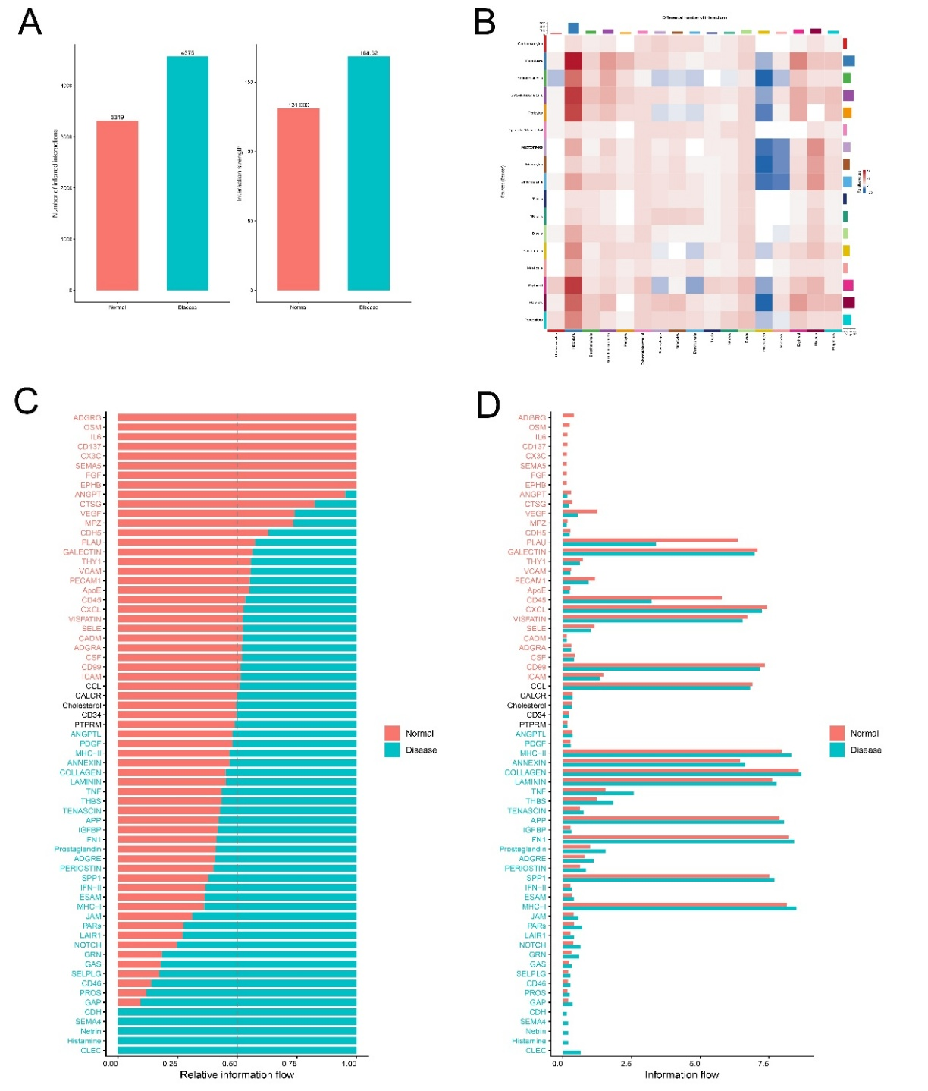
Supplementary Figure 6. Global cell-cell communication landscape in asymptomatic and symptomatic carotid plaques. CellChat inference summarizes total inferred interaction number, aggregate interaction strength and pathway-level information flow.
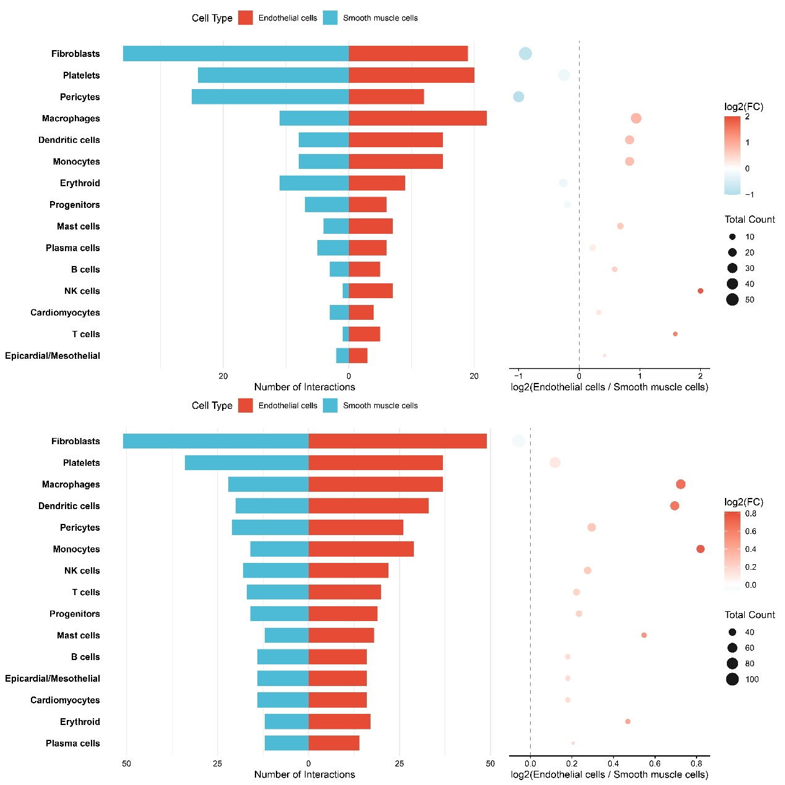
Supplementary Figure 7. Endothelial- versus smooth muscle-derived outgoing signaling bias. Diverging bars and dot plots compare EC-derived and SMC-derived inferred outgoing ligand-receptor interactions across recipient cell populations.
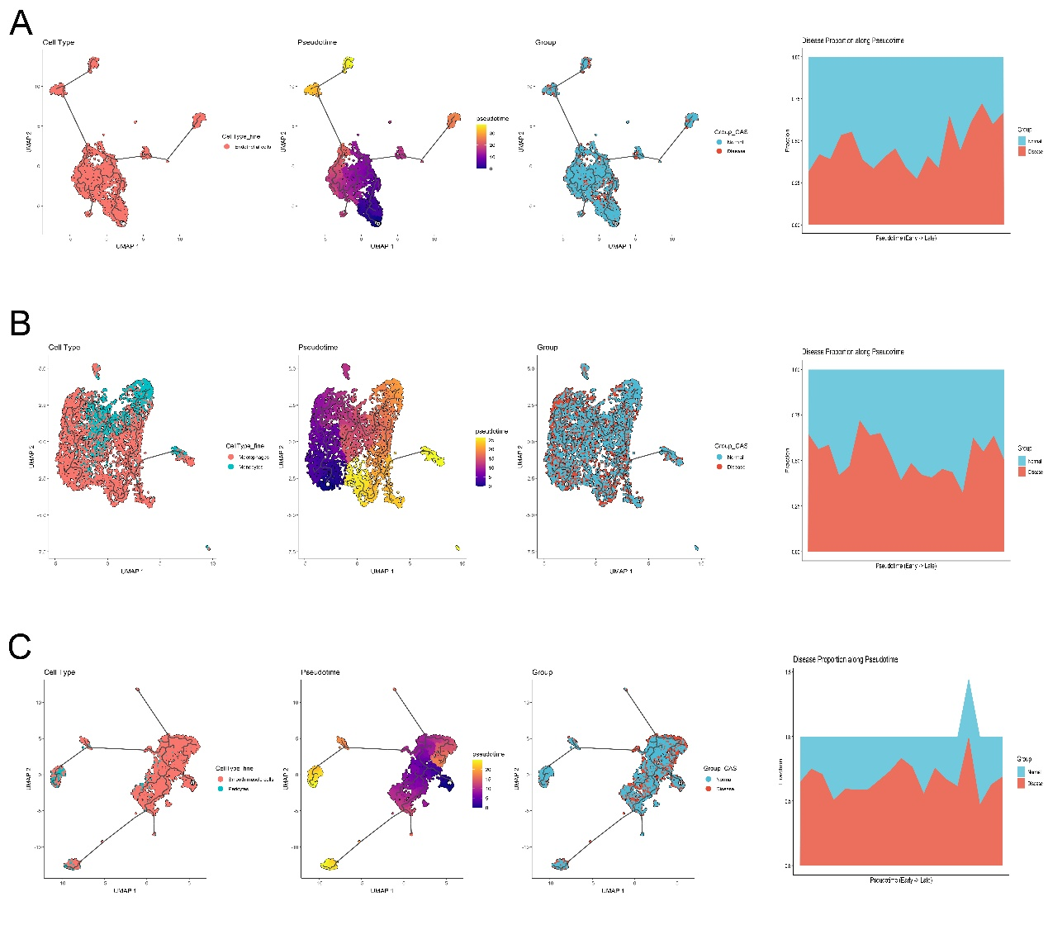
Supplementary Figure 8. Lineage-resolved pseudotime trajectories and disease enrichment along progression. Endothelial, myeloid and mural lineage trajectories are shown with inferred pseudotime and symptomatic/asymptomatic representation along the ordered axis.
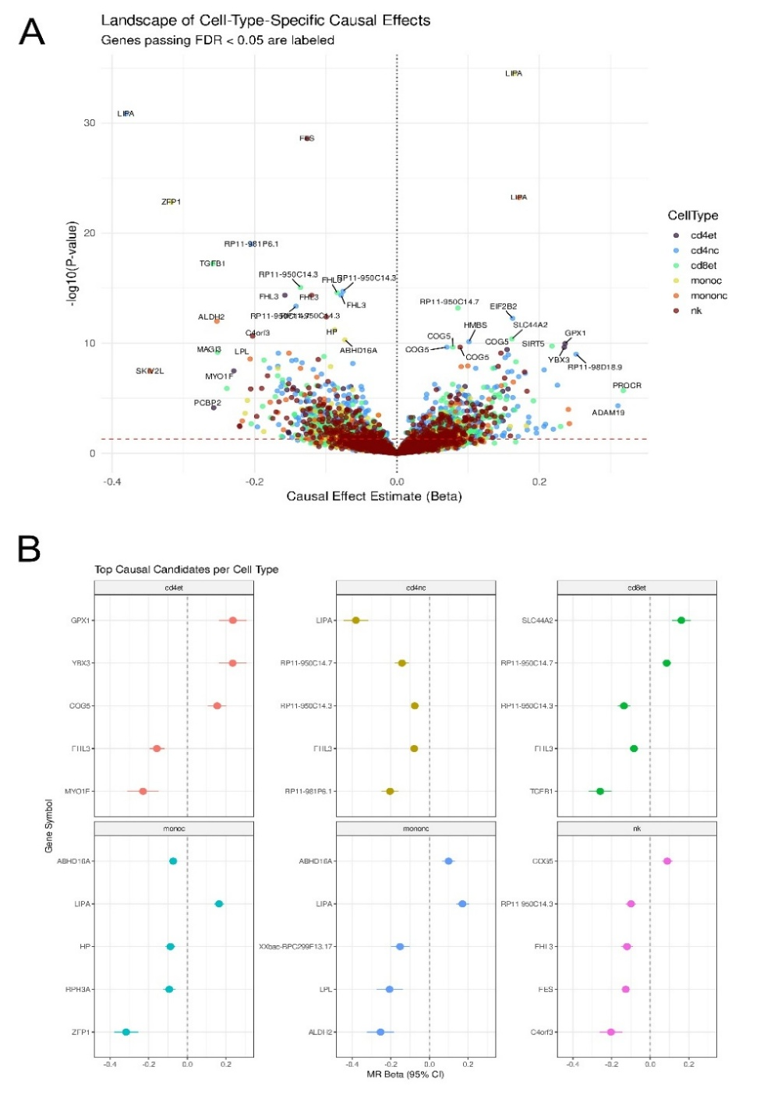
Supplementary Figure 9. Exploratory immune cell-type-specific genetically informed prioritization landscape. Cell-type-stratified analyses nominate putative driver genes. These analyses are retained only as exploratory genetic context and are not used as definitive causal evidence.
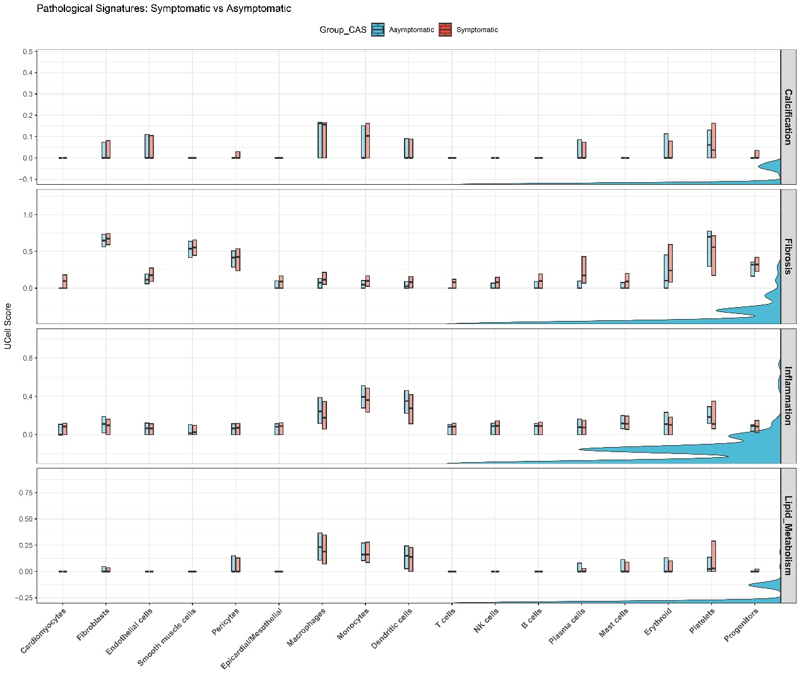
Supplementary Figure 10. Cell-type-resolved pathological signature activity in symptomatic versus asymptomatic carotid atherosclerosis. UCell rank-based scoring summarizes calcification, fibrosis, inflammation and lipid-metabolism programs across cell types.
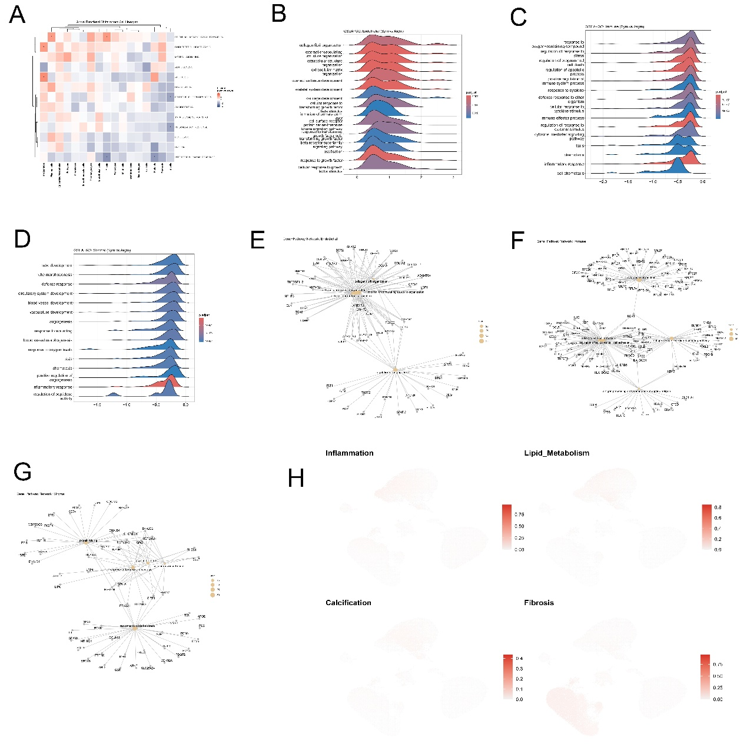
Supplementary Figure 11. Cell-lineage-resolved functional remodeling in symptomatic versus asymptomatic carotid plaques. Heat maps and feature visualizations summarize functional shifts across vascular and immune compartments.
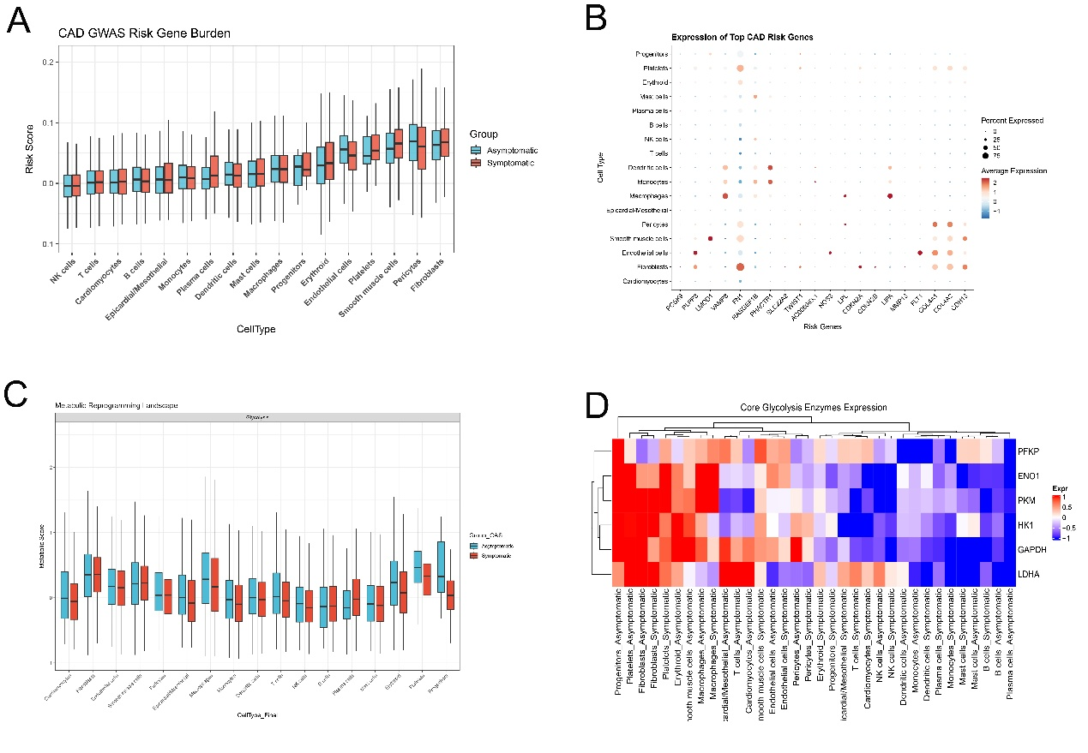
Supplementary Figure 12. Exploratory cell-type-specific CAD genetic risk burden and glycolytic reprogramming across symptomatic status. These analyses provide contextual support for vascular and metabolic remodeling but are not interpreted as primary causal evidence.
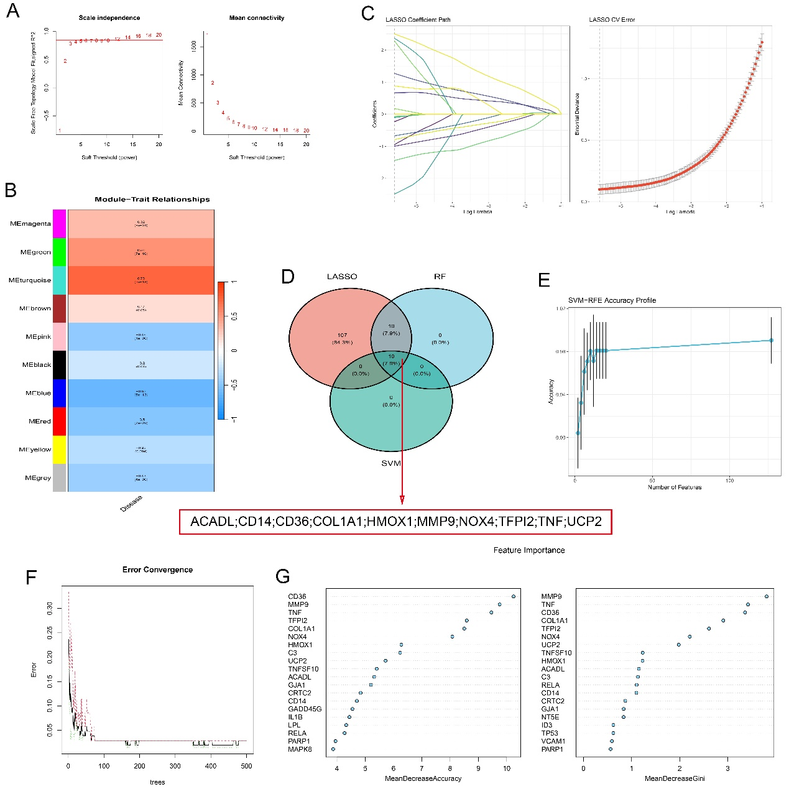
Supplementary Figure 13. Systems-level module discovery and machine-learning feature selection for candidate genes. WGCNA, feature-selection filters and overlap analyses support candidate prioritization.
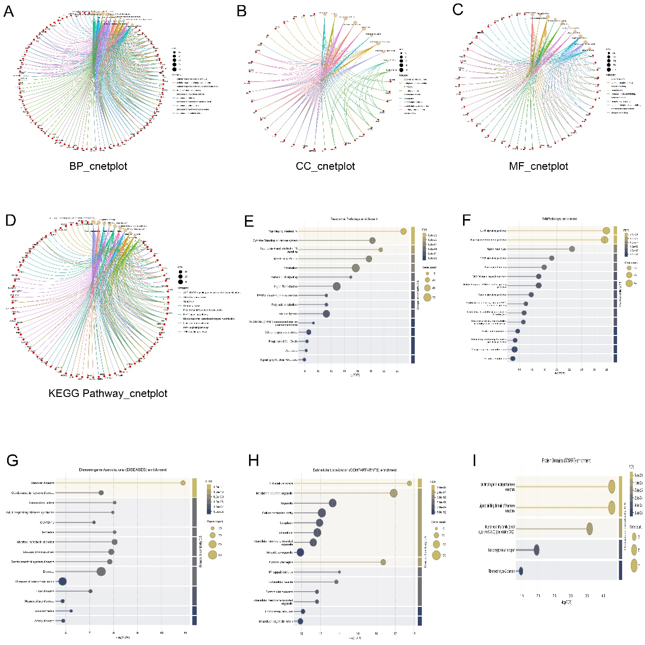
Supplementary Figure 14. Multi-database functional enrichment landscape of candidate gene set. Pathway and disease-enrichment summaries support inflammatory, proteolytic and vascular-remodeling interpretation of the candidate genes.
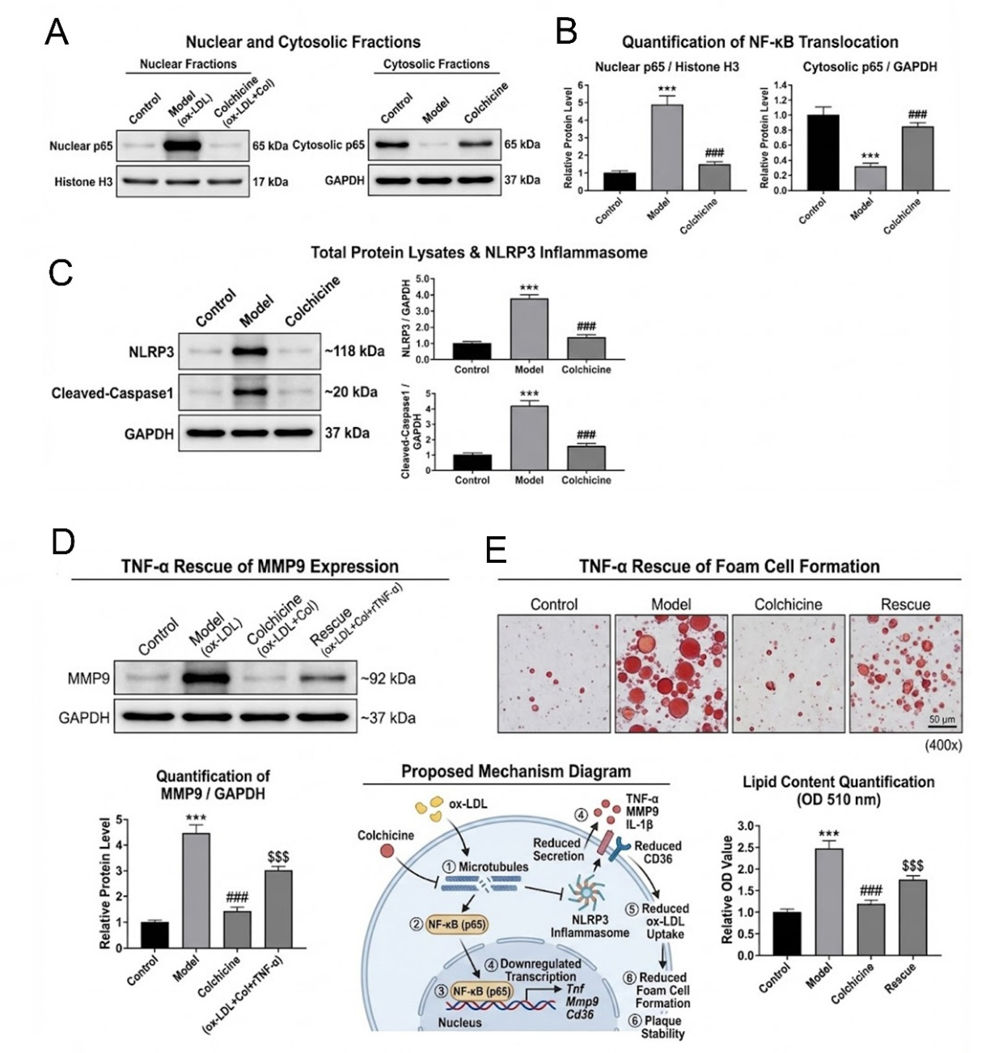
Supplementary Figure 15. Colchicine suppresses NF-kappa B/NLRP3 activation and TNF-alpha rescues MMP9 expression and foam-cell formation. Western blotting, nuclear fractionation, ELISA and Oil Red O analyses support the macrophage inflammatory-proteolytic framework.
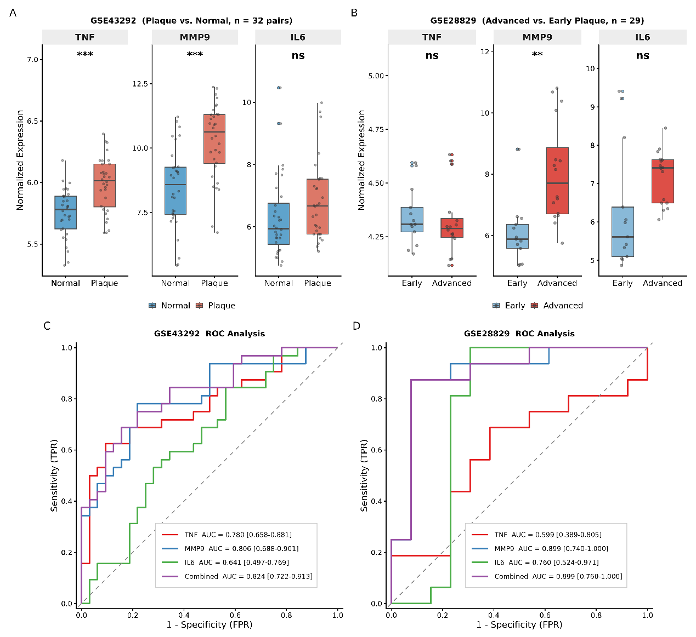
Supplementary Figure 16. Independent transcriptomic validation and marker-level discrimination of TNF, MMP9 and IL6 in external atherosclerosis datasets. Receiver operating characteristic curves are descriptive marker-level summaries and are not diagnostic model validation.
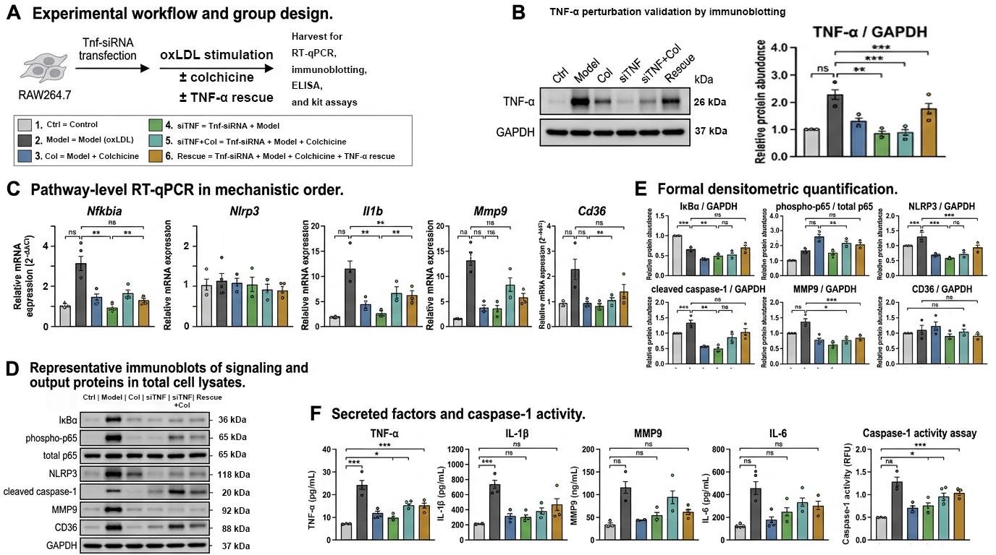
Supplementary Figure 17. TNF loss-of-function defines the upstream position of TNF in the colchicine-responsive macrophage inflammatory-proteolytic program in oxLDL-primed RAW264.7 foam cells.
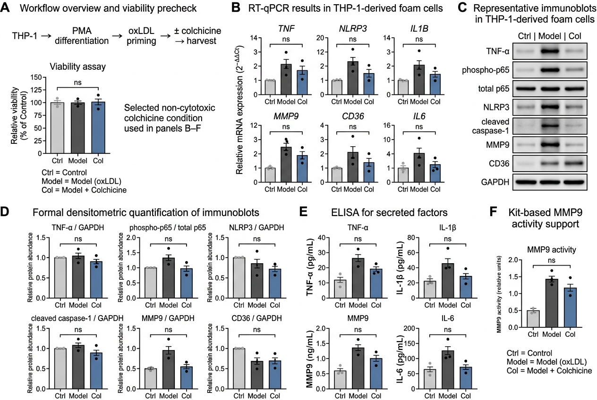
Supplementary Figure 18. Orthogonal support for colchicine-responsive inflammatory-proteolytic modulation in oxLDL-primed THP-1-derived macrophage foam cells.
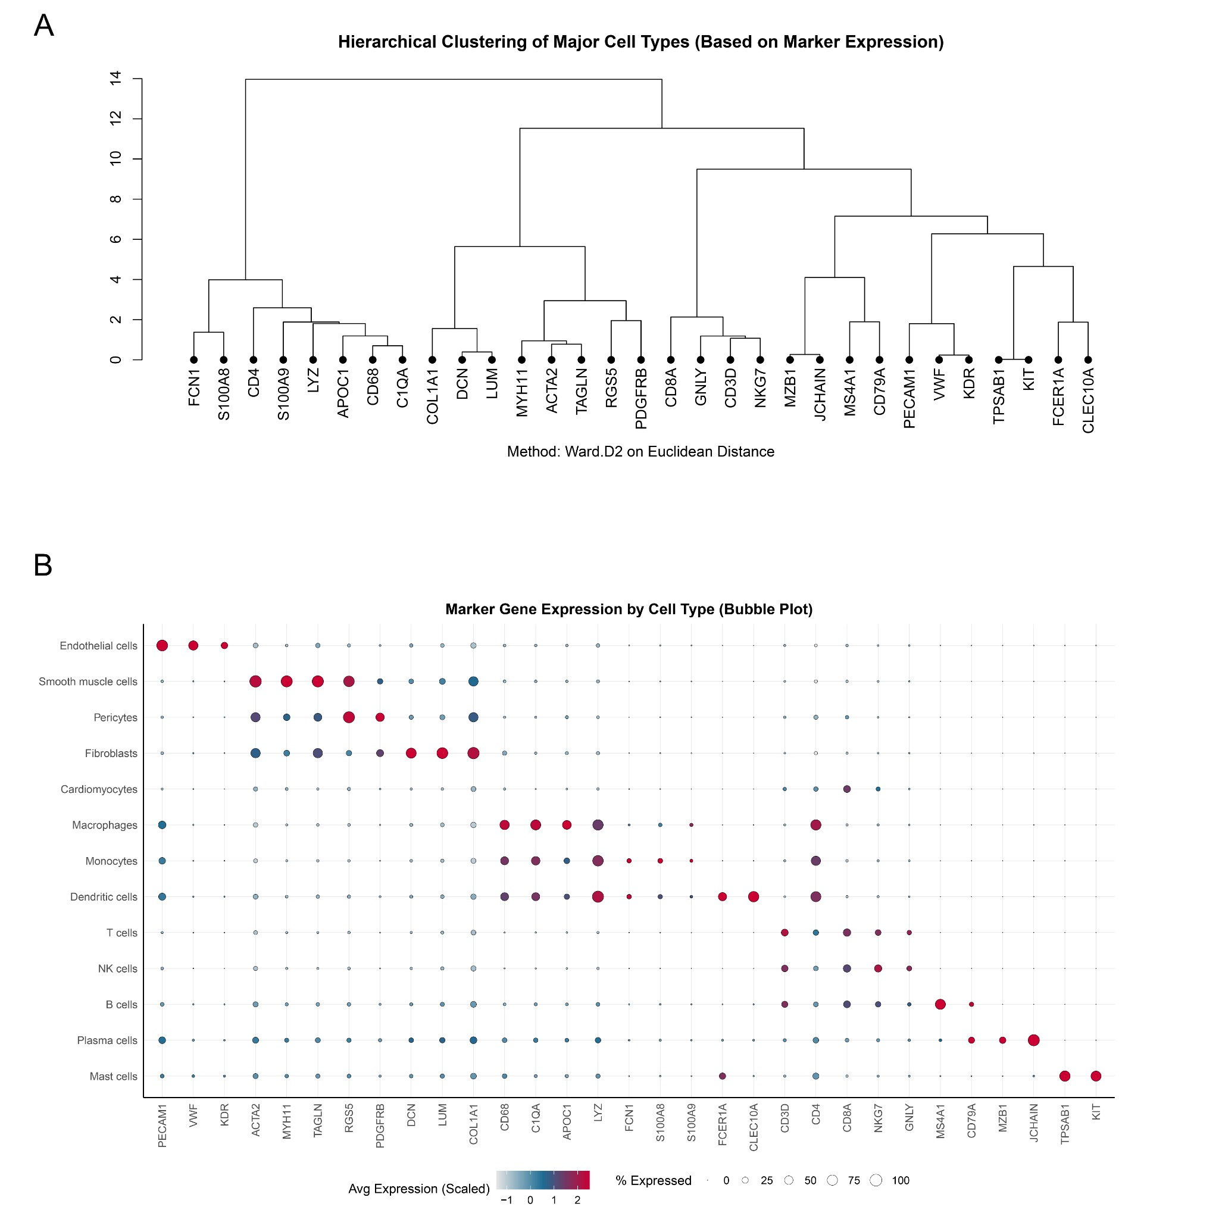
Supplementary Figure 19. Marker-based validation and hierarchical relationships among plaque cell types.
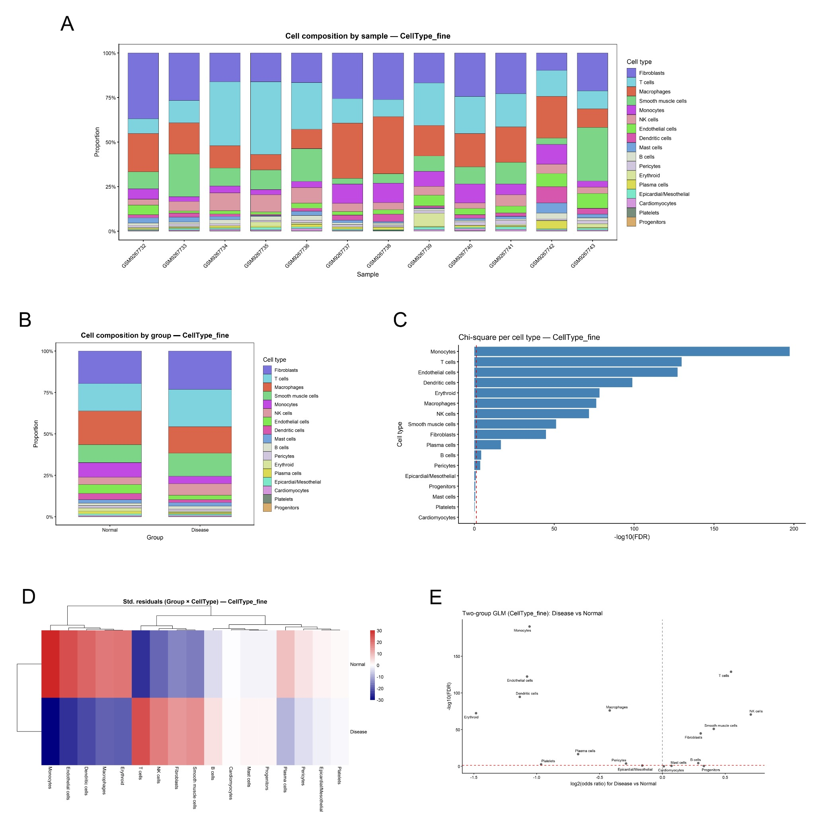
Supplementary Figure 20. Subject-level compositional modeling of symptomatic versus asymptomatic carotid plaques.
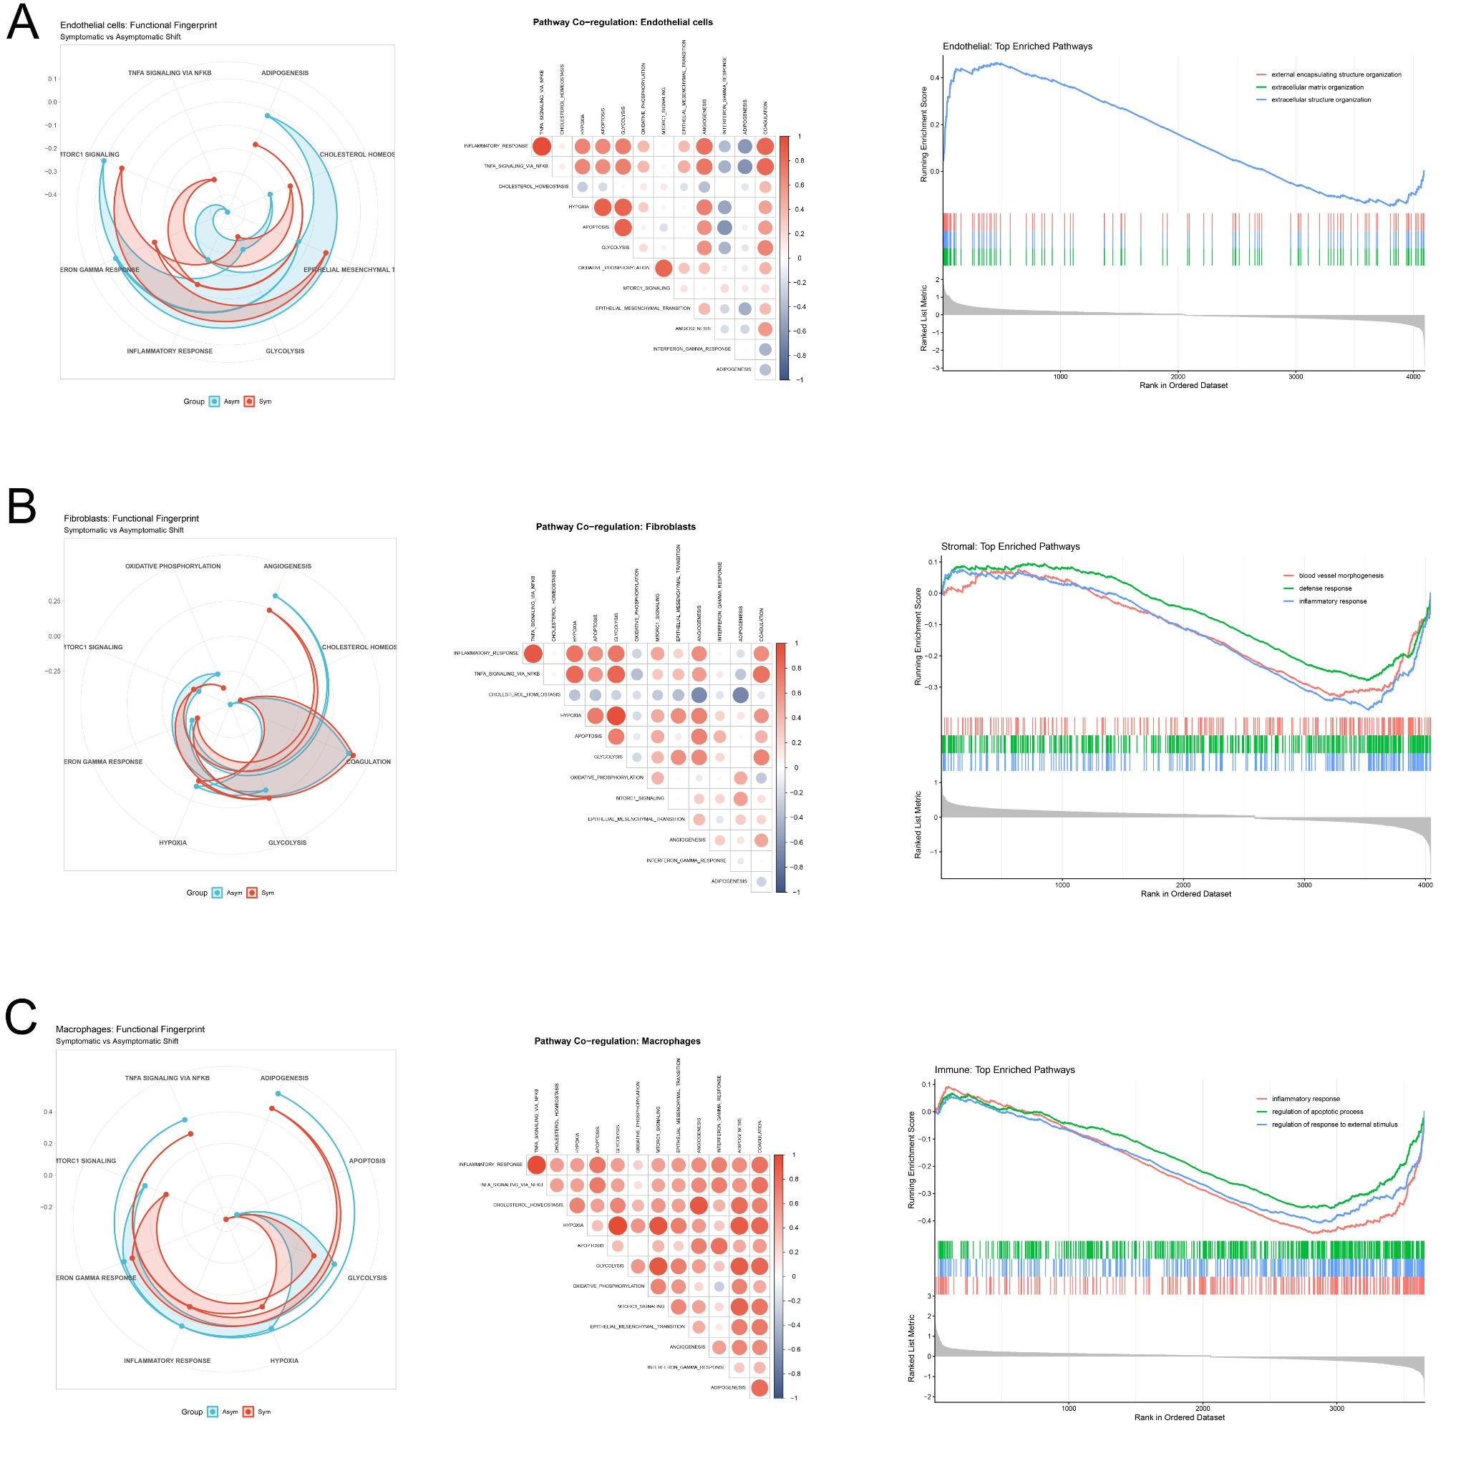
Supplementary Figure 21. Functional fingerprinting and pathway co-regulation across key vascular and immune compartments.

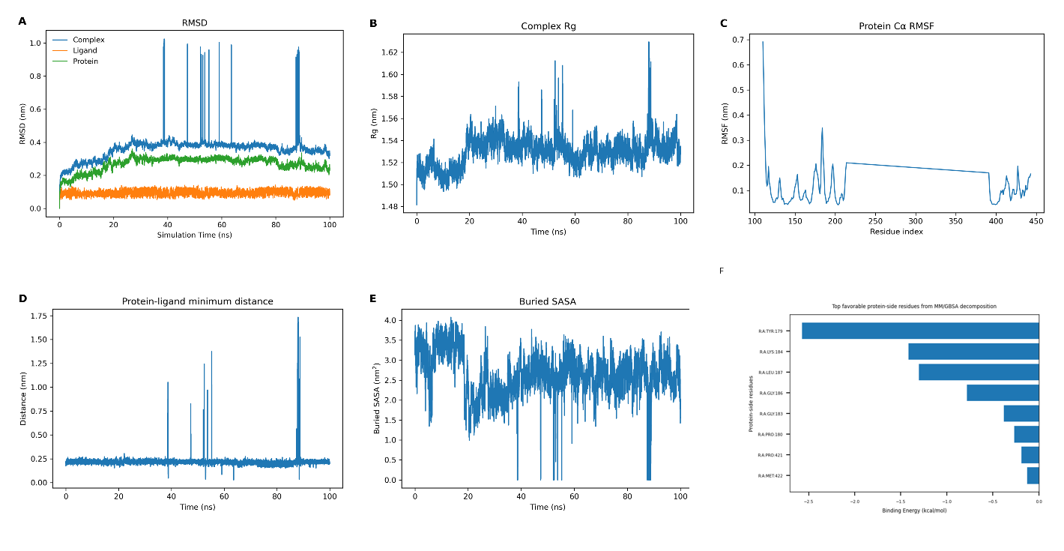
Supplementary Figure 22. Molecular dynamics simulation of the colchicine-MMP9 complex. RMSD, radius of gyration, RMSF, protein-ligand distance, buried solvent-accessible surface area and MM/GBSA decomposition support structural plausibility while retaining the boundary that MD does not prove direct biochemical target engagement. The corrected decomposition panel displays protein-side residue contributions after excluding the ligand self-term, and the trajectory is interpreted as predominant or recurrent pocket engagement with transient excursions rather than as experimental proof of binding.

Supplementary Tables
Supplementary Table 1. Molecular docking results of colchicine with core targets. Predicted Ki values were removed from the main table because docking scores should not be overinterpreted as experimental binding constants.
Ligand | PubChem CID | Receptor protein | PDB ID | Docking affinity (kcal/mol) | Ligand efficiency
Colchicine | 6167 | Matrix metallopeptidase 9 (MMP9) | 4WZV | -12.22 | 0.421
Colchicine | 6167 | Tumor necrosis factor alpha (TNF-alpha) | 2AZ5 | -6.769 | 0.233

Supplementary Table 2. Primary antibodies for Western blotting.
Target protein | Expected molecular weight (kDa) | Host species / clonality | Dilution
MMP-9 | ~92 (Pro) / ~84 (Active) | Rabbit polyclonal | 1:1000
TNF-alpha | ~26 (membrane) / ~17 (soluble) | Rabbit polyclonal | 1:1000
CD36 | 88 | Rabbit monoclonal | 1:1000
NF-kappa B p65 | 65 | Rabbit monoclonal | 1:1000
NLRP3 | ~118 | Rabbit monoclonal | 1:1000
Caspase-1 | ~45 (pro) / ~20 (cleaved) | Rabbit monoclonal | 1:1000
Lamin B1 | 66 | Rabbit monoclonal | 1:2000
GAPDH | 36 | Rabbit monoclonal | 1:5000
Histone H3 | 17 | Rabbit monoclonal | 1:2000

Supplementary Table 3. Oligonucleotide sequences for RT-qPCR.
Gene symbol | Species | Forward primer sequence (5′ to 3′) | Reverse primer sequence (5′ to 3′) | Amplicon size (bp)
Tnf | Mus musculus | CCTGTAGCCCACGTCGTAG | GGGAGTAGACAAGGTACAACCC | 108
Mmp9 | Mus musculus | CTGGACAGCCAGACACTAAAG | CTCGCGGCAAGTCTTCAGAG | 134
Cd36 | Mus musculus | ATGGGCTGTGATCGGAACTG | GTCTTCCCAATAAGCATGTCTCC | 165
Il1b | Mus musculus | GCAACTGTTCCTGAACTCAACT | ATCTTTTGGGGTCCGTCAACT | 152
Gapdh | Mus musculus | AGGTCGGTGTGAACGGATTTG | TGTAGACCATGTAGTTGAGGTCA | 123

Supplementary Table 4. Public datasets and analytical roles.
Dataset | Data type | Primary role in this study | Interpretation boundary
GSE41622 | Bulk plaque transcriptome | Discovery of disease-associated genes and modules | Prioritization only; not a diagnostic model
GSE100927 | Bulk vascular transcriptome | Independent discovery support and module overlap | Cross-platform differences considered
GSE309462 | Human carotid plaque scRNA-seq | Donor-aware cell atlas, composition, functional remodeling and communication inference | Donor-level interpretation; modest cohort size
GSE43292 | Paired plaque/intact tissue transcriptome | External validation of candidate genes | Marker-level summary only
GSE28829 | Early-versus-advanced plaque transcriptome | External validation of advanced plaque signals | Marker-level summary only

Supplementary Table 5. Analytical layers and evidence boundaries.
Analytical layer | Main output | How it was interpreted
Bulk transcriptomics and network topology | Six-gene core and ten-gene prioritization panel | Mechanistic prioritization, not clinical classification
Single-cell atlas | Composition, marker validation and lineage remodeling | Donor-aware plaque context
CellChat inference | EC-to-SMC and global communication rewiring | Hypothesis-generating ligand-receptor inference
Docking and molecular dynamics | Structural compatibility and trajectory plausibility for colchicine-MMP9 | Supportive structural plausibility only
Macrophage perturbation assays | Suppression of foam-cell, inflammatory and proteolytic readouts | Experimental support for macrophage program responsiveness

