Supporting Information
Volumetric Bioprinting of Aqueous Two-Phase Bioinks Enables High-Fidelity Microporous Hydrogel Scaffolds for Volumetric Muscle Loss Repair
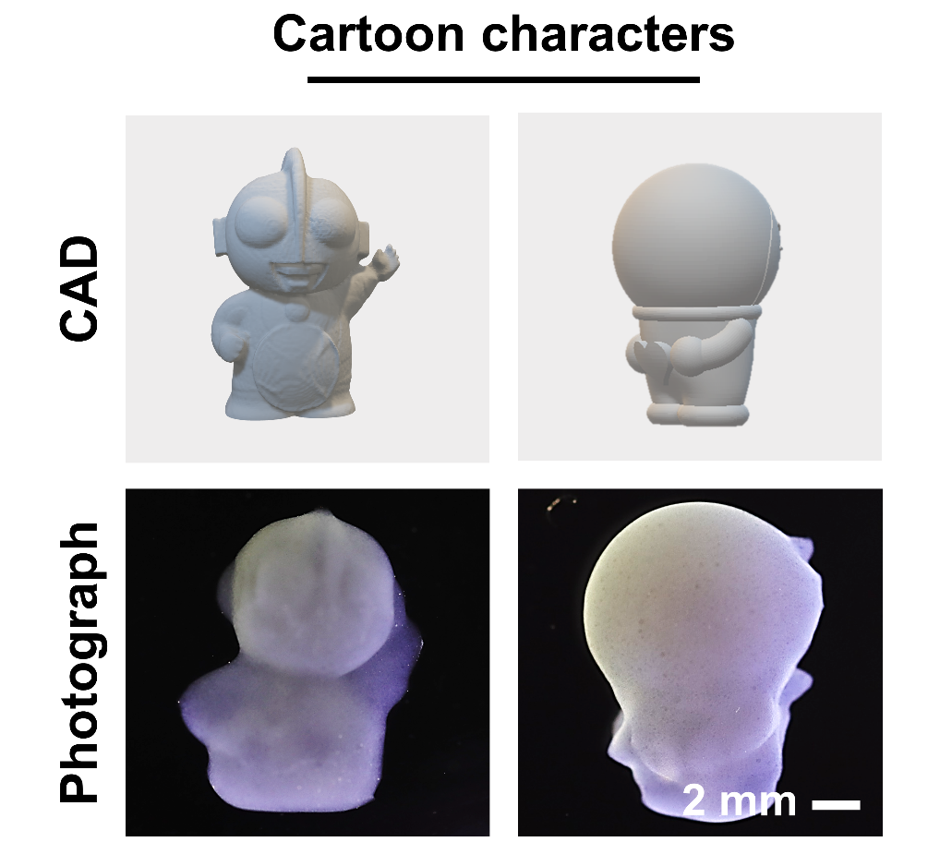
Figure S1. Microscopic images of representative 3D constructs fabricated via VBP using PVA–gelatin emulsion bioinks.

Figure S2. Similarity between different printed constructs and their corresponding CAD models.

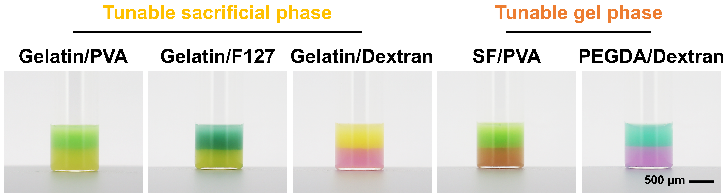

Figure S3. Photographs showing macroscopic phase separation of gelatin-based ATPE formulations with different aqueous polymer phases.

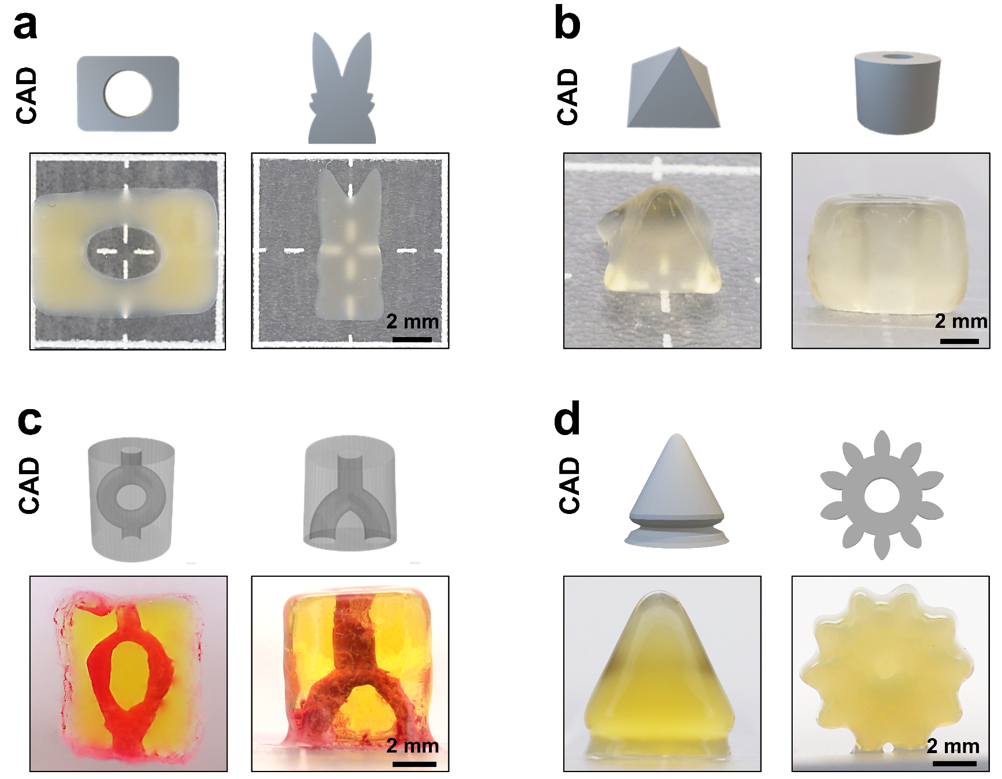
Figure S4. VBP printing performance using ATPE-based bioinks. (a) CAD models and photographs of constructs printed from an ATPE bioink composed of 10% gelatin and 10% F-127 at 4:1 (v/v) ratio. (b) CAD models and photographs of constructs printed from an ATPE bioink composed of 10% gelatin and 10% dextran at 4:1 (v/v) ratio. (c) CAD models and photographs of constructs printed from an ATPE bioink composed of 5% SF and 3% PVA at 4:1 (v/v) ratio. (d) CAD models and photographs of constructs printed from an ATPE bioink composed of 10% PEGDA and 5% dextran at 4:1 (v/v) ratio.

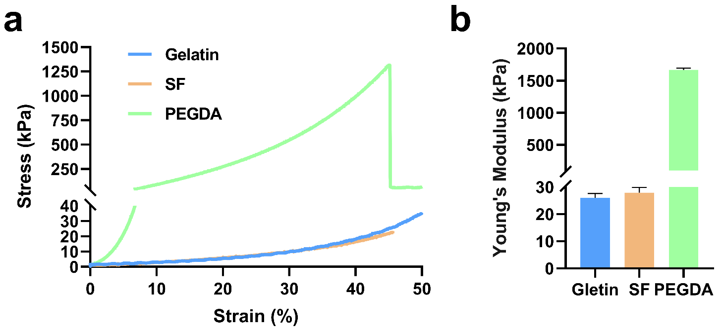
Figure S5. Compressive mechanical properties of different hydrogel matrices. (a) Representative stress–strain curves of hydrogels prepared from gelatin, silk fibroin (SF), and PEGDA under uniaxial compression (strain up to 50%). (b) Corresponding Young’s modulus calculated from the initial linear region of the stress–strain curves. Data are presented as mean ± s.d.

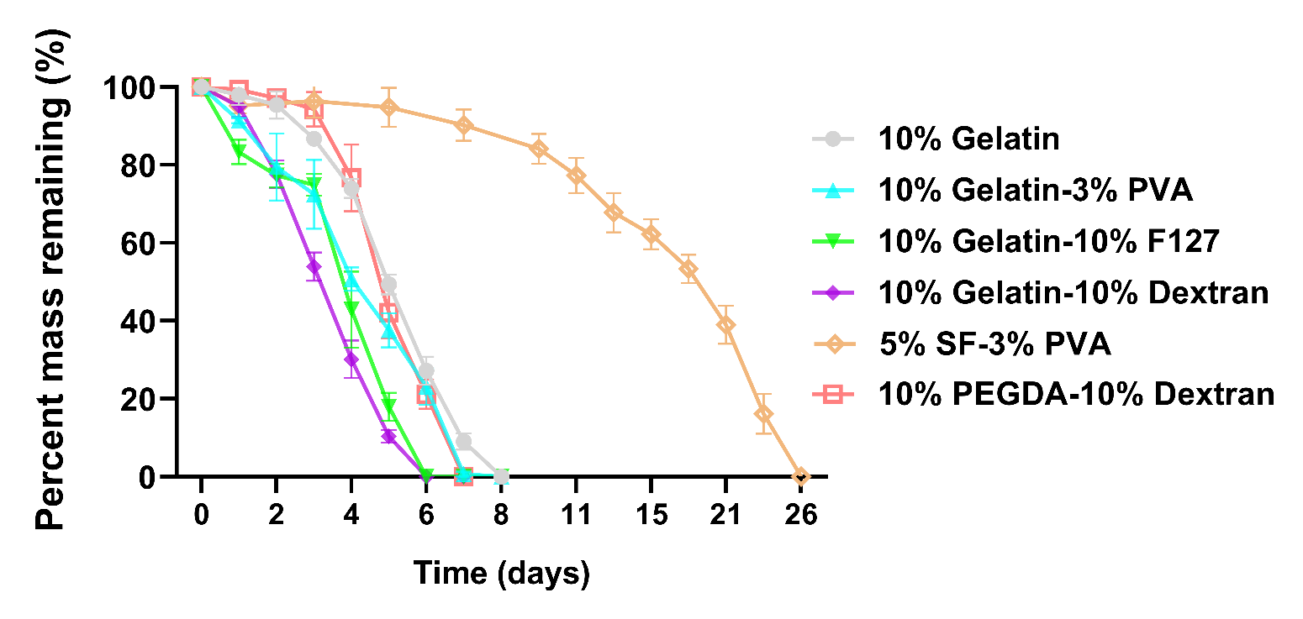
Figure S6. In vitro degradation profiles of ATPE-derived hydrogels with different phase compositions. Data are presented as mean ± s.d.

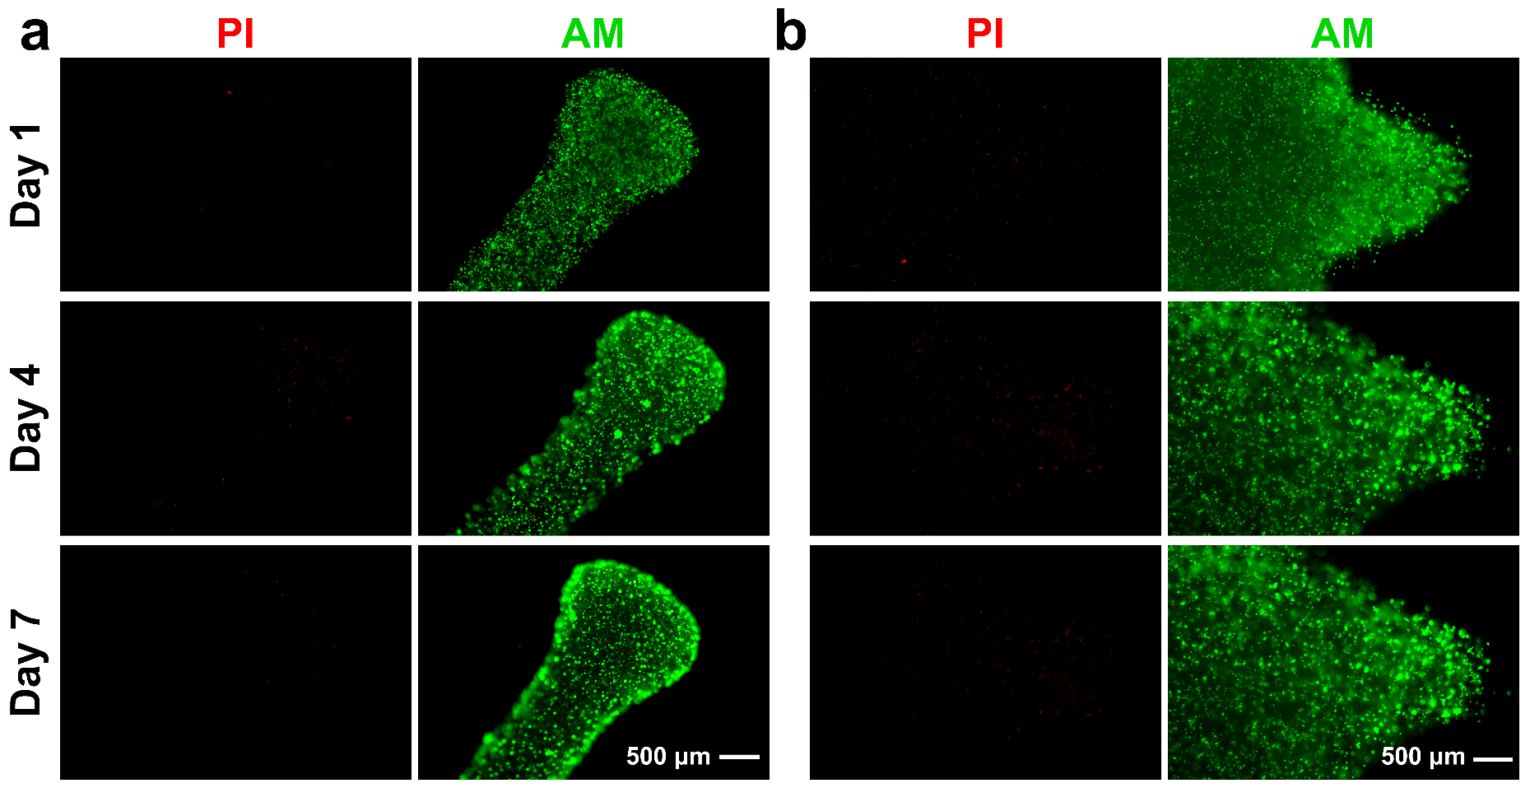

Figure S7. Live/Dead staining of 3T3 and H₉C₂ cells in VBP-fabricated constructs. Representative fluorescence images of 3T3 (a) and H₉C₂ (b) cell-laden constructs after Live/Dead staining (green = live, red = dead).
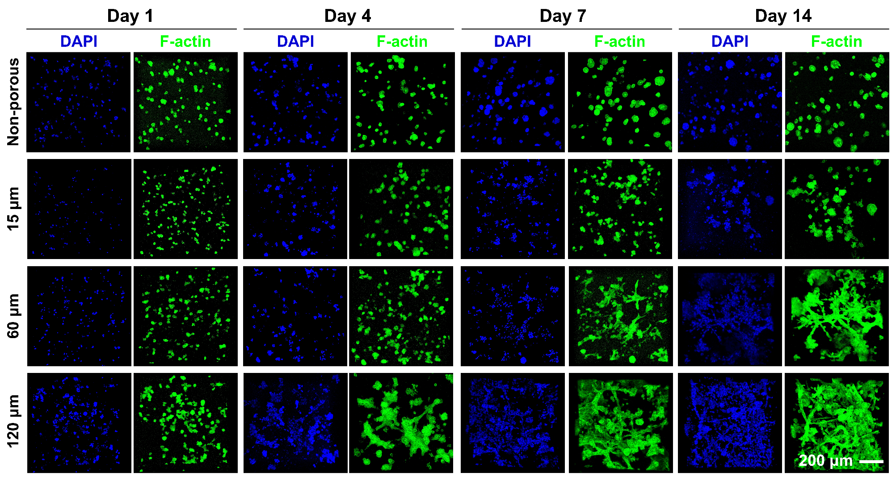
Figure S8. Representative split-channel fluorescence images showing F-actin (green) and nuclei (DAPI, blue) of HUVECs cultured on non-porous and porous PVA/gelatin scaffolds with different pore sizes (non-porous, ~15 μm, ~60 μm, and ~120 μm) at days 1, 4, 7, and 14. Scale bar: 200 μm.

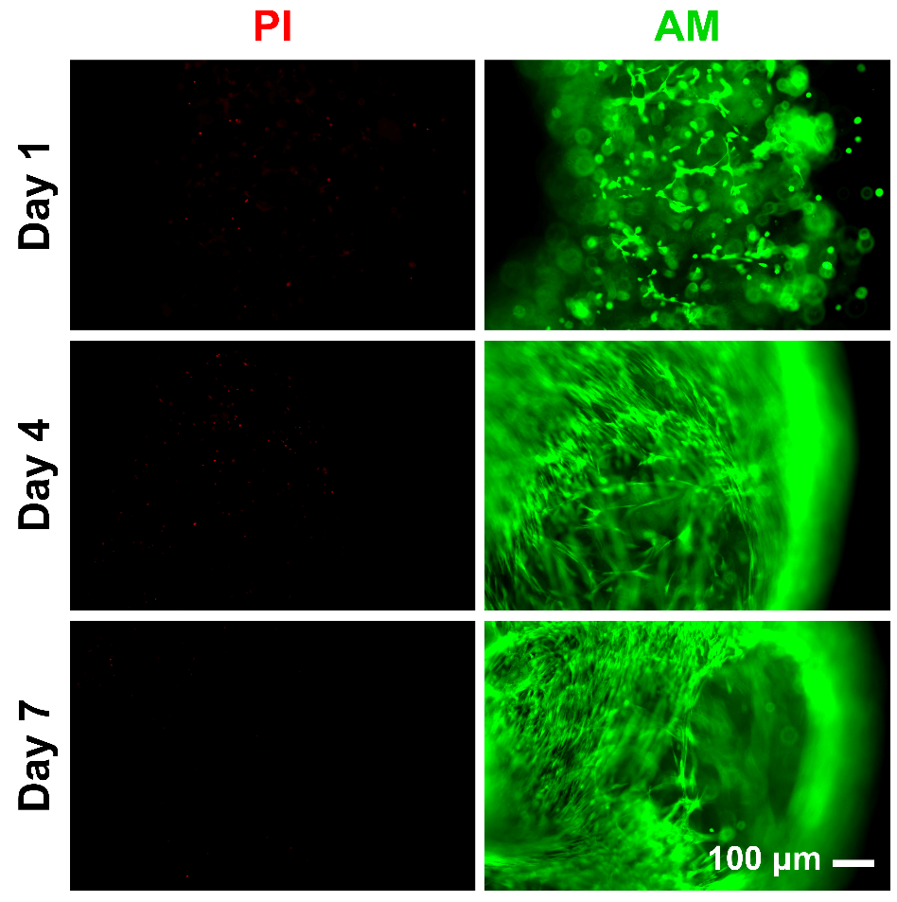
Figure S9. Live/Dead staining of ADSC-laden constructs fabricated by VBP (green = live, red = dead).

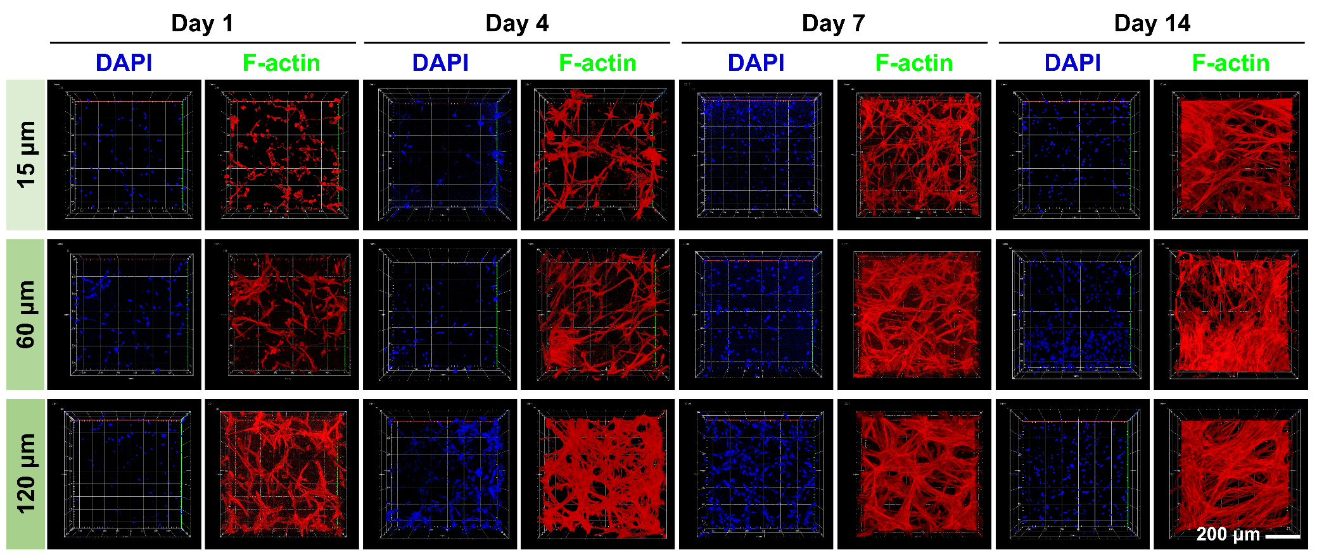
Figure S10. Split-channel confocal 3D reconstructions of MSCs cultured in scaffolds with different pore sizes (DAPI: blue; F-actin: Red).

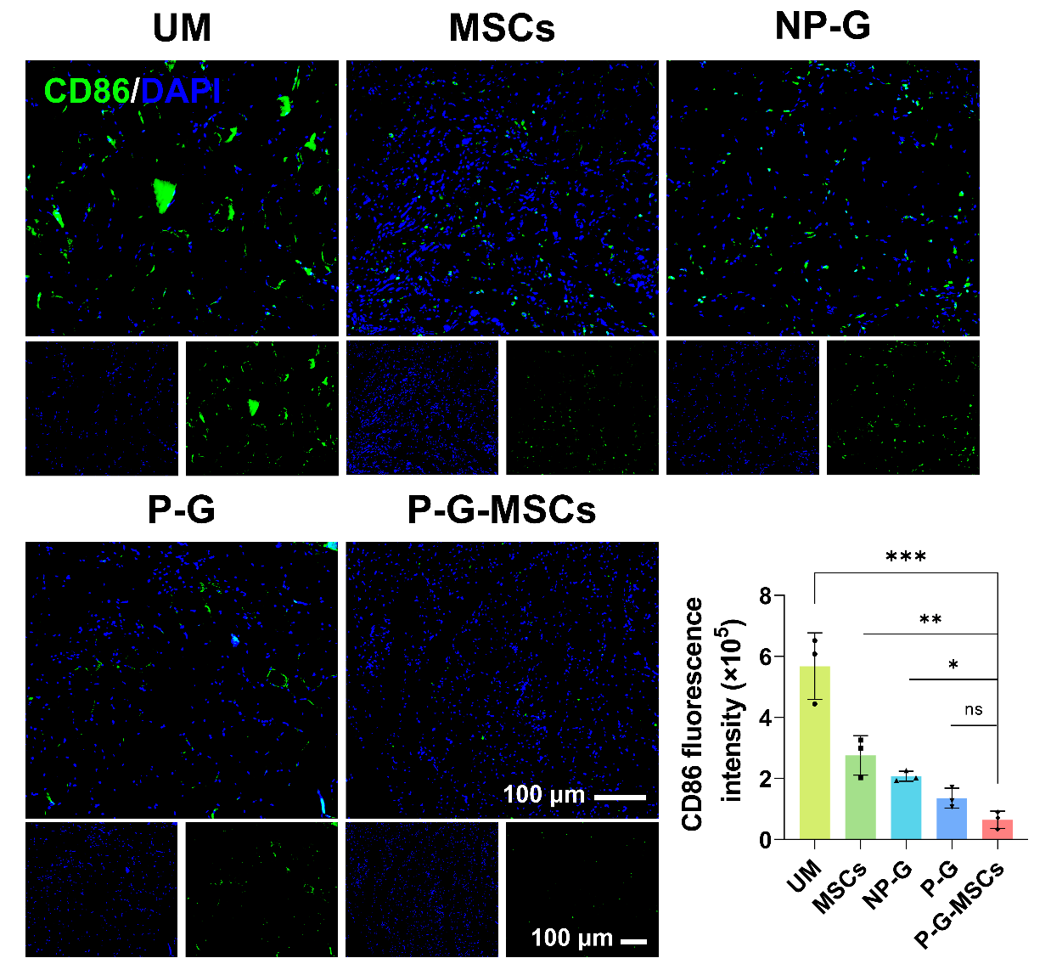
Figure S11. Fluorescence microscopy images showing CD86 expression in the TA defect region at 8 weeks after VML treatment. Data are presented as mean ± SD (n = 3 biologically independent samples). ***P < 0.001, **P < 0.002, *P < 0.033, ns: no significant difference, one-way ANOVA.

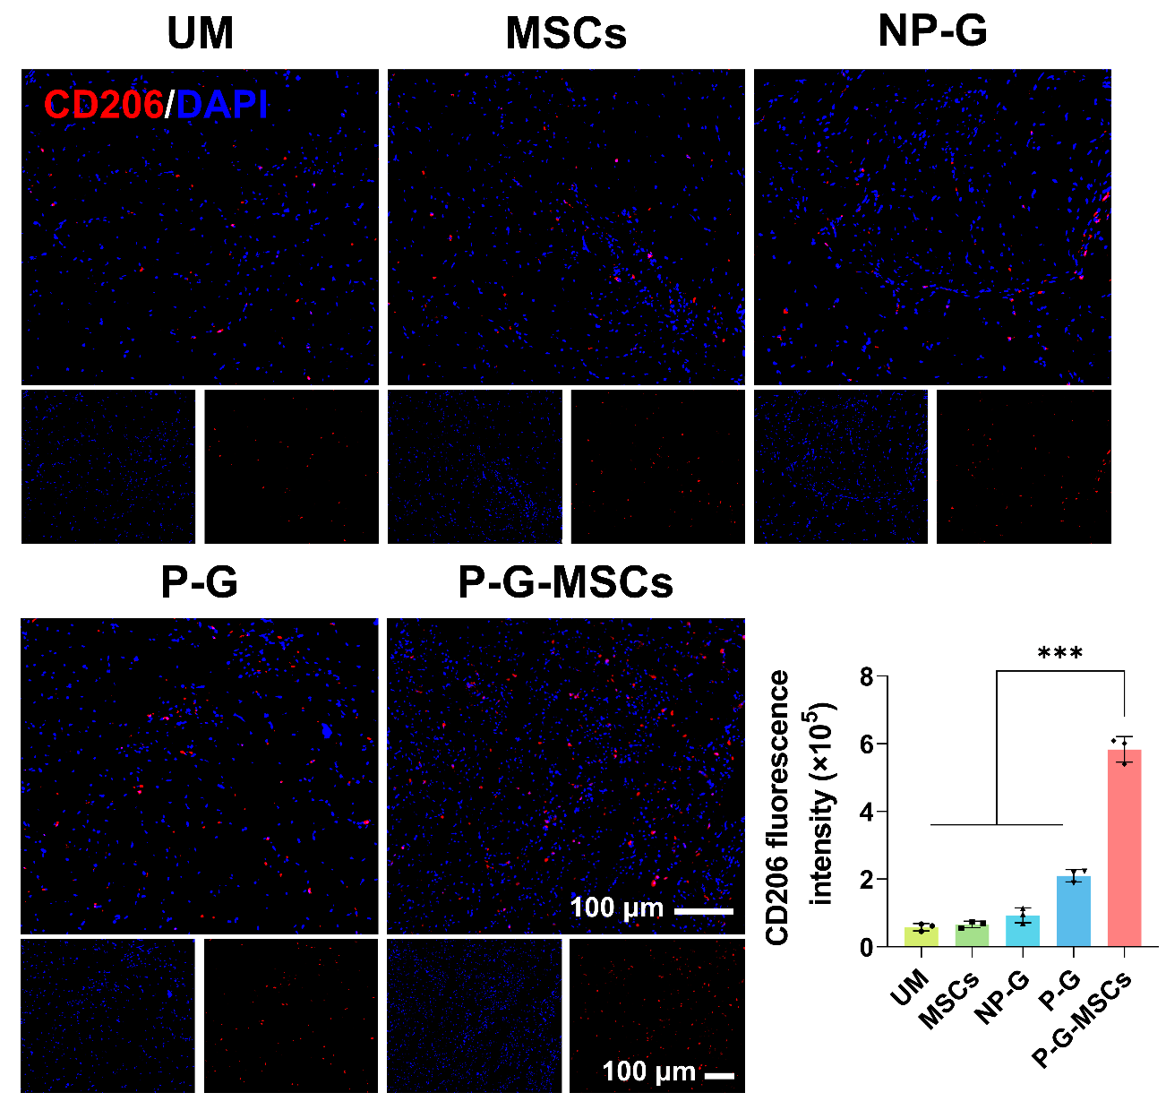
Figure S12. Fluorescence microscopy images showing CD206 expression in the TA defect region at 8 weeks after VML treatment. Data are presented as mean ± SD (n = 3 biologically independent samples). ***P < 0.001, **P < 0.002, *P < 0.033, ns: no significant difference, one-way ANOVA.

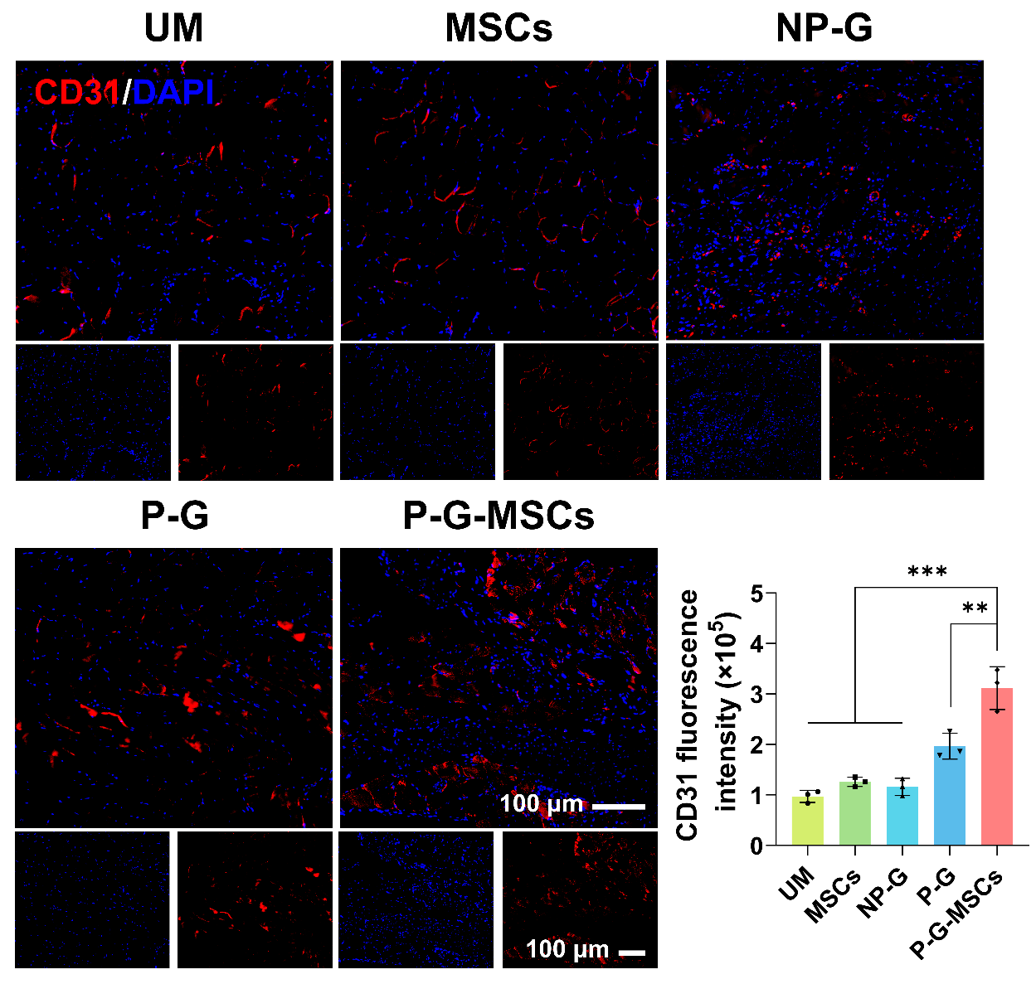
Figure S13. Fluorescence images analysis showing CD31 expression in the TA defect region at 8 weeks after VML treatment. Data are presented as mean ± SD (n = 3 biologically independent samples). ***P < 0.001, **P < 0.002, *P < 0.033, ns: no significant difference, one-way ANOVA.

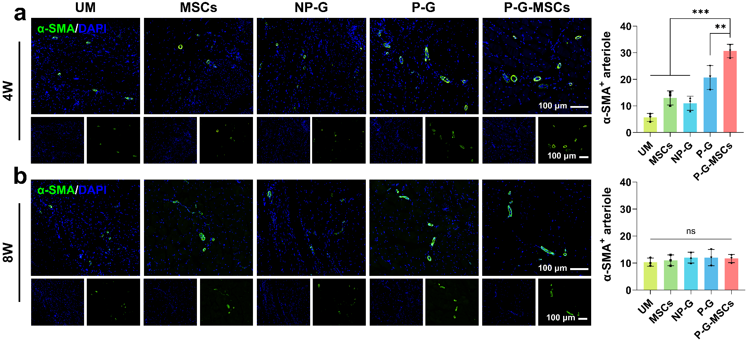
Figure S14. Representative α-SMA immunofluorescence staining and quantification of α-SMA⁺ arterioles (mature vessels) in the TA defect region at 4 (a) and 8 (b) weeks after VML treatment. Data are presented as mean ± SD (n = 3 biologically independent samples). ***P < 0.001, **P < 0.002, *P < 0.033, ns: no significant difference, one-way ANOVA.

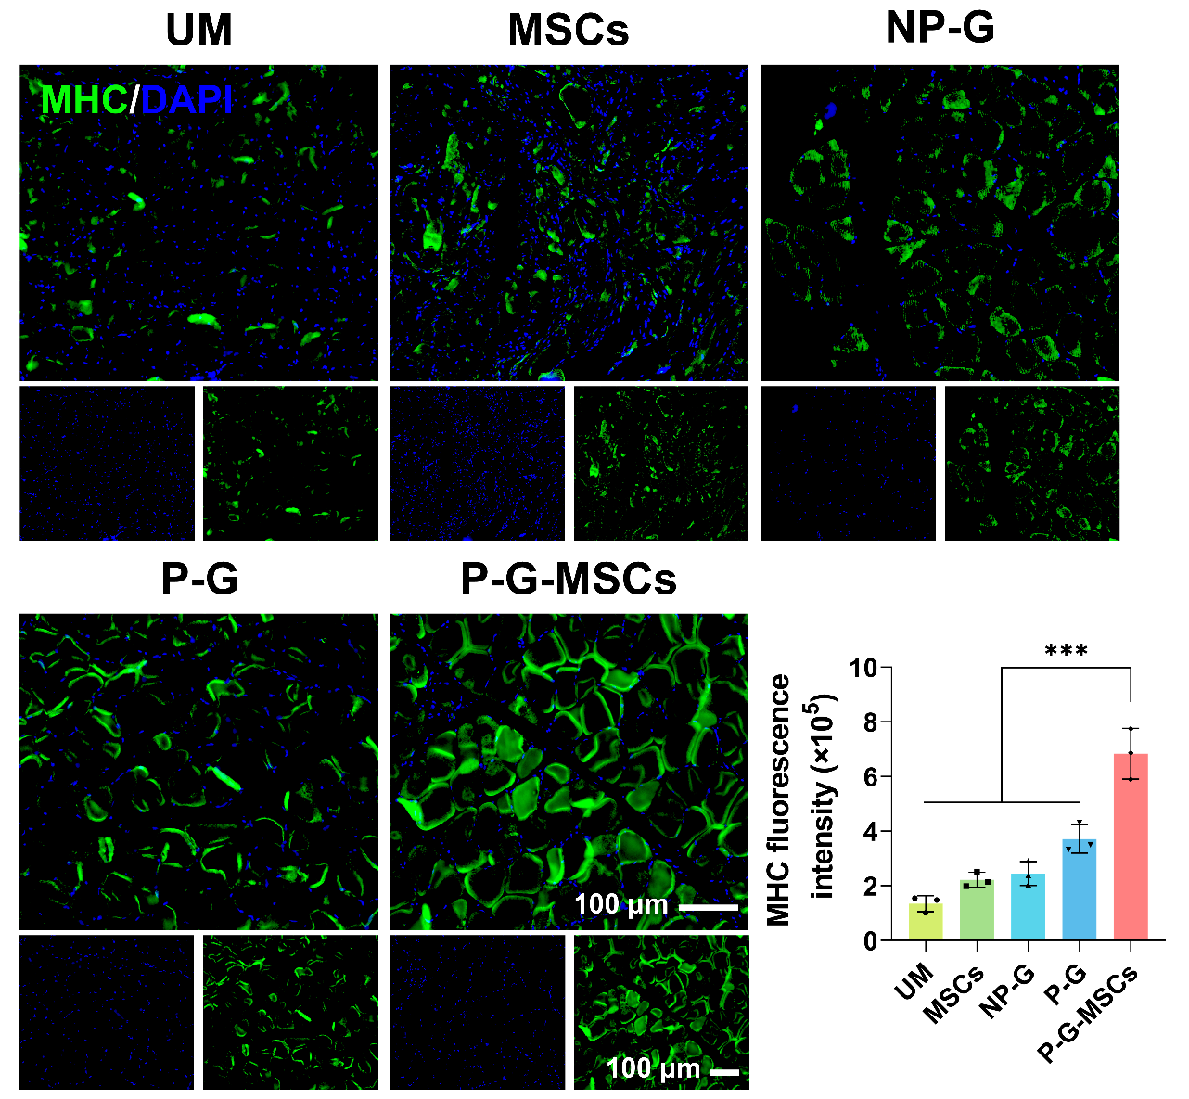
Figure S15. Fluorescence images analysis showing MHC expression in the TA defect region at 8 weeks after VML treatment. Data are presented as mean ± SD (n = 3 biologically independent samples). ***P < 0.001, **P < 0.002, *P < 0.033, ns: no significant difference, one-way ANOVA.

