Supplementary Materials for

Decoding Smell from Receptor Structure

Hsiu-Yi Lu^{1,†,*}, Aashutosh Vihani^{2,†}, Maira H. Nagai¹, Xiaoyang S. Hu¹, Dan Takase¹, Conan Juan¹, Claire A. deMarch¹, Hiroaki Matsunami^{1,3,*}

*Corresponding author. Email: hyjusticelu@gmail.com & Hiroaki.matsunami@duke.edu

The PDF file includes:

Figs. S1 to S6
Tables S1 to S2

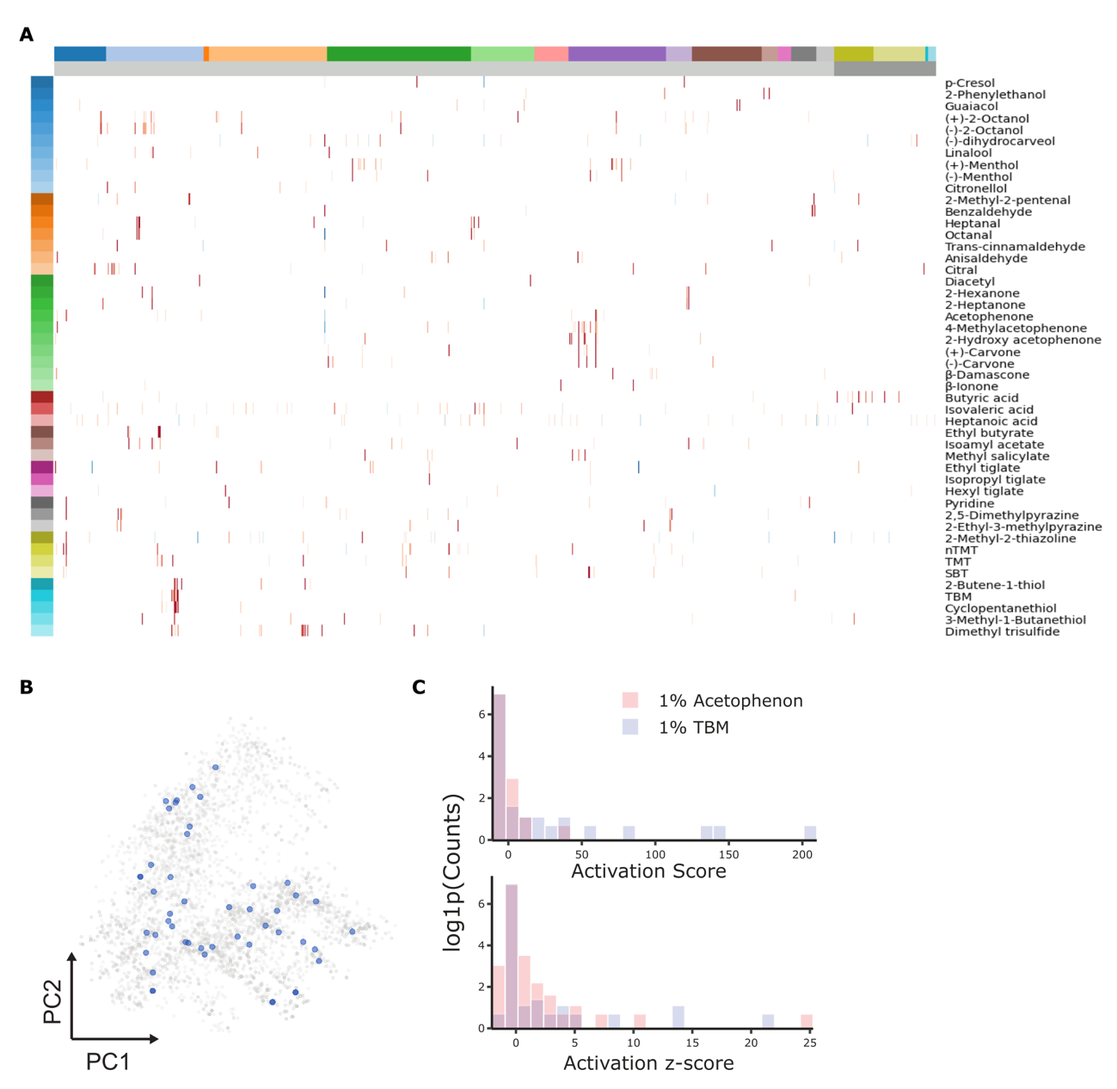

Figure S1. Global overview of pS6-IP activation profiles and chemical space coverage.
A. Heatmap of pS6-IP–derived activation z-scores across all tested odorant–receptor pairs. Rows correspond to the 48 odorants, and columns represent individual ORs, organized by class and family. B. Chemical space representation of odorants based on Morgan fingerprint principal component analysis (PCA). Odorants included in the pS6-IP panel are highlighted in blue relative to the full reference set.

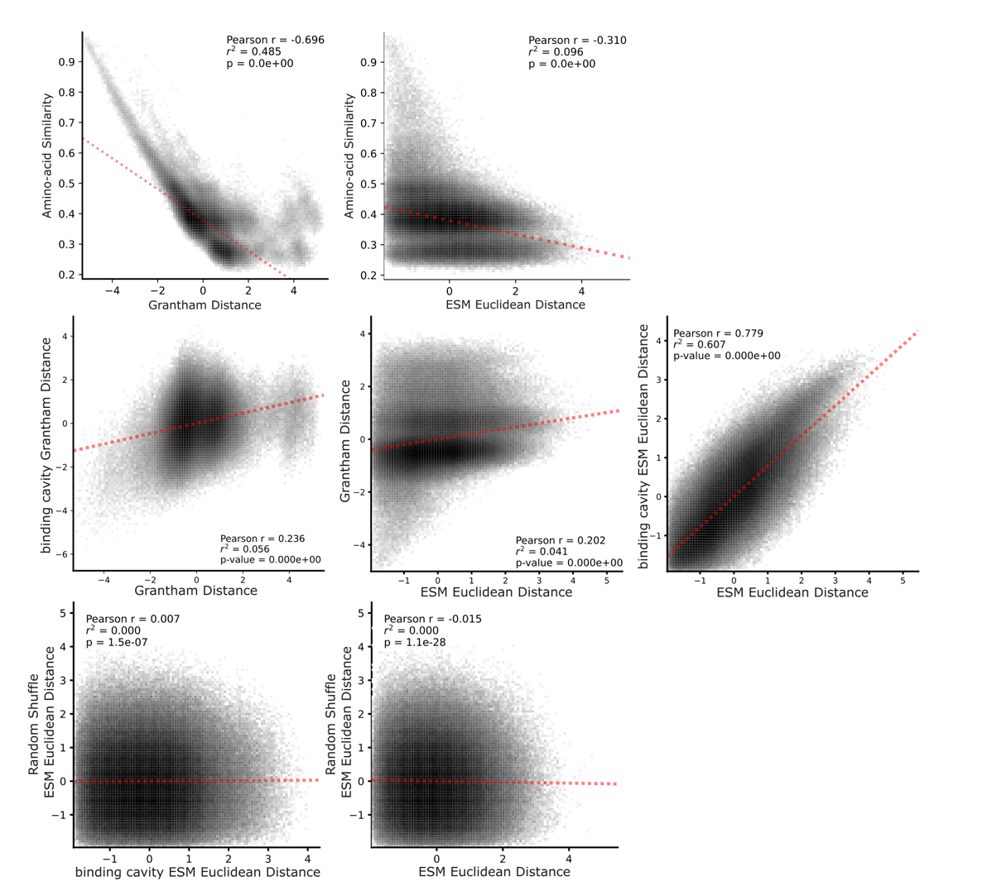

Figure S2. Comparison of sequence- and embedding-based similarity metrics across olfactory receptors.
Top: Pearson correlation analysis comparing amino acid similarity–based Grantham distances with ESM-derived Euclidean distances across OR pairs. Middle: Pairwise Pearson correlations among sequence- and structure-informed similarity measures, including full-length sequence Grantham distance vs. binding cavity Grantham distance, Grantham distance vs. ESM Euclidean distance, and binding cavity ESM Euclidean distance vs. full-sequence ESM Euclidean distance. Bottom: Control comparisons against randomized embeddings. Pearson correlations between binding cavity ESM Euclidean distances and randomly shuffled ESM embeddings, and between full-sequence ESM Euclidean distances and shuffled controls, demonstrating preservation of biological signal in learned representations.

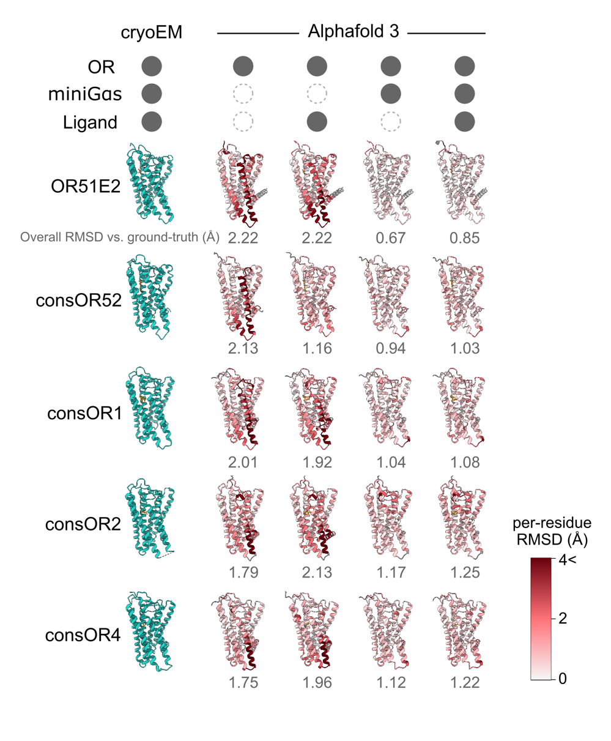

Figure S3. Structural agreement between cryo-EM olfactory receptor structures and AlphaFold3 predictions.
Comparison of experimentally determined cryo-EM structures with AlphaFold3-predicted models across multiple modeling conditions, including receptor alone (OR), receptor with ligand (OR + ligand), receptor with mini G protein (OR + miniGαs), and receptor with both ligand and miniGαs protein (OR + ligand + miniGαs). For each receptor, per-residue root-mean-square deviation (RMSD) relative to the cryo-EM structure is shown to assess local structural agreement, alongside overall backbone RMSD values summarized below each model.

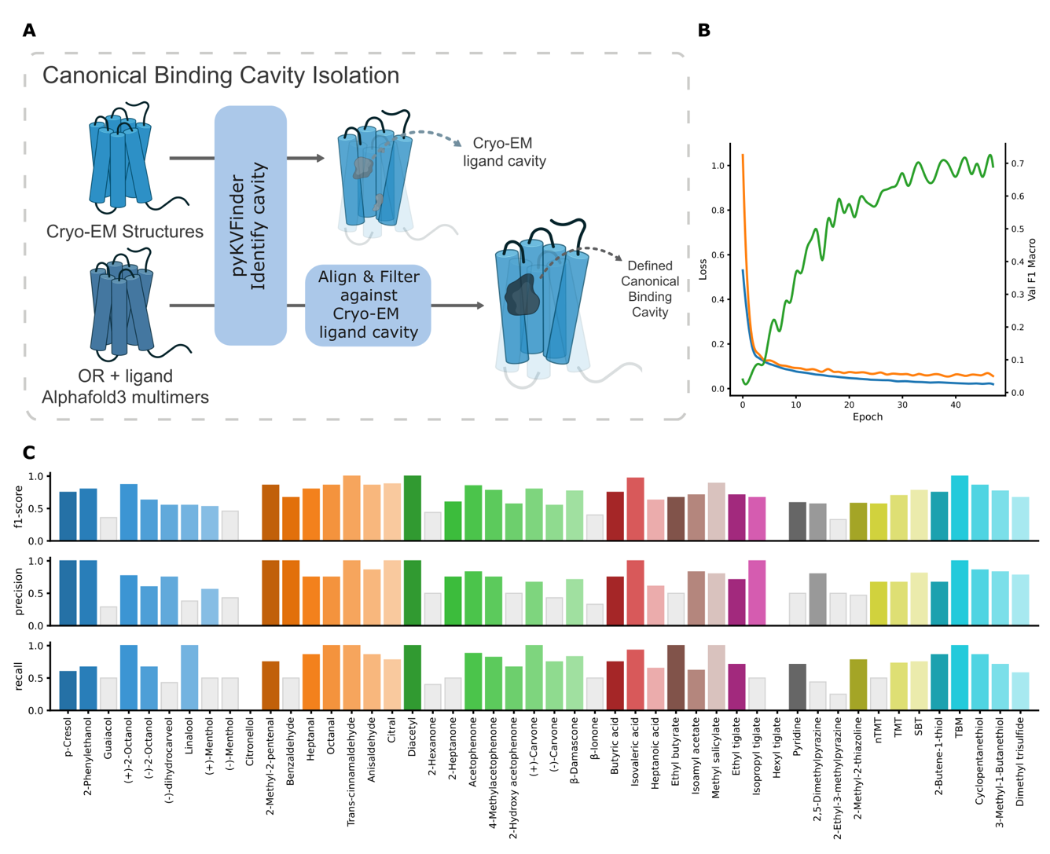

Figure S4. Binding cavity definition and model performance evaluation.
A. Schematic of the pipeline for canonical binding cavity identification. Cryo-EM structures and corresponding AlphaFold3-predicted models (OR + ligand + miniGαs) were analyzed using pyKVFinder to detect putative cavities. The cryo-EM derived cavity was used as a reference to align and superimpose predicted cavities. The resulting consensus region was defined as the canonical binding cavity used for downstream filtering and voxelization (see Methods for details). B. Training dynamics of the final CNN model. Loss curves for training (blue) and validation (orange) are shown across epochs, alongside validation macro F1-score (green), demonstrating stable optimization and concordant performance improvement. C. Precision, recall, and F1-score for each of the 48 odorants. Odorants with performance values below 0.5 are highlighted in gray.

Figure 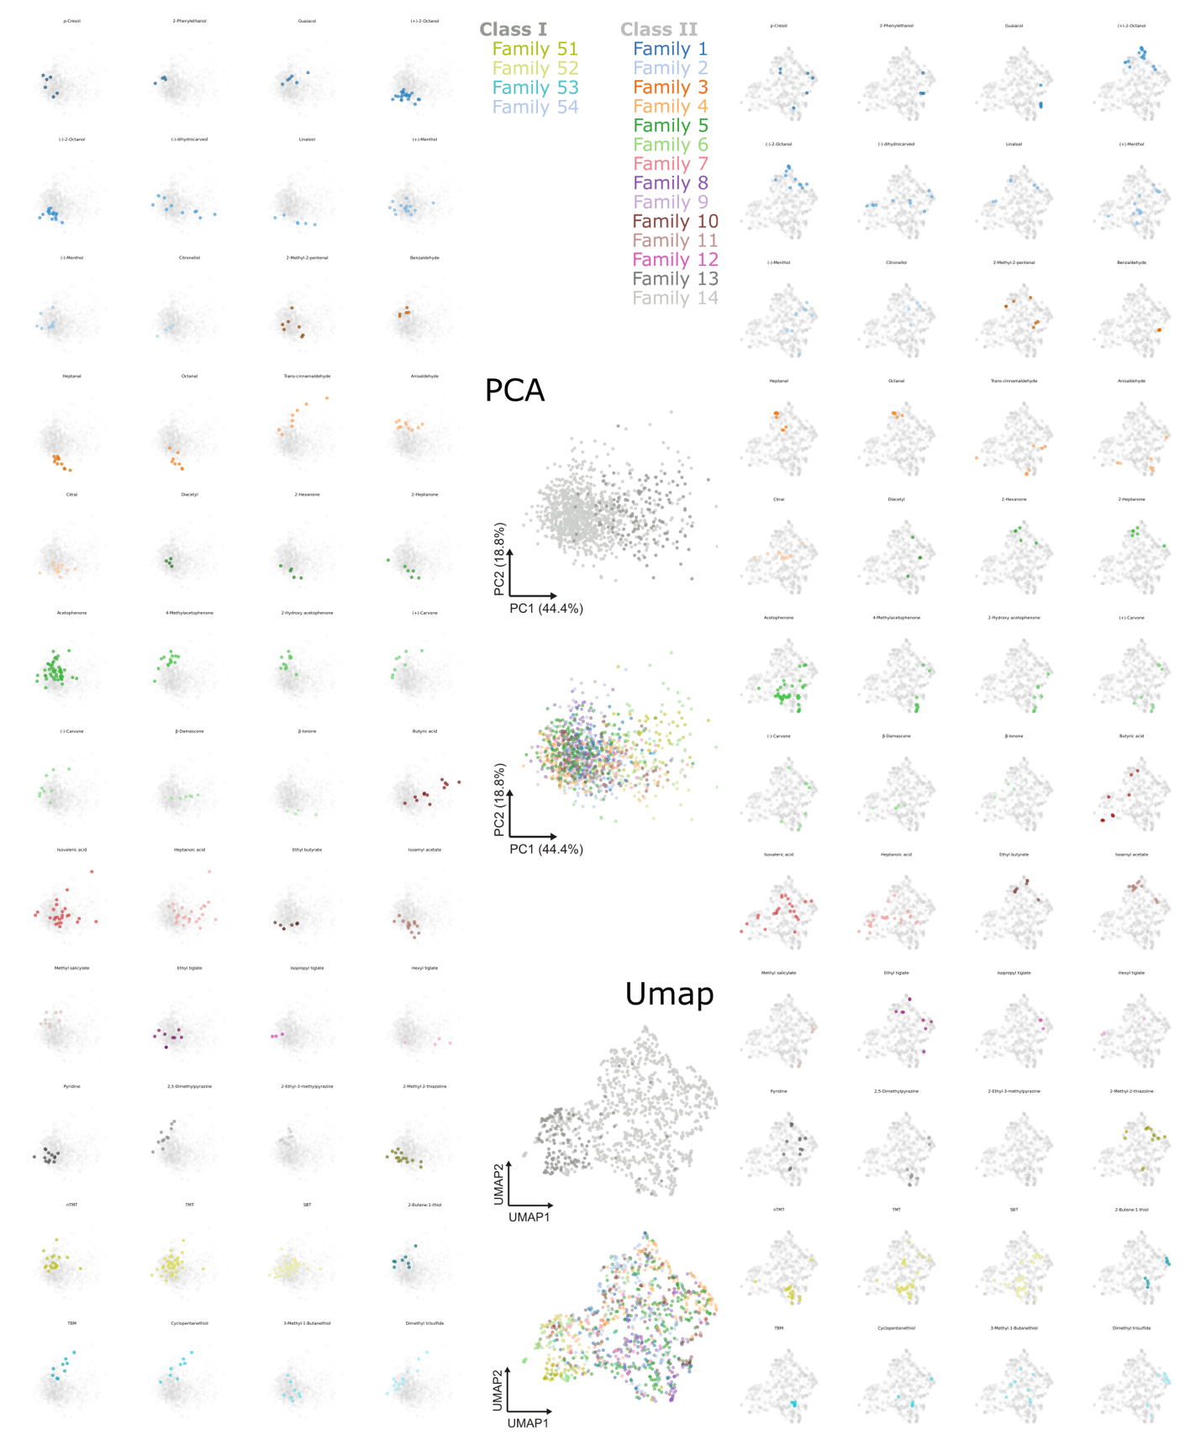S5. Global organization of CNN-derived receptor embeddings across dimensionality reduction methods.
Comprehensive visualization of receptor embeddings using principal component analysis (PCA) and UMAP (smeLLMap). Left: PCA projections showing OR distributions for each of the 48 odorants, with receptors responding to each ligand highlighted. Right: Corresponding UMAP (smeLLMap) projections illustrating odor-specific clustering in the learned embedding space. Middle: Distribution of OR classes and families mapped onto both PCA and UMAP representations, demonstrating that higher-level class separation is preserved while finer family-level organization is less pronounced relative to functional clustering by odor response.

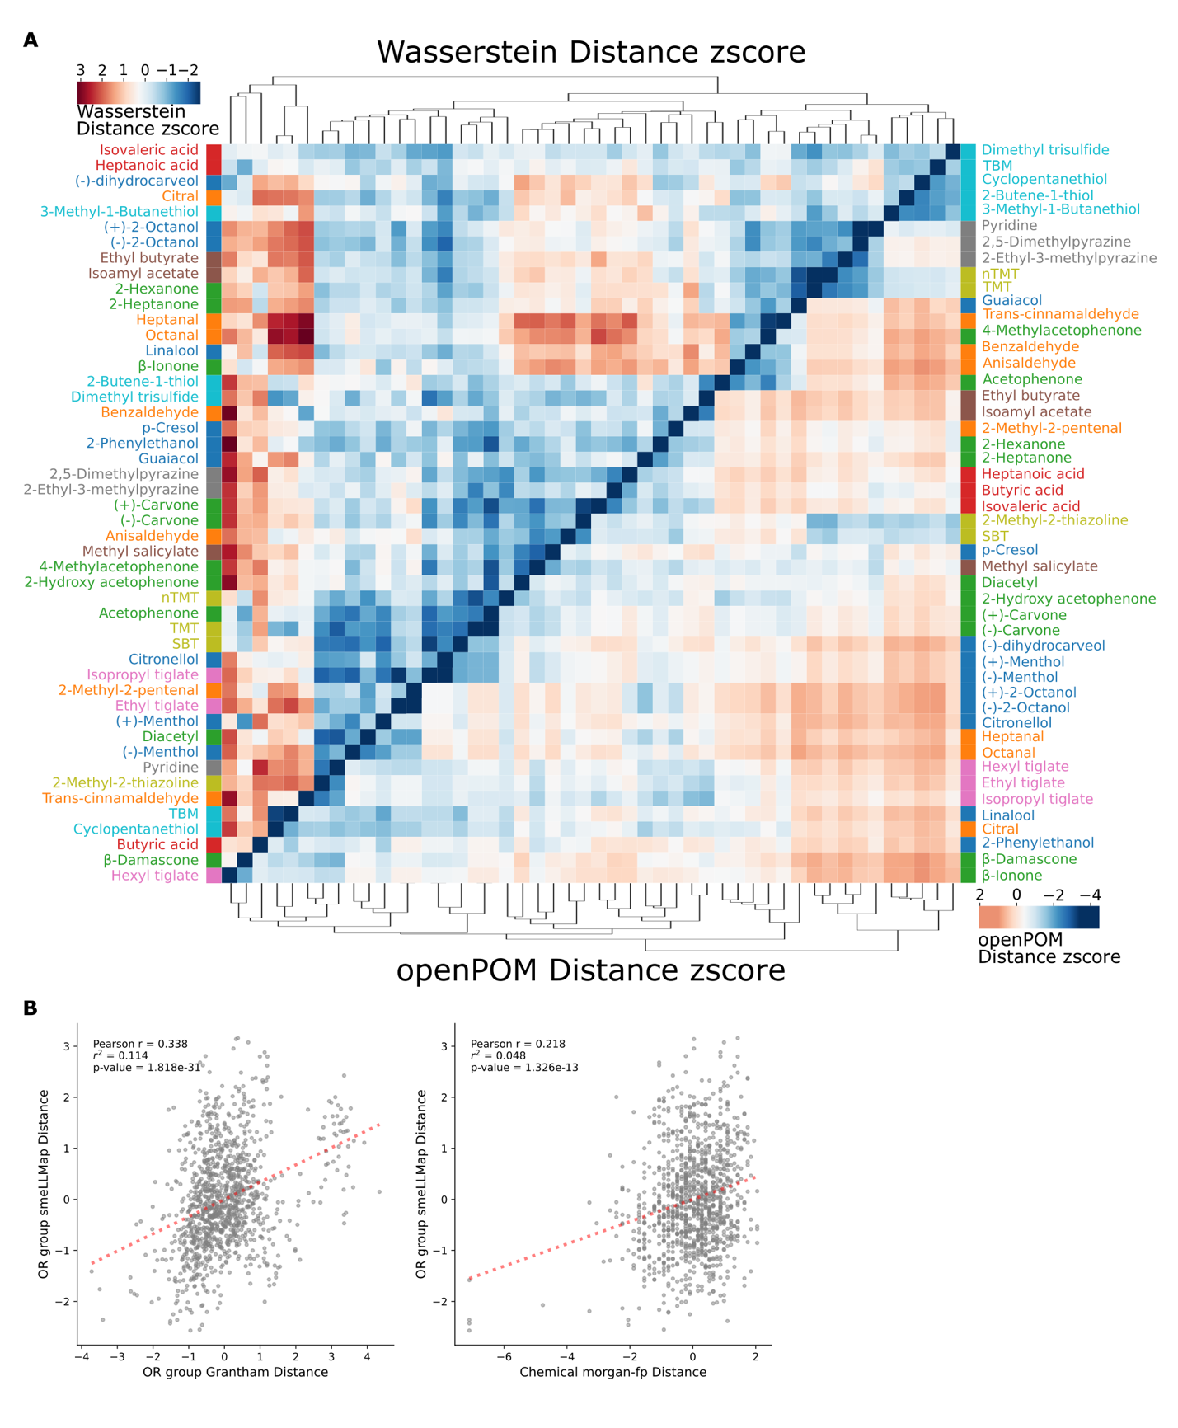

Figure S6. Comparison of embedding-derived receptor distances with sequence- and chemistry-based similarity metrics.
A. Dual-clustered heatmaps comparing normalized distance metrics across odorants. Top: z-scored Wasserstein distances between distributions of OR embeddings (smeLLMap) for each odorant pair. Bottom: corresponding z-scored Euclidean distances in OpenPOM space, representing perception-informed chemical similarity. B. Correlation analyses comparing receptor embedding distances with alternative similarity measures. Left: Pearson correlation between OR group distances in smeLLMap (Wasserstein) and sequence-based Grantham distances. Right: Pearson correlation between OR group distances in smeLLMap and chemical similarity derived from Morgan fingerprint representations

 | aucroc | prob_corr | f1-score | precision | recall
p-Cresol | 0.89 | 0.73255 | 0.75 | 1 | 0.6
2-Phenylethanol | 0.94224422 | 0.80710558 | 0.8 | 1 | 0.67
Guaiacol | 0.97512438 | 0.49389872 | 0.36 | 0.29 | 0.5
(+)-2-Octanol | 1 | 0.91053396 | 0.87 | 0.77 | 1
(-)-2-Octanol | 0.96201814 | 0.67341891 | 0.63 | 0.6 | 0.67
(-)-dihydrocarveol | 0.96392496 | 0.69319504 | 0.55 | 0.75 | 0.43
Linalool | 1 | 0.72351811 | 0.55 | 0.38 | 1
(+)-Menthol | 0.85589744 | 0.62406313 | 0.53 | 0.56 | 0.5
(-)-Menthol | 0.9480737 | 0.5197812 | 0.46 | 0.43 | 0.5
Citronellol | 0.96393035 | 0.37660607 | 0 | 0 | 0
2-Methyl-2-pentenal | 0.97263682 | 0.84515149 | 0.86 | 1 | 0.75
Benzaldehyde | 0.98275862 | 0.6881775 | 0.67 | 1 | 0.5
Heptanal | 0.98917749 | 0.73052781 | 0.8 | 0.75 | 0.86
Octanal | 1 | 0.90210967 | 0.86 | 0.75 | 1
Trans-cinnamaldehyde | 1 | 0.9859638 | 1 | 1 | 1
Anisaldehyde | 0.9963925 | 0.86971289 | 0.86 | 0.86 | 0.86
Citral | 0.99489796 | 0.86625893 | 0.88 | 1 | 0.78
Diacetyl | 1 | 0.89681083 | 1 | 1 | 1
2-Hexanone | 0.962 | 0.52969527 | 0.44 | 0.5 | 0.4
2-Heptanone | 0.99497487 | 0.75804466 | 0.6 | 0.75 | 0.5
Acetophenone | 0.95014094 | 0.81457382 | 0.85 | 0.83 | 0.88
4-Methylacetophenone | 0.95829428 | 0.83288983 | 0.78 | 0.75 | 0.82
2-Hydroxy acetophenone | 0.96901173 | 0.62587029 | 0.57 | 0.5 | 0.67
(+)-Carvone | 1 | 0.90482121 | 0.8 | 0.67 | 1
(-)-Carvone | 0.99129353 | 0.70908125 | 0.55 | 0.43 | 0.75
Œ≤-Damascone | 0.9120603 | 0.86859694 | 0.77 | 0.71 | 0.83
Œ≤-Ionone | 0.94581281 | 0.49842657 | 0.4 | 0.33 | 0.5
Butyric acid | 0.99875622 | 0.88191084 | 0.75 | 0.75 | 0.75
Isovaleric acid | 0.99719298 | 0.91817394 | 0.97 | 1 | 0.93
Heptanoic acid | 0.89893617 | 0.6611081 | 0.63 | 0.61 | 0.65
Ethyl butyrate | 0.99261084 | 0.57559229 | 0.67 | 0.5 | 1
Isoamyl acetate | 0.95748731 | 0.74228959 | 0.71 | 0.83 | 0.62
Methyl salicylate | 1 | 0.90854191 | 0.89 | 0.8 | 1
Ethyl tiglate | 0.98556999 | 0.71354159 | 0.71 | 0.71 | 0.71
Isopropyl tiglate | 1 | 0.79596373 | 0.67 | 1 | 0.5
Hexyl tiglate | 0.9141791 | 0.05535212 | 0 | 0 | 0
Pyridine | 0.85930736 | 0.67125846 | 0.59 | 0.5 | 0.71
2,5-Dimethylpyrazine | 0.9739229 | 0.67666771 | 0.57 | 0.8 | 0.44
2-Ethyl-3-methylpyrazine | 0.93159204 | 0.38868748 | 0.33 | 0.5 | 0.25
2-Methyl-2-thiazoline | 0.93877551 | 0.63984346 | 0.58 | 0.47 | 0.78
nTMT | 0.75124378 | 0.64863775 | 0.57 | 0.67 | 0.5
TMT | 0.96969697 | 0.76199443 | 0.7 | 0.67 | 0.73
SBT | 0.94612591 | 0.75225294 | 0.78 | 0.81 | 0.75
2-Butene-1-thiol | 0.86075036 | 0.7815141 | 0.75 | 0.67 | 0.86
TBM | 1 | 0.99962926 | 1 | 1 | 1
Cyclopentanethiol | 0.998557 | 0.9202946 | 0.86 | 0.86 | 0.86
3-Methyl-1-Butanethiol | 0.98124098 | 0.80131139 | 0.77 | 0.83 | 0.71
Dimethyl trisulfide | 0.98272884 | 0.68576128 | 0.67 | 0.78 | 0.58

Table S1. Trained model’s validation odor prediction metric
Summary of validation performance for each odorant, including area under the receiver operating characteristic curve (AUROC), probability–response correlation (prob_corr), F1-score, precision, and recall.

 | odor | cid | n_OR | obs_grantham_mean | obs_grantham_median | null_grantham_mean | null_grantham_median | p_grantham_perm_mean | p_grantham_perm_median | obs_euclid_mean | obs_euclid_median | null_euclid_mean | null_euclid_median | p_euclid_perm_mean | p_euclid_perm_median
0 | Dimethyl trisulfide | 19310 | 16 | 0.0139 | 0.2510 | 0.0045 | 0.0374 | 0.5020 | 0.8260 | -0.4434 | -0.9146 | 0.0121 | -0.1635 | 0.0560 | 0.0000
1 | 3-Methyl-1-Butanethiol | 10925 | 8 | -0.6002 | -0.6424 | -0.0052 | 0.0222 | 0.0360 | 0.0320 | -0.5814 | -0.5565 | -0.0139 | -0.1509 | 0.0600 | 0.1320
2 | Cyclopentanethiol | 15510 | 9 | -1.2545 | -0.7162 | 0.0070 | 0.0321 | 0.0000 | 0.0080 | -0.2826 | -0.4438 | 0.0395 | -0.1076 | 0.1980 | 0.1780
3 | TBM | 6387 | 10 | -1.3706 | -0.8363 | -0.0123 | 0.0275 | 0.0000 | 0.0020 | -0.7029 | -0.7895 | 0.0199 | -0.1409 | 0.0180 | 0.0140
4 | 2-Butene-1-thiol | 6433451 | 9 | -0.1284 | -0.0562 | -0.0218 | 0.0145 | 0.3740 | 0.4240 | -0.7640 | -0.7688 | 0.0242 | -0.1264 | 0.0160 | 0.0280
5 | SBT | 162148 | 49 | -0.3311 | -0.2973 | -0.0039 | 0.0218 | 0.0000 | 0.0000 | -0.7523 | -0.8661 | 0.0069 | -0.1583 | 0.0000 | 0.0000
6 | TMT | 263626 | 45 | -0.3582 | -0.2838 | -0.0032 | 0.0135 | 0.0020 | 0.0140 | -0.6614 | -0.8130 | 0.0141 | -0.1579 | 0.0000 | 0.0000
7 | nTMT | 61653 | 19 | -0.6101 | -0.6017 | -0.0061 | -0.0018 | 0.0000 | 0.0000 | -0.5728 | -0.6272 | 0.0089 | -0.1558 | 0.0140 | 0.0240
8 | 2-Methyl-2-thiazoline | 16867 | 15 | 0.1310 | 0.1996 | 0.0058 | 0.0274 | 0.7020 | 0.7780 | -0.7255 | -0.9066 | -0.0142 | -0.1840 | 0.0040 | 0.0000
9 | 2-Ethyl-3-methylpyrazine | 27457 | 9 | -0.1909 | 0.1550 | -0.0033 | 0.0011 | 0.2520 | 0.6840 | -0.9526 | -0.8981 | 0.0094 | -0.1229 | 0.0060 | 0.0160
10 | 2,5-Dimethylpyrazine | 31252 | 11 | -1.0211 | -0.7582 | 0.0051 | 0.0426 | 0.0000 | 0.0040 | -0.6545 | -0.7139 | 0.0001 | -0.1873 | 0.0160 | 0.0220
11 | Pyridine | 1049 | 13 | -0.1694 | -0.0762 | 0.0033 | 0.0198 | 0.2280 | 0.3220 | -0.9442 | -1.0281 | 0.0188 | -0.1384 | 0.0000 | 0.0000
12 | Hexyl tiglate | 637523 | 4 | 1.1755 | 1.0706 | 0.0027 | 0.0449 | 0.9920 | 0.9740 | 0.0642 | -0.0640 | 0.0033 | -0.0989 | 0.5840 | 0.5220
13 | Isopropyl tiglate | 5367745 | 3 | -0.8005 | -0.5705 | 0.0188 | 0.0704 | 0.1140 | 0.1960 | -1.4211 | -1.4639 |  |  | 0.0120 | 0.0100
14 | Ethyl tiglate | 5281163 | 10 | -0.2343 | 0.1063 | -0.0070 | 0.0057 | 0.2480 | 0.6020 | -0.5717 | -0.5491 | -0.0331 | -0.1650 | 0.0800 | 0.1520
15 | Methyl salicylate | 4133 | 9 | -0.5034 | -0.4769 | -0.0134 | -0.0001 | 0.0360 | 0.0420 | -1.0183 | -1.0613 | 0.0065 | -0.1460 | 0.0020 | 0.0020
16 | Isoamyl acetate | 31276 | 15 | -0.6118 | -0.7165 | -0.0032 | 0.0290 | 0.0000 | 0.0000 | -0.9296 | -0.9819 | 0.0114 | -0.1349 | 0.0000 | 0.0000
17 | Ethyl butyrate | 7762 | 9 | -1.0085 | -0.4191 | 0.0045 | 0.0060 | 0.0000 | 0.0860 | -0.9256 | -0.5746 | -0.0030 | -0.1478 | 0.0040 | 0.0900
18 | Heptanoic acid | 8094 | 29 | -0.0594 | -0.0132 | 0.0006 | 0.0212 | 0.3500 | 0.4100 | -0.1697 | -0.3239 | 0.0147 | -0.1579 | 0.1720 | 0.1860
19 | Isovaleric acid | 10430 | 25 | 0.0693 | 0.0724 | -0.0045 | 0.0086 | 0.6660 | 0.6380 | -0.1424 | -0.4405 | -0.0009 | -0.1642 | 0.2600 | 0.0780
20 | Butyric acid | 264 | 13 | -0.8434 | -0.5156 | 0.0001 | 0.0394 | 0.0000 | 0.0140 | 0.0322 | -0.1850 | 0.0103 | -0.1571 | 0.5200 | 0.4680
21 | Œ≤-Ionone | 638014 | 4 | -0.2785 | -0.3560 | 0.0469 | 0.1100 | 0.2640 | 0.2260 | -0.4353 | -0.6930 | 0.0021 | -0.0907 | 0.2560 | 0.1220
22 | Œ≤-Damascone | 32052 | 6 | -0.2710 | -0.1163 | -0.0173 | 0.0429 | 0.2620 | 0.3660 | -0.8630 | -0.8647 | -0.0101 | -0.1489 | 0.0320 | 0.0360
23 | (-)-Carvone | 439570 | 9 | -0.9101 | -0.6223 | 0.0132 | 0.0439 | 0.0020 | 0.0220 | -0.2588 | -0.3203 | 0.0115 | -0.1372 | 0.2560 | 0.3120
24 | (+)-Carvone | 16724 | 8 | -1.0134 | -0.8159 | -0.0174 | 0.0083 | 0.0040 | 0.0160 | -0.3974 | -0.6011 | -0.0206 | -0.1714 | 0.1900 | 0.1200
25 | 2-Hydroxy acetophenone | 68490 | 11 | -1.2471 | -0.7958 | -0.0041 | 0.0402 | 0.0000 | 0.0060 | -1.0496 | -1.1636 | -0.0162 | -0.1591 | 0.0000 | 0.0000
26 | 4-Methylacetophenone | 8500 | 14 | -1.5150 | -1.1524 | -0.0035 | 0.0306 | 0.0000 | 0.0000 | -0.9671 | -1.0855 | 0.0329 | -0.1243 | 0.0000 | 0.0000
27 | Acetophenone | 7410 | 50 | -0.4086 | -0.3580 | -0.0056 | 0.0189 | 0.0000 | 0.0000 | -0.6622 | -0.7055 | -0.0113 | -0.1744 | 0.0000 | 0.0000
28 | 2-Heptanone | 8051 | 6 | -1.0715 | -1.0579 | -0.0062 | 0.0150 | 0.0060 | 0.0060 | -0.7345 | -1.0901 | 0.0101 | -0.1677 | 0.0480 | 0.0040
29 | 2-Hexanone | 11583 | 5 | -1.5064 | -1.6568 | 0.0125 | 0.0608 | 0.0000 | 0.0000 | -0.9709 | -0.9581 | 0.0597 | -0.0765 | 0.0120 | 0.0200
30 | Diacetyl | 650 | 4 | -0.2798 | -0.1759 | -0.0133 | 0.0248 | 0.3340 | 0.3820 | -1.4941 | -1.5429 | -0.0021 | -0.0714 | 0.0000 | 0.0000
31 | Citral | 638011 | 12 | -0.8474 | -0.8365 | -0.0069 | 0.0208 | 0.0000 | 0.0000 | -0.9139 | -1.0209 | -0.0101 | -0.1720 | 0.0000 | 0.0000
32 | Anisaldehyde | 31244 | 11 | -0.7312 | -0.2821 | -0.0174 | 0.0070 | 0.0100 | 0.1440 | -1.0188 | -1.0694 | 0.0347 | -0.1174 | 0.0020 | 0.0000
33 | Trans-cinnamaldehyde | 637511 | 8 | 0.1378 | 0.2113 | 0.0124 | 0.0123 | 0.6700 | 0.6960 | 0.1259 | -0.1036 | 0.0008 | -0.1271 | 0.6420 | 0.5280
34 | Octanal | 454 | 8 | -1.6014 | -1.3522 | -0.0002 | 0.0241 | 0.0000 | 0.0000 | -1.1745 | -1.0998 | -0.0159 | -0.1651 | 0.0000 | 0.0020
35 | Heptanal | 8130 | 11 | -0.9677 | -0.8765 | 0.0087 | 0.0237 | 0.0000 | 0.0020 | -1.2894 | -1.3305 | 0.0007 | -0.1670 | 0.0000 | 0.0000
36 | Benzaldehyde | 240 | 5 | 0.2295 | -0.0425 | 0.0084 | 0.0230 | 0.6980 | 0.4600 | -1.4918 | -1.3870 | 0.0216 | -0.1232 | 0.0000 | 0.0000
37 | 2-Methyl-2-pentenal | 5319754 | 7 | -0.4334 | -0.0888 | -0.0015 | -0.0007 | 0.1000 | 0.3900 | -0.4622 | -0.4358 | 0.0059 | -0.1330 | 0.1480 | 0.2500
38 | Citronellol | 8842 | 5 | -0.4148 | 0.1307 | -0.0095 | 0.0116 | 0.1720 | 0.6000 | -1.1600 | -1.3094 | -0.0015 | -0.1350 | 0.0060 | 0.0000
39 | (-)-Menthol | 16666 | 9 | -0.5812 | -0.6679 | -0.0212 | 0.0061 | 0.0400 | 0.0240 | -0.9245 | -0.9452 | -0.0225 | -0.1713 | 0.0060 | 0.0120
40 | (+)-Menthol | 165675 | 15 | -0.9349 | -0.8441 | -0.0050 | 0.0167 | 0.0000 | 0.0000 | -0.6592 | -0.7303 | 0.0084 | -0.1751 | 0.0020 | 0.0060
41 | Linalool | 6549 | 6 | -0.9286 | -0.8246 | -0.0060 | 0.0142 | 0.0120 | 0.0380 | -0.4534 | -0.3529 | 0.0261 | -0.0989 | 0.1460 | 0.2800
42 | (-)-dihydrocarveol | 443163 | 10 | -0.2008 | -0.1261 | 0.0156 | 0.0478 | 0.2320 | 0.3160 | 0.5272 | 0.2167 | -0.0021 | -0.1701 | 0.9200 | 0.8340
43 | (-)-2-Octanol | 80080 | 17 | -0.8222 | -0.8550 | -0.0043 | 0.0277 | 0.0000 | 0.0000 | -1.1240 | -1.1137 | 0.0057 | -0.1652 | 0.0000 | 0.0000
44 | (+)-2-Octanol | 2723888 | 22 | -0.2801 | -0.3046 | 0.0000 | 0.0317 | 0.0680 | 0.0640 | -0.9740 | -1.0792 | 0.0128 | -0.1573 | 0.0000 | 0.0000
45 | Guaiacol | 460 | 6 | -0.8643 | -0.3343 | -0.0144 | 0.0206 | 0.0140 | 0.1860 | -1.0240 | -1.2228 | -0.0112 | -0.1419 | 0.0040 | 0.0020
46 | 2-Phenylethanol | 6054 | 4 | -1.0953 | -0.9677 | -0.0570 | 0.0070 | 0.0200 | 0.0420 | -1.2577 | -1.3415 | 0.0196 | -0.0261 | 0.0020 | 0.0000
47 | p-Cresol | 2879 | 6 | -0.8059 | -0.7866 | -0.0238 | 0.0237 | 0.0260 | 0.0480 | -0.4143 | -0.3852 | -0.0011 | -0.1114 | 0.2060 | 0.2760

Table S2. Pairwise receptor similarity metrics for odor-specific responding ORs.
Summary of observed and permuted pairwise distances among ORs responding to each odorant, computed using Grantham sequence distances and smeLLMap embedding Euclidean distances. For each odorant, mean and median distances are reported alongside corresponding null distributions generated by random permutation, with associated permutation-based p-values indicating statistical significance.

