Supplementary Information for Spatial lock-in and a utilisation trap constrain sustainable scaling of shared micromobility

Supplementary Fig. S1 | Quarter-specific trajectories change in daily trips

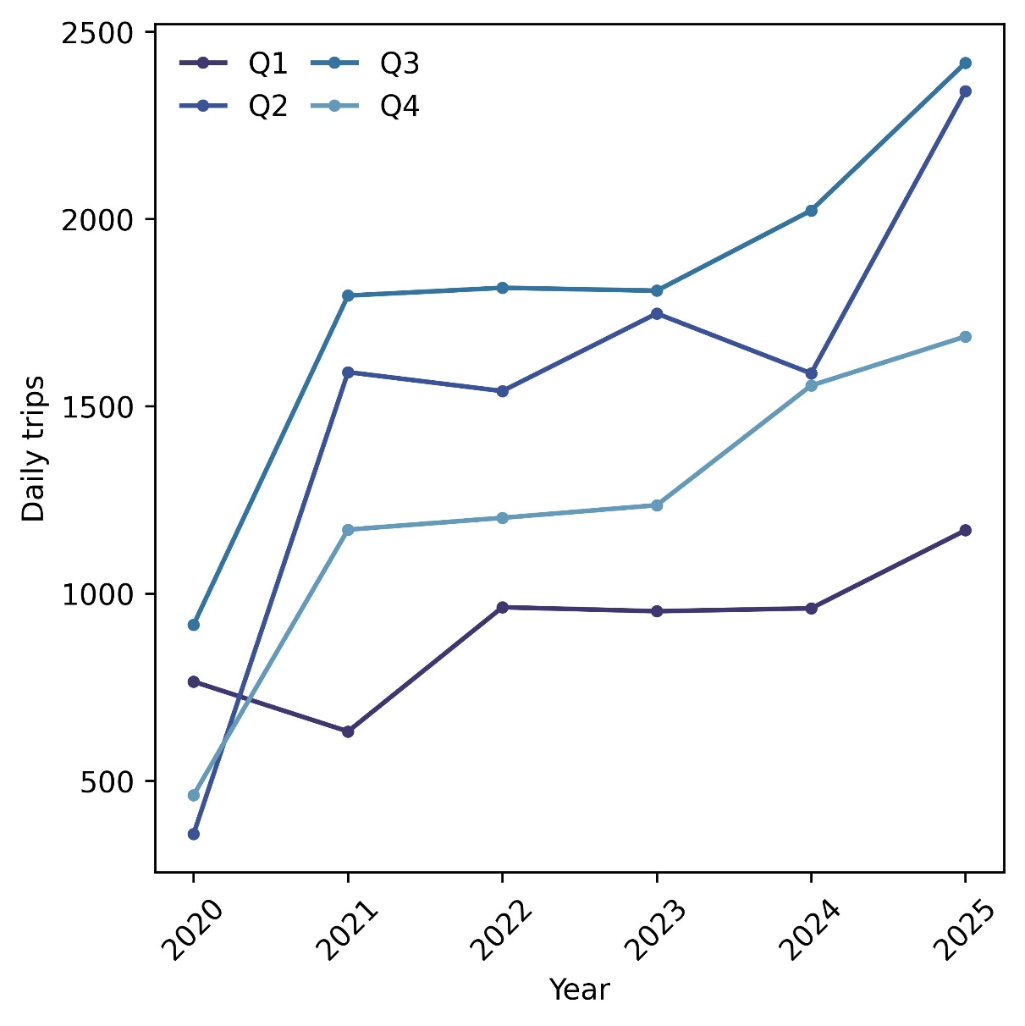
Fig. S1 Daily trips changes over quarters

Fig. S1 reorganises the main quarterly median series into quarter-specific trajectories (Q1–Q4) to better distinguish seasonal ordering from interannual change in SMM use. Across the whole period, Q3 consistently records the highest median daily trips, whereas Q1 remains the lowest, with Q2 and Q4 occupying intermediate levels. Despite these seasonal differences, the four quarter-specific series exhibit a broadly similar temporal pattern that daily trips rose sharply between 2020 and 2021, remained comparatively stable during 2021–2023, and increased again from 2024 onward, especially in Q2–Q4. This pattern suggests an initial boost in activity, followed by a stabilisation period and then renewed growth.

Supplementary Fig. S2 | Kaplan–Meier survival curves stratified by utilisation

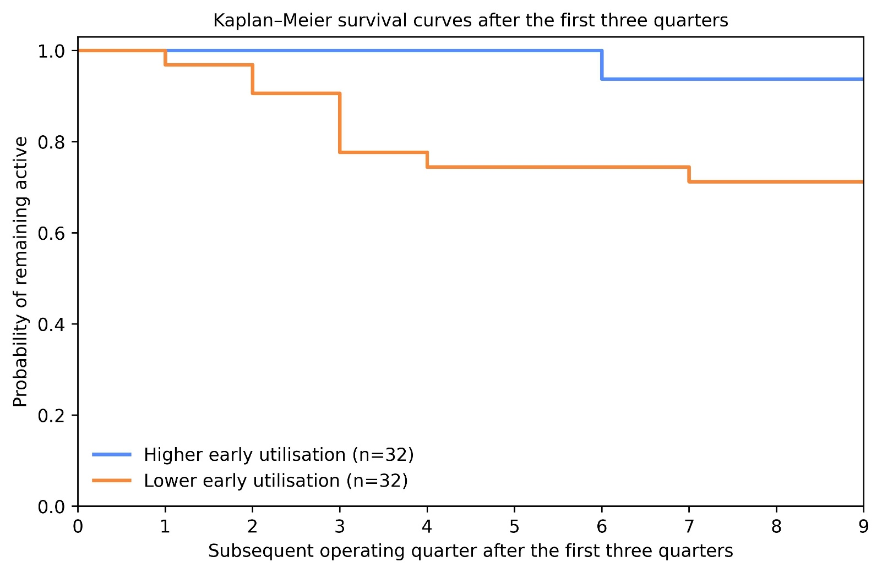
Fig. S2 Kaplan–Meier survival curves

To further test whether the early divergence observed in the main analysis was associated with closure of system, we conducted a survival-based sensitivity analysis using a landmark design. Specifically, we first defined early operational performance as the mean utilisation over the first three operating quarters for each city. We then restricted the sample to cities that remained active through these first three quarters, so that early utilisation could be measured consistently before any subsequent exit event was evaluated. From this common landmark, subsequent system survival was assessed from quarter four onward.

Fig. S2 shows Kaplan–Meier survival curves stratified by the median of mean utilisation over the first three operating quarters. Cities with lower early utilisation exhibited earlier exit and consistently lower subsequent probabilities of remaining active, whereas cities with higher early utilisation showed substantially greater persistence over time. This pattern is consistent with the interpretation that divergence in system trajectories emerges early and is not merely a retrospective consequence of eventual exit.

Supplementary Fig. S3 | Urban-centre concentration under various dominance thresholds

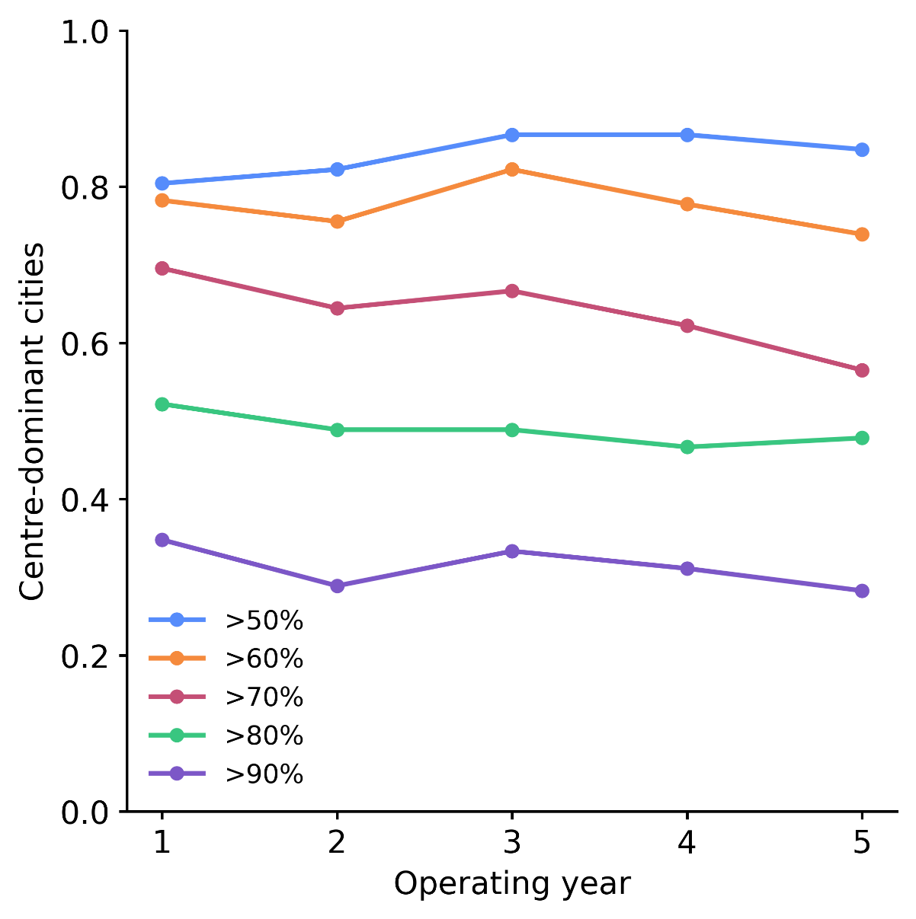
Fig. S3 Cities with high centre-share ride intensity

In the main analysis, centre dominance was defined as the urban centre accounting for more than 50% of total ride intensity. Fig. S3 further tests stricter thresholds of 60–90% to assess the sensitivity of this definition. The overall pattern remains robust: even at an 80% threshold, nearly half of cities still concentrate at least 80% of ride intensity in the urban centre across operating years, whereas the proportion declines more clearly only at the 90% threshold, reaching roughly 30%. This suggests that the observed centre-focused structure is not driven by the choice of a 50% cutoff, but reflects a persistent spatial concentration of SMM activity.

Supplementary Fig. S4 | Key BE indicators for judging the SMM development

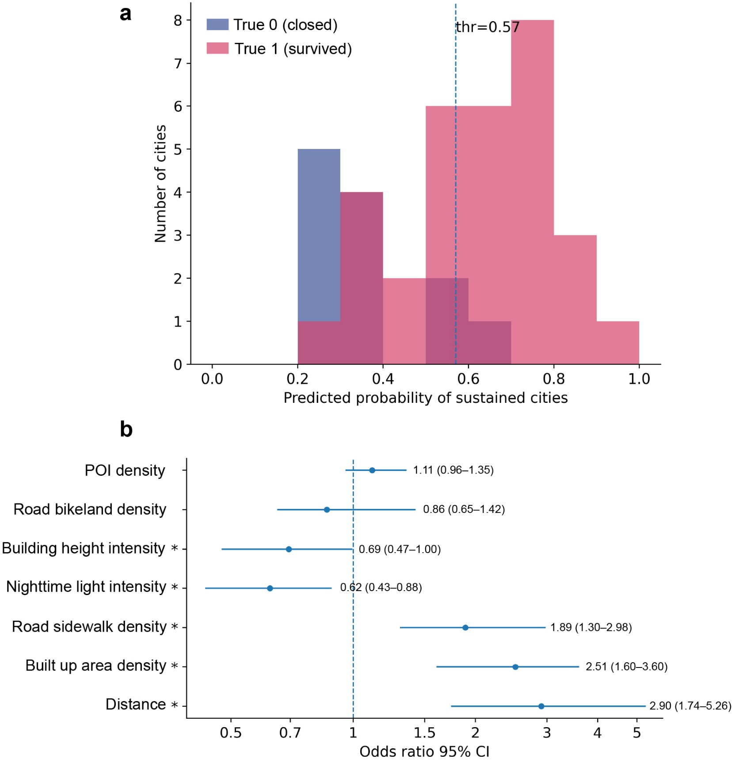
Fig. S4 Threshold selection and feature effects

The city label is defined at the operational status (survived cities = 1, closed cities = 0). Accordingly, the effective sample size for inference is the number of cities rather than the number of ring observations. We represent each city by a set of concentric rings (radial-profile samples), where each ring is characterised by BE indicators and its radial distance from the city centre. Then, we assign the city label to all rings and fit a weighted logistic regression that includes distance as an explicit covariate to capture systematic differences in radial-profile structure between survived and closed cities. During fitting, we apply city-balanced weights so that each city's total weight is approximately 1. To convert city-level predicted probabilities into discrete class assignments for diagnostics, we scan thresholds over $\left[0 , 1\right]$ in 0.01 increments and select the threshold that maximises balanced accuracy; this yields an operating threshold of 0.57 (Fig. S4a).

In Fig. S4b, feature effects are summarised as odds ratios (ORs) with percentile-based 95% confidence intervals. Asterisks indicate predictors whose 95% confidence intervals exclude OR = 1. We estimate uncertainty via a city-level bootstrap in which cities are resampled with replacement and the model is refit to obtain an empirical distribution of coefficients. The 500 replicates had been employed as a pragmatic compromise, providing stable CI endpoints while keeping computation tractable. All predictors are standardised before fitting, so each OR corresponds to a +1 SD increase in the predictor.

As shown in Fig. S4b, Distance, Built up area density, and Road sidewalk density have ORs whose 95% Cis lie entirely above 1, indicating robust positive associations with survived cities after adjusting for the other covariates. In contrast, Nighttime light intensity has an OR entirely below 1, indicating a robust negative association with sustained classification, while Building height intensity shows a borderline negative association (upper CI close to 1), suggesting weaker evidence of stable effects. These results are associative and should not be interpreted as causal estimates. These results are associative and should not be interpreted as causal estimates.

Supplementary Fig S5 | SMMs systems operating for years

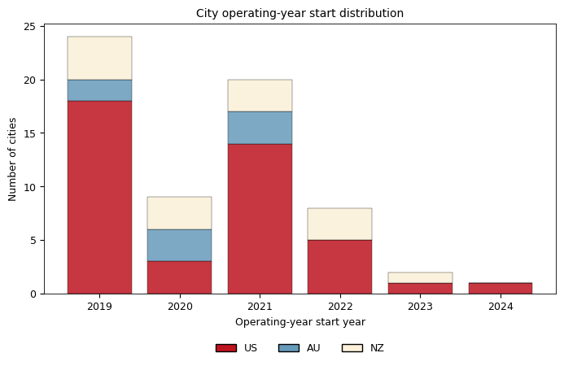
Fig. S5 SMMs operating year start distribution

Fig. S5 shows that 53 cities introduced SMMs, either e-scooters or e-bikes, in 2021 or earlier. All NZ cities in our sample began SMMs by 2021, whereas the latest start in AU occurs in 2023. In the US, start years are more widely distributed. Because SMMs adoption is not synchronised around a single calendar year across cities and countries, our analyses do not align observations by calendar year. Instead, we align systems by operating year, defined relative to each system’s own start of observed operations, to enable like-for-like comparisons across different adoption timings.

Supplementary Fig. S6 | Urban partitioning based on spatial buffer

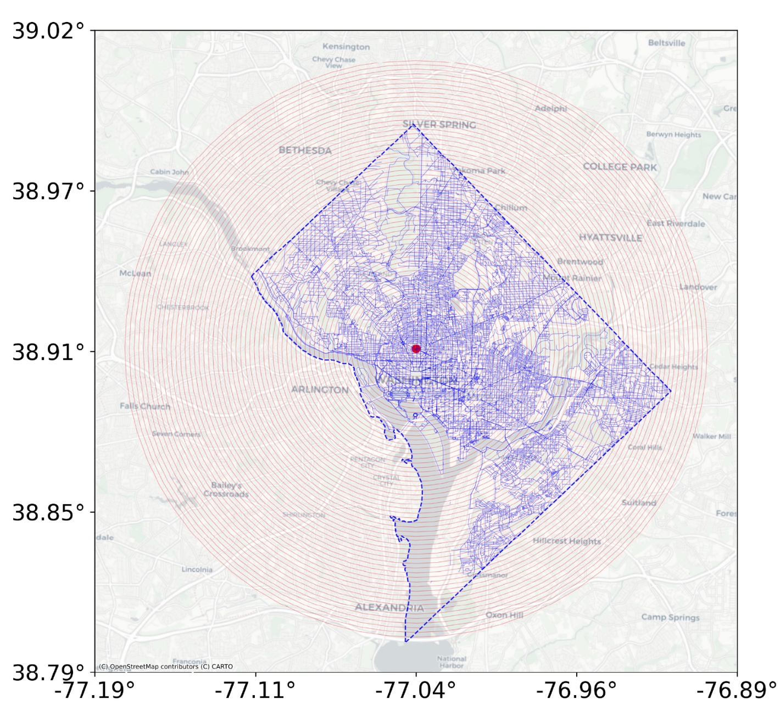
Fig. S6 Buffer rings construction in Washington, D.C.

Fig S6 shows the constructed buffer system for Washington D.C. We first identified the downtown centre of each city using the coordinates of the corresponding city entry in GeoNames, a widely used global geographical database¹. We then classified cities into different urban types according to the measured distance from the city centre to the outermost ring; the detailed classification method is provided in Table S1. Washington, D.C., was classified as Class 2. Accordingly, we divided the urban space into concentric buffers at 200 m intervals.

Supplementary Fig. S7 | Data processing for SMMs restricted zone

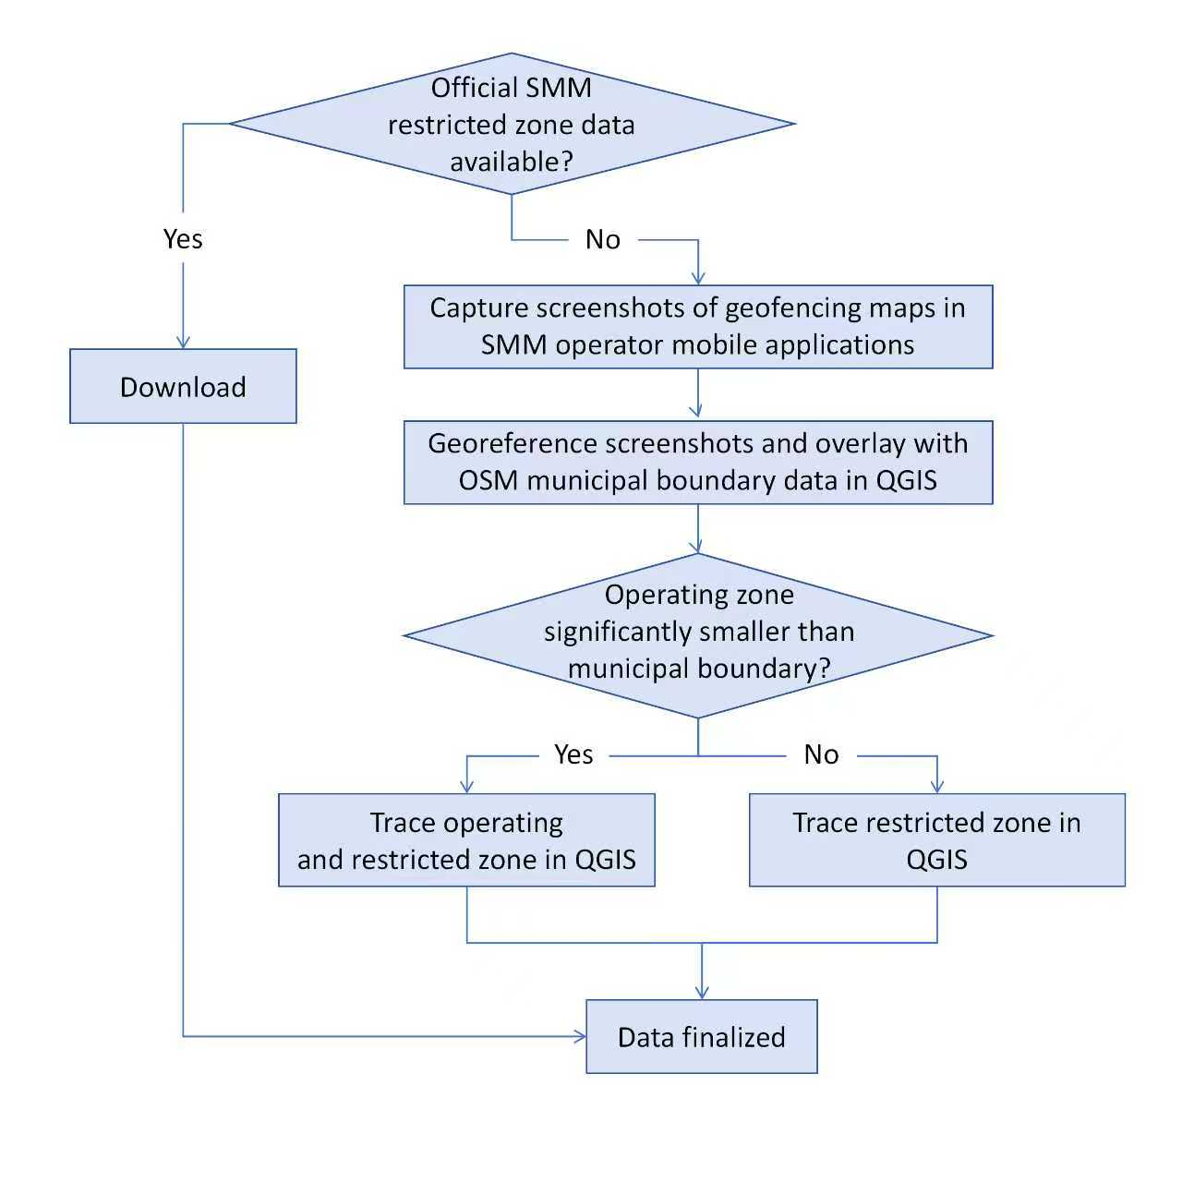
Fig. S7 Data processing flow

The data processing workflow of restricted-zone are illustrated in Fig. S7. As cities do not publicly release official boundary files for restricted zones, we manually digitised restricted-area polygons from major mobile applications of the SMMs operator. Specifically, screenshots of in-app geofencing maps were georeferenced and overlaid with OSM municipal boundary data in QGIS.

Supplementary Fig. S8 | Ring-aggregated restricted zone

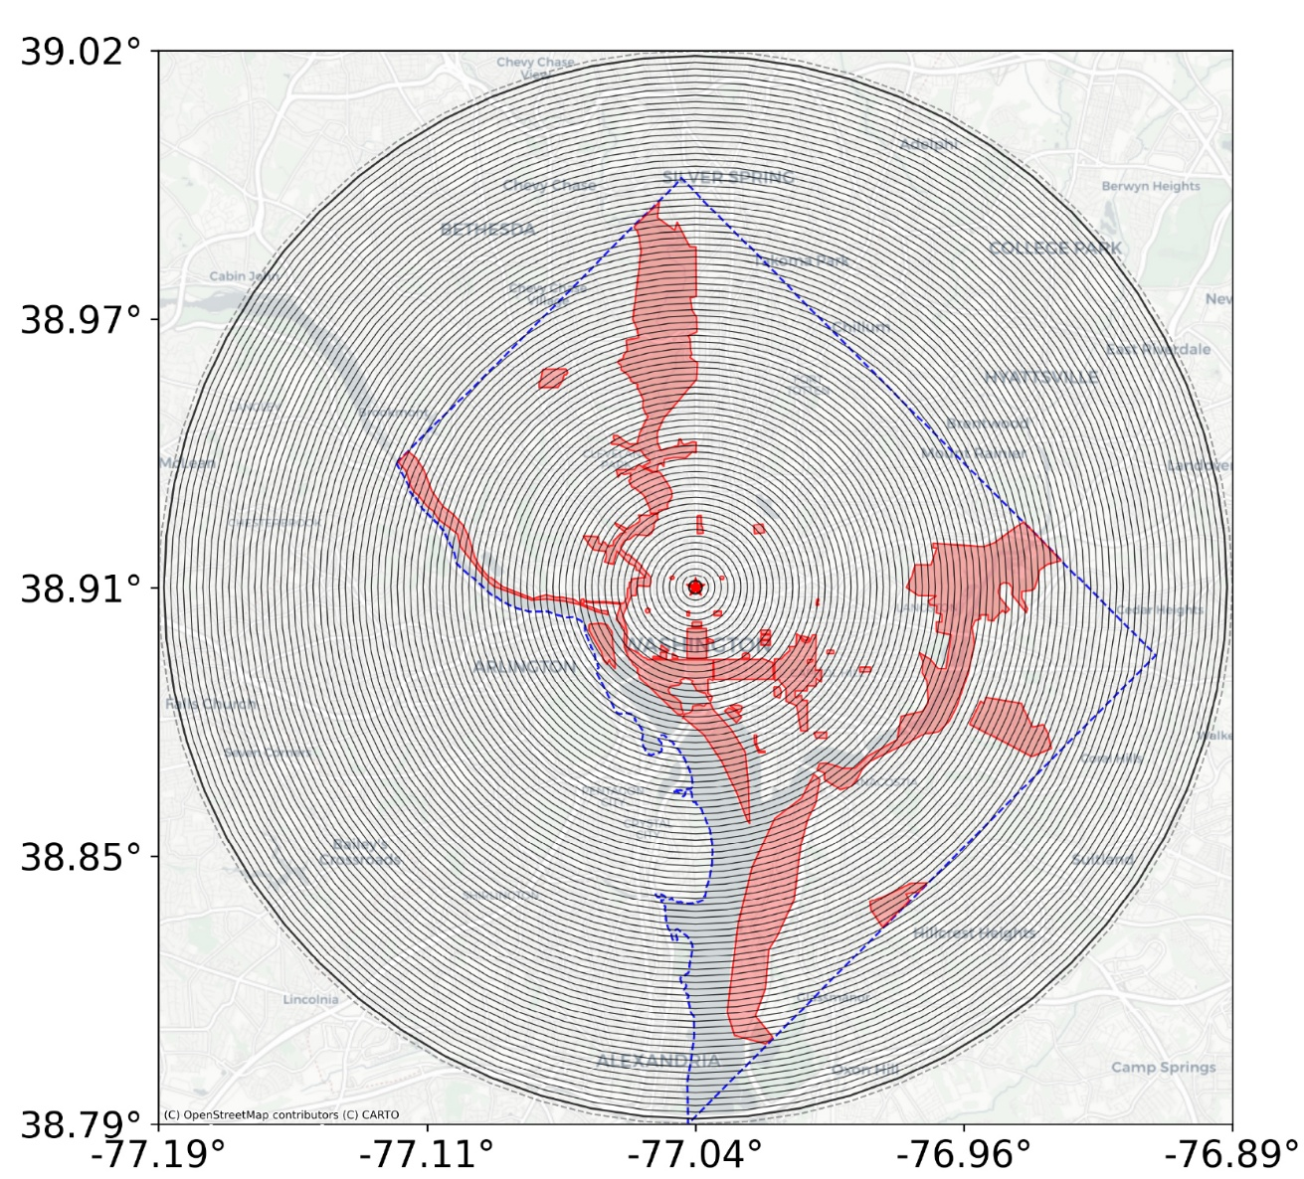
Fig. S8 Restricted zone in Washington, D.C

Using Washington, D.C. as an example, Fig. S8 illustrates the final delineation of restricted-zone boundaries, which were manually traced to create spatial polygon layers for subsequent analysis. In all cities, restricted zones were excluded from the analysis.

Supplementary Fig. S9 | SMM trip trajectories and concentric rings in Washington, D.C.

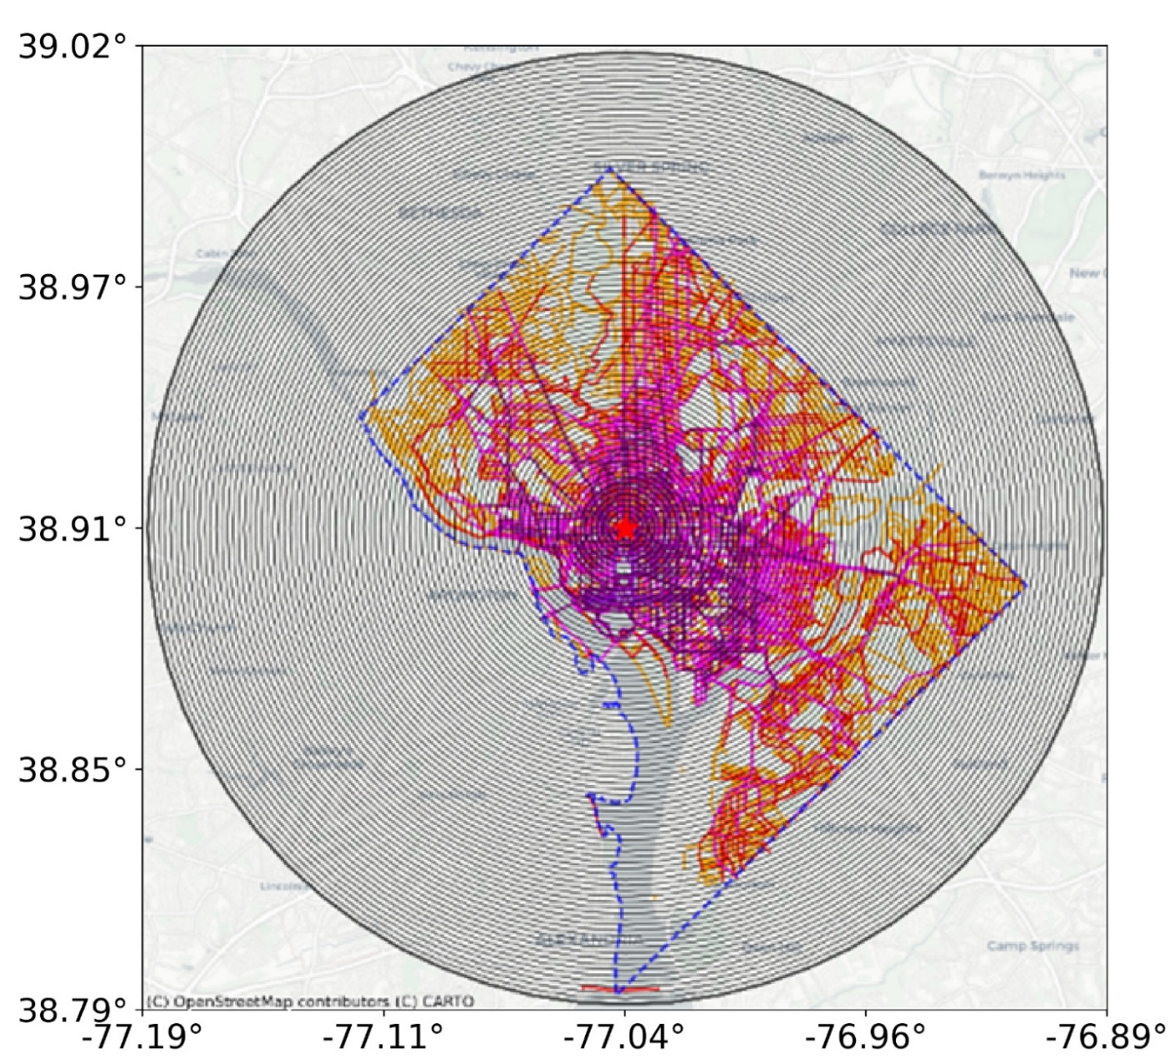 | 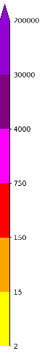
Fig. S9 SMM trip activity and concentric rings in Washington, D.C.

Figure S9 shows the spatial distribution of SMM trip trajectories in Washington, D.C. during 2025 Q4, together with the concentric rings used for ring-level aggregation. The length of the portion of each trajectory falling within a given ring, weighted by the trip count associated with that trajectory, is then used to calculate ring-level ride intensity.

Supplementary Table S1 | Landmark-based discrete-time hazard model of SMMs exit based on early utilisation

Table S1. Results of the Landmark-based discrete-time hazard model
Variable | Coefficient | ORs | 95% CI | P-value
Constant | -6.463 | 0.002 | 0.000–0.036 | <0.001
Subsequent operating quarter | 0.884 | 2.421 | 0.646–9.077 | 0.190
Subsequent operating quarter² | -0.118 | 0.889 | 0.761–1.038 | 0.137
Mean utilisation over the first three quarters (z-score) | -4.002 | 0.018 | 0.001–0.310 | 0.006

Table S1 reports results from a landmark-based discrete-time hazard model. Table S1 presents the results of the discrete-time risk model based on landmark points. This model uses the standardised average utilisation rate for the first three quarters of operation as the independent variable to perform a regression analysis of exit events in the fourth quarter and beyond, while controlling for subsequent operational quarters and their squared terms to capture the baseline exit risk over time.

The coefficient for early utilisation was negative and statistically significant (coefficient = −4.002, P = 0.006), corresponding to an OR of 0.018 (95% confidence interval: 0.001–0.310). This indicates that a one-standard-deviation increase in early utilisation was associated with substantially lower subsequent odds of exit. Although the confidence interval is relatively wide, it remains entirely below 1, supporting a robust negative association between early utilisation and later system exit.

Supplementary Table S2 | Buffer definition based on city size

Table S2. City size adaptive buffer ring scheme
City | Radius(km) | Buffer interval | Total count
Class 1 | $≤$ 15km | 100m | 27
Class 2 | 15-25km | 200m | 23
Class 3 | $>$25km | 400m | 14

Table S2 summarises how we construct concentric buffer rings centred on each city’s CBD point. Because cities vary substantially in spatial extent, we define three radius classes and apply different ring intervals to balance spatial resolution and cross-city comparability: Class 1 (radius ≤ 15 km; 100 m interval), Class 2 (15–25 km; 200 m interval), and Class 3 (> 25 km; 400 m interval). This ring-based delineation follows established practice in urban radial spatial gradient analysis.², where cities are represented as distance bands from a centre rather than being compared at the absolute spatial scale.

Supplementary Table S3 | Data availability for SMMs restricted zone

Table S3. SMMs' availability of the restricted zone
City | Y/N | Total count
Denver, Melbourne, Boulder, Atlanta, Austin, Tempe, Christchurch, Spokane, San Francisco, Grand Junction, Hamilton, West Sacramento, Sacramento, Charlotte, Oklahoma City, Louisville, Colorado Springs, Arvada, Phoenix, Wellington, Palmerston North, Tauranga, Auckland, Dunedin, Porirua, Waimakariri, Ballarat, Adelaide Central, Australian Capital Territory, Brisbane, Davis, Fayetteville, Portland, Newark, Arlington, Fort Collins, St. Louis, Gainesville, Boise, Milwaukee, Coral Gables, Durham, San Jose, Littleton, Brighton, Chula Vista, Bakersfield, Thornton, Greensboro, Greeley, Sydney, Washington, Detroit, Hobart, Santa Monica, Selwyn | Y | 56
Taupō, Napier, Lower Hutt, Whanganui, Richmond, Whangārei, Aurora, Launceston | N | 8

Restricted zones (including no-ride and no-parking zones) in the SMM system are not arbitrarily defined by individual operators, but are shaped through municipal regulation and coordination processes and subsequently enforced uniformly across licensed operators^{3,4}. Accordingly, restricted zones identified by any major local SMM operator are used as a reasonable proxy for government-defined restricted areas.

Tables S3–S4 summarise the availability of restricted zone information across SMM operators and the corresponding data sources. For the following cities—Taupō, Napier, Lower Hutt, Whanganui, and Richmond, there was no restricted zone data available. In addition, restricted zone data could not be accessed for Whangārei, Aurora, and Launceston because the relevant operator applications required local location tracking, which prevented remote data collection. A limitation is that these restricted zones reflect a snapshot at the time of access (2 Jan 2026) rather than a complete historical archive; zones may change over time as regulations and geofencing settings are updated.

Supplementary Table S4 | Data source for SMMs restricted zone

Table S4. Data source of the restricted zone
City | Data source
Denver, Melbourne, Boulder, Atlanta, Austin, Tempe, Christchurch, Spokane, San Francisco, Grand Junction, Hamilton, West Sacramento, Sacramento, Charlotte, Oklahoma City, Louisville, Colorado Springs, Arvada, Phoenix | Lime APP
Wellington, Palmerston North, Tauranga, Auckland, Dunedin, Porirua, Waimakariri, Ballarat | Flamingo APP
Adelaide Central, Australian Capital Territory, Brisbane | Neuron APP
Davis, Fayetteville, Portland, Newark, Arlington, Fort Collins, St. Louis, Gainesville, Boise, Milwaukee, Coral Gables, Durham, San Jose, Littleton, Brighton, Chula Vista, Bakersfield, Thornton, Greensboro, Greeley | Spin APP
Sydney | Ario APP
Washington | Capital Bikeshare (https://opendata.dc.gov/datasets/8837b2ccf07540ae92f17142fc7f757b_47/explore?location=38.961737%2C-76.921805%2C11.33)
Detroit | Detroit Open Data Portal (https://data-detroitmi.hub.arcgis.com/)
Hobart | City of Hobart (https://hobartcc.maps.arcgis.com/home/index.html)
Santa Monica | GIS Open Data Portal (https://gissmgov.opendata.arcgis.com/datasets/smgov::mobility-prohibited-riding-areas/)
Selwyn | Selwyn District Council (https://www.selwyn.govt.nz/services/roads-And-transport/using-the-road/e-scooters)

Supplementary Equation S1-S2 and Fig. S10 | Ring-aggregated road network density
Road-network intensity. To characterise SMMs' supportive street infrastructure, we derived road network indicators from OSM. As shown in Fig. S10, we focused on sidewalks and bicycle lanes and did not include motorised roads in this indicator. For each ring $i$, The combined density of sidewalks and bicycle lanes was calculated in equation (S1).
$RD_{i}=\frac{L_{i}^{\text{sidewalk }}+L_{i}^{\text{bikelane }}}{A_{i}}$ (S1)
Where $L_{i}^{\text{sidewalk }}$ and $L_{i}^{\text{bikelane }}$ denote the total length of sidewalks and bicycle lanes within the ring $i$, respectively, and $A_{i}$​ is the area of the ring $i$. To facilitate comparison across rings within the same city, the combined road-network density was normalised using min–max scaling in equation (S2).
$RD_{i}^{'}=\frac{RD_{i}-RD_{min}}{RD_{max}-RD_{min}}$ (S2)
where $RD_{min}$​ and $RD_{max}$​ denote the minimum and maximum values of $RD_{i}$​ across all rings in the same city.
(a) road network map  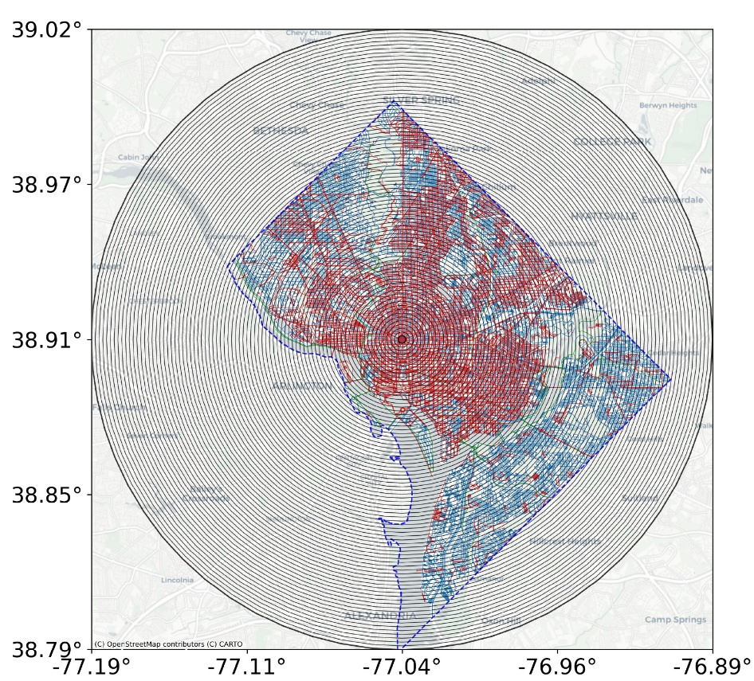 | 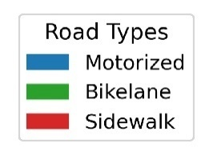 | (b) Gradient curve (normalised)  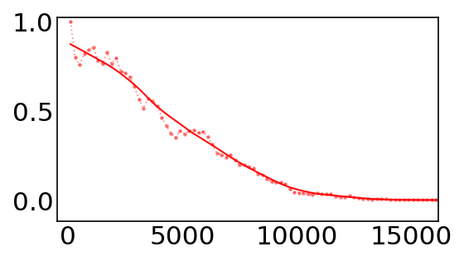  Distance to city centre (m)
Fig. S10 Road network map and concentric rings (Washington D.C. as an example)

Supplementary Equation S3-4 and Fig. S11 | Ring-aggregated land use intensity
Land-use intensity. Using Sentinel-2 10-m global land-use data, we compute the built-up area density in a ring $i$ was calculated as in equation (S3).
${LUD}_{i}=\frac{S_{i}^{built}}{S_{i}-S_{i}^{water}-S_{i}^{snow/ice}}$ (S3)
where $S_{i}^{built}$denotes the built-up area, $S_{i}$ is the total area of valid land pixels within the ring, corresponding to the built-up class shown in the pink area in Fig. S11. $S_{i}^{water}$and $S_{i}^{snow/ice}$represent areas covered by water bodies and permanent snow or ice, respectively.

${\text{ LUD }}_{i}^{'}=\frac{Den_{i}-Den_{\text{min }}}{Den_{\text{max }}-Den_{\text{min }}}$ (S4)

where ${Den}_{\text{min }}$and ${Den}_{\text{max }}$denote the minimum and maximum values of ${LUD}_{i}$ across all rings in the same city. This measure captures the relative intensity of developed land while excluding non-developable surfaces.
(a) Land-use map  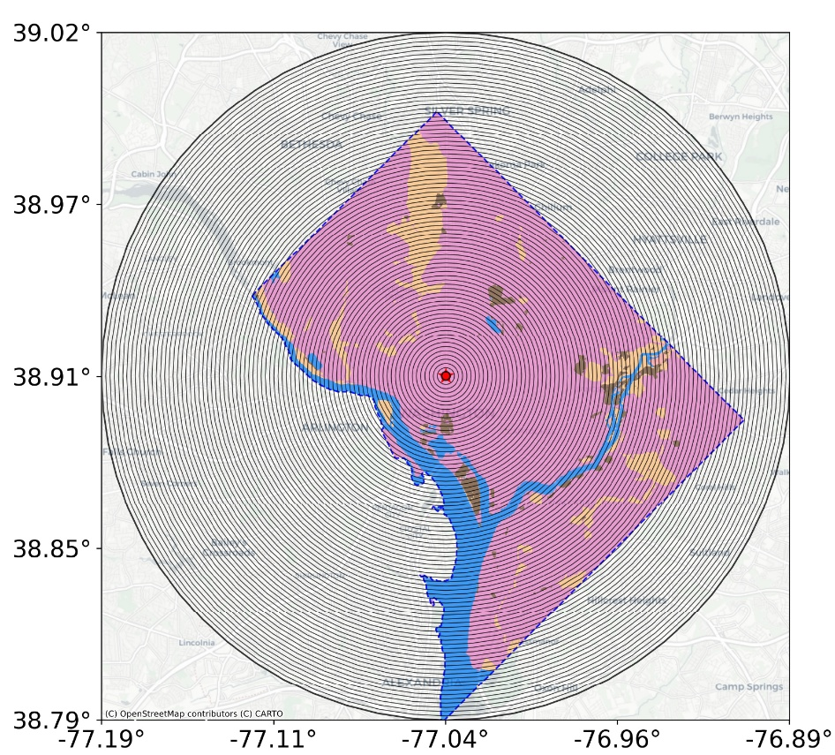 | 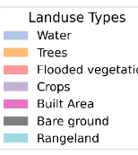 | (b) Gradient curve (normalised)  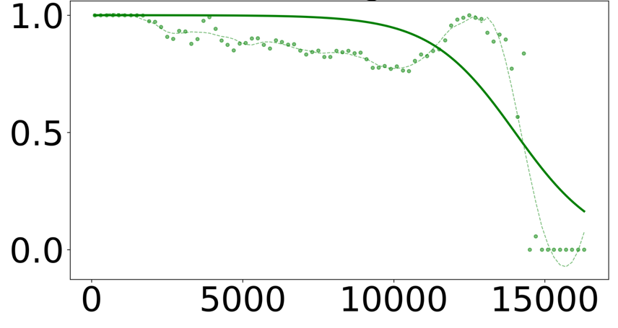  Distance to city centre (m)
Fig. S11 Land-use map and concentric rings (Washington D.C. as an example)

Supplementary Equation S5-6 and Fig. S12 | Ring-aggregated nighttime light intensity
Nighttime light intensity. Nighttime activity was measured using annual VIIRS nighttime light data. As shown in Fig. S12, we compute the mean digital number (DN) for each ring, which was calculated as in equation (S5):
$NLD_{i}=\frac{1}{n_{i}}\sum_{k=1}^{n_{i}}{ }LD_{ik}$ (S5)
Where $LD_{ik}$ is the DN value of the $k$-th valid pixel in the ring $i$, and $n_{i}$ is the number of valid pixels in that ring. To facilitate comparison across rings within the same city, the ring-level mean DN value was normalised as in equation (S6):
$NLD_{i}^{'}=\frac{LD_{i}-LD_{min}}{LD_{max}-LD_{min}}$ (S6)
where $LD_{min}$and $LD_{max}$are the minimum and maximum ring-level mean DN values within the same city. The normalised value $LD_{i}^{'}$ ranges from 0 to 1.

(a) Nighttime light map  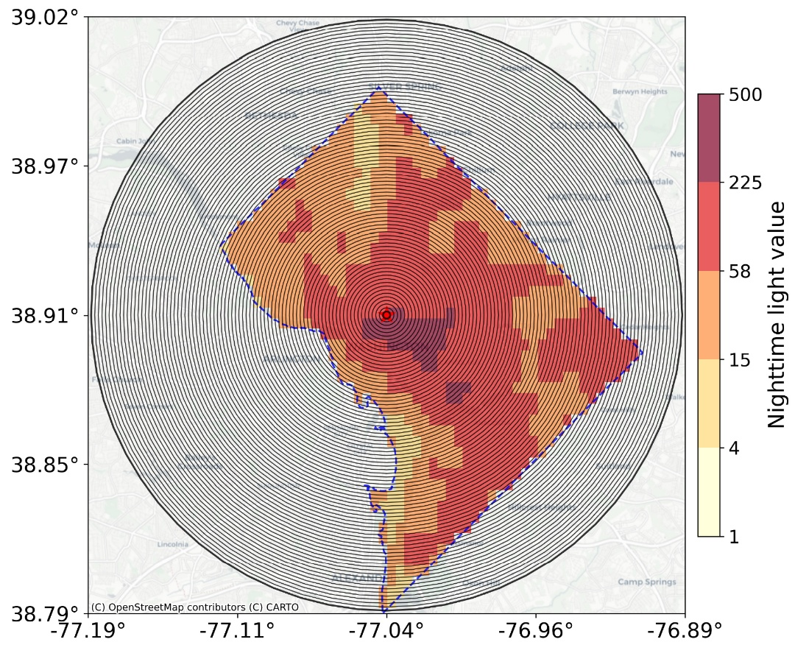 |  | (b) Gradient curve (normalised)  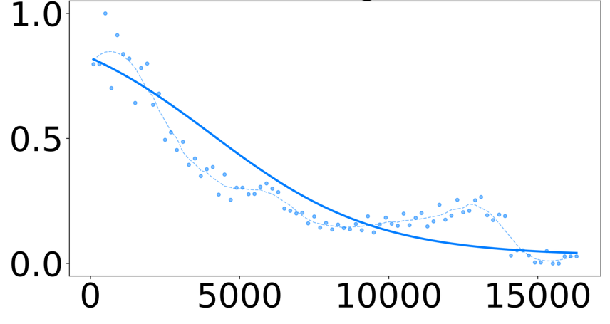  Distance to city centre (m)
Fig. S12 Nighttime light and concentric rings (Washington D.C. as an example)

Supplementary Equation S7-8 and Fig. S13 | Ring-aggregated nighttime light intensity
Building height density. Building form intensity was characterised using the Global Building Height 2020 (GBH2020) dataset. The mean building height mapped in Fig. S13 is calculated as in equation (S7).
${HD}_{i}=\frac{1}{n_{i}}\sum_{k=1}^{n_{i}}{H_{ik}}$ (S7)
where $H_{ik}$ is the height of the $k$-th valid building-height pixel in the ring $i$, and $n_{i}$ is the number of valid pixels. To facilitate comparison across rings within the same city, mean building heights are normalised using equation (S8).
${HD}_{i}^{'}=\frac{H_{i}-H_{min}}{H_{max}-H_{min}}$ (S8)
where $H_{min}$and $H_{max}$ denote the minimum and maximum values of $H_{i}$ across all rings.

(a) Building height map  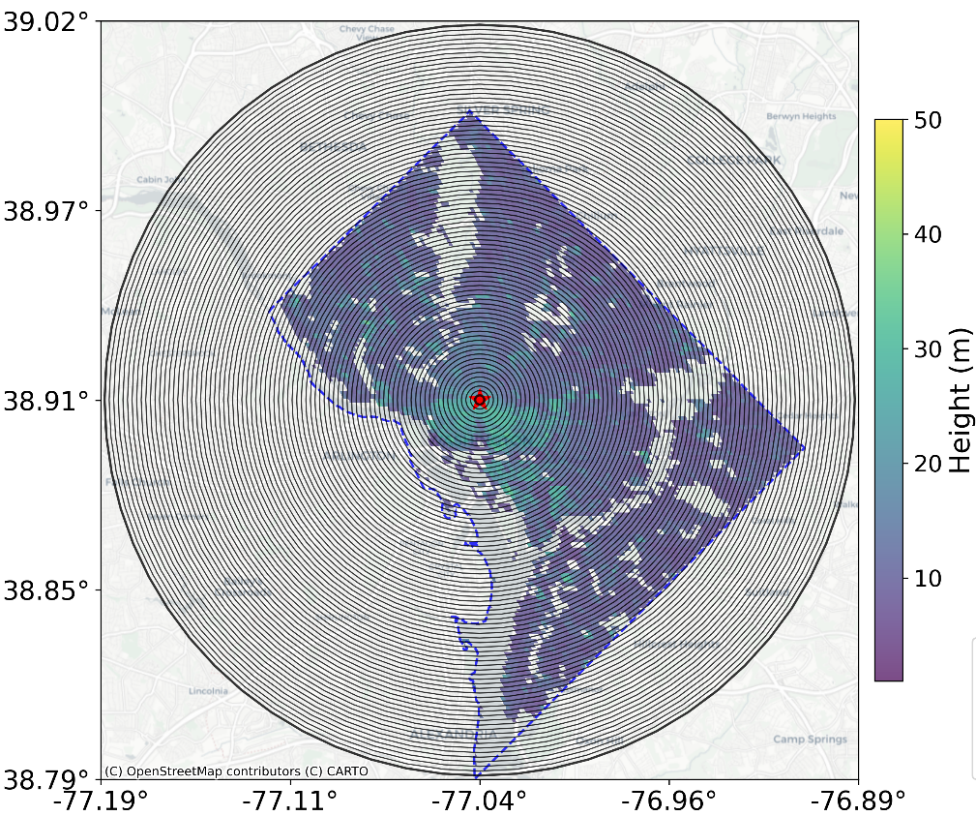 |  | (b) Gradient curve (normalised)  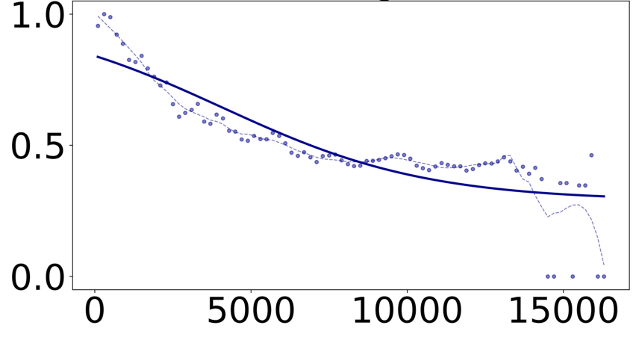  Distance to city centre (m)
Fig. S13 Building height map and concentric rings (Washington D.C. as an example)

Supplementary Equation S9-10 and Fig. S14 | Ring-aggregated nighttime light intensity
POI density. Functional destination intensity was captured using POIs from OSM in Fig. S14. For each ring $i$, POI density was calculated as in equation (S9).
$PD_{i}=\frac{N_{i}^{POI}}{A_{i}}$ (S9)
where $N_{i}^{POI}$​ is the number of POIs within the ring $i$, and $A_{i}$​ is the area of the ring $i$. To facilitate comparison across rings within the same city, POI density was normalised using min–max scaling as (S10).
$PD_{i}^{'}=\frac{PD_{i}-PD_{min}}{PD_{max}-PD_{min}}$ (S10)
where $PD_{min}$​ and $PD_{max}$​ denote the minimum and maximum values of $PD_{i}$ across all rings in the same city.
(a) POI map  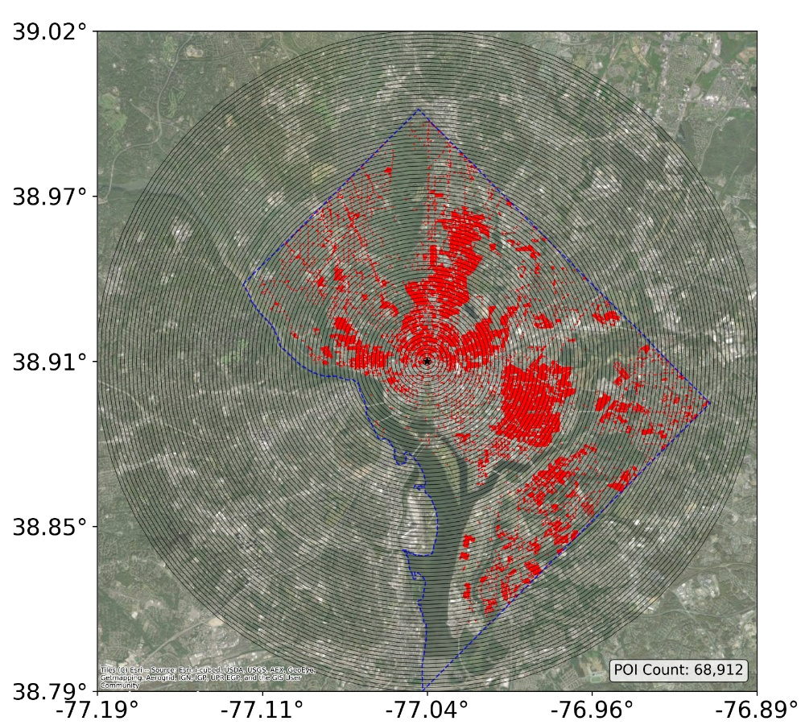 |  | (b) Gradient curve (normalised)  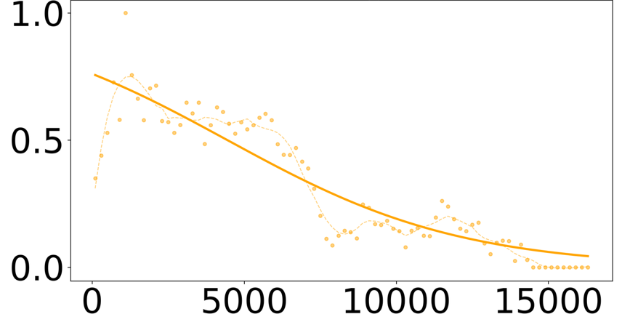  Distance to city centre (m)
Fig. S14 POIs and concentric rings (Washington D.C. as an example)

Reference
1. GeoNames. About GeoNames. https://www.geonames.org/about.html.
2. Zheng, M., Huang, W., Xu, G., Li, X. & Jiao, L. Spatial gradients of urban land density and nighttime light intensity in 30 global megacities. Humanit. Soc. Sci. Commun. 10, 404 (2023).
3. Moran, M. Drawing the map: The creation and regulation of geographic constraints on shared bikes and e-scooters in San Francisco, CA. J. Transp. Land Use 14, (2021).
4. International Transport Forum. Micromobility, Equity and Sustainability: Summary and Conclusions. (OECD, 2021). doi:10.1787/b71317cd-en.

