Supplementary Table S1. Item properties of the NeuroQ

Item | Pre-course |  | Post-course
Item | CITC | Alpha if deleted | CITC | Alpha if deleted
Item 1 | 0.63 | 0.69 | 0.54 | 0.63
Item 2 | 0.57 | 0.72 | 0.55 | 0.63
Item 3 | 0.55 | 0.72 | 0.35 | 0.70
Item 4 | 0.68 | 0.69 | 0.55 | 0.62
Item 5 | 0.33 | 0.80 | 0.36 | 0.71
CITC, corrected item–total correlation. Alpha if deleted indicates Cronbach’s α after removing the item.

Supplementary Table S2. Item-level construct validity of the NeuroQ based on theoretically corresponding Schon items
timepoint | neuroq_item | schon_item | Expected  direction | rho | p | FDR p
Pre-course | Item 1: concepts difficult to understand | Schon item 3: perceived difficulty | Positive | 0.356 | 0.004 | 0.006
Pre-course | Item 2: confidence in understanding concepts | Schon item 2: perceived knowledge | Negative | -0.319 | 0.011 | 0.014
Pre-course | Item 3: neurology more complex | Schon item 3: perceived difficulty | Positive | 0.486 | <0.001 | <0.001
Pre-course | Item 4: confidence in studying neurology | Schon item 4: confidence assessing neurology patient | Negative | -0.433 | <0.001 | <0.001
Pre-course | Item 5: difficulty applying theory clinically | Schon item 4: confidence assessing neurology patient | Negative | -0.380 | 0.002 | 0.004
Post-course | Item 1: concepts difficult to understand | Schon item 3: perceived difficulty | Positive | 0.213 | 0.097 | 0.108
Post-course | Item 2: confidence in understanding concepts | Schon item 2: perceived knowledge | Negative | -0.521 | <0.001 | <0.001
Post-course | Item 3: neurology more complex | Schon item 3: perceived difficulty | Positive | 0.478 | <0.001 | <0.001
Post-course | Item 4: confidence in studying neurology | Schon item 4: confidence assessing neurology patient | Negative | -0.522 | <0.001 | <0.001
Post-course | Item 5: difficulty applying theory clinically | Schon item 4: confidence assessing neurology patient | Negative | -0.195 | 0.128 | 0.128
Spearman correlation coefficients were calculated between prespecified NeuroQ items and theoretically corresponding Schon items at the same time point. Positive correlations were expected for item pairs reflecting perceived difficulty/complexity, whereas negative correlations were expected for item pairs reflecting confidence or knowledge. P-values were adjusted for multiple comparisons using the Benjamini–Hochberg false discovery rate method.

Supplementary Table S3. Pre-course and post-course changes in Schon-related constructs
Construct | n | Pre-course | Post-course | p | FDR-adjusted p
Interest | 62 | 3.50 (3.00–4.00) | 3.00 (3.00–4.00) | 0.739 | 0.739
Knowledge | 62 | 3.00 (2.00–3.00) | 3.00 (3.00–3.00) | 0.007 | 0.029
Difficulty | 62 | 4.00 (3.00–4.00) | 4.00 (3.00–4.00) | 0.299 | 0.398
Confidence | 62 | 3.00 (2.25–4.00) | 3.00 (2.00–3.00) | 0.187 | 0.374
Values are presented as median (interquartile range, IQR). Pre-course and post-course differences were analysed using Wilcoxon signed-rank tests. P-values were adjusted using the Benjamini–Hochberg false discovery rate method.

Supplementary Figure S1. Individual-level changes in NeuroQ total scores from pre-course to post-course assessment.
Each line represents one student’s paired NeuroQ total score before and after completion of the neurology course. Higher NeuroQ scores indicate greater neurophobia.
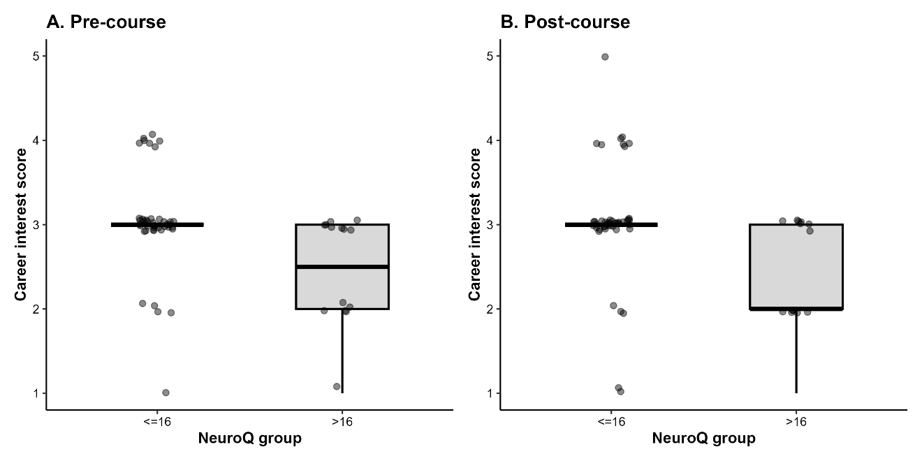
Supplementary Figure S2. Career interest scores according to NeuroQ group at pre-course and post-course assessment.
Career interest in neurology was assessed at the end of the course using a 5-point Likert scale, with higher scores indicating greater interest. Students were grouped according to NeuroQ scores using the prespecified cut-off of >16. Panel A shows career interest according to pre-course NeuroQ group, and Panel B shows career interest according to post-course NeuroQ group. Boxplots show the median and interquartile range, and overlaid dots represent individual students.

