Additional files
Table S1. Full baseline characteristics according to sleep status.
Characteristic | Total (n=726) | Normal sleep (n=408) | Poor sleep (n=318) | P value
Age, years | 72.26 ± 5.14 | 72.39 ± 5.17 | 72.08 ± 5.10 | 0.419
Men, n (%) | 361 (49.7) | 219 (53.7) | 142 (44.7) | 0.019
Chronic conditions = 0 | 295 (40.6) | 175 (42.9) | 120 (37.7) | 0.262
Chronic conditions = 1 | 241 (33.2) | 135 (33.1) | 106 (33.3)
Chronic conditions = 2 | 127 (17.5) | 69 (16.9) | 58 (18.2)
Chronic conditions = 3 | 63 (8.7) | 29 (7.1) | 34 (10.7)
PSQI score | 6.67 ± 4.52 | 3.35 ± 1.66 | 10.93 ± 3.29 | <0.001
BMI, kg/m² | 23.11 ± 3.31 | 22.95 ± 3.22 | 23.31 ± 3.42 | 0.160
Weight, kg | 54.11 ± 9.09 | 54.25 ± 8.90 | 53.93 ± 9.35 | 0.645
Body fat percentage, % | 32.33 ± 8.28 | 31.63 ± 8.07 | 33.22 ± 8.46 | 0.012
Skeletal muscle mass index | 6.02 ± 0.94 | 6.07 ± 0.91 | 5.96 ± 0.96 | 0.127
Visceral fat area | 91.57 ± 36.98 | 88.95 ± 35.49 | 94.97 ± 38.62 | 0.034
Total energy intake, kcal/day | 1667.29 ± 525.56 | 1701.87 ± 526.52 | 1622.91 ± 521.79 | 0.044
Dietary fat energy ratio | 0.36 ± 0.09 | 0.35 ± 0.09 | 0.37 ± 0.09 | 0.007
Fat intake, g/day | 65.68 ± 24.62 | 65.82 ± 25.53 | 65.49 ± 23.42 | 0.856
Carbohydrate energy ratio | 0.52 ± 0.11 | 0.52 ± 0.11 | 0.51 ± 0.10 | 0.052
Carbohydrate intake, g/day | 215.40 ± 82.76 | 222.26 ± 82.70 | 206.61 ± 82.13 | 0.011
Protein energy ratio | 0.13 ± 0.03 | 0.13 ± 0.03 | 0.13 ± 0.03 | 0.154
Protein intake, g/day | 55.16 ± 24.01 | 57.10 ± 24.46 | 52.69 ± 23.22 | 0.013
ECW/TBW | 0.39 ± 0.01 | 0.39 ± 0.01 | 0.39 ± 0.01 | 0.981
Basal metabolic rate, kcal | 1157.46 ± 147.22 | 1167.58 ± 143.62 | 1144.44 ± 150.98 | 0.039
Waist-to-hip ratio | 0.87 ± 0.05 | 0.87 ± 0.05 | 0.87 ± 0.05 | 0.657
Obesity degree, % | 107.58 ± 16.16 | 106.64 ± 15.61 | 108.80 ± 16.78 | 0.081
Body cell mass, kg | 23.48 ± 4.50 | 23.78 ± 4.39 | 23.09 ± 4.62 | 0.046
Bone mineral content, kg | 2.04 ± 0.34 | 2.07 ± 0.34 | 2.01 ± 0.35 | 0.027
Protein mass, kg | 7.09 ± 1.36 | 7.18 ± 1.33 | 6.97 ± 1.39 | 0.040
Phase angle, 50 kHz | 4.62 ± 0.63 | 4.63 ± 0.64 | 4.60 ± 0.63 | 0.635
Values are mean ± SD or n (%). Poor sleep quality was defined as PSQI score >5.

Table S2. Pearson correlation matrix for key variables.
Variable | Dietary fat energy ratio | Fat intake, g/day | PBF | SMI | PSQI score
Dietary fat energy ratio | 1 | 0.544*** | 0.086* | -0.133*** | 0.136***
Fat intake, g/day | 0.544*** | 1 | -0.084* | 0.140*** | -0.005
PBF | 0.086* | -0.084* | 1 | -0.289*** | 0.156***
SMI | -0.133*** | 0.140*** | -0.289*** | 1 | -0.100**
PSQI score | 0.136*** | -0.005 | 0.156*** | -0.100** | 1
Values are Pearson correlation coefficients. * p < 0.05, ** p < 0.01, *** p < 0.001.
Table S3. Multicollinearity diagnostics.
Predictor | Tolerance | VIF
Dietary fat energy ratio | 0.8609 | 1.1616
Body fat percentage | 0.0963 | 10.3858
SMI | 0.1038 | 9.6363
Age | 0.8903 | 1.1232
Sex | 0.4002 | 2.4984
BMI | 0.0752 | 13.2914
Total energy intake | 0.7037 | 1.4210
Red meat intake | 0.7211 | 1.3867
VIFs were calculated using PSQI score as the dependent variable. Highly correlated body-composition indicators were not entered simultaneously in the main mediation model. VIF, variance inflation factor.
Table S4. Exploratory mediation analyses.
Exploratory pathway | a path (P value) | b path (P value) | Direct effect c' (P value) | Indirect effect | 95% BC bootstrap CI | Inference
Fat intake, g/day → PBF→PSQI | -0.028 (p=0.026) | 0.059 (p=0.016) | 0.023 (p=0.019) | -0.0017 | -0.0046 to -0.0002 | Significant, very small negative
Fat intake, g/day → SMI → PSQI | 0.0053 (p<0.001) | -0.101 (p=0.660) | 0.024 (p=0.015) | -0.0005 | -0.0034 to 0.0019 | Not significant
Dietary fat energy ratio → SMI → PSQI | -0.983 (p=0.002) | -0.173 (p=0.456) | 6.074 (p=0.002) | 0.170 | -0.271 to 0.714 | Not significant
All exploratory models used PROCESS Model 4 and the same covariate strategy as the primary mediation model. PBF, body fat percentage; SMI, skeletal muscle mass index; PSQI, Pittsburgh Sleep Quality Index.
Table S5. Sex-stratified descriptive statistics for key variables.
Variable | Men, n | Men, mean ± SD | Women, n | Women, mean ± SD | P value
Dietary fat energy ratio | 361 | 0.35 ± 0.09 | 365 | 0.37 ± 0.09 | 0.048
Body fat percentage, % | 352 | 27.68 ± 6.54 | 355 | 36.93 ± 7.18 | <0.001
PSQI score | 361 | 6.08 ± 4.12 | 365 | 7.26 ± 4.82 | <0.001
P values were obtained using independent-sample t tests. Sex was coded as male = 1 and female = 2.

Table S6. Sensitivity analyses.
Sensitivity analysis | Key result | Inference
Alternative Model 7: sex moderating the dietary fat energy ratio → PBF pathway | Interaction β = 3.785, SE = 5.903, p = 0.522; index of moderated mediation = 0.284, 95% BC CI: −0.506 to 1.304 | No evidence of first-stage sex moderation
Main mediation model using binary sleep-quality outcome | Indirect effect = 0.129, 95% BC CI: −0.022 to 0.447 | The indirect effect was attenuated when PSQI was dichotomized
Main mediation model after excluding one participant with absolute studentized residual >3 | Indirect effect = 0.471, 95% BC CI: 0.061 to 1.255 | The primary indirect pathway remained significant
Sensitivity analysis | Key result | Inference
Alternative Model 7: sex moderating dietary fat energy ratio -> PBF | Interaction β=3.785, SE=5.903, p=0.522; index=0.284, 95% BC CI: -0.506 to 1.304 | Not significant; supports the second-stage moderation specification
Primary mediation model after excluding one participant with absolute studentized residual >3 | Indirect effect=0.471, 95% BC CI: 0.061 to 1.255 | Primary indirect pathway remained significant
BC, bias-corrected; CI, confidence interval; PBF, body fat percentage.

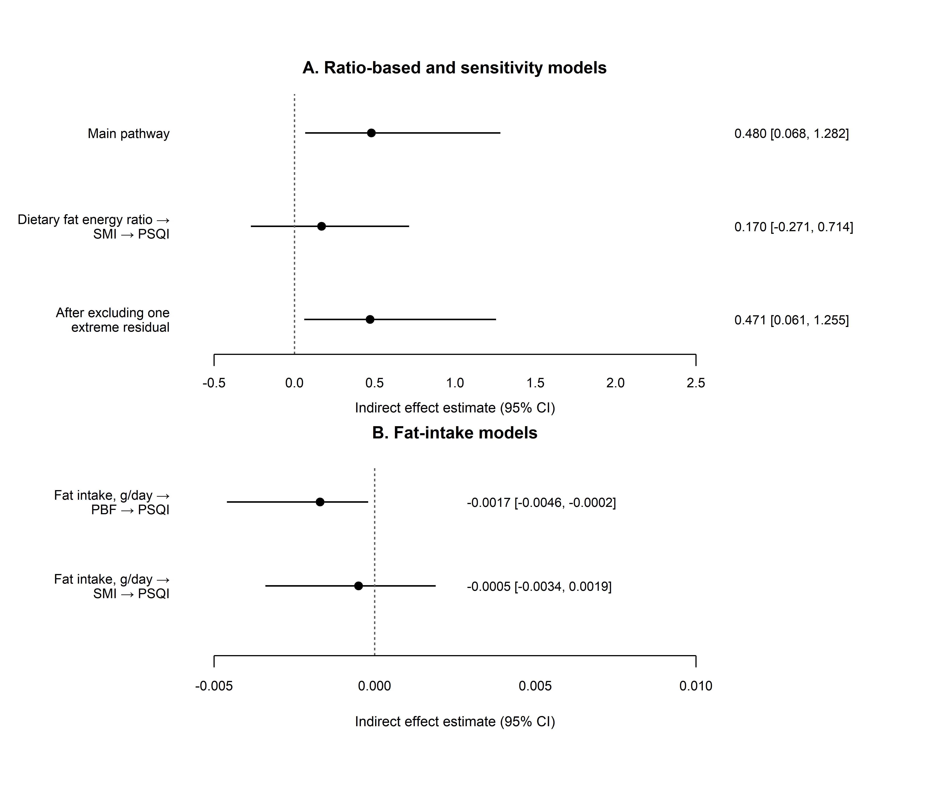
Figure S1. Exploratory and sensitivity indirect-effect estimates for the main and alternative mediation pathways shown in the supplementary analyses. Error bars represent 95% bias-corrected bootstrap confidence intervals. PBF, percentage body fat; SMI, skeletal muscle index; PSQI, Pittsburgh Sleep Quality Index.

