Appendix 1: Effects of aqueous extracts of V. amygdalina and C.odorata on rice seedling (a) seed germination experimemts (b) Graph showing germination percentage
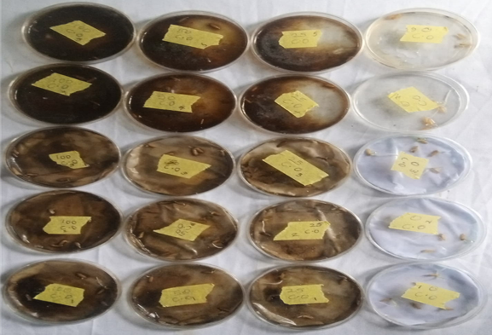 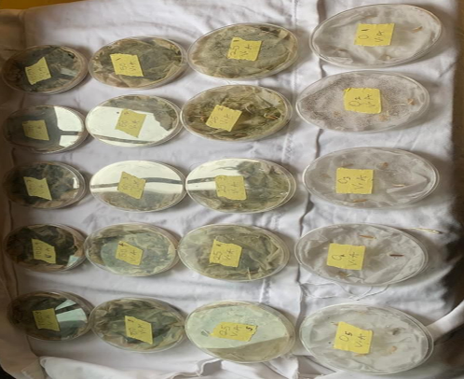 (a)
(b)

