Table 2 Tailored personas of palliative care decision-making characteristics among caregivers of patients with end-stage heart failure
Name | Proactive type | Anxious-conflicted type | Resistant-avoidant type | Isolated-helpless type
Persona illustration | 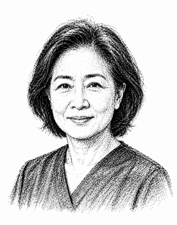 | 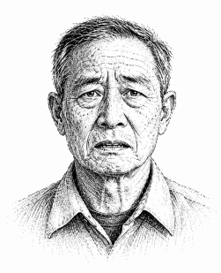 | 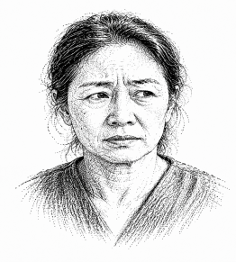 | 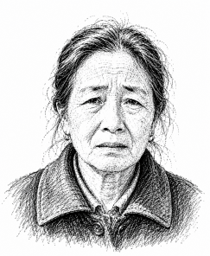
Individuals | C2, C4, C18, C19 | C1, C5, C6, C7, C9,  C11, C15, C12, C22 | C3, C14, C17, C21 | C8, C10, C13, C16,  C20
Gender and age | 2 men and 2 women, Aged 56–62 | 4 men and 5 women,  Aged 45–65 | 4 women, Aged 58–66 | 1 man and 4 women,  Aged 47–72
Educational level | Higher education: 4 people | Secondary education: 4 people  Higher education: 5 people | Uneducated: 1 person  Secondary education: 3 people | Uneducated: 1 person  Primary education: 3 people  Secondary education: 1 person
Residential  address | Town: 4 people | Town: 9 people | Town: 3 people  Village: 1 person | Town: 1 person  Village: 4 people
Employment status | Employed: 1 person  Retired: 3 people | Employed: 1 person  Retired: 8 people | Retired: 3 people  Unemployed: 1 person | Retired: 1 person  Unemployed: 4 people
Care duration | 1-2 years: 2 people  2-3 years: 2 people | < 1 year: 1 person  1-2 years: 3 people  2-3 years: 4 people  > 3 years: 1 person | < 1 year: 1 person  1-2 years: 3 people | < 1 year: 1 person  1-2 years: 4 people
Cognitive level | Comprehensive Disease Understanding;  Strong Palliative Care Awareness;  Strong Information-Seeking Ability; | Fragmented Disease Understanding;  Limited Palliative Care Awareness;  Poor Information Integration; | Insufficient Disease Knowledge;  Misconceptions About Palliative Care;  Information Avoidance; | Severely Limited Disease Knowledge;  Minimal Palliative Care Awareness;  Restricted Access to Information;
Psychological state | Emotional Stability;  Low Anxiety Levels;  Death Acceptance;  Proactive Decision Engagement; | Emotional Volatility;  Heightened Anxiety;  Fear of Death;  Decisional Conflict; | Psychological Resistance;  Death Avoidance;  Low Decision-Making Engagement; | Feelings of Isolation and Helplessness;  Caregiver Exhaustion;  Decision-Making Uncertainty;
Value preference | Patient-Centred Comfort and Dignity;  Acceptance of a Good Death;  Respect for Patient Autonomy; | Treatment–Comfort Care Dilemma;  Filial Piety Orientation;  Concern About Social Judgment; | Life-Prolongation Orientation;  Rejection of Palliative Care Values; | Status Quo Preference;  Passive Reliance on Professional Advice;
Social support | Strong Family Support;  Active Professional Support Seeking;  Active Peer Engagement;  Strong Social Support Network;  Low Financial Burden; | Family Disagreement;  Limited Trust in Healthcare Professionals;  Susceptibility to External Opinions;  Lack of Consistent Decision Support;  Moderate Financial Burden; | Family Communication Barriers;  Resistance to Professional Advice;  Limited Caregiving Communication;  Avoidance of External Support; | Lack of Family Support;  Poor Communication with Healthcare Professionals;  Limited Peer Support Access;  Limited Social Resources;  High Financial Burden;
Resource  Needs | Personalised Palliative Care Planning;  Continuity of Home-Based Care Resources;  Anticipatory Grief Counseling; | Clear Medical Decision Guidance;  Palliative Care and Disease Education;  Family Communication Support;  Psychological Support and Emotional Counseling; | Trust-Building with Healthcare Professionals;  Palliative Care and Disease Education;  Gradual Communication Approach;  Emotional Expression Support; | Integrated Decision Support Services;  Palliative Care and Disease Education;  Financial and Social Care Resource Support;

