Supplementary Table 1. Rectal MRI acquisition protocol
Sequence | TR (ms) | TE (ms) | Slice thickness  (mm) | Gap  (mm) | FOV  (mm) | Matrix
Sagittal T2WI | 3000–3230 | 110–132 | 4 | 0.4 | 220–260 | 292 × 291
Coronal T2WI | 3372–5620 | 110–128 | 4 | 0–0.4 | 220–280 | 292 × 291
Axial T2WI | 3625–4290 | 103–120 | 4 | 0.4 | 280–320 | 492 × 465
Axial T1WI | 650–750 | 13–15 | 4 | 0.4 | 320–330 | 376 × 408
Axial DWI | 5000–6000 | 58–63 | 4 | 0.4 | 330–420 | 192 × 106
Oblique axial high-resolution T2WI | 3700–5060 | 103–120 | 3 | 0.3 | 140–150 | 232 × 192
Abbreviations: DWI, diffusion-weighted imaging; FOV, field of view; TE, echo time; TR, repetition time; T1WI, T1-weighted imaging; T2WI, T2-weighted imaging.

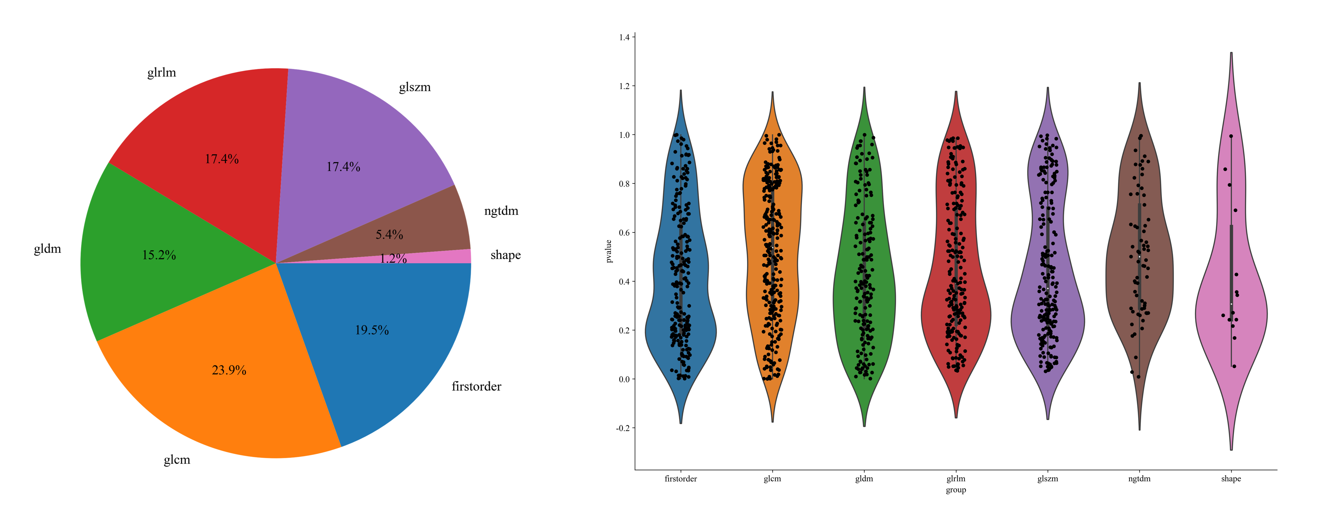
Supplementary Figure 1. Composition and distribution of radiomics feature categories
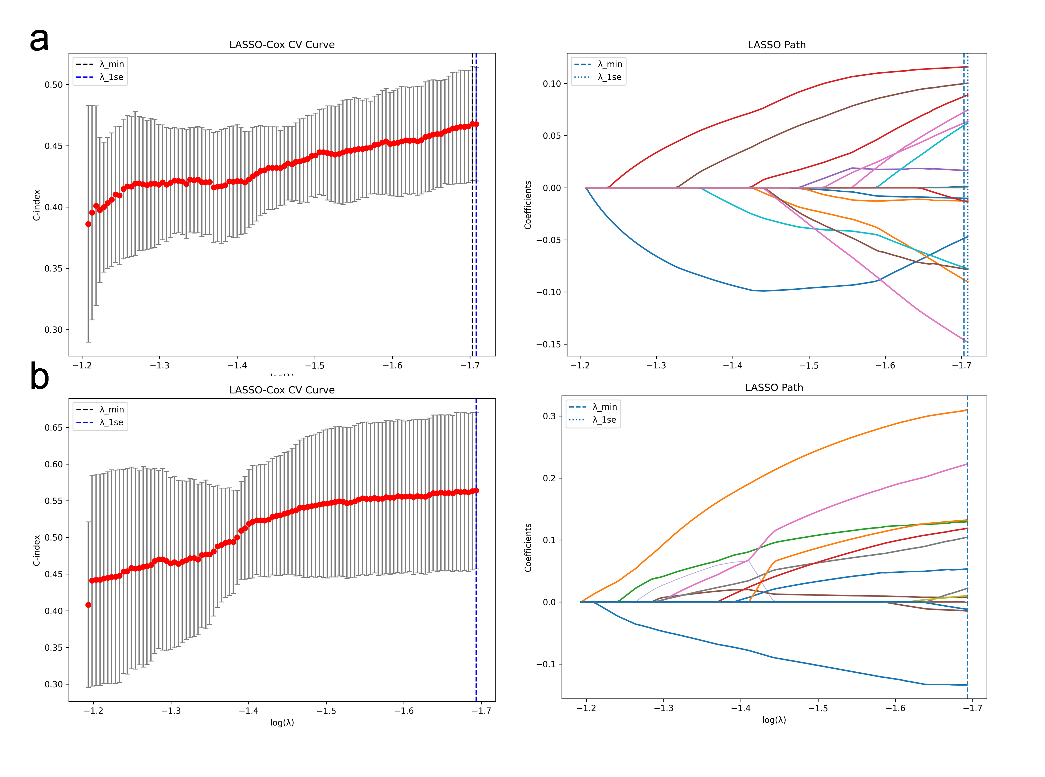
Supplementary Figure 2. LASSO-Cox feature selection for DWI and T2WI sequences. (a) DWI sequences. (b) T2WI sequences.

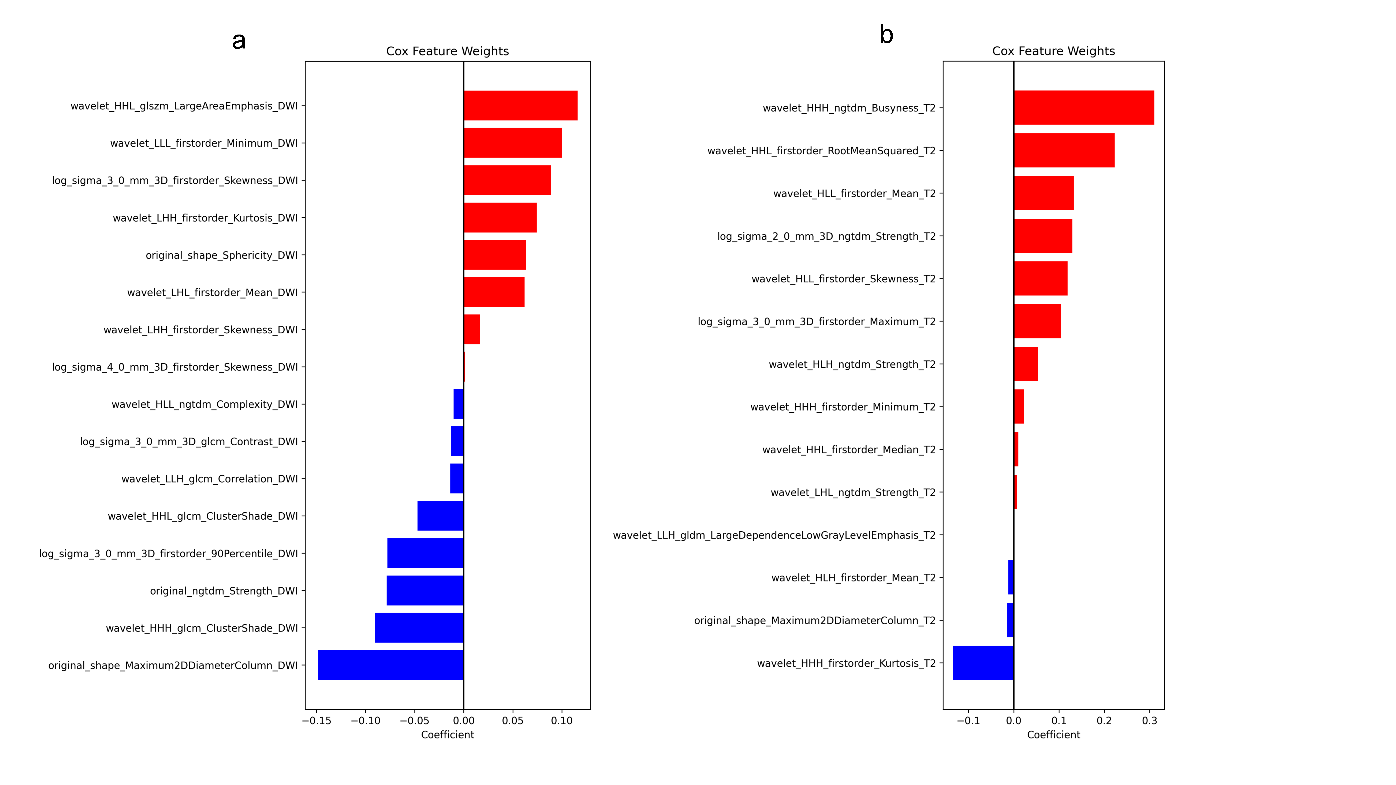
Supplementary Figure3. Distribution of Cox regression coefficients for LASSO-selected candidate radiomics features from DWI and T2WI. (a) DWI sequence. (b) T2WI sequence.

